Alhassanain (p) Network for Islamic Heritage and Thought

THE LIFE OF IMAM AL-MAHDI Peace Be Upon Him

By: Allama Baqir Sharif al-Qarashi

Translated by: Sayyid Athar Husain S.H. Rizvi

Publisher: Ansariyan Publications - Qum

First Edition 1427 -2006 - 1385

ISBN: 964-438-806-2

ALL RIGHTS RECORDED AND RESERVED FOR THE PUBLISHER

[www.alhassanain.org/english](http://www.alhassanain.org/english)

Table of Contents

[بسم الله الرحمن الرحيم 8](#_Toc452467877)

[Dedication 9](#_Toc452467878)

[Translator’s Foreword 10](#_Toc452467879)

[Foreword 11](#_Toc452467880)

[Manifestation of the Light 18](#_Toc452467881)

[The name of Imam Mahdi's Mother 18](#_Toc452467882)

[In Praise of Imam Mahdi's Mother 19](#_Toc452467883)

[Performance of rituals connected with the new birth 20](#_Toc452467884)

[Public Feast 21](#_Toc452467885)

[Shias informed of the birth of the Imam of the time 21](#_Toc452467886)

[Felicitations for the birth of the Imam of the time 21](#_Toc452467887)

[Manifestation of the Light of the Imam of the Time (a.s) 23](#_Toc452467888)

[Performance of rituals connected with the new birth 24](#_Toc452467889)

[Public Feast 24](#_Toc452467890)

[Shias informed of the birth of the Imam of the time 24](#_Toc452467891)

[Felicitations for the birth of the Imam of the time 25](#_Toc452467892)

[Name of the Imam of the Time 26](#_Toc452467893)

[Titles of Imam Mahdi (a.s) 26](#_Toc452467894)

[Agnomen of the Imam of the time 26](#_Toc452467895)

[Year of Birth of the Imam of the Time 26](#_Toc452467896)

[The Blessed Night 27](#_Toc452467897)

[Recommendation of Supplication on the Night of the Imam’s Birth 28](#_Toc452467898)

[Acquainting the Shias with Imam of the time 30](#_Toc452467899)

[Characteristics and Qualities of the Imam of the time 31](#_Toc452467900)

[Resemblance of Imam of the time with the Prophet 31](#_Toc452467901)

[Concocted Traditions 33](#_Toc452467902)

[Prominent Characteristics and Merits of the Imam of the Time 35](#_Toc452467903)

[Encompassing knowledge of the Imam of the time 35](#_Toc452467904)

[Piety of the Imam of the time 36](#_Toc452467905)

[Patience of Imam of the Time 36](#_Toc452467906)

[Worship of the Imam of the time 37](#_Toc452467907)

[Supplications of the Imam of the time in the Qunut of Ritual Prayers 37](#_Toc452467908)

[Another Supplication of the Imam of the time 41](#_Toc452467909)

[Valor of the Imam of the time 44](#_Toc452467910)

[Steadfastness of the Imam of the time in rightfulness 44](#_Toc452467911)

[Generosity of the Imam of the time 44](#_Toc452467912)

[Some Brilliant Legacies of the Imam of the Time 46](#_Toc452467913)

[Supplications of the Imam of the time 46](#_Toc452467914)

[1. Supplication of the Imam of the time for the Muslims 46](#_Toc452467915)

[2. Supplication of the Imam of the time for Believers 48](#_Toc452467916)

[3. Supplication of the Imam of the time for fulfillment of needs 49](#_Toc452467917)

[4. Supplication of the Imam of the time for cure 51](#_Toc452467918)

[5. Ziyarat and Supplication 52](#_Toc452467919)

[6. Supplication of the Imam of the time for Early reappearance 59](#_Toc452467920)

[7. Supplication of the Imam of the time for his Shias 63](#_Toc452467921)

[8. Supplication of the Imam of the time for the Prophet of Islam and the Imams of Guidance (a.s) 64](#_Toc452467922)

[9. Supplication of the Imam of the time for release from imprisonment 71](#_Toc452467923)

[Ziyarat of Imam Husain (a.s), a medium of His Eminence, Baqiyyat allah (a.s) 73](#_Toc452467924)

[Letters of the Imam of the Time (a.s) 79](#_Toc452467925)

[1. Letter of the Imam of the time to Ahmad bin Ishaq 79](#_Toc452467926)

[2. Letter of the Imam of the time to Al-Amri and his son 81](#_Toc452467927)

[3. Letter of the Imam of the time to some of his Shias 82](#_Toc452467928)

[4. Letter of the Imam of the time to Muhammad Asadi 83](#_Toc452467929)

[5. Replies of the Imam of the time to the Questions of Ishaq 84](#_Toc452467930)

[6. Letters of the Imams of the time to Shaykh Mufeed 86](#_Toc452467931)

[Second letter of the Imam of the time for Shaykh Mufeed 88](#_Toc452467932)

[Examples of Jurisprudence of the Imam of the Time 90](#_Toc452467933)

[1. Queries of Muhammad bin Abdullah bin Ja’far 90](#_Toc452467934)

[Prayer of Ja’far at-Tayyar 91](#_Toc452467935)

[2. Others Queries of Muhammad bin Abdullah 92](#_Toc452467936)

[3. Other Queries 95](#_Toc452467937)

[Other Queries of Muhammad 97](#_Toc452467938)

[The Minor and the Major Occultation 102](#_Toc452467939)

[The Imam of the time under the shade of his respected father 102](#_Toc452467940)

[Imam Hasan Askari (a.s) goes towards the Eternal Abode 102](#_Toc452467941)

[Clarification of Imam Hasan Askari (a.s) on the Imamate of the Awaited Imam (a.s) 103](#_Toc452467942)

[Assassination of Imam Hasan Askari (a.s) 105](#_Toc452467943)

[Vigilance of the Abbaside rule 106](#_Toc452467944)

[Towards Paradise 106](#_Toc452467945)

[The Last rites of Imam Hasan Askari (a.s) 106](#_Toc452467946)

[Elaborate arrangements of the Funeral Procession of Imam Hasan Askari (a.s) 107](#_Toc452467947)

[Burial Place of Imam Hasan Askari 107](#_Toc452467948)

[Raid on the house of Imam Hasan Askari (a.s) 107](#_Toc452467949)

[Delegation from Qom 107](#_Toc452467950)

[Ja’far and the Abbaside Caliph 109](#_Toc452467951)

[The Minor Occultation 110](#_Toc452467952)

[Period of Minor Occultation 110](#_Toc452467953)

[Place and situation of Minor Occultation 110](#_Toc452467954)

[Lies And Allegations 110](#_Toc452467955)

[2. Existence of cellar in Samarrah 111](#_Toc452467956)

[(A) Suwaidi 111](#_Toc452467957)

[(B) Ibne Taiymiyah 111](#_Toc452467958)

[(C) Ibne Hajar 112](#_Toc452467959)

[(D) Qaseemi 112](#_Toc452467960)

[Investigation in this matter 112](#_Toc452467961)

[(A) Muhaddith Noori 113](#_Toc452467962)

[(B) Allamah Sadruddin 113](#_Toc452467963)

[(C) Muhaqqiq Arbili 113](#_Toc452467964)

[(D) Muhaqqiq Amini 113](#_Toc452467965)

[The Great Emissaries of the Imam of the Time (a.s) 114](#_Toc452467966)

[1. Uthman bin Saeed Amri 114](#_Toc452467967)

[Uthman bin Saeed's services to the Imam (a.s) 114](#_Toc452467968)

[Trustworthiness and reliability of Uthman bin Saeed 114](#_Toc452467969)

[Deputyship of Uthman bin Saeed from His Eminence, the Awaited Imam (a.s) 115](#_Toc452467970)

[Death of Uthman bin Saeed 115](#_Toc452467971)

[Condolence of the Awaited Imam (a.s) 115](#_Toc452467972)

[2. Muhammad bin Uthman 116](#_Toc452467973)

[Justice and Trustworthiness of Muhammad bin Uthman 116](#_Toc452467974)

[Writings of Muhammad bin Uthman 116](#_Toc452467975)

[Deputyship of Muhammad bin Uthman from Imam Mahdi 117](#_Toc452467976)

[Death of Muhammad bin Uthman 117](#_Toc452467977)

[3. Husain bin Ruh 117](#_Toc452467978)

[Debate of Husain bin Ruh with the opponents 117](#_Toc452467979)

[Steadfastness of Husain bin Ruh 118](#_Toc452467980)

[Dissimulation of Husain bin Ruh 119](#_Toc452467981)

[Husain bin Ruh with Ali Qummi 119](#_Toc452467982)

[Death of Husain bin Ruh 119](#_Toc452467983)

[4. Ali bin Muhammad Samari 119](#_Toc452467984)

[Guardianship of the Scholar (Wilayat-e-Faqih) 121](#_Toc452467985)

[Responsibilities of the Religious Jurisprudent 122](#_Toc452467986)

[The Major Occultation 123](#_Toc452467987)

[Dajjals 123](#_Toc452467988)

[1. Ahmad bin Hilal 123](#_Toc452467989)

[Imam’s censure of Karkhi 123](#_Toc452467990)

[2. Hasan Sharii 123](#_Toc452467991)

[3. Husain bin Mansur 124](#_Toc452467992)

[Another fraud of Husain bin Mansur 124](#_Toc452467993)

[4. Muhammad bin Ali 125](#_Toc452467994)

[Claimants of Mahdaviyat 125](#_Toc452467995)

[1. Mahdi Sudani 125](#_Toc452467996)

[Beginning of his Mission 126](#_Toc452467997)

[Control on Sudan 127](#_Toc452467998)

[Death of Mahdi Sudani 128](#_Toc452467999)

[2. Mahdi Tahama 128](#_Toc452468000)

[3. Mahdi of Senegal 128](#_Toc452468001)

[4. Mahdi of Soos 128](#_Toc452468002)

[5. Mahdi of Somalia 128](#_Toc452468003)

[A Study of the Occultation of Imam Mahdi 129](#_Toc452468004)

[Causes of the occultation of Imam Mahdi (a.s) 129](#_Toc452468005)

[1. Fear of tyrannical Abbaside regime 129](#_Toc452468006)

[Letter of Khwarizmi to the people of Nishapur 130](#_Toc452468007)

[Doubt of Khanizi 144](#_Toc452468008)

[2. Test and Trial 145](#_Toc452468009)

[3. Secrets of the Occultation of the Imam of the Time 145](#_Toc452468010)

[4. Not paying allegiance to the oppressors by the Imam of the time (a.s) 145](#_Toc452468011)

[Some Queries 147](#_Toc452468012)

[1. What is the benefit derived from the occultation of the Imam of the Age (a.s)? 147](#_Toc452468013)

[2. Longevity of the Imam of the Age 149](#_Toc452468014)

[3. Why such a long age? 150](#_Toc452468015)

[4. Why does the Imam of the Age not reappear? 150](#_Toc452468016)

[5. How would the Imam of the time reform the world? 151](#_Toc452468017)

[Those Who Prophesied the Reappearance of the Imam of the Time (a.s) 152](#_Toc452468018)

[1. The Holy Prophet (a.s) 152](#_Toc452468019)

[2. His Eminence, Amirul Momineen (a.s) 155](#_Toc452468020)

[3. His Eminence, Imam Hasan Mujtaba (a.s) 156](#_Toc452468021)

[4. His Eminence, Imam Husain (a.s) 157](#_Toc452468022)

[5. His Eminence, Imam Zainul Abideen (a.s) 158](#_Toc452468023)

[6. His Eminence, Imam Muhammad Baqir (a.s) 158](#_Toc452468024)

[7. His Eminence, Imam Ja'far as-Sadiq (a.s) 159](#_Toc452468025)

[8 - His Eminence, Imam Musa Kazim (a.s) 160](#_Toc452468026)

[9. His Eminence, Ali bin Musa (a.s) 160](#_Toc452468027)

[10. His Eminence, Imam Muhammad Jawwad 161](#_Toc452468028)

[11. His Eminence, Ali al-Hadi (a.s) 162](#_Toc452468029)

[12. His Eminence, Imam Hasan Askari (a.s) 163](#_Toc452468030)

[The Reappearance of the Great Reformer of the World - A Fundamental Religious Belief 165](#_Toc452468031)

[The Universal reformer in the view of the Christians 165](#_Toc452468032)

[Return of the Christ for reformation of the People 165](#_Toc452468033)

[1. Gospel of John 166](#_Toc452468034)

[2. Gospel of St. Luke 166](#_Toc452468035)

[3. Gospel of St. Matthew 166](#_Toc452468036)

[Signs of reappearance of Christ (a.s) 166](#_Toc452468037)

[The Great Reformer in the view of Jews 168](#_Toc452468038)

[Description of the Advent of the Reformer of Jews 168](#_Toc452468039)

[Signs of Reappearance of the Imam of the Time 169](#_Toc452468040)

[The Vast Spread of Bounties after the Advent of the Savior of the Jews 170](#_Toc452468041)

[Believers and Deniers of the Imam of the Time (a.s) 171](#_Toc452468042)

[Those who believe the Imam is born and exists 171](#_Toc452468043)

[1. Muhammad bin Talha Shafei 171](#_Toc452468044)

[2. Ibne Arabi 172](#_Toc452468045)

[3. Ibne Sabbagh Maliki 172](#_Toc452468046)

[4. Ibne Athir 172](#_Toc452468047)

[5. Shamsuddin 173](#_Toc452468048)

[6. Abul Fida 173](#_Toc452468049)

[7. Qirmani 173](#_Toc452468050)

[8. Ibne Khallikan 173](#_Toc452468051)

[9. Dhahabi 173](#_Toc452468052)

[10. Sirajuddin Rufayi 173](#_Toc452468053)

[11. Shaykh Shablanji 173](#_Toc452468054)

[12. Sulaiman Ibne Khwaja 174](#_Toc452468055)

[13. Abdul Wahhab Sherani 174](#_Toc452468056)

[14. Khairuddin Zarkali 174](#_Toc452468057)

[15. Baihaqi 174](#_Toc452468058)

[16. Husain Kashifi 174](#_Toc452468059)

[17. Shuqrani 175](#_Toc452468060)

[18. Salahuddin Safadi 175](#_Toc452468061)

[19. Muhammad Najjari 175](#_Toc452468062)

[20. Sayyid Ahmad Zaini Dahlan 175](#_Toc452468063)

[Books Written about His Eminence, Imam Mahdi (a.s) 176](#_Toc452468064)

[Poets who believed in Imam Mahdi (a.s) 179](#_Toc452468065)

[1. Kumayt 179](#_Toc452468066)

[2. Dibil Khuzai 179](#_Toc452468067)

[3. Sayyid Himyari 179](#_Toc452468068)

[4. Wurd bin Zaid 179](#_Toc452468069)

[5. Musab bin Wahab 180](#_Toc452468070)

[6. Muhammad bin Ismail Saimari 180](#_Toc452468071)

[7. Ali Khawafi 180](#_Toc452468072)

[8. Qasim bin Yusuf 180](#_Toc452468073)

[9. Ibne Rumi 181](#_Toc452468074)

[10. Yahya bin Aqib 181](#_Toc452468075)

[11. Fazl bin Ruzbahan 181](#_Toc452468076)

[12. Abdur Rahman 181](#_Toc452468077)

[13. Ibne Abil Hadid 181](#_Toc452468078)

[14. Amir Basri 181](#_Toc452468079)

[15. Abul Ma’ali 181](#_Toc452468080)

[16. Bahauddin Amili 182](#_Toc452468081)

[17. Sayyid Haider Hilli 182](#_Toc452468082)

[18. Sayyid Ali Khan 182](#_Toc452468083)

[19. Khalie-e 182](#_Toc452468084)

[20. Abdul Ghani Aamili 182](#_Toc452468085)

[21. Hasan Qaftan 183](#_Toc452468086)

[22. Sayyid Abbas 183](#_Toc452468087)

[23. Shaykh Muhammad Samawi 183](#_Toc452468088)

[Deniers of Imam Mahdi (a.s) 184](#_Toc452468089)

[1. Ibne Khaldun 184](#_Toc452468090)

[2. Muhammad Amin Baghdadi 184](#_Toc452468091)

[3. Ahmad Kasravi 185](#_Toc452468092)

[4. Ahmad Amin 185](#_Toc452468093)

[5. Shukri Afandi 186](#_Toc452468094)

[Signs of the Reappearance of the Imam of the Time (a.s) 187](#_Toc452468095)

[Certain Signs 187](#_Toc452468096)

[Widespread Injustice and Oppression 187](#_Toc452468097)

[The Signs of the Hour (Qiyamat) 189](#_Toc452468098)

[First Tradition 190](#_Toc452468099)

[Second Tradition 192](#_Toc452468100)

[Advent of Dajjal (Anti-Christ) 198](#_Toc452468101)

[Emphasis of traditions for the advent of Dajjal 198](#_Toc452468102)

[Titles of Dajjal 199](#_Toc452468103)

[Patronymics of Dajjal 199](#_Toc452468104)

[Characteristics of Dajjal 199](#_Toc452468105)

[Fabricated Traditions 199](#_Toc452468106)

[Plight of the Believers under Dajjal 200](#_Toc452468107)

[Followers of Dajjal 200](#_Toc452468108)

[Faith of Jews on Dajjal 200](#_Toc452468109)

[Signs of the advent of Dajjal 201](#_Toc452468110)

[Treasures under Dajjal’s control 201](#_Toc452468111)

[The End of Dajjal 201](#_Toc452468112)

[Advent of Sufyani 202](#_Toc452468113)

[Sufyani’s Lineage 202](#_Toc452468114)

[Physical features of Sufyani 202](#_Toc452468115)

[Sufyani’s Character 202](#_Toc452468116)

[Tradition of His Eminence, Ali (a.s) regarding Sufyani 202](#_Toc452468117)

[Duration of Sufyani’s Rule 204](#_Toc452468118)

[Black Flags 204](#_Toc452468119)

[Voice from the Sky 205](#_Toc452468120)

[First Group of Traditions 205](#_Toc452468121)

[Second Group of Traditions 206](#_Toc452468122)

[Third Group of Traditions 207](#_Toc452468123)

[Jesus shall pray behind Imam Mahdi (a.s) 207](#_Toc452468124)

[Time and Venue of the Reappearance of His Eminence, the Master of the Age (a.s) 209](#_Toc452468125)

[Time of Reappearance 209](#_Toc452468126)

[Time of the call of the Angel 209](#_Toc452468127)

[Widespread Power of the Imam of the Time (a.s) 209](#_Toc452468128)

[System of the Imam’s Government 211](#_Toc452468129)

[The Imam’s Companions 211](#_Toc452468130)

[Characteristics of the Companions of Imam Mahdi 211](#_Toc452468131)

[Number of the companions of Imam Mahdi (a.s) 212](#_Toc452468132)

[Venue of Allegiance 213](#_Toc452468133)

[Conditions imposed by the Imam of the time (a.s) for giving allegiance 213](#_Toc452468134)

[The Standard-Bearer of Imam Mahdi (a.s) 214](#_Toc452468135)

[Period of Imam Mahdi’s Government 214](#_Toc452468136)

[Abundance of riches and blessings during the reign of His Eminence, Imam Mahdi (a.s) 214](#_Toc452468137)

[Ziyarat of Imam al-Mahdi (a.s) 216](#_Toc452468138)

[Supplication for Imam al-Mahdi (a.s) 228](#_Toc452468139)

[Glossary of Islamic Terms 240](#_Toc452468140)

[Notes 249](#_Toc452468141)

بسم الله الرحمن الرحيم

وَلَقَدْ كَتَبْنَا فِي الزَّبُورِ مِن بَعْدِ الذِّكْرِ أَنَّ الأَرْضَ يَرِثُهَا عِبَادِيَ الصَّالِحُونَ.

سورة الأنبياء/ 105

وَعَدَ اللَّهُ الَّذِينَ آمَنُوا مِنْكُمْ وَعَمِلُوا الصَّالِحَاتِ لَيَسْتَخْلِفَنَّهُم فِي الأَرْضِ كَمَا اسْتَخْلَفَ الَّذِينَ مِنْ قَبْلِهِمْ وَلَيُمَكِّنَنَّ لَهُمْ دِينَهُمْ الَّذِي ارْتَضَى لَهُمْ وَلَيُبَدِّلَنَّهُمْ مِنْ بَعْدِ خَوْفِهِمْ أَمْنًا يَعْبُدُونَنِي لاَ يُشْرِكُونَ بِي شَيْئًا وَمَنْ كَفَرَ بَعْدَ ذَلِكَ فَأُوْلَئِكَ هُمْ الْفَاسِقُونَ.

سورة النور/55

In the Name of Allah, the Beneficent, the Merciful

And certainly We wrote in the Book after the reminder that as for the land, My righteous servants shall inherit it. (21/105)

Allah has promised to those of you who believe and do good that He will most certainly make them rulers in the earth as He made rulers those before them, and that He will most certainly establish for them their religion which He has chosen for them, and that He will most certainly, after their fear, give them security in exchange; they shall serve Me, not associating aught with Me; and whoever is ungrateful after this, these it is who are the transgressors. (24/55)

Dedication

To the designer of the human civilization that is established on the Unity of Almighty Allah…

To the redeemer of human volition and thought…

To the Seal of the Prophets and the Master of all beings; the Holy Prophet Muhammad - peace be upon him and his Household…

I dedicate this survey on the Seal of his Successors, the Reviver of his Faith, and the resuscitator of his Mission: Imam al-Mahdi, peace be upon him who shall fill the earth with justice and righteousness after it will be filled with injustice and prejudice. I thus hope for acceptance so that I will keep it as reservoir for the day on which I shall meet Almighty Allah.

O my Master! The whole world is looking forward to receiving your delightful advent so that you shall raise the standard of justice, very high and fluttering; and you shall spread security and luxury over the peoples of the world and the inhabitants of this globe; and you shall save human beings from the dooms of the oppressors and the persecutions of the terrorists; and you shall fold the frivolous political regimes that have violated all the sanctities of Almighty Allah, abused all human rights, transmuted the earth into hell, and exhausted the fortunes of the peoples on making destructive weapons that are destroying “the crops and the cattle” while millions of people are starving!

O My Master! O the hope of the weak and the tortured on this earth! To you are the eyes of these people turning and for you are they desiring so that you shall save them from their bitter actualities, establish social justice in their lands, and distribute the riches of Almighty Allah among them fairly in order that hunger and deprivation will no longer snap at the body of anyone under your authority; rather everybody will live as exactly as Almighty Allah wants for them to live with comfort and opulence; neither attacked by humility nor fearing any meekness, nor anticipating any partiality.

O My Master! Ethics have collapsed, virtues have been eliminated, human race have fallen down to a baseless, lowly level as honesty has disappeared, fabrication has prevailed, hypocrisy has become common, social relations have vanished, and man has no longer played his role that Almighty Allah wanted for him - to act as His representative on this earth by following the right and seeking the justice.

Consequently, humanity is aspiring after your arrival and hoping for your government so as to save them from this horrible collapse that is preparing for the revival of the jungle law.

O My Master! The laws of Islam have been frozen, its commandments have been impeded, and nothing of it has remained except the name. Here it is crying for your aid so that you may reinforce its marks and bring back its signs so that the world will flourish with the justice of Islam, the fearful will be secured, and the enfeebled will be delighted by its laws.

Translator’s Foreword

Praise be to Allah, the Lord of the worlds and benedictions upon the Messenger of Allah and his Purified Progeny.

By the Grace of the Almighty, the English translation of “Life of the last successor, Imam Mahdi (a.s)” is complete.

The esteemed author, Baqir Sharif Qarashi, has to his credit detailed biographies of the Holy Imams (a.s) and he covers almost all aspects of the respective Imam in the particular book.

This book is the biography of the Twelfth Imam, Imam Muhammad al-Mahdi (a.s), also referred to as the Qaim of Aale Muhammad, the Awaited Imam and the Last of the Successors.

The book also covers major objections that the opponents of Shias aim against belief in Imam Mahdi (a.s), which the respected author, Baqir Sharif Qarashi has refuted in a convincing way.

I have translated the Arabic term, ‘Hazrat’ as ‘his or her eminence’ and also used the same titles and honorifics that the original author has employed, though English readers may find this a little unusual, especially when the same personality is referred to by different appellations in a single sentence. For example the same Twelfth Imam is called as the Qaim, the Awaited Imam, the Promised Mahdi and the Imam of the Time, the Remnant of Allah…etc.

Since the English equivalents of Islamic terminology do not convey the exact meaning, I have sometimes used the original Arabic terms with the English meaning in parentheses. However those who are not conversant with Arabic words may refer to the “Glossary of Islamic Terms” at the end of the book.

Wassalaam

Sayed Athar Husain S.H.Rizvi

Al-Qalam Translators & Writers Bureau,

Vasai, (India)

Email: sayedathar@hotmail.com

Foreword

In The Name Of Allah, The Beneficent, The Merciful

We Shias are caught in the clutches of the hopes of humanity and we are being grinded between the oppressors. Therefore our sights are fully trained on the advent of a great savior so that he comes to establish the divine rule, as no one is needless of it and there is no injustice in it.

We are convinced of the age of justice in which injustice, oppression and slavery would be eradicated and he would spread love, lofty morals, equality and sacrifice among the people, and in the shade of such a government those powers would be destroyed and suppressed who play with human life or those who spread destruction on the earth.

We are present in the age of that divine just one and the Awaited one, who is the Haibatullah (awe of Allah), a gift and a great bounty of Allah for the humanity. That awaited leader, who is the hope for the deprived ones and the helpless and who would bestow them mercy and distribute goodness and divine bounties among them.

We live during the age of the twelfth Imam from the Imams of Ahle Bayt who is also known as the Qaim-e-Aale Muhammad, whom the Almighty Allah has prepared for the reformation of the world and changing of the system of the corrupted rulers of the world who have pushed the people into the worst circumstances.

The Almighty Allah has created the holy personality of Imam Mahdi (a.s) for the loftiest aims and the greatest reformation of human society. Thus it is him who would fill the earth with justice and equity after it would have been filled with injustice and oppression.

The Kind Lord has selected him from among the saints for such a lofty purpose, because the heart and the original essence (teenat) of the His Eminence is purer and cleaner than all the people and from the aspect of insight and intelligence is the most dominant one because he is from a family, which the Almighty Allah has honored and kept away from all sorts of uncleanness and bestowed it with purity and chastity.

He, the Promised Mahdi, is the most important religious fact and the clearest of the Islamic beliefs. Indeed the Holy Prophet of Islam (a.s) did not say anything of his own and in the same way are the Imams of Muslims and leaders of Muslim Ummah who are the treasures of Prophetic sciences and exponents of Prophetic wisdom. They have all conveyed the good news of the existence and advent of the Mahdi. Reports and traditions of these great personalities in the terminology of the science of narrators (Ilme Rijal) are not ‘solitary narrations’ that could be doubted or refuted and finally discredited. Rather, these reports, in the terminology of the science of narrators are known as ‘Mutawatir’ (widely narrated) and reach to the level of certainty, and scholars and experts of traditions have certified them and guaranteed their veracity. All of them have included these traditions in their collections, writings and histories. ‘Tawatur’ (widely narrated) and certainty in these reports has reached to the limit that doubt and misgiving about them is like doubting a necessary principle of faith, because it is narrated from the Holy Prophet (a.s) that he said: “One who disbelieved in the advent of Mahdi is a disbeliever.”

The perfect intellect, absolutely believes in the existence of the Promised Mahdi and the Awaited Imam and that he would surely reappear. Because reason dictates that it has to be thus and it is a confirmed matter and no kind of intellectual proof goes against it, because these traditions are mentioned under such discussions in the history of the Holy Prophet (a.s), his practice and also that of his honorable successors that they have removed every kind of doubt and uncertainty and very clearly throughout his life he issued sayings regarding the confirmed reappearance for the eradication of injustice and oppression and for infusing fresh life into the religion of Islam and its complete reformation and well-being.

In addition to these reports and narrations, all divine religions and sects are unanimous that a reformer would surely arrive to establish truth and a just rule, and who would destroy all corruptions and evils.

Also the rule and system of this holy personality would be such that nothing as great and as perfect had ever been present on the face of the earth throughout history in the destiny of the humanity. It would be much higher and exalted. In addition to this his rule and rulership will have such progress as human civilization has never seen anywhere previously.

If we desire to study the life history of Imam Mahdi (a.s) with all its characteristics and different aspects on the basis of philosophical arguments, it would necessitate that we associate with it and bring faith upon it. Because the Almighty Allah has always continued His Grace upon His creatures and this shall never be stopped by Him. He has bestowed bounty upon His servants that shall never be stopped from them. He brought them from non-existence into existence and created them in the best of the forms and made him superior to most of the creatures and commanded the angels to prostrate before their father, Adam, and gave the Sun and the Moon in their control and provided them with everything they are in need of.

The greatest grace and bestowal of Allah upon His servants is that He has kept them away from deviation and misguidance. For their guidance He sent great prophets like Ibrahim, Musa, Isa and Muhammad (a.s) at the time when humanity was sunk in ignorance, crimes and evils. The Almighty Allah says:

“And you were on the brink of a pit of fire, then He saved you from it.”[1]

His Eminence, Amirul Mo-mineen (a.s) has described the society, which was filled with all evil when the Holy Prophet (a.s) announced his prophethood in the following words:

“Allah sent the Prophet when the mission of other prophets had stopped and the people were in slumber for a long time. Evils were raising heads; all matters were under disruption and in flames of wars, while the world was devoid of brightness, and full of open deceitfulness. Its leaves had turned yellow and there was absence of hope about its fruits.”[2]

In the same way the reappearance of the Qaim of Aale Muhammad would occur at a time when humanity and human beings would be under the yoke of injustice and oppression, undergoing pains and calamities and tasting the bitterness of oppression and falsehood. That is the time when the most kind Lord would save humanity through the great reformer, His Eminence, the Mahdi. He would establish peace and justice and provide all kinds of comforts and good things to the humanity, which is eagerly waiting for his advent and he would spread all these good things among them.

The birth, occultation and reappearance of His Eminence, Mahdi (a.s) resembles the various aspects of the great divine Messengers and social reformers of the earth. The concealed birth of Imam Mahdi (a.s) closely resembles the birth of Prophet Musa (a.s) because in the case of Musa (a.s) the Pharaoh had appointed female spies to inform him about the birth of male children to every woman so that they could be murdered. If the newborn were female it was of no concern. This was so because astrologers had predicted to Pharaoh that his power and kingdom would be brought to end through a young man who would be born in that same period.

In the same way was the incidence of the conception and birth of His Eminence, Mahdi, the awaited one, that the most Wise Lord kept him concealed because the Abbaside tyrants were in search of him so that as soon as he is born he should be murdered. So much so that the house of Imam Hasan Askari (a.s) was surrounded by the security forces and filled with male and female informers so that they may identify the newborn child of Imam Hasan Askari, who according to the sayings of the Holy Prophet (a.s) would be the last Caliph. Thus the Abbasides may put an end to his life immediately. The Abbaside rulers had become certain that their power and kingdom would be destroyed through such a personality. Thus through any means he should be captured and killed like his forefathers.

In the same way, Imam Mahdi (a.s) resembles the great Prophet Isa, the son of Maryam (a.s) in the matter that he spoke as soon as he was born. When he was born from the womb of his mother, Maryam, a group of people gathered near her and accused her of unchastity. Maryam pointed towards her newborn child. The Almighty Allah made the newborn Isa to speak in the cradle and he said:

“Surely I am a servant of Allah; He has given me the Book and made me a prophet; and He has made me blessed wherever I may be, and He has enjoined on me prayer and poor-rate so long as I live…”[3]

When the Master of the Age, Imam Mahdi (a.s) was born, he recited the following verse of Quran:

“And We desired to bestow a favor upon those who were deemed weak in the land, and to make them the Imams and to make them the heirs.”[4]

His Eminence, the Awaited Imam, was not similar to the prophets in only these aspects. He was having similarity in more important aspects like changing the society and taking the ethics of the society to a great height and also to destroy evil; reformation of the society, and crystallization in proper way of the thoughts and views of the people and to suppress and destroy injustice and oppression.

His Eminence, Mahdi, the Awaited one fulfills the same function that the great Messengers of the Lord had performed. On the basis of this, he would eradicate inequity and oppression and establish justice, truth and brotherhood among the people.

In my view, no other topic of discussion, except the subject of the Promised Imam is accorded more importance and significance in the writings of scholars and researchers. Scholars, biographers and researchers have discussed all the aspects of the Imam on the basis of Quran and traditions. They have studied and written upon all the aspects connected with the signs and prophecies connected with the reappearance of the Awaited Imam. It is necessary to mention that books of Ahle Sunnat scholars written on Imam Mahdi (a.s) exceed those written by Shia scholars. We would mention a list of 50 such books in the forthcoming pages. The subject of Imam Mahdi (a.s) reaches to such a limit of certainty among Muslims that to harbor any doubt about it is like doubting in the established principles of faith. Such that reason and common sense do not support it and logic does not accept it.

In any case, to say anything in denial of the holy existence of His Eminence, Mahdi (a.s) is a sign of deficient intelligence and superficial thinking. However, the cause and the philosophy of denial of those like Ibne Khaldun, Kasrawi Majoosi and Ahmad Amin Misri is due to the enmity and deep hatred of these people with the Imams of Ahle Bayt (a.s). All these writers have been disrespectful to these honorable personalities and guides of humanity. However, the readers of books written by these writers do not consider them to be serious and reliable and that whatever they have written about the reformers of the community and Imams of Muslims, has no scholarly value and authenticity because they write thus only due to their malice and bigotry.

Shias and followers of Ahle Bayt (a.s) have been unjustly made the butts of criticism and allegations throughout the ages due to their belief in the Awaited Imam, may the souls of the worlds be sacrificed on him. Allegations of falsehood and lies have been associated with them. For example, they say: The Shias believe in an Imam who disappeared from the cellar of his house in Samarrah and they await for him to emerge from that same cellar.

And they say: The Shias gather in a particular cellar in Babylon and await the reappearance of that Imam from that same cellar.

These kinds of foolish allegations are made against the Shias.

It is definite that the belief of the Shias and followers of the school of Ahle Bayt (a.s) in the matter of the Awaited Imam and the universal reformer is like all their principles of belief, clean and pure and as clear and illuminated as the shining sun. It is based on the respected Islamic texts and teachings of the Imams of guidance of Ahle Bayt of the Messenger (a.s). The Almighty Allah has kept them away from every impurity and dirt and bestowed on them purity and sanctity. Thanks be to Allah, our belief is not taken from the liars, forgers and deviated persons.

There is no kind of deficiency, deviation, falsehood or misguidance in the beliefs of the Shias and it is in no way against the rules of nature and natural aspects. Rather the followers of Ahle Bayt (a.s), all of them together believe in all that is accepted by logic, argumentative proof, nature and realization and all the human society in all the ages are unanimous upon it.

Shias believe that when the Abbasid tyrants surrounded the Imam and wanted to put an end to his life, he disappeared just like his grandfather, the Messenger of Allah (a.s) when he was surrounded by the Quraish in his house. He appointed his successor and the gate of the city of his knowledge, His Eminence, Amirul Momineen (a.s) in his place and escaped to Yathrib (Medina) from between them. Ali (a.s) slept on the bed of the Messenger of Allah (a.s) and the Quraish were not able to perceive it.

Shias have clearly announced their belief and they continue to do so, that the reappearance of the Master of the Age will not be from the cellar of Samarrah. Rather the place of reappearance of His Eminence is the Holy Mecca and the Honorable Ka’ba and it shall be on a clear day just as his respected grandfather had risen up from this holy land. We shall discuss this aspect in the coming pages.

People ask regarding the wisdom and philosophy of occultation of the Awaited Imam that why does the Imam not meet the Shias and other people during the period of occultation. Why he does not participate in the affairs of the worlda In my view, the Almighty Allah on the basis of hidden wisdom has kept concealed the true wisdom and secret of occultation from the people like He has reserved the secret of the Night of Power, the Day of Judgment and the time of Friday when prayers are accepted and the form and appearance of the spirit and place of the birth of the Prophet of Allah, Musa Ibne Imran was kept secret. The occultation and reappearance of His Eminence, Imam Mahdi (a.s) is also in the same way. It is an accepted fact that limited human understanding is not capable to fully realize the affairs of the great creator of the universe and existence. The Omnipotent Lord has made apparent the existence and the universe and designed a system for controlling and running them. We humans do not have any knowledge about these systems and rules. However, the Wise Lord possesses perfect knowledge about His creation and has true wisdom about everything while man sometimes understands His wisdom and philosophy but most of the time he is helpless to perceive them.

Search for recognition and knowing the signs of the reappearance has been given utmost importance and arrangements made for the same. In my view, such elaborate arrangement shows that people are fed up with the systems created by human beings. Their cries and protests have risen up greatly, while these systems and kingdoms have considered it permissible to torment and oppress the people. They have put the people and the world in mischief and destruction. It is here that people of the world are desirous of the command of Allah and a divine government so that political and social justice may be accorded to them and that they may be saved from the attack of those who do as they like. Numerous reports and narrations recorded in books of history and traditions from the Messenger of Allah (a.s) and Imams of guidance mention and explain the signs of reappearance of Imam Mahdi (a.s).

In this book, we shall study in brief the special characteristics of Imam Mahdi (a.s) especially those lofty qualities that are spiritual and moral. Doubtlessly these qualities are permanent and everlasting and were present in his forefathers and ancestors, all of whom were sources of good and beneficial to people of all communities and societies.

The most apparent and obvious quality of the Imams of the Muslims was that they were the destroyers and crushers of oppressions and false deities.

His Eminence, Amirul Momineen (a.s), the chief and the senior member of the purified progeny of the Messenger of Allah (a.s) has said: “The strong one in my view is weak till I take from him the right and the weak one is strong in my view till I obtain his right for him.”

The same blessed quality and personal characteristic in its best form is present in his (grand) son, the Awaited Imam. In the light of the widely related reports, when Imam Mahdi (a.s) would reappear he would spread justice and destroy injustice and oppression. He would lay the foundation of the centers of justice and equality and shake up the throne of rebellion and oppression.

In this book, a section is devoted to the tortures and pressures witnessed by the Sayyid elders and their followers at the hands of the tyrannical rulers and oppressors of their time. These rulers dealt very harshly with these noble souls and even used to bury them alive and raise walls over them. They used to drown their young children by throwing them into the river.

So much so, ministers on special occasions and for flattery and gaining proximity with the caliphs, used to present the heads of the Sayyids and Shias to the oppressive rulers. In other words the tortures of the oppressors on the Imams of guidance and their Shias were of the worst kind.

The time and place of the reappearance of Imam Mahdi (a.s) is discussed in this book in the light of traditional reports. The place of reappearance of Imam Mahdi (a.s) is the Holy Mecca, the Masjidul Haram and at the sanctified Ka’ba. It is that same House of Allah, Hajj towards which Allah made obligatory on the people. It is that holy place from where would be raised the call of justice and truth by the divine promised one and reach the ears of the people of the world. In the same way, this book has explained the method and policies of the Imam (a.s) and activities of the Master of the Age. We shall also explain the system of his government to some extent.

When that divine personality reappears, he would establish peace, comfort and prosperity for the people and establish justice among them. Such a kind of justice as had never been witnessed in the rules (kingdoms) throughout history.

In this book we shall also discuss about the helpers and supporters of Imam Mahdi (a.s) and their lofty qualities and merits as befits the fighters in the way of Allah. Those great people whose help the Imam takes to spread divine principles and human virtues and to make apparent virtues of humanity and after the proof of humanity is taken from them they would be appointed for this task. These were some topics that are going to be discussed in this book.

It is appropriate that before I conclude this discourse, I should clearly announce that this book is a life sketch of the Imam of the Age whom the Almighty Allah has prepared and treasured to reform the world and to keep the religion established and to further spread the religion of Islam. This is neither an underestimation nor extremism. Rather, it is fact that his holy existence is shading all the people and has them in his control and submission.

As the practice and method of this dear Imam and his respected forefathers and the life of these great people in all aspects, resembles their grandfather, the Messenger of Allah (a.s) it has continued in the Imam of the present Age, such that he shall fill the earth with his virtues and sciences. No book can be comprehensive enough to cover all the facts and realities of this matter and it is not possible to expose all the secrets and realities of his existence. Thus are the respected successors and protectors of the knowledge and wisdom of the prophets…

Baqir Sharif Qarashi

Najaf Ashraf

Manifestation of the Light

Before we mention about the blessed birth of the great universal reformer and the hope of humanity, the great leader of the people, the Awaited Imam (a.s), it would be most fitting to mention in brief about the exalted family and genealogy of the holy Imam (a.s), and the true loftiness and exaltedness that is present in this pure family tree and is the source of heavenly light. He it is who would illuminate the horizon of the world and eradicate oppression and darkness of ignorance and stupidity and destroy the mischief-makers and their centers of destruction and oppression.

Honorable father of Imam Mahdi (a.s)

The eleventh of the Imams of guidance is Imam Hasan Askari (a.s). Like all the Imams, he was the source of contemplation and awakening of the Islamic world and one who made the people proximate to God, one who entreats and pleads in the court of the Lord of the world.

According to unanimity of historians and biographers, Imam Hasan Askari (a.s) was the greatest personality of Islam of his time and the leader of opposition of the usurper and oppressor Abbaside ruler, whose rule was based on injustice and the rights of the people were being trampled upon.

The Abbaside rule kept on increasing pressure and force on the Imam (a.s) till they finally imprisoned the Holy Imam. And he was forcibly taken to Samarrah and put under surveillance and house arrest. Every type of communication between the Imam and his Shias was stopped. The complete life history of this holy Imam has been discussed by us in the book, Life of Imam Hasan Askari (a.s). In the forthcoming discussion we would again touch upon some aspects of his blessed life.

Respected mother of Imam Mahdi (a.s)

The genealogy of the respected mother of the Awaited Imam can be traced to the great Roman personalities on the basis of traditional reports and clear statements of the historians. She was the daughter of Yusha whose genealogy goes back to Caesar of Rome. In the same way her mother's lineage could be traced to Simon, the successor and one of the companions of Prophet Isa (a.s).[5]

This chaste lady is one of the greatest lady of the Muslims by way of purity, faith and chastity, and she is the mother of the greatest reformer of human society after his honorable forefathers, throughout history. This alone is sufficient for her from the viewpoint of dignity and honor.

In spite of the fact that Imam Hasan Askari (a.s) himself possessed absolute perfections and virtues, he used to accord utmost respect to this esteemed lady, just as the respected aunt of His Eminence, Askari (a.s) paid due honor to her since her nephew informed her that the Awaited Imam would be born through her.[6]

The name of Imam Mahdi's Mother

Historians have mentioned the following good names of this honorable lady: Susan[7], Raihana[8], Narjis[9], Saqeel[10], Khamt.[11] From the aspect of her being pregnant with the holy effulgence of the Promised Mahdi and that she was the mother of that respectable personality she was surrounded by effulgence and light, therefore she was addressed by these blessed names.

In Praise of Imam Mahdi's Mother

In history a part of traditional reports and narrations of the Imam of guidance is recorded in praise of this honored lady. We mention below a few of them.

1. In the final stages of the Battle of Naharwan the matter of the advent and reappearance was presented before His Eminence, Amirul Momineen (a.s). Ali (a.s) praised and glorified the mother of Imam Mahdi (a.s) and said thus:

"O Son of the best of the maidservants! How long would you waita I give good news of a near victory from the Merciful Lord."[12]

2. Abu Basir, a student of the school of Ahle Bayt says, "I asked Imam Sadiq (a.s), 'O Son of the Messenger of Allah (a.s)! Who is the Qaim among you Ahle Bayta' He replied: 'O Abu Basir! He is my fifth descendant from my son, Musa (a.s). He would be the son of the chief of the maidservants and the greatest of ladies. He would go into an occultation and the followers of falsehood would doubt in him. After that, the Almighty Allah would make him reappear, and conquer the east and west of the earth through his powerful hands.'"[13]

3. Muhammad, the son of Asaam, through his own chain of narrators narrates from Abu Basir (a.s) that he quotes Imam Muhammad Baqir (a.s) or Imam Ja'far as-Sadiq (a.s) that he said, "There are two signs in His Eminence, Qaim (a.s), a black spot on the head and a black spot between the shoulders, just as the leaf of the sweet basil. He is the son of the female prisoner and the best of maidservants."[14]

History mentions numerous narrative reports of such kinds from the Imams of Ahle Bayt (a.s) describing the lofty station of this exalted lady and her greatness and majesty. Inspite of the fact that she was a slave maid there is no negative effect in her status because the great religion of Islam has destroyed and eradicated all types of criteria, standards and baseless veils and made piety and obedience of the Lord of the world to be a distinction and merit.

Manifestation of the light of the Imam of the time (a.s)

The sky and the atmosphere of the world became illuminated by the birth of the great reformer who would once again create the grandeur and bounty of Islam for the people and save them from the darknesses of oppression and transgression.

Among the greatest of bounties of Almighty Allah upon His Eminence, Mahdi (a.s) was that his presence in the womb of his mother and his birth was kept concealed like that of Prophet Musa Ibne Imran (a.s). Historians state that Imam Hasan Askari invited his aunt, Hakima the daughter of Imam Jawwad (a.s) to his house, who was an Alawite lady of a very pious character. Her chastity and purity closely resembled that of her honorable grandmother, Fatima Zahra (s.a.). When she arrived at the residence of her nephew, Imam Hasan Askari (a.s), he welcomed her with utmost respect and said,

“Auntie, be with us today for breaking the fast. Very soon the Almighty Allah would gladden you as a result of His Wali and Proof (Hujjat) on the people and my caliph after me.”

The whole being of the exalted lady became surrounded with elation and joy just by hearing these words of the Imam and she said, “O my master and chief! May I be sacrificed on you, from whom would the caliph be borna”

Imam (a.s) replied, “From Susan (or Narjis).”[15]

Her Eminence, Hakima cast a glance at Susan but did not see any sign of pregnancy in her. She turned to Imam (a.s) and said, “She is not pregnant.” The Imam (a.s) smiled and said, “The pregnancy would be manifested for you at dawn. Because her pregnancy has not become apparent like that of the mother of Musa (a.s) and no one could learn about it till the time of delivery. This was so because, the Pharaoh used to have the bellies of expecting ladies cut open so that he could get hold of Musa (a.s); and this newborn child is also like His Eminence, Musa (a.s).”

When the time of evening prayer (Maghrib) arrived, Lady Hakima recited the evening and night prayers. After that she sat down with Lady Susan for breaking the fast. Later she went to sleep. She awoke during the night and glanced at Susan but again saw no sign of pregnancy and childbirth in her. When the last hours of the night approached she arose and began to perform the Midnight (Shab) Prayer. When she reached the one-unit ‘watr’ prayer, Susan, the chaste lady, woke up from her sleep and also recited the Midnight Prayer. After the prayers she began to feel labor pains. Lady Hakima approached the honorable maid and asked, “Do you feel somethinga” She replied, “I am feeling a severe thing.”

Lady Hakima addressed her with utmost kindness and respect, “If Allah wills, there is no fear for you.” Not much time passed when a beautiful male child was born from the womb of his mother, Susan. The child who would purify the earth from transgressors and oppressors and establish the rule of God over it.

His Eminence, Imam Hasan Askari (a.s) was extremely overjoyed at the birth of this blessed and fortunate child and he began to speak up in refutation of the Abbaside rulers that they used to think that they would be able to soon kill him and deprive the Imam from continuing his progeny. He said in this way, “These cruel people thought that they would kill me so that this progeny could be cut off. What an estimation of God’s power they hada”[16]

Performance of rituals connected with the new birth

Lady Hakima took the newborn child of exalted rank to its honorable father, Imam Hasan Askari (a.s) who welcomed him with great pleasure and joy and initiated the Islamic rituals connected with the occasion. In the right ear of the newborn child, the Imam recited the 'Azan'[17] and in his left recited the 'Iqamat'.[18] Thus the first words to reach his ears were, 'God is the Greatest'[19] and, 'There is no god, except Allah'[20].

In fact, Imam Hasan Askari (a.s), by these words fed the child with the secret of existence and the aim of the prophets and it resulted in completely surrounding the heart with kindness, feelings and understanding and at this moment the nascent divine child spoke up, like among the past prophets Isa (a.s) had done, reciting the following verse from the Holy Quran:

"And we desired to bestow a favor upon those who were deemed weak in the land, and make them the Imams, and to make them the heirs…"[21]

In this way, the Proof of Allah on people and His Guardian (Wali) was born in such a concealed way due to the fear of the oppressive rulers who were in severe pursuit to find and kill him. Lady Hakima took him in her arms, kissed him and said, "I smelt such a sweet fragrance from him as I had never before experienced."

Imam Hasan Askari (a.s) again took the child from Lady Hakima and said, "I am entrusting you to the one whom Musa's mother had entrusted, Remain in the care and protection of Allah."

Then he said to Lady Hakima, "Auntie take him back to his mother, and keep the report of the birth of this newborn child a secret and do not convey it to anyone till the time is ripe for it…"[22]

Public Feast

After the birth of his blessed child, Imam Hasan Askari (a.s) ordered that a large quantity of meat and bread be purchased and distributed among the needy people of Samarrah. In this way seventy sheep were slaughtered for his Aqiqa Ceremony from which four were dispatched to his friend, Ibrahim along with the following letter: "In the name of Allah, the Beneficent, the Merciful. These sheep are due to (the birth of) my son, Muhammad Mahdi. Partake it yourself and whomsoever of our Shias you see, make them partake it too."[23]

Shias informed of the birth of the Imam of the time

The Shias learnt of the birth of the Imam, Proof of Allah upon the people, the awaited Imam, and they were overjoyed upon this news with their whole beings. Among those who received the good tidings was Hamzah, son of Abul Fath. He was told, "Good news! Yesterday, the Almighty Allah bestowed, Abu Muhammad, Imam Hasan Askari (a.s) with a child, though the holy Imam has ordered that this information be kept confidential."

Hamzah asked, "What is the name of the childa" He was told, "His name is Muhammad and agnomen, Abu Ja'far."[24]

Felicitations for the birth of the Imam of the time

As a result of the birth of Imam Mahdi (a.s) all the centers and gatherings of Shias were in joy and exultation. Prominent personalities and elders came to Imam Hasan Askari (a.s) in groups and congratulated him for the birth of Imam Mahdi (a.s). One of them, Hasan, the son of Husain Alawi says, "I came to Imam Hasan Askari (a.s) in Samarrah and complimented him about the birth of his son, Qaim (one who rises)."[25]

Not much time elapsed after the birth of the Holy Imam that Shias continued to compliment and congratulate each other for the good news, and poets composed couplets and poems on the festive occasion expressing their joy. Shaykh Muhammad Samawi says,

"O the night that passed in the birth of that child.

By whom the atmosphere was mesmerized and his fragrance spread all around…"[26]

Among those who composed eulogical poems on this occasion was Shaykh Kazim Aale Nuh, the acknowledged and successful literary personality. He writes in a panegyric thus,

"Good news arrived on this great night.

Of the one who is as great as this night."

Manifestation of the Light of the Imam of the Time (a.s)

The sky and the atmosphere of the world became illuminated by the birth of the great reformer who would once again create the grandeur and bounty of Islam for the people and save them from the darknesses of oppression and transgression.

Among the greatest of bounties of Almighty Allah upon His Eminence, Mahdi (a.s) was that his presence in the womb of his mother and his birth was kept concealed like that of Prophet Musa Ibne Imran (a.s). Historians state that Imam Hasan Askari invited his aunt, Hakima the daughter of Imam Jawwad (a.s) to his house, who was an Alawite lady of a very pious character. Her chastity and purity closely resembled that of her honorable grandmother, Fatima Zahra (s.a.). When she arrived at the residence of her nephew, Imam Hasan Askari (a.s), he welcomed her with utmost respect and said,

“Auntie, be with us today for breaking the fast. Very soon the Almighty Allah would gladden you as a result of His Wali and Proof (Hujjat) on the people and my caliph after me.”

The whole being of the exalted lady became surrounded with elation and joy just by hearing these words of the Imam and she said, “O my master and chief! May I be sacrificed on you, from whom would the caliph be borna”

Imam (a.s) replied, “From Susan (or Narjis).”[27]

Her Eminence, Hakima cast a glance at Susan but did not see any sign of pregnancy in her. She turned to Imam (a.s) and said, “She is not pregnant.” The Imam (a.s) smiled and said, “The pregnancy would be manifested for you at dawn. Because her pregnancy has not become apparent like that of the mother of Musa (a.s) and no one could learn about it till the time of delivery. This was so because, the Pharaoh used to have the bellies of expecting ladies cut open so that he could get hold of Musa (a.s); and this newborn child is also like His Eminence, Musa (a.s).”

When the time of evening prayer (Maghrib) arrived, Lady Hakima recited the evening and night prayers. After that she sat down with Lady Susan for breaking the fast. Later she went to sleep. She awoke during the night and glanced at Susan but again saw no sign of pregnancy and childbirth in her. When the last hours of the night approached she arose and began to perform the Midnight (Shab) Prayer. When she reached the one-unit ‘watr’ prayer, Susan, the chaste lady, woke up from her sleep and also recited the Midnight Prayer. After the prayers she began to feel labor pains. Lady Hakima approached the honorable maid and asked, “Do you feel somethinga” She replied, “I am feeling a severe thing.”

Lady Hakima addressed her with utmost kindness and respect, “If Allah wills, there is no fear for you.” Not much time passed when a beautiful male child was born from the womb of his mother, Susan. The child who would purify the earth from transgressors and oppressors and establish the rule of God over it.

His Eminence, Imam Hasan Askari (a.s) was extremely overjoyed at the birth of this blessed and fortunate child and he began to speak up in refutation of the Abbaside rulers that they used to think that they would be able to soon kill him and deprive the Imam from continuing his progeny. He said in this way, “These cruel people thought that they would kill me so that this progeny could be cut off. What an estimation of God’s power they hada”[28]

Performance of rituals connected with the new birth

Lady Hakima took the newborn child of exalted rank to its honorable father, Imam Hasan Askari (a.s) who welcomed him with great pleasure and joy and initiated the Islamic rituals connected with the occasion. In the right ear of the newborn child, the Imam recited the 'Azan'[29] and in his left recited the 'Iqamat'.[30] Thus the first words to reach his ears were, 'God is the Greatest'[31] and, 'There is no god, except Allah'[32].

In fact, Imam Hasan Askari (a.s), by these words fed the child with the secret of existence and the aim of the prophets and it resulted in completely surrounding the heart with kindness, feelings and understanding and at this moment the nascent divine child spoke up, like among the past prophets Isa (a.s) had done, reciting the following verse from the Holy Quran:

"And we desired to bestow a favor upon those who were deemed weak in the land, and make them the Imams, and to make them the heirs…"[33]

In this way, the Proof of Allah on people and His Guardian (Wali) was born in such a concealed way due to the fear of the oppressive rulers who were in severe pursuit to find and kill him. Lady Hakima took him in her arms, kissed him and said, "I smelt such a sweet fragrance from him as I had never before experienced."

Imam Hasan Askari (a.s) again took the child from Lady Hakima and said, "I am entrusting you to the one whom Musa's mother had entrusted, Remain in the care and protection of Allah."

Then he said to Lady Hakima, "Auntie take him back to his mother, and keep the report of the birth of this newborn child a secret and do not convey it to anyone till the time is ripe for it…"[34]

Public Feast

After the birth of his blessed child, Imam Hasan Askari (a.s) ordered that a large quantity of meat and bread be purchased and distributed among the needy people of Samarrah. In this way seventy sheep were slaughtered for his Aqiqa Ceremony from which four were dispatched to his friend, Ibrahim along with the following letter: "In the name of Allah, the Beneficent, the Merciful. These sheep are due to (the birth of) my son, Muhammad Mahdi. Partake it yourself and whomsoever of our Shias you see, make them partake it too."[35]

Shias informed of the birth of the Imam of the time

The Shias learnt of the birth of the Imam, Proof of Allah upon the people, the awaited Imam, and they were overjoyed upon this news with their whole beings. Among those who received the good tidings was Hamzah, son of Abul Fath. He was told, "Good news! Yesterday, the Almighty Allah bestowed, Abu Muhammad, Imam Hasan Askari (a.s) with a child, though the holy Imam has ordered that this information be kept confidential."

Hamzah asked, "What is the name of the childa" He was told, "His name is Muhammad and agnomen, Abu Ja'far."[36]

Felicitations for the birth of the Imam of the time

As a result of the birth of Imam Mahdi (a.s) all the centers and gatherings of Shias were in joy and exultation. Prominent personalities and elders came to Imam Hasan Askari (a.s) in groups and congratulated him for the birth of Imam Mahdi (a.s). One of them, Hasan, the son of Husain Alawi says, "I came to Imam Hasan Askari (a.s) in Samarrah and complimented him about the birth of his son, Qaim (one who rises)."[37]

Not much time elapsed after the birth of the Holy Imam that Shias continued to compliment and congratulate each other for the good news, and poets composed couplets and poems on the festive occasion expressing their joy. Shaykh Muhammad Samawi says,

"O the night that passed in the birth of that child.

By whom the atmosphere was mesmerized and his fragrance spread all around…"[38]

Among those who composed eulogical poems on this occasion was Shaykh Kazim Aale Nuh, the acknowledged and successful literary personality. He writes in a panegyric thus,

"Good news arrived on this great night.

Of the one who is as great as this night."

Name of the Imam of the Time

The name of the Holy Imam was same as that of his respected great grandfather, the Messenger of Allah (a.s). The Holy Prophet saved the people from deviation and his grandson and last of the twelve successors is also the savior of humanity. Historians and tradition reporters are unanimous that his holy great grandfather, the Messenger of Allah, selected this name for him.[39]

Titles of Imam Mahdi (a.s)

The Holy Imam is endowed with numerous titles, some of which are as follows:

1. Mahdi - It is the most popular and well-known title of the Holy Imam (a.s). It is due to the fact that he would guide the people in truth and in every concealed affair. That is why he is given the title of “Mahdi”. The same title was once accorded to the Messenger of Allah, (a.s). The distinguished poet, Hisaan bin Thabit has worded the following couplet at the tragedy of passing away of the Holy Prophet (a.s):

“What has happened to my eyes that I cannot sleep As if in my eyes is the Kohl of sleeplessness.”[40]

In the same way, the Prophet of Allah (a.s) says in his supplication,

“O Allah, embellish me with the embellishment of faith. O Allah! Make me of the guided ones.”[41]

This title was also associated with Imam Hasan (a.s). Sulaiman bin Sard, one of the prominent penitents of Kufa says, “O Allah, have mercy on Hasan, the martyr, son of the martyr, the Mahdi, son of the Mahdi.”[42]

However, this honorific is specially associated with the Awaited Imam in such a way that its application to any other personality is very rare and any reference to it is without fail associated with Imam Mahdi (a.s) as mentioned by Ibne Manzoor [43] and Zubaidi [44], the well known lexicographers and experts of Arabic.

2. Qaim (One who rises). This is also a title of the Holy Imam Mahdi (a.s). It is due to the fact that he would arise for truth.[45] And he is also referred to as the Qaim of the Progeny of Muhammad (a.s).

3. Muntazar[46] (The Awaited one). As the believers are patiently waiting for his reappearance.

4. Hujjat[47] (Proof). This is because he is the Proof of Almighty God upon His creatures and servants.

5. Khalaf-e-Salih (the best and the righteous Successor), because he is the heir of the greatest families of the Islamic world…

Agnomen of the Imam of the time

It is a confirmed fact that the Prophet of Islam (a.s) had designated, Abu Abdillah[48] as the agnomen of his last successor, the Awaited Imam. It is also said that the agnomen of the Holy Imam is, Abu Ja’far and Abul Qasim.[49]

Year of Birth of the Imam of the Time

The birth of His Eminence, Mahdi (a.s), the great reformer of humanity is said to have been in the year 255 A.H.[50] and the year 232 all is also mentioned in this regard.[51]

The Blessed Night

The Qaim of the Progeny of Muhammad was born on the blessed night of the 15th of the month of Shaban al-Moazzam. It is the most holy night and it is mentioned in some traditions and narrations that the night of Power (Shab-e-Qadr) is this very night. And that all affairs are appointed on this night. On this night, the Ziyarat (visitation) of the father of the independent ones and the beloved of the Messenger of Allah (a.s), the chief of the Martyrs, Imam Husain (a.s) is recommended.

Recommendation of Supplication on the Night of the Imam’s Birth

Supplications and recitals of prayers quoted from the Imams of guidance are recommended on the night of the auspicious birth of the Awaited Imam. And the following supplication is recommended:

English Transliteration Arabic

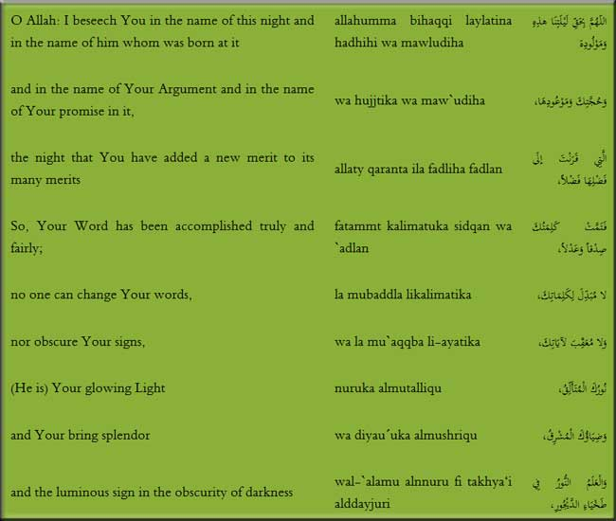

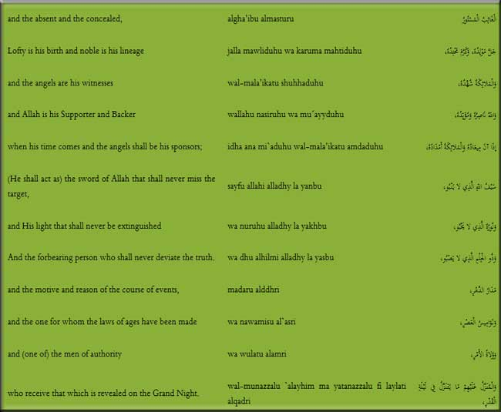

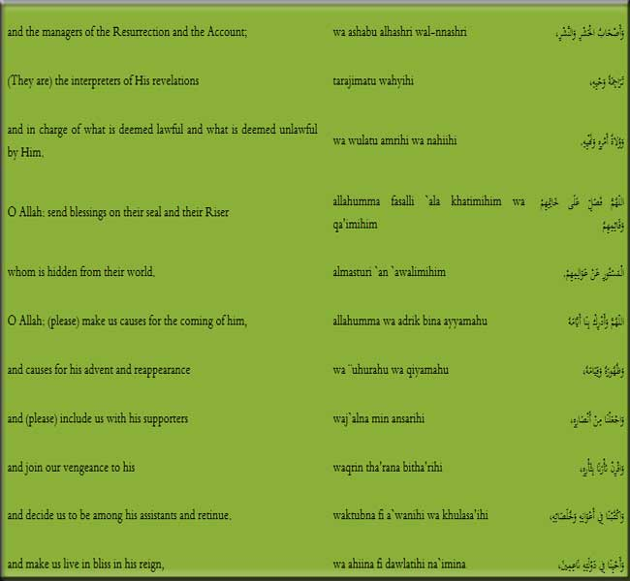

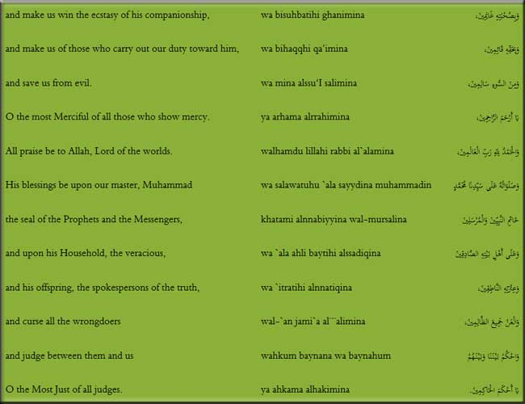

The night of the birth of the Qaim of the Progeny of Muhammad (a.s) is considered as the holiest and the greatest night in the view of Islam. On this night was born the one who would establish justice and equity and eradicate injustice and oppression and he will destroy every falsehood and false deities.

Acquainting the Shias with Imam of the time

Imam Hasan Askari (a.s) initiated training so that the sincere Shias and his good friends may recognize His Eminence, Mahdi (a.s) in such a way that none could deny or have doubts about him.

Muawiyah Ibne Hakim, Muhammad Ibne Ayyub and Muhammad Ibne Uthman, each of them have separately narrated that His Eminence, Abu Muhammad Hasan Askari (a.s) acquainted us, forty persons, with his newborn son, His Eminence, Mahdi, while we were present at his house. He said: “This son of mine is my Imam and Caliph for you after me. Obey him and after me do not become disunited in your religion, that you be destroyed. But you should know that, after this, you will not see him…”[52]

Imam Hasan Askari completed the argument upon them and acquainted them with the Imam of their time so that they may be testifiers of truth and that they may convey to others what they had witnessed.

Characteristics and Qualities of the Imam of the time

The qualities and merits of His Eminence, Mahdi (a.s) are same as those of the divine messengers and legatees. The effulgence of Imamate and the awe of the prophets was perfectly apparent in the face of the Holy Imam. His description and details have come in the narrations as follows:

1. Abu Saeed Khudri narrates from the Messenger of Allah (a.s) that he said, “Indeed, the Almighty Allah will raise from my progeny and Ahle Bayt a man, who would have appropriate gap between his front teeth and have a bright forehead so that he may fill the earth with justice, welfare and economic equality.”[53]

Numerous traditions of the same type have been recorded by the scholars and narrators of Ahle Sunnat from the Holy Prophet (a.s) describing the various characteristics of Imam Mahdi, the descendent and great grandson of the Prophet.

2. His Eminence, Abu Ja’far, Imam Muhammad Baqir (a.s) through his forefathers has narrated from the chief of Ahle Bayt, His Eminence, Amirul Momineen (a.s) that His Eminence proclaimed from the pulpit, “In the last age a man from my progeny would rise, having a fair complexion that has some redness (hue) and having a clear and wide belly and his thighs would be broad and his bones shall be long (big) and prominent and he would have two beauty spots one of whom shall be the color of the Prophet. He shall rise up.”

3. In another tradition His Eminence, Ali (a.s) again mentions about Imam Mahdi (a.s) in the following words:

“He shall have a wide forehead and big eyes and a clear and wide belly, broad thighs, his front teeth would be sparkling and there is a mole on his right thigh.”[54]

A fact derived from traditions and reports of the Holy Prophet (a.s) is that in his facial appearance he is most handsome and elegant. All physical and facial beauties would be humble and submissive before the elegance of Imam Mahdi (a.s).

The prominent and acknowledged poet, Agha Sayyid Hasan has thus mentioned about His Eminence:

“The elegance came up (arose) through his clear face The morning breeze spread from his calming countenance.”[55]

Resemblance of Imam of the time with the Prophet

Among all the people, His Eminence is most resembling His great grandfather, the Messenger of Allah (a.s), by way of method, Jihad and revolution against oppression and transgression and transformation of the system of the oppressive rulers in society, from theft and destruction humiliation, affliction and problems. He would replace all this with a system that would provide every kind of comfort and security and be a cause of general welfare and happiness of the people. When the Qaim of the progeny of Muhammad would appear, he would work in the same way as his great grandfather had done. That is why he would destroy the false powers and tyrannical rulers whose power is based on falsehood and hypocrisy and he shall eradicate them completely. He would then establish justice and equity in every sense of the term.

Numerous traditions of the Holy Prophet (a.s) and the Imams of guidance have reached us that mention that Imam Mahdi (a.s) resembles his great grandfather, the Messenger of Allah (a.s). Some of them are mentioned below:

1. Abdullah Ibne Masud narrates from the Messenger of Allah that he said, “A man from my family would arise having my name, and his manners and habits would be like my manners and habits and he would make the earth abound with justice and equity.”

2. Huzaifah relates from the Messenger of Allah (a.s) that he said:

“Even if there remains one day in the life of the earth, God will bring forth a man whose name and character will be like mine, and whose patronymic will be Abu Abdillah. People would pay allegiance to him between the Rukn and Maqam[56] of Ka’ba. Through him God will revive His religion and bring it back to its early glory. God will also endow him with many victories and there will remain on earth none other than the ones who will declare: There is no god, except Allah.”

Sulaiman got up from his place and asked as to which of his children’s descendent he would be.

The Prophet struck his hand on Husain (a.s) and said, “From his [descendants].”

3. Ayesha has narrated from the Messenger of Allah (a.s) that he said:

“Mahdi is a person from my progeny. He will fight for my Sunnah like I have fought for revelation.”[57]

4. Jabir Ibne Abdullah Ansari has quoted the Messenger of Allah (a.s) that he said:

“The Mahdi is from my progeny, his name and patronymic is same as mine. Among all the people he would resemble my character. There would be an occultation for him during which people shall be perplexed. After that he would reappear like a bright star and make the earth abound with justice and equity after it had been completely fraught with injustice and oppression.”

5. Imam Ja’far Sadiq (a.s) has narrated through his forefathers from the Messenger of Allah (a.s) that he said:

“The Mahdi shall be from my descendants. He would be having the same name and agnomen as I have. He would resemble me most in character; he would have an occultation which would cast people into confusion, till they deviate from their religion. At the time he reappears he shall be like a brilliant star. Then he would spread justice and equity on the earth just as it would have been absolutely fraught with injustice and inequity.”[58]

6. Imam Ja’far as-Sadiq (a.s) has narrated through his blessed ancestors from the Holy Prophet (a.s) that he said:

“The Qaim is from my descendents. His name is same as mine and patronymic is same as mine. His appearance is like my appearance and his practice like my practice. He will establish the people on my religion and my law and call them to the Book of my Lord, the Mighty and the sublime. One who obeys him has obeyed me and one who disobeys him has disobeyed me. And one who denies his occultation has denied me. And one who falsifies him has falsified me. And one who testifies for him has testified for me. I would complain to Allah about those who falsify me in my affair and those who mislead the people. And the oppressors would soon realize where they would be returned when they are sent back (to Hell).”[59]

The above tradition is the most comprehensive one that shows that Imam Mahdi (a.s) would be like his great grandfather, the Messenger of Allah (a.s) in many respects.

7. Abu Salih Saibi in Al-Fitan has narrated from His Eminence, Amirul Momineen (a.s) that he said: “His Eminence, Mahdi (a.s), in appearance, character, habits and good virtues, would most resemble the Messenger of Allah (a.s).”[60]

Such types of traditions have reached us in large numbers from the Holy Prophet (a.s) and the Holy Imams (a.s). They all prove beyond any doubt that Imam Mahdi (a.s) not only resembles the Holy Prophet (a.s) in appearance and built; he is also having the same type of character and habits, due to which he is more superior to the other prophets of God. Rather in his method of reformation, engagements and his war tactics for the annihilation of oppression and injustice and for the establishment of equity and justice on the earth he closely resembles his great grandfather, the Messenger of Allah (a.s).

Concocted Traditions

Sources of Islamic beliefs are heavenly revelation, the Holy Quran and the practice of the Infallibles (a.s). Reason, understanding, conscience and nature are bestowed by Almighty God so that through them we may derive the authentic and correct heavenly sciences and avoid the pitfalls of deviation. All these are provided as internal prophets for humanity. That is why Islamic thoughts derived from these pure sources are actually bestowed by God. They all are pure and conform to reality.

In spite of all this, people of evil and malicious nature and enemies of religion have always been in pursuit to cast doubts and spoil the true face of religion and religious leaders.

That is why enemies of faith and malicious people have concocted many traditions to defame and spoil the true Islamic facts and beliefs and these concocted traditions were surreptiously included in the tradition compendiums. In the parlance of traditional science these concocted traditions are termed as “Israiliyat.” One of such fabricated traditions is related by Ganji and others that the Messenger of Allah (a.s) said,

“Mahdi is from my descendants. His face is like a bright star and his complexion is of Arab and his body is of an Israelite. He would make the earth abound with justice just as it would be filled with oppression. All the folks of the heaven and the earth and also the birds would be happy during his kingdom and caliphate. He would reign for twenty years.”[61]

The reason that this tradition is fabricated is that the body of the Holy Imam (a.s) is a part of the body of the Prophet and Amirul Momineen (a.s), which were the most pure and clean; infused with the effulgence of guidance. How can the physique of Imam (a.s) resemble that of the Israelites, while they are having the worst of the bodies and the most evil of the appearancea They are the wolves among human beings, the germs and personification of low character. Most probably, the Jews have fabricated this tradition to defame the Muslims on the basis of their enmity towards Islam and to present their own deficiencies in favorable light.

Prominent Characteristics and Merits of the Imam of the Time

The predominant characteristics and personal traits of His Eminence, Mahdi (a.s) are the same as that of his honorable ancestors and forefathers, the Holy Imams (a.s). Those great personages were the centers of mercy and torchbearers of effulgence of guidance on the earth, as the Almighty had sent them for the guidance of His creatures, they were created from effulgence, and appointed as guides and callers to Himself. Some of the important merits of the Holy Imam Mahdi (a.s) are as follows:

Encompassing knowledge of the Imam of the time

It is an established fact that His Eminence, would be the most knowledgeable and possess proficiency in all the sciences because he is the heir of his grandfather, the Messenger of Allah (a.s) and he is the custodian of the treasure of prophetic wisdom.

He is having encompassing knowledge about the religious law and the various aspects of the Shariah of his grandfather, the chief of the prophets. It is one of the comprehensive sciences of the Awaited Imam.

The Purified Imams have mentioned the high intellectual level of Imam Mahdi (a.s) in their sayings issued long before he was born in this world.

1. His Eminence, Amirul Momineen (a.s) says with regard to the virtues of Imam Mahdi (a.s), “He shall be most refuge-giving and the one having most knowledge and the one who does the most ‘Sile Raham’ (doing good to relatives).”[62]

2. Harth Ibne Mughaira Nazari says, “I inquired from His Eminence, Aba Abdillah Husain Bin Ali (a.s), ‘From what would the Mahdi be recognizeda’ He replied, ‘By recognizing the permissible and the prohibited and by the fact that people would be needful of him while he would not be needful of them.’”[63]

3. His Eminence, Imam Muhammad Baqir (a.s) said, “His matter, that is, Kingdom would be from the youngest and the most handsome of us (the Progeny of Muhammad). The Almighty Allah would give him knowledge in inheritance and not leave him on his own (rather He is his helper and supporter).”[64]

4. His Eminence, Imam Muhammad Baqir (a.s) said, “Knowledge of Almighty Allah, the Mighty and Sublime and the Sunnah (practice) of the Messenger of Allah (a.s) grows luxuriantly in the heart of our Mahdi in the best form. Any of you that survives and sees it should say when you see him: ‘Peace be upon you (all) of Ahle Bayt of Mercy and Prophethood and the mines of knowledge and the location of messengership.’”[65]

Under the discussion of his excellent knowledge and accomplishments of His Eminence it is narrated that when he would reappear, he will discuss and prove his points with the Jews on the basis of Torah as a result of which a majority of them would accept Islam.[66]

His Eminence, Mahdi (a.s) during the minor occultation, was the sole point of reference and the greatest center of the final decision. Therefore the special deputies used to convey the questions of the people to the Holy Imam and obtain their replies. Such questions in large numbers are recorded in books of jurisprudence and traditions and they serve as references for the Islamic jurisprudents in deriving their verdicts.

It is better to reiterate here that Shaykh Saduq (a.r.) had collected many replies bearing the signature of the Holy Imam.

Piety of the Imam of the time

The character and hearts of the Imams of Ahle Bayt (a.s) in all aspects of thoughts and actions (among them is piety in the world and giving up of material pleasures and joys) are same for all of them. It is not possible to pick out a single instance from them but that it would be found to be piety in the world and the renunciation of material things. His Eminence, Amirul Momineen (a.s), the gate of the city of knowledge of the Messenger of Allah (a.s) in fact, divorced the world thrice so that it did not remain worthy of reconciliation. His pure and chaste descendents have also been bestowed with this exalted quality. Many traditions regarding the piety of Imam Mahdi (a.s) are recorded in history. Some of them are presented below:

a. Muammar Ibne Khuld has narrated from Imam Reza (a.s) the he said, “The dress and food of the Qaim of the Progeny of Muhammad shall be coarse and dry.”[67]

b. Abu Basir has quoted that Imam Sadiq (a.s) said, “Do not be in haste of the advent and reappearance of the Imam of the time. By Allah, his dress shall be coarse and his food, barley bread, thick and dense.”[68]

c. Ali Ibne Hamzah and Wahab have narrated from Imam Sadiq (a.s) that he proclaimed regarding His Eminence, the Awaited Imam, “His dress is coarse and thick and his food is hard and rigid.”[69]

It is an established fact that this method is found in all aspects of the life of His Eminence. If he had not possessed such mannerism, the Almighty Allah would not have selected him for the greatest reformative movement, from all the personalities of the earth. Then he it is, who would make the earth abound with justice and equity, as it would be completely fraught with injustice and oppression, and he would save humanity from arrogance and pride of oppressors. He would distribute divine wealth and goodness between deprived and needy people.

Patience of Imam of the Time

One of the prominent characteristics and spiritual excellence of His Eminence is patience and forbearance.

His Eminence is encountering more severe problems and calamities than faced by all the infallible Imams. During his prolonged life he has experienced many bitter incidents and great tragedies, which has made the Islamic world black and broken its limbs and the Muslim community with these pieces, is subjugated under the yoke of disbelievers and tyrants and struggling in that position. Such types of different oppressions have become common in the world of Islam and the divine rules and laws have been rendered useless. The wealth of the Muslims has been plundered and they interfere in all the decisions of the Muslim nation and they force their own view upon them.

All these calamities and corruptions are being wrought under the very eyes of His Eminence and he, being the father of the broken-up community, is very much pained by it.

He has indeed resorted to patience and forbearance and entrusted everything to the Almighty. And this is so because He is the One, Who has everything in His power, and He is the true Ruler on His creatures, and there is no kind of any command or opinion for anyone else.

Worship of the Imam of the time

It is beyond any doubt that the worship of His Eminence, Mahdi (a.s) is also like the worship of his respected forefathers, the Purified Imams (a.s). All the Imams had devoted their whole lives to the Almighty Allah. They have deeply imbibed the love and regard of Allah in the depths of their hearts. Their complete beings are surrounded by the love of Almighty. That is why they fasted most of the days and prayed during the better part of the night, extolling and praising the Lord. Yes, the method of worship of the Awaited Imam is also same. Therefore, the tradition scholars have recorded some of his supplications in the ritual prayers or otherwise, that point out the extreme piety and attachment of the Holy Imam with his Lord and his aloofness from everything else. Some of them we present below:

Supplications of the Imam of the time in the Qunut of Ritual Prayers

His Eminence, the Master of the Age, recites the following supplication in the Qunut of his ritual prayers. The actual supplication is as follows:

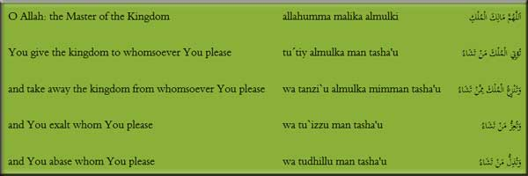

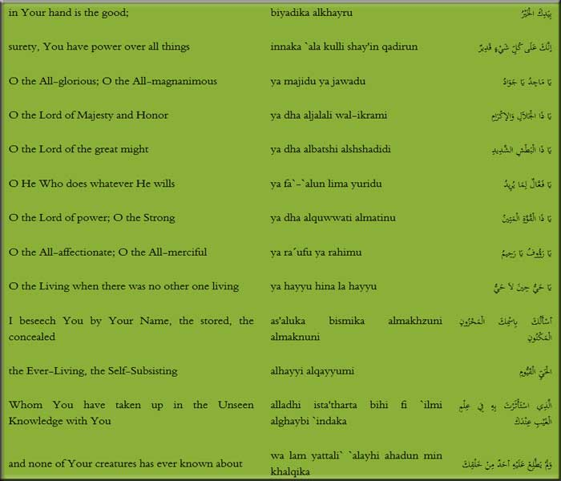

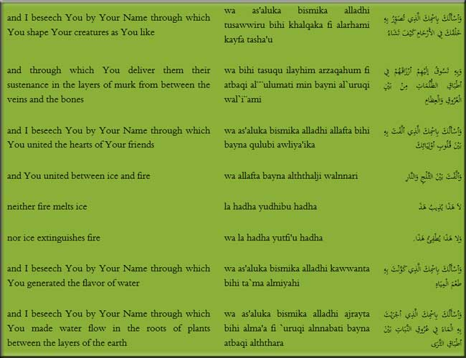

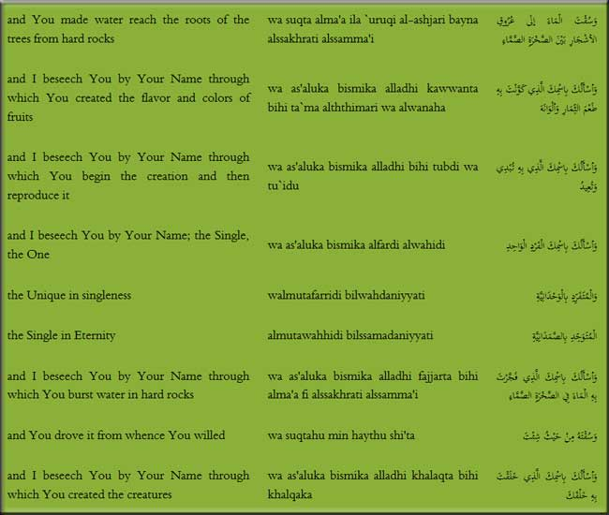

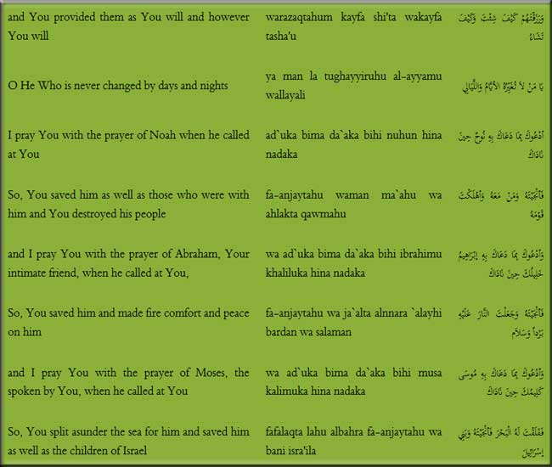

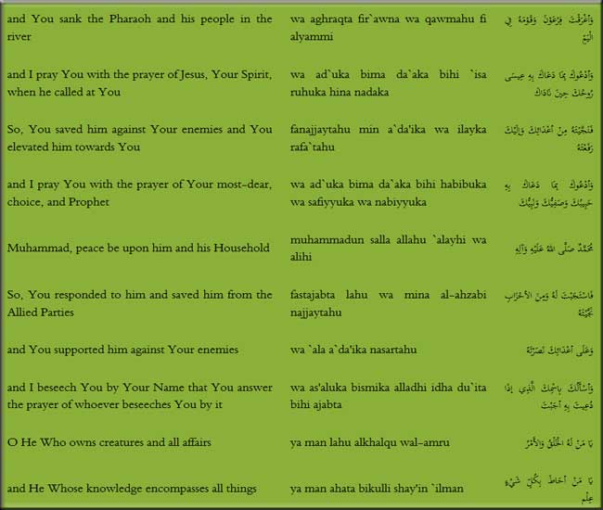

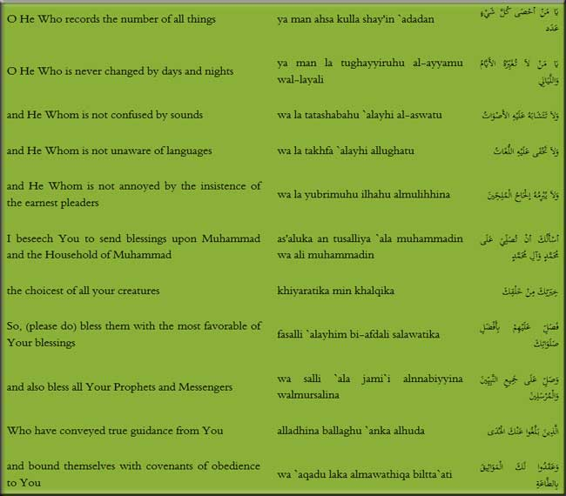

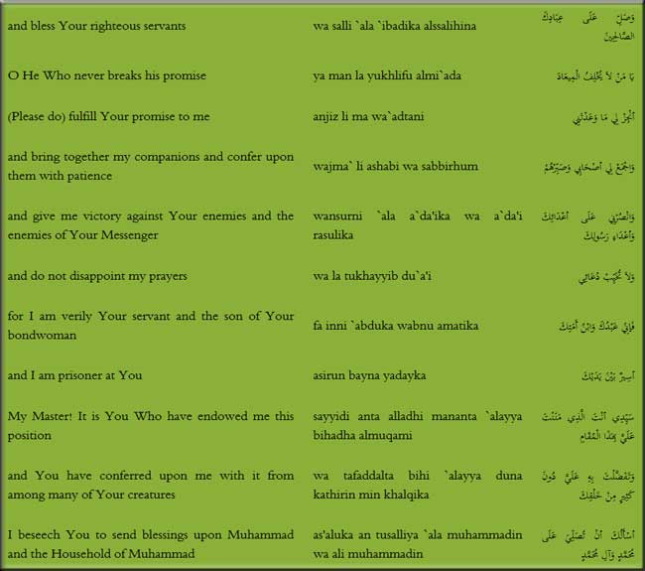



This blessed supplication mentions the unimaginable power of the Lord Creator Who has brought everything into existence. He is the One Who bestows existence and is the originator of all creatures. In the same way the supplication also proves that His Eminence, begs to the Almighty for help and success over the enemies of Allah and the prophets. And also desires that his helpers should be gathered so that the religion may be enlivened and bestow exaltation of the Kalimah.[71]

Another Supplication of the Imam of the time

His Eminence, Mahdi (a.s) recites the following blessed supplication in some of his prayers:

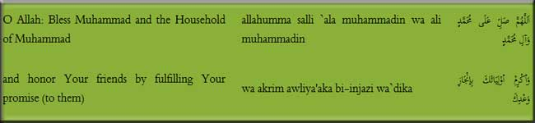

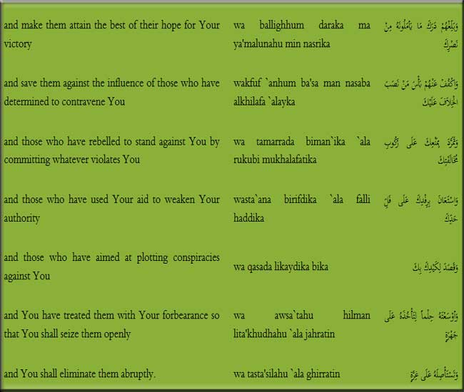

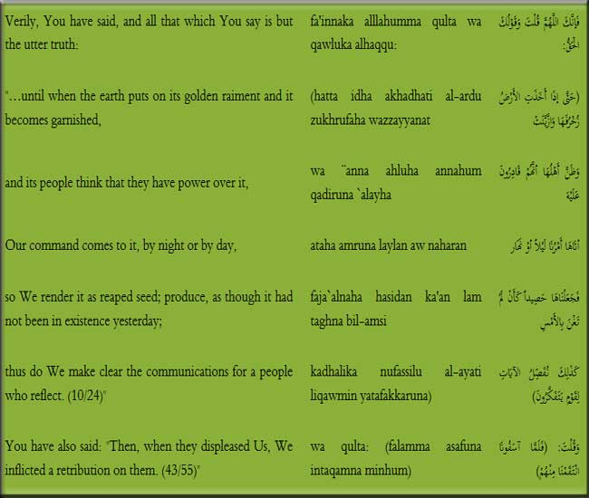

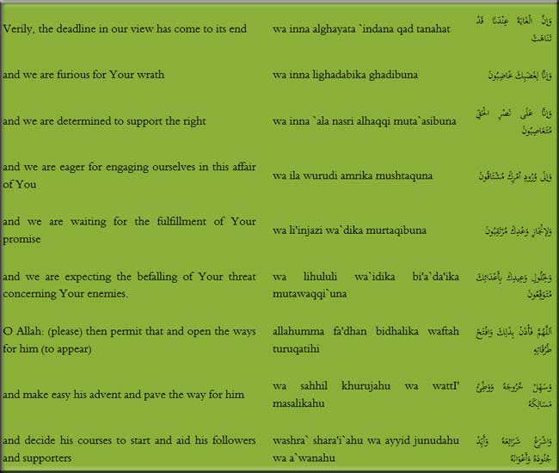

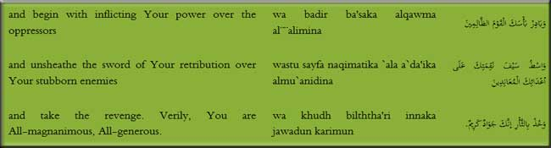

In this blessed supplication, His Eminence has clearly explained that he is very eager for his reappearance and extremely keen to enliven the religion and practice of his grandfather, the chief of the prophets and to take revenge from the enemies of Islam and monotheism. He is very keen and desirous to reappear as soon as possible.

Valor of the Imam of the time

His Eminence, Mahdi (a.s) is the bravest and the most valiant of all the people. In strength, power, courage and daring, he is like his great grandfather, the Messenger of Allah (a.s), because His Eminence, with all his capacity uprooted the powers of polytheism and destroyed roots of ignorance and oppression and announced the rights and honor of human beings. The Prophet of Islam rose against the leaders of oppression and enemies of Islam who intended to destroy and humiliate the lofty religion of God and destroyed their leaders and dispersed their supporters and bestowed honor and majesty to the word of Allah on the earth. In the same way, his great grandson and caliph, the Promised Imam, will also perform the same function. He would make the oppressors and rebels taste their misdeeds. And with firm determination, bereft of sloth, reinfuse greatness and honor to Islam without in any way surrendering to any sort of difficult matter and painful circumstances due to weakness and lack of attitude.

Steadfastness of the Imam of the time in rightfulness

His Eminence, the Awaited Imam is among the most steadfast defenders of truth and his defense and help for the oppressed and tortured one is more than that of anyone else. No kind of criticism hinders him from the deliverance of truth and its establishment.

The forefather and elders of His Eminence supported truth and displayed steadfastness in the face of falsehood and presented their sacrifice for social justice among the people. His Eminence, the Mahdi (a.s) also possesses the same quality.

When the world shall be illuminated by the reappearance of the Qaim of the Progeny of Muhammad and humanity would become fortunate by the advent of His Eminence, His Eminence would enliven all aspects of truth and destroy every kind of fraud, cheating and oppression.

Generosity of the Imam of the time

His Eminence, the Awaited Imam is the most generous and charitable among all the people. Narrators of traditions are unanimous that during the time of his government, His Eminence would distribute bounties and sustenance of God among all the poor people in such a way that not a single poor and needy person would remain on the face of the earth; so much so, that a person who desires to pay his Zakat to the eligible one would not be able to find a single recipient of alms. Some of these types of traditions are presented below:[72]

a. Abu Saeed Khudri has narrated from the Prophet of Islam, in the events of His Eminence, Mahdi (a.s) that he said, "A man comes to him and says, 'O Mahdi! Give me! Give me!' His Eminence fills his utensil to the extent of what he could lift."

b. Ibne Asakir has quoted from the Messenger of Allah (a.s) that he said, "In the last age there would be a caliph who would pile up wealth."[73]

c. Jabir has narrated that he was in the company of His Eminence, Abu Ja'far Imam Muhammad Baqir (a.s) when a person came to him and addressing the Imam said, "Please accept these 500 dirhams, that is the Zakat of my wealth, and spend it in a suitable way." His Eminence, Imam Muhammad Baqir (a.s) said, "Search for them yourself in your neighbors, orphans, the needy and brothers-in-faith and distribute it among them. And it is the time when our Qaim would rise so that he could distribute it in equitable way and establish justice among the creatures of God, according to their good or evil. One who obeys him has obeyed Allah and one who disobeys him has disobeyed Allah. Since he guides in a secret and subtle manner, he is called 'the Mahdi.'"

His Eminence will bring out the Torah and other books from a cave in Antioch and command the people of Torah by Torah and people of Injeel with Injeel and people of Zabur with Zabur and people of Quran with Quran. All the wealth of the earth that is on its surface and below its surface would be gathered with him. Then he would say, 'O People! Come towards that for which you had severed relations and spilled blood on the earth and committed things prohibited by God.' Then he would give so much wealth to them as had never been given.[74]

And other traditions that prove that His Eminence is a sea of mercy and generosity are those that mention that His Eminence would deal with the people with kindness and favors and save them from the yokes of hunger and deprivation and spread peace, comfort and needlessness among them.

Some Brilliant Legacies of the Imam of the Time

His Eminence, the Awaited Imam is in possession of those brilliant legacies that include the most exalted values. Some of the supplications of His Eminence are from that legacy, that is the mine of monotheism and from the treasures of Islamic concepts. In the same way there are letters of His Eminence, that he wrote to some of his prominent companions and sincere Shias. They are a part of that legacy too. Some of these letters are composed of replies to questions regarding religious laws that people posed to the Holy Imam. And the following are a part of that legacy:

Supplications of the Imam of the time

Supplication is speaking privately to God and to be cut off with everything and remaining connected only to God. Supplication tells us that the suppliant is one with a clear conscience and a pure heart and connected to Almighty Allah Who is the Creator of existence and bestower of life. Some of the supplications of the great Imam Qaim of Aale Muhammad that are recorded in history are as follows:

1. Supplication of the Imam of the time for the Muslims

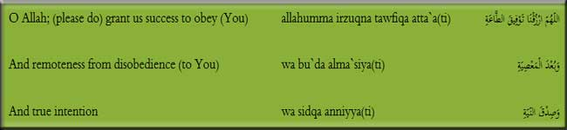

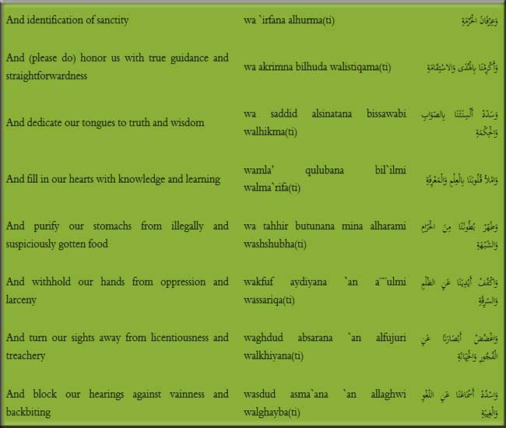

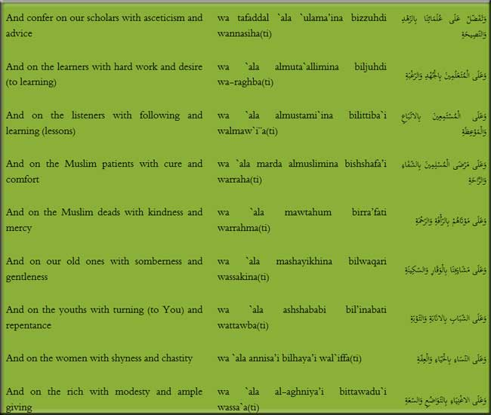

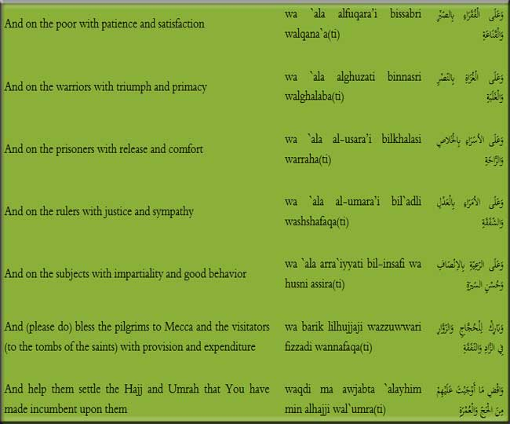

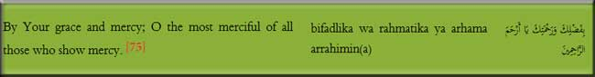

His Eminence implores the Almighty in the most sincere and heartful way that he bestows favor on the Muslims and imbues them with the best manners, ethics, good habits and every quality that would make them proximate to the Lord.

2. Supplication of the Imam of the time for Believers

His Eminence, Mahdi (a.s) has supplicated in favor of the righteous believers as follows:

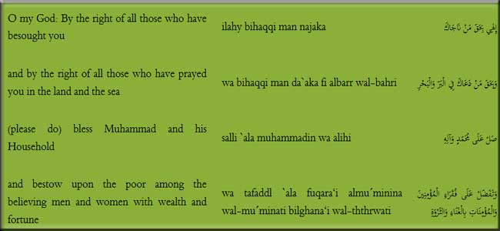

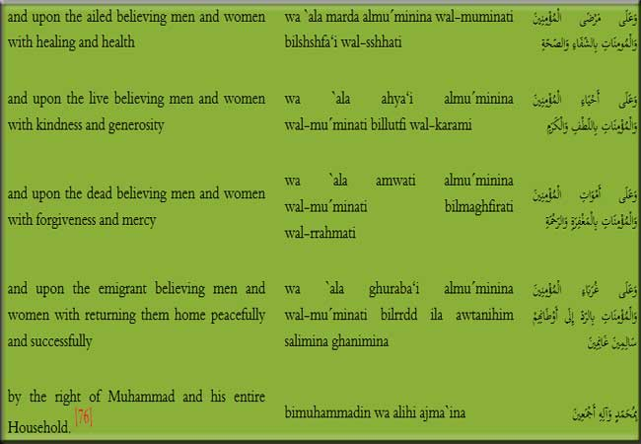

This supplication shows how much His Eminence, have kindness, love and regard for the believers. He beseeches the Almighty for their welfare, reform and happiness in the world and the hereafter.

3. Supplication of the Imam of the time for fulfillment of needs

His Eminence, the Awaited Imam has recited the following supplication for the fulfillment of his needs:

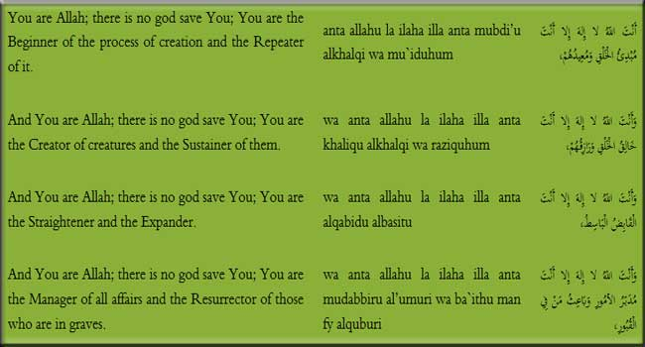

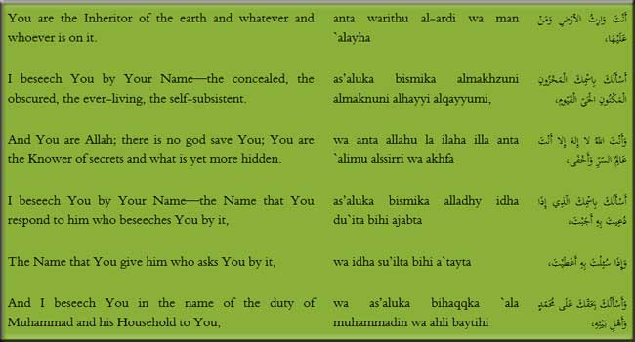

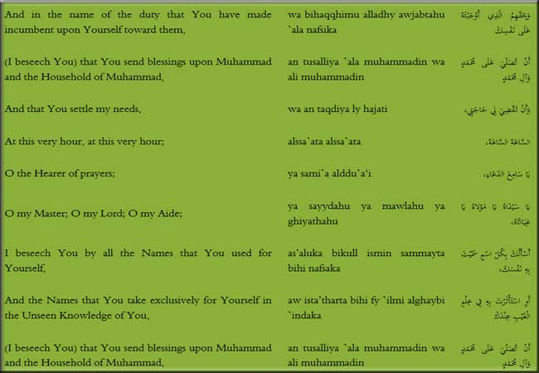

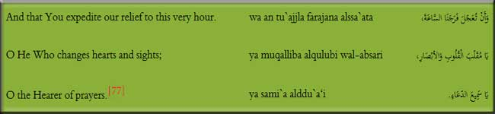

This blessed supplication demonstrates that His Eminence possessed absolute trust in the Almighty and in all his affairs and activities he seeks the refuge of Allah.

4. Supplication of the Imam of the time for cure

Whenever His Eminence, Mahdi (a.s) was indisposed he used to write the following supplication on a new utensil with the clay (Turbah) of the grave of Imam Husain (a.s) and wash it with water and drink it:

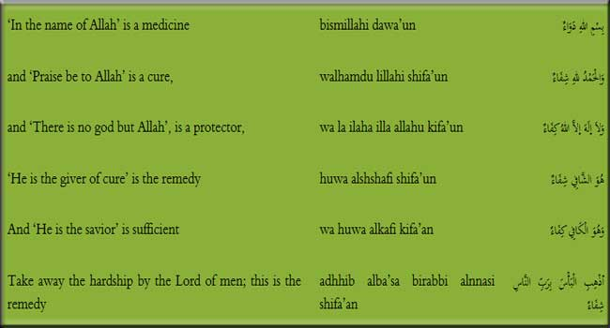

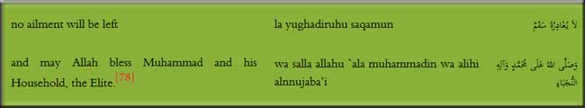

5. Ziyarat and Supplication

His Eminence, Mahdi (a.s) has advised some of the believers and Shias that they should address the Holy Imam with the following Ziyarat and supplication:

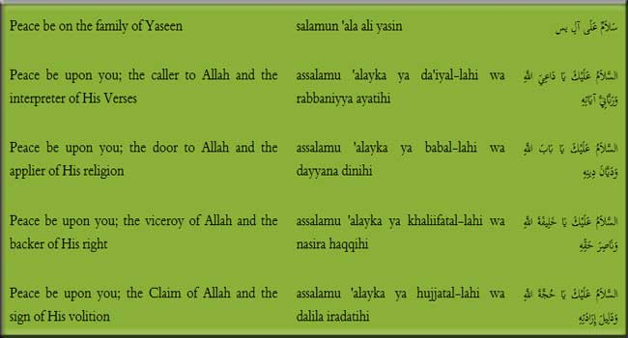

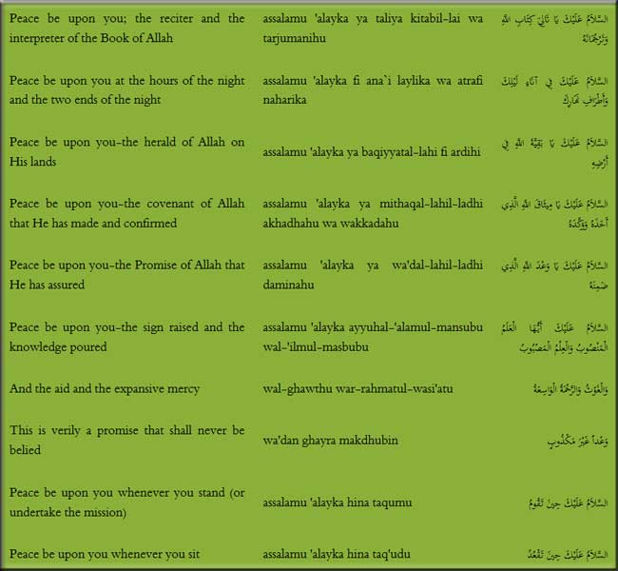

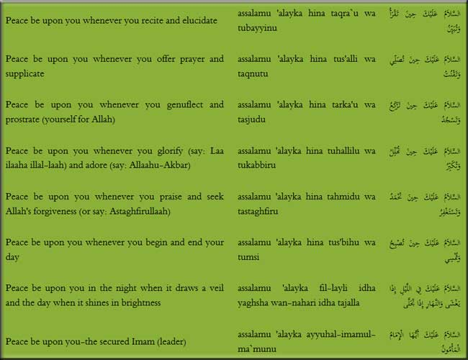

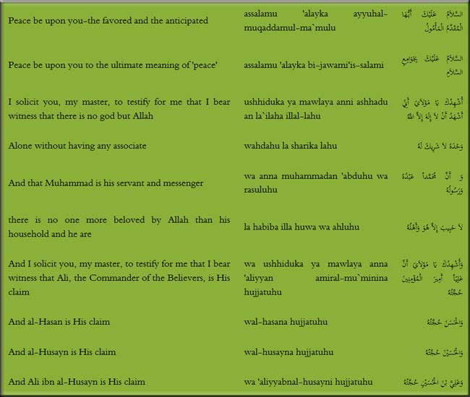

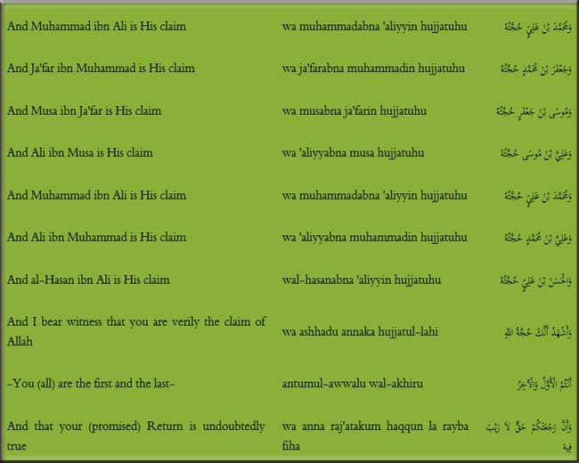

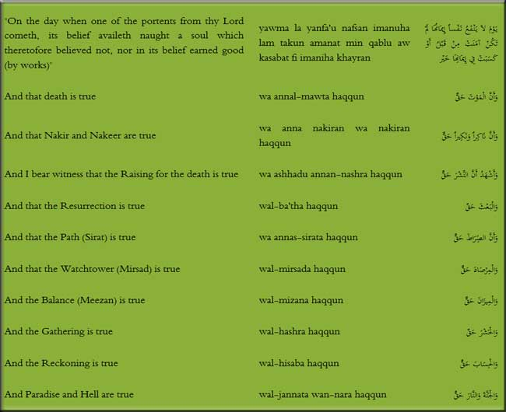

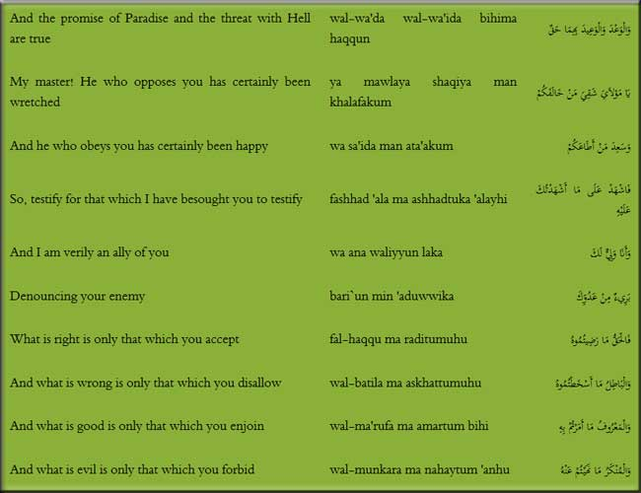

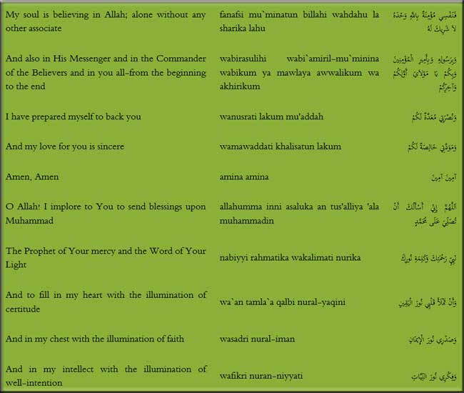

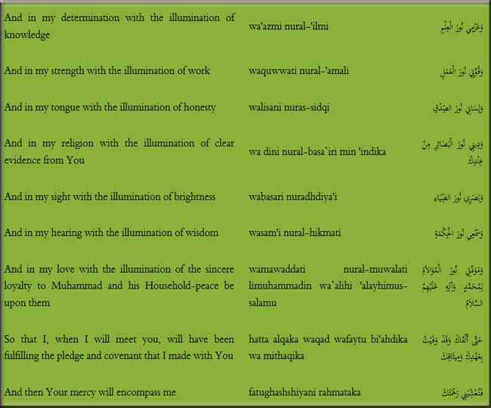

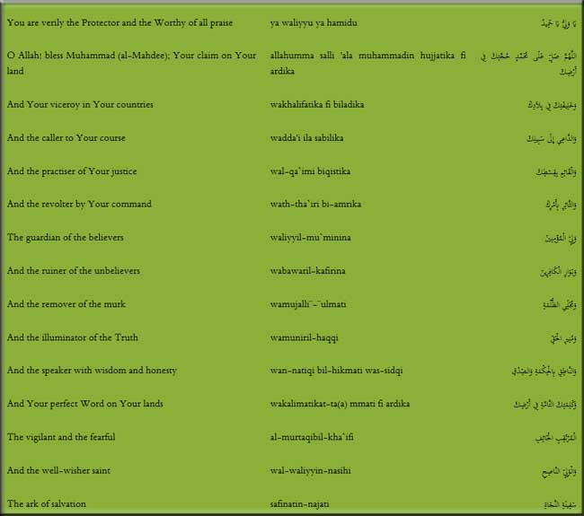

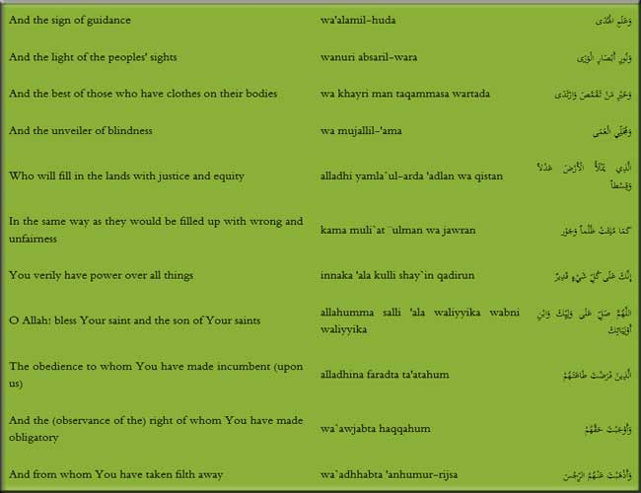

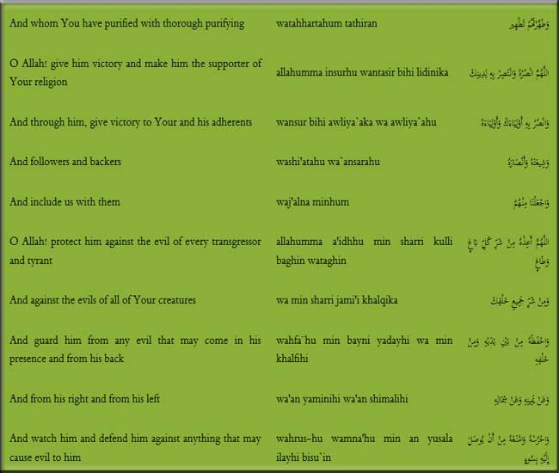

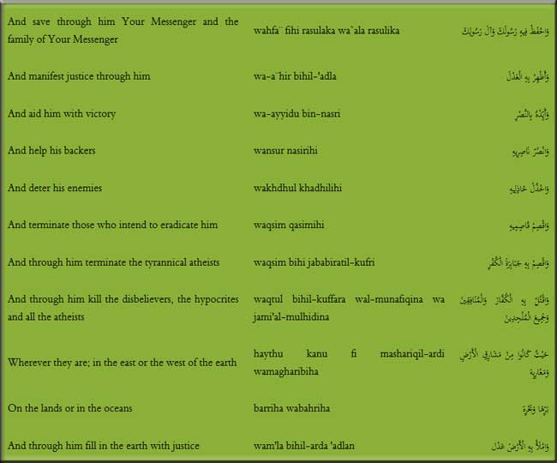

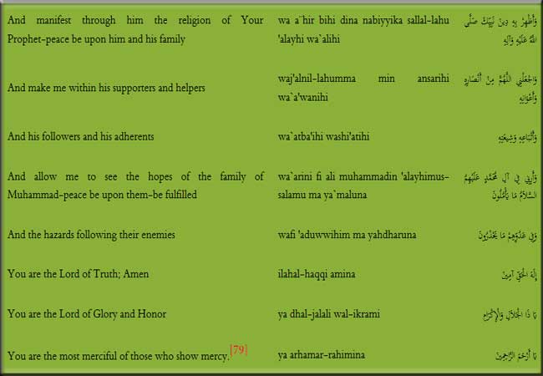

His Eminence, the awaited Imam has instructed his followers to address and perform his Ziyarat by these visitations and supplication and supplicate him, and they should beseech Allah for his help and early reappearance so that he may establish truth and destroy falsehood and exalt the word of Allah on the earth.

6. Supplication of the Imam of the time for Early reappearance

Among the supplications of His Eminence, the following is the most important:

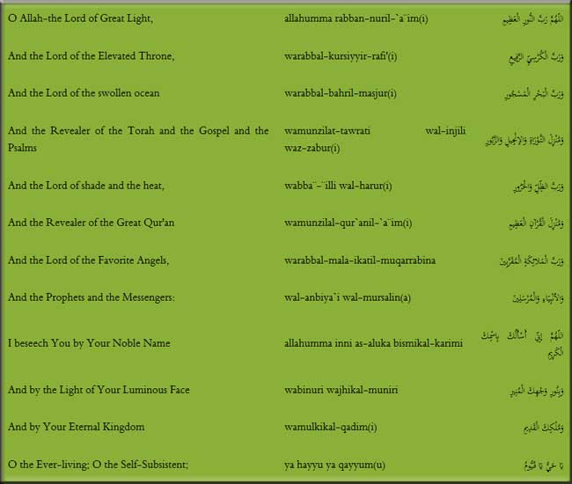

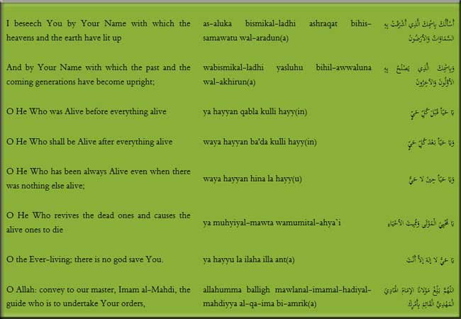

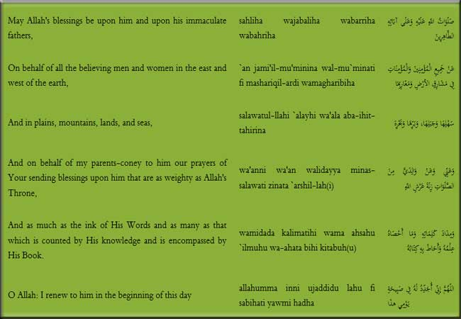

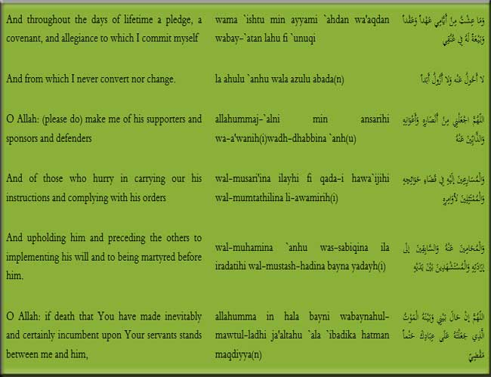

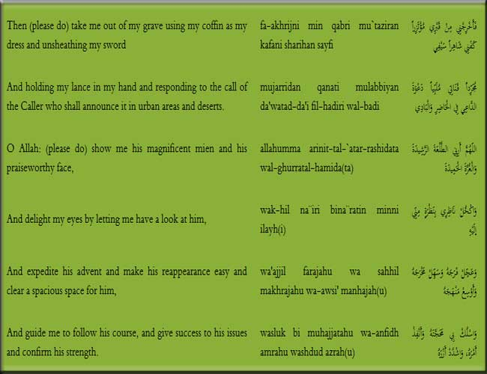

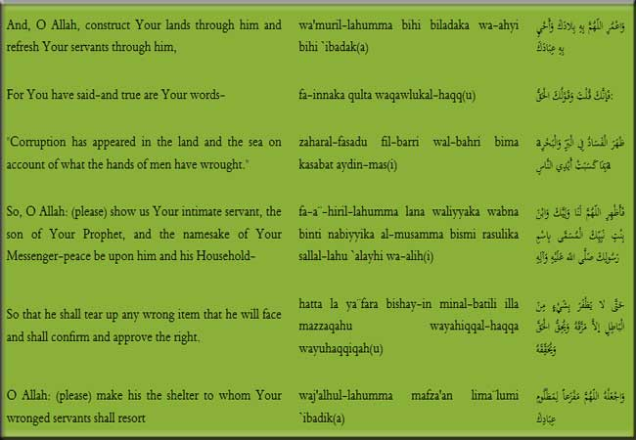

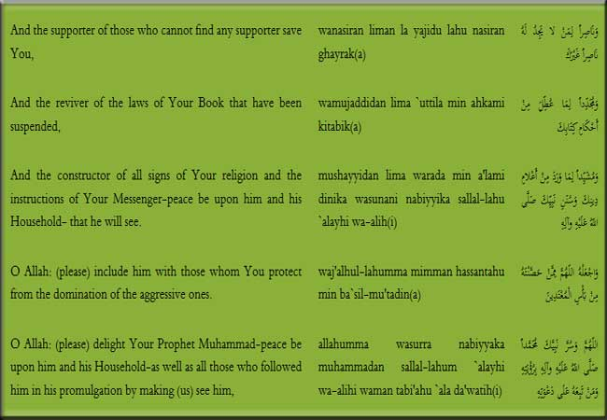

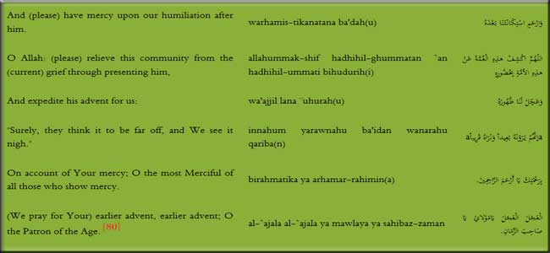

This supplication, also called 'Dua al-`Ahad, is full of extolling and praise of the Almighty Lord and mentions His most exalted qualities and is replete with the refuge-taking of the Imam (a.s). It is dissociation from everyone and everything except Allah, as everything is in His power alone.

7. Supplication of the Imam of the time for his Shias

His Eminence, Mahdi (a.s) supplicates in favor of his Shias that they may obtain release from needfulness and deprivation. The supplication is as follows:

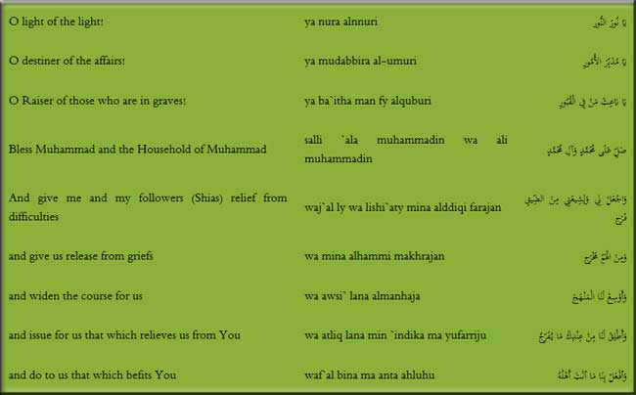

D:\barkatullah\books\new books\shaban\the_life_of_imam_al_mahdi\images_pics\055.jpg

8. Supplication of the Imam of the time for the Prophet of Islam and the Imams of Guidance (a.s)

His Eminence, Mahdi has requested some of his Shias to recite the following supplication for the Holy Prophet and Imams of guidance:

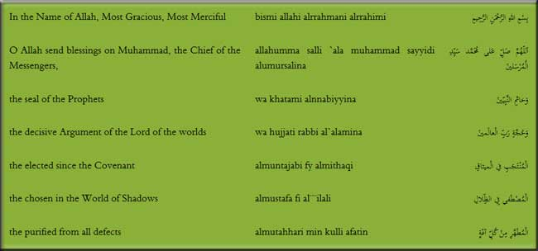

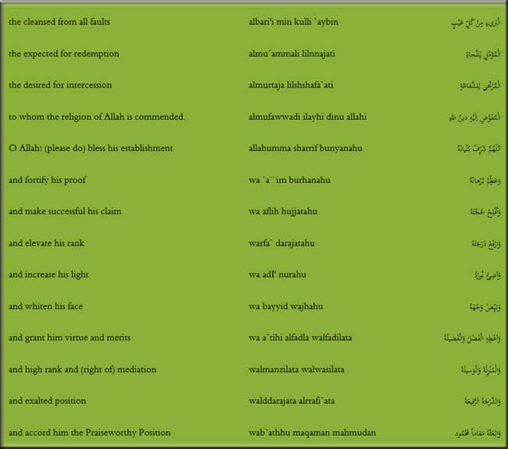

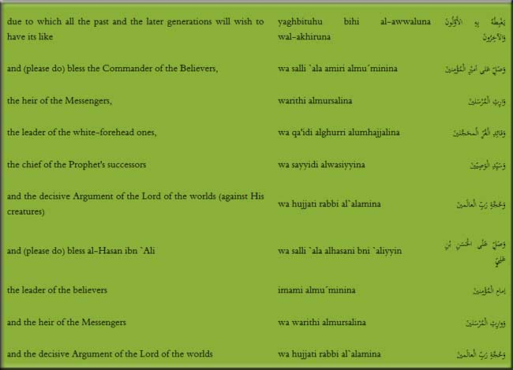

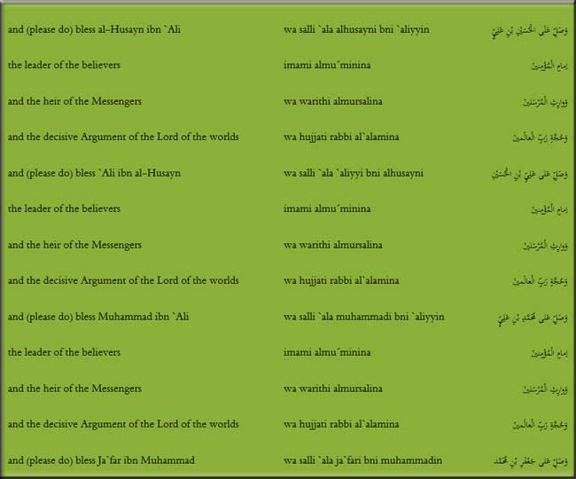

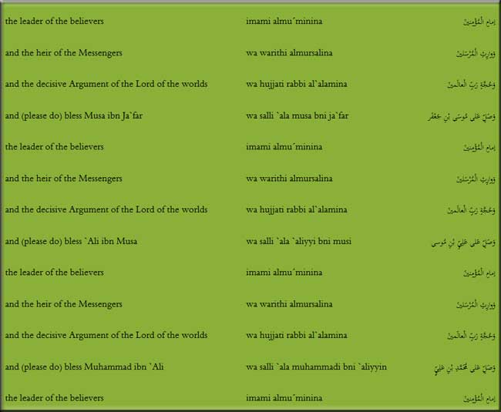

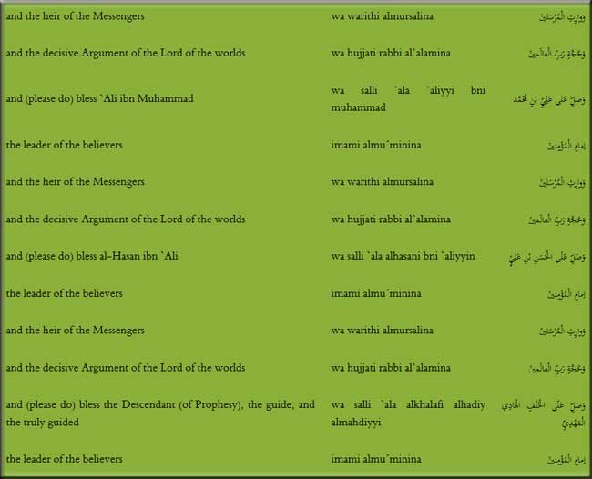

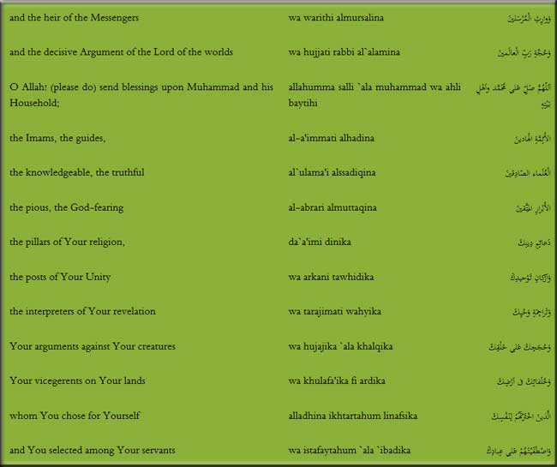

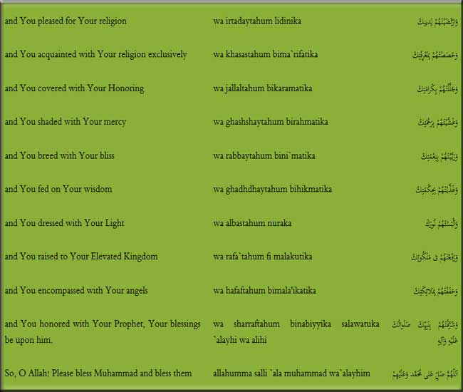

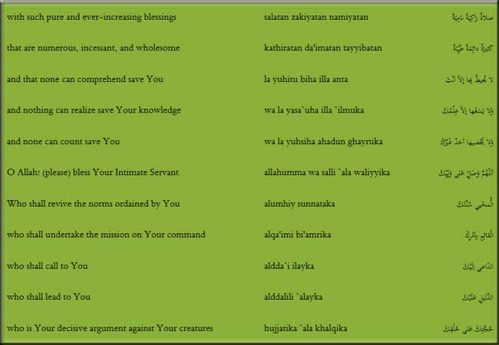

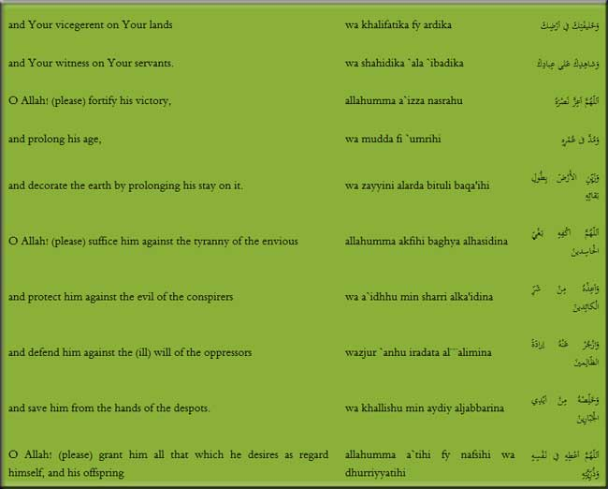

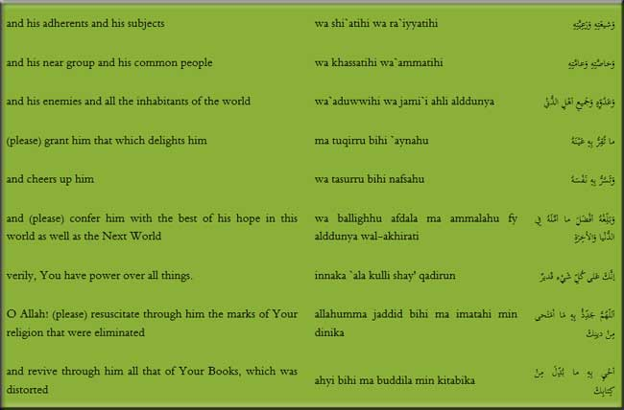

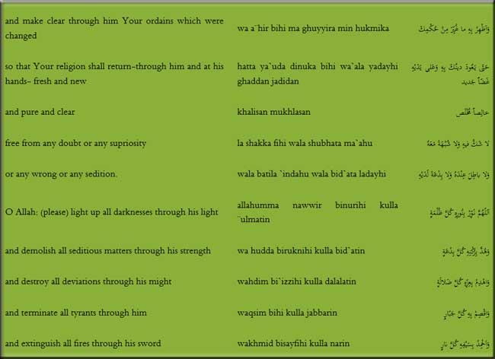

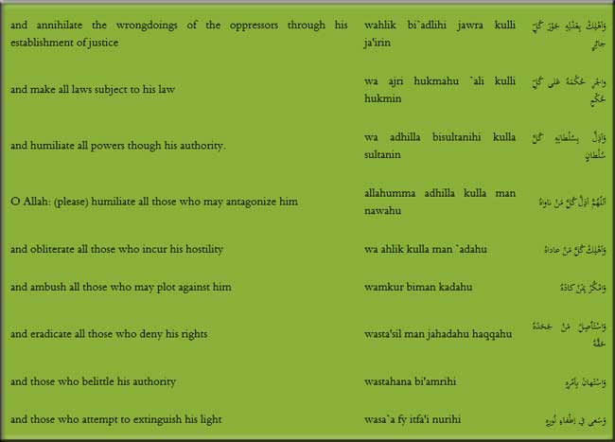

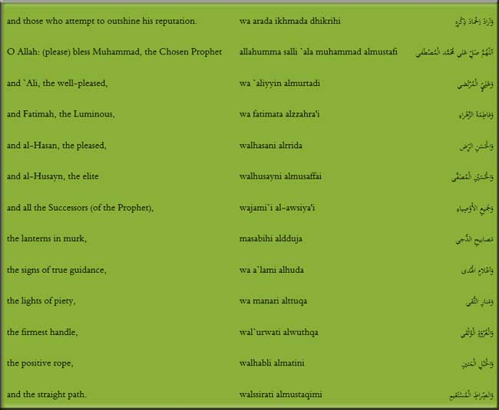

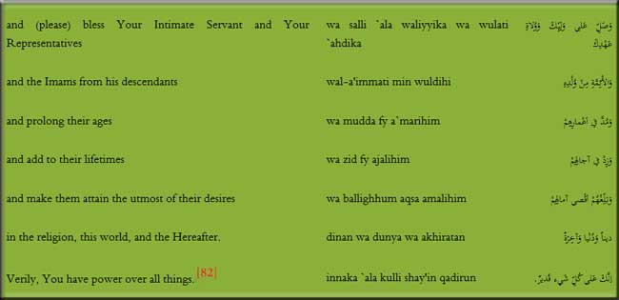

This supplication has praised the Holy Prophet and his successors, the Purified Imams (a.s) and requested the Almighty for elevating their stations near Him. In the same way it is about the Qaim of the Progeny of Muhammad (a.s) who would establish signs of religion and enliven the faith of his great grandfather.

9. Supplication of the Imam of the time for release from imprisonment

His Eminence; Mahdi (a.s) has taught this supplication to some of his Shias who were spending their days in imprisonment.

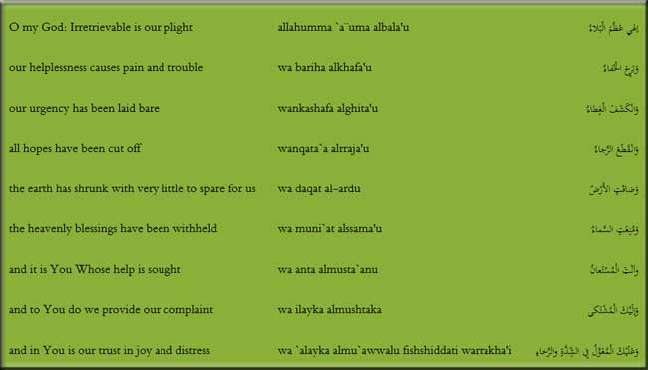

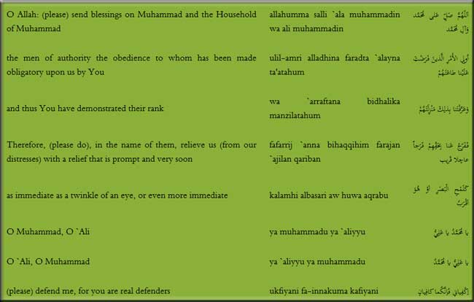

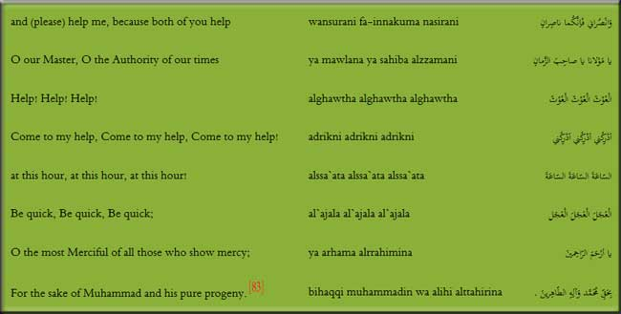

Seeking refuge in the Almighty Allah and to have certainty in it saves one from calamities of the days and the day-to-day problems and the Holy Imams (a.s) have endeavored to teach the Shias so that they may be protected from the future events and bad times.

Ziyarat of Imam Husain (a.s), a medium of His Eminence, Baqiyyat allah (a.s)

The tragedy of Kerbala was such a terrible calamity that in the whole course of history no social reformer ever faced such disaster as faced by the maternal grandson and the beloved one of the Prophet (a.s), Imam Husain (a.s). Indeed it has scorched the hearts of Muslims and infuriated them and made them sorrowful forever. The Purified Imam (a.s) considers the calamities that befell His Eminence, the chief of the Martyrs to be the greatest of the calamities, and the tragedy of Kerbala has surrounded the whole existence of his Eminence, Imam Mahdi (a.s). That is why, His Eminence weeps and recites the Ziyarat by absolute sincerity and from the depths of his hearts. It is the Ziyarat known as the Ziyarat-e-Nahiya. It is the Ziyarat, which is full of the sorrow and anger of His Eminence. It is a Ziyarat in which His Eminence describes the various difficulties and sorrowful calamities that befell Imam Husain (a.s) and those painful incidents that the daughters of the Messenger of Allah (a.s) had to endure. So, we must pay attention to some of the sentences of the Ziyarat that have reached us through the honorable special deputies of the Holy Imam. His Eminence has saluted some of the prophets of Allah in this Ziyarat and then saluted his great grandfather, Imam Husain (a.s) and said as follows:

Peace be upon Husain (a.s), who sacrificed his remaining life for Allah despite his injuries. Peace be upon the one who obeyed Allah secretly and openly. Peace be upon the one whose grave's soil is bestowed with curative powers by Allah.

This part of the Ziyarat informs us about the absolute certainty of Imam Husain (a.s) about the Almighty and His obedience in an apparent as well as a secret manner of His commands. The greatest obedience and sincerity of His Eminence, the Chief of the Martyrs (a.s) for the Majestic Lord, is that he presented his own life with a pure intention for revival of religion and Word of Allah. If such a sacrifice had not been offered the standard of Islam would have folded up and the period of ignorance would have regained predominance. Because the Bani Umayyah had been trying their best to destroy religion and it was Imam Husain (a.s) who rendered their fraud and deceit ineffective. By sacrificing his life, which shook the world of Islam, he caused anger which served as motivation for internal uprisings against the Umayyad rulers, which finally destroyed the crown and throne of Bani Umayyah.

The Almighty Allah has also thanked His friend and beloved, His Eminence, Imam Husain (a.s) for this magnificent sacrifice and therefore prepared a great reward in the hereafter and in this world also bestowed him with miracles and distinctions. One of the miracles is that He has bestowed cure to the dust of his grave and also made his tomb and the tombs of his successors, the Purified Imams to be the place of acceptance of supplications. And some of the sentences of this Ziyarat are as follows:

Peace be upon the son of the Seal of the Prophets. Peace be upon the son of the Chief of the Successors. Peace be upon the son of Fatima Zahra (s.a.). Peace be upon the son of Khadijatul Kubra.

The above words prove the great and honorable ancestry of His Eminence, Aba Abdillah al-Husain (a.s). Then the great grandfather of His Eminence is the seal of the Prophets and the chief of the Prophets and the respected father of His Eminence is the chief of the legatees and the gate of the city of knowledge of the Messenger of Allah (a.s), and the chief of the believers. And the mother of His Eminence is a part of the body of the Messenger of Allah (a.s) and the chief of the ladies of the worlds; that Allah's pleasure is through her pleasure and His anger is through her anger and the great grandmother of His Eminence is Khadijatul Kubra by whose sacrifice and financial assistance the religion of Islam was established. Then salutations and blessings of Allah be on His great family and on these purified branches who have illuminated the world through their virtues. Some of the statements of this Ziyarat are:

Peace be upon the one who was smeared in blood. Peace be upon the one whose tents were torn asunder. Peace be upon the fifth one of the people of Kisa (blanket). Peace be upon the most alien one.

This part of the Ziyarat mentions some qualities of the father of the noble Imams (a.s), Imam Husain (a.s). Just as His Eminence was drenched in his own blood on the path of Allah and suffered calamities for the establishment of the signs of religion. And also that he was one of the five holy souls of the Blanket (Kisa) whom the Lord Almighty purified of every dirt and finally that he was that oppressed and tyrannized one that he was martyred in an astonishing way on the sands of Kerbala and the angels of the Lord lamented the enormity of the afflictions that befell him. And also His Eminence, the Awaited Imam has said thus in this Ziyarat:

Peace be upon those (martyrs) who were cut into pieces. Peace be upon the souls whose belongings were plundered soon after their killings. Peace be upon the uncovered dead bodies. Peace be upon the emaciated and the deformed corpses.

These sentences prove the different types of injustices and tortures that the Umayyad militants considered permissible towards him and towards his sons, and companions. The Umayyads stopped water supply to him till his lips were dried and parched due to thirst and his purified body was cut into pieces by sword. Their heads were hoisted on spear points while he was making the paths of nobility and greatness apparent for the people. Due to this he was martyred and the ladies of his house were taken captives from one town to another.

His Eminence, the Awaited Imam takes his Ziyarat forward in the following way:

Peace be upon the Proof of the Lord of the worlds. Peace be upon you and upon your purified ancestors. Peace be upon you and upon your martyred offsprings.

His Eminence, Imam Mahdi (a.s) presents his tribute and respects in the following manner to his respected great grandfather, his sons who were slain before his very eyes and the angels who are appointed to serve on the grave of Imam Husain (a.s):

Peace be upon the bodies that were hung after being killed. Peace be upon the nearest of the Prophet's progeny. Peace be upon the corpses that were abandoned in the desert. Peace be upon the travelers who were driven out from their homes. Peace be upon those who were buried without shrouds.

In these statements, His Eminence, the Awaited Imam has sent salutation on the bodies that the Umayyads enemies left unburied on the sands of the desert. Till the time that the Almighty Allah made a community that had not been smeared with the disgrace of fighting against the sons of the Prophet, bury the martyrs in their own clothes that had been torn up by the Umayyads. These statements are from this same Ziyarat:

Peace be upon the one who is purified by the Mighty (Allah). Peace be upon the one who was prided upon by Jibraeel. Peace be upon the one who was put to sleep in the cradle by Mikaeel. Peace be upon the one regarding whom oaths were broken. Peace be upon the one whose dignity was lowered. Peace be upon the one whose blood was shed unjustly.

These sentences prove that His Eminence, is extremely devastated and sorrowful due to the calamity that befell his great grandfather, Imam Husain (a.s), in such a way that he also wishes that he had been present in the battlefield and by sacrificing himself had saved his ancestor from the sad tribulations and protected his life.

Let us hear to what these sentences of Ziyarat say:

Since I have been pushed behind by the passage of time and being prevented from helping you by fate and I could not fight those who had fought you. And (since) I had not been able to face your enemies I will continue to weep morning and evening and weep for you with tears of blood.

His Eminence, the Awaited Imam is sorrowful and restless due to his oppressed and tyrannized ancestor. So much so, that he laments and bemoans His Eminence day and night and instead of tears, blood flows from his eyes. This condition will endure till the last moments:

I witness that certainly you established the prayer and gave Zakat, and enjoined good and forbade evil. You obeyed Allah and never disobeyed Him. And remained in contact with Him. And satisfied Him, and were awed by Him, and were attentive towards Him, and satisfied with His wish and will.

These words prove that the greatest virtues and merits had gathered in the maternal grandson and favorite one of the Messenger of Allah (a.s). The Almighty Allah has not created any virtue but that it is one of the virtues possessed by His Eminence. The Awaited Imam (a.s) further says:

You protect guidance and help it. And propagate justice and equity and help the religion and make it manifested and hinder and obstruct those people who consider it lowly. And extract the rights of the weak from the strong. And with regard to the orders, both of them (the weak and the strong) were equal in your eyes.

This part demonstrates the uprising of the father of the noble ones, Husain Ibne Ali (a.s) in support of truth and in help of justice and the defense of Islam and the establishment of high moral values and noble virtues that Islam has brought. And His Eminence, Imam Husain (a.s), in fact, trod the path of his grandfather, the Messenger of Allah and his respected father,

Amirul Momineen (a.s) for seeking the pleasure of Allah and their path and method was not different.

Till the time that corruption became audacious and the slight veil lifted from the face of injustice and it summoned its cahoots for support. Then at that time you were at the sanctuary of your grandfather (Medina) and absolutely aloof from the unjust people. You sat in the prayer niche, busy in prayers.

These words contain the Jihad of His Eminence, the chief of the Martyrs, against the Umayyad rulers who had trampled upon human rights and spread mischief and destruction on the earth. His Eminence did not consider silence permissible and he stood up for Jihad and confrontation. He denied and denounced his deniers with all his being, by his heart, tongue and actions and invited the people to the Lord of the worlds by wisdom and good exhortation. Let us consider another portion of this Ziyarat:

So when the enemies saw you to be resolute and fearless they began to plot and lay traps for you and began to fight with you with the cunning and mischief. And the accursed Umar Ibne Saad ordered his cunning army to cut off the water supply.

The meaning of these words is that when the Umayyad mercenaries saw His Eminence, Aba Abdillah al-Husain (a.s) raising up his head towards the heavens against the politics and method of the Umayyads which was opposed to the practice of the Prophet and alien to and dissociated with the Book of Allah, that he was denouncing and confronting them with all his might and was not cowed down by their domination and rule, they also confronted him with all their might. So much so that they cut off the water supply of Kerbala from them till the women and children of the Holy Imam almost perished. They fought the Imam (a.s) and made him the target of their arrows. They did not take into consideration the sanctity of the Messenger of Allah with regard to Imam Husain (a.s). However, His Eminence, in face of all difficulties and afflictions maintained such patience and forbearance that even the angels of the heavens were astonished. The following is another part of the Ziyarat:

Then the enemies surrounded you from all the sides and began to give you one injury after another and made you fatigued. No helper remained between you and your women and children. You were still deflecting the crowd of attackers with persistence and patience away from your women and children.

These words shows that in his last moments, what types of calamities and afflictions the grandson of the Messenger bore that no living being could endure. Indeed, all the troubles of the world, one after other gathered on the beloved son of the Prophet and the inheritor of the merits of the Messenger of Allah.

On one hand was the terrible calamity in which the followers of Ahle Bayt and their sons were lacerated like the meat of slaughtered animals and on the other hand were the mournful cries and screams of children due to the intensity of thirst. And the wails and weeping of the ladies and girls of the family of revelation due to the severity of the disaster as they witnessed their loved ones lying slain on the earth, drenched in their blood in their very youth. They especially beheld the oppressed Imam and the chief of the youths of Paradise who was ready to bear the trials while the Umayyad criminals were competing with each other for the murder Imam Husain (a.s) and they attacked him with all the available weapons till his complete body was covered with spears and arrows.

Yes! The daughters of the Messenger witnessed this terrible scene and their hearts burst with sorrow and they were horrified and did not know what calamities would befall them after the killing of Imam Husain (a.s). And the condition of the daughters and ladies of the Messenger of Allah (a.s) was more severe and hard than all the afflictions of Imam Husain (a.s). In fact, all their calamities had surrounded the being of the chief of the Martyrs. When His Eminence was slain in the battlefield and his severed head was hoisted up on the spear point that it may be presented to Ibne Marjana the wails of the daughters of Allah's Messenger rose up in protest and the oppressors thrashed the heads and faces of women and children. At that same time, Ibne Marjana and his mercenaries put their tents on fire and beat them with lashes. Then they tied with iron chains their hands to their necks and made them sit on the camels. At last they took them as presents to their masters, Ibne Marjana and Yazid Ibne Muawiyah. In fact, in front of such calamities it should be said: "Indeed we are from Allah and indeed towards Him we shall return."

Please note another part of the captioned Ziyarat:

Woe be unto those disobedient transgressors who murdered Islam by killing you and invalidated the prayers and fasts. And broke up the (Prophetic) practice and the (Islamic) laws. And demolished the regulations of faith. And burnt up the verses of the Quran and they rushed into transgression and rebel­lion.

Here we conclude a brief discussion on some parts of "Ziyarat Nahiya" although Allamah Majlisi has also mentioned a prayer and a supplication that should be recited after this Ziyarat besides the grave of the Holy Imam (a.s).

Letters of the Imam of the Time (a.s)

Narrators have recorded some of the letters that His Eminence addressed to Shia personalities. Some of them are replies to legal questions posed to His Eminence. Here we present some examples of the same:

1. Letter of the Imam of the time to Ahmad bin Ishaq

Ahmad bin Ishaq Ashari Qummi was the leader of the group of Qom pilgrims who went for the Ziyarat of the Purified Imams (a.s). He is one of the important narrators of traditions. Once a Shia man met him and gave him a letter of Ja’far, the son of Imam Hadi (a.s). In this letter, Ja’far had introduced himself and informed that after the passing away of his brother, Imam Hasan Askari (a.s), he was the leader and chief of the Islamic world. And Ja’far claimed to possess what the people were in need of regarding the lawful and the unlawful matters of the Islamic Law. After he got this letter, Ahmad wrote to His Eminence, the Awaited Imam, and also enclosed the original letter of Ja’far. His Eminence, Imam Mahdi (a.s) replied to Ahmad as follows:

In the name of Allah, the Beneficent, the Merciful

“Your letter has been received, may Allah protect you, and a letter attached to it, with the things mentioned in your letter. In spite of the fact that the words and imports of the letter were metamorphosed and confused and mistakes and errors were numerous, as I have understood; if you had paid close attention to it you would also have realized it.

Praise is only to the Lord of the worlds, a praise not shared by anyone else: Praise be to Allah the Lord of the worlds and by that favor and kindness that is on us from Him. Allah Almighty has perfected the truth and rendered falsehood invalid. And Him that I mention is the witness and there is no doubt in what I am saying, we shall collate these things now. And every fact about which questions shall be raised. And the writer of that letter to you and none from the creatures has the responsibility of Imamate, obedience and covenant. And soon we shall explain to you those matters that shall be sufficient to convince you.

O Ahmad! May Allah have mercy on you. The Almighty Allah has not created people in vain and He has not left them aimless and useless. Rather, by His power He created them and provided them with hearing, sight, mind and conscience. Then He sent towards them prophets, who were warners and givers of glad-tidings. They command the people for obedience of Allah and restrain them from His disobedience. They introduce the divine command and religion to them. He sent down the Book on them and sent angels towards them so that they may be mediums and channels between the Almighty and the prophets.

Among the prophets there is someone for whom Allah made the fire, cool and mercy and made him His friend and confidant.

Among them was one such that Allah spoke with him emphatically and openly made his staff into a python.

Someone from them is such that enlivened the dead and cured the born blind and the leper.

Someone from them is such that Allah taught him the language of the birds and he was given everything.

And after that He sent His Eminence, Muhammad (a.s) the mercy for the worlds. And by him He completed the favor and ended the series of prophets and sent him for all the people of the world. And (he) demonstrated and explained his truthfulness, his signs and his prophethood to the people. At last, he, who was a praiser of Allah Almighty, fortunate and successful, he also met his Lord.

On this point, he entrusted the affairs to his brother, cousin, legatee and inheritor, that is Ali Ibne Abi Talib (a.s) and after that to his successors from the sons of His Eminence one after the other. And revived His religion and perfected His light through them. He accorded them a clear distinction among their brothers, cousins and other family members so that they may be recognized as the proof of Allah and leaders among the common people. In such a way that He made them (Prophet and his legatees) free of all sins and defects and pure from impurity. And also, the Almighty Allah made them the custodians of His knowledge and wisdom and the center of His secrets and confidential matters and supported them with proofs and arguments. And if He had not done so, all the people would have been same from all aspects indeed; truth and falsehood, knowledgeable and ignorant would not have been distinguished.

Therefore, know that this false man has associated falsehood to the Almighty God. And that what he claims (in this letter) is falsehood and fabrication, I don’t know on what he relies to prove his claima On his deep understanding of the religion of Goda By Allah! He is not capable to discriminate between legal and illegal and incorrect from correct. And whether it is on his knowledge and know-howa He is not able to distinguish a fact from a lie and the clear from the ambiguous, and the extent of ritual prayer and its time. Or is it that he relies on his piety and abstemiousnessa Allah is a witness that he omitted obligatory prayer for forty days with the false notion that by omitting prayer he would be able to acquire the art of deception. And may be this information has reached you also. The containers of wine are present for him and signs of his sins and disobedience of Allah Almighty are obvious for everyone. Does he intend to prove his claim by a sign and miraclea Then he should put forward his argument and miracle. Does he rely on any argumenta Then he should mention his argument. The Almighty Allah says:

“Ha Mim. The revelation of the Book is from Allah, the Mighty, the Wise. We did not create the heavens and the earth and what is between them two save with truth and (for) an appointed term; and those who disbelieve turn aside from what they are warned of. Say: Have you considered what you call upon besides Allaha Show me what they have created of the earth, or have they a share in the heavensa Bring me a book before this or traces of knowledge, if you are truthful. And who is in greater error than he who calls besides Allah upon those that will not answer him till the day of resurrection and they are heedless of their calla And when men are gathered together they shall be their enemies, and shall be deniers of their worshipping (them).”[84]

O Ahmad! May Allah give you divine opportunity to test and ask this transgressor about those matters I have explained to you. And ask him about a verse of Quran so that he may explain its meaning and ask him about an obligatory prayer to explain its extent and its obligatory rituals. At that time you would know his condition and limits, understand his defect and ignorance. May Allah make him accountable.

Although the Almighty Allah has not appointed Imamate on any two brothers, except Imams Hasan and Husain (a.s). And in the same way has accorded us permission in some matters. Truth is manifested and falsehood, destroyed. And I am hopeful of the favors and sufficiency. Allah is sufficient for us and the best of helpers. And may Allah bless Muhammad and the progeny of Muhammad.”

This letter proves that the personality of Ja’far who claimed Imamate was questionable and in fact, the Imam considered him to be bereft of all the qualities necessary for the high position of Imamate. So much so that he has introduced Ja’far to be absolutely ignorant and foolish. Not only was he incapable to interpret the law of Shariah and other religious matters, he could not even discriminate between his right and left hand. Therefore, how could he claim the lofty status of Wilayata [85]

2. Letter of the Imam of the time to Al-Amri and his son

Uthman Ibne Saeed Amri and his son Muhammad wrote a letter to His Eminence, Imam Mahdi (a.s) stating that Mithami, a Shia, has informed them that Mukhtar, a deviated person, has called the Shias to the Imamate of Ja’far. In reply to that letter, His Eminence wrote as follows:

“May Allah make you successful in His obedience and steadfast in his religion and may He make you fortunate by His pleasure. I have learnt of what you have mentioned about Mithami and what he has stated about Mukhtar. And the one who met Mukhtar and spoke to him and concluded that the sole successor of Imam Hasan Askari (a.s) is only Ja’far, the son of Imam Hadi (a.s), and that he considered his Imamate to be valid. We have taken note of the whole matter that you had received from the friends and companions (Shias). And I seek refuge of Allah from blindness after light and vision, and from deviation after guidance and from evil deeds and dangerous mischiefs, while the Almighty Allah says:

“Do men think that they will be left alone on saying: We believe, and not be trieda”[86]

And it is indeed surprising! How people fall into mischief and step into bewilderment and lean towards left and right and separate from their religion. Are they victims of doubta Are they inimical to trutha Are they ignorant of the message and import of authentic traditions and correct reports Or is it that they are aware of it but they have made themselves forget it.

Indeed the earth is never devoid of the proof, whether apparent or hidden. They have not seen and do not know that the Imams have arrived one after the other after their Prophet till the position reached Imam Hasan Askari (a.s) and he sat on the seat of his respected father by the leave of Allah and guided towards the true path. He was the luminous star and the brilliant moon.

Then the Almighty Allah summoned him to His presence and took him in His mercy. He, like his respected forefathers, made a bequest and entrusted his successorship and the covenant and last Imamate to his successor and his legatee. The Almighty Allah, by His predetermined will, concealed his location and His elevated rank is with us, Ahle Bayt and His favor is for us. If the Almighty Allah permits me to reappear, I would present truth in the best form and the most illuminated argument and sign, and I would have made myself apparent and established the proof. But the will of Allah is more dominant and cannot be subverted and His decision does not change. And the time decided by Him does not become apparent. On the basis of this they should keep aloof from their sensual desires and remain steadfast on the path they were on before this. And they must not try to search out needlessly that, which Allah has kept concealed as they would become sinful and they must not try to expose the divine secret, as they would regret it.

Although they should know that the truth is by us and with us and no one except us would claim thus, but that he or she would be a liar and fabricator. None except us can claim thus, except that he or she be deviated. Therefore, what we have stated here should suffice for them, rather than seeking further clarifications. Rather than desiring more explanation and details, they should rest content with this much, if Allah wills.”[87]

Ja’far had spread deviation and misguidance among the Shias and had become a denier of His Eminence, the Awaited Imam. In this letter, His Eminence, Imam Mahdi (a.s) has exposed him and due to their deviation from truth and because of their own misguidance he has denounced his followers. In the same way he has justified his occultation and lack of reappearance to divine will and says that His Eminence, had no say in it.

3. Letter of the Imam of the time to some of his Shias

Ibne Abi Ghanam Qazwini along with some Shia people had a difference of opinion regarding the successorship of His Eminence, Imam Hasan Askari (a.s). So much so that Qazwini denied the existence of His Eminence, the Awaited Imam (a.s). However, others stressed that the successor of His Eminence was present and he is His Eminence, Imam Mahdi (a.s). They wrote a letter to the Awaited Imam and related their discussion with Qazwini. His Eminence, wrote in reply as follows:

In the Name of Allah, the Beneficent, the Merciful.

May the Almighty Allah keep you and us safe from the mischiefs and may He bestow you and us with certainty and may He also protect you and us from bad consequences. Information regarding the doubt and denial of a group from you in religion and the matter of guardianship (Wilayat) has reached us. Our sorrow and anger is for you and not for our ownselves, as the Almighty Allah is with us, therefore except for Him we are not needful of anyone else and the truth is with us. Therefore I am not afraid if someone turns away from us. And we are the first creations of our Lord and (other) creatures and people were created afterwards. And you O People! Why have you fallen into doubt and bewildermenta Have you not heard the statement of Almighty Allah that He said:

“O you who believe! Obey Allah and obey the Apostle and those in authority from among you; then if you quarrel about anything, refer it to Allah and the Apostle, if you believe in Allah and the last day; this is better and very good in the end.”[88]

Don’t you know that it has come in traditional reports that unforeseen events had befallen the past and would befall the remaining Imamsa Have you not seen how in all the times, the Almighty Allah had made a refuge for you to seek protection ina He appointed torches of guidance from the time of Adam (a.s) till the time of Imam Hasan Askari (a.s) that you may obtain guidance and direction, in such a way that whenever a guide went away, another one took up his place and torch.

When the Almighty Allah took away Imam Hasan Askari (a.s), do you think He has rendered His religion invalid and severed His relation with the creaturesa Never! Till the Day of Judgment and the time of the exposure of Allah’s command, which is not in favor of the people, it cannot be thus.

Indeed, His Eminence, Imam Hasan Askari (a.s) passed away with success and good fortune like his respected forefathers and in such a condition that his knowledge and will is present with us. And his successor would perform his functions. And except for an unjust criminal, no one has a dispute with us in this matter. And except for a denier disbeliever, no one claims this our divine position. And if it would not have rendered the command of Allah to be subverted and His secret had not been exposed, our right upon you would have become so clear that your intellects would have become astonished and your doubts and uncertainties would have disappeared. However, what Allah had willed, predestined and written would surely happen and nothing except that. Then fear Allah and submit to our affair, and leave this matter with us. And do not persist in acquiring that which Allah has concealed and do not get deviated to the left and right. And make our right and illuminated path as the aim. Indeed I wish your well-being and Allah is witness upon you and me. If I had no affection for you and had not desired mercy and good for you, I would not have said anything to you.

It is by way of trial and divine test for us that a misguided oppressor, without any right has become a prisoner of his selfish desires and usurped the right of others. Like the daughter of the Messenger of Allah it is obligatory I should be patient and in the end the ignorant and tyrant would see the consequences of his deeds. May Allah Almighty protect you and us from perditions, calamities and evils. And Allah is having authority and power on them and blessings and mercy of Allah be upon all the successors, saints and believers. And may Allah bless Muhammad, the Prophet, and his progeny and peace be upon them.[89]

4. Letter of the Imam of the time to Muhammad Asadi

Muhammad bin Ja’far wrote a letter to His Eminence, Imam Mahdi (a.s) asking him about some religious problem. His Eminence replied as follows:

As for a question you asked about the Prayer at the time of sunrise and sunset its reply is as follows: It is so that they say that the sun rises and sets between the two horns of Shaitan, then what is better than prayer that it may rub the nose of Shaitan on the eartha Therefore recite prayer at this time and rub the nose of Shaitan (humiliate him).

As for a question about that which has become endowed about us and that which is fixed for us, but inspite of this if its owner becomes needful of it, its reply is as follows: Till it has not been accepted, a transaction is allowed to be made invalid and one could spend from it. If it has been accepted it cannot be made invalid, whether he is needful of it or not.

3. As for that which you asked: that if someone is having something from our property and he spends it without our permission as if he is himself the owner and considers it permissible for himself. The reply to it is as follows: One who does thus is accursed and on the Day of Judgment we would be displeased with him. The Holy Prophet (a.s) has certainly said: “Anyone who considers a prohibited thing of my progeny as permissible is eligible for my curse and that of all the prophets. One who encroaches upon our rights is among those who are unjust upon us and the curse of Allah is upon him. The Almighty Allah says:

“Know that! The curse of Allah is upon the oppressors.”[90]

His Eminence, the Awaited Imam has replied to some queries regarding the Islamic practical law:

1. Prayer at the time of sunrise and sunset is considered lawful. And one, who says against it, is saying so without any proof. In the same way the saying that “The sun rises and sets between the two horns of Shaitan” has been told to be a joke because these things are nothing but a part of baseless and useless views and statements.

2. Regarding endowments, especially for the Ahle Bayt (a.s), before it is accepted, the endowment maker is allowed to retract it in the circumstances that he has not yet entrusted to them, he can spend from it and take it back. But if the endowment has already been accepted by them, he is not allowed to annul it and take it back, because he has made it a necessity and taking back a necessity is not correct and the Imamate jurisprudents have issued a decree based on this.

3. It is not lawful to spend from the property that belongs exclusively to the Ahle Bayt (a.s). Then if someone considers it lawful he is an oppressor and usurper.

5. Replies of the Imam of the time to the Questions of Ishaq

Ishaq Ibne Yaqub wrote a letter to His Eminence, Imam Mahdi (a.s) containing numerous religious questions that were difficult for him. He sent this letter to His Eminence through Muhammad Ibne Uthman, who was one of the trustworthy and pure persons. His Eminence wrote the following replies:

O Ishaq! May Allah guide you, make you steadfast and keep you safe. As for what you asked me regarding some of your family and cousins and their denial about me, you should know that there is no proximity and relationship between Allah and anyone, and anyone who denies me is not from me and his path is like the path of Prophet Nuh’s son. And as for the path of my Uncle, Ja’far, it is like the path of Prophet Yusuf’s brothers. As for “Fuqaa” (A drink prepared from barley extract) it is unlawful to drink it. And as for “Shilmaab” (A non-intoxicant drink and its use in the present age is common); it is not doubtful. And as for your property, till you do not purify it, do not use it. Then anyone who wants to send it to me and anyone who does not want to be separated from it, then what Allah has bestowed to us is better than what Allah has given you.

As for the reappearance and advent, it solely depends on the will of Allah and those who fix a time for it are liars.

As for the saying of those who think that Imam Husain (a.s) has not been slain is a kind of disbelief, denial, deviation and misguidance.

“But as for the problems which will occur in the future, you should refer to the narrators of our traditions for their verdicts as they are my proofs to you, and I am Allah’s proof to them.”

As for Muhammad bin Uthman Amri, may Allah be pleased with him and his father, he is trustworthy and reliable one of mine and his writing is my writing.

As for Muhammad bin Ali bin Mahziyar Ahwazi, then very soon, Allah would reform his heart and remove his doubt.

As for the money that you sent for me is not acceptable to me, except that money which is pure. And the compensation for a singing girl is unlawful.

As for Muhammad bin Shazan bin Naeem, he is from the Shias of us, Ahle Bayt (a.s).

As for Abul Khattab Muhammad bin Ali Zainab Ajdaa, then he and all his associates are accursed and you do not cultivate the company of those who harbor their beliefs. And my forefathers and I are aloof from them.

As for those who are in possession of our funds, in a way that they consider it lawful for themselves and spend it, have in fact devoured (Hell) Fire.

As for Khums, it is lawful for our Shias till the time of reappearance, so far as their children are pure and not involved in sinful activities.

As for the funds that are sent to us and after which they fell into doubts and became regretful of having paid it to us, then anyone who wants we would return to him and we are not needful of the money of those who harbor doubt with regard to Allah.

As for the cause of occultation, the Almighty Allah has said:

“O you who believe! Do not put questions about things which if declared to you may trouble you…”[91]

Each of my forefathers in his time was compelled by the oath of allegiance to the tyrant ruler and when I reappear I would not be having the allegiance of any tyrant on my neck. As for how people would benefit from me during my occultation, it is like getting benefits from the sun, which is concealed by the clouds. And I am the security for the people on the face of the earth just as stars are security for the inhabitants of the heavens. Therefore do not ask what you are not in need of and do not put yourself into undue trouble. And pray more for an early reappearance as in it lies your success. Peace be on you O Ishaq Ibne Yaqub and peace be on all those who follow the guidance…[29]

This letter, in addition to legal problems also contains various other matters:

Firstly: some of the Sadat (Sayyids) among the cousins of Imam Mahdi (a.s) denied the existence of His Eminence, inspite of so many signs and proof for it. In this letter, His Eminence, Imam Mahdi (a.s) has introduced them to be deviated and misguided people and the Almighty Allah would interrogate them regarding their denial and deviation.

Secondly: the reappearance of His Eminence for the establishment of truth and justice is not at his own discretion, but it is at the discretion of someone else. Rather it is solely at the discretion of Allah, the Wise. It is He alone, who would fix the time of the reappearance of his Wali (Vicegerent).

Thirdly: some people started a false propaganda that His Eminence, the chief of the Martyrs, Imam Husain (a.s) is not martyred and the killers of His Eminence are wrongly accused. Rather someone resembling His Eminence, Imam Husain (a.s) had been murdered. His Eminence, the Master of the Age (a.s) in this letter, has denounced this false propaganda and labeled it to be a fraud, deviation, falsehood and an invalid claim.

Fourthly: In this letter, His Eminence, has praised and supported Muhammad bin Uthman Amri so much so, that he has designated his writing as his own writing. Similarly he has described Muhammad bin Shazan to be of the Shia personalities and considered him trustworthy in his religion and piety.

Fifthly: In this communication, His Eminence has prohibited his Shias from cultivating the company of the group of Abu Khattab Ajdaa, who are misguided and perjurers, because they have gone out of the religion of Islam and they have made the lawful as unlawful and the unlawful as lawful. And having any connection with them is misguidance and ignorance.

Sixthly: One who unlawfully usurps the property of Ahle Bayt (a.s) is denounced herein; because of this usurpation of their property very soon that property would become a burning fire.

Seventhly: His Eminence has prohibited from the pursuit of finding out the wisdom behind occultation and the lack of reappearance, because the reappearance of His Eminence is not at his own discretion. It is solely at the command and will of Allah. And the Almighty Allah is aware of all the aspects of His creatures.

Eighthly: In this letter of his, the Imam (a.s) has introduced himself to be the source of benefits and favors for the people during the period of occultation, because the Almighty Allah, by the blessings of the existence of His Wali and Proof keeps away punishment from the people and he is the security for the people of the earth like the stars are security for the inhabitants of the sky.

Ninthly: His Eminence has commanded his Shias to pray more for his reappearance so that he may establish truth and justice on the earth. These are some of the important things discussed in the letter.

6. Letters of the Imams of the time to Shaykh Mufeed

His Eminence, the Promised Imam (a.s) sent some letters to the Trustworthy one of Islam, the Shaykh al-Mufeed. May Allah purify his burial place of whom Shaykh Tabarsi has quoted two letters. They are as follows:

1. This letter is for the worthy brother and righteous friend, Shaykh Mufeed Abu Abdillah Muhammad Ibne Muhammad Numan, may Allah always maintain his honor, it is from the position achieved due to the covenant taken from the people:

In the name of Allah, the Beneficent, the Merciful.

So to say: Peace be on you, O friend who is sincere in the religion of Allah and is successful in certainty in us. We are thankful for our existence to Allah, except Whom there is no God. And we ask Allah for blessings and mercy upon our Prophet Muhammad and the Progeny of Muhammad. And may He always give you divine opportunity to help the truth and increase your rewards for speaking up in our favor. We announce that we have been permitted to honor you with our letter and entrust you with responsibility of our friends who are present around you. May Almighty Allah befriend them due to His obedience and may He suffice them in their important matters. May the Almighty Allah help you against the pledge-breakers who have gone out of the religion of God. Then consider what I am explaining to you and convey it to those whom you rust, if Allah wills.

If we are in such a position that we are away from the habitations of the oppressors and it is due to hidden wisdom that the Almighty Allah has considered best for us and the believer followers of us, till the material wealth is in control of the transgressors. Inspite of all this we are perfectly cognizant of all your affairs and problems and nothing regarding you is hidden from us.

We have received information about the disgrace and humility suffered by you all due to most of you acting in opposition to the ways of your predecessors, regarding which you may not have received any information. And that we are concerned about you and we do not forget you and if this attention and favor had not been there, poverty and tension would have befallen you and your enemies would have destroyed you. Therefore fear the Almighty Allah and help us to save you from this mischief. Anyone whose death is near shall be killed in this mischief and one who has obtained his desire shall remain safe and this mischief is a sign of distance and proximity of our commands and prohibitions. Although the Almighty Allah would perfect His light even if it is detestable to the disbelievers. Remain attached to dissimulation and keep away from stoking the fire of ignorance…

At the end he writes: This letter is for you, O sincere brother and friend. O loyal friend. May Allah protect you. Keep this letter in safe custody and do not show it to anyone. Though you may convey the points mentioned therein to those whom you trust. And persuade them to act upon it, if Allah wills.

And may Allah bless Muhammad and his Purified Progeny.

This blessed letter contains many important matters:

Firstly: Shaykh Mufeed is considered great and is praised. He is one of the pillars of Islam in knowledge, merits, piety and steadfastness in religion and its propagation. He was one who had been permitted to remain in contact with the Imam of the Age (a.s) and that in fact, he should be an emissary of His Eminence among his Shias.

Secondly: In this letter, His Eminence has indicated that the place of his residence is away from the area of the oppressors, and that his uprising has been concealed from them. And it is only known to the Almighty and depends on His will, till the time the oppressors rule the earth, His Eminence would not reappear.

Thirdly: From the whole letter it becomes apparent that His Eminence is aware of all the aspects and conditions of his Shias and no matter is concealed for him. Then His Eminence is concerned for them and helps them and by the permission of Allah keeps harm away from them. Such that if the care of His Eminence had not be there for the Shias they would have been surrounded by their enemies from all sides.

Second letter of the Imam of the time for Shaykh Mufeed

The second letter of His Eminence was received by Shaykh Mufeed (r.a.) on 23 Zilhajj 412 A.H. it is as follows:

In the name of Allah the Beneficent the Merciful.

Peace and mercy of Allah be upon you, O helper of religion. O one who invites to Allah with the word of truth. We thank Allah, except Whom there is no deity, for your existence and invoke His blessings for our master and chief, Muhammad, the seal of the prophets and his Ahle Bayt. The letter inter alia says:

O sincere friend and struggler, may Allah help you as He had helped His chosen servants in the past. I promise that if anyone from your brothers in faith acquires the fear of Allah and pays that amount which is obligatory on him to the eligible recipient, would be safe from sorrow and calamities. But if anyone is miserly in giving away the wealth that Allah has given him temporarily he has made a loss for his children and his hereafter.

This letter written on the 1st of Shawwal in 412 A.H. by His Eminence contains the following in the end:

This is my letter to you; O friend the truth is inspired upon you. Keep it secret from everyone and only convey the points mentioned in it to those of our friends whom you trust. If Allah wills, the blessings of Allah would be in their share. Praise be to Allah and blessings be upon our chief Muhammad the Prophet and his purified Progeny.[93]

This letter contains some remarkable points:

In this letter, His Eminence, the Master of the Age has addressed Shaykh Mufeed as the helper of truth and the caller to Allah with truth, which are some of the loftiest qualities of righteous people.

In this letter he has announced that his Shias should recite the supplication for the safety and release of His Eminence from oppressors and nothing would come in between the supplication from reaching the Almighty.

In this letter, His Eminence has commanded his Shias to observe piety and to keep away from disobedience of Allah. They must pay up their religious taxes. In the same way they should cultivate fear of Allah and obey Allah in the true sense. If they do thus no barrier would remain between them and His Eminence and they shall be endowed with the good fortune of seeing the Imam. But their sins are barriers between the Shias and His Eminence and it does not allow them to have the honor of meeting the Imam.

Examples of Jurisprudence of the Imam of the Time

1. Queries of Muhammad bin Abdullah bin Ja’far

Muhammad bin Abdullah bin Ja’far wrote some questions regarding religious law in a letter to His Eminence, the Awaited Imam. The letter was as follows:

In the Name of Allah, the Beneficent the Merciful.

May Allah always keep you safe, happy and honorable. And may He perfect the favor of His blessings upon you. May He sacrifice me upon you before any evil befalls you. People compete with each other for scaling the heights of status but in my view whomsoever you accept has achieved true status. And whomsoever you reject is the one who is drowned and fallen. The deprived is the one who has been spurned away from your court. I seek the refuge of Allah from such a condition.

There is a group of Shias in our city having the same social status. And by way of position and grades they are more proximate to each other. A letter that you wrote to a group of them commanding them to help “Suad”, but a person named Ali bin Muhammad Husain bin Malik, famous as Malik Baduke, who is also son-in-law of “Saud”, no letter was taken among them. Therefore he has become aggrieved and requested me to convey it to His Eminence. In this way a sin has been committed by him. He should be prepared to atone for it. If there is some other reason for it, it should be announced to him so that he is satisfied. If Allah wills.

This letter proves its writer is a person from the believers and one who was proximate to His Eminence. Therefore he was cognizant of the position and value of the Imam (a.s). In the end he poses the following questions:

Question 1: Scholars of the progeny of Muhammad have narrated for us that a question was asked regarding some people who were praying the congregation prayer behind the leader of congregation when suddenly something happened to him and he died. Then what should his congregation members doa He replied that some should go ahead and some move behind and complete their prayer and those who have touched him should perform the ritual bath.

Reply: One who has moved him aside with his hands has not to do anything except wash his hands. And if nothing extraordinary happens to break the Prayer, he should complete the Prayer with them.

The explanation of direction received from the Imam (a.s) is as follows: If during a congregation prayer something happens to the congregation leader, like sudden death, the person who moves him aside is only obliged to wash his hands. This is so because to touch a dead body before it has cooled does not make one needful of ritual bath. Also, among the people praying behind the congregation leader who has suddenly collapsed, one of them should step forward and stand in the place of the congregation leader and others should continue to pray behind and complete their prayers. In case, instead of sudden death the congregation leader collapses or become unconscious etc. and then again he recovers during the prayer he is obliged to redo the ablution and lead the congregation again in place of one who was substituting for him previously.

Question 2: It is narrated from the scholar (Imam) that if one touches a dead body while it is still warm he is only obliged to wash his hands and if the corpse has cooled down and one touches it after that, one is obliged to perform the ritual bath of touching a dead body. The congregation leader who had just died is warm or may be the person who has moved him aside does not touch the body. He handles him from over his dress so how the ritual bath would become obligatory on him?

Reply: If he touches him while he is still warm, it is only necessary to wash his hands.

Question 3: In Prayer of Ja’far-e-Tayyar if a person forgets to recite the Tasbihat-e-Araba in standing, or bowing or prostration and later when he has gone ahead he remembers it. Does he have to recite the forgotten Tasbihat-e-Araba now or he should continue his prayer.

Before we mention the reply of His Eminence, the Imam (a.s) we shall describe the Prayer of Ja’far at-Tayyar:

Prayer of Ja’far at-Tayyar

Prayer of Ja’far at-Tayyar is a very much recommended ritual. It is also called as the prayer of Tasbih and Prayer of Habwa. Shia and Sunni both have recorded numerous traditions in recommendation of Prayer of Ja’far Tayyar. The method of this prayer is as follows:

It is a four unit Prayer, divided into two parts. Pray each part exactly like the Morning Prayer, with the following adjustments:

(i) First Unit

After recitation of Suratul Faatihah, recite Suratuz Zilzaal

(ii) Second Unit

After recitation of Suratul Faatihah, recite Suratul Aadiyaat

(iii) Third Unit

After recitation of Suratul Faatihah, recite Suratun Nasr

(iv) Fourth Unit

after recitation of Suratul Faatihah, recite Suratul Ikhlaas.

(If you have not learnt by heart the second Surah of each unit, recite suratul Ikhlaas in all 4 units).

In each unit recite Tasbeehaatul Arba.

Subhaanallaahi wal hamdu lillaahi wa laa ilaaha illallaahu wallaahu Akbar.

[Glory be to Allah, Praise be to Allah, there is no god but Allah, and Allah is Great.]

(i) After recitation of Surahs… 15 times

(ii) In Rukoo… 10 times

(iii) In Qiyaam after Rukoo… 10 times

(iv) In the First Sajdah… 10 times

(v) While sitting after First Sajdah… 10 times

(vi) In the second Sajdah… 10 times

(vii) While sitting after second Sajdah… 10 times.

There are altogether 300 Tasbeehaat-e-Arba in this prayer.

Reply: If he forgets it in one position and remembers it in another position he should recite it then and if he forgets some of the Tasbih recitals and is reminded later on, he should recite it then and his Prayer is correct.

Question 4: Is it allowed for a woman whose husband dies to accompany the funeral procession.

Reply: It is allowed for a woman to leave the house to accompany the funeral procession of her late husband.

Question 5: Can the woman visit the grave of her deceased husband while she is in the Iddah.

Answer: She is allowed to visit the grave of her deceased husband.

The Iddah of the woman whose husband has passed away consists of giving up embellishments she used to have previously. And it does not become a cause to prevent her from visiting her husband’s grave. Or those things that are a necessary part of her life and she is in need of them, she cannot forgo them. And its further explanation has come in the statements of Imam (a.s).

Question 6: Can a woman during Iddah period leave her house for necessary errands.

Reply: If it is necessary to do that job by going out of the house, she can do so but she must spend the night in her house.

Question 7: It is narrated from scholars regarding the reward of Quran in its necessary and non-necessary aspects that he said: It is astonishing that a person who does not recite Surah Qadr in his prayer, how his Prayer is accepted.

It is narrated that: A prayer in which “Qul huwallaho Ahad” is not recited does not scale heights of honor.

It is narrated that: One who recites Surah Humazah in his prayers, he would get the reward equal to the whole world. Then is it allowed for one to recite Surah Humazah and omit other Surahs that we mentioned, while it is narrated that Prayer is not accepted without thema And the purity and loftiness of the Prayer is due to those Surahs.

Reply: Imam (a.s) replies to the three questions as follows:

The rewards of the Surahs is on the same basis as narrated. If one leaves the Surah that is eligible for rewards and instead recites “Surah Qul huwalho Ahad or Surah Inna Anzalna” for their merits he would get the rewards of the Surahs he has recited as well as the rewards of the Surahs he has left. Although it is also allowed to recite a Surah other than these and his Prayer is correct but that he has omitted a meritorious deed.

Question 8: When is the supplication of the Farewell to month of Ramadan reciteda Because people have different views regarding it. Some say that it should be recited on the last night of the month of Ramadan while others say that it should be recited on the last day of the month of Ramadan at the time of viewing the new moon of Shawwal.

Reply: This ritual is for the last of the nights of the month of Ramadan and in the last night of the month of Ramadan. Therefore if one fears that the month will be reduced by a day, he should recite the supplication on last two nights.

2. Others Queries of Muhammad bin Abdullah

Muhammad bin Abdullah Himyari also sent other queries to His Eminence, the Imam (a.s) and they are as follows:

Question 1: When a person is praying and after the first Tashahud getting up to perform the third prayer, is it obligatory to recite Takbir (Allaho Akbar) or is it sufficient just to say “Bi hawlillah wa quwwatihu Aqoomo wa Aqud.” (By the strength and power of Allah I stand up and I sit).

Reply: There are two traditions regarding this matter. One says that when one goes from one position to another one must say Takbir. Another tradition says that: If one raises ones head from the second prostration and says the Takbir and then sits down and then gets up and after the Qiyam, sits down again, he does not have to say the Takbir. In the same way it is in the first Tashahud and in every position whatever you do by way of acceptance is correct. Takbir during standing up after the first Tashahud and etc. is not obligatory and the person has the choice to say it or not.

Question 2: A person purchases a sacrificial sheep for one who is not present and takes it to slaughter it in Mina. But at the time of slaughter he forgets the name of that person and just slaughters it on his behalf and later he remembers the name. Would it be considered to be on behalf of that person.

Reply: There is no doubt in it. The sacrifice would be considered on his behalf.

On the basis of this narration and similar reports from the Purified Imams (a.s) jurisprudents have issued the verdict that if a person forgets the name of the person who has paid for a share in the sacrifice, it is no problem. If the sacrifice is made on his behalf it is sufficient.

Question 3: Among us are those Magian weavers who eat carrion and do not perform the ritual bath of Janabat. They weave clothes for us. Is it allowed to pray in these clothes before they are washed.

Reply: There is no problem in it. Because there is no certainty that the Magian has touched the cloth with a wet hand. Even if there is a doubt in it, it should be considered pure. Therefore there is no problem in praying in these clothes.

Question 4: If a person is praying in a dark and by mistake he puts his forehead on a cloth or a sack and does not do the Sajdah on a Mohr (soil) and he gets the Mohr only after he raises his head, would this prostration be sufficient.

Reply: Till the time he sits down completely after the prostration there is no problem if he picks up that object on which prostration is correct and performs the prostration again.

Question 5: A person who is wearing Ihram removes the covering of the canopy but leaves the frame. Is it allowed.

Reply: There is no problem if he leaves the frame.

One of the things a person in Ihram has to avoid is shade. Thus if he rides a camel with a canopy or a bus with roof he has to pay the Kaffarah (Penalty) of sacrificing a sheep. But if the covering of the canopy or the bus is removed, leaving the frame and walls there is no problem in it.

Question 6: If a person wearing Ihram shades himself with a sack or with something else to protect himself or his seat from getting soaked in rain, is it allowed for him to do so.

Reply: If he does this on the way with canopy the Kaffarah is obligatory on him. The penalty of a goat is due to the fact that the person has shaded himself from rain and to shade oneself is an omission for a person wearing Ihram.

Question 7: Is it necessary for a person doing Hajj as proxy, to mention the name of the one whose Hajj he is doing at the time of Ihrama Is it obligatory that he must do separate sacrifice for himself as well as whose Hajj he is performing.

Reply: It is not necessary to recite it in details and one sacrifice is sufficient on behalf of the one whose Hajj he is performing.

It has come in the reply of Imam (a.s) that taking the name of one whose proxy he is, is not necessary. Rather he makes an intention in his heart about the one whose Hajj he is performing and he does not even have to utter his name. It is sufficient. In the same way one animal on behalf of the person is sufficient because the person doing the Hajj is not doing for himself. He is a proxy of someone else. Therefore one sacrifice is sufficient.

Question 8: Is it permitted for man to tie up the Ihram with a sheet of fur.

Reply: There is no problem, righteous and decent people have been Muhrim with it.

Ihram in a sheet of fur has no problem, but Ihram of soft wool of that animal whose meat is not eaten and it is prohibited to tie Ihram with its fur is impurity the extent of which is not condoned for a person who prays the prayer and the stitched cloth, as the jurisprudents have mentioned, is not allowed.

Question 9: A man goes for Hajj with a group of opponents and they do not tie up the Ihram at Maslakh. Whether for this man who is from the companions, is it allowed to delay his Ihram till Zaat-e-Arq so that he becomes Muhrim with them at that place.

Reply: It is necessary to become Muhrim from the Miqaat and say the Talbiyah softly and when he reaches the Miqaat with them he should make it obvious.

One who intends to perform Hajj or Umrah and is passing by the Miqaat he must become Muhrim at that Miqaat and he must not pass the Miqaat without Ihram. However, if tying the Ihram at the Miqaat frightens him due to the presence of those who do not consider it Miqaat, he must get into Ihram but keep it concealed.

Question 10: How is wearing leather slippers, because people say that it is Makruh to wear them.

Reply: It is permissible and there is no problem.

Question 11: A man is a treasurer in endowments, and he is careless. He considers as permissible for himself the endowments, which are under his control, and he does not abstain from them. Often when I enter his office and he is present or I enter his house and he is present he invites me to eat and if don’t eat at his place he would become inimical to me and say: such and such has not considered my food lawful that is why he has not eaten it. Now please tell me if it is allowed for me to eat with him and then later pay Sadaqah for it. And how much Sadaqah should I paya Or whether it is allowed for me to accept a gift that he gives to me.

Reply: If this man is having other property in addition to the endowments he holds and has other occupations also you may eat with him and accept his gifts. If it is not so, you must neither eat at his place nor accept any gift from him.

If a person perfectly knows that so and so who is offering him food, it is from unlawful wealth, he must not partake it. But if he knows that the man possesses lawful as well as unlawful wealth, and the food or gift he is offering could be from unlawful or lawful money, then it is not unlawful for him.

Question 12: A man is a Shia and considers Mutah and temporary marriage permissible and also believes in the Rajat (return) and all his family members are united. This man has made a vow that he would not take a second wife according to them and nor would he do Mutah. And he has spent 19 years with this vow. Now if he breaks his vow, does he become liable for a penalty or sin.

Reply: It is Mustahab (recommended) for him to do Mutah at least once for obedience of Allah so that the sin of the vow is removed from him.

Vow and oath becomes valid when it is with relation to a preferable thing and not for something inferior and unlawful. On the basis of this if the action or leaving the action is inferior, these oath and vow shall not be valid in it. And Mutah, as it is legal and lawful in the view of Quran, to leave it through a vow or an oath is not allowed. But the prohibition of Mutah is an opinion in comparison to textual command and therefore it is of no value. Although, regarding this, we have a detailed discussion and its lawfulness and legality has been proved on the basis of Quran and traditions.

3. Other Queries

Muhammad Ibne Abdullah wrote other queries to His Eminence and asked for replies and they are as follows:

Question 1: A person who is praying in the beginning of the prayer when he recites the verse:

“Surely I have turned myself, being upright, wholly to Him Who originated the heavens and the earth, and I am not of the polytheists.”[94]

Is it necessary for him to add: Upon the religion of Ibrahim and the faith of Muhammad. May Allah bless the religion of Muhammad (a.s)a As some people have said that whoever recites “Upon the religion of Muhammad” has committed an innovation as we have not found it the books of prayer. And only the tradition in the book of Qasim from his grandfather from Hasan Ibne Rashid is there, that His Eminence, Sadiq (a.s) said to Hasan: How do you recite the Verse of Tawajjoha[95] Hasan replied: I say: Labbaik wa Saadaik. Imam Sadiq (a.s) said: My question was not that. Rather I asked you how you recite the verse:

“Surely I have turned myself, being upright, wholly to Him Who originated the heavens and the earth, and I am not of the polytheists.”[96]

Hasan Said: I recite that only.

His Eminence, Sadiq (a.s) said: “When you say thus, after that you must add: Upon the religion of Ibrahim and the faith of Muhammad and the way of Ali bin Abi Talib and following the progeny of Muhammad, the upright, the submissive and we are not from the polytheists. May Allah bless the religion of Muhammad (a.s).”

Reply: Actually the verse of Tawajjoh and saying: “Surely I have turned myself, being upright, wholly to Him Who…” is not obligatory. It is an emphasized recommended deed like an unanimous view as no one has opposed it:

“Surely I have turned myself, being upright, wholly to Him Who originated the heavens and the earth, upon the religion of Ibrahim and the faith of Muhammad and the guidance of Amirul Mo-mineen and I am not of the polytheists. Surely my prayer and my sacrifice and my life and my death are (all) for Allah, the Lord of the worlds. No associate has He; and this am I commanded, and I am the first of those who submit. O Allah make me among the Muslims. I seek refuge in Allah the All- hearing the All-knowing from the accursed Shaitan.

In the name of Allah, the Beneficent, the Merciful.”

After that recite the Surah Hamd.

These supplications and recitals are recommended practices and are not from the obligatory rituals of prayers and the Imam (a.s) has explained its method.

Question 2: After a person completes reciting the Qunut is it allowed for him to pass his hands over his face and chesta On the basis of a tradition quoted in this regard, “In fact the Almighty Allah is much higher than it that He keeps the hands of his servants empty. Rather He fills them with bounties.” While some of our scholars have mentioned that it is one of the rituals in prayers.

Reply: To pass the hands over the head and face after Qunut is not permitted in obligatory prayers.

Question 3: How about the prostration of thanks after obligatory prayers because some people say that it is an innovation. If it is allowed should it be performed after the obligatory Magrib Prayer (evening prayer) or after the Nafila[97] of Maghrib.

Reply: “The prostration of thanks is among the most necessary and proven practices and none says that prostration is innovation but that he intends to create an innovation in the religion of Allah. Because the prostration of thanks is an emphasized recommended deed. And one who considers it an innovation has not any cognizance of the religion of Allah and religious jurisprudence.” After the Imam (a.s) denied its innovation he further says:

“A tradition that says that it must be performed after Magrib Prayer, which is of three units, or after four units of Nafila. Because the merit of supplication and Tasbih[98] after obligatory prayer in relation to supplication after recommended prayer is just like the superiority of the obligatory prayer over that of the recommended prayer. And prostration is a supplication and Tasbih, thus it is preferable that it should be after the obligatory prayer. But even if it be after the recommended prayer, it is allowed. On the basis of this, the prostration of thanks is supplication and Tasbih and it is preferable that it should be performed immediately after the obligatory prayer. Although it is allowed to be performed after the recommended prayer also.”

Question 4: Some of our brothers have got new farms and besides them are bad farmlands and non-habitated lands which hold shares of the ruler. The agents and officials of the rulers continuously trouble our brothers. In this way the ruler intends to compel them to purchase the barren lands from him. Though it is said that the share of the king had been originally an endowment.

Therefore is it allowed to purchase this land from the ruler.

Reply: It is not lawful to purchase that land except from its owner or by the permission and order of the owner. And the land which is adjacent to their farms about which it is not known whether the ruler is its owner or not, cannot be purchased till they find out its actual owner and buys it from them.

Other Queries of Muhammad

Muhammad Ibne Abdullah Himyari wrote a letter to His Eminence asking the following questions:

Question 1: A person is riding on a camel and there is so much of snow that it is as high as a man and he is afraid to come down and pray. Is it allowed for him to recite the Prayer on the camel?

Reply: If it is necessary there is no problem in it. The condition for praying the Prayer on the ground is superseded by the difficulty present there hence praying on the ground is given exemption in this case.

Question 2: A person joins the congregation prayer when the congregation leader is in the Ruku (bowing). Would it be counted as one unit for hima As some of scholars have said that if one has not heard the Takbir of Ruku of the Imam one must not count it as one unit?

Reply: If the follower is able to reach even one recitation of the ruku it would be counted as one unit. If he does not hear the Takbir of ruku and joins when the Imam is in the ruku before he raises up his head it would be counted as one unit and he would get the reward of congregation.

Question 3: Do the people of Paradise have children?

Reply: Women in Paradise shall not become pregnant and would be free of dirt and labor and postnatal bleeding. In Paradise all those things are present that a person desire to have. As the Almighty Allah says. Thus if a believer desires to have a child the Almighty would create it without making a woman pregnant just as He had created Adam (a.s).

Question 4: Is it allowed for a man to marry the step daughter of his wife.

Reply: If she has been bred in his lap it is not allowed for him. But if she was not brought up with him and her mother is from another family, it is narrated that it is lawful for him.

"Step daughter is unlawful for the husband of her mother. She is like a daughter of this man. In case the man has married a woman but did not have sexual intercourse with her and he divorces her or gives up the time (in case of Mutual Marriage), her daughter is not unlawful for him.

Question 5: The soil of the grave is kept along with the dead body in the grave. Is it permitted?

Reply: It should be kept with the dead body in the grave and it should be mixed in the Hunut [99], if Allah wills.

It is a strong possibility that the soil of the grave is the same soil of the grave of the chief of the martyrs, the beloved son of the Messenger of Allah, May Allah bless him and his progeny and peace be upon them, His Eminence, Imam Husain (a.s).

Question 6: It is narrated for us that His Eminence, Imam Sadiq (a.s) wrote on the shroud of his son, Ismail: He witnesses that there is no god except Allah. Is it allowed to write that with the soil of Imam Husain's grave?

Reply: It is allowed.

Question 7: Is it allowed to recite the rosary of the soil of the grave of the chief of the martyrsa Is there is any special merit in it?

Reply: Make Tasbih of it, because nothing is better than it. And of its merits is that when you forget to recite the Tasbih and only turn about the beads the reward of reciting the Tasbih will continue to be written for you.

Question 8: Is it permitted to perform prostration on a piece of clay of the grave of Imam Husain (a.s)a Is there any special merit in it?

Reply: Is it allowed and also has merit.

We are commanded that we prostrate on the earth in obescience to Allah and the mentioned soil and mud is a part of the earth. And the soil of the grave of the place of the martyrdom of the chief of the youths of Paradise and the beloved one of the Messenger of Allah, His Eminence, the chief of the martyrs (a.s) is the most exalted and meritorious piece of earth. Therefore prostration on soil taken from Kerbala is the most superior prostration for the Almighty Allah. A faithless group makes unmanly and cowardly attacks on the Shias regarding this and makes false allegations saying that Shias worship the soil of the grave of Husain (a.s), although the Shias prostrate to Allah, the Mighty and Sublime, on a piece of the earth which is most superior one and it is not that they prostrate for the soil itself.

Question 9: Is it allowed for a person who goes for the Ziyarat of the graves of the Holy Imams to prostrate on the gravesa Is it allowed for one to recite prayers besides the grave of these noble soulsa Is it allowed for him to stand behind the grave and face the grave like prayer direction (Qibla) and stand at the head or the feeta And is it allowed to stand before the grave and recite the prayer while the grave is behind him?

Reply: As for prostrating on a grave - whether in supererogatory or obligatory prayer is not allowed. What is to be done is that you must put your right cheek on the grave. As for prayer, it is necessary to recite it behind the grave and to keep the grave in the front. And it is not allowed to recite the prayer ahead of the grave and it is also not allowed to recite prayers besides the head or the feet side. It should be performed either behind the grave or at the head or the feet side but a little behind and not exactly parallel to the head or the feet. However there is no problem in reciting it behind the grave. It is better to recite it at the head side but one should not be parallel to the head. (One should be a little behind it).

Question 10: Is it allowed for a man to turn the beads of the rosary with his left hand and recite the Tasbih?

Reply: It is allowed. And praise be to Allah the Lord of the Worlds.

Question 11: For a person reciting an obligatory or recommended prayer is it allowed for him to keep the Tasbih with him for counting?

Reply: If he fears he may forget the counting of recitation, it is allowed.

Question 12: A thing, which is from the endowments to particular persons and if all of them do not agree to sell it. Is it allowed to purchase from thema Is it allowed to sell endowed properties?

Reply: If the endowment is for the Imams of Muslims its sale is not allowed. If it is for a group of Muslims and every group that is capable to sell it they can sell it whether as a group or their own share in it.

Question 13: Is it allowed for a Muhrim,[100] to use Murtak and Tutiya (fragrant substances) to ward off the smell of his armpits?

Reply: It is allowed and Tawfeeq (divine opportunity) is from the Almighty Allah.

Question 14: A person is an eyewitness to something and later he loses his eyesighta Is his testimony valid?

Reply: If he perfectly remembers the place and time of the incident, it is allowed.

Question 15: A person has endowed a farm or cattle and he witnesses it in the name of one of the trustee of the endowment. After that this trustee dies or his place changes and another man becomes a trustee. Is it allowed for the new trustee (the representative) to give testimony?

Reply: It is not permitted, because the testimony mentioned is not for the representative. It is for the original owner and the Almighty Allah has said:

"…and give upright testimony…"[101]

Question 16: Regarding the last two units of the four-unit prayer some narrations say that reciting Surah Hamd is preferable and some say that Tasbihat-e-Arba is better. Which is the preferable option?

Reply: The Surah Hamd in those two units (rakats) is abrogated and the saying of Masoom (a.s) that: "Every prayer in which it is not recited is incomplete except for the sick person or for one who is very forgetful which causes the risk of making the prayer invalid," has abrogated the reciting of Tasbihat-e-Arba.

Question 17: Among us there is a custom that for pain in throat and cough we take the paste of walnut. Its detail is as follows: Fresh walnut before it becomes hard is grinded and then cooked till its volume is halved and kept aside for 24 hours. After that it is put on fire and for every six measure, one measure of honey is mixed with it and then boiled. Then dry ammonia and vitriol is added of one mithqal weight. At this time one dirham dry saffron is also added to it. Then all of it is boiled and its froth is removed and it becomes thick like honey. Then it is brought down from the fire and cooled and then consumed. Is it allowed to drink it?

Reply: In case it is intoxicating in large or small quantity it is unlawful but if it is non-intoxicating, its consumption is allowed.

Question 18: A man is facing a decision to do something or not. He picks up two rings. On one is inscribed, "Do it" and on the other "Don't do it". Then he seeks good from God and picks up one of them and acts upon it. Is this lawful actiona Can it be said that this is also like Istekhara?

Reply: What the Scholar (a.s) have ruled to be the Istekhara is by lots and prayer.

Question 19: What is the best time for reciting the prayer of Ja'far bin Ali Taliba Does it have a Qunut?

Reply: The best time to recite this prayer is on Friday at the time when the sun has risen. Apart from this it is good to recite it any time of the days of the week. It has two Qunuts. In the second unit it is recited before the bowing (ruku) and in the fourth unit it is recited after the bowing (ruku).

Question 20: A man separates a part of his money with the intention of giving it to a brother in faith. Later he learns that some people of his family are needful. In such a situation should he pay the money to the former or the latter?

Reply: Whoever is more religious should be given preference. As the Scholar (a.s) has said: The Almighty Allah does not accept Sadaqah (giving of alms) till there remains some needy person in the family. Pay attention, and distribute it among them so that you obtain the merits of both.

Question 21: It is narrated from Imam Askari (a.s) that he was asked regarding the wearing of rabbit skin in prayers. He permitted it. But in another narration he is reported to have prohibited it. Thus on which report should we rely?

Reply: If the garment is made of only the fur of the rabbit it is allowed. But if it is made of rabbit skin (leather) it is not allowed.

One of the conditions for the dress of a person who prays is that his garments must not be made from any part of the body of an animal whose meat is unlawful. That is why the skin (leather), or its hair or fur and every part of body of every animal is unlawful to be worn in Prayers. However the religious jurisprudents have exempted pure silk, which is not mixed with rabbit, or fox fur is exempted.

Question 22: Some scholars have reported that Imam Sadiq (a.s) was asked about this and he replied: Do not pray in the fox or rabbit fur and neither in cloth like the same.

Reply: His Eminence replied: Here it denotes the skin of these animals and not something else.

Question 23: There is a garment in Isfahan, which is decorated with silk. Is prayer valid in it?

Reply: Prayer is not valid except of garments whose yarn is of cotton or linen.

Question 24: Should the wiping of feet be done one after the other or it can be done for both the feet together?

Reply: Both can be done together. But if it is done one after the other the right feet should be wiped before the left. The wiping of the feet should be done from the tips of the toes till the ankles. It is a part of ablution and their wiping together is allowed. But if done for one foot at a time, he should wipe the right feet first.

Question 25: Is it allowed for a person to recite prayer of Ja'far at-Tayyar during a journey?

Reply: Yes.

Question 26: A person reciting the Tasbih of Her Eminence, Zahra (s.a) recites the Takbir (Allaho Akbar) more than 34 times. Should he continue with the Tasbih or restarta If he has uttered it for 67 times what should he doa Should he start all over againa Please explain what is obligatory in this case?

Reply: If he makes a mistake in repeating the Takbir and exceeds 34 times he should suffice with it. But if he recites 67 times he should be content with it. But if "Alhamdo lillah" is recited more than the stipulated times there is nothing upon him.[102]

This was a part of that which has reached us from the Master of the Age and it was the most beautiful and lasting reminder of the purified Imam (a.s).

The Minor and the Major Occultation

I am certain that the readers would be eager to gain information on the minor and major occultation of His Eminence, Imam Mahdi (a.s), as this belief is not fully supported by all the sects of Muslims. Therefore, we present the following discussion for the benefit of our respected readers.

The Imam of the time under the shade of his respected father

As His Eminence, Imam Mahdi (a.s) is that divine reformer whom the Almighty Allah has kept especially for the reformation of the world and the establishment of religious rule on the Earth therefore, His Eminence, Imam Hasan Askari (a.s) also accorded the best of respects and honors to his son who would be the “Remnant of Allah on His Earth” (Baqiatullah Fil Arzih). He kept his affair concealed very meticulously from the oppressive Abbasids who were in severe pursuit of him. In spite of this Imam Askari (a.s) informed many great trusted personalities of the Shias regarding this matter and introduced His Eminence, Imam Mahdi (a.s) to them in special audiences. These people saw His Eminence, Imam Mahdi (a.s) in some gatherings of Imam Askari (a.s). These gentlemen in turn conveyed this information to the other Shias who were considered trustworthy and sincere with regard to the Wilayat (love and guardianship) of Ahle Bayt (a.s) till the existence of His Eminence, Imam Mahdi (a.s) became a certain fact to all of them and no doubts remained in this regard.

The subject of the Awaited Imam is the foremost of the accepted and clear beliefs of the Shias. He is the last of the successors of the Messenger of Allah (a.s) who were certified by him as the leaders of his community. Therefore, it was but natural for the Shias to pose many detailed questions about him to the Prophet and other Imams in order to recognize him perfectly and to gain as much information in this subject as possible. We have hinted about this in the previous discussions.

Imam Hasan Askari (a.s) goes towards the Eternal Abode

The Abbasid tyrants used to wreak the worst kind of tortures and pressures on His Eminence, Imam Askari (a.s). They transferred him from one prison to another so that a major part of his limited and brief life passed away in dark and horrible prisons. Similarly they did not permit that Shias should meet His Eminence and that the scholars and narrators of tradition should benefit from the company of the Imam. Also, with absolute strictness and mercilessness they imposed economic embargo on His Eminence and all this was as a result of malice and jealousy that these evil people had harbored against the Holy Imam for the following reasons:

Firstly: His Eminence, Imam Hasan Askari (a.s) was the most eminent personality of his times, as a big portion of the Muslim community regarded him as their Imam and leader. And it did not support the tyrannical rule of the Abbasides and were not in favor of it. Rather they were in the forefront of opposition to the oppressive Abbaside regime and their view was exactly opposed to the Abbasides to the extent of even criticizing and denouncing them. Therefore, the Abbasides behaved with utmost severity and force with His Eminence.

Secondly: The Abbaside rulers were absolutely terrified of the son of His Eminence and the Awaited Imam whom the Messenger of Allah (a.s) had prophesied that he would be his last vicegerent and the unique reformist who would establish the system of absolute justice and equity and wipe off all oppressions and injustice, because they were certain that their oppressive rule would be destroyed at his hands. That's why they tried to murder Imam Hasan Askari (a.s) time and again so that his progeny is cut off just as some letters of His Eminence state. In letters that he wrote to some of his Shia followers it is mentioned:

“They thought that they could plan to murder so that my progeny may be cut off. And the Almighty Allah rendered their word and their plots ineffective and thanks and gratitude is to the Allah, the High.”

The above letter was written after the birth of His Eminence, the Awaited Imam (a.s).

Thirdly: The Alawite Sadats raised standards of revolts in various areas against the tyrannical and despotic rule of the Abbasides in order to establish justice and restore the rights of humanity that had been trampled by the Abbasides. These uprisings were supported in sections of the society and Muslim community. Naturally this was a matter of great consternation for the Abbasides who became deadly foes of anyone who was even suspected to be an Alawite and they wreaked upon them the worst of the tortures and atrocities. At that time Imam Hasan Askari (a.s) was a pivot and a great personality and obeyed by everyone. Therefore he was the target of the wrath and enmity of the Abbaside tyrants. Thus they subjected him to the worst of the tortures, atrocities and pressures. All these are examples of the causes for the enmity and malice of the Abbasides against the Holy Imam (a.s).

Clarification of Imam Hasan Askari (a.s) on the Imamate of the Awaited Imam (a.s)

When Imam Hasan Askari became cognizant that his death and martyrdom was near he clearly announced the Imamate of His Eminence, Imam Mahdi (a.s) and he introduced him to his close confidants and reliable followers. Ahmad bin Ishaq Ashari, a trustworthy, pious and god-fearing man was one of these persons. It has come in narrations that he said: I went to Imam Hasan Askari (a.s) and wanted to inquire about his successor. His Eminence, preceded me in the matter and said as follows:

“O Ahmad bin Ishaq! The Almighty Allah has not left the earth without a Divine Proof since the creation of Adam (a.s) and would not leave it without a Divine Proof till the hour shall be established (Day of Judgment). Through the Divine Proof calamities are repelled from the inhabitants of the Earth, rain falls and the bounties of the earth come out.”

After hearing these words Ahmad asked His Eminence: “Who is the Imam and Caliph after youa” Imam Hasan Askari arose from his seat and hurried inside his house and returned after a short while in such a way that upon his neck on his shoulders sat a boy, whose face seemed to be like the full moon and it seemed that he was three years old. After that, His Eminence, Imam Hasan Askari (a.s) said:

“O Ahmad! If you were not having a special and exalted position before Allah and the Proof of Allah, I would not have shown this son of mine to you. His name and patronymic is the same as that of the Messenger of Allah (a.s). He would fill the earth with justice and equity, as it would be fraught with injustice and oppressions. O Ahmad! In this community his example is like that of Khizr and Dhulqarnain. By Allah! He will have an occultation and none shall be safe from destruction but one whom Allah has kept steadfast in the belief of his Imam and given the divine opportunity (Tawfeeq) to pray for his reappearance.”

Ahmad immediately asked, “Is there any sign or symbol so that it may satisfy my heart?”

Just then the boy, who looked like a full moon, began to speak and he said:

“I am the remnant of Allah on His earth and the revenge- taker from His enemies and do not demand proof after what is before you…”

After hearing these words of the Proof of Allah, Ahmad went out of the house of Imam Hasan Askari (a.s) in such a condition that his complete being was surrounded by joy. When again he came to Imam Hasan Askari (a.s) after that he said: “O son of Allah's Messenger! I was very much pleased with the favor you bestowed me that day. Thus what is the continuing practice of Khizr and Dhulqarnain?”

His Eminence, Imam Hasan Askari (a.s) said in reply, “Prolonged occultation.”

Ahmad at once said, “O son of Allah's Messenger, would the occultation of the Promised Imam (a.s) be also prolonged?”

His Eminence, Imam (a.s) replied, “By my Lord! Yes, so much so, that even those who had accepted him, would turn away from their belief and none shall remain except one from whom Allah has taken the covenant of our guardianship and in whose hearts is rooted our love and those who support it with their hearts.

O Ahmad! This is the command of Allah and one of the divine secrets and one of the Unseen matters of Allah. So remember what I am telling you and keep it confidential and be of the thankful ones so that you may reside in the position of Illyeen[103] with us.”[104]

This tradition contains some very important points as follows:

Firstly: Since the Almighty Allah created man on the earth, He considered it necessary for their needs to establish His proof on them. So He sent prophets and successors towards them that they may convey the message of their Lord and complete the proof upon them. And this is due to the kindness of the Lord. And divine grace is having a logical base which the scholars and experts of scholastic theology in their discussions present their arguments through it. And they say that it is incumbent on Allah according to rational arguments to establish and complete His argument on the people so that one who intends to awaken himself, his awakening should be on the basis of proof and logical arguments. And one who desires to destroy himself, it should also be on the basis of proof and argument. And apart from this, the existence of the Proof of Allah is itself a cause of His innumerable fruits and blessings. Some of them are repelling of calamities from the creatures of the earth and the coming down of rain etc.

Secondly: When the Almighty Allah favors His creatures with the reappearance and advent of His great reformer, His Eminence, the Awaited Imam (a.s), they would establish the loftiest values, chief of whom is the establishment of political and social justice in the world and destroy the various forms of oppressions that shall be present there.

Thirdly: The Almighty Allah shall prolong the age of the Awaited Imam (a.s) like the age of Khizr (a.s) and Dhulqarnain. And this is not difficult for the All-powerful and All-wise Lord. It is the same way as the Almighty has made the stars and the planets fixed in their orbits and which continue to exist on the face of the earth. Thus for such a wise Lord it is not difficult to prolong the age of His reformer saint in view of those hidden wisdoms that only He is aware of.

Fourthly: The Almighty Allah tests His servants through the prolonged occultation of His Saint and helper, the Awaited Imam (a.s). And only those shall remain steadfast on his Imamate who are firm in their belief about him. These were some important points mentioned in the blessed tradition.

One of the traditions that Imam Hasan Askari (a.s) has stated to explain the Imamate of his great son, His Eminence, the awaited Imam (a.s) is the one quoted by the eminent and trustworthy personality, Muhammad Ibne Uthman Amri from his father. He said: I was present in the service of Abu Muhammad Imam Hasan Askari (a.s) when His Eminence was asked about the traditions, ‘Indeed the earth shall never be devoid of the Proof of Allah upon His creatures till the Day of Qiyamat and if he dies without recognizing the Imam of his time he dies the death of ignorance...’ that had been narrated by the forefathers of His Eminence. His Eminence in reply to the question emphasized on the authenticity of this tradition and said: “This tradition is true and correct, just as the day and the sun is true and correct...”

At that time a person in the gathering stood up and asked: “O son of Allah's Messenger! Who is the Divine Proof and Imam after youa”

His Eminence, Imam Hasan Askari (a.s) guided him to the Imam after him and said, “My son, Muhammad, is the Imam and the Proof of Allah after me. Whosoever dies without recognizing him shall die the death of ignorance. He has an occultation when the foolish and misguided people would be perplexed and destroyed. And those who fix the time of his reappearance are liars. Then he shall reappear.”

This tradition also contains the same points as the previous one we had discussed before.

Assassination of Imam Hasan Askari (a.s)

Since His Eminence, Imam Hasan Askari (a.s) was famous among all and worthy of respect and honor of the Muslims and all the Alawites, it was hard upon the tyrant Abbaside, Mutamid. And they were not able to bear this honor and respect of Imam (a.s), therefore they decided to poison the Imam (a.s).[105] And they proceeded with the plan. And when His Eminence was poisoned, he fell down on the earth due to the severe effect of pain and discomfort of the poison. In spite of this the Imam bore the pain and discomfort patiently.

Vigilance of the Abbaside rule

The Abbaside rule became severely vigilant and they were horrified. Therefore Mutamid Abbaside ordered five of his confidants and one of his servants instructed Nahrir not to leave the house of His Eminence and observe all the information connected with the Imam (a.s) closely and to pass on the information to him. On the other hand he formed a medical committee and ordered them to visit His Eminence every morning and late afternoon. Two days after the poison was administered to His Eminence his condition worsened and he became weak. Mutamid commanded the physicians they must not leave the side of Imam (a.s) and not leave him alone.[106] In the same way he instructed the chief Qazi who was that day appointed as a minister. He in turn provided ten people to further subject the Imam to surveillance with clear orders not to be away from the side of Imam (a.s).

Towards Paradise

Due to the effect of the terrible poison, the condition of His Eminence became more and more serious and the physicians became hopeless to save him. Therefore, the Imam turned to Qibla and immersed himself in the remembrance of Allah and recitation of the Holy Quran. And with complete entreaty and weeping sought the proximity of Allah and supplicated and pleaded till his purified soul flew away towards the high heavens and towards the Lord and was welcomed by the angels and the pure souls of the Prophets and saints.

The death and martyrdom of Imam Hasan Askari (a.s) at that time was great loss and a severe calamity for the whole world of Islam while the Muslim community had been deprived of the great religious guide and protector of human rights. Therefore plaintive cries and mournful chorus arose from the house of Imam (a.s).

The Last rites of Imam Hasan Askari (a.s)

At last the purified body of Imam (a.s) was given the funeral bath, anointed, shrouded and readied for the funeral prayers. Abu Isa Ibne Mutawakkil was appointed by Mutamid, the Abbaside to recite the funeral prayer. (It has come in narrations that Ja'far, the uncle of Imam-e-Zaman (a.s) stepped forward to recite the prayer but Imam-e-Zaman (a.s) pulled him back and said, “I am more deserving to pray over my father than you.” After that he recited the prayer over the holy corpse of his father. At that time Ja'far's face became red in shame. Those who were present there asked him regarding the Awaited Imam, who had prayed on his father. He said he did not know him. After the funeral prayers were over the regime ordered to keep the face of the Imam open so that Bani Hashim, Abbasides and defense officials, civil servants, chiefs of organizations and government magistrates may see His Eminence for the last time. At that moment he said in this way: This is Hasan Ibne Ali Ibne Muhammad Ibne Reza, who has died a natural death, while such and such employees of the caliph and so and so officials of the chief Judge were at his bedside.[107] After that he covered the face of the Holy Imam (a.s). They did thus so that the Abbaside regime may not be held responsible for having poisoned the Imam like they had poisoned his grandfather, Imam Musa Ibne Ja'far.

Elaborate arrangements of the Funeral Procession of Imam Hasan Askari (a.s)

People from all walks of life of Samarrah converged on the residence of the Imam (a.s) in aggrieved condition to participate in the funeral. All the official organizations, courts and markets closed down and Samarrah resembled a scene of apocalypse.[108]

Till that day Samarrah had not seen such a huge gathering in a funeral. People came in groups and in crowds and participated in the funeral of the Holy Imam. They paid condolence to each other and comforted each other for the gigantic loss suffered by the community. They reminded each other of the virtues and merits of the Holy Imam (a.s).

Burial Place of Imam Hasan Askari

The holy body of Imam Hasan Askari (a.s) was buried in his own house besides the grave of his respected father, Imam Ali al-Hadi (a.s). Yes! The beloved of the Holy Prophet of Allah and the illuminated leaf and a luminary of the Holy Progeny was at last buried.[109] The Alawite Sadat and Abbasides stood besides the grave. People came in groups and paid condolence to them and the funeral program came to an end. People departed for their homes in aggrieved condition with heavy hearts.[110]

Raid on the house of Imam Hasan Askari (a.s)

The Abbaside regime was so much terrified and concerned regarding the Awaited Imam that they immediately surrounded the house of Imam Hasan Askari (a.s) and the neighboring houses also in case a lady of the Imam (a.s) may be hiding there. The house of Imam (a.s) was thoroughly searched and then sealed and locked and it was instructed to some woman to keep strict vigilance on the ladies of the Imam's household. And if anyone of them were to be pregnant she was to be arrested. Till the time they were informed that a lady was pregnant. She was immediately taken into custody and put under the charge of Nahrir and some lady officers. The oppressive Abbaside rulers took such severe measures so that the Awaited Imam may not come and destroy their rule. However, divine will is not that it could be prevented by such raids and searches etc.

Delegation from Qom

A group of Iranians from Qom departed for Samarrah carrying some monies as trusts and religious payments of the Shias of Qom to visit His Eminence, Imam Hasan Askari and to deliver him the monies. But when they reached Samarrah they learnt that Imam Hasan Askari (a.s) had passed away. Some servants of Ja’far told them that after him the Imam was Ja’far. At that same time Ja’far has gone out with his singers and musicians to entertain himself on the banks of Tigris River. That is why the delegation of Qom did not believe that Ja’far could be the Imam because they knew that an Imam and a Divine Proof is aloof from sinful acts and disobedience. Thus they decided to see him and learn the truth about him. So they arrived when Ja’far returned home and met him saying: We are a group of Shias from Qom and we bring some monies for our master, Imam Hasan Askari (a.s). Ja’far did not let them complete the sentence and asked in haste: Where are the moniesa “With us”, they replied but they requested Ja’far to tell them about the amount of money they had brought and who had given it to them. Because previously whenever they came to Imam Hasan Askari (a.s) he used to inform them all these things. Ja’far was dumbfounded and did not know what to do. Ja’far protested that they were lying and the knowledge of the unseen was only for Allah and his brother was not having such knowledge. The delegation of Qom was further perplexed and they looked at each other. But Ja’far told them in an angry and harsh tone to hand him the money. The group said that they were representatives of the people of Qom and that they would hand him the monies only if he could furnish some signs like Imam Hasan Askari (a.s) used to do. Therefore if he were their Imam he should prove that he is the Imam otherwise they would return the monies to their respective owners. On hearing this reply Ja’far hurried to the Abbaside Caliph and informed him about the matter concerning the group from Qom. Ja’far sought his help in taking hold of the monies from the Qummi group. The Caliph also pressured the Qummis and said to them, “Give this money to Ja’far.” The Qom delegation said that they were representatives and agents of people of Qom. “They have requested us not to give these monies to anyone without getting a proof of Imamate. And this same procedure was prevalent during the time of Imam Hasan Askari (a.s).”

“What was that sign that Imam Hasan Askari (a.s) presented?”

The group said, “Without us saying anything, His Eminence used to inform us the details of whatever we had brought. And when we used to be reassured that the Imam is perfectly knowing those things we used to hand them over to him. Now if this man is the owner of Guardianship (Wilayat) like his brother he should inform us about these things and explain their quantity and condition so that we can hand it over to him. Otherwise we would convey it back to the owners.”

Ja’far was infuriated and he turned to the Caliph and said, “O Master of believers! These people attribute falsehood to my brother because this is knowledge of the unseen and my brother had no such knowledge.”

The Caliph paid no attention to the statement of Ja’far but said, “They are agents and they are not the owners so they could not be held responsible for their decision.”

The delegation implored the Caliph to help them leave the city in safety and security. The Caliph ordered they be taken out of the city under police protection and none should obstruct their passage.

The Qom delegation left the boundaries of the city and all of a sudden they decried a handsome young man who mentioned each of their names and said, “Accept your Master!” The group said, “Are you the master of Guardianshipa” The youth replied, “Refuge of Allah (No)! Rather I am the slave and the obedient one of your Master, so come with me to be in the presence of our Master.”

The Qom group happily followed the young man. When they reached the house of Imam (a.s) they saw that the Imam was sitting on a platform wearing a green dress. His face shone like a full moon. They saluted the Holy Imam (a.s) and after they had made themselves comfortable the Imam informed them about the amount of monies with them and the details of other items as well.

The Qom group fell into prostration of thanks for Almighty Allah for having given them the recognition of their Imam and the Divine Proof. After that they posed some religious queries to His Eminence and His Eminence provided the replies. Then they handed over the monies and goods to the Imam. His Eminence instructed them that in future they must not bring anything to Samarrah but that it should be handed over to the Imam's representative in Baghdad. The Imam's written communications must also be taken from this representative. In that same gathering Imam (a.s) gave a shroud and camphor to Abu Abbas Muhammad Ibne Ja’far Qummi Himyari and said, “May Allah magnify your rewards...”

After having received these favors the group bid farewell to His Eminence and departed for Iran and Qom and during the journey when they reached between Uqbah and the area of Hamadan, the above-mentioned gentleman, Abu Abbas died.[111]

Ja’far and the Abbaside Caliph

After the passing away of the Imam Hasan Askari (a.s), Ja’far sent 20000 Dinars to the Abbaside Caliph and requested him to bestow Ja’far the status and position the eleventh Imam was having. The Abbasides replied to him that the position and elevated status of the previous Imam was not bestowed by them but it was from the Almighty Allah. He further confessed that they had applied all their resources to destroy all that but the Almighty Allah continued to elevate the position of the Holy Imam. That's why His Eminence was having perfections of knowledge, merit and virtues. So if Ja’far was having the same elevated status in the view of the Shias and followers of the Holy Imam he did not need anything else. But if the Shias of Imam Askari (a.s) do not recognize the merits it is evident that he did not possess what his late brother was having. In such circumstances any assistance from the Abbasides would be useless for Ja’far.[112]

In fact the statement of the Abbaside Caliph was true, that the position and status of Iman (a.s) was not in the control of the Abbasides, that they may bestow it to anyone they pleased. Rather the personality of the Imam and his honorable post was from the Almighty Allah. And it is He alone who selects the best of His servants for Imamate and guardianship (Wilayat). The Abbaside regime had concentrated all their efforts to bring down the elevated position and status that was possessed by Imam Hasan Askari (a.s) and the other Imams. And they considered every type of atrocity and tyranny permissible on the Ahle Bayt and their followers. In spite of this their position and success increased day by day. And trust and satisfaction of the people with regard to His Eminence continued to increase. However, Ja'far with his false claim of Imamate and Wilayat continued to suffer loss and his request to the Abbaside Caliph was of no avail and he did not succeed in achieving this position and honor.

The Minor Occultation

The oppressive Abbasid caliphs tried very much to arrest His Eminence, Imam Mahdi (a.s) and put him to death. Therefore the Almighty Allah bestowed a great favor and mercy on His Eminence, the Awaited Imam and kept him away from the eyes of the Abbasids, just like He had concealed the great-grandfather, the Prophet of Islam (a.s) from the view of the Quraish who had gathered to assassinate him and the Holy Prophet (a.s) came out from among them and they did not see him. In the same way His Eminence, Imam Mahdi (a.s) was among Abbasides but they were not able to see him. In the forthcoming discussion we would present some details about the period of the Minor Occultation.

Period of Minor Occultation

The period of minor occultation commenced from the time of the martyrdom of Imam Hasan Askari (a.s) in 260 A.H.[113] After the passing away of his respected father, His Eminence disappeared from the view of people and only some believers, righteous persons and trustworthy gentlemen met His Eminence as we shall discuss in the forthcoming pages.

Place and situation of Minor Occultation

His Eminence disappeared in his house in Samarrah where the holy graves of holy grandfather, His Eminence, Imam Ali al-Hadi (a.s) and his father, His Eminence, Imam Hasan Askari (a.s) are situated.

Lies And Allegations

Shias and followers of the school of Ahle Bayt (a.s) are made targets of unjust calumnies and allegations. And many false things are heaped upon those who have always served the religion of Islam and helped in its spread. One of these concocted and shameful allegations is regarding the Awaited Imam. According to them Shias claim that His Eminence, had disappeared into the cellar and in this also there are two statements, one of them mentions a cellar in Babel and another in Samarrah.

1. Cellar in Babel[114]

Ibne Khaldun has mentioned the location of the cellar to be in Babel. He says: The Shias think that their twelfth Imam is Muhammad Ibne Hasan al-Askari (a.s) and that his title is Mahdi. He entered the cellar of his house in Hilla with his mother and disappeared from there. And he will reappear in the last period of time and fill the earth with equity and justice. The Shias quote the tradition that Tirmidhi has recorded in his book regarding Mahdi. And they (the Shias) still await for him and that's why they refer to him as “the Awaited Imam” and every evening after the sunset prayers they wait outside the entrance of this cellar with a steed calling him by his name and urging him to reappear. They continue till the stars fade from the sky and then disperse to return again the next day.

This statement of Ibne Khaldun is a lie and calumny and full of malice and hatred towards the Holy Ahle Bayt (a.s) and their followers. We shall point out some of the factual errors of Ibne Khaldun as below:

Firstly: On the basis of his statement quoted above, Ibne Khaldun has rejected the existence of His Eminence, the Awaited Imam (a.s) whereas there are numerous traditions and narrations of the Holy Prophet of Islam (a.s) regarding His Eminence and his reappearance. Such that they reach to the level of Tawatur (widely narrated) and certainty. The well-known scholar and teacher-researcher, Agha Ahmad Muhammad Shakir has explained the weakness of the statements of Ibne Khaldun and he says:

“Ibne Khaldun has followed a thing about which he has no knowledge and has put himself in a way that is full of difficulties and it is not a way traversed by knowledge of narrators. His involvement in political affairs of the rulers and governments has hindered him. That is why he has conjectured that the belief of Mahdi is a Shiite belief. And in his book, Muqaddimah, he has written a detailed chapter: Section regarding the Fatimi when people go to him by his command.”[115]

The belief of Shias and all the Muslims regarding His Eminence, Imam Mahdi (a.s) is a part of the Islamic Messengership. Whoever denies it, has in fact denied Islam as some scholars of Ahle Sunnat have explained it. We shall discuss this also in the coming pages.

Secondly: In this statement the errors and factual mistakes of Ibne Khaldun is that he says: The Awaited Imam entered the cellar with his mother and disappeared from there. This allegation is one that exposes his weakness, because:

A. The mother of His Eminence, Imam Mahdi (a.s) had died two years prior to the martyrdom of Imam Hasan Askari (a.s), as we have already mentioned in the beginning chapters of this book.

B. No Shia or non-Shia historian has ever written that His Eminence was arrested or that the Abbaside ruler had got power over them. Neither at Hilla nor anywhere else: What Ibne Khaldun has quoted regarding the Shias is pure calumny and an allegation, and it inverts the beliefs of the Shias.

Thirdly: Among the allegations of Ibne Khaldun against the Shias is that Shias gather before the entrance of the cellar in Hilla and present a mount for him and pray for his advent and reappearance.

Shias are present in all parts of the world and such a thing has never been heard or seen. And they are aloof from all kinds of such lies. Yes, such types of calumnies and allegations have been concocted by Ibne Khaldun, who himself possessed not a single merit or virtue.

2. Existence of cellar in Samarrah

Some Ahle Sunnat historians have written that Shias say the Awaited Imam (a.s) disappeared into the cellar in his house in Samarrah.

Historians like:

(A) Suwaidi

He says: “The Shias believe that the Awaited Imam (a.s) disappeared in the cellar of his house in Samarrah in 260 A.H. and the protectors protect him.”[116]

(B) Ibne Taiymiyah

He thinks that Shias believe that the Awaited Imam (a.s) is alive in a cellar in Samarrah and that they are awaiting his reappearance from that same cellar.[117]

(C) Ibne Hajar

He has also mentioned the same thing and on the basis of the view of Ibne Khallikan he has associated it to Shias and quoted from Ibne Khallikan that: “The Shias believe that Imam Mahdi (The Awaited Imam) is the inmate of the cellar and in the last age he would reappear from that same cellar in Samarrah.” He says: “The Awaited Imam entered the cellar in 265 AH while his mother saw him do it.” Then he has quoted two couplets in his praise as follows:

Is it not time for the cellar that it should show up the one whom you have made a human on the basis of your ignorance?

Then may locks be on your senses because you have concocted a third, after the griffon (legendary bird) and ghoul (legendary desert demon).[118]

May a handful of mud be upon the faces of these poets who have criticized that in which the Shias have no belief. This poet and others like him have heaped calumnies against Shias. And all this is due to the hatred and malice they harbor against the Shias. And this is not only against the Shias, it is also against the Imams of guidance, those from whom Allah has removed all impurities.

(D) Qaseemi

Abdullah Qaseemi has also alleged falsehood against the Shias regarding the Awaited Imam as follows that the readers may also note. It is nothing but a false word and lie of Qaseemi: “In fact the greatest stupid and dogmatic are those who have made their Imam in the cellar and kept the Quran and their scrolls concealed with him. And it is the same people, who every night, take their horses and asses in front of the cellar and await for the Hidden Imam and they call him to reappear. They follow the same ritual since the last thousand years.”[119]

Allamah Muhaqqiq Amini has written a gloss on these black words of Qaseemi as follows: “The calumny of the cellar is the worst of allegations, though before this some writers of Ahle Sunnat have mentioned the same allegation in their books, but Qaseemi has added to it. It is that he has added horses and asses to it. And also claimed that the Shias have a custom of standing before the cellar with their horses and asses since a thousand years. While the Shias do not believe that the occultation of the Imam (a.s) was in the cellar and neither was it that the Shias have made him disappear in the cellar. They also do not believe that he would reappear from the cellar. Rather the belief of the Shias that is supported by traditions of Ahle Bayt (a.s) is that His Eminence would reappear in Mecca next to the Holy Ka'ba. None have said that he is in the cellar.”[120]

Investigation in this matter

Here it is necessary that we have a brief discussion on this topic. Because a cellar which is besides the graves of Imam al-Hadi and Imam Hasan Askari (a.s) is revered by all the Shias. Just as the Abbaside caliph, Nasiruddinollah also considered it holy because it was the place of prayers of three Imams: His Eminence, Hadi, His Eminence, Askari and His Eminence, the Proof (Hujjat (a.s), and thus he put a grill on it. And none of the Shia scholars and historians have said that His Eminence, the Awaited Imam (a.s) has disappeared into the cellar, whether it be a cellar in Samarrah or Hilla or Baghdad. Let us see the view of some Shia scholars:

(A) Muhaddith Noori

Muhaddith Noori the complier of Mustadrak says: “Though we have scanned history we do not find what they say. Actually there is no mention of the cellar in the traditions.”[121]

(B) Allamah Sadruddin

Allamah Sadruddin says: “Most Sunni scholars say that Shias believe that the Imam of the time disappeared in the cellar. But this claim of Sunnis has no firm basis and we find no such thing in existence among the Shias.”[122]

(C) Muhaqqiq Arbili

Muhaqqiq Arbili says: “Those who say that His Eminence exists do not say that he is in the cellar. Rather they say that like others he walks and lives on the earth.”[123]

(D) Muhaqqiq Amini

A while before we had mentioned some statements of Allamah Amini that he had boldly issued against those allegations. The following is the final portion of his discourse in this regard:

“Alas! These allegation-makers on the topic of cellar:

if only they had sufficed on one allegation it would not have exposed their fallacies further. Ibne Batuta would not have said that this cellar is in Hilla and Qirmani would not have claimed that it is in Baghdad and others would not have remarked that it is in Samarrah. And then after this Qaseemi would not have remained perplexed and astonished and he would have simply mentioned the word of “Cellar” without stating anything about its location and town, so that his defect would have remained concealed.”[124]

Therefore the disappearance of His Eminence, the Awaited Imam (a.s) in the cellar is a piece of fiction that none has mentioned it in the whole history of Shias. Rather the haters and enemies of the Shias have concocted it and attributed it to the Shias.

The Great Emissaries of the Imam of the Time (a.s)

His Eminence, Imam Mahdi (a.s) appointed some prominent scholars and worthy people as his emissaries so that they may act as medium between the Imam and the Shias. Their function was to convey the problems and queries of the Shias to His Eminence and seek their solution from His Eminence. We have already mentioned some of these queries in the past pages. In the following pages we shall provide some details about the special representatives of the Holy Imam (a.s).

1. Uthman bin Saeed Amri

He was the first representative and ambassador of His Eminence. He had the honor of being the Imam's representative for a long time. He was a very worthy personality and most trustworthy and reliable gentleman. Let us briefly discuss the life and times of Uthman bin Saeed.

Uthman bin Saeed's services to the Imam (a.s)

Uthman bin Saeed remained in the service of the Holy Imam (a.s) for many years. He joined the services of the Infallible Imams (a.s) when he was just a lad of eleven.

At that time, the situation was very tense and especially during the rule of the Bani Abbas and Mutawakkil, the tyrant Abbaside who was absolutely cruel and atrocious on the Holy Imam, and he subjected them to constant surveillance and surrounded them with police and kept them under house arrest. Uthman bin Saeed for the sake of their holy mission of Imamate and Wilayat (Guardianship) posed as an oil-vendor till he got the appellation of “Samman”. And in this disguise he became a link between the Shias and their Imam. The Shias sent to him their religious payments and he also put these monies in the oil containers and delivered them to His Eminence, Imam Hadi (a.s) and after that to Imam Askari (a.s) and thus by this he used to solve the financial problems of the Holy Imams. And after those two Imams, he also received the honor of representing His Eminence, the Awaited Imam (a.s).

Trustworthiness and reliability of Uthman bin Saeed

According to historical sources and biographical sciences, Uthman bin Saeed was among the trustworthy, pious and just people. So much so, that His Eminence, Imam Hadi (a.s) has certified his reliability and introduced him to be a trustworthy person:

A. Ahmad bin Ishaq has narrated that he asked Abul Hasan, Imam Hadi (a.s) from whom should he take the material of Imam (a.s) and whose statement should be accept.

His Eminence, Imam Hadi (a.s) guided him to the course of truth and reality and said: “Amri (Uthman bin Saeed) is my trustworthy associate, so whatever he conveys to you on my behalf it is in fact from myself, and whatever he has said on my behalf, it is in fact what I have said. Thus listen and obey him because he is trustworthy and reliable...”[125]

These certifications of the master of Wilayat (Guardianship) and infallibility, His Eminence, Imam Hadi (a.s) regarding Uthman bin Saeed Amri prove that Uthman bin Saeed held an esteemed position and trustworthy status with the Imam (a.s).

B. A person inquired from His Eminence, Imam Hasan Askari (a.s) regarding Amri.

His Eminence replied: “Al-Amri and his son, both of them are trustworthy and reliable. Whatever they convey to you from me is in fact from me, and whatever they say on my behalf is actually what I have said. Thus listen to them and obey them because they are worthy of trust and are reliable.”[126]

C. A matter that proves the position and elevated status of Uthman bin Saeed and confirms his trustworthiness and reliability is that letter of His Eminence, Imam Hasan Askari (a.s) that he sent to Ibrahim bin Abde Nishapuri, commanding him to obey and follow Uthman bin Saeed: “Do not leave the town till you meet Amri and be in his charge and obedience. Recognize him and let him also recognize you. Because he is a pure, chaste and trustworthy man in our view...”

These statements and other certifications, all inform us of the piety and elevated status of Uthman bin Saeed.

Deputyship of Uthman bin Saeed from His Eminence, the Awaited Imam (a.s)

Uthman bin Saeed was having the absolute deputyship and general representation of His Eminence, Imam Mahdi (a.s). He was a link between His Eminence and his Shias. He used to convey their letters, rights and religious payments to His Eminence. And no one else had received such trust and deputyship among the Shias from His Eminence.

Death of Uthman bin Saeed

The blessed grave of Uthman bin Saeed is in Baghdad besides Rasafa where the believers and religious people visit it.

Shaykh Tusi says: “We used to visit the grave of Uthman bin Saeed and the Ziyarat was performed openly. This practice continued from the time I arrived in Baghdad in 408 A.H. till the year 430.”

Shaykh Tusi further says, “The Governor, Muhammad bin Faraj had a metal enclosure constructed over the grave of Uthman bin Saeed and the neighbors and people visit the grave and obtain blessings therefrom.”[127]

Condolence of the Awaited Imam (a.s)

After the death of Uthman bin Saeed, His Eminence, Imam Mahdi (a.s) sent condolence letter to his knowledgeable son, Muhammad bin Uthman as follows:

“Indeed we are from Allah and to Him we shall return...We submit to His command and are satisfied with His decree. Your father has lived in good fortune and has passed away with dignity. May Allah's mercy be upon him, he has joined his friends and masters. Your father was always in the affair of the Imams (a.s) and whatever would bring him near to Allah. May Allah brighten his countenance!

May Allah give you more reward...and from the success of that departed one it is sufficient that he had a son like you, who would succeed him in his place and invoke mercy for him. And I also say that thanks be to my Lord because the hearts of the Shias are happy because of what Allah had made in you. May Allah help you and make you succeed. May He be your guardian and protector.”

Just as the sorrowful statements of His Eminence, the Master of the Age prove the trustworthiness and elevated status of Uthman bin Saeed, in the same way they confirm the reliability and trustworthiness of his son, Muhammad bin Uthman, who also possessed great merits and good manners...

2. Muhammad bin Uthman

After the death of his father, Muhammad bin Uthman succeeded to the post of the special deputyship of the Awaited Imam (a.s). Muhammad was among the trustworthy and reliable persons and was a dignified personality of the Shias in his knowledge as well as his actions. Since everyone also trusted him like his father, the Shia people now forwarded their queries and religious payments through him to the Holy Imam. Muhammad bin Uthman then conveyed the replies of the Imam to his Shias.

Justice and Trustworthiness of Muhammad bin Uthman

All biographers of Muhammad Ibne Uthman are unanimous about his work, position and elevated status among the Shias. And this distinction is sufficient for him that he was a special deputy of the Proof of Allah, and the Awaited Imam (a.s). A position held by his father during his lifetime, which after his passing away was transferred to Muhammad Ibne Uthman.[128] The written communication of His Eminence, the Master of the Age, proves his position and elevated status and the letter is as follows:

“And as for Muhammad bin Uthman Amri, may Allah be pleased with him and his father before him, is my trustworthy and reliable associate and his writing is my writing.”[129]

Imam Hasan Askari (a.s) was asked regarding Uthman Amri. He replied: “Amri and his son, both are trustworthy and reliable. Whatever they do on my behalf is in fact from me. And whatever they say on my behalf is in fact my saying. Then listen to and obey them because they are trustworthy and reliable.”[130]

Regarding him, His Eminence, the Master of the Age (a.s) writes in a letter to Muhammad bin Ibrahim bin Mahziyar Ahwazi: “Muhammad was always in the time of his father, may Allah be pleased with him, worthy of our trust. He is like his father in our view and he is appointed to his post and he acts according to our commands. May Allah protect him. So act upon what he says.”[131]

And Muhammad bin Uthman has narrated that His Eminence, the Master of the Age (a.s) performed the Hajj Pilgrimage every year. He says, “By Allah! His Eminence, the Master of the Affair (a.s) is present every year in the Hajj season and he sees the people and recognizes them, but the people do not recognize him.”[132]

Writings of Muhammad bin Uthman

Muhammad bin Uthman has compiled a book on Islamic Jurisprudence and traditions that he heard from Imam Hasan Askari (a.s), Imam Mahdi (a.s) and his father, Uthman bin Saeed who had also heard them from the Holy Imams (a.s). Umme Kulthum daughter of Abu Ja'far has mentioned that her father's books reached Husain Ibne Ruh.[133]

Deputyship of Muhammad bin Uthman from Imam Mahdi

Muhammad bin Uthman had the absolute deputyship and general representation from His Eminence, Imam Mahdi (a.s) for fifty years. The Shias came to him from all corners and sent to him their religious payments so that he may convey them to the Imam of the time (a.s). They also received replies to their numerous juristic inquiries through him from the Imam (a.s).

Death of Muhammad bin Uthman

Abu Ja’far Muhammad bin Uthman had gained much from faith and piety, therefore when he perceived that his death was near and that he must move towards meeting with Allah, he dug a grave for himself and once in a while descended into it for reciting Quran therein. So much so, that he had inscribed some verses of Quran and names of the Holy Imam on a tablet and had made a bequest that it be buried with him. After a few days his illness worsened and his soul flew away to the ethereal world and he submitted his life to his creator. This occurred in the end of the month of Jamadi I in the year 305 A.H.[134]

3. Husain bin Ruh

Husain bin Ruh was the third special deputy of His Eminence, Imam Mahdi (a.s) during the period of minor occultation. He was a worthy personality, a pious, intelligent and a knowledgeable man. In this way he was greatly respected among all Muslims, whether Sunnis or Shias. When Muhammad bin Uthman was on his deathbed he was surrounded by the Shias of his time. They asked him: Who is the deputy of His Eminence, Imam Mahdi (a.s) after you?

He replied: This Abul Qasim shall take my place and he would be the link between you and the Master of the Age (a.s). He is the deputy and representative of His Eminence. He is a trustworthy and a reliable person. Therefore, refer to him in your affairs and seek his counsel in your problems. I have been ordered to convey this message to you and I have done so.

Debate of Husain bin Ruh with the opponents

A person from among the opponents had a debate with Husain bin Ruh Nawbakhti that shows the intellectual level and powerful knowledge of the latter. The opponent said to Husain bin Ruh, “I wish to pose some questions to you.”

He replied, “You may ask.”

He asked, “Please tell me if Husain (a.s) is the Wali (saint) of Allaha”

He replied at once, “Yes.”

He asked, “Is it possible for Allah to give power to His enemy over this frienda”

Husain bin Ruh said, “Pay attention to what I am saying and remember it. You should know that the Almighty Allah does not speak to the people directly. But He sends some prophets of His to them. If He had sent non-humans as prophets they would not have gathered near him, they would have shunned him. That's why the prophets were from the people (human). They used to eat like humans and walked in the streets and bazaars. People used to say to him: You are like us and we are like you. We do not accept that you are a prophet but that you present some miracle. If you show a miracle we would know that you have a special distinction from Allah, which we do not have. Thus the miracles of the prophets are the greatest proof of the veracity of their claims. Therefore some of them after warnings and completion of proof presented the miracle of the flood and storm and the arrogants were drowned. Some were such that when thrown into the fire, it became cool and comfort for them. For some of them the sea split and the enemies drowned in it. The Almighty Allah turned the dry staff into a python. Of them were such through whose hands the Almighty enlivened the dead and for some split the moon and in the same way gave speech to animals like camel and wolf, etc.

In other words the divine prophets presented such miracles that people were not capable of performing them. The wisdom of the Almighty was such that the prophets, though they possessed the miracles sometimes they achieved victories and sometimes they suffered defeat. If they had always been victorious and had never suffered defeat and calamities the people would have mistaken them for being god and considered them all-powerful. Thus the prophets, despite their miracles were sometimes victorious and successful and sometimes vanquished, Therefore the people did not perceive them to be omnipotent and realized that there was a power above the prophets Who is the creator and Nourisher of the Universea They were compelled to confess to Him and obey His prophets, who are the proofs of Allah over the people. Anyone who saw their propagation, warnings and signs decided and confessed that it was truth and worth obedience. In this way they secured their salvation and those who deviated from this and became inimical to the divine messengers fell into everlasting chastisement.”

This reply and debate shows the powerful rational capability and knowledge of Husain bin Ruh. The opponent was so much affected by the discourse that he fell into bewilderment. Therefore, Muhammad bin Ibrahim bin Ishaq who was present in the gathering says that the reply of Husain bin Ruh was so astonishing that the next day I went to him to ask him whether it was his own reply or he had learnt it from the Infallible Imam (a.s). Husain bin Ruh told him: “O Muhammad bin Ibrahim! I never say anything on my own even in the most difficult circumstances. Rather the source of all the things is from the favors I have received from the Proof of Allah and heard from him...”[135]

Steadfastness of Husain bin Ruh

Husain bin Ruh had a powerful determination on the path of truth and possessed great steadfastness and bravery. Abu Sahl Nawbakhti says: “If Abul Qasim had the Imam underneath his garment, and even if his flesh was being cut into pieces to make him reveal his whereabouts, he would not yield or reveal his presence to his foes.”[136]

Dissimulation of Husain bin Ruh

Husain bin Ruh was living in a time when the society was full of hatred and malice towards the family of the Messenger of Allah (a.s). Therefore he was compelled to secure his life. So that he may continue to fulfill the great duty and heavy responsibility of the deputyship of the Imam of the time. Thus he used to act in dissimulation. Historians state that one day a sentry of his cursed Muawiyah, therefore Husain bin Ruh terminated his services and though many people interceded that he be reinstalled he was not taken back by Husain bin Ruh ever.[137]

Husain bin Ruh with Ali Qummi

The great Allamah, Ali bin Husain Qummi wrote a letter to Husain bin Ruh that he request His Eminence, to pray that the Almighty Allah may give him a child who may become a scholar of religion from his present wife, who was the daughter of his uncle. Husain bin Ruh also conveyed his request to His Eminence, Imam Mahdi (a.s). The reply came that he would not have any children from this wife. But soon he would become a master of a bondmaid through whom would be born two sons, deeply knowledgeable about religion and religious law. Not much time passed but that he became a master of a Dailamite lady. The Almighty Allah gave him three sons from this lady, Muhammad, Husain and Hasan. But Muhammad and Husain became prominent scholars of Shia Islam having few equals. They were experts of religion and memorizers of the verses of Allah Almighty and their powerful memory astonished the people and people say that this distinction was due to the blessings of His Eminence, Imam Mahdi (a.s). However Hasan was an ordinary man and was always engrossed in prayers, away from the company of people.[138]

Death of Husain bin Ruh

Husain bin Ruh was the sole deputy and emissary of His Eminence, Imam Mahdi (a.s) for 21 or 22 years. He was the sole link and medium between Shias and His Eminence (a.s). He used to convey the queries and religious payments to His Eminence and obtain their replies from him. After this period he fell ill and in the year 326 he passed away from this world and was buried in Baghdad with elaborate funeral arrangements at Bazar Shorja, which is an important business center and court of law. People go for Ziyarat to his grave and obtain blessings therefrom.

4. Ali bin Muhammad Samari

Ali bin Muhammad Samari was a man of faith and piety and had a very special and elevated position of spirituality among the people. It is sufficient for his distinction that he had the honor of being the special deputy of His Eminence, the Master of the Age (a.s). In spite of the fact that in his time there existed many worthy and capable people among the Shias, he became the last special deputy of His Eminence. And with his passing away commenced the Major Occultation of the Twelfth Imam. Now the general deputyship of His Eminence became the share of the great scholars of Shia religion.

Narrators have reported that His Eminence wrote an Epistle to Ali bin Muhammad Samari before his death as follows:

“O Ali bin Muhammad Samari, may Allah reward you. You are going to die in six days. Tie up your affairs and do not appoint any successor to carry out your duties after your final transfer. The full occultation has begun and there shall be no appearance but after Divine permission, high His name is, and that shall be after lengthy times, and the hardening of the hearts and the earth being replete with inequity. Individuals who claim to have seen me will come to my Shia. Behold, whoever claims seeing me before the rise of Sufyani and the Call, is a liar and a slanderer. And there is no power except through Allah, the Lofty, the Great.”[139]

We learn from this epistle that if anyone after the major occultation claims to meet His Eminence, Imam Mahdi (a.s) he would be a blatant liar. On the other hand we have historical records of many people and many great scholars meeting the Imam (a.s). Now how can we reconcile the two things. The explanation is that one who claims to meet the Imam at will and also says that he is an agent of the Imam like some people did during the minor occultation is a liar. However, if one reports without such a claim there is no harm in it. This according to me is the apparent explanation of this puzzle.

Death of Ali bin Muhammad Samari

Ali bin Muhammad Samari became indisposed and the Shia people visited him and inquired, “Who is your successor after youa”

He replied, “The affair rests in the hands of Allah (I do not have a successor).” Samari entered into the mercy of the Lord on 15th of Shaban 328 A.H.[140]

Guardianship of the Scholar (Wilayat-e-Faqih)

The Awaited Imam (a.s) has appointed the great Shia jurists as his Wali and deputies just as the Purified Imams (a.s) had appointed them from their side and commanded their Shias that during the time of the Abbasides when it is not possible to contact the Imams, they must refer to the religious jurists and seek their opinion in legal matters. In a well-known tradition from Umar Ibne Hanzala it is mentioned that two Shia persons had a dispute and were going to present their case to the government magistrate. When Imam Sadiq (a.s) was asked if such a step was permitted, he replied,

“One who presents his case to a tyrant and he gives a verdict it is invalid, even though it may be his lawful right. Because he has got it through the verdict of a tyrant while the Almighty Allah has commanded shunning the tyrants.”

I asked, “Then what should these people doa” He replied, “See who relates our traditions and narrations to you and who considers our permitted and prohibited and who possesses knowledge and information about our commands. Be prepared to follow him. I have appointed him as authority on you. And when he commands our commands and prohibits our prohibitions and he is not obeyed, it is as if the commands of Allah were considered unimportant. And we have been denied. And one who denies us has denied Allah. Such that he shall be in the limits of having associated with Allah.”[141]

In this discourse, the Holy Imam (a.s) has given a general Wilayat to the jurists and made him the authority as the ruler and point of reference for all Muslims in their social aspects. Like this tradition there is another famous narration of Ibne Khadijah that the Imam (a.s) told him:

“Beware! Do not take your mutual disputes to the tyrant rulers. Rather search among yourselves and see if you can find one who is knowledgeable about our judgments and solutions to religious problems. Make him a judge among yourselves. Because I have appointed him as a judge. So take your cases to him.”[142]

On the basis of this we can say that Imam Ja'far Sadiq (a.s) has appointed the just jurisprudent as the general authority and the point of reference for the Muslims. Similar to these two traditions is an epistle of His Eminence, the Master of the Age (a.s) addressed to Shaykh al-Mufid (r.a.). It is as follows:

“As for the events, which will occur, turn to the narrators of our traditions, because they (the narrators) are my proof to you, while I am the proof of Allah to them...”

In this tradition and others like it, His Eminence, Imam Mahdi (a.s) has appointed the jurists as his deputies and commanded the Shias to refer to them and follow their verdicts in all religious aspects of their life.

However, one who is responsible for the religious leadership of Muslims during the occultation of His Eminence must possess the following qualities:

1. Adulthood 2. Sanity 3. Justice 4. Man 5. Knowledge of Jurisprudence 6. Independence (according to some narrations.[143]

Responsibilities of the Religious Jurisprudent

The following are the responsibilities of the religious jurisprudent appointed as the general deputy of His Eminence:

A. The Islamic world and all the sects have considered (accepted) that he is one who takes care and is concerned for everything regarding the world of Islam and if there is an attack from the enemy or an infidel invades Muslim lands it is necessary that he should rise to defend them and the Shia point of reference is in Najaf Ashraf. Thus when Libya was attacked by the Italians and Muslims of Palestine were under the yoke of the Zionists (Jews) the scholars of Najaf Ashraf always supported the people of Libya and rose up to defend the Muslims.

B. He must possess expertise on all the faculties of the colleges of religious sciences and he must be responsible for their expense and the budgets.

C. He must convey funds to the poor and deprived people of community and fulfill their needs. These were some of the responsibilities of the religious jurisprudents appointed as point of reference by the Holy Imam (a.s) for the Muslims.

The Major Occultation

The major occultation began after the death of Ali bin Muhammad Samari in 328 A.H. and the point of referral and general deputyship of His Eminence, the Master of the Age (a.s) reached the great jurists. Throughout the period of the major occultation attention and written communications have come from His Eminence, to the prominent and knowledgeable Shia personalities. For example, that great personality sent a few letters to the great scholar and leader, Shaykh Mufeed from his side, which were received by Shaykh Mufeed, and we shall quote two of these letters in the coming pages. Similarly it has been proved by widely related reports that some pious and righteous Shia persons were blessed with the audience of His Eminence and its details shall be stated in the forthcoming discussion.

Dajjals

A group of hypocrites and deviated people claimed that they were the deputies of the Awaited Imam (a.s). Their root cause was either jealousy with the honorable emissaries of His Eminence or they intended to usurp the monies dispatched by the Shias for the Imam (a.s). By way of examples we shall mention a few of such claimants below:

1. Ahmad bin Hilal

Ahmad bin Hilal Karkhi was of the companions of Imam Hasan Askari (a.s) and after the martyrdom of His Eminence the special deputyship of Muhammad bin Uthman from His Eminence, the Master of the Age (a.s) made him jealous. Hence he denied the deputyship of Muhammad. Shias asked him why he did not accept the commands of Muhammad bin Uthman while the Holy Imam has clearly made his obedience compulsory.

He replied, “I have not heard about his deputyship openly and clearly.”

They told him, “Though you have not heard, other reliable and trustworthy people have heard it.”

He said, “Your hearing is for you.”[144]

Some of the claims of Karkhi and his written statements prove that he had departed from religion and denied some necessary principles of faith.

Imam’s censure of Karkhi

When the denial of Ahmad bin Karkhi became public knowledge, Imam (a.s) became aloof from him and an epistle was received from him containing curse on Ahmad bin Hilal:

“We seek aloofness from Ibne Hilal from the Almighty Allah. May Allah not have mercy on him and those who do not seek aloofness from him. Then convey this matter to Ishaqi and his townspeople and inform about this sinner man and also whoever who has inquired about it or would inquire from you in the future.”[145]

2. Hasan Sharii

But Hasan Sharii was a liar and a Dajjal (mischief-maker) and was formerly a companion of His Eminence, Imam Hadi (a.s) and Imam Hasan Askari (a.s) and later he became an apostate. He claimed to be the holder of the venerable position of the deputyship of His Eminence, Imam Mahdi (a.s). And he attributed those things to the Holy Imams did not befit them.

Those great personalities dissociated themselves from him. Therefore the Shias have also sought aloofness from him and cursed him. His Eminence has also cursed him in one of his blessed epistles.[146]

3. Husain bin Mansur

Husain bin Mansur al-Hallaj was another liar, deviant and misguider from truth who claimed deputyship of His Eminence, the Awaited Imam (a.s). And he requested the prominent Shias to accept his deputyship. Therefore he sent a letter to Abu Sahl Nawbakhti and desired from him that he join him and promised to give him a lot of wealth.

Nawbakhti replied, “I am a person who is fond of bondmaids but my old age is an obstacle in my enjoyments. Every Friday I am compelled to dye my grey hair. So it would be very nice if you can make me needless of hair dye, save me from this expense and also make my beard black. If you do this I shall become your follower and it would also prove the veracity of your claim! Consequently I would become your greatest companion and propagator.”

Hallaj was perplexed by this demand of Nawbakhti and this incident became public knowledge. It became a topic of great amusement while the deceit and deviation of Hallaj became clear for the people.

An example of Hallaj's fraud is as follows: He invited an intelligent person to dinner. When he arrived at his place, Hallaj told him, “If I stretch my hands towards the river, I could catch a live fish from there.” Then he went into the room and came back with a big live fish in his hands and presented it to his guest saying, “This is my miracle.” Perchance there was a knock at the door from inside. Hallaj went inside and the guest also went inside the house to find behind the curtain a pool having many fishes. The guest also caught a fish brought it inside and placed it next to the fish Hallaj had brought. When Hallaj returned, the guest told him, “This is my miracle.” Hallaj was shocked and hastily expelled the guest from his house because he had detected his fraud.

Hallaj used to pose himself to be very pious and religious. He was seen in the mountains of Isfahan wearing tattered clothes and carrying a water-skin and a walking stick.

Another fraud of Husain bin Mansur

He had instructed some of his disciples to conceal a quantity of sweet meat and bread at a particular spot in the desert. Then he took along some people with him and with his companions went to that same desert. When he reached that place, his disciple used to remark, “How nice it would have been if we had got bread and Halwa (sweet) right now, so that we could have enjoyed it.” At that time Hallaj would recede to a corner and pray two units of prayer and supplicate the Lord for bread and Halwa for the people. His disciple would intentionally wait for sometime as if waiting for the acceptance of prayers. Then he used to go to that place where bread and Halwa was buried and announce, “We have received this bread and Halwa as a result of the prayer of Hallaj.” Many gullible people used to be influenced by this fraud and it seemed to be an unnatural phenomenon and a miracle and they used to become such zealous disciple of his that they even sought his urine as means of cure.[147]

It is said that Hallaj also claimed divinity and one of his writing says as follows, “If one fasts for three days continuously without breaking it and then breaks it with three leaves of Chicory, the Almighty Allah would forever exempt him from keeping the fasts of the month of Ramadan! And anyone who recites a two-rakat (unit) prayer from sunset till the next morning, Allah would make him needless of prayer. One who donates all of ones property on a single day in charity would gain exemption from performing Hajj. And one who stays at the graves of martyrs in the Quraish cemetery for ten days, praying and fasting and breaking the fast only with some barley bread and salt he would be made needless of worship and obedience of Allah.”

Hallaj is credited with having started many innovations. His activities were reported to the Abbaside Caliph, Muqtadir, who had him arrested and executed in 309 A.H.

4. Muhammad bin Ali

Muhammad bin Ali Shalmaghani, popularly known as Ibne Abil Gharaqar was a moderate for a long time and had no sort of deviation. But after that due to jealousy towards Shaykh Abul Qasim Husain bin Ruh, the special deputy of His Eminence, Imam Mahdi (a.s), he became deviated and he left the religion of Ahle Bayt (a.s), aligning himself with some debased sects. Some of the principles of those sects were: No kind of worship act was obligatory and every kind of adultery between people of prohibited degree as well as others was allowed. Also, that every person of high social class should marry a spouse of a lower class so that he may induct effulgence into them.

An epistle was issued by His Eminence, the Master of the Age, containing curse on Shalmaghani and stating his dissociation from him.

When the innovations of Shalmaghani became known to all, the ruler of that time had him executed in Baghdad in 323 A.H.

Some of the above false claimants and Dajjals of the period of minor occultation came into being due to their jealousy towards the special deputyship of the Imam of the time, and considered themselves to be deprived of that exalted position and that's why they resorted to such fraudulent claims.

Claimants of Mahdaviyat

During the whole period of history there were some people who for the sake of political gains claimed to be Mahdi in spite of the fact that they did not profess the religion of Ahle Bayt (a.s). We shall discuss a few of such claimants in the following pages:

1. Mahdi Sudani

Among such well-known characters was Mahdi Sudani from the African continent.

Mahdi Sudani was born in 1848 at the Sudanese village of Dolga inhabited by people whose main occupation was building boats. He became the most well-known pseudo-Mahdi in Europe. His real name was Muhammad Ahmad and he assumed the title of Mahdi. By displaying excessive piety, he gained respect and honor at the age of twenty-two years. He was an eloquent speaker and he mostly condemned Egyptian authorities in his speeches. He exposed the tyranny of the rulers to the people and laid great stress upon the reappearance of Mahdi.

This self-proclaimed deputy of the Prophet and the false leader of the Muslims raised the standard of revolt in Sudan, which was under the rule of Egyptians in connivance with the oppressive Britishers. In his eloquent speeches he condemned the tyranny of the Egyptians to such an extent that Sudanese people began to hate them. He made special references to Imam Mahdi (a.s) and gradually proclaimed himself to be connected with the Mahdi as had been the usual practice of all false claimants at the start of their claim. Finally, he claimed to be Mahdi himself from the lineage of the Holy Prophet (a.s), the 12th Imam and the son of Imam Hasan Askari (a.s).

After obtaining basic education, he entered into the Sanusiya Sufi order and on the Island of Abba began to spend his time in meditation. His false claim of Mahdaviyat received support for the first time on this Island, which is 150 miles south of Khartoum.

Beginning of his Mission

Some historians state that after joining the Sanusiya Sufi order he had an argument with his Peer (Sufi guide) and hence began to collect his own disciples and subsequently claimed to be Mahdi of the time and the last Imam. At the outset itself Abdullah Al-Taaisha (Caliph) supported and advised him to accompany him to a place where the militant tribes could be instigated to rise in revolt.

In May 1881 the Egyptian government issued an order for him to present himself in Khartoum and clarify his position. But Muhammad Ahmad ignored this order, assumed rulership of the country and declared a holy war against the infidels as well as the progressive Muslims.

The Egyptian government dispatched an army of two hundred soldiers under Rauf Pasha to subdue him. On 11th of August the Egyptians landed on the Island of Abba to attack the followers of Muhammad Ahmad. The supporters of Muhammad Ahmad did not possess any firearms so they kept themselves hidden till night fell. As soon as it was dark they surrounded the Egyptian army and attacked it ferociously till the complete army was wiped out. After this Muhammad Ahmad fled to a secluded place where the possibility of retaliation from the Egyptian army did not exist. On the way he met the local leaders from whom he learned that there was great discontent among the people regarding the Egyptian government. The abolishing of slave trade was also a cause of economic unrest.

At the Jebel Ghadir he had to face the men of Yusuf Pasha and they compelled him to retrace his steps. In May 1882 the Egyptian government dispatched an army of 6000 to attack Muhammad Ahmad. One night, Muhammad Ahmad attacked the army of Yusuf Pasha and put them to death. After victory Muhammad Ahmad gained more clout and was joined by many people greedy for the spoils of war.

In the last part of the month of November 1882 Muhammad Ahmad concluded that he had sufficient military strength to capture the Egyptian fort of Al-Abeed. So he attacked Al-Abeed and captured it. Then he converted the fort as his residence and made it the seat of power.

Muhammad Ahmad used to wear a simple cotton dress. His followers also imitated him in his style of dressing. Outwardly he put up a facade of simplicity but used to lead a life of sensuality in secret. Women were his weakness. He tried to imitate the conditions of the Holy Prophet (a.s) and called his wife Ummul Momineen Ayesha. He also named his followers after the companions of the Holy Prophet (a.s) viz. Abu Bakr, Umar, Hassaan Ibn Saabit, Khalid bin Waleed, etc. The common followers were called as helpers (Ansar) He seemed to bring about the condition similar to the time of the Holy Prophet of Islam (a.s). But actually it was not so. If it had not been for the spread of oppression by the British and the Egyptians, this pseudo Mahdi would have never succeeded. But the oppressed people were tired of the tyranny and hence various tribes joined hands with Muhammad Ahmad.

When Muhammad Ahmad traveled for the first time from the Island of Abba towards Masat he termed his journey as "Hijrat" - migration. He also appointed his four caliphs. The first caliph was Abdullah Al-Taaisha. He was given the title of Abu Bakr. He pretended to establish a rule on the Quranic principles but the actual fact was that he wanted to put up this false show so that he could collect people under himself. In order to administer the country, he collected both Zakat and Khums. But the distribution of the same was with favoritism. He prohibited the study of religion and Fiqh. He only stressed on the recitation of the Holy Quran but strictly prohibited any discussion on it. Like the Wahabis he prohibited the consumption of tobacco and considered it more sinful than drinking wine. He did not forgive even the smallest of the sins.

Control on Sudan

Due to the Egyptian and the British rule, Sudan was passing through a very critical period. The British dispatched an army of 10,000 under William to attack Muhammad Ahmad. On the 3rd of November Muhammad Ahmad reached Kashgil to confront the army and inflicted a terrible defeat upon it. Now the whole of Sudan was virtually under his control.

In December 1884 the army sent by Salauddin Pasha under an Austrian officer was defeated by Muhammad Ahmad after a conflict which lasted a whole year. At this defeat the British prepared to flee Sudan. In order to facilitate this exit, General Charles George Gordon was dispatched. Prior to this, he had held the post of the Governor General of Sudan and hence was very popular among the locals.

Secondly, he was capable to handle Muhammad Ahmad who had by now established himself as the Mahdi and the complete master of Sudan. He reached Khartoum on the 18th February 1884 and made an offer of recognizing the rule of Muhammad Ahmad if he would free all the prisoners. He also offered to permit the resumption of the slave trade.

Instead of accepting these conditions Mohammed Ahmad prepared to attack Khartoum and on the 22nd August laid siege to the city. Even though he could not face the fire arms and the sophisticated weapons he prolonged the siege so much that the people began to worry. There was a great shortage of the necessities of life in the city as Muhammad Ahmad had prevented all sort of communication. Muhammad Ahmad found the time ripe for his purpose and entered the city on 25th January 1885 and started plunder and destruction.

General Gordon was killed just outside his palace. Sudan was completely lost by the British and Muhammad Ahmad made Khartoum the seat of his Caliphate. In order that he may exercise a complete control over Sudan he sealed all the borders and even prohibited the people from going for Hajj.

Death of Mahdi Sudani

This false Mahdi died on 22nd June 1885 due to high fever. He had already appointed Abdullah Al-Taaisha as his successor but due to his weak disposition he faced defeat at the hands of General Kitchener. Sudan once again fell into the hands of the British. In order to take revenge the British dug up the grave of Muhammad Ahmad, cut off his head and sent it to England.

2. Mahdi Tahama

Mahdi Tahama was a native of Yemen and around the year 1159 A.D. he appeared and claimed that he was the Awaited Imam whose glad tidings were given by the Prophet (a.s). A group of Bedouins followed him and he annexed the Kingdom of Hamadani dynasty in Sanaa and Najjahi Kingdom in Zubaid. His grandson, Abdul Nabi took over the position of his grandfather in 1162 AD and continued the efforts of his predecessor. However, Turan Shah, on behalf of Salauddin Ayyubi destroyed his rule.[148]

3. Mahdi of Senegal

In 1828 A.D. a character appeared in Senegal and claimed to be the Awaited Mahdi. He took up the standard of revolt against the regime of that time but was defeated badly and executed.[149]

4. Mahdi of Soos

Soos is a town in Western Arabia. In this place a man arose and claimed to be the Awaited Imam. A large number of people began to follow him but he was shot dead.[150]

5. Mahdi of Somalia

A person named Muhammad, the son of Abdullah Somalian claimed in 1899 A.H. to be the Awaited Imam. He had great influence in his tribe, Ujadin and he fought the British and Italian forces for almost 20 years and died in 1920 A.H.[151]

These were some persons who claimed to be the Promised Mahdi. Here we conclude our discussion on this subject.

A Study of the Occultation of Imam Mahdi

The most important discussion in this book, in my view, is that the readers of this book learn something about the causes of the occultation of Imam (a.s) and also that the information about the natural causes of the longevity of His Eminence may be conveyed.

Causes of the occultation of Imam Mahdi (a.s)

The occultation of His Eminence, the Master of the age (a.s) is a necessary thing and His Eminence is not needless of it. We shall discuss those factors that rendered it an absolute necessity.

1. Fear of tyrannical Abbaside regime

When Abbaside rulers gained power they initiated the worst of atrocities and tortures on the Holy Imams (a.s). Basically they considered the school of Ahle Bayt (a.s) and anyone who was their adherents to be eligible for extreme pressure and restrictions. They were thrown into horrible prisons and then put to death. Poets and historians have drawn a pathetic picture of the perilous circumstances suffered by the Alawite Sayyids.

Abu Ataa says:

Alas! If only the oppression of the Merwanids (Bani Umayyah) had returned and the justice of Abbasides were destroyed and thrown into the fire.

Dibil Khuzai says:

The oppression of Bani Abbas has covered everything and no one was secure from its oppression. If we regard the oppression of Bani Umayyah an expected fact, as they were enemies of Bani Hashim, how can we justify the oppression of Bani Abbas who were themselves from Bani Hashim.

Yaqub bin Sikkit, an intellectual and a scholar of language says regarding Mutawakkil, the Abbaside, when he razed the tomb of the beloved one of the Holy Prophet (a.s) and harassed and tortured the visitors to his grave:

“It is true that Bani Umayyah unjustly killed the son of the daughter of the Prophet of Islam (a.s). But the Bani Abbas regretted not being present among them when they committed this crime. So their malice was expressed in mutilating the grave of the His Eminence...”

Abu Faras Hamadani has described the various kinds of tortures and atrocities wrought by the Abbasides with regard to Ahle Bayt (a.s) in the following words:

“The Abbasides have metamorphosed the religion of Allah and usurped the rights and subjected the progeny of Ali to humiliation and imprisoned and tortured them. Though the Bani Abbas can never reach the elevated position of the progeny of Ali (a.s). They cannot aspire for the exalted status of Bani Hashim. Their ancestor, indeed was not having even one-tenth of the position of the Progeny of the Prophet. Basically there is no similarity between the two clans. On the basis of this, the Progeny of Ali is great and honorable. Even though Abbasides are rulers, but in fact they shall remain servants of the Progeny of Ali (a.s).”

Abu Faras further satires the Abbasides thus:

“Why are these blatant behaviors and unsuitable things kept away from the Progeny of the Messengera Really, how deep you have gone into deceit in religion. How much blood of the Progeny of Messenger has been spilled at your hands! No matter how hard you try, you are going into further deviation. You can never gain the status of the Progeny of Ali. This is your Haroon who could not be compared with Musa bin Ja’far (a.s). And this is your Mamun, who like his father, was sunk in evil deeds and so he could not be compared to Ali bin Muse ar-Reza (a.s). The fact is that you exceed the Umayyads in your atrocities towards the progeny of the Prophet.”

Ibne Rumi has penned the following:

“You have two options before you. One is the straight path of truth and the other is a deviated road. Man is given the option to take one of the two. The path of enmity to the progeny of the Prophet, which is the path of deviation or the path of truth.”

Then he says:

“How prolonged is the path of usurping the rights of the Progeny of Ali (a.s) and their tortures and killings. How long would the progeny of the prophet be continued to be killed, and for how long would their blood continue to be spilleda How long would you continue to sell your religion to these rulers to whom you have paid allegiancea Is there none among you who could respect the rights of the Messenger of Allah (a.s) and have fear of the Lord of retributiona So that you may help them in such times of terrible calamities and oppressionsa”

He further says:

“Beware of the Bani Abbas and keep away from them. You should know that they are drowned in the sea of oppression and injustice. And their kingdom and regime is not permanent and it should not be a cause of your pride and deceit. Very soon an avenger shall arise and seek revenge of the blood of the progeny of the Messenger, which was spilled unjustly; because after every dark night there is a bright day.

Apparently, Ibne Rumi has alluded to the reappearance and advent of His Eminence, Imam Mahdi (a.s) who would rise up to establish his right.

The above were some examples of the atrocities the Abbasides had committed on the descendants of Imam Ali (a.s) that were versified by these poets.

Letter of Khwarizmi to the people of Nishapur

Abu Bakr Khwarizmi wrote the following letter to the people of Nishapur. It is an example of records containing the oppressions done on the Ahle Bayt (a.s) after the passing away of the Messenger of Allah (a.s) that were committed by Umayyads, Abbasides and others. Here we shall quote this letter verbatim, because it contains in details some of the tortures suffered by the Alawites. It is as follows:

“Know that! May Almighty Allah guide your efforts and may He gather your activities on piety and fear of God. There is a matter on which no powerful person has spoken about. That he could not bear any kind of difficulty except that he should have kept it in his own place and would not confess to its greatness but that he be inclined to it and no one shall care, that he should destroy his religion. If his world becomes bad and if he saw his happiness in it he does not care about the pleasure of Allah.

You all and me - may Allah reform you and us. We are that group that Allah has not made us for this world. Rather he was kept us for the Hereafter. He has kept us away from instant happiness and prepared the rewards of the Hereafter for us. We are divided into two groups: A group that accepted sacrifice and another group that is a life of homelessness. The living people doubt regarding those who have died and had reached an elevated status and are not pleased with the life given to them. [That is the life of homelessness].

Amirul Mo-mineen (a.s), the chief of religion said: “Calamities reach our Shias more swiftly than water reaches a low-lying land.” The conclusion of this discourse is that these things are obtained by patience; and he found the people of his house to be always in difficulties and calamities. Their life was always in difficulties and their hearts were always filled with sadness and grief and the world had becomes aloof from them. If we wish to be the Shias of Ahle Bayt (a.s) in the obligatory and recommended deeds and wish to act on all their commands, we must also be prepared to bear the worst kinds of difficulties.

In the end of his discourse he has mentioned the different types of atrocities wrought upon the Shia by the tyrant rulers and the calamities that befell them shall be recompensed in form of great reward of Paradise by the Almighty Allah, which is for His favorite ones. The Almighty would reward them more in recompense of the atrocities borne by them, due to their having affection for Ahle Bayt (a.s)...”

Among the points derived from his statements is that the people of Nishapur were subjected to great oppression and calamities due to their love for Ahle Bayt (a.s) therefore, Abu Bakr has written this letter comforting them in their troubles. Further on the letter-writer says:

“The right of Fatima Zahra (s.a.) regarding her inheritance from her father was usurped on the day of Saqifah and Amirul Momineen (a.s) was deprived of caliphate. Imam Hasan (a.s) was secretly administered poison and his brother was slain openly. Zaid Ibne Ali was crucified on a tree in Kanasa and he was beheaded in the battle [though it is said that he was beheaded after the battle]. His sons, Muhammad and Ibrahim were murdered by Isa bin Musa, the Abbaside. Imam Musa bin Ja'far (a.s) passed away [was martyred] in the prison of Haroon. Imam Reza (a.s) was poisoned at the behest of Mamun. Idris fled from the battles of Fakh and led a solitary life in Andulasia. Isa bin Zaid died while he had been expelled and had fled. Yahya bin Abdullah was killed inspite of having been guaranteed safety.”

In this part of the letter Khwarizmi has detailed the atrocities borne by the Ahle Bayt (a.s). The most serious of these crimes against them was against the chief of the ladies of the world and the beloved of the Messenger of Allah (a.s) and a part of his body, Her Eminence, Fatima Zahra (s.a.). That she was deprived of her inheritance on the day of Saqifah. On the day whose calamity shall remain forever in the history of the world. And all those atrocities and oppression that have reached the Ahle Bayt (a.s) all of them are the consequences of that unfortunate day; when they kept away the Master, Amirul Momineen (a.s), from the center of caliphate even though the Prophet of Allah (a.s) had appointed him to Imamate on the day of Ghadeer. From that day onwards, such atrocities continued on the Ahle Bayt of the Messenger (a.s). Muawiyah, the son of Hind, had Imam Hasan (a.s), the great leader of the youths of Paradise, poisoned. Yazid, the son of Muawiyah, massacred the beloved grandson of the Messenger of Allah (a.s) and his family members and friends at Kerbala. It was such a terrible carnage that its equal is not present anywhere in the history of mankind.

Among the calamities that befell Ahle Bayt (a.s) was the martyrdom of Zaid, the son of Imam Sajjad (a.s) who was killed by the Umayyads and after that he was impaled on a date tree. He continued to remain there for some years. He showed the Muslims the path of freedom and dignified humanity. He persuaded them to fight for freedom rather than lead a life of degradation.

In the same way the greater personality from Ahle Bayt of his time, His Eminence, Musa bin Ja'far (a.s), who was also the leader and guide of the people had to bear the wrath of Haroon, who suppressed social justice and cast the Holy Imam (a.s) in the dark dungeons of the prison and finally had him martyred by poison.

After that his son, Imam Reza (a.s) became engrossed in the atrocities of Mamun, the Abbaside, when he was compelled to accept the heir-apparency of Mamun. Later on, the same Mamun had him martyred through poison.

Such atrocities were heaped upon the purified Sadat while they all were those who invited the people to justice and freedom in the world of Islam.

Khwarizmi further details the problems suffered by the Alawites and says:

“Apart from this Yaqub bin Laith oppressed the Alawites in Tabristan. Muhammad bin Zaid and Hasan bin Qasim Dai were arrested and imprisoned by the Sassanids. Additionally we have the troubles that Abu Saj imposed on the Alawites of Medina when he forcibly brought them to Samarrah in such a way that no shade was provided over their heads and only barren earth was there to walk and sit. This occurred after the killing of Qutaybah bin Muslim along with his family and children who had been arrested by Umar bin Ali who was overpowered by Babawahy. Later on he concealed himself and changed his name in order to escape death.

In addition to what Husain bin Ismail Musabi did with Yahya bin Umar Zaidi. It was what Muzahim bin Khaqan did with the Alawites of Kufa and it is sufficient for you. There is no town in the Islamic lands but that at least one martyr from the Alawites is buried therein and none but the Umayyads or the Abbasides had a hand in their killings and the Arabs of Adnan and Qahtani descent are unanimous on this.

There is none of the living ones whom we could recognize from Yemen, Bakr and Mudir but that they were partners in the bloodshed of Ahle Bayt (a.s). They are partners in it just as the butcher divides the meat of the slaughtered animal.”

In these statements, he has mentioned the atrocities of Bani Abbas with regard to the great personalities of the Alawites and Shias, who were subjected to killings and destruction. The Abbaside ruler had commanded his security organization to find the Alawites wherever they might be and subject them to the worst tortures. Khwarizmi has given a brief account of all the leading Alawite personalities who were martyred at the hands of Abbasides.

Khwarizmi then moves ahead and further details perilous circumstances of the Alawites and says:

“Their personality and abstemiousness guided them to death. A life of degradation was not a good future for them. Thus they welcomed a death of dignity. They reposed their faith on that which was stored for them in the Hereafter. They kept their temporal selfish desires at a distance. Thus none but their Shias and fans had to drink the cup of death. Their helpers and followers bore each and every kind of torture with patience and forbearance.”

In this section, Khwarizmi has described the honor and dignity of the Alawites and says that the Alawites possessed such self-respect that they could not bear a life of degradation under the shameless indignities from the Abbasides. Therefore they raised the flags of opposition and revolution so that they may gain and retain freedom and they bore unlimited atrocities in this process. The worst tortures descended upon the Shias who took up resistance against the tyrannical Abbasides and Umayyads.

Thereafter, Khwarizmi has mentioned the tortures borne by the Alawites and their Shias:

“In the illuminated Medina, Uthman bin Affan kicked Ammar bin Yasir severely in the stomach. He also arrested and confined Abu Zar Ghiffari, and harassed Ammar bin Abdul Qais Tamimi. Ashtar Nakhai and Abi bin Hatim at-Tai were beaten up by him. Ubayy Ibne Kaab was tortured and Muhammad bin Hanafiyyah was oppressed and kept away. He did what he intended with the blood of Ibne Salim. He did not fell short in doing what he intended with Ka'ab Zihatba.”

In these statements Khwarizmi has described the behavior of Uthman bin Affan, the senior member of the Umayyad clan towards the senior companions of the Prophet and the punishments and mental tortures meted out to them. For example, the great companion, Ammar Yasir and the respected companion, Abu Zar Ghiffari and others like them also opposed the politics of wealth hoarding and the precedence given to Bani Umayyah and Progeny of Abu Muit. Uthman had gifted to them vast wealth and imposed their power on the lives of Muslims. This alone became the cause of the Muslims coming together upon the killing of Uthman.

Khwarizmi has mentioned all the problems and oppression borne by the Ahle Bayt and the Shias and he says:

“And Bani Umayyah followed the footsteps of Uthman. Thus whoever confronted them in war was killed and whoever submitted to them was abused. They did not provide any social security for the Emigrants (Muhajarin) and made them dispersed. Nor did they accord any place of safety for the helpers (Ansar). They had no fear of God and they had no respect for anyone. They considered the people as their slaves and considered the property of God as their own. They made the Ka'ba deserted and invited their companions to worship them. They omitted the ritual prayers. They destroyed the freedom of people. Their behavior in the holy places and cities of Muslims was like that of the infidels in their own holy places and cities. And if a person from the Umayyads committed a sin, it was not even criticized, as if he had committed nothing wrong.”

In this section, he has penned the crimes and misappropriations of Bani Umayyah. They were not having any kind of regard for the people upon whom they ruled with an iron hand. They considered lowly all those who wanted to advise them to good and they forced all that the people did not like. Similarly he mentions other calamities imposed by the Umayyads.

After that Khwarizmi details the continuous oppressions and atrocities of Bani Umayyah upon the Alawites:

“Muawiyah killed Hujr bin Adi; he also arrested and killed Amr bin Hamaq Khuzai in spite of having given him guarantee of safety and a promise of according him security. Ziyad bin Sumaiyah massacred thousands of Shias of Kufa and tortured and killed the Shias of Basra. He was the one whose prison was the largest and who had the largest number of captives under him. Finally the Almighty Allah gave the worst form of death to Muawiyah and life ended in the worst manner. After that he prepared his son to finish off the remaining righteous people and slaughter the children of the martyrs. Thus first he put to death Hani bin Urwah Muradi and Muslim bin Aqeel Hashmi. After that Harith bin Ziyad Riyahi then Abi Musa Amr bin Qarda Ansari, then Habib bin Mazhar Asadi, Saeed bin Abdullah Hanafi, Nafe bin Hilal Jamali, Hanzala bin Asad Shami and Abis bin Abi Shabeeb Shakiri. The number reached to more than seventy Shias who were killed by him.

And after that he ordered for the killing of Imam Husain (a.s) in Kerbala so that the second part of the strategy was started. Then the son of the bastard, Ubaidullah Ibne Ziyad, was imposed on the people, so that he impales his opponents on date palms, and people were killed in different ways till the time he was killed. But the great burden of bloodshed of the sacred blood and the gigantic sin remained on his neck, till a group which Allah had intended, rose up to finish off those who had committed the heinous crime. They were supporters of Ahle Bayt (a.s) and they came together to oppose this group and sought revenge for the martyrs. Although the son of the Bastard was not totally helpless and continuous assistance reached him. The prominent personalities of Kufa rose up against him to oppose him and be killed and there was no other way for them. They sacrificed their lives and property on this path. So much so, that Sulaiman bin Surd Khuzai, Musayyab bin Najih Farazi and Ubaidullah bin Waal Tamimi and some of the prominent people and the best believers and the chiefs of the followers of companions, who were the leading lights and the brave stalwarts of Islam, were martyred.”

In these statements, Khwarizmi has delineated the tortures and oppressions borne by the Shias during the caliphate of Muawiyah bin Abi Sufyan. It was that he appointed Ziyad bin Abih and initiated the massacre and pursuit of the Shias. When the tenure of Muawiyah ended, his son, Yazid assumed power and committed such oppressions as have no equal in the history of the world. He martyred the progeny of the Messenger of Allah (a.s) in such a terrible manner with such mercilessness that its equal is not found anywhere else in history, because here the sanctity of the Holy Prophet and his descendants was trespassed, and whatever Ibne Ziyad did with the chief of the youths of Paradise did not suffice for him. He also stretched his hands towards the great Shia leaders. For example, he had Mitham bin Tammar crucified on a date tree. After that a religious group of supporters of the Shias revolted and demanded revenge for the blood of Imam Husain (a.s), who were called Tawabeen (the repenters). Their leaders were martyred, like Sulaiman bin Surd Khuzai, Musayyab bin Najih Farazi and Abdullah bin Waal Tamimi, and also others who were the leading lights of Shia Islam.

Khwarizmi goes further regarding the calamities of the Shias and says:

“After that Ibne Zubair gained power in Hijaz and Iraq and killed Mukhtar. It was Mukhtar who had raised the banner of revolt and revenged the blood of the martyrs of Kerbala and put to death all those who were involved in the martyrdom of the chief of the martyrs (a.s) and arrested those who had dishonored him.

After Mukhtar, Ibne Zubair killed Abi Umar Ibne Kaisan, Ahmar Ibne Shameet, Rufa bin Yazid, Saib bin Malik and Abdullah bin Malik and those who were of the Shias. He had them arrested and cut up into pieces and had them killed in the most terrible manner. Till the time the Almighty Allah had the cities rid of Abdullah bin Zubair and got the people peace from his brother Musab Ibab. Both of them were killed by Abdul Malik bin Marwan.

“In this way we shall put some of the oppressors with other oppressed as a consequence of the deeds they had committed.”

And when Muhammad Ibne Hanafiyyah was in the prison of Ibne Zubair and wanted to burn him to death he also arrested Abdullah Ibne Abbas and caused a lot of bloodshed.

The above words are about a great commander and a powerful ruler like Mukhtar bin Yusuf Thaqafi, who had purified the earth of the impurity of the misappropriators and criminals who were the killers of the Chief of the Youth of Paradise, Imam Husain (a.s). He pursued all of them and caught them from wherever they were hiding and executed them.

After that people aligned with Abdullah bin Zubair and his brother Musab and gained power in Hijaz and Iraq and started the killing of the Shias of Ahle Bayt (a.s) and at the end of that killed the ruler of Iraq, Mukhtar and his group who were the signs of the believers and righteous people. But not much time had passed when Abdul Malik bin Marwan killed both of them and the Almighty Allah saved the people from their tyranny.”

Here Khwarizmi has related some of the atrocities of Abdul Malik Marwan and other Umayyads against the Shias:

“When the kingdom of Progeny of Marwan became consolidated they appointed Hajjaj on the governorship of Mecca and Medina and later as the governor of Kufa and Basra and he did whatever oppressions on the Bani Hashim he was capable of. And he terrorized the Fatimids and massacred the Shias of Imam Ali (a.s) and the heritages of the house of the Prophet were destroyed. He did what he did with Kumail Ibne Ziyad Nakhai. In this way the oppressions continued during the period of the caliphate of the Merwanids till the time of the Abbasides. The Almighty Allah decided to put an end to the caliphate of Merwanid with the most terrible crime. The greatest crime they committed against the rightful group at the end of their rule was that the hypocrites deserted Zaid bin Ali and he was martyred at the hands of the Syrians. And his Shias like Nasr bin Khuzaimah Asadi, Muawiyah bin Ishaq Ansari and a group who had supported and followed him were also executed. Rather whoever was found to have any relationship with him was murdered.”

He has described the evil handiworks of the Merwanid rule; how they occupied the seat of Muslim rule, how they hoisted themselves to misappropriate the wealth of Muslim and how they wrought havoc on the populace. The chief of them being the appointment of Hajjaj bin Yusuf Thaqafi on the necks of Muslims. He initiated elaborate measures to tyrannize the believers and righteous people by employing spies and mercenaries. The atrocities reached such a stage that Zaid bin Ali decided to rise up in revolt against all these tyrannies and gathered a group around himself. However, the hypocritical people soon deserted Zaid and he was also executed on Hajjaj's orders. Hajjaj also destroyed all the signs of the House of the Prophet and was so atrocious that anyone suspected of being a Shia was immediately arrested and executed and anyone even supportive of the Shias was not spared.

After that, Khwarizmi has indicated how the Kingdom of the Umayyad declined and how the Abbasides achieved power and how the Shias were again between atrocities and calamities:

“When they destroyed the sanctity of Ahle Bayt and martyred Zaid bin Ali, the Almighty Allah became infuriated with them and He tore away power from Abu Mujrim, no Abu Muslim Khorasani, gained the power. When he saw the atrocities upon the Alawites being wrought by the Umayyads he took it as a pretext to raise the standard of revolt against them and in the process obtained for the Abbasides the Kingdom and rule of Islamic lands. But soon they also began to continue the misdeeds of their predecessors. They began with the killing of Abdullah bin Muawiyah bin Abdullah bin Ja’far bin Abi Talib. They imposed the rebels of Khorasan and the Khawarij of Seestan and the kings of Isfahan upon the necks of Progeny of Ali Talib. These people were hotly pursued and sought out from wherever they had taken refuge. Ultimately they abandoned the towns and villages and retired into wilderness or mountains to save their lives. Till the time, the Almighty Allah imposed His best friend upon them and the foe was killed. Everyone who followed Abu Muslim was killed. He then invited the people to pay allegiance to him. Till the time the Almighty Allah became infuriated with him and he committed the most heinous crime upon whomsoever he could reach. Then came Dawaniqi, who made himself cheap like the rate of jewels falls but he did not select the straight path. He ruled with a heavy hand till he finally died while his prison was filled with the Ahle Bayt and the repositories of Prophethood.

He pursued those who had concealed themselves and put them to death. Till the time he had Abdullah bin Muhammad bin Abdullah Hasani killed in Sindh at the hands of Umar bin Hisham Taghlibi. Then at the time he was killed in Sindh, know that also, whoever he could reach what was it that he did not do with them. Was it anything less than what Haroon Rashid and Abu Musa had done previouslya And you will know what Musa did with Husain bin Ali at the Fakh and similarly what Haroon did with Ali bin Aftas Husaini and that was what had been done with Ahmad bin Ali Zaidi, Qasim bin Ali Husaini and Ali bin Ahsan Hazir Khuzai.

At last Haroon died and by the time of his death, he had destroyed the tree of Prophethood and uprooted the foundation of Imamate. And you (O people of Nishapur) may Allah reform you. You had a great part of faith. They abused Amash, dethroned Shareek, terrorized Hisham bin Hakam and made allegations against Ali bin Yaqtin.”

In the above statements, Khwarizmi has drawn a picture of the handiworks of the Abbaside tyrants against the holy Ahle Bayt (a.s) and their sincere followers. We can say that what the Umayyads could not do was accomplished by the Abbasides who claimed affinity to the Prophet. Khwarizmi has drawn up a list of the Alawi Sadat who were put to death at the hands of Abu Musa Khorasani. The same Abu Musa from whom Allah took revenge. Mansur made him taste what he had done with hundreds and thousands of Muslims. But the greatest atrocities were committed on the Alawi Sadat during the caliphate of Mansur Dawaniqi. He exceeded all limits in their killing and he gave up all the pretences of self-respect and merits. He pursued all of them in such a severe manner, that even if one concealed oneself behind the rocks or below the earth, he used to search him out and had him killed or had him imprisoned in his dark dungeons where one could not distinguish between day and night.

At the time he died, his prisons were crowded with Sadat and sincere Shias and the same atrocities continued under the sons of Mansur. The worst times came during the caliphate of Haroon Rashid that he wreaked terrible oppressions on the Alawites and destroyed the descendants of the Messenger of Allah (a.s). He massacred and trampled upon them with utmost ferocity. He oppressed the leader of the family of the Prophet, Imam Musa Ibne Ja'far (a.s), had him imprisoned for years and then finally had him poisoned.

After this, Khwarizmi further details the troubles faced by the Alawites and Shias as follows:

“In the beginning important personalities like Zaid bin Sauhan Abadi, Uthman bin Hunaif Ansari were convicted. Then Harith bin Qudama Sa'adi went into hiding and Jundab, Shareeh, Malik, Motal, Harith and Abu Tufayl etc. were killed or humiliated in their own houses. They heard their friends being abused and insulted and they could not say anything against it. They saw their followers being killed before their own eyes but had to maintain silence. It did not remain hidden that they did not create any obstacle and most of them were kept bewildered. For example, people like Jabir, Rashid, Zurarah and others like them, who had devotion towards the holy saints and had kept aloof from their enemies. And when they were put into perplexity the most terrible crime of theirs was that they did not recognize their own Imam.”

In these lines, Khwarizmi has described the perilous circumstances of the great Shia personalities and their followers during the regime of Bani Umayyah and all these atrocities were not except due to their devotion towards Ahle Bayt (a.s), whose love the Almighty Allah had made obligatory on all the Muslims.

After that Khwarizmi describes the bitter conditions of the Shias during the tyrannical rule of the Abbasides and says:

“In Bani Abbas there are a lot of things that you will see and ponder upon as much as you can and you will find many strange things in them.

And at the time when money was brought for them it was distributed among the Dailamites and Turks and they used to spend it on the Maghribis and Farghabis. When an Imam of the Imams of guidance and a chief from the Sadat of Bani Mustafa passed away no one used to participate in his funeral and his grave was not cemented. And for one who passes flatulence loudly regularly or a sportsman or gymnast or jester or one who dies by the whips of women, the magistrates and judges used to attend his funeral and arrange mourning assembles for him under the command of the regime. Those who are atheists or sophists are not objected to anything and no action is taken against them. They are in peace and security. If anyone reads the books of philosophy and mysticism he is not restrained or objected to. However, if anyone is recognized as a partisan of Shia religion, he is killed. Anyone who named a child of his as Ali was executed. If anyone was even suspected to be a Shia, except of the partisans of Mualla bin Khumais, who was killed at the hands of Dawood bin Ali, he was put to death. If they had not imprisoned all the Shias except those of Abi Turab Maruzi it would have been such a wound that never heals and such a fire that never cools, a headache that never goes away, a crack that is never filled. It is sufficient what the poets of Quraish say: In the period of ignorance there were some poems through whom they attacked Amirul Momineen (a.s) and confronted the Muslims through the couplets. When their poems were collected and their narrations were classified. So much so that writers have recorded their histories in their books like Waqidi, Wahab bin Mamba Tamimi, Kalbi Sharqi bin Qatami, Haitham and Daab bin Canaani etc.

However, whenever a Shia poet composes poems in the honor of the virtues of the Master and mentions the miracles of the Prophet, his tongue is pulled out and his collection is torn up. Just as in the case of Abdullah bin Ammar, Kumail bin Zaid Asadi. The grave of Mansur bin Zabarqa was ransacked. The house of Dibil bin Ali Khuzai was destroyed. While they supported and helped Marwan and Ali bin Jahm. Though it was not but due to their extreme enmity to Ahle Bayt (a.s). They had indeed earned the worst anger of the Almighty. The circumstances reached such a stage that Haroon bin Khaizan and Ja'far who was the agent of Satan, and not that of the Beneficent, he did not spend but to help the abusing and denouncement of the Master and help the enemies of Ahle Bayt (a.s). For example Abdullah bin Musab, Wahab bin Wahab Bakhtari and the poets like Maswan, and the litterateurs like Abdul Malik and in the caliphate of Ja'far people like Bakar, Abi Samt and Ibn Abi Shaurab etc.”

In these words, Khwarizmi has described the calamities faced by the Shias of Ahle Bayt (a.s) during the regime of the Abbaside ruler who had the audacity to shed their blood and pressurized them. The great Shia luminaries who were executed or put into prison had no crime upon their necks except their devotion to Ahle Bayt (a.s), and Khwarizmi has mentioned their names. Another activity of the Abbasid was to suppress the remembrance of Ahle Bayt among the people. They did it firstly by censuring and torturing anyone who composed an elegy or praised their virtues; he was either executed or put into prison. Also, whoever abused and denounced them was accorded great honors by the regime and rewarded greatly.

And those things that further illuminate their dealings with the Shias are as follows:

“May the Almighty Allah guide. Indeed we have held the strong rope of Allah (Ahle Bayt) and followed the religion and preferred them to material wealth. None saw us but that there was an increase in his insight. And one who has more defects than us cannot point out our shortcomings. Since the beginning, Islam was only poor and in this way it would be again turned poor. It is the statement of Almighty Allah and bequest of the Messenger of Allah (a.s) that He would give power and rulership to whomsoever He likes and the final end is for those who fear Allah. And know that after everyday there is a tomorrow and after every Saturday there is a Sunday. That is, the world is not the same always.

In the battle of Siffin, Ammar Yasir said: If the enemy kills and when we lose all hopes of survival we still know that we are on the right and the enemy is wrong. Indeed the Messenger of Allah (a.s) was weak in the beginning but later he became strong. In the same way Islam was initially backward but afterwards it achieved honor and precedence:

“Do men think that they will be left alone on saying, we believe, and not be tried?”[152]

And if the severity upon the believers and their paucity had not been there and if the power of the disbelievers and their great numbers had not been there, indeed, the Hell would not be filled up. And that it says: Give me more! And the Almighty Allah would not have said: But most of them do not know! And it is not known that the one who pleads and begs is of the patient and forbearing one. And the thanks-giver would not have been distinguished from the denier. The obedient one, eligible for reward and the sinner who is liable for chastisement would not have been distinguished. Thus whenever a calamity befalls us,

we indeed consider it our habit. If power and kingdom comes into our hand while we are expecting, thanks be to the Almighty. We are seeking salvation in all circumstances and always we hope for the best but maintain patience in even the worst circumstances. Indeed, the Master (Ali) was abused for a thousand months but we never doubted his teachings. And the Holy Prophet (a.s) was falsified for 10 years but we laid no blame on his prophethood and the Iblis lived for years more than the number of grains of sand and we do not refrain from cursing him. We had been tested with wealth for a long time also and indeed we had faith in the Kingdom of Allah. And Imams after an Imam and the pleasure of Allah with His Will. They were all martyred but we did not doubt their Imamate. Indeed the promise of Allah would be fulfilled and the command of Allah changes never. You will never come to know it, never; very soon, the oppressors shall know what their end shall be. Indeed, you shall know their fate after sometime, in Qiyamat.”

These words describe the patience and forbearance of the Shias, and their lack of undue concern towards the problems that befall them which are caused by the misappropriators and enemies of Ahle Bayt. They never compelled them to abandon their love and devotion of Amirul Momineen (a.s) and his descendants.

They were the callers to the social activities in Islam. And the Shias proved in two periods, in the rule of the Umayyads and Abbasids that they were the strongest defendants of Islam and open opposition of the people against oppression and rebellion and as a result the standard of Islam was raised high and fluttered. And they never submitted defeat to the Umayyads and Abbasids and confronted them with all resources they had.

And Khwarizmi further says:

“Know that! May Allah have mercy on you! Bani Umayyads, all of them are the accursed tree and it has come about them: They are the followers of the sinners and rebels and the cahoots of falsehood who had the audacity to conceal the virtues and merits of the Master and they gathered some people around them to forge traditions of the Messenger of Allah (a.s). They changed their residence from Medina to the neighborhood of Baitul Maqdas and transferred the seat of Caliphate from Kufa to Damascus. In this field they spent a lot of wealth for causing destruction. They appointed an official agent in every place and appointed those who were like ruffians. But they could not destroy any tradition of the Messenger of Allah (a.s) neither could they interpolate any verse of the Book of Allah. They could not even place one of the enemies of Allah at the position of His friends. Indeed the merits of the Progeny of the Messenger of Allah (a.s) and their fame spread to all corners and their proof and argument was presented to others. Actually the awe of the King and the Sultan had no effect on their hearts that they be afraid of him or be affected by him. And truth had always been dominant and lofty even if the people of truth were downtrodden and there were very few like it and they are lowly and humiliated. On the other hand falsehood is honorless and insulted even though they may try to bestow great honor upon it. It is bad even if it is presented in a beautiful manner.

Abdur Rahman the leading light of Bani Umayyads says:

Sumaiyah increased her progeny so much that it became equal to the grains of sands in the deserts, while the daughter of the Prophet had no descendants.

Another poet rebuts this saying:

May Allah curse all those who abuse Ali (a.s) and Husain (a.s) who is the Imam and leader of all.

Abu Dahbal says regarding the power of the Kingdom of Bani Umayyah and devotion of Progeny of Abu Sufyan:

The Bani Umayyads intoxicated with comfort turn the night into a day while in Taff and Kerbala the martyrs of Ahle Bayt (a.s) did not get to sleep.

Sulaiman says:

And the one killed at Taff from the progeny of Hashim, how he has degraded the reputation of Muslims. What a great disrespect!

But Kumayt has replied by saying:

Ask the Bani Umayyads what religion they have chosen for themselves that you threaten the people of cutting off their limbs.

May Allah starve those whom you have fed and may He satiate those whom you have starved.”

In the above discussion, Khwarizmi speaks about the steps Bani Umayyads took in order to suppress and destroy the excellent merits and virtues of Amirul Momineen (a.s). They employed their wealth, power and all means to efface the signs of Ahle Bayt so that their virtues may remain hidden but they did not succeed and their merits and good qualities become apparent just as humanity becomes apparent from a human being. In all the stages of history it was picturized just as it was for everyone and it became apparent that they were the defrauders who cheated the Muslims of what was rightfully theirs. They spent all the wealth in the fulfillment of their selfish desires and vices and the Muslims were forced upon what they were helpless in. Khwarizmi says:

“And what is being said is not surprising. What the poets of Bani Abbas have narrated to the Caliphs, even though they did not like to hear it. That is they spoke in praise of Ahle Bayt (a.s) though the Abbasids did not like to hear all that.

Mansur bin Zabarqan said in the presence of Haroon:

The progeny of the Prophet and their supporters conceal themselves due to the fear of being killed while the Jews and Christians are in peace and security. Even though they are the people of Monotheism they lead a life of fear and insecurity.

Dibil says:

Don't you see that I am nearly eighty years of age and day and night I am in sorrow and anger to see the property of Ahle Bayt (a.s) being usurped by others and spent upon themselves while the followers of Ahle Bayt do not get anything!

Ali bin Abbas Rumi says:

Every period of time is a killing one for the Holy Prophet (a.s) and it is smeared in its own blood.

Ibrahim, a scribe and a close confidant of Mamun says:

The Bani Abbas give the wealth of Ahle Bayt to their followers with great obligation while they would not give anyone more than a hundred.”

The above statements describe that the compositions of the poets that announce the virtues and merits of Ali (a.s) and his descendants were more than those of the Abbasides and they announced for them the most severe times and the most bitter of them. When anyone remembered the Purified Imams in a good way, he got nothing except sword or spear. That is they were put to death. But these people were lion-hearted and brave. They had no fear to speak the truth.

Khwarizmi moves forward saying:

“And how could these poets not denounce the people while they had starved their cousins and filled up the cities of Dailam and Turks with gold and silver. And they supported the Maghribi and Farghana people while they oppressed the Emigrants and Helpers. They accorded ministerial posts to non-Arabs. They gave military commands to Tamatam and Persians while they denied the descendants of Abu Talib from the inheritance of their mother. And even though it all belongs to their ancestor if the Alawites wanted to spend a penny from it, he was deprived of it. They were kept hungry during the day and not given any food and while all the Islamic wealth and income from various provinces was bestowed to Ibne Abi Maryam Madyani, Ibrahim, Ibne Jame, Zulzal and Soma. And the Bakhtish Christians are given the food equal to that of a town. The Jari and Afshin are given food equal to a community. Mutawakkil keeps 12000 slave girls in his harem to have sexual enjoyments while a chief of the Sadat has to content himself and protect his chastity with a single slave girl. A lot of wealth is reserved for the vain pastimes, unlawful foods, feeding the dogs, training the monkeys and paying for female singers and falcons. The Court jester, Umar is given a lot of wealth while they are miserly to the Fatimids even to the extent of giving them a morsel of food and a draught of water. They deny them 1/6 of a Dirham and a grain and give them the leftovers which they purchase before it becomes stale while the Almighty Allah has made Khums their obligatory share and made Sadaqah prohibited for them. And love and devotion towards them is incumbent while they spend their lives in hardships and pass away in poverty. In order to satiate their hunger some of them pawn their sword and some sell off their clothes while they behold the wealth of God with sorrow. They experience such a difficult life as there is nothing equal to it while their only sin is that their ancestor is the Messenger of Allah, their Father is Master (Ali), their mother is Fatima and their grandmother is Khadijah and their faith and their guide is Quran.”

In this portion, Khwarizmi speaks about some difficulties that made the Alids sorrowful that were caused due to the economical hurdles posed by the Abbasides. They denied even the minimum human rights to them. They imposed upon them the worst of the hardships, so much so that the Alawites did not own a piece of cloth to cover their nakedness and food to satiate their hunger. While all the wealth was diverted to the singers, the players and those who flatter. Khwarizmi has listed the names of those who were bestowed great favors and millions of good things by the Abbasides. While on the other hand they put the Muslim Community in poverty and deprivation.

The letter continues:

“Indeed, the shameful deeds of the Umayyads were mentioned from people to people and their evil doings were transferred from generation to generation. Muawiyah was such a person who killed the companions of the Prophet and the companions of the companions. His mother was the one who had chewed the liver of the purified martyrs. His son, Yazid was addicted to playing with monkeys and wild dogs. He was the demolisher of the Ka’ba, the plunderer of Medina and the killer of Ahle Bayt; and Marwan the son of the Lizard because he listened to the talks of the Prophet’s house from behind the wall and he is the one whose father was cursed by the Prophet, while Marwan was in the loins of his father. Thus the divine curse fell upon him also. And Abdul Malik was one who had committed a great sin, who made the earth narrow and spread his power in all directions. He was the one who appointed Hajjaj Ibne Yusuf Thaqafi, who in the due course killed the people and trampled the principles of Islam and uprooted the branches of faith and made the cities into deserted ruins. He was the most unchaste of the people whoever ruled over the Islamic lands and many of his misdeeds are recorded in books of history and biography.

Walid was another Umayyad transgressor. He appointed Hajjaj on the Eastern lands and give the western dominions to Qurrah bin Shareek. Sulaiman was one with a huge appetite and this eventually became a cause of his death, while he had filled his belly with food and seeds.

Yazid was having a sting of a serpent and his belly was like a great utensil; he abrogated Jihad by wine and spent the period of his Caliphate on the lute and Zumar (a wind instrument). He was the first to increase the payments of singing girls and committed every lewd action openly. And what can be said that on one side is Marwan and on the other, Yazid bin Muawiyah and they inherited their genes from both of these accursed ones. Thus he was the offspring of two accursed ones and the partner of two disbelievers.

Hisham was the killer of Zaid bin Ali and the patron of Yusuf bin Umar Thaqafi.

Walid Ibne Yazid was the last of the Umayyad Caliphs. He was a denier of God (atheist) and he used a copy of the Holy Quran for target practice. He was the to compose poetry in denial of faith and openly committed lewd and unchaste deeds.”

In this section, Khwarizmi has described the conditions of the Umayyad rulers and their remaining activities that opened up shameless deeds and blackened the pages of history. And the community also bore their worst tortures and most heinous crimes under their shade. They destroyed public property and snatched away from people their freedom. Hajjaj bin Yusuf Thaqafi and stonehearted and tyrannical people like him behaved with them like wolves and wild criminal. They transformed this life into hell and made oppression and corruption common among the people.

Now pay attention to the part of this letter, which says:

“In spite of the greatness of the crimes of Umayyads and their magnitude and severity, in comparison to that of Bani Abbas they were like dispensations of justice and their rule was marked with a distinct support for justice and equity. Their Friday prayer leaders also used to mention these qualities and congregation prayers were established by them. On the other hand the Abbasides had established a city of injustice and oppression and spent the wealth of Muslims in sinful activities and gatherings of vain pastimes and vices while they themselves were supposed to be the leaders of guidance and the Friday leader used to describe them thus in their sermons.”

In these statements, Khwarizmi has described the sinful activities of Bani Abbas and says that the crimes of the Abbasids were much more in magnitude and severity than those of the Umayyads. The Abbasides spent public funds on the fulfillment of their sensual desires and their intrigues and bloody associates, while the majority of the people spent a life of poverty and sorrow. The most astonishing thing is that the best titles are attributed to these rulers and it is said that they were the leaders of guidance, that they ruled with justice and actions and equality is associated with them.

Here our discussion about the letter is coming to an end. The letter, which is the most important political document and has great authenticity and is most appropriate with the topic of our discussion. It is that the Sadat and Shias had borne with great difficulty the tortures and calamities caused to them by the Umayyad and Abbaside rulers. And the letter itself shows what could be the reason for occultation of His Eminence, Imam Mahdi (a.s), and why he is concealed from the view of the people. That which is thought to be the basic reason is the force applied upon the two Imams, Imam Hadi and Imam Askari (a.s) who were made to reside at Samarrah under house arrest. And moreover they were surrounded by a large army of male and female spies so that they may come to know when Imam Mahdi (a.s) is born so that he is immediately taken into custody and put to death. Since their heart was throbbing with anxiety and fear due to the numerous reports of the Prophet of Islam (a.s) and also those of the successors among the purified Imams (a.s), that the Awaited Imam is the last caliph of the Messenger of Allah (a.s) and that he is the one who would establish justice and spread the truth. He would create peace, security and comfort between the people and it is he only who would destroy all types of oppressions and defeat the oppressors. Therefore they considered it necessary upon themselves to employ strict surveillance on his grandfather and father and after the passing away of Imam Hasan Askari (a.s) [(Actually it was after Imam Hadi (a.s)] they laid siege to his house and arrested some ladies from the Imam's household suspected of being pregnant and kept them in custody as we have already described in detail in the foregone pages. This is one of the most important causes of the disappearance of Imam (a.s) and his not being identified by the people. In the tradition of Zurarah this same cause is mentioned by the Imam that:

“For the Qaim (a.t.f.s), there is an occultation before his reappearance.”

Zurarah immediately asked, “What fora” Imam replied, “For fear of being murdered.”[153]

Shaykh Tusi says: The cause of the obstacle in the reappearance of Imam Mahdi (a.s) is nothing but the fear of being killed. Because if there had been any other reason, his remaining in occultation would not have been justified.[154]

Doubt of Khanizi

Abul Hasan Khanizi has objected to the belief that the non-reappearance of Imam Mahdi (a.s) is due to the fear to his life. He says that such a surmise is baseless and wrong and that it is a sort of allegation to say that Imam Mahdi (a.s) is not reappearing due to the fear of enemies.[155]

The objection of Khanizi is incorrect, because if the Abbaside rulers had managed to get hold of His Eminence, they would definitely have put him to death, in the same way as they had martyred his respected father and grandfather. They kept his father, Imam Hasan Askari (a.s) under strict surveillance and after the martyrdom of His Eminence, they surrounded and raided his house and tried their utmost to find the whereabouts of the Awaited Imam. The Almighty Allah kept him concealed from the Abbasid tyrants so that he remains safe in order to allow him to spread truth and justice and establish peace and security on the earth. The time for that occasion is known only to Allah. None else has any idea about it nor anyone is having control over it.

2. Test and Trial

One of the causes of the occultation of His Eminence, Imam Mahdi (a.s) is said to be the test of people. It is narrated from His Eminence, the Messenger of Allah (a.s) that he said:

"By Allah! He would go into occultation and none shall get salvation except those who have faith in the heart and whom Allah helps."[156]

Although the divine practice is appointed that people should be subjected to tests and trials so that those who perform better deeds may be rewarded suitably. The Almighty Allah says:

The one who created death and life so that "He may test you, which of you has the best deeds."

He also says:

"Do men think that they will be left alone on saying, we believe, and not be trieda"

The occultation of His Eminence, Imam Mahdi (a.s) is a very important component of Divine test. None has faith in it except those who have perfect belief and testify to what the Messenger of Allah (a.s) and the Purified Imams (a.s) have said regarding the occultation of His Eminence and that he does not fix the period of his occultation. Rather he should agree that the reappearance of His Eminence is upto the wise decision of the Almighty Allah. No one has any choice in it. The example of His Eminence is like that of the Hour (Qiyamat) that there is no doubt in its coming.

3. Secrets of the Occultation of the Imam of the Time

The occultation of the Awaited Imam (a.s) is explained to be one of the divine secrets and no one else has any knowledge of it. It is this same point stated by the Messenger of Allah (a.s) when he said:

"The example of the occultation of the Qaim is like that of the Hour (Qiyamat), that only the Almighty Allah is cognizant of it and that it will not come towards you but all of a sudden."[157]

It is narrated from His Eminence, Imam Mahdi (a.s) that he said:

"Do not put yourself into difficulty and do not ask about matters that have no material or spiritual benefit. And do not ask but pray more for the reappearance as in it lies your success; and peace be to those who follow the guidance."[158]

Shaykh Miqdad Siyuri says:

"The wisdom of the occultation of His Eminence, Imam Mahdi (a.s) is restricted only to Allah and its knowledge is only with Almighty Allah."[159]

4. Not paying allegiance to the oppressors by the Imam of the time (a.s)

As a justification of the occultation of His Eminence, the Master of the Age (a.s), it is mentioned that the Imam (a.s) is in occultation so that he does not have to pay allegiance to any oppressive ruler. Hasan bin Ali bin Fazal has narrated from his father from Imam Reza (a.s) that he said:

"The Shias, during the absence of the son of the third of us would be like sheep that run towards the pasture but they would not find the pasture."

Then he was asked, "O son of Allah's Messenger! Why is it soa"

He replied, "Because their Imam shall be in occultation."

He asked, "Why?"

He replied, "Because if he rises up with a sword he would be compelled to have the allegiance of others upon his neck."

His Eminence, the Master of the Age (a.s) has announced that each of his predecessors had the allegiance of the tyrants on his neck but when he reappears he shall not have the allegiance of any tyrant on his neck.[160]

The above were some of the important causes of the occultation of His Eminence, which we have explained. And the fact is that the Almighty Allah has kept His Wali and the great reformer in occultation due to the reasons best known to Him alone, which we are not aware of.

Some Queries

There are some doubts regarding the occultation of His Eminence, the Awaited Imam (a.s) that we shall study in the following pages:

1. What is the benefit derived from the occultation of the Imam of the Age (a.s)?

A lot of discussion is carried out on the benefits of the occultation of the Awaited Imam (a.s). Those who do not have deep understanding of the matter have expressed their view saying that the existence or absence of the Imam, whether he is in occultation or not is one and the same. The Shia scholastic theologians have later rebutted their view and mentioned numerous benefits, and they are as follows:

Firstly: Even though His Eminence is concealed from public view, his existence is the cause of security for the inhabitants of the earth, as mentioned clearly in numerous traditions regarding this matter. Some of them are as follows:

a. The Messenger of Allah (a.s) said:

“My Ahle Bayt are security for the inhabitants of the earth. If my Ahle Bayt are not there, the inhabitants of the earth shall be destroyed.”[161]

b. The Messenger of Allah (a.s) said:

“This religion shall always be upright till there are twelve chiefs from Quraish. When they pass away, the earth will swallow all its inhabitants.”[162]

c. His Eminence, Amirul Momineen (a.s) said:

“Yes! The earth is never devoid of the Qaim from Allah...”

Other traditions also prove that the Purified Imams (a.s) are the security for the inhabitants of the earth and their existence repels calamities and troubles from all the people of the earth. And the traditions also prove that the occultation of His Eminence, Imam Mahdi (a.s) is for the well-being of people.

Secondly: The occultation of the Awaited Imam is so because the people do not deserve him and also because of prevailing evils among the people. Were they righteous and deserving and had not deviated from the path of truth, His Eminence would have appeared. The great scholar, Tusi (a.r.) has pointed towards these two causes mentioned above. He says:

“The existence of His Eminence is a grace; his authority is another grace.”[163]

Thirdly: While he is in occultation, Imam Mahdi (a.s) is kind on his Shias and he prays for them and there is no obstacle in his prayer and if the prayer of the Imam had not been for them, the oppressors would never have allowed the righteous people to control their desires and they would have destroyed all of them. The same point is mentioned in a letter of His Eminence (a.s) to Shaykh Mufeed (a.r.). In the letter he says:

“Surely we are neither negligent of your affairs, nor are we forgetful of your remembrance. Had it been so, afflictions would have descended upon you and enemies would have suppressed you.”

Fourthly: His Eminence, the Baqiatullah (a.s) has himself mentioned a benefit of his occultation and said:

“Taking benefit from me during my occultation is like getting benefit from the sun while it is hidden from the view.”

Sulaiman Amash bin Mehran asked His Eminence, Imam Sadiq (a.s): How do the people benefit from His Eminence, the Proof (Hujjat) (a.s) when he is concealed from the viewa His Eminence, Imam Sadiq (a.s) replied:

“Just as they benefit from the sun when a cloud comes over it.”

Allamah Majlisi (r.a.) explains this tradition and says:

a. Effulgence, generosity, knowledge and guidance reaches the people through His Eminence because it is proved from traditions that His Eminence is the cause of the creation of the creatures. Thus if he had not been there no one else would have come into existence. Rather, sciences and recognition is due to his blessings and cure and mediation of His Eminence becomes apparent on the people and calamities are repelled through him. It is so because if they had not been there, people would have been involved in various chastisements due to their evil deeds. As the Almighty Allah has said: “Allah would not punish them till you are among them.”

And we have often experienced that when we are in difficulties and our avenues are closed and we are distanced from the Almighty and we have closed the doors of mercy due to our deeds. Yes! At that time we have made those noble personages as our mediums. And we pray through the holy effulgence of those personages in proportion to our proximity with them. Our complicated problems are solved and whosoever's heart Allah has illuminated with faith realizes this fact and is not able to deny it.

b. Just as people gain benefit from the sun hidden behind clouds and wait for the cloud to move away so that they could gain more benefits, in the same way the real awaiter and the sincere Shias wait for His Eminence during the occultation every moment that when His Eminence reappears there may be greater benefit from him.

c. One who denies His Eminence during the period of occultation is like one who has denied the sun when it is behind the clouds.

d. Sometimes, when the sun is behind the clouds, it is for the good of the people. In the same way the occultation of His Eminence is better for the people rather than his reappearance due to the condition of the people (who are not capable or deserving).

e. It is ordinarily not possible to see the sun directly when it is not behind a cloud. It can lead to blindness if one sees the sun with naked eyes. In the same way the sun of the existence of His Eminence may cause the incapable people to be blinded of truth.

f. Sometimes the sun comes out from behind the clouds and some people see it. In the same way during the period of occultation some people see His Eminence and are honored to be in his service.

g. His Eminence, like the sun, gives benefit to all, although one who is blind is not able to take benefit from him. As the Almighty Allah says:

“And whoever is blind in this, he shall (also) be blind in the hereafter, and more erring from the way.”[164]

It is explained in this way:

h. Just as the rays of the sun enter the house according to the space of the slits and windows and by it gives light and energy, in the same way are the hearts of the people. As much as they remove the curtains of sensuality and physical attachments and open up the slits and windows of the heart for the recognition of Allah, the same proportion of the light of guidance of those great personages would benefit them. In the same way they must remove from them the obstacles and curtains like one who stands below the shining sun and the rays of the sun surround him. By this eight doors of Paradise of spirituality are opened up for him and the rays of guidance and guardianship (Wilayat) cover him...[165]

Fifthly: We do not know the Hidden wisdom of the occultation of His Eminence as many traditions have explained.

Abdullah bin Fazl Hashimi says that he heard from His Eminence, Imam Sadiq (a.s) that he said:

“The Master of this affair has an occultation which is certain, and every untrue person falls into doubt regarding it.”

Abdullah asked: May I be sacrificed for you. Why is it so?

His Eminence replied:

“It is a matter regarding which we are not permitted to inform you.”

Abdullah asked: Then what is the wisdom behind occultation?

The Imam said in reply:

“The wisdom behind the occultation of His Eminence is the same that had been in the occultation of the previous Divine Proofs. The cause of the wisdom shall be known after the reappearance just like the wisdom behind the actions of His Eminence, Prophet Khizr, regarding the damaging of the boat, the killing of the boy and the repairing of the wall. It was not clear to His Eminence, Prophet Musa (a.s) till they were about to part ways. O son of Fazl! This is an affair of Allah and the secret and mystery of the occultation is from the secrets and mysteries of Allah. As we have faith that Allah is the wisest one we must have certainty that all His actions are based on wisdom. Even though we may not be aware of the hidden wisdom in detail.”[166]

These were some causes and factors regarding the benefits of the occultation of His Eminence, Imam Mahdi (a.s).

2. Longevity of the Imam of the Age

Numerous questions are raised regarding the age of the Imam of the Age (a.s) and it is asked how His Eminence has continued to live for 1150 years and how natural factors like old age and weakness have not affected him.

In reply to this question it is said:

Firstly: It is logically possible for one to have a long age and it is not from the impossibilities. In the same way it is not possible for a thing to be single and two at the same time. On the other hand it is rationally possible for a person to land on the moon or another planet and therefore after obtaining the causes and means of it, his landing becomes practical. In the same way, the prolonging of the life of a man is rationally possible and from the scientific and rational view there is no doubt in it. When divine providence has favored him, his body is shielded from natural factors and unaffected by the ageing process and old age does not approach him. Such an example is also present in the Holy Quran, where Prophet Nuh is said to have lived among his people for 950 years. On the basis of this, how do we accept the long age of Nuh but not accept the long age of His Eminence, Imam Mahdi (a.s)a Even though both of them were appointed for the reformation of humanity.

Secondly: If, supposedly we accept that an age of hundreds and thousands of years is an impossible thing because it is against the natural factors, but we say that it is possible for the Almighty Allah and it is very much in His power if He wants. Just as fire has a natural effect of burning; He made it cool and comfortable for His friend, Ibrahim (Surah Anbiya 21:69). And He split the sea for His Prophet, Musa (a.s) and saved Musa and his people and drowned the Pharaoh and his people. Thus when the Almighty Allah intends such things, He does it. Therefore,

He can also protect and shield His Wali from natural disasters and ageing factors. The Almighty Allah renders the natural qualities of various things ineffective. Just as infidels and polytheists of Mecca were unable to see His Messenger and he went out right under their eyes.

3. Why such a long age?

Here another question arises that why the Almighty Allah has bestowed such a long life to His Eminencea And why his age was not like his respected great grandfather, the Messenger of Allah (a.s) and his ancestors, the Infallible Imams (a.s)?

The reply to this is that His Eminence, the Baqiatullah is an exception among them, because the reformation of all the world and saving of all the people from the waves of darkness and ignorance is restricted to His Eminence. Therefore, the Awaited Imam, is the last reformer of human society of the world, thus it should be that the afflictions should be maximum on the people when the illuminated sun of His Eminence grace shines upon them and that he fills the whole earth with justice and equity.

His Eminence, Imam Mahdi (a.s) is that champion that will alter the flow of the history of the world. He would on the basis of a lofty civilization destroy all those civilizations that have filled the earth with injustice and oppression and dominated the whole world. Thus it is necessary for His Eminence to have a long life so that he could cover the whole world and he may reform them in every way.

4. Why does the Imam of the Age not reappear?

One of the questions that arise regarding His Eminence, Imam Mahdi (a.s) is that why His Eminence is not reappearing to establish the rule of God on the Earth and save the people from difficulties and problems?

Its reply is that the reappearance of His Eminence is not in the control of man and the will of humanity. It is in the hands of the Almighty Allah. The Almighty Allah raised the great Prophet of Islam after five centuries of ignorance. And he was raised only when the conditions that were suitable for his advent had been fulfilled. Apparently such an advent did not take place before the conditions were conducive for it. The reappearance of His Eminence, Imam Mahdi (a.s) is also like that. Till the world and all the conditions of the world are not eligible for reformation and the atmosphere is not conducive for his reappearance, his reappearance will not occur. When its time would be mature and the worldly systems would not be able to lead humanity, such is the time when His Eminence would arise and install the system of divine religion in human society, which is presently incapable of guiding the people.

5. How would the Imam of the time reform the world?

Another question regarding His Eminence is how can one individual take upon himself the task of reforming the whole world and fill the earth with justice and equity as it would have been filled with injustice and oppression in such a way that the rights of everyone are protected and that the oppressors, oppression, deprivation and poverty is destroyeda And all the human beings, to whichever religion they may belong, would have their rights protected.

The reply is as follows: The greatest systems and events that changed the world were caused at the hands of a single individual and not by a group of people. For example, the Prophet of Islam was a single individual, who had such influence that he destroyed the systems of the period of ignorance and replaced it by a heavenly and illuminated system. The same was the case of Prophets Musa and Isa (a.s), that each of them, completely and even without the help of their relatives, rose up and fulfilled the functions of their divine messengership. All of them performed those feats single handedly and not in the form of a group. It is against what the Marxists believe, who say that it is not possible for an individual to compete and bring about complete reformation. Rather a group would be effective in this. However, this view of the Marxists is not based on facts and it is far from reality. In all conditions, His Eminence, the Awaited Imam would arise like his holy great grandfather to establish peace, justice, truth and prosperity and save humanity from all difficulties and evils and spread love and brotherhood and unity of mankind. The time of his reappearance is not in control of anyone except that it is at the discretion of the wise will of the Almighty Lord.

Those Who Prophesied the Reappearance of the Imam of the Time (a.s)

Numerous traditions of the Prophet of Islam and the Infallible Imams (a.s) have predicted the reappearance of His Eminence, Imam Mahdi (a.s). And that His Eminence will reappear and straighten the deviations and release humanity from the mischief of oppressors and he would establish peace and security on the earth and spread love and equity among the people and remove fear and anxiety from them. Those who have mentioned such prophecies are as follows:

1. The Holy Prophet (a.s)

Numerous traditions are quoted from the Prophet of Islam that prophesize the advent of His Eminence, Imam Mahdi (a.s):

a. Huzaifah has narrated from the Messenger of Allah (a.s) that he said, “If only a single day remains from the tenure of this world, the Almighty Allah in that same day, will raise a person from my descendants whose name and manners shall be like mine and his patronymic shall be Abdullah, and people would pay allegiance to him between Rukn and Maqam and the Almighty Allah will revive the religion through him and give him victories and all the people on the earth shall be the reciters of the formula ‘La ilaaha Illallaah’ (There is no God except Allah).”

Salman asked: O Allah's Messenger, which of your sons?

The Holy Prophet (a.s) said, “This son of mine. So saying, he placed his hand on Husain (a.s).”[167]

This tradition means that the reappearance and advent of His Eminence, Imam Mahdi (a.s) is from the confirmed and certain matters that it will indeed come to pass even if a single day remains for the world to end.

b. Abdullah bin Umar has narrated from the Holy Prophet (a.s) that he said, “In the last age a man from my descendants, whose name is same is mine, shall arise and fill the earth with justice and equity just as it would be fraught with injustice and oppression.”[168]

According to this tradition, the Master of the Age (a.s) shall spread truth and justice among the people and destroy oppression and injustice from the world.

c. Amirul Momineen (a.s) has quoted the Prophet of Islam that he said, “Mahdi is from my progeny and he has an occultation that many from the communities shall be misguided and deviated and in the end the treasures of the prophets shall become apparent through His Eminence, the remnant of Allah (Baqiatullah). He would establish justice and equity just as it would be fraught with injustice and oppression.”[169]

This tradition proves that His Eminence, the Master of the Age shall have an occultation and that a group of people would deny him and another group shall have faith in him. When he reappears he would be having with him the relics of the prophets and their successors and he would establish justice and truth.

d. Jabir bin Abdullah Ansari has related from the Prophet of Islam (a.s) that he said, “Mahdi is from my progeny and his name and patronymic is same as mine. He shall have an occultation; during which the communities would be lost and deviated. At last, like a brilliant moon he would shine and fill the earth with justice and equality just as it would be fraught with injustice and oppression.”[170]

e. Saeed bin Jubair has narrated from Ibne Abbas who quotes the Holy Prophet (a.s) to have said, “Indeed, Ali is my successor and His Eminence, the Awaited Qaim, Mahdi (a.s) is from his descendents. And he would fill the earth with justice and equality just as it would be full of injustice and oppression. By the One Who has sent me as a Prophet and warner, those who are steadfast on his Imamate during his occultation shall be more precious than red sulphur.” Jabir asked His Eminence, “O Allah's Messenger! Is there occultation for the Qaim of your progeny?”

The Holy Prophet (a.s) replied, “Yes, by Allah! So much so, that he would purify the believers and destroy the infidels.”

Then he said, “O Jabir! This is one of the divine affairs and one of the secrets of Allah, so do not ever doubt it because doubt in a divine affair is disbelief.”[171]

This tradition also explains that those who shall believe in His Eminence, the Master of the Age during his occultation shall be very less and they shall be like red sulphur and their existence is very pure. And the occultation of His Eminence is by way of the test of the people. It is a matter not known to the people and it is in the hands of Allah. It is one of the divine secrets and if one has any doubt about it, one leaves the pale of Islam.

f. The Prophet of Islam (a.s) said, “The world shall not end but that a man from my Ahle Bayt, whose name shall be same as mine, would have power and authority over all.”[172]

The Qaim of the Progeny of Muhammad shall establish justice on the earth and fulfill the aims of the prophets and messengers. He shall hoist the flag of monotheism and he would destroy polytheism and apostasy.

g. Huzaifah bin Yaman has narrated from the Prophet of Islam (a.s) that he said, “O Huzaifah! Even if a day remains from this world, the Almighty Allah would prolong that day till a man from my Ahle Bayt takes over the reigns of power and establishes Islam. And the Almighty Allah never breaks His promise and He is having power over it.”

h. Abi Saeed Khudri has narrated from the Prophet of Islam (a.s) that he said, “In the last age, there would be terrible oppressions for my community from the rulers of that time the like of which have never occurred; so much so, that the world would become narrow for them and the earth shall be replete with injustice and oppression and the religiously inclined people shall not have any refuge. It is the time when the Almighty Allah would raise a man from my progeny and he would fill the earth with justice and equity just as it would be fraught with injustice and oppression. The earth shall become populated and divine blessings shall descend and the people who shall live for a few years would say, ‘If only those who had died were alive to witness this scene.’”[173]

i. Ali Hilali has narrated from his father that he came to the Prophet of Islam (a.s) to find Fatima (a.s) sitting near his head while he was on his deathbed and she was wailing aloud. The Messenger of Allah (a.s) turned to Fatima and asked, “My dearest Fatima! Why do you weep?”

She replied, “Due to the afflictions after you.” He said, “My dear! The Almighty Allah sent your father for the people of the earth, then He selected your husband and revealed to me to marry you to him. And the Almighty Allah has bestows us, Ahle Bayt (a.s) with seven special characteristics, such that none before or after us shall have them. I am the seal of the Prophets and the greatest of them and the most beloved creature of Allah among them. And I am your father. And my successor is the best successor and the most beloved of them and he is your husband. Among us is the one with two green wings who glides in Paradise with the angels. He is the son of your father's uncle and the brother of your husband. And the two grandsons of this community are from us. And they are your sons, Hasan and Husain and they are the chiefs of the youths of Paradise and their father, by the One who sent me with truth, is the best; and he is from us.”

“O Fatima! By the One Who sent me with truth, the Mahdi of this community is from us. When mischief, corruption and troubles shall surround the world and the paths become unsafe and the elders are not kind on the youngsters and the youngsters do not respect the elders, at that time the Almighty Allah will send the one who shall conquer the fortifications of deviation and ignorance and establish the religion just as I had done so in the beginning and he shall fill the earth with justice and truth just as it would be fraught with injustice and oppression.”[174]

j. His Eminence, Amirul Momineen (a.s) has said, “I asked the Messenger of Allah (a.s), ‘O Allah's Messenger! Is the Progeny of Muhammad from us or from someone other than usa’ He replied, ‘Indeed it is from us. The religion shall be completed on us just as it began with us. People shall be relieved of mischiefs through us, just as they have got relief from polytheism through us. And through us they cultivate love and amity among themselves and their brotherhood is strengthened.’”[175]

It is understood from this tradition that just as the Holy Prophet (a.s) saved mankind from deviation and polytheism and guided it to the straight path in the same way his last successor, His Eminence, the Remnant of Allah, the great (Baqiatullah Azam) would remove the problems of humanity and establish justice and truth upon them.

k. Jabr bin Nauf says that he told Abu Saeed Khudri, “By Allah! Our each year is worse than the previous one and every ruler and leader who comes is worse than his predecessor.” Abu Saeed said, “I have also heard from the Prophet of Islam (a.s) that he said:

Continuous mischief and calamities shall come on you. So much so that none shall dare to say: ‘God.’ After that the Almighty Allah shall raise a man from my progeny and he would fill the earth with justice and equity just as it would be fraught with injustice and oppression. And the earth shall expose its treasures for him. The economic affair and prosperity of the people shall be at its zenith and Islam shall become stable.”

l. Abu Saeed Khudri has narrated from the Holy Prophet (a.s) that he said from the pulpit, “Indeed the Mahdi is from my Progeny and from my Ahle Bayt. He shall reappear in the last age. The sky shall send its rain for him and the earth shall expose its contents for him. Then he would fill the earth with justice as the oppressors had filled it with injustice and oppression.”[176]

These were some examples of the traditions of the Holy Prophet (a.s) that are narrated and recorded in the books of all sects of Muslims. These traditions prove that the reappearance of His Eminence, Imam Mahdi (a.s) is a certainty. They give glad tidings to the Islamic world that His Eminence, Imam Mahdi (a.s) will definitely come and he would establish truth, justice and peace; such that no one would have ever witnessed such a period.

2. His Eminence, Amirul Momineen (a.s)

Numerous traditions have been recorded from the chief of the Progeny of the Messenger of Allah, His Eminence, Ali (a.s) regarding the reappearance of His Eminence, the Awaited Imam Mahdi (a.s). Some of them are presented in the following pages:

a. Abu Wail, His Eminence, Ali (a.s) glanced at Husain (a.s) and said, “This son of mine is the chief, just as the Messenger of Allah (a.s) has named him the chief and master. And in the future a man from his progeny having the same name as that of your Prophet's shall appear in the period of heedlessness of the people and non-existence of truth and the appearance of oppression; and the heavenly folks shall be elated by his advent and he is a man with a bright forehead and a high nose.”[177]

The above tradition proves the following points:

1. His Eminence, Imam Mahdi (a.s) is from the progeny of Aba Abdillah, the chief of the Martyrs, Imam Husain bin Ali (a.s).

2. The reappearance of His Eminence shall be sudden and people would be least expecting it.

3. Suppression of truth and elevation of oppression are the signs of the reappearance of His Eminence.

4. The tradition has described the excellent physical appearance of the Holy Imam.

5. When he reappears, he would spread truth and justice in the true sense of the word.

b. His Eminence, Ali (a.s) has said in some of his sermons, “A man from my Ahle Bayt shall be my caliph who would command by the order of Allah and strengthen the commands of Allah at a time when mischiefs and calamities would have surrounded human societies and hopes would be cut off and bribing would be commonplace.”[178]

c. Asbagh bin Nubata has narrated from His Eminence, Ali (a.s) that he said, “In the last age, the Mahdi is from us. There is none in the community who does not wait for his reappearance.”[179]

d. Imam Husain (a.s) has quoted his father, His Eminence, Ali (a.s) that he told him, “O Husain, your ninth descendent is the Qaim by truth and one who would spread religion and establish justice everywhere.” After that Imam Husain (a.s) asked for more details. In reply, His Eminence said, “Yes! By Allah! Who sent His Eminence, Muhammad and chose him above all, it is so, but he shall have an occultation which shall be confusing and perplexing but only those who are sincere and those who have certainty and from whom the Almighty Allah has taken the covenant of our guardianship (Wilayat) and in whose hearts He has made belief firm, and supported them and blessed them, they shall be steadfast on that Qaim and continue to have faith in him.”[180]

e. His Eminence, Imam Ali (a.s) said, “Very soon the Almighty Allah shall bring a community that He shall love and they shall also love Allah and anyone who is poor among them shall become powerful. He is that same Mahdi whose appearance…”

These were some examples of the traditions of Ali (a.s) that convey glad tidings of the reappearance of the universal reformer, His Eminence, the Remnant of Allah, the Greatest (Baqiatullahil Aazam). And it is that he shall revive Islam and prove the signs of Allah among the people.

3. His Eminence, Imam Hasan Mujtaba (a.s)

Numerous traditions are recorded from His Eminence, Imam Hasan (a.s) regarding the subject of His Eminence, the Master of the Age. Some of these traditions were of the time of the forced treaty with Muawiyah. Some partisans of His Eminence criticized him for signing the treaty and he told them, “Woe be unto you! Don't you know that I am your Imam and my obedience is obligatory upon youa And on the basis of the clear statement of the Prophet I am one of the two chiefs of the youths of Paradise?”

The replied, “Yes! It is so.”

He asked, “Don't you know that when His Eminence, Prophet Khizr made a hole in the boat, repaired the wall and killed that boy, Prophet Musa bin Imran, because he did not know the wisdom of those actions, became upset while all these actions were right and based on wisdom in the view of Allah. Don't you know that all of us are having the allegiance of tyrant of the time on our necks except His Eminence, Qaim (a.s), behind whom the spirit of Allah (Ruhullah) would recite the prayera The Almighty Allah has concealed his birth and kept him in occultation otherwise he too would have been forced to have the allegiance of a tyrant on his neck. That Qaim is the ninth descendant of my brother, Husain, the son of the chief of the ladies of the worlds. Almighty Allah will prolong his age and occultation. After that, by His power, He would make him reappear in the form of a young man aged less than forty years. And He is powerful over everything.”[181]

The above tradition contains some very important points. Some of them are as follows:

a. The treaty of Imam Hasan (a.s) with Muawiyah was a necessary step as there was no other solution, because if armed confrontation had started, the victory would have been Muawiyah's. While on the other hand the military prowess of the Imam had been greatly marred due to the previous battles and due to the emergence of the Khawarij beliefs in the people their sloth and inclination towards a life of comfort and luxury had increased. In addition to this, his army was also infiltrated by some hypocritical elements and Muawiyah’s agents. Therefore it was not possible to have a serious military confrontation with Muawiyah and defeat him. So much so, that they were also prepared to abduct the Imam and hand him over to Muawiyah in exchange of monetary favors. Thus there was no other option except to sign a treaty and Imam Hasan (a.s) selected this same option. If he had not done so, Muawiyah would have defeated him and openly announced disbelief and irrelegiousity; like his son, Yazid had done.

b. His Eminence, the Master of the Age, will not have the allegiance of any oppressor on his neck. Rather the Almighty Allah has kept him safe and secure away from the tyrant rulers.

c. When His Eminence, Imam Mahdi (a.s) reappears, His Eminence, Isa Masih (Jesus Christ) will arrive and recite congregation prayer behind him.

d. The Almighty Allah has concealed the birth of His Eminence, Imam Mahdi (a.s) from the tyrant Abbaside rulers so that they may not get hold of him, as we have already discussed in detail before.

e. The Almighty Allah shall give to His Wali, a long life and make him reappear as a young man, so that he may establish justice and truth on the earth.

4. His Eminence, Imam Husain (a.s)

Many traditions have been quoted from His Eminence, the chief of the martyrs (a.s) regarding the reappearance of the Awaited Imam (a.s). Some of them are presented below:

a. Imam Husain (a.s) said, “The ninth of my descendants has a similarity with Prophet Yusuf and a similarity with Prophet Musa (a.s). And he is Qaim of us, Ahle Bayt of the Prophet. The Almighty Allah will improve his affairs in a single night.”[182]

The similarity to Prophet Musa (a.s) is that like him, Imam Mahdi (a.s) also was born unknown to the tyrannical ruler of that time due to his fear. And in the matter of his being concealed from the view of the people, His Eminence was like Prophet Yusuf (a.s), who remained in prison for a long time.

b. His Eminence, Imam Husain (a.s) said, “The Qaim of the Ummah (community) is my ninth descendant and he is having an occultation.”

c. His Eminence, Imam Husain (a.s) said, “The twelve leaders are from us. The first of them is His Eminence, Amirul Momineen Ali bin Abi Talib (a.s) and the last of them is my ninth descendant who will arise with truth and rid the earth of barrenness and give life to it and make the true religion dominant even if the polytheists dislike it. Although he has an occultation during which a group will have doubts in him, another group will remain steadfast on it. He shall be in a painful condition (uncomfortable). He would be asked, ‘When would your promise be fulfilled if you speak trutha’ Though the patient ones and his supporters would have forbearance on this denial and falsification. And their reward and recompense is like that of the holy fighters who have fought with the sword, side by side the Messenger of Allah (a.s).”[183]

We come to know from this tradition that people shall be tested and examined through the occultation of His Eminence, the Awaited Imam (a.s). Only one whom the Almighty Allah has blessed and whose heart is made firm with faith would remain steadfast on the Imamate of His Eminence. These people shall be like the holy fighters of early Islam who fought alongside the Holy Prophet (a.s).

d. Imam Husain (a.s) said, “The master of this affair, that is the Mahdi, has two occultations, one of which shall be longer than the other till some people say that His Eminence has expired.

And some of them shall go out to search for him but they would not be able to trace him. And only the Wise Lord is his guardian and only He is aware of his whereabouts.”[184]

5. His Eminence, Imam Zainul Abideen (a.s)

Numerous narrations are recorded from the Imam of the Pious, His Eminence, Imam Zainul Abideen (a.s) regarding the glad tiding of the reappearance of His Eminence, the Master of the Age. Some of them are presented below:

a. His Eminence, Ali bin Husain, Imam Sajjad (a.s) recited the verse of, “that He will most certainly make them inherit the Earth…”[185] and then said, “They are the supporters of us, Ahle Bayt and this “inheritance” shall be through a man from us, and he is the Mahdi of this community. The Holy Prophet (a.s) has said, ‘Even when the entire duration of the world's existence is exhausted, and one solitary day is left to embrace the eve of Doomsday, Allah will prolong that day and make it swell to such a length of time as to accommodate the ultimate reign of a person out of my holy Progeny who will be called by my name and my agnomen (Abul Qasim). He will then make the earth abound with peace and justice as it will have been fraught with injustice and tyranny before him.’”[186]

b. His Eminence, Imam Zainul Abideen (a.s) said, “The verse of: Allah has promised...(24:55), is revealed about the Imam Qaim, His Eminence, Mahdi (a.s).”[187]

c. When His Eminence, Imam Zainul Abideen (a.s) was apparently taken as a prisoner he said inter alia in his sermon, “From us was the Messenger of Allah and his successor, the chief of the Martyrs, Ja'far at-Tayyar in Paradise, the two grandsons of this community and the Mahdi who would slay the Dajjal.”[188]

d. His Eminence, Imam Zainul Abideen (a.s) said, “Our Qaim has the characteristics of seven prophets: From our forefather Adam (a.s), from Nuh (a.s), from Ibrahim, from Musa (a.s) from Isa (a.s), from Ayyub (a.s) and His Eminence, Muhammad Mustafa (a.s).

As for the similarity with Adam and Nuh (a.s) it is a long life. From Ibrahim is the concealed birth and going away from among the people. From Musa (a.s) it is fear and occultation. From Isa (a.s) it is the controversies that people created about him. From Ayyub (a.s) it is release and success after trials and tribulations. From the Holy Prophet (a.s) is the armed uprising.”[189]

6. His Eminence, Imam Muhammad Baqir (a.s)

Traditions regarding His Eminence, Imam Mahdi (a.s) and the certainty of his reappearance are also recorded from Imam Baqir (a.s). Some of them are as follows: Abu Basir has narrated that His Eminence said, “In the Master of this affair are similarities with Prophet Musa, Prophet Isa, Prophet Yusuf and Prophet Muhammad (a.s). As for the similarity with Prophet Musa (a.s) it is fear; from Yusuf (a.s) it is his imprisonment and occultation; from Prophet Muhammad (a.s) it is the taking up of arms. He shall continue to exterminate the enemies of God so that Divine Pleasure is achieved.”

Abu Basir asked, “How would it be known that the Almighty Allah is pleaseda”

He replied, “He (God) will put mercy and kindness in his heart.”[190]

His Eminence, Imam Muhammad Baqir (a.s) mentioned the names of the twelve Imams and successors of the Holy Prophet (a.s) that he had introduced and appointed and said, “The last and the twelfth of them is the one under whose leadership Isa bin Maryam will perform the prayer.”[191]

7. His Eminence, Imam Ja'far as-Sadiq (a.s)

Numerous traditions are quoted from Imam Sadiq (a.s) regarding the subject of the Awaited Imam (a.s) and the fact that his reappearance is certain, some of which are quoted by us as follows:

a. The great Sayyid Ismail bin Muhammad Himyari, a prominent poet among the partisans of Ahle Bayt (a.s) says, “I was an extremist (ghulat) for a long time and believed in the occultation of Muhammad bin Hanafiyyah till the time Allah favored me and saved me from hell fire through Imam Ja'far as-Sadiq (a.s) and guided me to the true path. When it was finally proved to me with arguments and proofs that His Eminence, Imam Sadiq (a.s) is the proof of Allah on me and all the people and the one whose obedience is obligatory and incumbent. At that time I asked His Eminence, “Traditions are quoted from your respected forefathers regarding occultation and its authenticity; on whom would this occultation take placea”

The Imam replied, “This occultation will occur for my sixth descendant who is the twelfth Imam from the Imams of guidance after the Prophet of Islam (a.s). These Imams, the first of whom is Amirul Momineen Ali (a.s) and the last is Mahdi, who will rise with truth. He is the remnant of Allah (Baqiatullah) and the Master of the Age. By Allah! Even if his occultation may be prolonged, he will in the end definitely reappear and fill the earth with justice and equity, as it would be fraught with injustice and oppression.”

Sayyid Himyari says, “When I heard this matter from my master, His Eminence, Imam Ja'far as-Sadiq (a.s), I repented to Allah and became regretful of my past. Then I composed a panegyric, which begins as follows:

When I saw that people have become deviated in religion

I said ‘Bismillah’ and became a Ja’fari with the Ja’faris.”[192]

b. His Eminence, Imam Ja'far Sadiq (a.s) said, “Our Master, that is Imam Mahdi (a.s) shall reappear and he is from the progeny of this person.” And so saying he pointed towards Musa Ibne Ja'far. “And he shall fill the earth with justice just as it would be full of injustice and oppression and the world shall be reformed through him.”[193]

c. His Eminence, Imam Ja'far Sadiq (a.s) said, “The Khalaf-e-Salih (The righteous successor) is from my descendants and he is the Mahdi, whose name is Muhammad and patronymic Abul Qasim. He shall reappear in the last period of time. His mother shall be Narjis. There would be a cloud over the head of His Eminence and it would never leave him so that the heat of the sun may not affect His Eminence. The cloud remains with His Eminence and cries out loudly: ‘This is Mahdi, follow him.’”

Narrators have quoted many traditions like this from Imam Ja'far Sadiq (a.s) and all announce the certainty of the reappearance of the Awaited Imam who would establish truth and destroy falsehood.

8 - His Eminence, Imam Musa Kazim (a.s)

Like the other Imams, His Eminence, Musa bin Ja’far has also explained the Imamate of His Eminence, the Master of the Age. Yunus bin Abdur Rahman says that he went to His Eminence, Musa bin Ja’far (a.s) and asked him if he were the Qaim.

The Imam replied, “I am indeed the Qaim but the Qaim who would purify the earth from Allah’s enemies and fill it with justices and equity like it would be filled with injustice and oppression is my fifth descendant. He shall have a prolonged occultation such that many people shall deny him and others would have firm faith in him. Congratulations to our Shias who shall remain attached to our guardianship (Wilayat) during the occultation of our Qaim. They shall be steadfast on our guardianship and keep aloof from our enemies. They are from us and we are from them. They are pleased with our Imamate and we are satisfied with their adherence. Therefore, blessed are they. I swear to Allah, that they shall be with us in our rank in Paradise.”[194]

This tradition shows that His Eminence, Imam Mahdi (a.s) shall purify the earth of Allah’s enemies and destroy the oppressors.

9. His Eminence, Ali bin Musa (a.s)

His Eminence, Imam Reza (a.s) has also given glad tidings to the Muslims that His Eminence, the Remnant of Allah (Baqiatullah) in the earths shall reappear. For example:

a. The poet among the partisans of Ahle Bayt, Dibil Khuzai came to Imam Reza (a.s) and recited a panegyric he had composed regarding the afflictions of Ahle Bayt from Bani Umayyah and Bani Abbas. The opening lines were as follows:

Schools divine verses are bereft of recitation place.

Places of divine revelation are empty and the area has become deserted.

When he reached the lines:

Then if it had not been what I desire for today or tomorrow any heart would have broken in the grief of your signs.

His Eminence raised up his head to listen to what Khuzai hoped. That hope, which if it had not been there, his longings would have killed him. Dibil continued to recite and when he recited:

Advent of an Imam; it would definitely happen.

He will rise in the name of God and come with the bounties. He will differentiate between who is right and who is wrong.

And give recompense for good and bad.

His Eminence, Imam Reza (a.s) began to weep incessantly and turned to Dibil, the poet of the oppressed ones, saying, “O Khuzai! Ruhul Qudus (the angel) has made you recite these two couplets. Do you know who that Imam isa And when he would arise?”

Dibil replied, “No my master. I have only heard that an Imam from among you shall arise and purify the earth of corruption and fill it with justice.” His Eminence, Imam Reza (a.s) began to introduce the great reformer, His Eminence, Imam Mahdi (a.s) and said:

“O Dibil after me, my son Muhammad shall be the Imam and after him, his son Ali, and after him, his son Hasan al-Askari, and after him, his son, Al-Qaim who shall be the awaited one during the period of his occultation. When he shall reappear, the believers would follow him. Even if a single day remains for this world, Allah, the Sublime and the Mighty, shall prolong that day till he reappears and fills the earth with justice as it has been filled with tyranny. And as for the time of his reappearance, or to forecast about it, indeed, my father has heard from my grandfather and he from his forefathers from Ali (a.s) who says that the Messenger of Allah (a.s) was asked, ‘O Messenger of Allah, when will the Qaim of your progeny arise?’

He replied, ‘His likeness is to the Hour (Qiyamat), that only the Almighty Allah knows about it and it will arrive all of a sudden.’”[195]

b. Hasan bin Khalid has narrated from Imam Ali bin Musa ar-Reza (a.s) that he said, “One who has no abstemiousness, has no faith and one who has no dissimulation cannot be a believer. And the most honorable of you near Allah, is the most pious; that is one who is most particular about dissimulation.”[196] His Eminence was asked, “O son of Allah’s Messenger, till what time?”

He replied, “Till the appointed day, and that is the day of the reappearance of our Qaim. Therefore, whoever gives up Taqayyah before the reappearance of our Qaim is not from us.”

His Eminence was asked, “O Son of Allah’s Messenger. Who is your Qaim?”

He replied, “My fourth descendant. He is the son of the Chief of the slave maids. He shall purify the earth of injustice and oppression. He is such that his birth will be a matter of doubt for most of the people and he shall have an occultation. And when he reappears he would spread light and he would establish the scales of justice among the people and none shall be oppressed. And he is such that he shall encompass the world and a caller shall proclaim from the sky and call the people towards him and all the people of the earth shall hear that call. The call would be as follows:

“Know that! The proof of Allah has reappeared from the side of the House of Allah! Thus follow him. Because the truth is in him and with him. And it is the statement that He says:

If We please, We should send down upon them a sign from the heaven so that their necks should stoop to it.”[197]

And the Almighty Allah has said:

“And listen on the day when the crier shall cry from a near place. The day when they shall hear the cry in truth; that is the day of coming forth.”[198]

“That is the advent of my son, Mahdi Qaim (a.s).”[199]

These were some traditions narrated from Imam Reza (a.s) regarding Imam Mahdi (a.s). The most important point derived from all these traditions is that the Imam of the time shall soon be the source of light of the whole earth.

10. His Eminence, Imam Muhammad Jawwad

His Eminence has also given glad-tidings regarding the perfect reformer, the Master of the Age (a.s) and considered his reappearance a certainty in the following traditions quoted from him:

a. The great trustworthy personality, His Eminence, Abdul Azim Hasani says: I came to my master, Muhammad bin Ali (a.s) and wanted to ask His Eminence regarding the word ‘Qaim’, that whether it is for the Mahdi or someone else. I saw that His Eminence began to speak and told me, “O Abul Qasim, indeed the Qaim is from among us, he is that same Mahdi, who should be awaited during his occultation. And when he reappears he should be followed. He is my third descendant. By the God Who sent Muhammad (a.s) and restricted the Imamate to us, if only a day remains from the world, the Almighty Allah shall prolong that same day till His Eminence reappears and fills the earth with justice and equity just as it would be fraught with injustice and oppression. And the Almighty Allah would reform his affairs in a single night just as He reformed the affair of His Kaleem (who conversed with Allah), Musa (a.s) when he went to get fire, but he returned in such a way that he had become a prophet and messenger of Allah.” Then he said: “The best deed of my Shias is to wait for the reappearance.”[200]

In the above tradition, Imam Jawwad (a.s) has proved to the Shias and the narrators of his traditions regarding the Awaited Imam that the reappearance of His Eminence is definite and this will indeed come to pass.

b. Saqar bin Abu Dalf says: I heard from His Eminence, Abu Ja’far Muhammad bin Ali (a.s) that he said, “The Imam after me is my son, Ali. His command is my command, his saying is my saying. His obedience is my obedience.” Then he fell silent. I asked him, “O Son of Allah’s Messenger! Who is the Imam after Ali?”

He replied, “His son, Hasan.”

I asked, “Who is the Imam, after Imam Hasan Askari (a.s)?”

His Eminence, Jawwad (a.s) wept severely and then said, “The son of Imam Hasan will the Qaim with truth and the Awaited one.”

I asked His Eminence, “Why is he given the title of ‘Qaim’?”

He replied, “Because his advent (Qiyam) shall be after he is forgotten and after the apostasy of those who had initially believed in his Imamate.”

I asked His Eminence, “Why is he given the title of the Awaited one (Muntazar)?”

He replied, “He shall have an occultation, which shall be greatly prolonged, and his sincere followers will wait for him and those who doubt shall reject him. And his deniers will ridicule about him and those who fix the time of his reappearance shall be proved liars. The people of falsehood shall be destroyed and the Muslims and the people of submission shall get salvation.”[201]

11. His Eminence, Ali al-Hadi (a.s)

His Eminence, Imam Hadi (a.s) has also given glad tidings regarding the Holy existence of His Eminence, the Wali of Almighty God in the following traditions narrated from him:

a. Saqar bin Abu Dalf says: I heard Ali bin Muhammad bin Ali ar-Reza (a.s) say, "The Imam after me is my son Hasan and after him, his son Qaim who would fill the earth with justice and equity after it would be fraught with injustice and oppression."[202]

b. The great religious jurisprudent, Sayyid Abdul Azim Hasani says: I came to my master Ali bin Muhammad (a.s). When His Eminence turned his attention to me he said, "Welcome to Abul Qasim who is our real supporter."

I told him that I wanted to present my religion to him and if he had no objection to it I would remain on it till I meet my Lord. His Eminence said, "You may begin reciting it."

I said: There is nothing like Allah and the Almighty Allah is beyond the two invalid extremes and comparison. He has no shape, form or substance. Rather He is the Creator of all bodies, the maker of faces, the originator of forms and substances. He is the master and Lord, the one who appoints for everything. And His Eminence, Muhammad (s.a.) is the slave and Messenger of Allah and seal of the prophets and no other prophet will come after him. And his Shariah (religious law) is the last Shariah. Till the Qiyamat, no other Shariah will arrive. After the Messenger of Allah (a.s), the Imam, the Caliph and the guardian (Wali) of the affair is His Eminence, Amirul Momineen Ali bin Abi Talib (a.s) after that. Imam Hasan, Imam Husain, Ali bin al-Husain, Muhammad bin Ali, Ja'far bin Muhammad, Musa bin Ja'far, Ali bin Musa, Muhammad bin Ali and after that you are my master!

After this statement, His Eminence, Abdul Azim fell silent. At that time the Holy Imam told him about the Imam after him and said, "The Imam after me is my son, Hasan. Then after him how would the people be with the successor of His Eminencea"

Abdul Azim eagerly asked about the successor of His Eminence, Hasan Askari (a.s). Imam Hadi (a.s) said, "He is the Awaited Imam, who is concealed from the eyes till he reappears and fills the earth with justice and equity as it would be fraught with injustice and oppression."

Abdul Azim confessed to what Imam Hadi (a.s) commanded him and brought faith on the occultation of His Eminence, Imam Mahdi (a.s). After that His Eminence, Hadi (a.s) turned to him and said, "O Abal Qasim! This is the religion Allah likes for His slaves."[203]

12. His Eminence, Imam Hasan Askari (a.s)

His Eminence, Imam Hasan Askari (a.s) has also explained about his son, the Qaim, the awaited Mahdi (a.s). We have mentioned some of his traditions in the foregone pages. One of them was as follows:

The reliable personality, Ahmad bin Ishaq bin Sa'ad Ashari says: I went to Imam Hasan Askari, Abu Muhammad (a.s) and wanted to ask him about his successor. His Eminence, Askari (a.s) began speaking and said,

"O Ahmad bin Ishaq! The Almighty Allah has not left the earth without a Divine Proof since the creation of Adam (a.s) and would not leave it without a Divine Proof till the hour shall be established (Day of Judgment). Through the Divine Proof calamities are repelled from the inhabitants of the Earth, rain falls and the bounties of the earth come out."

After hearing these words Ahmad asked His Eminence, "Who is the Imam and Caliph after you?" Imam Hasan Askari arose from his seat and hurried inside his house and returned after a short while carrying on his shoulders a young boy, whose face seemed to be like the full moon and it seemed that he was three years old. After that, His Eminence, Imam Hasan Askari (a.s) said,

"O Ahmad! If you were not having a special and exalted position before Allah and the Proof of Allah, I would not have shown this son of mine to you. His name and patronymic is the same as that of the Messenger of Allah (a.s). He would fill the earth with justice and equity, as it would be fraught with injustice and oppression. O Ahmad! In this community his example is like that of Khizr and Dhulqarnain. By Allah! He will have an occultation and none shall be safe from destruction but one whom Allah has kept steadfast in the belief of his Imam and given the divine opportunity (Tawfeeq) to pray for his reappearance."

Ahmad immediately asked, "Is there any sign or symbol so that it may satisfy my heart?"

Just then the boy, who looked like a full moon, began to speak,

"I am the remnant of Allah on His earth and the revenge-taker from His enemies; do not demand proof after what is before you…"

After hearing these words of the Proof of Allah, Ahmad went out of the house of Imam Hasan Askari (a.s) in such a condition that his complete being was surrounded by joy. When again he came to Imam Hasan Askari (a.s) after that day he said, "O son of Allah's Messenger! I was very much pleased with the favor you bestowed me that day. Thus what is the continuing practice of Khizr and Dhulqarnaina"

His Eminence, Imam Hasan Askari (a.s) said, "Prolonged occultation."

Ahmad at once said, "O son of Allah's Messenger, would the occultation of the Promised Imam (a.s) be also prolonged?"

His Eminence, Imam (a.s) replied, "By my Lord! Yes, so much so, that even those who had accepted him, would turn away from their belief and none shall remain except one from whom Allah has taken the covenant of our guardianship and in whose hearts is rooted our love and those who support it with their hearts.

O Ahmad! This is the command of Allah and one of the divine secrets and one of the Unseen matters of Allah. So remember what I am telling you and keep it confidential and be of the thankful ones so that you may reside in the position of Illyeen[204] with us."[205]

Here we conclude the prophecies of the Messenger of Islam (a.s) and the Infallible Imams (a.s) regarding Imam Mahdi (a.s). The conclusion derived from all these traditional reports is that the Awaited Imam shall reappear and make the earth replete with justice and equity and he would eradicate all injustice and oppressions. Also that he is the son of Imam Hasan Askari and Her Eminence, Narjis (s.a.). He is the ninth descendant of Abu Abdillah Al-Husain (a.s). His name and patronymic is same as that of the Holy Prophet (a.s).

The Reappearance of the Great Reformer of the World - A Fundamental Religious Belief

The belief that at the end of the time a universal reformer will arise and provide success to mankind and save people from their afflictions and calamities, is one of the most ancient and fundamental beliefs, that all the heavenly religious have given glad tidings of this and all the history of mankind has recorded it as a sanctified and respectful belief.

The man who has witnessed the worst of the disasters, battles and turmoil caused by the inhuman people and surrounded the whole mankind. The man who is trampled upon by tyrants and deprived by greedy and selfish elements from the blessings that should have been available to all in the world. Such a man is in anticipation of a reformer who would transform the flow of history and establish the Kingdom of truth. There is no doubt that he shall be that same Mahdi of the Progeny of Muhammad. The world shall be graced by his knowledge, justice, good diplomacy and planning. The Prophet of Islam (a.s), who never spoke without revelation, and his Infallible Successors who had always been associated with piety and godfearingness have explained about that great reformer, that is the Qaim of the Progeny of Muhammad (a.s). Here it would be appropriate that we mention some examples of the advent of the universal reformer and his justice and truth.

The Universal reformer in the view of the Christians

A great number of religious and faithful people from the Christians were subjected to tortures and calamities during the time of His Eminence, Prophet Isa (a.s) and also after His Eminence at the hands of the oppressors and tyrants, especially during the reign of Nirun in the year 64 A.D. and during the reigns of Tarajan in 106 A.D. and Desius in 249-251 A.D. They witnessed such atrocities as defy description. They were very severe on the people during the reign of Nero and blamed for burning Rome, therefore terrible calamities descended upon them and they were stuffed in the skins of animals and thrown to dogs and torn to pieces. In the same way some were clothed into tar clothes and put to fire and Nero himself ignited these tar torches and they continued to burn till they were reduced to ashes.

During the reign of Tarajan also, different types of tortures and punishments befell them. If anyone was found to be a believer in Prophet Isa (a.s), he or she was immediately put on the stake. However, if anyone worshipped idols, drank wine and spoke ill of Prophet Isa (a.s) he was saved from the stake. These tortures and severities continued on Christians till the death of Tarajan. When Desius ascended the throne he imposed such tortures on the people that they shake the foundations of humanity.

Return of the Christ for reformation of the People

Christians believe that His Eminence, Prophet Isa (a.s) is the awaited reformer and one who would rise with truth. He would definitely return to the earth to establish the kingdom of knowledge and learning and that he may spread peace and security and general prosperity. These are some of the statements of the New Testament:

1. Gospel of John

It is mentioned in the Gospel of St. John:

“Truly, truly, I say to you, the hour is coming, and now is, when the dead will hear the voice of the Son of God, and those who hear will live. For as the Father has life in himself, so he has granted the Son also to have life in himself, and has given him authority to execute judgment, because he is the Son of man. Do not marvel at this; for the hour is coming when all who are in the tombs will hear his voice.”[206]

2. Gospel of St. Luke

The Gospel of St. Luke says:

“And there will be signs in sun and moon and stars, and upon the earth distress of nations in perplexity at the roaring of the sea and the waves, men fainting with fear and with foreboding powers of what is coming on the world; for the powers of the heavens will be shaken. And then they will see the Son of man coming in a cloud with power and great glory.”[207]

3. Gospel of St. Matthew

This Gospel contains prophecies regarding the reappearance of Prophet Isa (a.s). Some of them are as follows:

(a) “Immediately after the tribulation of those days the sun will be darkened, and the moon will not give its light, and the stars will fall from heaven, and the powers of the heavens will be shaken; then will appear the sign of the Son of man in heaven…”[208]

(b) “But at midnight there was a cry, ‘Behold, the bridegroom! Come out to meet him.’”[209]

(c) “Therefore you also must be ready; for the Son of man is coming at an hour you do not expect.”[210]

These prophecies about unfavorable circumstances show that the return of Jesus Christ shall be to remove all pains and difficulties of the people. This is the belief of all the Christians of the world.

And Will Durant says: “Christians of the world scattered on the earth believe in the return of Christ and that he would return to the earth and establish his rule and one who brings faith in him shall be bestowed with bounties of the Hereafter. And that Jesus is the son of God, is a general belief among the Christians.”[211]

Signs of reappearance of Christ (a.s)

Some of the signs of the reappearance of Jesus Christ are mentioned in the New Testament. It is mentioned in the Gospel of Mark:

And as he came out of the temple, one of his disciples said to him, “Look, Teacher, what wonderful stones and what wonderful buildings!” And Jesus said to him, “Do you see these great buildingsa There will not be left here one stone upon another, that will not be thrown down.”

And as he sat on the Mount of the Olives opposite the temple, Peter and James and John and Andrew asked him privately, “Tell us, when will this be, and what will be the sign when these things are all to be accomplisheda” And Jesus began to say to them, “Take heed that no one leads you astray. Many will come in my name, saying, ‘I am he!’ and they will lead many astray. And when you hear of wars and rumors of war, do not be alarmed; this must take place, but the end is not yet. For nation will rise against nation, and kingdom against kingdom; there will be earthquakes in various places, there will be famines; this is but the beginning of the birth pangs.

“But take heed to yourselves; for they will deliver you up to councils; and you will be beaten in synagogues; and you will stand before governors and kings for my sake, to bear testimony before them. And the gospel must first be preached to all nations. And when they bring you to trial and deliver you up, do not be anxious beforehand what you are to say; but say whatever is given you in that hour, for it is not you who speak, but the Holy Spirit. And brother will deliver up brother to death, and the father his child, and children will rise against parents and have them put to death; and you will be hated by all for my name’s sake. But he who endures to the end will be saved.

“But when you see the desolating sacrilege set up where it ought not to be (let the reader understand), then let those who are in Judea flee to the mountains; let him who is on the housetop not go down, nor enter his house, to take anything away; and let him who is in the field not turn back to take his mantle. And alas for those who are with child and for those who give suck in those days! Pray that it may not happen in winter. For in those days there will be such tribulation as has not been from the beginning of the creation which God created until now, and never will be. And if the Lord had not shortened the days, no human being would be saved; but for the sake of the elect, whom he chose, he shortened the days. And then if any one says to you, ‘Look, there he is!’ do not believe it. False Christs and false prophets will arise and show signs and wonders, to lead astray, if possible, the elect. But take heed; I have told you all things beforehand.

“But in those days, after that tribulation, the sun will be darkened, and the moon will not give its light, and the stars will be falling from heaven, and the powers in the heavens will be shaken. And then they will see the Son of man coming in clouds with great power and glory. And then he will send out the angels and gather his elect from the four winds, from the ends of the earth to the ends of the heaven.

“From the fig tree learn its lesson; as soon as its branch becomes tender and puts forth its leaves, you know that summer is near. So also, when you see these things taking place, you know that he is near, at the very gates. Truly, I say to you, this generation will not pass away before all these things take place. Heaven and earth will pass away, but my words will not pass away.

“But of that day or that hour no one knows, not even the angels in heaven, nor the Son, but only the Father.”[212]

In all periods of time the Christians have been waiting for the advent of the Jesus Christ. Amir Shabib Ansatan says: Huart, the French historian and the author of the History of Arabs says: The Britishers come to the Baitul Maqdas in the valleys where it is said that very soon judgment will be established. There, every morning they beat the drums and await his reappearance. And I have heard that the English woman - I think - came to Quds and for the sake of Jesus Christ prepared tea.

And La Martine the French Poet in his travelogue says regarding the Mountain of Lebanon that in the village named Jaun, he met Madame Istir Satanub, the well known minister of British Isles and saw that a female attendant was ready with a saddled horse so that if Jesus Christ returns she must be ready for it.[213]

These were some of the examples that the Christian thinkers and scholars have mentioned regarding the return of Jesus Christ. As for the Muslims, they on the basis of widely related reports, have the belief that Jesus Christ shall come to the earth and that he would not be directly doing the reformation but he will be assisting Imam Mahdi (a.s) and his followers in the establishment of peace and kingdom of truth and whatever shall be best for humanity.

The Great Reformer in the view of Jews

One of the beliefs of the Jews is the advent of a Universal reformer in the Last Age. He is the one who would purify the evil manners of the people. As Ibne Qayyim says: Indeed the Jews are anticipating a revolution from the Progeny of Prophet Dawood (a.s) in such a way that even if his lips move in prayers, all the communities shall be destroyed. This Promised one in the view of the Jews is the savior who was promised to the Jews.[214]

Description of the Advent of the Reformer of Jews

As for the description of the advent of the reformer of the Jews, a prophet named Ashiya has said as follows: Very soon, one who is from the Progeny of Prophet Dawood shall arise and the Holy Spirit would enter into him and the Spirit of Wisdom, understanding, power, recognition of the fear of God would become dominant on him. He shall rule with justice for the good of the oppressed people and procure justice for them and destroy the hypocrites. He would establish peace and security in such a way that all the people would live a life of peace and prosperity.[215]

Although it is an established fact that such a golden era has never occurred in the history of the world so far, that justice is established in every corner of the earth. It shall only be achieved at the hands of only and only the Universal Reformer, the Mahdi from the Progeny of Muhammad (a.s). He is the one who would fill the earth with justice and equity and lead the people with heavenly guidance such that there shall be no deceit and fraud in his Kingdom.

Signs of Reappearance of the Imam of the Time

The Jews have recorded in their books the signs of the reappearance of the universal reformer whom they are expecting:

a) All the ten sons of Prophets Dawood (a.s) shall come together and arise from the House of Dawood.

b) Gog and Magog shall be killed

c) The Mount of Olive shall burst asunder

d) The valley of Egypt shall become dry

e) Sweet water springs will burst forth from Jerusalem and from Baitul Maqdas.

f) Ten leaders of different religions of the world shall be dressed up in Jewish dress and they shall request to be taken into their fold as they have heard that God is with the Jews.

g) All the people (communities) shall migrate to Jerusalem to participate in the worship of Almighty.

h) The mischief and corruption of the earth shall be destroyed. Their view is that Prophet Isa (a.s) will not come before one who had arisen on the religion of Bani Israel is destroyed. Therefore it is incumbent on every Jew that all the sects do not unite. So that power remains in the hands of the Jews. Before Jews are able to gain complete domination of the world, it is certain that there would be wars as a consequence of which one-third of the world population will perish. The Jews shall rule the world for seven years at a stretch and burn up the weapons they have obtained after gaining victory. It is the same day when the Jews shall reach an elevated position and be absolute masters of the wealth of the world. Very soon the treasures of the earth would fill up their lavish homes. Such that 300 asses would be required to carry their keys. It would be the time when people shall enter the fold of Jews in groups and all would welcome them except the Christians who are destroyed, as they are from the progeny of Satan.[216]

This part shows that the Jews have animosity towards all faiths, especially Christianity. They desire to be the most dominant people on the earth and that the rest of the world should come under their domination and power.

i) Peter has mentioned one of the signs of reappearance as follows:

Since all these things (religions) are thus to be dissolved, what sort of persons ought you be in lives of holiness and godliness, waiting for and hastening the coming of the day of God, because of which the heaven will be kindled and dissolved, and the elements will melt with fire. But according to his promise we wait for new heavens and a new earth in which righteousness dwells.[217]

j) In the teachings (Talmud), regarding the signs of the advent of the Jewish savior it is mentioned: It is incumbent upon every Jew that he or she strives to obtain the power in the world and subject others to the worst form of humility. And before the last victory there shall be war and two third of the world would be destroyed. And the Jews shall remain dominant for seven years and burn up the weapon they lay their hands on. And it would be the time when the enemies of the Jews shall have their teeth 22 yards long and they shall be protruding out from their mouths!!!

The Jews during this time shall be at war against all the communities and the last real savior will come and he shall be the one who is anticipated. They shall be successful and the Jew community shall be at the Zenith in matter of wealth and prosperity as they shall be the masters of all worldly wealth. So much so, that at least 300 asses will be required to carry the keys of their treasures.[218]

These statements show that the Jews harbor enmity and animosity to all the other religious communities of the world and their aim is to grab all the wealth and power of the world and that they be dominant over the world.

The Vast Spread of Bounties after the Advent of the Savior of the Jews

Jews believe that after the advent of the savior, the widespread bounties shall reach to every nook and corner of the world. Such that people shall continue to live for centuries and their stature would be 200 yards in height.[219]

It is said: Very soon the lands of Israel will fructify with bread and fabrics and the stalks of wheat will grow high in Lebanon like the date palms and they would sway in the wind so fast that they grind the grains in them.[220]

Also, the lands of Israel will give out unleavened bread and each grain will produce a thousand grains. Wine shall be available in abundance and the cultivation of grapes will increase. Buildings of Jerusalem shall rise high upto three miles. Their gates shall be made of pearls and genuine gemstones such that each part shall be 30 yards long.[221] Poverty will be eradicated and people shall be healthy and acquire more good qualities. Justice, truth and peace shall be dominant.[222] And this is the time when Jews shall dominate the world and all communities will submit to that savior. Each Jew shall have 2800 servants to attend him.[223]

Yes! The Jews have such beliefs and it is the part of their fundamental principles of faith. On the basis of this they aim to subjugate the world and acquire all the wealth of the world.

Thus we conclude our discussion regarding the signs of the advent of the last savior of mankind that are present in the teachings of the greatest world religious. And it is noteworthy that according to the beliefs of all people, the advent of this savior is definite and certain.

We have also established that this last savior is none but Imam Mahdi (a.s), the Awaited Imam. He is the one at whose hands Christians and Jesus would submit immediately and Almighty Allah would support and help him like He supported His chosen representatives. He shall also be the recipient of Unseen help till the time he establishes truth, justice, peace and equity among the people.

Believers and Deniers of the Imam of the Time (a.s)

All Islamic scholars are unanimous regarding the belief that Imam Mahdi (a.s) shall indeed reappear and reform the world and destroy all oppression. The government of His Eminence shall be such a great success and achievement, as the mankind has never seen in the history so far. The scholars of Islam have faith in it and consider it to be an inseparable part of religious belief. It is due to the widely related and authentic traditions narrated from the Holy Prophet (a.s) and the Imams of guidance (a.s) sources of which we have already quoted in the foregone pages. Therefore there is no difference of opinion in the above-mentioned matter. Rather the difference is regarding some other matters, for example in the birth and existence of His Eminence. All Shias, without any exception and a large number of Ahle Sunnat scholars and historians believe that His Eminence is already born and exists in the present time. However some of them say that he shall be born in the future. We shall investigate this opinion of theirs.

Those who believe the Imam is born and exists

Shia Imamites are unanimous that the Awaited Holy Imam (a.s) exists and that he has already taken birth and at present he is the Proof of Allah on the Earth. The Almighty Allah has kept him alive by providing all the necessities for survival and he is away from all weakness, old age and death, and nothing is difficult for the Almighty God.

The One Who has kept the stars and the planets rotating in their orbits in space and One Who has life and death under His control and has power over everything. He is the One Who had made the people of the cave asleep for 309 years and then revived them and kept them alive. He is the One Who kept Prophet Yunus alive in the whale’s belly. When he sought forgiveness he was brought out. If he had not sought forgiveness he would have remained alive inside the whale till Qiyamat. Such types of examples are numerous in the Holy Quran. Now we shall mention some statements of Ahle Sunnat scholars that are in consonance with the beliefs of the Shia Imamiyah.

1. Muhammad bin Talha Shafei

Muhammad bin Talha bin Muhammad Qarashi Nasibi says:

“Muhammad bin Hasan Khalis, son of Ali Mutawakkil, son of Muhammad Qane’, son of Ali ar-Reza, son of Musa Kazim, son of Ja’far Sadiq, son of Muhammad Baqir, son of Ali Zainul Abideen, son of Husain Zaki, son of Ali Murtada, son of Abu Talib is the Mahdi, the Hujjat (Proof), the Khalaf Salih (the righteous successor) and the awaited one, peace be upon him.”

This is the righteous proof (Khalaf Salih)

Allah indeed has helped him…

He also said: “As for the place of his birth, it is Sar-man-rai (and he was born) on the 23rd of Shaban 258 A.H.”

These sentences prove the belief of Muhammad bin Talha in the existence of His Eminence, Mahdi (a.s) on the basis of traditions and sayings of the Holy Prophet (a.s) regarding Imam Mahdi (a.s).

2. Ibne Arabi

Muhyuddin Muhammad bin Ali known as Ibne Arabi Andulusi has explained the Imamate of His Eminence, Mahdi (a.s) and his birth. He says, “Mahdi will reappear in the last age and the Messenger of Allah (a.s) has prophesied about him, and he is from the purified Ahle Bayt (a.s) and from the lineage of Muhammad.

Indeed the Imam is needful of a vizier.

And upon the two of them the whole universe rotates.

You should know that the Almighty Allah has a Caliph who would reappear and fill the earth with justice and equity after it would have been filled with injustice and inequity. Even if a single day remains for the earth, the Almighty Allah will prolong this very day till this Caliph, who is from the Progeny of the Messenger of Allah and from the descendants of Fatima, reappears. The grandfather of this Caliph is Husain bin Ali bin Abi Talib and his respected father is Hasan Askari (a.s). He shall have the same name as that of the Holy Prophet (a.s) and people would pay allegiance to him between Rukn and Maqam. In appearance he shall be like Allah’s Messenger and in manners slightly less than the Prophet, because no one could be equal to the Prophet. The Almighty Allah has said: ‘Indeed you are having lofty manners.’

He is having an illuminated forehead and a raised nose. People would become fortunate through him and he would distribute wealth evenly among the people and establish justice. There would be such prosperity during his time that when a man comes and asks him for monetary help he would be given as much as he could lift. In his tenure bad manners and evil traits shall be transformed into amicable mannerisms.

It would be seen that a person who was ignorant and cowardly at night would become knowledgeable, kind and brave in the morning and success, help and assistance would be surrounding him.

He shall be the helper and supporter of the weak and helpless people and dominating and strict for the oppressors.

He shall practically act upon what he preaches and teach the people what he acts upon. Through him, Islam would get respectability and revival. People who are cognizant of the Almighty and truth shall be surrounding him and they would help and assist His Eminence. His Eminence, Ali (a.s) shall descend from the heavens in such a manner that an angel would be at his right and another at his left; he would assist Imam Mahdi (a.s) and he would break the cross and kill the pig.”[224]

3. Ibne Sabbagh Maliki

Shaykh Nuruddin Ali bin Muhammad, popularly known as Ibne Sabbagh Maliki says, “The twelfth Imam is Muhammad bin Hasan.” Then he mentions the date of his birth and the proof of his Imamate and also some traditions regarding His Eminence, his occultation and the duration of his government etc.[225]

4. Ibne Athir

Ali bin Karam Muhammad bin Muhammad Shaibani, alias Ibne Athir Jazari says, “In that year, that is in 260 A.H., His Eminence, Abu Muhammad Hasan Askari Alawi passed away and he was the eleventh of the twelve Imams of the Imamiyah (Shias). He was the father of Imam Mahdi (Muhammad) who was born in the year 232 A.H.”[226]

5. Shamsuddin

Shamsuddin Abu Muzaffar Yusuf bin Faza Ali, known as Sibte Ibne Jawzi has said, “Muhammad bin Hasan bin Ali bin Muhammad bin Ali bin Musa ar-Reza bin Ja’far bin Muhammad bin Ali bin Husain bin Ali bin Abi Talib (a.s), whose patronymic is Abu Abdullah and Abul Qasim, is the Caliph, the Proof, the Master of the time, the Qaim, the Awaited one and the last of the twelve Imams.”[227]

6. Abul Fida

Ismail Abu Fida writes, “Imam Hasan Askari is one of the twelve Shiite Imams. He is the father of Muhammad, the Awaited one who was born in the year 235 A.H.”[228]

Shias do not believe that the Imam (a.s) has disappeared into the basement, and in the same way they do not await his return at the basement, rather the Shias say that Imam (a.s) is hidden from the eyes of people and he is in occultation. Shias await for the reappearance of the Imam at the House of Allah (Ka’ba) as we have already explained in the foregone pages.

7. Qirmani

Qirmani has written, “Imam Abul Qasim Muhammad bin Hasan Askari who was five years old when his father passed away was bestowed wisdom by the Almighty Allah, just as He had blessed Yahya (a.s) with it. He is of medium height, elegant stature, beautiful hair, raised nose and illuminated forehead.”[229]

8. Ibne Khallikan

Ibne Khallikan has written in his biography of the Awaited Imam (a.s) as follows, “Abul Qasim Muhammad bin Hasan bin Muhammad Jawwad, is the twelfth of the twelve Imams and he was born on Friday, the 15th of Ramadan (15th Shaban) in the year 255 A.H.”[230]

9. Dhahabi

Dhahabi has mentioned regarding the birth of His Eminence, the Awaited Imam as follows, “An important event of the year 261 A.H. was the passing away of Hasan bin Ali bin Jawwad bin Reza (a.s) who was one of the twelve Imams and the father of the Awaited Imam (a.s), Muhammad bin Hasan.”[231]

10. Sirajuddin Rufayi

Shaykhul Islam, Abul Maali Sirajuddin Muhammad Rufayi has written, “His title was Naqi (Pure), Aalim, (Scholar), Faqih (Jurisprudent), Amir (Chief), Daleel (Proof) and Askari (one from the army cantonment)…He had five issues, Imam Hasan Askari, Husain, Muhammad, Ja’far and Aishah. But the Awaited Proof, the Wali of Allah, Imam Mahdi was (born) from Imam Hasan Askari (a.s).”[232]

11. Shaykh Shablanji

The accomplished scholar, Shaykh Shablanji has mentioned, “This section is about the merits of Muhammad bin al-Hasan al-Khalis bin Ali al-Hadi bin Muhammad al-Jawwad bin Ali ar-Reza bin Musa al-Kazim bin Ja’far as-Sadiq bin Muhammad al-Baqir bin Ali bin al-Husain bin Ali bin Abi Talib. His mother is Ummul Walad, Narjis, Saiqal and also known as Susan and his patronymic is Abul Qasim and the Imamite Shias have given him the following titles: Hujjat[233], Mahdi[234], Khalaf Salih[235], Qaim[236], Montazar[237] and Sahib-uz-Zaman.[238] The most well known of these titles is Mahdi. His Eminence is a tall young man with a beautiful face and hair that reaches to his shoulders. He has big eyes and a brilliant countenance.”[239]

12. Sulaiman Ibne Khwaja

The great scholar, Shaykh Sulaiman bin Khwaja has given a lengthy explanation in which he has proved that the Promised Mahdi about whom the Messenger of Allah (a.s) has prophesied is the same Proof of God, Muhammad bin Hasan Askari and he has mentioned proofs and testimonies to support his belief. And it is interesting to note that this Shaykh was from the Hanafi school and he followed the Sufi religion.[240]

13. Abdul Wahhab Sherani

The mystic Shaykh, Abdul Wahhab Ahmad bin Ali Sherani says, “The birth of the Awaited Imam took place on the 15th of Shaban in the year 255 AH and he is alive and present, till the time he would reappear and Isa bin Maryam would also be with him. He is from the progeny of Imam Hasan Askari (a.s).”[241]

14. Khairuddin Zarkali

Khairuddin Zarkali has said, “Muhammad bin Hasan Askari Khalis bin Ali al-Hadi, Abul Qasim is the last leader of the twelve Shia Imams. Among the Imamites, he is known as the Mahdi, the Master of the Age, the Awaited one, the Proof and the owner of the cellar. He was born in Samarrah and when he was five years old, his father passed away. When he was nine, ten or nineteen years old he entered the cellar in the house of his father and he never emerged from it.”

Ibne Khallikan says, “In the last age the Shias expect him to reappear from any of the cellars of Samarrah.”[242]

However, as we have repeatedly mentioned, Shias never expect the Imam to reappear from a cellar of Samarrah; they believe that the advent of the Holy Imam shall be from the Holy Ka’ba.

15. Baihaqi

Baihaqi Shafei says, “People have differed regarding Mahdi. A group has stopped and entrusted his knowledge to its scholar and have the belief that he is from the progeny of Fatima, the daughter of the Messenger of Allah (a.s).” He further says, “His long age is not impossible like that of His Eminence, Isa bin Maryam and His Eminence, Prophet Khizr (a.s).”[243]

16. Husain Kashifi

Husain, the compiler of Quranic exegesis says, “Muhammad bin Hasan is the twelfth Imam and his patronymic is Abul Qasim and he was born in Samarrah.”[244]

17. Shuqrani

Shuqrani says, “The sixty-sixth discussion is about the conditions of the coming of the Final Hour as the Holy Prophet (a.s) has informed. All of them are true and all of them shall indeed occur before the Day of Judgment, like the advent of the Mahdi (a.s), then the Dajjal and the descent of Isa (a.s), the advent of the creature (Daabba), the rising of the sun from the west and the breaking of the barrier of Gog and Magog. So much so, that even if a solitary day remains for the end of the world, all of them shall come to pass.”[245]

18. Salahuddin Safadi

Shaykh Salahuddin Safadi writes, “The Promised Mahdi is the same twelfth of the Twelve Imams, the first of whom is the Chief of the Pious, Ali (a.s) and the last is Mahdi.”[246]

19. Muhammad Najjari

Hafiz Muhammad bin Muhammad Najjari, a prominent Hanafi scholar says, “Abu Muhammad is the father of Imam Mahdi. His son is Muhammad known to the closest members of his family and his trusted relatives. Then he goes on to describe the circumstances surrounding his holy birth.”[247]

20. Sayyid Ahmad Zaini Dahlan

Sayyid Ahmad Zaini Dahlan in refutation of the belief of those who say the Abbaside Mahdi was the Awaited Imam, says, “As the traditions and narrative reports prove and as the scholars have explained, the Awaited Mahdi has not reappeared till date and some of the signs of his reappearance have already occurred and some of them have yet to occur. And the clearest sign of him is that the Almighty Allah will improve his affair on a Saturday and he would be from the Progeny of Fatima…but it is certain that he would definitely reappear.”

These were some examples of the statements of Ahle Sunnat wal Jamat scholars that have been recorded and all of them clearly explain that His Eminence does exist and his reappearance is imminent. The great traditionists, Shaykh Noori in his book, Kashful Astar, has mentioned forty Ahle Sunnat intellectuals and scholars who have expressed faith in His Eminence, and considered his reappearance imminent. And the accomplished teacher, Haaj Ali Muhammad Ali Dokhiayyal has mentioned 144 books dealing mainly about the topic of Imam Mahdi (a.s) and the interesting thing is that a majority of these books are written by Ahle Sunnat scholars.[248]

Books Written about His Eminence, Imam Mahdi (a.s)

Scholars and intellectuals of the Islamic world have written numerous books about Imam Mahdi (a.s) and it is worth pointing out that a majority of them are from Ahle Sunnat community. Moreover, the Shia scholars have also written many books about Imam Mahdi (a.s).[249] Below we mention some of these books:

1. Al-Bayan Fi Akhbar Sahib az-Zaman, written by Abu Abdillah Muhammad bin Yusuf Ganji Shafei. Recently, the great researcher Sayyid Mahdi Khorasani has written a very nice foreword to this book.

2. Iqdud Durar Fi Akhbar-e-Montazar wa Huwal Mahdi (a.s), written by Allamah Yusuf bin Yahya bin Ali bin Abdul Aziz Muqaddasi Shafei Salmi and Shaykh Muheeb bin Salih Burini has researched it fully. It is published by Maktab al-Manar, Jordan.

3. Al-Burhan Fi Alamaat Mahdi Aakhir az-Zamaan, written by Shaykh Ali bin Husam, popularly known as Muttaqi Hindi. It is a two-volume book. Jasim bin Muhammad Ilyasin has researched it and it is printed by Zatul Salasil Co., Jordan. It is one of our sources for this book.

4. Al-Mahdi al-Maood al-Montazar Inda Ahlas Sunnah wal Imamiyah, written by the great scholar, Shaykh Najmuddin Ja’far bin Muhammad Askari in two volumes. It is published from Dar az-Zahra, Lebanon.

5. Ash-Shia war Raja’, written by the scholar and researcher, Shaykh Muhammad Reza Tabasi Najafi which has recently been published mentioning the original sources.

6. Al-Fitan, written by Naeem bin Hammad Maroozi (died 228 A.H.). Copies of this manuscript are available in Riyadh, Medina, Mecca from Turkey, London, India and Iraq.[250]

7. Al-Malahim, written by Abul Hasan bin Manadi Ahmad bin Ja’far (died 336 A.H.).[251]

8. Al-Mahdi or Akhbar al-Mahdi, written by Abu Naeem Isfahani (died 430 A.H.) is present in manuscript form.

9. Al-Sunan Warida Fil Fitan, written by Abu Amr Uthman bin Saeed Dani Maqri, (died 444 A.H.) is present in manuscript form.

10. Al-Ba’ath wan Nushoor, written by Baihaqi (died 458 A.H.) is available in manuscript form.

11. Irtiqa al-Farq, written by Sakhawi, (died 903 A.H.). It is mentioned in his book, Maqasid.

12. Al-Arful Wardi fi Akhbar al-Mahdi, written by Suyuti (died 911 A.H.). It is published alongside his another book, Al-Hawi fil Fatawi.

13. Al-Qaul al-Mukhtasar Fi Alamat al-Mahdi al-Montazar, written by Ibne Hajar Haithami Shafei, (died 974 A.H.) is also available in manuscript form.

14. Al-Mashrab al-Wardi fi Mazhab al-Mahdi, written by Mulla Ali Qari, (died 1033 A.H.) and Baranji has mentioned about it in his book, Ashraat as-Saa-a.

15. Fawaid Fawaid al-Fikr fil Mahdi al-Montazar, written by Mari’ bin Yusuf Karami Hanbali, (died 1033 A.H.) is available in manuscript form. A copy of the same is available in Paris, France.

16. Al-Ishaa-a li Ashrat as-Saa-a, written by Baranji (died 1103 A.H.) is available in printed form.

17. Al-Ahadith al-Qaziya Bi Khurooj al-Mahdi, written by Muhammad bin Ismail Sanai and it is mentioned in the book, Al-Izaa-a.

18. Al-Bahoor as-Zakhira fi Uloom al-Aakhira, written by Muhammad bin Haaj Ahmad Safarini Hanbali, (died 1088 A.H.).

19. At-Tauzeeh Feema Tawatur fil Muntazar wal Dajjal wal Masih, written by Shaukani (died 1250 A.H.). And Shaukani has mentioned it in his Tafsir Fathul Qadeer (Vol. I).

20. Talkhis al-Bayan fi Alamaat Mahdi Aakhir az-Zaman, written by Shaykh Akhsarai is available in manuscript form. It is present in the Arif al-Hikmah Library of Medina under the listing no. 26/240/7/Q.

21. At-Tasrih Bima Tawatur fi Nuzool al-Masih, written by Kashmiri (died 1352 A.H.) is available in printed form.

22. Al-Jawab Muqna al-Muharrar Fir Radde A’laa Man Tagha wa Tajabbar bi Dawa An Isa Huwal Mahdi al-Montazar, written by Muhammad Habibullah Shanqeeti and it is available in printed form.

23. Al-Khitab al-Malih fi Tahqiq al-Mahdi wal Masih, written by Shaykh Ashraf Ali Thanavi. This book is available in Urdu language.

24. Tahdeeq an-Nazar bi Akhbar al-Montazar, written by Shaykh Muhammad bin Abdul Aziz Mane’, is available in manuscript form and one copy is available in Dar al-Kutub al-Misriyya.

25. Mukhtasar al-Akhbar al-Masha-a fil Fitan wa Ashraat as-Saa-a wa Akhbaar al-Mahdi, written by Abdullah bin Shaykh and it is published from Riyadh.

26. Al-Bayanaat anil Mahdi, written by Mauridi.

27. Al-Ahadith Waarida fil Mahdi fi Meezan al-Jarah Ta’deel, written by Abdul Aleem bin Abdul Azeem and it was published in the Makkah Mukarrama University.[252]

28. Al-Muntazar A’laa Zawa al-Haqaiq, written by Muhammad Husain Adeeb, published from the Haidariyya Press, Najaf al-Ashraf.

29. Al-Imam al-Mahdi, written by the accomplished Haaj Ali Muhammad Ali Dokhaiyyal, published from Aadaab Printing Press, Najaf al-Ashraf.

30. Muntakhab al-Athar fil Imam at-Thani Ashar, written by the great scholar, Shaykh Lutfullah Safi Gulpaygani and this is one of the best books on the subject of the Awaited Imam.

31. Ibraz al-Waham al-Maknoon min Kalaam Ibne Khaldun, written by Ahmad bin Siddiq Bukhari published from the Taraqqi Printing Press, Damascus.

32. Arbaeen Hadithan Fil Mahdi, written by Abul Alaa Hamadani.

33. Arbaeen Hadithan Fil Mahdi, written by Hafiz Abu Naeem Ahmad bin Abdullah Isfahani.

34. Talkhis al-Bayan Fi Alamaat Mahdi Aakhir az-Zamaan, written by Ibne Kamal Basha Hanafi, (died 940 A.H.).

35. Al-Qatar ash-Shahdi Fi Awsaaf al-Mahdi, edited by Shahabuddin Ahmad bin Ahmad Ismail Halwani Shafei (died 1308 A.H.).

36. Al-Mahdi, written by Abu Dawood Sulaiman bin Ashath Sajistani. He is the compiler of one of the six Sunni authentic books (Sihah Sittah).

37. Al-Mahdi Ilaa Maward Fil Mahdi, written by Shamsuddin Muhammad bin Tulun.

38. An-Najm al-Thaqib Fi Bayan Aal al-Mahdi min Aulad Ali bin Abi Talib.

39. Al-Hadiyatul Mahdaviyyah, written by Abul Rajaa Muhammad Hindi.

40. Al-Awasim Anil Fitan al-Qawasim, written by Ali bin Burhanuddin Halabi Shafei.[253]

41. Al-Ghaybah, written by Shaykh Tusi

42. Kamaluddin, written by Shaykh Saduq

43. Al-Ghaybah, written by Muhammad bin Ibrahim Nomani

44. Al-Malahim wal Fitan, written by Raziuddin Ali bin Tawoos

45. Baheth Hawl al-Mahdi, written by Shahid Sadr

46. Basharatul Imam Fi Zahoor al-Mahdi, written by Mustafa Aale Sayyid Haider Kazmi

47. Al-Ghaybah, written by Shaykh Muhammad Hirzuddin, with research of Shaykh Muhammad Husain Hirzuddin is available in manuscript form.

48. Al-Ghaybah, written by Shaykh Mufeed

49. Mahdi Maood, translated by Ali Dawani

50. Al-Mahdi al-Maood, written by Sayyid Muhammad Sadr

These were some of the books that are written about His Eminence, Imam Mahdi (a.s) and most of them are compiled by Ahle Sunnat scholars and I don’t think as many books are written regarding any other Imam by Ahle Sunnat scholars.

Poets who believed in Imam Mahdi (a.s)

1. Kumayt

The poet of Ahle Bayt (a.s), Kumayt bin Zaid Asadi had faith in His Eminence, Imam Mahdi (a.s) and it was a part of his religious belief. This faith of his was due to the training of the Purified Imams (a.s) as he was a contemporary of theirs.

The following is one of his couplets:

“When the truth shall be established among you.

When your second Mahdi will rise up.”

2. Dibil Khuzai

This poet was having a firm and a deep-rooted faith in His Eminence and he considered it a necessary principle of Islamic belief. He composed and recited poetical compositions in the presence of Imam Ali Reza (a.s) that impressed the Holy Imam (a.s) a great deal.

He composed the following couplets:

“Then if it had not been what I desire for today or tomorrow.

Any heart would have broken in the grief of your signs.

Advent of an Imam whose advent is imminent.

He will move with the name of God and with bounties.”

Imam Ali Reza (a.s) glanced towards Khuzai and said, “The Holy Spirit (Ruh al-Qudus) has spoken through your tongue. Do you know who this Imam is?”

He replied, “No, I have only heard that an Imam from among you shall reappear and fill the earth with justice and equity…”

His Eminence, Imam Ali Reza (a.s) said, “O Dibil! Indeed, the Imam after me is my son, Muhammad and after him his son, Ali and after Ali his son, Hasan and after Hasan his son, Hujjat (Proof) and the Qaim (One who rises). And he is the one who shall be awaited during his concealment and when he reappears, he shall be obeyed and he shall fill the earth with justice and equity like it would have been filled with injustice and inequity. But when shall he arisea This news is from the time when I heard through my father from his forefathers, that the Holy Prophet (a.s) said, ‘He is like the Hour, that would come all of a sudden and no one has any information about it.’”

3. Sayyid Himyari

One of the prominent poets and followers of Ahle Bayt (a.s) is Sayyid Himyari who composed poems in praise of His Eminence, Ali (a.s) and the occultation of Imam Mahdi (a.s). His poem regarding the reappearance of His Eminence, the Master of the Age is as follows:

“And in the same way we have narrated from the successors of Muhammad And none of us that has said it has any falsehood in it.”

4. Wurd bin Zaid

This poet, like Kumayt, was among the sincere followers of the Imams of Ahle Bayt (a.s). He came to the presence of His Eminence, Imam Muhammad Baqir (a.s) and recited a poem regarding His Eminence. And also in the end he recited couplets about Imam Mahdi (a.s) as follows:

“When is the one going to be born in Samarrah, if it comes to pass

That will be shinning like the shooting star

So much so that if the land of Iraq throws it to Hijaz, he will stay at Ja’ja’”

It can be understood from these couplets that this poet has already heard the traditions about Imam Mahdi (a.s) much before his holy birth.

And the saying of the Purified Imams is the saying of the Messenger of Allah and it is the continuation of the knowledge of their great grandfather. In these couplets he mentions the qualities of the Awaited Imam that shall come together in that new born infallible after his birth.

5. Musab bin Wahab

Musab bin Wahab Nausajani was a contemporary of His Eminence, Imam Ali Reza (a.s). His poetical compositions inform us about his faith in the twelve Holy Imams, especially in the Awaited Imam (a.s) even before he (the Imam) was born.

The following is one of his couplets:

“Then if he asks me what my religion is

Thus what I express is what I hide. (It is the same)”

These couplets tell us about the faith of Musab regarding the Almighty Allah and the prophethood of the Messenger of Allah (a.s) who is the greatest messenger of God and the twelve Holy Imams (a.s) who are the vicegerents and successors of the Holy Prophet (a.s).

6. Muhammad bin Ismail Saimari

This personality is one of the best and prominent partisans (Shia) of Ahle Bayt (a.s). He came to Imam Hasan Askari (a.s) after the passing away of Imam Hadi (a.s) and recited a poem, which also mentioned about Imam Mahdi (a.s). A sample of his couplets is as follows:

“There were ten stars in the sky that are silent and Allah will make to rise other stars like them.”

7. Ali Khawafi

Ali bin Abu Abdillah Khawafi was a companion of Imam Ali Reza (a.s) and when the Islamic world was mourning the martyrdom of Imam Reza (a.s), the poets composed elegies in his honor and Khawafi was among those reciters who also mentioned about Imam Mahdi (a.s) in his compositions.

“In every age there is a guiding Imam from among you.

Then one-fourth of it is filled with your followers and also friendly (familiar) people.”

8. Qasim bin Yusuf

One of those who had faith in His Eminence, Imam Mahdi (a.s) and awaited his reappearance was Qasim bin Yusuf. He has said as follows:

“Indeed I hope that I reach them with their hands.

So that my heart is satisfied by it.”

This poet is anticipating the reappearance of His Eminence, Imam Mahdi (a.s) so that he may arrive and take revenge from the enemies of God and those who have dishonored whatever He has sanctified.

9. Ibne Rumi

Ibne Rumi is among the most prominent and accomplished poets of his times. The elegy he composed in the honor of the martyr, Yahya Alawi and the atrocities he suffered at the hands of the oppressors also mentions about the Master of the Affair, Imam Mahdi (a.s). He has also denounced the tyrannical Abbasid rulers through this. He says:

“You are in deceit if you say the truth that this condition will remain same forever for you.

While time obviously has two colors.”

10. Yahya bin Aqib

Yahya bin Aqib in his panegyric regarding His Eminence, the Awaited Imam (a.s) has praised and extolled the Holy Imam and explained about the peace and security of his reign. Just as it is mentioned that the Imam would restore all the laws that have become ineffective down the ages:

“The complexion is wheaten, the countenance is blooming, the face is salty and fresh and ripe.”

11. Fazl bin Ruzbahan

Fazl bin Ruzbahan has praised and described the Purified Imam (a.s) and His Eminence, Imam Mahdi (a.s) and says:

“Peace be on the Qaim, the awaited one.

Abul Qasim, the master, the light of guidance.”

12. Abdur Rahman

Abdur Rahman Bistami is one of those poets who believed in the existence of Imam Mahdi (a.s) and in his panegyric he says as follows:

“The M of the greatness of the Progeny of Muhammad will reappear.

And first of all the justice of God will come in the people.”

13. Ibne Abil Hadid

He has compiled the following couplets:

“And certainly I know that it is necessary that your Mahdi will come.

And I am awaiting for that day.”

14. Amir Basri

He is also among the poets who had faith in the existence of the Imam of the time (a.s) and considered the reappearance of His Eminence imminent. He says as follows:

“Imam of guidance! How long will you be away from the sight?

To whom do we complain about your return, O our father?”[254]

15. Abul Ma’ali

Abul Ma’ali Sadruddin has said as follows:

“He will be established on the earth by the command of Allah and reappear on the earth

In spite of the mischiefs of the evil people.” [255]

These couplets show that he has mentioned some of the signs of the reappearance of Imam Mahdi (a.s) on the basis of the science of letters (Huruf) that was taught by the Holy Imam (a.s).

16. Bahauddin Amili

Muhammad bin Husain Shaykh Bahai is a prominent personality of the Islamic world and a great intellectual of the Shia school. He has written on various subjects like jurisprudence, exegesis, astronomy, mathematics, geometry, divination and prosody etc. He has also composed poems regarding His Eminence, the Awaited Imam (a.s) that appear under the title of Waseelatul Fauz wal Amaan fi Madhe Sahibuz Zaman:

“Lightning flashed from Najd and refreshed the memory.

The covenant became clear as an ember for strangers at Zeeqaar.” [256]

17. Sayyid Haider Hilli

Sayyid Haider Hilli was a prominent personality and a meritorious and daring person. He had independent views and was a respectable man. He was among the famous litterateurs and an eminent man of letters. He composed elegies mourning the martyrdom of his ancestor, Imam Husain (a.s). These compositions are considered the treasures of our culture. In some of his poetical compositions he addressed His Eminence, the Remnant of Allah, the Great (a.s) and implored him to reappear and purify the earth of the wild wolves of the Umayyads, polytheism and corruption. The composition runs as follows:

“Is there anyone to take my message to the master of affair?

That contains the true feelings (sadness) and all of them are sparks of fire (embers).”

18. Sayyid Ali Khan

Sayyid Ali Khan Huwaizawi has said the following with regard to His Eminence, Imam Mahdi (a.s):

“Or a Qaim who is the Mahdi, the Jabbar[257] of the Sky

The one who is the guided one and the guide of all the creatures of the world from the darkness of the night of ignorance.”[258]

19. Khalie-e

Khalie-e is among the believers in the Awaited Imam (a.s) who has also implored him to reappear.

“Holding strong spears, one who desires to scale great heights

He stops the she-camel to aim the arrow.”

20. Abdul Ghani Aamili

This poet is from the lineage of the great scholar of the Islamic world, the Late Shaykh Muhammad Hurre Aamili, the compiler of Wasaelush Shia, the most famous book of the Shia Imamiyah and a reference book for Islamic jurisprudents. He composed many poems about His Eminence, Imam Mahdi (a.s) which were published in book form from Hadariya Press, Najaf Ashraf, Iraq in 1339 A.H. In one of his panegyrics he writes:

“O Imam of guidance and the best of the Masters

Allah has appointed angels as his soldiers.”

21. Hasan Qaftan

Shaykh Hasan Qaftan is another poet who has many poetical compositions to his credit regarding His Eminence, the Awaited Imam (a.s). He says:

When he mounted the horse, those before him fled

Like goats of slaughter flee from slaughter.

22. Sayyid Abbas

This poet is divinely inspired to compose such beautiful poems about the Holy Imam. He says in one of his compositions:

“O chief of those having a bright forehead

Who is foremost among the righteous in piety and forbearance.”

23. Shaykh Muhammad Samawi

He composed many poems about His Eminence, Imam Mahdi (a.s) and the following is a couplet from his works:

“Congratulations to the prophethood and Imamat the one who is firm with the truth.

His personality is exalted and having real power.”

With this we conclude our discussion about the poets who had sincere faith in His Eminence, Imam Mahdi (a.s) and who were prominent poets of the Islamic world. They composed their poems regarding His Eminence, imploring him to reappear and establish justice and truth and destroy infidelity and oppression.

Deniers of Imam Mahdi (a.s)

A group has denied the Holy Existence of Imam Mahdi (a.s) while some of the Shias and believers have actually met the Holy Imam (a.s) in person. Here we shall mention about some deniers of Imam Mahdi (a.s):

1. Ibne Khaldun

In a chapter of his Muqaddimah, Ibne Khaldun has brought the traditions of the Holy Prophet (a.s) narrated by the narrators and he has endeavored to prove that all these traditions are baseless. The great scholar and teacher, Ahmad Shakir has written a refutation of Ibne Khaldun and said:

“However Ibne Khaldun has taken up a subject about which be has no knowledge and spoke of a matter regarding which he had no proficiency. Ibne Khaldun was involved in political affairs and was busy in the service of the rulers. Therefore he conjectured that the subject of His Eminence, Imam Mahdi (a.s) was a Shiite belief or he has put himself in doubt regarding this matter. On the basis of this, be has written a long chapter in his well-known Proglamena. (Chapter on Fatimids or that which the people did unto them).”[259]

The teacher, Ahmad Shakir, in refutation of Ibne Khaldun’s skepticism writes that his denial with regard to the Awaited Imam (a.s) is denial of a necessary principle of religion, because the traditions of the Holy Prophet (a.s) about His Eminence, Imam Mahdi (a.s) reach to the level of widely-related (Tawatur) and there is no scope of doubt in them.

2. Muhammad Amin Baghdadi

Muhammad Amin Baghdadi, famous as Suwaidi, has denied the existence of His Eminence, the Awaited Imam (a.s) but said that he shall be born in the future. He also says, “The Shias think that he disappeared into a basement of Samarrah in 262 A.H. and he is the sword-bearer and one who would arise prior to Qiyamat. Also that before his reappearance he shall have two occultations, one of them being longer than the other.”

I say that there are many facts that invalidate the statement of Muhammad Amin when he says that Imam Mahdi (a.s) will be born in the future before Qiyamat; thus implying that he does not presently exist. This is against the principles of Shia faith available in their books of religion. The important points can be summarized as follows:

1- Appointment of Imam is incumbent on God.

2- It is not permissible for God to keep any period of time devoid of an Imam.

3- Imamate is restricted to twelve personalities.

4- Shias believe that all of the above must be infallible.

On the basis of what this writer says, “Allah did not bring about what was incumbent on Him. That is, after the passing away of Imam Hasan Askari (a.s) He did not appoint Imam Mahdi (a.s) immediately. Rather He has postponed the Imamate of Mahdi (a.s) for the Last Age!!”

If Shias say that this same Mahdi is now the Imam we shall ask what is the use of an Imam in occultationa Since he is incapable of removing oppression. In spite of the fact that the Imams prior to him, even though their tenure was close to the period of the Prophet, they were present in public view. Whereas this period, which is furthermost from the period of the Prophet and oppressions have increased, there is greater need of an Imam.

And that upon which the scholars are unanimous is that Mahdi is the Qaim of the Last Age and he would fill the earth with justice.[260]

The denial of Suwaidi has no basis and the belief of the Shias regarding the Imam of the time has no contradiction with the other principles of faith as Suwaidi has conjectured. Because the appointment of the Imam is logically incumbent on Allah, in view of His Grace, and Shias are firmly convinced about this. Imam Mahdi (a.s) is one of the twelve Imams who are successors of the Prophet of Islam. He has gone into occultation away from the view of people due to hidden wisdom as we have already explained in the forgone pages. He would indeed reappear and establish truth, justice, prosperity and peace among the people.

3. Ahmad Kasravi

Ahmad Kasravi had been unjust upon the Shia people and attributed falsehood and made allegations about them regarding the Imam of the time (a.s) saying:

“When Imam Hasan Askari (a.s) passed away in 260 A.H., a great problem arose because he did not leave behind any issue. The Rafidis (Shias) fell into great confusion and many divisions appeared among them. A group claimed that the purpose of Imamate was over hence it had come to an end. A group began to follow Ja’far, the brother of Imam Hasan Askari (a.s). While Uthman bin Saeed a trusted aide of Imam Hasan Askari (a.s) made a very surprising claim that Imam Hasan Askari indeed had a five year old son who disappeared into the basement and he shall not appear for anyone and that he is the Imam after his father.”[261]

Partialities and loyalties of this writer towards the imperialist powers are known to all. He says: “The claim of Uthman bin Saeed a deputy of Imam Hasan (a.s), that His Eminence had a son who will not appear to anyone and he is the Awaited Imam and the Mahdaviyat is firm with him, and from all aspects all his claims and statements are baseless.” However, his statement is absolutely invalid because we have already quoted in the forgone discussions, in a clear manner, traditions and reports from the Holy Prophet (a.s) and Purified Imams (a.s) and all those narrations and reports have given glad tidings to the world of Islam about the reappearance of Imam Mahdi (a.s) and that His Eminence will revive the religion and make it strong.

4. Ahmad Amin

Ahmad Amin, like the Magian Kasravi is also having malice and jealously against Imams of guidance, whom the Almighty Allah has purified from all filth and impurities. He also issued statements on the basis of his bigotry, instead of referring to authentic Shia sources. He made baseless claims and false allegations regarding them and he has himself accepted this. Due to his animosity towards the Shias he has heaped every type of falsehood on them. Those Shias who shape a great part of the Islamic community and desire truth and justice and despise dispute, rebellion and oppression are well known.

Dr. Abdur Rahman Badawi says, “Shias posses greater virtue and are pre-eminent among all because they have preserved Islam with its originality and perfection and bestowed the restless and confused consciences with spirituality, steadfastness and aplomb; otherwise petrifaction and a dry and motionless structure would become dominant.”

In any case, Ahmad Amin has written a treatise in which he has denied Imam Mahdi (a.s) and considered the Shia belief regarding His Eminence a defect. He has not given any importance to the traditions of the six canonical books of Ahle Sunnat on the subject. The compilers of books of Prophetic narrations, the widely related reports and widespread sayings of the Prophet of Islam (a.s) regarding Imam Mahdi (a.s) are known to all. The great scholar, Hujjatul Islam wal Muslimeen Ustad Shaykh Muhammad Ali Zahiri have refuted Ahmad Amin with logical arguments and textual proofs. He has replied to the baseless statements of Ahmad Amin. The honorable personality, Imam Shaykh Muhammad Husain Kashiful Ghita in his foreword to the book of Zahiri says:

“The matter of His Eminence, the Awaited Imam in occultation - may our souls be sacrificed on him - is a belief rooted in truth and a social principle and it is based on a firm foundation and it is not possible to deny it. It is included among the significant and most important principles.”[262]

5. Shukri Afandi

Shukri Afandi Baghdadi has composed a panegyric in which he has expressed doubts about Imam Mahdi (a.s) and has denied him! He says:

“O the scholars of the time! O those who know everything (deeply). The thought about him is perplexing.”

Scholars and learned men of Najaf Ashraf have taken steps to refute him. Muhaddith Noori - may Allah the Almighty be pleased with him - has compiled a book, Kashful Astar Anil Hujjatul Ghalib Anil Absar to refute him. In this book he has collected statements of forty great Ahle Sunnat scholars - regarding the birth and existence of His Eminence, Imam Mahdi (a.s). In the same way, Imam Kashiful Ghita has in response to Afandi composed a beautiful panegyric, which runs as follows:

“My life be sacrificed for one who is far away from home, but whom remembrance brought close.

And the fascination and remembrance of his followers have kept him near.”

This complete panegyric is quoted in the book, Ilzamun Nasib.

Signs of the Reappearance of the Imam of the Time (a.s)

Traditional reports of the Prophet of Islam and Purified Imams (a.s) on the subject of the reappearance of His Eminence, Imam Mahdi (a.s), mention about signs and portents of his advent. They mention about the time and place where he would reappear. However, the signs of reappearance can be categorized into the certain and probable signs of reappearance.

Certain Signs

Narrations and traditions are unanimous in this respect and some of the signs preceding the reappearance of Imam Mahdi (a.s) are certain and inevitable. Among them are the following:

Widespread Injustice and Oppression

Among the prominent signs of reappearance of His Eminence, Imam Mahdi (a.s) is widespread injustice and oppression and total absence of peace and security in such a way that fear, terror, calamities, problems, corruption, mischief and ignorance will dominate human society. The people shall do anything for the sake of the world and they shall compete with each other on the way of sin and evil and in their view sin would be considered good and on one hand the Islamic Law, like in the beginning, would be unknown to the people. Kingdoms of the great oppressors of the world would subjugate Muslims and their reputation and economic sources shall be destroyed. Following are some traditions in this regard:

1. Abu Saeed Khudri has narrated that the Holy Prophet (a.s) said, “After me mischiefs will arise and Ihlas (Addiction) is one of them. And in it is war and flight and after that also mischiefs will arrive in such a way that for every age it would be said that another mischief has ended in the same way it will move forward and these mischiefs will enter each and every center of the family of all Arabs and Muslims till a man from my progeny will appear.”[263]

This tradition proves that tribulations, bloodshed, calamities and horrible events would surround the Islamic and non-Islamic countries and the life of all Arabs and Muslims.

2. Abu Saeed Khudri has narrated that the Holy Prophet (a.s) said, “This severity and suffocation would continue on you in such a way that the earth shall be replete with injustice and oppression and no one would dare to say, “God”. After that the Almighty Allah would send a man from my progeny who would fill the earth with justice and equity just as it would have been fraught with injustice. And the earth will discharge its bounties and blessings and the life of Muslims would become prosperous and comfortable.”[264]

3. Abu Saeed Khudri narrated that the Holy Prophet (a.s) said, “In the Last Age, severe tribulations would afflict my community from their rulers and kings such that they have not heard of more severe atrocities and the earth shall become constricted for them and become filled with injustice and oppression and the faithful believer would have no place of refuge from those oppressions. At that time, Almighty Allah would send a man from my progeny who would fill the earth with justice and equity and all inhabitants of the earth and heavens would be satisfied and happy and the earth would spew out its treasures and the sky would shower its blessings...”[265]

4. The Holy Prophet (a.s) said, “After me are Caliphs and after Caliphs, rulers and after rulers, kings and after kings, emperors and tyrannical and rebellious dictators. After that a man from my Ahle Bayt will reappear and fill the earth with justice and equity just as it would be fraught with injustice and oppression.”[266]

This tradition shows that the administrators of the Muslims shall be of various kinds: Some caliphs, some kings and some tyrants. They would fill up the earth and cities with injustice. After that Almighty God would send the great savior, Mahdi of the Progeny of Muhammad and he would destroy the tyrants and establish Divine Law on the earth.

5. Auf bin Malik has narrated from the Messenger of Allah (a.s) that he said, “How shall you be, O Aufa When the community would be divided into 73 sects, one of whom would go to Paradise and the rest to Hell?”

Auf immediately asked, “How?”

The Prophet of Islam (a.s) said, “...A time when fools would occupy the pulpits and Zakat would be considered a loss and trusts shall be considered as war booty. Contemplation in religion of Allah shall be for other than Allah. Men shall obey their wives and be disowned by their mothers. They shall become aloof from their father. The last of this Ummah will curse the first and the transgressing tribes shall be leading them and the leaders of the people will be the worst people among them. People would respect them for being safe from their mischief. At that time people will take refuge in Damascus which is the best city of Sham (Syria) and they shall remain safe from the enemies.”

It was asked, “O Allah’s Messenger! Would Sham be conquereda”

He replied, “Very soon (it would be conquered), after that mischief will arise. Then the mischief of the worst kind would appear. In short, there would be mischief after mischief till finally a man from my Ahle Bayt would appear, whose name is Mahdi (a.s).”[267]

6. The Prophet of Islam (a.s) said, “The Mahdi of this community is from us (our family). When confusion, turmoil and mischief would surround the world and the paths shall be cut off and people will destroy each other and the elders shall not be merciful on the young and the young shall not respect the elders. In that period, the Almighty Allah would send our Mahdi, who is the ninth descendant of Imam Husain (a.s) and he would conquer the centers of deviation and the oblivious hearts and establish religion just as it were founded and he shall fill the earth with justice and equity just as it would be full of injustice and oppression.”[268]

7. It is narrated from Imam Muhammad Baqir (a.s) that he said, “Mahdi (a.s) will reappear at the time when fear, mischiefs, calamities, epidemics, violence, divisions in religion and transformation of the peoples’ condition shall be dominant on the world and society. Day and night people would yearn for death and shall be at each other’s throat. In other words despair and hopelessness would have conquered them. At that time His Eminence would reappear; and congratulations to the one reaches Imam Mahdi (a.s) and becomes his supporter and woe to the one who opposes him.”[269]

8. His Eminence, Imam Muhammad Baqir (a.s) said to a group of his Shias regarding His Eminence, Imam Mahdi (a.s), “Our Qaim would receive help in instilling fear and awe in the hearts of the enemies, and the earth will come into his control and its treasures would be uncovered for him. His rulership will extend to the east and the west. The Almighty Allah would make His religion dominant even if polytheists detest it. He would revive the barren lands and the earth would sprout out its vegetation and during his time, people would be immersed in blessings such that its parallel has never been seen.”

A man in the gathering asked, “When would your Qaim reappear?”

The Holy Imam (a.s) in reply to this question related the signs of reappearance saying, “A time when men shall resemble women. When women shall be in saddles and men shall omit prayers and follow the base desires and take usury and consider spilling of human blood easy and deal with usury and openly commit fornication and construct high-rises and consider lying permissible and accept bribery and follow sensual desires and sell religion in exchange of material benefits and dissociate from relatives and consider forbearance as weakness and oppression as pride. The rulers shall be sinners, the administrators, liars, the trustees, misappropriators and friends and helpers shall be oppressors. Reciters of Quran shall be sinners. Oppression would be open and divorces common and sins would be committed openly and false testimonies would be accepted, wine would be imbibed and man shall mount upon man and women shall be needless of men and public funds would be considered spoils of war, alms would be considered a monetary loss. They would be afraid of the tongue of the evil people. A time when Sufyani would arise from Sham and Yamani would appear from Yemen and a descendant of the Progeny of Muhammad would be slain between Rukn and Maqam. A caller will call out from the sky: The truth is with him and his followers. This is the time of the reappearance of our Qaim. When he reappears he would lean on the Ka’ba and 313 of his followers will gather around him. The first words he utters would be: The remnant of Allah is best for you, if you only knew it. Then he would say: I am the remnant of Allah and the Caliph of Allah and His proof upon you. At this his point every Muslim would salute him in the following manner: Peace be upon you, O remnant of Allah on His earth. And when ten thousand men gather before him neither would Jews survive nor Christians or those who worship other than Allah. Rather all would bring faith on him and testify about him and a single community, that is the Islamic community shall come into being. Indeed a fire would descend from the sky and burn up all the deities other than Allah that are deified in every nook and corner of the world.”[270]

The Signs of the Hour (Qiyamat)

Some traditions mention the events of the Final Age, like the mischiefs, calamities and tribulations and it is assumed that these are also signs of the reappearance of Imam Mahdi (a.s) and we shall mention two traditions of this type:

First Tradition

Ata, son of Abu Riyah narrated from the Rabbi of the Ummah, Abdullah bin Abbas that he said: I performed the Farewell Hajj with the Holy Prophet (a.s). His Eminence held the door of the Ka’ba and glanced to the people and said, “Do you want me to inform you about the signs of the Hour and Qiyamata”

Salman Farsi who was the most proximate to the Prophet replied, “Yes, O Allah’s Messenger!”

His Eminence began to reply and said, “One of the signs of Qiyamat is that the Prayer would be wasted - that is the Prayer of the Muslims will lapse. And sensual desires shall be followed.

And people would be inclined to their carnal desires. Religion would be lost for material gains. It is the time when hearts of the faithful shall be terrified of widespread evils that they would witness but would be unable to change. It would be like salt dissolves in water.

Salman inquired in surprise, “O Allah’s Messenger! Indeed, would such a time really come to passa” He replied, “Yes! By the God in Whose control is my life! O Salman! At that time leadership and guardianship of Muslims shall be in the hands of tyrannical rulers. Rulers, whose ministers shall be transgressors and the nobles, unjust and the trustees, misappropriators.”

Salman (r.a.) asked, “Would such conditions really occur, O Allah’s Messenger!” He replied, “Yes! By the God in Whose hands is my life! At that time evil shall be considered good and good, evil. The misappropriator would be a trustee on paper only and the trustee would misappropriate. The liar shall be testified for and the truthful deemed a liar.”

Salman asked in astonishment, “O Allah’s Messenger! Would it indeed be in this waya”

He said, “Yes! By the God in Whose Control is my life! O Salman! In that age, women shall be rulers and maidservants would become consultants and children would mount pulpits. Lying would be a way of life, Zakat would be considered a monetary loss, and misappropriation of public funds would be considered a type of profit. Men shall oppress their parents and be kind to their friends and a comet shall appear.”

Salman again asked, “O Allah’s Messenger would it indeed be in this waya” He replied, “Yes! By the God in Whose control is my life! O Salman! At that time, the wife would be a partner in the trade of her husband and rain would not fall in its season. But it would fall in summer. The kind people would be very hot- tempered. The poor man shall be humiliated. At that time markets shall become proximate to each other. A time when one would say: I have not sold anything and another would say: I have made no profit. In such a way that everyone who hears this would understand that he is thankless to God.”

Salman asked, “O Allah’s Messenger! Would this indeed come to pass?”

He replied, “Yes! By the God in Whose control is my life! O Salman! At this time some groups would be dominating them. Such that even if they move their lips they shall be killed and if they don’t say anything their enemies would consider their property permissible for themselves. Till they would fill their pockets with public funds and misbehave with their ladies, spill their blood and their fill their hearts with fear, terror and awe. In those days you will not see the believers except in a condition of fear, terror and awe.”

Salman beseeched, “O Allah’s Messenger! Would such a time come for the believers?”

He replied, “Yes! By the God in Whose hands is my life! O Salman! At this time, they would get some things from the east and some from west so that they may lead the Muslim community. In that period woe be to the helpless condition of my community by the mischiefs of the east and west. And woe be on the condition of the easterners and westerners from divine chastisement. Yes, neither would they be merciful on the young nor have any respect for elders and nor would they condone anyone who commits a mistake. Their news are all indecencies and improper. Their bodies are humans but their hearts like satans.”

Salman implored, “O Allah’s Messenger! Would such a day really come to pass?”

The Messenger of Allah (a.s) replied, “Yes! By the God in Whose hands is my life! O Salman! At that time males shall satisfy their lusts with males and females with females. And in the same way the father and people of family will be possessive of their own daughters and sons (that is they would want them for themselves). Men shall resemble women and women shall resemble men and women shall ride mounts. May curse of Allah be on them.”

Salman asked in surprise, “O Allah’s Messenger! Would this indeed happena”

The Messenger of Allah (a.s) replied, “Yes! By the God in Whose hands is my life! O Salman! At that time mosques would be decorated with gold like churches and synagogues. Qurans would be taken as ornament and decoration and shops would be elevated and rows, elongated but they would be inimical to each other and everyone shall have their own justifications.”

Salman asked, “O Allah’s Messenger! Would this really happen?”

The Messenger of Allah (s.a.w.s) said, “Yes! By the God, in Whose hands is my life! At that time men and boys of the community would wear gold and silk and deal in leopard skins.”

Salman asked, “O Allah’s Messenger! Would this also happen?”

The Prophet replied, “Yes! By the One in Whose hands is my life! O Salman! At that time usury would be widespread and a common activity and business transactions would comprise of backbiting and bribery. Religion shall be humiliated and the world shall be honored.”

Salman asked, “O Allah’s Messenger! Would this also come to pass?”

He replied, “Yes! By the One in Whose hands is my life! O Salman! At that time divorces would increase and no penalty would be carried out although Almighty Allah would not be harmed by all this in any way.”

Salman asked, “Would this also happen?”

He replied, “Yes! By the God in Whose Hands is my life! O Salman! In that age singing girls would appear and the mischiefs of my community shall dominate.”

Salman asked, “O Allah’s Messenger! Would such circumstances really appear?”

The Prophet replied, “Yes! By the One in Whose hand is my life! O Salman! The affluent people of my community would go for Hajj for the sole purpose of recreation and the middle class would go for business and the poor for show off. In that time the community would learn Quran for (a purpose) other than Allah and recite it with musical instruments. A group of people will obtain knowledge of religious jurisprudence for other than Allah. In that time illegitimate children will increase, Quran will be recited in tune for entertainment.”

Salman requested, “O Messenger of Allah! Would such a day come to pass?”

He replied, “Yes! By the God in Whose hands is my life! O Salman! It is the time when no type of sanctity and limits shall be observed and people would knowingly and willingly commit sins and evil people will dominate righteous souls. Lying would become open and flattery will become general, the poor shall openly display their poverty, some would pride upon others with regard to their clothes. Rain shall be unseasonal. People would consider chess, backgammon and music as favorite activities and in comparison to it they would consider Amr bil Maroof (Advising good) and Nahy Anil Munkar (Restraining from evil) as bad. So much so, that a faithful person shall be the most degraded and despised person of the community. The reciters (of Quran) will denounce the worshippers and the worshippers shall denounce the reciters. These are the people who are considered as filth in the kingdom of the heavens.”

Salman asked in astonishment, “O Messenger of Allah! Would such a day really come?”

He replied, “Yes! By the God in Whose hands is my life! O Salman! In that time the ‘Ruwabyiza’ will speak.”

Salman asked, “O Messenger of Allah! My parents be sacrificed on you! What is ‘Ruwabyiza’?”

He replied, “A thing or a person’s speaking about the general matters that has never been spoken about. In that time people will not have a long life, suddenly the earth will call out and every person will think it is for him or her. After that the world would remain in that condition till Allah likes and after that it would be destroyed. The earth would spew out whatever it contains. The Prophet himself said: That is Gold and Silver. At that moment he pointed out to the pillars and said: Like this, but on that day neither gold nor silver be of any use. This is the meaning of the verse: Now indeed the tokens of it have come…”[271]

Second Tradition

Humran has related that Imam Sadiq (a.s) was speaking about the pomp and splendor of the tyrant rulers and the poverty and bad conditions of the Shias. He says, “I was in the presence of Abu Ja’far Mansur Dawaniqi while he was the ruler and he was riding his mount accompanied by numerous attendants. Some others were riding astride him. He asked me, ‘O Aba Abdillah! Indeed it is a fact that the Almighty Allah has given us kingdom and security and an honor, which He made easy for us. Be happy with it and do not say to the people you and your Ahle Bayt are more eligible than us for this rulership because if you utter such a thing it would be as if you have instigated yourself and the people against me.’”

He says, “I said, ‘Who has told you such a thing. Whoever has said it has lied.’” Mansur asked, “Can you swear that you have not said anything like it?”

He says, “I replied, ‘People are magicians. They like to instigate you against me. It is upto you to keep your ears protected and do not accept all they say because our caution regarding you is more than your caution about us.’

At that time he said to me, ‘Do you remember that day when I asked you whether I would reach your thronea You said: Yes! A rule of long duration widespread and secure, which will not decline in your kingdom you will be given respite and comfort. And in your world would be increase and excess till the time that in the Holy month and the Holy city their hands shall be smeared in our blood.’”

The Imam says, “I understood that I remembered that incident. I said, ‘Yes! I hope Allah, the Mighty and the Sublime would keep you safe and I also on that day by those words did not mean you by that person. Rather it was a tradition I had quoted for you. Although it is possible that person who would smear his hands with our blood may be a person from your family.’

When I told him this he fell silent and did not say anything else. After we reached our destination one of our supporters came to me with some people and said to me, ‘May I be sacrificed on you! I saw you in the caravan of Abu Ja’far (Mansur). You were on an ass while he rode a horse. His head was bowed towards you and he was speaking to you. As if he wanted to control you. I said to myself: O flatterer! This is the proof of God on the creatures and is the real owner of this kingdom and grandeur. And he is the one whom all the rulers of the world should follow. And this other person is an oppressor, a tyrant and the slayer of the children of the prophets and a blood-shedder who spills innocent blood and whom Allah does not like. At that time he was riding a horse while you rode an ass. That thought worried me so much and I got such a doubt that I began to doubt about my life and my religion.’

Imam (a.s) said, “I told you that if you had seen the honor and the service of the angels who were moving ahead of me and behind me, Mansur’s kingdom would have become worthless in your view.”

When my follower heard this he said, “Now my heart is satiated.”

And then he asked, “For how long would these people remain in powera And in which time would Islam become safe from their mischief?”

I replied to him, “But you don’t know that there is a limit to everything.”

He said, “Why not! (I know it)”

I said, “If you know when this would occur, before the blink of the eye. At that time your knowledge would be beneficial to you. Yes! You knew the position these people have near Allah at that time your hatred to them will increase. If you and all the people of the earth endeavor to make more severe the condition in which they are, you are not at all capable of it. Then Shaitan would not touch you that honor is for Allah, the Messenger and the believers but the hypocrites do not know.”

Do you not know that one who is in anticipation of our affair and are patient on difficulties they face, tomorrow he shall be in our army. Thus whenever you see that truth is extinct and inhabitants of the earth are destroyed and injustice and oppression have surrounded from all sides and Quran has become old-fashioned and those things become apparent in it that are not in it and you see Quran interpreted by selfish motives and see that religion is inverted like a bowl. (Another version says: Like water is inverted). And you see people of falsehood dominating over people of truth and see mischief becoming common but no one restraining it. Rather the mischief-makers shall be defended and you will see that transgression is openly committed. Men shall satisfy their lust with men and women shall satisfy theirs with women. You will see that the believer assumes silence as his advice will not be accepted. You will see the transgressor lying and also see that his lies are being accepted and no one is refuting and falsifying his words. You will see the young insulting the elders. You will see that dissociating with relatives has become common. You will see that when a person praises sin he would do it laughingly and one who says it will not be refuted. You will see boys will be given to those whom they give women. You will see women marrying women. You will see that praise and extolling would increase. You will see that people spending their wealth on the way of other that God and there would be none to restrain them and hold back their hands. You will see that when people see a believer making effort and searching, they would seek the refuge of Allah that they may not become like him. You will see a neighbor harassing other neighbor and no one would stop him. You will see that when a disbeliever sees the poor condition of the believer he would be elated by his own condition and when he sees corruption widespread on the earth he would be happy. And you will see that wine is openly imbibed and people who are gathered around tables do not care about Allah, the Mighty and the Sublime. You will see that enjoining good has become extinct. You will see that the transgressor is powerful and is being defended and praised in deeds disliked by Allah. You will see that those having the signs (Another version: Those having the relics) would also face humiliation. You will see that the path of good is closed and the path of mischief is open and full of people who walk upon it. You will see that the Holy Ka’ba is rendered empty and people shall be prevented from its visitation and encouraged to leave it. You will see each one advising others what he himself hasn’t done. You will see men dressing up for men and women shall dress up for women (and show off themselves as they are not). You will see men earning their living through service and women through their private parts.

You will see women arranging for themselves assemblies like men do. You will see descendants of Bani Abbas openly committing sodomy and women becoming men. That is why they dye and comb their hair like ladies make up their hair for their husbands. Men would spend their wealth for their private parts. Many people would fight for one man and each of them would try to put to shame the other.

You will see that one possessing wealth is more respected than a believer. Usury would be openly practiced and none shall be chastised about it. You will see a woman praised for her adulterous exploits. The wife would help and support her husband in committing sodomy with another man. You will see people helping their ladies in sensual deeds and they shall be considered the best family men.

You will see the believer always in sorrow, degradation and humiliation. You will see innovations and adultery common. You will see people competing with each other in testifying falsely. You will see that the prohibited has become permissible, the permissible has become prohibited. You will see people justifying their religion on the basis of their personal views and opinions and the Book of God and its commands are rendered useless.

You will see that no one is committing sins in the darkness of the night. Rather you will see them committing sins in broad daylight. You will see the believer, except by his heart, cannot refute the evils. You will see unprecedented wealth being squandered on activities hated by God. You will see wealthier people more deserving of leadership of the people. You will see relatives of prohibited degree satisfying each other and marrying each other. You will see people killed merely on allegations and doubts. You will see men dropping their shame in competing for the love of a boy. So much so, that they would sacrifice their life and wealth on this love.

You will see people denouncing men who go to women for satisfying their lusts. You will see people living off the adulterous earnings of their wives knowingly. You will see wives dominating and suppressing their husbands. They act contrary to their desires and spend money on it. You will see people hiring out their wife, daughter, and maid for sex and be satisfied to eat and drink things purchased by such money. And you will see that false oath is common, chess is played openly and wine is sold openly and no one is prohibiting it. And you will see Muslim women giving their kinswomen to disbelievers.

And you will see music and singing very open and common. Muslims would go beyond that and none shall refrain the other and none shall dare to prevent him. You will see respectable people humiliated by those whose power they dread. You will see that the closest people to their leaders shall be those who speak ill of us, Ahle Bayt and praise those leaders. You will see that people would find it very difficult to listen to Quranic recitation while on the other hand, it would be easy and acceptable for them to listen to impermissible sounds.

You will see people respecting a neighbor for fear of his sharp tongue. You will see the most truthful people lying. You will see that mischief is open and tale telling is common. You will see that rebellion and injustice has come out in open. You will see backbiting has become a sort of good and jovial manner and people would give glad-tidings to each other through it. You will see that the aspect of other than Allah would be found in Hajj and Jihad. You will see the ruler humiliating a believer because of a disbeliever. You will see destructions dominating their lives. You will see that human life would become a saleable commodity. You will see that bloodshed would become an easy and very common matter.

You will see that someone is standing up for leadership while his sole aim will be the world and he would introduce himself to be a harsh-tongued person so that none may dare to oppose him and through it he may have his purpose solved. You will see that carelessness is exercised with the Prayer. You will see that the rich has much wealth collected with him and since he has started hoarding it he has not paid Zakat on it. You will see that they would take out the corpse out of the grave, hurt it and sell off its shroud. You will see that there is too much of topsy-turvy. You will see that people are intoxicated in the morning and late afternoon without any care for anyone or anything. You will see them having sexual intercourse with animals. You will see animals fighting and killing each other.

You will see people going to places of worship and coming back in condition of having their garments looted. You will see that the hearts of the people have become hard and their eyes have no shame and the remembrance of Allah is hard on them and consumption of prohibited would become open and they would compete with each other in this. You will see that if a worshipper goes to the worship house he does so with the intention of showing off, that people may see him. If you see a jurisprudent is contemplating something other than religious aim it is that he intends to obtain material gains and worldly power. You will see that people are supporting only those who are powerful and those who are victorious without any thought of whether he had been on the right or wrong.

You will see that those who try to earn through lawful means are denounced and criticized and those who seek through unlawful means are respected and praised. You will see such activities in the two holy sanctuaries of Ka’ba and Medina, that the Almighty Allah does not like and none would be there to stop it. Rather there would be no obstacle between them and their ignorance. You will see that music is played openly in the two sanctuaries. You will see a person issuing good exhortation but someone would stand up and say that Allah does not want him to say these things; while he would be considered a well-wisher of this man. You will see people united in following the people of mischief. You will see that paths of good are deserted and no one walks upon them.

You will see that they shake up the dead body and no one would be disturbed by it. You will see that every year there is increase in innovations and mischief would increase. You will see that people and groups do not follow anyone except the rich. You will see that the needs of the needy are fulfilled laughingly and mockingly and their kindness shall be for ulterior motives. You will see that the heavenly signs shall become apparent but none would be afraid of them. You will see people clinging to each other like animals and none would consider it bad. Even if they consider it bad, they would not say anything against it due to the fear of the people. You will see people spending most of their wealth in ways other than Allah’s and they would be unwilling to spend even a little on the way of Allah. And you will see that hurting parents, being disowned by them or insulting the parents would be common. Parents would be considered the worst of the people in view of their children. So much so, children will be pleased when allegations are made against their parents. You will see women dominating rulership and they would be having power on everything that fulfills their sensual desires.

You will see children making allegations against their parents and criticizing them. They would be elated on hearing the news of their demise. You will see that the conditions reach to such a stage that if a day passes for a man without having committed any sin, short-selling, misappropriation, usurpation and wine-drinking he would think that a day of his life is wasted. You will see the ruler hoarding essential commodities and the property of the near kindered of the Prophet (a.s) being distributed unjustly. And he will spend it in gambling and drinking.

You will see him seeking cure through wine, and he would praise and recommend it for those who are sick. He would say: Such and such wine is beneficial for you. He would seek cure from alcohol. You will see people united in leaving off the enjoining of good and restraining from evil. You will see that the flag of hypocrites is flying high and the flag of people of truth missing. You will see callers to Prayer and worshippers calling Azan and performing prayers for money.

You will see the mosques full of people who do not fear God. They have gathered to backbite and consume the flesh of the people of truth. They shall discuss about wine-drinkers. You will see the prayer leader leading prayer in a state of intoxication. Such that he would not understand what he is reciting and none would denounce him. Rather if he is intoxicated, people would respect him due to fear and leave him alone. They would not pursue him; rather they would consider him worthy of being excused. You will see people who usurp the property of orphans praised. You will see judges issuing judgments against divine commands. You will see rulers, because of greed, seeking refuge of those who misappropriate.

You will see the guardians giving off the wealth to transgressors and sinners against Allah rather than pay the inheritance according to religious law. They would accept their bribes as fees. And they shall leave him free so that inheritors may do whatever they like. You will see people advising good from the pulpit but themselves not acting upon it. You will see that Prayer is not recited on time and preference will not be accorded for praying at the earliest hour. You will see charity (Sadaqah) and alms are being paid on the basis of recommendation. And in it there would be no intention of seeing Allah’s pleasure but it would be only because people are petitioning. You will see that people are free in satisfying carnal desires and they do not care what they eat and where they fulfill their lust. You will see that the world is moving towards the people.

You will see that the signs of religion have become outdated, antiquated and old. Then beware of such a day for the sake of Allah and beseech the Almighty for salvation. Know that in such days people shall be deep in divine chastisement. And if the Almighty Allah has given them respite it is because you must wait for the time Allah has appointed for a matter. You must try to be such that you are opposed to these types of people so that if chastisement descends upon them, you may soon reach the mercy of Allah. If their chastisement is delayed and they fall into it, you may be out of their midst; you must not be the one who has dared to disobey Allah. You should know that the Almighty Allah does not waste the rewards of the good doers. And the mercy of Allah is near to the righteous ones.”[272]

Here we conclude our discussion about traditions that speak about the signs of the Day of Judgment. These traditions clearly show that the moral and ethical level of the people shall be at the lowest and they shall be mired in the filths of ignorance. It is very likely that these would also be the signs of the reappearance of Imam Mahdi (a.s).

Advent of Dajjal (Anti-Christ)

One of the sure signs of reappearance of His Eminence, the Awaited Imam, is the advent of Dajjal. He would misguide the thinking of the people and Jews would accept him and become attached to him and be fond of him. Dajjal would deceive the gullible people with wealth and money. He would become so powerful that he would control some parts of the Islamic world. Here we shall explain some things related to him.

Emphasis of traditions for the advent of Dajjal

Traditions are emphatic that Dajjal would appear before the advent of His Eminence, Imam Mahdi (a.s). Here are some of these traditions:

1. Hisham bin Aamir has narrated from the Messenger of Allah (a.s) that he said, “There is nothing greater than Dajjal between the Creation of Adam and the Day of Judgment.”[274]

2. Anas bin Malik has related from the Messenger of Allah (a.s) that he said, “All prophets have warned about the liar Dajjal. But on Dajjal’s forehead is the inscription that he is a disbeliever.”[275]

3. Asma binte Yazid has narrated that the Messenger of Allah (a.s) was in her house when there was a discussion about Dajjal and he (a.s) said, “His tenure shall be for three years. In one year, it would rain for a third of the year and for the rest two-thirds of the year there would be drought. In the second year the earth and sky would have no rain and cultivation, thus all cattle and quadrupeds would perish. The most terrible mischief of the Dajjal is that he would come to a Bedouin and say, ‘If I bring your dead camel back to life would you not accept me as your Lorda’ The Bedouin would reply, ‘Yes!’ Thus Satans will appear in the form of a fitful camel with huge udders and long teeth and go to the man whose brother and father have died and say to him, ‘If we bring your brother and father back to life would you not create a belief in our divinity?’ He would reply, ‘Yes!’ At that time the satans will appear in the form of his brother and father.”

Asma says: His Eminence left the house for some work and then returned. The people in his house were still shocked and sorrowful due to what they had heard from the Prophet about Dajjal. Then, His Eminence took me near the door and asked, “Are you perplexed and worried?”

Asma replied, “O Allah’s Messenger! The discussion about Dajjal has made me distraught.”

The Messenger of Allah (a.s) said, “If Dajjal appears and I am alive I would stand up to confront him and I would prevent his deceits. Otherwise my Lord would be the protector and defender of every believer.”[275]

4. Abu Amama Bahili has quoted the Messenger of Allah (a.s) that he said, “From the time the Almighty Allah created Adam, there had been no mischief greater than that of Dajjal. All prophets have issued warnings against the mischief of Dajjal. I am the last of them (prophets) and you are the last community. On the basis of this, Dajjal is sure to appear in this community…He would be between Syria and Iraq and wherever he goes he would create chaos and confusion. I am explaining in a way no prophet has explained. Then he (Dajjal) would say, ‘I am a Prophet and after me there is no prophet.’ Then he would say, ‘I am your Lord.’ From his mischiefs is the claim that Hell and heaven are with him (in his control). Then his hell is heaven and his heaven, hell. And whoever falls into his Hell should seek refuge of Allah and recite Surah Kahf so that it becomes cool and safety for him. Just as the fire became such for Ibrahim. And from his mischief is that he shall say to a Bedouin, ‘If I bring your parents back to life would you testify that I am your lorda’ He would reply, ‘Yes!’ At that time two Satans shall come in the form of his parents and tell him. ‘O Son, obey him, because he is your Lord.’”[276]

Titles of Dajjal

His name is not clear but he would be famous by the titles of ‘Aawar’ (one-eyed) and Dajjal. Another title of his is ‘Christ’. It is due to the following reasons:

(a) His eye has been rubbed out.

(b) He would conquer the earth from Mecca, Medina to Baitul Maqdas.[277]

Patronymics of Dajjal

1- Abu Yusuf

2- ‘Amirus Salem’ or ‘Ilahkar’; these titles are given by Jews.[278]

3- ‘Raees’ - the Christians has given him this title.[279]

4- Dictator[280]

5- The Great Ruler[281]

Characteristics of Dajjal

The qualities of Dajjal are abhorring and despicable and show his evil and filthy character. In some traditions of the Messenger of Allah (a.s) it is mentioned:

1- His left eye is blind.[282]

2- His right eye is blind.[283]

3- He is blind and the pupils of his eyes are protruding out.[284]

In other words he is one-eyed or he is blind in the right or the left eye.

4- He is fair complexioned.[285] There is redness in his face.

5- He has broad forehead and long neck.[286]

6- He has long and curly hair.[287]

Fabricated Traditions

Zahak has narrated that Dajjal has no beard and has a long mustache and his face is two yards long and his stature is eighty yards to the sky. His dress, shoes, saddle and bridle are of gold and precious stones and there is a crown on his head, set with precious stones…[288]

It is not possible for a human being to posses these characteristics and no other tradition has supported the above report. Therefore it shows that it is a fabricated tradition.

Plight of the Believers under Dajjal

The people of belief shall be troubled and oppressed under the tyranny of Dajjal and some say that nothing is more terrible than the scourge of Dajjal.[289

Nawawi says, “Dajjal is a person to whose scourge the Almighty Allah would subject the people and install him upon some of the destined affairs.[290] Through him some of the signs and miracles, like the rain etc. shall be brought out. And this would cause many people to be deceived by him. But the Almighty Allah would make his tactics known to the people of faith. However the gullible and simple-minded people shall be fooled by him.”[291]

It is narrated from the Messenger of Allah (a.s) that he said, “How shall you be when a man shall be controlling the streams and fruits of the earth and you are involved with hima While he would provide food to whosoever follows him and he would turn him into a disbeliever.”[292]

The aim of Dajjal is mischief, calamities and tests of the people. One who brings faith in him has exited from Islam. One who denies him shall be a believer, whose heart the Almighty Allah has prepared for faith. Faith has become deep-rooted in him. However, Dajjal shall wreak the worst of the tortures on the believers.

Followers of Dajjal

As for the followers and supporters of Dajjal - most of them shall be Jews - are the actual source of mischief in the world. It is narrated from the Messenger of Allah (a.s) that he said, “The first supporters of Dajjal would be seventy thousand Jews wearing silk garments and the Jew magicians and sooth-sayers that deceive the people - shall be with him.”[293]

In another tradition it has come that, “Seventy thousand Jews of Isfahan shall become followers of Dajjal; they shall be wearing skins.”[294]

Also 13000 women would follow him. The Messenger of Allah (a.s) says, “A group of people would go out to him and shall be deceived by his propaganda and the greedy people shall become his supporters.”

It is quoted in prophetic traditions that, “Some communities would gather around Dajjal and say, ‘We are with him so that we may get food from him and we know that he is an infidel.’ Thus when the divine chastisement descends, it would fall on all of them.”[295]

Faith of Jews on Dajjal

The Jews would bring faith on Dajjal and consider him their greatest leader and guide. They would think that he is the promised savior of their scriptures. They shall say, “He is that same savior, in whose anticipations we had been for a long time. He is the same person described in our Holy Book.”

The actual cause of the Jews having faith in Dajjal is their animosity towards Islam and very soon Dajjal would battle against Muslims; which in fact is the ultimate aim of Jews and Zionists.

Signs of the advent of Dajjal

Among the portents of advent of Dajjal are: Widespread oppression, injustice and usurpation of rights, corruption, discords, ill manners, deviations and other social evils. It is mentioned in a tradition of the Holy Prophet (a.s) that he said, “Five years prior to the advent of Dajjal there shall be drought and nothing shall be cultivated. Such that all the hoofed animals shall perish.”

Dajjal would bring food for them so that he may deceive them and prevent them from the path of God. It is that time when hunger would melt their bodies and in a condition that technology shall fail to provide food to the people.

A tradition says, “We know what Dajjal has; there are two streams with him; one of them is of white water and other of blazing flames of fire.”[296]

Treasures under Dajjal’s control

One of the tortures of Dajjal is that the treasures of the earth would come under his control. It has come in traditions that: Dajjal would pass by a ruin and say to it: Throw out your treasure. The ruin would also bring out its treasure.[297]

In another tradition it is mentioned that Dajjal would say to the earth: Sprout forth. And the earth would also sprout forth vegetation.[298] The meaning of these acts is that in order to achieve his aim and to deviate the people, Dajjal would resort to magic and sorcery. Thus magic is that sole weapon and medium that would dominate over people who are gullible and the general public, which does not have knowledge and piety.

The End of Dajjal

The end of this dangerous criminal and sinner shall be at the hands of the Awaited Imam (a.s), the Great reformer of humanity. His Eminence, Imam Sadiq (a.s) narrates from his father and he from his great grandfather, the Messenger of Allah (a.s) that he mentioned about the advent of Dajjal, the place of his appearance and some of his characteristics and said that the Dajjal would claim divinity and on the first day of his appearance, seventy thousand Jews of illegitimate birth, habitual drinkers, singers, musician, bedouins and women shall follow him.

He said, “Then Dajjal would make fornication, sodomy and all sinful activities lawful. So that people may have illicit relationships with women and children openly on the roads. His followers shall be prolific in consuming pork, wine and all types of sinful acts. They would obtain control over various areas of the earth except Mecca, Medina and shrines of the Holy Imams (a.s). At the time when his transgression would exceed all limits and the earth full of his oppression and his followers, one behind whom Isa bin Maryam (a.s) shall pray would slay him. And that person is Imam Mahdi (a.s).”[299]

For the sake of Zionism, Dajjal would continue to increase terrorist attacks and keep on increasing corruption and destruction. He would rise up to fight against God. His end shall be at the hands of the greatest reformer of society, His Eminence, the Remnant of Allah, the Great (Baqiyatullah-il-Aazam).

Advent of Sufyani

One of the sure signs of the reappearance of the Awaited Imam (a.s) is the advent of Sufyani who is one of the pillars of mischief and corruption on the earth. We shall discuss in brief about him also.

Sufyani’s Lineage

Some sources explain that Sufyani is from the lineage of Khalid bin Yazid the great grandson of Abu Sufyan, the oldest enemy of the Holy Prophet (a.s) and Islam. Actually this clan was nurtured for the sole purpose of animosity towards Islam, Quran and wickedness.

Physical features of Sufyani

He shall be having a fat body and a swollen face and there is a white spot on his eye.[300]

Sufyani’s Character

Sufyani shall be having a mischievous temperament and oppressive nature towards people. Actually, he shall be a person who has transmogrified and the filthiest of them. When appears, he would have children killed and bellies of women slit.[301] He would put righteous people to death and commit the worst of deeds and destructions.

Tradition of His Eminence, Ali (a.s) regarding Sufyani

His Eminence, Ali (a.s) issued an important and detailed narration regarding the crimes, oppressions and tyrannies of Sufyani. After His Eminence mentioned the name of Sufyani he said, “He is the accursed one in the heavens and the earth and the most oppressive of the creatures of Allah…Thus he would appear suddenly, and greedy and hateful people would gather around him and their figure shall reach 50000. Then he would send them to the Kalb tribe. They would come towards him like floodwaters. At that time Berbers shall fight with Abbaside rulers and they are from Dailamites, Turks and non-Arabs. They shall have black flags and Berbers shall have yellow flags while the flag of Sufyani shall be red. They shall have a severe battle in the center of the Jordan valley and 60000 men shall be killed and as a result of this Sufyani would be victorious and he shall adjudicate regarding them so that the sayer says, ‘Nothing but lies have been told about him.’ By Allah, they themselves are liars. If they realize what benefits the community of Muhammad has obtained from them, they would never speak about them in this manner. He would dispense justice in this way and move forwards and pass by the Euphrates River and then return to Damascus. He would prepare two armies and send one of them to Medina and another to the East. However, the army that he dispatches to the East would kill 70000 people in Zura (Baghdad) and slit the bellies of 300 women; and from Baghdad it would move to Kufa and slay some people there also.

The army sent towards Medina would accomplish what it had intended, then move towards Mecca. When they shall be in the middle of the desert, a caller would call to them. And he is Jibraeel. Then none would remain among them except that Allah shall cause them to sink into the earth. There would be only two survivors. One shall be the giver of glad-tidings and the other a warner. So the two of them would return to Sufyani and inform him about the fate of his army. These two persons shall be from Juhaina.

After that a group from the descendants of the Messenger of Allah (a.s) shall flee towards Rome. Sufyani would ask the ruler of Rome to send them back and the Roman king would deport them. Then Sufyani would slay them in the eastern side of the Damascus Mosque and none would say anything against it. Then 70000 persons would move to Kufa and Basra. They would surround the cities, kill the enemies, burn the Quran, demolish mosques, make unlawful as lawful, make sinful acts lawful and make everything that Allah had made obligatory on them as unlawful. They will not refrain from any transgression and sinful act. On the basis of their animosity towards the Progeny of the Messenger, they would put to death anyone having the name of Ahmad, Muhammad, Ali, Ja’far, Hamzah, Hasan, Husain, Fatima, Zainab, Ruqaiyyah, Umme Kulthum, Khadijah or Aatika.

After that they would collect children, boil olive oil for them, and kill them. Children would plead that even if their parents had opposed them, they have caused them no harm. He would take out two children from them named Hasan and Husain and crucify them.

Then they would rush to Kufa and do the same thing with children there. Here also two children, named Hasan and Husain would be crucified at the Mosque gate. Their blood would boil like the blood of Yahya bin Zakaria. So when he sees them he would become certain that calamity and death is inevitable. After that he would go Syria and not bear to see anyone opposing him. When he enters Syria he would make wine and sinful activities lawful for himself and his followers and command them for these acts. Sufyani will come out openly armed and catch a woman and throw her towards his companions and tell them to rape her. They would rape her in the middle of the road and then slit her belly and take out the fetus from her and none would raise any voice against it. Then angels of God would become restless in the heavens. At that time the Almighty Allah would command Jibraeel to scream over the festivities of Damascus, ‘O community of Muhammad! The refuge and shelter has arrived. Your release has come. This is Mahdi, who has arisen from Mecca. So harken to him.’”

Then His Eminence, Ali (a.s) explained the characteristics of Imam Mahdi (a.s), characteristics and number of his followers, the Hasanid Sayyid who would pledge allegiance to him etc.

“And clamor would arise in Syria that the Bedouins of Hijaz are moving towards them. Then Sufyani shall ask his companions, ‘What do you think about this communitya’ They would reply, ‘They are archers and camel riders while we are strong and armed with weapons. Take us out so that we may confront them.’ They think that Sufyanis are fearful and he knows what is expected of him. After that 260 persons shall come out and reach Hira (Tiberia) and Mahdi shall also move forward and on his way no town or city comes but that it gives the message of peace, security and glad tidings. Jibraeel shall be to his right and Mikaeel to his left and people would join him from all sides. In these circumstances there is confrontation with Sufyani at Tiberia. The Almighty Allah sends His wrath on Sufyani and his followers and all the creatures, including the bird are wrathful on Sufyani and his followers hitting him with their wings and feathers. The mountains hit the Sufyani army with stones and the Almighty Allah destroys the army of Sufyani. Due to the defeat they flee the battlefield and a man named Sabah, a follower of Imam, arrests Sufyani and brings him to Imam Mahdi (a.s) while he was concluding his night Prayer (Isha). The Imam concludes his Prayer and comes out to see that a turban is put around the neck of Sufyani and is being pulled. After that Sufyani is left with the Imam and he addresses the Imam, ‘O cousin! Have pity on me so that I may survive. I give you my word that I would be your sword and fight your enemies.’ While he (the Imam) is among his companions he says, ‘Catch hold of him.’

The companions would ask, ‘O son of the daughter of the Messenger of Allah! Would you let him live while he has killed the descendants of the Messenger of Allah?’

His Eminence shall say, ‘The decision is upon you.’

Sabah along with a group of people would take Sufyani near Sidra, behead him and bring his severed head to His Eminence, Imam Mahdi (a.s). Then Shias of Mahdi shall glance at the severed head and raise slogans of ‘Allah is the Greatest. There is no God except Allah and Praise be to Allah.’ Then His Eminence would command them to bury it.’”[302]

Since the chain of narrators of this tradition is authentic it provides a detailed account the circumstances of Sufyani, that he shall be a sinful and tyrannical fellow who would render the prohibited of God as lawful. And that his end shall be at the powerful hands of His Eminence, the Wali of Allah, the Greatest.

Duration of Sufyani’s Rule

The period of Sufyani’s rule and his oppression shall last for eight months. In this brief time span he would exceed all limits in wreaking havoc and terror. He shall slay the righteous and during his tenure the hope of the weak, the deprived and the oppressed, His Eminence, Imam Mahdi (a.s) shall reappear.

Black Flags

Another sure sign of the reappearance is the formation of Islamic army, which would raise up black standards and it is strongly conjectured that the black flags shall be for the sake of the mourning for the chief of the martyrs and the beloved grandson of the Messenger of Allah (a.s), Imam Husain (a.s). Here we narrate some traditions on this subject:

1. Thauban narrates from the Messenger of Allah (a.s) that he said, “When you see black flags approaching from Khorasan, join them, because the Caliph of God, His Eminence, Imam Mahdi (a.s) is among them.”[303]

2. Hasan narrates from the Messenger of Allah (a.s) that His Eminence mentioned the calamities that would befall his Ahle Bayt (a.s) and then said, “Till the time the Almighty Allah brings out the black flags from east; and He shall help all those who help it. And whosoever causes disrespect to him shall be degraded by Allah. Till the time they shall gather near a person having my name and entrust their affairs to his guardianship (Wilayat). Then the Almighty Allah would support and help him.”[304]

3. Jabir has quoted from Imam Muhammad Baqir (a.s) that he said, “The flags that arrive from Khorasan shall reach Kufa. And when His Eminence, Imam Mahdi (a.s) reappears from Mecca, these flags shall go towards him and pledge allegiance to him.”

4. Abdullah bin Masud says, “We were with the Messenger of Allah (a.s) and suddenly we saw that some Hashemite youths approached and upon seeing them, His Eminence became worried and his eyes opened wide and his complexion changed. I asked, ‘O Allah’s Messenger! What’s wrong with youa Why your mood has changed suddenlya’ He replied, ‘We and my Ahle Bayt, the Almighty Allah has selected for us the Hereafter over the world. Very soon my Ahle Bayt shall fall into calamities, arrests and flights. Till the time groups will come from east, holding black flags. Then they would not get anything but good. They would fight a battle and they shall be victorious and whatever they desire shall be given to them but they shall not accept it. A person from my Ahle Bayt would be given the power to fill the earth with justice and equity, as it would be full of injustice and oppression. Whomsoever of you reaches them should join that group.’”

5. Jalaluddin Suyuti quoted the Messenger of Allah (a.s) that he said, “Black flags shall come out of Khorasan and nothing could halt their movement till they reach Eliya.”

Ibne Kathir says, “These are not flags of Abu Muslim Khorasani that the Umayyads may destroy. Rather they are some other flags that shall be with His Eminence, Imam Mahdi (a.s).”

6. Abu Tufail Aamir narrated from His Eminence, Ali (a.s) that he said, “O Aamir! Whenever you hear that flags are moving from Khorasan, and you are in a casket and it is locked, you must break the lock so that you may lay your life below those flags. If you are not able to break it, you must overturn it so that you may reach under the flags.”

Others traditions that prove that black flags would appear from the east or from Khorasan, imply that it is the preface to the reappearance of His Eminence, Imam Mahdi (a.s).

Voice from the Sky

One of the sure signs of the reappearance of the Awaited Imam is the voice of the angel of sky giving glad-tidings of the reappearance of His Eminence and it would invite people towards the Imam. There are there kinds of traditions in this regard:

First Group of Traditions

This group clearly says that when the Awaited Imam (a.s) reappears there would be an angel above his blessed head proclaiming: This is the same Mahdi, so follow him.

(a) Abdullah bin Umar narrated from the Messenger of Allah (a.s) that he said, “The Mahdi shall reappear and there would be a cloud above him and in it shall be angel proclaiming: This is the Caliph of Allah and the same Mahdi, so obey him.”[305]

(b) Abu Naeem quoted from Ibne Umar that the Messenger of Allah (a.s) said, “The Mahdi shall reappear in such a way that an angel shall proclaim above his head: This is the same Mahdi, who is the Caliph of Allah. So follow him. And people would bring faith on him and his love shall enter the hearts of the people. He is one who shall rule over the east and the west and those who pledge allegiance to him first shall be same as the number of Badr fighters. They shall give allegiance to him between Rukn and Maqam.”[306]

(c) Abu Naeem quotes from Ibne Umar that the Messenger of Allah (a.s) said, “The Mahdi shall reappear in such a way that an angel shall proclaim from above his head: This Mahdi is the Caliph of Allah. So obey and follow him.”[307]

Second Group of Traditions

An angel shall proclaim from the sky that the Awaited Imam (a.s) has reappeared, so you all follow him:

(a) His Eminence, Imam Reza (a.s) said, “When His Eminence, Imam Mahdi (a.s) reappears, the earth shall be illuminated by his effulgence and scales of justice shall be established among people. Then none shall oppress the others and the earth shall be at his disposal. A caller shall proclaim from the sky and all the inhabitants of earth shall hear it: Know that, the Proof of God has reappeared near the House of God. The truth is in him and with him. So you all follow him. And that is the saying of Allah when He says:

If We please, We should send down upon them a sign from the heaven so that their necks should stoop to it.”[308]

(b) Rabi bin Kharrash narrates from Huzaifah regarding the tradition about Sufyani that he said, “When the slaves who have fled from Rome reach the gates of Damascus a caller shall proclaim from the sky: O People! The time of the oppressors, hypocrites and their followers is over and the best of the Progeny of Muhammad (a.s) that is the same Mahdi, the master of guardianship over you has arrived. Then go and join him at Mecca.”[309]

(c) Huzaifah Yamani narrated from the Prophet of Islam (a.s) that he said, “At that time - that is during the tyranny of Sufyani - a voice shall proclaim from the sky: O people! Almighty Allah has ended the reign of the tyrants and oppressors and the best member of the community of Muhammad, that is His Eminence, Mahdi is appointed as your guardian. So join him at Mecca.”[310]

(d) His Eminence, Ali (a.s) said, “Await for the reappearance of the Awaited One on three occasions.” He was asked what those three occasions area He replied, “When the Syrians fight among themselves, when black flags arrive from Khorasan and when there is terror and fear in the month of Ramadan.” His Eminence was asked as to what is the terror and fear of the month of Ramadana He replied, “A caller will proclaim from the sky in such a way that all those who are asleep shall wake up and all those awake shall be shook up. A young maiden shall come out from behind the veil and all shall hear the heavenly call. And whoever comes from whichever side would say: I have also heard the voice.”

(e) His Eminence, Amirul Momineen (a.s) said, “When the caller proclaims from the sky: The Truth is indeed with the Progeny of Muhammad - That is the same time when His Eminence, Imam Mahdi (a.s) shall reappear and people shall become prosperous and the matter of the reappearance of His Eminence, will become known to all.”[311]

Third Group of Traditions

This group states that the angel who proclaims from the sky giving glad tidings of the reappearance of His Eminence, Imam Mahdi (a.s), is Jibraeel:

His Eminence, Imam Muhammad Baqir (a.s) says, “That call shall be raised in the month of Ramadan on Friday Eve. So pay heed to it and obey it. And at the end of the day the accursed Shaitan would raise a call that such and such - probably Sufyani - has been killed unjustly. He would make the people fall into doubt and on that day many people shall be perplexed.” His Eminence said, “If you hear the call in the beginning of the month of Ramadan do not doubt it as that call is from Jibraeel and its sign is that he would call by the name of Mahdi and his father.”[312]

Jesus shall pray behind Imam Mahdi (a.s)

Among the sure signs of the reappearance of His Eminence, the Master of the Age (a.s) is the coming down on earth of His Eminence, Jesus Christ and his paying allegiance to and praying behind in congregation Prayers led by His Eminence, Imam Mahdi (a.s). When Christians see him, they shall bring faith on Islam and embrace it and abandon Christianity.

1. The Prophet of Islam (a.s) said, “Isa bin Maryam shall descend to the earth at dawn, decked in Mahar and Deen. And Mahar and Deen are two pieces of saffron garments. He shall be fair complexioned and his hair would be red, shinning and thin. It would be as if oil is dripping from his hair. In his hand he shall hold a weapon with which he shall break the cross, kill the pig and destroy Dajjal and recover the Imam’s property and the People of the Cave shall walk behind him. And he shall be the vizier, the right hand, the guard and protector of the Qaim of the Progeny of Muhammad. He shall spread peace in the East and the West.”[313]

2. After the description of the scourge of Dajjal, His Eminence, Ali (a.s) says, “When it would be Friday and the people would be ready for Prayers, Isa bin Maryam shall descend to the earth wearing two pieces of bright garments. As if oil is dripping from his hair, he shall have an elegant face and he shall resemble Prophet Ibrahim (a.s) greatly. Then His Eminence, Imam Mahdi (a.s) would glance at him and say, ‘O Son of the Chaste lady (Maryam)! You lead the Prayer.’ Jesus Christ would reply, ‘Leading the Prayers is your prerogative.’ Then Imam Mahdi (a.s) would step forward and lead the congregation Prayer and Christ would pray behind him. Then he would pay allegiance to him. When His Eminence, Isa (a.s) comes out he would see Dajjal taunting; he (Dajjal) would melt like lead.”[314]

3. Saeed bin Jubair has narrated from Ibne Abbas that the Messenger of Allah (a.s) said, “My Caliphs and successors are twelve persons, first of whom is my brother and the last my great grandson.” He was asked, “O Allah’s Messenger! Who is your brothera” He replied, “Ali bin Abi Talib.” He was asked, “Who is your great grandsona” He replied, “Mahdi, who shall fill the earth with justice and equity like it would be fraught with injustice and oppression. By the One in Whose hands is my life! Even if a day remains for the earth, the Almighty Allah will prolong this day till my son, Mahdi reappears and Isa bin Maryam descends to the earth and recites prayer behind His Eminence. The earth shall be illuminated from the east to the west.”[315]

4. Abu Amama Bahili has related that the Messenger of Allah (a.s) recited a sermon for us and spoke about the Dajjal and his mischief. Then he said, “And the Imam of the people is a righteous and worthy person, who would be His Eminence, the Mahdi. It would be told to His Eminence to lead the Morning Prayer and when he recites the Takbir (Allaaho Akbar) and begins the prayer, Isa Ibne Maryam shall descend and when Imam Mahdi (a.s) sees him, he shall recognize him. He would slowly move behind till Isa bin Maryam becomes ahead of him. However Isa (a.s) would put his hand on his shoulder and say,

“You lead the prayer, as the establishment of prayer is for you.” Then Isa (a.s) shall recite his prayers behind His Eminence, Imam Mahdi (a.s) and then say, “Open the gates,” and gates shall be opened and there shall appear Dajjal with 70000 armed Jews. When Dajjal sees Prophet Isa (a.s) he shall melt like lead melts in fire or like the ice melts in water and is dissolved in it…”[316]

5. Muhiyyuddin Arabi says, “Know that His Eminence, Mahdi - May Allah, the High, hasten his reappearance - when he reappears, all Muslims shall be in a prosperous condition and people of God shall accept his invitation. They shall help him and be his deputies as they would be responsible for important functions of his government. Isa bin Maryam shall descend to the white minaret on the east of Damascus while an angel shall be on his right and another on his left and he shall meet His Eminence, Imam Mahdi (a.s).”[316]

Although numerous narrations prove the descent of His Eminence, Jesus Christ from the sky and also mention that Isa (a.s) shall pay the oath of fealty at the hands of His Eminence, Imam Mahdi (a.s) and assist him in truth and justice.

Although other signs and portents like the advent of Yamani, killing of the Pure Soul (Nafs-e-Zakiyyah), rising of the sun from the west etc. have been recorded in traditional sources we have refrained from quoting them here. Those who desire may refer to the concerned books.

Time and Venue of the Reappearance of His Eminence, the Master of the Age (a.s)

Here we shall discuss in brief traditions of the Messenger of Allah (a.s) regarding the time and place of reappearance of His Eminence, system of his government and the special characteristics of the companions of His Eminence.

Time of Reappearance

As for the time of the reappearance of His Eminence, Imam Mahdi (a.s), it would be a Saturday of the month of Mohurrum. It shall be the day when the chief of the martyrs, Imam Husain (a.s) was martyred (10th Mohurrum).

1. Abu Basir narrated from Imam Ja'far Sadiq (a.s) that he said, “Our Qaim shall reappear on Saturday, the day of Ashura - the day when Imam Husain (a.s) was martyred.”[317]

2. Ali Ibne Mahziyar narrated from His Eminence, Imam Muhammad Baqir (a.s) that he said, “As if I am seeing the Qaim on a Saturday, the day of Ashura, standing between Rukn and Maqam and Jibraeel is in the front calling that oath of fealty be given to him for the sake of God. Then he shall fill the earth with justice and equity like it would have been full of injustice and oppression.”[318]

3. Abu Basir narrated from Imam Ja'far Sadiq (a.s) that he said, “Our Qaim shall not reappear but in an odd numbered year, like one, three, five, seven or nine, on the day of Ashura and (it would be) a Saturday. He shall stand between Rukn and Maqam and someone standing before him would be calling: ‘Allegiance, allegiance!’ Thus the helpers of His Eminence shall rush towards him from all around the world and give allegiance to him. Then through him the Almighty Allah would fill the earth with justice and equity, just as it would have been filled with injustice and oppression. Then he would move from Mecca to Kufa and camp at Najaf. From there he would dispatch his armies to various cities.”[319]

Time of the call of the Angel

As for the time of the call of the angel or Jibraeel and his glad-tidings about the reappearance of His Eminence, Imam Mahdi (a.s) it is the eve of 23rd of the month of Ramadan. Some of the traditions about this are as follows:

Muhammad bin Muslim says: A person asked His Eminence, Imam Ja'far Sadiq (a.s), “When would your Qaim reappeara” He replied, “When misguidance shall be more and guidance less… at such time, with the blessed name of Qaim on the eve of the 23rd of the month of Ramadan a call shall be issued and he would arise on the day of Ashura.”[320]

And it is said that the call of the angel is in the month of Ramadan and the reappearance of His Eminence is in the month of Shawwal of an odd numbered year.[321]

Widespread Power of the Imam of the Time (a.s)

His Eminence, the Awaited Imam (a.s) is the first ruler of Islam whose dominion shall stretch from the east to the west and in the world there would be no command without his command.

1. Ibne Abbas has narrated from the Messenger of Allah (a.s) that he said, “Caliphs, successors and proofs of God on the creatures, after me are twelve persons. The first of them is my brother and the last of them is my (great grand) son.” It was asked, “O Messenger of Allah (a.s)! Who is your brothera” He replied, “Ali bin Abi Talib (a.s).” He was asked, “Who is your sona” He replied, “Mahdi, who would fill the earth with justice and equity just as it would have been fraught with injustice and oppression. By the One Who has sent me as a giver of glad tidings, even if a solitary day remains for the tenure of the world, the Almighty Allah shall prolong this day till my son, Mahdi reappears in it, then His Eminence, the Spirit of Allah, Jesus son of Maryam shall descend (from the heavens) and stand to pray behind the Imam and the earth shall be washed in divine light and his rule shall surround the east and the west.”[322]

2. Abu Saeed Khudri narrated from the Messenger of Allah (a.s) that he said, “The world shall not end till a man from my Ahle Bayt (a.s) is at the helm of affairs and fills the earth with justice and equity just as it would have been fraught with injustice and oppression…”[323

3. Abdullah Ibne Abbas narrated from the Messenger of Allah (a.s) that he said, “Four persons had been absolute rulers on the earth, two were believers and two infidels. Thus the two believing ones were Dhulqarnain and Sulaiman Hashmatullah and the two infidels were Bakht-e-Nasr and Nimrod and soon the fifth one, a person from my Ahle Bayt (a.s) shall be its undisputed ruler.”

System of the Imam’s Government

The program of the government and his policies shall be mainly concerned with spreading of truth and justice and making peace and security general for all the people. His policies shall be based on commands of the Book of Allah, practice of the Messenger of Allah (a.s) and manners of his honorable grandfather, Amirul Mo-mineen (a.s). His Eminence shall be the standard bearer of social justice and one to establish justice and truth. Here we quote some traditions on this subject:

1. Jabir narrated from Imam Muhammad Baqir (a.s) that he said, “Mahdi shall reappear in Mecca at the time of Isha (Night Prayer) and the flag, the dress and the sword of the Messenger of Allah (a.s) shall be with him and he shall be having the signs of effulgence and mode of speech. Thus after he completes the Isha Prayer, he shall raise his voice and say, ‘I would make you remember Almighty Allah while you are in fact in the service of your Lord. And the proof is complete upon you and the messengers have been sent and the books have been revealed and they command you not to associate anything with God and obey Allah and His Prophet. Whatever the Quran has kept alive you also keep alive and whatever the Quran destroys you also destroy it. Be supporters of guidance and remain with piety because the world is soon to end and to announce its farewell. And I invite you to Allah and the Messenger of Allah (a.s) and to act on the Book of Allah and to destroy falsehood and to revive the practice of the Prophet…’”

2. His Eminence, Imam Muhammad Baqir (a.s) said, “When our Qaim reappears he shall distribute equally and judge between good and bad for the creatures of Allah.”[324]

3. His Eminence, Imam Muhammad Baqir (a.s) said, “When our Qaim reappears, he shall rule with justice, and injustice and oppression shall be destroyed and roads shall become safe and the earth shall spill out its treasures and every right shall be restored to its rightful owner.”[325]

4. His Eminence, Imam Muhammad Baqir (a.s) said, “His Eminence, Mahdi (a.s) shall ward off oppressions of the people. So much so, that even if it is held between the teeth, he would restore it to its owner.”[326]

In fact, the method and diplomacy of His Eminence, Imam Mahdi (a.s) is only the continuation of the practice of his grandfather, the Messenger of Allah (a.s) and the legatee and the Gate of the City of the knowledge of the Holy Prophet (a.s). He would rise up just as they had risen. Imam Muhammad Baqir (a.s) was asked about the system of the government of His Eminence, the Remnant of Allah and the Imam replied, “He would cancel the past just as the Messenger of Allah (a.s) had done and establish Islam anew.”[327]

The Imam’s Companions

Companions and helpers of His Eminence shall be persons of piety, caution, merits and purity. They shall be the best kind of people.

Characteristics of the Companions of Imam Mahdi

1. Muhammad bin Hanafiyyah has narrated that a person inquired from Imam Ali (a.s) about Imam Mahdi (a.s) and Ali (a.s) replied, “He shall reappear in the Last Age.” Then he mentioned the characteristics of his companions and said, “Then the Almighty Allah shall collect a group of people near him like pieces of scattered clouds and he shall create love among themselves and none of them shall be fearful…”[328]

This tradition means that companions of His Eminence shall be having religious insight and the proofs of Allah are complete on them. They shall not be pleased or sad to see anyone joining or leaving them. Their hearts are filled with the blessings of Allah and with faith, and they are appointed for the service of Islam, its significance and the aims of His Eminence.

2. His Eminence Ali (a.s) has said about their characteristics, “They shall be a group that does not oblige Allah by its patience. And they do not consider themselves great while sacrificing their lives on the path of truth…”[329]

3. His Eminence, Amirul Momineen (a.s) has said regarding their characteristics, “They are warriors on the path of God and the arrogant and transgressors consider them lowly. Their worth is not known on the earth but they are well known in the heavens.”[330]

4. Muhiyuddin Arabi said, “The people having divine recognition shall pay the oath of allegiance to His Eminence and they are the servants of God who shall harken to the call of His Eminence and become his supporters. They are those deputies of his who shall take up the responsibility of the important functions of his government…the Almighty Allah would select those persons as his deputies whom He has made cognizant of divine realities.”

Number of the companions of Imam Mahdi (a.s)

As for the number of the companions of His Eminence, Imam Mahdi (a.s) who shall pay allegiance to him are same as the number of the warriors of Badr, that is 313. Sulaiman bin Haroon Ajali narrated that he heard His Eminence, Imam Sadiq (a.s) saying, “Indeed the master of this affair, that is the Qaim of the Progeny of Muhammad is safe, such that if all the people go away, the Almighty Allah shall bring his companions and they are the same that are implied in the words of Allah:

O you who believe! Whoever from among you turns back from his religion, then Allah will bring a people, He shall love them and they shall love Him, lowly before the believers, mighty against the unbelievers…”[331]

And also:

“…wherever you are, Allah will bring you all together…”[332]

They shall be the companions of His Eminence, Imam Mahdi (a.s). His Eminence, Imam Ali (a.s) said, “By Allah! I am aware of the companions of Imam Mahdi (a.s); I know their names, tribes and the names of their chiefs. These are the people whom Almighty Allah shall gather in ones and twos from different tribes and communities till they are nine. Then their number shall reach the warriors of Badr, that is 313 persons. And that is the saying of Almighty Allah:

“…wherever you are, Allah will bring you all together; surely Allah has power over all things.”[333]

So much so, that people would not have time to change and Allah would make them reach the Imam.[334]

Abu Khalid Kabuli narrated from His Eminence, Imam Zainul Abideen (a.s) that he said, “They are such that they sleep on their beds (It means that they were asleep and Allah took them out and gathered them in Mecca). They are 313 persons, same as the number of Badr warriors and they shall be in Mecca overnight and that is the saying of Allah:

‘…wherever you are, Allah will bring you all together…’[335]

And these are the companions of the Qaim of the Progeny of Muhammad.”[336]

Venue of Allegiance

The venue where companions of His Eminence, Imam Mahdi (a.s) pay the oath of fealty at his hands is between the Rukn and Maqam, which is the most sanctified and exalted spots. And a many traditions have been recorded on this subject.[337]

Conditions imposed by the Imam of the time (a.s) for giving allegiance

Narrators of traditions and historians have mentioned that His Eminence, the Master of the Age (a.s) would put some conditions for accepting allegiance. They are as follows:

His Eminence, Amirul Momineen (a.s) after describing the characteristics of the companions of Imam Mahdi (a.s) mentions the conditions that Imam Mahdi (a.s) shall impose for those who wish to pay allegiance to him: They should promise that they shall not steal and commit fornication. Should not commit murder or defile honor. They must not speak ill to the Muslims. They must not attack any house and must not kill anyone except for justification.

(He would mean to say:) You shall not tie bands of gold or wear silk. You shall not desecrate the mosque and you shall not block the paths. You shall not oppress the orphans and make the paths insecure. You shall not resort to intrigue and deceit. You shall not usurp the property of the orphans. You shall not commit sodomy, drink wine and do misappropriation with Imamate and guidance. You shall not break oaths and promises. You shall not hoard wheat and barely. You shall not kill the one who has taken asylum with you. Do not pursue those who flee. Do not shed blood and do not attack an injured person. Wear coarse garments and prostrate on the bare earth. Eat barely bread and fight on the way of Allah. Wear perfumes and despise the impure things.

Meanwhile, His Eminence will impose upon himself the condition that there shall be no obstacle between him and his followers. All his activities shall be before them. He shall be satisfied with less and by the help of Allah he shall fill the earth with justice just as it would be fraught with oppression. And he shall serve Allah as He ought to be served…[338]

These conditions and characteristics show that the aim of His Eminence is spreading justice and equality and the establishment of the rule of Allah on the earth in such a way that no power and value remains for the tyrants. Also it shows that the ruler and the subjects are eligible for equity and there shall be no kind of discrimination between different classes of people except that it be having a firm base. His humility and his being with the common people shall be among the characteristics of His Eminence, the Master of the Age, the Remnant of Allah the Great (a.s).

The Standard-Bearer of Imam Mahdi (a.s)

According to traditions, the standard bearer of His Eminence, Imam Mahdi (a.s) shall be Shuaib, the son of Salih, who shall be the commander of a huge army. He shall arrive from Khorasan to help and pay oath of allegiance to Imam Mahdi (a.s).[339] And it is said that he is from the Tamim and he is the one who shall defeat the Sufyani so that they come to Baitul Maqdas and prepare the ground for the government of His Eminence, the remnant of Allah. And from the time of the reappearance of Imam Mahdi (a.s) till the time his command gains absolute authority, there is a period of 72 months.[340]

It is narrated that on the flag of Imam Mahdi (a.s) shall be written: The allegiance is only for Allah.[341] The philosophy behind it is that the allegiance to His Eminence, Imam Mahdi (a.s) is allegiance to Allah, and his command is the Command of Allah.

Period of Imam Mahdi’s Government

There is difference of opinion among narrators of traditions as regards the period of the Imam’s government since there are various narrations on this subject.

1. The period of his government shall be 40 years and this is narrated from Imam Ali (a.s).[342]

2. It is 30 years[343]

3. It is 21 years[344]

Abundance of riches and blessings during the reign of His Eminence, Imam Mahdi (a.s)

Numerous traditions are recorded that convey that during the period of the Imam’s government there shall be widespread blessings:

1. Abu Saeed Khudri narrated from the Prophet of Islam (a.s) that he said, “Mahdi will be from my progeny. In his regime, my nation shall be bestowed with bounties, without parallel in the history of mankind. Everything will be available and distributed freely. Wealth and riches will be in excess. A person shall implore, ‘O Mahdi, give me,’ Imam (a.s) will reply, ‘Take whatever you please.’”[345]

2. Abu Saeed Khudri narrated from the Prophet of Islam (a.s) that he said, “In the last age of my nation, the Mahdi shall reappear. And the Almighty Allah would shower His blessings upon him and the earth shall put forth its wealth. And the earth shall produce more and perfect economic possibilities. (Good Vegetation).”[346]

3. His Eminence, Imam Ali (a.s) says regarding His Eminence, Imam Mahdi (a.s) that, “Imam Mahdi (a.s) shall instruct his representatives in all cities that they should deal justly with people in such a way that the jackal and the ewe may graze at the same place. And evil may disappear and only goodness remains. Those who sow one mudd (unit) shall reap seven mudds as the Almighty Allah has said. Fornication, wine drinking and usury shall be finished and people shall be inclined towards worship, Islamic Law, charitable deeds, Prayers and religious programs. And the trusts shall be restored to their owners; there shall be increase in vegetation and blessings shall increase. Evils shall be destroyed and goodness shall remain and none who harbors animosity towards Ahle Bayt (a.s) shall survive.”[347]

Ziyarat of Imam al-Mahdi (a.s)

|  |  |  |
| --- | --- | --- |
| Peace be upon you; O the vicegerent of Allah and the vicegerent of your well-guided fathers. | alssalamu `alayka ya khalifata allahi wa khalifata aba’ihi almahdiyyina | اَلسَّلامُ عَلَيْكَ يا خَليفةَ اللهِ وَخَلَيفةَ آبائِهِ الْمَهْدِيّينَ، |
| peace be upon you; O the Successor of the past Successors (of the Prophets). | alssalamu `alayka ya wa siyy alawsya‘i almadina | اَلسَّلامُ عَلَيْكَ يا وَصِيَّ الاَْوْصِياءِ الْماضينَ، |
| Peace be upon you; O the keeper of the secrets of the Lord of the worlds. | alssalamu `alayka ya hafi¨a asrari rabb al`alamina | اَلسَّلامُ عَلَيْكَ يا حافِظَ أَسْرارِ رَبِّ الْعالَمينَ، |
| peace be upon you; O Allah’s remainder from among the elite, select ones. | alssalamu `alayka ya baqiyyata allahi mina alssafwati almuntajabina | اَلسَّلامُ عَلَيْكَ يا بَقِيَّةَ اللهِ مِنَ الصَّفْوَةِ الْمُنْتَجَبينَ، |
| peace be upon you; O son of the luminous lights. | alssalamu `alayka yabna alanwari alzzahirati | اَلسَّلامُ عَلَيْكَ يَا بْنَ الاَْنْوارِ الزّاهِرَةِ، |
| peace be upon you; O son of the splendid signs. | alssalamu `alayka yabna ala`lami albahirati | اَلسَّلامُ عَلَيْكَ يَا بْنَ الاَْعْلامِ الْباهِرَةِ، |
| peace be upon you; O son of the immaculate progeny. | alssalamu `alayka yabna al`itrati alttahirati | اَلسَّلامُ عَلَيْكَ يَا بْنَ الْعِتْرَةِ الطّاهِرَةِ، |
| peace be upon you; O the essence of the Prophetic knowledge. | alssalamu `alayka ya ma`dina al`ulumi alnnabawiyyati | اَلسَّلامُ عَلَيْكَ يا مَعْدِنَ الْعُلُومِ النَّبَوِيَّةِ، |
| peace be upon you; O Allah’s gate - the only gate from which one can enter to Him. | alssalamu `alayka ya baba allahi alladhy la yu´ta illa minhu | اَلسَّلامُ عَلَيْكَ يا بابَ اللهِ الَّذي لا يُؤْتى إِلاّ مِنْهُ، |
| peace be upon you; O Allah’s course that perdition will be the result of anyone who takes other than it. | alssalamu `alayka ya sabila allahi alladhy man salaka ghayrahu halaka | اَلسَّلامُ عَلَيْكَ يا سَبيلَ اللهِ الَّذي مَنْ سَلَكَ غَيْرَهُ هَلَكَ، |
| peace be upon you; O the observer of the Tree of Bliss (tuba) and the Farthest Lot-tree. | alssalamu `alayka ya na¨ira shajarati tuba wa sidrati almuntaha | اَلسَّلامُ عَلَيْكَ يا ناظِرَ شَجَرَةِ طُوبى وَسِدْرَةِ الْمُنْتَهى، |
| peace be upon you; O Allah’s light that never extinguishes. | alssalamu `alayka ya nura allahi alladhy la yutfa | اَلسَّلامُ عَلَيْكَ يا نُورَ اللهِ الَّذي لا يُطْفى، |
| peace be upon you; O Allah’s decisive argument that is never hidden. | alssalamu `alayka ya hujjata allahi allaty la takhfa | اَلسَّلامُ عَلَيْكَ يا حُجَّةَ اللهِ الَّتي لا تَخْفى، |
| peace be upon you; O Allah’s decisive argument against all those in the earth and in the heavens. | alssalamu `alayka ya hujjata allahi `ala man fi al-ardi walssama‘i | اَلسَّلامُ عَلَيْكَ يا حُجَّةَ اللهِ عَلى مَنْ فِي الاَْرْضِ وَالسَّماءِ، |
| peace be upon you - a salutation of one who recognizes you as exactly as Allah has introduced you, | alssalamu `alayka salama man `arafaka bima `arrfaka bihi allahu | اَلسَّلامُ عَلَيْكَ سَلامَ مَنْ عَرَفَكَ بِما عَرَّفَكَ بِهِ اللهُ، |
| and one who mentions only some of your characteristics that you are worthy of and even more. | wa na`ataka biba`di nu`utika allaty anta ahluha wa fawqaha | وَنَعَتَكَ بِبَعْضِ نُعُوتِكَ الَّتي أَنْتَ أَهْلُها وَفَوْقُها، |
| I bear witness that you are the argument against the past and the coming generations, | ash-hadu annaka alhujjatu `ala man mada wa man baqiya | أَشْهَدُ أَنَّكَ الْحُجَّةُ عَلى مَنْ مَضى وَمَنْ بَقِيَ، |
| and that your party are the true triumphant, | wa ann hizbaka humu alghalibuna | وَأَنَّ حِزْبَكَ هُمُ الْغالِبُونَ |
| and your friends are the true winners, | wa awlya‘aka humu alfa’izuna | وَأَوْلِياءَكَ هُمُ الْفائِزُونَ |
| and your enemies are truly losers. | wa a`da‘aka humu alkhasiruna | وَأَعْداءَكَ هُمُ الْخاسِرُونَ، |
| and that you are the keeper of the entire knowledge | wa annaka khazinu kulli `ilmin | وَأَنَّكَ خازِنُ كُلِّ عِلْم، |
| and that you are the opener of all closed things | wa fatiqu kulli ratqin | وَفاتِقُ كُلِّ رَتْق، |
| and that you are the establisher of all rights | wa muhaqqiqu kulli haqqin | وَمُحَقِّقُ كُلِّ حَقٍّ، |
| and that you are the eradicator of all wrongs. | wa mubtilu kulli batilin | وَمُبْطِلُ كُلِّ باطِل، |
| O my master: I accept you as my leader, guide, master, and adviser. | radituka ya mawlaya imaman wa hadiyan wa waliyyan wa murshidan | رَضيتُكَ يا مَوْلايَ إِماماً وَهادِياً وَوَلِيّاً وَمُرْشِداً، |
| I never seek any alternative and I never betake any master save You. | la abtaghy bika badalan wa la attakhidhu min dunika waliyyan | لا أَبْتَغي بِكَ بَدَلاً وَلا أَتَّخِذُ مِنْ دُونِكَ وَلِيّاً، |
| I bear witness that you are verily the unchanging right that is free of any defect | ash-hadu annaka alhaqqu alththabitu alladhy la `ayba fihi | أَشْهَدُ أَنَّكَ الْحَقُّ الثّابِتُ الَّذي لا عَيْبَ فيهِ، |
| and that Allah’s promise concerning you is so true that I never doubt no matter how long the occultation will take and the time (of your advent) will be far | wa anna wa `da allahi fika haqqun la artabu lituli alghaybati wa bu`di al-amadi | وَأَنَّ وَعْدَ اللهِ فيكَ حَقٌّ لا أَرْتابُ لِطُولِ الغَيْبَةِ وَبُعْدِ الاَْمَدِ، |
| and I will never have misgivings like those who ignore you and ignore the right that you represent | wa la atahayyru ma`a man jahilaka wa jahila bika | وَلا أَتَحَيَّرُ مَعَ مَنْ جَهِلَكَ وَجَهِلَ بِكَ، |
| and I am waiting and expecting your age | munta¨irun mutawaqqi`un li-ayyamika | مُنْتَظِرٌ مُتَوَقِّعٌ لإَِيّامِكَ، |
| and you are the unmatched intercessor | wa anta alshshafi`u alladhy la tunaza`u | وَأَنْتَ الشّافِعُ الَّذي لا تُنازَعُ، |
| and the irrefutable master. | walwaliyyu alladhy la tudafa`u | وَالْوَلِيُّ الَّذى لا تُدافَعُ، |
| Allah has saved you for the support of the religion and for the fortification of the believers | dhakharaka allahu linusrati alddini wa i`zazi almu´minina | ذَخَرَكَ اللهُ لِنُصْرَةِ الدّينِ وَإِعْزازِ الْمُؤْمِنينَ، |
| and for retaliating upon the deniers and the apostates. | wal-intiqami mina aljahidina almariqina | وَالاْنْتِقامِ مِنَ الْجاحِدينَ الْمارِقينَ، |
| I bear witness that through the loyalty to you, deeds are approved | ash-hadu anna biwilayatika tuqbalu al-a`malu | أَشْهَدُ أَنَّ بِوِلايَتِكَ تُقْبَلُ الاَْعْمالُ، |
| and acts are purified | wa tuzakka alaf`alu | وَتُزَكَّى الاَْفْعالُ، |
| and rewards are doubled | wa tuda`afu alhasanatu | وَتُضاعَفُ الْحَسَناتُ، |
| and wrongdoings are erased. | wa tumha alssayyi’atu | وَتُمْحَى السَّيِّئاتُ، |
| therefore, he who bears loyalty to you | faman ja‘a biwilayatika | فَمَنْ جاءَ بِوِلايَتِكَ |
| and recognizes your Imamate | wa`tarafa bi-imamatika | وَاعْتَرَفَ بِإِمامَتِكَ |
| will have his deeds approved, | qubilat a`maluhu | قُبِلَتْ أَعْمالُهُ |
| his sayings credited, | wa suddiqat aqwaluhu | وَصُدِّقَتْ أَقْوالُهُ |
| his rewards doubled, | wa tada`afat hasanatuhu | وَتَضاعَفَتْ حَسَناتُهُ |
| and his wrongdoings erased. | wa muhiyat sayyi’atuhu | وَمُحِيَتْ سَيِّئاتُهُ، |
| while if one rejects the loyalty to you | wa man `adala `an wilayatika | وَمَنْ عَدَلَ عَنْ وِلايَتِكَ |
| and ignores the recognition of you | wa jahila ma`rifataka | وَجَهِلَ مَعْرِفَتَكَ |
| and follows anyone else, | wastabdala bika ghayraka | وَاسْتَبْدَلَ بِكَ غَيْرَكَ |
| Allah shall throw one down in Hellfire on the nose, | kabbhu allahu `ala mankharihi fi alnnari | كَبَّهُ اللهُ عَلى مَنْخَرِهِ فِي النّارِ، |
| and He shall never approve any of one’s acts | wa lam yaqbali allahu lahu `amalan | وَلَمْ يَقْبَلِ اللهُ لَهُ عَمَلاً |
| and shall never set up a balance for one on the Day of Resurrection. | wa lam yuqim lahu yawma alqiyamati waznan | وَلَمْ يُقِمْ لَهُ يَوْمَ الْقِيامَةِ وَزْناً، |
| I ask Allah and His angels and you, my master, to testify to this for me | a’ushhidu allaha wa a’ushhidu mala’ikatahu wa a’ushhiduka ya mawlaya bihadha | اُشْهِدُ اللهَ واُشْهِدُ مَلائِكَتَهُ وَاُشْهِدُكَ يا مَوْلايَ بِهذا، |
| the outward of this declaration is as same as its inward | ¨ahiruhu kabatinihi | ظاهِرُهُ كَباطِنِهِ |
| and its secret is as same as its overtness, | wa sirrhu ka`alaniyatihi | وَسِرُّهُ كَعَلانِيَتِهِ، |
| and you are the witness on this declaration, | wa anta alshshahidu `ala dhalika | وَأَنْتَ الشّاهِدُ عَلى ذلِكَ، |
| and this is my pledge with you and my covenant to you | wa huwa `ahdy ilayka wa mithaqy ladayka | وَهُوَ عَهْدي إِلَيْكَ وَميثاقي لَدَيْكَ، |
| since you are verily the system of the religion | idh anta ni¨amu alddini | إِذْ أَنْتَ نِظامُ الدّينِ، |
| and the leader of the pious ones | wa ya`subu almuttaqina | وَيَعْسُوبُ الْمُتَّقينَ، |
| and the dignity of the monotheists | wa `izzu almwahhidina | وَعِزُّ الْمُوَحِّدينَ، |
| and this is the command of the Lord of the Worlds to me. | wa bidhalika amarany rabbu al`alamina | وَبِذلِكَ أَمَرَني رَبُّ الْعالَمينَ، |
| even if times take longer periods | falaw tatawalati aldduhuru | فَلَوْ تَطاوَلَتِ الدُّهُورُ، |
| and even if ages take extend | wa tamadati al-a`maru | وَتَمادَتِ الاَْعْمارُ، |
| this will increase in me nothing but belief in you | lam azdad fika illa yaqinan | لَمْ أَزْدَدْ فيكَ إِلاّ يَقين |
| and love for you | wa laka illa hubban | وَلَكَ إِلاّ حُبّاً، |
| and reliance and trust in you | wa `alayka illa muttakalan wa mu`tamadan | وَعَلَيْكَ إِلاّ مُتَّكَلاً وَمُعْتَمَداً، |
| and anticipation and expectation of your advent | wa li¨uhurika illa mutawaqqi`an wa munta¨iran | وَلِظُهُورِكَ إِلاّ مُتَوَقِّعاً وَمُنْتَظِرَاً، |
| and waiting to strive hard in your presence | wa lijihady bayna yadayka mutaraqqiban | وَلِجِهادي بَيْنَ يَدَيْكَ مُتَرَقِّباً، |
| So, I provide myself, my fortune, my sons, my family members and all that which Almighty Allah will grant me for your sake and for obeying your orders and refraining from that which you order me not to do. | fabdhul nafsy wa mali wa walady wa ahly wa jami`a ma khawwalany rabby bayna yadayka wal-ttasarrufa bayna amrika wa nahyika | فَأَبْذُلُ نَفْسي وَمالي وَوَلَدي وَأَهْلي وَجَميعَ ما خَوَّلَني رَبّي بَيْنَ يَدَيْكَ وَالتَّصَرُّفَ بَيْنَ أَمْرِكَ وَنَهْيِكَ، |
| O my master: If I catch your thriving days | mawlaya fa-in adraktu ayyamaka alzzahirata | مَوْلايَ فَإِنْ أَدْرَكْتُ أَيّامَكَ الزّاهِرَةَ |
| and I will see your splendid signs, | wa a`lamaka albahirata | وَأَعْلامَكَ الْباهِرَةَ |
| then, here I, a servant of you, am yielding to your orders and abstaining from that which you order me not to do. | faha anadha `abduka almutasarrifu bayna amrika wa nahyika | فَها أَنا ذا عَبْدُكَ الْمُتَصَرِّفُ بَيْنَ أَمْرِكَ وَنَهْيِكَ، |
| through all that, I hope for martyrdom before you and success in your view. | arju bihi alshshahadata bayna yadayka wal-fawza ladayka | أَرْجُو بِهِ الشَهادَةَ بَيْنَ يَدَيْكَ وَالْفَوْزَ لَدَيْكَ، |
| O my master: But if death comes upon me before your advent, | mawlaya fa-in adrakany almawtu qabla ¨uhurika | مَوْلايَ فَإِنْ أَدْرَكَنِي الْمَوْتُ قَبْلَ ظُهُورِكَ |
| then I beseech you and your immaculate fathers to mediate for me before Almighty Allah | fa’inni atawassalu bika wa bi-aba’ika alttahirina ila allahi ta`ala | فَإِنّي أَتَوَسَّلُ بِكَ وَبِآبائِكَ الطّاهِرينَ إِلَى اللهِ تَعالى |
| Whom I pray to send blessings upon Muhammad and the Household of Muhammad, | wa as’aluhu an yusalliya `ala muhammadin wa ali muhammadin | وَأَسْأَلُهُ أَنْ يُصَلِّيَ عَلى مُحَمَّد وَآلِ مُحَمَّد، |
| and to decide for me a return after your advent | wa an yaj`ala li karratan fi ¨uhurika | وَأَنْ يَجْعَلَ لي كَرَّةً في ظُهُورِكَ |
| and a second life during your days | wa raj`atan fi aiyyamika | وَرَجْعَةً في أَيّامِكَ، |
| so that I will attain obedience to you, which is my desire, | li-ablugha min ta`atika muradi | لإَِبْلُغَ مِنْ طاعَتِكَ مُرادي |
| and to heal my heart from your enemies. | wa ashfiya min a`da’ika fu´adi | وَأَشْفِيَ مِنْ أَعْدائِكَ فُؤادي، |
| O my master: While I am visiting you, I am standing in the position of the repentant wrongdoers, | mawlaya waqaftu fi ziyaratika mawqifa alkhati’ina alnnadimina | مَوْلايَ وَقَفْتُ في زِيارَتِكَ مَوْقِفَ الْخاطِئينَ النّادِمينَ |
| who fear the chastisement of the Lord of the Worlds | alkha’ifina min `iqabi rabbi al`alamina | الْخائِفينَ مِنْ عِقابِ رَبِّ الْعالَمينَ، |
| and I am, meanwhile, depending upon your intercession for me | wa qadi attakaltu `ala shafa`atika | وَقَدِ اتَّكَلْتُ عَلى شَفاعَتِكَ، |
| and I, through my loyalty to you and your intercession for me, wish for eradication of my sins | wa rajawtu bimuwalatika wa shafa`atika mahwa dhunubi | وَرَجَوْتُ بِمُوالاتِكَ وَشَفاعَتِكَ مَحْوَ ذُنُوبي، |
| and covering of my defects | wa satra `uyubi | وَسَتْرَ عُيُوبي، |
| and forgiveness of my slips. | wa maghfirata zalali | وَمَغْفِرَةَ زَلَلي، |
| So, O my master, (please) help me, your servant, achieve my hope | fakun liwaliyyika ya mawlaya `inda tahqiqi amalihi | فَكُنْ لِوَلِيِّكَ يا مَوْلايَ عِنْدَ تَحْقيقِ أَمَلِهِ |
| and (please) ask Allah to forgive my slips | wasali allaha ghufrana zalalihi | وَاسْأَلِ اللهَ غُفْرانَ زَلَلِهِ، |
| verily, I am clinging to your rope | faqad ta`allaqa bihablika | فَقَدْ تَعَلَّقَ بِحَبْلِكَ، |
| and holding on my loyalty to you  and declaring my disavowal of your enemies. | wa tamassaka biwilayatika  wa tabarra’a min a`da’ika | وَتَمَسَّكَ بِوِلايَتِكَ،  وَتَبَرَّأَ مِنْ أَعْدائِكَ، |
| O Allah: (please) bless Muhammad and his Household and fulfill Your promise to Your Friend. | allahumma salli `ala muhammadin wa alihi wa anjiz liwaliyyika ma wa`adtahu | اَللّهُمَّ صَلِّ عَلى مُحَمَّد وَآلِهِ وَأَنْجِزْ لِوَلِيِّكَ ما وَعَدْتَهُ، |
| O Allah: (please) make prevalent his word | allahumma a¨hir kalimatahu | اَللّهُمَّ أَظْهِرْ كَلِمَتَهُ، |
| and elevate his mission | wa a`li da`watahu | وَأَعْلِ دَعْوَتَهُ، |
| and support him against Your and his enemies; O the Lord of the Worlds. | wansurhu `ala `aduwwihi wa `aduwwika ya rabba al`alamina | وَانْصُرْهُ عَلى عَدُوِّهِ وَعَدُوِّكَ يا رَبَّ الْعالَمينَ، |
| O Allah: (please) send blessings upon Muhammad and the Household of Muhammad | allahumma salli `ala muhammadin wa ali muhammadin | اَللّهُمَّ صَلِّ عَلى مُحَمَّد وَآلِ مُحَمَّد |
| and allow Your Perfect Word and Your concealed one in Your lands | wa a¨hir kalimataka alttammata wa mughayybaka fi ardika | وَأَظْهِرْ كَلِمَتَكَ التّامَّةَ وَمُغَيَّبَكَ في أَرْضِكَ |
| - the afraid, the vigilant - to reappear. | alkha’ifa almutaraqqba | الْخائِفَ الْمُتَرَقِّبَ، |
| O Allah: (please) support him with powerful support | allahumma unsurhu nasran `azizan | اَللّهُمَّ انْصُرْهُ نَصْراً عَزيزاً |
| and give him a nigh victory. | waftah lahu fathan yasiran | وَافْتَحْ لَهُ فَتْحاً يَسيراً، |
| O Allah: (please) fortify the religion through him after it will have been sluggish, | allahumma wa a`izza bihi alddina ba`da alkhumuli | اَللّهُمَّ وَأَعِزَّ بِهِ الدّينَ بَعْدَ الْخُمُولِ، |
| and demonstrate the right through him after it will have declined, | wa atli` bihi alhaqqa ba`da al-ufuli | وَأَطْلِعْ بِهِ الْحَقَّ بَعْدَ الاُْفُولِ، |
| and remove darkness through him | wa ajli bihi al¨¨ulumata | وَأَجْلِ بِهِ الظُّلْمَةَ |
| and relieve griefs through him. | wakshif bihi alghummata | وَاكْشِفْ بِهِ الْغُمَّةَ، |
| O Allah: (please) spread security over the lands through him | allahumma wa amin bihi albilada | اَللّهُمَّ وَآمِنْ بِهِ الْبِلادَ، |
| and guide the servants (of You) through him. | wahdi bihi al`ibada | وَاهْدِ بِهِ الْعِبادَ، |
| O Allah: (please) fill the earth with justice and equality through him as it will have been filled with injustice and wrong. | allahumma imla bihi al-arda `adlan wa qistan kama muli’at ¨ulman wa jawran | اَللّهُمَّ امْلأَْ بِهِ الاَْرْضَ عَدْلاً وَقِسْطاً كَما مُلِئَتْ ظُلْماً وَجَور |
| verily, You are All-hearing and Responsive. | innaka sami`un mujibun | إِنَّكَ سَميعٌ مُجيبٌ، |
| Peace be upon you; O Allah’s friend. | alssalamu `alayka ya waliyya allahi | اَلسَّلامُ عَلَيْكَ يا وَلِيَّ اللهِ، |
| (please) permit me, your servant, to enter your holy place. | i’dhan liwaliyyika fi alddkhuli ila haramika | اْئْذَنْ لِوَلِيِّكَ في الدُّخُولِ إِلى حَرَمِكَ |
| May Allah’s blessings, mercy, and benedictions be upon you and your immaculate fathers. | salawatu allahi `alayka wa `ala aba’ika alttahirina wa rahmatu allahi wa barakatuhu | صَلَواتُ اللهِ عَلَيْكَ وَعَلى آبائِكَ الطّاهِرينَ وَرَحْمَةُ اللهِ وَبَرَكاتُهُ. |

Supplication for Imam al-Mahdi (a.s)

|  |  |  |
| --- | --- | --- |
| English | Transliteration | Arabic |
| O Allah! defend Your friend | allahumma idfa’ `an waliyyika | اللَّهُمَّ ادْفَعْ عَنْ وَلِيِّكَ |
| and representative - a decisive argument for mankind | wa khalifatika wa hujjatika ‘ala khalqika | وَخَلِيفَتِكَ وَحُجَّتِكَ عَلَى خَلْقِكَ |
| Your mouthpiece who speaks on behalf of You | wa lisanikal-mu’abbiri ‘anka | وَلِسَانِكَ الْمُعَبِّرِ عَنْكَ |
| The speaker with Your wisdom | an-natiqi bi-hikmatika | النَّاطِقِ بِحِكْمَتِكَ |
| Your eye that sees with Your permission | wa ‘aynikan-na¨irati bi-idhnika | وَعَيْنِكَ النَّاظِرَةِ بِإِذْنِكَ |
| Your witness on Your servants | washahidika ‘ala ‘ibadika | وَشَاهِدِكَ عَلَى عِبَادِكَ |
| The master and the struggler (for the sake of Allah) | al-jahjahil-mujahidi | الْجَحْجَاحِ الْمُجَاهِدِ |
| The seeker of Your shelter and the full worshipper in Your measures | al-‘a`id'i bikal-‘abidi ‘indak | الْعَائِذِ بِكَ الْعَابِدِ عِنْدَكَ |
| Keep him safe from the intrigues and evil schemes of all that which You created and made | wa a’idhhu min sharri jami’i ma khalaqta wa bara`t | وَأَعِذْهُ مِنْ شَرِّ جَمِيعِ مَا خَلَقْتَ وَبَرَأْتَ |
| And that which You established and formed | wa ansha`ta wa sawwart | وَأَنْشَأْتَ وَصَوَّرْتَ |
| And protect him from that which is there in his presence, from that which comes from behind | wahfa¨-hu min bayni yadayhi wamin khalfih | وَاحْفَظْهُ مِنْ بَيْنِ يَدَيْهِ وَمِنْ خَلْفِهِ |
| And from that which comes from his right and from that which comes from his left | wa ‘an yaminihi wa ‘an shimalih | وَعَنْ يَمِينِهِ وَعَنْ شِمَالِهِ |
| And from that which comes from above and from that which comes from beneath | wa min fawqihi wamin tahtih | وَمِنْ فَوْقِهِ وَمِنْ تَحْتِهِ |
| With Your thorough safety that preserves the one on which it is practiced from any loss | bihif¨ikal-ladhi la yadi’u man hafi¨tahu bih | بِحِفْظِكَ الَّذِي لاَ يَضِيعُ مَنْ حَفِظْتَهُ بِهِ |
| And keep Your Messenger and his (Imam al-Mahdi) fathers safe through saving him | wahfa¨ fihi rasulaka wa aba`ah | وَاحْفَظْ فِيهِ رَسُولَكَ وَآبَاءَهُ |
| They are verily the guides and the pillars of Your religion | a`immataka wa da’a`ima dinik | أَئِمَّتَكَ وَدَعَائِمَ دِينِكَ |
| And include him with Your deposit that never loses | waj’alhu fi wadi’atikal-lati la tadi’ | وَاجْعَلْهُ فِي وَدِيعَتِكَ الَّتِي لاَ تَضِيعُ |
| And with Your vicinity that is never violated | wafi jiwarikal-ladhi la yukhfar | وَفِي جِوَارِكَ الَّذِي لاَ يُخْفَرُ |
| And with Your protection and power that are never defeated | wafi man’ika wa ‘izzikal-ladhi la yuqhar | وَفِي مَنْعِكَ وَعِزِّكَ الَّذِي لاَ يُقْهَرُ |
| And afford security to him in Your safe and trustworthy sanctuary that does not forsake him who takes asylum in it | wa aminhu bi-amanikal-wathiqil-ladhi la yukhdhalu man amantahu bih | وَآمِنْهُ بِأَمَانِكَ الْوَثِيقِ الَّذِي لاَ يُخْذَلُ مَنْ آمَنْتَهُ بِهِ |
| And make him under Your protection that saves him who is put under it from any harm | waj’alhu fi kanafikal-ladhi la yuramu man kana fih | وَاجْعَلْهُ فِي كَنَفِكَ الَّذِي لاَ يُرَامُ مَنْ كَانَ فِيهِ |
| And give him Your insuperable victory | wansurhu binasrikal-‘aziz | وَانْصُرْهُ بِنَصْرِكَ الْعَزِيزِ |
| And aid him with Your superior weaponry | wa ayyid-hu bijundikal-ghalib | وَأَيِّدْهُ بِجُنْدِكَ الْغَالِبِ |
| And strengthen him with Your strength | waqawwihi biquwwatik | وَقَوِّهِ بِقُوَّتِكَ |
| And put Your angels at his disposal | wa ardifhu bimala`ikatik | وَأَرْدِفْهُ بِمَلاَئِكَتِكَ |
| And support him whoever support him | wawali man walah | وَوَالِ مَنْ وَالاَهُ |
| And be the enemy of him whoever opposes him | wa ‘adi man ‘adah | وَعَادِ مَنْ عَادَاهُ |
| And dress him Your fortified armor | wa albis-hu dir’akal-hasinah | وَأَلْبِسْهُ دِرْعَكَ الْحَصِينَةَ |
| And make the angels surround him | wahuffahu bil-mala`ikati haffa | وَحُفَّهُ بِالْمَلاَئِكَةِ حَفّ |
| O Allah! through him, patch up the differences of opinion | allahummash-‘ab bihis-sad-’ | اللَّهُمَّ اشْعَبْ بِهِ الصَّدْعَ |
| And bring into order again confusion | wartuq bihil-fatq | وَارْتُقْ بِهِ الْفَتْقَ |
| And eradicate oppression | wa amit bihil-jawr | وَأَمِتْ بِهِ الْجَوْرَ |
| And manifest justice | wa a¨-hir bihil-‘adl | وَأَظْهِرْ بِهِ الْعَدْلَ |
| And adorn the earth by a lengthy life for him | wazayyin bi-tuli baqa`ihil-arda | وَزَيِّنْ بِطُولِ بَقَائِهِ الْأَرْضَ |
| And support him with victory | wa ayyid-hu binnasri | وَأَيِّدْهُ بِالنَّصْرِ |
| And give him victory through throwing horror in his enemies’ hearts | wansurhu bir-ru’b | وَانْصُرْهُ بِالرُّعْبِ |
| And reinforce his supporters | waqawwi nasirih | وَقَوِّ نَاصِرِيهِ |
| And thwart his enemies | wakhdhul khadhilih | وَاخْذُلْ خَاذِلِيهِ |
| And give over to destruction those who lay traps for him | wadamdim man nasaba lah | وَدَمْدِمْ مَنْ نَصَبَ لَهُ |
| And annihilate those who cheat him | wadammir man ghashshah | وَدَمِّرْ مَنْ غَشَّهُ |
| And through him kill the chiefs, pillars and supports of infidelity | waqtul bihi jababiratal-kufr wa ‘umudahu wada’a`imah | وَاقْتُلْ بِهِ جَبَابِرَةَ الْكُفْرِ وَعُمُدَهُ وَدَعَائِمَهُ |
| And though him crush the heads of deviation and the innovators of heresies | waqsim bihi ru’usad-dalalati wa shari’atal-bida’ | وَاقْصِمْ بِهِ رُءُوسَ الضَّلاَلَةِ وَشَارِعَةَ الْبِدَعِ |
| And the eradicators of the Sunnah and the backers of wrong | wa mumitatas-sunnati wa muqawwiyatal-batil | وَمُمِيتَةَ السُّنَّةِ وَمُقَوِّيَةَ الْبَاطِلِ |
| And through him humiliate the haughty tyrants | wa dhallil bihil-jabarin | وَذَلِّلْ بِهِ الْجَبَّارِينَ |
| And through him terminate the infidels and all the atheists | wa abir bihil-kafirina wa jami’al-mulhidin | وَأَبِرْ بِهِ الْكَافِرِينَ وَجَمِيعَ الْمُلْحِدِينَ |
| Wherever they are - in the east or west of the world | fi mashariqil-ardi wamagharibiha | فِي مَشَارِقِ الْأَرْضِ وَمَغَارِبِهَ |
| On the lands or in oceans | wabarriha wabahriha | وَبَرِّهَا وَبَحْرِهَ |
| In plains or on mountains | wasahliha wajabaliha | وَسَهْلِهَا وَجَبَلِهَ |
| Until You will not leave a single one of them | hatta la tada’a minhum dayyara | حَتَّى لاَ تَدَعَ مِنْهُمْ دَيَّار |
| And you will not even leave a single trace of them | wala tubqi lahum athara | وَلاَ تُبْقِيَ لَهُمْ آثَار |
| O Allah! clear up Your lands from them | allahumma tahhir minhum biladak | اللَّهُمَّ طَهِّرْ مِنْهُمْ بِلاَدَكَ |
| And heal your servants’ hearts from them | washfi minhum ‘ibadak | وَاشْفِ مِنْهُمْ عِبَادَكَ |
| And consolidate the faithful believers | wa a’izza bihil-mu`minin | وَأَعِزَّ بِهِ الْمُؤْمِنِينَ |
| And through him, revive the norms of the Messengers and the rules of the Prophets that were obliterated | wa ahyi bihi sunanal-mursalina wa darisa hukmin-nabiyyin | وَأَحْيِ بِهِ سُنَنَ الْمُرْسَلِينَ وَدَارِسَ حُكْمِ النَّبِيِّينَ |
| And renew though him the signs of Your religion that were erased and Your judgments that were distorted | wajaddid bihi mamtaha min dinika wabuddila min hukmik | وَجَدِّدْ بِهِ مَا امْتَحَى مِنْ دِينِكَ وَبُدِّلَ مِنْ حُكْمِكَ |
| Until you rekindle Your religion through him and at his hands | hatta tu’ida dinaka bihi wa’ala yadayhi jadida | حَتَّى تُعِيدَ دِينَكَ بِهِ وَعَلَى يَدَيْهِ جَدِيد |
| As well-defined, pure and sound as it is | ghaddan mahdan sahiha | غَضّاً مَحْضاً صَحِيح |
| Free from loopholes and heresies | la ‘iwaja fihi wa la bidhata ma’ah | لاَ عِوَجَ فِيهِ وَلاَ بِدْعَةَ مَعَهُ |
| And until You illumine the murk of unfairness by means of his justice | wahatta tunira bi-‘adlihi ¨ulamal-jawr | وَحَتَّى تُنِيرَ بِعَدْلِهِ ظُلَمَ الْجَوْرِ |
| And extinguish the fires of atheism though him | watutfi`a bihi niranal-kufr | وَتُطْفِئَ بِهِ نِيرَانَ الْكُفْرِ |
| And elucidate the positions of truth and the concealed justice | watudiha bihi ma’aqidal-haqqi wamajhulal-‘adl | وَتُوضِحَ بِهِ مَعَاقِدَ الْحَقِّ وَمَجْهُولَ الْعَدْلِ |
| For he is verily Your servant that You have saved for Yourself | fa-innahu ‘abdukal-ladhis-takhlastahu linafsik | فَإِنَّهُ عَبْدُكَ الَّذِي اسْتَخْلَصْتَهُ لِنَفْسِكَ |
| And You have chosen him for keeping the unseen matters of You | wastafaytahu ‘ala ghaybik | وَاصْطَفَيْتَهُ عَلَى غَيْبِكَ |
| And You have protected him against sins | wa’asamtahu minadh-dhunub | وَعَصَمْتَهُ مِنَ الذُّنُوبِ |
| And You have cleaned him from any defect | wabarra`tahu minal-‘uyub | وَبَرَّأْتَهُ مِنَ الْعُيُوبِ |
| And You have purified him from filth | watahhartahu minar-rijs | وَطَهَّرْتَهُ مِنَ الرِّجْسِ |
| And You have kept him away from dirt | wasallamtahu minad-danas | وَسَلَّمْتَهُ مِنَ الدَّنَسِ |
| O Allah! We will verily testify to him on the Day of Resurrection | allahumma fa-inna nashhadu lahu yawmal-qiyamah | اللَّهُمَّ فَإِنَّا نَشْهَدُ لَهُ يَوْمَ الْقِيَامَةِ |
| And on the day when the overwhelming event | wayawma hululit-ta(a)mmah | وَيَوْمَ حُلُولِ الطَّامَّةِ |
| That he did not commit a single sin | annahu lam yudhnib dhanba | أَنَّهُ لَمْ يُذْنِبْ ذَنْب |
| Nor did he practice an unlawful thing | wa ata huwba | وَلاَ أَتَى حُوب |
| Nor did he do any act of disobedience | walam yartakib ma’siyah | وَلَمْ يَرْتَكِبْ مَعْصِيَةً |
| Nor did he miss any act of obedience (to Allah) | walam yudayyi’ laka ta’ah | وَلَمْ يُضَيِّعْ لَكَ طَاعَةً |
| Nor did he violate any sanctified thing | wa lam yahtik laka hurmah | وَلَمْ يَهْتِكْ لَكَ حُرْمَةً |
| Nor did he distort any precept | walam yubaddil laka faridah | وَلَمْ يُبَدِّلْ لَكَ فَرِيضَةً |
| Nor did he change any law | walam yughayyir laka shari’ah | وَلَمْ يُغَيِّرْ لَكَ شَرِيعَةً |
| And he is verily the guide and the rightly guided | wa-annahul-hadil-muhtadi | وَأَنَّهُ الْهَادِي الْمُهْتَدِي |
| The pure and the pious | at-tahirut-taqiyy | الطَّاهِرُ التَّقِيُّ |
| The immaculate, the approved, the righteous | an-naqiyyur-radiyyul-zaki | النَّقِيُّ الرَّضِيُّ الزَّكِيُ |
| O Allah! give him what he wishes regarding his own self | allahumma a’tihi fi nafsih | اللَّهُمَّ أَعْطِهِ فِي نَفْسِهِ |
| And his family and his sons and his offspring and his nation and all of his subjects | wa-ahlihi wawaladihi wadhurriyyatihi wa-ummatihi wajami’i ra’iyyatih | وَأَهْلِهِ وَوَلَدِهِ وَذُرِّيَّتِهِ وَأُمَّتِهِ وَجَمِيعِ رَعِيَّتِهِ |
| All that which make him delighted | ma tuqirru bihi ‘aynah | مَا تُقِرُّ بِهِ عَيْنَهُ |
| And all that which please him | watasurru bihi nafsah | وَتَسُرُّ بِهِ نَفْسَهُ |
| And put under his sphere of influence all kingdoms | watajma’u lahu mulkal-mamlakati kulliha | وَتَجْمَعُ لَهُ مُلْكَ الْمَمْلَكَاتِ كُلِّهَ |
| The near and the remote | qaribiha waba’idiha | قَرِيبِهَا وَبَعِيدِهَ |
| The powerful and the weak | wa’aziziha wadhaliliha | وَعَزِيزِهَا وَذَلِيلِهَ |
| Until You cause his rule to prevail on every rule | hatta tujriya hukmahu ‘ala kulli hukm | حَتَّى تُجْرِيَ حُكْمَهُ عَلَى كُلِّ حُكْمٍ |
| And his right (issue) will overcome all wrong ones | wayaghliba bihaqqihi kulla batil | وَيَغْلِبَ بِحَقِّهِ كُلَّ بَاطِلٍ |
| O Allah! Lead us, at his hands, to the course of guidance and to the greatest Path | allahummas-luk bina ‘ala yadayhi minhajal-huda wal-mahajjatal-‘u¨ma | اللَّهُمَّ اسْلُكْ بِنَا عَلَى يَدَيْهِ مِنْهَاجَ الْهُدَى وَالْمَحَجَّةَ الْعُظْمَى |
| And the equitable way of life to which will come back (repentant) those who had gone too far and catch up those who had fallen down | wat-tariqatal-wustal-lati yarji’u ilayhal-ghali wayalhaqu bihat-tali | وَالطَّرِيقَةَ الْوُسْطَىالَّتِي يَرْجِعُ إِلَيْهَا الْغَالِي وَيَلْحَقُ بِهَا التَّالِي |
| And encourage us to carry out the acts of obedience to him | waqawwina ‘ala ta’atih | وَقَوِّنَا عَلَى طَاعَتِهِ |
| And make us stand firmly in following him | wathabbitna ‘ala mushaya’atih | وَثَبِّتْنَا عَلَى مُشَايَعَتِهِ |
| And make us the favor of the adherence to him | wamunu ‘alayna bimutaba’atih | وَامْنُنْ عَلَيْنَا بِمُتَابَعَتِهِ |
| And include us with his group who achieve his commands | waj-‘alna fi hizbihil-qawwamina bi-amrih | وَاجْعَلْنَا فِي حِزْبِهِ الْقَوَّامِينَ بِأَمْرِهِ |
| And who are steadfast and who are seeking his pleasure by leading to him | assabirina ma’ahuttalibina ridaka bimunasahatih | الصَّابِرِينَ مَعَهُ الطَّالِبِينَ رِضَاكَ بِمُنَاصَحَتِهِ |
| So that You will gather us on the Resurrection Day with his supporters | hata tahshurana yawmal-qiyamati fi ansarih | حَتَّى تَحْشُرَنَا يَوْمَ الْقِيَامَةِ فِي أَنْصَارِهِ |
| And his backers and those who consolidate his authority | wa-a’wanihi wamuqawwiyati sultanih | وَأَعْوَانِهِ وَمُقَوِّيَةِ سُلْطَانِهِ |
| O Allah! Make us do all these things without any doubt or confusion | allahumma waj’al dhalika lana khalisan min kulli shakkin washubhah | اللَّهُمَّ وَاجْعَلْ ذَلِكَ لَنَا خَالِصاً مِنْ كُلِّ شَكٍّ وَشُبْهَةٍ |
| Or ostentation or seeking reputation | wariya`in wasum’ah | وَرِيَاءٍ وَسُمْعَةٍ |
| So that we will rely upon none save You | hatta la na’tamida bihi ghayrak | حَتَّى لاَ نَعْتَمِدَ بِهِ غَيْرَكَ |
| And we will seek none save Your sake | walan natluba bihi illa wajhak | وَلاَ نَطْلُبَ بِهِ إِلاَّ وَجْهَكَ |
| And You will put us up in his vicinity | wahatta tuhillana mahallah | وَحَتَّى تُحِلَّنَا مَحَلَّهُ |
| And You will place us with him in Paradise | wataj’alana fil-jannati ma’ah | وَتَجْعَلَنَا فِي الْجَنَّةِ مَعَهُ |
| And protect us against weariness, laziness and lethargy | wa a’idhna minas-sa`mati wal-kasali wal-fatrah | وَأَعِذْنَا مِنَ السَّأْمَةِ وَالْكَسَلِ وَالْفَتْرَةِ |
| And include us with those whom You take up for backing Your religion | waj’alna mimman tantasiru bihi lidinik | وَاجْعَلْنَا مِمَّنْ تَنْتَصِرُ بِهِ لِدِينِكَ |
| And whom You take up for increase the victory of Your Saint | watu’izzu bihi nasra waliyyik | وَتُعِزُّ بِهِ نَصْرَ وَلِيِّكَ |
| And put not others in our places | wala tastabdil bina ghayrana | وَلاَ تَسْتَبْدِلْ بِنَا غَيْرَنَ |
| For it is easy for You to put others in our places | fa`innas-tibdalaka bina ghayrana ‘alayka yasir | فَإِنَّ اسْتِبْدَالَكَ بِنَا غَيْرَنَا عَلَيْكَ يَسِيرٌ |
| But it is extremely difficult for us if You do it | wahuwa ‘alayna kathir | وَهُوَ عَلَيْنَا كَثِيرٌ |
| O Allah! send blessings upon his representatives and on the leaders (Imams) after him | allahumma salli ‘ala wulati ‘ahdihi wal-a`immati min ba’dih | اللَّهُمَّ صَلِّ عَلَى وُلاَةِ عَهْدِهِ وَالْأَئِمَّةِ مِنْ بَعْدِهِ |
| And fulfill their wishes | waballigh-hum amalahum | وَبَلِّغْهُمْ آمَالَهُمْ |
| And increase their ages | wazid fi ajalihim | وَزِدْ فِي آجَالِهِمْ |
| And support their victory | wa a’izza nasrahum | وَأَعِزَّ نَصْرَهُمْ |
| And make perfect for them that which props them in carrying out Your will | watammim lahum ma asnadta ilayhim min amrika lahum | وَتَمِّمْ لَهُمْ مَا أَسْنَدْتَ إِلَيْهِمْ مِنْ أَمْرِكَ لَهُمْ |
| And strengthen their pillars | wathabbit da’a`imahum | وَثَبِّتْ دَعَائِمَهُمْ |
| And make us their helpers | waj’alna lahum a’wana | وَاجْعَلْنَا لَهُمْ أَعْوَان |
| And the supporters of Your religion | wa ‘ala dinika ansara | وَعَلَى دِينِكَ أَنْصَار |
| For they are the sources of Your Words | fa`innahum ma’adinu kalimatik | فَإِنَّهُمْ مَعَادِنُ كَلِمَاتِكَ |
| And the treasures of Your knowledge | wakhuzzanu ‘ilmik | وَخُزَّانُ عِلْمِكَ |
| And the pillars of (calling to) Your Oneness | wa-arkanu tawhidik | وَأَرْكَانُ تَوْحِيدِكَ |
| And the posts of Your religion | wada’a`imu dinik | وَدَعَائِمُ دِينِكَ |
| And the ones in authority of Your command | wawulatu amrik | وَوُلاَةُ أَمْرِكَ |
| And the choices of Your servants | wakhalisatuka min ‘ibadik | وَخَالِصَتُكَ مِنْ عِبَادِكَ |
| And the well-chosen ones among Your creatures | wasafwatuka min khalqik | وَصَفْوَتُكَ مِنْ خَلْقِكَ |
| And Your saints and the offspring of Your saints | wa-awliya`uka wa sala`ilu awliya`ik | وَأَوْلِيَاؤُكَ وَسَلاَئِلُ أَوْلِيَائِكَ |
| And the selected descendants of Your Prophet | wasafwatu awladi nabiyyik | وَصَفْوَةُ أَوْلاَدِ نَبِيِّكَ |
| Peace and Allah’s mercy and blessings be upon them and him. | wassalamu ‘alayhi wa ‘alayhim warahmatul-lahi wabarakatuh | وَالسَّلاَمُ عَلَيْهِ وَعَلَيْهِمْ وَرَحْمَةُ اللَّهِ وَبَرَكَاتُهُ |

Glossary of Islamic Terms

|  |  |
| --- | --- |
| a.s. | :An abbreviation of ‘alaihis salaam’, that is “Peace be on him”. |
| a.t.f.s. | :An abbreviation of ‘ajjil allaahu ta’ala farajahu shareef’, that is “May Allah hasten his reappearance”. |
| Aale Muhammad : | Progeny of Muhammad |
| Aamal : | Rituals |
| Ababeel | :Little birds that destroyed the army of the People of Elephants by dropping on them pebbles of baked clay they had carried in their beaks and claws. |
| Abjad | :Numerical values of Arabic letters |
| Ahle Sunnat wal Jamat | : Majority Muslims who believe Abu Bakr to be the first caliph |
| Ahlul Bayt | :People of the house. They are the Holy Prophet (a.s), Janabe Fatima Zahra (s.a.), Ali (a.s) and his eleven successors. |
| Allamah | :A learned scholar |
| Amirul Momineen | :Leader of the believers. Title of Imam Ali bin Abi Talib (a.s) |
| Amr-e-Takveeni | :Things beyond the control of man. Natural factors etc. |
| Amr-e-Tashri | :Things under the control of man. Voluntary deeds etc. |
| Aqiqa Ceremony | :Islamic ritual of sacrificing a goat |
| Arsh | :Throne or heavens |
| Ashura | :10th of Mohurrum, day of the martyrdom of Imam Husain (a.s) and the tragedy of Kerbala |
| Asr | :Afternoon (prayer) |
| Ayat | :Verse of the Holy Quran |
| Azan | :Call for prayer |
| Bada | :Change in divine will |
| Baseer | :All-seeing |
| Bismillah | :In the Name of Allah |
| Dirham | :Unit of currency |
| Dua | :Invocation |
| Etekaaf | :A recommended ritual consisting of a continuous stay of at least three days in the mosque during the last ten days of the month of Ramadan. |
| Fajr | :Morning |
| Faqih | :Jurisprudent |
| Firon | :Pharaoh |
| Ghusl | :Ritual bath |
| Hadith-e-Nabawi | :A statement of the Holy Prophet (a.s) or a Masoom (a.s) |
| Hadith-e-Qudsi | :A saying of Allah apart from the verses of Quran |
| Hafiz | :One who knows the Quran by heart |
| Hajj | :Annual pilgrimage to Mecca during the month of Zilqad |
| Halaal | :Permissible, legal |
| Haraam | :Prohibited, illegal |
| Hasanah | :Unit of heavenly rewards |
| Hijrat/Hijrah | :Flight of the Holy Prophet (a.s) from Mecca to Medina. Beginning of the Islamic calendar. |
| Hourul Eein | :Black-eyed Houries of Paradise |
| Hujjat | :Proof |
| Iblis | :Satan |
| Iddah | :Waiting period for women before they could remarry |
| Ihram | :Pilgrim dress |
| Ijma | :Consensus |
| Imam-e-Zaman | :Imam of the time |
| Insha-Allah | :If Allah wills |
| Iqamah | :Shorter call for Prayer |
| Isha | :Late evening |
| Istekhara | :Seeking the advice of Allah |
| Janabat | :A state of ritual impurity that can be removed by performing Ghusl (Bath) |
| Jannatul Maawa | :Paradise, Lit. Garden of perpetuity |
| Juz | :Arabic word for part. 30th part of Quran |
| Ka’ba | :The Holy House of Allah, the directions that Muslims face during prayers. |
| Kaffarah | :Fine, penalty |
| Khariji | :A group which arose against Ali bin Abi Talib (a.s) after the battle of Siffin. A heretic sect. |
| Khilqat | :Creation |
| Liaan | : Sworn allegation of adultery committed by either husband or wife |
| Maghrebain | :The two prayers of Maghrib (early evening) and Isha (late evening) |
| Maghrib | :Evening prayer, time of sunset |
| Mahram (pl. Mahrams) | :Relatives between whom marriage is prohibited |
| Makrooh | :Detestable, in the Islamic terminology it denotes an action performing which does not incur sin but refraining from which earns divine rewards |
| Makruh | :variant spelling of above term |
| Maliki | :Followers of the Sunnite Imam. Imam Malik |
| Maraja’ Taqleed | :The Mujtahid whom people follow in matters of practical law |
| Masjidul Haram | :The sacred mosque in Mecca |
| Masoomeen | :(Singular- Masoom): Infallible |
| Mehr | :Dower |
| Mithqal | :A measure of weight of about 4.6 gms. |
| Momin | :Believer |
| Mubah | :Permitted. It denotes an action performing which earns no rewards and refraining from it is not punishable. |
| Muhrim | :One dressed in Ihram (pilgrim dress) |
| Mullahs | :Muslim scholars/leaders |
| Mureed | : The Restorer |
| Mus’haf | :Scroll |
| Mustahab | :Recommended. It is an action performing which earns rewards and refraining from it is not punishable. |
| Mutawatir | :A tradition related through so many narrators that it is considered absolutely authentic |
| Najis | :Unclean |
| Nasibi | :A person who harbors malice against any one of the members of Holy Ahle Bayt (a.s). |
| Nawafil | :Recommended prayers |
| Para | :30th part of Quran |
| q.s. | :An abbreviation of ‘Quddasa Sirruhu’, which literally means: “May his resting place remain pure.” |
| Qaim | :One would rise. A title of Imam Mahdi (a.s) |
| Qibla | :Prayer direction |
| Qunut | :Supplication recited in ritual prayers, usually in the second unit (rakat) |
| Quraish | :the tribe of the Messenger of Allah (a.s) |
| Rajm | :Stoning, punishment for adultery |
| Rakat | :A unit of ritual prayer |
| Rizq | :Sustenance |
| Ruhul Quds | :An angel |
| Ruku | :Bowing down or genuflection in the ritual prayers |
| (a.s) | :An abbreviation of ‘sallallaahu alaihi wa sallam’, that is “Blessings be on him and peace”. |
| Sadat | :Sayyid, descendants of Imam Ali (a.s) through Imam Husain (a.s). |
| Sadaqah | :Voluntary charity, alms |
| Safar | :Second month of the Islamic calendar |
| Salaam | :Salute, Islamic greeting |
| Salaat | :Ritual prayers |
| Salawat | :Allaahumma S’alle a’laa Muha’ammadinw wa aali Muh’ammad |
| Samee | :All-hearing |
| Saqifah | :The place where Abu Bakr took caliphate |
| Sayyid | :Lit. chief. A term for descendants of Lady Fatima through Imam Husain (a.s) |
| Sayyidush Shohada | :Chief of the Martyrs, a title of Imam Husain (a.s) |
| Shabaan | :The eighth month of the Muslim (Lunar) calendar |
| Shab-e-Qadr | :The Night of Power or 19th, 21st and 23rd nights of the month of Ramadan |
| Shaf | : Lit: Middle. It is a Two Unit prayer and a part of Salaat of Shab (Midnight Prayer) |
| Shahadatain | :the two testimonies of Islamic faith. |
| Shariat/Shariah | :Islamic law |
| Shaykh | :Lit. elder. A genealogical division among Muslims |
| Sheb-e-Abi Talib | :Valley in Mecca where the Messenger of Allah (a.s) and the early Muslims took refuge for sometime |
| Shura | :Consultation committee formed by Umar for selecting Uthman as the next caliph |
| Siraat | :Path |
| Sujud | :Plural of Sajdah, prostration |
| Sunnah | :Practice (esp. of the Messenger of Allah) |
| Surah | :Chapter of Quran |
| t.s. | :Abbreviation of Taaba Saraa. See the meaning of ‘q.s.’ |
| Tabi’in | :Followers of the companions of the Prophet |
| Tahlilaat | :Saying: Laa Ilaaha illallaah |
| Takbir | :Allaho Akbar, God is the Greatest |
| Takbiratul Ihram | :Saying Allaho Akbar at the beginning of the ritual prayer |
| Taqayyah | :Dissimulation |
| Taqleed | :Emulation of a scholar in Islamic practical law |
| Taqwa | :Piety |
| Tasbeehaat | :Plural of Tasbih, glorification of Allah (esp. in bowing and prostrations in the ritual prayers) |
| Tasbeehaat-e-Arba | :Glory be to Allah and Praise be to Allah and There is no god except Allah and Allah is the Greatest. |
| Tasbih | :Rosary |
| Tashahud | :Recitation in the sitting position in the second and the last unit of the ritual prayer |
| Tawakkul | :Reliance |
| Tawfeeq (pl. Tawfeeqaat) | :Divine inspiration |
| Tawheed | :Belief in the absolute Oneness of Allah |
| Tayammum | :Substitute of ablution/ritual bath when use of water is not possible or advisable |
| Taziyah | :A replica of the tomb of Imam Husain (a.s) |
| Thawr, cave of | :The cave where the Messenger of Allah (a.s) hid on way to Medina |
| Torah | :The Old Testament |
| Two Shaykhs | :Abu Bakr and Umar |
| Umrah | :Optional pilgrimage to Mecca |
| Umratul Qaza | :Lapsed Umrah |
| Wajib | :Obligatory |
| Wali | :Guardian |
| Watr | :Single Unit Prayer. A part of Midnight Prayer |
| Wilayat | :Guardianship, belief in the guardianship of Ahle Bayt (a.s) and love towards them |
| Wudhu | :Ritual ablution |
| Zakat | :Obligatory Islamic wealth tax |
| Ziyarat | :Visitation/ or recitation of salutation while facing the tomb of religious personalities |
| Zihar | : Pre-Islamic form of divorce, consisting in the words of repudiation: You are to me like my mother’s back. (anti a’layyah ka-zahri ummi). |
| Zinnoorain | :Master of two lights. Uthman, the third caliph |
| Zuhoor | :Reappearance (of Imam Mahdi [a.t.f.s.]). |
| Zuhr | : Noon prayers |
| Zuhrain | :The two ritual prayers of Zuhr (noon) and Asr (afternoon) |

Notes

[1] Surah Aale Imran 3:103

[2] Nahjul Balagha

[3] Surah Maryam 19:30-31

[4] Surah Qasas 28:5

[5] Bihar, 13/5

[6] Bihar, 13/5

[7] Matalib as Soo-ol fi Manaqib Aale Rasool, Bihar, 13/7

[8] Bihar, 13/6

[9] Wafayatul Ayaan, Al Irshad

[10] Miraatuz Zamaan

[11] Bihar

[12] Yanabiul Mawaddah

[13] Kamaluddin

[14] Ghaibat Nomani

[15] Bihar 13/5

[16] Bihar 13/10

[17] Call for Prayer

[18] Shorter call for prayer

[19] Allaho Akbar

[20] Laa ilaaha illallaah

[21] Surah Qasas 28:5

[22] Bihar, 13/7

[23] Bihar, 13/10

[24] Bihar, 13/4

[25] Bihar, 13/6, Ghaybah, Shaykh Tusi

[26] Minanur Rahman, 2/233

[27] Bihar 13/5

[28] Bihar 13/10

[29] Call for Prayer

[30] Shorter call for prayer

[31] Allaho Akbar

[32] Laa ilaaha illallaah

[33] Surah Qasas 28:5

[34] Bihar, 13/7

[35] Bihar, 13/10

[36] Bihar, 13/4

[37] Bihar, 13/6, Ghaybah, Shaykh Tusi

[38] Minanur Rahman, 2/233

[39] Iqdud Durar

[40] Diwan, Hisaan bin Thabit, Pg. 97

[41] Musnad, Imam Ahmad, Vol. 4, Pg-264

[42] Tarikh, Tabari 7/70

[43] Tajul Uroos 1/409

[44] Lisanul Arab, 3/787

[45] Bihar 13/10

[46] Bihar

[47] Bihar

[48] Iqdud Durar fi Akhbar-e-Muntazar, Pg. 194

[49] Rauzatush Shohada, Pg. 326

[50] Wafayatul Ayan, 2/451, Usool-al-Kafi

[51] Bihar

[52] Yanabiul Mawaddah, Pg 460, Kamaluddin

[53] Iqdud Durar fi Akhbar-e-Muntazar, Pg. 101

[54] Yanabiul Mawaddah, Pg. 423

[55] Minanur Rahman, 2/237

[56] The two main landmarks connected with Hajj

[57] Yanabiul Mawaddah, Pg. 433

[58] Kamaluddin, Yanabiul Mawaddah, Pg. 493

[59] Kamaluddin

[60] Al-Malahim wal Fitan, Chap. 79

[61] Al Bayan fi Akhbare Sahibus Zaman

[62] Ghaybah, Nomani

[63] Iqdud Durar

[64] Iqdud Durar, Pg. 109

[65] Kamaluddin

[66] Bihar, etc

[67] Ghaybah, Nomani

[68] Ghaybah, Nomani

[69] Ghaybah, Nomani

[70] Muhajjud Dawat, Pg. 84-86

[71] Formula: There is no God, except Allah

[72] Yanabiul Mawaddah, Pg 431

[73] Tarikh, Ibne Asakir, 1/186

[74] Kamaluddin, Biharul Anwar

[75] Misbah, Kafami, Pg. 281

[76] Misbah, Kafami

[77] Muntakhabul Athar, Pg. 521

[78] Misbah, Kafami

[79] Bihar, 13/245

[80] Al Baladul Amin, Pg. 60

[81] Al Imam Al-Mahdi, Pg. 244

[82] Al Baladul Amin, Pg. 570

[83] Al Baladul Amin, Pg. 570

[84] Surah Ahqaf 46:1-6

[85] Guardianship

[86] Surah Ankabut 29:2

[87] Kamaluddin 2/190

[88] Surah Nisa 4:59

[89] Bihar 13/247

[90] Kamaluddin 2/199

[91] Surah Maidah 5:101

[92] Ihtijaj 2/281-284

[93] Ihtijaj 2/324-325

[94] Surah Anam 6:79

[95] Surah Anam 6:79

[96] Surah Anam 6:79

[97] Supererogatory

[98] Repetitions

[99] Camphor rubbed at the seven prostration points of the body of the dead

[100] A person who is performing pilgrimage

[101] Surah Talaq 65:2

[102] Ihtijaj 2/309

[103] The highest place in Hereafter

[104] Kamaluddin, Saduq, Pg 216

[105] Life of al-Imam Al-Hasan al-Askari

[106] Al-Irshad, Pg. 283

[107] Al-Irshad, Pg 383

[108] Al Irshad, Pg. 383, Dairatul Ma'rif, Bustani 7/45

[109] Life of al-Imam al-Hasan al-Askari

[110] Ibid

[111] Kamaluddin

[112] Muntakhabul Athar, Pg. 370

[113] Miraatul Jinaan, 2/462; Tarikh Khamis, 2/ 347; Tarikh Ibne Wardi, 1/319

[114] Al-Muqaddimah, Pg. 359

[115] Sharh Musnad Imam Ahmad, 5/197

[116] Sabaikuz Zahab, Pg. 78

[117] Minhajus Sunnah

[118] As-Sawaiqul Mohreqa, Pg 100

[119] Al-Sirah bainal Islam Wal Wathinina, 1/ 374

[120] Al-Ghadeer, 3/308

[121] Kashful Astar

[122] Al-Mahdi, Pg 155

[123] Kashful Ghummah, 3/283

[124] Al-Ghadeer, 3/309

[125] Tanqihul Maqal, 2/245, Usool al-Kafi

[126] Mawaqidul Maarif, 2/63

[127] Moraqidul Maarif, 2/63

[128] Tanqihul Maqal, 3/149

[129] Tanqihul Maqal, 3/149

[130] Bihar, 13/97

[131] Bihar, 13/97

[132] Bihar, 13/97

[133] Bihar, 13/97

[134] Bihar

[135] Muntakhabul Athar, Pg. 397-399

[136] Bihar, Maraqidul Ma'arif, 1/25

[137] Bihar

[138] Ghaybah, Shaykh Tusi, Pg 188

[139] Mojam Rijalul Hadith, 13/186

[140] Ghaybah, Shaykh Tusi

[141] Wasaelush Shia, Kitabul Qaza

[142] Wasaelush Shia, Kitabul Qaza

[143] Urwathul Wuthqa, Vol. 1. Pg. 4

[144] Ghaybah, Shaykh Tusi; Mojamur Rijalul Hadith Vol. 2 Pg. 369

[145] Ghaybah, Shaykh Tusi

[146] Ghaybah, Shaykh Tusi, Al-Ihtijaj, Tabarsi, Mojam Rijalul Hadith, Vol. 5, Pg. 166

[147] Arabic=Tabarruk

[148] Tarikh Ash Shaubul Islamiya, Pg. 324-326

[149] Hazirul al-Islami, 2/195

[150] Al-Burhan, 1/281

[151] Tarikh Ashshuyub al-Islamiya, Pg. 640

[152] Surah Ankabut 29:2

[153] Ghaybah, Shaykh Tusi and Al-Kafi

[154] Ghaybah, Shaykh Tusi, Pg. 199

[155] Ad-Dawaatul Islamia, Pg. 199

[156] Bihar 53, Pg 7 and 281

[157] Al-Burhan fi Alaamaat-i-Aakhiruz Zaman, 1/255

[158] Bihar, 52/92

[159] Mukhtasar al-Tohfatul Ithna Ashariya, Pg. 199

[160] Muntakhabul Athar, Pg, 267

[161] Zakhairul Uqbah, Pg 17, Kanzul Ummal, 6/116

[162] Muntakhabul Athar, Pg. 27, quoted from Kashful Astar

[163] Sharh Tajreed, Tusi, Pg. 389 (Iran Edition)

[164] Surah Bani Israel 17:72

[165] Muntakhabul Athar, Pg 271-272

[166] Jalalul Uyun, 3/157

[167] Iqdud Durar, Chapter 2, Tradition 41

[168] Iqdud Durar, chapter 2

[169] Faraidus Simtain, End of Part II, Yanabiul Mawaddah, Pg. 448

[170] Yanabiul Mawaddah, Pg. 448

[171] Yanabiul Mawaddah

[172] Sahih Tirmidhi 2/46; Musnad Ahmad Hanbal, 1/376

[173] Yanabiul Mawaddah, Pg. 448; Al-Burhan fi Alamat-e-Aadkhiruz Zaman, Chapter 2; Muntakhabul Athar Pg. 149; Kashful Ghummah

[174] Al-Bayan fi Akhbar-e-Sahibuz Zaman

[175] Al Bayan Fi Akhbar-e-Sahibuz Zaman

[176] Ghaybah, Shaykh Tusi

[177] Iqdud Durar, Chapter 3

[178] Muntakhab Kanzul Ummal, 6/34

[179] Dalailul Imamah

[180] Kamaluddin

[181] Kamaluddin, Kifayatul Athar

[182] Kamaluddin, Al-Ihtijaj

[183] Kifayatul Athar

[184] Al-Burhan Fi Alamat-e-Sahibuz Zaman

[185] Surah Nur 24:55

[186] Yanabiul Mawaddah Pg. 426; Majmaul Bayan; Tafsir Ayyashi

[187] Yanabiul Mawaddah, Pg. 425

[188] Muntakhabul Athar, Pg. 172

[189] Kamaluddin, Pg. 318

[190] Kamaluddin, Pg. 319

[191] Kamaluddin

[192] Kamaluddin

[193] Ghaybah, Shaykh Tusi

[1941] Kifayatul Athar

[195] Ghayatul Maram, Pg. 696

[196] Taqayyah

[197] Surah Shoara 26:4

[198] Surah Qaf 50:41-42

[199] Faraidus Simtain, Kifayatul Athar

[200] Kifayatul Athar, Kamaluddin wa Itmamin Ni'mah

[201] Kifayatul Athar, Kamaluddin, Alaamul Wara

[202] Alaamul Wara, Kifayatul Athar

[203] Kamaluddin, Pg. 325

[204] The highest place in Hereafter

[205] Kamaluddin, Shaykh Saduq, Pg 325

[206] John 5:25-28

[207] Luke 21:25-28

[208] Matthew 24:29-30

[209] Matthew 25:6

[210] Matthew 24:44

[211] Al Masih fil Quran wa Taurat wa Injeel, Pg. 533

[212] Marks 13:1-32

[213] Hajir ul Aalamul Islami, Vol. 2, Pg. 195

[214] Hidayatul Hayari Fee Ajwabal Yahood wan Nasari, Pg. 133

[215] Al Burhan fi Alamate Akheruz Zaman 1/122

[216] Al-Burhan, Pg. 8, Quoted from Qisse Diyanat, Pg. 376

[217] Peter II (3:11-13)

[219] Israel and Talmud, Pg. 60

[219] Al-Burhan, 1/129

[220] At-Talmud Tarrkhiya wa Tahmiya, Pg. 60

[221] Qisatud Diyanat, Pg. 376

[222] At Talmud, Tarikh and Talim, Pg. 61

[223] Al Burhan, 1/3, quoted from Al-Masih fil Quran, wal Taurat wal Injeel, Pg. 526

[224] Futuhat-e-Makkiyah, 3/429-430

[225] Al-Fusulul Muhimma

[226] Tarikh Ibne Athir, 5/373

[227] Tadkiratul Khawas al-Aimma

[228] Tarikh Abul Fida, 2/152

[229] Akhbaarud Dawl, Pg. 117

[230] Wafayatul Ayan, 2/457

[231] Tarikh Dawl al-Islami, 5/115

[232] Sihahul Akhbar

[233] Proof

[234] Guided one

[235] Righteous Successor

[236] One who rises

[237] Awaited one

[238] Master of the Age

[239] Nurul Absar, Pg. 152

[240] Yanabiul Mawaddah

[241] Al-Yuwaqeet

[242] Al Alaam, 6/309-310

[243] Sha'b al-Eimaan

[244] Rauzatush Shohada, Pg. 326

[245] Al-Yuwaqeet wal Jawahir

[246] Yanabiul Mawaddah, Pg. 471 quoted in Sharh Dairah

[247] Faslul Khitab

[248] Al-Futuhat al-Islamiyyah, 2/322

[249] Al-Imam al-Mahdi, Pg. 310-318

[250] Iqdud Durar Fi Akhbar al-Montazar, Pg. 32

[251] Iqdud Durar Fi Akhbar al-Montazar, Pg. 32

[252] Iqdud Durar Fi Akhbar al-Muntazar, Pg. 33-35

[253] Razail Shaykh Mufid

[254] Al-Imam al-Mahdi

[255] Yanabiul Mawaddah, Pg. 469

[256] A reference to Sermon 33 of Nahjul Balagha

[257] Powerful, strong etc.

[258] Minanur Rahman, 2/230

[259] Sharh Musnad Al-Imam Ahmad, 5/197

[260] Sabaikuz Zahab, Pg. 78

[261] At Tashiyyo wash-Shia, Pg. 31

[262] Al-Mahdi wa Ahmad Amin, Pg. 7

[263] Iqdud Durar, Pg. 119; Al-Masabih

[264] Amali, Shaykh Tusi

[265] Iqdud Durar, Pg. 113

[266] Kanzul Ummal, Pg. 7/186

[267] Kanzul Ummal, 6/44

[268] Biharul Anwar, 13/174

[269] Qalaidud Durar, Pg. 133

[270] Al Fusulul Muhimma Ibne Sabbagh Maliki, Pg. 248

[271] Surah Muhammad 47:18, Tafsir Qummi

[273] Rauzatul Kafi, Vol. 8, Pg. 36-42

[274] Iqdud Durar, Pg. 324

[275] Iqdud Durar, Pg. 323

[275] Iqdud Durar, Pg. 329

[276] Iqdud Durar, Pg. 332-334

[277] Al-Fitan, Ibne Kathir, Pg. 172

[278] Al-Masih ad-Dajjal, Pg. 237

[279] Al-Masih ad-Dajjal, Pg. 238

[280] Al-Masih ad-Dajjal, Pg. 238

[281] Al-Masih ad-Dajjal, Pg. 238

[2821] Sahih Muslim, Tibrani

[283] Bukhari, 4/537

[284] Mustadrak al-Hakim, 4/537

[285] Musnad Ahmad, Tibrani, Az-Zawaid 7/337

[286] Mustadrak al-Hakim, 4/535

[287] Sahih Muslim, 18/62

[288] Al-Unsul Jaleel Bi Tarikhul Quds wal Khaleel, 1/233

[289] Kitabus Sunnah Ibne Hasim, 1/173

[290] Sahih Muslim, 18/58

[291] Al-Fatawi al-Kubra, Ibne Taiymiyah 20/456, At-Tawatur, Pg. 368

[292] Az-Zawaid, Tibrani 7/346

[293] Al-Masih ad-Dajjal, Pg. 248

[294] Al-Masih ad-Dajjal, Pg. 249

[295] Al-Masih ad-Dajjal, Pg. 549

[296] Muslim, 18/61

[297] Al-Masih ad-Dajjal

[298] Al-Masih ad-Dajjal

[299] Muntakhabul Athar, Pg. 480

[300] Iqdud Durar

[301] Iqdud Durar

[302] Al-Mahdi Maood Al-Muntazar, 2/97-100 quoted from Iqdud Durar

[303] Kanzul Ummal, 7/182

[304] Al-Malahim wal Fitan, Ibne Tawus 1/100

[305] Al-Arful Wurdi, 2/61

[306] Isafur Raghibeen, printed on the margins of Nurul Absar, Pg. 127-130

[307] Faraidus Simtain

[308] Surah Shoara 26:4

[309] Al-Malahim wal Fitan, 3/104

[310] Iqdud Durar, Chap. 3, Tradition 49

[311] Al-Malahim wal Fitan, Pg. 36

[312] Iqdud Durar, Chap. 4, Tradition 148

[313] Ghayatul Maraam, Pg. 697 quoted from Tafsir of Thalabi

[314] Iqdud Durar, Tradition 352

[315] Faraidus Simtain, Ghayatul Maraam, Pg. 43

[315] Al-Mahdi al-Maood, 2/236, quoted from Al-Malahim wal Fitan 2/110

[316] Al-Futuhat-e-Makkiyyah

[317] Kamaluddin

[318] Ghaybah, Shaykh Tusi

[319] Muntakhab al-Athar, Pg. 465, quoted from Kashful Astar, Pg. 181

[320] Kashful Astar, Pg. 181

[321] Yanabiul Mawaddah, Pg. 194

[322] Faraidus Simtain, Yanabiul Mawaddah, Pg. 447

[323] Al-Arful Wardi, Pg. 2/63

[324] Biharul Anwar

[325] Al-Irshad

[326] Al-Malahim wal Fitan

[327] Ghaybat Nomani, Pg. 123

[328] Mustadrak Hakim, 4/554

[329] Yanabiul Mawaddah, Pg. 437

[330] Yanabiul Mawaddah, Pg. 437

[331] Surah Maidah 5:54

[332] Surah Baqarah 2:148

[333] Surah Baqarah 2:148

[334] Ghaybah, Shaykh Tusi

[335] Surah Baqarah 2:148

[336] Kamaluddin

[337] Iqdud Durar, Musnad Ahmad

[338] Al-Mahdi Maood 3/11, quoted from Al-Malahim wal Fitan, Ibne Tawus 2/104

[339] Kanzul Ummal, 7/260

[340] Al-Malahim wal-Fitan, 1/3

[341] Al-Mahdi Maood

[342] Al-Bayan Fi-Akhbaar-e-Sahebuzzman, Minanur Rahman 2/42

[343] Muntakhab Kanzul Ummal, 6/34

[344] Isafur Raghibeen, Pg. 140

[345] Mustadrak Hakim, 4/558

[346] Mustadrak Hakim, 4/558

[347] Muntakhabul Athar, Pg. 474 quoted from Kashful Astar

All rights reserved for Al-Hassanain (p) Network, ImamHussain (p) Foundation

Alhassanain (p) Network for Islamic Heritage and Thought

[www.alhassanain.org/english](http://www.alhassanain.org/english)