CASH-WAQF:

A NEW FINANCIAL INSTRUMENT FOR FINANCING ISSUES: AN ANALYSIS OF STRUCTURE AND ISLAMIC JUSTIFICATION OF ITS COMMERCIALIZATION

Majid Khademolhoseini

khademalhosseini@isu.ac.ir

BSs in Finance

Imam Sadiq University

Table of Contents

Abstract: 3

Introduction: 4

Definition of Cash-Waqf: 6

Types of Waqf: 7

Legitimacy of Cash-Waqf: 9

Sources of Cash-Waqf: 10

Cash and E-Waqf Fund: 10

Per-square Feet Value Certificate: 10

The Issuance of Sukuk: 10

Iqbaz (Receiving): 11

Not to Be Suspend: 12

Waqif ejection: 12

Perpetuity: 12

Conditions relating to Waqif: 13

Bulugh (Maturity), Aql (wisdom) & liberty: 13

To be owner: 13

Not to be Insolvent: 13

Conditions associated with Mawquf (property or Cash): 13

Possibility to make profit from it and to be perpetual contemporary: 13

Possibility of Qabz: 13

To Be in Dominance of Owner: 13

Merit to own it: 13

To Be Present: 13

Waqf Profit Be lawful For him: 13

To Be Specify: 14

Conditions associated with Mutavalli: 14

Be Aqil, Baligh, Rashid & Trusty: 14

Current Application of Cash-Waqf: 14

[Models of Waqf] 15

I) Waqf Shares Model: 15

II) Corporate Cash-Waqf Model: 16

III) Deposit Product Model: 17

IV) Waqf Mutual Fund Model: 18

V) Wakalah with Waqf Fund: 19

Establishment of a Cash-Waqf Financial Institution (CWFI): 20

Corporate Cash-Waqf Model: 21

Deposit Product Model: 21

Wakalah Model: 21

Conclusion: 22

References: 23

Notes 25

Abstract:

Cash-Waqf means the dedication of some money from one's possessions and establishing a Waqf based on that amount and offering it to the benefit of people generally or allocating it to make use of them by some segments of the community particularly. In this meaning and from theoretical and implemented point of view, some kinds of Waqfs have caused disputes.

In this study, we start with putting forward the definition and introducing different types of Waqf and then focus on Waqf''s components and sources. Then, legal status of cash Waqfs will be evaluated. Also we focus on the development of Cash-Waqf management from theoretical perspective particularly in modeling the optimal cash Waqf management. The management of Cash-Waqf has a unique characteristic that conceptually is different from the management of foundation, charities or donation fund in Western perspective, i.e. Ford, Rockefeller, Carnegie, British Trust, etc. Waqf has a principle of perpetuity that makes it differ from a foundation, charity or ordinary donation fund as widely practiced in Western countries. Perpetuity principle means that the principal of Waqf should be preserved, but its benefit is available for repeating extraction whether for religious or philanthropic and righteousness purposes. Perpetuity in Waqf means that once a property is devoted as a Waqf, it remains so that until the Day of Judgment and no one can change it later on. So the property of Waqf can not be sold, transferred or liquidated. The ownership of Waqf property lies outside the Waqif (person who perform Waqf) or Mutavalli (person who entrusted to manage) but it belongs to Allah. So the Waqf property should be hold, maintained, preserved and prohibited from disposing. Finally, we will peruse Islamic (Shia) approach on models which we will depict.

Keywords: Cash-Waqf, Waqif (Founder), Mawquf 'alaih (Beneficiaries), Mawquf (Property or Cash), Waqf Contract (Waqfieh), Mutavalli.

Introduction:

From historical point of view there is no precise history to identify "What time was the emersion of Waqf exactly?" However from some historical surveys we can deduce that waqf was originated at the same time of synagogues and shrines emersion which had some vows to consume in charity purposes and restructuring of them (e.g. shrines). So not only Waqf was not created by Islam presence, but also it has been a rational deed(Hăshemi Nasab,1999,P.109).Some inductions on this claim are such as:

Imam Khomeini in his book said:

"Waqf was common in other nations, even it probably have been common on impious nations"(Khomeini Mousavi, Vol.3, P.81).

Dr Abouzohre in his book stated:

"Before the emersion of Islam, Waqf was prevalent in other names. As far as we concerned there were shrines, synagogue and even some mosques (e.g. Al-Aqsa mosque) that so many lands and properties were allocated for their maintenance by beneficent people. Therefore we can't assume whose ownership was for some specific people; those lands and properties and the income which was made form them were consumed for people who worshiped in those buildings"( Hăeri Yazdi, 2002, P.44).

Consequently, although Waqf has played a considerable role before the emersion of Islam, Islam was the first religion that developed its legal and regulated form.

Islamic jurisprudents believe that initial building which consecrated for worshiping was Ka'bah. In addition, along the history, there were so many shrines, synagogues, churches and such these buildings which consecrated for doing religious deeds and ceremonies (Săfi, 2006, P.62).

The history of Islam shows that Quba mosque in Medina was the first foundation which was endowed by Prophet Mohammad (Peace be upon him) in 622 A.C. It is stable nowadays but in extending structure (Shakoori, 2007, P.10 & 11).

As we mentioned in the topic, this paper is intent on discussing about Cash-Waqf. So in following the most of materials are about Cash-Waqf. Previously, Waqf of buildings and lands were the most popular forms of Waqf. Nowadays, Cash-Waqf has become increasingly well-known particularly because of its flexibility which allows distribution of the Waqf’s potential benefit to the poor anywhere (Mannan, 1999, P.5).

Although, some historians believe that initial root of Cash-Waqf returns back to 8th century in Islamic era (Saădat Far; Dădgar, 2008, P.3) - while various questions about the usage of such Waqf were asked from "Zafar Ibn Hazil" and he answered that those amount of money have to be accomplished by Mudzarabah Contract- others believe that after emersion of Cash-Waqf in Rome, it was firstly introduced in Ottoman era in Egypt (Dian Masyita, P.2). Professor Mannan then socialized Cash-Waqf in Bangladesh through Social Investment Bank Limited (SIBL). SIBL issues Cash-Waqf Certificate to collect funds from the rich and to distribute gains of the managed funds between the poor (Mannan, 1998, P.10). Like those of Bangladesh, in other Islamic countries, most of people are poor. Therefore, effectiveness of cash Waqf certificate program to help reduce poverty in Bangladesh gives hope that a similar program can be successfully implemented in other countries. So, by the time, this Waqf model has developed day to day. These days this model is expanded through most of Islamic and even Western countries.

There are two ideas in Shia school about Cash-Waqf, some jurisprudents believe that it is not acceptable e.g. Mohaqeq Helli (Mohaqeq Helli, 1982, Vol.3, P.444), Sheikh Tousi (Tousi, Vol.3, P.288) and others are in contrast e.g. Shahid Săni (Shahid Săni, 2001, P.520) and Mămaqăni (Mămaqăni, 1983, P.322 & 323). The believers of later idea assume that the significant conditions of Cash-Waqf accuracy are based on two components 1) to make juridical profit from those cash, 2) and the origin of cash must be survival perpetually.

According to precede statements, firstly we focus on Waqf in general and then discuss on Cash-Waqf in details.

Necessity of Cash-Waqf Projects Construction and Waqf Institutions:

Cash-Waqf a special charitable endowment fund, is expected to become one of the alternative instruments for the poverty alleviation programs in worldwide particularly in Islamic countries. These programs require huge amount of fund that can not be provided thoroughly by the government. Therefore, initiation of new sources of fund for such a program is inevitable. In the Islamic socio-economic concept, there is a source of social fund that is economically and politically free of charge, namely Cash-Waqf. In this concept, Mutavalli (Cash-Waqf Fund manager) collects the fund from Waqif and invest the money in the real sector (mainly Small & Medium-sized Ventures) and in any Shariah based investment opportunities.

Mutavalli will then allocate all profits and returns gained from the investment to any poverty alleviation program to enhance the quality of poor people’s life, such as free education and health services, cheap basic food, etc. He (Mutavalli) is obliged to maintain the amount of fund in such a way that does not go below the initial amount. Therefore, Mutavalli not only should be highly capable but also needs a financial institution which has been proven to be experienced, highly capable and effective in helping SMEs development efforts. Then such a micro-financing program is considered as the most vital portfolio in the poverty alleviation program. Therefore, it’s necessary to design an instrument which is able to control the endowment fund management especially Cash-Waqf.

Definition of Cash-Waqf:

Waqf means appropriation of the Mawquf (property) with its separation from private ownership and dedication of its usufruct to charitable purpose. So Cash-Waqf according to upon definition means "the devotion of an amount of money by a founder and the dedication of its usufruct in perpetuity to the prescript purposes" (Magda Ismail Abdel Mohsin, 2008, P.4)

Types of Waqf:

Waqf or endowment is a well-known issue in area of Islamic economic and finance .In general, Waqf could be categorized based on five aspects i.e. timing, legitimacy, Beneficiaries, usage area and object of Waqf

It is generally accepted that the timing of Waqf must be "Permanent". However some jurisprudents believe that it could be "Temporary" in accordance to the Waqif view, which is called Habs. In terms of the legitimacy of Waqf, it could be "Legitimate"-adjusting with religious respect- or "Illegitimate". In terms of the beneficiary of Waqf, it could be divided into "Family" (specific purpose), "Public" (charitable purpose) and "Mushtarak"(consists of both purposes). However, from the managerial point of view, Public Waqf is better than the Family one, since it gives more flexibility. In terms of the usage type of Waqf, it could be categorized to "Intifa'" such as establishing a school on your personal land and "Benefit" whose purpose is making profit. In terms of the object of Waqf, generally it could be "Moveable" or "Immoveable"(Saiyăh, 2007, P.5 & 6). This categorization is illustrated in figure 1:

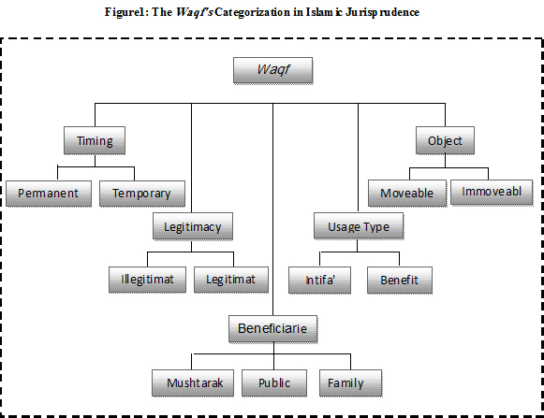

In above we argue about Waqf and its different types according to Islamic jurisprudence up to now. Whereas, from historical point of view, most of Waqfs has performed on real capital, "Cash-Waqf" don’t has played a distinguished role in Islamic economic yet. Therefore, its name didn't come in Waqf categorization figures .But basically it is placed under "Movable Waqf ". As mentioned before, this paper focuses on Cash-Waqf and its establishment. So we define it more exactly by introducing different models of Cash-Waqf, their functions, Islamic restrictions, legitimacy and so on.

Components of Waqf:

Every Waqf has some components such as: Waqif (Founder), Waqf Contract (Waqfieh), Mawquf 'alaih (Beneficiaries), Mawquf (Property) and Mutavalli (Dian Masyiat & Erie Febrian, 2004, P.6) which are described in follow:

Waqif: A person who endows his property or cash to charitable purposes.

Waqf Contract: The way in which a Waqif states his/her asset or fund as Waqf.

Mawquf 'alaih: Persons who are or areas which are the purpose of Waqf. In other word, those people of areas entitled to benefit from return of Waqf.

Mawquf: Assets or fund which are endowed as Waqf in charitable purposes and so on. In this article regarding to our goal, we use "Cash" instead of "Mawquf" because we are going to apply some Cash-Waqf methods.

Mutavalli: A person or institution who is assigned as legal custodianship over Mawquf which is not belonging to him in order to follow endowment same as Waqf Contract.

Legitimacy of Cash-Waqf:

Although, the term "Waqf" doesn’t appear in the "Quran" but Muslim jurisprudents obviously deduced its legitimacy from some "Hadith" and "Ayeh"[1] which their interpretation imply Waqf (Abidolkabisi, 1986, P84). Because of our tight opportunity and despite there are so many "Hadith" on this regard; we only point to two Hadith:

The first that points to Waqf generally[2]:

From "Abi Horeireh" who quoted from Prophet Mohammad (peace be upon him):"When a person dies, his deeds will separate from him excepting in three cases: recurring charities, beneficial knowledge and righteous child who preys him/her" (Năsif, 2003, Vol.2, P.243).

But the second that point to our goal, it signifies Cash-Waqf which was augmented under "Waqf al-darahim & al-dananir" in Islam school.

The words about this issue are in follow[3]:

Waqf al-darahem and al-dananir (dirham and dinar endowment) is reliable providing that we can make profit from it that is perpetual contemporary. But it can not be transferred, lent or mortgaged after endowing, because transferring is not possible, while it is reliable to be leased. (Àle Kăshif'u Al-Ghitae', 1984, Vol.2, P.78)

Sources of Cash-Waqf:

The accumulated funds for the construction of Cash-Waqf Project could be realized through setting up of three instruments namely; Cash and E-Waqf Fund, Per-square Feet Value Certificate and the Issuance of Sukuk (Abbdullaah Jalil & Asharaf Mohd Ramli Abdul, 2008, P.3). These instruments provide an opportunity for the donors to dedicate their wealth for Waqf purposes according to their preference as stated below:

Cash and E-Waqf Fund:

Cash and E-Waqf Fund is considered as the easiest means for the public to join Waqf scheme because they are only obliged to donate their money in cash or deducting from their bank account via E-Waqf facility. As shown in figure2 the accumulated fund will be managed by Mutavalli who is acted as an agent on behalf of the Waqif based on Wakalah Contract. Under Wakalah Contract, Mutavalli is responsible to channel the fund for project construction and the balance will be returned back to the fund for future project. Wakalah Contract is deemed more practical due to the difficulty of getting permission to the Waqif to exchange (Istibdal) cash money into immovable property. Upon getting the approval by Waqf Project management, Mutavalli is allowed to use the fund and appoints contractor for the construction of Waqf Project.

Per-square Feet Value Certificate:

The certificate of per square feet value for Waqf Project will be offered to the public once the details of the intended project are finalized. The essential elements of the project such as the type of construction project, the cost of the project, the price of each certificate and the duration of the project must be disclosed in details. Any individual or institutions must pay certain amount in order to get the certificate e.g. 30$ per square feet. The pool of money accumulated will be directed to our purposes.

The Issuance of Sukuk:

Developing Waqf assets through the issuance of sukuk is another potential instrument to be applied by Waqf administrations. This instrument is still underdeveloped in Islamic countries although some countries are well known for pioneering the issuance of various sukuk at the domestic and global stages such as Malaysia.

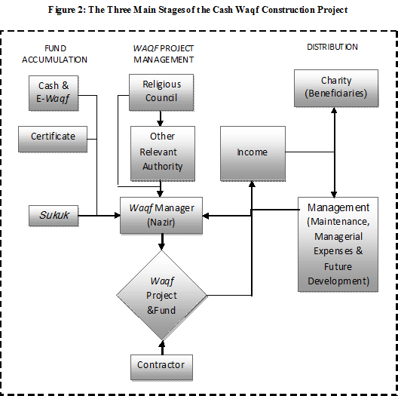

Legal conditions for Cash-Waqf creation:

In this part, all conditions that are associated with Cash-Waqf (as same as Waqf) such as: Waqf Contract, Waqif, Mawquf, Mawquf 'alaih and Mutavalli will be provided .These conditions come as following:

Conditions associated with Waqf Contract:

Ijab(Exigency) & Qaboul(Acceptance):

Waqf will be established by Ijab via Waqif in any terms that directly signify on its definition and Qaboul via Mawquf 'alaih or his trustee namely Mutavalli (Allameh Helli, 1990, P.161)

Ghorbat (Intention):

Undoubtedly, in Waqf like other actions, Niyat (Intention) as a will of act is an essential and inevitable component. Therefore, transferring won't be accomplished and Waqf won't be valid without it (Helli, 1990, Vol.3, P.155)

Iqbaz (Receiving):

The Waqf Contract will be a substantive contract while the Waqif delivers his property to Mawquf 'alaih or Mutavalli .We should consider in Cash-Waqf methods that Waqif has to deliver the cash to Waqf Institution or Mutavalli in base of Wakalah contract (Mohaqeq Sani, 1989, Vol.9, P.11)

Not to Be Suspend:

If we suspend our Waqf on a condition(s), it won't be valid. In loose speaking, the nature of Waqf is dependent to “Being unconditional" (Mohaqeq Helli, 1995, P.255)

Waqif ejection:

Waqif doesn’t have to mention himself as a Mawquf 'alaih in Waqf Contract .Otherwise, the Waqf will be void (Najafi, 1998, Vol.28, P.67)

Perpetuity:

One of the basic conditions in Waqf Contract is perpetuity. It means that the nature of Waqf has to ensure regular and continual support from the Waqf property or Cash-Waqf towards financing charitable areas such as mosque (Hăshemi Nasab, 1999, P.49)

Conditions relating to Waqif:

Bulugh (Maturity), Aql (wisdom) & liberty:

It is widely believed that the maturity, wisdom and liberty are the most important conditions about Waqif. No need to say that no person without these conditions can make decision based on productivity (Najafi, 1981, Vol.28, P.20)

To be owner:

The Mawquf (property or cash) has to be Waqif's Property. Otherwise, it would be invalid (Allameh Helli, 1997, Vol.2, P.393)

Not to be Insolvent:

Due to the fact that everyone is disregard about insane person and his actions, Jurisprudents have a consensus on this condition that his actions aren’t valid (Hăeri Yazdi, 2002, P.126)

Conditions associated with Mawquf (property or Cash):

Possibility to make profit from it and to be perpetual contemporary:

In Cash-Waqf, Waqif is obligated to deliver his money to the Mutavalli through Wakalah contract (Qorbăni, 1997, P.115)

Possibility of Qabz:

If Qabz and Iqbaz aren't applicable for Mawquf, the Waqf Contract (Waqfieh) will be invalid. In other words, it's necessary that founder has enough power to deliver his property to Mawquf 'alaih. Notice that in Cash-Waqf, the Waqif has to deliver his cash to Mutavalli like Waqf Institution (Hăshemi Nasab, 1999, P.58)

To Be in Dominance of Owner:

The property or cash doesn’t be involved in other purposes or nobody has claim on it (Mohaqeq Helli, 1982, Vol.2, P.212)

Conditions associated with Mawquf 'alaih:

Merit to own it:

The Mawquf 'alaih (if he is a human being) has to be Aqil (in full possession of his physical and mental faculties), Baligh (adult) and Hurr (a free man or women). In loose speaking, he has to be deserved to be owner. But in other cases like as Waqf Institution, it has to be adapted with Islamic rules (Sahid Avval, 1997, Vol.2, P.294)

To Be Present:

In this case, Waqif just able to endow a property or Cash in charitable purpose, while Mawquf 'alaih are present .Otherwise endowment of one for absent Mawquf 'alaih is an inoperative Waqf. In other words, the original condition on this issue is "Presence".

(Imami, 1957, P.76)

Waqf Profit Be lawful For him:

In Islamic approach for Waqf, there are some restrictions that limit Waqif in practice. One of these for example is that Mawquf 'alaih must be a person who has general authority over his or others. If no, Waqf will be void (Mohaqeq Helli, 1982, Vol.2, P.214)

To Be Specify:

In Family Waqf, We should notice that the Mawquf 'alaih has to be clear. But in Public Waqf, the Waqif can endow his property or cash to vast group (Imam Khomeini, 2002, Vol.3, P.31o)

Conditions associated with Mutavalli:

Be Aqil, Baligh, Rashid & Trusty:

The first three conditions mean Mutavalli must be able to manage all cash & properties without enormous loss. But the last means Mutavalli mustn't be traitorous and all revenue that acquired from Cash (or properties) must be used in fields that mentioned in Waqf Contract (Ryiăhi, 2000, P.97)

Be Righteous:

Jurisprudents have different ideas either it is irresolvable component or not in this condition. Some of them like "Shahid Sani" (Sahid Sani, 1982, P.177) believed at first that mean Mutavalli has to be righteous; and others like "Imam Khomeini" believe on second (Imam Komeini, 1997, P.325)

Current Application of Cash-Waqf:

The witnesses of 21st century signify the revival of Waqf Institution in many Muslim countries and the creation of Movable Waqf especially Cash-Waqf in large extent. In this section, some models for the creation of Cash-Waqf which have been practiced in Muslim countries will be presented. They are known as Waqf Shares Model, Corporate Cash-Waqf Model, Deposit Product Model, Cooperative Model, Waqf Mutual Fund Model and Wakalah with waqf fund Model.

[Models of Waqf]

I) Waqf Shares Model:

This model is a Public Waqf which has been practiced in Malaysia, Indonesia, Sudan, Kuwait and UK.

The procedure of this plan, in detail, is as follows (Magda Ismail Abdel Mohsin, 2008, P.9):

Founders will buy Waqf shares from specified religious institution with prices ranging between $1to $100 according to each country.

Founders will receive Cash-Waqf certificates as evidence that they purchase Waqf shares with a specific amount.

These Waqf shares will then be endowed to the issuing institution that will act as a Mutawalli to manage the collected fund.

The collected fund will then be distributed to charitable purposes as specified by the institution itself e.g. building mosques, schools, training center, etc.

This model can be clearly seen in following figure:

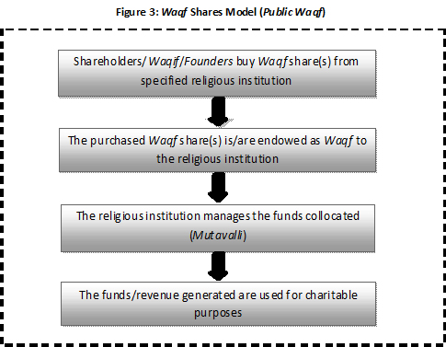

II) Corporate Cash-Waqf Model:

This model is a public Waqf which has been practiced in Malaysia specifically in Kumpulan Waqf an-Nur 1998, Turkey in Sabanci Foundation 1974, Pakistan in Hamdard Foundation 1953 and South Africa in the National Awaqaf Foundation 2000. The Founder in this model might be either an individual or a corporation.

The procedure of this plan, in detail, is as follows (Magda Ismail Abdel Mohsin, 2008, P.14):

Dividends earned for example by individuals, corporations will convey to an Associated Waqf Institution as Cash-Waqf.

The Associated Waqf Institution will act as a Mutawalli where manages and invests the accumulated Cash-Waqf.

The revenue earned will then be directed to charitable projects after operational expenses have been deducted.

This model can be clearly seen in following figure:

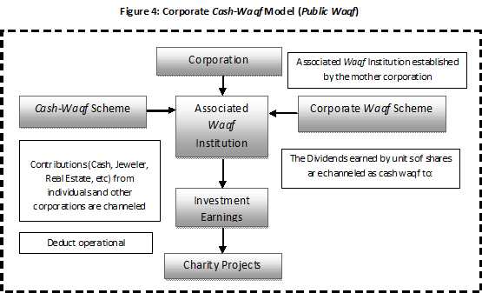

III) Deposit Product Model:

This model is a Public Waqf which has been practiced in Bangladesh in two banks, the Social Investment Bank Limited (SIBL) and the Islamic Bank Bangladesh Limited) IBBL).

The procedure of this plan, in detail, is as follows (Magda Ismail Abdel Mohsin, 2008, P.14 & 15):

The founder deposits money into Cash-Waqf based account in the bank.

While depositing the money, the founder will be given a list of the Beneficiaries whereby he can chose or specify his/her Beneficiaries.

The bank will act as a Mutawalli and will invest the capital through Mudzarabah Contract.

The revenue generated will be channeled to charitable purposes or purposes specified by the founder.

This model can be clearly seen in following figure:

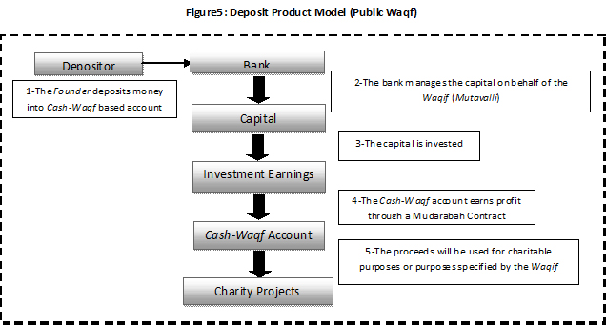

It has been realized as a good model where Mudzarabah mode has been practice and at the same time the Founder has the right to choose his/her own Beneficiaries.

IV) Waqf Mutual Fund Model:

This model is a combined Waqf which has been practiced in Indonesia in the Dompet Dhuafa Batasa. This mutual fund is managed by the Batasa Capital Asset Management.

The procedure of this plan, in detail, is as follows (Magda Ismail Abdel Mohsin, 2008, P.16 & 17):

The Founder will contribute to the mutual fund, and at the same time he/she can contribute to the Waqf fund. In this case the Founder will specify for example 70% of his investment earnings return to the mutual fund i.e. his personal account and the remaining 30% will be appropriated to the Waqf fund.

The Waqf institution will act as the Mutawalli to manage and invest the capital.

The investment earnings will then be distributed according to the Founder condition where 70% will go for his mutual fund and 30% will go to Waqf fund and distributed to charity projects, as highlighted below.

This model can be clearly seen in following figure:

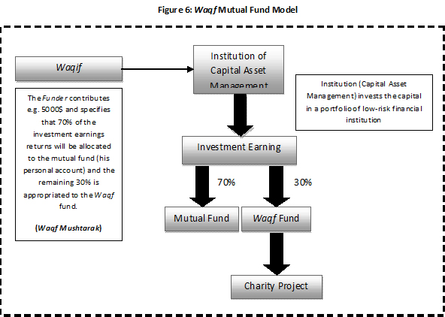

From the above model it may be seen that it is Waqf Mushtarak, but in this case the capital of the 70% and the revenue generated from investing this portion will go back entirely to the Founder leaving the 30% as Cash-Waqf.

V) Wakalah with Waqf Fund:

This model is a Public Waqf which has been practiced in Pakistan and Malaysia.

The procedure of this plan, in detail, is as follows (Abdul Rahim Abdul Wahab, 2006, P.11)

The Shareholders would initially make a donation to establish the Waqf fund. The donation can be of any reasonable amount (Shariah scholars may specify such an amount). After the creation of the Waqf fund the Shareholders would lose their ownership rights on the Waqf fund and would become the property of the Waqf fund. However, they will have the right to administer and develop rules and regulations of the fund.

The original donation of the Waqf fund needs to be invested in a very safe Shariah compliant investment and its returns would be used for the benefit of the participants. The idea being that the Waqf fund should remain intact with high likelihood.

Company would take this donation on behalf of the Waqf fund as administrator of the fund and deposit this in the fund.

The donations received from the participants, seeking Takaful protection, would also be a part of this fund and the combined amount will be used for investment and the profits earned would again be deposited into the same fund. As per Waqf principles, a member (donor) can also benefit from the Waqf fund.

This model can be clearly seen in following figure:

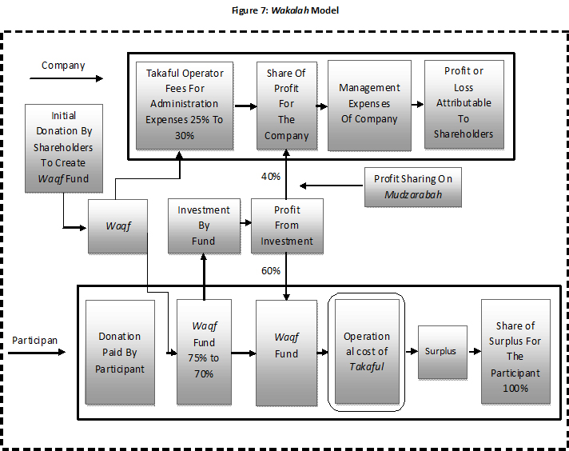

Establishment of a Cash-Waqf Financial Institution (CWFI):

Inasmuch as the above models are just associated with some instrument to simplify poverty alleviation, one or several persons can not implement them in real. So we require to some institutions or corporations that have high capability, skill and enough experiences to implementing our goal (Poverty alleviating via Cash-Waqf models). Cash-Waqf management institution should manage the accumulated Cash-Waqf created by the different Founders in such a way that the collected fund becomes more and more productive. The more the Waqf investment return, the more Mawquf ‘alaih benefit from Waqf fund. Only gains of the invested Waqf fund will be delivered to Mauquf 'alaih and the principal of fund keep being invested in potential investment opportunities.

Islamic (Shia) school's approach on these models:

With reference to all models that are presented, we consider the Islamic approach about them in order to state which of them is acceptable.

Although, in regards with Islam School's approach, "Waqf Shares Model, Corporate Cash-Waqf Model, Waqf Mutual Fund Model and Cooperative Model" are admissible, but Wakalah Model is not admissible. In follow we will concern to each model for stating more points about them.

Waqf Shares Model, Waqf Mutual Fund Model & Cooperative Model:

However, for these models, two important things are not clearly highlighted for the creation of Cash-Waqf:

The Founder of the Waqf has no choice in specifying his/her Beneficiaries as this might discourage more Founder to create Cash-Waqf.

It is very difficult to ensure the element of perpetuity of the Cash-Waqf as it is not clear how the Cash-Waqf is invested and how to ensure the capital is intact.

Corporate Cash-Waqf Model:

According to this model, Associated Waqf Institution that established by the mother corporation, channel accumulated Cash to investment after deducting operational expenses. If Waqif mentions this condition in Waqf Contract, it will be valid. Otherwise it will be void and Associated Waqf Institution won’t be allowable to deduct operational expenses from earned revenues.

Deposit Product Model:

In this model we should consider that the Founder mustn't be allowable to withdrawal his contributions from deposit account after some times. Because one of most important conditions on Waqf Contract is "The Mawquf (i.e. cash) should be perpetual". This model will be admissible, if Founders follow this way.

Wakalah Model:

One of most important conditions on Waqf Contract is "The Founder mustn't allocate any part of revenue from Cash-Waqf toward himself ". But in this model, as appeared, this condition isn’t followed. So, according to Islam jurisprudence, it will be void

Conclusion:

Based on historical literature, the Waqf plays an important role in socioeconomic life of Muslim societies. Recently, one of the types of Waqf is Cash-Waqf. Based on our study, we conclude following points:

Cash-Waqf is a type of Waqf that revived in recently century.

This paper reviewed the Cash-Waqf history and then its necessity to poverty alleviation.

Cash-Waqf is justified with Islamic jurisprudence providing that while it is making profit and earning income, it remains perpetual.

This article surveyed validity conditions of Waqif (Founder), Mawquf ‘alaih (Beneficiaries), Mawquf (Cash as property), Mutavalli and Waqf contract.

Then, this study introduced some contemporary practical models in Cash-Waqf and analyzed their validity according to Shia’ jurisprudence. Based on this study, Waqf Shares Model, Waqf Mutual Fund Model and Cooperative Model are acceptable for running but establishing Corporate Waqf Model is conditional. On the other hand, Deposit Product Model and Wakalah Model can not justify with Islamic principal.

References:

Hăshemi Nasab, Seyyed Mohammad Mahdi, Thesis Presented For Degree Of Master Of Art In Management:"To Examine The Possibility Of Increasing The Interests Which Can Obtained From Endowed Possession By Considering Financial Knowledge", Imam Sadiq University, 1999.

Khomeini Mousavi, Roohollăh, Ketab’u al-baye', Qom, Matbouăti Esmăeilian Press Institution.

Hăeri Yazdi, Dr Mohammad, Endowment In Islamic Jurisprudence And It's role in Efflorescence of Islamic Economic, 1th Edition, Mashhad, Àstăn Qodse Razavi Press Institution, 2002.

Săfi, Mohammad Reza, The Reviewing Of Waqf's Condition in Islamic World, Waqf Mirăth-e- Javidan: A cultural, Social & Historical Quarterly, Nom.53, 14thYear, 2006.

Shakoori, Săber, Thesis Presented For Degree Of Master Of Art In Management:"Endowment Of Stock In Jurisprudence and A Financial Model", Imam Sadiq University, 2007.

Mannan, M.A.Abdul, Cash Waqf Certificate- An Innovation In Islamic Financial Instrument: Global Opportunities For Developing Social Capital Market In The 21st Century Voluntry Sector Banking, Presentation at the Third Harvard University Forum on Islamic Finance, October 1, 1999.

Saădat Far, Javăd; Dădgar, Dr Yadollăh, To Examine The Cash-Waqf (New Instrument In Developing Economical Literature And Activities), Economical Research Quarterly, Nom.1, 7th Year, 2007.

Dian Masyita, A Model Of Portfolio Investment Management Of The Islamic Endowment Funds Using System Dynamics Methodology, In <http://pustaka>.unpad.ac.id/archives/1233 website.

Mannan, M.A.Abdul, Cash Waqf; Enrichment Of Family Heritage Generation To Generation, Social Investment Bank Press, 1st edition, 1998.

Mohaqeq Helli, Ja'far Ibn Al-Hasan, Sharăie'u Al-Islam Fi Al-Halal &Al-Haram, 3th Edition, Tehran, Isteqlql Press, 1982.

Tousi, Mohammad Ibn AL-Hasan, Al-Mabsoot, Al-Maktabat'e Al-Mortazaviah Press.

Shahid Săni, Zeinoddin, Hăshie Sharăie'u Al-Islam, 1th Edition, Qom, Al-Tăbe' Lemaktab'e Al-Ae'lăm'e Al-Islami Press Center, 2001.

Mămaqăni, Abdullah, Manăhej'u Al-Mottaqin, Qom, Àlolbeit Press Institution, 1983.

Magda Ismail Abdel Mohsin, Cash Waqf A New Financial Product Model Aspects Of Shariah Principles On ITS Commercialization, This paper is presented at Islamic Banking, Accounting and Finance Conference (iBAF 2008), organized by Faculty of Economics and Muamalat, Universiti Sains Islam Malaysia, 28-29 July 2008 at The Legend Hotel, Kuala Lumpur 2008.

Sayiăh, Sajjăd, Proposal Of Waqf Institution's Establishment As a Islamic Financial Institution, submitted to International Conference On Islamic Finance, Organized by Islamic Research & Teaching Institute and Center Of Technology Studies; Sharif University Of Technology, 22-24 October 2007.

Dian Masyiat & Erie Febrian, The Role Of BRI In The Indonesian Cash-Waqf House's System, Submitted to BRI International Seminar on Developing Microbanking: Creating Opportunities for the Poor through Innovation in Denpasar, Bali, Indonesia on the 1-2 December 2004.

Abidolkabisi, Mohammad, Waqf's Rule In Islamic Jurisprudence, Sadeqi Goldar, Ahmad, 1th Edition, Măzandarăn, , General Office of Hajj, Awaqf & Charity Of Măzandarăn Province Press, 1986.

Năsif, Mansoor Ali, Al-Tăjj'u Al-Jăme'u Al-Osoul, 3th Edition, Egypt, Al-Maktabat'u Al-Islamieh Press, Vol.2, 2003.

Àle Kăshif'u Al-Ghitae', Mohammad Hosein, Tahir'u Al-Majallah, Najaf, Maktabat'u Al-Mortazavieh Press, Vol.2, 1984.

Abbdullaah Jalil & Asharaf Mohd Ramli Abdull,Waqf Instruments For Construction Contract: Analysis Of Structure" This paper is submitted at Islamic Banking, Accounting and Finance Conference (iBAF 2008), organized by Faculty of Economics and Muamalat, Universiti Sains Islam Malaysia, 28-29 July 2008 at The Legend Hotel, Kuala Lumpur 2008.

Allămeh Helli, Hasan Ibn Yousof, Tabserat'u Al-Motea'llemin, 1th Edition, Tehran, Faqih Press, 1990.

Helli, Ibn Idris, Al-Sarăer, 2th Edition, Qom, Islamic Press, 1990.

Mohaqeq Sani, Ali Ibn Al-Hosein, Jăme'u Al- Maqăsed, 1th Edition, Qom, Alolbeit Press Institution, Vol.9, 1989

Mohaqeq Helli, Ja'far Ibn Al-Hasan, Al-Mokhtasar'u Al-Năfe', 2th Edition, Al-Be'seh Press Institution, 1995.

Najafi, Mohammad Hasan, Javăhir'u Al-Kalăm, Tehran, Dărolketăb'u Al-Islamieh Press, 1998.

Najafi, Mohammad Hasan, Javăhir'u Al-Kalăm Fi Sharhe Sharăie'u Al-Islam, 7th Edition, Beirut, Dăr'u Ehia'e Al-Torăs'e Al-Arabi,1981.

Allameh Helli, Hasan Ibn Yousof, Qavăed'u Al-Ahkăm, 1th Edition, Qom, Islamic Press, 1997.

Qorbăni, Farajollah, Civil-Fundamental Law, Tehran, Daneshvar Press, 1997.

Mohaqea Helli, Ja'far Ibn Al-Hasan, Sharăie'u Al-Islam, Beirut, Dăr'u Al-Azvae' Press, 1982.

Sahid Avval, Mohammad Ibn Makki, Doroos'u Al-Share'iiah, Mashhad, Àstan Qods Razavi Islamic Researches Press Institution, 1997.

Imami, Seyyed Hasan, Civil Low, Tehran, Tehran University Press, 1957.

Imam Khomeini, Tahrir'u Al-Vasileh, Mousavi, Seyyed Mohammad Băqer, 4th Edition, Qom, Dărolelm Press Institution, 2002.

Ryiăhi Sămăni, Nader, Waqf and Process and Evaloution Of Legalize In Mawqufat, Shiraz, Novid Press, 2000.

Sahid Sani, Zeinodin, Rozat'u Al-Bahiiah, Beirut, Ehiăe'u Al-Torăs'e Al-Arabi Press, 1982.

Abdul Rahim Abdul Wahab, Takaful Business Models; Wakalah Based On Waqf: Shariah And Actuarial Concerns And Proposed Solutions, Presented at the Second International Symposium on Takaful 2006, Malaysia.

Lankarăni, G.A. Făzel, Resalah of Tawdhih-al-Masael of G.A.Fazel Lankarani, 5th Edition, Qom, Amir'u Al-Elm Press, 2006.

Notes

1. There are various Ayeh in Quran that imply on urgency of *Waqf* .Among them, "Ale Emran-92" is the most reputed which Allah, in that, advice us to donate extra partial of our wealthin charitable purposes when occasion serves.
2. عن أبی هریرة عن النبی(صلی الله علیه و آله) قال: "إذامات الانسان إنقطع عنه عمله إلّامن ثلاثه :صدقة جاریة أوعلم ینتفع به أوولدصالح یدعوله"
3. "یصح الوقف الدراهم والدنانیر إذا امکن الانتفاع بها منفعه محللّه مع بقاء عینها،ولکن لا یصح بعد وقفهما الشراء بها و لا إقراضها ولا رهنها لأنّ الوقف لا یصح للنقل و الانتقال.نعم یصح إعارتها و اجارتها ونحوذلک ممّا لا یوجب نقل عینها".