Alhassanain (p) Network for Islamic Heritage and Thought

Habib b. Mudhahir

Biography of the devoted friend of Imam Husayn (a).

Author(s): Kamal al-Sayyid

Translator(s): Jasim al-Alyawy

Publisher(s): Ansariyan Publications - Qum

[www.alhassanain.org/english](http://www.alhassanain.org/english)

Table of Contents

Habib bin Mudhahir 3

I am Habib 4

In Karbala 6

The Siege 7

Tasu'a 8

For Prayers 9

Imam Husayn [a] gets ready to fight. 10

The Prisoner of War 11

Zaynab's Tent 12

Dream 13

Ashoora 14

The Battle 15

Muslim dies a Martyr 16

Happiness 17

Final Prayers 18

The End 19

In the Believers' Hearts 21

Habib bin Mudhahir

The desert was very vast. The sky was full of stars. An old man aged seventy-five left his tent. The old man jumped on his horse and rode away.

The old man heard a wolf howling. He was afraid of nothing. He intended to get to Mudharib (Bani Asad's tribe) near the Euphrates.

When the old man got there, some dogs barked at him. Some men of Bani Asad's tribe were sitting in a big tent. They were chatting with one another at night.

The old man greeted them. They stood up for him. He looked dignified, but they did not know him.

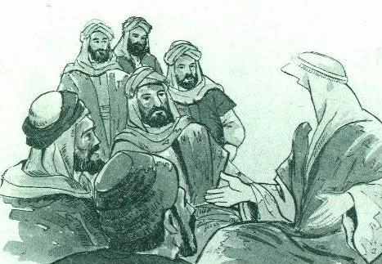

The old man sat down. He had a beard. His beard was as white as cotton. The men began looking at his calm expression and his white beard.

I am Habib

The old man introduced himself to the men in the tent.

I'm Habib bin Mudhahir: I belong to Bani Asad's tribe.

One of the men was very old. He was acquainted with ancestry. So, he knew Habib and said:

Habib is telling you the truth.

Then the old man added:

He's bin Riaab bin al-Ashtar bin Fakas bin Tareef bin Qais bin al-Harith bin Thalaba bin Doodad bin Asad.

Another man added:

This is the companion of Allah's Apostle. He has lived in Kufa since Imam Ali's Caliphate. He stood by him at the Battle of Camel, the Battle of Siffeen, and the Battle of Nihrawan.

One of the men asked Habib:

Bani Asad's Shaikh, what have you brought?

Habib quietly answered:

I've brought you good no leader has brought to his people.

The men listened to him attentively. Then he added:

Al-Husayn, Ali and Fatima's son is around. A group of the believers has accompanied him. His enemies have surrounded him. They want to kill him. So, I've come to you. I ask you to defend him against his enemies to save the dignity of Allah's Apostle. By Allah! If you support him, Allah will give you honour in here and hereafter.

One of the men stood up. His name was Abdullah bin Bashher al-Asady. He said:

May Allah thank you for your effort. You've brought us a good deed. I'm the first to defend al-Husayn against his enemies.

The number of the volunteers became ninety fighters. Habib took them and headed for an area called Karbala. Their Imam Husayn [a], his family, and his believing supporters had camped there.

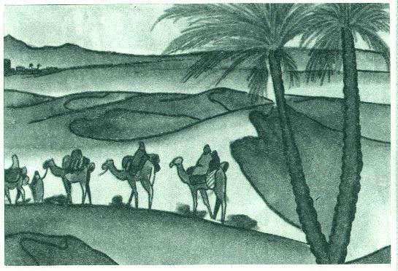

A man belonging to Bani Asad was a traitor. He took advantage of the darkness and hurried to tell Umar bin Saad, the leader of Yazeed's Army, about Habib and his friends.

Yazeed's Army had besieged Imam Husayn's caravan and prevented them from drinking water.

Umar bin Saad formed a division. The number of the division was five hundred horsemen. Al-Azraq headed them.

The horsemen hindered Bani Asad. Al-Azraq asked them to come back, but they refused. A fight took place between the two sides. So, some men of Bani Asad were killed and some were wounded.

The volunteers knew that there was a big army before them. And there were big supplies behind the army. For this reason, they decided to come back.

When the volunteers got to their tribe Mudharib, they warned it of staying at that area.

The men quickly collected their tents and moved to another place in the desert.

Habib came back by himself. He was sad. He told Imam Husayn [a] about Bani Asad's attitude. Imam Husayn [s] said:

There's neither might nor power but with Allah!

In Karbala

Mu'awiyah died. His son Yazeed succeeded him. So, the Caliphate became a kingdom.

Yazeed was a bad man. He drank alcohol. He committed illegal actions. He amused himself with his dogs and monkeys. Thus Imam Husayn [s] refused to pay him homage.

The people in many Muslim cities suffered from Mu'awiyah's unjust policy. They wanted him to die to get rid of his bad behaviour. When the Muslims knew that Yazeed would be the Caliph, they felt pain and were full of anger. They opposed his rule because he did not respect Islam and Muslims.

The people in Kufa liked Imam Ali [a] because he was just and merciful. Besides they knew al-Husayn's good behaviour and his kind treatment towards his Muslim brothers. Therefore, they sent him many letters.

In Makkah, Imam Husayn [s] received the Muslims messengers. In their signed letters, the Muslims said to Imam Husayn [a]:

Come to us! You are our leader only!

Imam Husayn [a] accepted the Muslims request. He decided to revolt against Yazeed bin Mu'awiyah. He took his family and supporters and left for Kufa.

The Siege

Ubaidullah bin Ziyad had sent a military division. The number of the division was one thousand horsemen. Its aim was to hinder Imam Husayn's caravan.

It was very hot. Ubaidullah's horsemen used up their water. Imam Husayn [a] took a pity on them, and ordered his companions to give them water.

Imam Husayn [a] camped near River Euphrates. Ubaidullah appointed Umar bin Saad over the division. Umar bin Saad occupied the riverbanks. He prevented Imam Husayn [a] and his companions from drinking water.

Umar bin Saad sent a man called Qurra bin Qais to Imam Husayn [a]. He ordered him to ask the Imam:

Why have you come to Kufa?

When Qurra went to Imam Husayn [a], the Imam asked Habib bin Mudhahir about him:

Do you know him?

Habib answered:

Yes, this is Qurra bin Qais. I know his good opinion. I don't think he'll fight you.

Qurra came and greeted the Imam. He told him about Umar bin Saad's letter. The Imam said:

The people of Kufa have asked me to come. If they hate me, I'll leave them.

Qurra bin Qais kept silent. He wanted to come back to Umar bin Saad. So Habib said to him:

Qurra, woe unto you! Don't come back to the unjust people! Support Imam Husayn!

Qurra said:

I'll tell Umar about Imam Husayn's answer. Then I'll consider your request.

Tasu'a

On Muharram 9th, 61 A.H. Umar bin Saad started his attack at night. He advanced towards Imam Husayn's camp. Zaynab, Imam Ali's daughter, heard the enemy's voice. She said to her brother al-Husayn:

The enemies have approached!

Imam Husayn [a] ordered his brother al-Abbas to ask them. Al-Abbas, Habib bin Muzahair, and twenty persons jumped on their horses and rode away. Al-Abbas asked them about their aim. They said:

Obey Ubaidullah bin Ziyad, otherwise we'll attack you!

Al-Abbas came back to Imam Husayn [a] to tell him about the enemy's attitude.

Habib stayed behind. He began advising the enemy army:

By Allah, tomorrow, Allah will regard you as bad people! How will you meet Him while you are going to kill Imam Husayn and his family? Don't you know that they're the Prophet's grandsons? Don't you know that they pray to Allah after midnight and remember Him very much?

An enemy person called Uzrah said:

Habib, you're praising yourself!

Zuhair answered:

Allah has praised and guided him. Uzrah I advise you to fear Allah!

For Prayers

Al-Abbas went to Imam Husayn [a] to tell him about the enemies' attitude. The Imam said to him:

Go back and ask them for time to pray. We want to pray to Allah tonight. We want to ask Him to forgive us. Allah knows that I love prayers, reading the Qur'an, and asking forgiveness.

Al-Abbas came back and asked them for some time. Umar bin Saad thought for a while. He thought that Imam Husayn [a] would change his mind. So, he agreed on Imam Husayn's request and said:

We'll give you a chance till tomorrow. If you give in, we'll take you to Emir Ubaidullah bin Ziyad. If you refuse to give in, we won't let you go.

Imam Husayn [a] gets ready to fight.

Imam Husayn [a] and his companions began praying and reading the Qur'an, for it was the last night in the world.

The tents were here and there. Imam Husayn [a] wanted to prevent the enemies from penetrating them. So, he ordered his companions to tie them to each other. He also ordered his companions to dig a trench at the back of the tents to fight the enemies at one front.

The Imam met his companions and said:

I praise Allah with the best praise! I am thankful to Him in all conditions whether pleasant or otherwise! Allah, I thank you for making my grandfather a prophet and teaching us the Qur'an! I thank you for giving us ears, eyes and hearts. I thank you for you have not made us polytheists!

The Imam added:

I don't think that there are companions better than mine, there's a family more loyal than mine! May Allah reward you all. I think that we'll face those enemies tomorrow! Now you may go!

All refused and said:

We'll sacrifice our lives, money, and families to defend you against the enemies! We'll stand by you!

The Prisoner of War

A young man came to Imam Husayn's camp. He was looking for his father Muhammad bin Basheer al-Hadramy.

The young man said to his father:

My brother is a prisoner of war at Ray (a town near Teheran).

His father said:

I'll support Imam Husayn at any rate!

Imam Husayn said:

You're free. Go and release your son.

Muhammad bin Basheer refused that and said:

By Allah, I won't leave you!

Imam Husayn [a] gave him five garments. Each cost one thousand dinars. Then he said to him:

Give your son these garments to release his brother.

Thus Imam Husayn's companions preferred death with him to life with the unjust.

Zaynab's Tent

At midnight, Imam Husayn [a] went out to see the nearby hills. One of his companions, named Nafi bin Hilal al-Jamaly, saw and followed him.

The Imam asked his companion about his going out.

His companion said:

Son of Allah's Apostle, I'm anxious about you.

Imam Husayn [a] said to him:

I've gone out to see the nearby hills.

Imam Husayn [a] and his faithful friend came back together. On their way, Imam Husayn [a] said to him:

Why don't you go through those two hills in the dark to save yourself?

Hilal wept and said:

No! By Allah, I won't leave you alone! I want to be killed with you!

When the Imam got to the tents, he came into the tent of his sister Zaynab. Hilal stood by the tent waiting for him. Hilal heard Zaynab saying to her brother:

Are you certain of your companion's intentions?

The Imam said:

By Allah, I've tried them. They are brave. They are ready to die for me.

When Nafi heard Zaynab's words, he wept and went to Habib's tent. He told him about Zaynab's word. The he said to him:

We'd better go to her to relieve her worry.

Habib stood, left his tent, and said loudly:

Good friends!

The men went out. They stood around Habib. He said to them:

Let us go to Zaynab's tent to relieve her worry.

The men took their swords and went to Zaynab's tent. They said to her:

By Allah, we're ready to sacrifice our lives for you!

Zaynab went out and said:

Good companions, defend the grandsons of Allah's Apostle against their enemies.

Habib and his friends wept. They decided to fight till death.

Dream

Imam Husayn's [s] companion went to their tents. Some companions went to bed to get ready to tomorrow's fight, and some began praying and reading the Qur'an. Al-Husayn was in his tent mending his sword. He felt tired and closed his eyes.

It was early morning. Imam Husayn [a] dreamt that he saw dogs attacking him. One of the dogs was spotted. It was biting his neck. Al-Husayn woke and said:

We belong to Allah, we shall come back to Him!

Ashoora

In the morning, Muharram 10th, Imam Husayn [a] and his companions said their prayers.

Imam Husayn [a] prepared his companions for the battle. He divided them into three small groups: Zuhair bin al-Qain headed the right wing. Habib bin Mudhahir headed the left wing, and al-Abbas, the Imam's brother, headed the core.

Imam Husayn [a] rode his she-camel and stood before Yazeed's Army. He preached and advised them. He warned them of committing such a crime. All Imam Husayn's efforts were in vain. Satan led Yazeed's fighters astray. So, they forgot Allah.

The Battle

Yazeed's army began attacking Imam Husayn's army, throwing many arrows at them.

Imam Husayn [a] said to his companions:

Good companions, stand up for death!

The two sides met for the first time in a small clash. The clash was over and the Imam's companions came back to their places.

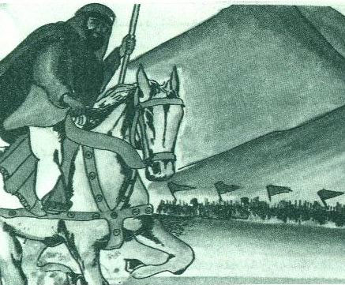

Then Yazeed's Army launched savage attacks against the Imam Husayn's companions.

Imam Husayn's companions resisted the attacks bravely. Some of them fell over the ground and died martyrs for the Prophet's grandson.

Muslim dies a Martyr

Amru bin al-Hajjaj began a big attack. Imam Husayn's companions faced the attack and fought bravely.

Muslim bin Ausajah, a companion of the Imam's, was fighting with enthusiasm. Then he was badly wounded and fell over the ground.

Imam Husayn [a] saw Muslim lying on the ground. He and Habib bin Mudhahir attacked Yazeed's Army. They saved Muslim bin Ausajah from them. Muslim was about to die.

Imam Husayn [a] sadly said:

Muslim, may Allah have mercy upon you. I'm giving you good news about the Paradise.

Muslim answered faintly:

May Allah give you good news!

Habib said:

I wish I could listen to your will, but I'll die after you.

Muslim looked at Habib. Then he looked at Imam Husayn [a] and said:

Habib, I ask you to die for Husayn!

By the Lord of Kaaba, I will!

Happiness

On that day, Habib was full of happiness. His face was smiling.

A companion of Habib's wondered and asked him:

Why are you happy?

Habib answered:

I'm happy because I'll be killed and enter the Paradise!

Final Prayers

The fights went on till noon. A companion of Imam Husayn's looked at the sun. He knew that it was time to pray.

Imam Husayn [a] asked Yazeed's Army to stop fighting to say their prayers.

Al-Husayn bin Numair said to Imam Husayn [a]

Husayn, Allah won't accept your prayers!

Habib bin Mudhahir said stormily:

Donkey! Will Allah accept your prayers, but won't accept the prayers of the Prophet's grandson?

The End

Al-Husayn bin Numair was full of spite. He whipped his horse and attacked Habib. Habib faced him. He hit al-Husayn's horse on the face. So, al-Husayn bin Numair fell over the ground.

Many fighters rushed to save al-Husayn bin Numair. Habib clashed and fought them bravely.

In spite of his old age, Habib could kill over sixty fighters. When the fight became strong, a fighter threw a spear at Habib. So, Habib fell over the ground and became a martyr.

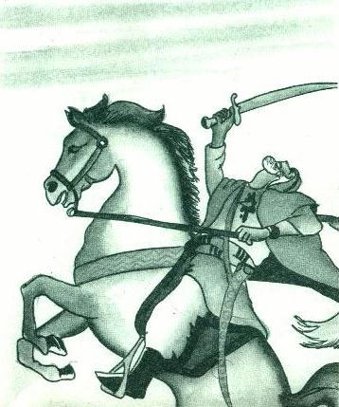

Thus the brave companion's life was over. He spent all his life waging holy war for Islam.

Al-Husayn bin Numair was not satisfied with killing Habib. He took his head and tied it to his horse's neck. Then he began roaming through Yazeed's fighters. He was boasting of his bad action.

Imam Husayn [a] tried to save Habib, but he got there late. So, his eyes shed tears. He sadly said:

We belong to Allah and we shall come back to Him.

Imam Husayn [a] came back to his camp. He was sad because he lost the closest and the most loyal companion.

In the Believers' Hearts

Today Muslims all over the world go to Karbala to visit Imam Husayn [a]. In the distance, they can see a high gold dome and high minarets.

When a Muslim enters the holy shrine full of perfume, he will find a tomb near Imam Husayn's tomb. That tomb belongs to Habib bin Mudhahir, Bani Asad's leader, and the master of the loyal.

The visitor to Imam Husayn [a] must greet his companion and say:

Peace be upon Habib bin Mudhahir al-Asady.

All rights reserved for Al-Hassanain (p) Network, Imam Hussain (p) Foundation

Alhassanain (p) Network for Islamic Heritage and Thought

[www.alhassanain.org/english](http://www.alhassanain.org/english)