Alhassanain (p) Network for Islamic Heritage and Thought

Kumayl bin Ziyad:

Biography of the companion of Imam 'Ali (a)

Author(s): Kamal al-Sayyid

Publisher(s): Ansariyan Publications – Qum

[www.alhassanain.org/english](http://www.alhassanain.org/english)

Table of Contents

Kumayl bin Ziyad 3

Whose supplication is it? 4

Who was Kumayl? 4

The Beginning 5

Al-Khidr's Supplication 6

Al Hajjaj 8

The Revolution 9

Abid al-Rahman bin al-Ashath 10

The Fights 12

The Battle of Deer al-Jamajum 13

The End 14

Kumayl's Memories 15

Why did Kumayl surrender? 16

Before Al-Hajjaj 17

Kumayl's Shrine 18

Kumayl bin Ziyad

On Thursday night, the Muslims finish the night prayers. They sit down in lines. They implore Allah, the Merciful Creator, to forgive them their sins. They ask Him to be pleased with them.

Sweet words flow out of the mosque minarets. The words fly high in the clear sky full of stars:

Allah, I implore You with Your mercy that has included everything,

And with Your power with which you have overcome everything,

And everything has yielded to it...

Whose supplication is it?

What's the story of this supplication?

Who was Kumayl?

He was Kumayl bin Ziyad al-Nakhay. He was one of Imam Ali's companions. He was a noble man. His people obeyed him. He came from Yemen. His family inhabited Kufa during Imam Ali's Caliphate.

Abid al-Rahman bin al-Ashath led a revolution against al-Hajjaj. Kumayl joined the revolution. He led the Qur'an Readers Battalion.

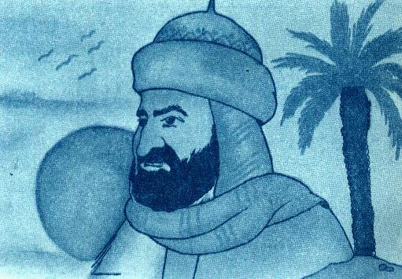

The Beginning

Our Master Muhammad [s] said:

I'm the city of knowledge and Ali is its gate.

Imam Ali [a] was a great scholar. He said:

Allah's Apostle has taught me a thousand doors of knowledge. Each door leads to a thousand doors.

He also said:

The Zakat (alms) of knowledge is to publish it.

So, Imam Ali [a] taught his companion whatever they wanted. One day, he took Kumayl with him outside Kufa. It was night. The sky was full of stars. Northern fresh breeze was blowing.

Imam Ali [a] said to his companions: Kumayl, these hearts are containers (of knowledge). The best of them are those that best preserve knowledge. Therefore, preserve what I say to you:

There are three classes of people. The first class knows Allah. The second learns knowledge as means of salvation. And the third is rabble: followers of every crier, who bend with every breeze. These men do not seek to be illuminated by the light of learning, nor do they resort to any authority.

Kumayl, knowledge is better than wealth. Knowledge guards you while you guard wealth. Wealth is diminished by expenditure while knowledge is increased even by giving it away.

Kumayl, those who amass wealth die even as they live while those who have knowledge will continue to exist for as long as time lasts.

Al-Khidr's Supplication

Imam Ali [a] was sitting with a group of his companions. One of them asked him about the explanation of the following Holy Verse:

Therein every wise affair is made distinct.

The Imam said:

It's on 15th Shaaban.

Then he added:

By Allah, man faces his fate on Shaaban 15th. So, man must implore Allah at such a night. He must recite al-Khidr's supplication. Certainly Allah accepts it.

The meeting was over. The Imam went home.

The evening came. Then it got dark. People went to bed. At that hour, Kumayl got up. He went to Imam Ali's house. He had question.

Kumayl knocked the door. Imam Ali [a] said:

Kumayl, what has brought you?

Kumayl, politely said:

Amirul Mu'mineen, al-Khidr's supplication.

The Imam said kindly:

Kumayl, please sit down.

The he added:

I'll read you a supplication. Read it on Thursday nights.

The Imam began reading the supplication. Kumayl was writing it. Nowadays, millions of Muslims read the supplication. They call it Kumayl's supplication.

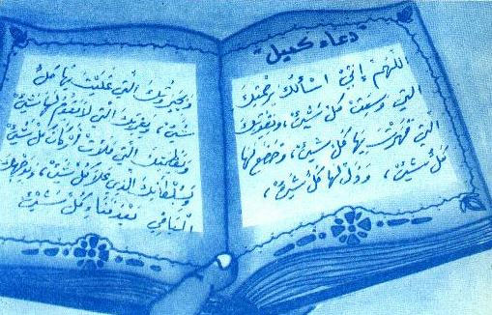

Thursday night, when you are free, then read Kumayl's supplication. Faith will shine in your heart. It will illuminate the way of your life as it had illuminated the way of Kumayl's life.

Al Hajjaj

Imam Ali passed away. Mu'awiyah became a Caliph. Unjust rulers succeeded him. Life in Kufa became unbearable.

The rulers imprisoned and killed the God-fearing followers of Ahlul Bayt.

Ziyad bin Abeeh ruled Kufa. Then his son Ubaidullah succeeded him. The latter killed the Prophet's grandson. Besides he killed seventy of his companions and his family.

Al-Hajjaj did his best to please the Umayyad rulers. He filled his prison with innocent men and women. In his prison, there were fifty thousand men and thirty thousand women.

The prison was roofless. The prisoners were subjected to sun and heat in summer. And they were subjected to rain and cold in winter.

A person had been in prison for months. One day his mother went to the prison to visit him. She was astonished to see him. She said:

He's not my son. My son is white. This young man is a Negro. I don't know him.

The young man reminded his mother of some marks. The mother became certain of her son. She burst into tears. Then she died of sadness.

The Revolution

Al-Hajjaj hated the Ahlul Bayt and their followers very much. So, he filled the prisons with Shias. They had no fault but they loved Muhammad's family.

Al-Hajjaj was unjust. People hated him. They asked Abid al-Malik to remove him from office. Abid al-Malik refused because al-Hajjaj wanted to strengthen the Umayyad rule with fire and sword.

Al-Hajjaj was wicked. He sent people to fight and occupy lands. He forced them to join the invading armies. He wanted them to get the booty of the conquered lands. In the meantime, he wanted to get rid of them.

Abid al-Rahman bin al-Ashath

King Ratbil ruled Turkey. Al-Hajjaj sent Abid al-Rahman bin al-Ashath to Turkey to invade it. Abid al-Rahman went deep into the Turkish land. He won victories at some battles. So, he sent al-Hajjaj a letter. In the letters he asked him to stop fighting to refresh his fighters.

Al-Hajjaj's answer was full of abuses. Meanwhile, he ordered Abid al-Rahman to go deeper into the Turkish lands.

Abid al-Rahman and his fighters knew al-Hajjaj's wicked aims. So, they decided to revolt against al-Hajjaj and Abid al-Malik.

After Abid al-Rahman had announced the revolution, he came back from Turkey. Many people supported him. The Qur'an readers were the first to support him.

The Qur'an readers formed a battalion. Kumayl bin Ziyad led the battalion.

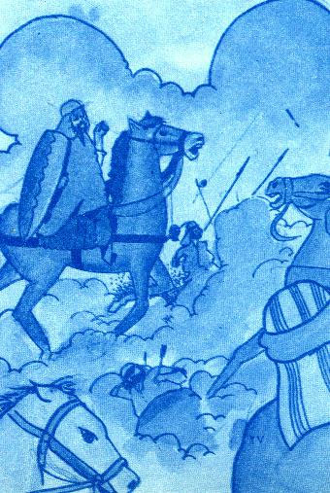

Because the Kufians suffered from persecution, they also supported the revolution.

The number of revolutionaries was over one hundred people. This number included the Qur'an readers, worshippers, poets, religious jurists, and the commoners. Half the number were foreigners. They suffered from racial discrimination. The Umayyads preferred Arabs to non-Arabs.

Saeed bin Jubair, the most famous jurist, was among the revolutionaries. He made people eager to start the revolution.

Poets urged Abid al-Rahman to go on revolting to end persecution.

The Fights

In 81 A.H., Abid al-Rahman advanced towards Iraq. Violent fights took place there. The revolutionaries defeated al-Hajjaj's army. They freed many cities such as Sajestan and Kirman in Iran, Basrah and Kufa in Iraq.

Abid al-Malik sent a man to Abid al-Rahman to hold talks with him. He accepted some conditions such as removing al-Hajjaj from office.

People rejoiced at their freedom and victory. So, they insisted on removing Abid al-Malik from the office, for he appointed al-Hajjaj ruler over them.

Abid al-Malik sent military supplies to support al-Hajjaj. The army in Khurasan joined him, too.c

The Battle of Deer al-Jamajum

The two armies met at Deer al-Jamajum. A violent fight took place between the two sides. Al-Hajjaj defeated Abid al-Rahman.

Abid al-Rahman's army scattered. Some fighters escaped. Some passed away. Abid al-Rahman himself took refuge in Turkey. Some revolutionaries such as Saeed bin Jubair and Kumayl bin Ziyad disappeared.

Al-Hajjaj began looking for the revolutionaries. He managed to execute some of them. And some were able to hide from him.

The End

After Deer al-Jamajum Battle, Kumayl bin Ziyad was far away from spies.

The police were looking for Kumayl everywhere.

Al-Hajjaj used a new way to arrest Kumayl. He ordered the police to annoy Kumayl followers. He deprived them of money. So, their economic condition was bad. Kumayl heard about that. Thus, he decided to surrender. The police took him to al-Hajjaj.

Kumayl's Memories

Kumayl bravely walked with the police. In the meantime, he recalled the beautiful days with his teacher and leader, Imam Ali [a].

Kumayl remembered the days when he was a soldier in the Imam's army. He remembered his fights against the disloyal, the unjust and the apostates.

Kumayl remembered the day when he led an army of four hundred fighters to face a raid by Mu'awiyah's army.

Kumayl remembered the day when he chased the invaders of Kirkeesya. He remembered the Imam's scolding letter because he left the borders of his country without soldiers.

The Imam's letter read as follows:

Certainly, you have deeply gone into Kirkeesya. And you have left the positions without protection. The idea is incorrect. You have become a bridge for your enemies to protect your friends.

Why did Kumayl surrender?

Kumayl believed in Allah and the hereafter. He loved all people. He loved his family and his tribe.

Al-Hajjaj mistreated Kumayl's family and tribe. So, Kumayl surrendered to save them from persecution.

Kumayl remembered Imam Ali's words:

Kumayl, order your family to do good. Order them to help people at night.

Before Al-Hajjaj

Kumayl's face was bright. His beard was white. His heart was certain.

Kumayl came into al-Hajjaj's palace. He saw al-Hajjaj sitting and his guards standing around him. He saw a headsman carrying a sword.

Kumayl knew that al-Hajjaj would kill him, for Imam Ali had told him about that.

Paying no attention to al-Hajjaj, Kumayl said:

My master, Imam Ali [a] has told me that you will kill me. Allah's enemy, do whatever you like! And know that Judgement Day will be after killing.

Al-Hajjaj said:

Disown Ali to save your soul.

Kumayl said:

Show me a religion better than Ali's.

Al-Hajjaj ordered the headsman to behead Kumayl.

Kumayl's Shrine

Nowadays, the visitor sees Kumayl's shrine on a hill at Wadi al-Salam in the holy city of Najaf.

On Thursday nights, sweet words fly high in the sky full of stars. The words remind people of that great martyr whose name is connected with the supplication. So, his name will be immortal.

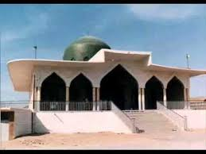

All rights reserved for Al-Hassanain (p) Network, Imam Hussain (p) Foundation

Alhassanain (p) Network for Islamic Heritage and Thought

[www.alhassanain.org/english](http://www.alhassanain.org/english)