Alhassanain (p) Network for Islamic Heritage and Thought

The Origins of Islamic Science

by: Muhammad Abdul Jabbar Beg

In the following well documented article Dr Muhammad Abdul Jabbar Beg surveys the origins of Islamic science, with a special focus on its interaction with the previous intellectual traditions of the ancient world as well as a survey of the beginnings of scientific activity in Arabic. In this first part, he depicts in details the impact of Islamic principle in shaping the contours of the early scientific activity in the Muslim civilisation. Afterwards, in the second part, the author surveys some key contributions of the scientists of Islam in the fields of astronomy, mathematics, chemistry, and medicine.

Dr. Muhammad Abdul Jabbar Beg

Ph.D. (Cantab), FRAS (London), Visiting Research Scholar at Cambridge University, UK.

www.muslimheritage.com

[www.alhassanain.org/english](http://www.alhassanain.org/english)

[In The Name of Allah, The Beneficent, The Merciul]

Table of Contents

Note of the editor 4

1. The Ancient Sciences and the Arabs 5

1.1. Mesopotamia 10

1.2. Ancient Egypt 13

1.3. The Greek legacy 13

1.4. Various influences in Pre-Islamic Arabia 16

1.5. The First Occurrences (Awa'il) 20

2. Islam as a Source of Inspiration for Science and Knowledge ('Ilm) 22

2.1. The Rise of Islam and the Early Intellectual Fertilisation 22

2.2. The Islamic Background to Intellectual Activity 24

2.3. Unity of Knowledge: Religious, Rational and Experimental 27

2.4. Maurice Bucaille's Theses 30

3. The Seeds of Islamic Science 33

3.1. Some Chronology 33

3.2. Defining Islamic Science 33

4. Translation as a Source of Knowledge 36

5. Islamic Science or Arabic Science 43

6. Astronomy 46

7. Mathematics 51

8. Alchemy and Chemistry 57

9. Medicine 60

10. Hospitals 66

11. Notes and References 68

Note of the editor

This article is part of Essays on the Origins of Islamic Civilization, available from Kube Publishing Ltd., Markfield, Ratby Lane, Leicestershire, LE 67 9SY, UK (ISBN 0954188292).

1. The Ancient Sciences and the Arabs

At the beginning of the 7th century CE, very few Arabs could read, write or calculate. However, an elite group of traders who travelled from such towns as Makkah, Yathrib, Khaybar and from Yemen to the centres of ancient civilizations, including Syria, Mesopotamia and Egypt, were open to outside influences. A handful of traders were familiar with reading and writing of one sort or another. Among them were members of the Quraysh tribe and it was they who brought foreign influences into Arabian trading centres. Nevertheless, most of the population of Arabia were pastoralists who often quarrelled among themselves. It was only during the pilgrimage season to Makkah that fighting was abandoned by common consent. On the whole the Arabian environment did not encourage the growth of civilized values. It is hard to see how such a primitive people could emerge from centuries of backwardness to a level of culture.

The march of the Arabs from darkness to light is one of the conundrums of history and few historians have adequately explained the phenomena. By harnessing their latent physical and spiritual power, the Arabs somehow reconstructed their own lives. Having begun with a tabula rasa, they achieved an astonishing advancement in their social, political and intellectual life within a very short time. How did they do this? Incredible though it may seem to any uninitiated student of history, these Arabs not only changed their way of thinking but also their view of the world and their role in it. Hardly had they time to imbibe the teachings of a visionary like the Prophet Muhammad ibn Abdullah than they became a powerful conquering force that had won an empire within fifty years of their mentor's death. How could such a people have made any contribution towards the progress of any science, be it natural, physical or social?

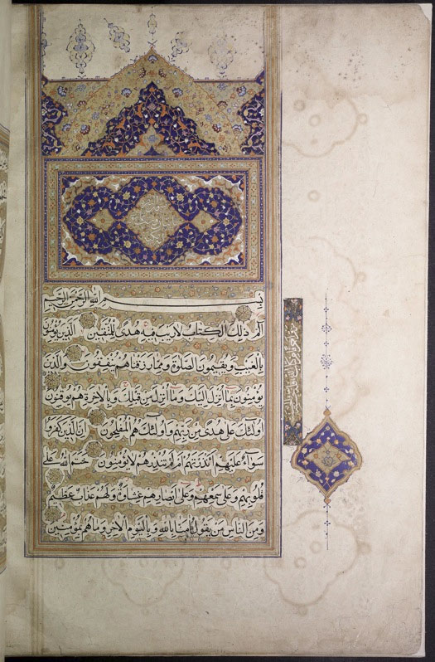

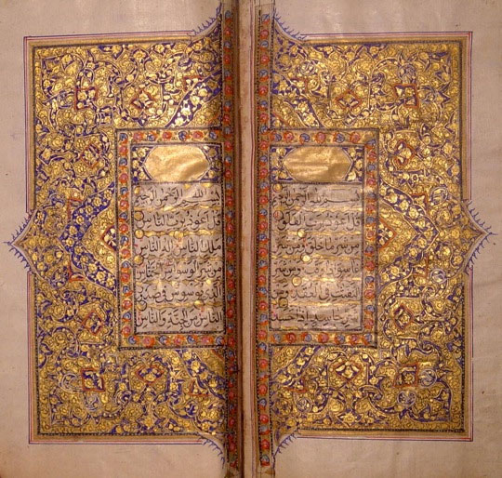

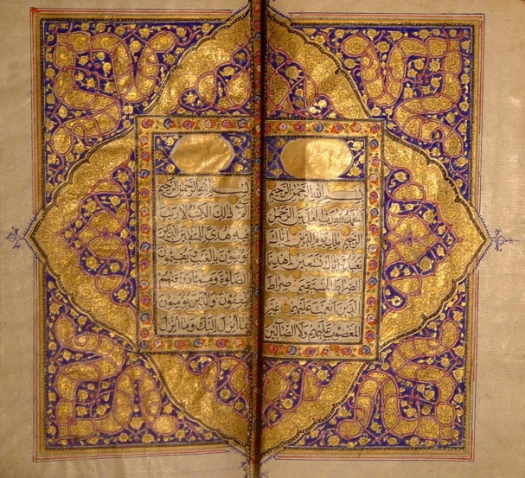

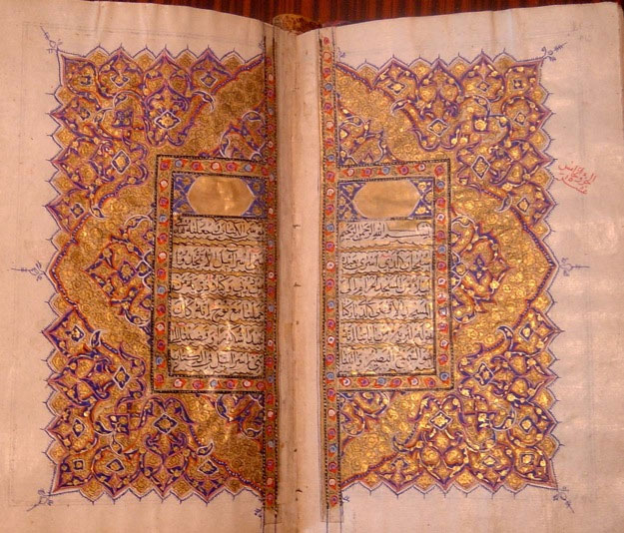

Figure 1a-b: Two manuscripts of the Quran: (a) This Quran, written in nasta'līq script, one of the main genres of Islamic calligraphy, is most likely of Persian origin from between the 16th and 17th centuries. (b) An elegantly illuminated Qur'an from Kashmir, c. 1800, in fine naskh, of which the style and binding point to a North Indian origin.

Historians must find an answer to these questions and to others which may arise from them. From a historical point of view, it would seem absurd to talk of the origin of any form of Islamic sciences within a century or two of the rise of Islam. How and where do we begin such a discussion? To find an answer to the phenomenal rise of Islam and the Islamic sciences, one looks to the role of Islam in Europe, when Arabic books on science and philosophy were translated into Latin in the Arab Kingdoms of Spain, Sicily and southern Italy and the effect of this development on European society in the 15th and 16th centuries CE.

If we proceed from these preliminaries to a proper discussion of the rise of Islamic sciences, we must take a broader view of world history. In my opinion, the origins of Islamic sciences can be traced back partly to the scientific heritage of Sumer, Babylon, Egypt, Greece, Persia and India, partly to the inspiration derived from the Qur'an and the Prophetic words of the Prophet Muhammad (hadith), and also partly to the intellectual and creative genius of Muslim scientists, thinkers and philosophers during that extraordinary five hundred years of Islamic history (7th-11th centuries CE). It would seem that we need a satisfactory explanation to make sense of the development of Islamic science and the intellectual roots of Islamic civilization.

In trying to approach such a subject we are entering into a potentially controversial area and one that requires a good deal of research and perseverance. Three essential factors need to be analyzed: (1) the origins of the sciences and their effect on the Arabs, (2) the inspiration that the Muslims derived from the teachings of the Qur'an and Hadith, (3) the achievements of the Muslim scientists and thinkers in various branches of knowledge. We may refer to these three essential sources of Islamic science one after another. In doing so, one could not ignore the relevance of Islamic sciences to medieval Europe [1].

1.1. Mesopotamia

Let us recall the heritage of science and technology that preceded the advent of Islam in the 7th century CE and what might have been inherited by the Arabs along with the rest of mankind. It is thought by some that civilization had its earliest manifestations in the Tigris-Euphrates valley (Mesopotamia), where the cities that emerged at Sumer, included Ur (founded ca 4000 BCE), Uruk, and Babylon, which in 600 BCE was the largest city on earth under King Nebuchadnezzar II. Sailing ships were known as early as 5000 BCE; the wheel, which was invented in Mesopotamia, was used by potters, and by armies for transportation. Standard weights were used in commerce (based on the shekel of 8.36 gr. = 129 grains); measures of shekel and mina were used in the 3rd and 2nd millennium BCE, and records were kept on baked clay tablets; bricks were fired in kilns in the 4th millennium BCE, and the monumental architecture of the Ziggurat featured columns, domes, arches and vaults. The same Mesopotamian civilization of Sumer, Assyria and Babylon also gave rise to the Law Code of King Hammurabi (ca 1750 BCE). The Sumerians, who were advanced in astronomy, made star catalogues in the 2nd millennium BCE, identified the Zodiac, and used a 12-month solar calendar along with a 354 day lunar calendar; but in the 3rd millennium BCE regularly used a 360-day calendar, which had been adopted, in a modified form, by Jews and Muslims. The Babylonians recorded a solar eclipse as early as 763 BCE and devised an instrument to detect when a star or planet was due to appear in the south. Some of these achievements resulted from developments in mathematics, notably by the application of multiplication tables. Solutions to quadratic and cubic equations were achieved; theorems governing plane geometry were created, together with a system of sixty for measuring time. Positional notation was in use in Mesopotamia four thousand years ago. The Assyrians used water clocks. King Sargon produced maps in Mesopotamia for the purpose of tax collection (ca 2400 BCE). Medicine and surgery also developed in Mesopotamia, where tooth filling was practiced, physicians established an important profession, and incompetent surgeons were liable to compensate patients in the event of error. Lamps made of stone and pottery were used in ancient Mesopotamia. Although ploughshares were used in Canaan (ancient Palestine), the Mesopotamians used a primitive form of plough called an ard, which has been found in Uruk, and the irrigation system caused a revolution in Mesopotamian agriculture. Metallurgy also developed in this region of the Middle East. A wide range of advances in Mesopotamian civilization became part of the common heritage of mankind.

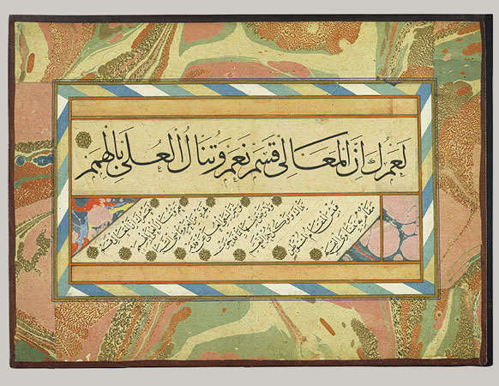

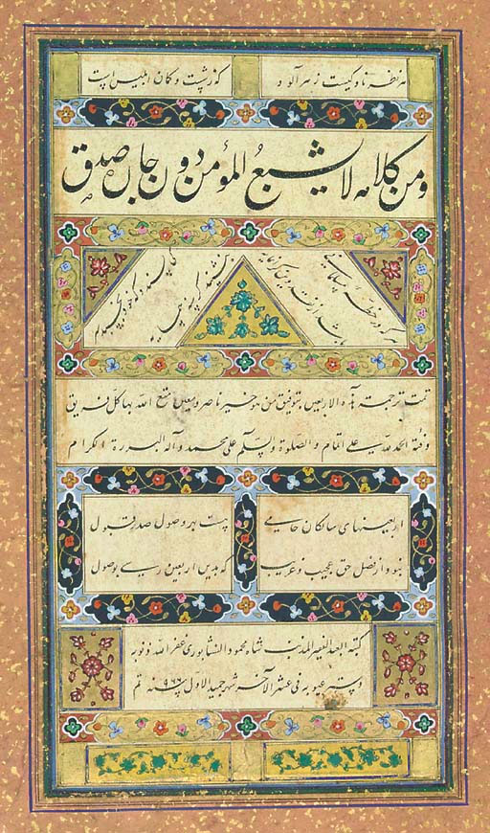

Figure 2a-b: Two manuscripts of Hadith: (a) the Arba'un hadithan copied by Shah Mahmud Nishapuri in Safavid Iran in the last days of Jumada I, 966/late February 1559 CE; (b) Page from an Ottoman Album of Calligraphies of Prophetic Traditions, signed by Hamdullah ibn Mustafa Dede (Istanbul, ca. 1500).

1.2. Ancient Egypt

The Egyptian civilization (ca 3000 BCE to 300 CE), which developed after the Mesopotamian, has been credited with instituting a 365-day solar calendar (ca 2773 BCE). In 1500 BCE, it produced the gnomon, the L-shaped indicator found in a sundial and the water clock (ca 1450 BCE). Egyptian medicine, practised by the priests in the 2nd millennium BCE, was the most sophisticated in ancient times, and some carvings of about 2500 BCE depict a surgical operation in progress. Imhotep, an Egyptian (d. ca 2950 BCE), became the architect of Memphis. An early form of hieroglyph (i.e. writing system), the use of papyrus as a writing material, and a number system came into use around 3000 BCE, as did the employment of scribes by the ancient Pharaohs, the process of embalming and mummifying, and the art of the Pyramids. The Giza Pyramids were built between 2700 and 2200 BCE. The paintings and reliefs on the walls of ancient palaces and inside the Pyramids, elegant furniture and the use of bronze for utensils were also among the achievements of the ancient Egyptians, the Pyramids being the high point. Many of these objets d'art are preserved in Egypt and in collections around the world. Knowledge of these ancient civilizations was spread through stories told by Arab sages.

1.3. The Greek legacy

The Greeks also made a significant contribution to science and technology. The Greek civilization, which flourished during 600 BCE-529 CE, was, in a chronological sense, a successor to the Middle Eastern civilizations of Mesopotamia and Egypt, but its impact on the Arabs did not occur until two centuries after the advent of Islam. As a historian of science admits: “Although Greek science may have been a continuation of ideas and practices developed by the Egyptians and Babylonians, the Greeks were the first to look for general principles beyond observations. Science before the Greeks, as practised in Babylon and Egypt, consisted mainly of the collection of observations and recipes for practical applications ”[2].

Science defined as ‘an organized body of thought' and an interpretation of the universe was said to have originated in about 600 BCE with the Ionian school of Greek philosophers, and continued until the early 6th century CE. According to one source, what was achieved before the Greeks was treated as only advances in technology rather than theoretical science. In the brief summary of Greek science and philosophy that fol¬lows, philosophy will be excluded. Greek philosophers studied science out of curiosity, as an effort to know and understand things. They were not inspired by religion or mythology nor were they interested in the application of science. They introduced scientific methods based on reason and observation. They built institutions, such as the Academy, the Lyceum and the Museum. With the closure of the Academy and Lyceum in 529 CE, followed by the Museum, the Greek epoch in the history of science ended. However, their influence spread far and wide for at least another millennium.

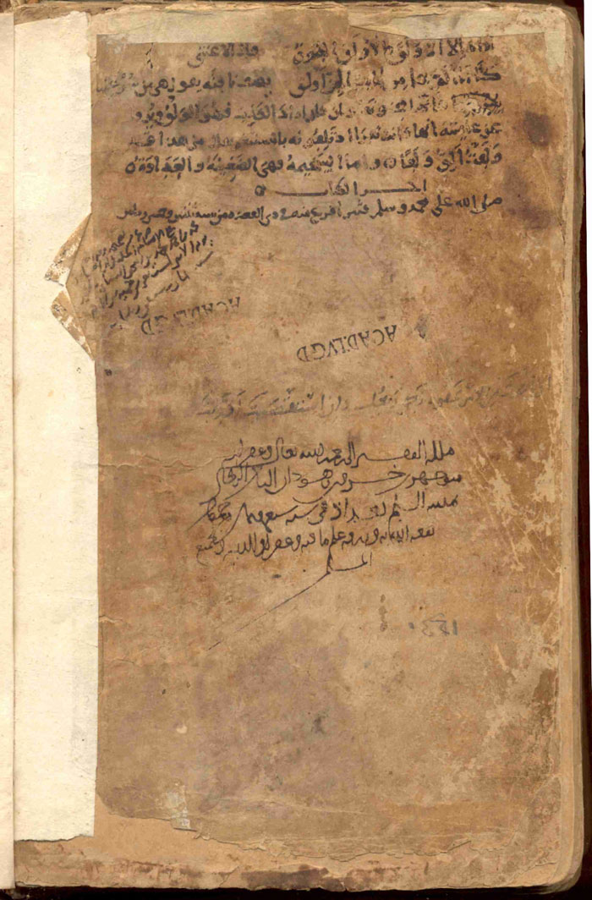

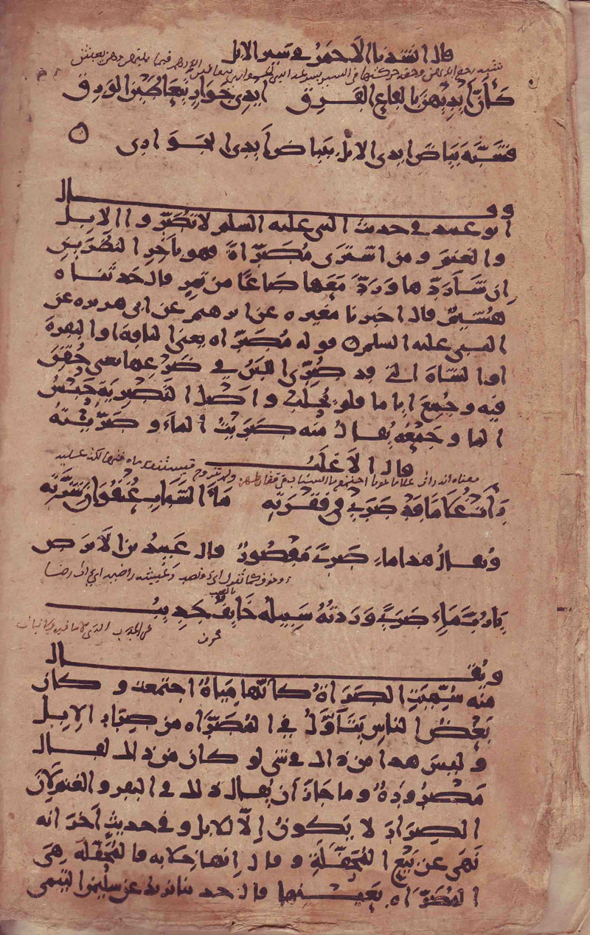

Figure 3a-b: Two pages from the oldest known dated Arabic manuscript on paper (dated Dhu al-Qa'da 252/866 CE), folios 2b and http://www.islamicmanuscripts.info/E-publications/witkam_oldest_dated/or.... This is MS Leiden Or. 298 in Arabic, on paper, 241 folios, and thereby probably the oldest dated Arabic manuscript on paper, bound in a full-leather standard Library binding. The volume contains an incomplete copy of Gharib al-Hadith, by Abu 'Ubayd al-Qasim b. Sallam al-Baghdadi (d. 223/837)

The earliest Greek scientists were Thales, Anaximander and Anaximenes. Thales (ca 600 BCE) believed that water was the essence of natural phenomena. To him, matter came in three forms: mist, water and earth. He also thought that the stars were made of water. His pupil Anaximander, (ca 545 BCE) was believed to have written the earliest book on science, which claimed that life originated in the sea. Anaximenes (ca 500 BCE), a pupil of the former, thought that air was the essence of the universe, and that a rainbow was a natural phenomenon and not a divine sign.

Aristotle is generally thought to be the father of life sciences. He studied 540 plants and classified plants and animals. He also wrote on embryology. Aristotle believed that the earth was the centre of the universe. The greatest Greek contribution to medicine was made by Hippocrates of Cos, an author of many books, whose Hippocratic Oath is still used as a code of ethics by the medical profession. He freed medicine from superstition and religion. Greek medicine also spread to Rome, where the physician Galen, through his teaching and prolific writings popularised it. The Greek scientist Empedocles formulated the idea of the elements (air, water, earth and fire), which were adopted by Plato and Aristotle. To Plato, geometry was the most suitable method of thinking about nature. Euclid of Alexandria, the author of the Elements, was the most influential Greek geometrician. The Greeks made important contributions to mathematics, which is a science based entirely on reason, with no need for observation or experiment. Pythagoras (5th century BCE) regarded mathematics as the most important branch of science. Diophantus was regarded by some as the Greek founder of ‘algebra' (although the term itself had an Arabic origin). Archimedes founded mathematical physics and discovered the laws of hydrostatics. He also invented the Archimedian Screw, a device designed to raise water for irrigation. The Alexandrian engineer Hero was credited with the invention of a series of automata. The Greeks also built a water-carrying tunnel through a mountain.

Aristotle thought that motion is created by an object trying to reach its natural place. Ctesibius was thought to have been the founder of the Alexandrian school of engineering. Philon was credited with some technical achievements, including a force pump, and a mechanically driven water clock. Ptolemy, a great Greek astronomer from Alexandria, wrote the Almagest, which described the planetary motion and placed the Earth as the centre of the Universe, with the Sun and the Moon revolving around it. In 270 BCE, Aristarchus of Samos challenged Aristotle's geocentric idea, asserting that the Sun was the centre of the solar system. He also emphasized that all other planets revolve around the Sun [3]. Greek and Hellenistic sciences reached West Asia and elsewhere in the wake of Alexander's conquests.

1.4. Various influences in Pre-Islamic Arabia

Some of the ancient buildings of Mada'in Salih in Arabia and the Dam of Marib in Yemen are reminders of how the influence of ancient technology reached Arabia. In the 7th century, the Arabs already had a calendar with twelve months named in Arabic (e.g. Muharram, Safar, Rabi‘ al-Awwal, Rabi‘ al-Thani, Jumada 'l-Ula, Jumada al-Akhir, Rajab, Sha‘ban, Ramadan, Shawwal, Dhu'l-Qa‘dah, and Dhu'l-Hijjah) which might have originated in ancient Mesopotamia. The Arabs had no schools or educational institutions in the pre-Islamic era, but these existed in Alexandria, Antioch, Edessa and Harran in Mesopotamia and Persia where some of them were employed at the medical school of Jundishapur (in south-west Persia) during the 6th and 7th centuries. In Syria, Byzantine (Eastern Roman) and Persian influence mingled. From here, Greek science and learning spread to the East and the West. Among the Syrians were two Christian sects. The Nestorians taught Greek science and philosophy in their schools and translated Greek books into the Syriac language and these were translated into Arabic during the Islamic period. Nestorias held theological views contrary to those of the patriarch of Constantinople and consequently they were banned in 481 C.E. Nestorias and his followers fled Byzantium for Syria, but on being persecuted there some of them escaped to Mesopotamia, and few of them were employed at the medical school of Jundishapur (which was founded by the Sassanian King Khusraw Anushirwan in the mid-6th century CE) [4]. The school at Jundishapur survived until the early ‘Abbasid period (9th century CE). Thus education in one form or another was available in Egypt, Syria, Mesopotamia and Persia at the time of the advent of Islam in the 7th century, though the inhabitants of Arabia, on the edge of civilization, remained in ignorance of them.

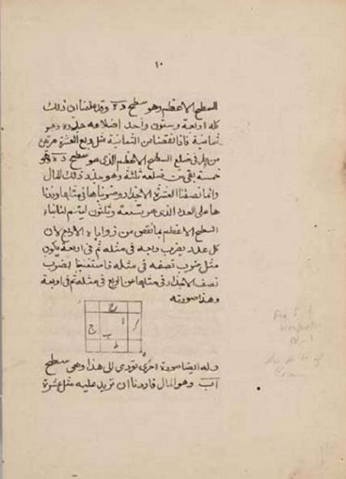

Figure 4: A page from Kitāb al-jabr wa-'l-muqābala, the first extant algebra text, written in about 825 CE by Muhammad ibn Mūsā al-Khwārizmī.

To see education in perspective we should now turn to some Arabic sources. Some taken from Ibn Qutaybah's (d.276 AH/ 889 CE) short encyclopaedia entitled al-Ma‘arif (Book of Knowledge) [5] and al-Khwarizmi's Mafatih al-Ulum [6] (Keys to Sciences), (composed ca 977 CE), and the history of philosophers, physicians, astronomers and mathematicians known in Arabic as Ta'rikh al-Hukama' [7] by Ibn al-Qifti (d. 1248). Al-Khwarizmi's book is regarded as the first attempt to survey the Islamic sciences. The work of Ibn al-Qifti, who was employed by the famous Saladin (Salah al-Din Ayyubi), comprises 414 biographies, including the biographies of Greek philosophers and physicians such as Euclid, Socrates, Aristotle, Plato, Galen, Ibn Sina, al-Khwarizmi, al-Farabi, al-Razi and Ibn Rushd.

The Arabs from the Arabian Peninsula lived close to the Near Eastern civilizations of antiquity. Knowledge of ancient arts, sciences and technology was transmitted to them from their wisemen (hukama') and elders in the form of folklore, tales and myths, and was passed on from generation to generation, although it is hard to determine exactly how much information was transmitted to the Arabs before the rise of Islam. The Arabs called the ancient sciences ‘ulum al-awa'il (literally, “sciences of the ancients”) and on becoming civilized under Islam acknowledged that the ancient knowledge belonged to the category the awa'il (first occurrences, antiquity) as a theme in a chapter or as a title of a book. As we have already indicated, the Arabs until the 6th century CE transmitted everything orally, including Arabic poetry.

We learn from Ibn Qutaybah in al-Ma'arif every ancient thing known to the Arabs. The book begins with a chapter on the creation myth, which cites the Genesis in the Old Testament as a source narrated by Wahb ibn Munabbih. The interpretation of Islamic history begins with the story of Adam and Eve and proceeds to narrate the role of the Prophets and Messengers chosen by God from their children as part of the process of passing divine guidance to mankind from generation to generation. The story of the Prophets and Patriarchs was also narrated by the great Arab historian al-Tabari in his book Ta'rikh al-Rusul wa'l-Muluk (History of the Prophets and Kings).

Ibn Qutaybah claimed that before the advent of Adam and Eve, the earth was inhabited by spirits (Jinn). According to Ibn Qutaybah, Adam had tilled the soil and Eve had woven cloth and by so doing the pair had provided the essential first steps towards a civilized life. Adam's son Qabil became a farmer, and his brother Habil a shepherd [8]. Adam had 40 sons and 20 daughters. Adam was seen as a Prophet of God who received divine revelations. Among the revelations he received were ones which prohibited the eating of dead flesh (carrion). He also learnt from God about the alphabet and writing (e.g. the cuneiform). However, there is no evidence to substantiate this ‘myth'. Whether or not writing originated with Adam, we know from ancient inscriptions in Mesopotamia that some form of writing came into existence during the civilization of Sumer in the 3rd Millennium BCE.

Among the descendants of Adam were many Prophets including Seth ( Arabic Shith) who, it is claimed, lived 912 years and received fifty revelations; then came Noah, whose descendant was Idris (Enoch) [9]. Noah is associated with the story of the Flood and the construction of an Ark in which a pair of every living creature was saved from extinction. Among the children of Noah were Sam (whence the Semites) and Ham (whence the Hamites or Hamitics of Africa) who, according to Ibn Qutaybah, were Prophet of God [10]. Among the other Prophets listed by Ibn Qutaybah were: Hud, Salih, Abraham, Isma'il (Ishmael), Ya‘qub (Jacob), Yusuf (Joseph), Ayyub (Job), Musa (Moses), Harun (Aaron), Dawud (David), Sulayman (Solomon), Uzair (Ezra), Danyal (Daniel), Shu‘aib, Ilyas, Yasa‘, Zakariyah (Zakharaya), Yahya (John), Jarjis, Dhu'l-Qifl, ‘Isa (Jesus) and Muhammad [11].

According to the same author the total number of Prophets (as educators of mankind) was 124,000. Among them were 315 prophet-messengers (Nabiy Rasul); five of them were of Syriac origin, namely Adam, Shith (Seth), Idris (Enoch), Noah and Ibrahim (Abraham); and five were Arabs, namely Hud, Salih, Isma‘il, Shu‘aib and Muhammad (peace be upon all of them). Ibn Qutaybah also claimed that the first prophet of the Israelites was Moses (Musa) and their last prophet was ‘Isa (Jesus) [12]. This last view, which was expressed in the 9th century CE, may be considered controversial today.

The stories of these Prophets served as illustrations of the divinely inspired educators of mankind. Moreover, the ‘creation myth' cited by Ibn Qutaybah had been repeatedly en¬dorsed by Islamic writers over the centuries. A modern doctoral dissertation of Cambridge University entitled ‘The Problem of Creation in Islamic Thought' examines the subject comprehensively from the standpoint of primary sources, such as the Qur'an, Hadith, Commentaries and Kalam (speculative theology) [13]. On the whole, Islam upholds the theory that every creature in heaven and on earth was created by God Almighty. This resembles the theory of divine creation ex nihilo. Therefore, mankind should offer praise and prayer to Him as an act of thankfulness and gratitude. From an Islamic perspective, there is no support for Darwinism.

1.5. The First Occurrences (Awa'il)

A number of Arabic books on the subject of Awa'il or the first occurrences refer to things dating from antiquity. According to Qalqashandi and Hajji Khalifah, the science of Awa'il introduces the first occurrences and events (awa'il al-waqa'i' wa-'l-hawadith) [14]. Such books cover religious as well as secular subjects [15]. The origins of things relating to the Islamic period are usually reliable, but the same cannot be said with certainty about events in the remote past, which could be merely legends or myths. Some of the topics are also of scientific interest. For instance, the Arab belletrist Tha‘alibi claimed that the name of Prophet Idris (Enoch) was associated with the study of astronomy, including observations on ‘the pattern of the heavenly spheres and their influences on human affairs [16]. Idris was also credited with the invention of writing. Similarly, the Jewish Prophet Joseph (Yusuf) was said to have used papyrus for writing on. Moreover, the Jewish prophet Dawud (David) was credited with inventing the coat of mail and Solomon (Arabic Sulayman ibn Dawud) (968-928 BCE), with the making and use of soap [17]. According to Freud, ‘we are not surprised by the idea of setting up the use of soap as an actual yardstick of civilization' [18]. Soap removes dirtiness and promotes cleanliness. Hippocrates is regarded by some Arabs as the earliest Greek writer on medicine [19]. It was in the light of the Awa'il tradition that Arab writers, including Ibn Qutaybah, Ibn Sa‘d and al-Jahiz, cited the name of Khalid ibn Yazid ibn Mu‘awiyah (d.82 AH /701 CE) who was praised as a poet, orator and a man of sound judgement. He was the first Arab to have books of astronomy (al-nujum), medicine (al-tibb) and alchemy (al-kimiya') translated into Arabic [20].

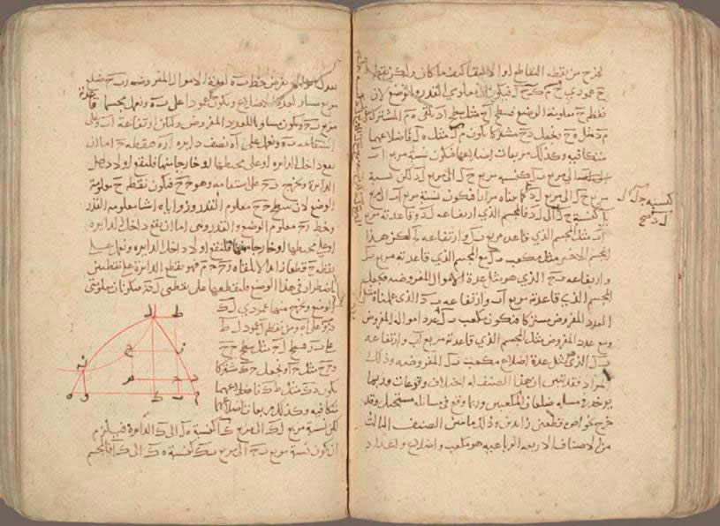

Figure 5: Page from a manuscript of the Algebra (Maqālah fi al-jabr wa-'l muqābalah) of ‘Umar Al-Khayyām (1048-1131). Manuscript on paper, 56 leaves, 13th century. Columbia University Libraries, Smith Oriental MS 45.

The achievements of these ancient people in science were celebrated in the genre of the Awa'il. The curiosity and innovative spirit of early Muslims especially following the conquest of the ancient cities of the Fertile Crescent was limitless. A result of this interaction between the Islamised Arabs and non-Arabs was cross-fertilisation. The rapid cultural expansion of Islam resulted in many conversions from ancient faiths. In turn, Muslims became acquainted with the culture, history and sciences of the ancient civilizations. For instance, an Arab prince named Khalid ibn Yazid b. Mu‘awiyah developed an interest in ancient science and is now regarded as the first Arab alchemist. He encouraged a number of Egyptian scholars to translate books on alchemy, medicine and astronomy from the Greek and Coptic languages into Arabic for his private library. In this enthusiasm for alchemy, Khalid was aided by an Egyptian monk named Stephens or Maryanos. Khalid is also remembered as a writer on science [21]. By the end of the 8th century scientific curiosity was recognised. A foundation had been laid and in the following century many scientists achieved distinction in Islamic society.

2. Islam as a Source of Inspiration for Science and Knowledge ('Ilm)

2.1. The Rise of Islam and the Early Intellectual Fertilisation

The 7th century witnessed the intellectual and cultural transformation of the Arab people principally as a result of some unique events that occurred in Arabia. The preaching of Islam (da‘wah) by the Prophet Muhammad to his fellow tribesmen, and their reluctant but gradual conversion to the new faith through a process of persuasion and political struggle, influenced the behaviour and outlook of the Arabians, who became imbued with a new sense of purpose. For the first time they were exposed to a set of new ideas on the creation, the Supreme Creator, the purpose of life on Earth and in the Hereafter, the need for a code of ethics in private and public life, the obligation to worship the one and only Lord Almighty of the Universe (Allah), through ritual prayers on a regular basis and sessions of remembrance (dhikr, plural adhkar) or meditation, and to pay homage to a religious and political head as personified by the Prophet Muhammad and, to his Successors or Caliphs (Ar., Khalifah, pl. Khulafa') as leaders of the new community (ummah). All this was new to the Arabs. The whole package of Islamic teachings was propagated by the Prophet and accepted by his fellow Arabs within a generation (610-632 CE).

The Prophet Muhammad taught the peoples of Arabia a great deal. Before the advent of Muhammad, the Arabs had no books and no sacred scriptures. The Qur'an was the first Arabic book and the first scripture in the Arabic language. Its chapters and verse were unique in style and substance in purest Arabic. The Arabs who, from time immemorial, had memorised poems and proverbs, found it easy to learn a part or the whole of the Qur'an for ritual prayer. For the Arabs, the Qur'an, it would seem, was a substitute for old Arabic poetry. The difference was that poetry was recited at home and in the market, whereas the Qur'an was recited only after ablution and reverential devotion. Incidentally, the word “al-Qur'an” means ‘the recitation' or the reading. It is essentially a book of revelation from God, embodying Islamic law and ethical code.

Through an understanding of the Qur'an, the Arabs began to think and behave differently from their polytheistic ancestors (mushrikun), becoming more like Jews and Christians in their monotheism. Thus they had begun to reflect on the mysteries of the universe and the importance of being imbued with a sense of brotherhood. For the first time their lives were regulated by a book of revelation and were turned around by it. The Qur'an was to Muslims what the Bible was to the Christians and the Torah to the Jews; and they were more affected by the Qur'an than Christians and Jews were by their Scriptures.

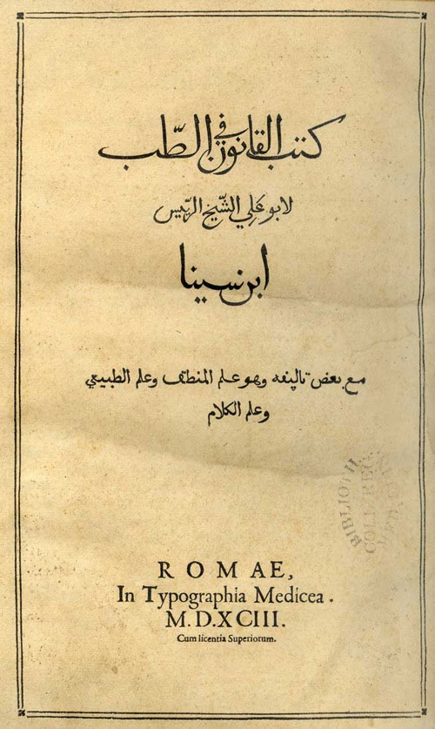

Figure 6: The title page of Ibn Sina's (11 century CE) Kitab Al-Qanun fi al-Tibb taken from a printed copy of the book, based on a Florentine manuscript, in the rare book collection of the Sibbald Library at the Royal College of Physicians of Edinburgh.

When the Islamic education was introduced to his disciples by the Prophet through the process of da‘wah (‘call to Islam'), it was as though a whole people went to school to read, write and memorise their first primer, al-Qur'an. Among the celebrated teachers of the Qur'an in early Islam, were ‘Ubadah ibn al-Samit, Mus‘ab ibn ‘Umayr, Mu‘adh ibn Jabal, ‘Amr ibn Hazm [22], and Tamim al-Dari. These teachers were sent to various parts of Arabia and beyond. Islamic education begins with the lessons of the Qur'an. It is a religious duty and an obligation for every Muslim to preach and teach to his fellow Muslims and non-Muslim acquaintances what he knows of the Qur'an and the Traditions. Such a process of informal mass education and Islamisation began in the Arabian Peninsula during the Prophet's last years and the process was carried forward under his successors. These early Muslims also became familiar with the life style of the Prophet (Sunnah). Everything the Prophet said, did, approved of, condemned and encouraged others to do became the source of inspiration for Muslims and the Sunnah (custom, or Islamic way of life) for the Muslim community. The Qur'an describes Muhammad as the unlettered/illiterate Prophet (al-Nabi al-Ummi) [23], which was true at the time of his receiving the first revelation from God through the angel Gabriel (Jibril) at the age of 40, when he was ordered to ‘Read in the Name of God who creates, creates man from congealed clot; Read and your Lord is most gracious, Who teaches by the pen; (He) teaches what man(kind) does not know' [24]. To Archangel Gabriel's command, Muhammad replied that he was unable to read, a clear indication of his illiteracy, his knowledge of Jewish and Christian religions being based on what Gabriel communicated to him directly. However, according to an authority on Muhammad, after he received the divine order to ‘read' (Iqra'), ‘he could - and did - learn how to read and write, at least a bit' [25]. This explains how letters he dictated to his amanuenses were signed by him. Therefore, by the end of his life Muhammad was literate. The collection of Muhammad's words and thoughts and his tacit approval is known as hadith (plural ahadith). This hadith became one of the basic sources of Islam.

2.2. The Islamic Background to Intellectual Activity

The question that now arises is: ‘What is the relevance of the Qur'an and Hadith to Islamic science?' To begin with, everything Islamic is influenced by these two sources. The learning process of the Arabs began with the Qur'an and everything else followed accordingly. The Prophet told his disciples: “Wisdom (Hikmah) is the object for the believers” [26]. Thus Muhammad created an incentive to pursue all kinds of knowledge, including science and philosophy.

The questions that we should ask and to which we should find answers are: ‘does Islam encourage or stifle knowledge in a broad sense and secular sciences in particular? Is there any conflict between reason (‘aql) and revelation (wahy) in Islam?'

The Arabic term ‘ilm literally means science and knowledge in the broadest sense. It is derived from the Arabic verb ‘alima, to know, to learn. Therefore, ‘ilm implies learning in a general sense. The Prophet Muhammad, like all the Semitic Prophets before him, was an educator and spiritual mentor. He contended that the pursuit of knowledge (‘ilm) is a duty (fardh) for every Muslim [27]. This statement unmistakably attaches the highest priority to knowledge and encourages Muslims to be educated. Another statement praises religious knowledge even more highly, maintaining that it is a key to various benefits and blessings and that those who teach the Qur'an and Hadith have inherited the role of the ancient Prophets [28]. In a separate statement, Muhammad said that the scholars of religion (‘ulama') are the trustees of the Messengers (of God) (umana' al-Rusul) [29]. In praise of knowledge, the Prophet also said that the pursuit of knowledge is superior to ritual prayer (Salah), fasting (during Ramadan), pilgrimage (Hajj) and the struggle for Islam (Jihad) in promoting the cause of God [30]. This last Tradition is often misinterpreted by some Muslims who think (quite mistakenly) that religious learning and the pursuit of science exempts them from prayer, fasting, pilgrimage and Jihad. This is not at all the intention of the statement. What it emphasizes is that religious education is no less important than the time and efforts devoted to Salah, Sawm, Hajj and Jihad. Thus learning gets priority over those usual duties of a believer.

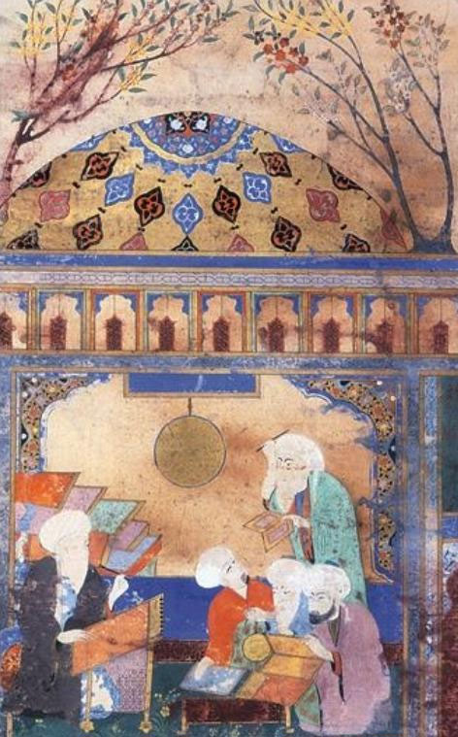

Figure 7: Nasir al-Din al-Tusi is pictured at his writing desk at the high-tech observatory in Maragha, Persia, which opened in 1259. © British Library.

The concept of science and knowledge was also widely diffused in the Prophet's Traditions and in Arabic belles lettres (adab). It only proves the point that Islam inspires its adherents to think of science or knowledge not only for its spiritual and utilitarian value, but also as an act of worship. Some of the sayings attributed to the Prophet Muhammad elevated the pursuit of knowledge as an act of worship. The discourse on knowledge in Arabic sources frequently use two terms, ‘ilm and ‘aql. The former applies to sacred knowledge as well as profane science, and ‘aql connotes intellect or intelligence.

2.3. Unity of Knowledge: Religious, Rational and Experimental

The first subjects that began to take shape among Muslim scholars after the spread of Islam were related to the commentary on the Qur'an (tafsir), Traditions (Hadith) and Asma' al-Rijal (biographies of Hadith scholars), Sirah (Biography (of the Prophet) and Maghazi (Battles of the Prophet), Usul al-Din (theology), Fiqh (Jurisprudence) and Usul al-Fiqh (methodology/principles of Jurisprudence). The Arabic language was classified by Ibn Khaldun as an auxiliary science to explain the terminology of the Qur'an [31]. It would therefore appear that during the 1st and 2nd Hijri centuries a number of new subjects were gradually developed to explain the Qur'an, the Traditions and Islamic history. On the whole the study of basic religious sciences was given priority over other subjects.

The Islamic scholar Muhammad ibn Idris al-Shafi'i (d. 204/820) classified science into two broad categories, science of the bodies (‘ilm al-abdan) and science of the religions (‘ilm al-adyan) [32]. In the hierarchy of science Islamic scholars placed religious subjects at the top of their list, although secular sciences, such as mathematics, physics, chemistry, astronomy and philosophy were recognised as useful branches of knowledge. From the ‘Abbasid period onwards, Muslims were avid readers of religion, science and philosophy. In fact, religious and philosophical sciences developed in parallel. Although some religious scholars (the ‘ulama' and fuqaha') undervalued philosophical sciences [33], such secular subjects were, however, widely tolerated, allowed to flourish in Islamic society and were accommodated in the educational curriculum. The critical attitude of the ‘ulama' towards the philosophical sciences has belatedly attracted severe criticism from some Orientalists [34]. More often than not, it seems quite clear that there was no clear division between sacred and profane sciences. Usually, scholars of the calibre of Ibn Khaldun divided science into two classes, namely the traditional sciences (‘ulum naqliyah) and the philosophical sciences (‘ulum 'aqliyah) [35].

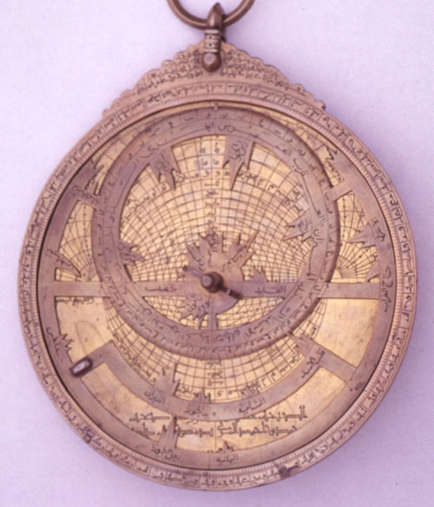

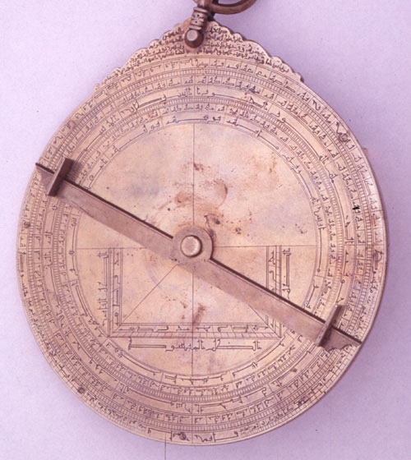

Figure 8a-b: The front and back of an Islamic Astrolabe in the Whipple Museum, Cambridge. This astrolabe is signed “Husain b. Ali” and dated 1309/10 AD. It is probably North African in origin, and is made of brass. It has four plates (for the front of the astrolabe, representing the projection of the celestial sphere and marked with lines for calculation), each for a specific latitude, and 21 stars marked on the rete (the star map, with pointers, fitting over the plate).

Many outstanding scholars emphasized the unity of knowledge. Thus scientists of the calibre of Jabir ibn Hayyan, al-Kindi, al-Khwarizmi, al-Razi, al-Biruni, al-Farabi and Ibn Sina were as adept in the religious (sacred) sciences as in the profane sciences of medicine, philosophy, astronomy or mathematics. They were conscious of the various dimensions of science.

The Prophet Muhammad was credited with a number of statements regarding cleanliness, health and medicine. These were collected together and became known to Muslims as the Prophetic medicine (al-tibb al-nabawi). A number of books bear this title, including one written by Ibn al-Qayyim al-Jawziyyah [36] and another by al-Suyuti [37]. These books contain some authentic statements of the Prophet and include herbal medicine and natural cures. Drinking honey and reciting the Qur'an are recommended as a panacea for all kinds of ailments. One such Tradition asserts that every disease has a cure [38]. In other words, God has provided cures for all kinds of disease. Commenting on this and other Traditions, Muhammad Asad says that when his followers read the Prophet's saying (quoted in al-Bukhyii): “God sends down no disease without sending down a cure for it as well”. They understood from this statement that by searching for cures they would contribute to the fulfilment of God's will. So medical research became invested with the holiness of a religious duty [39] Ibn Khaldun, while commenting on the Prophetic medicine, said that it resembled medicine of the nomadic type, which is not part of the divine revelation, and therefore is not the duty of Muslims to practise it [40].

It is generally believed by Muslims that no contradiction exists between religion and science. However, this is not the case in Europe, as we shall see.

2.4. Maurice Bucaille's Theses

The relevance of science to scripture has been examined by a French scholar, Maurice Bucaille, whose study The Bible, the Qur'an and Science (an English version of his La Bible, le Coran et la science) [41] is relevant to our discussion. Bucaille, aware of the fact that Judaism, Christianity and Islam are Abrahamic religions, makes the following observations.

1. The Old Testament, the New Testament and the Qur'an differ from each other. The Old Testament, he claims, was composed by different authors over a period of nine hundred years. The Gospels, on the other hand, were the work of different authors, none of whom witnessed in person the life of Jesus. The latter merely relayed what happened to Jesus. Islam has something comparable to the Gospels in Hadith, which are collection of sayings and descriptions of the Prophet. Comparing the Gospels with the Hadith Bucaille says: “Some of the Collections of Hadiths were written decades after the death of Muhammad, just as the Gospels were written decades after Jesus. In both cases, they bear human witnesses to events in the past”[42].

Some Western scholars, including Ignaz Goldziher and Joseph Schacht, have argued against the authenticity of certain Traditions. Even Bucaille wrote critically [43] of a few that dealt with the ‘creation myth' finding them incompatible with modern science. Such reservations inevitably offend Muslims, because the Traditions enshrine the moral and spiritual values of Islam. However, the author is equally critical of the four Canonic Gospels and cannot therefore be accused of bias or prejudice. In fairness to Bucaille, it should be said that he was studying the Scriptures from the point of view of science and not vice versa. His objectivity, though inevitably hurtful to some, is rare even in modern scholarship. The author boldly argues that Christianity does not have ‘a text that is both revealed and written down. Islam, however, has the Qur'an, which fits this description' [44].

The Qur'an is an expression of the Revelation from God delivered by the Archangel Gabriel to Muhammad, which was memorised, written down by the Prophet's amanuences [45] and recited as liturgy. The Qur'an was thus fully authenticated. The Revelation lasted around twenty years. Muhammad himself arranged the chapters and the full text was compiled into a book by Caliph ‘Uthman ibn ‘Affan about eighteen years after the death of the Prophet(ca 650 CE).

2. Debates between the Biblical Exegists and Western scientists have arisen as a result of discrepancies between the Scriptures and science [46]. In contrast, many verses of a scientific nature can be found in the Qur'an. Bucaille asks: “Why should we be surprised at this when we know that, for Islam, religion and science have always been considered the twin sisters? From the very beginning Islam directed people to cultivate science; the application of this precept brought with it the prodigious strides in science taken during the great era of Islamic civilization, from which, before the Renaissance, the West itself benefited ”[47].

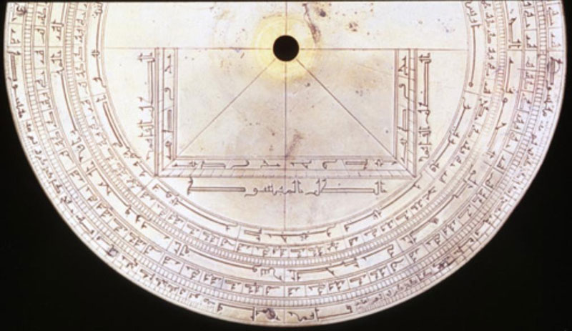

Figure 9: The calendar scales (round the outside edge) on an Islamic astrolabe in the Whipple Collection, Cambridge, a case of calendrical applications of Islamic astrolabes. Islamic astrolabes have calendar scales on them that enable the positions of the moon and the dates of the lunar calendar to be calculated easily.

According to Bucaille, some verses of the Qur'an have puzzled interpreters until the discoveries of modern science attested to the truth. The range of the scientific data contained in the Qur'an is explored in the following pages.

The creation of the heaven and earth and everything in them happened in six days [48]. The term six “days” is interpreted by modern exegetes of the Qur'an as six “periods” or “stages”. The Qur'an also refers to a day as being equivalent to a thousand earthly years [49]. In another context, a day is described as being equivalent to 50,000 years [50].

Moreover, some verses of the Qur'an refer to such things as ‘heaven and the earth being a solid mass [51], which was ripped apart. There are references to navigation in the seas [52]; and God created meat (fish) [53] for food, and precious objects, such as coral [54] (marjan) and pearls [55] for use as jewellery; that God created an orderly cosmos in which every planet, including the sun and the moon, moved along its prescribed orbit [56]. For instance, the sun does not overtake the moon [57]; and that God created male and female for humans [58] as well as for vegetables and animal kingdoms [60]; that man was created through the sex [61] act and that women's menstruation [62] is a time for sexual abstinence; that God created everything out of water [63]. God sends down rain [64] to revive the dead earth to produce and for growing grains, fruit and vegetable; and that He let the earth produce all kinds of food [65]; that God created cattle to produce milk for humans [66]; that He created horses, mules and donkeys as working animals [67]; that He created the constellation [68], and the sequence of day and night [69] as natural phenomena to remind people of God's majesty and power and to encourage them to study astronomy. There are many more examples, but these should suffice for our purpose.

Nowhere in the Qur'an is there anything which has been proven scientifically untrue? Thus Maurice Bucaille, after considering all the scientific data in the Qur'an concluded as follows: “In view of the level of knowledge in Muhammad's day, it is inconceivable that many of the statements in the Qur'an which are connected with science could have been the work of a man. It is, moreover, perfectly legitimate, not only to regard the Qur'an as the expression of a Revelation, but also to award it a very special place, on account of the guarantee of authenticity it provides and the presence in it of scientific statements which, when studied today, appear as a challenge to explanation in human terms”[70].

Imbued with the values of the Qur'an, the early Muslims were psychologically ready to travel widely in search of all kinds of knowledge and were urged to study nature. Through trying to establish the coordinates of longitude and latitude of the Ka‘bah, the Muslims developed their knowledge of geography and cartography. Books were written and maps were used as illustrations. As a result of the study of science in other cultures through the translation of books in Greek, Sanskrit and Middle Persian at the institutions like the Bayt al-Hikmah in Baghdad from the 9th to the 11th century CE, the incipient scientific movement among the Muslims received a boost and contributed to the further development of science in the lands of the Caliphate.

3. The Seeds of Islamic Science

3.1. Some Chronology

During the first Islamic century (1-100 AH/ 622-719 CE), the Arabs were preoccupied with the propagation of Islam and with conquest of the Middle East and North Africa, which during the 2nd century (101-200 AH /719-815) was extended into Central Asia and the Iberian Peninsula. In the midst of these activities, the Arabs devoted themselves to the gathering of information on the life of the Prophet Muhammad and his Companions through the collection of Traditions, which were seen as essential for the practice of Islam and the administration of the Shari‘ah (Islamic Law). The spread of the early Islamised Arabs and Muslim from other ethnic origins over a far-flung territory in Asia and Africa enabled them to come into contact with the natives of those regions and thus initiate a process of gradual conversion to Islam.

As Muslims advanced into foreign territories, they were exposed to various cultural influences. At first these influences had no effect but after a while cultural integration resulted in the burgeoning of an active interest in the scientific and intellectual achievements of the older civilizations. Although the translation of foreign books began on a modest scale during the first Islamic century, it increased during the second and by the 3rd (9th century CE), it had had a profound effect on the intellectual milieu when Greek, Persian and Indian sciences became available in Arabic translation. It was around this time that the ideas of secular science began to flourish under the influence of such Muslim philosophers and scientists as al-Kindi, Jabir ibn Hayyan, al-Khwarizmi and al-Razi.

3.2. Defining Islamic Science

Let us try to define now Islamic science and try to explain how it came into being. The Qur'an made its greatest impact on Muslim minds by making them aware of the natural world. The Qur'an also referred to peoples in the past, such as the Ad and Thamud, the people of Lut (Ashab Lut), Moses, Banu Israel and the Pharaohs. This emphasis on antiquity appears to be deductive in purpose.

Taking these factors into account, Muhammad Iqbal came to some interesting conclusions. He thought that the Qur'an pointed to Nature and History [71] as sources of human knowledge. He also claimed that the birth of Islam heralded the birth of inductive intellect [72]. He therefore concluded that Islam bridges the ancient and the modern worlds. He justified such a claim by assuming that Islam belonged to the ancient world in so far as it used revelation but was essentially modern in spirit. These conclusions of Iqbal may be significant in so far as Islam has motivated its adherents to pursue vigorously both religious and secular science. Islam encouraged scholars the exploration of all kinds of knowledge. One explains the pursuit of Islamic science thus: “Islamic science came into being from a wedding between the spirit that issued from the Qur'anic revelation and the existing sciences of various civilizations which Islam inherited and which it transmuted through its spiritual power into a new substance, at once different from and continuous with what had existed before it” [73].

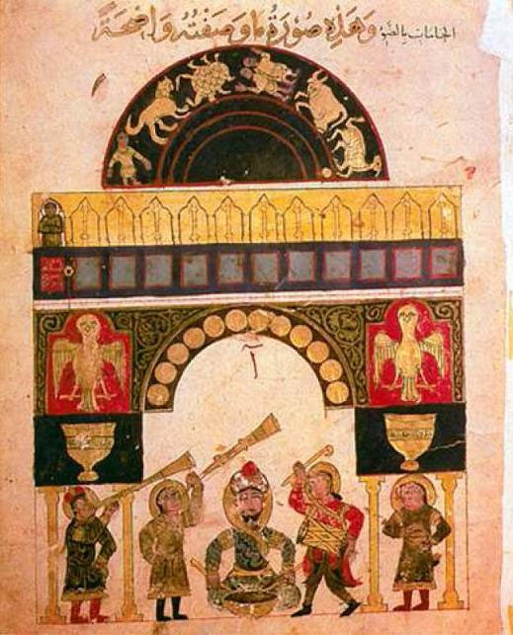

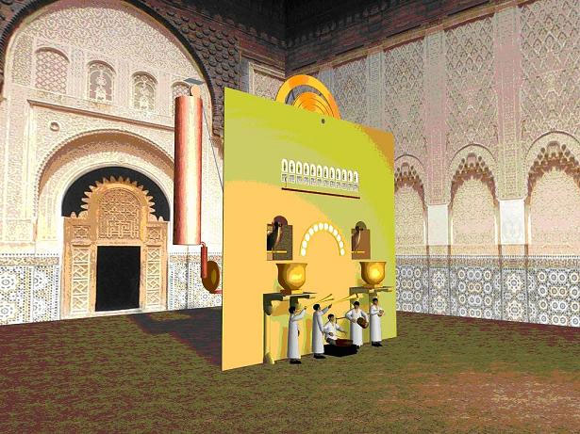

Figure 10a-b: (a) manuscript view of the castle clock of Al-Jazari at the Museum of Fine Arts, Boston (Egyptian manuscript, Mamluk period, Accession number: 14.533).; (b) view of the computer assisted reconstruction of the castle clock by FSTC. See Professor Salim T. S. Al-Hassani, Al-Jazari's Castle Water Clock: Analysis of its Components and Functioning (published on www.MuslimHeritage.com).

4. Translation as a Source of Knowledge

Just as certain political events create hostilities between nations that end in cooperation so, in human history major political events have long term intellectual consequences. One such consequence is the translation of foreign books and the transmission of ideas across cultures. When Alexander the Great conquered Asia Minor, Syria, Egypt, Persia, Afghanistan and the Indus Valley, many rulers were unseated, including Emperor Darius of Persia. Some of Alexander's generals were appointed governors or administrators of these territories, and on Alexander's death the Ptolemies ruled Egypt and the Seleucids Mesopotamia and Persia. The long term consequence of these conquests was the spread of Greek thought throughout much of Asia and Egypt in the fields of philosophy, art and science.

Long after the fall of the Greek Empire, the empire of Darius was revived by the Sassanid dynasty, and some of the former territories of the Greek Empire, including Asia Minor, Syria and Egypt were incorporated into the Byzantine or Eastern Roman Empire. The Sassanian and the Byzantine emperors fought one another until the early 7th century CE. It was in this century that the Arabs, an isolated people of the Arabian Peninsula who were least influenced by neighbouring civilizations, emerged with a new political vigour and spiritual vision. Within a short period they had conquered the Sassanian Empire and the Byzantine provinces of Syria and Egypt.

Consider the Sassanid legacy to the Arabs. Persia, being situated between Byzantium and India, had absorbed both Greek and Indian influences. As George Sarton puts it: “Arabic science was the fruit of Semitic genius fertilized by the Iranian genius” [74]. This theory may explain some points regarding the role of the Arabs and Persians during the formative period of Islamic science. Sarton also gives a historical perspective on Arabic/Islamic science when he claims that the ‘almost unbelievable development of Arabic science did not begin until the second half of the 2nd century Hijrah' [75]. This places the approximate time of birth of Islamic science in the late 8th century CE, a view which has recently been endorsed by Dimitri Gutas, who maintains that secular Greek texts were not translated into Syriac before the Abbasids came to power and that no scientific text was translated into Arabic during the Umayyad era [76]. In other words, he denies that any translations from Greek and Syriac into Arabic occurred under the Umayyads, and that ‘the bulk of the Greek scientific and philosophical works were translated into Syriac as part of the Abbasid translation movement during the 9th century' [77]. One of the reasons for this conclusion was the assumption that pre-Abbasid society did not provide a social, political and scientific context. However, such a thesis is not entirely defensible in the light of the various individual translation initiatives during the Umayyad period.

The Abbasid Caliphs, who succeeded the Umayyads after 132 AH/749/50 CE, had a significant role in the development of Islamic science. The foundation of Baghdad in 145 AH/762 CE by Caliph al-Mansur ushered in a new political era in the history of the Middle East. The new ‘city of Peace' (Madinat al-Salam), saw a coalition between the Arabs and Persians under the second Abbasid Caliph Abu Ja‘far al-Mansur (754-775 CE), who has been credited with initiating the Arabic translation movement. Of the several astrologers in his service, Nawbakht was a Persian who converted from Zoroastrianism to Islam and Masha'Allah al-Yahudi was a Jew. Other astrologers at his court were Muslims, such as Ibrahim al-Fazari and ‘Umar al-Tabari. Some scholars have suggested that Nawbakht initiated the translation of some Persian texts into Arabic, though the books are not identified. It has also been claimed, though without evidence, that the Barmakid family of Secretaries and Ministers (Wazirs), who were influential in early Abbasid bureaucracy during the 8th century CE, had financed the translation of some Pahlavi (Middle Persian) texts into Arabic. However, we are on surer ground when we consider the role of Ibn al-Muqaffa‘ in the translation of some Pahlavi books into Arabic.

Abdullah ibn al-Muqaffa' (a Persian convert, formerly called Rozbih, born 720-d. 756 CE) was regarded as one of the geniuses of early ‘Arabic literary prose'. He published literary works/ belles lettres (adab) such as Adab al-Kabir wa Adab al-Saghir and translated from the Pahlavi Kalilah wa-Dimnah [78] (the Fables of Bidpai, which were originally translated from Sanskrit into Pahlavi). He also translated the Pahlavi Khuday-Nama (Book of Kings) into Arabic (Siyar Muluk al-A‘jam), of which excerpts survived in Ibn Qutaybah's Taj-nama. Although primarily known as a translator from Pahlavi, some scholars credit him (or his son, Muhammad) with translating some Greek texts into Arabic [79]. Persian wisdom literature immortalised the names of ancient Sassanian Kings, such as Anushirvan, in Arabic literature. To this period also belongs the translation of Persian astronomical works into Arabic, such as Zij-i-Shayriyar or Zij-i Shah (Royal Astronomical Tables). Astronomy and medicine were subjects of special interest to early Muslim men of science and physicians. Ibn al-Qifti claimed in 156 AH/773 CE that an Indian traveller brought into Baghdad an Indian manuscripts on mathematics and astronomy entitled Sidhdhanta (Arabic version Kitab al-Sindhind), which the Caliph al-Mansur wished to be rendered into Arabic. This Indian manuscript, which Ibrahim al-Fazari [80] undertook the task of translating, was related to such astronomical works, as Aryabhatiya by Aryabhatta and Khandakhadyaka by Brahmagupta and the Brahmapaksa [81]. It introduced to the Arabs not only aspects of Indian astronomy but also the Indian numerals. The names of Ibrahim al-Fazari and Ya‘qub bin Tariq were initially associated in Baghdad with the Sindhind school of astronomy.

It was Caliph al-Mansur who invited to Baghdad Jurjis (Georges) bin Bukhtishu‘[82], the senior physician at the Jundishapur hospital and medical college in Ahwaz (Fars). To cure al-Mansur of his illness, he received ten thousand dinars. During the reign of al-Mansur's grandson, Harun al-Rashid, medical experts from Jundishapur were recruited to found Baghdad's first hospital.

Curiosity concerning astronomy and astrology was noticeable during the early Abbasid period. Even the orthodox Abbasid Caliph Muhammad al-Mahdi (158-169 AH /775-785), who suppressed heresies, including Manichaeism (zandaqah), was superstitious about astronomy and astrology, as is shown from his patronage of two astronomers, including Abu Sahl ibn Nawbakht. It was in his reign that the Aristotelian work Topics (topoi), translated by Athanasias of Balad (d. 686), was brought to the attention of the Caliph.

Al-Mahdi's son, Harun al-Rashid (170-193 AH/786-809 CE), was well known as connoisseur of talented artists, philosophers and scientists. He, his son Caliph al-Ma'mun and the Barmakid viziers were among those of wealth and power who commissioned men like ‘Allan al-Shu‘ubi to copy translations of Greek and Syriac manuscripts, including Aristotle's Physics, which had been rendered into Arabic by Sallam al-Abrash.

In addition to this large body of translation into Arabic, existing translations were amended by scholars. Most translators were Christians belonging to either the Orthodox Church, or Jacobites and Nestorians [83]. There were also Jews, Sabean (pagan star worshippers) of Harran and Arab Muslims. The majority of this work was undertaken between 800 and 1000 CE, and covered subjects including philosophy, politics, astronomy, geometry, zoology and medicine.

The translation of philosophical texts reached an apogee during the Caliphate of Abdullah al-Ma'mun (813-33 CE) and his successors. The translation movement declined and ended during the Buwayhid period (945-1055CE). These men took a personal interest in the progress of theology, philosophy, science and literature. Some families associated with the Abbasids became patrons of scholars and translators.

Most notable among the early translators were Banu Musa Bin Shakir, Abu Ishaq al-Kindi, Masarjawaih, Yuhanna ibn Masawaih, Hunayn ibn Ishaq al-‘Ibadi, Thabit ibn Qurrah and Qusta ibn Luqa. Some of these should be examined more closely.

The astronomer Musa bin Shakir [84] was associated with prince Abdullah al-Ma'mun before his rise to power. When Ibn Shakir died prematurely his three sons, Ahmad, Muhammad and al-Hasan (who became celebrated as mathematicians) were the wards of al-Mamun, and each achieved success as a patron of translators. Muhammad, the eldest of Ibn Shakir's sons, employed Thabit ibn Qurrah in his house (library) and other translators worked for him at Bayt al-Hikmah. The wealthy family of Banu Musa paid 500 dinars a month to translators and were responsible for twenty translations covering such subjects as astronomy, mathematics and mechanics. Ahmad b. Musa b. Shakir himself has been credited with writing Kitab al-Hiyal, a book on mechanics and inventions.

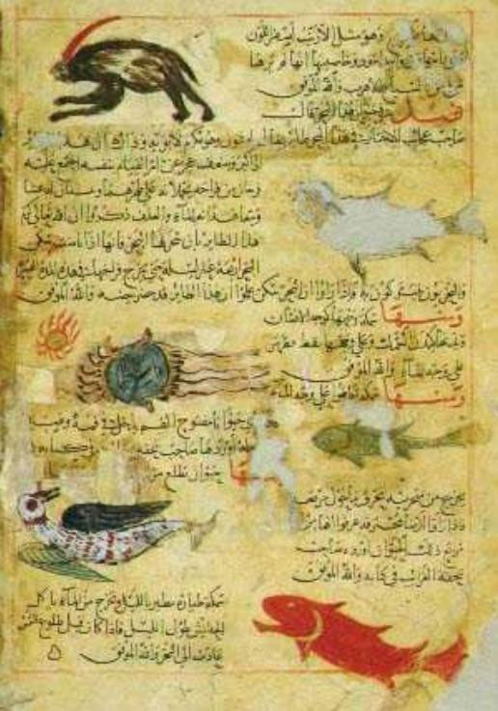

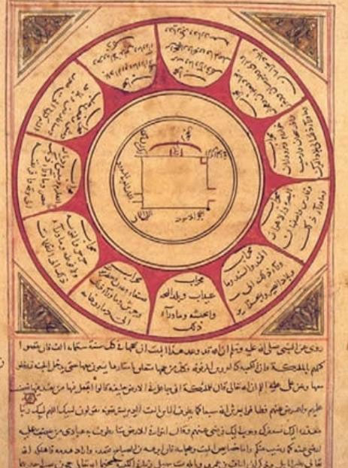

Figure 11a-b: Two pages from Zakariya ibn Muhammad al-Qazwini's works (died 682/1283), both at the The British Library in London: (a) A 14th-century CE manuscript of al-Qazwini's Aja'ib al-makhluqat (The Wonders of Creation), MS Or. 14140; (b) Athar al-bilad wa-akhbar al-'ibad, the geography of al-Qazwini, MS Or.3623.

One outstanding translator of this period was Hunayn ibn Ishaq [85] who worked under Harun al-Rashid, al-Ma'mun, al-Mu‘tasim and al-Muwakkil ‘ala-Allah. He was familiar with Syriac, spoke Arabic and late in his career mastered Greek at Alexandria or Byzantium. He travelled from Baghdad through Syria, Palestine and Egypt in search of Syriac and Greek manuscripts. To Hunayn goes the credit for translating into Arabic a substantial body of Greek medical writings, including Kitab al-Masa'il fi'l-tibb (Medical Questions for beginners) and an original treatise on opthalmology, al-Masa'il fi'l-'Ayn. He regarded the Hippocratic Oath as a genuine work, which he translated into Arabic. He also published a bibliography of one hundred medical works by the Roman physician Galen (Kitab Istikhraj Kammiyat Kutub Jalinus). His translations from Syriac and Greek inspired his son, Ishaq ib. Hunain and his nephew Hubaish, whose works he supervised. According to Strohmaier, he was ‘the most important mediator of ancient Greek science to the Arabs [86].'

Thabit ibn Qurrah (d.288/901) of Harran, a Syriac speaking person who wrote and translated into Arabic, was associated with Banu Musa ibn Shakir by whom he was inspired to learn mathematics, astronomy and philosophy. Among the celebrated Greek texts he translated was Nichomachus's Kitab Nichomachus fi'l al-Arthamatiqi [87] (Nichomachus of Gerasa's book on Arithmetic). He also revised earlier translations of Ptolemy's Kitab al-Majisti and Euclid's Elements. Although primarily a mathematician, he also wrote on medicine and music.

Other celebrated translators included Qusta bin Luqa, a Syrian Christian from the Ba‘labakk region who was well versed in the Syriac,Greek and Arabic languages and collected Greek manuscripts from Byzantium, which he carried to Baghdad to translate. According to Ibn al-Qifti, he was a contemporary of the first notable Arab philosopher, Ya‘qub ibn Ishaq al-Kindi. He was known to be a versatile scholar, knowledgeable in contemporary astronomy, geometry, mathematics, natural science and medicine [88], and like many of his contemporaries, a scientist in his own right.

Apart from private collections of foreign manuscripts, there were also public libraries founded during the 2nd-4th century AH /8th-10th century CE, which were designated by the following terms: Bayt al-Hikmah, Khizanat al-Hikmah, or Dar al-Hikmah, or Dar al- ‘ilm, Dar al-Kutub, Khizanat al-Kutub and Bayt al-Kutub. The Bayt al-Hikmah (also known as Khizanat al-Hikmah), according to Shalabi, was founded in Baghdad by Caliph Harun al-Rashid. Others maintain, however, that caliph al-Ma'mun established it. At the time of Ali ibn Yahya al-Munajjim (d. 275/888), there flourished an institution known as Khizanat al-Kutub and Khizanat al-Hikmah [89]. Since the 9th century CE, many more libraries housed books of foreign sciences. Some of these libraries were privately owned, while others were established by Caliphs, Amirs (governors), Sultans and Wazirs. For instance, in Abbasid Mawsil (Mosul) there existed a large library called Khizanat al-Kutub. Similarly, a wealthy textile trader, Ali b. Muhammad al-Bazzaz (d. 323/942), was said to have possessed a Bayt al-‘ilm (library; lit. house of science or knowledge). Sabur bin Ardashir (d. 416/ 991) bought a house, Dar al-‘ilm, in which he kept ten thousand volumes of manuscripts on all subjects. By the 4th century AH/10th century, there was a proliferation of libraries and institutions, which had been founded in Basrah, Isfahan, Nishapur, Ramhurmuz, Rayy and Cairo [90]. Some of the books in similar libraries were listed by Ibn al-Nadim in his bibliographical compilation al-Fihrist and in Ibn al-Qifti's biographies of scientists and philosophers, Ta'rikh al-Hukama', Ibn Abi Usaybiyah's ‘Uyun al-Anba' fi-Tabaqat al-Atibba' and, for Muslim Spain, by Ibn Juljul's Tabaqat al-Atibba' wa'l-Hukama'. These works provide biographical and bibliographical information about Muslim scientists and philosophers of all ethnic backgrounds up to the 13th century CE. Modern historians and bibliographers of Islamic science, including George Sarton, Carl Brockelmann and Fuat Sezgin, have identified and described manuscripts and printed books on the history of Islamic science.

5. Islamic Science or Arabic Science

There is a tendency among some modern writers, including Abdulhamid Sabra and Muhsin Mahdi, to describe Islamic Science as ‘Arabic Science'. One should not attach any special significance to this new description of an old subject. Is it simply a question of terminology and nothing else? What exactly is Arabic Science?

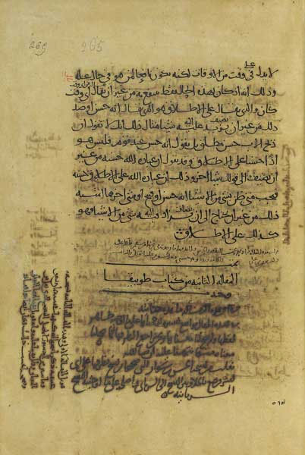

Figure 12: End of the second part of the Arabic translation by Abû 'Uthmân al-Dimashqî (died ca 920) of Aristotle's Organon, Rhetoric and Poetics, copied in 1027. Bibliothèque Nationale de France, Paris, MS Arabe 2346, folio 264v-265r.

The science which the early Muslims acquired through the translation of ancient books on scientific texts came to be known as Islamic Science, which is currently being described by some as Arabic science. Sabra and Sarton tried to define Arabic science,which is so called because, first, it owed its beginning to Arab initiative and patronage; secondly, because such science used Arabic as its linguistic medium;and thirdly, because the Arabic language was seen as a unifying factor which enabled the ancient scientific heritage to be carried, which was a fact of specific significance for ‘the general history of science and culture as well as for the history of science in Islam [91].' Sabra also acknowledged that premodern translations into Arabic led to ‘an accumulation of scientific learning that surpassed anything previously known'. On the other hand, George Sarton compares the Arab acquisition of Greek and Indo-Persian science to the Meiji assimilation of modern science and technology. Islamic rulers of the Abbasid dynasty made the best of Greek knowledge available in Arabic. Pleading for an understanding of the Arab contribution to science Sarton states that ‘the scientific books written in Arabic durng the Middle Ages were, for a few centuries, the main vehicle of the living science' [92]. Moreover, he notes that some historians tried to minimise the Arab achievements and contributions to science by claiming that Arabic science lacked originality and that the Arabs were ‘nothing but copycats'.Such a judgement, according to Sarton, was wrong [93].

Sarton justifies his statement by saying that the Arabs created a genuine ‘hunger for knowledge' and that they not only translated from the Greek and other sources but before long had begun to transform the knowledge they had gained into something new. For instance, in the field of mathematics, rather than copy Greek and Sanskrit sources they fertilised Greek sources with Hindu ones. Sarton also claims that ‘if these were not inventions, then there are no inventions in science. A scientific invention is simply the weaving together of separate threads and the tying of new knots. There are no inventions ex nihilo' [94].

It is possible that Arab scientists did not realise the value of their discoveries. Thousands of Arabic manuscripts on science are scattered in different collections across the globe. Until these texts are edited and analyzed historians of science cannot know the true extent of the Arab contribution to premodern science.

Professor Muhsin Mahdi explains why the study of Arabic science is desirable: “In the absence of an adequate historiography of the history of Arabic science, a preliminary typology of approaches may prove useful.”

‘In the Arab world, widespread interest in the history of Arabic science is due to the special status of modern science and the perception that modern science must be acquired if the third world is to modernise itself; the fact that Arabic science existed in the past is meant to prove that the acquisition of modern science is at least possible. In the West, the relative neglect of the history of Arabic science is part of the neglect of the history of science in general [95]... The study of Arabic science in the Western world aims at discovering those aspects of Arabic science in which advances were made or which contributed to the rise of modern science; and the study of Arabic science in the Arab world is meant to prepare the way for the appropriation of modern science and technology. In every case modern science and technology is taken to be the aim of scientific development and the measure by which earlier science is to be judged. History, on the other hand, is thought to be a method to be used in search for, collecting, organising and presenting the Arabic science of the past.: ....What then is the history of Arabic science -Arabic science and philosophy cannot be separated in the period under discussion without doing violence to each of them; and generally speaking, science should be understood to include the philosophic sciences [96].” These statements are selected at random on account of their relevance to our investigation into Arabic or Islamic science.

Due to shortage of serious studies on Arab science discoveries (at the end of the second millennium CE) our understanding of its origins and achievements must remain incomplete. Some of the relevant facts, however, could be summarised.

6. Astronomy

Astronomy can be identified by several Arabic terms, such as ‘ilm al-Nujum or Science of the Stars; ‘ilm al-Hay'ah, or Science of the āure (of the heaven), and ‘ilm al-Falak, or Science of the Celestial Orb. The observation of stars and the movement of heavenly bodies is perhaps as old as civilization. To the pre-Islamic Arabs, the division of the solar year into different periods was known as Anwa' (singular naw'). The multiplicity of terms may suggest that astronomy was variously defined. Until foreign books on the subject were translated in the 2nd/8th century, Arab interest was based on the science of Anwa'.

On the whole, this interest was a constant factor in Islamic culture. It has been claimed with some justification that the number of scientists involved in the study of Arabic astronomy was considerably higher than in any other science. Moreover, more books have been written on this subject than on any other branch of science; the number of private or public observatories was also highly significant. Belletrists, philosophers, physicians, mathematicians, geographers, royal princes and ministers showed an equal interest in astronomical topics. One only has to read the biographies of scientists and philosophers in Ibn al-Qifti's Ta'rikh al-hukama' to understand how true this is. Moreover, modern scholars, including Régis Morelon [97] have recognised the fact that astronomy held a pride of place among medieval Arabs and Muslims of diverse ethnic backgrounds.

Muslims who face the sacred mosque of the Ka‘bah at their daily prayer and who have oriented all mosques towards this most sacred mosque, called for a scientific method of fixing the qiblah according to precise knowledge of mathematical astronomy. In the light of this fact, the following statement is significant: ‘Muslim astronomers from the 9th century onwards also computed tables displaying the qiblah as a function of terrestrial latitude and longitude, some based on approximate formulae and others based on the accurate formula' [98]. Many astronomical tables using geographical coordinates were a feature of astronomical handbooks. Books were written on how to use astrolabes and varieties of quadrants to locate the qiblah. Compass boxes featuring with the qiblah were available from the Mamluk period.

Although an interest in astronomy was an ancient one, it was not until the 8th and 9th centuries CE that any scientific treatise on the subject became known to them. But help was at hand. Shortly after 117AH/735CE, the Zij al-Arkand (an astronomical table of Arkand) was translated. This served as the basis for other astronomical tables (Zijes). Some elements of Arkand were derived from Brahmagupta's Khandakhadyaka of 665 CE, which probably belonged to the Midnight School (Ardharatrika) of Aryabhata. Nearly four decades later, when a traveller from India presented an astronomical treatise to Caliph al-Mansur, it was translated into Arabic at the Caliph's order by Ibrahim al-Fazari. This text became known as Kitab al-Sindhind, a book on Indian Sidhantas relating to astronomy. Some Persian works on astronomy, for instance the Zij-i Shah (Royal Astronomical Tables) of King Yazdijird III (632-52 CE), were translated into Arabic during the latter part of the 8th century. Shortly afterwards, the Zij Shahyaran (Astronomical Table of Anushiravan (written ca 556 CE) was also translated into Arabic. Thus the Indian and Sassanian influence on astronomy preceded that of the Greeks. As a result of the translation of Ptolemy's Almagest (Kitab al-Majisti) into Arabic in the 9th century, the fascination with astronomy became anchored in ancient astronomical science. Such a translation process was completed around 900CE with al-Battani's work Al-Zij al-Sabi'i (Sabaean Astronomical Tables).

These astronomical tables were used by the scholars of the Muslim world to construct tables for their royal patrons in the 9th century. The ancient tools of astronomy, such as the astrolabe (Ar. Usturlab) and sundial, became familiar to the Arabs. One Arabic source claimed that Ibrahim b. Habib al-Fazari (d. 8th century CE), a descendant of the Prophet's Companion Samurah ibn Jundub, was the first Arab to make an astrolabe [99].

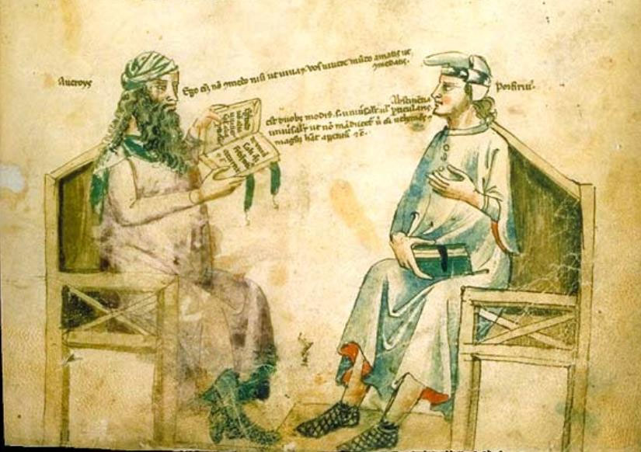

Figure 13: Ibn Rushd in a dialogue with Porphyre in a medieval Latin manuscript Liber de herbis by Monfredo de Monte Imperiali. Italian manuscript from the first half of the 14th century. Bibliothèque Nationale de France, Paris, MS Latin 6823, folio 2.

Many astronomers, including Ibrahim al-Fazari, Masha'Allah al-Munajjim al-Yahudi, Habash al-Hasib, Jabir ibn Hayyan, HibatAllah ibn al-Husayn al-Baghdadi, Muhammad ibn Musa al-Khwarizmi and al-Fath ibn Najabah, were credited with writing books on how to construct an astrolabe, including Kitab al-'Amal bi'l-Asturlab al-Musattah and Kitab Sina'at al-Asturlab wa'l-'Amal biha [100].

Normally, the Arabs would use the plain spheric astrolabe (asturlab al-musattah), the most versatile instrument of its type at this time in medieval Islamic lands and in the West. There, the spherical astrolabe (al-asturlab al-kuri) was also used.

During the reign of Caliph al-Ma'mun, an astronomer, Yahya ibn Abi Mansur [101], became celebrated for recording astronomical observations from Shammasiyah in Baghdad and from the top of the Qasiyun mountain near Damascus in the years 215-217 AH/830-832 CE. Observatories were built in various cities, such as Baghdad, Cairo, Maragha, Tabriz, Samarqand, Istanbul and Delhi.

The extent of Muslim advancement in astronomy was measured by the critical response of Ibn al-Haytham (d.1039) to Ptolemy's books the Almagest (Kitab al-Mjjisti) and Planetery Hypothesis in his famous treatise al-Shukuk ‘ala Batlamiyus. His criticism was not limited to Ptolemy's planetary models but extended to other scientific fields, such as the optics [102]. Naturally, Ibn al-Haytham acknowledged Ptolemy's excellence as a scientist and then proceeded to discuss the optical effect of the sun's movement. He noted that the size of the sun varied at different times of the day: it appears larger when on the horizon than it does in the middle of the sky. He also noted Ptolemy's contradictory statements regarding planetary motion and the epicycle of the planets.

According to one analysis, the Greek theories of vision were principally: (i) the object-copy theory, and (ii) the tactile theory. The latter was questioned by al-Razi and Ibn Sina. Ibn al-Haytham (Alhazen) refuted the object-copy theory and concluded that ‘we see by refraction' [103]. This theory was expounded in his treatise Kitab al-Manazir (Book of Optics), which remained influential (through a Latin translation) in Europe until the late 16th century. According to Gül Russel, “Ibn al-Haytham showed that the object itself is not sensed at all, but that innumerable points of light deflected from the surface of the object to the eye resulted in the sensing of an image which is formed according to optical principles”[104]. In order to prove this theory, Ibn al-Haytham studied the anatomy of the eye and the effect of light on vision. This original theory of vision repudiated the Greek theory of vision. Thus, it was that although Arabic science was initially influenced by Greek theories, in some fields the scientists of Islam subsequently advanced the subject beyond the Greek boundaries.

Among other famous astronomers who made significant contribution to astronomy were al-Biruni and Nasir al-Din al-Tusi.

While visiting Palestine, a 12th century Spanish Jewish traveller, Benjamin of Tudela, recorded the Muslim and Jewish role in astronomy of his time:

“To learn about planetary motions, they [the scholars of the Islamic world] studied Ptolemy's Almagest, which they translated from old Greek into Arabic. The Jews, in turn, translated some works of the Muslim astronomers out of Arabic into Hebrew and Latin and European vernaculars. This was not like the field of pharmacology, where Jews learned by trading in the products; astronomy was a science of ideas, and Jews learned its new ideas by translating.

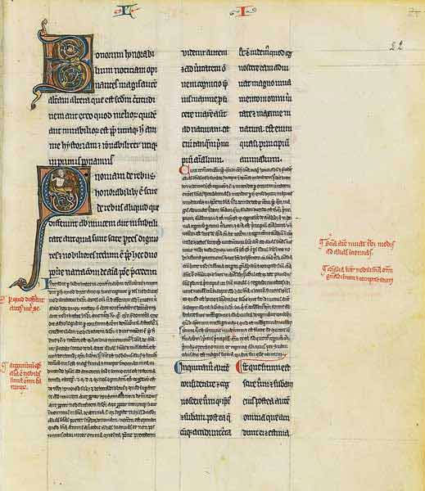

Figure 14: Page of a Latin edition of the commentary of Ibn Rushd (Averroes) on Aristotle's De Anima, Commentarium magnum Averrois in Aristotelis De Anima libros, translated by Michel Scot around 1230, in Paris, third quarter of the 13th century. Bibliothèque Nationale de France, Paris, MS Latin 16151, folio 22).

“The Muslims built magnificent observatories, of which the best contained the most advanced armillary spheres, quadrants, and astrolabes, supplementing a grand variety of sundials and water clocks, alidades, and double-pointed alidades called compasses. The astronomers among the Jews had to have regarded all this with envy. Few Jews could find a place of work in the Muslims' grand observatories, and for financial and religious reasons the Jews had no equivalent observatories, so Jews interested in astronomy had to work along theoretical lines. Yet the Jews' deemed the Muslim astronomers' calendar seriously deficient, for the Islamic year is significantly shorter than the solar year (just like the calendar of the ancient Hebrews).The Muslim calendar consists of twelve months, into which no month is intercalated, so that their year has 354 or 355 days. It takes 103 Muslim years to measure the same duration as 100 of our years [105].

7. Mathematics

Due to its diverse origins, Arabic/Islamic science had a syncretic character. It has been claimed that Muslims inherited a complex set of mathematical ideas, which had been developed in ancient Mesopotamia, Greece, Persia and India. The Greek contribution was mainly in Euclidean geometry; the Persian and Indian influences were detected in trigonometry and in numerals, which came into use from the 2nd century AH/8th century CE; Egyptian ideas related to calendar computation; ancient Babylonia provided the sexagesimal system, which formed the basis of Hisab al-Jummal (i.e. computing with the letters of the alphabet). Writing in his short Encyclopaedia of Sciences (Mafatih al-'Ulum), Abu ‘AbdAllah Muhammad b. Ahmad al-Khwarizmi (ca 977 CE) briefly discussed the mathematics of his epoch, citing the Indian numerals, algebra, trigonometry and alphabetical arithmetic or Hisab al-Jummal (also known as Hisab al-Abjadiyah, the abjad system), in which number values were attributed to the letters of the Arabic alphabet [106]. This method of computing was quoted as follows:

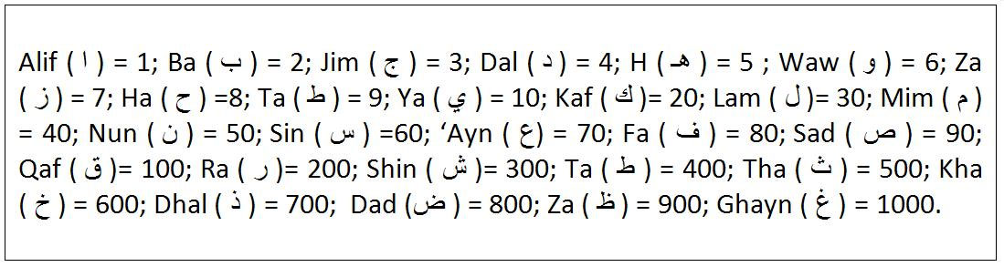

Although this alphabetical arithmetic existed from pre-Islamic to early Islamic times, there were other types of arithmetic used, known as Hisab al-Yad or Finger calculation and Hisab al-‘uqud (arithmetic of knots). The art of finger-reckoning was also identified in Arabic works as ‘the arithmetic of the Rum (i.e.,the Byzantines) and the Arabs'. When and how it came to the Islamic world has yet to be explained fully, but it is likely that before Islam Arab merchants learnt to count using their fingers. The system afterwards seems to have been spread throughout the civilized world [107]. This type of arithmetic was used in government chanceries during the early Caliphates of Madinah and the Umayyad dynasty of Damascus.

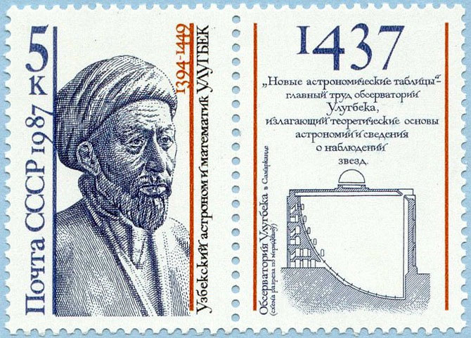

Figure 15: Ulugh Beg (1394-1449), astronomer and last great ruler of the Timurids, commemorated on Soviet stamp issued in 1987. Source.

Initially, Islam inspired the Arabs to apply mathematics in order to resolve the Islamic Law of Inheritance (‘ilm al-Fara'id), which subsequently was able to outline the formula for assessing how an estate could be divided among the beneficiaries. This process often involved the application of algebra. Thus an incentive now existed for Muslims to learn mathematics. Assessing the shares, or quotas, of female relatives of the first and second degree required specialised knowledge. Usually, all Muslim jurists (fuqaha') or judges were called upon to administer an estate. Hence it was a practical as well as a legal necessity for Muslims to be familiar with mathematics.

Muhammad ibn Musa al-Khwarizmi, a Muslim of Central Asian origin, who lived in Baghdad in the early ninth century, wrote the earliest Arabic works on arithmetic. He was associated with Bayt al-Hikmah (the House of Wisdom), a research library in the Abbasid capital. Between 813 and 833 CE, he composed some original treatises on mathematics and it is to him that we owe the origin of the term Algebra, which appears in the title of his Hisab al-Jabr wa'-l-Muqabala and which was later translated by Robert of Chester as Liber Algebras et al-Mucabala. Another translation of this work, Liber De Jebra et Almucabola, rendered by Jerard of Cremona (ca 1114-87CE), helped advance European mathematical thought.

Al-Khwarizmi's book laid the foundation of modern algebra and anotrher of his publications al-Jam' wa'l-Tafriq bi-'l-Hisab al-Hindi (Book of Addition and Subtraction in Indian Mathematics) introduced the Indian place-number system into the 10th-century Andalus (Spain). A certain John of Seville made a Latin translation of this book, as Liber Alchorismi de practica arismetrice, which, according to André Allard, is ‘the most detailed and complete of all the ancient works stemming from the arithmetic of al-Khwarizmi' [107]. Only this translation has survived, the original Arabic text having presumably been lost.

It was probably this same work that was referred to in a 13th-century Latin manuscript as Dixit Algorizmi, which had a chapter on ordinary fractions and another on sexagesimal fractions. Finally, another of al-Khawarizmi's works, as indicated by Ibn al-Qifti, was al-Zij al-Sindhind which comprised al-Zij al-Sindhind al-Awwal and al-Zij al-Sindhind al-Thani, both dealing with astronomical tables. This work was translated into Latin around 1142-46 by Adelard of Bath and influenced the Toledan Tables of Gerard. On the whole, al-Khwarizmi's name was associated not only with Algebra but also with the introduction of the term algorism, or Algorithm, into European science.

Al-Khwarizmi was also credited with writing a book on ‘the Image of the Earth' (Kitab Surat al-Ard) in which the latitude and longitude of towns, cities, mountains, seas and rivers were given, and the earth was shown to be divided into seven climes following the Ptolemaic system. Due to the originality of his work al-Khwarizmi's work was linked with the origins of astronomy and mathematics in Islamic society. Kramers claimed that al-Khwarizmi was the ‘prototype of the Islamic scholar who had a very wide field of interest and at the same time was connected with the traditional Islamic sciences by also being the author of a Ta'rikh or Historical Chronicle'. Secondly, he presented the pre-Islamic sciences in an Islamic literary form. Thirdly, he applied science to the practical legal needs of the Islamic community, such as the question of fixing the qiblah or direction to the Ka‘bah in Makkah. Fourthly, his writings contained several pre-Islamic concepts, such as the earth's position in the universe, and the seven climes [108] (aqalim) and his introduction of Indian numerals, which became a permanent feature of science in Islamic societies for centuries.

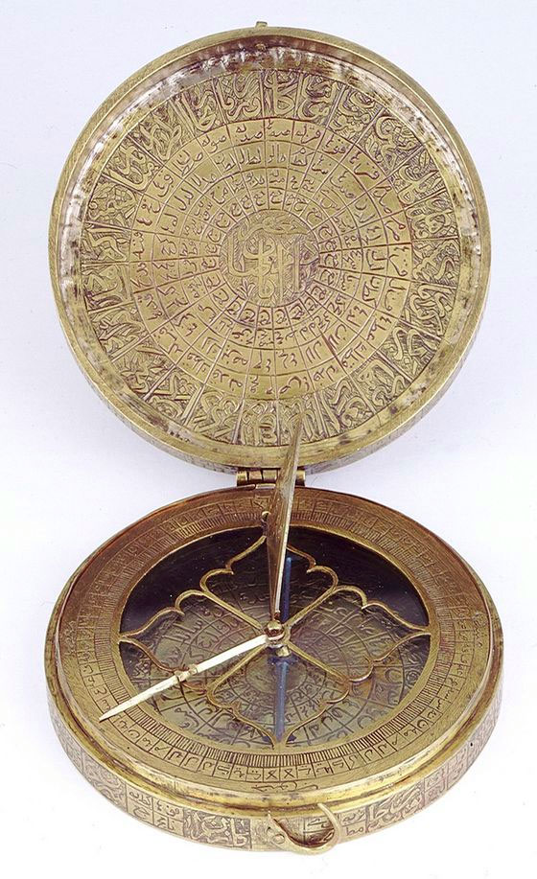

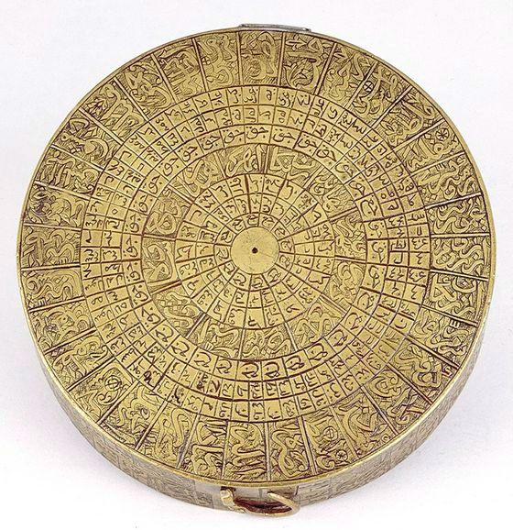

Figure 16a-b: Qibla indicator, comprising a round brass box with a hinged lid and an inset magnetic compass at the National Maritime Museum at Greenwich and London (Georges Prin Collection). All sides of the box are covered with inscriptions in Arabic, consisting of lists of 151 places with their longitudes and latitudes.

The many successors of al-Khwarizmi included Abu Kamil, who wrote a celebrated book on algebra ca 880 CE. Other mathematicians who followed the Khwarizmian school of algebra were Sind ibn ‘Ali, Sinan b. Fath, Abdul-Hamid Ibn Turk and Abu 'l-Wafa' al-Bujazani. These mathematicians in turn had their disciples who included Abu ‘AbdAllah al-Mahani, al-Khujandi and al-Karaji during the 10th century. Although ‘Umar al-Khayyam is known in Europe through Fitzgerald's translation of his Ruba'iyat poems, he was better known in his lifetime as a metaphysician, astronomer and mathematician. The Algebra of ‘Umar al-Khayyam, according to Nasr, was, on account of his throughness and clarity, one of the most outstanding mathematical texts of the medieval period [109]. As an astronomer, ‘Umar al-Khayyam will be remembered for helping to construct the Jalali calendar, named after the Saljuq Sultan Jalal al-Din Malik Shah (d.485/1092), which was more accurate than the Gregorian calendar.

The Arab belletrist al-Jahiz [110] rightly stated that members of the royal family ought to acquire the knowledge of genealogy, history and jurisprudence, soldiers should know about warfare (al-Maghazi) and should read biographies (siyar), just as traders ought to be familiar with arithmetic and book-keeping. It was the knowledge of geometry that made a profound impact on Islamic art and architecture, especially in the geometric decoration of windows, and domes and the use of mosaic tiles.

8. Alchemy and Chemistry

Alchemy (Ar. al-kimiya'), which was variously associated with ancient art, mythology, gnosticism and religion had its origin in antiquity. Some alchemic texts were written in hieroglyphs on steles and these texts were forbidden to be divulged. Mysterious and controversial as were the etymologies of ‘alchemy', so was its association with Greek philosophers, such as Pythagoras, Plato, Socrates and Aristotle, and the Roman physician Galen. The attraction for Arabs was no less strong. The names of Khalid bin Yazid and Jabir ibn Hayyan were closely linked with this pseudo-science. The ancient champions of alchemy believed that it could transform base metals into precious ones and produce an elixir of life, among other things. The Umayyad Prince Khalid was attracted by its mystery and had an ancient Egyptian book on alchemy translated into Arabic with the help of an Egyptian monk, Marianus.

Although Jabir ibn Hayyan (Latin Geber, d. ca 803 CE) was the most famous Arab alchemist, the names of Ja‘far al Sadiq (d. 765), Dhu'l-Nun al-Misri (d.861) and Abu Bakr al-Razi (b.250/864) are also associated with alchemy. It is a short step from alchemy to pure chemistry. Jabir did laboratory work in chemistry and his research has entered the history of science. Al-Razi accepted Jabir's theory regarding sulphur and mercury components of metals and described his chemical apparatus and laboratory research. According to al-Razi, chemical procedures comprised distillation, solution, calcination, evaporation, crystallisation, sublimation and filtration [111]. His laboratory work advanced the science of pharmacy.

Among other alchemists were the Spanish Arab Maslama al-Majriti (d.1007) and al-Jaldaki (d.1341CE). Al-Jaldaki, author of a book on precious stones (Kitab Anwar al-durar fi idah al-hajar) analysed the theory of elixir -its essence, unity, qualities, distillation and purification.

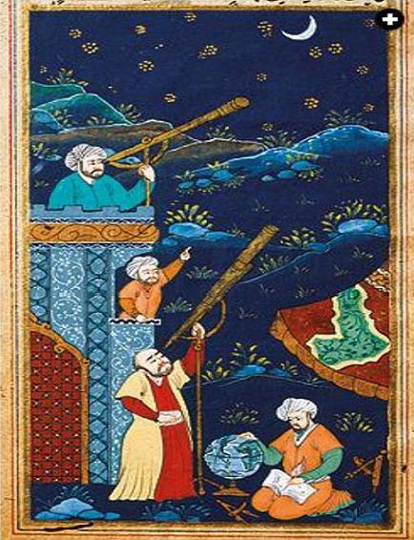

Figure 17: Ottoman astronomers studying the moon and the stars in a miniature dating from the 17th century held in a manuscript owned by Istanbul University Library.

Ibn Sina (Avicenna) repudiated alchemy's value as science, arguing that the transmutation of metals was impossible, though dyes might be transmuted. Ibn Khaldun also scorned alchemy. Jabir too, in his numerous books and epistles [112] on alchemy, though praising the magical things it could produce, claimed that it only produced false gold and was incapable of creating a miracle. Although pretensions of alchemy were seriously challenged, the laboratory methods of the alchemists led to the discovery of new chemical products and some technological procedure useful in everyday life, including perhaps, pharmaceutical products. Alchemic speculation produced intellectual fermentation.

Many Arabic books on alchemy/chemistry were translated into Latin. Julius Ruska acknowledged that: ‘We can never stress enough that the Latin Alchemy of the Latin West owes nothing to the Greeks, to the Arabs it owes more or less everything. For decades we have persisted in studying fragments from the alchemists as if the contents and essence of Latin alchemy could be explained by it... It was not the Greek alchemists but the translations from original Arabic works which paved the way to Western development' [113].

9. Medicine

Our knowledge of the history of Islamic medicine in the ancient and medieval Middle East is mainly based on biographical sources, such as Ta'rikh al-Hukama (History of the Physicians and Philosophers) by Ibn al-Qifti and ‘Uyun al-Anba' fi Tabaqat al-Atibba' (Sources of Information on the Classes of Physicians) by Ibn abi Usaybi'ah, besides some fragmentary references in literary works.

In pre-Islamic Arabia medicine consisted of herbal and natural remedies. The Prophet Muhammad's statements regarding cleanliness, diet, sickness and cure were collected together in books, which came to be known as Tibb al-Nabawi (or the Prophetic medicine) but little is known about how this medicine was practiced. The Shi‘ite Muslims added to the medical canon with Tibb al-A'immah or medicine of the Imams (Leaders).

There is also some indication of foreign medical influence reaching Arabia from neighbouring lands, such as Persia, where the Arabian physician al-Harith ibn Kaladah al-Thaqafi [114] studied medicine in Jundishapur, the ancient seat of a hospital and medical college. Persian, Indian and Nestorian physicians were said to have practised at the Jundishapur hospital and to have translated various medical books from Indian and Syriac texts into Pahlavi. However, recent research [115] has questioned whether a hospital and medical school ever existed at Jundishapur in Ahwaz. Instead, it is claimed that Jundishapur had only an infirmary, and no medical school. What interests us here, however, is that al-Harith ibn Kaladah al-Thaqafi studied medicine in Jundishapur. Significantly, Ibn Kaladah was a contemporary of the Prophet Muhammad, and though his existence has recently been doubted, he was a real person. It is known that he originated in Ta'if and belonged to the tribe of Thaqif. His link with the Jundishapur centre suggests a Persian influence in the advancement of the early Arabian medicine. Harith was reported to have met the Prophet during the Farewell Pilgrimage, to have cured a sick Sa‘d ibn Abi Waqqas. Harith's conversion to Islam, however, has been questioned. From the little we know of his medical theories, it is possible to conclude that his “main point was the Arab view that excess of diet was the main cause of all disease. He also recommended the simplest possible way of life. Diet should be of the plainest. Water is to be preferred to wine and salt and dried meat to fresh meat. The dietary should include fruit. The hot bath should be taken before meals” [116].

There is also evidence to suggest that a physician, Ibn Abi Rimthah, used surgery to remove a mole from the Prophet's back [117]. For this, according to al-Qifti, Ibn Abi Rimthah was given the title of ‘Tabibu-Allah' (literally God's physician), whereas al-Harith b. Kaladah was known as the ‘physician of the Arabs' (Tabib al-'Arab), just as al-Kindi was called the philosopher of the Arabs (Faylasuf al- ‘Arab).

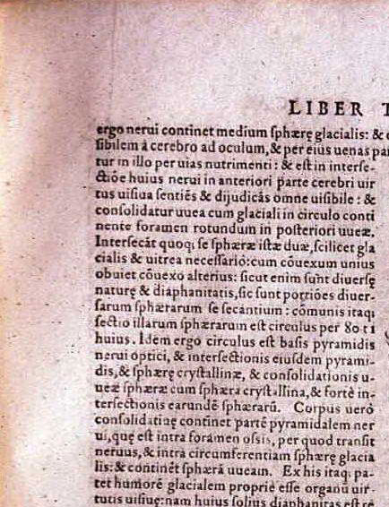

Figure 18: Diagram of the eye from Risner's edition of Opticae thesaurus. Alhazeni Arabis libri septem Opticae thesaurus... (Basilea, 1572), the first edition of the Latin translation of Ibn al-Haytham's Kitab al-manazir, the most important and most influential Arabic treatise on physics, that exercised profound influence on Western science in the 16th and 17th centuries. Sarton calls Ibn al-Haytham “the greatest Muslim physicist and one of the greatest students of optics of all times.”

During the Umayyad period (660-750 CE), parts of North Africa, Spain, eastern and northern Persia, and the Indian province of Sind were being conquered. Such conquest started a process of gradual integration of the Arabs with non-Arabs, between Muslims with non-Muslims, and allowed the intrusion of non-Muslim ideas (including Greek, Persian and Indian secular traditions) into the formation of literature and science. It was at Jundishapur that ancient Indian writings on toxicology were translated from Sanskrit into Arabic (e.g. Kitab al-Sumum, according to Hajji Khalifah). Elsewhere, it has been claimed that knowledge of Indian drugs, including poisons, spread from Jundishapur to the Middle East. ‘Ali b. Sahl Rabban al-Tabari (d. ca 240/854-5CE), in the first systematic medical work in Arabic, Firdaws al-Hikmah (The Paradise of Wisdom), expounded upon the Arab knowledge of Indian medicine, and Syriac and Greek medical literature during the 9th century CE. Elsewhere, the belletrist al-Jahiz (d.255/869) also acknowledged the advances made by Indians in the sciences of astronomy, mathematics and medicine and pharmacology [118]. Modern research has also discovered that contact existed between the Arabs and the Chinese, and that Chinese medical herbs were used in West Asia. It has been suggested that the Arab polymath al-Kindi indicated in his pharmacopeia that Arab physicians were already using Chinese herbs during the 9th century CE. A century later, Ibn Sina recorded that seventeen medical herbs imported from China were currently in use and that even the Chinese pulse theory was applied by some physicians. Chinese medical influence reached a peak in Persia and the rest of the Middle East during the era of the Ilkhanids (1256-1335), when Rashid al-Din Fadlullah, the wazir of Ghazan Khan (1295-1304 CE) had some Chinese medical books translated into Persian, including Tansuk-Nama [119].

Among the earliest notable translations into Arabic during the Umayyad period were the Kunnash (Pandects) of Ahron al-Qass, a Priest of pre-Islamic Alexandria. The translator was a Basran-born Jewish Physician, Masarjis or Masarjawaih [120] who lived, according to Ibn al-Qifti, during the reign of ‘Umar II (d. 101 AH/720 CE) and who was credited with writing medical treatises, including Kitab Qawi al-At'imah (a treatise on food) and Kitab Qawi al-Maqaqir (a book on drugs). A book on the Substitution of Remedies (Kitab fi Abdal al-Adwiyah) was also attributed to Masarjawaih, but modern commentators, such as Max Meyerhof, have rejected the claim. Little is known of Masarjawaih's medical practice, but we know that he prescribed eating raw cucumber on an empty stomach for a patient who complained of constipation.

In Damascus, during the Umayyad era, some events of medical significance included the amputation of a leg infected with gangrene. In this rare case the leg belonged to a celebrated Arab, namely ‘Urwah ibn al-Zubayr, a brother of ‘AbdAllah ibn al-Zubayr ibn al- ‘Awwam. While visiting (ca 85 AH/785 CE) the Umayyad prince al-Walid, he became afflicted with gangrene (al-ikla) [121] in his foot. ‘Urwah lived for another eight years, after the leg was amputated in the presence of al-Walid b. ‘Abd al-Malik, the future Umayyad Caliph (r.86-96/705-15 CE) and died in Madinah in 94 AH/713 CE. This celebrated amputation was also recorded by Abu 'l-Faraj al-Isfahani in his entertaining literature Kitab al-Aghani, and Ibn al-Jawzi in his Dhamm al-Hawa'.

It is clear from our sources that Islamic science and medicine developed rapidly in Baghdad under the early ‘Abbasid Caliphs, especially al-Mansur, Harun al-Rashid and al-Ma'mun. Among the prominent medical personalities of this period were members of the Bukhtishu‘ family who moved from Jundishapur and established a prosperous medical practice in Baghdad. The translation into Arabic by the physician Hunayn ibn Ishaq and his son, Ishaq b. Hunayn, and others, of medical treatises, mainly from Greek, brought Arabic medicine under the Hellenistic medical influence. In particular, the translations of Hunayn made the works of Hippocrates and Galen available and shaped the Arabic medical vocabulary in classical Arabic. Hunayn's original medical treatises include Kitab al-Masa'il fi'l-Tibb (a book on medical problems) and Kitab al-‘Ashar Maqalat fi 'l-‘Ayn (Ten Treatises on the Eye), both of which became standard works during the 9th and 10th century. The first was used by the Hisbah officers (municipal officials) to assess the professional qualifications of physicians. Hunayn also edited the translation of Istafan bin Basil of the Materia Medica of Pedanius Dioscorides (1st century BCE). This was variously titled as Hayula ‘ilaj al-Tibb, Kitab al-Adwiyah al-Mufrada and Kitab al-Hasha'ish, during the 3rd century AH/9th century CE. This translation provoked a number of commentaries and these served as the most valuable works of Arabic pharmacology. Al-Biruni's Kitab al-Saydalah (The Book of Drugs), which records 850 drugs, survives in a modern edition. The most notable Arabic book of this genre is Kitab al-Mughni fi'l-Adwiyat al-Mufradah (a treatise on simple drugs) by the 13th century Andalusian Ibn al-Baytar. This records 1400 drugs of mineral, vegetable and animal origin.

The publication of medical works by Muhammad ibn Zakariyya' al-Razi (Latinised Rhazes) (d. 313 AH/925 CE), Ali b. ‘Abbas al-Majusi, the Andalusian surgeon Abu 'l-Qasim al-Zahrawi, the ophthalmologist ‘Ali ibn ‘Isa, and Abu ‘Ali Ibn Sina, hailed by his contemporaries as the prince of the physicians (Ra'is al-atibba'), marked a high point in Islamic medicine.

Between the 9th and 14th centuries, Islamic medicine and pharmacology advanced to such a point that some medical works which were translated into Latin in Toledo and southern Italy influenced the development of medicine in medieval Europe. The achievements of this Golden Age are worth noting.

Al-Razi, the great medical systematiser of all Muslim medical authorities, derived his surname from his native city Rayy, where he became the chief physician of the hospital, later holding the same position in Baghdad. Al-Razi (d. 313 AH/925 CE), was the greatest clinician and pathologist of his time. His notebooks, which comprised 25 volumes of Kitab al-Hawi fi'l-Tibb (The Comprehensive Book of Medicine), were translated into Latin as the Continens by the Jewish physician Faraj bin Salim or Farraguth in 1279 CE. However, al-Razi's magnu opus, according to some, was not al-Hawi, but Kitab al-Jami' al-Kabir (the Great Medical Compendium). Besides this, a treatise on Smallpox and Measles (Kitab al-Jadari wa'l-Hasbah), which was translated into Latin and other European languages as Liber de Pestilentia, earned him international recognition. Other medical works included Kitab al-Hasa fi 'l-Kula wa-'l-mathana (Stones in the kidney and bladder) and Kitab al-Mansuri (Latin Liber Medicinalis ad al Mansorem), which was dedicated to his patron Mansur ibn Ishaq, the Samanid governor of Rayy. He also wrote a book on psychic therapy, Al-Tibb al-Ruhani (lit. Spiritual Medicine) [122], in which he provided insights into the theory and practice of clinical and psychiatric medicine. Like Galen, he believed that a physician should also be a philosopher, but his independence was articulated in his Shukuk 'ala Jalinus (Doubts about Galen). His “clinical records did not conform to Galen's description of the course of fever. And in some cases he finds that his clinical experience exceeds Galen's” [123].

After al-Razi, another influential figure in Islamic medicine was ‘Ali b. ‘Abbas al-Majusi (Latin Haly Abbas) whose famous Complete Book of the Medical Art (Kitab Kamil al-Sina'ah al-Tibbiyah), also known as Kitab al-Maliki (Latin Liber Regius), was written while he was director of the ‘Adhudi Hospital in Baghdad. The work contained important observations on medical theories and diagnoses and was a dominant text throughout the East. A contemporary of Haly Abbas, Abu 'l-Qasim al-Zahrawi (in Latin Abulcasis/Albucasis), who served the Andalusian Caliph Abd al-Rahman III al-Nasir (300-350/912-961) in Cordoba. He wrote Kitab al-Tasrif li-man 'ajiza 'an al-Ta'lif, a medical encyclopaedia, dealing with 325 diseases. The part of this book devoted to surgery described cautery, incisions, bloodletting and bonesetting [124]. All surgical methods together with the tools were illustrated.

In the history of Islamic medicine, Abu Ali al-Husayn ibn Sina (known in the West as Avicenna) was a towering figure. Born at Afshana near Bukhara in 370 AH /980 CE, he died at Hamadhan in 428/1037CE. Like al-Razi, he was a great physician and philosopher and wrote a dozen medical works, although the historian Ibn al-Qifti listed a few more. Among these were A Book of Healing (Kitab al-Shifa'), in 18 volumes, Kitab al-Qanun fi 'l-Tibb (The Canon of Medicine) in 14 volumes, Kitab al-Adwiyah al-Qalbiyah (Medicine of the Heart)), Kitab al-Qawlanj (Book of Colic) and a mnemonic in verse for physicians, al-‘Urjuzah fi 'l-Tibb. Ibn Sina's full bibliography includes 270 titles. However, his magnum opus was Kitab al-Qanun fi 'l-Tibb or The Canon of Medicine, which was, according to Goichon, ‘the clear and ordered “Summa” of all the medical knowledge of Ibn Sina's time, augmented from his own observations” [125]. This Canon (Qanun), through its European translations, became ‘a kind of bible of medieval medicine, replacing to a certain extent the works of al-Razi. It was printed in Rome as early as 1593, shortly after the introduction of Arabic printing in Europe [126].'

It is tempting to compare the stature of Al-Razi and Ibn Sina as medical authorities of the pre-modern world. It has been aptly noted that Al-Razi made his original contribution in the practice of medicine, whereas Ibn Sina gained prominence in medical theory. Despite their greatness, both were subjected to harsh criticism by al-Ka‘bi and ‘Abd al-Latif Baghdadi respectively. Islamic medicine declined after the death of Ibn Sina, but many commentaries on and epitomes of the Canon (Qanun) were made by successive generations of physicians. Among the commentaries, the most notable was that of Ibn al-Nafis (d. 687/1288), the chief physician in Cairo, who composed Sharh al-Qanun, a commentary on the entire Canon, and Mujiz al-Qanun and an epitome Sharh Tashrih al-Qanun, which he devoted to comment on its anatomical and physiological aspects, It is in the latter that Ibn al-Nafis described his discovery of the lesser or pulmonary circulation of the blood, which made him famous.

Within a century of his death, Ibn Sina's works began to appear in European translations. Between 1170 and 1187, Gerard of Cremona translated the Canon of medicine at the order of Frederick Barbarossa. Even lesser works of Ibn Sina were translated, including the Sufficientia by Gundisalvus, whilst Armengaud translated Canticum de Medicina (Urjuza fi'l-tibb) with Ibn Rushd's commentary on it; and Arnold of Villanova did the same in De Virivus Cordis. Michael Scot, in collaboration with Andrew the Jew, translated some works of Ibn Sina into Latin between 1175 and 1232 CE. The death in 1285 of Farraguth, the translator of Al-Razis' Continens, brought the era of Latin translations to an end. The Universities of Montpellier and Bologna, taught the works of Al-Razi and Ibn Sina in their medical schools. “From the 12th to the 17th century, Rhazes and Avicenna were held superior even to Hippocrates and Galen” [127]. Al-Razi is depicted in the stained glass of the chapel in Princeton University, and in the University of Brussels lectures on Ibn Sina were given until 1909.

Al-Razi's book Diseases in Children may justifiably earn him the title of father of paediatrics. Ibn al-Jazzar (d. 984 CE) of Tunisia also wrote on the care for children from birth to adolescence, though this work was later surpassed by the Cordoban ‘Arib ibn Sa‘id, whose treatise on gynecology, embryology and paediatrics was published in Andalusia.

In the dusty conditions of the Middle East, eye diseases were common and Muslim physicians developed special skills for treating blindness. Although most medical books devoted a separate chapter to eye diseases, monographs were also written on the subject. One early work on ophthalmology was Hunayn ibn Ishaq's ‘Ashar Maqalat fi'l-'Ayn (Ten Treatises on the Eye), which remained a standard for many centuries. However, the most important book was ‘Ali ibn ‘Isa's (d. 400/1010 CE) Dhakhirat al-Kahhalin (Treasury for Ophthalmologists), which was translated into Latin as Tractus de Oculis Jesu Ben Hali.

The transfer of scientific knowledge from Arabic into Latin contributed to the European Renaissance.

10. Hospitals

It is well known that the institution of the hospital is closely linked with the history of medicine and has its origins in antiquity [128]. Although care for the sick began to take place in Middle Eastern temples in the second millennium BCE, Islam resurrected the idea of caring for the sick in the 7th century CE. When the Arabs conquered Egypt, they found a medical school and hospital in Alexandria. On conquering Persia, an infirmary was discovered in Jundishapur, where, according to some, there existed a hospital and medical school. The existence of these medical institutions, however, is open to question. At the beginning of the 8th century, Caliph al-Walid b. ‘Abd al-Malik (r.705-715 CE) reportedly built a maristan or hospital in Damascus, the exact nature of which is not known, though it was probably a sanatorium for lepers and other chronically sick people.

The history of Islamic medicine and hospitals began during the ‘Abbasid Caliphate. The name of Yahya al-Barmaki, Harun al-Rashid's Prime Minister (wazir), was associated with the foundation of the first hospital in Baghdad. Since then, many hospitals have been built in the ‘Abbasid capital, including Bimaristan al-Sa‘idi (Sa‘idi hospital) or Bimaristan al-Mu‘tadidi (ca 279/892) on the east bank of Tigris, for which Caliph al-Mu‘tadhid (d. 289AH/902) allotted 450 dinars per month. It was the only hospital in Baghdad at the time; another hospital, the Bimaristan al-Sayyidah, was built by the Queen Mother, Shaghab, in 306/918 CE in al-Mukharram (306/918); its expenses perhaps did not exceed more than 600 dinars a month. Another hospital, built in the same year by Caliph al- Muqtadir bi-Allah (d. 320/932), was known as Bimaristan al-Muqtadiri at the Syrian Gate of Baghdad. Caliph al-Muqtadir's “good wazir” ‘Ali ibn ‘Isa also built a hospital at his own expense. In 329/940, the Amir al-umara' Bajkam built a hospital at the Basrah gate in Baghdad, and the chief adviser to this hospital was the physician Sinan b. Thabit ibn Qurrah. The hospital of Ibn al-Furat was built (ca 313/925). In 372/982, west Baghdad's celebrated Adhudi hospital, linked to a medical school with twenty four staff physicians, was built by the Amir Adhud al-Dawlah. Waqf property was allocated to its maintenance. In fact, all these hospitals were supported by charitable endowments (waqf, pl. awqaf). In Damascus, the Nuri hospital was the most famous; in the capitals of Egypt, Fustat and Cairo, hospitals were built by Ibn Tulun in the 870s; Salah al-Din al-Ayyubi founded the Nasiri hospital and the Sultan Qala'un established Bimaristan al-Mansuri (ca 1284).

Salah al-Din was a particularly important founder of hospitals in Egypt and Syria. He built one each in Cairo, Alexandria, Jerusalem and Damascus. Sultan Salah al-Din's 21 court physicians included eight Muslims, eight Jews -including Cordoba-born Maimonides (Musa b. Maymun) who produced Aphorisms (Kitab al-Fusul)-, Ibn Jumay‘, and at least five Christians and a Sabian. Hospitals offered free treatment to all and physicians were recruited from both the Muslim and non-Muslim community (ahl al-Dhimmah/Dhimmis). Arab hospitals were built elsewhere, including Marrakesh in 1199 CE and in Granada in 1397 CE. Andalusian-born Ibn Rushd (Averroes), author of the Kulliyat (Latin Colliget) and Ibn Tufayl worked at Marrakesh. These prototype hospitals [129], which some Muslims regarded as a glory of their civilization, shaped the development of hospitals in Europe and Africa.

11. Notes and References

[1] Cf. W. M. Watt, The Influence of Islam on Medieval Europe, Edinburgh University Press, 1972, pp. 30-43; 60-71; 82-4;

[2] Alexander Hellemans et al., The Timetables of Science: A Chronology of the Most Important People and Events in The History of Science, Simon and Schuster, Rockefeller Centre, New York, 1988,p. 20.

[3] Ibid, p. 38.

[4] C. A. Qadir, Philosophy and Science in the Muslim World, Croom Helm, London and New York, 1988, pp. 15-41.

[5] Ibn Qutaybah, al- Ma'arif, Beirut, Dar Ihya' al-Turath al- ‘Arabi, 1970.

[6] Muhammad ibn Ahmad al-Khwarizmi, Mafatih al-‘Ulum, Cairo, Al-Sharq Publications, 1342/1923-4, pp. 2-154.

[7] Jamal al-Din Ibn al-Qifti, Ta'rikh al-Hukama', ed. Julius Lippert, Leipzig, 1903, 2 vols., (reprinted in Baghdad and Cairo).

[8] Ibn Qutaybah, op. cit., p. 9.

[9] Ibid, pp. 9-10.

[10] Ibid, p. 12.

[11] Ibid, pp. 14-27.

[12] Ibid, p. 26.

[13] Published as Husam Muhi El-Din al-Alousi, The Problem of Creation in Islamic Thought, The National Printing and Publishing Co, Baghdad, 1965.

[14] Katib Celebi, Kesf el-Zunun, Istanbul 1941, p. 199. Ahmad al-Qalqashandi, Subh al- A'sha, vol. 1, Cairo, 1913, pp. 412-36.

[15] Sulayman b. Ahmad al-Tabarani, Kitab al-Awa'il, (Dar al-Furqan, Beirut),1983, pp. 1-127; Jalal al-Din al-Suyuti, Al-Wasa'il Ila Maarifat al-Awa'il, ed. ‘Abd al-Qadir, Cairo, 1990, pp. 15- 200. See also The Book of Curious and Entertaining Information The Lata'if al- Maarif of al-Thaalibi ( translated with Introduction and Notes by C. E. Bosworth), The University Press, Edinburgh, pp. 38-9.

[16] The Book of Curious and Entertaining Information The Lata'if al- Ma‘arif of al-Thaalibi ( translated with Introduction and Notes by C.E. Bosworth), The University Press, Edinburgh, pp. 38-9.

[17] Ibid, p. 40.

[18] S. Freud, Civilization and Its Discontents (tr. and ed. J. Starchey), W. W.Norton & Co., New York, 1961, p. 44.

[19] Franz Rosenthal, ‘Ishaq ibn Hunain's Ta'rikh al-Atibba', in ORIENS, Leiden, vol. 7, 1954, pp. 61, 70.

[20] Al-Jahiz, Al-Bayan wa'l-Tabyin, ed. Sandubi, Cairo, 1926, vol. 1, p. 213.

[21] M.A.J. Beg, Wisdom of Islamic Civilization - A Miscellany o f Islamic Quotations, Kuala Lumpur, 1986, p. 87. M. Ullmann, ‘Khalid b. Yazid ‘ in The Encyclopaedia of Islam, Leiden, 1978, vol. 4, pp. 929-30. Ibn al-Qifti, Ta'rikh al-Hukama', ed. Lippert, Leipzig, 1903, p. 440.

[22] ‘Ali ibn Muhammad al-Khuza‘i, Takhrij al-Dalalah al-Sam'iyah, Cairo,1401/1981, pp. 65-69.

[23] Al-Qur'an, Chapter al-A ‘raf, Verse 7.

[24] M. Hamidullah, in The Muslim World Book Review, vol. 1, No.3, Leicester, 1981, p. 15.

[25] Ibid, p. 15.

[26] Sayyid Ahmad al-Hashimi, Mukhtarat al-Ahadith al-Nabawiyah wa'l- Hikam al-Muhammadiyah, Cairo, n.d. (1950s), p. 69.

[27] Ibid, p.93; cf. also A.J. Wensinck, Concordance et Indices de La Tradition Musulmane, E.J. Brill, 1962, vol. 4, p. 10.

[28] Ibid., p. 93. Wensinck, op. cit., vol. 4, p. 321.

[29] Ibid., p. 100.

[30] M.A.J. Beg, Wisdom of Islamic Civilization, pp. 35-6.

[31] Ibn Khaldun, The Muqaddimah (tr. F. Rosenthal), vol. 2, p. 437.

[32] Ibn ‘Abd Rabbihi, al- 'Iqd al-Farid, Cairo, 1940, vol. 2, p.208. Cf. also M. A. J. Beg, Wisdom of Islamic Civilization (A Miscellany of Islamic Quotations), Kuala Lumpur, 1986, p. 57.

[33] Ibn Khaldun, The Muqaddimah: An Introduction to History (tr. F. Rosentahal), Princeton, N.J., 1980, vol. 3, pp. 143-47.

[34] Patricia Crone, Pre-Industrial Societies ( New Perspectives on the Past),Blackwell, Oxford, 1995, p.97. The author of this book notes that “In the Muslim world, for example, the religious scholars did not fear lay participation in religious knowledge for the simple reason that they were laymen themselves, not members of a hierarchy sealed off from the lay society: their authority rested on mastery of learning available to anyone; they simply had more of it than the rest. But here as elsewhere knowledge had to be controlled. ..Muslim scholars were happy to share religious learning with everyone who wanted it, but they were suspicious of different types of learning associated with different exponents (such as doctors and philosophers); obviously had these types of learning won out, their own knowledge would have been devalued, meaning loss of income and prestige alike.”

[35] Ibn Khaldun, The Muqaddimah: An Introduction to History (tr. F. Rosentahal), Princeton, N.J., 1980, vol. 3, p.150.

[36] Ibn al-Qayyim al-Jawziyyah, Tibb al-Nabawi, Dar al-Fikr, Beirut, circa 1957, pp. 334.

[37] Al-Suyuti, Tibb al-Nabi (The Medicine of the Prophet), tr. Cyril Elgood, OSIRIS, Brussels, 1962.

[38] M.A.J. Beg, Wisdom of Islamic Civilization, Kuala Lumpur, 1986, p. 57 (citing Ibn ‘Abd Rabbih, al- ‘Iqd al-Farid, Cairo, 1940, vol. 2, p. 208).

[39] Quoted from Muhammad Asad's monthly journal Arafat, Lahore, 1946-7,in M.A. J. Beg (ed.) The Image of Islamic civilization, Kuala Lumpur, Malaysia, 1980, pp. 66-7.

[40] Maurice Bucaille, The Bible, the Qur'an and Science (translated from the French by Alistair Pannell), Paris edition, 1977; English edition, North American Trust Publications, Indianapolis, 1979.

[41] Ibid, p. vi.

[42] Ibid.

[43] Ibid, pp. 242-8.

[44] Ibid, p. vi.

[45] Al-Khuza‘i, Takhrij al-dalalat al-Sam‘iyah, pp. 159-69. The Prophet's secretaries who wrote down the Revelation were ‘Uthman ibn ‘Affan, ‘Ali ibn Abi Talib, Ubayd ibn Ka‘b and Zayd ibn Thabit. When all of these four amanuenses were absent, others took their place, for instance Mu ‘awiyah ibn Abi Sufyan, Khalid ibn Sa ‘id ibn al-‘As, Aban ibn Sa‘id, al- ‘Ala' ibn al- Hadrami and Hanzalah ibn al-Rabi'.

[46] Bucaille, op. cit., p. vi.

[47] Ibid, p. ix.

[48] Al-Qur'an: Chapter 54: Verse 7.

[49] Ibid, Chap. 32 : Verse 5.

[50] Ibid, Chap. 70: Verse 4.

[51] Ibid, Chap. 21: Verse 30.

[52] Ibid, Chap. 31: Verse 31.

[53] Ibid, Chap. 16: Verse 14.

[54] Ibid, Chap. 55: Verse 58.

[55] Ibid, Chap. 55: Verse 22.

[56] Ibid, Chap. 21: Verse 33.

[57] Ibid, Chap. 36: Verse 42.

[58] Ibid, Chap. 49: Verse 13.

[59] Ibid, Chap. 20: Verse 53; Chap. 13: Verse 53.

[60] Ibid, Chap. 36: Verse 36 ; Chap. 53: Verses 45-46.

[61] Ibid, Chap. 86: Verses 6-7.

[62] Ibid, Chap. 2: Verses 222-223; Chap. 65: Verse 4.

[63] Ibid, Chap. 21: Verse 30. Some scholars and scientists interpret an acquatic origin of life to include a reference to semen.

[64] Ibid, Chap. 10: Verse 4.

[65] Ibid, Chap. 55: Verse 10-13.

[66] Ibid, Chap. 16 : Verse 66.

[67] Ibid, Chap. 16: Verses 5-8.

[68] Ibid, Chap. 85: Verse 1.

[69] Ibid, Chap. 2: Verse 164.

[70] Bucaille, op. cit., pp. 251-2.

[71] Sir Mohammad Iqbal, Six Lectures on the Reconstruction of Religious Thought in Islam, ( Kapur Art Printing Press), Lahore, 1930, p. 177.

[72] Ibid, p. 176.

[73] Seyyed Hossein Nasr, Islamic Science. An Illustrated Study, photographs by Ronald Michaud, World of Islam Festival Publishing Company Ltd., London, 1976, p. 9.

[74] George Sarton, ‘Science' in Mid-East: World-Center, Yesterday, Today and Tomorrow, ed. Ruth Nanda Anshen, Cooper Square Publishers, New York, 1975, p. 273.

[75] Ibid.

[76] Dimitri Gutas, Greek Thought, Arabic Culture : The Graeco-Arabic Translation Movement in Baghdad and Early Abbasid Society (2nd-4th/8th-10th Centuries), Routledge, London and New York, 1998, pp. 22-3.

[77] Ibid, p. 22.

[78] Ibn al-Qifti, Ta'rikh al-Hukama' (History of Philosophers and Scientists) ed. J. Lippert, Leipzig, 1902/3, p. 220.

[79] Ibn al-Qifti, op. cit., p. 220. See also D.R.Hill, Islamic Science and Engineering, Edinburgh University Press,1993, p. 11.

[80] Ibn al-Qifti, Tarikh al-Hukama', ed. Lippert, p. 270.

[81] D. Pingree, ‘Ilm al-Hay'a, The Encyclopaedia of Islam, Leiden, vol. 3, 1986, p. 1137; see also S.H. Nasr, Islamic Science, op. cit., p. 97.

[82] Ibid., pp. 158-60.

[83] Richard Walzer, Greek Into Arabic : Essays on Islamic Philosophy, Bruno Cassirer, Oxford, 1962, pp. 6-9.

[84] Ibn al-Qifti, op. cit., pp. 441-3.

[85] Ibid, pp. 171-7; Sulayman ibn Hassan ibn Juljul al-Andalusi (well-known as Ibn Juljul), Tabaqat al-Atibba' wa'l-Hukama'( Les Génerations des Médicins et des Sages), ed. Fu'ad Sayyid, Cairo, 1955, pp. 68-72.

[86] G. Strohmaier, ‘ Hunayn ibn Ishaq al-‘Ibadi', The Encyclopaedia of Islam, vol. 3, Leiden, 1986, p. 578.

[87] Ibn al-Qifti, op. cit., pp. 117-8.

[88] Ibid, pp. 262-3.

[89] George Makdisi, The Rise of Colleges, Edinburgh University Press, 1981, pp. 24-5. Cf. also Ahmad Shalaby, History of Muslim Education, Dar al-Kashahaf, Beirut, 1954, pp. 73-89.

[90] Ibid, pp. 26-7.

[91] Abdelhamid I. Sabra, ‘The Exact Sciences', in The Genius of Arab Civilization: Source of Renaissance, Phaidon, Oxford, 1975, p. 121.

[92] George Sarton, Science, in The Mid-East: World-Center, New York, 1975, p. 269.

[93] Ibid, p. 274.

[94] Ibid, p. 275.

[95] Muhsin Mahdi, “Postface: Approaches to the History of Arabic Science”,in Encyclopaedia of the History of Arabic Science, edited by Roshdi Rashed and Régis Morelon, Routledge, London and New York, 1996, vol. 3, p. 1027.

[96] Ibid, p. 1026.

[97] Régis Morelon, “General Survey of Arabic Astronomy”, in Encyclopaedia of the History of Arabic Science ed. R. Rashed et al., op. cit., vol. 1, pp. 1-57.

[98] David A. King, “Astronomy and Islamic Society: Qibla, Gnomonics and Timekeeping”, in Encyclopaedia of the History of Arabic Science, op. cit., vol. 1, p .147.

[99] Ibn al-Qifti, op. cit., p. 57.

[100] Ibid, pp. 160-61; 170; 242; 256; 286;328.

[101] Ibid, p. 357.

[102] G. Saliba, “Arabic Planetary Theories after the Eleventh century”, in Encyclopaedia of the History of Arabic Science, op. cit., vol. 1, p.74.

[103] Gül A. Russell, “The Emergence of Physiological Optics”, in Encyclopaedia of the History of Arabic Science, op. cit., vol. 2, p.701.

[104] Ibid, p.703.

[105] Sandra Benjamin, The World of Benjamin of Tudela : A Medieval Mediterranean Travelogue, Madison, Teaneck, (Associated University Presses), Cranbury, NJ. and Ontario, Canada, 1995, pp. 197-8.

[106] Abu ‘AbdAllah Muhammad ibn Ahmad b. Yusuf al-Katib al-Khwarizmi, Mafatih al- 'Ulum, Cairo, 1342/ 1923, p. 114.

[107] Ahmad S. Saidan, ‘Numeration and Arithmetic', and André Allard, “The Influence of Arabic mathematics in the medieval West”, in Encyclopaedia of the History of Arabic Science, op. cit., vol. 2, pp. 331-2 and p. 561.

[108] J. H. Kramers, ‘Science in Islamic Civilization' in Analecta Orientalia Posthumous Writings and Selected Minor Works of J.H. Kramers, E.J. Brill,Leiden, 1956, pp. 127-29.

[109] Seyyed Hossein Nasr, Science and Civilization in Islam, Dewan Pustaka Fajar, Malaysia, 1984, p. 160.

[110] Amr bin Bahr al-Jahiz, Kitab al-Bayan wa'l-Tabyin editor Sandubi, Cairo,1926, part III, p. 211.

[111] G. C. Anawati, “Arabic Alchemy”, in Encyclopaedia of the History of Arabic Science, op. cit., vol. 3, pp. 857-8; see also p. 868.

[112] The Arabic Works of Jabir ibn Hayyan (edited with critical notes by Eric John Holmyard), vol. 1, part 1 (Arabic text), Paris 1928.

[113] Robert Halleux, ‘The Reception of Arabic Alchemy in the West', in Encyclopaedia of the History of Arabic Science, op. cit., vol. 3, pp. 896-7.

[114] Ibn al-Qifti, Ta'rikh al-Hukama (ed. J. Lippert), Leipzig, 1903,pp. 161-2. See also Ibn Juljul, Tabaqat al-Atibba' wa'l-Hukama' ed. F. Sayyid,Cairo, 1955, pp. 54-6.

[115] Emilie Savage-Smith, ‘Tibb', The Encyclopaedia of Islam, vol. 10, Fascicules 171-2, Leiden, 1999,p. 452. The author claims that there are no reliable sources to prove that there was either a hospital or a medical school at Jundishapur; what existed there was an infirmary in which Graeco-Roman medicine was practiced.

[116] Cyril Elgood, A Medical History of Persia and the Eastern Caliphate: From the Earliest Times to the year A.D. 1932, Cambridge, 1951, p. 66.

[117] Cf. Ibn Juljul, Tabaqat al-Atibba' wa'l -Hukama' ( Les Générations des Médicins et des Sages) ed. Fu'ad Sayyid, Cairo, 1955,pp.57-8. Emilie Savage-Smith, “Medicine”, Encyclopaedia of the History of Arabic Science op. cit., vol. 3, p. 908.

[118] M.A.J. Beg, ‘Arab Impressions of Ancient Nations and Civilizations', Wisdom of Islamic Civilization, Kuala Lumpur, 1986, pp. 101-2.

[119] Cf. F. Klein-Franke and Zhu Ming, “Tibb: 2. Medical Exchange between China and the Islamic World”, The Encyclopaedia of Islam, vol. 10, Leiden, 1999, pp. 460-461.

[120] Ibn al-Qifti, op. cit., pp. 324-6; Ibn Juljul, op. cit., pp. 61-2.

[121] Ibn Qutaybah, al-Maarif (ed. by Muhammad Isma'il ‘AbdAllah al-Sawi), Beirut 1390/ 1970, p. 98.

[122] Ibn Juljul, op. cit., pp. 77-80; Ibn al-Qifti, op. cit., pp. 271-7.

[123] L.E. Goodman, “Al-Razi”, The Encyclopaedia of Islam, vol. 8, new edition, E.J. Brill, Leiden,1994, p. 476.

[124] Emilie Savage-Smith, “Medicine”, in Encyclopaedia of the History of Arabic Science, op. cit., vol. 3, p. 920.

[125] A.M. Goichon, ‘Ibn Sina', The Encyclopaedia of Islam, vol. 3, Leiden, 1986, p. 942. For a list of Ibn Sina's works, see Al-Qifti, Ta'rikh al-Hukama', pp. 413-26.

[126] Martin Plessner,” Science”, in The Legacy of Islam, ed. J. Schacht and C.E.Bosworth, Oford University Press, London, 1974, p. 449.

[127] Cyril Elgood, op. cit., p. 207.

[128] M.A.J. Beg, ‘The Origin and Growth of Hospitals in Islamic Civilization', Muslim Education Quarterly, vol. 13, No. 4, Cambridge, UK, 1996, pp. 73-77. Cf. also Françoise Michaeu, ‘The Scientific Institutions in the Medieval Near East', Encyclopaedia of the History of Arabic Science, op. cit., vol. 3, pp. 991-2; 999-1001.

[129] Aydin Sayili, ‘The Emergence of the Prototype of the Modern Hospital in Medieval Islam', Bulletin, Uç Ayda Bir Çikar, Turk Tarih Kurumu, Ankara,Turkey, 1980, pp. 280-6.

All rights reserved for Al-Hassanain (p) Network, ImamHussain (p) Foundation

Alhassanain (p) Network for Islamic Heritage and Thought

[www.alhassanain.org/english](http://www.alhassanain.org/english)