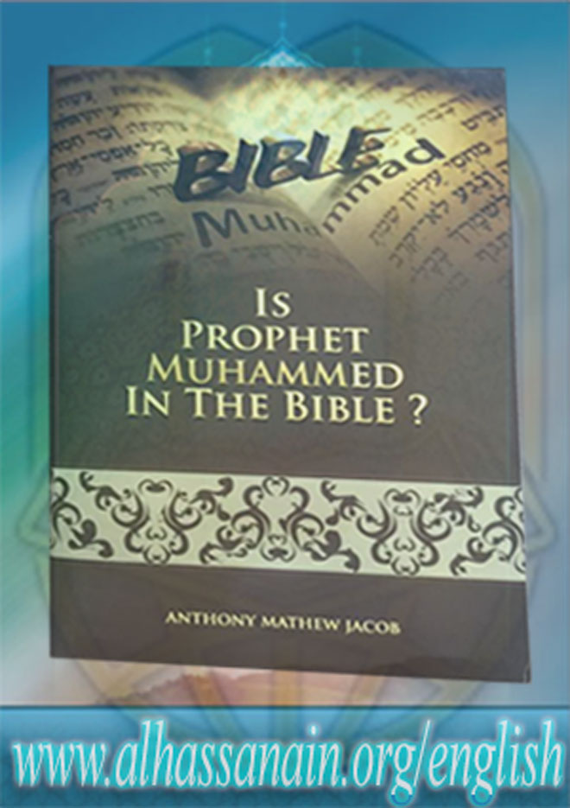

www.alhassanain.org/english

Is Prophet Muhammed (s.a.w.a.) In the Bible?

Author(s): Anthony Mathew Jacob

Publisher(s): World Islamic Network (WIN)

www.alhassanain.org/english

The Holy Bible contains many prophecies both in the Old and the New Testament about the coming of a great prophet of God. The coming of this Prophet is mentioned both directly and indirectly by Abraham(A.S), Moses (A.S), John (A.S) and Jesus (A.S) amongst others. To discuss all the related material in the Bible would be too lengthy and beyond the scope of this book.
This is a selection of only a few of those verses that are very clear and are supported by history for discussion. This selection is comprehensible not only to those who have an in-depth understanding of the Bible but also those who are reading the Bible for the first time.

Miscellaneous information:
Is Prophet Muhammed (s.a.w.a.) In the Bible? Anthony Mathew Jacob ISBN : 81-87793-78-3 Published By:WIN 67/69, H. Abbas (a.s.) Street, Dongri, Mumbai - 400 009. (India) Tel.: (91-22) 2343 3540 / 4304 / 2345 4676 Email : winislam@gmail.com Website : www.channelwin.tv

Notice:
This version is published on behalf of www.alhassanain.org/english
The composing errors are not corrected.

Table of Contents

Dedication 7
Acknowledgements 8
Introduction 9
Foreword 10
Chapter 1 11
Prophecy 1 13
Notes 15
Chapter 2: Prophecy 2 16
Notes 19
Chapter 3: Prophecy 3 20
Note 22
Chapter 4: Prophecy 4 23
Note 25
Chapter 5: Prophecy 5 26
Notes 28
Chapter 6: Prophecy 6 29
Notes 31
Chapter 7: Prophecy 7 32
Notes 34
Chapter 8: Prophecy 8 35
Notes 38
Chapter 9: Prophecy 9 39
Notes 43
Chapter 10: Prophecy 10 44
Notes 49
Conclusion 50

Dedication
This book is dedicated to all those who are sincerely searching for the truth, and have the courage to accept it, when confronted.

Acknowledgements
My sincere thanks to my family members…
My dear friends Ali Husain Hyderi, Sohel Hussain Merchant, Ali Abbas Panjetani and others whom I have not mentioned but who are in my heart and always remain, deserve my sincere gratitude for their constant support and encouragement. My sincere thanks to Sayyed Muhammed Hadi for hadiths and their references throughout the book. I also thank the publishers for their trust and support.
And of course, I am greatly indebted to the compilers of the Bible, who have taken care to include the Prophesies throughout the centuries. And also, the Biblical scholars and commentators who have sincerely and faithfully interpreted the Prophesies that we have studied here.
My proofreaders and editors,
1. Who did not wish to be named,
2. Mr. Sohel Hussain Merchant.

Introduction
The Holy Bible contains many prophecies both in the Old and the New Testament about the coming of a great prophet of God. The coming of this Prophet is mentioned both directly and indirectly by Abraham(A.S), Moses (A.S), John (A.S) and Jesus (A.S) amongst others. To discuss all the related material in the Bible would be too lengthy and beyond the scope of this book.
This is a selection of only a few of those verses that are very clear and are supported by history for discussion. This selection is comprehensible not only to those who have an in-depth understanding of the Bible but also those who are reading the Bible for the first time.
It is expected that the material presented here will clearly and without any doubt show this Prophet, who was to come after Jesus is Muhammed bin Abdullah (S.A.W) the promised Prophet of God.
This book covers only 10 prophecies or references from the Holy Bible about Prophet Muhammed (s.a.w.a.) and his Pure Progeny (a.s.) who were sent as guides for all of humanity. It is written as a dialogue between a Christian and a Muslim. The aim is to understand each other and discuss our similarities in a brotherly manner. I have tried to use the suffixes used by the Muslims after the names of Allah, Prophets and holy men.
The word Allah (s.w.t) is the Arabic word for God.
1. ‘s.w.t’ that follows Allah stands for ‘Subhanahu wa ta’aala’ or ‘glorified and exalted be HE’
2. ‘s.a.w.a.’ that follows Prophet Muhammed stands for ‘Salallahu Alaihi wa Aalehi wa Sallam’ or ‘peace be upon him and his progeny’
3. ‘a.s.’ that follows the Prophets and the Progeny of the Holy Prophet stands for ‘Alaihis Salaam’ which means ‘Peace be upon him’
4. ‘s.a’ stands for ‘Salamun Alaiha’ which means
5. ‘Peace be upon her’
I have used the Quran translation by M.H. Shakir throughout the book.

Foreword
This book is written on two levels. The first level is the obvious Theological level, where the matter is treated as Biblical Study and Perusal.
It is the second level which would be of utmost interest to students of Prophets and Prophesies. Here, Jesus Christ is brought into relief as a Prophet also.
And here we study Prophesies.
We study the anatomy of Prophesies. How they are made. The wording of the Prophesies, the linkages made in it to the available knowledge not only of the times, but all time to come. We see the unerring clarity and depth of the Prophesies. And when they come to pass, we realize the knowledge and grandeur of the Prophets themselves.
I hope the readers enjoy studying this book as much as I enjoyed writing it.
Anthony Mathew Jacob
Mumbai, India
January, 2017

Chapter 1
John: Hi, how are you Ali?
Ali: Alhamdulillah; I am good, how are you John?
John: I am good thank you. What is Alhamdullilah?
Ali: ‘Alhamdulillah’ means all praise to Allah.
John: We say “Praise the lord” or “Hallelujah”.
Ali: Yes, that’s right.
John: And what is ‘Salaam Alaikum’
Ali: ‘Salaam Alaikum’ means peace be with you…
John: We too use this praise, especially in the church. Brother Ali I have some questions for you…
Ali: Yes please….
John: Dear brother, you Muslims say that your Prophet Muhammed (s.a.w.a.) is mentioned in our Holy Bible, how can you make such claims without any proofs?
Ali: Dear brother, these claims are substantiated with proofs; if you want I can provide them to you?
John: Yes please.
Ali: Sure, let us discuss ten prophecies about our dear Prophet Muhammed (s.a.w.a.) from your Holy Bible.

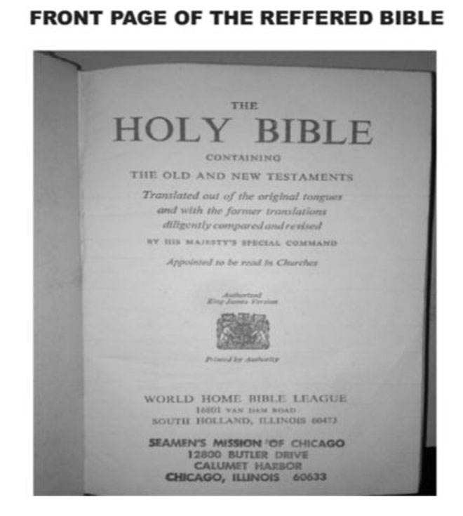

Prophecy 1
Ali: The first prophecy of our discussion is from Genesis chapter 17 verses 6-7:
“And I will make thee exceeding fruitful, and I will make nations of thee, and kings shall come out of thee. And I will establish my covenant between me and thee and thy seed after thee in their generations for an everlasting covenant, to be a God unto thee, and to thy seed after thee.”1
Ali: This is the promise of God almighty made to Prophet Abraham (a.s.), that he shall make a great nation from his seed.
John: But, this promise is about Issac and his descendents and not Ishmael and his descendents.
Ali: Well brother, this covenant between Abraham and God almighty was made after the birth of Ishmael and before the birth of Issac, so how can you say that it was about Issac and not Ishmael. Furthermore, Muslims do not deny that Issac was a mighty prophet of God, whereas our Christians brothers refuse to attribute the same respect to Prophet Ishmael (a.s.).
John: We do this because Ishmael was the son of a slave woman and not a wife.
Ali: Dear brother, Sarah (s.a.) herself got Hagar (s.a.) married to Prophet Abraham (a.s.).
John: What proof do you have?
Ali: Well, the proof lies in the Bible itself, why don’t we refer
Genesis 16 verse 3
“And Sarai Abram’s wife took Hagar her maid the Egyptian, after Abram had dwelt ten years in the land of Canaan, and gave her to her husband Abram to be his wife.”2
So if Hagar was Prophet Abraham’s wife, shouldn’t prophet Ishmael be attributed the same respect as Issac?
John: Yes of course! I’m sorry I have never paid attention to the Bible before.
Ali: It is not only you; John, who has not paid attention to the Bible, and I feel the responsibility also lies with the church.
John: How come the church?
Ali: Have you ever heard a sermon on Genesis 16 verse 3 during Mass?
John: No. Never!
Ali: Why doesn’t the Church highlight the fact that Hagar is Abraham’s wife and that Ishmael is the son of Abraham instead of calling Ishmael the “son of a slave-woman” and brushing the whole matter under the carpet and never speaking about it?
John: Why?
Ali: This is done to belittle the status of Prophet Ishmael so that it makes it easy to deny and obfuscate the fact that the covenant (Genesis 17:6-7) also included him. And as a result the mission of Prophet Muhammed (s.a.w.a.) the last Prophet of God can also be denied easily.
Now, after clarifying this issue we come to the conclusion that Genesis 17:6-7 speaks about the covenant of God that was fulfilled through Prophet Muhammed (s.a.w.a.) who was an Arab and a descendent of Prophet Ishmael (a.s.) the son of Prophet Abraham (a.s.).

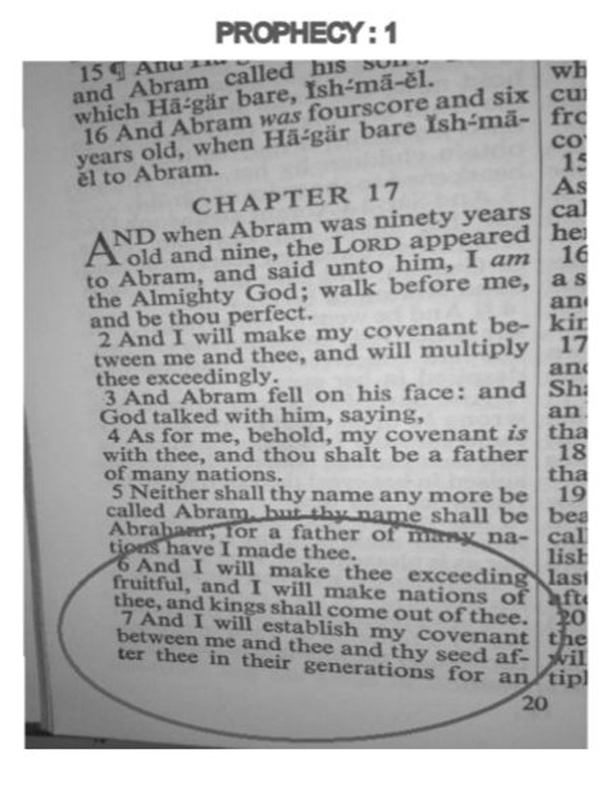

Notes
1. Genesis 17:6-7
2. Genesis 16:3

Chapter 2: Prophecy 2
Ali: The second prophecy that we shall discuss today is from the ‘Book of Deuteronomy’ which is believed to have been written by Prophet Moses (a.s.).
Let’s refer to Deuteronomy chapter 18 verse 18:
“I will raise them up a prophet from among their brethren, like unto thee, and will put my words in his mouth; and he shall speak unto them all that I shall command him.”1
John: But this prophecy refers to Jesus Christ (a.s.), and not Muhammed (s.a.w.a.).
Ali: Let us see whom it refers to, firstly the prophecy says that the Prophet will be like ‘You’ meaning like Prophet Moses.
What were the similarities between Jesus Christ (a.s.) and Prophet Moses (a.s.)?
Was Jesus Christ (a.s.) indeed like Prophet Moses (a.s.)?
Let us compare Jesus Christ (a.s.) and Prophet Moses (a.s.):
1. Jesus had a miraculous birth but Moses had a natural birth.
2. Jesus had only mother but Moses had both mother and father.
3. Jesus was rejected by his followers but Moses was not.
4. Jesus didn’t come with a new law but Moses did.
It’s clear that Jesus (a.s.) is not like Moses (a.s.) in more ways than one. Thus, it is clear that the ‘Prophet like You’ (Moses {a.s.}) in the above Prophecy is not Jesus Christ (a.s.).
Another important message of the prophecy is that the Prophet will be from ‘among their brethren’, meaning the brethren of the followers of Prophet Moses (a.s.). The brethren of the Israelites are the Arabs who were the descendents of Prophet Ishmael (a.s.) the brother of Issac (a.s.). Thus when the bible says, the prophet will be from ‘among their brethren’ it means he will be from the Arabs, isn’t it?
Now who is the Prophet who came from the Arabs to guide humanity?
That prophet dear brother is none other than Prophet Muhammed (s.a.w.a.) who was an Arab and a descendent of Prophet Ishmael (a.s.).
Now let us see if Prophet Muhammed (s.a.w.a) was like Prophet Moses (a.s):
1. Moses had a natural birth and so did Prophet Muhammed. (s.a.w.a)
2. Moses had both parents and so did Prophet Muhammed. (s.a.w.a)
3. Moses was accepted by his followers and so was Prophet Muhammed.(s.a.w.a)
4. Moses and Muhammed both had worldly authority.
5. Both brought a new law for the people.
6. Both got married and had children.
Finally, one important thing that you and my Christian brothers need to remember before attributing this prophecy to Jesus Christ (a.s.) is that according to your own admission Jesus Christ (a.s.) is the son of God and not a prophet of God, isn’t it? So when this prophecy speaks about a Prophet like Moses (a.s.) how can it be Christ (a.s.)?
Moreover, the prophecy says ‘I will put my words in his mouth, and he will tell them everything I command him’ Let me read a verse from the Holy Quran that will further prove that the above biblical prophecy is indeed about Prophet Muhammed (a.s.).
Surah Al-Najm, that is chapter 53 verses 3-4 says:
“Nor does he speak out of desire. It is naught but revelation that is revealed.”2 Quran 53:3-4
Similarly, all chapters of the Holy Quran (except one) begin with:
‘In the Name of Allah the Beneficent the Merciful’ thereby indicating the one from whom it has come.
Ali: Shall we go to the next prophecy.
John: Yes.

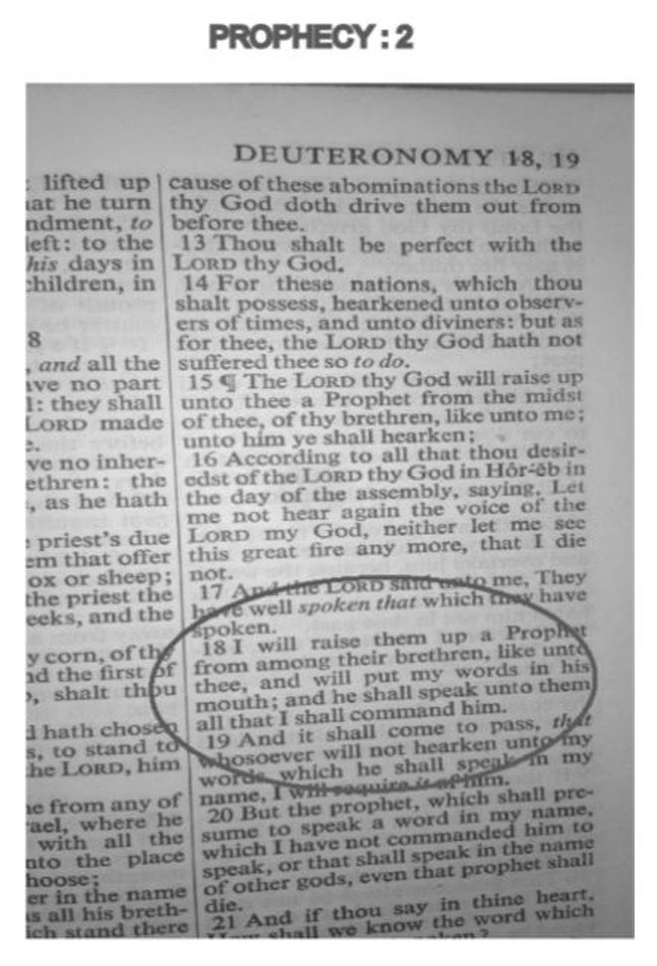

Notes
1. Deuteronomy 18:18
2. Quran 53:3-4

Chapter 3: Prophecy 3
Ali: The third prophecy is from the book of Deuteronomy Chapter 33 verses1-2:
“And this is the blessing, wherewith Moses the man of God blessed the children of Israel before his death. And he said, The Lord came from Sinai, and rose up from Seir unto them; He shined forth from Mount Paran, and He came with ten thousand of saints: from His right hand went a fiery law for them.”1
Ali: Before we analyze the prophecy, let me inform you that Sinai is the mountain where Prophet Moses (a.s.) received the Ten Commandments. Seir is in Palestine, where Prophet Jesus (a.s.) preached his message and Paran is a mountain in Mecca. The cave of Hira is located on Mount Paran and mount Paran is also known as Jabal un Noor. Paran is the same place where Prophet Ishmael (a.s.) settled and got married according to Genesis 21:21. The coming of the Lord means coming of God’s Representatives. Now the prophet of God who came from Sinai was Prophet Moses (a.s.) and the one who rose from Seir is Prophet Jesus (a.s.). So who is the Prophet who shined forth from Mount Paran and came with ten thousands of saints and brought a fiery law for them?
John: But then the name of Muhammed is not mentioned in this prophecy?
Ali: Well dear brother how come you understand that Sinai refers to Prophet Moses (a.s.) Sier refers to Jesus Christ the Messiah (a.s.), but only when it comes to Paran you want the
name of the Prophet to be mentioned?
John: Well…
Ali: Therefore my dear brother, the Prophet of God who shone forth from Paran is none other than Prophet Muhammed (s.a.w.a.) and the fiery law that came from his right hand is the well-defined and complete legal system of Islam, which we call the Sharia.

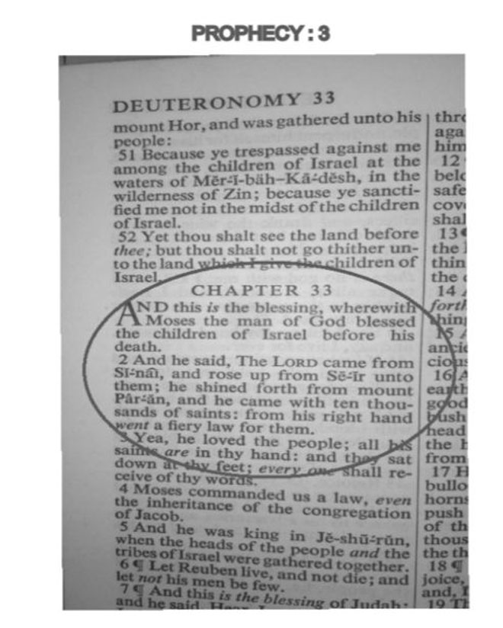

Note
1. Deuteronomy 33:1-2

Chapter 4: Prophecy 4
Ali: The next prophecy that we shall discuss is from the book of Isaiah. Prophet Isaiah is considered to be one of the major prophets of the Old Testament, in the book of Isaiah there are several prophecies about the coming of the messiah. In chapter 42, Isaiah begins with a prophecy for the coming of Prophet Jesus (a.s.). Now after verse number nine we see that God declares through Isaiah, the “new things” that are to “spring forth” in the Land of Kedar, the land of Kedar is Arabia. So obviously this prophecy speaks about Prophet Muhammed (s.a.w.a.).
Let us discuss Isaiah Chapter 42, Verses 9-12. God declares through Prophet Isaiah;
“Behold, the former things are come to pass, and new things do I declare: before they spring forth I tell you of them. `Sing unto the Lord a new song, and his praise from the end of the earth’, Ye that go down to the sea, and all that is therein; the isles, and the inhabitants thereof. Let the wilderness and the cities thereof lift up their voice, the villages that Kedar doth inhabit: let the inhabitants of the rock sing, let them shout from the top of the mountains. Let them give glory unto the Lord, and declare His praise in the inlands.”1
Before we analyze the prophecy let us see where the land of Kedar is;
Ezekial chapter 27 verse 21 says:
‘Arabia, and including all the princes of Kedar, they occupied with thee in lambs, and rams, and goats; in these were they thy merchants’.
The personality called Kedar in the Bible is that of the grandson of Prophet Abraham (a.s.), through his son Ishmael which is mentioned in the book of Genesis 25:13. Kedar’s descendants had settled in Paran (Sino-Arabian dessert). In the Rabbinic literature Arabia is called the “Land of Kedar”. Prophet Muhammed (s.a.w.a.) was a descendant of Kedar. God did reveal in the Land of Kedar, through Prophet Muhammed – a direct descendant of Kedar, a ‘New Song’ i.e: The Qur’an (Koran). (The Recitation)
This (The Quran) happens to be the only scripture to be revealed in the language of the Kedarites. The verses of the Qur’an are recited like a poem. Nearly 1.2 billion Muslims, residing all over the world, recite this ‘new song’ and Glorify Allah (s.w.t), in their daily five-time prayers. The initial Revelation came to Prophet Muhammed in a cave of Mount Hira near the city of Mecca. There are several mountains near Mecca and during the annual Islamic Pilgrimage called ‘Hajj’, Muslims from all over the world, assemble in Mecca and shout Glory to the Lord from the top of Mount Arafat. The pilgrims continuously give Glory to Allah on their way, to and from Mecca.
Do you require any more clarifications regarding the above verse?
John: No.

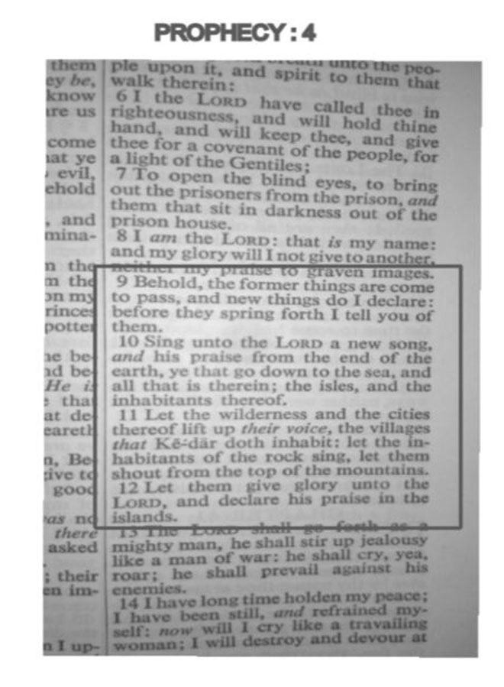

Note
1. Isaiah 42: 9-12

Chapter 5: Prophecy 5
Ali: Let’s go to the next one, the following Prophecy is from the book of Habakuk in the Old Testament of the Holy Bible. Before we go to the Prophecy let me inform you about the book of Habakuk, this book is named after Prophet Habakuk, who is also believed to be its author. According to bible scholars he is believed to have lived in the late 7th century B.C.
Let’s have a look at the prophecy in the book of Habakuk Chapter 3 verse 3 :
“God came from Teman, and the Holy One from Mount Paran. Selah. His glory covered the heavens, and the earth was full of his praise.”1
As in most prophecies and even in the third prophecy that we discussed, ‘God’ here refers to the representatives of God. So when the prophecy says: “God comes from Teman and the Holy one from Mount Paran” it means prophets of God will rise from these two places. Now the question is, who are these two great prophets who are prophesized in the above verse? For the answer to this question, let us see where Teman and Mount Paran are.
John Gill, the famous author of the ‘Gill’s Exposition of the Bible’ mentions under the commentary of Habakuk 3:3: “Teman is a city in the land of Edom, which is five miles from Petra, in Idumea, where was Mount Seir, from whence the Lord arose” that is Jesus Christ (a.s.). Now, mount Sier is a mountain in Palestine where Jesus Christ (a.s.) preached his message. Therefore, the first part of the prophecy refers to Jesus Christ (a.s.).
We already discussed in the last prophecy about Mount Paran, let us see what your Bible scholars say about Mount Paran. According to John Gill. “the valley or plain of Paran, where Simon of Gerasa made caves and dens, and hid the treasure he plundered from the people: according to Adrichomius, it was a most dreadful barren desert, where nothing grew, or was to be had, through which the children of Israel journeyed; and was sometimes taken for the first part of the desert of Arabia”
So according to the admission of your own Bible scholars and the Bible itself in Genesis 21:21 Paran is in Arabia, the land where prophet Ishmael settled, isn’t it?
Then who is the Prophet who rose from Arabia….?
John: Muhammed peace be unto him.
Ali: Yes, the Prophet of God from Arabia is none other than Prophet Muhammed (s.a.w.a.). Furthermore, the last part of the prophecy says that “His glory covered the heavens, and the earth was full of his praise.”
Indeed the glory and praise of Prophet Muhammed (s.a.w.a.) filled the heavens and the earth. According to a hadith:
Lady Aminah bint Wahab (s.a.) (the mother of Prophet peace be upon him and his progeny) said: “When I became pregnant with the Messenger of Allah peace be upon him and his progeny; I had been visited by some people (perhaps angels) and they said to me: you are expecting the master of this nation (or people). So when he falls on the ground (is born) say: I seek the protection of Allah for him from every envious’s evil.
And the evidence (that he will be the master of this nation) is:
A light will come out with him and it will fill Busra’s palaces in Sham [Busra is a town in Southern Syria, part of Daraa Governorate) So if he came out you name him (Muhammed) because his name in Torah is Ahmad the people of Heavens and Earth praise him, and his name in Injeel (Bible) is Ahmad the people of Heavens and Earths praise him and his name in Furkan (Holy Quran) is Muhammed.” Lady Aminah peace be upon her said: So I named him Muhammed.2

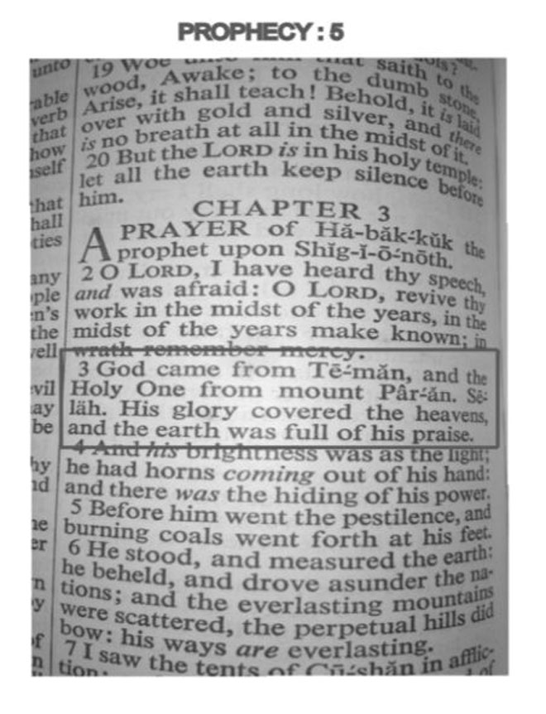

Notes
1. Habakuk 3:3
2. Elamo Al-Wara be A’lamo Al-Huda, Vol. 1, p. 56. Edition: Moa’sasto Ale Al-Bait (a.s.) [Alo Al-Bait foundation]

Chapter 6: Prophecy 6
Ali: Our next prophecy is from the book of Isaiah Chapter 42:17
“They shall be turned back, they shall be greatly ashamed, that trust in graven images, they say to the molten images, ‘Ye are our gods.”1
Who is the Prophet of God who turned a large number of people away from idolatry and pagan worship and taught them to worship the creator of the universes? Who is the Prophet who shattered the hopes and authority of the idol worshippers?
The mighty Prophet of God who did this is none other than The Holy Prophet of Islam (s.a.w.a.)….because at the beginning of the mission of the Holy Prophet (s.a.w.a.) he faced immense opposition from the idol worshippers of Mecca who tried all that they could to stop him from his noble mission.
Ultimately after years of hardship, struggle and danger that forced him to migrate from Mecca to Medina, it was Islam that prevailed and when the Holy Prophet (s.a.w.a.) came back to Mecca after 10 years, the following verse was revealed to him:
In the name of Allah the Beneficent the Merciful
When comes the Help of Allah, and Victory,
And you see men entering the religion of Allah in companies,
Then celebrate the praise of your Lord, and ask His forgiveness; surely He is oft-returning (to mercy).2
John: But, dear brother all these prophecies that you mentioned are from the Old Testament and not the New Testament….Old Testament was for the people before Jesus Christ and not for the followers of Jesus Christ….
Ali: My dear brother, when you want to prove the coming of Jesus Christ the Messiah (a.s.) you require the Old Testament and when we prove that Prophet Muhammed (s.a.w.a.) is mentioned in it, you say “it is in the Old Testament and not the New Testament,” as though it is not a part of the Bible. Nevertheless, if you want I will discuss prophecies about Holy Prophet Muhammed (s.a.w.a.) from the New Testament also.

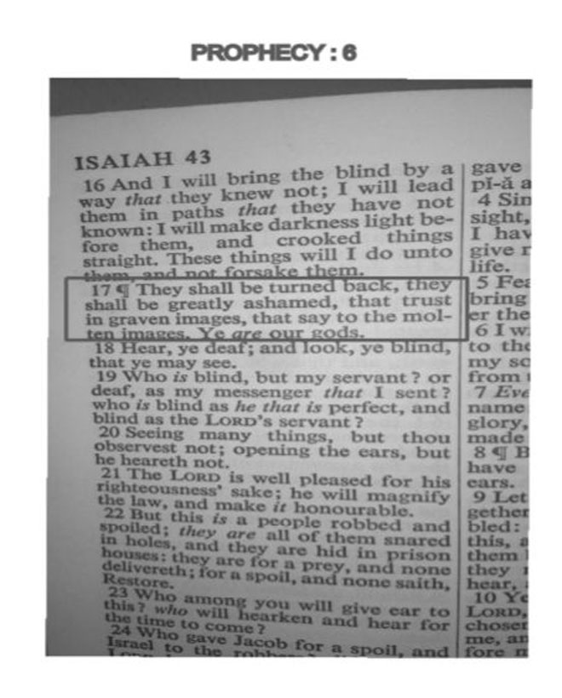

Notes
1. Isaiah 42 Verse 17
2. Sura An-Nasr (Chapter 110)

Chapter 7: Prophecy 7
Ali: Let us discuss a prophecy from John chapter 16: verses 7-8:
“Nevertheless I tell you the truth; it is expedient for you that I go away: for if I go not away, the Comforter will not come unto you; but if I depart, I will send him unto you. And when he is come, he will reprove the world of sin, and of righteousness, and of judgment.”1
In some versions of the Bible the Comforter is translated as the Advocate, Pareclete, helper, etc. However, many versions still retain the word Comforter and Pareclete.
John: This verse speaks about the Holy Spirit and not Prophet Muhammed.
Ali: But my dear brother Jesus (a.s.) says: “for if I do not go away, the Comforter will not come to you; but if I go, I will send him to you….”
And according to the Bible, The Holy Spirit was already present on earth even before Jesus’s birth and during his lifetime… let us see a reference from Mathew chapter 3 verse 16 “And Jesus when he was baptized, went up straightway out of the water. And, lo, the heavens were opened unto him, and he saw the Spirit of God descending like a dove, and lighting up on him.”2
There is another instance where the Bible speaks about the Holy Spirit being present before the birth of Jesus Christ and that is from Luke chapter 1 verses 39-41:
And Mary rose in those days, and went into the hill country with haste, into a city of Juda; And entered into the house of Zacharias and saluted Elisabeth. And it came to pass, that, when Elisabeth heard the salutation of Mary, the babe leaped in her womb; and Elisabeth was filled with the Holy Ghost.3
From the above verses it becomes clear to us that the ‘comforter’ is not the Holy Spirit because the Holy Spirit was already on earth before Jesus’ (a.s.) birth and during his lifetime and Jesus (a.s.) very clearly says that “If I do not go away the Pareclate will not come to you.”
John: If it is not the Holy Spirit then who is it?
Ali: For answer to this question let us study another reference of the Pareclete in the Gospel of John, John Chapter 14 verse 26 says: “But the Comforter, which is the Holy Ghost, whom the Father will send in my name, he shall teach you all things, and bring all things to your remembrance, whatsoever I have said unto you.”4
Now; my dear reader, who is the one who came after Jesus Christ and taught all things and brought to remembrance whatever Christ had said?
Come let us see a reference from the Holy Quran, Surah Aale Imran, that is chapter 3 verses 45-48:
When the angels said: O Marium, surely Allah gives you good news with a Word from Him (of one) whose name is the ‘ Messiah, Isa son of Marium, worthy of regard in this world and the hereafter and of those who are made near (to Allah). And he shall speak to the people when in the cradle and when of old age, and (he shall be) one of the good ones. She said: My Lord! When shall there be a son (born) to me, and man has not touched me? He said: Even so, Allah creates what He pleases; when He has decreed a matter, He only says to it, Be, and it is. And He will teach him the Book and the wisdom and the Tavrat and the Injeel.5

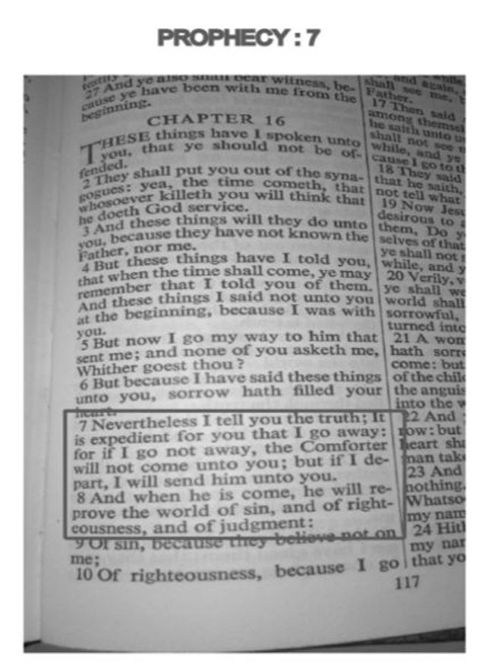

Notes
1. John 16: 7-8
2. Mathew 3:16
3. Luke 1:39-41
4. John 14:26
5. Holy Quran 3: 45-48

Chapter 8: Prophecy 8
Ali: Our next prophecy is from John Chapter 1 Verse 19-21:
“And this is the record of John’s when the Jews sent priests and Levites from Jerusalem to ask him, who art thou? And he confessed and denied not ; but confessed, I am not the Christ. And they asked him, what then? Art thou Elias?” And He said, I am not. “Art thou that Prophet?”And he answered, No.”1
If we carefully observe the sequence of these questions it becomes clear to us that the Jews during the time of Jesus were waiting for two more Holy men to come after Jesus Christ,
One is Elias and the other is ‘that’ Prophet Let us analyze the first question:
Are you the Christ? John the Baptist who is also known as Yahya (a.s.) in the Holy Quran denies being Christ and we all know that Jesus Christ (a.s.) was already present during the time of John the Baptist….
Let us see the second question Art thou Elias?
About Elias (a.s.) Jesus Christ says that he has already come but the Jews did not recognize him…
Let us see John chapter 17 verse 12
“But I tell you, Elias has already come, and they did not recognize him, but have done to him everything they wished. In the same way the Son of Man is going to suffer at their hands.”2
So it is clear to us about Elias that he has already come but the Jews did not recognize him…. Therefore our first two questions are answered….. Now, this brings us to our last question…
Art thou that Prophet?
To which John the Baptist or Yahya (a.s.) denies saying
“No, I am not.”
Now who is the Prophet who came after Jesus Christ (a.s.) and fulfilled all the signs predicted by Jesus Christ…? Let us see some of the predictions of Jesus Christ regarding the one who will come after him in John Chapter 16: 12-14, Christ says:
I have yet many things to say unto you, but ye cannot bear them now. When he, the Spirit of truth, is come, he will guide you into all truth: for he shall not speak of himself; but whatsoever he shall hear, that shall he speak: and he will show you things to come. He shall glorify me: for he shall receive of mine, and shall show it unto you.3
Who is the one who came after Jesus Christ (a.s.) and guided the people into all truth?
Who is the one who did not speak of himself but only spoke what was revealed to him?
And who is the one who glorified Jesus Christ (a.s.)?
For answers to these questions let us see a few verses of the Holy Quran that was revealed to Prophet Muhammed (s.a.w.a.) by the creator and sustainer of the universes:
Surah Aale Imran, that is chapter 3 verses 45-48:
“When the angels said: O Marium, surely Allah gives you good news with a Word from Him (of one) whose name is the Messiah, Isa son of Marium, worthy of regard in this world and the hereafter and of those who are made near (to Allah). And he shall speak to the people when in the cradle and when of old age, and (he shall be) one of the good ones. She said: My Lord! when shall there be a son (born) to I me, and man has not touched me? He said: Even so, Allah creates what He pleases; when He has decreed a matter, He only says to it, Be, and it is. And He will teach him the Book and the wisdom and the Tavrat and the Injeel.”4 (3:45-48)
Let us see another verse from the Holy Quran:
Surah A’raf that is chapter 7 verse 157:
“Those who follow the Messenger-Prophet, the Ummi, whom they find written down with them in the Taurat and the Injeel (who) enjoins them good and forbids them evil, and makes lawful to them the good things and makes unlawful to them impure things, and removes from them their burden and the shackles which were upon them; so (as for) those who believe in him and honor him and help him, and follow the light which has been sent down with him, these it is that are the successful.”5 (7:157)
It is also important to inform you that the Bible translators have changed the word ‘that Prophet’ to ‘the Prophet’.
John: But why?
Ali: Well, the translators would better know why after so many years from the revelation of the Bible, they are still making changes to it…
However, I have provided an image of the Holy Bible where the original word ‘that Prophet’ is still retained…Is it clear to you now?
John: Yes
Ali: Before going to the next prophecy let me also inform you that many researchers have also said that ‘Elias’ in the Bible is the Hebrew equivalent to the Arabic ‘Ali’ who was the successor of Prophet Muhammed’s legacy.

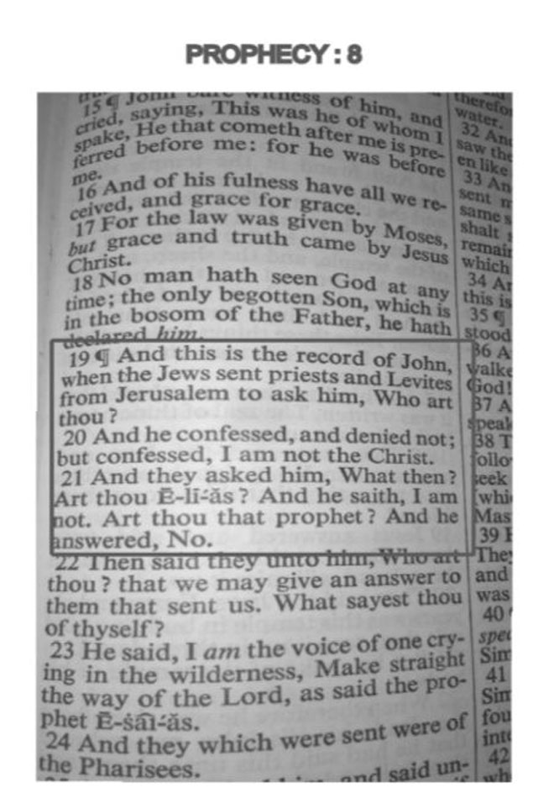

Notes
1. John 1: 19-21
2. John 17:12
3. John 16:12-14
4. Holy Quran 3: 45-48
5. Holy Quran 7:157

Chapter 9: Prophecy 9
Ali: Our next prophecy is from the Book of John, John Chapter 14 verses 15 to 16:
“If ye love me, keep my commandments. And I will pray the Father, and he shall give you another comforter, that he may abide with you forever”1
Now our Christian brothers say that it is about the Holy Spirit. Let us see whether it is indeed about the Holy Spirit. There are many verses about the advocate in the book of John, for example:
John chapter 16 verse 7 where Jesus says… “Nevertheless I tell you the truth; it is expedient for you that I go away: for if I go not away, the Comforter will not come unto you; but if I depart, I will send him unto you.”2
Therefore, it becomes clear to us that the precondition for the Holy Spirit to come; is that Jesus has to go away. And we have clear verses in the Bible stating the presence of the Holy Spirit during the lifetime of Jesus Christ (a.s.) and even before his birth, which we already discussed in Prophecy number 7 of this book.
If we observe these verses, Jesus Christ (a.s.) always refers to the comforter as ‘he’ and not ‘it’, therefore we know that the comforter is a person and not a spirit. Finally, Jesus says ‘He’ i.e: the advocate will abide with you forever.
The comforter my dear brother is none other than Prophet Muhammed (s.a.w.a.) who came with the last revelation of God almighty. Prophet Muhammed (s.a.w.a.) is the last of the 124,000 prophets sent by Allah (s.w.t.) to guide mankind till the day of Judgement. The Holy Quran is the last revelation of God almighty for mankind. Since there will be no Prophets after Prophet Muhammed (s.a.w.a.), God almighty has appointed twelve successors of Prophet Muhammed from his progeny to guide mankind after him. And as the prophecy in John says that the advocate will remain with him forever, the Holy Prophet of Islam (a.s.) says in the famous Hadiths Saqlain:
Narrated Zayd ibn Thabit:
Allah’s Apostle (s.a.w.a.) said:
“I will always leave among you two SUCCESSORS: the Book of Allah, a rope stretching between the heaven and the earth, and my progeny, my Ahl Al-Bayt. Both shall NEVER separate till they return to me at the Lake-Front.”3
The Holy Prophet (s.a.w.a.) has left the Holy Quran and his pure progeny the Ahlul Bayt to guide mankind till the day of Judgment. Now it is upto us whether we accept Jesus Christ (a.s.) advice and the guidance of the Prophet Muhammed (s.a.w.a.) or reject it as those who rejected Prophet Noah, Abraham, Moses and other Prophets of God (a.s.).
Let us see a verse from the Holy Quran Surah Al-Baqarah that is chapter 2 verse 136
“Say: We believe in Allah and (in) that which had been revealed to us, and (in) that which was revealed to Ibrahim and Ismail and Ishaq and Yaqoub and the tribes, and (in) that which was given to Musa and Isa, and (in) that which was given to the prophets from their Lord, we do not make any distinction between any of them, and to Him do we submit.”4
John: Well brother, you said that Prophet Muhammed (s.a.w.a.) had twelve successors, why then do most Muslims not accept them?
Dear brother, in many places The Holy Quran has said that the believers are very few compared to the unbelievers, let me quote you one such verse:
“Until when Our command came and water came forth from the valley, We said: Carry in it two of all things, a pair, and your own family-- except those against whom the word has already gone forth, and those who believe. And there believed not with him but a few.”5
Even the Holy Bible says:
But small is the gate and narrow the road that leads to life, and only a few find it.6
Have you heard about the event of Karbala?
John: Not much.
Ali: The event of Karbala is the biggest proof that just because you are larger in number doesn’t mean you are on the right path. In 61 Hijri Imam Hussain (a.s.) the grandson of Prophet Muhammed (s.a.w.a.) and his third successor courageously stood up against Yazid; the accursed son of Muawiya. This tyrant Yazid was openly committing corruption and destroying the pure religion of Islam and wanted Imam Husain (a.s.) to pledge allegiance to him. So that whatever he did had the implicit approval of the Imam. It was at such a time that Imam Husain (a.s.) refused to pay allegiance to him and stood up against this wretched tyrant. The Muslims very well knew about the status of Imam Husain (a.s.), even the Holy Quran testifies to his purity in Surah Ahzab (i.e: chapter 33 verse 33) and in many occasions the Holy Prophet (s.a.w.a.) has said that “Hasan and Hussain are the leaders of the youth of Paradise” despite such a dignified status of Imam Husain (a.s.) How many people do you think accompanied the Imam when he stood up against Yazid?
John: How many?
Ali: 72, apart from his family members that included children.
These few but God-fearing companions of Imam Husain (a.s.) bravely faced Yazid’s 10,000 strong army on the banks of river Euphrates. Armed with unwavering faith in Allah (s.w.t) and love for his Prophet (s.a.w.a.) and his household (Ahlul Bayt) these companions of Imam Husain (a.s.) sacrificed their lives for truth and justice. History has recorded the atrocities committed on the Imam’s (a.s.) companions; they were deprived of water for three days and slaughtered in the most brutal way the world has ever known.
When thirst had become unbearable and the little children were crying for water, Imam Husain (a.s.) took his six months old Baby Ali Asgar (a.s) to the battle and spoke to Yazid’s army, he said
“Your fight is with me, what is the fault of this six month old child that you deprive it of water?”
While he was still speaking to them, the enemy’s hatred took the form of an arrow and pierced through the tender little neck of his six month old child. Husain (a.s.) stood alone in the battlefield with his last companion martyred. Finally, even Husain (a.s.) who grew up in the house of the Holy Prophet’s (s.a.w.a.) daughter Fatima (s.a.) was slaughtered hungry and thirsty.
This ruthless and atrocious event is also mentioned in the Holy Bible where God promises revenge against the killers of Husain (a.s.)
John: Where in the Bible?
Ali: In the book of Jeremiah chapter 46 verse 10:
“For this is the day of the Lord GOD of hosts, a day of vengeance, that he may avenge him of his adversaries: and the sword shall devour, and it shall be satiate and made drunk with their blood: for the Lord GOD of hosts hath a sacrifice in the north country by the river Euphrates.”7
Therefore brother, numbers don’t have anything to do with the truth.
Shall we go to the next prophecy?
John: Yes sure.

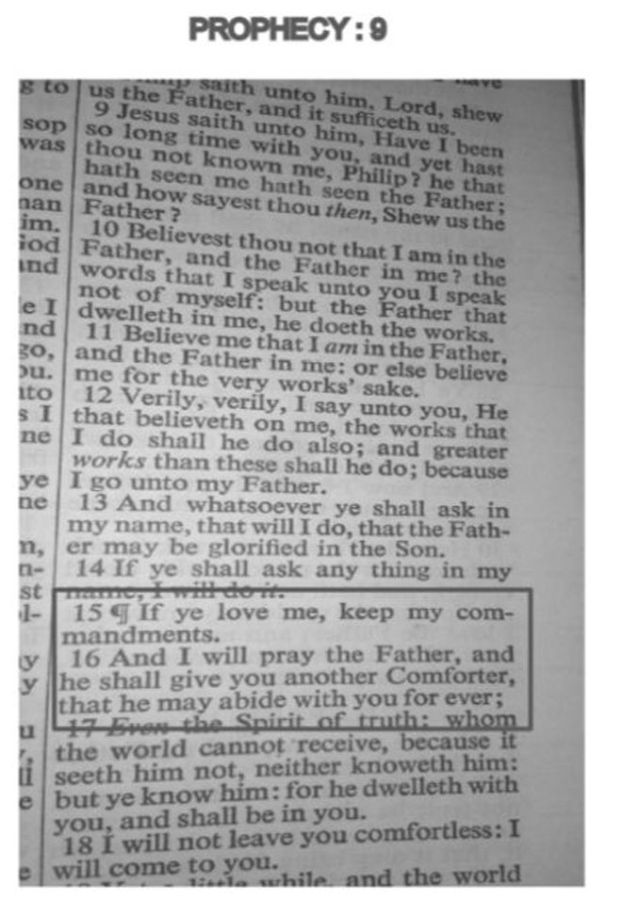

Notes
1. John 14: 15-16
2. John 16:7
3. Musnad Ahamd bin Hanbal, vol. 35, p. 456 - Hadith (narration) No. 21578. Edition: Moa’sasto Al-Resalah - Beirut – Lebanon, First Editon 1999
4. Holy Quran 2:136
5. Holy Quran 11:40
6. Mathew 7:14
7. Jeremiah 46:10

Chapter 10: Prophecy 10
Ali: Our next prophecy is from the Book of Revelation, in chapter 12 of the book, John speaks about a lady with the child, let us read the entire chapter to understand the prophecy.
Revelation 12:
And there appeared a great wonder in heaven: a woman clothed with the sun and the moon under her feet, and upon her head a crown of twelve stars. And she being with child cried, travailing in birth, and pained to be delivered. And there appeared another wonder in heaven: and behold a great red dragon, having seven heads and ten horns, and seven crowns upon his heads. And his tail drew the third part of the stars of heaven and did cast them to the earth. And the dragon stood before the woman which was ready to be delivered, for to devour her child as soon as it was born. And she brought forth a male child, who was to rule all nations with a rod of Iron.
And her child was caught up unto God and to his throne. And the woman fled into the wilderness, where she hath a place prepared of God, that they should feed her there a thousand two hundred and threescore days. And there was war in heaven. Michael and his angels fought against the dragon, and the dragon fought and his angels. And prevailed not; neither was their place found anymore in heaven. And the great dragon was cast out, that old serpent, called the Devil, and Satan, which deceiveth the whole world. He was cast out into the earth, and his angels were cast out with him. And I heard a loud voice saying in heaven, Now is come salvation and strength and the kingdom of our God, and the power of his Christ. For the accuser of our brethren is cast down, which accused them before our God day and night. And they overcame him by the blood of the Lamb and by the word of their testimony; they loved not their lives unto the death.
Therefore rejoice ye heavens and ye that dwell in them. Woe to the inhibiters of the earth and of the sea, for the devil is come down unto you, having great wrath, because he knoweth that he hath but a short time. And when the dragon saw that he was cast unto the earth, he persecuted the woman which brought forth the man child. And to the woman were given two wings of a great eagle, that she might fly into the wilderness, into her place, where she is nourished for a time, and times, and half a time, from the face of the serpent. And the serpent cast out of his mouth water as a flood after the woman, that he might cause her to be carried away of the flood. And the earth helped the woman, and the earth opened her mouth and swallowed up the flood which the dragon cast out of his mouth. And the dragon was wroth with the woman, and went to make war with the remnant of her seed, which keep the commandments of God and have the testimony Jesus Christ.
Ali: Whom do you think this prophecy speaks about?
John: Without any doubt this prophecy speaks about Mother Mary and her son Jesus Christ. Even Mathew Henry in his Bible commentary says that: “It is generally agreed by the most learned expositors that the narrative we have in this and the two following chapters, from the sounding of the seventh trumpet to the opening of the vials, is not a prediction of things to come, but rather a recapitulation and representation of things past, which, as God would have the apostle to foresee while future, he would have him to review now that they were past, that he might have a more perfect idea of them in his mind” (Mathew Henry Commentary)
Ali: Are you sure?
John: Yes of course.
Ali: Can you please read out the first three verses of the Book of Revelation for me….?
John: Yes, of course :
“The revelation from Jesus Christ, which God gave him to show his servants what must soon take place. He made it known by sending his angel to his servant John, who testifies to everything he saw - that is, the word of God and the testimony of Jesus Christ. Blessed is the one who reads aloud the words of this prophecy, and blessed are those who hear it and take to heart what is written in it, because the time is near.”1
Ali: Isn’t it clear that the Book of Revelation speaks about the future events and not the past?’
John: Yes it is….but…the Bible commentators say that it is about the past.
Ali: Well brother, you have a choice whether to believe the Bible commentators or the Bible itself.
John: Alright, if you say it is not about Mother Mary and Jesus Christ, whom is it about?
Ali: Dear brother, the woman here refers to the Prophethood of Prophet Muhammed (s.a.w.a.), who came in all majesty and on whose birth the heaven rejoiced. The Crown of twelve stars refers to the twelve Imams who succeeded Prophet Muhammed (s.a.w.a.) namely Imam Ali (a.s.), Imam Hasan (a.s.), Imam Husain (a.s.), Imam Ali bin Husain (a.s.), Imam Muhammed Baqir (a.s.), Imam Jaffer al-Sadiq (a.s.), Imam Musa Kazim (a.s.), Imam Ali Reza (a.s.), Imam Muhammed Taqi (a.s.), Imam Ali Naqi (a.s.), Imam Hasan Askari (a.s.) and Imam Mahdi (a.t.f.s.).
These are the very 12 who are mentioned in innumerable places in the Holy Bible, for example, Revelation 22:1 which speaks about the river of life that nourishes twelve trees which are a guidance to all nations.
Similarly, there are many hadiths of the Holy Prophet (s.a.w.a.) that speak about twelve Imams both in Shia and Sunni books, let me mention one such hadith:
The Prophet (s.a.w.a.) said, “There will be twelve Muslim rulers (who will lead the Islamic world).” He then said a sentence which I did not hear. My father said, “All of them (those rulers) will be from Quraysh.”2
John: But the crown of twelve can also refer to the twelve apostles of Jesus Christ who spread his message after him.
Ali: Can you name the twelve apostles?
John: Why not...the twelve apostles were Simon (Peter), Andrew, James (son of Zebedee), John, Philip, Bartholomew, Thomas, Mathew, James (son of Alphaeus), Jude (Thaddaeus), Simon (The Zealot) and Judas.
Ali: But I thought Judas was the same apostle who betrayed Jesus and later committed suicide…Then how did he guide the nations after Jesus?
John: There was another apostle called Mathias who replaced Judas…he is believed to have been appointed by Jesus.
Ali: But it is not proved that Mathias was indeed appointed by Jesus or he replaced Judas. Let me quote William Steuart McBirnie from his book ‘In Search for the Twelve Apostles’
“Matthias was chosen as an apostle to take the place of Judas of Kerioth after his betrayal. It is believed that Matthias was one of the “Seventy” disciples sent out by Jesus”3

“HOWEVER, THIS CANNOT BE PROVEN.”
So how can you say that the twelve trees in the Book of Revelation refer to the twelve apostles?
To continue with the prophecy, the great dragon or the old serpent called the Devil and Satan becomes angry over the woman and devices means and ways to destroy her.
But she is helped by God. The earth also helped the woman by drinking the water which was poured out by the serpent. This points out to a very important personality which has helped the last Prophethood.
This great personality is none other than Hazrat Ali (a.s.) and one of the appellations given to him by the Prophet Muhammed is ‘Abu Turab’ which means ‘Father of Earth.’ It was ‘Abu Turab’ (Ali) who safeguarded the Prophet in the holy wars when most of the helpers and supporters deserted the Holy Prophet (s.a.w.a.) in the face of the enemies. In every battle against the pagans, it was Abu Turab (Ali) who protected the Holy Prophet (s.a.w.a.) and had it not been for the bravery and the sacrifice of Ali (a.s.), the Holy Prophet (s.a.w.a.) would have been murdered and thus would have ended the Prophethood of this mighty Prophet of Allah (s.w.t).
Coming back to the dream, when the dragon failed to harm the woman, ‘he went to make war with the remnant of her seed.’
Thus it is proved that this woman is Prophethood and her first child is the Holy Prophet (s.a.w.a.). Therefore, Satan wants to take revenge from her by trying to destroy her progeny who are the successors of the legacy of Prophethood.
It is further written that there was war in heaven between Michael and Satan and that Satan was thrown down and never found place in heaven anymore. Before the birth of the Holy Prophet, Satan used to go to heaven regularly to hear the conversation of the Angels and on his return to earth used to preach the same to people. Through this source people would foretell events. But on the day of the birth of Prophet
Muhammed (s.a.w.a.) the going of Satan to heaven was stopped.
This incident is mentioned in Surah Jin, Chapter 72: 7-9:
“And that they thought as you think, that Allah would not raise anyone; and that we sought to reach heaven, but we found it filled with strong guards and flaming stars. And that we used to sit in some of the sitting-places thereof to steal a hearing, but he who would (try to) listen now would find a flame lying in wait for him.”4
Hence it is clear that Muhammed Mustafa (s.a.w.a.) is the last prophet and his prophethood is strenght and salvation to entire humanity. Moreover, the opposition of Satan to the remnants of his progeny clearly speaks about all the Imams (a.s.) or successors of the Holy Prophet (s.a.w.a.) who were martyred mercilessly until the last of them, Imam Mahdi (a.s.) went into occultation by the command of the Almighty.
John: So who are the Muslims who believe in the twelve successors of the Holy Prophet (s.a.w.a.)?
Ali: The Shia Ishna Asheri or the Twelver Shias.
I hope I have been clear and unambiguous in my explanations and arguments?
John: Yes absolutely and this discussion has made me think and view things in a different way than I usually did. May be we should meet up again and take this further.
Ali: Yes brother I would love to discuss these things with you. But, before I say goodbye let me read out a verse from the Holy Quran about the Christians:
“…..and you will certainly find the nearest in friendship to those who believe (to be) those who say: We are Christians; this is because there are priests and monks among them and because they do not behave proudly.”5

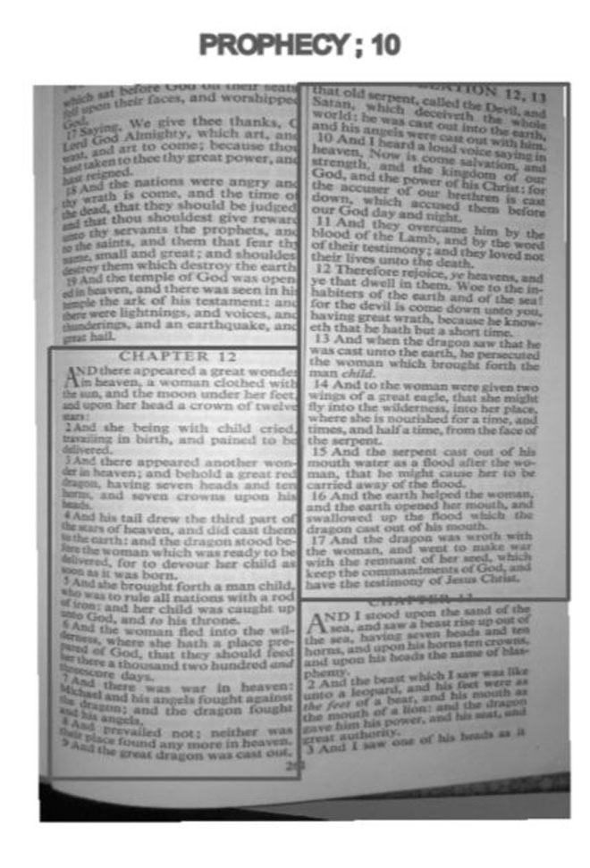

Notes
1. Revelation 1:1-3
2. Sahih Al-Bukharai - Ketabo Al-Hakam - Page no.: 1784 - Hadith’s (Narration) number: 7223 - edition: Dar ibn Katheer - First edition 2002 - Damascus - Syria
3. Luke 10:1
4. Surah 72:7-9
5. Holy Quran Surah Maidah that is chapter 5 verse 82

Conclusion
All Prophets and all scriptures are sent from God Almighty, who wanted to guide humanity towards Himself, these scriptures contained rules, regulations and a way of life for human beings and all of these scriptures spoke about the forthcoming Prophets. But unfortunately, these Prophets and their scriptures were a direct threat to the power hungry and the greedy elite of every society. After the Prophets passed away their teachings were interpolated, changed and twisted to serve selfish ends. Therefore you will see that Islam never criticizes other faiths and religions but respects every religion equally because many of the so-called gods and sons of gods are actually Prophets of God whose messages and teachings were twisted and turned after they had gone.
Dear readers if you wish to undertake a study of Islam, do study the event of Sakifa and Karbala very carefully because these were two important events that shaped the history of Islam and Muslims.
The event of Karbala is guidance to the one who seeks to understand Islam and its true message.
If you disagree with any part of this book you are free to write to my personal email address anthony_jacob3@yahoo.com I’ll try to reply as early as possible.
And if you have liked or benefited from this book, please keep me in your prayers.
I hope and pray that God and his chosen ones continue to bless us with success and keep us on the straight path.
Recommended reads:
1. The Holy Quran translation by M.H.Shakir
2. Seeking the Straight Path-Reflections of a New Muslim by Dianna Beatty.
3. Let us understand each other – Shia Sunni dialogue by Abdul Hadi Abdul Hameed Saleh.
4. Then I was guided by Dr. Tijani al-Samavi.
5. To be with the Truthful by Dr. Tijani Al-Samavi.
6. Ask those who know by Dr. Tijani Al-Samavi.
7. Hazrat Zahra (s.a.) and the Heart Rending Episode of Fadak by Ayatollah Makarem Shirazi.
8. Karbala and Ashura by Ali Husayn Jalali.
9. God An Islamic Perspective by S.S. Akhtar Rizvi
10. Justice of God by S.S. Akhtar Rizvi.
11. Islamic Teaching An Overview by A.S. Mohammed Hosayn Tabatabai.
12. Al-Ghadeer, vol. 1-2 by Allamah Shaykh Abdul Husain Amini (r.a.)

www.alhassanain.org/english

