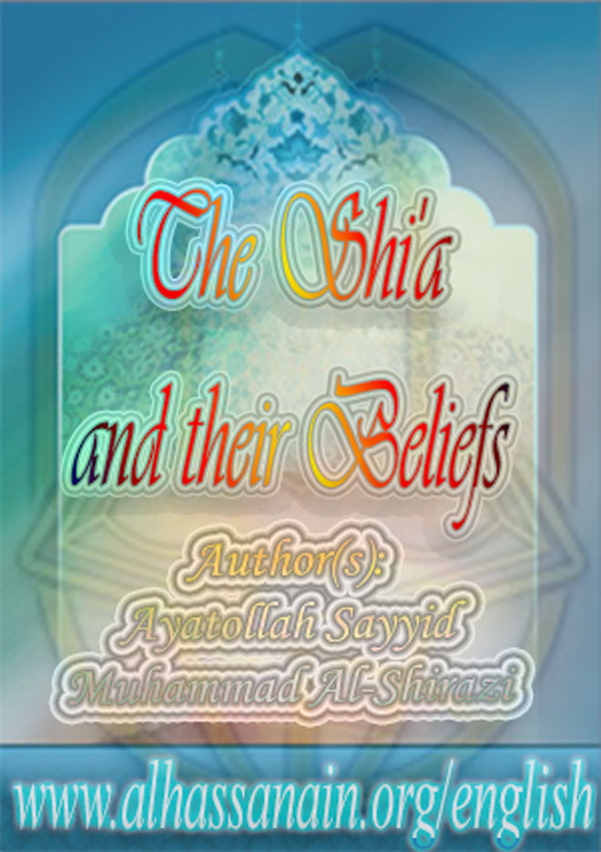

[www.alhassanain.org/english](http://www.alhassanain.org/english)

The Shi'a and their Beliefs

Author: Grand Ayatollah Sayyid Muhammad Al-Shirazi

Translated by: Ali Adam

Published by: Fountain Books

Frist English edition, 2008

ISBN: 1-903323-12-6

[www.alhassanain.org/english](http://www.alhassanain.org/english)

Notice:

This version is published on behalf of [www.alhassanain.org/english](http://www.alhassanain.org/english)

The composing errors are not corrected.

Table of Contents

Foreword 7

The Shia in Brief 9

The Creed of Shia and Sunna 11

Introducing the Shia 12

Islam in the View of the Shia 14

1. Shia Doctrine 14

2. Shia View of Islamic Law 16

The Five Laws 17

Sources of Islamic Law 18

Governance in Islam 19

Power in Islam 20

Sources of Public Wealth 21

Islamic Freedom 22

3. The Islamic System in the View of the Shia 24

Shiite Doctrine 28

Divine Unity (tawhid) 28

Prophethood (nubuwwah) 29

The Prophets 30

Islam 31

The Qur’an 33

Direction of Prayer 34

Imamate 35

The Awaited Imam Mahdi 36

Infallibility 37

Allegiance and Dissociation 38

Resurrection 39

Divine Decree 40

Compulsion and Delegation 41

Dissimulation 42

Temporary Marriage 43

Prostrating upon Pure Earth 44

Combining the Prayers 45

Intercession 46

The Building of Shrines 47

The Visiting of Graves 48

Weeping and Mourning for Imam Husayn 49

No to Slandering and Excommunication 50

Mandatory Duties and Islamic Laws 51

Islamic Morals 52

The Single Nation 53

Cleaning up Society 54

Restoring the Glory of Islam 55

Invitation to Islam 56

Awakening the Muslims 57

Shia Culture 58

General Statistics 58

The Shia and the History of Islam 59

The Shia and Islamic Sciences 60

Successors of the Prophet 61

A Brief History of the Imams 62

Fatima al-Zahra’ daughter of the Prophet 63

Hadith from Fatimah al-Zahra’(AS) 63

The First Imam 65

The Virtues of Ali 65

Hadith from Amir-ul-Mu’minin (AS) 66

Amir-ul-Mu’minin, Imam Ali (AS) also said: 66

The Second Imam 70

Hadith from Imam Hassan (AS) 70

The Third Imam 72

What others have said about Imam Husayn 73

The Fourth Imam 74

Hadith from Imam Zayn al-A idin (A) 74

The Fifth Imam 76

Hadith from Imam Baqir (A) 76

What others have said about Imam Muhammad al-Baqir 77

The Sixth Imam 78

Hadith from Imam Sadiq (A) 78

What others have said about Imam Ja‘far al-Sadiq 79

The Seventh Imam 80

Hadith from Imam Kadim (A) 80

What others have said about Imam Musa al-Kadim 81

The Eighth Imam 82

Hadith from Imam Rida(A) 82

What others have said about Imam Ali al-Rida 83

The Ninth Imam 84

Hadith from Imam Jawad (A) 84

The Tenth Imam 86

Hadith from Imam Had i (A) 86

The Eleventh Imam 88

Hadith from Imam Askari (A) 88

What others have said about Imam Hasan al-Askari 88

The Twelfth Imam 90

Hadith from Imam Mahdi (A): 90

Evidence for the Shiite Point of View 92

The Evidence for the Successorship of Ali 92

1. The Warning of his close family 92

2. The Day of Ghadir 92

3. The tradition of the ‘station’ 93

4. Successorship of other Imams from Prophet’s family 93

5. The tradition of the two weighty things 94

6. The tradition of the Ark 95

Shiism in the eyes of Sunni scholars 96

Shams al-Din al-Dhahabi 97

Shaykh Shaltut 98

The Edict in Full 99

Shaykh Muhmoud Shaltut answered: 100

Sources for Information on Shiism 100

Afterword 101

Transliteration 102

The Author 105

Notes 107

Foreword

In ancient times before human beings stepped upon this earth, a dialogue took place. The angels of the heavens were surrounding the divine throne glorifying the praises of their Lord and never wearying. When Almighty Allah willed it He created mankind, and the dialogue began, as the scene is depicted for us in the Quran thus: “Now your Lord said to the angels: ‘I am placing a vicegerent (khalifah) in the earth.’ They said: ‘Will you place therein one who will cause corruption therein and shed blood, while we glorify your praise and exalt you?’ He said: ‘I know what you do not know1.

Allah creates Adam, peace be upon him, and he descends to the earth bearing within himself ideas, feelings and needs. Little by little the number of individuals increases and societies grow. Some individuals stand face to face in battle and war for their own selves and their interests. Here the mercy of Allah becomes apparent in that he sends messengers and prophets for the guidance of mankind and to save them from the seas of ignorance and error, and take them to felicity and comfort.

But mankind rebels against the prophets and messengers and instead of engaging them in insightful dialogue creates a rowdy atmosphere which takes many forms including refusing to listen, throwing stones, scorning, fathers preventing sons [from following the messengers], and, at its most severe, murder and dissension. On the other hand, we see the behaviour of the prophets and the messengers - kind words, replying to bad with good, bearing hardships, and so on which stems from their faith and their refusal to adopt these violent means.

The dialogue continued on this course until Islam came. Amongst the scenes depicted for us by the Holy Quran regarding the dialogue which took place in ancient times, we see that mankind is invited to reflection and to peaceful and purposeful dialogue and to return to the Allah given human nature (fitrah) and to disavow violence in discussing the issues that concern him.

We notice always in the dialogue that there is a truth which is right and proper to follow after its features have been made clear and the shadows have been removed from it, and after its vital form has been given to it in order to arrive at the desired reality. Dialogue has a number of courtesies which should be observed during discussions, many of which are laid out for us in the Holy Quran in a number of verses, for example invitation [to Islam] with wisdom and fine preaching2; demonstrating clear proofs and evidences3; listening and then following the best of speech4, and so on.

It is on this basis that that the late supreme religious authority Imam Sayyid Muhammad al-Husayn: al-Shirazi, he of encyclopaedic knowledge, universal thought and scope, and Islamic output, undertakes to introduce the school of the household of the Prophet Muhammad (ahl al-bayt), peace be upon them, so that the world may come to know their straight way and the benevolent message of Islam and the happiness it leads to in this world and the next.

Imam Shirazi wrote in a simple and attractive style, and his writings have been translated into a number of languages, and they are distributed in the greatest of Islamic conferences namely the yearly .ajj pilgrimage. This book constitutes a collection of Imam Shirazi’s short works regarding the school of the Prophet’s household which clarify many misconceptions about the school.

The Shia in Brief

The Shia (or Shi’ites) are those Muslims who follow [after the Prophet Muhammad] Ali ibn Abi Talib Commander of the Believers, and his pure progeny, peace be upon them.5 They constitute more than 500 million people and are spread throughout all the Muslim lands and make up minorities of differing number in most other countries of the world. Their numbers have increased day by day particularly since the crystallisation of Islamic thoughts and the opening of the door to dialogue and the rejection of blind partisanship.

They believe in Allah as their Lord, Cherisher and Sustainer, in Muhammad, blessings and peace be upon him6, as their prophet, in Islam as their religion, in the Quran as their holy book, in the Kabah in Mecca as their direction of prayer (qiblah), in the questioning in the grave by the angels Munkar and Nakir, in the accounting on the day of resurrection, in heaven and hell, and in all that Allah’s messenger - Muhammad (S) - brought from his Lord.

They also establish the daily prayer (Salah), and pay the ftithe (khums) and obligatory alms (zakah), and they fast the month of Ramazan, and make pilgrimage to the Holy House in Mecca, and they make it incumbent to struggle with might and main (jihad) in the way of elevating the word of Islam, and they enjoin what is good and they forbid what is bad, and they ally themselves with the friends of Allah, and are against the enemies of Allah. They are foremost in good and charitable deeds, and are steadfast in fulfilling extra and recommended acts of worship, and adopting virtues and avoiding unlawful things and vices.

They believe that Islam is a complete religion which was revealed by Allah for the happiness of mankind. Hence, everything in Islam should be implemented in the various areas of life since there is no happiness without implementing the laws of Islam and having no need for the laws of the east or the west.

Almighty Allah has said: “And whoever desires other than Islam as a religion, it will never be accepted from him and in the afterlife he will be amongst the losers 7 Also, in the traditions it is said: ‘That which Muhammad has declared lawful will remain lawful until the day of resurrection and that which he has declared unlawful will remain unlawful until the day of resurrection’8. They also believe that it is obligatory to unite the Muslims under one banner as Almighty Allah has ordered: “And hold on firmly to the rope of Allah and do not be disunited9 and eAnd do not dispute amongst yourselves so that you will fail and your power will go10.

They also believe that it is necessary to solve the differences that have arisen and caused disunity between Muslims, doing so in the light of the book of Allah and the authentic traditions (sunnah) far from different groupings and hateful and unwarranted partisanships and cliques.

They also believe that any law which goes against Islam is unlawful and wrong and should not be acted upon, as Almighty Allah has said: “And whoever does not rule by what Allah has revealed, then they are the unbelievers11.

The top scholars of the Sunni school of thought have ruled that it is permissible to follow and adopt the Shiite school of thought. They include Shaykh Mahmud Shaltut the former rector of the University of al-Azhar in Cairo, Egypt and others.

The Shia are distinguished in that they hold that the door to independent legal judgement (ijtihad) remains open; and in that reason (aql) is central to the divine law as well as the Quran, the traditions and consensus. They have a glowing history from the dawn of the message of Islam until today. The Shiite element was the most active in establishing Islamic thought and in building Islamic civilisation. They have to their credit innumerable writings.12 They have a tremendous number of schools, institutes, libraries, scholars and preachers in Islamic and non-Islamic lands.

They controlled [throughout history] a number of states in differing lands.13 They distinguished themselves throughout history with their long struggle against the unbelievers, the crusaders, the heretics, the Zionists and the colonialists. All along the way there was between them and their Sunni brothers brotherhood and friendship and interaction and companionship.

They are found today in most if not all of the countries of the world. However, the main Shia population centres are Iraq, Iran, the Gulf states, Pakistan, India, Afghanistan, Lebanon and Indonesia. Currently thay have educational and cultural institutes and top scholars in Najaf, Karbala, Baghdad, Kadhimiyyah, Samarra, Beirut, Cairo, Qum, Khurasan, Tehran, Karachi, Mumbai, Jakarta, Kuwait, Qatar, Ahsa’ and QaUif provinces (Arabia), Afghanistan, Damascus, Libya, Tunisia, Algeria, Jordan, African countries, Europe, America and elsewhere.14

The Creed of Shia and Sunna

The world’s Muslims are divided into two groups - the Shia who number more than 500 millions, and the Sunnis who make up the rest of the Muslims. There is no difference between the two groups regarding the three fundamentals of the religion which are:

1. Belief in monotheism (tawhid).

2. Belief in prophethood (nubuwwah).

3. Belief in the resurrection (maad).

All Muslims believe in the existence of the one diety who is eternal and everlasting, all-knowing and all powerful, ever living and self subsisting, having no partner, and having all the beautiful attributes.

All Muslims also believe that Allah sent rightly guided prophets to mankind as guides to direct them to the truth and to happiness in this world and the next, and that Muhammad ibn Abdullah (S) is the ‘seal’ or last of the prophets and that there is no prophet to come after him. Similarly, all Muslims believe that when a person dies and his/her body perishes his/her soul (or spirit) remains and he/she will be brought back to life on the day of resurrection. Whoever has done good in the earthly life will be of the people of the garden of heaven and bliss, and whoever has done ill in the earthly life will be of the people of punishment and hellfire.

As for divine justice (adl)15, the Shia believe that Almighty Allah is just and does not wrong anyone and does not act without purpose.

And as for Imamate, the Shia believe also that the Prophet of Islam Muhammad (S) appointed twelve successors and said: ‘The successors (khulafa’) after me will be twelve.’16 He (S) also said: ‘Whoever dies without knowing the Imam (leader) of his time has died the death of the age of ignorance.’17 These twelve successors were named18 by the messenger of Allah (S) himself and they are, in order:

1. Imam Ali ibn Abi Talib (Amir al-Mo’mineen) (a.s.).

2. Imam Hasan ibn Ali. (al-Mujtaba) (a.s.).

3. Imam Husayn ibn Ali (Sayyid al-Shuhada) (a.s.).

4. Imam Ali ibn Husayn (al-Sajjad) (a.s.).

5. Imam Muhammad ibn Ali (al-Baqir) (a.s.).

6. Imam Jafar ibn Muhammad (al-Sadiq) (a.s.).

7. Imam Musa ibn Jafar (al-Kadim) (a.s.).

8. Imam Ali ibn Musa (al-Riza) (a.s.).

9. Imam Muhammad ibn Ali (al-Jawad) (a.s.).

10. Imam Ali ibn Muhammad (al-Had:) (a.s.).

11. Imam Hasan ibn Ali (al-Askar:) (a.s.).

12. Imam Muhammad ibn Hasan (al-Muntadar al-Mahdi) (a.s.).

The last of the successors of these pure people is the Imam who is Muntadar (the awaited) Mahdi (rightly guided Imam) who is alive in this world but hidden from sight and who will appear at the end of time when Allah grants him permission so that he can fill the earth with justice and equity after it having been filled with wrongdoing and oppression. Then the servants of Allah will unite under his banner in a single Islamic government which will flourish by the will of Allah. There are widespread traditions about him reported from the Prophet Muhammad (S).19 The Shia have brought forward proofs and evidences for these two fundamentals of religion (osool al-deen) - divine justice and Imamate - from both rational and traditional sources. As for the ‘branches’ of Islam (furu al-deen) meaning the acts of worship and social contracts and all other laws and rulings of Islam, Shia Muslims have stated that the sources for them are four:

1. The Holy Quran. This is the book which is in the hands of the Muslims today. It has neither been added to or subtracted from.

2. The Purified Traditions (the sunnah) reported from the Prophet (S) and his pure family (a.s.).

3. The consensus (ijma) of the Muslims.

4. Reason.

They have also said that the door to independent legal judgement (ijtihad) is open, so whoever derives - according to the proper conditions - a ruling from these four sources may act upon it.

## Introducing the Shia

The word ‘Shia’ is derived from an Arabic word meaning ‘following’. The word Shia is applied in the Holy Quran to the followers of Noah (a.s.) as Almighty Allah says: “And indeed amongst his followers (Shia) was Abraham 20 The Prophet (S) applied the name Shia to the followers of Imam Ali (a.s.) and named them with this name, and it is related by historians and traditionalists of the Shia and the Sunni schools alike in their books that the Prophet (S) said: ‘O Ali, you and your Shia (followers) are the ones who will triumph.’21 Thus the followers of Imam Ali (a.s.) were known by this name from the days of the Messenger of Allah (S) who was the first to apply this name to them. And since the speech of the Messenger (S) is revelation from Almighty Allah who has said in the Holy Quran [referring to the Prophet]: “And he does not speak of his own desire, it is nought but revelation revealed to him 22 it follows that naming the Shia this name is nothing but revelation from Almighty Allah.

The Shia are those Muslims who follow Amir al-Mo’mineen (Commander of the Believers) Imam Ali ibn Abi Talib (a.s.) and his pure sons (a.s.) after the Messenger of Allah (S); and this is following the order of the Noble Messenger (S) who said before his death: ‘I am soon to be called and will answer, and I am leaving with you the two weighty things (thaqalayn). As long as you adhere to these two you will never go astray after me ever; the book of Allah and my family; the people of my house.’23 The Messenger of Allah (S) also said: ‘Ali is with the truth and the truth is with Ali.’24

He (S) also said: ‘There will occur dissension after me. When this happens then align yourselves with Ali ibn Abi Talib for he is the first who will see me and the first who will shake my hand on the day of resurrection and he will be with me in the highest heaven and he is the criterion (al-faruq) between truth and falsehood.’25 He (S) also said: ‘There will occur dissension after me. When this happens then align yourselves with Ali ibn Abi Talib for he is the criterion (al-faruq) between truth and falsehood.’26 He (S) also said: ‘Amongst the people there will occur schism and difference but this man (meaning Ali [a.s.]) and his companions are in the right.’27

The Shia are also named the ‘Imamites (imamiyah)’ as they believe in the imamate of Ali, Amir al-Mo’mineen (Commander of the Believers), and his eleven sons and grandsons (a.s.).

They are also named the ‘Jafarites (jafariyah)’ since they follow the Imams of the people of the prophet’s house (the Ahl al-Bayt) in matters of what is lawful and unlawful since these Imams are most knowledgeable of the book of Allah and what the Messenger of Allah (S) said. The sixth of these Imams is Jafar ibn Muhammad (known as ‘al-Sadiq’, ‘the truthful’). He was able to propagate Islamic teachings - the fundamentals (osool al-deen), branches (furu‘ al-deen), etiquettes (adab) and ethics (akhlaq) - in a more comprehensive and complete manner, something which conditions did not permit the rest of the Imams to do in such a complete way. The Shia took from Imam Jafar most of the features of their religion and for this reason they are related to him. The other Imams did not have as much opportunity to do this as they met with troubles as in the time of Ali and his sons Hasan and Husayn (a.s.), or with oppression and terror from the Umayyad and Abbasid Caliphs. However, Imam Sadiq (a.s.) lived during a period in which the Umayyad dynasty was in decline and the Abbasid dynasty was in ascendance and he took the opportunity to spread the realities of Islam on a wide scale. The Shia are also named the ‘Twelvers (ithn" Ashariyah)’ as they believe in the Imamate of the twelve Imams of the Prophet’s house, the prophet having said: ‘The successors after me will be twelve in number.’28

The Shiite sect, then, is a practical form of Islam as the Prophet (S) and his pure household put forward. The other Islamic sects are practical forms of Islam as put forward by these particular sects’ leaders.

Islam in the View of the Shia

Islam in the view of the Shia consists of doctrine (aqidah), law (shariAh) and system (nidam).

1. Shia Doctrine

The Shia believe in Allah as their Lord, who is just and who has no partner or associate (sharik). They believe in Muhammad (S) as their Prophet, in Islam as their religion, in the Quran as their holy book, in the Kabah in Mecca as their direction of prayer (qiblah), and that all that Muhammad brought from his Lord was the truth, and that Allah will bring back to life those who are in the graves, and that heaven and hell are realities, and that mankind has freedom to choose in this life (without compulsion or delegation) and that if he acts well he will be rewarded for it and if he acts badly he will be punished for it.

The Shia also believe that the religion of Islam is complete and lacks nothing, as Allah revealed it and the trusty Messenger (S) and his pure successors (a.s.) propagated it. It is the one religion which must be followed in doctrine and in actions and any deviation from it brings about calamity in this life and tribulation in the next life, while adherence to it brings about happiness in this life and the next. It is a complete way of life that addresses the human being in his entirety. Hence it is concerned with nurturing the soul or spirit just as it is concerned with nurturing the body, it deals with values as well as with systems.

The fundamentals or roots of the religion in the view of the Shia are five in number:

1. Divine unity.

2. Divine justice.

3. Prophethood.

4. Imamate.

5. Resurrection.

Divine unity means that Allah is one and has no partner and no equal as Almighty Allah has said in the Quran: “Say: He is Allah unique, Allah the eternal, He begets not nor was He begotten, and there is none like unto Him29 Divine justice means that Allah is just and does not wrong anyone or tolerate wrongdoing.

Prophethood means that Allah by His grace has sent prophets to mankind to clarify the way of good and bad and to direct them to the good and prevent them from the bad. Imamate means that the Messenger of Allah (S) appointed, by order of Allah, his twelve successors to come after him and named them one after the other and specified them by name and epithet and fathers’ and mothers’ names just as every Imam specified the succeeding Imam. Hence it is obligatory to follow them and to take the features of the religion from them. Their names were mentioned previously [on page 13].

Resurrection means that Almighty Allah will revive creation on the day of resurrection and reward those who do good and punish those who do bad. eAnd whoever does a speck’s weight of good will see it and whoever does a speck’s weight of bad will see it 30. tails of these five fundamentals please refer to the books and encyclopaedias of the Shia such as: sharh al-tajrid31, Abaqat alanwar32, al-ghadir33, al-fusul al-muhimmah34, or al-murajat35. These are amongst thousands of books authored by the Shia scholars in this regard.

2. Shia View of Islamic Law

In the view of the Shia, Islamic law or shariah consists of:

1. Acts of Worship. These are the acts by which nearness is sought to Allah and include daily prayers (Salah), fasting (sawm), tithe (khums), almsgiving (Salah), pilgrimage (hajj), struggle (jihad), purification (taharah), spiritual retreat to the Mosque (itikaf), and enjoining the good and forbidding the bad etc.

2. Contracts (muamilat) such as selling, renting, endowments and mortgages etc.

3. Ethics (akhlaq) which consist of: virtues which Islam has made either obligatory or recommended such as truthfulness, honesty, bravery, chivalry, activity and the like; and vices which Islam discourages either by forbidding or by considering them reprehensible such as betrayal, lying, cowardice, inactivity, causing corruption etc.

4. Etiquettes (adab) which are the actions Islam considers to be courtesies such as the courtesies of sleep and wakefulness, of marriage, or of gatherings, travel and the like.

5. Laws (ahkam) which comprise obligatory (wajib), forbidden (haram), recommended (mustahab), reprehensible (makruh), and neutral (mubah). They are also divided into taklifiyah (duty bound) and wadiyyah (statuary) such as the laws of marriage and divorce and inheritance, and justice, penal codes and compensations.

The Five Laws

There are five types of laws (ahkam):

1. Obligatory (wajib).

2. Forbidden (haram).

3. Recommended (mustahabb).

4. Reprehensible/Discouraged (makruh).

5. Neutral (mubah).

Obligatory acts are those which Islam has made compulsory such as prayer, fasting, almsgiving, pilgrimage, and struggle. Forbidden acts are those which Islam prevents such as drinking alcohol, eating pork, gambling, dealing in usury, and adultery. Recommended acts are those which Islam encourages with permissibility of not doing them such as daily optional prayers (nafilah, pl. nawafil), recommended charity, and fulfilling other people’s needs.

Reprehensible acts are those which Islam discourages without making them forbidden such as divorce. Neutral acts are those the doing of which or not doing are considered equal in the view of Islam such as the drinking of water.

Sources of Islamic Law

The Shia believe that the sources from which Islamic law is derived are four in number and are:

1. The Holy Quran.

2. The Traditions (sunnah). These are the sayings, actions and ratifications of the Messenger of Allah Muhammad (S) as well as that of the infallible Imams of his household (Ahl al-Bayt) (a.s.).

3. Consensus (ijma).36

4. Reason. It is related that ‘Allah has two proofs [over mankind] - an outward proof which is the prophets, and in inward proof which is reason.’37

Therefore, the Shia take their legislation from the Holy Quran and the traditions of the Messenger (S) and his pure household (a.s.) acting upon the tradition of the ‘two weighty things’.38 They also consider these four to be the source of Islamic legislation and that no individual or group may legislate a law which goes against them as any other legislation is false. Almighty Allah has said: “And whoever does not rule by what Allah has revealed, then they are the unbelievers 39.

A great deal in the way of Quranic exegesis, jurisprudence, traditions, information about the beginning of creation and the end of time, fundamentals and branches of the religion and other branches of knowledge have been related from the Prophet Muhammad (S) and his household (a.s.). The scholar Muhammad Baqir al-Majlis: collected a large amount of these traditions in over 100 volumes and named the book Bihar al-Anwar (Oceans of Lights). In these traditions there is enough to grant the Muslims, indeed the whole of humanity happiness in this world and the next.

Governance in Islam

The Shia believe that there are two aspects to ruling in the view of Islam:

1. A permanent aspect concerned with the ‘ruler’ and the ‘law.’ Thus the ruler must be male, a believer, of pure birth (not illegitimate), and a jurist. The law must be derived from the four sources of legislation.

2. A developing aspect concerned with the way in which the Islamic Law is implemented. This aspect is subject to independent legal judgement and it is the responsibility of the jurist-consults/authorities to make their views known in this aspect according to stipulated legal checks and balances.

Power in Islam

The Shia also believe that holy struggle (jihad) is a kifaie (common) obligation whereas defence is an ‘ayni (individual) obligation40. Hence, it is mandatory for the Islamic state to prepare the requisite number of Muslims by the ways mentioned in Islamic law so that it may have a preventative force which will protect them and their interests wherever they are.

This power is not solely confined to military power but includes intellectual, economic and industrial power so that the prophetic tradition ‘Islam is above all and none shall be above it’41 may be realised.

Sources of Public Wealth

The Shia believe that the sources of public wealth are the khums (tithes), zakah (obligatory alms), jizyah (tax paid by non-Muslims living under the protection of the muslim state), kharaj (tax paid on certain categoriesof land), tijarah (trading), and such like. This wealth is spent in ensuring the public good and preventing individual hardship so that under the reign of the Islamic government no public good is left neglected and no one suffers from poverty or that his/her essential needs are not met.

The Shia also believe that Islam allows private ownership on condition that the wealth is obtained legally and that the owner pays his dues on it. Under no circumstances is the wealth of the people to be usurped. At the same time, Islam protects the rights of the worker and the farmer as well as those of the employer and landlord so that there is no inflation or no feudal system, and no ‘cheap/free labour’ or oppression.

Islamic Freedom

The Shia believe that freedom is one of the fundamental goals of Islam; for Allah sent his noble Prophet Muhammad (S) to: “Put off their heavy burdens and the fetters that were upon them”42 The Muslim then has full freedom to express his/her opinion in speech and in writing as well as full freedom in his/her social contracts, to travel, to marry, and to trade.

This wide scale freedom which Islam gives to its people prepares the practical and psychological climate for success in its efforts so that the Islamic society grows and flourishes. For this Islam, firstly, combats the four causes of backwardness which are:

1. Ignorance. Islam works to make education general by making learning compulsory as in the tradition: ‘The seeking of knowledge is an obligation for every Muslim man and woman.’43 Islam also encourages the learning of different sciences as in the tradition: ‘If the people knew the benefits of seeking knowledge they would seek it even by crossing the seas and shedding one’s blood.’44 Also amongst many other traditions it is said that: ‘The Angels lower their wings to the seeker of knowledge [in humility before them].’45

2. Poverty. Islam prohibits idleness, prevents unemployment, and encourages those who are able to work to do so and makes the State responsible for those who are incapable of work.

3. Illness. In Islamic Law there are many laws which are there to prevent and cure many diseases. Furthermore Islam actively promotes medicine to be widely available. In the traditions: ‘Knowledge is of two types - knowledge of religion and knowledge of bodies (i.e. medicine).’

4. Vice. Islam bases society in a way that no-one is forced to commit vices and puts in place preventative punishments - under stipulated conditions - for those who do.

Secondly, Islam works to promote peace and stability so that there is an environment for the flourishing of industry, trade, agriculture, and construction.

Islam also frees up all powers & energies to take part in encouraging growth: it frees up human potential since it makes marriage easy and prohibits adultery, it strengthens the pillars of the family and encourages a high birth rate so that the Islamic nation may be the largest as well as the most powerful. It also sets free the potentials of land and water for ‘the land belongs to Allah and whoever develops it’46, and water belongs to whoever stakes it off and uses it, and any Muslim can develop or plant what land he/she is able to.

Islam also frees up the potentials of labour since there should be no borders between Islamic lands and all of Islamic lands are a wide area for the use of all Muslims, and any Muslim may travel and work and live anywhere he/she wishes.

All Muslims are also brothers in Allah. Hence there are no sectarianism, tribalism, nationalism, or racism in Islam. These are the bare bones of the ideas of the Shia in a number of fields and these are the bases upon which the Muslim entity was raised when it was raised high and touched the clouds and was so wide that the clouds did not encompass it.

3. The Islamic System in the View of the Shia

The Shia believe that the Islamic system consists of the laws which regulate the life of a person from before birth until after death. They also regulate society and strive to develop the land and advance life and bring about the happiness of mankind in this life and the next. These laws are such as the laws of selling, renting, trade, politics, economics, the army, the State, agriculture, construction, mortgages, travel, residency, security, marriage, divorce, the judiciary, testaments, reparations, inheritance, etc.

To show the comprehensiveness of Islam and that it answers every need of mankind and society we have selected from the Holy Quran and the traditions some texts which show the broad lines of Islamic thought in all areas of life:

1. Doctrine. Almighty Allah has said in the Quran: “Say: We believe in Allah and what He has revealed to us and what He revealed to Abraham and Ishmael and Isaac and Jacob and the Tribes and what was given to Moses and Jesus and what was given to the prophets from their Lord 47. 2. Worship. Almighty Allah has said in the Quran: “And I did not create mankind and the Jinn except that they may worship Me 48.

3. Education. Almighty Allah has said in the Holy Quran: “Are they equal? - Those who know and those who do not know”49. Also, in the traditions: ‘The seeking of knowledge is compulsory for every Muslim man and woman.’50.

4. Equality - No racial discrimination. Almighty Allah has said in the Holy Quran: “The most honourable of you in the sight of Allah is the most pious of you”51. Also, in the traditions:

‘People are equal like the tooth of a comb’52.

5. Peace. Almighty Allah has said in the Holy Quran: “O you who believe, enter into peace one and all 53.

6. Honour. Almighty Allah has said in the Holy Quran: “And we have honoured the sons of Adam and have borne him in the land and in the sea and we have sustained them with the good things”54.

7. Trade. Almighty Allah has said in the Holy Quran: “O you who believe, do not eat up your wealth amongst yourselves unjustly, but it should be trade by mutual consent amongst yourselves”55.

8. Politics. Almighty Allah has said in the Holy Quran: “And their affairs are [decided by] mutual consultation amongst themselves”56.

And in the hadith, “[The Almighty] made ye [the Ahl al-Bayt] the leaders of the people”.57

9. The Army and Power. Almighty Allah has said in the Holy Quran: “And prepare for them what you can in the way of force”58.

10. The Conquest of Space. Almighty Allah has said in the Holy Quran: “O you the Jinn and mankind, if you are able to penetrate the realms of the heavens and the earth then do so. uou will not do so without authority”59. Also in the traditions: ‘If knowledge was to be found in the Pleiades men would attain it.’60, and in another tradition: ‘I am more knowledgeable about the ways of the heavens than the ways of the earth.’61

11. Love. Almighty Allah has said in the Quran: “And He has placed between you love and mercy”62.

12. Freedom. Almighty Allah has said in the Holy Quran in description of the Prophet (S): “And he puts off their heavy burdens and the fetters that were upon them”63. Also, in the traditions: ‘Do not be the slave of another when Allah has made you free.’64 Also, there is the Islamic principle [which is derived from the prophetic hadith]: ‘people have authority over their wealth and their selves.’65

13. Combatting Crime. Almighty Allah has said in the Holy Quran: “And do not transgress”66 He has also said: “And whoever transgresses thereafter will have a painful torment”67. He has also said: “Verily the punishment of those who make war on Allah and His Prophet and strive to make corruption in the land is that they be killed or crucified or that their hands and feet be cut off”68.

14. Cleanliness. Almighty Allah has said in the Holy Quran: “Verily Allah loves those who repent and He loves those who purify themselves”69. In the traditions: ‘Cleanliness is a part of faith.’70

15. Beauty. Almighty Allah has said in the Holy Quran: “Put on your finery at every prayer place”71. And in the traditions: ‘Allah is beautiful and loves beauty.’72

16. Health. Almighty Allah has said in the Holy Quran: “And eat and drink but do not be excessive”73. In the traditions: ‘Fast and be healthy.’74, ‘Make the pilgrimage and be healthy.’75, and ‘Travel and be healthy.’76

17. Making use of the potentialities of the universe. Almighty Allah has said in the Holy Quran: “And He has made subject to you the sun and the moon, contatnt in their courses, and he has made subject to you the night and the day g and He has given you all that you asked of Him”77.

18. Reconciliation. Almighty Allah has said in the Holy Quran:

“And reconciliation is best”78. He has also said: “And if two groups of believers fight then make peace between them”79. He has also said: “If the two of them seek to put things to rights then Allah will bring accord between them”80.

19. Co-operation. Almighty Allah has said in the Holy Quran: “And co-operate in righteousness and piety”81.

20. Unity. Almighty Allah has said in the Holy Quran: “And this is your nation - a single nation”82. He has also said: “And be not disunited”83. He has also said: “And do not dispute amongst yourselves lest you fail and your power will go”84.

21. Work. Almighty Allah has said in the Holy Quran: “And say: act”85. Also, in the traditions: ‘One who toils to support his dependants is like one who engages in holy struggle in the way of Allah.’86

22. Virtue and good morals. Almighty Allah has said of the Prophet (S) in the Holy Quran: “And he purifies you and teaches you the book and wisdom”87. The Almighty also said regarding the Prophet (S): “And indeed you have sublime morals”88. Also, in the traditions related from the Prophet (S): ‘I was sent to perfect the noblest of morals.’89

23. Tranquillity and the absence of anxiety. Almighty Allah has said in the Holy Quran: “Indeed it is through the remembrance of Allah that the hearts find tranquility”90. He has also said: “And whoever believes in Allah, He will guide his heart”91.

24. Justice. Almighty Allah has said in the Holy Quran: “And if you speak then be just”92 He has also said: “And stand upright in equity”93. He has also said: “Verily Allah orders justice and benefaction”94.

25. Responsibility and social vigilance. Almighty Allah has said in the Holy Quran: “Let there be of you a nation which invites to what is best, and orders good and forbids evil”95.

26. Progress. Almighty Allah has said in the Holy Quran: “Race towards the good things”96. Also, in the traditions: ‘Whoever has two days the same is a loser.’97

27. Seeking the middle course in all things. Almighty Allah has said in the Holy Quran: “And in this way we made you a nation of the middle”98.

28. Riches. Almighty Allah has said in the Holy Quran: “And if only the people of the towns had faith and piety we would open upon them blessings from the heavens and the earth”99. In the traditions: ‘How excellent a helper in religion is independence.’100

29. Social Responsibility. Almighty Allah has said in the Holy Quran: “And know that whatever you gain one fifth of it belongs to Allah”101. He also has said: “Verily charity is for the poor and the indigent . . .”102.

30. Ease and Tolerance. Almighty Allah has said in the Holy Quran: “And for you to forgive is closer to piety”103 He has also said: “Allah desires for ye ease and He does not desire hardship for ye”104.

31. Civilisation. Almighty Allah has said in the Holy Quran: “He raised you up from the earth and let you dwell therein”105. He has also said: “And We made from you peoples and tribes so that you may know one another”106. Also, in the traditions: ‘Seek knowledge, for if you do not you will be nought but uncivil desertdwellers.’107

32. Life . . . with all that is meant by the word ‘life’. Almighty Allah has said in the Holy Quran: “O you who believe, respond to Allah and to the Messenger when he calls you to what will give you life”108.

33. This world and the hearafter. Almighty Allah has said in the Holy Quran: “And of them there are those who say: O Our Lord, give us in this world good and in the next world good”109. In the traditions: ‘Work for your worldly life as if you will live forever; and work for your afterlife as if you will die tomorrow.’110

34. A law for everything. Almighty Allah has said in the Holy Quran: “Today I have completed for ye your religion and perfected my blessings upon ye”111. He has also said: “And We sent down upon you the book as an explanation of everything”112.

35. Manufacture. In the book nahj al-balaghah related from Imam Ali (a.s.): ‘And have concern for the merchants and craftsmen and give them good counsel.’113 Ali (a.s.) also said:

‘There is no basis to society without merchants and craftsmen.’114

36. Agriculture. In the traditions it is said: ‘The farmers are Allah’s treasures in the earth.’115

37. Development. Also in the book nahj al-balaghah: ‘And let your concern for developing the land be more far reaching than your concern for extracting the land tax.’116

38. Organisation. In the traditions: ‘I urge you by Allah to organise your affairs.’117

39. Empathy between the government (the legal authorities) and the people. Almighty Allah has said in the Holy Quran:

Obey Allah and obey the Messenger and those in authority over you”118. In the book nahj al-balaghah: ‘Let your heart feel mercy for your subordinates.’119

40. Lastly . . . universality. Almighty Allah has said in the Holy Quran regarding the Prophet (S): “And We sent you not but as a mercy to the worlds”120. He also said: “And We sent you not but as a bearer of good news and a warner for all the people”121. In the traditions: ‘The people are of two types - either your brother in religion or your equal in creation.’122

Thus the Shia are the practical and authentic expression of the way of Islam as put forward by the Prophet (S) and his pure household (a.s.). They are the practical form of all that is mentioned in the Holy Quran and the traditions.

Shiite Doctrine

Shiite doctrines and beliefs are derived from two original sources of Islam - the Quran and the sunnah (the teachings of the prophet Muhammad). They can be summarised as follows:

Divine Unity (tawhid)

The Shia believe that Allah (Allah ) is the Lord and sustainer and that he is the creator of this wide existence which contains millions of galaxies in which are stars larger than our sun by sixty million times, the sun being larger than the earth by thousands of times. This is Allah who has no partner or associate and He is just in his acts and commands, everlasting and subsisting, eternally living, all knowing and all powerful, giving of life and death. In His hands is all good and He has power over all things.

Prophethood (nubuwwah)

The Shia believe that Muhammad (S) is their Prophet and that he was sent as a mercy to the worlds by Allah, and that he is the last and ‘seal’ of the prophets. He came to the world with the religion of Islam as Almighty Allah’s chosen religion. The Prophet Muhammad (S) is the one who teaches humanity what will benefit them in this world and the next; beginning from the advent of his mission in the holy city of Mecca until the end of time. His religion (Islam) abrogates all previous religions.

The Prophets

The prophets according to Shiite belief are the messengers of Almighty Allah to His creation. They were sent to the people with Allah’s laws, and Allah authorised them to lead the people in their worldly lives and direct them towards paradise in the next life. They are 124,000 in number; the first being Adam and the last and best of them being Muhammad ibn Abdullah (S). May Allah’s blessings be upon them all.

There are five ‘Arch prophets’ meaning that their divine messages were universal - Noah, Abraham, Moses, Jesus, and Muhammad (Blessings and peace be upon them all.). The prophets are all brothers in Allah and we venerate and are allied to them all and, as the Quran says: “We do not distinguish between any of His messengers”123.

Islam

The Shia believe that Islam is the religion of Allah sent down from the heavens to rescue mankind from all problems and to bring about the people’s happiness in this world and the next. The Shia believe that it is obligatory to implement Islam in all areas of life - politics, economics, education, society, war, peace, in the house, in the school, in the workplace, in the barracks, and in all other stages of life.

Islam is a complete religion providing for all the needs of humanity in every place and at every time. Almighty Allah has said: “Today I have perfected for ye your religion and completed my blessings upon ye and have chosen for ye Islam as your religion”124. Therefore Islam lacks nothing and it is the best of religions and principles. If humanity implemented it eThey would eat from above them and beneath their feet”125. Islam then is the true religion and none other will be accepted by Allah, and mankind will not find happiness in this world and salvation in the next except by Islam. Almighty Allah has said: “And whoever desires a relgion other than Islam it will not be accepted from him and in the next life he will be among the losers”126.

Implementing Islam in the world is the hope of the Shia, for Islam provides for every person: correct belief; freedom for individuals and groups; happiness of life through being saved from poverty, illness, ignorance and crime; complete peace between countries, individuals, and nations. Every person has the right to free thought, free speech, freedom to work, freedom to travel and settle, freedom to write, all of this in a pure framework offered by tolerant Islamic law.

Islam consists of fundamentals (osool al-deen), ‘branches’ (foroo‘ al-deen), laws (ahkam al-deen), and morals (akhlaq). Whoever denies one of the fundamentals is considered to be an unbeliever. One is also considered unbeliever if one denies - without being ignorant or subject to ambiguity - any of the other three sections127. One who does not follow the laws of Islam in his personal life without denying them is considered to be a wrongdoer (fasiq) as Almighty Allah has said: “Whoever does not rule by what Allah has revealed then they are the wrongdoers”128. The Fundamentals of Islam are divine unity (tawhid), prophethood (nobuwwah) and resurrection (ma‘ad); and following on from divine unity there is divine justice (‘adl) and from prophethood the imamate (imamah).

The ‘Branches’ of Islam are prayer, fasting, tithe, alms, pilgrimage, jihad, enjoining the good, forbidding the bad, allegiance to Allah and His authorities (tawalli), and disassociation from the enemies of Allah and the enemies of His authorities (tabarri), as well as all other types of acts of worship such as the ablutions (wudu’), ritual bath (ghusl), purification with earth (tayammum), spiritual retreat to the mosque (i‘tikaf), etc. The Laws of Islam are all of the systems and laws which the Messenger of Allah (S) brought from Almighty Allah such as the laws of buying and selling, mortgaging129, renting, divorce, marriage, the judiciary, bearing witness, inheritance, retribution, compensations and the like.

The Shia believe that Islam has not neglected to make clear anything, so politics, economics, education, society, peace, war, agriculture, manufacturing, family life, government and all other affairs to do with mankind from his birth to his death are all clarified in Islam and have particular systems and just laws. If mankind implemented them they would find happiness in this world and the next.

Also, ‘That which Muhammad has declared lawful will remain lawful until the day of resurrection and that which he has declared unlawful will remain unlawful until the day of resurrection.’130

The Qur’an

According to Shiite belief, the Holy Quran which is read by all Muslims day and night is Islam’s holy book and it is the Messenger of Allah’s miracle. If the jinn and mankind gathered together to bring the like of it they would not be able to do so even if they assisted one another. The Quran is that book which is existent today distributed all over the world in many languages and is recited day and night in houses and mosques and on the radio.

There has been no corruption of it and no substitution, no addition and no subtraction and Allah has protected it from those who seek to corrupt it and no-one has been able to add even a single letter or subtract a single letter. As Almighty Allah has said: “Verily We sent down the reminder (the Quran) and We are its protectors”131. The Shia believe that the Quran was collated in the form we have it today - beginning with the opening chapter (al-fatihah) and ending with the chapter entitled ‘mankind’ (al-nas) - during the time of the Messenger of Allah (S) by order of Allah and under the supervision of His Messenger (S) without corruption or substitution, and without bringing forward or putting back. What some claim about the Qur’"n being collated after the death of the Messenger of Allah is not correct. The Qur’"n is the last of the divine books which Allah sent down upon His messenger Mu9ammad ibn Abdullah (S) to bring the people out of the darkness of ignorance, poverty and crime to the light of knowledge, truth and happiness. By this Allah completed the divine laws and made it a constitution for all humanity until the day of resurrection. The Quran was the source of honour and happiness to the first Muslims since they took it as a constitution to be implemented.

So if current and future Muslim generations wish to attain progress and development, they need to act according to the Qur’an and implement its teaching, and they abandon it, they will be entangled with hardship and deviance. The Almighty states and whoever disregards My message, his shall have a wretched life, and on the Day of Resurrection We shall raise him blind.132

The Shia concern themselves with the Quran to the utmost in its study, its recital in a beautiful way, in its exegesis, in memorising it by heart, and in acting by it and adhering to it, and in respecting it. They have special schools for the memorisation of the Quran, and their policy is to implement the [teachings of the] Quran in their lives and to invite the rest of the world to it.

Direction of Prayer

The Shia believe that the direction for prayer (qiblah) is the holy house of the Kabah in Mecca (may Allah increase its holiness) and that prayer is not correct unless directed towards it.

Imamate

The Shia believe that the successors to the Messenger of Allah (S) are the twelve Imams who were declared for successorship by the Messenger of Allah (S) himself and appointed them as his successors after him at the command of Allah. 133 Furthermore the prophet said: ‘Whoever dies without knowing the Imam (leader) of his time has died the death of the age of ignorance.’134 He also said: ‘The successors (khulafa) after me will be twelve.’135

These twelve Imams are:

1. Imam Ali ibn Abi Talib (Amir al-Mo’mineen) (a.s.).

2. Imam Hasan ibn Ali. (al-Mujtaba) (a.s.).

3. Imam Husayn ibn Ali (Sayyid al-Shuhada’) (a.s.).

4. Imam Ali ibn Husayn (al-Sajjad) (a.s.).

5. Imam Muhammad ibn Ali (al-Baqir) (a.s.).

6. Imam Jafar ibn Muhammad (al-sadiq) (a.s.).

7. Imam Musa ibn Jafar (al-Kadim) (a.s.).

8. Imam Ali ibn Musa (al-Rida) (a.s.).

9. Imam Muhammad ibn Ali (al-Jawad) (a.s.).

10. Imam Ali ibn Muhammad (al-Hadi) (a.s.).

11. Imam Hasan ibn Ali (al-Askari) (a.s.).

12. Imam Muhammad ibn Hasan (al-Muntadar al-Mahdi) (a.s.).

The Awaited Imam Mahdi

The Sh:‘ah believe that the twelfth Imam - the Mahdi (a.s.) - is alive and in the world and hidden from sight by order of Almighty Allah. When Allah permits him, he will emerge and fill the earth with justice and equity after it having been filled with wrongdoing and injustice; as the Prophet (S) foretold in many ubiquitous traditions136 related by all Muslim scholars, Sunni and Shia alike, in their trusted books. If one looks at the books muntakhab alathar 137 and al-Mahdi138 one will come to know the great amount of narrations from the noble messenger Muhammad (S) and his pure household on this subject.

Our desire and request from Allah is that the Mahdi appear as the Prophet foretold139 and all Muslims should await his appearance and his victory and pray for him night and day for he is the rescuer of the world from destruction and corruption. (Oh Allah, hasten his victory and ease his emergence and make us of his helpers.) In addition, modern science agrees that it is possible for a person to remain alive for thousands of years, and in the Holy Quran regarding Noah it is said that: “So he remained amongst them for one thousand years save fifty years”140.

Infallibility

The Shia believe that the noble Prophet (S), his daughter Fatimah al-Zahra (a.s.), and the twelve Imams (a.s.) are infallible and incapable of sin, error or forgetfulness since Allah has protected them from these things. There are evidences for this from both rational and traditional sources. Almighty Allah has said: Verily Allah wishes to take away from you all impurity, O Ahl al-Bayt (people of the house), and to purify you a thorough purification”141 This verse is related to the above mentioned infallibles in most Quranic commentaries.142 Additionally, the faculty of reason does not permit that the source of divine laws be exposed to the possibility of error and sin otherwise his words and actions could not be relied upon.

These fourteen infallibles are the authorities of Allah and those who follow them will be saved and those who lag behind them will perish. So it is obligatory to follow their every word, deed and ratification, and this is known as the sunnah or way of the Prophet (S) according to the terminology of the jurists.

These pure people laid down the rules for a noble life - under the directions of Almighty Allah - and they are preferable to all the other discoverers, politicians, and scholars and the like. The Prophet and Knowledge of the Unseen The Shia believe that the Prophet (S) knows the unseen by permission of Almighty Allah; he knows the past, present and future as taught to him by Allah. As Allah has said in the Holy Quran: “And He does not show His unseen to anyone except as He pleases to a messenger143 So Almighty Allah shows the messenger His unseen and the messenger teaches that to whoever he wishes at the command of Allah. The Prophet Muhammad (S) did this and taught his household (a.s.) the unseen.

Allegiance and Dissociation

The Shia believe that it is obligatory to be allied (tawalli) to Allah and His messenger and His authorities/patrons (awliya’), and that it is obligatory to be disassociated (tabarri) from the enemies of Allah and the enemies of His messenger and the enemies of His authorities/patrons.

Resurrection

The Shia believe in resurrection on the day of judgement which is the day when the believer who obeys Allah will find salvation and be rewarded with gardens of heaven which are as wide as the heavens and the earth; and the unbeliever who is sinful will be punished in the hellfire in the most severe physical and psychological pain.

Divine Decree

The Shia believe in the concept of revelation in the divine decree (bada) but in the correct way according to Allah’s words: “Allah effaces whatever He wishes and affirms [whatever He wishes]”144 The meaning of bada is revealing after concealing. This does not mean that Almighty Allah did not know something and then came to know it, for that is blatant heresy and no Muslim would say such a thing.

Compulsion and Delegation

The Shia, based on the traditions, believe that [on the question of human free will] ‘there is no compulsion (jabr) and no delegation (tafwid) rather a matter between the two matters.’145 This means that a person is not compelled in his/her actions, nor is he/she absolutely free to act. Bodily organs and limbs and powers are from Almighty Allah, and the will to act well or ill is from the person. If he/she acts well then this is due to Allah’s blessing, and if he/she acts ill then this is due to the person in question.

Dissimulation

The Sh:’ah believe in dissimulation (taqiyyah) as sanctioned by Islamic Law. Dissimulation in its correct form is one of the teachings of Islam. Its meaning is that it is obligatory for a person to protect his person and property and honour and those of all other believers from the unbelievers and the wrongdoers. The Holy Quran and the Prophet (S) and Imams (a.s.) have sanctioned this. In the Quran it says: “Let not the believers take the unbelievers for allies instead of the believers. Whoever does this is not of Allah at all, unless that ye guard yourselves against them”146 Almighty Allah has also said in the Quran: “And He has not placed upon you any hardship in the religion”147.

Temporary Marriage

The Shia believe in the legality of the divine law of temporary marriage or nik"9 al-mutah148. Almighty Allah has said: And those of whom ye seek content (by marrying them), give unto them their dowries as an obligation”149. Also they believe that the mutah of the .ajj pilgrimage which the Messenger of Allah (S) ordered his companions to do in the farewell pilgrimage is part of Islam. Mutah, as with all the other laws of Islam is valid for ever150, since ‘that which Muhammad has declared lawful will remain lawful until the day of resurrection and that which he has declared unlawful will remain unlawful until the day of resurrection.’151

Prostrating upon Pure Earth

The Shia believe that it is correct only to prostrate on the earth or what grows from it other than that which is edible or wearable as clothing.152 The Messenger of Allah (S) said: ‘The earth has been made a place of prostration for me and its soil is purifying.’153 Usually the Shia keep a tablet of clean pure earth with them upon which to prostrate to Allah during the ritual prayer since one cannot always easily find clean earth everywhere. They do not prostrate in a place not knowing whether it is clean or unclean. Often this tablet of clay comes from the earth of the holy site of Karbala’, the place where Imam Husayn ibn Ali (a.s.), grandson of the Prophet (S), is buried. There are narrations from the Prophet’s household (a.s.) which mention that it is recommended to pray on the earth of Karbala’. This reminds one of how one should defend Islam and make sacrifices in the way of religion just as Imam Husayn rose up against oppression and tyranny.

Combining the Prayers

The Shia believe that it is permissible to combine the noon (duhr) and afternoon (ANr) prayers, and the sunset (maghrib) and evening (isha) prayers as well as it being permissible to pray them separately. This is because the Prophet (S), at certain times, used to combine these prayers [at home, and not for reasons of fear, rain or being on a journey] as is found in a number of traditions.154 Combining the prayers is a way to hasten on the good155 as Almighty Allah has said: “And hasten to forgiveness from your Lord”156 and He has said: “Race for the good things”157 In addition, combining the prayers makes it easy for Allah’s servants as Allah has said: “Allah desires for you ease and He does not desire for you difficulty”158

The Shia also have sufficient evidences for the various legal issues159 such as the ritual ablution (wudu) in the way that is practiced by the Shia, and the adhan or the call to prayer in the way known to them, and praying with the hands by the sides and the like. They restrict themselves to taking minor and major Islamic laws from the Quran and the traditions and proven consensus and reason.

Intercession

The Shia believe that intercession or shafaAh is correct as is to be found in the Holy Quran and the authentic traditions.160 Almighty Allah has said in the Holy Quran: “they do not intercede except for someone He approves of”161 Beseeching the Prophet and his Pure Family The Shia believe it is permissible to seek a way to Allah (tawassul) through beseeching or pleading to the Prophet (S) and his pure family (a.s.). Allah has said of them in the Quran: “And seek the way (wasilah) to Him”162. The Shia also believe that it is permissible to seek the aid of Ahl al-Bayt in asking for needs to be fulfilled by Almighty Allah, for they are alive and receiving sustenance with their Lord, as is found in the Quranic verse about the martyrs163 who have a lesser station than the Prophet (S).164 Just as the companions of the Prophet (S) used to seek a way to Allah through the Prophet (S) and would seek their needs from him when he was alive in the world165, it is permissible for Muslims to seek a way to Allah through him and seek their needs from him now when the Prophet (S) is alive in the afterlife. The Prophet (S) and his pure household (a.s.) have a high station with Allah so Muslims seek a way to Allah through them to ask Allah to fulfil their needs.

Almighty Allah has said: “And if, when they wrong their own selves, they were to come to you [the Prophet]166 and seek forgiveness from Allah and the Messenger seeks forgiveness for them they would find Allah turning towards them, merciful”167 Therefore, seeking a way to Almighty Allah (tawassul) through the station of pious people in their graves such as the Prophets and friends of Allah is permissible because of the solid evidences from the Quran and the traditions and consensus as well as the practices of the Muslims in this regard.168 Visiting Shrines and Seeking Blessings From Them The Shia believe that it is a commendable act to make a visitation to the grave of the Prophet (S) and the pure Imams [of Ahl al-Bayt] and that it is permissible to seek blessings from them as is found in many holy traditions.169 For they are alive and receiving sustenance with their Lord. Almighty Allah has said: “Do not think that those who have been killed in the way of Allah are dead. Nay they are alive with their Lord receiving sustenance”170 and it is obvious that the Prophet (S) and members of his household have more virtue than the martyrs as we mentioned previously.

For these reasons the Shia visit their graves and seek blessings from their relics171 and kiss their shrines; and this is to show love for Allah and for His pure and saintly friends and is not at all any kind of worship of other than Allah. It is simply respect for the person in the shrines, just as people respect the binding of the Holy Quran and kiss it; not because it is leather but because it is associated with the Holy Quran. In the same way, Islam has ordered respect for ‘the black stone’ [of the holy Kabah] and the kissing of it; because it is one of the rites and symbols of Allah not because it is stone-worship. Kissing the pure shrines is meritorious and brings one closer to Allah and it is like kissing the black stone which the Messenger of Allah (S) himself kissed.172

The Building of Shrines

The Shia believe that it is permissible to erect building around the tombs and that it is recommended to build mosques and domes and shrines around the graves of the Prophet (S), the Pure Imams (a.s.), the faithful Companions of the Prophet (S), and the great Islamic personalities. Indeed, this is considered to be one of the best ways of drawing near to Almighty Allah. This is part of what is meant by Allah’s words: “And whoever magnifies the symbols of Allah it is surely of the piety of the hearts”173, and also his words regarding the youths of the cave: “And those who prevailed over their affair said: we shall surely build over them a place of worship”174 This is also confirmed by traditions.

Building over tombs and graves was practiced by Muslims throughout the generations from the beginning of Islam, and the grave of the Prophet (S) in the holy city of Medina and the graves of the Imams (a.s.) and those of the righteous scholars in various Islamic lands are the best testimony to this.175

The Visiting of Graves

The Shia believe that is permissible, rather, meritorious to visit graves. This is because the practise of visiting graves provides a lesson for those who wish to take heed or fear Allah. There are many traditions on this subject.176 Women and the Visiting of Graves The Shia also believe that it is religiously recommended for women to enter the graveyard of Baqi or other graves of Prophets, Imams, and righteous persons since women are equal to men in divine law except where there is a clear evidence to the contrary. In this case there is no evidence to the contrary and in fact the evidence points to it being permissible.177 Prayer in the cemetery of Baqi!

The Shia also believe that prayer in the cemetery of Baqi or in the resting places of the Prophets or Imams and righteous persons is religiously recommended in Islam and that there is no evidence for the prohibition of this.178 Almighty Allah has said in the story of the people of the cave: “We shall surely make over them a prayer place”179

Weeping and Mourning for Imam Husayn

The Shia believe in the permissibility, indeed, the merit of weeping for the tribulations of the Prophet (S) and his pure family (a.s.) and it is for this reason that they hold mourning ceremonies particularly for the martyred Imam Husayn ibn Ali ibn Abi Talib (a.s.). The Prophet (S) ordered Muslims to weep for his uncle Hamza the martyr of the battle of Uhud180, and he also wept for Imam Husayn before his martyrdom.181 This has been a normal practice for Muslims since the advent of Islam.

No to Slandering and Excommunication

The Shia, then, in all these aforementioned matters have religiously legal and rational evidences which are mentioned in the detailed books which have been printed and are distributed in all Islamic countries. So we ask why is there, from some quarters, slandering of the Imami Shia and attributing impiety and unbelief to them? A Muslim should not call another an unbeliever or impious or slander him or her simply because of differences in legal opinion. Rather, one should try to understand the evidences of the other party and its sources for religious rulings. In our opinion, Muslims should use their energies to unite and combat the enemies of Islam and rescue their lands from the pillagers, rather than false accusations of impiety and infidelity.

Mandatory Duties and Islamic Laws

The Shia believe that it is necessary to establish prayer (salah), and fasting (sawm), and to pay the mandatory tithes (khums) and alms (zakah), and to make the .ajj pilgrimage, and to struggle in the way of Allah (jihad), and to enjoin the good and forbid the evil, and to be allied with the friends of Allah (tawalli), and to be disassociated with the enemies of Allah (tabarri), and to fulfil all the mandatory acts, and abstain from all prohibited acts, and to keep away from vices and develop virtues. They believe that it is mandatory to implement all laws of Islam in all areas: acts of worship, social contracts, judiciary, testimonies, criminal punishments, reparations and all the other laws which are recorded in the books of Islamic jurisprudence and which come to almost one hundred thousand laws.

They also believe that all individual and social affairs should be consistent with Islam, in politics and economics, state and nation, morals and etiquettes, social interaction, marriage and divorce, crime and punishment and so forth.

Islamic Morals

The Shia believe that it is incumbent to adopt virtuous morals and Islamic etiquettes and avoid ugly traits and religiously prohibited things. This is their habit and practice. Islamic morals are all those things which Islam promotes or makes mandatory such as truthfulness, trustworthiness, modesty, chastity, bravery, generosity, activity, action, good morals, spreading peace, solving disputes, amiability, brotherhood, abstinence and the like. Ugly traits are those which Islam warns against either by considering them to be undesirable or prohibited such as lying, backbiting, betrayal, bad character, laziness, drunkenness, eating prohibited things, usury, theft, adultery, sodomy, hoarding, causing corruption, miserliness, cowardice, immodest dress, improper singing, slander, inactivity and so forth. Morals are a way to orient the behaviour of a person which have been set down by Allah by making virtuous qualities such as truthfulness, reliability, and steadfastness recommended and keeping away from base qualities such as lying, betrayal and deviation.

The Single Nation

The Shia believe that the Muslims - despite differences in schools of thought and their many different factions - are a single nation and that they are brothers in faith. Almighty Allah has said in the Quran: “uou are the best nation brought out for the people”182 He has also said: “And you became, by the blessing of Allah, brothers”183 And he has said: “Indeed the believers are brothers, so make peace between your two brothers”184 Any attempt to bring about disunity between them in the name of minorities, nationalisms or sectarianism and the like is not permissible either religiously or rationally. The Shia believe that differences in the ‘branches’ of religion between Islamic sects which arise out of differences in legal opinion, providing that the jurist-consult observes and adheres to the Quran and the traditions, are no cause for disunity amongst the Islamic nation.

They also believe that it is incumbent to exert all efforts to unite Muslims under the banner of the Holy Quran and the purified sunnah (or traditions) and that any legal ruling which is not derived from these two sources is false and should be rejected. It is also necessary to consolidate all energies to propagate Islam in the east and the west, and to raise it to the level of implementation. In this regard, as a prelude to that, it is necessary to:

1. Educate Muslims comprehensively in matters of religion and worldly affairs until they have a general awareness which leads in turn to a general opinion.

2. Cultivate Islamic intellectuals which move towards ongoing constructive action for the Islamic nation.

3. Co-ordinate efforts on various levels to move towards a common goal in the light of a single system.

4. Found Islamic institutions on the widest possible scale whether these be cultural, social, educational etc. These should be places for spreading light and coming together.

5. Industrialisation of Islamic lands with light and heavy industry so that they can be self-sufficient. Almighty Allah has said: “And to Allah belongs honour and to His Messenger and to the believers”185 The Prophet (S) said: ‘Islam should be above all and nothing should be above it.’186

Cleaning up Society

The Shia believe that it is necessary to cleanse society from the evil and harmful things which have been prohibited by Islam such as intoxicants, singing, gambling, adultery, usury, hoarding, fraud, theft, murder and other things which have been prohibited in the Quran and the traditions. They believe that rulers and people should combine their efforts to do away with these things, as Allah has said: “uou are the best nation brought out for the people, you enjoin the good and forbid the evil”187

Restoring the Glory of Islam

The Shia believe that it is necessary, and possible, to restore the glory of Islam in society. Indeed Allah has promised this: “Allah has promised those who have faith amongst ye and do good works that He will surely make them successors in the land as he made those before them successors and he will establish for them their religion which He has chosen for them and He will replace their fear with security. They will worship Me and not associate anything with Me”188 However, this is conditional upon true faith and good works and among these good works is amiability, and avoiding disunity, and struggling in the way of Allah with one’s wealth and by word and deed. Whenever these conditions are fulfilled - faith and good deeds - the result promised by Allah will surely come about.

Invitation to Islam

The Shiah believe that it is necessary to invite the people of the east and the west to Islam as Almighty Allah has said: “And let there be amongst you a nation who invites to the good and enjoins what is proper and forbids what is reprehensible. They are indeed the successful ones”189 The guidance of a single person to Islam is better in the sight of Allah than what is in the entire world as the Prophet of Islam has said.190

It is necessary then to form institutions, collect donations, send out missionaries, distribute books, and counter the attacks of the enemies of Islam both within and outside Islamic lands.

Awakening the Muslims

The Shia believe that it is the duty of every Muslim individual, according to the words of the Prophet (S): ‘Each of you is a shepherd and each of you is responsible for his flock’191, to work to awaken the Muslims so that they become the leaders of the world as they were previously. This is possible, indeed easy if the required effort is spent. Muslims have a number of advantages including large fertile populations, a strategic region, great wealth, healthy methodologies, and a strong, progressive way of life. If they were to, as a whole, make faith all encompassing, cleanse society of inappropriate things which Islam has forbidden, ensure freedoms, open the door of deriving legal opinions from the sources - the Quran, the traditions, consensus and reason and make these four the only source of legislation, make the basis of government consultative with the just jurists who have knowledge of worldly affairs and the exigencies of the time, and bring back the idea of Islamic brotherhood as opposed to nationalism, sectarianism, or parochialism etc.

then the Muslims would return to power in the twinkling of an eye by the will of Allah. Almighty Allah has said: “If you assist Allah He will assist you and He will make your feet firm.192

Shia Culture

General Statistics

The latest statistics show that the Shia number more than 500 millions.193 They are to be found in all countries of the world, in the east and west, and are distributed throughout all Islamic lands and in many non-Islamic countries. They have a civilisation which is derived from the Holy Quran, and the Prophetic traditions, and the conduct of the household of the Prophet (S).

In Iraq, Iran, India, Pakistan, the Gulf, Lebanon, Syria, Afghanistan, Turkey, Indonesia, Arabia, and the uemen they have many scholars and jurist-consults, religious schools, educational institutions, mosques and Islamic centres, charitable bodies, libraries and centres with all types of books, Quran schools and many other Islamic projects. In one Islamic land there are almost a quarter of a million scholars, speakers, writers and students. Throughout Islamic history they have had governments, scholars, writers, poets, philosophers, thinkers, schools, writings, libraries, speakers and guiders.

Since the time of the Messenger of Allah (S) they have taken noble religious stances and that continues until today. Whoever seeks more information about the precious knowledge of the Shia, and their dedication and struggle in the way of Allah should refer to any country where the Shia are to be found.

The Shia and the History of Islam

The Shia played a prominent role in the early Islamic conquests and also in stemming the tide of attacks on Islam and the Muslims. They helped to consolidate the pillars of Islam in the land and sent 47 missionaries and preachers to guide mankind and propagate the teachings of the Quran all throughout the history of Islam:'

1. The Buwayhids played a great part in propagating Islam in Iraq and its environs.

2. The .amdanids played their role in Syria and the surrounding area.

3. The Safavids did a great service to Islam in Iran and Afghanistan.

4. In India the kings of Qutb Shah: played their role.

5. The great statesman Nasir al-Din al-Tusi had a great role in stemming the attacks of the Mongols.

6. Allama .ill: did a great service in protecting the land from deviation in the affair of ‘Khuda Bandeh’.

7. Sayyid Muhammad ibn Ali al-Tabatabai al-Hairi’s struggle against the Tsarist Crusaders.

8. The struggle of Mirza Muhammad Hasan al-Shirazi against the western colonialists.

9. The struggles of Sharaf al-Din al-Musaw: to free Syria and Lebanon from French colonialism.

10. Mirza Taq: Shirazi’s fomenting of the 1920 revolt in Iraq to expel the colonisers.

All of this and more is the best evidence to prove the continuing struggle of the Shia and their protection of the land, their concern with propagating and protecting Islam, their sacrifices for it, and their defending it against attack.

As for their efforts at the current time, it is sufficient to know that a number of prominent Shia scholars have spent their lives in exile or in prison and under arrest in defence of Islam and protecting the Muslims. Similarly they have played a well acknowledged part in defending Palestine and Jerusalem and other occupied territories.

In addition, the services the Shia have provided to Islamic culture and economics, peace and politics, developing the land and industry, are great in number and would require large volumes to enumerate.

The Shia and Islamic Sciences

The Shia laid the foundation of Islamic sciences.194 For example, Abu Aswad al-DuvAli (605-688 C.E.) was the first to write about grammar under the tutelage of Imam Ali ibn Abi Talib (a.s.). Al- Khalil ibn Ahmad195 was the person to lay down the science of prosody. Jabir ibn .ayyan the student of Imam Jafar al-Sadiq (a.s.) was the pioneer of modern chemistry. In over 700 books he dealt with subjects such as: metals and their oxides and salts; nitric, sulphuric, and chloric acids; he also dealt with the preparation of alkalis and their purification through crystallisation, distillation, filtration, and sublimation. He added to Chemistry the fields of experiment and method and hence the world considers him to be the father of Chemistry.

According to Abdul-Rahman al-MiNr:, Jabir alluded to the radioactivity present in bodies. He also discovered new chemical elements unknown to the ancients. He would say: ‘I know from my experiments that there are other elements present in earth. However, I do not have the means at present to extract them.’ Historians say that Jabir pioneered the telephone and telegraph. He had a kind of small box connected to another box with wires with which he communicated with other people at long distances. He also invented a small aeroplane in which Khalid al-Barmak: used to sit and fly in the air. This aircraft could remain in flight for extended periods of time and was perhaps was of the helicopter type.

He also invented a robotic doorkeeper made of iron for the abode of a certain minister. This doorkeeper would move and walk and deal with gatecrashers who did not obey the protocols for visiting a minister. In sum, Jabir ibn .ayyan had a far-reaching influence on many modern inventions, and this age is indebted to him for his laying the foundations of Chemistry. Nasir al-Din al-Tusi was the founder of the famous astronomical observatory at Maragheh. He produced some original ideas about astronomical bodies and critiqued the Ptolemaic system in a scientific manner. He was the first to lay down the science of triangles and because of this he is considered by the west to be the founder of the science of missiles. He had many new and useful ideas in all other fields of mathematics. He also invented the new equipment which was used in the observatory to great effect. Shaykh Bahav al-Din al-wmil: (d. 1622 C.E.) discovered laws relating to sound waves which he put into use in some mosques in Isfahan, Iran. He also made use of the laws of water pressure and surface tension in the Fayn gardens in Kashan, Iran. He laid down new principles in Arithmetic.

There are many other Shia scholars and thinkers whose lifestories may be found in the relevant literature.

Successors of the Prophet

As was mentioned previously, the Shia believe that the Prophet Muhammad (S) appointed twelve successors to come after him and made it mandatory for the Islamic nation to follow them and learn from them and refer to them. He said in a well known tradition: ‘My successors will be twelve in number.’196 He also said: ‘I am leaving with ye the two weighty things (thaqalayn); the book of Allah, and my family; the people of my house(Ahl al-Bayt). As long as you adhere to these two you will never go astray after me ever’.197

These successors as appointed by the Prophet (S) in the tradition of Jabir ibn Abdullah al-AnNar: and others are in the following order as in the table below, together with the dates of their births and deaths and the location of their graves. The names of the other two of the fourteen inerrant ones - the Prophet Muhammad (S) and his daughter Fatima (a.s.) are included.

The twelve Imams and Fatima al-Zahra (a.s.) the foremost of the women of the worlds (Sayyidato-Nisa al-wlamin) the daughter of the Prophet are all like the great Prophet Muhammad (S) as regards knowledge and wisdom, virtue and morals, purity and inerrancy, and all other spiritual virtues and perfections; all except the station of prophethood which is particular to the Prophet Muhammad (S). They are all one light and whoever adheres to them will be saved and whoever lags behind them will drown and perish.198 Fatima al-Zahra is the wife of the Imam, mother of the purified imams, but she is not an imam.

A Brief History of the Imams

The Prophet Muhammad (S), his daughter Fatima (a.s.) and the twelve Imams, his successors who he ordered the Islamic nation to obey and follow, laid down a complete plan for a good life. They provide a complete constitution for a virtuous life and are role models for mankind for all times and in all their affairs:

governmental, economic, political, commercial, moral, military, agricultural, industrial, cultural, judicial, individual, familial and so on. This is because they undertook different roles in life such as ruler, minister, leader, soldier, revolutionary, teacher, educator, reclusive, trader, farmer, defender, prisoner, exiled, warrior, peacemaker etc. If the world were to follow the way of these leaders it would become an earthly paradise. Such a day is in store at the coming of Imam Mahdi (a.s.).

What follows is a brief history of each one of these twelve infallible Imams and their mother Fatima (a.s.), the wife of the first successor of the prophet, with a selection of hadith from each one of them, together with what notable people, including their enemies, have said about them:

Fatima al-Zahra’ daughter of the Prophet

Fatima al-Zahra (a.s.) is the daughter of the Prophet Muhammad ibn Abdullah (S) and her mother was the great lady Khadija, Mother of the Believers (a.s.). Fatima al-Zahra was married to Amir al-Mo’mineen Ali ibn Abi Talib the master of the successors of the Prophet. Her sons and grandsons are the pure Imams (a.s.). She was born on the 20th day of Jamadi I in the 45th year of the Prophet’s life. She died unjustly at the age of 18 on Tuesday the 3rd of Jamadi II in the 11th year of the migration or hijra. She was prepared for burial by her husband who buried her in a secret location in Medina according to her will. She was like her father in her worship of Allah and in her asceticism and virtue. Allah revealed a number of verses about her in the Holy Quran199. The Messenger of Allah (S) named her the ‘foremost of the women of the worlds (Sayyidato-Nisa al-wlamin)’200, and the ‘foremost of the women of paradise.’201 The Messenger of Allah (S) used to love her a great deal and whenever she came to visit him he would welcome her and stand up for her and sit her in his place and would often kiss her hands. He used to say that ‘Allah is pleased when Fatima is pleased and angry when she is angry.’202 He would also say: ‘Fatima is a part of me.’203 She had a number of children to her husband Ali (a.s.) who were Imam Hasan (a.s.), Imam Husayn (a.s.), Muhassin (a.s.) who was miscarried due to an injury she sustained [when she was brutally assaulted], Lady Zaynab (a.s.), and Lady Umm Kulthum (a.s.).

### Hadith from Fatimah al-Zahra’(AS)

‘He (Allah) invented all things not from a thing which existed before, and designed them not by emulating other samples. He created them by His might, and gave them life by His will; not because of a need He had for their creation, or a benefit He had for their design, except for the establishment of His wisdom, awareness (of His creation) about His obedience, appearance of His might, (to invite) His creation to servitude and worship, and to glorify His invitation.

‘ . . . So my father (Muhammad (S)) rose amongst the people to guide them. He saved them from perversion and aberration, and turned their blindness into enlightenment, and guided them towards the right religion, and invited them to the straight path.’

‘The holy Qur’an . . . following it leads to the pleasure of Allah, listening to it (implementing its teachings) results in salvation. Through it can be achieved the clear and enlightening proofs and evidences of Allah, His forewarned prohibitions, His conspicuous arguments, His comprehensive reasoning, His desired virtues, His bestowed permissions, and His written divine laws.’

‘Therefore Allah set faith as the purifier, for you, from polytheism, And (He set) the daily prayers to distance you from arrogance and egoism, And the (giving of) Salah as the purity of your soul and the growth of your sustenance, And rendered fasting for the firm establishment of sincerity, And the Hajj pilgrimage for the consolidation of the religion, And rendered justice for the harmonisation of the hearts, And (He set) the obedience of us (the Ahl-ul-Bayt) as the order (organising factor) for the religion, and our leadership (the Imamah) as the guarantor against disunity and division, And Jihad as the honour for Islam, and humiliating for the infidels and hypocrites, And perseverance as an aid for obtaining reward, And the ‘Enjoining good and forbidding evil’ for the interest and correction of the society and the public, And He rendered kindness to the parents as a shield from displeasure, And (He set) keeping bond with the kinship the cause for lengthening of life span, ‘O Allah! Belittle myself in my eyes, and glorify and magnify uour Station to me. Inspire me uour obedience, and the practice which brings about uour pleasure, and (inspire me) the avoidance of anything which may bring about uour wrath, O most merciful of all.’

The First Imam

He is Imam Ali the son of Abi Talib (a.s.) and Fatima bint Asad. Ali is the cousin and son-in-law of the Prophet Muhammad (S) since he married his daughter Fatima. Ali is the Prophet’s successor to follow him and is the ‘commander of the believers’ and the father of the Imams (a.s.).

Imam Ali ibn Abi Talib was born inside the holy house of the Kaba in Mecca on a Friday, the evening of the 13th of Rajab in the 30th year of the Prophet’s life. He was martyred on a Friday evening in the mosque of Kufa in Iraq while praying in the prayer niche, by the sword of the accursed Kharijite Ibn Muljam who struck him on the head on the night of the 1hth Ramazan. After three days he died from the blow at the age of sixty-three. His funeral was conducted by the two Imams Hasan and Husayn (a.s.) and he was buried at Najaf, Iraq where his tomb stands to this day.

### The Virtues of Ali

Imam Ali ibn Abi talib, commander of the believers (a.s.) had innumerable merits and virtues. Firstly, his faith and belief in Almighty Allah - he was the first man to submit to and believe in the message of Muhammad the Messenger of Allah (S)204 He never prostrated to any idol whatsoever. He took part in several battles in defence of Islam including the battles of Badr, Uhud, Khaybar, Hunayn, The Confederates (al-ahzab) and others. Victory was under his banner in all his battles and he was never defeated. On the night of the Prophet’s (S) migration from Mecca to Medina, Ali (a.s.) slept on the Prophet’s (S) bed to make those who wanted to kill the Prophet (S) think he was in bed.

He had abundant knowledge. So much so that the Prophet (S) said:

‘I am the abode of wisdom and Ali is its gate.’205 The Prophet (S) also said: ‘I am the city of knowledge and Ali is its gate.’206 This tradition has been related by many scholars including Ahmad ibn .anbal.

His good legal judgement was so far-reaching that it the Prophet (S) said of him: ‘Ali is the best judge amongst you.’207 The Prophet also said of him: ‘Ali is with the truth and the truth is with Ali.’208 He was just, fair and equitable with the people, and abstinent in the things of this world. He would go to the public treasury and look at the gold and silver and say: ‘O yellow stuff, O white stuff, tempt someone else.’209 Then he would distribute it to the people. He would be merciful to the indigent people, would sit with the poor and needy and help people in their needs. He would judge with truth and justice. In essence he was like the Prophet (S) in all respects except the station of prophethood to the extent that - as in the Quranic verse 3:61 - Almighty Allah considers him to be the same ‘self’ as the Prophet (S).210

There is also the tradition of the ‘station’ (manzila). This is the tradition that the Prophet (S) said to Ali (a.s.): ‘uour station to me is as the station of Aaron to Moses, except that there will be no prophet after me.’ This tradition has been narrated by many scholars including Bukhar:, Muslim, and many others.211 Ibn .ajar al-Haytham: relates212: ‘Ahmad relates that a man asked Muawiya about an issue. He said: ‘Ask Ali about it for he is more knowledgeable.’ The man said: ‘I would prefer your answer to that of Ali.’ Muawiya said: ‘What you say is foul, you have disdained a man that the Prophet honoured with knowledge and said to him: ‘uour station to me is as the station of Aaron to Moses, except that there will be no prophet after me’, and whenever Umar [ibn al-Khattab] found a problem he would refer to him.’

There is also the tradition of the ‘barring of the doors’. This came about when the Prophet (S), at the command of Almighty Allah, barred all the doors of the houses which led on to the mosque at Medina except the door of the house of Ali (a.s.). A collection of scholars have related this including al-.akim in the mustradak213. It was such that Umar [ibn al-Khattab used to say: ‘Ali ibn Abi Talib has been given three things any one of which would be more dear to me than red camels: his wife Fatima daughter of the Messenger of Allah, his dwelling in the mosque so that what is lawful for the Messenger of Allah is lawful for him too, and the banner on the day of the battle of Khaybar.’214 There is also a consensus of Quranic exegetes215 that the verse eIndeed your patron is Allah and His messenger and those who believe; those who establish prayer and give alms while they bow down in prayer g And whoever takes Allah and His messenger and those who believe as his allies . . . for indeed the party of Allah are the triumphant ones”216 Many books have been written by Sunni scholars about the virtues of Ali (a.s.) including al-manaqib of al-Kharazm: al-.anaf:, and yanabi al-mawadda of al-Qanduz: al-.anaf:, and others.

### Hadith from Amir-ul-Mu’minin (AS)

On the Almighty’s attributes Imam Ali peace be upon him states: aHe cannot be conceived of by the imagination and He cannot be determined by comprehension. He cannot be perceived by the senses and He cannot be compared with any person. He is One but not numerable and He is Eternal without end. He is the One who supports without being supported.” Imam Ali (AS) also said:

‘He is Allah, the Clear Truth, truer and clearer than the eyes perceive. The intellects cannot reach Him by any definition, since that would be to compare Him; and the imagination cannot reach Him by any evaluation; since that would be to give Him a likeness. There is no beginning to His primacy and there is no end to His eternity. He is the First and the Eternal, and He is the Everlasting without end. Foreheads bow down before Him and lips declare His Oneness. He gave all things limitations when He created them, so as to make it clear that He is not like them.’ Amir-ul-Mu’minin (AS) also said:

‘Time never changes for Him so as to cause a change in His state, and He is never in any particular place so as to entail His moving to another place. He knows of the secrets in the minds of the secretive, and the intimate meetings of those who meet behind closed doors, and the thoughts and opinions of those who speculate.’

### Amir-ul-Mu’minin, Imam Ali (AS) also said:

‘The eyes cannot perceive Him with the sense of sight, but the heart can perceive Him through the realities of trust. He is close to all things without being associated with them. He is remote from them without being distanced from them. He speaks yet without speech. He wills yet without wanting. He creates yet without physical means. He is Subtle yet obscurity cannot be attributed to Him. He is Great yet aloofness cannot be attributed to Him. He is Seeing yet sensory perception cannot be attributed to Him. He is Compassionate but sentimentality cannot be attributed to Him.’

Imam Ali (AS) also said:

‘The first part of the deen is knowledge of Him. The perfection of knowledge of Him is affirmation of Him. The perfection of affirmation of Him is affirming His Oneness. The perfection of affirming His Oneness is being sincere towards Him. He who makes a comparison to Him has set up a second with Him. He who sets a second with Him has divided Him. He who divides Him is ignorant of Him. Whoever tries to indicate to Him has given Him limitations, and whoever gives Him limitations has rendered Him finite.’ [On another occasion Imam Ali (A) says ‘The perfection of sincerity is avoiding disobedience’.] ‘No one accompanies the Qur’an except that when he departs from it he does so with a gain and a loss. (He leaves with) a gain of guidance (to the truth) and a loss of ignorance. Rest assured that there is no destitution for anyone after (knowing) the Qur’an, and no one has any riches before (knowing) the Qur’an.’

‘Do not enslave yourself to another person, for Allah has made you a free person.’ ‘Make your own self as a judge between yourself and others. Therefore, love for others whatever you love for yourself, and dislike for others whatever you hate for yourself.

Do not transgress just as you do not like to be transgressed upon, and be kind to others just as you like to see kindness from others. What you regard as bad and ugly to come from others also regard it bad and ugly (if it were) to come from yourself. If it pleases you what you do to others, then be pleased with that if they do it to you. Do not talk about what you do not know, still do not say all that you know.

Do not say (to others) what you do not like to be told.’ ‘Do not look at who is talking but look at what is said.’ ‘He who corrects his covert affairs, Allah would correct his overt (aspects of life). He who worked for his religious affairs, Allah would take care of his material life. He who enhances what is between him and Allah, Allah would improve what is between him and other people.’ ‘The example of the world is that of a snake; it is soft to touch but inside it carries a deadly poison. The ignorant one may be charmed by it, but the sage and the sane person would avoid.’ ‘How plenty are the lessons to learn from and how few are those who would learn from them.’ ‘Get rid of your wrong actions before they get rid of you.’ ‘Being thankful for every blessing is being careful to avoid what Allah has forbidden.’ ‘The least of what Allah demands of you is that you do not use His blessings to disobey Him.’

‘Be in awe of Allah in your dealings with His servants and His lands, for surely you are responsible, even if it is for a small piece of land and a few animals. Obey Allah and do not disobey Him. if you see good then take hold of it, and if you see evil then turn away from it.’

‘Beware of being disobedient to Allah when you are alone, for surely the One who witnesses is also the One who judges.’ ‘Well-being consists of ten parts; nine of them are in being silent - except in the remembrance of Allah - and one of them is in leaving the company of the foolish.’ ‘Supplication is the key to divine mercy.’ ‘Deflect the waves of misfortune by supplication.’ ‘Fortunate is he who remembers the promised Day of Judgement, and who acts with the Reckoning in mind, and who is content with what is just enough, and who is pleased with Allah.’

‘Perfect happiness comes with knowledge, and partial happiness come with abstinence. Worship without knowledge and without abstinence merely exhausts the body.’ ‘The most excellent worship is refraining from disobedience . . ‘Wherever there is wisdom, there is fear of Allah, and wherever there is fear of Allah, there is His mercy.’ ‘The most glorious thing to come down from the heavens is divine succour, and the most glorious thing to rise up from the earth is sincerity.’ ‘There are three things that set you free:

Fear of Allah in secret and in public, Moderation in times of poverty and wealth, and Being just in times of anger and contentment.’ ‘He who takes his self into account will profit, and he who is heedless of it will loose. He who is fearful will be secure, and he who reflects will discern, and whoever discerns will comprehend, and whoever comprehends will have knowledge.’ ‘The best way of life is the one that does not make you do wrong or make you distracted.’

‘Always observe your appearance in the mirror, and if it looks good consider it repulsive to associate an ugly action with it and so spoil it, and if it looks ugly consider it even more repulsive by combining the two forms of ugliness!’ ‘Train yourself in good behaviour with regard to what you dislike in others.’ ‘The devil of everyone is his own self.’

‘I am amazed at the heart of man: It possesses the substance of wisdom as well as the opposites contrary to it . . . for if hope arises in it, it is brought low by covetousness; and if covetousness is aroused in it, greed destroys it. If despair possesses it, self-pity kills it; and if it is seized by anger, this is intensified by rage. If it is blessed with contentment, then it forgets to be careful; and if it is filled with fear, then it becomes preoccupied with being cautious. If it feels secure, then it is overcome by vain hopes; and if it is given wealth, then its independence makes it over-extravagant. If want strikes it, then it is smitten by anxiety. If it is weakened by hunger, then it gives way to exhaustion; and if it goes too far in satisfying its appetites, then its inner becomes clogged up. So all its shortcomings are harmful to it, and all its excesses corrupt it.’ ‘Ask your hearts about friendship, for surely it is a witness that cannot be bribed.’

‘Kindle your heart with courteous behaviour just as you kindle a fire with fuel.’ ‘Surely hearts grow tired just as bodies grow tired, so seek out the novelties of wisdom for them.’ ‘The most self-sustaining wealth is the intellect.’ ‘The intellect is a king and the characteristics are its subjects, so if it is weak in governing them, disorder overtakes it.’ ‘The intellect is better than desire, for the intellect makes you king over your destiny, and desire makes you a salve of your destiny.’

‘Bodies are sustained by food, and intellects are sustained by wisdom, and whenever either of them is deprived of its sustenance then it perishes and disintegrates.’ ‘Keep company with the people of intellect, whether they are your enemies or your friends, for surely one intellect is only confirmed by another intellect.’ ‘If the intellect is given a free reign, and if it is not imprisoned by the desires of the self or by religious customs or by partisanship, then it will lead the one who possesses it to salvation.’

‘When Allah wishes to remove a favour from His servant, the first thing He changes in him is his intellect.’

‘The spirit gives life to the body, and the intellect gives life to the spirit.’ ‘Knowledge is the most precious of treasures, and the most beautiful. It is easy to carry, tremendously useful, beautiful in its completeness, and delightful in its uniqueness.’ ‘Life is too short for you to learn all the knowledge that find attractive, so learn what inspires you, only what inspires.’ ‘Knowledge is accompanied by action, for whoever has knowledge (should) act (accordingly). Knowledge calls out for action: if it responds to the call then it lives on . . . otherwise it perishes.’ ‘Nobility of characters consists of ten qualities: generosity, modesty, sincerity, and fulfilment of trust, humility, selfesteem, courage, forbearance, patience, and gratitude.’ What others have said about Imam Ali Abu Bakr [ibn Abu Quhafah] said to Amir al-Mo’mineen (Commander of the Faithful) Imam Ali: ‘O son of Abi Talib, you have become the mawl" (authority/patron) of every Muslim man and woman.’217 Umar ibn al-KhaUUab used to say: ‘May Allah not allow me to live after Ali ibn Abi Talib has died.’218 And he said: ‘He is my mawl" (authority/patron)219.’ He said also: ‘Congratulations to you O son of Abi Talib, you have become my mawl" (authority/patron) and the mawl" of every Muslim.’220 Uthman ibn Affan used to say: ‘Were it not for Ali, Uthman would have perished.’221

Aisha bint Abu Bakr said: ‘I never saw a man more beloved to the Messenger of Allah than him.’222 ‘Abdullah ibn ‘Umar said to a man who had said I loathe ‘Ali, aMay Allah loathe you! Do you loathe a man one of whose virtues is superior to the world and whatever is in it?”223 Muawiya ibn Abi Sufyan used to ask Ali ibn Abi Talib about difficulties he would come across and when he heard news of Ali’s death he said: ‘Knowledge and understanding have died with the death of Ali ibn Abi Talib.’224 Hasan of Basra said of Ali that he was: ‘a straight arrow from Allah’s bow against His enemies, and he was the divine of this nation.’225

The Second Imam

He is Hasan son of Ali ibn Abi Talib (a.s.) and Fatima al-Zahra (a.s.) daughter of the Prophet Muhammad (S). He is the grandson of the Messenger of Allah (S) and the second of his successors and the leader (imam) of the people after his father Ali, Amir al- Mo’mineen - the Commander of the Faithful. He was born in the enlightened city of Medina on a Tuesday, the 15th of the month of Ramazan in the second or third year of the hijra or migration of the Prophet (S), that is 2/3 A.H. or 624/625 C.E. He died as a martyr to poison on Thursday the 7th of the month of Safar 49 A.H (17th March 669 C.E.). His funeral was undertaken by his brother Imam Husayn (a.s.) and he was buried in the cemetery of Baqi in Medina where he lies to this day. He was the most devoted to Allah of his peers and the most knowledgeable and virtuous of them. He most resembled the Prophet (S) of all people and he was the most generous of the Prophet’s household in his time and he was the most clement of people.226 An example of his generosity is that one of his maidservants presented him with a bouquet of fragrant herbs so he said to her: ‘uou are free for the sake of Allah.’ Then he said:

‘Such has Allah taught us, for He has said: “And when you are greeted with a greeting then greet with a better one or return itf.227 , 228

An example of his clemency is that a Syrian once saw him riding and began to curse him but Imam Hasan did not reply to him. When the Syrian had finished Imam Hasan approached, greeted him and laughed and said: ‘O master, you seem to be estranged and you may have mistaken me for another. Were you to seek favour and goodwill we would show you favour and goodwill, and were you to ask of us we would give you, and were you to ask us for directions we would direct you, and were you to ask us for a mount we would give you a mount, and if you are hungry we will let you eat your fill, and if you have no clothes we will clothe you, and if you are in poverty we will enrich you, and if you are in exile we will give you sanctuary, and if you have any need we will fulfil it.’ When the man heard these words he wept and said: ‘I testify that you are Allah’s vicegerent (khalifa) on earth, eAllah knows full well where he places His missionf.229 230

### Hadith from Imam Hassan (AS)

‘He who claims he does not like wealth is, to me, a liar, and if his truth is established in this respect, then, to me, he is stupid.’ ‘Have you seen an oppressor who is more like an oppressed one? The Imam was asked: ‘How is that O son of Rasulollah?’ The Imam (A) replied: ‘He is the jealous person who is in perpetual anguish whereas the envied is in comfort.’

Imam Hassan (A) used to encourage the people to gain more and more knowledge, and used to say: ‘Teach others and learn from others’ knowledge, in this way you would have perfected your knowledge and learnt things you did not know . . . and to ask a question is half of the knowledge.’

‘He who does not have intellect, does not have etiquette, and he who does not have determination, does not have goodwill, and he who does not have a belief does not have morality. The peak of intellect is to socialise with, and treat the people nicely and kindly. Through intellect you can achieve the prosperity of both worlds and without it you would loose all.’ Someone asked Imam Hassan (A) about politics, the Imam replied ‘Politics is to attend to the rights and duties of Allah and to protect the rights of the people; dead or alive. As for the rights of Allah, it is to fulfil what He ordered and abstain from what forbade. And as for the rights of the living it is to discharge your duties towards your Muslim brethrens and not to hesitate serving your community, to be sincere towards leader as long as he is sincere to the Ommah, and to raise your objection to him if he deviated from the straight path. As for the rights of the dead, it is to commemorate their good deeds and conceal their bad deeds, for they have their Lord to deal with them.’ ‘There is no poverty like ignorance.’

‘The peak of wit and intelligence is the good conduct with the people.’

‘The distance between right and falsehood is (the width of) four fingers (i.e. the distance between the eye and the ear). What you see with your eyes is the truth, whereas you could hear many false things.’ ‘The people who practice consultation are guided (towards perfection).’ ‘(The beneficences of) both worlds are achieved through reasoning.’ ‘Do not hasten punishment for offence, and allow room for reason for the offence.’

‘I am surprised at one who takes care at what he eats, but does not do so about what he believes in. He avoids that which hurts him from entering his stomach, but allows that which makes him inferior to enter his heart (and mind).’ What others have said about Imam Hasan Anas ibn Malik, one of the Prophet’s companions said: ‘There was no-one among them who more resembled the Messenger of Allah than Hasan.’231

Abu Hurayra said: ‘I always loved Hasan ever since I saw how the Messenger of Allah used to treat him.’232 Abdullah ibn al-Zubayr said: ‘Let me tell you of the person from his [the Prophet’s] family who most resembled him and who was most beloved to him - it was Hasan son of Ali.’233 Ibn Sirin said: ‘Often Hasan ibn Ali would reward a single person with one hundred thousand coins.’234

WaNil ibn AUav said: ‘Hasan ibn Ali had the mark of a prophet and the aura of a king.’235 Abul-Fidav ibn Kothayr said [of him]: ‘If only they [the Muslims] knew, they would have venerated the blessings of Allah upon them when they swore allegiance to the son of the daughter of the Messenger of Allah and the chief of the Muslims and one of the most knowledgeable and intelligent of the companions.’ 236

The Third Imam

He is Husayn son of Ali ibn Abi Talib (a.s.) and Fatima al-Zahra (a.s.) daughter of Muhammad (S). He is the grandson of the Messenger of Allah (S) and the third of his successors and the progenitor of the nine Imams who came after him and the leader (imam) of the people after his brother Hasan (a.s.). He was born in the enlightened city of Medina on the 3rd of the month of Shaban within a year of the birth of his brother Hasan and was killed unjustly by the sword and in dire need of water at the battle of Karbala on the day of Ashura (Ashura), Saturday the 10th of the month of Muharram in the year 61 A.H. After three days, his son Imam Zayn al-wbidin (a.s.) undertook his funeral and buried him at Karbala in Iraq where his shrine is to this day. His virtues are countless. He is the Messenger of Allah’s rayhanah or (blessed) flower, as he is quoted as saying regarding Husayn and his brother Hasan (a.s.): ‘Those two are my favourite blessed flower of this world.’237 Allah’s messenger also said: ‘Husayn is from me and I am from Husayn.’238 He also said: ‘Hasan and Husayn are the chiefs of the youths of Paradise.’239

He also said: ‘Hasan and Husayn are two Imams whether they rise up it or not.’240 Husayn (a.s.) was the most knowledgeable of the people and the most worshipful of Allah and he used to pray one thousand units of prayer every night as did his father Imam Ali (a.s.). He often used to carry sacks of food at night to the poor, which left their marks on his body and they were visible after his death. He was noble, generous, and clement, and he could not bear that Allah be disobeyed.

By his brave and unique uprising he revivified the way of Islam and the religion of his grandfather the Messenger of Allah (S) which had become corrupted so soon after his death. Indeed, he revivified the entire world until the day of resurrection. He is the Masters of the Martyrs and the best of mankind after his brother. Hadith from Imam Hussain (AS)

‘I do not see death except prosperity and life along with the oppressors except anguish.’ ‘O Allah! uou know that all there was from us was not in competition to seek power, nor to gain refuse of the world (i.e. wealth), but it was nothing other than to present the signs and essence of uour religion, and to promote reform in uour land, (so that) oppressed members of your servants find safety and security, and uour laws, orders and obligations are acted upon.’

‘I have not arisen for the purpose of exuberance, arrogance, corruption, or oppression, but I have done so in order to seek reform in the nation of my Grandfather, Muhammad (S). I want to enjoin Good and forbid Evil, and I want to go down the path and tradition of my Grandfather, Muhammad (S), and the path of my father Ali ibn Abi Talib (A).

‘There are people who worship Allah out of desire (for reward), and this is the worship of traders, and there are people worship Allah out of fear (of punishment), and this is the worship of slaves. Whereas certain people worship Allah out of gratitude, and this is the worship of the free, and this is the best of the worships.’ ‘There are seventy benefactions for saluting, sixty nine for the one who initiates it and one for the replier.’ ‘Do not say about your brother in his absence other than that which you would like him to say about you in your absence.’ ‘(O Allah) . . . How can uou be reasoned about with that that is in need of uou in its existence? ‘(O Allah) . . . What did he find he who lost uou? And what did he loose he who found uou? Truly he has failed who is contented with other than uou.’

### What others have said about Imam Husayn

Umar ibn al-KhaUUab said to Imam Husayn: ‘It is Allah and then you that have made us what we are today.’241 Abu Hurayra said: ‘Husayn ibn Ali entered the room wearing a turban and I thought that the Prophet himself had been raised from the dead.’242 Abdullah ibn Amr ibn al-As said when Imam Husayn passed by him once: ‘Whoever wishes to see the most beloved of the people of the earth to the people of the heavens then let him look at this man who is passing by.’243 Muawiya said: ‘I cannot fault Husayn. I swear by Allah that there is no fault in him.’244

Ibn Sirin said: ‘After John son of Zechariah, the heavens never wept for anyone except for Husayn (a.s.). When he was killed the sky became dark and the stars appeared during the day and red dust fell.245 aOn the day of the martyrdom of al-Hussein (AS) the sky rained blood . . . .”246 aThere was not a stone which was not lifted but underneath it was found blood . . . . ”247 Records show that the skies wept blood for Imam Husayn throughout the globe. Christian monks in Britain recorded the following:

“685. In this year in Britain it rained blood, and milk and butter were turned into blood.”248

The Fourth Imam

He is Imam Ali son of Husayn (a.s.). His mother was Shahezanan, daughter of the Persian king uazdegird. He was born in the enlightened city of Medina on the 15th of the month of Jamadi I in the year 36 A.H. (hth November 656 C.E.) the day that his grandfather the commander of the faithful Ali (a.s.) captured the town of Basra in Iraq.

He died of poison on Saturday the 25th of the month of Muharram in the year 95 A.H. (20th October 713 C.E.) at the age of 57 years. His funeral was conducted by his son Muhammad al-Baqir (a.s.) and he was buried in the cemetery of Baqi In Medina, Arabia. He was, in knowledge, worship of Allah, virtue, abstinence, and helping the afflicted the foremost of his age. Jurists have used him as a source for abundant traditions and he gave many sermons and taught a great many supplicatory prayers.249

He used to go out in the dark of the night and carry a sack on his back containing gold and silver coins as well as food and fuel until he went to each door in turn of the poor people’s houses where he would knock and give to whoever came to the door. He used to cover his face so that the poor would not recognise him. When he died, the people of Medina realised that it was him that was the bearer of the sack. He used to love to host the poor and the orphans and the sick at his table.

Among his fine moral traits is that every month he would call his maidservants and say to them: ‘Whoever wishes that I marry them off I will marry them off; and whoever wishes that I sell them I will sell them; and whoever wishes that I free them I will free them.’ Whenever someone came to ask him something he would say: ‘Welcome to he who bears my provision to the afterlife.’ His piety was such that he would pray one thousand units of prayer every day and whenever the time for prayer came he would get goose bumps and turn white and shake. Among his names was ‘he of the calluses’ because of the effects of prolonged prostration to Allah on his forehead and palms and knees.’ Once a man swore at him and said awful things to him but he was calm and didn’t reply. After a moment he went over to the man and those present supposed that he was going to give the man a taste of his own medicine. But he recited the Quranic verse: “And those who contain their anger and forgive the people and Allah loveth those who do good”250 Then he stood before the man and said: ‘My brother, you stood before me before and spoke and spoke. If you said what is true about me then I ask Allah for forgiveness; and if you have said what is not true about me then may Allah forgive you.’251

### Hadith from Imam Zayn al-A idin (A)

Imam Zayn al-Abidin (A) said to his son, al-Baqir (A): ‘Do good to whoever seeks it from you. For if he deserved it then you have achieved your goal, and if he did not deserve it, you are the kind to do so. If someone swore at you, and he is on your right hand side, and he then turns to your left and apologised to you, accept his apologies.’ On the subject of trustworthiness and honesty, Imam Zayn al- Abidin (A) says:

‘By He who sent Muhammad (S), with the Truth (I swear that) if the killer of my father al-Hussain (A) entrusts me with the sword which he killed him (A) with, I would return it back to him.’ ‘Contemplate and strife for what you have been created for, for Allah did not create you in vain.’ ‘Do not have animosity towards anyone even if you thought he would not harm you, and do not fail to befriend anyone even if you thought he would not benefit you.’ ‘Indeed the ultimate knowledge and the perfection of the religion (and way of life) of a Muslim is to avoid talking about things which do not concern him, lack of his boasting, his forbearance, perseverance, and well-manners.’

‘Do not stop from refraining from evil even if you have been known to commit it.’ ‘The best keys to (one’s) affairs is truthfulness, and the best endings is faithfulness and loyalty.’ What others have said about Imam Ali Zayn al-Abidin Abu .azim said: ‘I never saw a Hashimite more meritorious than Ali ibn Husayn nor more knowledgeable than him.’252 Al-Zuhr: said: ‘I never saw anyone more knowledgeable than Zayn al-wbidin.’ If Ali ibn al-Husayn was mentioned he would weep and say: ‘The adornment of the worshippers.’253 Malik ibn Anas, the Imam of the Maliki sect, said: ‘He was named aZayn al-wbidin (the adornment of the worshippers)” because of the great amount of his worship of Allah.’254 The Ummayad Caliph Umar ibn Abd al-Aziz said after he had just left his presence: ‘Who is the most noble of people?’ Those around him said: ‘uou.’ He said: ‘Not at all, the most noble of people is he who has just left my presence.’ Nafi! said addressing Zayn al-wbidin: ‘uou are the chief of people and the best of them.’255

The Fifth Imam

He is Imam Muhammad al-Baqir (the splitter open of knowledge), son of Ali (a.s.) and his mother was Fatima daughter of Imam Hasan (a.s.). He was born on a Monday the 3rd of the month of Safar (it is also said to be on the 1st of Rajab) of the year 57 A.H. (16th December 676 C.E.). He is the first of the Alids who is of Alid parents. He died of poison on a Monday the 7th of the month of Dhul-.ijja in the year 114 A.H. (28th January 733 C.E.) at the age of 57 years. His funeral was conducted by his son Imam Jafar al-Sadiq (a.s.) and he was buried in the cemetery of Baqi in Medina.

He was extremely virtuous, noble, and religious. He had abundant knowledge, great clemency, and beautiful character, and he was worshipful, humble, generous, and tolerant. Once a Christian said to him: ‘uou are a cow (baqar).’ He said: ‘Rather I am baqir. The Christian said: ‘uou are the son of a scullery maid.’ Imam Baqir said: ‘That was her profession.’ The Christian said: ‘uou are the son of a licentious black negro woman!’

He said: ‘If you have spoken the truth then may Allah forgive her, and if you have lied then may Allah forgive you.’ At this, the Christian accepted Islam.256 He was a sea of knowledge and would answer any question posed to him without hesitation. Ibn AU" al-Makk: said: ‘I have never seen anyone else before whom the scholars are so humbled more than before Muhammad al-Baqir (a.s.). I saw al-.akam ibn Utayba, despite his greatness in the eyes of the people, before him like a child before his teacher.’257 Muhammad ibn Muslim said: ‘Whenever anything troubled my heart I would ask Abu Jafar (Muhammad al-Baqir) until I asked him about thirty thousand traditions.’258

He was constantly remembering Allah. His son Imam Sadiq said: ‘My father remembered Allah much. I would walk with him and he would remember Allah, eat with him and he would remember Allah, and even when he spoke to the people it would not distract him from remembrance of Allah.’259 He was much disposed to night prayer and worship and wept profusely.

### Hadith from Imam Baqir (A)

‘The practice of Islam is founded on five matters: upholding of the daily prayers, purification of the wealth (giving the Khums and Zakah), performing the Hajj pilgrimage, Fasting during the holy month of Ramadan, and allegiance to the authority (walayah) of the us the Ahl-ul-Bayt. Exceptions are given in four of them but none is given for the walayah. He who does not possess sufficient wealth, does not give Khums/Zakah. He who does not possess sufficient wealth, is not obliged to go to Hajj. He who is ill can perform the daily prayers in sitting mode, and does not fast during the month of Ramadan. However the walayah is obliged upon him regardless of his health and wealth.’

‘Three are amongst the noble values of this world and the hereafter: To forgive he who transgresses against you, To bond ties with he who severs ties with you, To forbear he who insults you.’ ‘The most regretting individual on the Day of Judgement is he who preaches to others to do good but does not practices it himself.’

‘He who says the truth, his acts would be purified, and he whose intention is good, his sustenance will be increased, and he who is kind to his family his lifespan would increase.’ ‘He who teaches guidance, will have a reward similar to the rewards of all of those who act upon it without reducing anything from their reward. He who teaches misguidance, will have a punishment similar to the punishments of all of those who act upon it without reducing anything from their punishment.’

### What others have said about Imam Muhammad al-Baqir

Ibn Umar said indicating Imam Baqir (a.s.): ‘They, the people of the house, are endowed with [Allah given] understanding.’260 Whenever Jabir al-Juifi wanted to narrate traditions from the Imam he would say: ‘The trustee of trustees and the heir to the knowledge of the prophets, Muhammad ibn Ali ibn al-Husayn, narrated to me . . .’261 Ibn Abi al-.adid said: ‘Muhammad ibn Ali ibn al-Husayn was the chief of the jurists of the .ijaz and it was from him and his son Jafar that the people learned jurisprudence.’262

The Sixth Imam

He is Jafar al-Sadiq (The Truthful), the son of Muhammad al- Baqir (a.s.). His mother was Fatima whose agnomen was ‘umm farwa’. He was born in Medina on Monday the 17th of the month of Rabi I in the year 83 A.H. (20th April 702 C.E.) - the date of the Prophet’s (S) birthday. He died of poisoning on the 25th of the month of Shawwal in the year 148 A.H. (14th December 765 C.E.) at the age of 65 years. His son Musa al-Kadim (a.s.) conducted his funeral and he was buried in the cemetery of Baqi in the city of Medina.

His knowledge and virtue, wisdom and understanding, abstinence and piety, truth and justice, nobility, generosity and bravery and all his other virtues are more than can be enumerated. Shaykh al-Mufid said: ‘The learned scholars have transmitted on the authority of no other member of the House (ahl al-bayt) as much as they have transmitted on his authority. None of them met as many of the reporters of traditions as he did, nor did the latter transmit on their authority to the same extent as they transmitted on the authority of Abu Abdullah (Jafar ibn Muhammad), peace be on him. The specialists in traditions have gathered together the names of those who narrated on his authority, who were reliable - despite differences in views and doctrines - and they were four thousand men . . .’263

Both Abu .anifa the Imam of the .anafite school and Malik the Imam of the Malikite school were students of his. His abstinence was such that he used to eat [only bread with] oil and vinegar and would wear a very rough and thick shirt and would often wear patched clothes. He used to work by himself in his orchard. As for his worship of Allah, he used to pray a great deal and often fainted during prayer. One night he was summoned by the Abbasid ruler Harun al-Rashid whose servant, when he went to his door, found him in solitude with his face and hands in the dust and the dust had left marks on his face and cheeks. He was very giving, of beautiful character, softly spoken, good company and a delight to be with.

### Hadith from Imam Sadiq (A)

‘Nothing other than three matters continue to bring an individual rewards after death. A charity that Allah helped him establish during his life and this (charity) continues after his death, a good practice acted upon (by others), and an offspring who prays for him.’ ‘The right of a Muslim upon another is that he is not full when his brother goes hungry, and he does not quench his thirst when his brother is thirsty, and he is not clothed when his brother is naked; it is most great the right of a Muslim upon his brother.’ ‘Love for your Muslim brother what you love for yourself.’ ‘Amongst the manners of the ignorant is to answer before he hears (the argument), to oppose before he understands, and to give a judgement upon what he does not know.’ ‘He who acts not in accordance with a vision, is like he who is going down the wrong way, and then speeding does not give him anything other than distancing him further from the truth.’ ‘The most beloved of my brothers to me is he who presents me my mistakes.’

‘Seventy sins of the ignorant are forgiven before one is forgiven for the scholar.’ ‘Make bonds with he who sever ties with you, give to he who denies you, be kind to he who was bad to you, salute he who swore at you, be fair and just to he who fought you, forgive he who oppressed you just as you would like to be forgiven, learn from Allah when He forgives you; do you not see the sun shines upon the believers and the non-believers, and the rain comes down upon the good and the bad?’

### What others have said about Imam Ja‘far al-Sadiq

Fuvad Saman said: ‘Imam Jafar al-Sadiq was a teacher for the other leaders of the islamic juridical schools such as Malik ibn Anas, Ahmad ibn .anbal, Abu .anifa, and al-Shafi and other leaders of sects.’ Abu .anifa said: ‘I have never seen anyone more knowledgeable than Jafar ibn Muhammad.’264 Muhammad Abu Zuhra said: ‘The Imams of the Sunnites who were his contemporaries received and took knowledge from him.’265 Ibn .ajar said: ‘The people transmitted knowledge from him far and wide and his fame spread to all lands.’266 Dr. Ahmad Amin said: ‘Imam Jafar was one of the greatest personalities to have influenced his own time and afterwards.’267

The Seventh Imam

He is Imam Musa al-Kadim, the son of Jafar al-Sadiq (a.s.). His mother was .amida al-MuNaffah. He was born at al-Abwav which is a waystation between Mecca and Medina on Sunday the 7th of the month of Safar in the year 128 A.H. (8th November 745 C.E.), and died of poison in the prison of the Abbasid ruler Harun al- Rashid after an unjust imprisonment of 14 years, on the 25th of the month of Rajab in the year 183 A.H. (1st September 799 C.E.). His funeral was conducted by his son Ali al-Riza (a.s.) and he was buried at Kadimiyya, Iraq where his shrine remains to this day. He was the most knowledgeable of his peers and the most virtuous, generous and valiant. He had a beautiful character and fine qualities and was of obvious knowledge and virtue. He was high minded and was disposed to much worship of Allah and long prostrations to Allah. He was named ‘al-Kadim’ due to his containment of his anger, and because of his righteousness he was called ‘the righteous servant of Allah.’

The evidence of his knowledge in different fields is astonishing. An example of this is the tradition narrated by Burayha the prominent Christian who was defeated intellectually by the Imam and accepted Islam and became a good Muslim.268 Once a poor person asked him for one hundred silver coins. The Imam asked him a question to test his knowledge and when he answered correctly he gave him two thousand silver coins. He was the most beautiful of reciters of the Quran and worshipped Allah and recited the Quran more than anyone else and prostrated longer than anyone and wept for the sake of Allah more than anyone. He died in a state of prostration to Allah.

### Hadith from Imam Kadim (A)

‘Allah has given the people two proofs, an apparent one and a hidden one. The apparent one is His messengers, prophets and Imams, and the hidden one is the intellect.’

‘Learn thoroughly the teachings of Islam for this learning is the key to the (correct) vision, perfect worship, the means to elevated stations, and honourable ranks in this world and the hereafter. For the merit of the learned scholar (Faqeeh) over the lifelong worshiper (Abid) is that of the sun over the planets. And he who does not seek knowledge about his religion, none of his achievements would be accepted by Allah.’ ‘Endeavour to divide your time into four categories: one for the supplication with Allah, another to make a living, the third for socialising with the brethrens and those trustworthy individuals who are honest to you and point out to you your mistakes in confidence, and the fourth to seek in seclusion non-forbidden pleasures, and with this you gain strength and vigour for the other three.’ 83 ‘. . . and the believer is the brother of the believer even if not born by the same parents. Cursed is he who accuses his brother, cursed is he who cheats his brother, cursed is he who does not admonish and advise his brother, cursed is he who backbites his brother.’ ‘He whose two days are equal is a looser, and he whose second day is worse than his first is cursed. He who does not observe progress in himself is in retreat and he who is in retreat, death is better for him than life.’ Addressing one of his disciples:

‘O Hisham! If you had a nut in your hand and the people said you have a pearl, it would be of no benefit to you and you know it is a nut. And if you had a pearl in your hand and the people said you have a nut in your hand, it would be of no detriment to you and you know that it is a pearl.’ ‘Any word of wisdom is sought after by the faithful Muslim, so always seek knowledge...’

### What others have said about Imam Musa al-Kadim

The Abbasid ruler Harun said to his son [referring to the Imam]: ‘He is the leader (imam) of the people and Allah’s proof (hujja) over his creation and His vicegerent (khalifa) for His servants.’269 Ibn Khallal the scholar of the Hanbalites said: ‘Whenever a matter concerned me and I sought out the grave of Musa ibn Jafar and asked Allah for a way (wasila) through him, Allah always made what I wanted easy for me.’270 Al-Shafi said: ‘The grave of Musa al-Kadim is a tried and tested panacea.’271

The Eighth Imam

He is Ali al-Riza (a.s.) son of Musa al-Kadim (a.s.). his mother was Lady Najma. He was born on Friday the 11th of the month of Dhul-Qada in the year 148 A.H. (2hth December 765 C.E.) in the enlightened city of Medina, Arabia and died of poisoning on the last day of the month of Safar of the year 203 A.H. (6th September 818 C.E.). His funeral was undertaken by his son Muhammad al- Jawad (a.s.) and he was buried in Mashhad (Meshed) in Khorasan, Iran where his shrine stands today.

His knowledge, virtue, nobility, generosity, good character, humility, and worship of Allah is very well known. The Abbasid ruler al-Mavmun requested of him that he assume the role of the Islamic Caliph in his place but he preferred to abstain from the things of this world and did not accept, understanding that it was not a sincere offer. Similarly, his grandfather before him, Amir al-Mo’mineen Ali ibn Abi Talib (a.s.) had refused the Caliphate from the Council when it was offered to him because it meant he would have to lie and say: ‘I accept your allegiance on condition that I act upon the book of Allah (the Quran), the way of the Messenger of Allah (S), and the way of the shaykhayn [i.e. the two sheikhs; Abu Bakr and Umar].’ Whereas the Imam would have acted according to his own judgement after the Quran and the Prophetic way.

When Imam Riza (a.s.) refused the caliphate, al-Mavmun coerced him into accepting the regency, so he accepted on condition that he would not interfere in any of the affairs of state.272 His great knowledge of religions and schools of thought and philosophies was made evident in the great debates that al- Mavmun and others hosted.

He used to keep vigil most nights and complete a recitation of the entire Quran every three days. He would often pray one thousand units of prayer per day and prostrate to Allah for long hours. He also fasted often. He was very kind and giving and gave charity in secret especially in the dark of the night. He never spoke harsh words to anyone or insulted anyone, nor did he ever recline in front of anyone he sat with. He was not given to raucous laughter and never spat in front of anyone. When he sat at table he would invite all his family and servants and he would eat with them.

### Hadith from Imam Rida(A)

‘Socialise with one another, so that you get friendlier.’ ‘He who repents is as he who has no sin.’ ‘Cleanliness and hygiene is one of the traits and manners of the prophets.’

‘The most superior knowledge is the knowledge of the self.’ ‘(In the Qur’an) Allah has commanded (us to do) three things which are linked to another three. He ordered (us to perform) the daily prayers and Zakah, and he who performs the prayers but not the Zakah, his prayers would not be accepted. He ordered (us) to be thankful to Him and to the parents, and he who is not thankful to his parents is not thankful to Allah. He ordered (us) to be pious and have fear of him, and keep close ties with the relatives, and he who does not keep close ties with his relatives is not pious.’

‘He who likens Allah to His creations is a Mushrik (polytheist), and he who attributes to Him something which He has forbidden is a Kafir (infidel).’ ‘The merit of Eman (faith) is a grade higher than that of Islam (Submission to Allah’s will), and the merit of Taqwa (Fear-of- Allah) is a grade higher than that of Eman, and the merit of uaqeen (conviction) is a grade higher than that of Taqwa, and the sons of Adam (or human beings) are not given anything better than uaqeen.’

‘Eman has four pillars: Trusting and relying on Allah, Contentment and pleasure with the will of Allah, Submittance to the ordinance of Allah, and Delegation and turning over (the affairs) to Allah.’ ‘Eman is to discharge the obligatory duties and to refrain from committing forbidden acts. Eman is recognition by heart, admission by tongue, and practicing, by all limbs, everything that has been ordered.’

‘The Qur’an is the sturdy rope of Allah and His firm grip, and His perfect road that leads to paradise, and delivers from the fire. It does not pall despite the passing of aeons, and does not dissipate despite being oft repeated, because it was not created for one time rather than another but it is the argument and proof for all humanity. Falsehood does not approach it from before or from behind, a revelation from The All Wise, The All Praised.’

A narrator reports, I asked Imam al-Rida(A) ‘What do you say about the Qur’an?’ Imam Rida(A) replied:

‘It is the word of Allah, and so do not surpass it, and do not seek guidance in anything else, for you will be deviated and go astray.’

### What others have said about Imam Ali al-Rida

Abu al-Salt said: ‘I have never seen anyone more knowledgeable than Ali ibn Musa al-Riza nor has any other scholar seen him without testifying the same about him.’273 The Abbasid ruler al-Mavmun said: ‘He is the most knowledgeable of the Hashimites.’274

Raja ibn zahhak said: ‘I swear by Allah that I have never seen a man who was more mindful of Allah, nor remembered Allah more at all times, nor was more in awe of Almighty Allah than him.’275

Al-Suli said: ‘I have never seen or heard of anyone better than Abu al-Hasan al-Riza and I have witnessed from him what I have not witnessed from any other . . . whoever claims to have seen the equal of him do not believe him!’276

The Ninth Imam

He is Imam Muhammad al-Jawad (a.s.) son of Ali al-Rida (a.s.). His mother was Lady Sabikah. He was born on the tenth day of the month of Rajab of the year 195 A.H. (8th April 811 C.E.) in the enlightened city of Medina, and died of poisoning in Baghdad on the 30th of the month of Dhul-Qada of the year 220 A.H. (25th November 835 C.E.) at the age of 25 years. His son Ali al-Had: (a.s.) conducted his funeral and he was buried by his grandfather Musa ibn Jafar al-Kadim (a.s.) at al-Kadimiyya, Iraq where his grave remains to this day.

He was the most knowledgeable of his peers and the most virtuous and magnanimous of them and the best company and the finest character. Whenever he rode he would carry gold and silver with him and whenever anyone asked him he would give to them. If any one of his uncles asked him he would never give him less than 50 gold coins, and if any one of his aunts asked him he would never give her less than 25 gold coins. An example of his knowledge which was made manifest to the people is when eighty scholars from all over the land gathered with him after the hajj pilgrimage one year and asked him various questions all of which he answered.

It is also related that a great many scholars and notables gathered with him and, over a number of days, asked him thirty thousand questions all of which he answered without failing or erring. It is related that his age at that time was nine years. This, however, is not strange for the household of the Prophet of revelation (S). The Abbasid ruler al-Mavmun married him to his daughter after having examined him with important questions all of which he answered as is related in a well known tradition.

### Hadith from Imam Jawad (A)

‘He who trusts upon Allah, He guides him to felicity and happiness. He who depends upon Allah, He suffices him the matters of his life. The trust in Allah is a fortress where no one other than the trustworthy believer is housed. Reliance on Allah is salvation from all evil and protection from all enemies. Islam is a source of honour. Knowledge is treasure.

Silence is light. The utmost degree of Zuhd (abstinence) is avoiding sin. There is no destruction for Islam like innovations (heresy). Nothing is more decadent for man then greed. Through (the pious) ruler the people are guided. Through supplication calamities are repelled. . . .’ ‘If the ignorant keeps silent, people would not differ.’ ‘As the beneficences of Allah upon a person increase, the needs of the people towards him enhance. Thus he who does not meet those needs, exposes those beneficences to annihilation.’

‘uou should know that you never go out of sight of Allah, so watch in what state you are.’ ‘The one who commits aggression and tyranny, and the one who helps him to it, and the one who condones it, they are all partners in crime.’ ‘Forbearance is the garment of the scholar, make sure you clothe yourself with it.’ ‘The believer needs three qualities; facility from Allah, selfadmonishing, and acceptance of constructive criticism.’ ‘Three practices enable an individual to reach the pleasure and approval of Almighty Allah: frequent repentance, leniency, and giving to charity regularly.

And (there are) three qualities which if one possesses, he would never regret: avoiding hastiness, consulting (with others), and to rely on Allah once a decision is made.’

What others have said about Imam Muhammad al-Jawad The Abbasid ruler al-Mavmun said of him: ‘I have chosen him due to his prominence over all other virtuous and scholarly people despite his young age. He is a prodigy. I would like him to display to the public what I have witnessed from him.’277 An Archbishop said: ‘This man is probably either a prophet or descended from a prophet.’278 Ibn al-Jawz: said: ‘He followed the path of his father in terms of knowledge, piety, self-restraint and generosity.’279 Al-£ifd: said: ‘He had a magnanimous nature and for this reason he was given the name al-Jawad (the generous). He is one of the twelve Imams.’280

The Tenth Imam

He is Imam Ali al-Had: (a.s.) son of Muhammad al-Jawad (a.s.). His mother was Lady Samana. He was born in the enlightened city of Medina on the 15th of the month of Dhul-.ijja, or, according to another narration, the 2nd of the month of Rajab in the year 212 A.H. (27th September 827/6th March 828 C.E.). He died of poisoning at Samarav, Iraq on a Monday the 3rd of the month of Rajab of the year 254 A.H. (18th July 868 C.E.) at the age of 42 years. His funeral was conducted by his son Imam Hasan al- Askar: (a.s.) and he was buried at Samarav, Iraq where his shrine is to this day. He was the best of his peers and the most knowledgeable and virtuous and generous and most kindly spoken of them and the most devoted to Allah, the most pure hearted and the finest of character.

Al-Arbali relates that the Caliph once sent to Imam al-Had: (a.s.) 30,000 silver coins. He gifted them to a Bedouin Arab from Kufa saying: ‘Pay off your debts with this and spend the rest on your family and dependents and excuse me [for not giving you more].’ The man said: ‘O son of the Messenger of Allah, I didn’t ever hope for even a third of this amount but Allah knows well where he places his mission.’ Then he took the money and left.281

### Hadith from Imam Had i (A)

‘Better than the good-deed is he who performs it. More striking than the beautiful words is he who says them. More worthy than knowledge is he who conveys it. More evil than evil is he who causes it. More frightening than fear is he who brings it.’ ‘Allah cannot be defined except with what he has defined himself. How can He be defined when wits are unable to perceive Him, imaginations fail to reach Him, minds cannot explain Him, and the visions cannot encompass Him?’ ‘When justice is dominant, one may not suspect another unless he is sure of his suspicion about him, and when injustice is dominant, one should not assume good thing about another unless he is sure of it.’

‘Jealousy erodes the good deeds and brings about the bad fortunes.’ ‘Beware of jealousy for it will work against you and will have no effect on your foe.’ ‘Indeed, both the scholar and the student share in prosperity.’ ‘Allah has made the world a place of calamity and the hereafter a place of outcome. He has set the calamities of the world to be the cause of the reward of the hereafter, and has made the reward of the hereafter a substitute for the calamities of the world.’ ‘Self-conceit restrains (one) from seeking knowledge and brings about scorn and ignorance.’ What others have said about Imam Ali al-Hadi Al-Junayd: said: ‘I swear by Almighty Allah that he is the best of the people of the earth and the most virtuous of Allah’s creation.’ The physician uazdad said: ‘If any created being knows the unseen then he does.’282

Al-uafi said: ‘He was a devoted worshipper of Allah, a learned jurist and an Imam.’

Ibn Hajar al-Haytham: said: ‘He was heir to his father’s knowledge and magnanimity.’283

Ibn al-Imad al-Hanbali said: ‘He was a learned jurist, an Imam, and a devoted worshipper.’284

Al-Shibrawi al-Shafi said: ‘He had many charisms (karamat).’285

The Eleventh Imam

He is Imam Hasan al-Askar: (a.s.) son of Imam Muhammad al- Had: (a.s.). His mother was Lady Jadda. He was born on Monday the 10th Rabi II in the year 232 A.H. (4th December 846 C.E.), and died of poisoning on Friday the 8th Rabi I in the year 260 A.H. (1st January 874 C.E.) at the age of 28 years. His burial was undertaken by his son Imam Muhammad al-Mahdi (a.s.) and he was buried beside his father at Samarav, Iraq where his shrine remains today.

His virtues and knowledge and nobility and his worship of Allah and his humility and all his other noble traits are well known. He was of good stature, handsome and well proportioned and was very venerable despite his young age. He was like the Prophet (S) in his character.

An example of his generosity is related by Ismail who said: ‘I waited for Aby Muhammad (hasan al-Askari) (a.s.) by the side of the road. When he passed by I complained to him that I was in need and swore that I had not a silver coin to my name let alone more than that nor lunch nor dinner.’ He said: ‘Do you swear by Allah falsely when you have already saved up 200 gold coins?! And I do not say this to get out of giving to you. [Then he indicated to his squire] Give him what you have.’ Then his squire gave me 100 gold coins.’286 Once a man went to him after he had heard about his generosity and magnanimity and he needed 500 gold coins. So the Imam gave him 500 gold coins and an extra 300 gold coins. The Christians testified that he was like the Messiah, Jesus, in his virtue and knowledge and miracles.287 He was very devoted to Allah, kept constant night vigils, was righteous and very venerable.

### Hadith from Imam Askari (A)

‘No respectful individual abandons the truth unless he becomes debased, and no abject individual pursues the truth unless he becomes honourable.’ ‘He who advices and criticises his brother covertly, has decorated him. He who does so in public has rebuked him.’ ‘The best of your brothers is the one who forgets your sins and remembers your favour to him.’ ‘The heart of the fool is in his mouth, and the mouth of the wise is in his heart.’ ‘He who uses false means to achieve his ends would regret his policy.’ ‘Rage is the key to every evil.’ ‘It is sufficient politeness and courtesy for you to refrain from what you dislike to see from others.’ ‘Be cautious about seeking fame and power for they lead to annihilation.’

What others have said about Imam Hasan al-Askari

The vizier Ibn Khaqan said to his son: ‘O my son, were the leadership of the Islamic nation (imamate) to be taken away from the Abbasid Caliphs no-one from the Hashimites would deserve it except him [Hasan al-Askar:] because of his virtue, his piety, his self-restraint, his being guided, his worship of Allah, his beautiful character and his righteousness.’288 The physician BakhtishY! said: ‘He is the most knowledgeable in our day than everyone on earth.’289 Anush the Caliph’s scribe said addressing the Imam: ‘We have found reference to you [people of the Prophet’s house] in this Gospel and you are like the Messiah Jesus son of Mary in the sight of Allah.’ A monk of the monastery of Aqul said to him: ‘uou are the equal of the Messiah in his signs and proofs.’

The Twelfth Imam

He is ‘Allah’s proof’ (hujja) and the rightly guided Imam and the Mahdi (Mahdi) Muhammad son of Hasan al-Askar: (a.s.). His mother was Lady Narjes. He was born at Samarav on the eve of the 15th of the month of Shaban in the year 255 A.H. (2hth July 869 C.E.). This Imam is the last of the proofs of Allah on earth and the ‘seal’ of Messenger of Allah’s (S) successors and the last of the twelve leaders of the Muslims. He remains alive and on earth since, by Allah’s will, his life has been prolonged and he is hidden from view. He will appear at the end of days after the world has been filled with oppression and injustice to fill it with justice and equity. He will take charge of the entire world and propagate justice and dispose of the tyrants. As Almighty Allah has said: “It is He [Allah] who has sent His Messenger with the guidance and the true religion to make it prevail over all religion even though the Polytheists may detest it”290 There are many widely known traditions in this regard related from the Prophet (S) and the Imams (a.s.) which have been narrated by Shia and Sunni scholars alike.291 As for his longevity, this is not strange since the power of Allah is all encompassing: “And He has power over all things”292 The prophet Noah (a.s.) also lived for a long time according to the Holy Quran which says: “And he [Noah] remained amongst them for a thousand years save fifty years”293 Modern science also confirms the fact that it is possible to live for thousands of years.

This great Imam became concealed from sight by the order of Almighty Allah while he was in his house, and since then, Muslims have taken the place associated with him in Samarav, Iraq - known as sirdab al-ghaybah - as a place of pilgrimage and worship.

O Allah! Hasten his victory, ease his reappearance, and make us amongst his helpers and supporters.

### Hadith from Imam Mahdi (A):

‘Almighty Allah sent Muhammad peace be upon him as a Mercy to the worlds, and with him He perfected His beneficence, and sealed His prophets, and He sent him (with His message) to all people (to come).’ ‘And as for the reason of the occultation, Almighty Allah says, .O ye who believe! ask not questions about things which, if made plain to you, may cause you trouble.1 ‘My benefit (to the people) during my occultation is similar to that of the sun when it disappears from sight behind the clouds.’

‘I am the Mahdi, and I am the leader of the time, I am the one who would fill it (the earth) with justice after it has been overcome with injustice and aggression. Indeed the earth never remains without a Proof and Authority (of Allah).’ ‘I am the seal of the awsiya (successors) and through me Allah would remove the hardship from my people and my followers (Shi’a).’

‘We have not ignored your consideration, and have not forgotten your mention; otherwise hardship would have descended upon you and your enemies would have exterminated you.’ 1 The holy Qur’an: The Table Spread (5): 101.

‘. . . and if Allah give us the permission of speech, then truth will manifest and falsehood would disappear.’ ‘As for the ongoing events, refer to the narrators of our hadith (i.e. the Fuqaha), for they are my claim and proof upon you and I am the claim and proof of Allah upon them.’ ‘Let every one of you do what brings closer to our love, and abstain from what brings about our displeasure and anger.’ ‘Increase and maintain the Du’a for the Faraj (the reappearance of the Imam) for that is the relief for you too.’ ‘Allah insists that eventually Truth must hold and Falsehood must decline.’ ‘Nothing like the daily prayers forces the nose of the Satan to the ground, so perform the daily prayers and force his nose to the ground.’

‘If our Shi’a (followers), may Allah help and succeed them to His obedience, were united in wholeheartedly honouring the promise and obligation that is upon them, there would have been no delay in meeting us (i.e. in our reappearance), and bliss and felicity for them would have hastened by seeing us with full knowledge and certainty of testifying to our (leadership)’ ‘As for the Dawn of the Relief (i.e. the reappearance of the Imam), this is for Allah to say, and those foretellers (about the time of the dawn) say lies.’

‘None of my fathers, peace be upon them, but each of them had (enforced) upon him an allegiance to the tyrant of his time. However when I arise there will be no allegiance upon me for any of the tyrants.’

‘O My Master! uou are the One who bestowed upon me this position and station, and with it favoured me over many of uour creatures. I ask uou to send your mercy and bliss upon Muhammad and his household, and to fulfil what uou promised, for uou are truthful and uou do not break uour promise, and uou are able upon everything.’ What others have said about Imam Muhammad al-Mahdi Al-Rifa: said: ‘Hasan al-Askar: had a child who has the sirdab (vault) in Samara. He is the awaited one, the proof and friend of Allah Muhammad the Mahdi.’

Al-Jam: said: ‘The Mahdi is a leader of the world.’294 Ibn .ajar said: ‘Abu al-Qasim Muhammad is the hujja or proof of Allah and he was five years old at the death of his father. Allah gave him wisdom at that age and he is named athe Awaited One, who will rise”.’295 Ibn Kothayr said in a tradition he narrates: ‘Jesus will pray behind the Mahdi.’296 Ibn Kothayr also said: ‘[With] black banners will come the companions of the Mahdi.’297 The role of the Imams and their followers (Shia) The Imams of the house of Muhammad (Ahl al-Bayt) gave the greatest of services to Islam and the Islamic nation, and, were it not for this, Islam would have been subject to the same storms which rocked previous religions and diverted them from their true paths.

The Shia themselves have strived in the path of Allah throughout history and helped to bring many people to the true religion of Allah. They stood in the path of various adverse (ideological) trends and currents and, were it not for the Shia, Islam and the Muslims may well have been swept away. All of this is detailed in the history books - a glance at the books ayan al-shi" of al- wmul:, and al-dhariA of al-Tehran: is sufficient to prove this fact.

Human civilisation is, in many respects, indebted to the services of Shiites and this has been recognised by secular and religious scholars alike and the Shia have finally gained the recognition they deserve.

Evidence for the Shiite Point of View

The Shia have a great deal of evidence to support their point of view, so much so that the great scholar al-.ill: composed a book named al-alfayn ‘the two thousand’ in which he mentioned two thousand proofs for the Shiite point of view many of which are sourced from Sunnite books and collections of traditions. In what follows, a few of these evidences will be mentioned:298

The Evidence for the Successorship of Ali

The Messenger of Allah Muhammad ibn Abdullah (S) alluded to and indicated, stated and reiterated time and again about the successorship of Ali ibn Abi Talib (a.s.). For example:

1. The Warning of his close family

This occasion known as the day of warning (yawm al-indhar) has been documented by many top Sunnite scholars such as Ibn Ishaq, Ibn Jarir, Ibn Abi .atim, al-Tabari and others.299 This happened at the beginning of the Prophet’s mission, before Islam appeared openly in Mecca after Allah had revealed to the Prophet (S) the words: “And warn thy close family”300 The Messenger of Allah (S) invited his relatives to the house of his uncle Abi Talib (a.s.) and there were forty men there more or less, including his uncles Abi Talib, Hamza, al-Abbas, and Abu Lahab. At the end of the discussions the Prophet said to them: ‘O sons of Abd al-Muttalib, I swear by Allah that I do not know of a young man of the Arabs who has brought his people something better than that which I bring you - I bring you the best of this world and the next. Allah has ordered me to invite you to this [Islam], so which of you will aid me in this affair of mine so that he will be my brother and my trustee and my successor amongst you?’

All were silent except for Ali (a.s.) who was the youngest of them. He stood up and said: ‘O Prophet of Allah, I will be your aid in this affair.’ Then the Messenger of Allah (S) put his hand on Ali’s shoulder and said: ‘This is my brother and my trustee (wasiy) and my successor (khalifa) amongst you so hear him and obey him.’

2. The Day of Ghadir

The tradition of Ghadir has been related by one hundred and twenty of the companions of the Messenger of Allah (S) and eighty-four of the generation after them (al-tabiun). The number of prominent traditionists who narrated this tradition exceeds three hundred and sixty.301.302 Those who have written about this tradition in books from both the Sunni and Shia schools number more than 166 people. In brief, when the Messenger of Allah Muhammad (S) returned from the final ‘farewell’ .ajj pilgrimage he reached a location named ‘Ghadir Khumm’. There he halted the people and mounted a pulpit in the noonday heat and delivered a long sermon in front of more than one hundred thousand people. During this speech he took hold of the hand of Ali (a.s.) and said: ‘O people, Allah is my master (mawla) and I am the master of the believers and I have more authority over them than they do over their own selves. So whoever I am the master of then this man - Ali - is his master. O Allah, be allied with who is allied with him and the enemy of he who is his enemy. I will surely ask you, when we meet again [in the afterlife] about the two weighty matters (al-thaqalayn) and how you act towards them after I am gone - the greater weighty thing is the Quran, the book of Almighty Allah. It is a heavenly course (sabab) one end of which is in the hand of Allah and the other end is in your hands so hold firmly on to it and go not astray and do not take any substitute for it. And [secondly] my family, the people of my house, for the Subtle and All-Aware [Allah] has informed me that they will never perish until they meet me at the well of Paradise.’303

Imam Ahmad mentions in his musnad: ‘that the Prophet (S) took the hand of Ali (a.s.) and said to those present: ‘Do you not know that I have more authority over the believers than they do over their own selves?’ They said: ‘Indeed we do.’ He said: ‘Do you not know that I have more authority over every believer than he does over his own self?’ They said: ‘Indeed we do.’ The he said: ‘Whoever I am his master (mawla: lit. place of authority) then Ali is his master. O Allah, be allied to his allies and be an enemy to his enemies.’ The narrator continues: ‘Then Umar went to him afterwards and said to him: ‘Congratulations O son of Abi Talib, you have now become the master of every believing man and woman!’ 304

In his book al-wilaya, al-Tabari relates that after this the Messenger of Allah (S) ordered that his companions greet Ali in acknowledgement of him as commander of the believers. Hence, the companions used to come to him and say to him ‘Peace be upon you O Commander of the Faithful ()!’

In answer to those who say that the Prophet (S) did not nominate a successor we would say that this is not sensible or logical especially as the Prophet was the most intelligent and sensible of people. He would not ever leave Medina even for a few days without nominating someone to lead the community in his place so when it came to his death it is not possible that he should leave his community rudderless.305

3. The tradition of the ‘station’

The tradition of the ‘station’ (manzilah), which has been mentioned by Imams Ahmad and al-Nasai and others, was when the Messenger of Allah (S) said to Ali (a.s.): ‘Will you not be content for your station to me to be as that of Aaron to Moses except that there is no prophet to come after me?’306 ‘I cannot go unless you are my successor (khalifa).’307 And there are great many other traditions and evidences to this effect.

4. Successorship of other Imams from Prophet’s family

The Messenger of Allah (S) spoke, by the authority of Allah, about the successorship of the Imams after him saying: ‘There will be twelve successors after me.’308 This has been narrated by Abu Dawud, Muslim, Ahmad ibn .anbal, and others.

The Prophet (S) nominated them and mentioned their names on many occasions as is mentioned in the book yanabi almawadda 309 for example related from the Messenger of Allah (S) in a tradition where someone asked him about the awsiya’ (trustees) those who would execute his will after him. The person asked him, ainform me of your was

i.” The prophet said: ‘My executor is Ali ibn Abi Talib, and after him my two grandsons Hasan and Husayn followed by nine Imams from the line of Husayn.’ The man said: ‘O Muhammad, name them!’ He said: ‘When Husayn has gone there will be his son Ali; when Ali has gone there will be his son Muhammad; when Muhammad has gone there will be his son Jafar; when Jafar has gone there will be his son Musa; when Musa has gone there will be his son Ali; when Ali has gone there will be his son Muhammad; when Muhammad has gone there will be his son Ali; when Ali has gone there will be his son Hasan; when Hasan has gone there will be his son Muhammad - the Mahdi - the Guided - the Hujjah - Proof of Allah.’

5. The tradition of the two weighty things

The Messenger of Allah (S) left two weighty things (al-thaqalayn) in his will - the Quran and his family, and he ordered the Muslims to follow these two in a well known tradition which has been recorded by both Sunni and Shia schools. The Prophet (S) said: ‘I am leaving with you the two weighty things - the book of Allah and my family the people of my house (Ahl al-Bayt). As long as you adhere to these two you will never ever go astray after me.’310 In another tradition he said: ‘I am leaving with you two successors (khalifatayn) - the book of Allah which is a rope extending between heaven and earth, and my family the people of my house (Ahl al-Bayt). They will never separate until they join me at the well of Paradise.’311

He also said: ‘I am leaving with you two successors - the book of Allah and the people of my house. These two will never separate until they both join me at the well of Paradise.’312 He also said: ‘I am leaving behind me two things so you will never go astray - the book of Allah and my lineage. They will never separate until they join me at the well of Paradise.’313 He also said: ‘I shall shortly die and I have left with you the two weighty things - the book of Allah and the people of my house. uou will never go astray with these two things.’314

6. The tradition of the Ark

The Messenger of Allah (S) likened the people of his house to the ark of the prophet Noah (a.s.) saying: ‘The similitude of the people of my house (Ahl al-Bayt) amongst you is as the ark of Noah amongst his nation - whoever boards it will be saved and whoever lags behind it will drown.’315 He also said: ‘The stars protect the people of the earth from drowning. The people of my house protect my nation from disputing. If an Arab tribe goes against them they will fall into dispute and they will become the party of the devil.’316

Shiism in the eyes of Sunni scholars

Islam makes Muslim unity mandatory as Almighty Allah has said: “This is your nation - a single nation, and I am your Lord so worship me”317

Therefore for Muslims to distance themselves from one another goes against the commandments of Islam and goes against what the great Sunni scholars have said throughout history. Here are some examples:

Shams al-Din al-Dhahabi

In his book mizan al-iatidal, al-Dhahab: said: ‘Shiism was frequent amongst the generation after the Prophet (tabieun) and in subsequent generations together with religiosity, piety and truthfulness. Were the traditions narrated by these people (the Shia) to be rejected then the whole body of the Prophetic traditions would be lost.’318 The great scholar Sharaf al-Din al-Musaw: in his valuable book al-murajaat mentions the names of one hundred Shia men from whom the scholars of traditions and others have obtained their sources.319

Shaykh Shaltut

Modern scholars are no different to their predecessors in this regard. Take for example the great former rector of al-Azhar University in Cairo Shaykh Muhmoud Shaltut who declared in a edict that: ‘The Jafari school of thought known as Twelve-Imam Shiism is a school of thought legally permissible to act upon similar to the other schools. It is necessary for all Muslims to know this and to cease their unwarranted fanaticism for particular schools of thought.’

The Edict in Full

A question was posed to Shaykh Muhmoud Shaltut: aCertain people believe that it is obligatory for a Muslim, so that his acts of worship and social interactions be correct, to follow one of the four well known schools of thought which do not include the Imami Shiites or the Zaydi Shiites. Do you agree with this opinion and hence forbid following the Twelver Shiite school for example?”

Shaykh Muhmoud Shaltut answered:

1. Islam does not make it obligatory for any of its followers to follow a particular school of thought. Rather we would say that every Muslim has the right to begin to follow any of the schools of thought that have been transmitted correctly and whose laws are recorded in that school’s particular books. Also, any follower of a particular school of thought has the right to change to another whatever that may be and there is no problem for him in this.

2. The Jafari school of thought known as Twelve-Imam Shiism is a school of thought legally permissible to act upon similar to the other schools. It is necessary for all Muslims to know this and to cease their unwarranted fanaticism for particular schools of thought. The religion and law of Allah is not subject to or limited to a particular school. All [scholars of schools of thought] are considered to have made their efforts to reach their opinions and they are acceptable in the sight of Almighty Allah. It is permissible for those who are not able to study and come to their own opinion to follow these schools of thought and to act upon what is laid down in their jurisprudence without distinction between acts of worship or social contracts.”

signature

Muhmoud Shaltut

Many other modern Sunni scholars and leaders have echoed the former rector of al-Azhar’s view.

Sources for Information on Shiism

In addition to the numerous books in Arabic written by or about the Shia, many of which have been mentioned in the endnotes of this book, and some can be found in web resources in English on the subject of Shiite beliefs and practices.

Afterword

Islam is a complete way and system of life which brought happiness to humanity for centuries, then was confined to beliefs in the minds of people. Recently, however, there are signs which show that Islam will shortly return as a system for life for the Muslims are tired of sectarianism and they are tired from the experience of other philosophies and ideas and now nothing remains for them except to:

1. Unite the Islamic sects under the banner of the Quran the book of Allah, and the family of the Messenger of Allah (a.s.).

2. Propagate Islam in its practical form throughout the earth. When this happens there will be an end to wars, anxiety, and unemployment and there will be progress in all fields. We Muslims are in dire need today of amity and mutual understanding. Therefore whoever believes in Allah and the last day and takes the Quran as a syllabus and the Prophetic traditions as a constitution must strive to put an end to these sectarian disputes so that things may run their natural course and so that the unity that the Muslims have lost may return to them. If not then it will be like: “She who unravels her spinning into strands after it has become strong”320.

Islam has suffered from various calamities and the unbelievers have plotted against it throughout history since the mission of the Messenger of Allah (S). The greatest of these was probably the Mongol invasions of the lands of Islam. But Islam has withstood all these plots and has moved forward with great and firm steps until the last dark century when foreign powers confronted the lands of Islam with material and intellectual attacks.

Transliteration

In the Arabic language, there are a number of letters that do not have a corresponding equivalent in the English language. As a result the sound or pronunciation of those letters would be unfamiliar to the English reader who has not come across them before. Some of them may easily be pronounced by the English reader, whereas s/he would find others difficult to pronounce, unless he has already been exposed to the sounds of the Arabic alphabet. The Arabic consonant characters are given below along with their equivalent English characters or sounds.

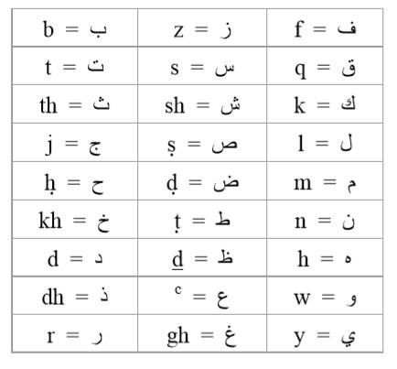

This presentation is an effort to describe the sounds of these letters, and endeavour to explain how their sounds are generated, so that the reader may obtain some idea about these particular characters, when they appear in some Arabic terms used in this work.

To distinguish these letters, either a combination of two letters are used or, in the case of the majority of the difficult letters, a normal Latin letter is used in association with a diacritic - dot or a line above or below the letter as shown in the table above. Furthermore there are also a couple of letters in the Arabic alphabet which are represented using the symbols:

’ and c. Beginning with the easy ones, there is the letter that is symbolized as:

th, which sounds like the ‘th’ in the word ‘three’. The other letter is:

dh, which sounds like the ‘th’ in the word ‘there’. As for the more difficult ones, they are as follows:

Gh or gh, the nearest sound for this is that of the French ‘r’.

H or h The sound of this letter resembles the sound of ‘strong, breathy’ H. The sound for h is generated from the proximity of the throat that the normal h is, but from an area slightly further up the throat, with more tension in the local throat muscle, with the back end of the tongue closing in against the roof of the throat immediately before the uvula.

Kh or kh The sound for this is perhaps somewhere between of that of ‘h’ and ‘k’, as far as the location of mouth where it is generated is concerned. It is generated at the back of the mouth, by pressing the back end of the tongue against the soft palate whilst forcing the air through in the outward direction, causing the uvula to vibrate.

The example of the sound of ‘kh’ found in English or that the English reader may be familiar with is Loch, the Scottish for lake, where the ‘ch’ in loch is pronounced as the designated ‘kh’ in Arabic.

S or s

The sound of this letter resembles the sound of ‘strong’ S. It is generated by involving the main trunk of the tongue, by slightly curving the centre of the front half of the tongue in the downward direction. In aid of pronouncing the sound of the ‘strong’ S, it would be helpful if you consider saying the normal letter ‘S’, when the front upper and lower teeth are brought closer together reducing the airflow, thus producing the sound of the letter ‘S’. The opposite process is used to generate the sound of the ‘strong’ S, i.e. the sound is produced when slightly moving apart the upper and lower teeth, thus pronouncing the ‘strong’ S.

D or d The sound of this letter is somewhere near the sound of the normal D. Whereas the sound of a normal D is generated by placing the front end of the tongue at the front end of the hard palate or the roof of the mouth adjoining the top teeth, the sound of d is generated by touching, to the same location, more of the front trunk of the tongue while caving in the middle part of the tongue.

D or d The best description of this sound is that it could be the strong version of the sound of ‘dh’ as in the word ‘there’. Whereas ‘dh’ is generated by placing the tip of the tongue between the upper and lower front teeth, whilst pressing against the upper front teeth, the sound for d is generated by pressing more of the front end of the tongue between the upper and lower front teeth, whilst pressing against the upper front teeth, and the centre of the tongue is curved downwards.

T or t

The sound of this letter resembles a ‘strong’ T. Whereas a normal T is generated by involving the front end of the tongue, the ‘strong’ T is generated by pressing the front end of the trunk of the tongue against the front end of the hard palate or the roof of the mouth. Also when the normal T is pronounced, the lower jaw does not move, whereas in the case of pronouncing the strong

T, or T, the lower jaw moves outwards.

Q or q

The sound for this letter is a short and sharp version of the letter ‘gh’ or the French R. Whereas in the process of generating the sound of ‘gh’ the back end of the tongue is pressed slightly against the uvula, allowing some air to flow, in the case of the sound of the Arabic alphabet represented by Q, the same process takes place with the difference that the passage is completely blocked, and the sound is actually generated by he sudden release of the passage.

’ or the hamzah; which is the character representing the glottal stop.

c also shown as ‘

This symbol is used to characterize an Arabic alphabet that represents the sound of a strong ‘throaty’ A. Just as the sound for A is generated at the back of the throat, in the same proximity, the sound for c or ‘ is also generated with the difference that the entire throat back is engaged in the process by a stroke of contraction in the muscle there. In this process more of the throat is blocked, which also involves the back end of the tongue, than when pronouncing the normal A. Just in the case of the normal A, the sound is actually generated at the time of the release of the contraction of the muscles involved.

‘Long’ a There are also cases when there is a diacritic or a small horizontal line above the letter, like a: this is to represent ‘long’ a, an alternative to writing aa. The nearest example for the long a, or a, in English words is case of afar” as opposed to the word afat”. In the case of afar”, the ‘a’ is elongated in the pronunciation, whereas in the case of afat”, the ‘a’ is short.

‘Double’ consonant letters

In the Arabic language, there are many instances where a letter in a word has double pronunciations with a very slight pause between the two. The first pronunciation is always the sound of the letter itself, and the second is the sound of the letter together with that of the following letter. For correct pronunciation of the word, it is important that there is a very slight pause between the sounds of the double letters. Some examples are as follows: Allah, where the presence of ‘ll’ indicates the requirement of the double pronunciation of the letter ‘l’. It may help if the word is considered as Al-lah, with the pause due to the hyphen being very slight. Another example is Muhammad.

The Author

Grand Ayatollah Imam Muhammad Shirazi is undoubtedly the most eminent Marje’ or authority on Islam in modern times. A charismatic leader who is known for his high moral values, modesty and spirituality, Imam Shirazi is a mentor and a source of aspiration to millions of Muslims; and the means of access to authentic knowledge and teachings of Islam. He tirelessly devoted himself, and his entire life, to the cause of Islam and Muslims in particular, and to that of mankind in general. He has made extensive contributions in various fields of learning ranging from Jurisprudence and Theology to Government, Politics, Economics, Law, Sociology, Human Rights. Through his original thoughts and ideas he has championed the causes of issues such as the family, freedom of expression, political pluralism, non-violence, human rights, and the Shura or consultative system of leadership.

Born in Najaf, Iraq, in 1347 AH, 1928 CE, the young Muhammad Shirazi continued his studies of different branches of learning under the guidance of various eminent scholars and specialists, as well as his father, the renowned Marje’ or the religious authority of the time, Grand Ayatollah Mirza Mahdi Shirazi. In the course of his training he showed an outstanding talent and a remarkable appetite for learning as well as a tireless commitment to his work and the cause he believed in. His extraordinary ability, and effort, earned him the recognition at the age of 25, by the various Marje’ and scholars of the time, of being a mujtahid, a fully qualified religious scholar and lawmaker in the sciences of Islamic jurisprudence and law. He was subsequently able to assume the office of the Marje’ at the age of 33 in 1380 AH, 1961.

Imam Shirazi is distinguished for his intellectual ability and holistic vision. He has written various specialized studies that are considered to be among the most important references in the relevant fields. He has enriched the world with his staggering contribution of more than 1,100 books, treatise and studies on various branches of learning. His works range from introductory works for the youth to literary and scientific masterpieces. Deeply rooted in the Holy Qur’an and the teachings of the Prophet of Islam, his vision and theories cover such areas as Theology, Philosophy, History, Legislation, Management, Environment, Governance, Law and Islamic Doctrine. His work on Islamic Jurisprudence (the al-Fiqh series) for example constitutes 150 volumes, which run into more than 70,000 pages.

Imam Shirazi came to prominence in Iraq from the early 1960’s for his works and his relentless efforts in setting up educational projects and institutions throughout the country. He endeavoured to bring about a renaissance amongst the Muslims and their countries through education and reawakening the Muslim masses about the teachings of Islam. But education of the masses is not something despotic regimes are fond of. His works and efforts were ruthlessly crushed by the iron-fisted tyrannical regime of the country’s Ba’thist regime run by the then deputy president the notorious Saddam Hussein. Having arrested and subjected his brother, Ayatollah Hasan Shirazi, to near death torture, Saddam’s Ba’thist regime sentenced Imam Muhammad Shirazi to the death by firing squad in absentia, which forced him to migrate to Kuwait in 1970.

Throughout the 1970’s in Kuwait Imam Shirazi continued his movement of mass education as he had in Iraq. In 1980 Imam Shirazi moved to the holy city of Qum in Iran, to continue his endeavour to disseminate the teachings of Islam as taught by the Prophet Muhammad and his impeccable descendents - the Ahl al-Bayt.

Throughout his life, because of his total dedication to the teachings of Islam, and because of his views on various issues of concern, which are based on those teachings, Imam Shirazi came under sustained pressure. His views on, and his call for issues such as freedom of expression, party political pluralism, peace and non-violence brought about the wrath of the authorities. His freedom and activities were restricted; his staff, followers, and family members were subjected to continued harassment, arbitrary arrest and torture, throughout the eighties and the nineties. Having spent the entire of his adult life striving for the greater enlightenment of the Muslims and mankind, Imam Shirazi died in the holy city of Qum, Iran, on Monday the 2nd Shawwal 1422 AH, 17th December 2001.

Imam Shirazi believed in the fundamental and elementary nature of freedom in mankind. He used to call for freedom of expression, debate and discussion, tolerance and forgiveness. He continuously called for the establishment of the universal Islamic government to encompass all the Muslim countries. These and other ideas are discussed in detail in his works of more than 1,100 titles.

Notes

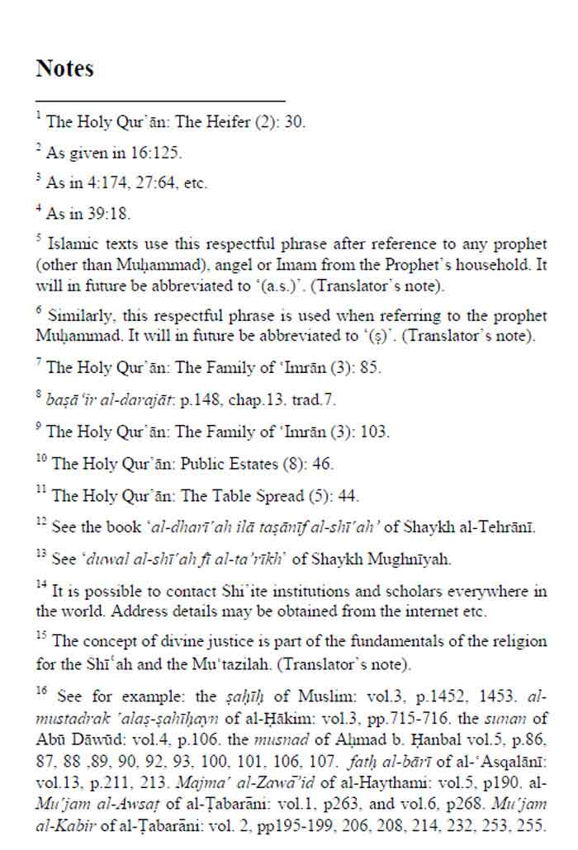

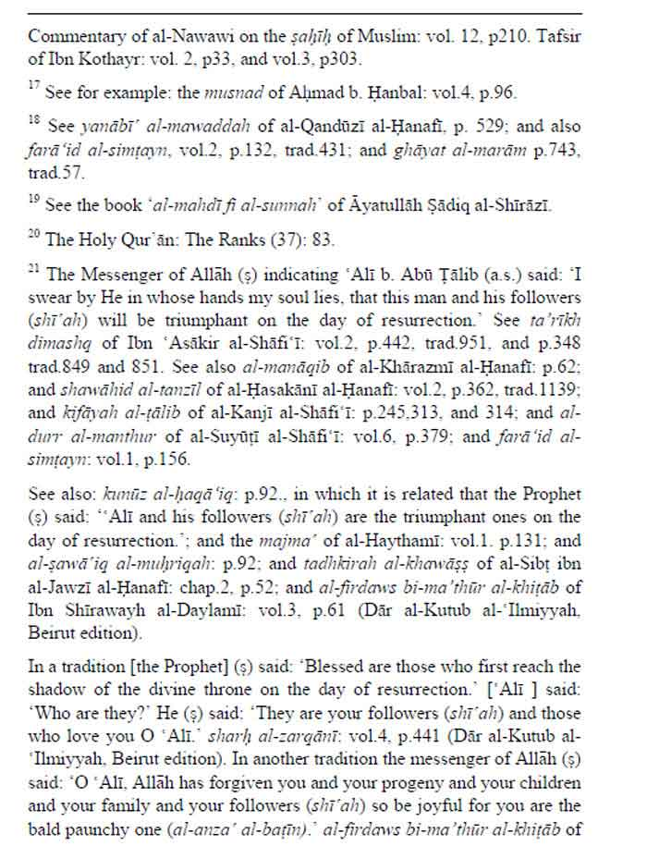

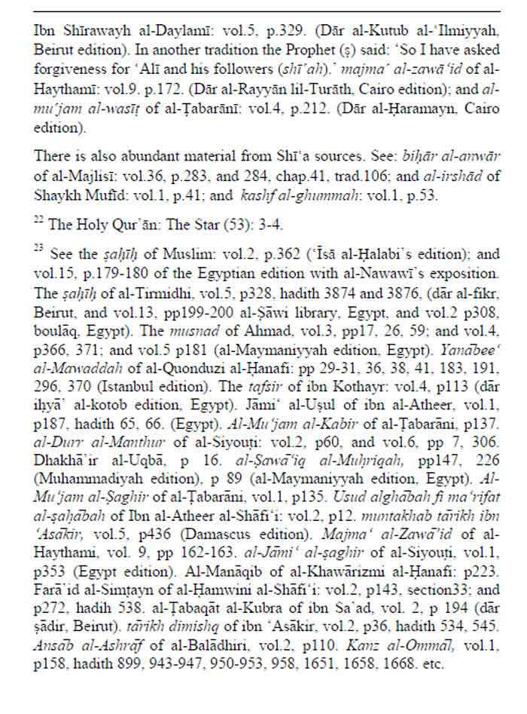

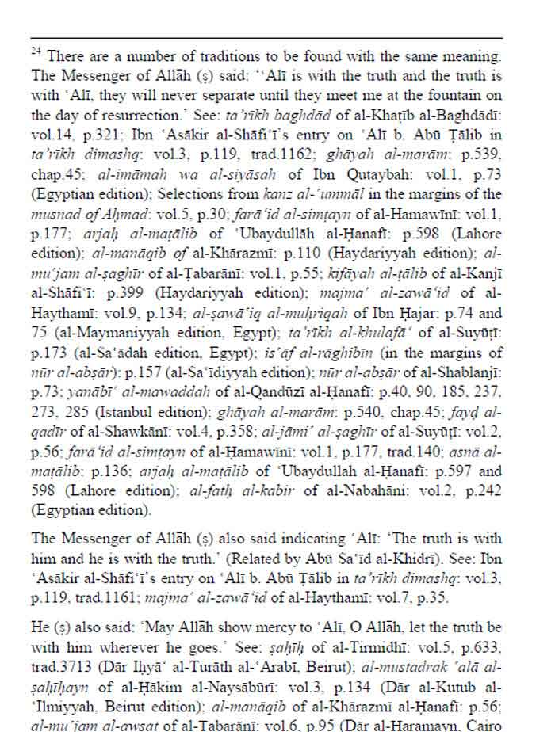

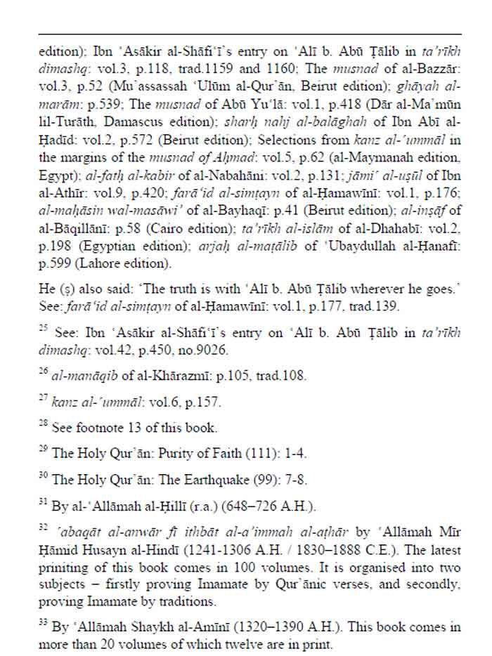

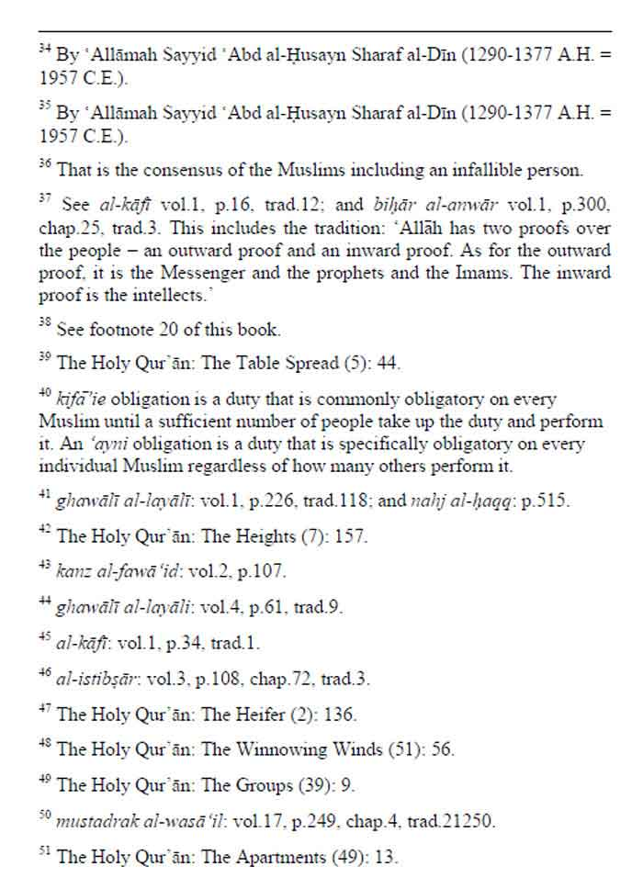



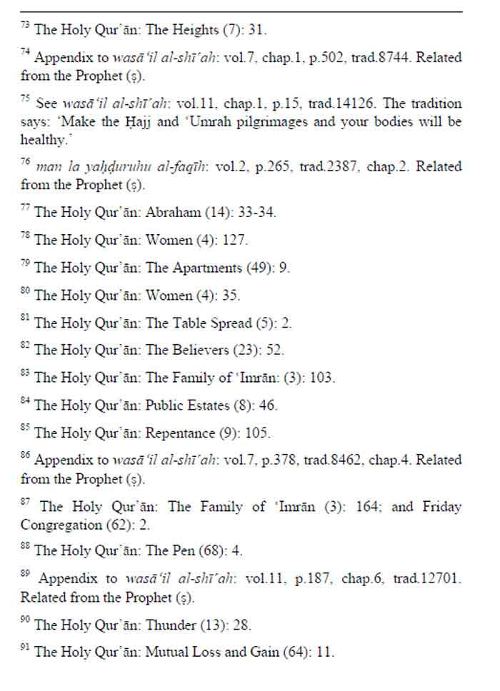

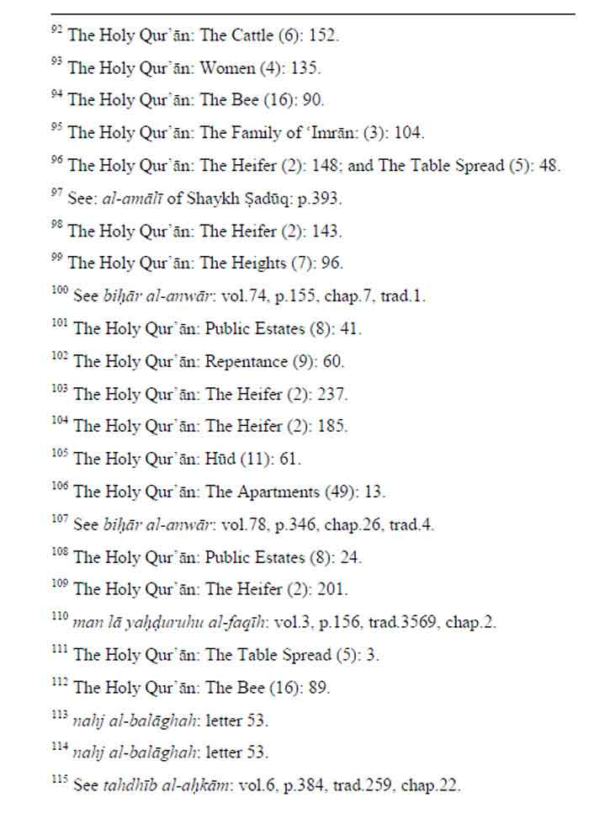

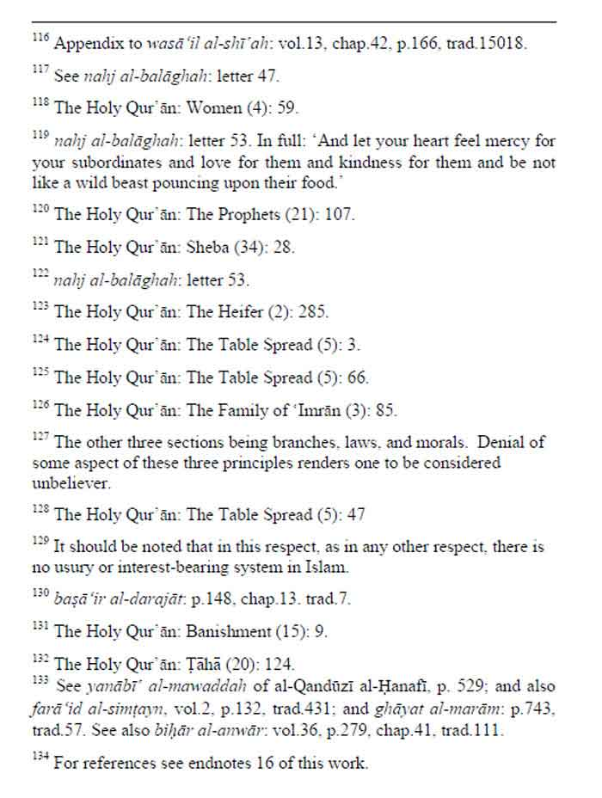

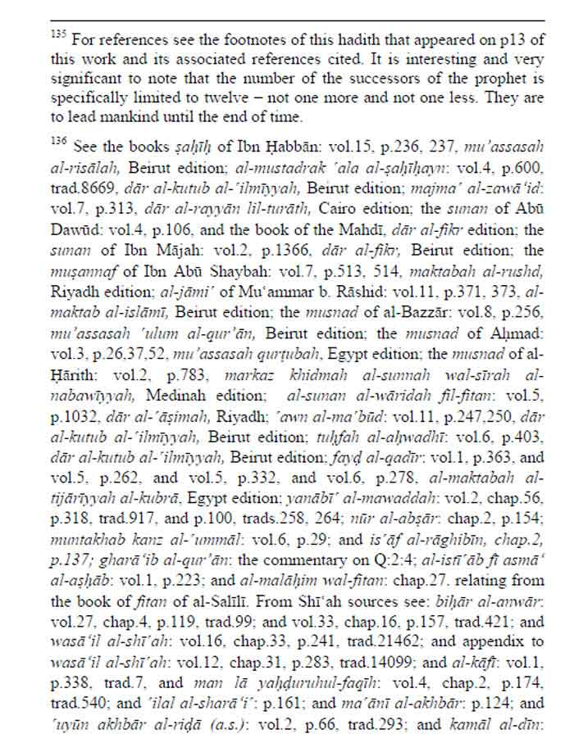

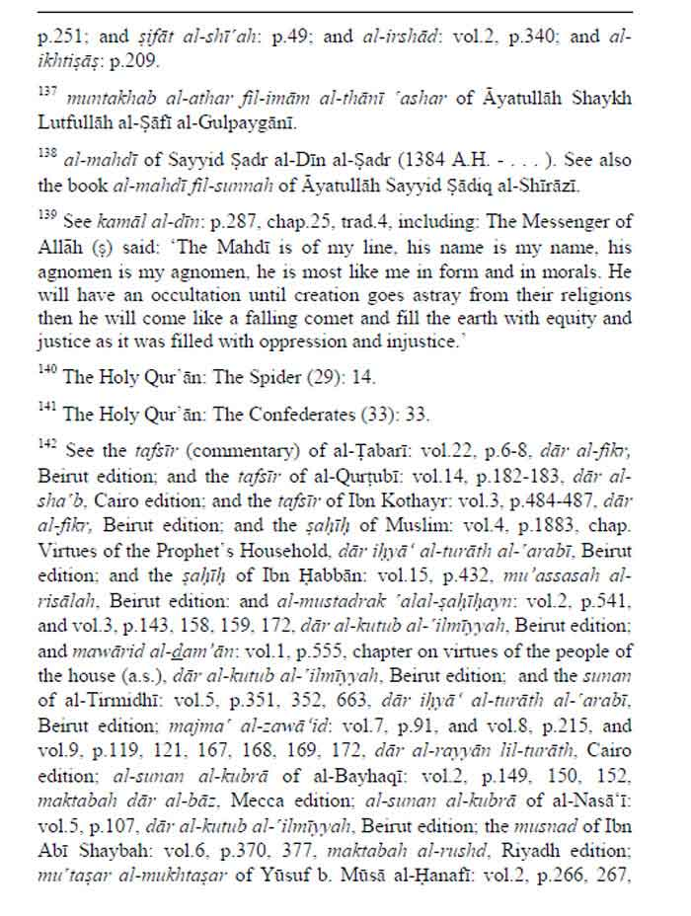

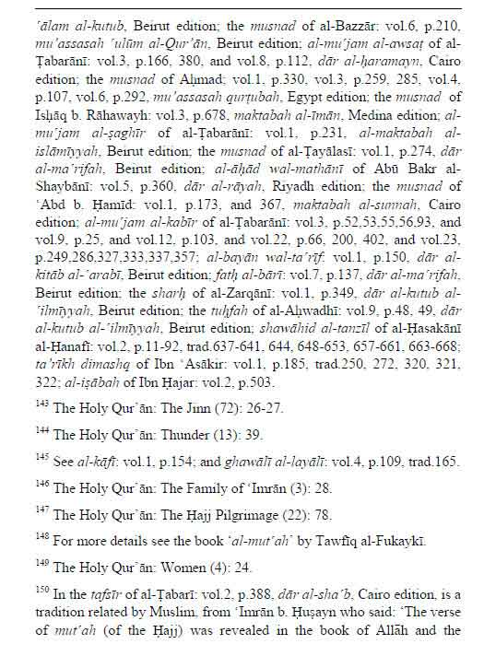

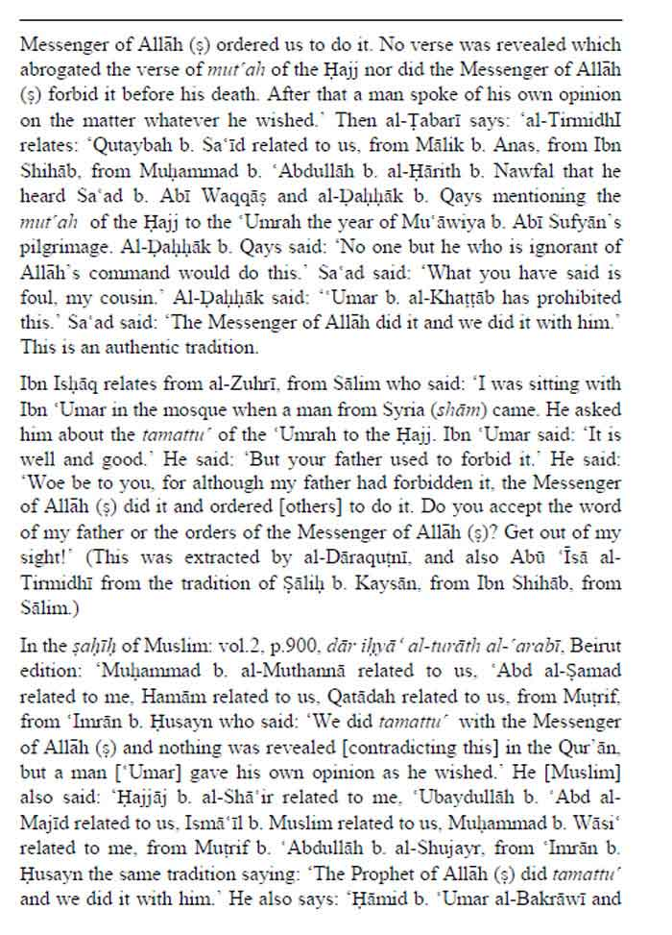

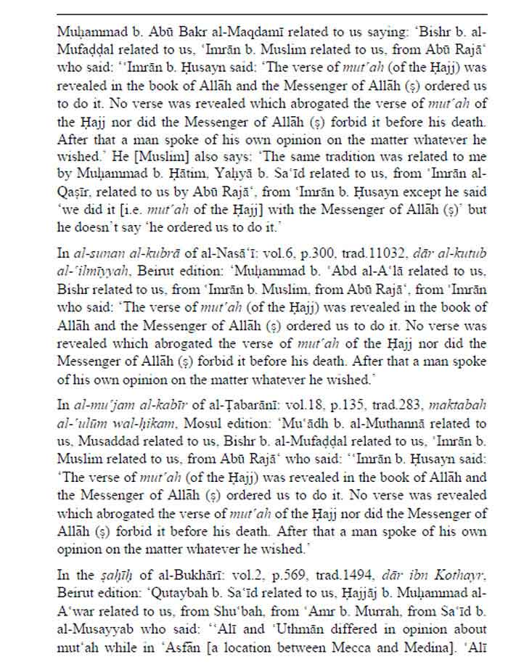

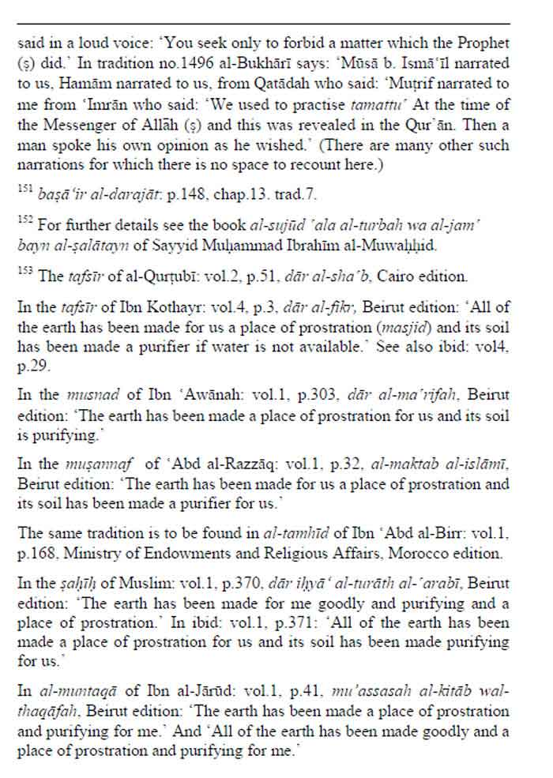

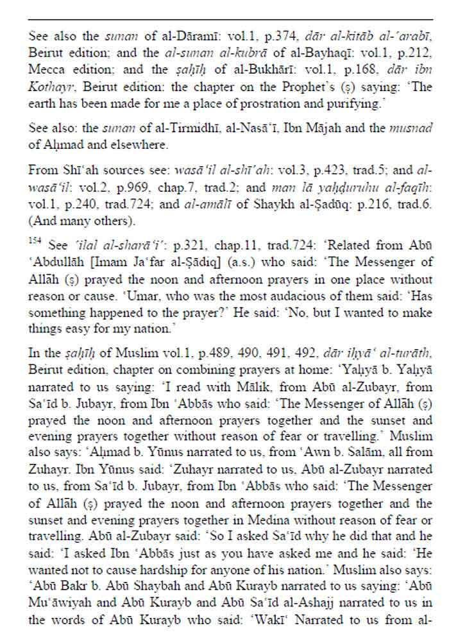

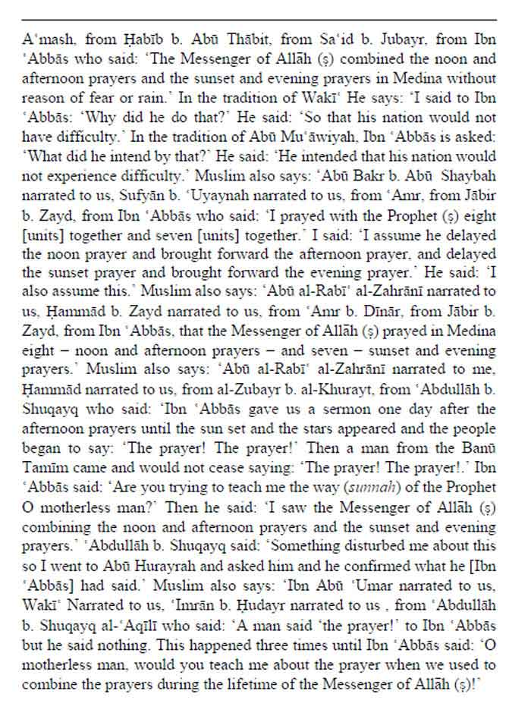

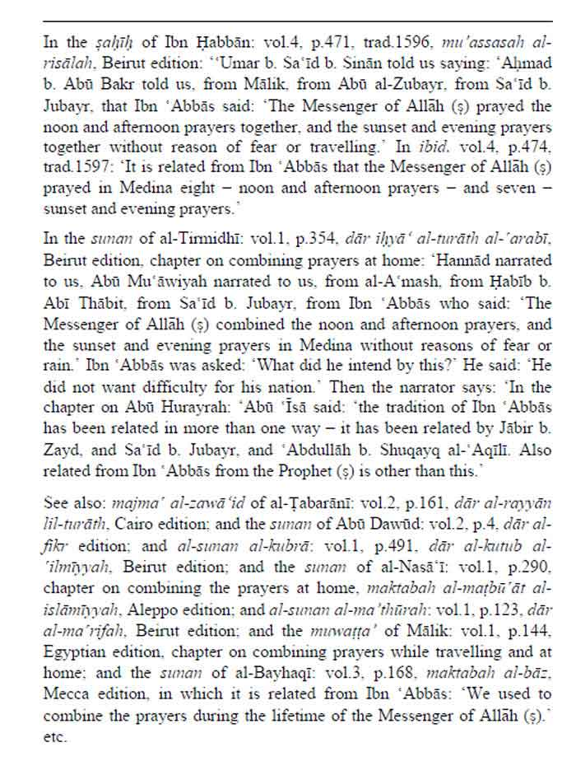

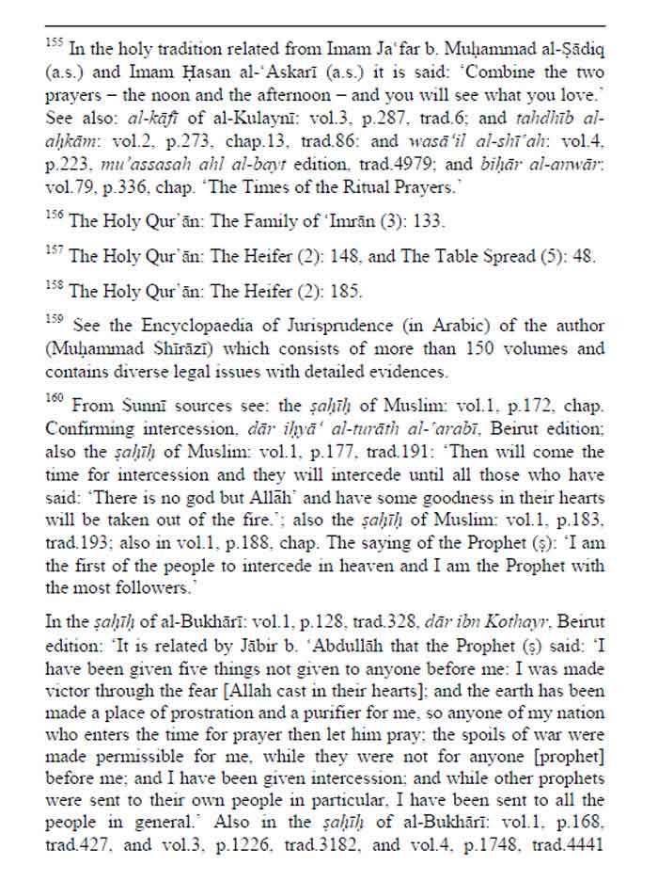

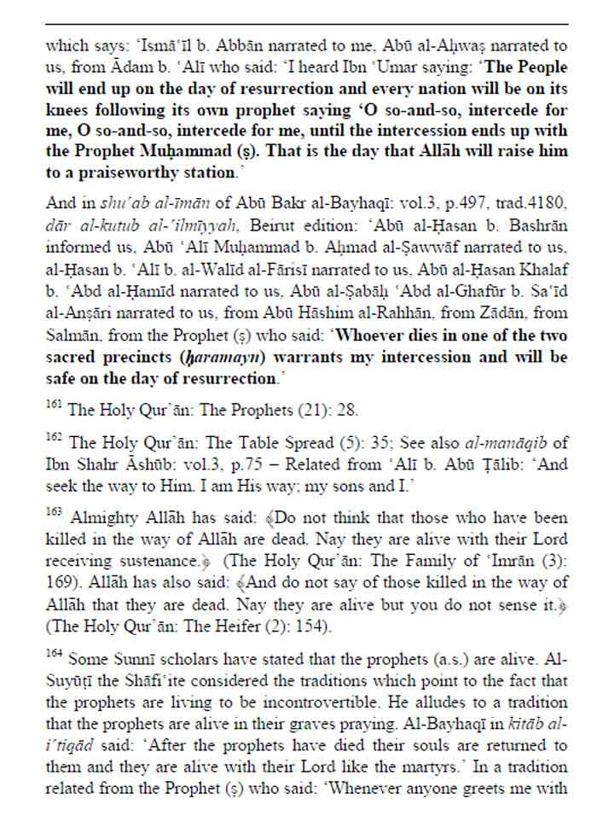

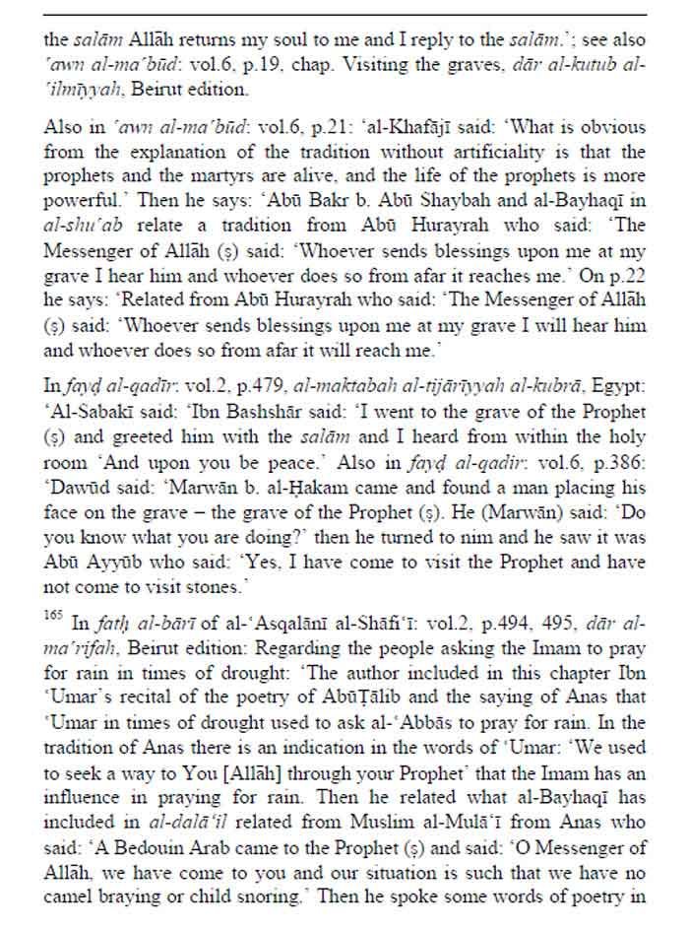

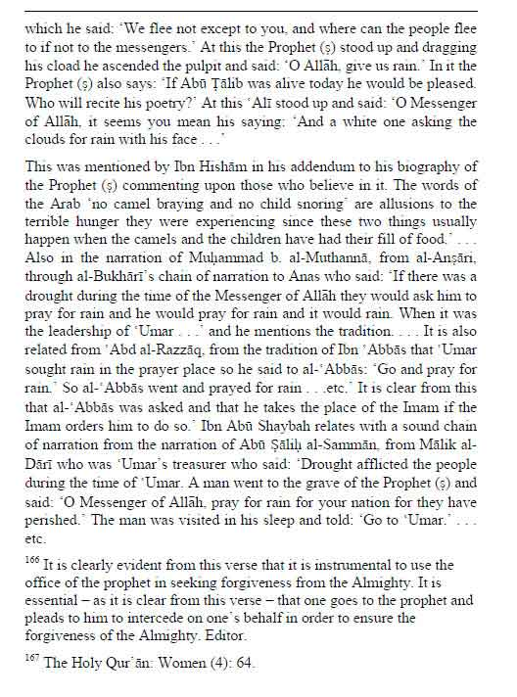

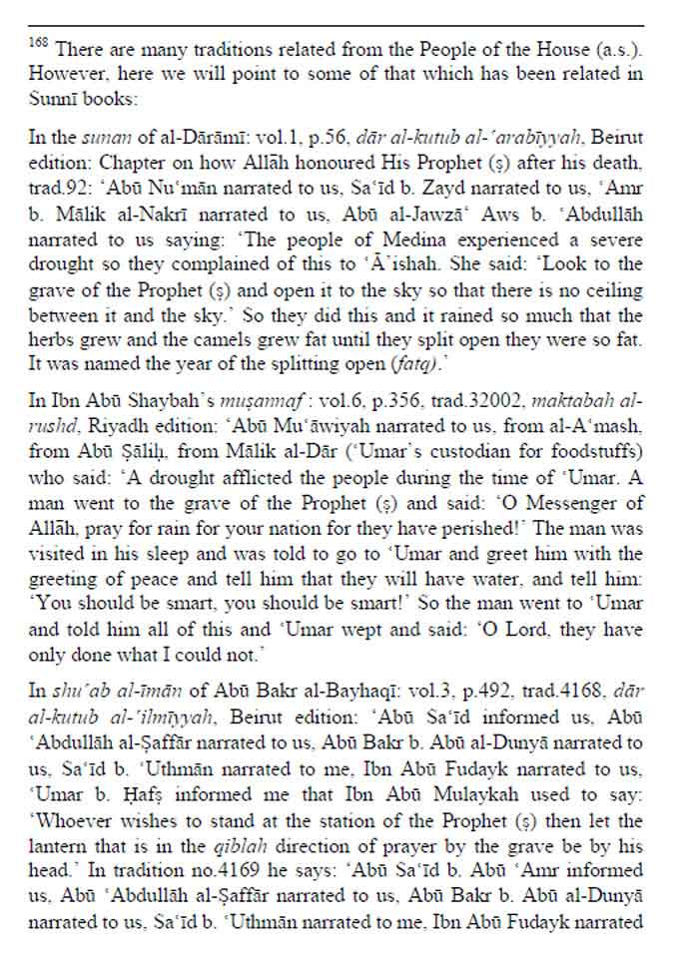

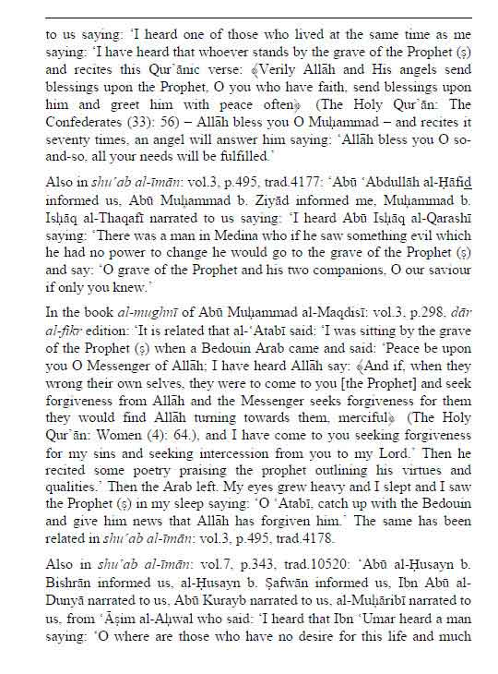

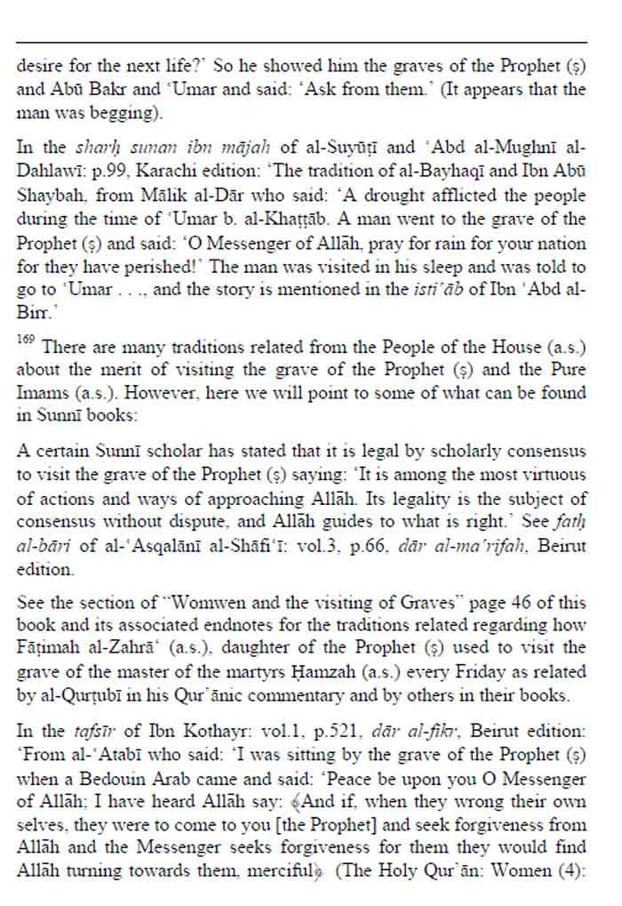

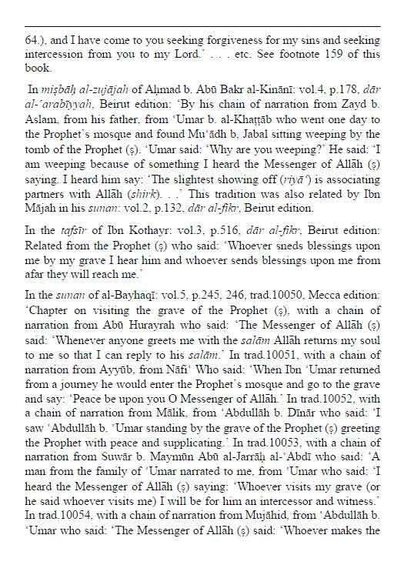

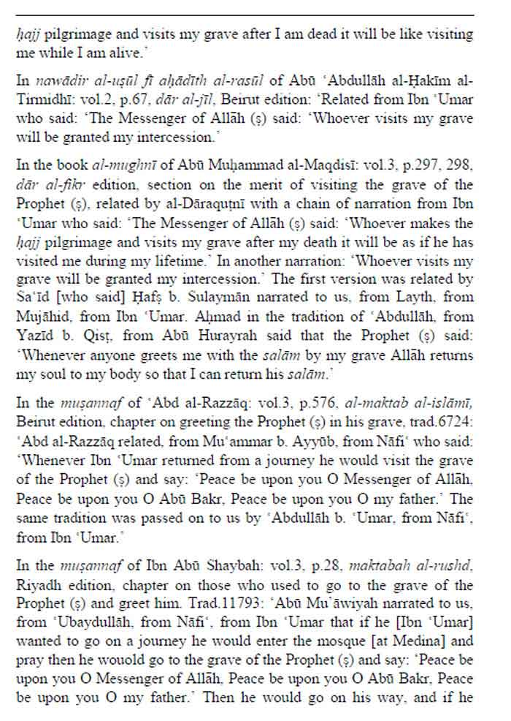

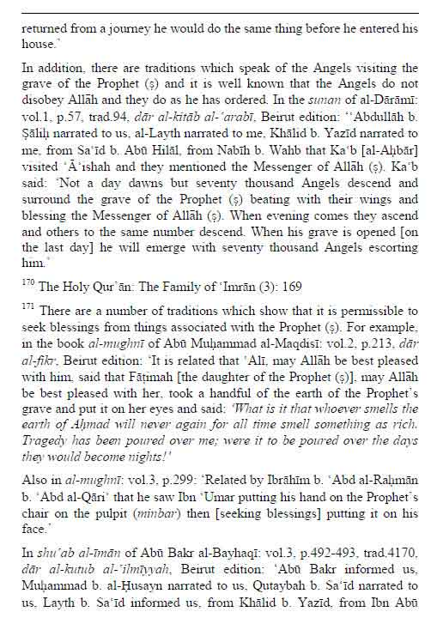

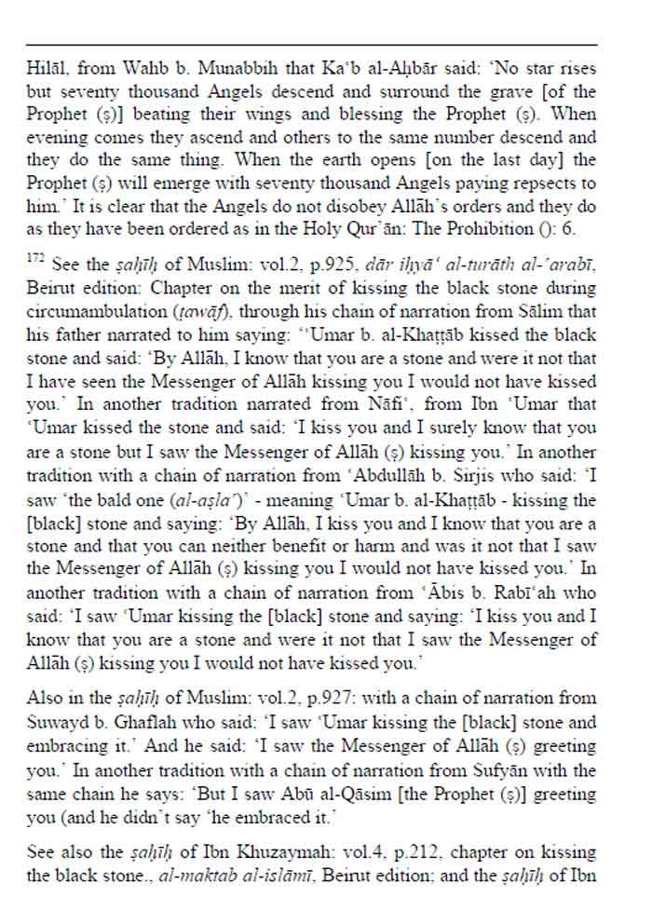

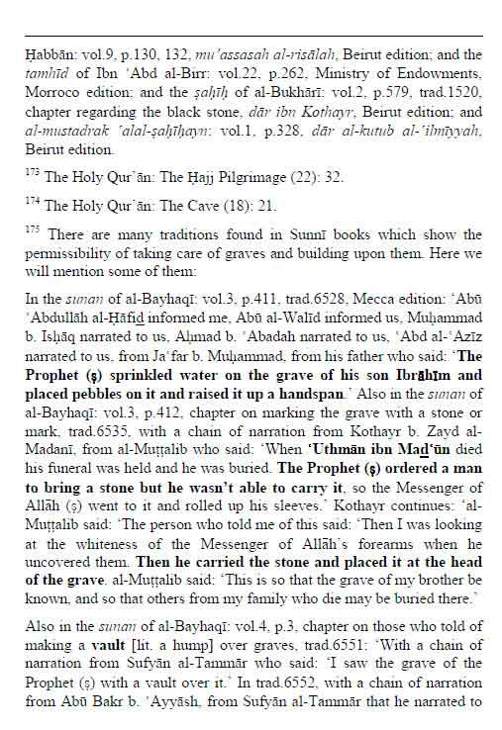

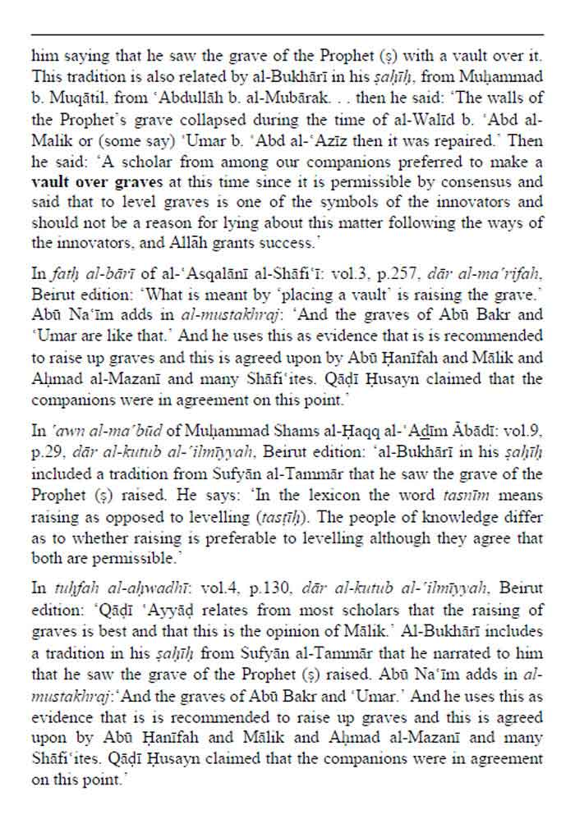

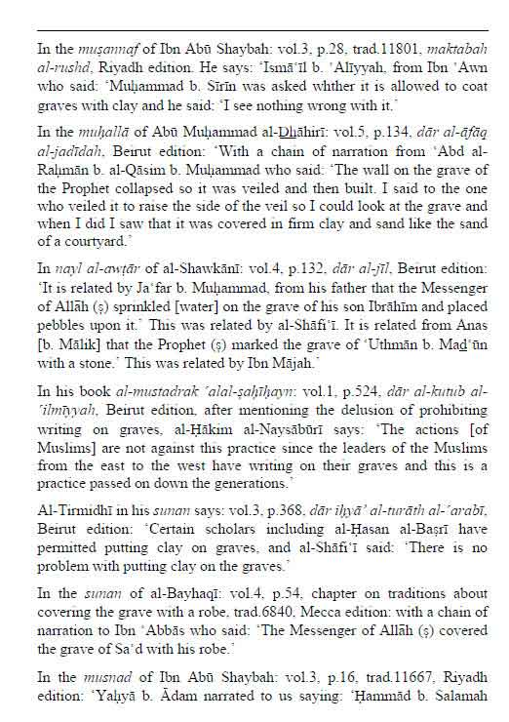

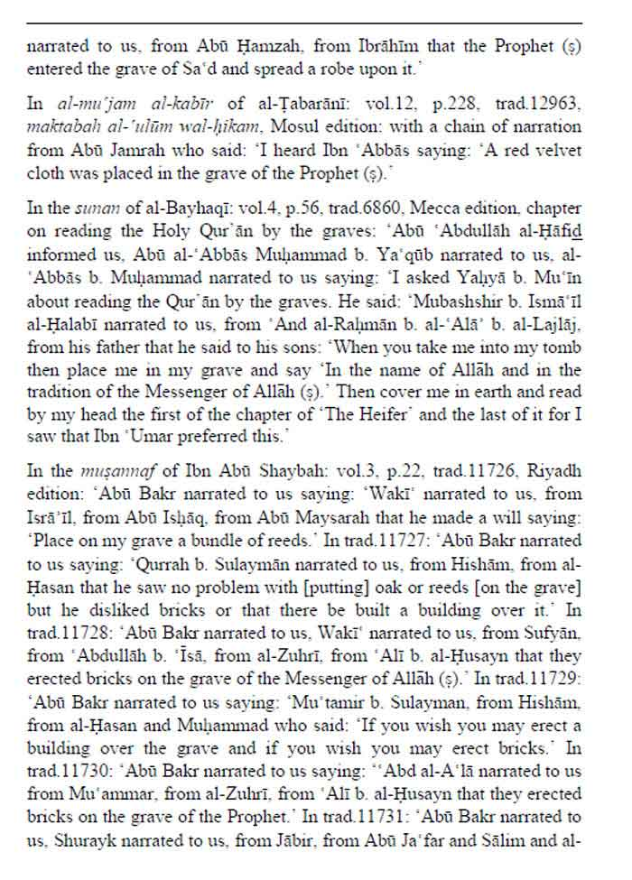

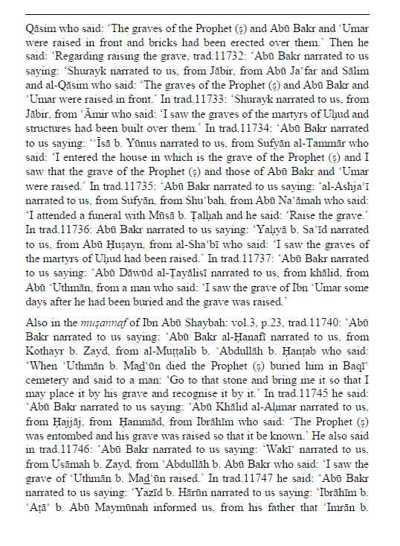

0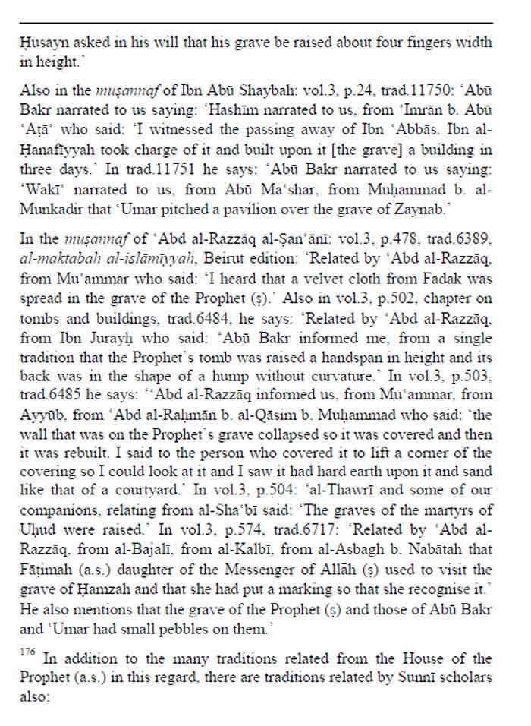

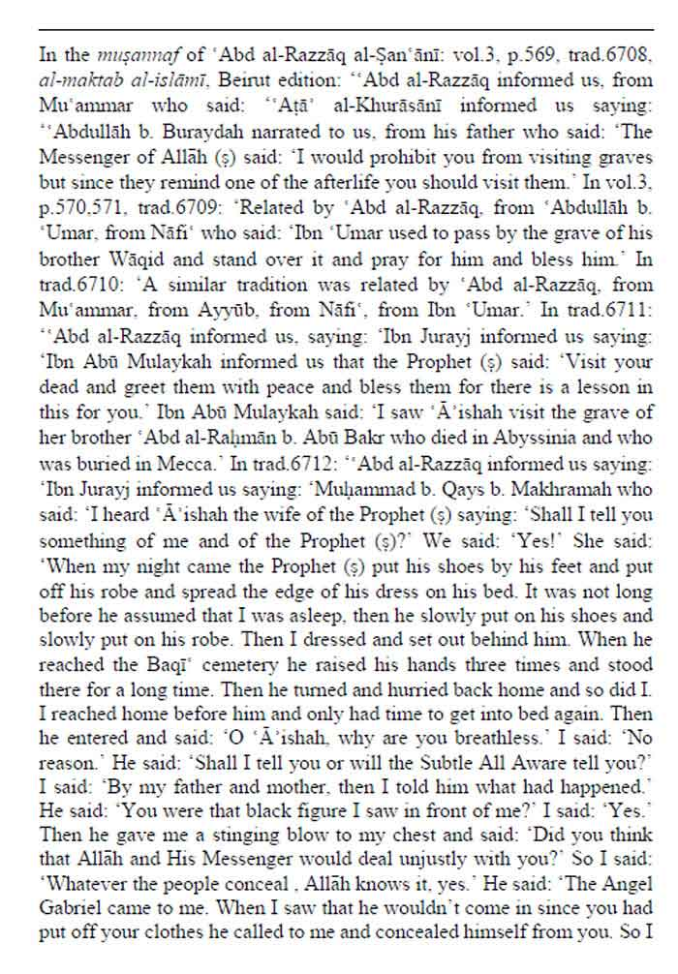

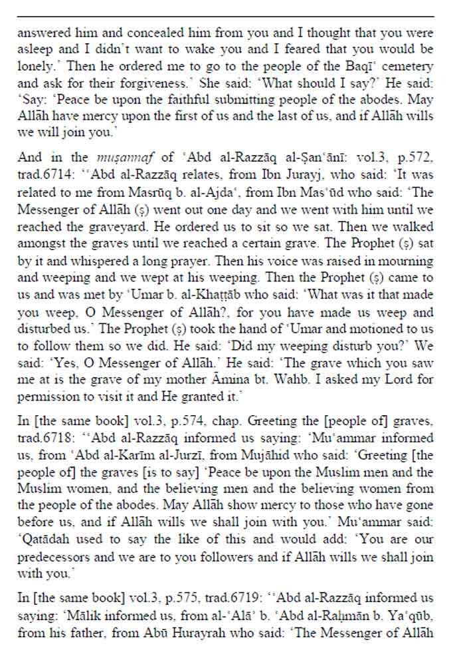

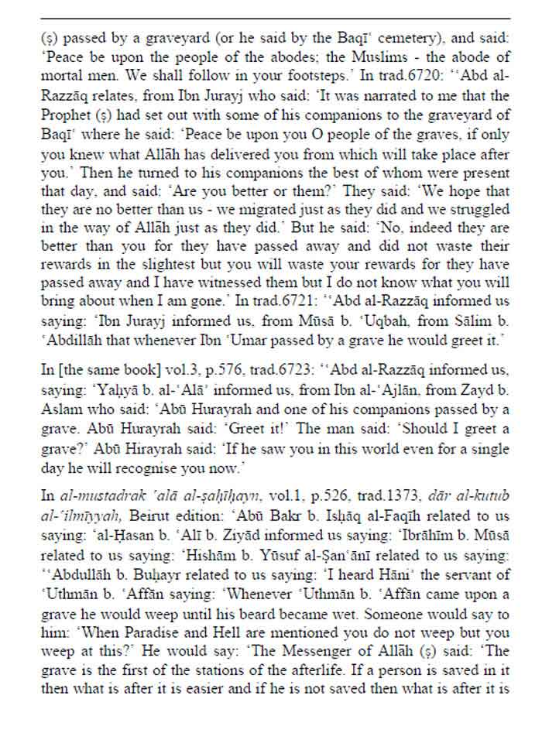

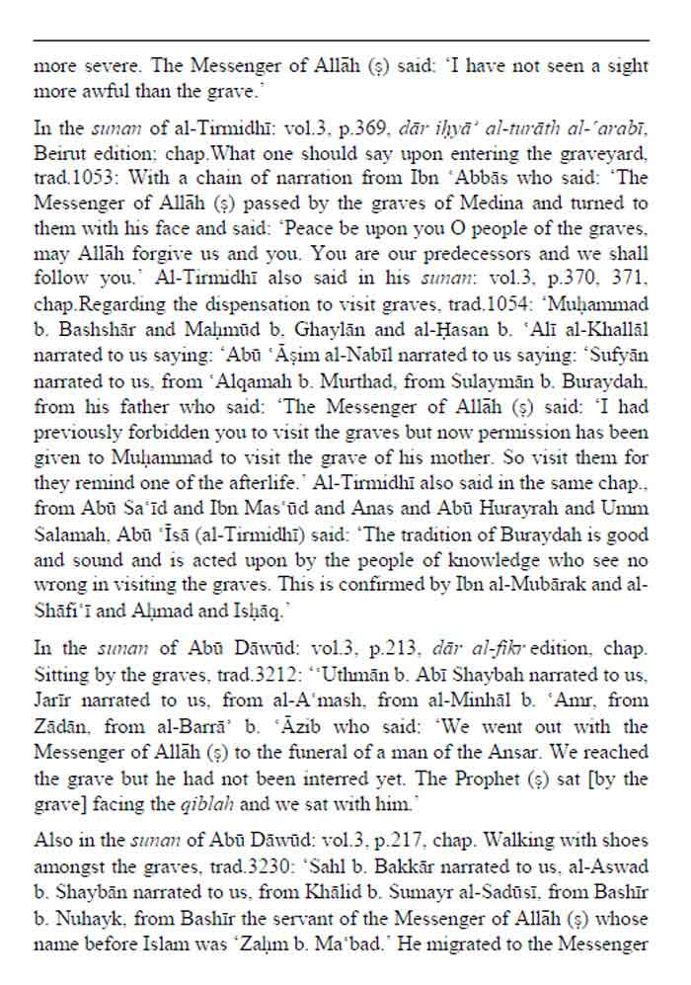

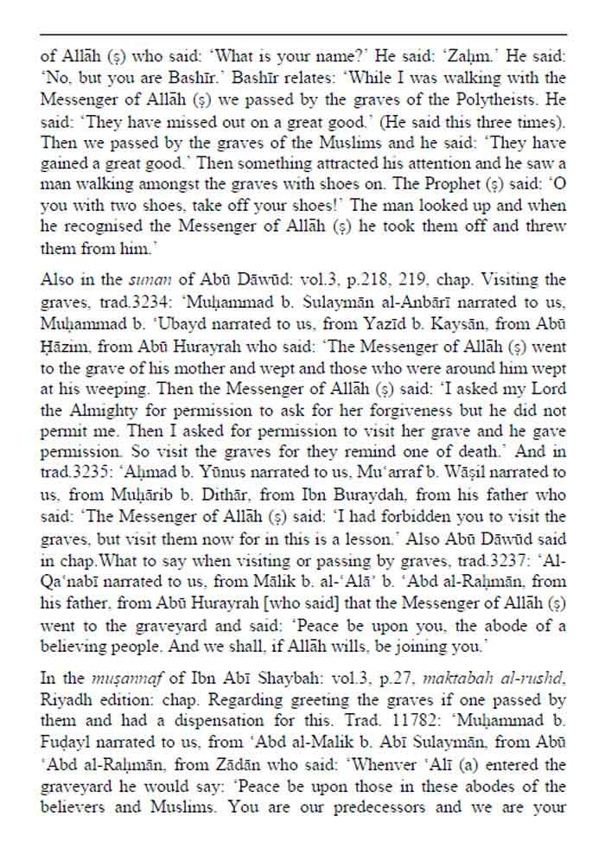

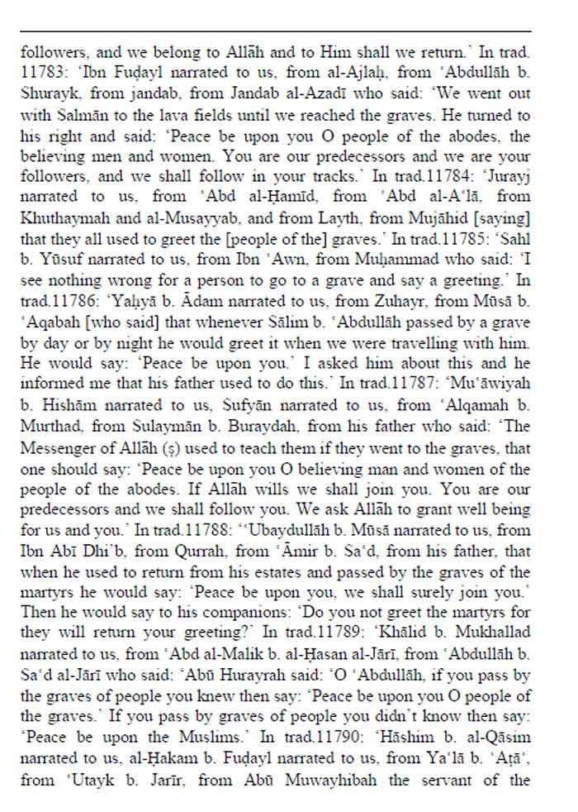

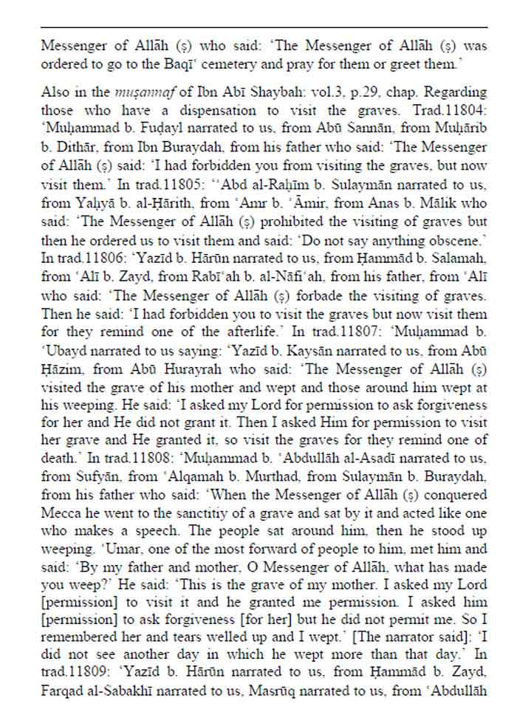

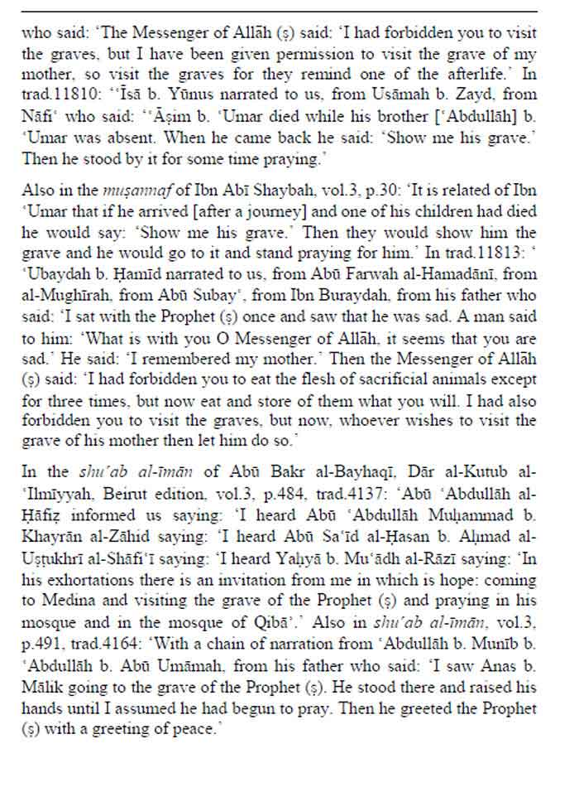

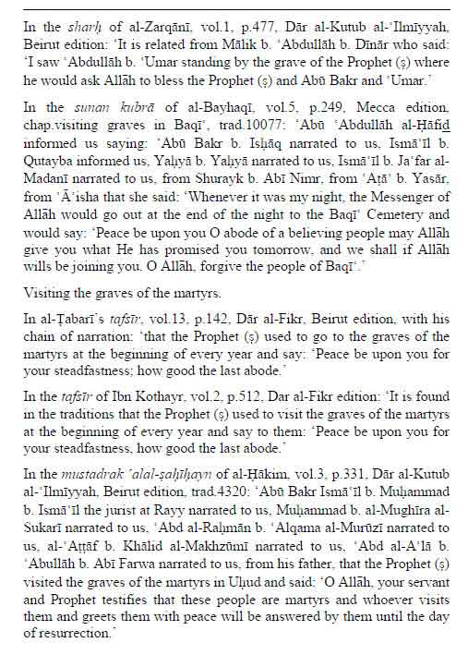

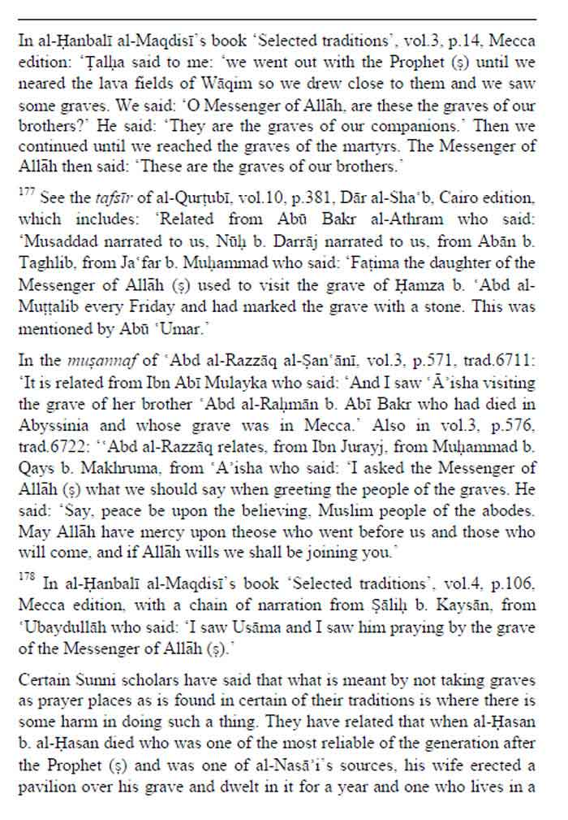

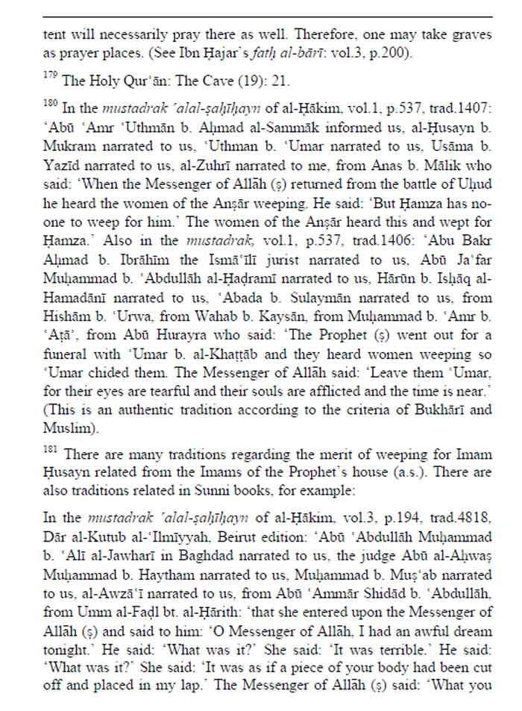

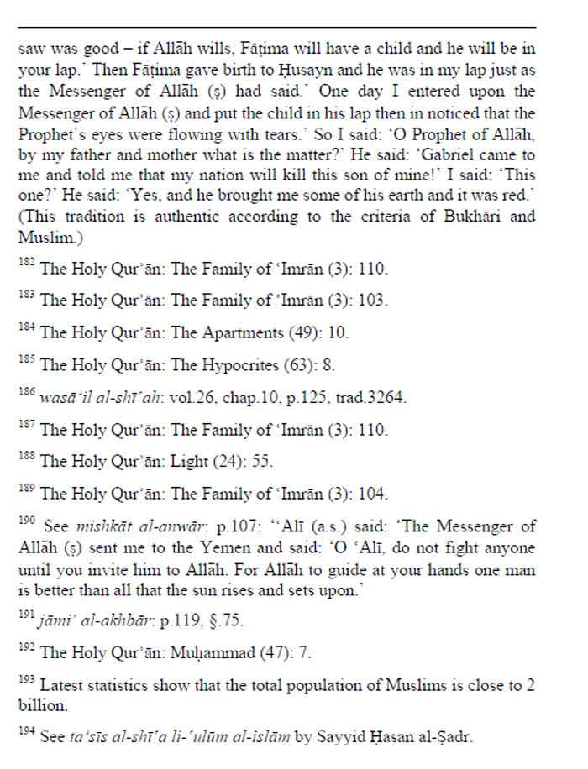

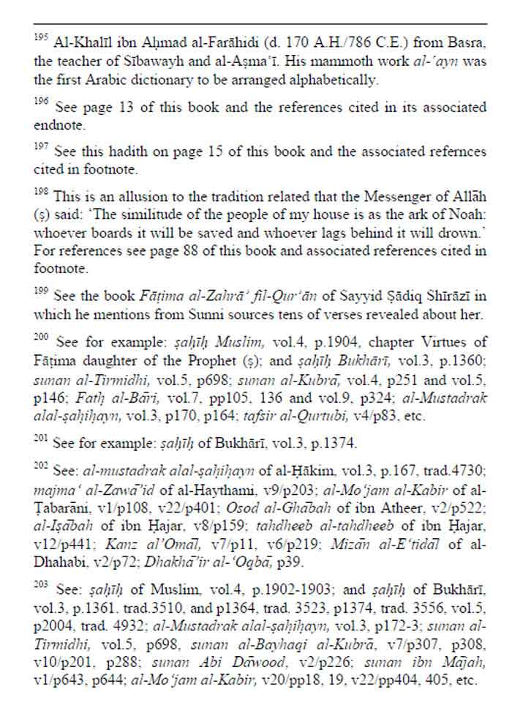

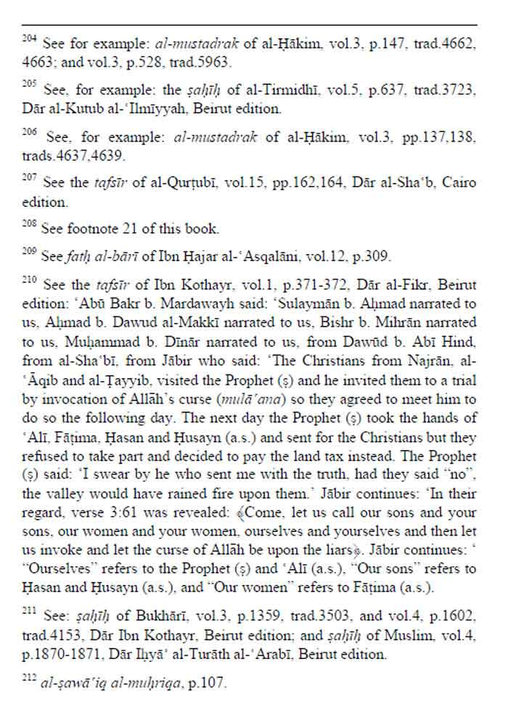

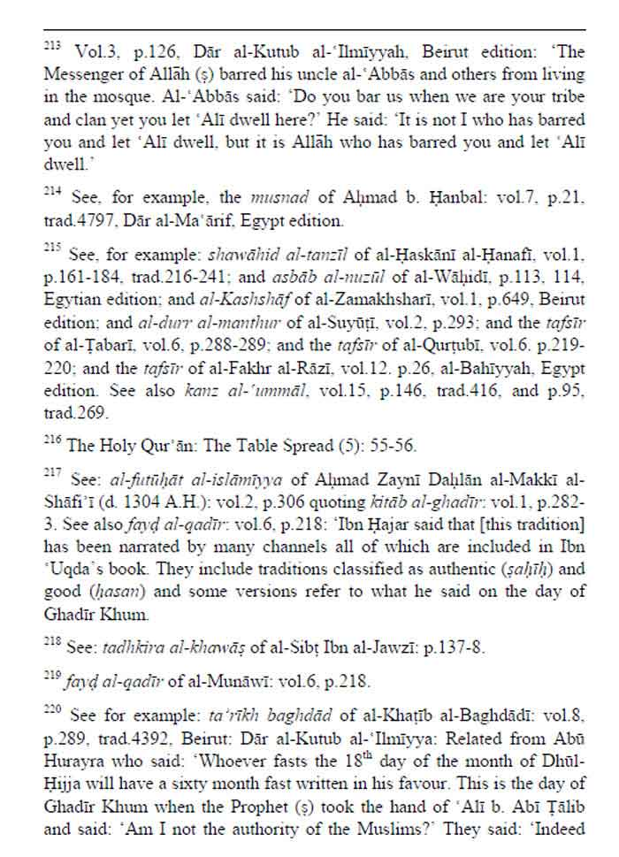

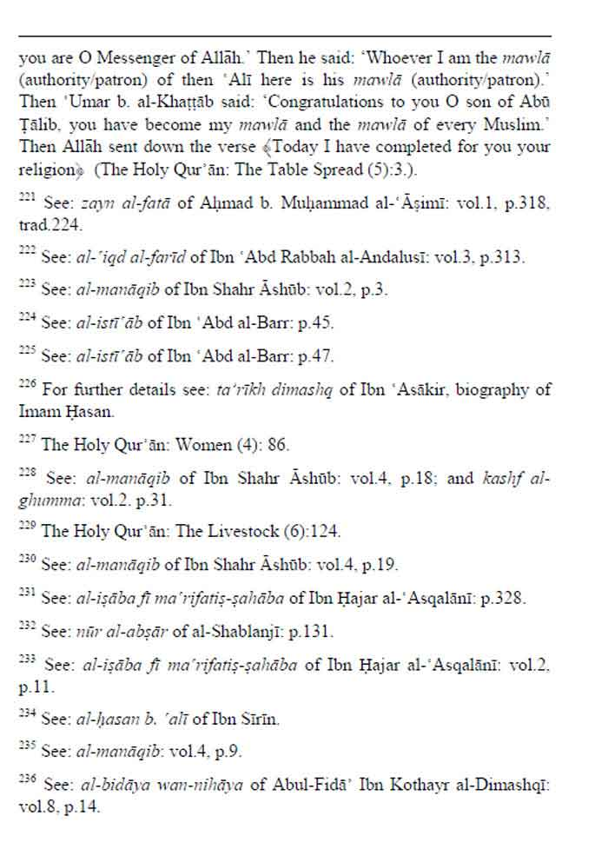

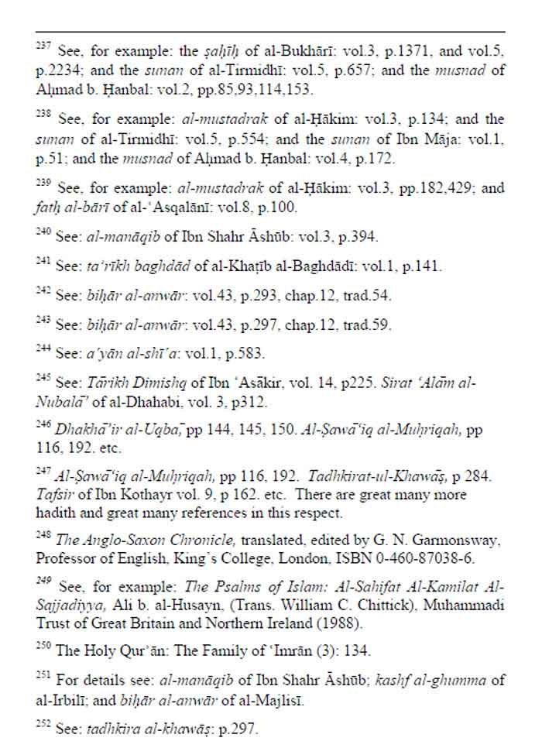

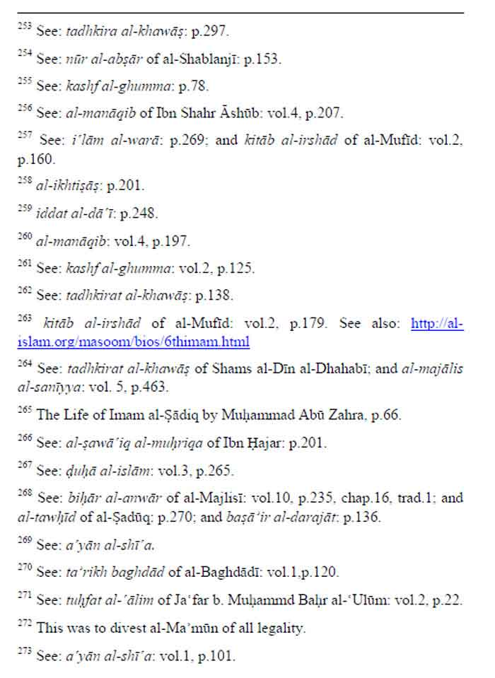

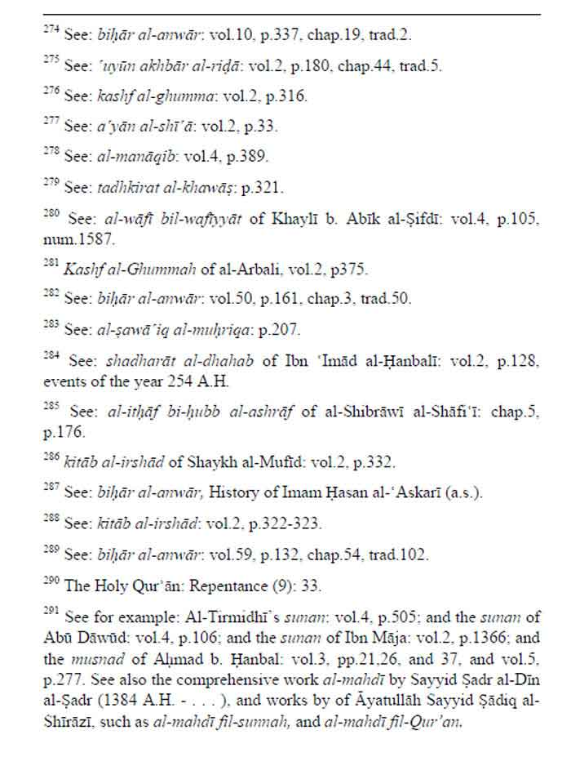

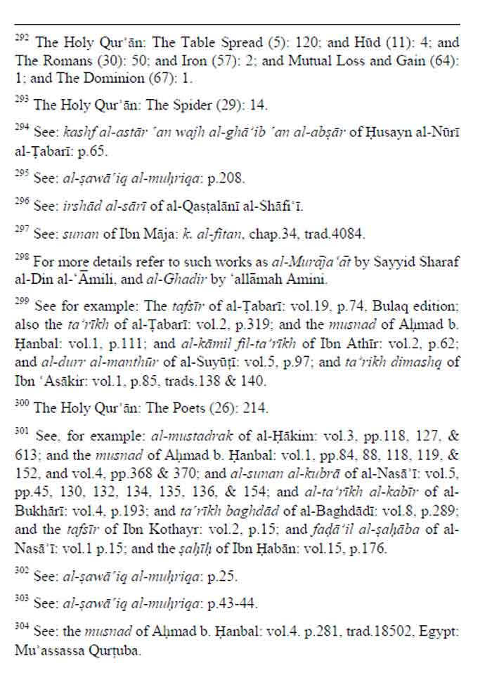

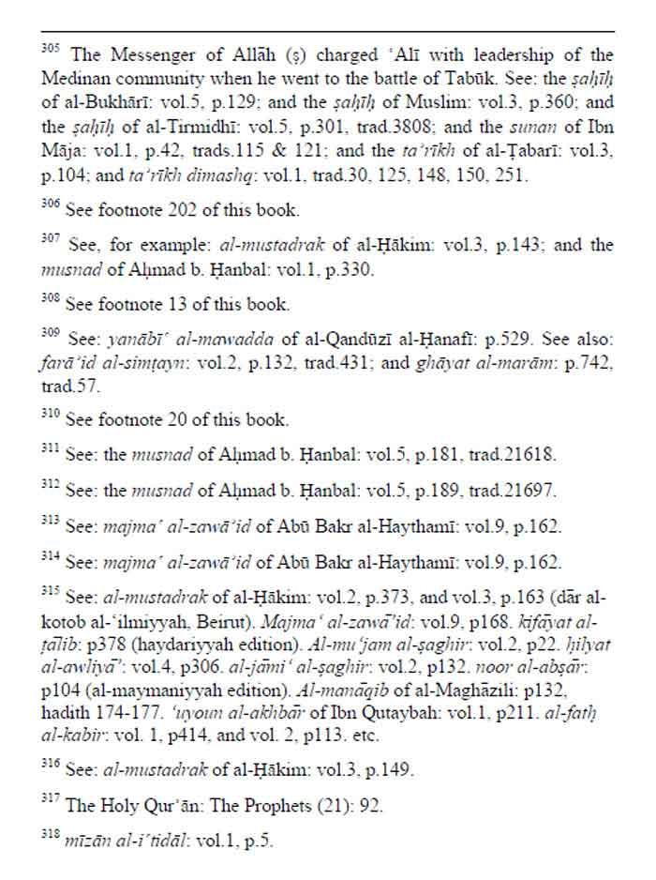

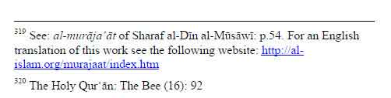

[www.alhassanain.org/english](http://www.alhassanain.org/english)