Alhassanain (p) Network for Islamic Heritage and Thought

QOM

and

THE VIRGIN OF THE CITY

A Biography of Fatima Al-Ma'sooma (s)

&

A Guide for Visitors and Tourists

Author: Kamal as-Sayyid

Translator: Abdullah al-Shahin

Publisher: Ansariyan Publications - Qom

First Edition 1423 - 1381 - 2003

ISBN: 964-438-430-X

ALL RIGHTS RESERVED AND RECORDED FOR THE PUBLISHER

[www.alhassanain.org/english](http://www.alhassanain.org/english)

Table of Contents

DEDICATION 4

QOM; GEOGRAPHICALLY AND HISTORICALLY 5

Qom in traditions 6

Biography of Fatima al-Ma’ssooma 6

The Holy Shrine 7

Qom; Country and People 9

The Village of Qom 10

Sheikh Abdul Kareem al-Yazdi 11

Al-Mutawally Bashi 11

The School of Qom 12

Mirza Abdullah at-Tehrani 12

The flood in Qom 12

Ma’ssooma Qom 12

Tombs of the Ulama and Narrators in Qom 12

Our Relatives in Qom 13

Our Works in Qom 13

The Salty Lake 14

Shahr-e-Muqaddas: The Other Face 14

Al-Ma’ssooma and the Hawza 17

QOM IN PHOTOS 19

Ansariyan Publications 52

THE VIRGIN OF THE CITY 54

Lamps in the heart of darkness 75

Ziyaraof lady Fatima al-Ma’ssooma (s) 78

The etiquette of ziyara 82

The Tombs of the infallible imams’ children in Qom 83

Numbers and addresses 84

Note: [added by www.alhassanain.org/english] 84

SOME INQUIRING AND EDUCATIONAL ESTABLISHMENTS IN QOM 84

CENTERS OF THE HAWZA 84

SOME PUBLISHING HOUSES IN QOM 85

OFFICES OF MARAJI’ AT-TAQLID (MUJTAHIDS) 85

THE DEPARTMENTS IN THE PURE HARAM AND THEIR TELEPHONES 85

ANSWERING RELIGIOUS QUESTIONS CENTERS 85

WEEKLY RITUALS IN THE HARAM 85

RELIGIOUS CEREMONIES 86

NECESSARY (TRIPLE) TELEPHONES 86

DEPARTMENTS AND ESTABLISHMENTS OF QOM 87

POLICE STATIONS AND TRAFFIC ACCIDENTS STATIONS 87

PARKING LOTS IN QOM 88

TAXI SERVICE (BY TELEPHONE) 88

TRAVEL BUREAUS 88

HOTELS IN QOM 89

FIVE STARS HOTELS: 89

FIRST CLASS HOTELS: 89

SECOND CLASS HOTELS: 90

HOSPITALS 90

ON DUTY (TWENTY-FOUR HOURS) PHARMACIES 91

SOME OF THE RESTAURANTS OF QOM 91

PUBLIC PARKS IN QOM 91

Notes 92

DEDICATION

To everyone whose heart

Longs for this city;

ground, man and history

The author

QOM; GEOGRAPHICALLY AND HISTORICALLY

There is no an accurate dating about the establishment of this city nor a certain reason behind its name. There are some historians confirming that its history belongs to the pre-Islamic conquest period relying on some historical manuscripts, which show clearly that the city has been available during the age of Anushirvan, the Persian king.[1] It (Qom) has been mentioned during the Islamic conquests when talking about the battle of Jalawla’ against Khosrow, the last king of the Sasanian dynasty, where Hijr bin Adiy was one of the leaders of the Islamic armies at that day.

Hence the history of the city belongs to the period before the year twenty-third A.H. (the year of (al-Fat~h-the Conquest) for a long time.

Many stories have been said about the name of the city each trying to give an explanation about it. Some have said that its name was “Kumondan”[2] and then some of its letters have been dropped and others have said that the original name was “Kam” meaning “little” that it was a small village and then it was Arabized into “Qom” after the Islamic conquests.[3]

But the name of the city began to shine on the Islamic map after it had been occupied by the Ash’arites[4] in ninety-four A.H. They had tried their best to build the city. It grew and became one of the important cities in Persia after its people had believed in Ahlul Bayt[5] (s) and after it had become independent of Isfahan[6] in 189 A.H.

The fate had willed that the city was to be one of the sacred cities after its ground had embraced the pure body of Fatima, the daughter of Imam Musa al-Kadhim[7] (s) in 201 A.H. Hence it could be said that since that date the city of Qom had begun to ascend the stairs of glory to be at the head of the Islamic capitals.

The city has paid the price of its allegiance and love to Ahlul Bayt (s) so expensively along all the ages. The Abbasid policy has followed a degrading means by imposing very heavy taxes.

In spite of that there was a kind of political ease towards Ahlul Bayt (s) during the reign of al-Ma’moon.[8] History has recorded that a revolution has broken out in Qom in 210 A.H. because of the heaviness of taxes but the revolution has been suppressed severely, the walls of the city have been destroyed and the taxes have been increased three and a half times.[9]

Some books of history mentions stories, which are like fables, about the name of the city. One of them says that the Prophet (s), during his ascension to the Heaven, has seen a place on the earth, which was more beautiful than the color of saffron and with a fragrance better than the fragrance of musk, and has seen an old man putting a long cap on his head. The Prophet (s) asked Gabriel and Gabriel said: “This is the place of your Shia and your guardian’s Shia and this old man is Iblis. He invites people to disbelieve.” The Prophet (s) asked Gabriel to swoop down and Gabriel swooped down faster than lightening. The Prophet (s) shouted at Iblis: “Get up (qom)[10] O you cursed!” Then the city was called as “Qom”!

In spite of the vicissitudes of time, the city has withstood throughout the ages of history and has remained as a capital of knowledge and intellect and as a refuge for the wronged and subdued people of the Prophet’s progeny. This is why there are many shrines of the Hashemites[11] in this great city.

Qom in traditions

Much praise has been mentioned in traditions related to Imam as-Sadiq[12] (s). He said:

“Above Qom there is an angel flapping his two wings. No arrogant intends to offend it (Qom), unless Allah will make him melt away like salt being melted in water.”[13]

He also said:

“If you are afflicted with distress and suffering, you are to resort to Qom because it is the refuge of the Fatimites [14] and the resort of the believers.”[15]

Imam Musa al-Kadhim (s) said:

“Qom is the shelter of Muhammad’s progeny and the resort of their Shia.”[16]

He also said in another tradition, which was as an astonishing prediction:

“There will be a man from Qom, who will invite people to the truth and great masses of people will join him. They will not be shaken by the most violent storms.”[17]

This tradition has become real after the Islamic revolution under the leadership of Imam Khomeini (may Allah be pleased with him).

There is another tradition of Imam as-Sadiq (s) deserving to be pondered on. Imam as-Sadiq (s) said:

“The ground of Qom is sacred. Its people are from us and we are from them. No arrogant tries to offend them, unless his punishment will be hastened to him as long as they do not betray their brothers. If they do that, then Allah will subject them to the offenses of the arrogants.”[18]

There is another tradition related to Imam as-Sadiq (s) talking about Fatima al-Ma’ssooma (s).

He said:

“We have a sanctum. It is the village of Qom, in which a woman from my progeny will be buried. Her name will be Fatima.”[19]

Biography of Fatima al-Ma’ssooma

Fatima al-Ma’ssooma (s) was born in Thil Qa’da,[20] 173 A.H. She was six years old when her father Imam al-Kadhim (s) was put in prison in 179 A.H.[21]

She had several surnames but she was known as “al-Ma’ssooma”. It not known exactly why she has been surnamed as al-Ma’ssooma but there might be some reasons behind that.

The girl was pure and infallible besides that she was a daughter of the seventh imam of the infallible house of the Prophet (s), a sister of an infallible imam (Imam ar-Redha[22] (s)) and an aunt of an infallible imam (Imam al-Jawad[23] (s)).

We could add another reason that she had died oppressedly far from her nation while she was still a famous than her name.

In 201 A.H. Fatima al-Ma’ssooma [24] (s) decided, with some of her brothers, to travel to Marw,[25] which was then the capital of the Islamic state after the end of the war between the two Abbasid brothers, al-Ameen and al-Ma’moon, who won the war and killed his brother.

Al-Ma’moon, after becoming the caliph, took a decision, whose motives have been still disputable until now, to make, apparently, reconciliation between the Alawite[26] house and the Abbasid house and to put an end to the distresses of Ahlul Bayt (s). Many people doubted the intents of al-Ma’moon when he appointed Imam ar-Redha (s) as his crown prince. They had convincing justifications about doubting the real intents and aims of al-Ma’moon towards the progeny of Ali (s).

It was very probable that the travel of Fatima al-Ma'ssooma (s) with her brothers, which was in tow separate caravans; one followed the way of Basra to Shiraz and then to Marw and the other followed the way of Hamadan-Sawa[27] and then to Marw, was to confirm the situation of Imam ar-Redha (s), whom al-Ma’moon had begun to confine. What confirmed these doubts that the two caravans did not reached Marw. The first one stopped at Shiraz and its people separated here and there after a clash with government forces and the other stopped at Sawa. Some historical sources mentioned that the second caravan had been attacked too and that Fatima al-Ma'ssooma (s) felt that she was about to die after she had felt too weak and this made her ask about the city of Qom. It was said to her that Qom was about eighty kilometers and so she asked to be taken there.

Whether her sickness was because of poison, which had been inserted into her food, or because of the great tiredness and sufferings that she had faced, she died after seventeen days only after arriving at Qom. She was as a guest of Musa bin[28] Khazraj until she died after some days to be buried in a land called Babulan belonging to this man.

After a period of time, this land became a great graveyard containing bodies of thousands of narrators, speechers, leaders and rulers. This peace of land became the central part of the city, which began to grow rapidly.

The Holy Shrine

The shrine (of Fatima al-Ma'ssooma) was at first as a shed of straw mat erected according to the order of Musa bin Khazraj al-Ash’ari to be now as a high gold dome, around which high minarets rising towards the Heaven.

Through twelve centuries the shrine has been rebuilt many times.

The first dome, after that straw mat shed, has been built after half a century by the order of Zaynab, the daughter of Imam al-Jawad (s) in the middle of the third century of hijra. It has been built with adobe, stone and plaster.

Then two other domes have been built after some Alawite ladies have been buried (in the same shrine). The three domes remained until the middle of the fifth century of hijra when the first high dome has been built to replace those three domes. It has been built by the vizier of Tugril the Great[29] after encouragement by Sheikh at-Toossi. This dome has been decorated with colored figures, bricks and tiles (kashi).

In 925 A.H. the roof of the dome has been decorated with mosaic according to the order of Lady Beigam, the daughter of Shah Issma’eel as-Safawi (the Safavid). Also a hall and two minarets have been built in the old yard.

Finally, Fathali (Fat~h Ali) Shah al-Qajari[30] has ordered to decorate the roof of the dome with gold plates to remain shining for two centuries.

After some damage had happen to some of the gold plates, the office of the custodian of the shrine decided to rebuild the dome. The old gold plates have been collected to be replaced with others in a great project,

whose cost might be twenty-five milliard Iranian rials (one dollar equals eight thousand rials).

In general the shrine is a structure with wonderful signs of Islamic architecture. It has been adorned with marvelous figures.

The total area of the shrine is about fourteen thousand square meters including the haram, the porches, the halls, the three yards,[31] the tombs of the kings and the two mosques; at-Tabataba’iy and Balasar (over the head). Lately the Great Mosque has been added to the shrine. The area of the Great Mosque alone is about twenty-five thousand square meters.

When a visitor arrives at the outskirts of the city, he will see two minarets shining distantly.

The dome leans over a silver tomb crowned with gold. The tomb is four meters high, five meters and twenty-five centimeters long and four meters and seventy-three centimeters wide.

The northern hall is fourteen meters and eighty centimeters high, eight meters and seventy centimeters wide and nine meters long. It is adorned with gold from inside and its figures are demarcated with gold too. Upon this hall the two minarets go high in the space until thirty-two meters and twenty centimeters from the ground. The diameter of each minaret is one hundred and fifty centimeters. This hall is called “the hall of gold” and its gate is called “the gate of gold”.

In the eastern side there is a hall decorated with hundreds of mirrors where lights reflect to make it more beautiful and wonderful. This hall adjoins with the haram by a porch, which is seven meters and eighty centimeters high, seven meters and eighty-seven centimeters wide and nine meters long. The porch stands on four stone pillars. Each of them is eleven meters high.

There are two minarets on this hall. Each of them is twenty-eight meters high from the roof of the hall. It is written on the top of them in one meter width “la hawla wela quwatta illa billah: there is no power save in Allah” and on the other one “subhanallah, wel hamdu lillah, wela ilaha illallah, wellahu akbar: glory be to Allah, praise be to Allah, there is no god but Allah and Allah is Great”.

The visitors feel a state of spirituality and happiness under the shadows of the shrine and in the new yard where several minarets extend high towards the Heaven and lights reflect in the hall, which is decorated with hundreds of mirrors besides the flying flocks of doves, which have taken this holy shrine as warm nests while the fountains dance in a glittering pool.

In the past the visitors and tourists could come into a museum from the yard of the shrine directly but now this way is closed and the museum has a gate outside the shrine in the Moozeh (museum) street.

The museum, which consists of two floors, contains a good group of gifts and valuable things that have been gifted to the holy shrine throughout its long history.

Surely whoever visits the museum feels eager to see al-Faydiyya school beside it, which is one of the most famous religious schools and hawzas.[32] This school, according to certified facts, has replaced al-Aastana school. It is connected with the haram by a hall in the old yard.

A tourist’s attention may be drawn by the masses of the passer-bys between the small park adjacent to the street and between the school, the museum and the markets. He may think to take his way to the bazaar!

A tourist will feel that he enters a museum showing him different kinds of arts of architecture and different handworked goods in this ancient bazaar.

A tourist may ask, in the other side of the bazaar, about “Baytun noor: the house of light”, which is one of the important marks in the city that has become a school called as-Satiyya, where Fatima al-Ma'ssooma (s) had lived as a guest for seventeen days before she left to the better world.

Qom; Country and People

Qom is the smallest governorate in Iran. Previously it was as a district belonging to the governorate of Arak and then it was attached to Tehran until it was certificated to be as independent governorate.

Its population was not more than one hundred and fifty thousand in 1957 A.D. In 1979, when the Islamic revolution triumphed, the population of the city was about three hundred thousand.

The city has progressed so much and has gotten much attention from the government after the years of deliberate neglect during the reign of Shah. After the triumph of the Islamic revolution, the city began to grow rapidly until its population became more than one million besides the many foreign students coming from the different continents of the world. They have come to study in Qom and then they got married and make families or they have brought their families with them. There are also many Afghan emigrants, who are more than half a million besides some thousands of Iraqi emigrants.

The city has flourished and prospered in every side especially that there is cheap employment because of the great numbers of the emigrant Afghans.

The cultural life has become too prosperous because of the availability of learned Arabs, among whom the Iraqis form a great proportion.

As for the texture of the local population of the governorate, we can say that only nine percent live in the countryside whereas ninety percent live in the city.

Nearly half a century ago the farms and gardens covered most parts of Qom and then they began to abate little by little before the expansion of building.

Some people, who have lived in the city about fifty years ago or those who have been born in the city, refer to some main streets of the city and say that they were as gardens full of pomegranate and fig trees.

Some famous quarters in the city are still having names that refer to their rural origins.[33]

Nevertheless Qom was and is still as a district having a desert and semi-desert climate.

There are some certain areas having cold mountainous climate and others having moderate climate but the general climate of this governorate is the semi-desert climate.

At the shores of the “Lake of Salt” there is a long line of desert having many dunes. After that and towards the north and the west-north there are wide wild lands, in the western side of which Qom is. As for the moderate areas, they form the western line and have an area four times more than the area of the desert line. There is a small area having a cold mountainous climate around Mountain Ghaleek, which is 3171 meters high.

The western line has an important role in the life of the governorate because it has fertile agricultural lands and many water sources.

From among fourteen rivers flowing in the land of the governorate there are only two permanent rivers; one is “Qara Chai”, which flows from the mountains of “Shazand” in Arak to the west of Qom and the other is “Qamrood”, which flows from the mountains of “Khawansar” in the south.

The rate of raining in the governorate is about 138 millimeter. It is very little rate in comparison with the general rate of rain in Iran, which is about 255 millimeter.

Once Sayyid Muhsin al-Ameen al-Aamily has passed by this city and written down his notes about it in his Iraqi-Iranian travel in 1353 A. H., 1933 A/D.

Here are some lines of his notes:

“A flood has come and covered all the streets (of Qom) so we were obliged to walk away from the places being covered by the flood. We couldn’t reach Qom at that day. We spent the night some kilometers before Qom in a café near a village there. In the café there was an official having a high position in the army. He began to smoke opium with the keepers of the café. In the morning we set out towards Qom. We found that the flood had covered the way. We could not pass the bridge near Qom by the car so we passed it on foot.”

The Village of Qom

Qom is a flourishing village with an ancient history. Particular histories have been written about it. Most of its people are poor. They are famous of their Shiism since the ages of the infallible imams (s) like the people of Kufa.[34]

Most narrators (of traditions) of the Shia were from these two cities (Qom and Kufa). The Arab Ash’arites had come to live in Qom after the advent of Islam. They were followers of Ahlul Bayt (s) and from among the narrators of their (Ahlul Bayt’s) traditions. The people of Qom nowadays are well-known for their piety.

In Qom there was a big river, on which there was an arch, flowing from the west to the east in the north part of the city.

Most buildings of the city were made of adobe and some were made of brick.

The water of the city was and is somehow salty but it is said that it is useful. There are many old wells, to which it is come down by ladders. They are too deep. They were the source of drinking water.

Mosquitoes spread in the city in big numbers. The prices were satisfactory. Eggplants were sold singly. One hundred eggplants equaled one kiran (five Syrian piasters) in comparison with the Ottoman lira, which equals five hundred and fifty Syrian liras. Pistachio is much cultivated in the governorate.

One of the wonders of this governorate is that there is a sandy land near it, which no one can walk in. Whoever enters this land will sink as if he sinks in water and mud and he cannot save himself from that.

The river of the city flows until it reaches this sandy land to sink in it.

In Qom there is a high minaret. It is said that it has been erected during the reign of Umar bin Abdul Aziz, the Umayyad caliph.

Sheikh Abdul Kareem al-Yazdi

He was the jurisprudent and teacher of Qom. He taught Sayyid Muhammad al-Isfahani. He was so prudent and strong-minded with great knowledge, high morals and deep thinking. We could not say that his knowledge was more than his mind or his mind was more than his knowledge because he was so skilled in both.

He lived in Sultanabad and then he moved to live in Qom, in which he established a religious school, until he died.

Everyday the postman came to the sheikh with a parcel of books and letters. The sheikh had a clerk, who used to receive the parcel. If there was something not so important, the clerk himself would answer it and bring it to the sheikh in order to sign it but if there was something important, the sheikh himself would reply to it.

In his meeting many scientific deliberations were held. I often attended them. They all were in Persian.

He had a disease in his stomach so he was confined to certain kinds of food and in certain times according to the doctors’ recommendations.

Because he was so prudent, he used not to take the monies that came to him (as religious rights) but he let them with a merchant and asked him to spend them in paying the students’ salaries and he himself took a salary from the merchant. By such he lived in ease and let none criticize him. The poor are always at his door. He either gave them from his own money or asked his companions to give them what they needed.

Al-Mutawally Bashi

From among the notables of Qom was al-Mutawally Bashi (the responsible) of the holy shrine of Fatima al-Ma'ssooma (s), whose name was Sayyid Muhammad Baqir bin Sayyid Hasan al-Husayni al-Aamily al-

Qommi. He was a lofty Hashemite man from Mountain Aamil in Lebanon. Once he went to perform hajj and we met him in Damascus.

When we came to Qom, we were told that he had been cripple. We visited him in his house. One day his son Sayyid Misbah visited us in our house. Now he undertakes the affairs of the shrine instead of his father.

The School of Qom

Sheikh Abdul Kareem (mentioned above) had established the (religious) school of Qom. It was said to us that the school had about nine hundred students. Sheikh Abdul Kareem paid the most of the students’ expenses. He had appointed to them a special doctor. Every six months and at the end of every year, Sheikh Abdul Kareem made a test for his students.

A delegate from the government attended this test to exempt the students from joining the military service. Sheikh Abdul Kareem often complained and said:

“We educate a student until he ripens and then he puts off the turban and the dress of the ulama to put on the dress of the people of rule to work in of the offices.”

Mirza Abdullah at-Tehrani

In Qom there was a man from Tehran called Mirza Abdullah at-Tehrani. He was one of the best students in the school of Sheikh Abdul Kareem. He was virtuous, prudent, with high morals, altruistic, sincere and kind. He often visited us, stayed with us and achieved our needs and affairs.

The flood in Qom

The flood-as we mentioned before-had occurred in Qom three days before we arrived. It had destroyed about three hundred houses in the new quarter because all the houses were built of adobe but no one was killed and no wealth was lost because usually the flood came to the city from a distant place and so the people had enough time to prepare their affairs.

A telegram had reached warning them of the flood. They got their furniture and animals out of the houses and they also got out of the houses, which were liable to fall down. When the flood came, the houses were empty; therefore no loss was among people, their cattle and furniture.

The Safavids had built a dam some distance away to prevent floods but it had been destroyed by time.

At the same time the news came saying that a flood had occurred in Tabriz and destroyed many houses there.

Ma’ssooma Qom

In Qom there is the holy shrine of Fatima, the sister of Imam ar-Redha (s). The Iranians call her Ma’ssooma (of) Qom. The shrine is so great and is visited by people from everywhere in the world. The shrine has its own officials and caretakers.

Inside the shrine, Mirza Ali Asghar Khan has been buried. He has been killed by the people of the (mashroota: constitutional movement). He was the vizier of Nasiruddeen Shah and the vizier of his son after him.

Tombs of the Ulama and Narrators in Qom

In Qom there is a graveyard called the graveyard of “Sheikhoon”, which means the sheikhs. Sheikhoon is the plural form of Sheikh in Persian. In fact it is sheikhan because the mark of plurality in Persian is by adding “AN” at the end of a word but when speaking the Iranians often change the “AN” into “O(O)N”.

In this graveyard there are many tombs of great narrators (of traditions) like Zakariyya bin Adam and some of bani[35] Babwayh and tombs of famous ulama like al-Mirza al-Qommi. These tombs are about to be obliterated because the government[36] has made streets in the graveyard without paying any attention to the tombs. In fact the government has intended to remove the graveyard totally.

Our Relatives in Qom

Sayyid Hasan bin Sayyid Muhammad al-Ameen, who was the brother of our grandfather Sayyid Ali bin Sayyid Muhammad al-Ameen, has traveled to Iraq to study (religious knowledges) with his brother Sayyid Husayn. His brother has stayed in Najaf and got a high position in knowledge but he himself has traveled to Qom and stayed there.

He had a progeny in Qom but they became extinct. One of his daughters had got married to a sayyid[37] from the sayyids of Qom and had offspring from him. Two virtuous sayyids, who are two brothers, of her progeny have still been living in Qom till now. Each of them is an imam of a mosque.

One of them has told us about the coming of our grandfather’s brother to Iran and his living in Qom in a wonderful story.

Our Works in Qom

We found in Qom “Thayl as-Sulafa”, from which we quoted necessary things in our book “A’yan ash-Shia”.

We kept on looking in the libraries for the books that we might make use of in writing our book mentioned above. We found a volume of “al-Majmoo’ ar-Ra’iq” and quoted some things from it. Also we found some other books that we do not remember their titles now.

We were told that in Isfahan there was a copy of “Riyadhul Ulama’” for sale. We asked Mirza Abdullah at-Tehrani about this and he confirmed the news and said:

“The keepers of the book want sixty tomans but we can buy it with less than this price.”

Sixty tomans equaled thirty Syrian liras or nearly five and a half Ottoman gold liras at that time.

We asked him to send a telegram to the keepers of the book. He said:

“The telegram will make them insist on the price. We send them a letter.”

Then he was told that the book had been bought by Hajji Agha Husayn at-Tehrani, the king of the merchants, with one hundred and twenty tomans, which was as twice as the previous price they wanted for the book.

We kept on looking for another copy. We found two volumes; the second and the third. We bought them with expensive price. The first and the fourth volumes of the book were lost. We could not find the fifth volume but we found a copy of it with somebody. We hired someone to copy it by hand and we gave him his wage. He said that it would be completed after our return from Khurasan. He corrected it and sent it to us in Tehran.

After buying the second and the third volumes and hiring somebody to copy the fourth volume, another volume, which was a manuscript written by the author himself, was offered to us. The keeper of this volume was a woman. She wanted thirty Ottoman liras for it. We would have bought it if she had deducted the price a little but she hadn’t. We could not buy it with this expensive price.

We stayed at Qom for about fifteen days and in the last of Safar,[38] 1353 A.H. we set out towards Tehran.

The Salty Lake

On the right side of the way between Qom and Tehran there was a salty lake, which was called in Iran as “Daryatcha Namak”.

It would be useful to mention here what the Egyptian writer and journalist Professor Fahmi Huwaydi had written about Qom through his visit to the city in 1983 A/D. nearly half a century after the visit of Sayyid Muhsin al-Ameen al-Aamily.

Professor Fahmi Huwaydi says:

“Qom remains as the key and the lock in Iran after the Islamic revolution.”

We often read longingly the reportages written by Professor Fahmi Huwaydi, which took the Arab readers to far horizons, especially when they (the reportages) were accompanied with the camera of the photographer Oscar Mitry. His writings had a great historical and scientific value.

Let us read what the professor and journalist has said about Qom:

Shahr-e-Muqaddas: The Other Face

[39]

With the sunshine of the next day we were at the gates of Qom. We moved on the wide and well-paved way, whose building started at the reign of the Shah to be completed at the age of the Revolution as the fate willed! We passed by wide wild land. We passed by the Lake of Salt, in which the men of SAVAK[40] used to throw whomever they wanted to get rid of to be swallowed by the lake and then to be dissolved by the salty water. We stopped at one of twelve checkpoints established recently to control coming and going. A bearded young man from the guards of the revolution with a machine gun on his shoulder gazed at us. His eyes stopped at me. The driver said to him: “He is a foreign Muslim”. He smiled and murmured: “Ya Allah!” he turned to check the bag of the car to be sure that there was no weapon or any kind of bombs or any forbidden thing else. Then he permitted us to move.

After two hundred meters we stopped at another checkpoint. The same procedures were done and then we entered Qom. The first thing we faced was a big signboard, on which it was written:

“Until the appearance of al-Mahdi our revolution will still be continuous.”

After some minutes, my host, whom I met for the first time, was leading me welcomingly to a rectangular hall, whose walls were hidden behind the shelves of the books and whose floor was covered with a modest rag whereas cushions and pads were here and there. No seat there was in the hall. We sat squatting on the ground and we were acquainted with each other so quickly. He said to me in good Arabic:

“Take your ease as if you are at your home or try here the life of the weak.”

Then he recommended his younger brother, who was one of the intelligent young students of the hawza, to take care of me and then he left to do his affairs. I did not see him during that week that I spent in his house-residing in that room-except two times only.

This was not my first visit to Qom although it was my first residence in it. I had come to Qom for the first time with Professor Muhammad Hasanayn Haykal, the famous writer and journalist, who had visited Iran in 1980 when he was trying to write his book about the Islamic revolution in Iran, which was published later on under the title of “The guns of Aayatullah”. At that time Imam Khomeini was still in Qom. Professor Haykal went to meet Imam Khomeini in Qom where I accompanied him and then we went back to Tehran in the evening of the same day.

We saw the Leader of the Revolution where his house was surrounded by a sea of people, who had come from every spot in Iran to announce their allegiance to him. We did not see anything in Qom save the shrine of al-Ma’ssooma with its gold dome shining in the sky of the city and with its wonderful building, which seized the sights of the visitors and which no eye would miss even if the visitor was-like us-just a passerby in his car towards the abode of the Imam.

At first sight, Qom takes you some centuries backward in the past when the Islamic world was full of centers of knowledge and science from Bukhara and Samarqand in central Asia to al-Qayrawan in the north of Africa and to Timbuktu in the west of the continent. Your eye is caught by the great numbers of libraries, jurisprudents, who walk in the streets with their distinguished turbans and wide cloths, the minarets and domes, the activity of trade in the roofed markets with the narrow streets and the sellers of rosaries, perfumes and charms. The new thing may be the voices of the reciters and mourners, which follow you wherever you go and the loudspeakers impose them on your hearing. Then you see the ads of the only cinema “al-Fajr”, which has been established after the Revolution. The film, which was on at that time and whose title was “sincere repentance”, conformed to the general condition of people in the city.

But this scene changes little by little whenever you approach to the other parts of the city and knock at its many gates. After the first round in Qom, you will discover that it is not just a “Shahr Muqaddas” holy city but it is a big centre followed by many quarters and districts. Among these quarters there is one called “Neauphle-le-château”. It is the name of the place in which Imam Khomeini has resided when he resorted to France after he has been exiled from Iraq in 1978.

You will discover too that it is not the city of the hawza only because the old of the hawza is just a little more than half a century, since it has been established by Sheikh Abdul Kareem al-Ha’iry after his departure from his birthplace Arak. Sheikh Abdul Kareem died in 1355 A.H. whereas the old of the city (Qom) is more than thirteen centuries.

As knowledge is what the city has become known of but it is just one face among its other faces, which have been prevailed by the hawza, whose fame has spread throughout the world during the last quarter of the century.

Just a few people know that Qom is an agricultural city having a good production of wheat, cotton, pomegranate, melon, fig and pistachio. Also a few people know that Qom is an industrial city. The merchants of carpets are more aware of Qom’s expensive silk carpets, which is enough to refer to and to say that they are made in Qom. As for its production of pottery, plastic products and materials of building no one outside Iran may have known about it.

At the same time the commercial Qom is unknown too. The city has gained its commercial value because it is a market that millions of peoples come to from everywhere to visit the shrine of al-Ma’ssooma (s) and to be blessed by visiting the tombs of the progeny of the infallible imams and the other saints. The excellent location of Qom, which is at the crossroads that connect the north of Iran with the south, has contributed to gain this value. Besides these excellences that have been realized by the good location of the city, its people have tolerated unwillingly its only disadvantage. It is the one that the river coming from the mountains of Bakhtiyariyya in the middle of Iran has brought to them. The river is called “Roodkhana-e-shoor” which means the salty river. The fate has decided that the people of Qom have to coexist with this river and to swallow its salt willingly and submissively since the existence of the two; Qom and the river. This river is the main source of the city’s drinking and irrigating water because the rain water in general is little and have no value in this concern besides that the winter is not long here anyhow.

If these faces have been unknown to those, who have known Qom through the books and the media, the visitors of the city will meet them all when their feet lead them to the main streets like “Imam Khomeini Street”, “Musa al-Sadr Street” and “Talaqani Street” besides the bazaar. In fact these streets show you more and more about the city and give you an impression that the city lives in its golden age since the Revolution has broken out and that the age of the ulama has circulated to everything in Qom from the hawza until the bazaar.

This is the functional Qom. But as for Qom the city, since it has become as a center of attracting people after the Revolution its population has been tripled to be more than one million.

A visitor can easily distinguish between three faces of the city; the old Qom surrounding the shrine of al-Ma'ssooma (s) with its narrow, circuitous, roofed and earthy streets and with its houses decorated from inside with beautiful architectural figures that distinguish the city from among the other cities, the modern Qom with its wide paved streets, high buildings, restaurants and hotels, which swim in seas of fluorescent lights and the most modern Qom, which has appeared after the Revolution and the beginning of the age of prosperity and flourishing, which has brought with it the agencies of the most modern Mercedes cars and the big supermarkets. Salarya quarter (the quarter of the notables) is a part of the most modern Qom although it is in the southern part of the city on the contrary to Tehran, whose quarter of the notables is in the north.

What I wanted to concentrate on through showing all these faces of the city was the hawza, which would have not existed unless the shrine of al-Ma’ssooma (s) had been there. The holy shrine of al-Ma’ssooma (s) was the cornerstone of the city and by which the birth certificate of the holy city had been written and then to have had a passport to enter into history.

Al-Ma’ssooma and the Hawza

Before I knocked at the doors, I had been busy with the meanings of the words that had succeeded in the record of time as the following: Qom, al-Ma'ssooma and the hawza and I found what I have looked for in the bookcase, which was above my head and against which I opened my eyes every morning along my residence in Qom.

The sayings were different about the name of the city although the likeliest of them was the story saying that there was a small village in the same location of the city called “Kam”, which means “small” or “little” in Persian, and when the Arabs conquered it in 23 A.H. and came to live in it, they changed its name from Kam into Qom. Some Arabs of the tribe of al-Asha’ira had come to live in the city and then some families of the Hashemites and the Alawites resorted to it in the first centuries of hijra when they had fled from the pursuits of the Umayyads and the Abbasids.

The Islamic encyclopedia of the Shia mentions that building has begun in Qom at the end of the first century of hijra whereas it does not refer to any history about the city before Fatima al-Ma'ssooma (s), the daughter of Imam Musa al-Kadhim (s), has been buried in it in 201 A.H. It is said that she has come from Medina to Marw in order to see her brother Imam Ali bin Musa ar-Redha (s) but she has fallen ill and asked to be carried to Qom, where she has died some days later. Since then she has been called as Ma’ssooma Qom. Since she was from the progeny of Ahlul Bayt (s) her tomb has become a holy shrine and then it has been referred to as “the haram”.

The notables, the emirs and the kings have competed to spend on the shrine and to enrich it costly; therefore it has become as a splendid architectural masterpiece surrounded by gates and windows made of gold and silver. It has always been expanded and developed until it has become as big as 13500 square meters in area.

Another kind of competition has occurred in burying the notables, the emirs and the kings near the tomb of Fatima al-Ma'ssooma (s). Her shrine has been still as a center of attraction to the masses of the Shia everywhere. They come to be blessed by visiting the holy shrine and to attend the different religious occasions. This has given the city of Qom a high and distinguished position.[41]

As for “al-hawza al-ilmiyya” it is an accurate Arabic name. Hawza in Arabic means a place or an area, which if is assigned for studying and learning can be called as hawza ilmiyya.[42] According to the linguistic origin, a hawza can be assigned for any human activity. But this word, according to the Shia intellect, has been correlated with “learning” until it has been understood spontaneously that a hawza must be a center of knowledge. In fact the word “hawza” itself has been dealt with as having this meaning and nothing else until it has been used alone without assigning to give the meaning of the two; “hawza” and “ilmiyya” at the same time.

Al-hawza al-ilmiyya is not one scientific institute as many people think, but it refers to the whole city of Qom as a place of learning through many religious schools with different ranks. The government has nothing to do with spending on al-hawza al-ilmiyya, which is run by the heads of the sect (the Shia), who are called “maraji’ at-taqleed[43]”.[44]

QOM IN PHOTOS

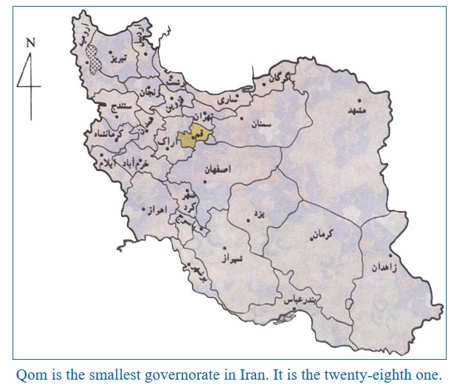

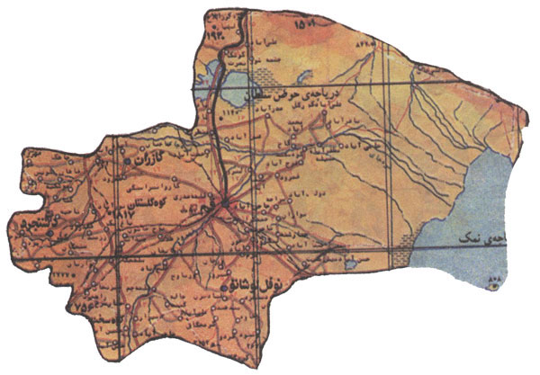

A spatial photo from about 705 kilometers high

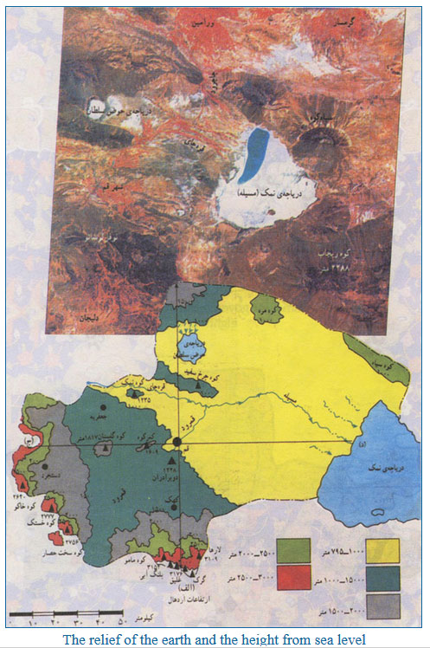

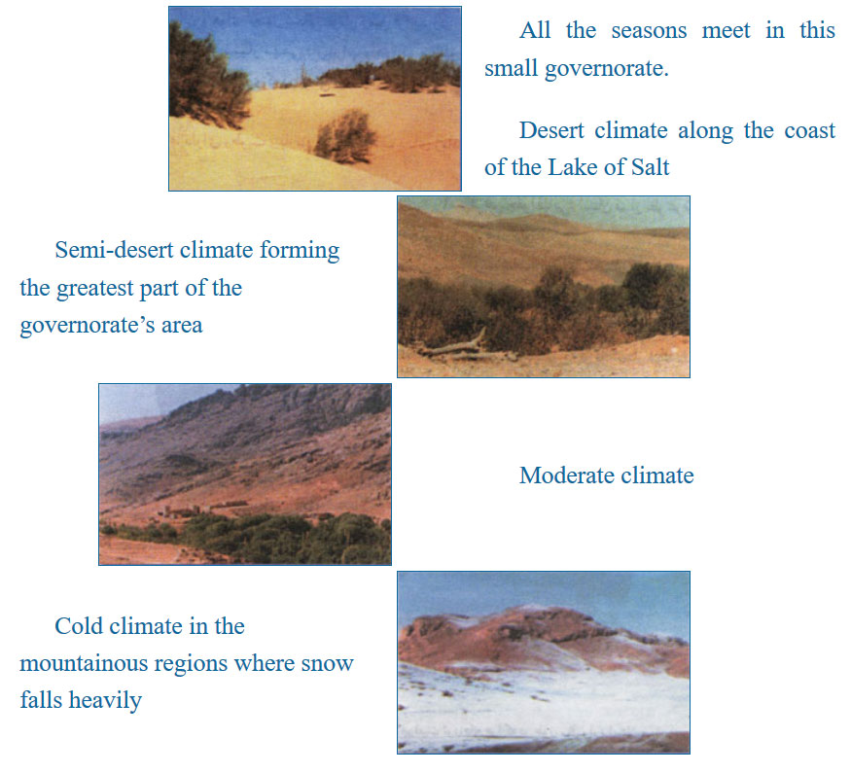

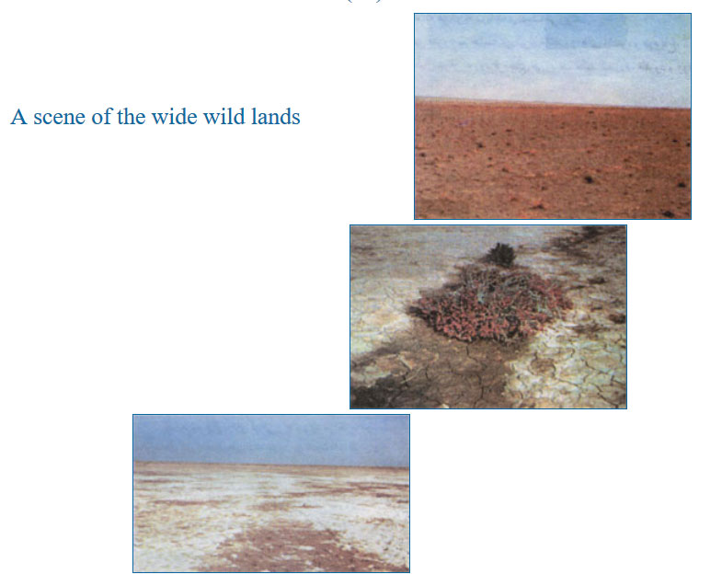

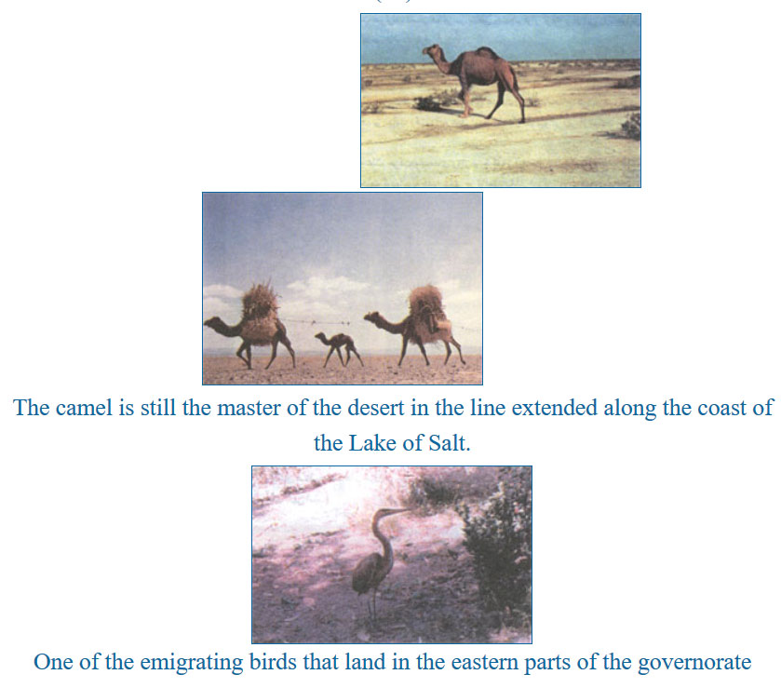

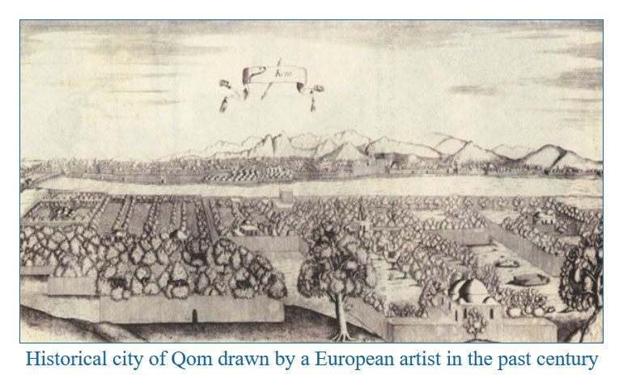

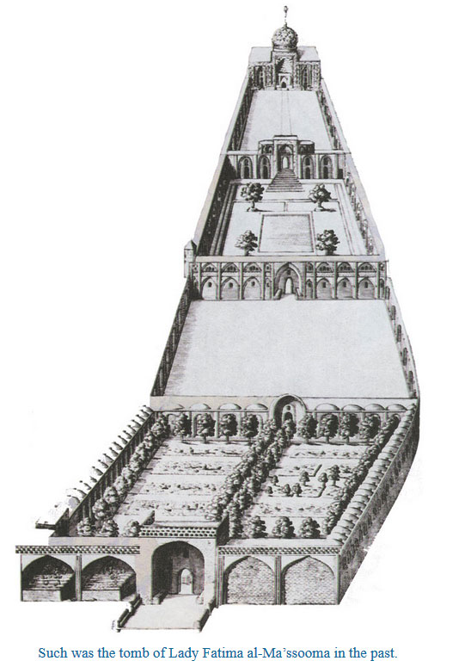

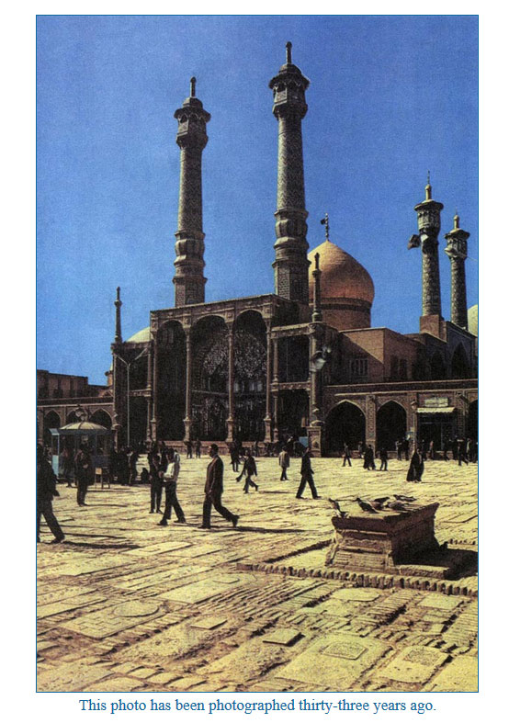

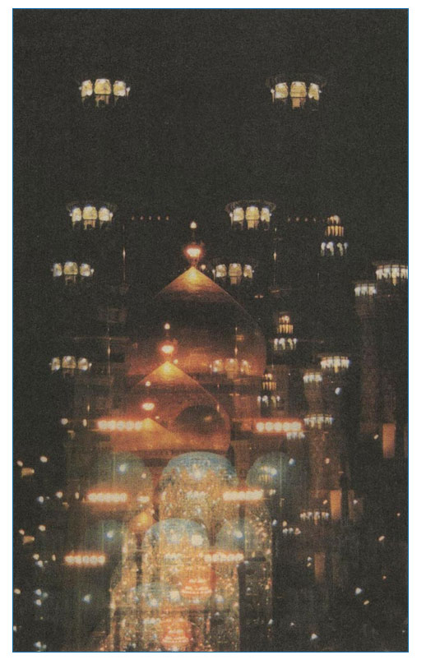

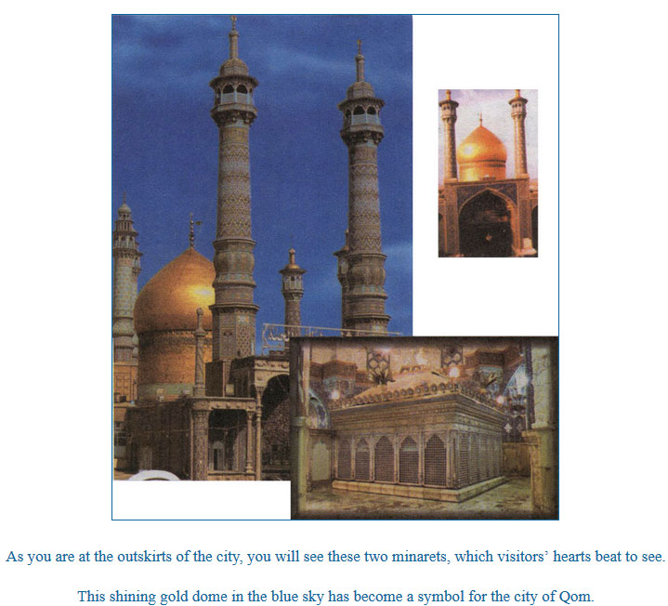

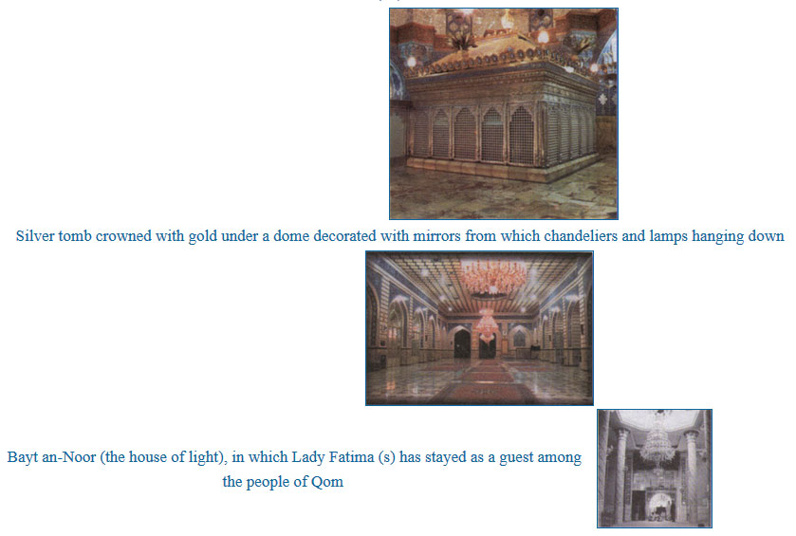

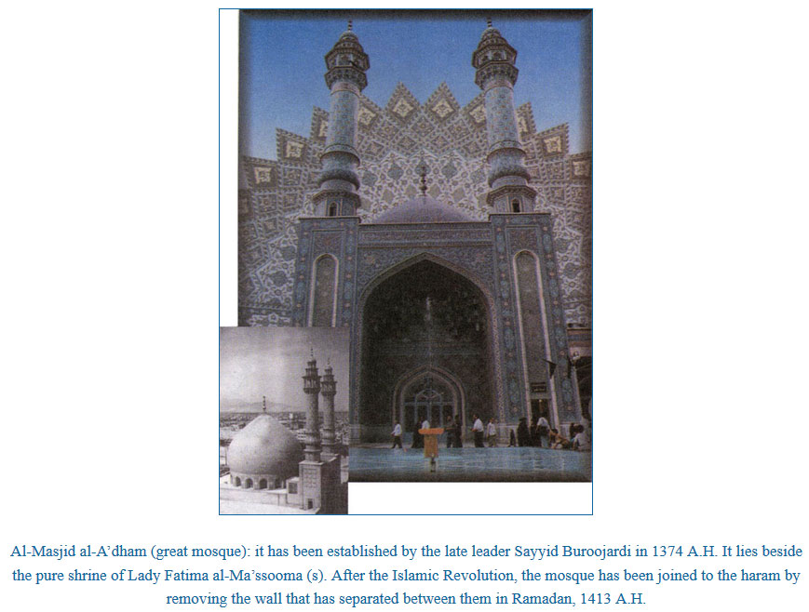

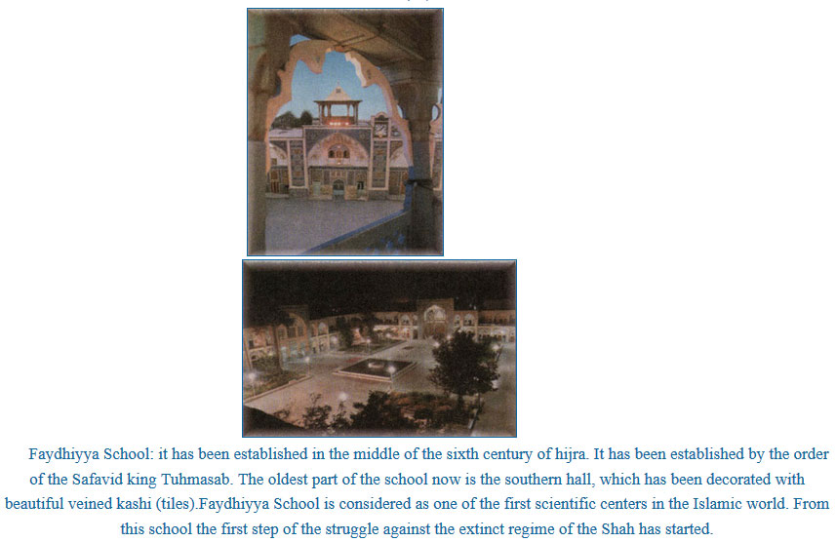

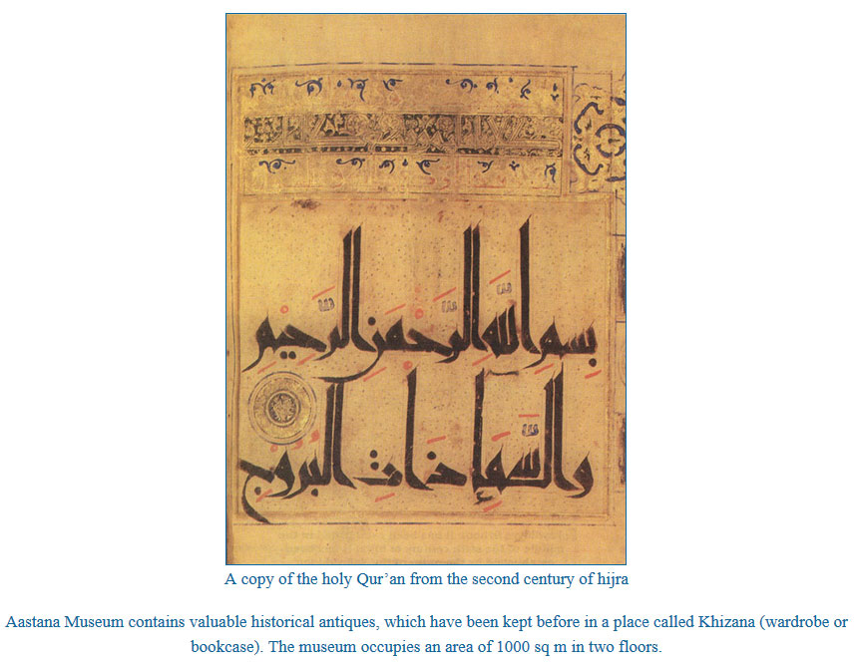

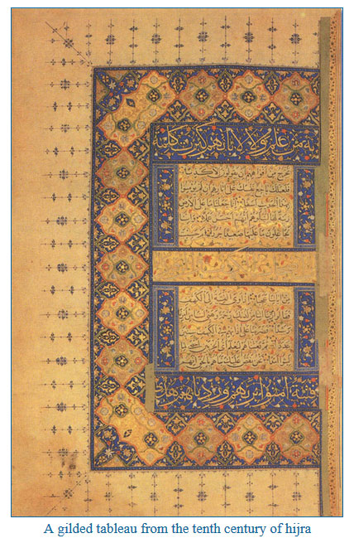

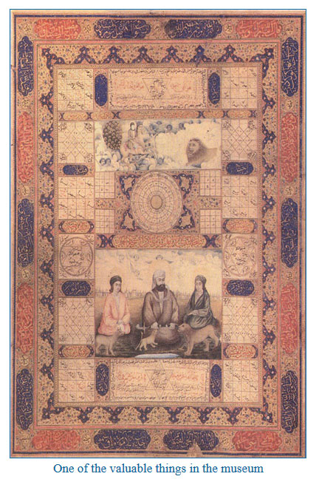

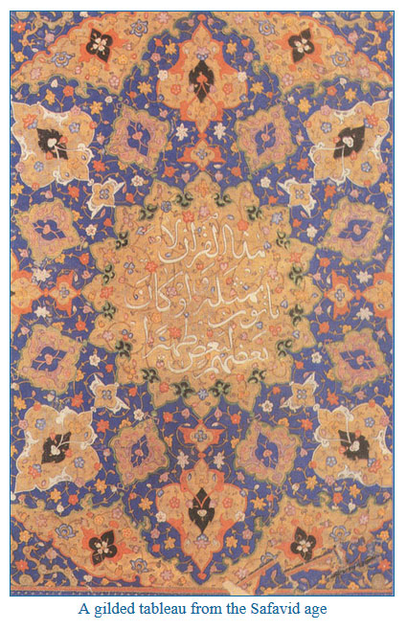

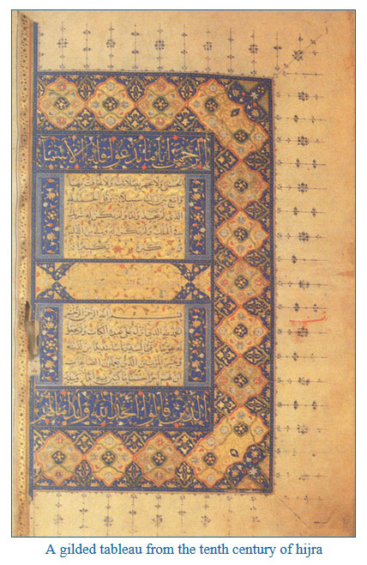

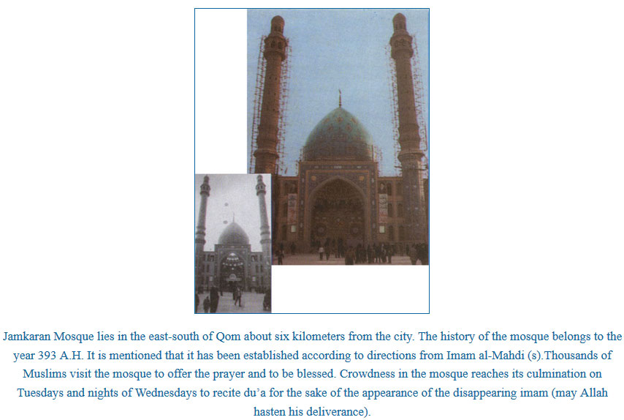

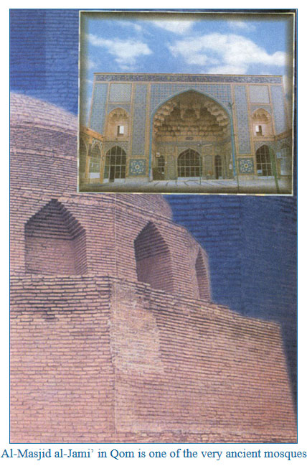

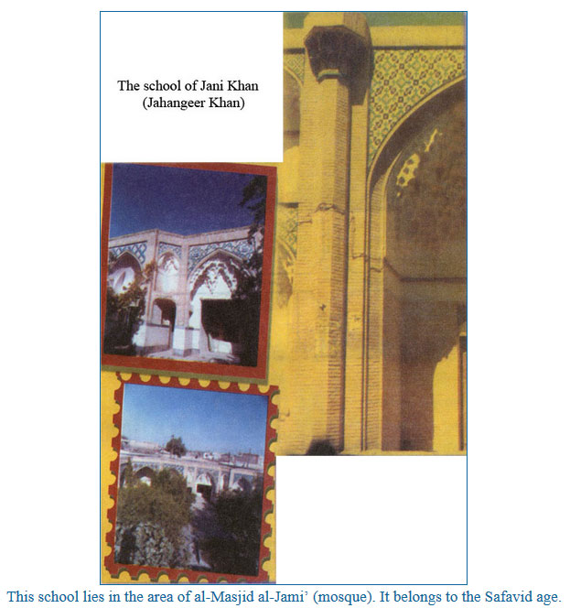

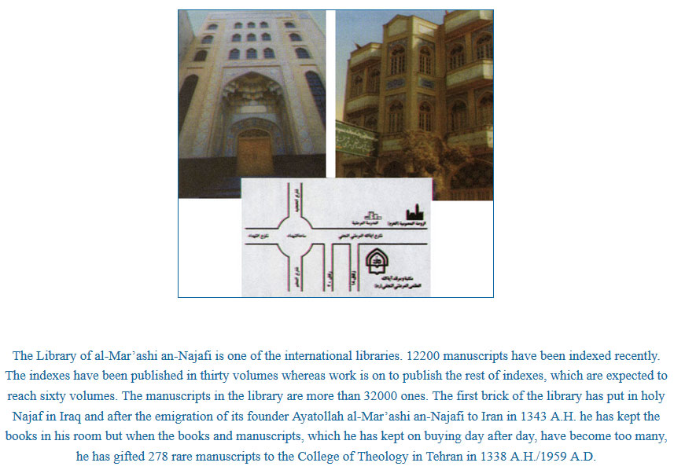

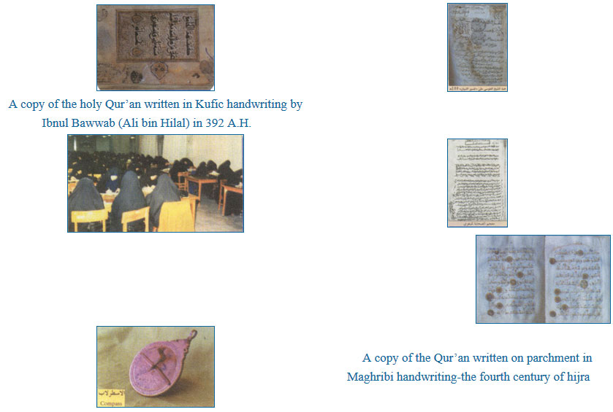

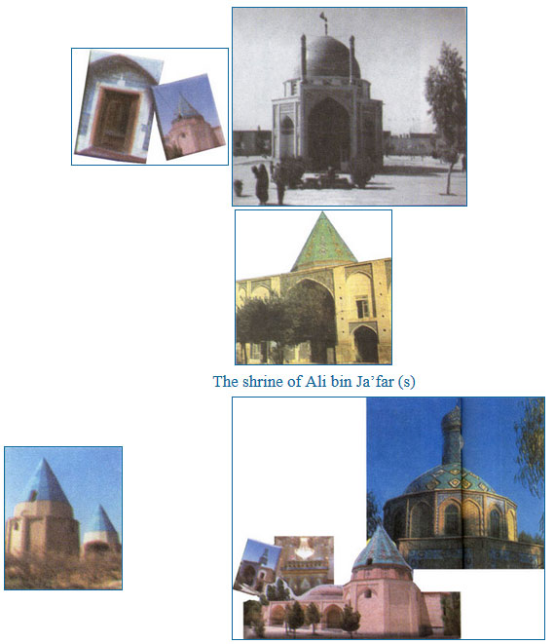

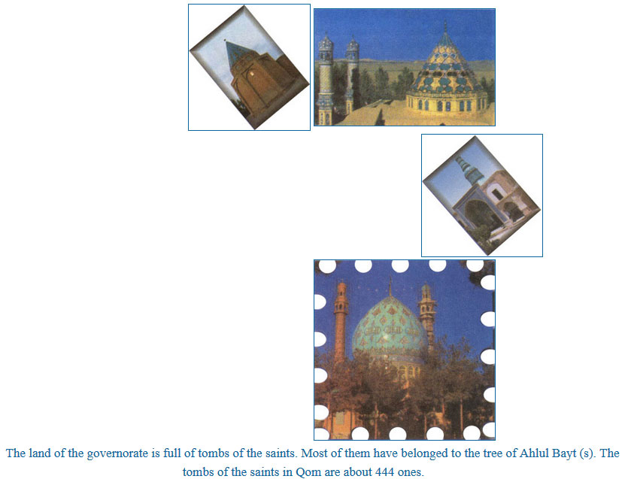

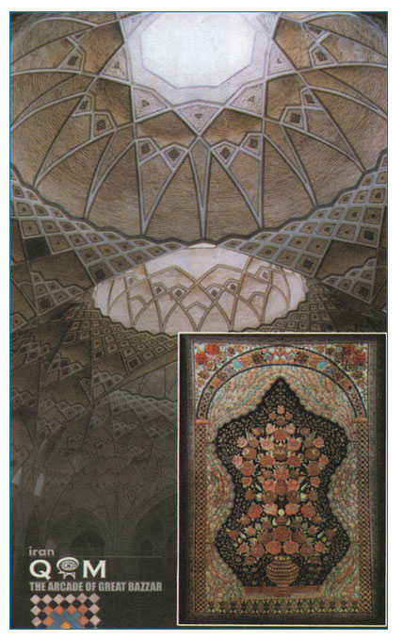

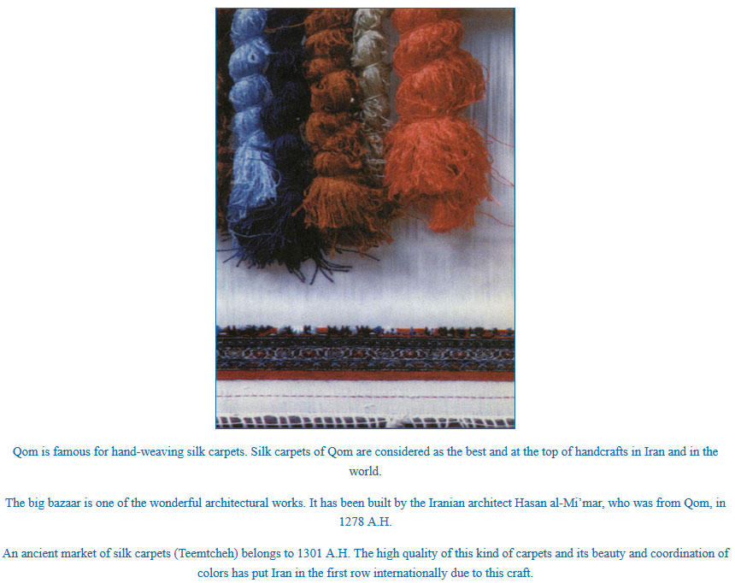

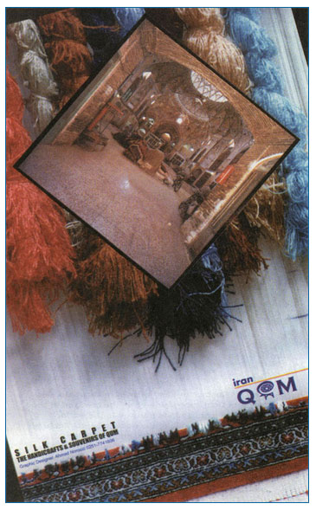

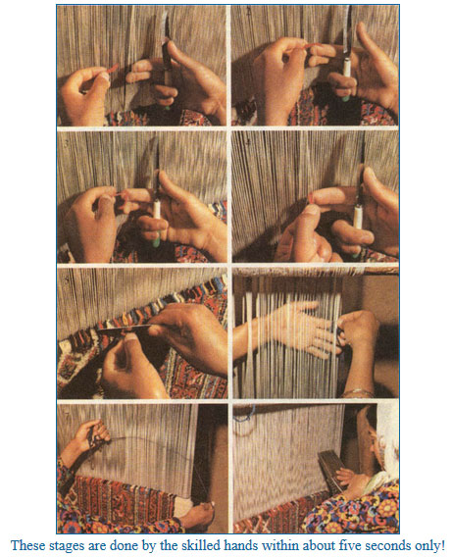

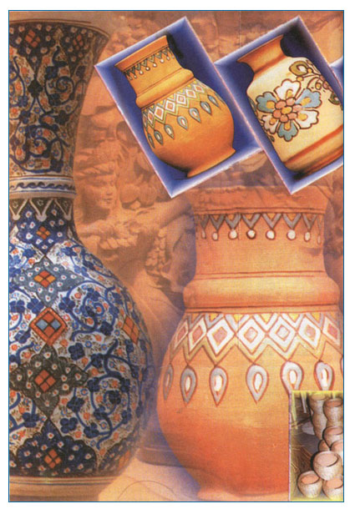

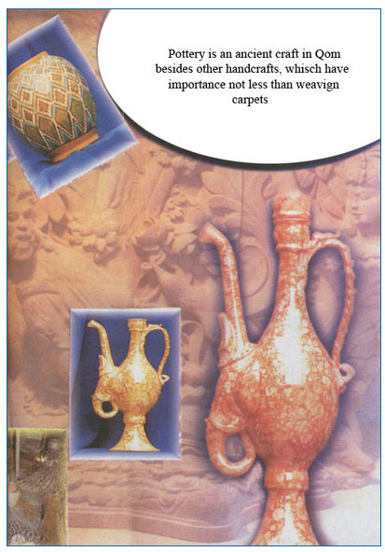

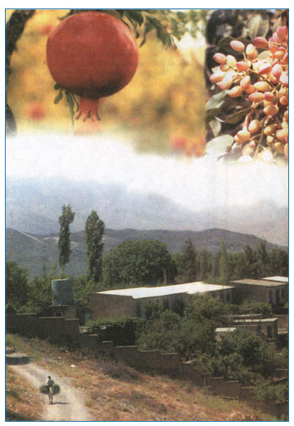

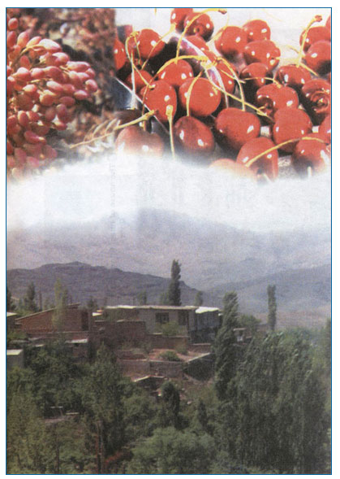

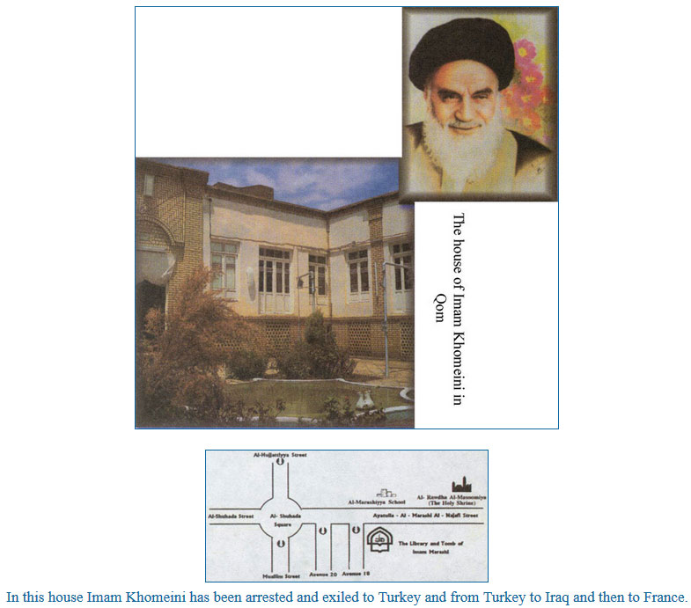

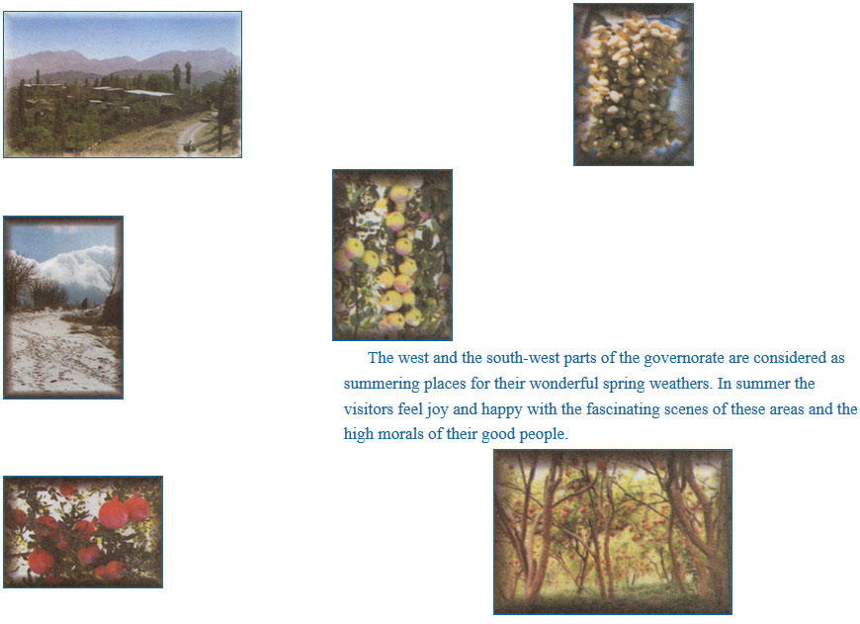

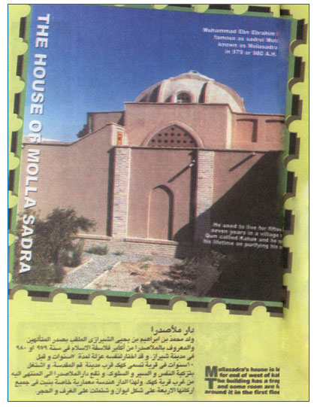

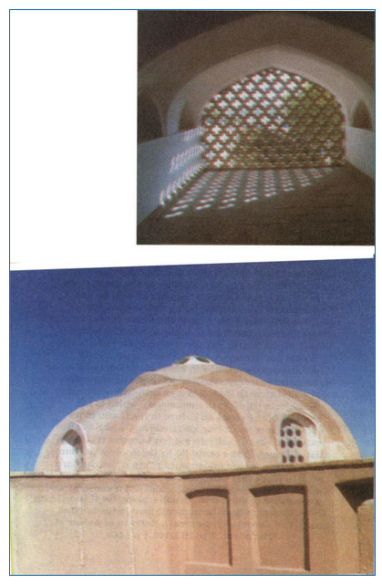

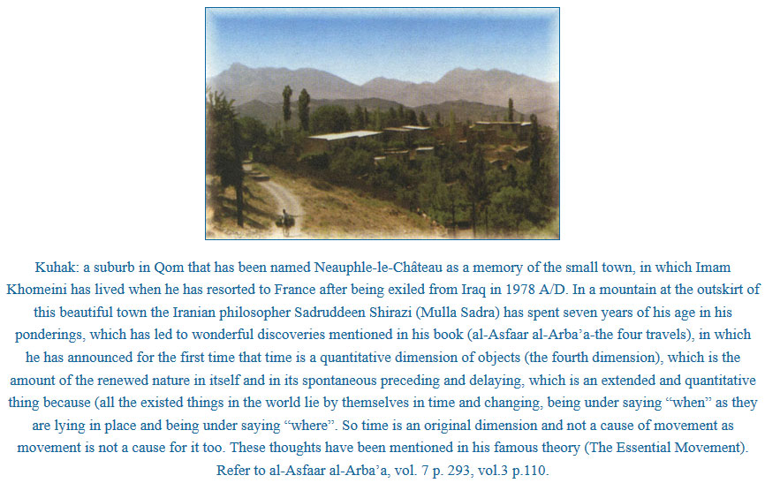

Ansariyan Publications

In 1975 A/D a candle was lit. It began to shine and its light spread little by little.

Yes! Such was the beginning; mercy of Allah and interests undertaken by believers who have believed in Islam as a religion and as a mission.

Such was the beginning; the letters of the Iranians, who have roved throughout the world for studying and trading.

Faithful youths and “men who are true to the covenant which they made with Allah” have seen the world, which has drowned in confusion, stray and suspicion…they inquired: Where is the preaching of Islam? Where is its humane mission?

They lived there and saw closely the confusion of the human beings; Muslims and non-Muslims. Everyone was looking for the right path.

Moreover, the fruitful meetings with Allama (jurisprudent) Tabataba’iy, with Professor Mahmood ash-Shahabi after his return from a travel then, and with others of ulama and learned people of the world of Shiism of Ahlul Bayt (s); all that has led to the establishment of Ansariyan Publications in the holy city of Qom. Ansariyan Publications has been granted with blessings of Allah, His messenger and Ahlul Bayt (s). The beginning was as any beginning. It opened its way slowly and step by step and when the Islamic Revolution triumphed the establishment of Ansariyan flourished to grow up, be firm and fruitful.

Worth mentioning that Ansariyan Publications is proud, in spite of all problems and defects, of suffering what it has suffered while opening its way to stand up nowadays with honor of what it has achieved and what it has presented to the Arabic, Islamic and international libraries, of witnessed services in this concern in spite that it has not got any official or personal subsidy.

And this book before you is one of the fruits of its efforts, which have continued for thirty years of perseverance. Nevertheless, it considers itself as in the beginning of the way beseeching Allah for help and invoking our master and imam al-Mahdi, the authority of Allah on His earth, to keep on this blessed work determinedly and sincerely.

Respectable visitor:

O you, whose heart burns for pure Islam!

O you, whose heart flourishes with loving the Prophet and his progeny!

O you, whose soul has absorbed allegiance to Ameerul Mo’mineen Ali (s)!

You undertake, today, a serious responsibility before Allah, the Almighty, with your tongue, pen, social position and moral and material capabilities and know well that Allah will ask us all about our deeds!

O our brothers in belief and humanity, come on to work and to cooperate and to invoke Allah to grant success to our Islamic Umma.

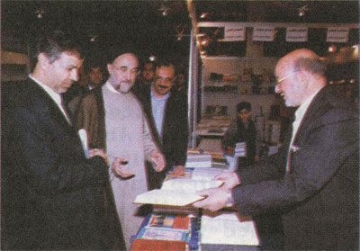

In Tehran International Book Fair

The meeting of the head of the establishment Professor Muhammad Taqi Ansariyan with the president of the Islamic Republic

THE VIRGIN OF THE CITY

Scenes from the Life of Fatima al-Ma'ssooma

(1)

As Musa bin Imran (Prophet Moses) had stood against the Pharaoh, Haman and Qaroon (Croesus), Musa bin Ja’far stood against Haroon[45]… Haroon, whose grandfather[46] had said before:

“I am the authority of Allah on the earth… the shadow of the heaven on the earth… the will and determination of Allah…”

Because of this Musa had risen by the will of Allah to say to Haroon “No!”… had come to ask for Fadak… Fadak, which once had been a small piece of land and then the Heaven had granted to Fatima[47] to be her gift…to be her inheritance and to be, later on, as a symbol of the extorted inheritance and the defeated truth…a symbol of all the Islamic lands.

Because of this Fatima bint[48] Muhammad (s) had risen to ask for her right of Fadak. How small Fadak was on the earth and in geography but how wide it was on the map of history!

Medina was shaken from its beginning to its end because Musa had come to ask for the inheritance of his grandmother az-Zahra’…had come to get Fadak back with its wonderful limits; from Aden to Samarqand to Africa to the shore of the sea beyond the islands and Armenia…!

Haroon was filled with spite…Musa had come to threat his throne, wealth, palaces, rule and state…

Fatima,[49] with her six years of old, stood up waiting for the coming back of her father, who had gone out in the dawn and had not come back yet. It was not only Fatima, who was waiting for the coming back of the brown man, who had images of prophethood in his face, but Medina all in all was expecting what Haroon wanted from Musa.

She was looking at her brother Ali, whose face seemed like a sky with sad clouds. Fatima thought that her father would be far away or he might never come back again. She might not see him or hear his warm voice again. She felt cold. Fear filled her inwards. Her eyes were filled with tears of sorrow.

The waves of sorrow have deeper influence than the shakes of joy. They dig their places deeper in memory. Nothing is more eternal in the world of innocent childhood than the scenes of orphancy.

Fatima had lost her mother while she was unable yet to understand what there was around her in this world. Then she faced the storm. It was the storm of the fate when the severe hands snatched her kind father away

from his family and children to burden him with ties and chains.

Fatima looked at her brother…She thought that she saw a sky with heavy clouds. Allah was the only One, who knew the bottom of the love, whose pure springs flowed inside the heart of Fatima…Fatima, who saw with her own eyes the storm of the bitter time!

The time of separation had begun…the time of vagrancy…the time, in which the accusation of disbelief was much easier than to be said that this one was from Ali’s progeny…from Muhammad’s grandsons…

Haroon feared Musa…feared his words. They were the echo of Muhammad’s words…the echo of Ali’s speeches.

Fatima stopped to farewell from far a caravan taking its way towards Basra and her heart beat rapidly longing after a howdah surrounded by swords and spears. Her heart would not fail her.

The caravan disappeared far away while the sky was still raining little by little.

Fatima came back with her brother Ali. She came back trailing her self and feet to the house that seemed as a tent torn by the wind in that cloudy morning. The father departed. The pole of the tent collapsed. Peace left far and it might not come back again. Fatima looked at the cloudy sky and the rain. Childish tears fell from her eyes. Tears like sad rain began to fall silently.

How bitter orphancy is in the orphans’ hearts. How bitter cold is…the cold of fear…the fear of the unknown.

When the father departs, life becomes cold and frosty…with no sun, no light and no warmth.

(2)

There is nothing bitterer than to see the moments of collapse…collapse of things and shaking of the firm principles of life.

Everything shook. The voice of the man died down and tens of obscure voices appeared…voices that took their powers from instincts hidden in the human inner in the moment when mind failed before the shine of greed.

Life is like a top whirling with its people in the middle of a fiery storm.

In that bad time where everything shook under the hoofs of mad horses, that fifty years-old-man stopped…his eyes traveled through an infinite sky and his hands extended whereto hearts would turn towards in the moment when the waves were about to destroy a straying ship…calm words entreating Allah suppliantly:

“O, You, Who have guided me to Yourself and made my heart submit to believe in You… I beseech You to grant me safety and belief in this life and the afterlife.”[50]

Fatima came in and sat beside her brother to feel security in a world full of terror…to absorb goodness in

a world swarming with evils. Bitter sorrow shone in her eyes…a sorrow that belonged to quarter a century; all her life that was full of sadness.

She still remembered twenty years ago the moments when her good father had been taken to Baghdad. She had never seen him since then. She could not forget yet the moment when her mother left to the better world. It was a very cold winter night. She could not find warmth except near her brother Ali.

And then was Ali in the middle of the storm…exactly in the calm spot…in the central point where there was no any stormy movement.

And there was Fatima, who had never found her equal since long ago, eager to find the man, with whom she would feel she was near the Kingdom…the Kingdom of the far Heavens. Near him Fatima would feel she had passed the limits of the self so that her soul would swim in a pool of that light, which shone in the hearts. As if thousands of lamps lighting inside her. Such Fatima lived near her alone brother.

The shakes of the volcano that had broken out in Mecca reached Medina, the capital of the Prophet (s). Muhammad bin Ja’far[51] revolted but his revolt was

defeated while it was yet a bud and then the forces of al-Ma’moon went towards Medina to revenge on the Alawites. Al-Juloodi, the harsh man, led led his soldiers to plunder the houses of the Talibites[52] in frightened Medina.[53]

The invading forces entered Medina to plunder the houses of the Talibites and to confiscate all what they had. In the mind of rude al-Juloodi there were personal orders from the seventh Abbasid caliph to rob the women their garments and jewels and not to leave for each of them save one dress to wear.

Terror spread. Everything shook. The invaders paid attention to no sacreds and al-Juloody kept on achieving his task.

Ali rose to stand against the coming terror. He gathered the women in one room and got ready to face the plunderers.

The heart of Fatima, which was the only heart that held all the pains waving in that room, began to beat rapidly. Her memory was full of all eternal valors…all that history over burdened with sorrow…all the bitter moments that the woman suffered; the pains of

He was sent under escort to Marw, the capital of al-Ma’moon at that time. He died in the way when coming back to Baghdad in mysterious circumstances. Al-Ma’moon attended the funerals. Refer to Murooj ath-Thahab, vol.3 p.439.

Khadeeja, the emigration of Fatima and the sorrows of Zaynab.[54]

The storm was still whistling with rage wanting to pluck up a good tree, whose root is firm and whose branches are in the Heaven.

Fatima, while pondering on the totters of the past, heard a dialogue near the door. A voice with harshness of executioners said:

“I just carry out the order of the caliph.”

A calm voice replied: “If your aim is to rob the women, I will do that for you.”

The harsh voice said: “How can I be certain that you will do that? The orders of the caliph state that the women must be robbed of their garments and jewels except one dress.”

The angelic voice said: “I swear that I will do that.”

Al-Juloodi looked at the Alawite man and saw in his eyes determination and firmness as if he was a mountain. He thought that if he broke into the house, he would pay the price so expensively and the public situation might break out. He had never met during his life a man standing so calmly before drawn swords. He saw many men bowing before him and their eyes shone with fright and fear. But now he found himself before a man of another kind…a man, whose eyes led to a bottom flooded with peace!

Al-Juloodi made a sign to his soldiers to retreat and turned towards the man, who was about fifty years old, saying:

“I am waiting.”

Ali went into the yard of the house and then to a room in one of its corners. He looked at the women and young girls.

The little hearts beat rapidly listening to the neighing of mad horses.

Fatima knew what was there inside her brother’s heart. The most difficult thing to a man was to rob a woman her jewels…to snatch her earrings, necklace and bracelets from her wrists.

Therefore Fatima advanced to destroy those bitter moments. She pulled out her own earrings and necklace, drew her hands out of her silver bracelets and offered them to her brother. Soon the rest of the women did the same one after the other. The garments and jewels heaped in Ali’s hands. He went with them to the wolves awaiting at the threshold.

Such the yellow storm passed thinking that it had pulled out everything standing in its way. It did not care about the violet flowers that spread here and there sending fragrance into the wide space without being paid attention by anyone.

In that winter night, while al-Juloodi was going away from the house, Fatima sat to talk to the women, who had gathered around her expecting her warm sacred words. She said:

“Fatima bint Ja’far bin Muhammad as-Sadiq told me from Fatima bint Ali bin al-Husayn from Fatima bint

al-Husayn bin Ali from Umm Kulthoom that her mother Fatima, the Prophet’s daughter (s), had said:

“Have you forgotten the saying of the messenger of Allah on the day of Ghadeer Khum “Whomsoever I am his guardian, Ali is to be his guardian” and his saying (to Ali) “You are to me as was Aaron to Moses…”[55]

Fatima turned to a young girl and said: “O My niece, write it down lest the heritage of the prophets is lost.”

Fatima became silent. She new that this storm coming from Marw wanted to get rid of Ali, who was still standing against the storms of time and whose love was still beating in the hearts of the free and the oppressed. Therefore Fatima said:

“Fatima bint Ja’far as-Sadiq told me from Fatima bint Muhammad al-Baqir from Fatima bint Ali bin al-Husayn from Fatima bint al-Husayn from Zaynab bint Fatima that Fatima, the Prophet’s daughter (s) had said: “I heard the messenger of Allah saying:

“When I had been carried to the Heavens in night, I entered into Paradise. I saw a palace of white hollow pearl. It had a gate crowned with pearls and corundum. There was a curtain on the gate. I raised my head to see that it had been written above the gate: “There is no god but Allah. Muhammad is the messenger of Allah. Ali is the guardian of people.” On the curtain it was written: “How great! Who is like the followers of Ali?!”

I came in and I saw a palace of hollow carnelian with a silver gate crowned with olivine. There was a curtain on the gate. I raised my head to see that it had been written on the gate: “Muhammad is the messenger of

Allah. Ali is the guardian of al-Mustafa[56]”. On the curtain it was written: “Tell the followers of Ali of their good birth”. I came in and saw a palace of hollow aquamarine that I had never seen more beautiful than. It had a gate of ruby crowned with pearls. There was a curtain on the gate. I raised my head to see that it had been written on the curtain: “The followers of Ali are the winners”. I said: “O my beloved Gabriel, for whom is this?”

He said: “O Muhammad! It is for your cousin and guardian Ali bin Abu Talib…All peoples will be resurrected barefooted on the Day of Resurrection except the Shia of Ali. People will be called with the names of their mothers except the Shia of Ali, who will be called with the names of their fathers.”

I said: “O my beloved Gabriel, what for?”

He said: “They love Ali; therefore their end will be good.”[57]

A fountain of divine love flowed to fill the hearts with joy and the souls with pellucidity.

Life becomes unbearable hell if the real hope of a better tomorrow that is full of light and spring beauty disappears.

(3)

The scene of sunset was generous with its transparent colors; orange, golden and red like a winter hearth full of firebrands. The sky seemed calm but there was some scattered clouds moving slowly as sleepy boats in a calm lake.

The wind of autumn roved through the houses and told of the coming of a long cold winter.

Fatima was pondering on her brother’s face. She had never seen him so depressed as in this evening. As if he was burdened with mountains of sorrows. She did not know why the old scenes…the very old scenes when her father was taken and she believed that she would not see him again had come to her mind! She might know that through her brother’s face, which seemed at that moment as a sky burdened with sad rain.

The letter that Imam ar-Redha (s) had received was like honey mixed with poison. It was like a smooth adder brimful of deadly poisons.

Al-Fadhl bin Sahl[58] knew how to dodge between the lines. It was an ambiguous letter from the highest official in the state asking him to leave Yathrib

(Medina) as soon as possible to assume his responsibility in the caliphate.[59]

Fatima asked herself about the secret of her brother’s sadness. She was conscious of the worries of her brother, who was pondering on the far extents where all the pains and dreams of the prophets were shaped.

There was no doubt that al-Ma’moon had known the source of the real challenge. He found that a personality like Imam ar-Redha (s) would uncover to the public opinion the extent of the moral corruption of the rulers besides that the farness between Medina and Marw would give Imam ar-Redha (s) some freedom to act and this would be dangerous to the rule, which was still shaking under the effects of the disturbances and revolts.

Sending for Imam ar-Redha (s) to go to Marw meant that al-Ma’moon hit tens of birds with one stone.

Imam ar-Redha (s) murmured with a sad voice: “Al-Ma’moon wants to tell people that Ali bin Musa (Imam ar-Redha) (s) has not abstained from this worldly life but the life has abstained from him. Have you seen how he hastened to Marw when life was offered to him? But how far! I do not accept any of his offers.”

Fatima knew that her brother had confronted the fox of the Abbasids, who was full of deceit and cunning. She knew that from the sadness of Imam ar-Redha (s) and the news she heard.

The love that her brother had among the people of Khurasan and its outskirts no one else had. If al-Ma’moon put him in the rule, it would give him allegiance of many districts and by this al-Ma’moon would prove to the nation that he had achieved the best hopes of people.

A servant knocked at the door saying: “A man says that he is Raja’ bin ad-Dhahhak. He wants to meet you now.”

Imam ar-Redha (s) turned to his sister and said: “This is a man sent by al-Ma'moon with what I dislike. We belong to Allah and to Him we shall return!”

Imam ar-Redha (s) got up to receive the man and Fatima left the room.

As Raja’ sat down, he offered a sealed letter from al-Ma'moon. Imam ar-Redha (s) opened the letter and took a look at it. A sign of sorrow appeared on his forehead. The light of the lamp was enough for Raja’ to discover the depth of the ordeal on Ali’s face. He assumed to be glad and said:

“O my master, congratulations!”

Imam ar-Redha (s) replied while looking to the far horizon:

“Do not be glad. It is a thing that will not be completed.”

Raja’ became silent for this Alawite man was different from many of the revolters, whom he had met. He was before a man reading ambiguous pages of the future. In fact he understood what was waving inside Ali’s self because Raja’ knew well the intents of al-Ma'moon and

many secrets of his plan! Therefore he got up rapidly assuming to be happy by carrying out his task.

He said while bowing respectfully: “Everything will be ready after tomorrow.”

Imam ar-Redha (s) said: “If it must be, then first we go to Mecca and then to Marw.”

Raja’ said: “As you like, my master!”

The brown face was covered with divine sorrow. Something was burning inside him. Something informed of tearing roots of a flower planted in a good soil.

Nothing is bitterer than to pull out a tree with its roots…Thus was the sorrow of the man, who had been touched by the Heaven. His roots had been extended into the good soil tens of years until that moment when the Messenger of the Heaven had put his feet in Yathrib.

The traces of Gabriel were still in those quarters, whose date-palms, mosque and beloved mountain were blessed.[60]

Ali turned his mind upon his calamity and the lamp was ejecting its last faint lights.

The Medinian[61] man (Imam ar-Redha) woke up from a deep pondering when a boy of seven years entered the

room.[62] He was carrying a vessel having some oil because the lamp was about to go out. Muhammad began to pour the oil into the lamp. The lamp breathed and the circle of light became more and more.

The sad father noticed his son, who came in walking on his toes regarding his father’s pondering, in the room. The father got up welcoming Abu Ja’far[63] and tens of stars shone in the sky of his eyes.

The son bowed to kiss his father’s hand. The father did not give his son time and embraced him as the leaves when embracing a new bud in its first spring.

The lamp recovered its youth and began to send its light and warmth in the little room.

The father said when a part of night had passed: “O my son, get ready to travel.”

The son asked: “O father, whereto?”

The father said: “To the Old House (the Kaaba).”

The boy wanted to remove from his father’s heart a grief depressing him. He said:

“Is it hajj or minor hajj?”

The father said: “I have been ordered to travel.”

The son said: “O my father! Do what you are commanded. If Allah wills, you will find me of the patient ones.”

Muhammad got up as he came in on his toes leaving his father, who returned to another pondering.

He, who watched his shining eyes and followed in their bottoms the reflections of light, would know the secret of that divine sorrow. As if his sharp mind swam in the far horizons to Tooss where Jabir bin Hayyan al-Kufi[64] had inhaled his last breaths and where Abul Saraya had been crucified on the bridge in Baghdad…and to the banks of the Tigris where Ma’roof al-Karkhi[65] used to sit pondering on the flowing waves and to farewell the life.

He might watch (the Battle of the River) at the shores of (Aroon) or he might come down to the bottoms of the valleys with his brother Ibraheem, who had fled to Yemen and his news were unknown.

No one knew the distresses of the Medinian man…distresses as heavy as the mountains of Tehama, al-Hijaz and Najd.[66]

There in Marw the spider wove its house, which was the weakest of houses.[67]

(4)

In that cloudy morning Medina seemed as a place of ghosts. The houses lost their joy. The lanes were covered with grief especially that lane where the camels had knelt down to carry those, who determined to travel unwillingly.

The man of the fifty years entered the mosque of the Prophet (s) with his son, who followed him as his shadow. The sky was burdened with clouds. Some tears gathered in this Medinian man’s eyes. He stopped before the tomb, which contained the last of the prophets. The man with the white cloths seemed as a sad cloud.

Those, who attended the meeting, were astonished at the tears of Muhammad’s grandson. The sorrow was as a rivulet flowing in autumn. Ali inhaled the fragrance of prophethood. He controlled himself to get up. He stepped one step backward and then fell down to the pure place again as if his roots were planted in that soil where Muhammad (s) had closed his eyes peacefully.

A man from Sajistan[68] approached and said: “O my master, congratulations on what you are going to be!”

Imam ar-Redha (s) said: “Let me alone! I am going away from the neighborhood of my grandfather to die there in desolation.”[69]

The man became astonished and made his mind to accompany the Imam to see by himself how his predicts would become real.

Muhammad put his small warm hand on his father’s shoulder and the father got up as if new blood flowed in his interiors and a new hope refreshed in his entity.

Fatima watched what happened. There was something tying her to her brother. It was not the tie of brotherhood. She lived the ordeal of her orphancy twenty years ago when her father had been taken and had never come back again and the death of her mother while she was a child yet.

Fatima stopped and the ordeals of the bad time came to her mind. She saw how the bad time snatched her darlings as if the years and days were mad wolves snatching the livestock of her dreams while grazing peacefully in the green valley.

A sacred anger exploded inside her heart…in that beating part, which summarized the entire world.

Imam ar-Redha (s) got up touching the pure tomb with his hand and embracing his son, whom Allah had granted wisdom while yet a child. He said to his son:

“I have ordered all my guardians and followers to listen to you and to obey you. I have told my close companions about you.”[70]

The camels got up. The caravan arranged and moved southward to the Kaaba.

When the caravan passed (Thaniyyatul Wada’) the Medinian man said to his son while dialoguing with him:

“The friend of everyone is his mind and the enemy of him is his ignorance.”[71]

“The best of intelligence is knowing oneself.”[72]

“From among the signs of understanding there are; discernment, knowing and silence. Silence is a gate of wisdom…silence brings love…it is a guide to every goodness.”[73]

Yassir, who was the servant of Imam ar-Redha (s), came near and heard the Imam saying:

“Man becomes most desolate in three positions; the day when he is born and he comes out to see the world, the day when he dies and sees the afterlife and its people and the day when is resurrected to see judgments that he has never seen in the worldly life. Allah has saluted Yahya (Prophet John) in these three positions and calmed his fear by saying:

And peace on him on the day he was born, and on the day he dies, and on the day he is raised to life.[74]”[75]

Some whiffs blew from the north carrying with them a humming of a shepherd complaining the time.

The caravan went on crossing the desert until it reached (Ghadeer Khum). The travelers stopped near a spring, whose water went out from under a rock and flowed into a wide valley. Some date-palms had grown because travelers often stopped here to rest and to have their food, among which dates were.[76]

The full moon shone from above the far hills. The man of fifty years pointed with a brown finger and said:

“That is the place when the messenger of Allah has stopped to say: “Whomever I am his guardian, here is Ali to be his guardian. O Allah, assist whoever assists him and be the enemy of whoever opposes him!”[77]

The old memories revived and the travelers were filled with reverence as if they were listening to the Prophet (s) making his speech in this place. The holy words were still roving in the space. The fragrance of Gabriel was still emitting while reciting the word of Allah:

This day have I perfected for you your religion and completed My favor on you and chosen for you Islam as a religion[78].[79]

Ali turned to his sister, who was looking at the moon on the far hills, and said:

“I have heard my father narrating from my grandfather as-Sadiq his saying: “Allah has a sanctum. It is Mecca. The Prophet has a sanctum. It is Medina. Ameerul mo’mineen has a sanctum. It is Kufa. And we also have a sanctum. It is the village of Qom, in which a woman from my progeny called Fatima will be buried. Whoever visits her will be in Paradise.”

The young boy (Muhammad) looked at his aunt, who was still looking at the moon in a state as if she was offering the prayer. She was standstill in her place while the whiffs were playing with the hems of her garment, which touched the brownness of the desert.

In that blessed spot of the world of Allah a fountain of prayers broke out. The words of praising and thanking Allah, the Creator of the earth and the heavens, shone through the dreamy darkness of the sunset. Little by little the stars appeared in the sky.

Some of them went to collect firewood. The sound of breaking the dry branches of the trees broke with it the silence of night.

After a short time two hearths lit through the darkness; one for cooking and the other for light and warmth. Some boys went toward a dune made by the wind to take it as a stage for their innocent playing.

(5)

The news of joy flew to the capitals and cities like butterflies announcing the coming of spring.

In Yathrib, the city of the Prophet (s), Abdul Jabbar al-Masaheeqi ascended the minbar in the holy mosque to announce loudly:

“O people, this is the thing you have wished, the justice you have expected and the goodness you have hoped. This is Ali bin Musa bin Ja’far bin Muhammad bin Ali bin al-Husayn bin Ali bin Abu Talib…six, whose fathers are the best of people.”[80]

But in Baghdad the volcano of the Abbasid spite awakened and the dragon[81] rose. The Abbasids rose with him and announced to depose al-Ma'moon and his heir apparent.

Baghdad fell in disturbance after the caliphate was despised to be as a toy in the hands of the singer ibn Shukla, who had not known save playing lute.

In a short time anarchy and corruption spread in all of Baghdad. The streets became under the control of thieves and robbers. Stealing and adultery spread widely.

Public groups were formed to enjoin the right and to forbid the wrong in order to resist the corruption.

In Kufa fighting broke out between the followers of the Abbasids and the followers of al-Ma'moon whereas Mecca received the news from Marw joyfully.

Soon the resistance stopped because of the popularity of Imam ar-Redha (s). Baghdad became separated from the other provinces except Kufa, which was under the control of Baghdad.

The month of Thul Qa’da was about to elapse. The clouds of spring appeared in the sky and then they were swept away by a northern wind. The rain did not bring good news about a fertile season because it didn’t rain along the winter and spring did not bring except a few drizzles, which did not nourish nor released from hunger.

Al-Ma'moon did not think about going to offer the hajj. Some people remembered the words that had been said by Imam ar-Redha (s) in Mecca many years ago when ar-Rasheed was circumambulating the Kaaba:

“Haroon (ar-Rasheed) is the last one of this family (the Abbasids), who offers the hajj.”[82]

Thul Qa’da gathered up its last days and the crescent of Thul Hijja appeared in the sky. The crescent appeared like a smile in the middle of the sky, in which some sad

clouds scattered here and there. In the second night it became as a straying boat crossing the sky rapidly.

While the Muslims were circumambulating the Kaaba, the cities near Basra received silently the news of the revolution of the Negroes and other news about killing and plundering.

Medina lived those days looking to the future hopefully.

An honorable house was there, whose windows lit with transparent light…a house, in which the family of Ali lived. An honorable letter came from Marw. It was from Abul Hasan (Imam ar-Redha) and it was in the name of Allah, the Beneficent, the Merciful:

“May I sacrifice myself for you! I have been informed that when you ride your sumpter, the mawali[83] make you go out from the small gate of the garden. It is because of stinginess in them lest no one (of people) may get some goodness from you!

I ask you with my right upon you…do not come in or go out except from the big gate.

When you ride your sumpter inshallah, let some gold and silver be with you. No one asks you for something unless you give him. If one of your uncles asks you to be pious to him, do not give him less than fifty dinars and you may give him more if you want. If one of your aunts asks you, do not give her less than fifty dinars and you may give her more if you want. If someone of Quraysh[84] asks you, do not give him less than twenty-five dinars and you may give him more if you want.

I just want Allah to make you succeed, so fear Allah and give and do not fear stinginess from Allah.”[85]

In that night Fatima was crying for her brother because she was the only one, who understood his ordeal. The position of the (heir apparent), of which the Alawites became delightful, was just a house woven by a spider. Her brothers Ahmad, Muhammad and Husayn and some of her cousins thought of going to Marw. A new era had come. The emigrants returned to their countries and families. The hidden and pursued people appeared.

Fatima listened to the document of the (position of) heir apparent when it had been written in the mosque of the Prophet especially the part that her brother Imam ar-Redha (s) had written. She found that it aroused hopes that her brother was trying his best to revive this straying nation to the right path.

It was the meaning of his saying: “…and I have made Allah upon my self that he has entrusted me with the affairs of the Muslims and invested me with His caliphate to achieve their affairs in obeying Him and obeying His messenger…and to choose the best as possible as I can.”

Fatima would not leave her brother alone. She would travel to him. She would ask her nephew for some money to be able to travel to Marw.

People became delighted when Imam ar-Redha (s) had been appointed as the heir apparent. The Alawites felt safe and there was no fear any longer.

Fatima got up to offer the prayer in her mihrab. Thus she did whenever obsessions came to her mind.

Allah, glory be to Him, was the only One, Who knew what griefs was there inside that gentle and pure heart. She would not tolerate more than that. There was something pulling her to Marw or to a point that she did not know where!

(6)

Fatima would not be able to tolerate more than this. Her heart was in Marw…in that city of the Far East. The news coming from Baghdad showed that the situation had been very bad and her brother faced the world alone and no one was with him.

The letter she received recently swept away all the obstacles that prevented her traveling. It aroused in her a determination that could not be resisted!

The letter was not sent to Fatima alone even it appeared as a personal letter. Imam ar-Redha (s) suffered his ordeal alone. The Abbasids would not be quiet as long as Imam ar-Redha (s) was the heir apparent and al-Ma'moon would not be able to resist long. Moreover she could not trust in this caliph, who had killed his brother a short time ago and committed massacres against the innocent. The bloods of the revolters in Kufa and Mecca had not dried yet.

She knew her brother well. He farewelled Medina with tears. So the letter looked like a call for help uttered by an oppressed man…a man trying to correct the path of history.

The phenomenon of emigration in the human life will remain as one of the most important human phenomena in history. Even it appears as just quiet

protest against oppression and injustice, yet it is considered as a great event and as a beginning of a new age in the life of man.

In a dawn of one of the last days of Safar while the moon was in wane, a caravan with some of the Alawites, in front of whom were the brothers of Imam ar-Redha (s); Ahmad, Muhammad and Husayn, set out. The number of the travelers in the caravan became three thousands when it left Medina. The camels set towards Basra then to Shiraz[86] and then to Kirman “if the wind flew as the ships liked”.

No one knew why this desert way had been chosen! Had the brothers of Imam ar-Redha (s) liked to gather a great number of men as much as they could throughout the way?!

The caravan grew bigger and bigger. The men of some cities and villages joined the caravan moving towards Marw in a thorny way full of dunes and dangers.

When the caravan arrived at Shiraz, the number of its travelers became five times more.[87]

As for the caravan of Fatima, it moved toward Kufa through a way passing through some mountains then the desert of Najd to Rafha[88] and then to Kufa to cross the Euphrates toward the East through the mountains of Hamadan after some curves between very high ranges of mountains.

And thus the caravan set about carrying twenty-two Alawites headed by a girl called Fatima and her brothers Haroon, Fadhl, Ja’far and Qassim.

In every village or city on the way, the caravan stopped and Fatima talked about the glory of Ali…Ali, whose name had become as a banner of revolution, a signpost of justice and epitome of honor and freedom.

Those, who looked forward to the green tomorrow, had to join the caravan of Ali, which had set out in the dawn from the mihrab of Kufa.

Fatima said: “Our (grand) mother Fatima (s) said:

“I have heard the Prophet (s) saying: “It is written on the curtain: How great! Who is like the Shia of Ali!”

Our mother Fatima (s) said too: “The Prophet (s) said: “Whoever dies on loving the Prophet’s family, will die as a martyr.”

Also she said: “Have you forgotten the saying of the Prophet (s) on the day of Ghadeer Khum: “Whoever I am his guardian, here is Ali to be his guardian” and his saying (to Ali): “You are to me as was Aaron to Moses.”

Ah! O you, the Day of al-Ghadeer! You are a day of the days of Allah! How have you been omitted from memory to be lost and then all the beautiful things have been lost with you?! You are an Eid that has been martyred since it has been born! Is that because you have become a symbol for the day of the Imam and an Eid for the Imamate?!

Fatima was drowned into a tragedy that she did not know its secrets. How was the truth defeated and why?! Why did people walk in the way of evils looking for happiness in dark valleys full of snakes and adders?

Why did Baghdad become so mad when it heard the news that Imam ar-Redha (s) had become the heir apparent? Did Baghdad decline to this extent until it became like “Sodom”?[89]

Fatima’s soul was moved by words said by her brother in moments full of prophets’ anger. When the umma had forgotten the words of the Heaven revealed in Ghadeer Khum, the words of her brother when arguing with his friend were still like fireflies scattering darkness:

“O Abdul Aziz, the people have ignored and have been deceived by their opinions. Allah has not made His messenger (s) die until He has perfected the religion and revealed the Qur'an to detail everything; permissible and impermissible things, judgements and penalties and every thing that people might need in their lives. Allah has said:

"We have not neglected anything in the Book."[90]

And He has revealed to His messenger in the last (farewell) hajj this verse:

"This day have I perfected for you your religion and completed My favor on you and chosen for you Islam as a religion."[91]

Definitely the matter of the imamate is from the religion and that religion is not perfected without it.

The Prophet (s), before leaving to the better world, has declared to his umma the principles of their religion and has showed them the straight path and the clear truth. He has appointed to them Ali as the imam. He has not left anything that the umma need unless he has declared it to them.

Then whoever claims that Allah has not perfected His religion denies the Book of Allah and so he becomes unbeliever.

Do they know the importance of the imamate and its position to the umma so that they determine as they like?

The imamate is much more important, greater in position, higher in rank, more impervious and profounder than to be perceived by their own minds or to be refuted by their own opinions or that they themselves appoint the imam according to their fancies.

The imamate is a divine position that Allah has favored Abraham (s) with after prophethood then He has honored him with companionship thirdly.

Allah has said:

"Surely I will make you an Imam of men."[92]

Abraham said delightfully:

"And of my offspring?"[93]

Then Allah has said:

"My covenant does not include the unjust."[94]

So this verse has annulled every imamate of every unjust one until the Day of Resurrection…

The imamate has been still in Abraham’s progeny inherited by one after the other and age after age until it has been inherited by Prophet Muhammad (s). Allah has said:

"Most surely the nearest of people to Ibrahim are those who followed him and this Prophet and those who believe and Allah is the guardian of the believers."[95]

Then the Prophet (s) has entrusted Ali (s) with it (the imamate) according to the order of Allah and then it has been inherited by Ali’s pure progeny, whom Allah has granted faith, knowledge and wisdom as He has said:

"And those who are given knowledge and faith will say: Certainly you tarried according to the ordinance of Allah till the Day of Resurrection."[96]

The imamate has been limited to the progeny of Ali (s) until the Day of Resurrection because there is no prophet after Muhammad (s). Then how can these ignorants choose the imam?

The imam is like raining clouds, like the shining sun, like the shady sky, like plain ground, like a flowing fountain, like a brook and a garden.

The imam is the trustee of Allah among His people, is like a close companion, a kind father, a good brother…”

Tears gathered in Fatima’s eyes. She cried for the umma that was still going too far in straying to drown into a sea of darkness.

The caravan was still making its way to reach the outskirts of Sawa through a wavy land, in which the caravans had drawn curled lines.

(7)

The caravan that had set out towards Shiraz reached Khan Zeinan. It was a big caravan of fifteen thousand persons willing to go to Marw but the fate was lying in wait for them.

The caravan, which had stopped to rest, was surprised by a big army of forty thousand soldiers! Qatlagh Khan, the ruler of Shiraz, appeared wearing a skin of a tiger.

In a place of twenty-two miles away from Shiraz the ruler shouted harshly:

“Where do you want to go?”

Ahmad replied: “We want to go to Marw.”

His brother Muhammad said: “We want to meet our brother ar-Redha. No one has blocked our way. Here is the permission of travel!”

The ruler said: “It may be as you say but we have orders from the caliph to prevent you from traveling to Marw.”

Then he shouted loudly to be heard by the all: “Go back to where you have come from!”

The brothers kept calm to discuss the matter between themselves to take a decision. The ruler of Shiraz was taken by vanity. He ordered his knights to do an ostentatious move around the caravan to frighten the travelers.

The ground around the caravan shook and dust rose. The hoofs of the horses leveled the ground.

Ahmad said to his brothers: “What do you think?”

Muhammad al-Aabid said: “We have passed hundreds of miles. Our brother (Imam ar-Redha) has invited us to come and surely he does not do that without the permission of al-Ma'moon.”

Husayn said: “How do we go back and leave our brother alone?”

Ahmad said: “We keep on our way. If they block our way, then the final word will be of the sword.”

In the next day the caravan moved toward the east.

The leader of the army shouted threateningly: “Go back to where you have come from!”

The travelers said: “If we do not do?!”

He said: “It will be your end.”

They said: “You are worse than the highwaymen.”

The harsh-hearted leader gave his order to attack the caravan. The camels knelt down and brave men got down.

Violent clashes happened. The swords shone through the dust like thunderbolts celebrating on a mad land. The brave men fought courageously. The neighing of the horses reminded of a fierce battle that had happened near the bank of the Euphrates.

The harsh-hearted leader used the weapon of deceit when he shouted: “If your aim is to visit your brother, (your brother) ar-Redha has died.”

The rumor acted upon them and despair slipped into the hearts that had dreamt of the meeting.

The brothers began their deliberation. It was not easy to risk the lives of those people. They declared their agreement to cease fighting. While the caravan was getting ready to go back, the three brothers fled toward Shiraz and hid there. The ruler of Shiraz gave his order to arrest them.

And there at hundreds of miles were another caravan moving toward ar-Riyy. It had reached Sawa on the mountainous way, which led to Khurasan.

The autumn wind of October had divested the gardens of pomegranate of their bright greenness and given them a color of reddish orange.

The orders coming from Marw were clear and firm. They had decided to block the way before the Alawites, who were going to Khurasan.

What was expected took place. Some forces of the police clashed with the Alawites. The men, “whom neither merchandise nor selling diverts from the remembrance of Allah and the keeping up of prayer” showed extreme courage.

Fatima looked with regret and sorrow at the killed beloved Haroon, al-Qassim, Ja’far, al-Fadhl and some of her nephews. It was a scene like the scenes of Kerbala’.[97]

Fatima fell down to the ground, which was dyed with the bloods of the innocent. When she opened her eyes,

she found herself in the middle of crying women. It was the noon. Far azan streamed sadly and movingly:

“I witness that Muhammad is the messenger of Allah”

Fatima said sorrowfully: “Where are you O, my grandfather, to see what has happened to your progeny?!”

When she wanted to get up to offer the prayer, her faint body could not carry her soul, which was getting ready to leave for a world faraway from the misfortunes of this earth and the evils of man.

There was the girl of twenty-eight years standing alone in the middle of the way between Medina and Marw. Neither she could return nor could she keep on her way.

She began to melt like a candle at the end of a long winter night.

In the memory of Fatima some traditions that she had heard in her childhood and youth shone. She still remembered her father when saying:

“Qom is the home of Muhammad’s progeny and the shelter of their Shia.”[98]

She had heard her brother saying:

“If seditions spread in the countries, you are to resort to Qom and its surroundings because afflictions do not include it.”[99]

Once again she had heard him narrating from her grandfather Imam as-Sadiq (s):

“The soil of Qom is sacred. Its people are from us and we are from them. No arrogant tries to do wrong to them, unless his punishment is hastened on him as long as they do not betray their brothers. If they do that, Allah will empower bad arrogants to rule them.”[100]

A divine light lit in her heart and the words of her grandfather as-Sadiq shone when saying:

“We have a sanctum. It is the village of Qom. A woman from my progeny called Fatima will be buried in it.”[101]

Because of this Fatima asked:

“How far is it to Qom?”

“Forty miles.” It was said.

She said while a hope of meeting shone in her heart:

“Take me to it!”

When the caravan took its way toward Qom, Fatima felt she was going to a good land and forgiving Lord.

Her weak body was melting under the burden of fever but her soul was shining like a shining star. In every station in the way she asked about some of her brothers, who had disappeared after the fighting. She wished they kept on their way to Marw in order to meet their brother.

But the news she had heard were not pleasant. The news of ar-Redha were unknown and there were other news talking about his griefs and loneliness and about

the sufferings of his Shia whenever they wanted to meet him!

Qom was the store of the brave men and the home of Muhammad’s progeny so she might, when arriving there, be able to do something for her alone brother!

And her brothers might come to visit her in Qom…or they might live in this good village…perhaps!

(8)

As the little caravan was about to reach the Mountain of Salt, the news of the coming of Muhammad’s granddaughter spread in Qom…Like a butterfly informing of the coming of spring the happy news roved through the houses of the small village.

The caravan passed across the Mountain of Salt about twenty miles from Qom and stopped at (Khan al-Qawafil) caravansary.

Fatima suffered her illness but her unsubdued will made her so determined to reach that good land.

Fatima asked with a faint voice: “How much distance remained (to Qom)?”

A young girl replied: “Some miles, O my lady. This khan is the last station on the way.”

The past events and days lit in her memory…old and new scenes, which the last one of was that bloody scene at the boundaries of Sawa. She had seen the killing of those sincere men…burning of butterflies in the middle of firestorm…she saw the killing of her brother Haroon. She saw how the human wolves attacked him while he was eating a bite of bread to support him to be ready for the last round.

But she did not see her brothers al-Fadhl and Ja’far!

A hope flourished in her heart like a rivulet, whose water flowed on its banks, or like a pure stream, which granted its nectar to the butterflies and flowers on its way.

The people of Qom went out to receive the daughter of the divine missions. Women and men were waiting for the daughter of Imam al-Kadhim (s) and the sister of Imam ar-Redha (s) and looking at the way of the caravans…the sun would shine from the north!

An Ash’arite man[102] leaned against a wall of an old castle, whose history belonged to Anushirvan. He was an Arab sheikh. He had heard during his youth traditions from Imam as-Sadiq (s)…traditions looking like prophecies. He was looking at the way, which appeared to him as full of crystals. The tears in his eyes changed the seen objects into scattered crystals and pearls!...Tears that he did not know their meaning…tears of joy or sorrow…joy of receiving the daughter of the mission or sorrow for the children of the prophets, who spread in the earth here and there like a rough sea scattering pearls and shells or like a sky dispersing its young stars on the earth!

An eagle-eyed man shouted: “There is a caravan coming!”

A vision appeared in the far horizon and little by little the image of the camels, which were like calm boats streaming towards the banks, cleared.

A young girl shouted joyfully: “Fatima has come!”

The hearts submitted to the shining name of the head of the ladies; Fatima az-Zahra’ (s). It was her daughter, who had her name, a light from her soul, features of her shining image and a memory of her as if the pure Zahra’ had offered her to the young girls of Qom as an excellent example in purity and straightness.

The Ash’arite man approached to take the reigns of the she-camel of Fatima. Fatima entered the small city and the city entered into a new gate of history. The city turned to be as a shell containing a pearl of the human existence.

The she-camel passed through farms of vegetables and then crossed the Salty River where there were humble houses of clay expressing the suffering of their inhabitants because of the severity of nature, drought and the oppression of the rulers in collecting taxes.

When Fatima entered the house of the generous man, the young girls of Qom flocked toward the house to be blessed by serving her. Young girls sent by their mothers or fathers to ladle from the purity, abstinence and knowledge of Ahlul Bayt (s), whom Allah had granted wisdom and purified a thorough purification.

Life flourished in the house and springs flowed with the Qur’an, prayers and principles of the prophets.

The sura of Maryam (Marry) shone…Marry the pure virgin…blessed was Fatima the daughter of Musa (al-Kadhim)…pure was the sister of ar-Redha.

A corner in one of the rooms became as mihrab and place of prayers. In spite of the rough winds of autumn in the last days of September, the words of Fatima brought good news about spring coming from the far horizon. She had heard her father saying:

“There will be a man from Qom inviting people to the truth. Great masses of People will gather with him. They will not be shaken by the violent storms…”[103]

While the wind of autumn was blowing violently, the world was waving with seditions and conspiracies, Marw was drowned into plots and Baghdad was in anarchy, Fatima sat in her mihrab quietly and tranquilly. Her soul shining with infinite faith glared from two large eyes like a houri coming from far heavens.

Fatima sat talking to the people of the earth before going back to the homeland.

Thus Fatima appeared with her luminous face surrounded by a rosy veil and a white garment like a dove of peace.

As Ulayya,[104] the aunt of the caliph of Marw and the sister of the caliph of Baghdad was singing and playful Baghdad was heedless…Baghdad, which had appointed ibn Shukla as the caliph in order to prevent Imam ar-Redha (s) from becoming the caliph, Fatima sat in the mihrab teaching traditions:

“I have heard Fatima bint Ja’far as-Sadiq (s) narrating from Fatima bint Muhammad al-Baqir (s) from Fatima bint Ali as-Sajjad (s) from Fatima bint al-Husayn (s)

from Zaynab bint Ali (s) that Fatima the daughter of the Prophet (s) had said:

“I have heard the messenger of Allah saying: “He, who dies on loving Muhammad’s family, dies as a martyr.”[105]

Those holy words turned to seeds planted in that good land, which would be the shelter of the Fatimites.[106]

In the nights of Rabee’ ath-Thani[107] and while autumn was gathering up its few days and moving by its wind longing in the hearts of the strangers, the hearths of winters glowed to get ready for the long nights of cold. Sincere prayers from hearts full of loving the Prophet (s) and his family ascended toward the Heaven so that Fatima not to leave…this angelic soul to stay among them…but when a soul glared too much, the human body would not be able to bear it and so it was to go back to the Heaven after removing the dresses of clay and soil.

Thus Fatima was getting ready to leave…to leave the earth that was full of calamities. Nothing of her springlike age remained save some days…like a candle at the end of a long night…as a lamp sending its last circles of transparent light…like a sun, a moon or a star just before the setting.

(9)

The clouds of December crowded in the sky. They drew gulfs, coasts, blue lakes and hills of cotton. The scene of the sky became wonderful.

Fatima went to the mihrab. The weak body was unable to carry the glaring soul, which was dazzled by the longing to leave for worlds full of light, love and peace.

She wanted to lighten up from the elements of the earth…the earth, which was burdened with bloods and soaked in tears. She wanted to leave for another world, which had no grief or suffering. There was some power pulling her upwards.

Her eyes dozed to open in another world, which would not be seen except after man would have closed his eyes forever.

She was in a white garment like the ice on the tops or like a dove of peace.

She flew high and high. She saw herself entering into a green world where everything was like the color of spring. The houris of Paradise were strutting between the eternal trees. She saw herself roving in a colored transparent world…a world full of wings of the angels…two, three and four.

She saw a young girl strutting in garments of brocade and sarcenet, around whom houris circled. She found herself hastening toward her and shouting: O, mother! Take me to you!

She began to cry in a lap full of the fragrance of Paradise. She awakened and some tears still hanged on her eyelashes. She murmured:

O mother, take me to you!

The sky began to rain softly and quietly like the tears of Fatima when crying silently.

The smell of the ground sprinkled with the pure water of the heaven diffused. Fatima was melting little by little as a candle in the darkness…the darkness of the earth in the last nights of autumn.

The women of the city understood that Fatima was about to leave. Her voice fainted while saying to a young girl of her old:

“O sister, I would like to take a bath.”

The young girl hurried joyfully with a hope that Fatima would recover.

Fatima bathed and became pure from the filths of the earth. She put on a new dress perfumed with the smell of camphor.

Her face shone with an angelic smile…a smile of the last moment before leaving…a moment of love to the girls of Qom, the good city, to remain as a dear memory.

Everyone in the house felt that this small room would witness the moment of leaving…the leaving of the pure soul…going out of the candles…departure of the

stars…setting of the sun that had been lighting the city of Qom for seventeen days.[108]

Fatima went to her bed. This night contentment shone from her eyes, which seemed as two windows looking at a world full of love, tranquility and peace.

A young girl, who had accompanied Fatima in her travel from Medina, thought that Fatima had recovered her health and the poison,[109] which had been mixed for her in Sawa, had become vain.

After the dawn men, women and children came to visit the virgin of Qom. But Fatima had gone far. She had left to the high world…the world of peace.

They didn’t found save a bier and tears like the rain of autumn the last night.

The Ash’arite man cried. He cried for the leaving spring…the girl that farewelled this life alone…no father, no mother and no brother beside her.

It was the fate that blew away with the children of Fatima az-Zahra’. They had been scattered on the different regions of the earth and different parts of the oppressed Islamic nation.

In the morning of the twelfth of Rabee’ ath-Thani the sun did not rise. It remained behind the clouds, which shed their heavy tears as if the sky was crying.

The funerals were carried out in silence and sorrow. It was autumn. Autumn often moved the feelings of longing in the selves.

The departure of Fatima in that cloudy morning seemed as the departure of all the beautiful things and the emigration of the sun.

A great procession moved and the white coffin upon the shoulders appeared as a martyred pigeon.

The sky was still showering. The sun appeared from behind the clouds pale and matt. The gardens of pomegranate shook off the remained yellow leaves, which were burdened with the moisture of the rain. A flock of emigrating birds passed. A thread of smoke rose from the middle of a small garden of vegetables. The escorts smelt a smell of firewood.

The procession, which girls and mothers formed the greater part of, went toward Babulan at the bank of the river, which the girl (Fatima) had crossed toward the city (Qom).

The smell of the ground diffused where the coffin was put. A problem appeared that no one had thought of before. Who would bring the dead girl down in her tomb?

Some of them remembered the pious man Qadir. He was a good old man. People new him well.

The Ash’arite man shouted: “Send for him!”

While the sky was showering its pure rain and the smell of the perfumed soil was rising to fill the space, two veiled knights appeared from the direction of ar-Ramla. They got down from their horses and approached toward the coffin where the all were astonished. Were they some of her brothers; al-Fadhl, Ja’far or al-Qassim?

One of them approached to go down into the grave. The other one carried the coffin to put it on the hands of the first one. It was a light coffin. It was pure. The fragrance of the pure soul confirmed that.

Blessed was Fatima. Blessed was the virgin, who had hastened to help her brother but the time and the fate assassinated her. Pure was the virgin of Qom.

The smell of the soil that was showered with rain diffused. It was still showering on the place where the pure girl had slept until the Day of Resurrection.

A heap of good soil rose about two spans. Mothers and girls gathered around the tomb. The virgins touched the soil that was perfumed with the fragrance of Paradise. They touched the tomb with white handkerchiefs to be blessed and pure. The mothers shed tears silently like the rain of autumn.

The two veiled knights rode their horses, moved toward ar-Ramla and disappeared in the cloudy horizon as they appeared in the first time!!

Lamps in the heart of darkness

The snows of (Bahman) that year were falling heavily. Muhammad went into his room and closed the door while the storm remained blowing violently. When the snow fell while the wind was blowing, the (kolak)[110] would be badly cold. Therefore Muhammad gave up the idea of going home and he preferred to stay in his small room near the gate of qibla (in the holy shrine).

He could go home and come back to the haram of Lady Fatima early because he had to light the lamps in the minarets of the haram.

Muhammad was a middle-aged man. He had accustomed his family not to wait for him because he might think of spending his night in the shrine of Lady Fatima (s) to offer night prayers. He found in that the sweetness of faith especially in this holy peaceful place.

The mad storm at that night chilled the passer-bys and travelers. Muhammad preferred to stay in his small warm room.

The old heater gave a faint light and spread warmth about. He lit a small lamp and sat on his bed. His eyes

fell on some old books. Among them were books of du’a[111] and some books of history. In a special place on the shelf there was the holy Qur’an wrapped with a green kerchief.

He had read the holy Qur’an many times. When he wanted to recite the Qur’an, he used to close his eyes and then he whispered submissively with praying Allah to bless Muhammad and his family (s) then he opened the holy Book and recited the two pages.

As usual in the winter nights Muhammad opened the Holy Book and the sura of (Fussilat)[112] appeared to him. The first verse in the beginning of the right page was the verse (39). Muhammad began to recite the verses with a moving voice and pondered on their meaning in Persian because he was careful to understand what he read:

"And among His signs is this, that you see the earth still, but when We send down on it the water, it stirs and swells: most surely He Who gives it life is the Giver of life to the dead; surely He has power over all things."[113]

The wind was still whistling while roving through the curved narrow lanes of Qom. The sound of the wind mixed with Muhammad’s voice while reciting the Qur’an:

And if We had made it a Qur'an in a foreign tongue, they would certainly have said: Why have

not its communications been made clear? What! a foreign (tongue) and an Arabian! Say: It is to those who believe a guidance and a healing…".[114]

"And certainly We gave the Book to Musa, but it has been differed about, and had not a word already gone forth from your Lord, judgment would certainly have been given between them; and most surely they are in a disquieting doubt about it."[115]

The wind was still storming and Muhammad was reciting the Qur’an with a nice voice until he reached the last verse in the left page:

"We will soon show them Our signs in the Universe and in their own souls, until it will become quite clear to them that it is the truth. Is it not sufficient as regards your Lord that He is a witness over all things?."[116]

Muhammad kissed the holy Book and put it back in its place.

The warmth of bed and the whistling of the cold wind outside made him sleep early.

The snows were still falling heavily to cover everything; the streets, the lanes and the trees. The city became as heaps of carded cotton. Nothing of its marks could be seen.

Muhammad did not know how much time passed when he wakened from his sleep. There were some drops of

sweat on his forehead. He looked at his old silver watch, whose hands told him that it was two o’clock after midnight. The sound that he had heard in the dream was still clear in his mind:

“Get up and light the lamps of the minarets!”

He got up from his bed and looked at the heavy falling snow. The minarets of the haram seemed silent waiting for the appearance of the dawn.

He thought that what he had seen in his sleep was just a confused dream so he went back to his warm bed.

Again he saw in his sleep the same young girl ordering him to get up. He did not see her face. She was standing behind white curtains emitting lights.

He got up from his bed. The sound filled his inners. He drove away his sleepiness. He put on his coat, held the lamp and went toward the stairs.

The minarets were lit. They became as springs of light. They seemed from far as if they were lighthouses in ports facing the wind.

Muhammad came back to his room. Three hours remained before the appearance of the dawn. He thought that his awake mind refused to sleep. The vision had shaken him and lit inside him thousands of lamps. The young girl, whom he had seen behind the white curtains with the emitted lights, was still dominating his mind. For the first time in his life he was invaded by irresistible feelings inviting him to know more and more about that virgin, who had stopped at Qom one thousand years ago. The old books on the shelf seemed as if they invited him to a journey to the bottom of history. Thus Muhammad had begun

his journey to probe the past so that he might see from near the virgin of Qom!

History is the memory of mankind…That old man drowned in the years and events, rubbed his forehead, which was full of wrinkles, to light a candle in this age or that, in this point of the wide world or that. So what had he talked about that young girl, who had come to Qom by the fate?

The cold wind was still blowing and the snow was still falling heavily. The small city slumbered. Only the travelers alone in that land, which had drowned in the night and snow, opened their eyes difficultly to move their steps on the right way. Muhammad was sitting with the sheikh listening to his loud silence.

* * *

The sun shone in a clear sky save from bits of clouds scattered here and there. The wind stopped blowing.

Muhammad put on his suit to stand at the gate of the shrine. The sun overcame the domes and minarets with its shining lights.

Muhammad was still under the effect of the vision. The angelic voice, which he had heard in his sleep, still circulated inside him.

The visitors from among the people of Qom began to come to the haram. Some of them saluted while approaching toward the dome.

Near the gate there were some travelers covering themselves with woolen cloths. They were sitting drinking tea and talking with each other.

One of them shook his head saying:

“How do we thank the Alawite lady for her favor on us last night?!”

The other said: “It was a terrible (kolak). We lost the way”

--“If lighting the minarets was delayed some minutes, we should have perished.”

--“Suddenly we saw a light shining like the light of lighthouses in the ports.”

--“O my friend, it is Ahlul Bayt (s)! They are the harbor for straying people.”

--“After tomorrow we shall go to Mashhad[117] to visit her brother ar-Redha (s).”

--“Let us stay for some days here near al-Ma’ssooma (s) and then we depend upon Allah to set out.”

Ar-Radhawi was listening to the talks of the travelers surprisedly. He approached to them and his eyes were full of tears. He said to them:

“O brothers, it was me, who lit the lamps of the minarets. I did not do that by myself. I saw in my sleep a young girl like a houri covered with light. She said to me:

“Get up and light the lamps of the minarets!”

She said that three times.”

One of the travelers cried astonishedly:

“Do you mean that the minarets are not lit at such a time?”

Ar-Radhawi replied:

“No, they are not. We put out the lamps before midnight and then we light them for one hour at the dawn.”

The eyes were filled with tears because of love, sincerity and devoutness.

Muhammad ar-Radhawi had recorded the details of this charisma.[118]

Every year when this warm anniversary came, Muhammad lit the lamps of the minarets to celebrate this occasion.

At those hours in every year when the heavy snows of Bahman fall, the travelers see the minarets shining like a port.

Ziyaraof lady Fatima al-Ma’ssooma (s)

[119]

السَّلامُ على آدَمَ صفوَةِ اللهِ

Peace be upon Adam, the choice of Allah,

السَّلامُ على نوحٍ نَبيِّ اللهِ

peace be upon Noah, the prophet of Allah,

السَّلامُ على إبراهيمَ خَليلِ اللهِ

peace be upon Ibraheem (Abraham), the friend of Allah,

السَّلامُ على مُوسى كَليمِ اللهِ

peace be upon Musa (Moses), the speaker to Allah,

السَّلامُ على عيسى رُوحِ اللهِ

peace be upon Eesa (Jesus), the spirit of Allah,

السَّلامُ عليكَ يا رَسولَ اللهِ

peace be upon you O messenger of Allah,

السَّلامُ عليكَ يا خَيرَ خَلقِ اللهِ

peace be upon you O the best of the creatures of Allah,

السَّلامُ عليكَ يا صَفيَّ اللهِ

peace be upon you O the choice of Allah,

السَّلامُ عليكَ يا مُحَمّدُ بنَ عَبدِ اللهِ خاتَم النَّبِيِّينَ

peace be upon you O Muhammad the son of Abdullah the last of the prophets,

السَّلامُ عليكَ يا أميرَ المُؤمنينَ عَليّ بنَ أبي طالبٍ وَصِيّ رسولِ اللهِ

peace be upon you O ameerul mo’mineen Ali bin Abu Talib the guardian of the messenger of Allah,

السَّلامُ عليكِ يا فاطِمةُ الزهراءُ سيّدةَ نِساءِ العَالمين

peace be upon you O Fatima the head of the ladies of the worlds,

السَّلامُ عليكُما يا سِبطَيْ نَبِيِّ الرّحْمَةِ وَسَيِّدَيْ شَبابِ أهْلِ الجَنَّةِ

peace be upon you O the two grandson of the prophet of mercy, O you the two masters of the youths of Paradise,

السَّلامُ عَليكَ يا عَلِيّ بنَ الحُسينِ سيّدَ العابدينَ وقُرَّةَ عَينِ النّاظِرينَ

peace be upon you O Ali bin al-Husayn the master of the worshippers and the delight of the eyes,

السَّلامُ عليكَ يا مُحَمَّد بنَ عَليٍّ باقِرَ العِلمِ بعد النّبِيِّ

peace be upon you O Muhammad bin Ali al-Baqir, who have cut open knowledge after the Prophet,

السَّلامُ عليكَ يا جَعفَر بنَ مُحَمّدٍ الصّادقُ البارُّ الأمِينُ

peace be upon you O Ja’far bin Muhammad as-Sadiq the truthful, the pious, the faithful,

السَّلامُ عليكَ يا مُوسى بنَ جَعفَرٍ الطّاهِرُ الطُّهْرُ

peace be upon you O Musa bin Ja’far the pure in utmost purity,

السَّلامُ عليكَ يا عَليّ بنَ موسَى الرِّضا المُرتَضَى

peace be upon you O Ali bin Musa ar-Redha the contented,

السَّلامُ عَليكَ يا مُحَمَّدُ بنَ عَلِيٍّ التّقِيّ

peace be upon you O Muhammad bin Ali the pious,

السَّلامُ عليكَ يا عَليّ بنَ مُحَمَّدٍ النّقِيُّ النّاصِحُ الأمِينُ

peace be upon you O Ali bin Muhammad the pure,

السَّلامُ عَليكَ يا حَسَنُ بنَ عَلِيٍّ

peace be upon you O Hasan bin Ali,

السَّلامُ على الوَصِيِّ مِنْ بَعدِهِ

peace be upon the guardian after you.

اللّهُمّ صَلِّ عَلى نورِكَ وَسِراجِكَ وَوَلِيِّ وَلِيِّكَ وَوَصِيِّ وَصِيِّكَ وَحُجَّتِكَ عَلَى خَلْقِكَ

O Allah, bless Your light, the guardian of Your guardian and Your authority upon Your people.

السَّلامُ عَلَيكِ يا بِنتَ رَسولِ اللهِ

Peace be upon you O the daughter of the messenger of Allah,

السَّلامُ عَلَيكِ يا بِنتَ فَاطِمَةَ وَخَدِيجَة

Peace be upon you O the daughter of Fatima and Khadeeja,

السَّلامُ عَلَيكِ يا بنْتَ أمِيرِ المُؤمِنِينَ

peace be upon you O the daughter of ameerul mo’mineen,

السَّلامُ عَلَيْكِ يا بِنْتَ الحَسَنِ وَالحُسَيْنِ

peace be upon you O the daughter of al-Hasan and al-Husayn,

السَّلامُ عَلَيكِ يا بِنْتَ وَلِيِّ اللهِ

peace be upon you O the daughter of the guardian of Allah,

السَّلامُ عَلَيكِ يا أُخْتَ وَلِيِّ اللهِ

peace be upon you O the sister of the guardian of Allah,

السَّلامُ عَلَيكِ يا عَمَّةَ وَلِيِّ اللهِ

peace be upon you O the aunt of the guardian of Allah,

السَّلامُ عَلَيْكِ يَا بِنْتَ مُوسَى بنِ جَعْفَرٍ وَرَحْمَةُ اللهِ وَبَرَكاتُهُ

peace, mercy and blessing be upon you O the daughter of Musa bin Ja’far.

السَّلامُ عَلَيْكِ

Peace be upon you.

عَرَّفَ اللهُ بَيْنَنا وَبَيْنَكُمْ فِي الجَنَّةِ

We pray Allah to make us close to you in Paradise,

وَحَشَرَنا فِي زُمْرَتِكُمْ

to insert us in your group,

وَأَوْرَدَنا حَوضَ نَبِيِّكُمْ

to bring us to the pond of your prophet,

وَسَقَانَا بِكَأسِ جَدِّكُمْ مِنْ يَدِ عَلِيِّ بْنِ أَبِي طَالِبٍ

to water us with the cup of your grandfather by the hand of Ali bin Abu Talib.

صَلَواتُ اللهِ عَلَيْكُمْ

The blessings of Allah be upon you all.

أَسْأَلُ اللهَ أنْ يُرِيَنَا فِيكُمُ السُّرورَ وَ

I pray Allah to make us delighted by your

وَالفَرَجَ

deliverance

وَأَنْ يَجْمَعَنا وَإِيّاكُمْ في زُمْرَةِ جَدِّكُمْ مُحَمَّدٍ صَلّى اللهُ عَلَيْهِ وَآلِهِ

and to gather us with you in the group of your grandfather Muhammad, peace be upon him and upon his progeny,

وَأَنْ لا يَسْلُبَنَا مَعْرِفَتَكُمْ

and not to deprive us of believing in you,

إنَّهُ وَلِيٌّ قَدِيرٌ

He is guardian, He is powerful.

أَتَقَرَّبُ إلَى اللهِ بِحُبِّكُمْ

I approach to Allah via loving you,

وَالْبَرَاءَةِ مِنْ أعْدائِكُمْ

detesting your enemies

وَالتَّسْلِيمِ إلَى اللهِ راضِياً بِهِ

and submitting to Allah contentedly,

غَيْرَ مُنْكِرٍ وَلا مُسْتَكْبِرٍ

neither denying nor priding,

وَعَلَى يَقِينِ مَا أَتَى بِهِ مُحَمَّدٌ وَبِهِ رَاضٍ

and believing sincerely in what Muhammad has brought and being satisfied with it.

اللّهُمّ وَأَسْأَلُكَ رِضَاكَ وَالدَّارَ الآخِرَةَ

O Allah, I pray You to be pleased with me and to enter me into Your paradise!

يا فَاطِمَةُ اشْفَعِي لِي فِي الجَنَّةِ فَإنَّ لَكِ عِنْدَ اللهِ شَأناً مِنَ الشّأْنِ

O Fatima, intercede for me in Paradise because you have a great standing near Allah.

اللَّهُمَّ إنِّي أَسْأَلُكَ أنْ تَخْتِمَ لِي بِالسَّعَادَةِ

O Allah, I pray You to end my life with happiness

فَلا تَسْلُبْ مِنِّي مَا أنا فِيهِ

and not to deprive me of what I am in.

وَلا حَوْلَ وَلا قُوَّةَ إلاّ بِاللهِ العَلِيِّ العَظِيمِ

There is no power save in Allah, the Most High, the Great.

اللَّهُمَّ اسْتَجِبْ لَنا وَتَقَبَّلْهُ بِكَرَمِكَ وَعِزَّتِكَ

O Allah, respond to us and accept (our deeds) with Your generosity, honor,

وَبِرَحْمَتِكَ وَعَافِيَتِكَ

Mercy and peace.

وَصَلَّى اللهُ عَلى مُحَمَّدٍ وَآلِهِ الطّاهِرِينَ وَسَلَّمَ تَسْليماً

O Allah, make Your blessing and peace be upon Muhammad and his pure progeny,

يَا أرْحَمَ الرّاحِمِينَ

You are the Most Merciful.

The etiquette of ziyara

Knowing the etiquette of ziyara is considered as one of the necessary matters that a visitor has to pay attention to in order to gain the reward of his ziyara.

Here are some of these etiquettes:

1. Taking a bath before offering the ziyara.

2. Doing ziyara with a pure spirit and being ready for repentance.

3. A visitor has to have done wudu’[120] and worn pure and perfumed cloths.

4. Proceeding with utmost sincerity, devoutness, submission, mentioning Allah and walking with short steps.

5. Going in with the right leg (the first step) and coming out with the left.

6. Mentioning (blessing and peace upon Muhammad and his progeny) when seeing the pure tomb.

7. Stopping-during ziyara- near the head (of the buried one in the tomb) and saying-before reciting the ziyara- Allahu akbar (Allah is great) thirty-four times, subhanallah (glory be to Allah) thirty-three times and alhamdu lillah (praise be to Allah) thirty-three times. Such it has been narrated from Imam ar-Redha (s).

8. Putting the right and left sides of the face on the pure tomb and praying Allah to grant one what he likes.

9. A visitor is to offer two rak’as prayer and to gift its reward to Lady Fatima al-Ma’ssooma (s).

10. Offering the prayer of jama’a[121] before ziyara if it is the time for the due prayer.

11. Being busy with asking Allah to forgive one, invocating upon Allah for oneself and for the other believers and reciting the Qur’an, du’a and ziyara that have been narrated from the infallible imams (s).

Finally we refer to two important points:

1. When having the honor of doing the ziyara in the shrines of the infallible imams (s) and their children, we have to avoid the conducts that do not fit the believers like prostrating when seeing the tomb because such doings please neither Allah nor the one in the tomb. Such doings just give our enemies excuses to accuse us and fabricate lies against us.

2. Muslim women and young girls, when visiting the saints of Allah, have to care much for the Islamic uniform and not to appear in a way that dissents from the Islamic principles; otherwise there will be no use of this ziyara.

The Tombs of the infallible imams’ children in Qom

Qom, since the Ash’arite Arabs had come to live in it, received hundreds of children of the infallible imams (s). Their honored tombs became as lamps shining in all sides of the city of Qom.

Here are some of them:

1) The pure tombs of Zaynab, Maymoona and Umm Muhammad, the daughters of Imam Muhammad at-Taqiy (al-Jawad).[122] They have been buried beside the holy tomb of Lady Fatima al-Ma’ssooma (s).

2) The tomb of Musa al-Mubarqa’, the son of Imam Muhammad at-Taqiy (s) (in Chihil Akhtaran (forty stars) Quarter).

3) The tomb of Shahzada[123] Ahmad, the son of Musa al-Mubarqa’ (beside his father’s tomb).

4) The graveyard of Chihil Akhtaran (beside the shrine of Musa al-Mubarqa’).

5) Imamzada[124] Sultan Muhammad Shareef (in Chahar Mardan Street).

6) Imamzada Hamza bin Musa (opposite to Kuhna Square in Azar Street).

7) Imamzada Ahmad bin Musa (beside Shahzada Ahmad).

8) Shahzada Ibraheem and Shahzada Muhammad, grandsons of Imam Musa al-Kadhim (s) (in Shahzada Ibraheem Street).

9) Imamzada Ahmad bin Qassim (at the end of Mu’allim Street).

10) Shahzada Sayyid Ali (at the end of Bajak Street, near Jihad Square).

11) Imamzada Sayyid Sarbakhsh (in Azar Street after Kuhna Square-opposite to Chihil Akhtaran).

12) Shahzada Nasir, one of Imam Hasan’s grandsons (opposite to Imam Hasan Askari Mosque).

13) Chahar (four) Imamzada, Imam Zaynulaabideen’s grandsons (at the end of Bajak Street).

14) Imamzada Khak Faraj (at the end of Imam Musa as-Sadr Street-Khak Faraj Quarter).

15) Imamzada Shah Jamal (Arak Highway, near Salarya).

16) Imamzada Abu Ahmad, one of Muhammad bin al-Hanafiyya’s grandsons (between Shah Sayyid Ali and Chahar Imamzada-15 Khurdad Street).

17) Imamzada Ali bin Ja’far (at the end of Chahar Mardan Street-near Golzar Shuhada’).

18) Shahzada Hadi and Shahzada Mahdi (in Jamkaran).

19) Imamzada Tayyib and Imamzada Tahir (on the side of Qom-Saraja Highway).

20) Shahzada Ja’far Ghareeb (Jamkaran crossroad- near Baqee’ Graveyard).

21) Imamzada Zayd (opposite to the tomb of Musa al-Mubarqa’).

22) The tombs of Bagh Gombad Sabz-the garden of the green dome (tombs of the walis of Qom from the dynasty of Ali as-Safiy- opposite to the shrine of Ali bin Ja’far).

Numbers and addresses

Note: [added by www.alhassanain.org/english]

The telephone numbers have been changed in 16-05-2013 and Qom Code into (0)25 from (0)251 while a digit of “3” is added to every local number: like +98-(0)25-37110100, so please if you to visit Qom and need to dial any number, just note this point.

[www.alhassanain.org/english](http://www.alhassanain.org/english)

SOME INQUIRING AND EDUCATIONAL ESTABLISHMENTS IN QOM

1. Ahlul Bayt estab. of Ihya’ut Turath: Fatimi St., la.9, bldg. 1,3, tel. 7730001-5.
2. Al-Ishragh studio: Shuhada St., tel. 7745270.
3. Computational inquiries of Islamic sciences center: Mu’allim St., tel. 8843413.
4. Darul Hadith: 19 Dey St. la.10 tel. 7701575-10.
5. Estab. of arranging and publishing the works of Imam Khomeini: Shuhada St., Mumtaz, bldg. 84, tel. 7742247-9.
6. Establishment of Baqir al-Uloom: Aastana square, upper floor of Hadhrati market, tel. 7740369.
7. Establishment of Nahjol Balagha: Shaheed Muhammad Muntadhary St. la. 34 bldg. no.28 tel. 7742594.
8. International assembly of Ahlul Bayt: Fatimy St. after la.21, bldg.41, tel.7740771-3.
9. International center of Islamic studies: Hujjatiyya St., opposite to Hujjatiyya school, tel. 7743289.
10. Islamic sciences and knowledge estab. for studies: Shaheed Muntadhari St., la. 8, tel. 7742010.
11. Library of Ayatollah al-Gulbaygani’s school: Ayatollah an-Najafi (Iram) St., tel. 7703076.
12. Library of Ayatollah al-Khamana’iy: Sahil (coast) St., tel. 7720760.
13. Library of Ayatollah an-Najafi: Ayatollah an-Najafi (Iram) St., tel. 7741970.
14. Noor cultural, artistic and sporting assembly: Neerogah, tel. 8824615.
15. Radio and TV centre of Islamic inquiries: Ameen St., tel.2933850.
16. University of al-Qur’an al-Kareem: Shuhada St. Mumtaz lane, second alley, bldg. 25, tel.7739073.

CENTERS OF THE HAWZA

1. Az-Zahra’ university: Ameen St., tel. 7741970.
2. International centre of Islamic studies: Hujjatiyya St., tel. 7742389.
3. The administrative body of al-Hawza al-Ilmiyya in Qom: Hadhrati St., Dar al-Shafa’ school, tel. 7740284.
4. The office of Islamic information: Shuhada crossroads, tel. 773001.
5. The society of teachers in al-Hawza al-Ilmiyya in Qom: Mu’allim St., tel. 7740771-3.

SOME PUBLISHING HOUSES IN QOM

1. Al-Ghadeer center for Islamic studies: Inqilab (revolution) St., Graveyard of the martyrs of the Islamic Revolution (Golzar), Department of Islamic Jurisprudence knowledge, tel. 7739999.
2. Ansariyan publications (religious books in different languages): Shuhada St., la.22, tel.7741744.
3. The center of printing the Qur’an: Khakfaraj St., al-Hadi square, beside al-Hadi school, tel. 6611125.

OFFICES OF MARAJI’ AT-TAQLID (MUJTAHIDS)

1. Ayatollah as-Sistani: Mu’allim St., tel. 7741416.
2. Ayatollah at-Tabrizi: Iram St., Ark, tel. 7744286.
3. Ayatollah Bahjat: Ayatollah al-Mar’ashi St., Guzarkhan, tel. 7743271.
4. Ayatollah Fadhil Lankarani: Bazaar crossroads, tel. 7717871.
5. Ayatollah Makarim ash-Shirazi: Shuhada St., tel. 7743111.
6. Ayatollah Noori Hamadani: Shuhada St., Bigdali, tel. 7741850.
7. Ayatollah Safi al-Golbaygani: Inqilab St., tel. 7715511.
8. Ayatollah sayyid Ali Khamana’iy: Shuhada St., tel. 7474.
9. Ayatollah Shubayri Zanjani: Shaheed Muntadhari St., tel. 7740322.
10. Ayatollah Waheed al-Khurasani: Shuhada St., tel. 7740611.

THE DEPARTMENTS IN THE PURE HARAM AND THEIR TELEPHONES

1. Al-Masjid al-A’dham (great mosque) 7742719
2. Culture manager 7735186
3. General manager of the Haram affairs 7743057
4. Health manager 7741439
5. International relations 7741441
6. Public relations 7731591
7. The assistant office 7741437
8. The fax 7741435
9. The library 7741440
10. The museum 7741491
11. The office of the custodian 7741434
12. The police of the yard 7741487
13. Tradal Za’ir library 7742519

ANSWERING RELIGIOUS QUESTIONS CENTERS

1. Legal questions and fatwas in Haram 7741425-33
2. The old yard 3283(internal)
3. Atabaki yard 3268(internal)
4. Post office box 37185-3775
5. Questions about Hadith, Qom 7710010
6. Questions about the belief 7743120-7743111
7. Questions about the Qur’an and Tafseer 7740804
8. Legal questions concerning women 2935848

WEEKLY RITUALS IN THE HARAM

1. Jama’a prayers
2. Fajr prayer (dawn):

The first: led by Ayatollah Salawati.

The second: led by Ayatollah Zanjani.

1. Dhuhr and Asr prayers (noon and after noon):

In the haram: led by Ayatollah Ishtihardi.

In al-Masjid al-A’dham: led by Hujjatol Islam Nadhari (temporary).

1. Magrib and Isha’ prayers (sunset and evening):

In the haram: Ayatollah Zanjani.

In al-Masjid al-A’dham: Ayatollah Ameeni.

RELIGIOUS CEREMONIES

1. Du’a an-Nudba: Fridays’ nights after maghrib and isha’ prayers.
2. Du’a Kumayl: on Wednesdays’ nights.
3. Fee Rihab ath-Thaqalayn: daily program in Arabic before Maghrib prayer in summer including explaining legal laws, elegies, praise poems and preaching.
4. Hareem ath-Thaqalayn: every night by the visitors, who speak Urdu in Dar at-Tilawa in al-Masjid al-A’dham.
5. Morning and evening speeches: everyday at 7:30 in the morning and at 7:00 in the evening in the haram opposite to the tomb of Fatima al-Ma’ssooma (s).
6. Ziyara of al-Jami’a al-Kabeera: Fridays’ nights at ten o’clock.

NECESSARY (TRIPLE) TELEPHONES

1. Al-Amr bil Ma’roof (enjoining the right) centre 145
2. Anesthetics resisting centre 128
3. Courts security 195
4. Data bank 190
5. Electricity accidents 121
6. Fire extinguishing calling centre 125
7. First aid centre 115
8. Gas accidents 194
9. Information 113
10. Inquisition department news centre 124
11. Islamic revolution guards information 114
12. Legal times and talking clock 119
13. Police calling centre 110
14. Police command centre 116
15. Police information 146
16. Police station 130
17. Post office 140
18. Public relations of telephonic communications 135
19. Reserving telephonic calls 126
20. Secretary-general of Anesthetics resisting centre 120
21. Social care centre 128
22. Taxis (wireless) 133
23. Telephone failures 117
24. Telephone information 118
25. Telephonic post 193
26. The Qur’an call 144
27. The weather 134
28. Traffic accidents 197
29. Vocal post 163
30. Ways and transportations office 141

DEPARTMENTS AND ESTABLISHMENTS OF QOM

1. The governorate office: Sahil St., tel. 771610.
2. Local and abroad tourism (Iran gardi wa jahan gardi): Sa’eedi square, tel. 6621577.
3. Visitors service centre: Shaheed Muntadhari St., tel. 7744635.
4. Education department: Ameen St., tel. 2937541-4.
5. Passengers transportation service: Tehran old street, tel. 66203008-11.
6. Religious endowment and charity department: Imam Husayn square, tel. 7756201-3.
7. Inquisition and censorship: tel. 6607088-9.
8. Governmental censures: tel. 6619060-1.
9. Taxis establishment: Seventy-two persons square, tel. 6656556.
10. Railway station: Eestgah square, tel. 6617141-5.
11. Islamic information organization: Aastana square, tel. 7740372-5.
12. Municipality of Qom: Sahil St., tel. 7704001.
13. Radio and TV station: Ameen St., tel. 2930040-2.
14. Ministry of Islamic Culture and Guidance: Mu’allim St., tel. 4437412.
15. The Cultural Heritage: Inqilab St., tel. 7736082.
16. District commissionership of Qom: Jihad square, tel. 7711524.
17. Post office: Seventy-two persons square, tel. 6658439.
18. Bank post (carrying out transactions by post): Imam St., tel. 7757541-3.
19. Shaheed (martyr) Establishment (Bunyad Shaheed): Shaheed Fatimi St., tel. 7736995-6.
20. The weak and handicapped establishment (Bunyad Mustadh’afan wa Janbazan): 15 Khurdad St., tel. 7716926.
21. Amakin (resisting abominable actions): tel. 773674.

POLICE STATIONS AND TRAFFIC ACCIDENTS STATIONS

1. Department of resisting anesthetics: Ameen St., 20 metri St., Golistan, tel. 2933068-128.
2. Department of Social Affairs: Sahil St., tel. 7727900.
3. General Department of Traffic: Ameen St., tel. 2933000- 2922030.
4. Intelligence Agencies: tel. 7722042-130.
5. Police Station of the Railway Station: Ghaffari crossroads, Eestgah St., tel. 617420.
6. Station no. 11: Safa’iyya, Shuhada crossroads, tel. 7742075.
7. Station no. 13: Eestgah St., tel. 6606085.
8. Station no. 15: Ameen St., Sadiqi, tel. 2922390.
9. Station no. 17: Imam Khomeini St., tel. 662033.
10. Station no. 2: Bazaar crossroads, 19 Dey St., tel. 7722044.
11. Station no. 8: Imam Khomeini St., Shaheed Hajji Khodakaram, tel. 660023.
12. Station of 15 Khurdad: 45 meters St., 15 Khurdad, tel. 7722080.
13. Station of Hajji Aabad: Eestgah St., Hajji Aabad crossroads, tel. 252323-3364.
14. Station of Imam Khomeini quarter: Imam Khomeini quarter, tel. 2929292.
15. Station of Ja’far Aabad: Qom-Kazaroon highway, Ja’far Aabad district, tel. 252622-2800.
16. Station of Jamkaran: Kashan highway, Jamkaran Village, tel. 252323-3320.
17. Station of Kuhak: Kashan highway, Kuhak district, tel. 252422-3432.
18. Station of Sheikh Aabad: Sheikh Aabad, tel. 8834715.

PARKING LOTS IN QOM

1. Central parking (Markazi): Ayatollah Najafi (Iram) St., tel.7743017.
2. Mahdiyya: Bajek, 19 Dey St., tel. 7703548.
3. The river (Nahr): beside Pul (bridge) Hujjatiyya.

TAXI SERVICE (BY TELEPHONE)

1. Ameen: Sumayya St., tel. 7734300.
2. Khayyam: Iram St., tel. 6601500.
3. Maytham: Sahil St., tel. 7726300.
4. Muhajir: Mutahhari St., tel. 6602212.
5. Rafah: Neerogah, tel. 8837575.
6. Tawheed: Doorshahr, tel.7733364.

TRAVEL BUREAUS

1. Ay. So. Da: Ameen St., beside Social Insurance, tel. 2933611-3.
2. Fakhir: Ameen St., beside Namoona Restaurant, tel. 2924249.
3. Fardees: Ammar bin Yassir St., Arabistan Lane, tel. 7718771.
4. Hadiyya Tour: 45 metri, Sadooq, lane four, tel. 2927189.
5. Homa Flight Company: Ameen St., Dr. Sadiqi Parking, tel. 2933096.
6. I’timad: 45 metri St., Sadooq, Mufattih square, tel. 2934050-2.
7. Jabaroot: Ameen St., Salarya, tel. 2932442.
8. Kareema: Neyayesh St., beside al-Quds Musalla (place of prayer), tel. 7736073.
9. Marjan Tour: Imam Khomeini square, tel. 6631191.
10. Nadhim Zada: Ameen St., opposite to Zaynabiyya lane, tel. 2314208.
11. Qom Cars Station: Tehran old highway, tel. 6604000.
12. Railway Station: Eestgah St., tel. 6617151.
13. Sajjad: 45 metri St., Ammar bin Yassir, opposite to 7 Teer St., tel. 7710297.
14. Shadi Tour: 45 metri St., Ammar bin Yassir, beside Imam Husayn Mosque, tel. 7718200.
15. Shahab Tour: Neerogah, 20 metri St., Zad, tel. 8823636.
16. Shahin Tour: Ameen St., beside the office of Homa Flight Company, tel. 2932797.
17. Taha Tour: Ameen, opposite to Zaynabiyya Lane, tel. 2392317.

HOTELS IN QOM

FIVE STARS HOTELS:

1. An-Nabi: Bahar St., tel. 7744270-4.
2. Az-Zahra’: Bahar St., tel. 774004-7.
3. Be Be: Qom Naw (new Qom), tel.6600324.
4. Iram: Iram St., tel. 7744089-91.
5. Itmeenan: opposite to Pul Aahantchi, Haramnama lane, tel. 6609640.
6. Kawthar: opposite to Pul Aahantchi, tel.7795578.
7. Markazi: Aastana square, tel. 7743321.
8. Muhammad: opposite to Pul Aahantchi, Haramnama lane, tel. 6614861.
9. Mumtaz Munadi: Aastana square.
10. Rose: Imam square, tel. 6613300-1.
11. Sepeeda: Bahar St.
12. Shah Khurasan: Arak St., tel. 6605746.
13. Tawheed: Mutahhari square, tel. 6616119.

FIRST CLASS HOTELS:

1. Atlas: Aastana square.
2. Bo Ali: Aastana square, tel. 7724139.
3. Fadak: opposite to Pul Aahantchi, Haramnama lane.
4. Firdousi: Aastana square, Adabi (passage) market, tel.7741375.
5. Husayni: Iram St.
6. Izzat: Bahar St., tel. 7743725.
7. Kaj: Iram St., tel.7725884.
8. Mahdiyya: Aastana square, tel. 7740381.
9. Meehan: Iram St., tel. 7742918.
10. Sa’di: opposite to Pul Aahantchi.
11. Tawakkuli: Chahar Mardan Jawad St., Bahar St.

SECOND CLASS HOTELS:

1. Adalat Naw: Iram St., tel. 7730835.
2. Azerbaijan: Aastana St., beside Bank Sadirat, tel. 7724142.
3. Furootan: Aastana St.
4. Haramnama: Iram St.
5. Hashimi:
6. Islami: Aastana St., beside Masjid Naw (new mosque), tel. 7726304.
7. Karamat Naw: Guzarkhan, tel. 7742975.
8. Park: Hadhrati St., Bilwar Shadiman, tel. 7722504.
9. Safa: opposite to Pul Aahantchi.
10. Shahin: Aastana square, tel. 7743261.
11. Waheed Najad: Iram St.
12. Zeeba: opposite to Pul Aahantchi, tel. 6633019.
13. FURNISHED APARTMENTS:
14. Al-Quds: Inqilab St., tel. 7735299.
15. Baba Ali: Inqilab St., opposite to Endowment Department, tel.7731919.
16. Safa: Mu’allim St., tel. 7732499.
17. GAS STATIONS
18. Alborz: at the beginning of Tehran old highway, tel. 6640272.
19. Al-Mahdi: Imam square, the end of 45 metri St., Kargar.
20. Imam Khomeini: Imam St., tel. 6620924.
21. Jawadul A’imma: 72 Persons square, tel. 6662233.
22. Muqaddas Zada: at the beginning of Isfahan highway, tel. 2923250.
23. Sadiqi: at the beginning of Arak highway, tel. 8825394.
24. The committee of protecting the prisoners: Neerogah St., tel. 885077.
25. Zabuti: Ayatollah Talaqani St. (Azar), tel. 7725260.

HOSPITALS

1. Ayatollah Golbaygani (charity): Mawlawi St., Mawlawi crossroads, tel. 6615511-5.
2. Dr. Bahishti: Shaheed Bahishti St., tel. 6618111-6.
3. Eezdi maternity (government): Ayatollah Talaqani St., after the gas station, tel. 7711301-5.
4. Kamkar Arab Niya (government): 19 Dey St., tel. 7713511-5.
5. Kodakan (government): Shaheed Luasani St., beside College of Medical Sciences, tel. 7715214-7.
6. Ma’ssoomiyya (charity): Imam Khomeini St., before the bridge of Shaheed Dastghayb, tel. 6651802-9.
7. Nekoey Hidayeti (government): Ayatollah Talaqani St., Nekoey square, tel. 7714001-5.
8. Waly Asr charity hospital: at the end of Yazdanshahr St., tel. 2924310.

ON DUTY (TWENTY-FOUR HOURS) PHARMACIES

1. Bajek (19 Dey): 19 Dey St., beside Kamkar hospital, tel. 7705888.
2. Children Hospital: Shaheed Luasani St., tel. 7715214-7.
3. Dr. Dahqan: Neerogah, after Hafiz square, tel. 8853985.
4. Dr. Sa’eedi: Ayatollah Talaqani St., Nekoey square, tel. 7725348.
5. Dr. Zareen Iqbal: Shuhada square, tel. 7742350.

SOME OF THE RESTAURANTS OF QOM

1. Eeraj: Ameen St., Dr. Sadiqi parking, tel. 2935606.
2. Iran: Ameen St., Dr. Sadiqi parking, tel. 2927968.
3. Marwareed: Ameen St., Zaynabiyya station, tel. 2935653.
4. Meehan: Ayatollah Najafi St., tel. 7743433.
5. Namoona: the beginning of Ameen St., tel. 2935097.
6. Nasir: 45 metri St., Sadooq, tel. 2930377.
7. Omeed: Shuhada St., tel. 7742111.
8. Pizza Kundo: Ameen St., tel. 2934438.
9. Shandeez: 45 metri St., Ammar bin Yassir, tel. 7751475.
10. Tawheed: Shaheed Mutahhari square, tel. 6603094.

PUBLIC PARKS IN QOM

1. Alawi: at the beginning of Isfahan old highway.
2. Al-Mahdi: at the end of 19 Dey St.
3. Awariz: at the beginning of the highway between Qom and Tehran.
4. Laleh: 72 persons square.
5. Shaheed (the Martyr): beginning of Doorshahr, Janbazan (commandos) square.
6. Waly Asr: Waly Asr square.

Notes

[1] Al-Akhbar at-Tiwal by ad-Daynowari, p.67.

[2] Mo’jamul Buldan, vol.4 p.397.

[3] Encyclopedia of the Shia Imamiyya.

[4] People of an Arab tribe.

[5] The Prophet’s progeny (s).

[6] A province in Persia.

[7] The seventh Imam of the Shia.

[8] He was an Abbasid caliph.

[9] Refer to The Encyclopedia of the Islamic History, vol.1 p.1206.

[10] Qom in Arabic means “get up” or “leave”.

[11] The Hashemites are the Prophet’s family. Hashem was the Prophet’s grandfather.

[12] He is the sixth imam of the Shia.

[13] Biharul Anwar, vol.60 p.216.

[14] The progeny of Fatima, the Prophet’s daughter.

[15] Biharul Anwar, vol.6 p.214.

[16] Ibid.

[17] Ibid, vol.53 p.216.

[18] Ibid, vol.6 p.218.

[19] Mustadrakul Wassa’il, vol.10 p.268.

[20] Thil Qa’da is the eleventh month in the Islamic calendar.

[21] Imam al-Kadhim (s) was put in prison by the orders of Haroon ar-Rasheed, the Abbasid caliph, himself. He (Imam al-Kadhim) was assassinated in one of the prisons of Baghdad in 183 A.H.

[22] He is the eighth imam of the Shia.

[23] He is the ninth imam of the Shia.

[24] The Iranians often say “an infallible (ma’ssoom) child” to mean an innocent child. Infallibility in the Persian literature means innocence.

[25] Marw belonged to Khurasan at those days but now it is Mary in Turkmenistan.

[26] Concerning Imam Ali’s progeny.

[27] Shiraz, Hamadan and Sawa are in Iran.

[28] Bin and ibn mean the son of.

[29] He was a Turkish ruler controlling the western part of Persia at that time.

[30] He was a king of Qajar; a northern Iranian people of Turcoman origin, who formed the ruling dynasty of Persia from 1794 to 1925.

[31] After adding the yard of the Great Mosque (al-Masjidul A’adham).

[32] Hawza is the greatest institute of teaching and learning Islamic knowledges.

[33] There is a quarter called (Zanbeelabad). Zanbeel means basket where fruits have been gathered in baskets during the season of harvest.

[34] Kufa is a town in Iraq. It was the capital of the Islamic state during the rule of Imam Ali (s).

[35] “Bani” means the family of or the tribe of.

[36] The government of the Shah but after the triumph of the Islamic revolution, the new government took much care for the graveyard and now it is one of the prominent historical places in Qom.

[37] Sayyid is one, who belongs to the Prophet’s progeny.

[38] Safar is the second month in the Islamic calendar.

[39] In Persian “shahr” means city and “muqaddas” means holy or sacred.

[40] The secret intelligence organization of Iran during the reign of Shah.

[41] Refer to Hasan al-Ameen-the Shia Islamic Encyclopedia, vol.3 p.229-article of “Qom”-at-Ta’aruf Publications, Beirut.

[42] Ilmiyya in Arabic means scientific.

[43] Taqlid refers to the necessity for a layman to accept and follow the opinions of an expert in Islamic law (mujtahid). Every individual who does not himself have the qualifications to interpret the sources of the law must choose a member of the religious class (the 'ulama') whom he accepts as his marji’ at-taqlid (“source of authority”) and whose teachings he observes.

[44] Iran from inside by Fahmi Huwaydi, p.115-121.

[45] Musa bin Ja’far is Imam al-Kadhim, the seventh imam of the Shia and Haroon is ar-Rasheed, the Abbasid caliph.

[46] It metonymically refers to the Pharaoh.

[47] The Prophet’s daughter.

[48] “Bint” means the daughter of.

[49] Fatima al-Ma’ssooma.

[50] Usool al-Kafi, vol.2 p.579.

[51] He was Muhammad the son of Imam Ja’far as-Sadiq (s). He was surnamed as ad-Deebaj. He was one of the ulama. He narrated knowledge from his father Imam as-Sadiq (s). He lived in Mecca and when the war between al-Ameen and al-Ma’moon broke out; he revolted in Mecca and was paid homage as the caliph. He was called as ameerul mo’minen. The people of Hijaz paid homage to him. Then al-Ma’moon sent an army to defeat the revolution. Muhammad bin Ja’far yielded after his forces had been defeated. He ascended the minbar to announce his apology to al-Ma’moon.

[52] The progeny of Abu Talib (Imam Ali’s father).

[53] Tareekh Baghdad, vol.2 p.113.

[54] Khadeeja was the Prophet’s wife, Fatima was his daughter and Zaynab was Imam Ali’s daughter, who had accompanied her brother Imam Husayn (s) when was martyred on the day of Aashura’.

[55] Asna al-Matalib, p.49.

[56] Al-Mustafa is one of the Prophet’s surnames.

[57] Kitab al-Musalsalat, p.250.

[58] He was the vizier of al-Ma’moon.

[59] The Political Life of Imam ar-Redha by Ja’far Murtadha al-Aamily, p.446.

[60] The prophetic tradition says: “Uhud is a mountain that loves us and we love.” Refer to the Mission of Islam, Muhammad, the messenger of Allah. P.261.

[61] From Medina.

[62] The Life of Imam Ali ar-Redha by Baqir Shareef al-Qarashi, vol.2 p.278.

[63] He is Muhammad the son of Imam ar-Redha (s). He is the ninth imam of the Shia. His surname is al-Jawad.

[64] He was born in Tooss (in Khurasan-Iran)-and it was said in Tarsoos- about 128 A.H. He was skilled in chemistry. He learned this science from his teacher Imam Ja’far bin Muhammad as-Sadiq (s). Jabir said in his philosophical book AL-HASIL: “…it is a book of measures and is considered as one of the philosophical books. I have titled it as Kitab al-Hasil because my master Ja’far bin Muhammad (as-Sadiq) peace be upon him, said to me: “What is the result (hasil) now after these books of measures and weights and what is the use of them?” I said: “The use is the science of the big formulations…” I wrote this book and my master called it as Kitab al-Hasil. It is of the science of measures (formulas). It is clear and does not need other than it to be understood. Such I have been ordered by my master (peace be upon him). Refer to Studies on the History of Sciences among the Arabs, p.249-252.

[65] Abu Mahfoodh Ma’roof bin Fayrooz al-Karkhi (ascribed to al-Karkh in Baghdad). He was a Christian and then turned a Muslim by Imam Ali bin Musa ar-Redha (s) and then his parents became Muslims. He was known of asceticism and piety. People visited him to be blessed. Among those, who used to visit him for blessing, was Ahmad bin Hanbal. Refer to Al-A’lam, vol.8 p.185, Wafiyyatul A’yan, vol.5 p.231, Tareekh Baghdad, vol.13 p.199.

[66] Tehama, Hijaz and Najd are places in Arabia.

[67] No one of the Alawites, who had gone to Marw, came back. All of them were killed in ambiguous circumstances.

[68] A province in Iran.

[69] A’yan ash-Shia, vol.4 p.122.

[70] The Life of Imam ar-Redha, vol.2 p.287.

[71] Usool al-Kafi, vol.1 p.11, Wassa’il ash-Shia, vol.11 p.161.

[72] A’yan ash-Shia, vol.4 p.196.

[73] Usool al-Kafi, vol.2 p.24.

[74] Qur’an, 19:15.

[75] Noor al-Absar, p.140.

[76] The Way to Ghadeer Khum, p.9.

[77] Ibid.

[78] Qur’an, 5:3.

[79] Mustadrakul Wassa’il, vol.10 p.368, Uyoon Akhbar ar-Redha, vol.2 p.267.

[80] Al-Iqd al-Fareed, vol.5 p.226.

[81] It was Ibraheem bin al-Mahdi (the Abbasid), who was known as ibn Shukla. He was surnamed as (the dragon) because of his corpulence. Shukla was his mother. She was a black bondmaid. Refer to Wafiyyatul A’yan, vol.1 p.20.

[82] The Life of Imam ar-Redha.

[83] Mawla means a freed slave. Mawali is the plural form.

[84] Quraysh was the greatest tribe in Mecca.

[85] The Life of Imam ar-Redha, vol.2 p.334.

[86] A’yan ash-Shia, vol.3 p.192.

[87] Ibid.

[88] Najd and Rafha are places in Arabia.

[89] Sodom was the village, whose people had disbelieved in Prophet Lot (s) and wanted to drive him away because he had glorified the purity of man.

[90] Qur'an, 6 :38.

[91] Qur'an, 5:3.

[92] Qur'an, 2:124.

[93] Ibid.

[94] Ibid.

[95] Qur'an, 3:68.

[96] Qur'an, 30:56.

[97] Kerbala’ is a place in Iraq, where Imam Husayn (s), his family and companions have been martyred in 61 A.H.

[98] Biharul Anwar, vol.60 p.214.

[99] Ibid.

[100] Ibid.

[101] Mustadrakul Wassa’il, vol.10 p.368.

[102] Musa bin Khazraj al-Ash’ari.

[103] Biharul Anwar, vol.53 p.216.

[104] Ulayya bint al-Mahdi (the Abbasid caliph) and the sister of Haroon ar-Rasheed has become famous for her singing and composing tunes. She has been in love with one of the servants of ar-Rasheed. She has not refrained from that even after been threatened many times by her brother. She has died in 210 A.H. Refer to A’lam an-Nissa’, vol.3 p.335.

[105] Awalim al-Uloom, vol.1 p.354.

[106] Biharul Anwar, vol.60 p.214.

[107] It is the fourth month in the Islamic calendar.

[108] The History of Qom, p.213.

[109] Qiyam Sadat Alawi (in Persian), p.168.

[110] Kolak is a snowstorm.

[111] Du’a is praying or beseeching Allah for something.

[112] Sura no. 41.

[113] Qur’an, 41:39.

[114] Qur’an, 41:44.

[115] Qur’an, 41:45.

[116] Qur’an, 41:53.

[117] Mashhad is the city, in which the holy shrine of Imam Ali bin Musa ar-Redha (s) is.

[118] Kareemat Ahlul Bayt (s) (in Persian).

[119] Ziyara: visiting sacred places and reciting certain du’a (invocation) as a kind of salutation.

[120] Wudu’ is a ritual ablution that precedes offering prayers.

[121] Offering the prayer together behind an imam.

[122] He is the ninth Imam of the Shia.

[123] Shahzada means the son of the Shah. The Iranians often call the imams and their sons as “shah”.

[124] Imamzada means the son of the imam.

All rights reserved for Al-Hassanain (p) Network, Imam Hussain (p) Foundation

Alhassanain (p) Network for Islamic Heritage and Thought

[www.alhassanain.org/english](http://www.alhassanain.org/english)