Method of Salat

Along with Pictures

Compiled by: Sayyid Muhammad Qadi Mar'ashi

Translator: Saleem Bhimji

Publisher: Ansariyan Publications - Qum

Second Reprint 1379 -1422 - 2001

Third Reprint 1382 - 1424 - 2003

Press: Bahman

Quantity: 5000

ISBN: 964-438-140-8

ALL RIGHTS RECORDED AND RESERVED FOR THE PUBLISHER



Table of Contents

A Word from the Publisher 3

Usu l-e-Din (Fundamental Principles of the Religion) 4

1. Tawhid [Oneness ofAllah] 4

2. Adl [Just] 4

3. Nubuwat [Prophethood] 4

4. Imamat [Leadership] 4

5. Qiyamat [Resurrection] 4

Furu'-e-Din (Branches of the Religion) 5

1. Salat [Prayers] 5

2. Sawm [Fasting] 5

3. Zakat [Poor Rate] 5

4. Khums 5

5. Hajj [Pilgrimage to Mecca] 5

6. jihad [Struggle] 5

7. Amr bil Ma'ruf [Enjoininq what is right] 5

8. Nahi anil Munkar [Forbidding what is wrong] 5

9. Tawalla [Friendship] 5

[10. Tabarra (Enemity] 6](#_Toc384020755)

The Importance of Salat 7

Five hadith from The Prophet (s) about Salat 8

Concentration during Salat 9

Wudhu 10

Conditions for Wdhu 16

Things that Make the Wudhu Void 17

Tayammum 18

Adhan & Iqamah 21

Adhan 21

Iqamah 22

The Method of Reading Our Salat 24

Surah al-Fatiha 25

Surah al-Tawhid 26

Tashhud 30

Salam 31

Tasbihat al-Arba'h 33

Things that make the Salat void 34

The Wajibat of the Salat 35

The Pillars of the Salat 35

The Place of Salat 36

In the Name of Allah, Most Gracious, Most Merciful

A Word from the Publisher

This booklet was originally printed in Persian by the Organization for the Establishment of Salatof the Khuzistan Province in the Islamic Republic of Iran in 1998.

We present the English translation of this small booklet to the dear, esteemed readers in hopes that the younger generation of Muslims will be able to benefit from it and learn the correct method of the Salat - the best way for the Muslim to get closer to his Creator. We ask Allah (Glorified and High is He) that He place us amongst His true worshippers and servants, InshaAllah.

Ansariyan Publications

Usu l-e-Din (Fundamental Principles of the Religion)

Fundamental Principles of the Religion are five:

1. Tawhid [Oneness ofAllah]

Tawhid means that God is One. He has no associates or partners. He was not born from anyone, nor is anyone born from him, and there is nothing like Him.

2. Adl [Just]

'Adl means that Allah is just and he does not oppress any of His creations. He will reward and punish everybody according to his or her actions.

3. Nubuwat [Prophethood]

Allah sent Prophets to mankind for guidance, and among their great characteristics is that they were Ma'sum - meaning that they were immune from committing sins and errors. A Prophet excels all other people for he is sent by Allah to perfect mankind and teach them the correct code of life. The first of the Prophets was Adam (Peace be upon him), and the last of them was Muhammad ibn 'Abdullah (Peace be upon him and his family). In total, Allah sent 124,000 Prophets to us.

4. Imamat [Leadership]

After the death of Prophet Muhammad (Peace be upon him and his family), Allah designated and appointed twelve Imams, one after the other, to lead and guide the community until the Day of Judgement. Just like the Prophets, the Imams too are immune from committing sins or errors. The Imams which are twelve in number and they are the only rightful successors to the Prophet of Islam. The first of them was 'Ali (Peace be upon him) and the last of them is Imam al-Zaman (may Allah hasten his reappearance), who is still alive.

5. Qiyamat [Resurrection]

Qiyamat means that when the Day of Judgement comes, all people will be brought back to life. Those who had performed good deeds in this world will be rewarded and will go to Heaven and those who did bad deeds will be punished for their actions.

Furu'-e-Din (Branches of the Religion)

The Branches of the Religion are ten:

1. Salat [Prayers]

There arc obligatory Salat for a Muslim to perform, one of which is the five daily prayers. These arc obligatory on those who have become baligh. For the purpose of fulfillment of religious obligations, a boy becomes baligh after completing 15 years and a girl on the completion of 9 years (or earlier - for a detailed explanation, look at the books of Islamic laws).

2. Sawm [Fasting]

Fasting during the Holy Month of Ramadan is wajib for a Muslim. The observance of the fast of the Month of Ramadan becomes obligatory from the day following the appearance of the new moon of the month of Ramadan until the night when the new moon of the following month is seen.

3. Zakat [Poor Rate]

This is payable at the rate of 2.5%, on the value of one's capital possessions such as gold and silver coins, wheat, barely, dates, raisins, camels, cattle, and sheep according to certain conditions.

4. Khums

Paying 20% of one's yearly savings, after deducting all legitimate expenses from the earnings of that year. The Sadat, or the descendants of the Holy Prophet have a right of half of this amount which must be paid to those amongst them who are poor and needy. The other half belongs to the 12th Imam and must be paid to his representatives (Maraja' Taqlid) or those whom they have given permission to collect on their behalf.

5. Hajj [Pilgrimage to Mecca]

Going to Mecca to visit the House of Allah for the pilgrimage, is called the Hajj. The Ha'' becomes obligatory on one who has the funds to travel to Mecca and return home, as well as the funds to maintain his family while he is gone. The Hajj is performed in the last month of the Islamic calendar, called Dhu al-Hijjah.

6. jihad [Struggle]

Jihad means to fight in the way of Allah. Jihad literally means to strive and struggle, and this can be in various ways and different forms. It can also include fighting one's own soul to prevent it from causing a

person to commit forbidden acts.

7. Amr bil Ma'ruf [Enjoininq what is right]

Guiding and encouraging other people to performing good deeds and actions.

8. Nahi anil Munkar [Forbidding what is wrong]

Preventing and stopping people from committing bad actions.

9. Tawalla [Friendship]

Loving and obeying Allah (SWT), the Prophet, the Imams and Fatimah az-Zahra (Peace be upon all of them), and being a friend and kind to those who love and follow them.

10. Tabarra (Enemity]

Staying away from and disassociating with those people who are the enemies of Allah (SWT), the Prophet, the Imams and Fatimah az-Zahra (Peace be upon all of them).

The Importance of Salat

The Prophet of Islam (Peace be upon him and his family) has said:

"The Salat is the most important act of worship in the religion. If Allah (SWT) accepts one's Salat, then all other acts of worship will be accepted, and if the Salat is not accepted, then all other acts of worship will not be accepted either."

He (Peace be upon him and his family) has also said:

"One who does not pay importance to the Salat and considers it as something insignificant, is worthy of punishment in the next world."

Five hadith from The Prophet (s) about Salat

اَلصَّلَاةُ عَمُوُد الدّين.

1. The Salat is the Pillar of Eligion.

اَلصّلَاةُ قُربَانُ كُلّ تَقيّ.

2. The Salat is a way that the God-Fearing become close to Allah.

أَحَبُّ الأَعمَال إلَى الله اَلصّلَاةُ لوَقتهاَ.

3. The most beloved action in the eyes of Allah is performing the Salat right when the time sets in.

أَوّلُ مَا يحَاسبُ به اَلصَّلَاةُ.

4. The first thing that will be taken account of (on the Day of Judgement) is the Salat.

اَلصَّلَاةُ مفتَاحُ الجَّنة.

5. The Salat is the Key to Paradise.

Concentration during Salat

During the battle of Siffin, an arrow went into the leg of Amir al-Mo'minin 'Ali ibn Abi Talib (peace be upon him). The Imam was in great pain because of this injury, and blood was flowing out of his wound. However much the Muslims tried, they were not able to remove the arrow.

The Muslims went to Imam Hasan al-Mujtaba (peace be upon him) and asked him what would be the best way to remove the arrow from his father's leg? Imam Hasan replicd, "Be patient and wait until my father stands for Salat, then at that time, pull the arrow out of his leg because at the time of Saldt, my father is so deeply engrossed in communicating with his Lord, asking and begging Him for his needs, that he will not feel the pain."

The people acted according to what Imam Hasan (peace be upon him) told them, and while The Commander of the Faithful 'Ali (peace be upon him) was praying to his Lord, they managed to pull the arrow out. After Imam 'Ali finished his Salat, he noticed that blood was coming out of his leg and asked those around him as to what had happened. The people replied that while he was praying, they removed the arrow from his leg!

Wudhu

It is compulsory to perform Wudhu for all the wajib Salat, with the exception of Salat al-Mayyit (Salat for the deceased person). In Wudhu, we wash our face and hands; and wipe our head and the top of our feet.

How do we Perform Wudhu?

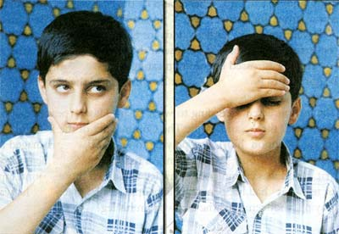

1. First, the face must be washed from the top of the forehead, the place where the hair grows, until the bottom of the chin. The width of the face that must be washed is the distance between the tip of the thumb to the tip of the middle finger. We must wash our face from top to bottom

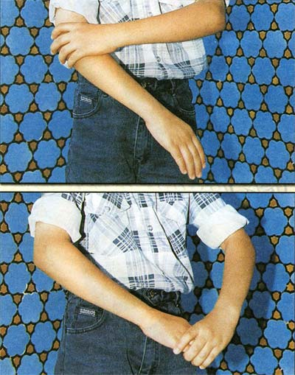

2. After washing our face, then we wash our right arm, from slightly above the elbow down to our fingertips. This too must be washed from top to bottom.

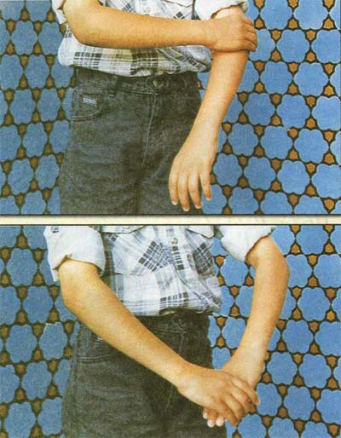

3. After our right arm, we must wash our left arm; again, from above the elbow down to the fingertips, and from the top to bottom.

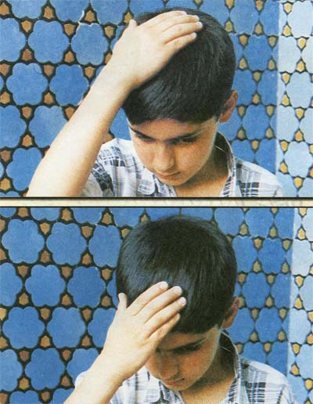

4. After these washings, are completed, with the water that is on our right hand, we have to wipe the top of our head (hum about the distance of one finger). We must not take any extra water for this.

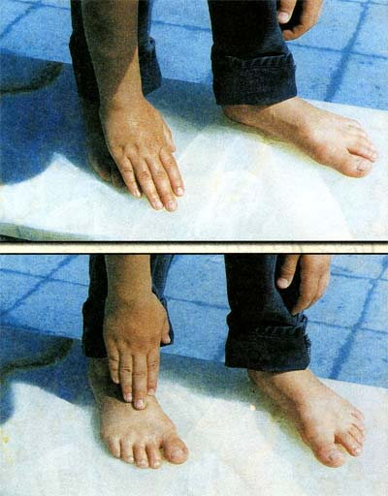

5. We then proceed to wipe our right foot with our right hand, from the tip of our toes, up to the ankle bone with the water that is remaining in our right hand. Again, we must not take any extra water.

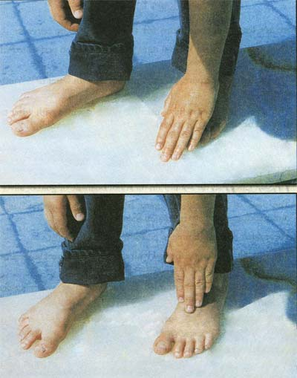

6. To finish, we wipe our left foot with our left hand from the top of our toes, up to the ankle bone with the water that is remaining on our left hand.

Conditions for Wdhu

There are fourteen conditions for the Wudhn to be correct:

1. The water we use for Wudhu must be clean. (Wudhu performed with water that is najis is void.)

2. The water must be pure. (Wudhu performed with water that is mixed is void.)

3. The water must be lawful to use. (Wudhu performed with water that is stolen or one does not have the permission to use is void.)

4. The container that the water is in must be permissible to use. (Wudhu performed with water that is in a stolen container or without the permission of the owner is void.)

5. The container that the water is in must not be made of gold or silver.

6. The parts of. the body that must be washed and wiped in Wudhu, must be clean (not have najasat on them).

7. There must be enough time to perform Wudhu and Salat.

8. The Wudhu must be performed with the intention of seeking nearness to Allah (SWT) and for His pleasure.

9. The Wudhu must be performed in the order that was mentioned (Tartib).

10. The actions in Wudhu must be performed one after another with no time gaps between them (Muwalat).

11. The person himself must perform the actions in Wudhu (washing his hands and face, and wiping his head and feet) and he must not get help from others.

12. There must be no problem or harm for one by using water.

13. The parts of the body where the water is applied must not contain anything that would prevent the water from reaching that area.

Things that Make the Wudhu Void

There are seven things which make the Wudhu void, some of them which are the most important are:

1. Urinating.

2. Defecating.

3. Passing gas.

4. Sleeping, such that you can't see or hear anything.

Tayammum

If we can not find water, or there is very little time left to perform Wudhu, or we arc sick and can not use water, then instead of Wudhu, we must perform Tayammum. This is done on those things that we are allowed to use for it, such as dirt or a rock.

In Tayammum, there are four things that are compulsory:

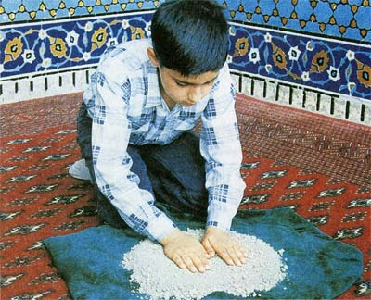

1. Intention (Niyyat)

2. The palms of both the hands must be struck on that thing which we are allowed to perform Tayammum on

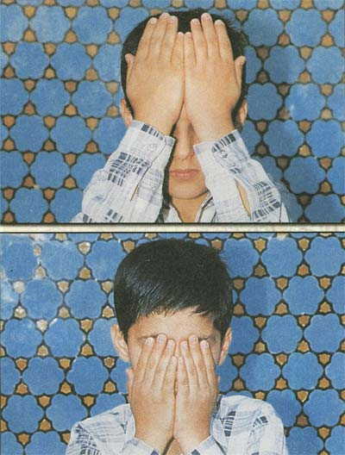

3. The palms of both hands must be rubbed on the forehead, and in both directions where the hair of the head grows until the bottom of the eyebrows and the tip of the nose.

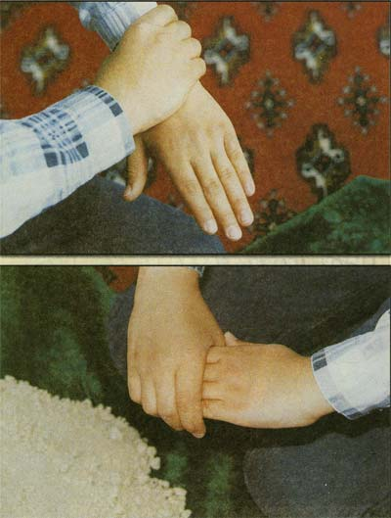

4. The palm of the left hand must be rubbed on the back of the right hand; and the palm of the right hand must be rubbed on the back of the left hand.

Adhan & Iqamah

It is recommended for both boys and girls to recite the Adhan and Iqamah before starting the Salat.

Adhan

اَللهُ أكْبَرُ

Allahu Akbar

Read 4 Times

(Allah is greater than anything else)

أشْهَدُ أنْ لاَ إلهَ إلاَّ اللهُ

Ashhaadu an la Ilaha Illal-lah

Read 2 Times

(I bear witness that there is no god except Allah )

أشْهَدُ أنَّ مُحَمَّداً رَسُولُ اللهِ

Ashhadu anna Muhammadan Rasulul-lah

Read 2 Times

(I bear witness that Muhammad is the Messenger of Allah)

أشهد أن عَلِيّا أمِيرَ الْمُؤْمِنِينَ وَلِيُّ اللهِ

Ashhadu anna Aliyan Amir al-Mo'mineena Waliul-lah

Read 2 Times

(I bear witness that 'Ali, The Commander of the Faithful is the Friend of Allah)

حَيَّ عَلى الصَّلاَةِ

Hayya Alas-Salaah

Read 2 Times

(Hurry towards the Salat! )

حَيَّ عَلى الْفَلاَحِ

Hayya Alal-falaah

Read 2 Times

(Hurry towards prosperity!)

حَيَّ عَلى خَيْرِ الْعَمَلِ

Hayya 'ala Khayril-'amal

Read 2 Times

(Hurry towards the best of deeds!)

اَللهُ أكْبَرُ

Allahu Akbar

Read 2 Times

(Allah is greater than anything else)

لاَ إلهَ إلاَّ اللهُ

La ilaha illal-lah

Read 2 Times

There is no god except Allah.

Iqamah

اَللهُ أكْبَرُ

Allahu Akbar

Read 2 Times

(Allah is greater than anything else)

أشْهَدُ أنْ لاَ إلهَ إلاَّ اللهُ

Ashhadu an la Ilaha Illal-lah

Read 2 Times

(I bear witness that there is no god except Allah)

أشْهَدُ أنَّ مُحَمَّداً رَسُولُ اللهِ

Ashhadu anna Muhammadan Rasulul-lah

Read 2 Times

(I bear witness that Muhammad is the Messenger of Allah)

أشهد أن عَلِيّا أمِيرَ الْمُؤْمِنِينَ وَلِيُّ اللهِ

Ashhadu anna Aliyan Amir al-Mo'mineena Wali-ullah

Read 2 Times

(I bear witness that 'Ali, The Commander of the Faithful is the Friend of Allah)

حَيَّ عَلى الصَّلاَةِ

Hayya 'alas-Salaah

Read 2 Times

(Hurry towards the Salat!)

حَيَّ عَلى الْفَلاَحِ

Hayya 'alal-Falaah

Read 2 Times

(Hurry towards prosperity!)

حَيَّ عَلى خَيْرِ الْعَمَلِ

Hayya 'alal Khayril-'amal

Read 2 Times

(Hurry towards the best of deeds!)

قَدْ قَامَتِ الصَّلاةُ

Qad qaamatis-Salaah

Read 2 Times

(The Salat is being established!)

اَللهُ أكْبَرُ

Allahu Akbar

Read 2 Times

(Allah is greater than anything else)

لاَ إلهَ إلاَّ اللهُ

La ilaha illal-lab

Read 1 Time

(There is no god except Allah)

The Method of Reading Our Salat

When we are praying, we must pay attention and realize who we are standing in front of, who we are speaking to, and that we are in the presence of Allah (SWT). Our Salat, therefore, must be performed correctly and in its entirety, and especially those eleven things which are Wajib in the Salat, must be completely and properly performed. The , things which make our Salat void, such as eating, drinking, laughing, speaking along with the other things must be avoided.

Since we are now acquainted with the etiquette of reading our Salat, we will now give a summary of how to pray, step by step.

1. First of all, we must face the Qiblah, and after having made our intention of which Salat we are about to perform, whether it be Fajr, Zuhr, or... we specify that we are praying this Wajib Salat with the intention of seeking nearness to Allah (SWT) and in compliance to His order.

2. Then, we recite the Takbiratul Ihram in the following way, by raising both the hands until they are parallel to our ears and then we say:

اَللهُ أكْبَرُ

Allahu Akbar

(Allah is greater than anything else)

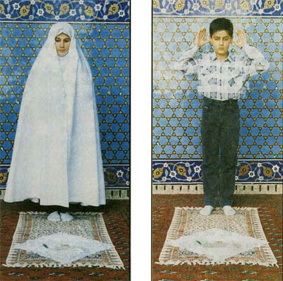

اَللهُ أكْبَرُ

Allahu AkbarAllah is greater than anything else)

3. We then lower our hands and rest them on our thighs and start by reciting Surah al-Fatiha, followed by another Surah of the Holy Qur'an.

Surah al-Fatiha

بِسْمِ اللّهِ الرَّحْمَنِ الرَّحِيمِ

Bismillah hir Rahmaanir Raheem

1. In the name of Allah, the Most Beneficent, the Most Merciful.

الْحَمْدُ لِلّهِ رَبِّ الْعَالَمِينَ

Al-hamdu-li-Llahi Rabbil-aalemeen

2. All praise is due to Allah, Lord of the Worlds.

اَلرَّحْمَنِ الرَّحِيمِ

Ar-Rahmaanir Raheem

3. The Most Beneficent, the Most Merciful.

مَالِكِ يَوْمِ الدِّينِ

Maaliki Yawmid Deen

4. Master of the Day of Judgement.

إِيَّاكَ نَعْبُدُ وإِيَّاكَ نَسْتَعِين

Iyyaaka na'budu wa Iyyaaka nasta'een

5. You alone (Allah) do we serve and You alone (Allah) do we ask for help.

اِهْدِنَا الصِّرَاطَ المُسْتَقِيمَ

Ihdinas siraatal mustaqeem

6. Keep us on the right path.

صِرَاطَ الَّذِينَ أَنعَمْتَ عَلَيهِمْ غَيرِ المَغضُوبِ عَلَيهِمْ وَلاَ الضَّالِّينَ

Siratal-ladhina an'amta 'alayhim, Ghayril maghdhuubi 'alayhim wa-ladh dhaaleen

7. The path of those upon whom You have bestowed favours. Not (the path) of those upon whom Your wrath is brought down on, nor of those who go astray.

Surah al-Tawhid

بسم الله الرحمن الرحيم

Bismil laahir Rahmaanir Raheem

In the name of Allah, the Beneficent, the Merciful.

قُلْ هُوَ اللَّهُ أَحَدٌ

Qul Huwal-laahu Ahad

1. Say: He, Allah, is One.

اللَّهُ الصَّمَدُ

Allahus Samad

2. Allah is He on Whom all depend.

لَمْ يَلِدْ وَلَمْ يُولَدْ

Lam yalid wa lam yoolad

3.  He begets not, nor is He begotten.

وَلَمْ يَكُن لَّهُ كُفُوًا أَحَدٌ

Wa lam yakun lahoo Kufuwan ahad

4. And none is like Him.

4. After reciting Sarah al-Hamd and the second Sarah, we go into the position known as Ruku, in which we bend at the waist and place our hands on our knee caps and then say the following line once (our body must be completely motionless):

سُبْحَانَ رَبَّيَ الْعَظِيمِ وَ بِحَمْدِهِ

Subhaana Rabbiyal Azheemi wa bi-hamdih

(Glory and Praise be to my Lord, the Magnificent)

We can also say the following line three times, instead of the above line:

سُبْحَانَ اللهِ

Subhaanal-laahe

(Praise be to Al1ah)

5. After Ruku', we stand up straight, and while standing, we recite:

سَمِعَ اللهُ لِمَنْ حَمِدَهُ. اللهُ أكْبَرُ

Sami' Allahu liman hamidah. Allahu Akbar

(Allah hears the one who praises Him. Allah is greater than anything else.)

6. Then, we go into Sajdah, and while in Sajdah, we say the following line once:

سُبْحَانَ رَبَّيّ الأَعْلى وَ بِحَمْدِهِ

Subhaana Rabbiyal A'laa wa bihamdih

(Glory and Praise be to my Lord, the Highest)

We can also say the following line three times, instead of the above line:

سُبْحَانَ اللهِ

Subhaanal-laahe

(Praise be to Allah)

While in the position of Sajdah, seven parts of our body must be touching the ground; and these include:

1. Forehead 2. Palms of both the hands 3. Both knees 4. Tips of the big toes



7. Once we have completed the first Sajdah, we lift our head off of the ground, and while sitting, we say:

أسْتَغْفِرُ اللهَ رَبَّي وَ أتُوبُ إلَيْهِ. اللهُ أكْبَرُ

Astaghfirul-laaha Rabbi ma Atoobu Ilayhi. Allahu Akbar.

(I ask forgiveness from Allah, my Lord and to Him I turn in repentance. Allah is the greatest.)



8. We then go back into Sajdah. While in Sajdah, we say the following line once:

سُبْحَانَ رَبَّيّ الأَعْلى وَ بِحَمْدِهِ

Subhaana Rahbiyal A'laa wa bihamdih

(Glory and Praise be to my Lord, the Highest)

We can also say the following line three times instead of the above line:

سُبْحَانَ اللهِ

Subhaanal-laahe

(Praise be to Allah)

Up until this point, we have finished one complete Rak'at of the Salat.

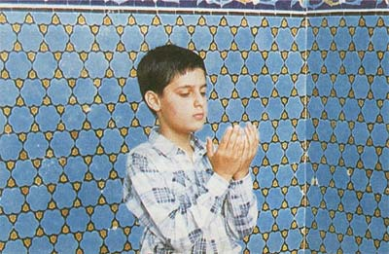

9. We then stand up, and as we are getting up, we should recite the following:

بِحَوْلِ اللهِ وَ قُوَّتِهِ أقُومُ وَ أقْعُدُ

Bihawlil-laahi wa quwwatihi aqoomu wa aq'u'du

(By the permission and power of Allah I stand and sit)

10. The second Rak'at is performed just the same way as the first Rak'at, however after the second Surah, it is better that we perform Qunut (as is shown in the above photograph). In Qunut, it is sufficient if we recite any Dua , even if we just recite Salawat on the Prophet and his family once, or even if we simply say the following one time:

It is better however, that we recite the following Dud':

رَبَّنَا آتِنَا فِي الدُّنْيَا حَسَنَةً وَ فِي الآخِرَةِ حَسَنَةً وَ قِنَا عَذَابَ النَّارِ

Rabbanaa Aatina Fid-dunyaa hasanatan wa Fil-akhirate hasanatan wa Qinnaa Adhaab an-Naar

O' Our Lord! Give us good in this world and in the hereafter and save us from the punishment of the hell fire.)

أللّهُمَّ صَلِّ عَلى مُحَمَّدٍ وَ آلِ مُحَمَّدٍ

Allahumma,Salli Alaa Muhammadin wa 'Aale Muhammad

(Q' Allah! Send your blessings upon Muhammad and the family of Muhammad)

Tashhud

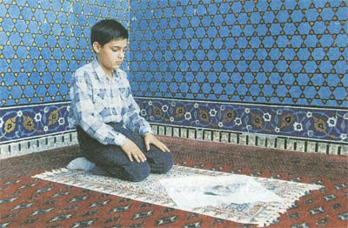

11. After the Qunut, we go into Ruku' and Sajdah, and after the second Sajdah, we sit, and while our body is stationary, we recite the Tashahud:

اَلْحَمْدُ لِلّهِ

Alhamdu'lillah

(All praise is due to Allah.)

أشْهَدُ أنْ لاَ إلهَ إلاَّ اللهُ وَحْدَهُ لاَ شَرِيكَ لَهُ

Ashhadu an Laa Ilaaha illal-laah, Wahdahu laa sharika lah.  
(I bear witness that there is no god except for Allah, the One who has no partners.)

وَأشْهَدُ أنَّ مُحَمَّداً عَبْدُهُ وَ رَسُولُهُ

Wa ashhadu anna Muhammadan 'Abduhu wa Rasooluh.

(And I bear witness that Muhammad is His servant and Messenger.

أللّهُمَّ صَلِّ عَلى مُحَمَّدٍ وَ آلِ مُحَمَّدٍ

Allahumma salli 'Alaa Muhammadin wa Aale Afuhammad.

(O' Allah, send your blessings on Muhammad and the family of Muhammad.)

Salam



At the end of the Salat, after the recitation of the Tashahud, we recite the Salam in the following manner:

اَلسَّلاَمُ عَلَيْكَ أيُّهَا النَّبِيُّ وَ رَحْمَةُ اللهِ وَ بَرَكَاتُهُ

As-salaamu 'alayka ayyuhan Nabiyyu wa Rahmatul-laahi wa barakaatuh

(May the peace, mercy and blessings of Allah be upon you O' Prophet.)

اَلسَّلامُ عَلَيْنَا وَ عَلى عِباَدِ اللهِ الصَّالِحِينَ

As-salaamu 'alayna wa 'alaa 'Ibaadil-laahis Saaliheen

(Peace be upon us and upon the righteous servants of Allah.)

اَلسَّلاَمُ عَلَيْكُمْ وَ رَحْمَةُ اللهِ وَ بَرَكَاتُهُ

As-salaamu 'alaykum wa rahmatul-laahi wa barakaatuh

(May the peace, mercy and blessings of Allah be upon you all.)

After the Salat has finished, it is better to recite the Takbir three times and each time, we should raise our hands so that they are parallel to our ears:

اَللهُ أكْبَرُ

Allahu Akbar

(Allah is Greater than anything else)

Tasbihat al-Arba'h

If we are praying a three or four Rak'at Salat, then after reciting the Tashahud in the second Rak'at, we immediately stand up and recite the Tasbihat al-Arba'h three times:

سُبْحَانَ اللهِ وَ الْحَمْدُ لِلّهِ وَ لاَ إلهَ إلاَّ اللهُ وَ اللهُ أكْبَرُ

Subhaanal-laahi wal-hamdu lil-laahi wa laa illaha illal-laahu wal-laahu Akbar

(Glory be to Allah and praise be to Allah and there is no god except Allah and Allah is Greater than anything else)

We then go into Ruku' followed by Sajdah, and after performing the two Sajdahs, we recite the Tashahhud and Salam. If we are reading a four Rak'at Salat, then we read one more Rak'at just as the third Rak'at and finish off the Salat with the Tashhahud and Salam.

Things that make the Salat void

Twelve things make the Salat void:

1. If during the Salat, one of the conditions that is necessary for the Salat to be correct goes away, then the Salat is void. For example, one realizes that he is praying in a usurped place, a place that is stolen, or does not have the permission of the owner.

2. One's Wudhu becomes void.

3. Placing one's hand on top of the other hand, just like most of the Muslims who are not Shi'a do.

4. Saying "Amin" after reciting Surah al-Fatiha.

5. Intentionally or unintentionally turning away from the Qiblah, or turning to the right or left.

6. Speaking intentionally during the Salat.

7. Intentionally or unintentionally laughing out loud, during the Salat.

8. Intentionally crying over matters of the world.

9. Breaking the form of the Salat, for example clapping, jumping up in the air, or anything else.

10. Eating and drinking.

11. Having a doubt in a two Rak'at Salat whether one has prayed two or three Rak'at, or in the first two Rak'at of a four Rak'at Salat.

12. Adding or subtracting any of the Pillars of the Salat, whether it be intentionally or unintentionally. Adding or subtracting those things that are not a Pillar of the Salat, if done intentionally (then it makes the Salat void; but if done unintentionally, then it is not a problem).

The Wajibat of the Salat

There are eleven things that are Wajib in Salat:

1) Intention (Niyyat)

2) Takbiratul Ihram (Saying Allahu Akbar)

3) Qiyam (Standing)

4) Ruku'

5) Suju'd

6) Recitation

7) Dhikr

8) Tashahud

9) Salam

10) Order (Tarteeb)

11) Continuity (Muwalat)

The Pillars of the Salat

The Pillars (Arkan) of the Salat are five:

1. Intention (Niyyat)

2. Saying of the Takbiratul Ihram (Allahu Akbar to begin the Salat).

3. Standing motionless at the time of saying the Takbir, and the standing before going into the state of Ruku'.

4. Ruku'.

5. Two Sajdahs.

The Place of Salat

The place where we want to recite our Salat, must fulfill the following conditions:

1. The place must be Mubah, meaning that it is not stolen property.

2. The place must not have any movement; for example, we can not pray our Salat in a car or on a train while it is moving, except in the case of necessity (such as if the entire time of the Salat we are on a moving object).

3. The place must not have a small roof such that we can not stand up properly, or that we can not do our Ruku or Sujud the way it is supposed to be performed.

4. If the place where we want to pray is Najis, it must not be so moist that the najasat gets transferred to our body or clothing.

5. The place where we put our forehead must not be higher or lower than four closed fingers, in relation to where our knees are.