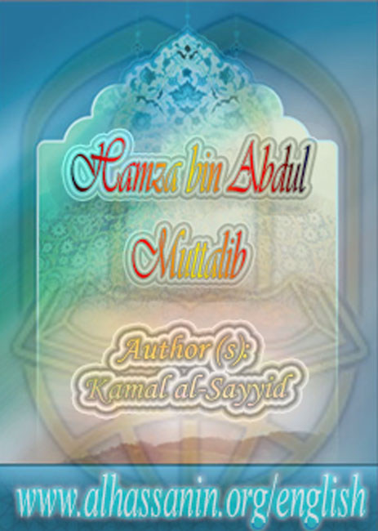

www.alhassanain.org/english

Hamza bin Abdul Muttalib

Author(s): Kamal al-Sayyid

Translator(s): Jasim al-Alyawy

Publisher(s): Ansariyan Publications - Qum

www.alhassanain.org/english

Notice:
This work is published on behalf of www.alhassanain.org/english
The typing errors are not corrected.

Table of Contents
With Abu Jahal 5
The Birthday 8
The Ninth Year after the Mission 9
The Migration 10
The Sacrifice 13
In Makkah 14
With Our Master Muhammad 15
The Revenge 17
The Master of Martyrs 21

With Abu Jahal
Al-Hamza set off for the hills overlooking Makkah. His strong horse was going up the sand hills. It was galloping along the valleys. Al-Hamza was looking carefully at the lovely scenery.
The sky was blue and clear. The hills were covered with sunshine. So the grains of sand were glittering in the sun.
Al-Hamza was thinking about our Master Muhammad's mission. His heart was with Allah's Apostle. He was repeating to himself:
Really there's no god but Allah. Al-Lat, al-Uzza and Munat are rocks. Man has made them with his hand. So why does he worship them?
The horse was roaming through the desert. The horse ran away when it saw a man holding a bow and looking for the lions.
Our Master Muhammad [s] sat on a rock on the road to al-Masa between al-Safa Mount and al-Marwa Mount. As usual, he was absorbed in thinking.
He was always thinking about his people and those who disbelieved in him and Allah's mission.
There was a house near the road to al-Masa. The house had a balcony overlooking the road. Two young girls were sitting in the balcony. They saw our Master Muhammad [s] thinking and looking at the sky and the mountains.
At that moment, Abu Jahal and some foolish persons from Makkah appeared. They were laughing loudly.
Abu Jahal looked at our Master Muhammad [s]. His eyes glittered out of spite. He wanted to sneer at him. So, he shouted:
Look at this magician! Look at this madman! He doesn't laugh as we do! He's silent!
The foolish persons laughed. Their satanic laughter filled the space.
Ha, Ha, Ha!
The two girls sadly watched what was happening. They saw Abu Jahal going round and round our Master Muhammad [s] laughing and being silly.
Abu Jahal took a handful of dust. He put the dust on the Prophet's head. The dust fell on the Prophet's face and clothing.
Abu Jahal and his foolish friends laughed. But our Master Muhammad [s] kept silent. He was sad.
The two young girls felt pain and sadness for our Master Muhammad [s]. Abu Jahal and his foolish friends went away. So, our Master Muhammad [s] stood up. He dusted is head and face and clothing. Then he went home.
The two girls decided to tell al-Hamza. So, they waited for him.
In the distance, al-Hamza appeared. He was coming down the hills riding his horse.

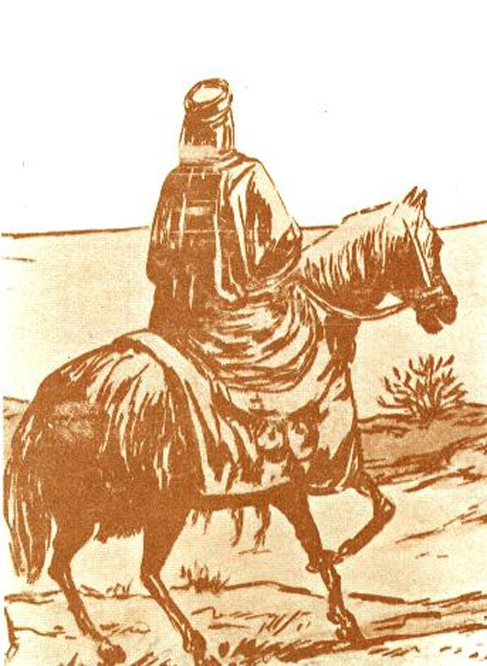

The girl shouted:
Hamza, come back!
The girl said to her sister:
Come on! Let's tell him!
The girl shouted:
Aba Amara!
Al-Hamza stopped and looked at the girl. The girl sadly said:
Aba Amara, Abu Jahal mistreated your nephew Muhammad.
Al-Hamza asked:
Did he mistreated him?
The girl said:
He came across him on the road. He abused him and put some dust on his head.
Al-Hamza was filled with anger. He hit his horse with the bow. The horse jumped angrily. Al-Hamza headed for the Ka'aba. He used to pass by the men and greet them when he came back from hunting. This time, he was angry for our Master Muhammad [s]. So, he did not greet anyone and went directly to Abu Jahal.
Al-Hamza jumped off his horse like the lion. He raised his bow and hit Abu Jahal on the head. Abu Jahal was afraid when he saw al-Hamza angry. So, he said humbly:
Aba Amara, he has abused our gods and stultified our thoughts.
Al-Hamza shouted angrily:
Answer me if you can!
The outcry of truth sounded in the yard of the Ka'aba. Al-Hamza said loudly:
I confess that there's no god but Allah and that Muhammad is Allah's Apostle.
Al-Hamza angrily looked at Abu Jahal and said:
Why did you abuse him? Don't you know that I follow his religion.
Abu Jahal bent his head humbly and kept silent. The foolish persons escaped with alarm.
While al-Hamza was in tears, he embraced our Master Muhammad [s]. Our Master Muhammad [s] became happy when his uncle al-Hamza became Muslim.
So, he named him the Lion of Allah and the Lion of His Apostle.

The Birthday
Al-Hamza was born in 570 AD., namely in the year of the Elephant. He was our Master Muhammad's foster brother, for a woman called Thwaibah suckled them.
Al-Hamza was brave and strong. He became Muslim in the second year of our Master Muhammad's mission.
The men knew that al-Hamza believed in Islam. So, the Muslims became happy. But the polytheists became sad.
Some Muslims hid their belief in Islam because they were afraid of Quraish. When al-Hamza became Muslim, a new time began - our Master Muhammad's followers became strong, so the Quraish were afraid of them and had a thousand apprehensions about them.

The Ninth Year after the Mission
Nine years after our Master Muhammad's mission passed. The number of the Muslims increased.
Umar bin al-Khattab was very sensitive.
One day, he took his sword to kill our Master Muhammad [s]. He asked about him. It was said to him:
He's with his Companions in a house near al-Safa Mount.
So, Umar headed for him. On the way to al-Safa Mount, a man belonging to the tribe of Umar named Naeem came across and asked him:
Umar, where are you going?
Umar rudely answered:
I want to kill Muhammad because this boy has abused our religion.
Naeem believed in Islam secretly So, he said to him:
If you hurt Muhammad, Bani Hashim won't leave you alive. Besides your sister and her husband have believed in Islam.
Umar shouted angrily:
What? My sister Fatimah?
Umar went to his sister's house. when he stopped at the door, he heard a man reading the Qur'an.
The Divine Words were impressive:
In the Name of Allah, the Beneficent, the Merciful. Taha, we have not revealed the Qur'an to you so that you may be unsuccessful.
Umar knocked at the door and entered. His sister hid the page of the Qur'an for he wanted to tear it up. He hit his sister. So, blood flowed out of her face.
Umar felt regret, So, he went out.
Our Master Muhammad [s] and some Companions were in a house near al-Safa Mount. He was teaching them the Qur'an and wisdom. He was reading to them of the Divine verses.
In the meantime, they heard a man knocking loudly at the door. One of the Muslims got up. He looked through a hole in the door.
Al-Hamza asked:
Who is it?
The Muslim answered
It's Umar holding a sword.
AI-Hamza said:
Do not be afraid. Open the door. If he wants good we'll give it to him. If he wants evil, we'll kill him with his sword!
Al-Hamza stood up to receive the newcomer. He opened the door and asked:
Bin al-Khattab, what do you want?
Umar answered:
I've come to confess that there's no god but Allah and Muhammad is Allah's Apostle!
Our Master Muhammad [s] said:
Allah is great!

The Migration
The people of Yathrib belonged to the tribe of al-Khazraj and the tribe of al-Aus. They promised our Master Muhammad [s] to support Islam with their lives and money.
When the Quraish harmed the Muslims severely, our Master Muhammad [s] ordered them to immigrate Yathrib.
So, the Muslims began leaving Makkah secretly, one by one, or group by group. Al-Hamza bin Abdul Muttalib immigrated, too.

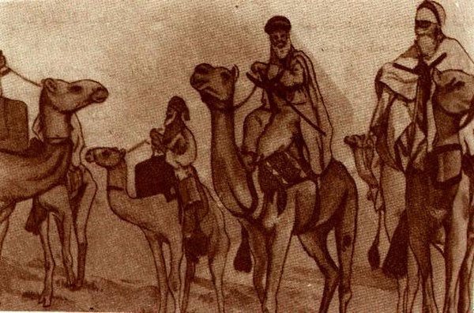

The immigrants and the supporters in Yathrib were eagerly waiting for our Master Muhammad's immigration. They were looking forward to his arrival.

The Sacrifice
The polytheists decided to kill our Master Muhammad [s]. Jibreel came down from the sky to tell him about the plot of the polytheists.
So, Allah's Apostle asked his cousin Ali bin Abu Talib [a] to sleep in his bed so that he would be able to immigrate to Yathrib safely.
Ali asked our Master Muhammad [s]:
Allah's Apostle, will you be safe?
Our Master Muhammad [s] answered:
Yes
Ali rejoiced when the Prophet [s] immigrated safely. He was not thinking about himself when the polytheists attacked our Master Muhammad's house.
Jibreel came down from the heavens reading the following holy verse:
And among them men is he who sells himself to seek the pleasure of Allah.
This verse meant there was a person who sacrificed his life to please Allah, the Glorified. Besides this verse has praised the attitude of Imam Ali [a] and his sacrifice.
Our Master Muhammad [s] arrived in Yathrib. After the Prophet [s] arrived, the Muslims named it al-Madina al-Munawwara (the Illuminated City).

In Makkah
The polytheists in Makkah attacked the Muslims houses and robbed them. The immigrants were sad to hear that.
So, our Master Muhammad [s] decided to send some groups of the Muslims to face the Quraishi trading caravans to punish them.
In Ramadhan, the first year after Hijra, our Master Muhammad [s] called al-Hamza, the Lion of Allah, and gave him the first banner in the history of Islam.
Our Master Muhammad [s] ordered al-Hamza to take his group, thirty immigrants, to the seaside were the caravans passed.
Al-Hamza found Abu Jahal at a district called al-Ais.
Three hundred fighters went with Abu Jahal, namely, ten times as many as the Muslims.
But al-Hamza, may Allah be pleased with him, and his group were not afraid of the Quraish. They were ready to clash with them.
But Majdy bin Amru al_Jahny, who had good with the Quraish and the Muslims, came between them to prevent them from clashing.
Al-Hamza was proud that he was the first to receive the banner of Islam from Allah's Apostle. Concerning this, he said pretty lines of poetry (the meaning only):
By the order of Allah's Apostle, a banner waved over me.
It had not waved before me.
The banner has victory from the owner of dignity,
The dear Allah whose action is the best action.
Then he referred to his clashing with Abu Jahal:
On the night when they (the polytheists0 marched, they were many.
And we all were his boilers that boiled because of the anger of his friends.
And when we saw one another, they made their camels kneel down and fettered them.
And we understood the range of the arrows target.
And we said to them:
Our supporter is the robe of Allah. But you have not any robe but misguidance.
There Abu Jahal became stirred up unjustly.
So, he became unsuccessful.
And Allah drove back Abu Jahal's plot.
We were only thirty riders,
And they were over three hundred.

With Our Master Muhammad
In the Assault of al-Asheera, our Master Muhammad [s] led, Hamza bin Abdul Muttalib was holding the banner.
The Muslim Army's companies and patrols succeeded to threaten the trade of the Quraish.
The Quraish announced the economic war against the Muslims. So, they attacked the Muslims' houses who immigrated from Makkah to Madina. They intensified their war against the Muslims everywhere.
In the meantime, the Quraish urged the Arab tribes to attack Yathrib.
Our Master Muhammad [s] wanted to punish the Quraish. He thought that the best way to punish them was to threaten their trading caravans going to Sham.
Al-Hamza went with our Master Muhammad [s] on each assault.
Our Master Muhammad [s] heard that a trading caravan headed by Abu Sufyan was coming back from Sham to Makkah. So, our Master Muhammad [s] asked the Muslims to face the caravan.
On Ramadhan 12th 2 AH., our Master Muhammad with 313 immigrants and supporters went outside Madina.
Abu Sufayn heard about the movement and the aim of the Muslims who wanted to face the caravan. So, he quickly sent man to the Quraish to tell them about the dangerous situation.
Abu Jahal found that action a suitable chance to destroy Islam and the Muslims. So he began urging the Quraish to fight the Muslims. He and the Quraishi leaders called up nine hundred and fifty fighters. Abu Jahal headed the fighters and marched towards the springs of Badr, where the Muslims had camped.
On Ramadhan 17th, the two armies came together. The polytheists were beating the war drums. But the Muslims were remembering and glorifying Allah.
Jibreel came down from the heavens. He read him this verse:
And if they incline to peace, then incline to it
The Prophet [s] asked the Quraish to make peace but Abu Jahal refused. He thought that he would destroy Islam, for his army was three times as many as the Muslim Army.
The two armies got ready to clash. One of the
polytheists shouted:
Muhammad, let your brave men come out to fight us!
So, our Master Muhammad [s] said:
Ubaidah bin al-Harith, al-Hamza bin Abdul Muttalib, and Ali bin Abu Talib, stand up.
They moved briskly. They were ready to die for Allah's way.
Ubaidah stood before his opponent Utbah bin Rabeeah.
Ali stood before al-Waleed bin Utbah.
Hamza stood before Shaiba bin Rabeeah.
So, the first battle in the history of Islam broke out.
Immediately, al-Hamza hit and knocked down his opponent. Ali hit the enemy of Islam and killed him.
Ubaidah hit his opponent, but his opponent hit him too. He fell to the ground. Al-Hamza and Ali killed Utbah. Then they took Ubaidah to the camp to tend to him.
When the polytheistic heroes fell over the ground one by one, Abu Jahal ordered his fighters to launch a general attack.
The Muslims faced the attack with spirits filled with belief confidence in Allah. So, Allah granted the Muslims a victory.
Abu Jahal and the polytheistic leaders fell over the ground. So, the other polytheists escaped with alarm.

The Revenge
The people of Makkah heard about the news of the defeat. So, the women wept over the killed polytheists. But Hind, Abu Sufyan's wife, kept silent.
The people said to Hind:
Why don't you weep over your brother, your father and your uncle?
She said:
I don't weep over them lest Muhammad and his companions rejoice at our misfortune!
Hind thought about a way to get her revenge on our Master Muhammad [s] or Ali bin Abu Talib [a] or al-Hamza bin Abdul Muttalib.
Hind urged the polytheists to get their revenge on them. Three thousand polytheistic fighters got ready. Hind bint Utbah, Abu Sufyan's wife, was with them. There were fourteen women around her. They were beating drums.
In Makkah there was a strong slave called Wahshy. Hind went to him. She promised to give him a lot of gold and money if he killed our Master Muhammad [s] or Ali bin Abu Talib [a] or al-Hamza (May Allah be pleased with him).
Wahshy said:
I can't hit Muhammad because his companions surround him.
I can't kill Ali because he is very alert.
I may kill al-Hamza because anger makes him see nothing.
Hind gave Wahshy some gold before hand. She was always looking at the spear Wahshy prepared to kill al-Hamza.
The polytheistic army arrived at al-Abwaa (an area near Madina where Aminah, our Master Muhammad's mother was buried fifty years ago).
Hind wanted to dig up Aminah and insisted on that. But the Quraishi leaders refused her action so that the Arabs would not dig out their dead.
Our Master Muhammad [s] headed the Muslims. Abu Sufyan headed the polytheists.
Our Master Muhammad [s] ordered fifty skilled bow men to stay at the foot of al-Ainain Mount to protect the Muslims' back troops. He ordered them not to leave their places under any circumstance.
The polytheists began attacking the Muslims. Uthman bin Abi-Talha, the banner holder, was in advance.
Hind and some women were surrounding him. They were beating the drums, and encouraging the fighters to fight.
They were singing the following lines of poetry (the meaning only):
We, Tariq's daughters, walk on the cushions.
Like the walking of bright sand grouse,
Musk is in the partings.
The pearls are round the necks.
If you advance, we'll embrace you.
And if you escape, we'll abandon you.
And the abandonment will be sorrowful.
Hamza shouted with enthusiasm:
I'm the son of the water carriers of pilgrims!
He attacked the banner holder. He hit him and cut off his hand. So the banner holder retreated. Then, his brother took the banner.
The Muslims were attacking them intensely. The banner holders were falling over the ground one by one.

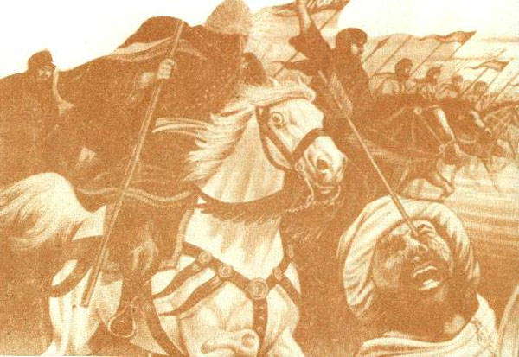

When the banner fell to the ground, the polytheists became dismayed. So, they ran away. The great idol, which they took to grant them a victory fell off the camel!
The Muslims chased the runaway. The archers forgot the Prophet's orders and left the foot of the mountain to collect booty. So, the lines of the Muslim Army was subjected to being surrounded and attacked.
Khalid bin al-Waleed, a polytheist then, took the Muslims aback. The surprise left the Muslim Army in chaos.
Wahshy, a slave from Makkah, was holding a long spear and looking for al-Hamza. He was thinking about nothing but to kill al-Hamza.
During the strong clashes, Wahshy was behind a big rock looking at al-Hamza.
While al-Hamza was busy fighting, Wahshy aimed his spear and threw it at the Prophet's uncle. The spear hit al-Hamza on the belly.
Al-Hamza tried to attack Wahshy. But he fell to the ground and became a martyr.
Wahshy ran fast to tell Hind about his action.
Hind rejoiced. She took off her gold and gave it to Wahshy and said:
I'll give you ten Dinars when we go back to Makkah.
Hind hurried to al-Hamza's body. She cut off his ears and nose to make a necklace. Then she drew a dagger and cut open the martyr's belly She took out his liver savagely and bit it like the dog.
Then Abu Sufyan came and tore al-Hamza's body with his spear.

The Master of Martyrs
The polytheists withdrew from the battlefield. Our Master Muhammad [s] and his companions came down the mountain to bury the martyrs.
The Prophet [s] asked his companions about the place of al-Hamza.
Al-Harith said:
I know his place.
Our Master Muhammad [s] asked al-Harith to show him al-Hamza's body.
The man went about looking for him. He found his body torn. So, he hated to tell the Prophet [s] about it.
Our Master Muhammad [s] ordered Ali to look for al-Hamza's body. He found him. He did not tell the Prophet because he did not want to hurt him.
So, our Master Muhammad [s] himself went to look for him. He found him in a sorrowful condition.
Our Master Muhammad [s] wept very much when he saw what they had done to al-Hamza's body.
The wolves did not do what Hind and Abu Sufyan did.
Our Master Muhammad [s] was very angry. So, he said:
Uncle, may Allah have mercy upon you. You had done good deeds and maintained close relations with your relatives!
If Allah grants me a victory, I'll maim seventy persons of the Quraish.
The Muslims swore by Allah to do that. So, Jibreel came down and read this verse:
And if you take your turn, then retaliate with the like of that which you were afflicted; but if you are patient it will certainly be best for those who are patient.
So Allah's Apostle forgave them. He was patient. And he prevented the Muslims from maiming.
Our Master Muhammad [s] took off his gown and covered the martyr and said to him:
Uncle, The Lion of Allah, the Lion of His Apostle, doer of good deeds, remover of worries, defender of Allah's Apostle, and saver of his face.
Safiyah, al-Hamza's sister and our Master Muhammad's aunt, went with Fatima aI-Zahra to make sure of the Prophet's safety.
Ali bin Abi Talib [s] came across Safiyah and said to her:
Aunt, come back!
He did not want her to see her brother in that condition. But she said:
I won't came back till I see Allah's Apostle.
In the distance, the Prophet [s] saw her. So, he ordered her son al-Zubair not to allow her to see her martyred brother.
Al-Zubair received her and said:
Mother, come back.
She said:
Till I see Allah's Apostle.
When she saw our Master Muhammad [s] and made sure of his safety, she asked him about al-Hamza:
Where's my brother?
The Prophet [s] kept silent. So, Safiyah knew that her brother became a martyr. So, she and Fatima al-Zahra wept over their martyred brother and uncle.
So, our Master Muhammad [s] condoled them:
Be cheerful! Jibreel told me that Hamza has been regarded as the Lion of Allah and the Lion of His Apostle in the Heavens!
Uhud Mount stands as evidence for al-Hamza's bravery, the Master of the Martyrs, and the polytheists' savageness.

www.alhassanain.org/english

