Alhassanain (p) Network for Islamic Heritage and Thought

Due e Nudba

Taken From: www.duas.org and www.nabacultural.org

Edited and Corrcted by: [www.alhassanain.org/english](http://www.alhassanain.org/english)

In the Name of Allah, the Beneficent, the Merciful

Table of Contents

Introduction 4

Notes 4

Dua e Nudba with English transliteration and Translation 5

Dua e Nudba only Arabic and English 19

Introduction

Among the valuable supplications that have been mentioned in this regard is Dua Nudbah which is recorded in Zaadul Maad[1] from the Sixth Imam (a.s.). It is emphasized that it must be recited on for Eids; Friday, Eidul Fitr, Eidul Qurban and Eid Ghadeer.

In Mazar Bihar,[2] it is narrated from Sayyid Ibne Tawoos that he said: Muhammad bin Ali bin Abi Qurra says: I have quoted Dua Nudbah from the book of Muhammad bin Husain bin Sufyan Bazufari and it should be remembered that this supplication is for the Leader of the Time (a.s.) and it is recommended to recite it on the four Eids.

Also, the great scholar, Muhaddith Noori has mentioned this Dua in Tahiyatuz Zaer from Misbahuz Zaer[3] of Sayyid Ibne Tawoos and Mazaar of Muhammad bin Mash-hadi from Muhammad bin Ali bin Abi Qurra on the authority of the book of Bazufari. In the same way Noori (r.a.) has also narrated it from Mazaar (Old) and adds that it is recommended to recite it on Friday eve also.

Notes

[1] Zaad al-Maad, Pg. 491-504

[2] Biharul Anwar; Vol. 102, Pg. 104-110

[3] Misbah az-Zaaer, Pg. 230-234

Dua e Nudba with English transliteration and Translation

|  |  |  |
| --- | --- | --- |
| Arabic | Transliteration | English Translation |

|  |  |  |
| --- | --- | --- |
| اَلْحَمْدُ للهِ رَبِّ الْعَالَمِيْنَ وَ صَلَّى اللهُ عَلٰى سَيِّدِنَا مُحَمَّدٍ نَبِيِّهِ وَ اٰلِه وَ سَلَّمَ تَسْلِيْمًا اَللّٰهُمَّ لَكَ الْحَمْدُ عَلٰى مَا جَرٰى بِه قَضَآئُكَ فِىْ اَوْلِيَآئِكَ الَّذِيْنَ اسْتَخْلَصْتَهُمْ لِنَفْسِكَ وَ دِيْنِكَ اِذِ اخْتَرْتَ لَهُمْ جَزِيْلَ مَا عِنْدَكَ مِنَ النَّعِيْمِ الْمُقِيْمِ الَّذِىْ لاَ زَوَالَ لَه وَالاَاضْمِحْلاَلَ بَعْدَ اَنْ شَرَطْتَ عَلَيْهِمُ الزُّهْدَ فِىْ دَرَجَاتِ هٰذِهِ الدُّنْيَا الدَّنِيَّةِ وَ زُخْرُفِهَا وَ زِبْرِجِهَا فَشَرَطُوْا لَكَ ذٰلِكَ وَ عَلِمْتَ مِنْهُمُ الْوَفَآءَ بِه فَقَبِلتَهُمْ وَ قَرَّبْتَهُمْ وَ قَدَّمْتَ لَهُمُ الذِّكْرَ الْعَلِىَّ وَ الثَّنَآءَ الْجَلِىَّ وَ اَهْبَطْتَ عَلَيْهِمْ مَلٰئِكَتَكَ وَ كَرَّمْتَهُمْ بِوَحْيِكَ وَ رَفَدْتَهُمْ بِعِلْمِكَ وَ جَعَلْتَهُمُ الذَّرِيْعَةَ اِلَيْكَ وَالْوَسِيْلَةَ اِلٰى رِضْوَانِكَ فَبَعْضٌ اَسْكَنْتَه جَنَّتَكَ اِلٰى اَنْ اَخْرَجْتَه مِنْهَا  وَ بَعْضٌ حَمَلْتَه فِىْ فُلْكِكَ وَ نَجَّيْتَه وَ مَنْ اٰمَنَ مَعَه مِنَ الْهَلَكَتِ بِرَحْمَتِكَ وَ بَعْضٌ اِتَّخَذْتَه لِنَفْسِكَ خَلِيْلاً وَ سَئَلَكَ لِسَانَ صِدْقٍ فِى الْاٰخِرِيْنَ فَاَجَبْتَه وَ جَعَلْتَ ذٰلِكَ عَلِيًّا  وَ بَعْضٌ كَلَّمْتَه مِنْ شَجَرَةٍ تَكْلِيْمًا وَ جَعَلْتَ لَه مِنْ اَخِيْهِ رِدْئًا وَّ وَزِيْرًا وَ بَعْضٌ اَوْلَدْتَه مِنْ غَيْرِ اَبٍ وَ اٰتَيْتَهُ الْبَيِّنَاتِ وَ اَيَّدْتَه بِرُوْحِ الْقُدُسِ  وَ كُلٌّ شَرَعْتَ لَه شَرِيْعَةً وَ نَهَجْتَ لَه مِنْهَاجًا وَ تَخَيَّرْتَ لَه اَوْصِيَآءَ مُسْتَحْفِظًا بَعْدَ مُسْتَحْفِظٍ مِنْ مُدَّةِ اِلٰى مُدَّةٍ اِقَامَةً لِدِيْنِكَ وَ حُجَّةً عَلٰى عِبَادِكَ وَ لِئَلاَّ يَزُوْلَ الْحَقُّ عَنْ مَقَرِّه وَ يَغْلِبَ الْبَاطِلُ عَلٰى اَهْلِه وَ لاَ يَقُوْلُ اَحَدٌ لَوْلاَ اَرْسَلْتَ اِلَيْنَا رَسُوْلاً مُّنْذِرًا وَ اَقَمْتَ لَنَا عَلَمًا هَادِيًا فَنَتَّبِعَ اٰيَاتِكَ مِنْ قَبْلِ اَنْ نَذِلَّ وَ نَخْزٰى اِلٰى اَنِ انْتَهَيْتَ بِالْاَمْرِ اِلٰى حَبِيْبِكَ وَ نَجِيْبِكَ مُحَمَّدٍ صَلَّى اللهُ عَلَيْهِ وَ اٰلِه فَكَانَ كَمَا انْتَجَبْتَه سَيِّدَ مَنْ خَلَقْتَه وَ صَفْوَةَ مِنَ اصْطَفَيْتَه وَ اَفْضَلَ مَنِ اجْتَبَيْتَه وَ اَكْرَمَ مَنِ اعْتَمَدْتَه قَدَّمْتَه عَلٰى اَنْبِيَآئِكَ وَ بَعَثْتَه اِلٰى الثَّقَلَيْنِ مِنْ عِبَادِكَ وَ اَوْطَاْتَه مَشَارِقَكَ وَ مَغَارِبَكَ وَ سَخَّرْتَ لَهُ الْبُرَاقَ وَ عَرَجْتَ بِرُوْحِه اِلٰى سَمَآئِكَ وَ اَوْدَعْتَه عِلْمَ مَا كَانَ وَ مَا يَكُوْنُ اِلَى انْقِضَآءِ خَلْقِكَ ثُمَّ نَصَرْتَهُ بِالرُّعْبِ وَ حَفَفْتَه بِجِبْرَئِيْلَ وَ مِيْكَائِيْلَ وَالْمُسَوِّمِيْنَ مِنْ مَّلٰئِكَتِكَ وَ وَعَدْتَه اَنْ تُظْهِرَ دِيْنَه عَلَى الدِّيْنِ كُلِّه وَ لَوْكَرِهَ الْمُشْرِكُوْنَ وَ ذٰلِكَ بَعْدَ اَنْ بَوَّئْتَه مُبَوَّ ءَصِدْقٍ مِنْ اَهْلِه وَ جَعَلْتَ لَه وَ لَهُمْ اَوَّلَ بَيْتٍ وُّضِعَ لِلنَّاسِ لَلَّذِىْ بِبَكَّةَ مُبَارَكًا وَّ هُدًى لِّلْعَالَمِيْنَ فِيْهِ اٰيَاتٌ بَيِّنَاتٌ مَّقَامُ اِبْرَاهِيْمَ وَ مَنْ دَخَلَه كَانَ اٰمِنًا وَ قُلْتَ اِنَّمَا يُرِيْدُ اللهُ لِيُذْهِبَ عَنْكُمُ الرِّجْسَ اَهْلَ الْبَيْتِ وَ يُطَهِّرَكُمْ تَطْهِيْرًا ثُمَّ جَعَلْتَ اَجْرَ مُحَمَّدٍ صَلَوَاتُكَ عَلَيْهِ وَ اٰلِه مَوَدَّتَهُمْ فِىْ كِتَابِكَ فَقُلْتَ قُلْ لَّا اَسْئَلُكُمْ عَلَيْهِ اَجْرًا اِلاَّ الْمَوَدَّةَ فِى الْقُرْبٰى وَ قُلْتَ مَا سَئَلْتُكُمْ مِنْ اَجْرٍ فَهُوَ لَكُمْ وَ قُلْتَ مَا اَسْئَلُكُمْ عَلَيْهِ مِنْ اَجْرٍ اِلاَّ مَنْ شَآءَ اَنْ يَّتَّخِذَ اِلٰى رَبِّهِ سَبِيْلاً فَكَانُوْا هُمُ السَّبِيْلَ اِلَيْكَ وَ الْمَسْلَكَ اِلٰى رِضْوَانِكَ فَلَمَّا انْقَضَتْ اَيَّامُه اَقَامَ وَلِيَّهِ عَلِىَّ بْنَ اَبِىْ طَالِبٍ صَلَوٰتُكَ عَلَيْهِمَا وَ اٰلِهِمَا هَادِيًا اِذْ كَانَ هُوَ الْمُنْذِرَ وَ لِكُلِّ قَوْمٍ هَادٍ فَقَالَ وَالْمَلاَءُ اَمَامَه مَنْ كُنْتُ مَوْلاَهُ فَعَلِىٌّ مَوْلاَهُ اَللّٰهُمَّ وَ آلِ مَنْ وَالاَهُ وَ عَادِ مَنْ عَادَاهُ وَانْصُرْ مَنْ نَصَرَه وَاخْذُلْ مَنْ خَذَلَه وَ قَالَ مَنْ كُنْتُ اَنَا نَبِيَّه فَعَلِىٌّ اَمِيْرُه  وَ قَالَ اَنَا وَ عَلِىٌّ مِّنْ شَجَرَةٍ وَاْحِدَةٍ وَ سَائِرُ النَّاسِ مِنْ شَجَرَةٍ شَتّٰى وَ اَحَلَّه مَحَلَّ هَارُوْنَ مِنْ مُوْسٰى فَقَالَ لَه اَنْتَ مِنِّىْ بِمَنْزِلَةِ هَارُوْنَ مِنْ مُوْسٰى اِلاَّ اَنَّه لاَ نَبِىَّ بَعْدِىْ وَ زَوَّجَهُ ابْنَتَه سَيِّدَةَ نِسَآءِ الْعَالَمِيْنَ وَ اَحَلَّ لَه مِنْ مَسْجِدِه مَا حَلَّ لَه وَ سَدَّ الْاَبْوَابَ اِلاَّ بَابَه ثُمَّ اَوْدَعَه عِلْمَه وَ حِكْمَتَهِ فَقَالَ :اَنَا مَدِيْنَةُ الْعِلْمِ وَ عَلِىٌّ بَابُهَا فَمَنْ اَرَادَ الْمَدِيْنَةَ وَ الْحِكْمَةَ فَلْيَاْتِهَا مِنْ بَابِهَا ثُمَّ قَالَ اَنْتَ اَخِىْ وَ وَصِيِّىْ وَ وَارِثِىْ لَحْمُكَ مِنْ لَحْمِىْ وَ دَمُكَ مِنْ دَمِىْ وَ سِلْمُكَ سِلْمِىْ وَ حَرْبُكَ حَرْبِىْ وَ الْاِيْمَانُ مُخَالِطٌ لَحْمَكَ وَ دَمَكَ كَمَا خَالَطَ لَحْمِىْ وَدَمِىْ وَ اَنْتَ غَدًا عَلَى الْحَوْضِ خَلِيْفَتِىْ وَ اَنْتَ تَقْضِىْ دَيْنِىْ وَ تُنْجِزُ عِدَاتِىْ وَ شِيْعَتُكَ عَلٰى مَنَابِرَ مِنْ نُوْرٍ مُبْيَضَّةً وُجُوْهُهُمْ حَوْلِىْ فِى الْجَنَّةِ وَ هُمْ جِيْرَانِىْ  وَ لَوْلاَ اَنْتَ يَا عَلِىُّ لَمْ يُعْرَفِ الْمُؤْمِنُوْنَ بَعْدِىْ وَ كَانَ بَعْدَه هُدًى مِّنَ الضَّلاَلِ وَ نُوْرًا مِّنَ الْعَمٰى وَ حَبْلَ اللهِ الْمَتِيْنَ وَ صِرَاطَهُ الْمُسْتَقِيْمَ وَلاَ يُسْبَقُ بِقَرَابَةٍ فِىْ رَحِمٍ وَ لاَ بِسَابِقَةٍ فِىْ دِيْنٍ وَ لاَ يُلْحَقُ فِىْ مَنْقَبَةٍ مِنْ مَنَاقِبِه يَحْذُوْ حَذْوَ الرَّسُوْلِ صَلَّى اللهُ عَلَيْهِمَا وَ اٰلِهِمَا وَ يُقَاتِلُ عَلَى التَّاْوِيْلِ وَ لاَ تَاخُذُه فِى اللهِ لَوْمَتُ لآَئِمٍ قَدْ وَتَرَ فِيْهِ صَنَادِيْدَ الْعَرَبِ وَ قَتَلَ اَبْطَالَهُمْ وَ نَاوَشَ ذُؤْبَانَهُمْ فَاَوْدَعَ قُلُوْبَهُمْ اَحْقَادًا بَدْرِيَّةً وَّ خَيْبَرِيَّةً وَّ حُنَيْنِيَّةً وَ غَيْرَ هُنَّ فَاَضَبَّتْ عَلٰى عَدَاوَتِه وَ اَكَبَّتْ عَلٰى مُنَابَذَتِه حَتّٰى قَتَلَ النَّاكِثِيْنَ وَ الْقَاسِطِيْنَ وَ الْمََارِقِيْنَ وَ لَمَّا قَضٰى نَحْبَه وَ قَتَلَه اَشْقَى الْاٰخِرِيْنَ يَتْبَعُ اَشْقَى الْاَوَّلِيْنَ لَمْ يُمْتَثَلْ اَمْرُ رَسُوْلِ اللهِ صَلَّى اللهُ عَلَيْهِ وَ اٰلِه فِى الْهَادِيْنَ بَعْدَ الْهَادِيْنَ وَ الْاُمَّةُ مُصِرَّةٌ عَلٰى مَقْتِه مُجْتَمِعَةٌ عَلٰى قَطِيْعَةِ رَحِمِه وَاِقْصَآءِ وُلْدِه اِلاَّ الْقَلِيْلَ مِمَّنْ وَفٰى لِرِعَايَةِ الْحَقِّ فِيْهِمْ فَقُتِلَ مَنْ قُتِلَ وَ سُبِىَ مَنْ سُبِىَ وَ اُقْصِىَ مَنْ اُقْصِىَ وَ جَرَى الْقَضَآءُ لَهُمْ بِمَا يُرْجٰى لَه حُسْنُ الْمَثُوْبَةِاِذْ كَانَتِ الْاَرْضُ لِلّٰهِ يُوْرِثُهَا مَنْ يَشَآءُ مِنْ عِبَادِه وَ الْعَاقِبَةُ لِلْمُتَّقِيْنَ وَ سُبْحَانَ رَبِّنَا اِنْ كَانَ وَعْدُ رَبِّنَا لَمَفْعُوْلاً وَ لَنْ يُّخْلِفَ اللهُ وَعْدَه وَ هُوَ الْعَزِيْزُ الْحَكِيْمُ فَعَلَى الْاَطَائِبِ مِنْ اَهْلِ بَيْتِ مُحَمَّدٍ وَ عَلِىٍّ صَلَّى اللهُ عَلَيْهِمَا وَ اٰلِهِمَا فَلْيَبْكِ الْبَاكُوْنَ وَ اِيَّاهُمْ فَلْيَنْدُبِ النَّادِبُوْنَ وَ لِمِثْلِهِمْ فَلْتُذْرِفِ الدُّمُوْعُ وَ الْيَصْرُخِ الصَّارِخُوْنَ وَ يَضِجَّ الضَّآجُّوْنَ وَ يَعِجُّ الْعَآجُّوْنَ  اَيْنَ الْحَسَنُ اَيْنَ الْحُسَيْنُ اَيْنَ اَبْنَآءُ الْحُسَيْنِ؟صَالِحٌ بَعْدَ صَالِحٍ وَ صَادِقٌ بَعْدَ صَادِقٍ اَيْنَ السَّبِيْلُ بَعْدَ السَّبِيْلِ؟اَيْنَ الْخِيَرَةُ بَعْدَ الْخِيَرَةِ ؟اَيْنَ الشُّمُوْسُ الطَّالِعَةُ ؟اَيْنَ الْاَقْمَارُ الْمُنِيْرَةُ؟اَيْنَ الْاَنْجُمُ الظَّاهِرَةُ؟اَيْنَ اَعْلاَمُ الدِّيْنِ وَ قَوَاعِدُ الْعِلْمِ؟اَيْنَ بَقِيَّةُ اللهِ الَّتِىْ لاَ تَخْلُوْ مِنَ الْعِتْرَةِ الْهَادِيَةِ ؟اَيْنَ الْمُعَدُّ لِقَطْعِ دَابِرِ الظَّلَمَةِ ؟اَيْنَ الْمُنْتَظَرُ لِاِقَامَةِ الْاَمْتِ وَ الْعِوَجَ؟اَيْنَ الْمُرْتَجٰى لِاِزَالَةِ الْجَوْرِ وَ الْعُدْوَانِ؟اَيْنَ الْمُدَّخَرُ لِتَجْدِيْدِ الْفَرَائِضِ وَالسُّنَنِ؟اَيْنَ الْمُتَخَيَّرُ لِاِعَادَةِ الْمِلَّةِ وَ الشَّرِيْعَةِ ؟اَيْنَ الْمُوٴَمَّلُ لِاِحْيَآءِ الْكِتَابِ وَ حُدُوْدِه ؟اَيْنَ مُحْيِىْ مَعَالِمِ الدِّيْنِ وَ اَهْلِه ؟اَيْنَ قَاصِمُ شَوْكَةِ الْمُعْتَدِيْنَ؟اَيْنَ هَادِمُ اَبْنِيَّةِ الشِّرْكِ وَ النِّفَاقِ؟اَيْنَ مُبِيْدُ اَهْلِ الْفُسُوْقِ وَ الْعِصْيَانِ وَ الطُّغْيَانِ؟اَيْنَ حَاصِدُ فُرُوْعِ الْغَىِّ وَ الشِّقَاقِ؟اَيْنَ طَامِسُ اٰثَارِ الزَّيْغِ وَ الْاَهْوَآءِ؟اَيْنَ قَاطِعُ حَبَآئِلِ الْكِذْبِ وَ الْاِفْتِرَاءِ؟اَيْنَ مُبِيْدُ الْعُتَاةِ وَ الْمَرَدَةِ؟اَيْنَ مُسْتَاْصِلُ اَهْلِ الْعِنَادِ وَ التَّضْلِيْلِ وَالْاِلْحَادِ؟اَيْنَ مَعِزُّ الْاَوْلِيَآءِ وَ مُذِلُّ الْاَعْدَاءِ؟اَيْنَ جَامِعُ الْكَلِمَةِ عَلَى التَّقْوٰى؟اَيْنَ بَابَ اللهِ الَّذِىْ مِنْهُ يُؤْتٰى؟اَيْنَ وَجْهُ اللهِ الَّذِىْ اِلَيْهِ يَتَوَجَّهُ الْاَوْلِيَآءُ؟اَيْنَ السَّبَبُ الْمُتَّصِلُ بَيْنَ الْاَرْضِ وَ السَّمَآءِ؟اَيْنَ صَاحِبُ يَوْمِ الْفَتْحِ وَ نَاشِرُ رَايَةِ الْهُدٰى؟اَيْنَ مُوٴَلِّفُ شَمْلِ الصَّلاَحِ وَ الرِّضَا؟اَيْنَ الطَّالِبُ بِذُحُوْلِ الْاَنْبِيَآءِ وَ اَبْنَآءِ الْاَنْبِيَآءِ؟اَيْنَ الطَّالِبُ بِدَمِ الْمَقْتُوْلِ بِكَرْبَلاَءَ؟اَيْنَ الْمَنْصُوْرُ عَلٰى مَنِ اعْتَدٰى عَلَيْهِ وَافْتَرٰى؟اَيْنَ الْمُضْطَرُّ الَّذِىْ يُجَابُ اِذَا دَعَا؟اَيْنَ صَدْرُ الْخَلاَيقِ ذُوالْبِرِّ وَ التَّقْوٰى؟ اَيْنَ ابْنُ النَّبِىِّ الْمُصْطَفٰى؟وَابْنُ عَلِىٍّ ۣالْمُرْتَضٰىَ؟وَ ابْنُ خَدِيْجَةَ الْغَرَّآءِ؟وَابْنُ فَاطِمَةَ الْكُبْرٰى؟بِاَبِىْ اَنْتَ وَ اُمِّىْ وَ نَفْسِىْ لَكَ الْوِقَآءُ وَ الْحِمٰى  يَابْنَ السَّادَةِ الْمُقَرَّبِيْنَ يَابْنَ النُّجَبَآءِ الْاَكْرِمِيْنَ يَابْنَ الْهُدَاةِ الْمَهْدِيِّيْنَ يَابْنَ الْخِيَرَةِ الْمُهَذَّبِيْنَ يَابْنَ الْغَطَارِفَةِ الْاَنْجَبِيْنَ يَابْنَ الْاَطَائِبِ الْمُطَهَّرِيْنَ يَابْنَ الْخَضَارِمَةِ الْمُنْتَجَبِيْنَ يَابْنَ الْقَمَاقِمَةِ الْاَكْرَمِيْنَ يَابْنَ الْبُدُوْرِ الْمُنِيْرَةٍ يَابْنَ السُّرُجِ الْمُضِيْئَةِ يَابْنَ الشُّهُبِ الثَّاقِبَةِ يَابْنَ الْاَنْجُمِ الزَّاهِرَةِ يَابْنَ السُّبُلِ الْوَاضِحَةِ يَابْنَ الْاَعْلاَمِ الْلاَئِحَةِ يَابْنَ الْعُلُوْمِ الْكَامِلَةِ يَابْنَ السُّنَنِ الْمَشْهُوْرَةِ يَابْنَ الْمَعَالِمِ الْمَاْثُوْرَةِ يَابْنَ الْمُعْجِزَاتِ الْمَوْجُوْدَةِ يَابْنَ الدَّلاَئِلِ الْمَشْهُوْدَةِ يَابْنَ الصِّرَاطِ الْمُسْتَقِيْمِ يَابْنَ النَّبَاءِ الْعَظِيْمِ يَابْنَ مَنْ هُوَ فِىْ اُمِّ الْكِتَابِ لَدَى اللهِ عَلِىٌّ حَكِيْمٌ يَابْنَ الْآيَاتِ وَ البَيِّنَاتِ يَابْنَ الدَّلاَئِلِ الظَّاهِرَاتِ يَابْنَ الْبَرَاهِيْنِ الْوَاضِحَاتِ الْبَاهِرَاتِ يَابْنَ الْحُجَجِ الْبَالِغَاتِ يَابْنَ النِّعَمِ السَّابِغَاتِ يَابْنَ طٰهٰ وَ الْمُحْكَمَاتِ يَابْنَ يٰسٓ وَ الذَّارِيَاتِ يَابْنَ الطُّوْرِ وَ الْعَادِيَاتِ يَابْنَ مَنْ دَنٰى فَتَدَلّٰى فَكَانَ قَابَ قَوْسَيْنِ اَوْ اَدْنٰى دُنُوًّا وَ اقْتِرَابًا مِّنَ الْعَلِىِّ الْاَعْلٰى لَيْتَ شِعْرِىْ اَيْنَ اسْتَقَرَّتْ بِكَ النَّوٰى بَلْ اَىُّ اَرْضٍ تُقِلُّكَ اَوْ ثَرٰى اَبِرَضْوَى اَوْ غَيْرِهَا اَمْ ذِىْ طُوٰى عَزِيْزٌ عَلَىَّ اَنْ اَرَى الْخَلْقَ وَ لاَ تُرٰي وَ لاَ اَسْمَعُ لَكَ حَسِيْسًا وَّ لاَ نَجْوٰى عَزِيْزٌ عَلَىَّ اَنْ تُحِيْطَ بِكَ دُوْنَىِ الْبَلْوٰى وَلاَ يَنَالُكَ مِنِّىْ ضَجِيْجٌ وَلاَ شَكْوٰى  بِنَفْسِىْ اَنْتَ مِنْ مُّغَيَّبٍ لَمْ يَخْلُ مِنَّا بِنَفْسِىْ اَنْتَ مِنْ نَازِحٍ مَا نَزَحَ عَنَّا بِنَفْسِىْ اَنْتَ اُمْنِيَّةُ شَآئِقٍ يَتَمَنّٰى مِنْ مُؤْمِنٍ وَ مُؤْمِنَةٍ ذَكَرٰى فَحَنَّا بِنَفْسِىْ اَنْتَ مِنْ عَقِيْدِ عِزٍّ لاَ يُسَامٰى بِنَفْسِىْ اَنْتَ مِنْ اَثِيْلِ مَجْدٍ لاَ يُجَارٰى بِنَفْسِىْ اَنْتَ مِنْ تِلاَدِ نِعَمٍ لاَ تُضَاهٰى بِنَفْسِىْ اَنْتَ مِنْ نَصِيْفِ شَرَفٍ لاَ يُسَاوٰى اِلٰى مَتٰى اَحَارُ فِيْكَ يَا مَوْلاَيَ؟وَ اِلٰى مَتٰى وَ اَىُّ خِطَآبٍ اَصِفُ فِيْكَ وَ اَىُّ نَجْوٰى؟عَزِيْزٌ عَلَىَّ اَنْ اُجَابَ دُوْنَكَ وَ اُنَاغٰى عَزِيْزٌ عَلَىَّ اَنْ اَبْكِيَكَ وَ يَخْذُلَكَ الْوَرٰى عَزِيْزٌ عَلَىَّ اَنْ يَجْرِىَ عَلَيْكَ دُوْنَهُمْ مَا جَرٰى هَلْ مِنْ مُعِيْنٍ فَاُطِيْلَ مَعَهُ الْعَوَيْلَ وَ الْبُكَآءَ؟هَلْ مِنْ جَزُوْعٍ فَاُسَاعِدَ جَزَعَه اِذَا خَلاَ؟هَلْ قَذِيَتْ عَيْنٌ فَسَاعَدَتْهَا عَيْنِىْ عَلَى الْقَذٰى؟هَلْ اِلَيْكَ يَابْنَ اَحْمَدَ سَبِيْلٌ فَتُلْقٰى؟هَلْ يَتَّصِلُ يَوْمُنَا مِنْكَ بِعِدَةِ فَنَحْظٰى؟ مَتٰى نَرِدُ مَنَاهِلَكَ الرَّوِيَّةَ فَنَرْوٰى؟مَتٰى نَنْتَقِعُ مِنْ عَذْبِ مَآئِكَ فَقَدْ طَالَ الصَّدٰى؟مَتٰى نُغَادِيْكَ وَ نُرَاوِحُكَ فَنُقِرُّ عَيْنًا؟مَتٰى تَرَانَا وَ نَرَاكَ وَ قَدْ نَشَرْتَ لِوَآءَ النَّصْرِ تُرٰى؟اَتَرَانَا نَحُفُّ بِكَ وَ اَنْتَ تَاُمُّ الْمَلَاَ وَ قَدْ مَلَاْتَ الْاَرْضَ عَدْلاً وَ اَذَقْتَ اَعْدَآئَكَ هَوَانًا وَ عِقَابًاوَ اَبَرْتَ الْعُتَاةَ وَ جَحَدَةِ الْحَقِّ وَ قَطَعْتَ دَابِرَ الْمُتَكَبِّرِيْنَ وَ اجْتَثَثْتَ اُصُوْلَ الظَّالِمِيْنَ وَ نَحْنُ نَقُوْلُ ’اَلْحَمْدُ ِللهِ رَبِّ الْعَالَمِيْنَ ‘اَللّٰهُمَّ اَنْتَ كَشَّافُ كُرَبِ وَ الْبَلْوٰى وَ اِلَيْكَ اَسْتَعْدِىْ فَعِنْدَكَ الْعَدْوٰى وَ اَنْتَ رَبُّ الْاٰخِرَةِ وَ الدُّنْيَا فَاَغِثْ يَا غِيَاثَ الْمُسْتَغِيْثِيْنَ عُبَيْدَكَ الْمُبْتَلٰى وَ اَرِه سَيِّدَه يَا شَدِيْدَ الْقُوٰى وَاَزِلْ عَنْهُ بِهِ الْاَسٰى وَ الْجَوٰى وَ بَرِّدْ غَلِيْلَه يَا مَنْ عَلَى الْعَرْشِ اسْتَوٰى وَ مَنْ اِلَيْهِ الرُّجْعٰى وَالْمُنْتَهٰى اَللّٰهُمَّ وَ نَحْنُ عَبِيْدُكَ التَّائِقُوْنَ اِلٰى وَلِيِّكَ الْمُذَكِّرِ بِكَ وَ بِنَبِيِّكَ خَلَقْتَه لَنَا عِصْمَةً وَّ مَلاَذًا وَ اَقَمْتَه لَنَا قِوَامًا وَ مَعَاذًا وَ جَعَلْتَه لِلْمُؤْمِنِيْنَ مِنَّا اِمَامًا فَبَلِّغْهُ مِنَّا تَحِيَّةً وَّ سَلاَمًا وَ زِدْنًا بِذٰلِكَ يَا رَبِّ اِكْرَامًا وَاجْعَلْ مُسْتَقَرَّه لَنَا مُسْتَقَرًّا وَ مُقَامًا وَ اَتْمِمْ نِعْمَتَكَ بِتَقْدِيْمِكَ اِيَّاهُ اَمَامَنَا حَتّٰى تُوْرِدَنَا جِنَانَكَ وَ مُرَافَقَةِ الشُّهَدَآءِ مِنْ خُلَصَآئِكَ اَللّٰهُمَّ صَلِّ عَلٰى مُحَمَّدٍ وَّ اٰلِ مُحَمَّدٍ وَصَلِّ عَلٰى مَحَمَّدٍ جَدِّهِ وَ رَسُوْلِكَ السَّيِّدِ الْاَكْبَرِ وَعَلٰى اَبِيْهِ السَّيِّدِ الْاَصْغَرِ وَ جَدَّتِهِ الصِّدِّيْقَةِ الْكُبْرٰى فَاطِمِةَ بِنْتِ مَحَمَّدٍ وَ عَلٰى مَنِ اصْطَفَيْتَ مِنْ اٰبَآئِهِ الْبَرَرَةِ وَ عَلَيْهِ اَفْضَلَ وَ اَكْمَلَ وَ اَتَمَّ وَ اَدْوَمَ وَ اَكْثَرَ وَ اَوْفَرَ مَا صَلَّيْتَ عَلٰى اَحَدٍ مِّنْ اَصْفِيَآئِكَ وَ خِيَرَتِكَ مِنْ خَلْقِكَ وَ صَلِّ عَلَيْهِ صَلوٰةً لاَ غَايَةَ لِعَدَدِهَا وَلاَ نِهَايَةَ لِمَدَدِهَا وَ لاَ نَفَادَ لِاَمَدِهَا اَللّٰهُمَّ وَ اَقِمْ بِهِ الْحَقَّ وَ اَدْحِضْ بِهِ الْبَاطِلَ وَ اَدِلْ بِه اَوْلِيَآئَكَ وَ اَذْلِلْ بِه اَعْدَآئَكَ وَ صَلِّ اللّٰهُمَّ بَيْنَنَا وَ بَيْنَه وُصْلَةً تُؤَدِّىْ اِلٰى مُرَافَقَتِ سَلَفِه وَاجْعَلْنَا مِمَّنْ يَاْخُذُ بِحُجْزَتِهِمْ وَ يَمْكُثُ فِىْ ظِلِّهِمْ وَ اَعِنَّا عَلٰى تَاْدِيَةِ حُقُوْقِه اِلَيْهِ وَالْاِجْتِهَادِ فِىْ طَاعَتِه وَاجْتِنَابِ مَعْصِيَتِه وَامْنُنْ عَلَيْنَا بِرِضَاهُ وَ هَبْ لَنَا رَاْفَتَه وَ رَحْمَتَه وَ دُعَآئَه وَ خَيْرَه مَا نَنَالُ بِه سَعَةً مِّنْ رَحْمَتِكَ وَ فَوْزًا عِنْدَكَ وَاجْعَلْ صَلٰوتَنَا بِه مَقْبُوْلَةً وَ ذُنُوْبَنَا بِه مَفْغُوْرَةً وَ دُعَآئَنَا بِه مُسْتَجَابًا وَاجْعَلْ اَرْزَاقَنَا بِه مَبْسُوْطَةً وَ هُمُوْمَنَا بِه مَكْفِيَّةً وَ حَوَآئِجَنَا بِه مَقْضِيَّةً وَ اَقْبِلْ اِلَيْنَا بِوَجْهِكَ الْكَرِيْمِ وَاقْبَلْ تَقَرُّبَنَا اِلَيْكَ وَانْظُرْ اِلَيْنَا نَظْرَةً رَحِيْمَةً نَسْتَكْمِلُ بِهَا الْكَرَامَةِ عِنْدَكَ ثُمَّ لاَ تَصْرِفْهَا عَنَّا بِجُوْدِكَ وَاسْقِنَا مِنْ حَوْضِ جَدِّهِ صَلَّى اللهُ عَلَيْهِ وَ آلِه بِكَاْسِه وَ بِيَدِه رَيًّا رَوِيًّا هَنِيْٓئًا سَآئِغًا لاَ ظَمَأَ بَعْدَه يَا اَرْحَمَ الرَّاحِمِيْنَ | Bismillaahir rahmaanir raheem  Alhamdo lillaahe rabbil a'alameena wa sallallaaho a'laa sayyedenaa mohammadin nabiyyehi wa aalehi wa sallama tasleeman allaahumma lakal hamdo a'laa maa jaraa behi qazaaa-oka fee awleyaaa-ekal lazeenas takhlastahum lenafseka wa deeneka ezikh tarta lahum jazeela maa i'ndaka menan na-e'emil moqeemil lazee laa zawaala lahu wa laz-mehlaala ba'da an sharatta a'layhemuz zohda fee darajaate haazehid dunyad daniyyate wa zukhrofehaa wa zibrejehaa fa-sharatoo laka zaaleka wa 'alimta minhomul wafaaa-a behi faqabiltahum wa qarrabtahum wa qaddamta lahomuz zikral a'liyya was sanaaa-al jaliyya wa ahbatta a'layhim malaaa-ekataka wa karramtahum be-wah-yeka wa rafadtahum be-i'lmeka wa ja-a'ltahomuz zaree-a'ta elayka wal waseelata elaa rizwaaneka fa-ba'-zun askantahu jannataka elaa an akhrajtahu minhaa  Wa ba'-zun hamaltahu fee fulkeka wa najjaytahu wa man aamana ma-a'hu menal halakate berahmateka wa ba'-zun ittakhaztahu lenafseka khaleelan wa sa-alaka lesaana sidqin fil aakhereena fa-ajabtahu wa ja-a'lta zaaleka a'liyyan wa ba'-zun kallamtahu min shajaratin takleeman wa ja-a'lta lahu min akheehe rid-an wa wazeeran wa ba'-zun awladtahu min ghayre abin wa aataytahul bayyenaate wa ayyadtahu be-roohil qodose wa kullun shara'-ta lahu sharee-a'tan wa nahajta lahu minhaajan wa takhayyarta lahu awseyaaa-a mustahfezan ba'-da mustahfezin min muddatin elaa muddatin eqaamatan le-deeneka wa hujjatan a'laa e'baadeka wa le-allaa yazoolal haqqo a'n maqarrehi wa yaghlebal baatelo a'laa ahlehi wa laa yaqoola ahadun lawlaa arsalta elaynaa rasoolan munzeran wa aqamta lanaa a'laman haadeyan fanattabe-a' aayaateka min qable an nazilla wa nakhzaa  Elaa anin tahayta bil-amre elaa habeebeka wa najeebeka mohammadin sallallaaho a'layhe wa aalehi fa-kaana kaman tajabtahu sayyeda man khalaqtahu wa safwata manis- tafaytahu wa afzala manij tabaytahu wa akrama manea' tamadtahu qaddamtahu a'laa ambeyaaa-eka wa ba-a'stahu elas-saqalayne min e'baadeka wa aw-taatahu mashaareqaka wa maghaarebaka wa sakhkharta lahul boraaqa wa a'rajta be roohe-hi elaa samaaa-eka wa awda'-tahu i'lma maa kaana wa maa yakoono elan qezaaa-e khalqeka summa nasartahu bir roa'-be wa hafaftahu be-jabra-eela wa meekaa-eela wal mosawwemeena min malaaa-ekateka wa wa-aztahu an tuzhera deenahu a'lad deene kullehi wa law-karehal mushrekoona wa zaaleka ba'-da an bawwa-tahu mobawwa-a sidqin min ahlehi wa ja-a'lta lahu wa lahum awwala baytin woze-a' lin-naase lal-lazee be-bakkata mobaarakan wa hodal lil a'alameena feehe aayaatun bayyenaatun maqaamo ibraaheema wa man dakhalahu kaana aamenan wa qulta innamaa yoreedullaaho le-yuzheba a'nkomur rijsa ahlal bayte wa yotahherakum tatheeraa  Summa ja-a'lta ajra mohammadin salawaatoka a'layhe wa aalehi mawaddatahum fee ketaabeka fa-qulta qul laa as-alokum a'layhe ajran illal mawaddata fil qurbaa wa qulta maa sa-altokum min ajrin fahowa lakum wa qulta maa as-alokum a'layhe min ajrin illaa man shaaa-a ayn yattakheza elaa rabbehi sabeelan fa-kaanoo homus sabeela elayka wal maslaka elaa rizwaaneka falamman qazat ayyaamohu aqaama waliyyahu a'liyyabna abee taalebin salawaatoka a'layhemaa wa aalehemaa haadeyan iz kaana howal munzera wa le-kulle qawmin haadin fa-qaala wal mala-o amaamahu man kunto mawlaaho fa-a'liyyun mawlaaho allaahumma waale man waalaaho wa a'ade man a'adaaho wan-sur man nasarahu wakh-zul man khazalahu wa qaala man kunto anaa nabiyyahu fa-a'liyyun ameerohu wa qaala anaa wa a'lyyun min shajaratin waahedatin wa saa-irun naaso min shajarin shattaa  Wa ahallahu mahalla haaroona min moosaa fa qaala lahu anta minnee be-manzelate haaroona min moosaa illaa annahu laa nabiyya ba'-dee wa zawwajahub-natahu sayyedata nesaaa-il a'alameena wa ahalla lahu min masjedehi maa halla lahu wa saddal abwaaba illaa baabahu summa awda-a'hu i'lmahu wa hikmatahu fa-qaala anaa madeenatul i'lme wa a'liyyun baabohaa faman araadal madeenata wal hikmata falyaatehaa min baabehaa summa qaala anta akhee wa wasiyyee wa waaresee lahmoka min lahmee wa damoka min damee wa silmoka silmee wa harboka harbee wal eemaano mokhaaletun lahmaka wa damaka kamaa khaalata lahmee wa damee wa anta ghadan a'lal hawze khaleefatee wa anta taqzee daynee wa tunjezo e'daatee wa shee-a'toka a'laa manaabera min noorin mubyazzatan wojoohohum hawlee fil jannate wa hum jeeraanee  Wa law-laa anta yaa a'liyyo lam yoa'-rafil mo-minoona ba'-dee wa kaana ba'-dahu hodan menaz zalaale wa nooran menal a'maa wa hablallaahil mateena wa seraatahul mustaqeema laa yusbaqo beqaraabatin fee rahemin wa laa be-saabeqatin fee deenin wa laa yulhaqo fee manqabatin min manaaqebehee yahzoo hazwar rasoole sallallaahu a'layhemaa wa aalehemaa wa yoqaatelo a'lat taaweele wa laa taa-khozohu fillaahe lawmato laaa-emin qad watara feehe sanaadeedal a'rabe wa qatala abtaalahum wa naawasha zoa-baanahum fa-awda-a' qoloobahum ahqaadan badriyyatan wa khaybariyyatan wa honayniyyatan wa ghayra hunna fa-azabbat a'laa a'daawatehi wa akabbat a'laa monaabazatehi hattaa qatalan naakeseena wal qaaseteena wal maareqeena wa lammaa qazaa nahbahu wa qatalahu ashqal aakhereena yatba-o' ashqal awwaleena  Lam yumtasal amro rasoolillaahe sallallaaho a'layhe wa aalehee fil haadeena ba'-dal haadeena wal ummato mosirratun a'laa maqtehi mujtame-a'tun a'laa qatee-a'te rahemehi wa iqsaa-e wuldehee illal qaleela mimman wafaa le-re-a'a-yatil haqqe feehim fa-qotela man qotela wa sobeya man sobeya wa uqseya man uqseya wa jaral qazaaa-o lahum bemaa yurjaa lahu husnul masoobate iz kaanatil arzo lillaahe yooresohaa man yashaaa-o min e'baadehi wal a'aqebato lil-muttaqeena wa subhaana rabbenaa in kaana wa'do rabbenaa la mafoolan wa layn yukhlefallaaho wa'-dahu wa howal a'zeezul hakeemo fa-a'lal ataa-ebe min ahle bayte mohammadin wa a'liyyin sallallaaho a'layhemaa wa aalehemaa fal-yabkil baakoona wa iyyaahum fal-yandobin naadeboona wa le-mislehim fal-tuz-rafid domoo-o' wal yasrokhis saarekhoona wa yazijjaz zaaajjoona wa ya-i'jjal a'aajjoona  Aynal hasano aynal husayno ayna abnaaa-ul husayne saalehun ba'-da saalehin wa saadequn ba'-da saadeqin aynas sabeelo ba'-das sabeele aynal kheyarato ba'-dal kheyarate aynash shomoosut taale-o aynal aqmaarul moneerato aynal anjomuz zaaherato ayna aa'-laamud deene wa qawaa-e'dul i'lme ayna baqiyyatullaahil latee laa takhloo menal i'tratil haadeyate aynal mo-a'ddo le-qat-e' daaberiz zalamate aynal muntazaro le-eqaamatil amte wal i'waje aynal murtajaa le-ezaalatil jawre wal u'dwaane aynal muddakharo le-tajdeedil faraa-eze was sonane aynal motakhayyaro le-e-a'adatil millate wash sharee-a't aynal mo-ammalo le-ehyaaa-il ketaabe wa hodoodehi ayna mohyee ma-a'alemid deene wa ahlehi ayna qaasemo shawkatil moa'-tadeena ayna haademo abniyyatish shirke wan nefaaqe ayna mobedo ahlil fosooqe wal i'syaane wat tugh-yaane ayna haasedo furoo-i'l ghayye wash sheqaaqe  Ayna taameso aasaariz zayghe wal ahwaaa-e ayna qaate-o' habaaa elil kizbe wal ifteraaa-e ayna mobeedul o'taate wal maradate ayna mustaa-selu ahlil e'naade wat tazleele wal ilhaade ayna mo-i'zzul awleyaaa-e wa mozillul aa'-daa-e ayna jaame-u'l kalemate a'lat taqwaa ayna baabullaahil lazee minho yoataa ayna wajhullaahil lazee elayhe yatawajjahul awleyaaa-o aynas sababul mutasselo baynal arze was samaaa-e ayna saahebo yawmil fathe wa naashero raayatil hodaa ayna mo-allefo shamlis salaahe war rezaa aynat taalebo be-zohoolil ambeyaaa-e wa abnaaa-il ambeyaaa-e aynat taalebo be-damil maqtoole be-karbalaa-a aynal mansooro a'laa manea'-tadaa a'layhe waf-taraa aynal muztarrul lazee yojaabo ezaa da-a'a ayna sadrul khalaaa-eqe zul birre wat taqwaa aynabnun nabiyyenil mustafaa wabno a'liyyenil murta-zaa wabno khadeejatal gharraaa-e wabno faatematal kubraa be-abee anta wa ummee wa nafsee lakal weqaaa-o wal hemaa  Yabnas saadatil moqarrabeena yabnan nojabaaa-il akrameena yabnal hodaatil mahdiyyeena yabnal khiyaratil mohazzabeena yabnal ghataarefatil anjabeena yabnal ataa-ebil motahhareena yabnal khazaarematil muntajabeena yabnal qamaaqematil akrameena yabnal bodooril moneerate yabnas sorojil mozeee-ate yabnash shohobis saaqebate yabnal anjomiz zaaherate yabnas sobolil waazihate yabnal aa'-laamil laa-ehate yabnal o'loomil kaamelate yabnas sonanil mash-hoorate yabnal ma-a'alemil maasoorate yabnal moa'-jezaatil mawjoodate yabnal dalaaa-elil mash-hoodate yabnas seraatil mustaqeeme yabnan naba-il a'zeeme yabna man howa fee ummil ketaabe ladallaahe a'liyyun hakeemun yabnal aayaate wal bayyenaate yabnad dalaaa-eliz zaaheraate yabnal baraaheenil waazehaatil baaheraate yabnal hojajil baaleghaate yabnan ne-a'mis saabeghaate yabna taa-haa wal mohkamaate yabna yaa-seen waz zaareyaate yabnat toore wal a'adeyaate yabna man danaa fatadallaa fakaana qaaba qawsayne aw adnaa donuwwan waqteraaban menal a'liyyil aa'-laa  Layta shea'ree aynas taqarrat bekan nawaa bal ayyo arzin toqilloka aw saraa a-be razwaa aw ghayrehaa am zee towaa a'zeezun a'layya an aral khalqa wa laa toraa wa laa asma-o' laka haseesan wa laa najwaa a'zeezun a'layya an toheeta beka doonayil balwaa wa laa yanaaloka minnee zajeejun wa laa shakwaa be-nafsee anta min moghayyabin lam yakh-lo minnaa be-nafsee anta min naazehin maa nazaha a'nnaa be-nafsee anta umniyyato shaa-eqin yatamannaa min mominin wa mominatin zikaraa fa-hannaa be-nafsee anta min a'qeede izzin laa yosaamaa be-nafsee anta min aseele majdin laa yojaaraa be-nafsee anta min telaade ne-a'min laa tozaahaa be-nafsee anta min naseefe sharafin laa yosaawaa elaa mataa a-haaro feeka yaa mawlaaya wa elaa mataa wa ayya khetaabin asefo feeka wa ayya najwaa a'zeezun a'layya an ojaaba doonaka wa onaaghaa azeezun a'layya an abkeyaka wa yakhzolakal waraa  Azeezun a'layya an yajreya a'layka doonahum maa jaraa hal min mo-e'enin fa-oteela ma-a'hul a'weela wal bokaaa-a hal min jazoo-i'n a-osaa-e'da jaza-a'hu ezaa khalaa hal qazeyat a'ynun fasaa-a'dat-haa a'ynee a'lal qazaa hal elayka yabna ahmada sabeelun fatulqaa hal yattaselo yawmonaa minka be-e'datin fa-nahzaa mataa naredomanaahelakar rawiyyata fa-narwaa mataa nantaqe-o' min a'zbe maaa-eka faqad taalas sadaa mataa noghaadeeka wa noraa-wehoka fa-noqirro a'ynan mataa taraanaa wa naraaka wa qad nasharta lewaaa-an nasre toraa a-taraanaa nahuffo beka wa anta ta-ummul mala-awa qad malaa-tal arza a'dlan wa azaqta aa'-daaa-eka hawaanan wa e'qaaban wa abartal o'taata wa jahadatal haqqe wa qata'-ta daaberal motakabbereena waj-tasasta osoolaz zaalemeena wa nahno naqoolo al-hamdo lillaahe rabbil a'alameena allaahumma anta kashshaaful kurbi wal balwaa wa elayka asta'-dee fa-i'ndakal a'dwaa wa anta rabbul aakherate wad dunyaa  Fa-aghith yaa gheyaasal mustagheeseena o'baydakal mubtalaa wa arehee sayyedahu yaa shadeedal qowaa wa azil a'nho behil asaa wal jawaa wa barrid ghaleelahu yaa man a'lal a'rshis-tawaa wa man elayhir ruj-a'a wal muntahaa allaahumma wa nahno a'beedokat taaa-eqoona elaa waliyyekal mozakkere beka wa be-nabiyyeka khalaqtahu lanaa i'smatan wa malaazaa wa aqamtahoo lanaa qewaaman wa ma-a'azan wa ja-a'ltahu lil momineena minnaa emaaman fa-ballighho minnaa tahiyyatan wa salaaman wa zidnaa be zaaleka yaa rabbe ikraaman waj-a'l mustaqarrahu lanaa mustaqarran wa moqaaman wa atmim nea'-mataka be-taqdeemeka iyyaaho amaamanaa hattaa tooredanaa jenaanaka wa moraafaqatash sho-hadaaa-e min kholasaaa-eka allaahumma salle a'laa mohammadin wa aale mohammadin wa salle a'laa mohammadin jaddehi wa rasoolekas sayyedil akbare wa a'laa abeehis sayyedil asghare wa jaddatehis siddeeqatil kubraa faatemata binte mohammadin wa a'laa manis tafayta min aabaaa-ehil bararate wa a'layhe afzala wa akmala wa atamma wa adwama wa aksara wa awfara maa sallayta a'laa ahadin min asfeyaaa-eka wa kheyarateka min khalqeka wa salle a'layhe salaatan laa ghaayata le-a'dadehaa wa laa nehaayata le-madadehaa wa laa nafaada le-amadehaa allaahumma wa aqim behil haqqa wa adhiz behil baatela wa adil behee awleyaaa-aka wa azlil behee aa'-daaa-aka wa selillaahumma baynanaa wa baynahu wuslatan to-addee elaa moraafaqate salafehee waj-a'lnaa mimman yaa-khozo be-hujzatehim wa yamkoso fee zillehim wa a-i'nnaa a'laa taa-deyate hoqooqehi elayhe wal ijtehaade fee taa-a'tehi wajtenaabe ma'-seyatehi wam-nun a'laynaa be-rezaaho wa hab lanaa raa-fatahu wa rahmatahu wa do-a'aa-ahu wa khayrahu maa nanaalo behee sa-a'tan min rahmateka wa fawzan i'ndaka waj-a'l salaatanaa behee maqboolatan wa zonoobanaa behi maghfooratan waj-a'l arzaaqanaa behi mabsootatan wa homoomanaa behi makfiyyatan wa hawaaa-ejanaa behi maqziyyatan wa aqbil elaynaa be-wajhekal kareeme waq-bal taqarrobanaa elayka wan-zur elaynaa nazratan raheematan nastakmelo behal karaamata i'ndaka summa laa tasrif-haa a'nnaa be-joodeka was-qenaa min hawze jaddehi sallallaaho a'layhe wa aalehi bekaa-sehi wa be-yadehi rayyan rawiyyan hanee-an saaa-eghan laa zama-a ba'-dahu yaa arhamar raahemeena | Praise be to Allah, the Lord of the worlds. And blessings of Allah and peace be on our Chief Muhammad, His Prophet, and on his children. O my Allah! (All) praise is for Thee for that which Thou decided upon and resolved in the matter of Thy friends, whom Thou purified for Thyself and Thy religion. When wisdom and high rank from Thee, prostrated themselves in adoration before them (from the Bountiful Preserving Lord), for whom neither there was any decreased, nor dispersion thereafter, then Thou stipulated for them piety and righteousness. While they were in this mean and crooked world, free from its pomp, vanity and false enjoyments, Thy overreaching authority made known their identity; and equipped them with sincerity and perfection stood surety for them and communicated intimately with them, sent the news of their auspicious arrival in advance, and praised them in clear terms for the benefit of one and all. Fell down on the ground in prostration Thy Angels before them, Thou chose them to reveal Thy Words, gave them Thy wisdom as a gift, set them up as the (only) medium to reach Thee, the only means to the eternal land of peace and happiness. One dwelled in Paradise until Thou sent him on (as the first Prophet)  One was made to cruise the "Ark", and had been rescued, and kept safe from destruction through Thy mercy.  One was chosen and prepared for Thy Mission, as (Thy) Friend, (who) made a request to Thee for a good report in (his) later generations, so Thou approved and complied with, exalted them and gave them authority.  One was spoken directly through the Tree, his brother was appointed his successor and helper. One was brought in without a father, was given clear proofs, and was supported with the Holy Spirit.  For each Thou prescribed a Divine law, and set up a traced out path, each was appointed a guardian-executor, (and each) fulfilled the duty after being kept safe and protected, in the term of establishing Thy religion, a witness and argument over Thy servants (mankind), Lest the truth staggered from its firm stand and foundation, and the falsehood conquered the hearts of the people, and might not say a single man: "If only Thou had sent a Messenger unto us as a Warner, to show us the path of wisdom and guidance, so that we might have followed Thy revelations before we were (thus) humbled and disgraced!" Then Thou made plans to bring out the wonderful advent of Muhammad, (Send blessing on him and on his children).  So Thou just as chose him master of Whosoever Thou created, made him (whom Thou Selected), pure, clean and the best, exalted and praised him (whom Thou elected), surpassed in generosity and liberality while bestowing high-mindedness and beneficence upon him (whom Thou took in confidence and relied upon); made him leader-in-chief of (all) thy Prophets, and sent him to the troubled world of men and jinn, among Thy servants, lowered and humbled before him the Easts and the Wests, under his total control was brought all affairs, exalted his soul in Thy heavens gave over to him the knowledge of what took place and what will happen, concerning facts and operation of creation.  Then invested him with awe and majesty, Jibraeel, Meekaaeel, and distinguished Angels stood around; him at his beck and call, gave Thy word to him that Thou would make his religion prevail over all religions, however much the idolaters may be averse.  Thereafter acknowledged his atonement and provided good and perfection for his children, allotted for him and his children the first sanctuary appointed for mankind, at Becca (Mecca), a blessed place, a guidance to the people, wherein are plain and clear signs; the place where Ibraahim stood up to pray, and whosoever enters it is safe.  Thou said: "Allah’s wish is but to remove uncleanness far from you, O "People of the House", and purify you with a thorough purification." Thereupon Thou settled conclusively fee (recompense) of Muhammad (Thy blessings be on him and on his children) love for them, in Thy Holy Book.  So Thou said: "Say (O Muhammad): I ask of you no fee (recompense) therefore, save love of (my) Kinsfolk." And Thou said: "Whatever recompense (return) I have asked for you, (it) is only for yourselves." And Thou said: "I ask of you no reward for this, save that, whoso will, chooses a way unto his Lord." Therefore they are the (only) means to (approach) Thee, the (only) medium to get Thy favours.  So Thou certainly did not let his hard work go waste, and gave authority to his successor, Ali ibne Abi Taalib, (Thy blessings be on them both, and on this children), a guide. At the time when he was made a warner and a guide for every people, said he (the Holy Prophet), their Guide, in a public meeting overflowing with people; "Of Whomsoever I am the Mawlaa (Lord, Master) Ali is his Mawlaa. O Allah! be a friend of him who is a friend of him, be an enemy of him who is an enemy of him, help that man who helps him, forsake that man who forsakes him" and said: "Of whosoever I am the Prophet Ali is his Chief."  And said: "I and Ali are (one basic root of) a tree, and the rest of mankind are like diverse plants, he proclaims the position (relationship) of Haaroon to Moosaa." Therefore he told him: "I am to you as Moosaa was to Haaroon, but certainly there is no Prophet after me."  His (Ali’s) life partner was his (Muhammad’s) daughter the chief of the women of the worlds. Lawful was for him (Ali), in "the mosque", that which was permitted to him (Muhammad), all doors were closed, except his door.  He (Muhammad) gave his knowledge and wisdom into his (Ali’s) keeping. He said: "I am the city (center) of knowledge and Ali is its gate.  Whoso desires to approach and dwell in the city of knowledge and wisdom should come through its door." Thereafter he said: "You are my brother, successor and inheritor, your flesh is my flesh, your blood is my blood, your truce is my truce, your fight is my fight, faith is blended, mixed and mingled (part and parcel) in your flesh and blood, just as it is compounded in my flesh and blood, you shall take charge of the reservoir of my inheritance, you are the fulfilment of my religion, you shall execute and keep alive my "way of life", your friends and followers shall speak with authority, command respect and hold the torch of good manners and refinements, their faces will be all around me in the eternal land of peace and bliss (Paradise), in my close company.  Were it not you O Ali, the faithfuls would not know the truth after me." After him (Muhammad) be (Ali) was the guide for the wanderers, a bright light in the blind darkness, the strong rope of Allah, and the right path, did not ever hold back kindness and compassion from the common people, nor ever made excuses or delay to give priority to the matters of religion, nor blew his own trumpet nor felt proud of his glory, did the same thing the Messenger used to do, (Blessing of Allah be on them both and on their children) put an end to misinterpretation, did not lose temper, for the sake of Allah, if any one turned to mud-slinging and name-calling.  He had thrown the proud tribal chiefs of Arabia into a fright, destroyed their heroes, attacked and dispersed their cavalries, because of which hatred and deep grudge took root in their hearts. Badr, Khaybar, and Hunain created jealousy and envy in them, therefore, united they joined hands to oppose him, and came out in great number to fight against him, till he destroyed all deserters, who had swerved from what was right, the shameless who deviated from true religion, while he was carrying out the important mission.  Killed him a malicious criminal, a contemporary, serving the interest and following the doctrine of earlier impudent villians. An unparalleled and outlandish approach was applied to the directions of the Messenger of Allah, (Blessings of Allah be on him and on his children), concerning the "Guides" (Imaams), one after the other. The narrow-minded obstinate "ummah" did not care for and had ill-feelings towards him.  Flocked together to pass up and deny his connection with his family, and pushed his children out of their way, but a handful of sincere faithfuls kept their promise and dutifully upheld the rights of his children; Some were slain, some were held prisoners, some were sent to distant foreign lands, and they met face to face (when came upon) their destiny (martyrdom).  That which is given to each (of them) as reward of good deeds is the best recompense, since the earth belongs to Allah, and He gives it for an inheritance to whom He wants from among His servants, and the (good) end is for the God-fearing wise; glory to our Lord! Verily the promise of our Lord must be fulfilled; Allah does not break His word, He is Almighty, Wise.  So be purified and refined by making known and remembering the choicest children of Muhammad and Ali, blessings of Allah be on them both, and on their children.  The heartbroken, in tears, make their hearts bleed, together with them, the deeply moved perceptive men of letters describe their wisdom and liberality, as they themselves used to do, eyes of sensitive and thoughtful people are full of overflowing tears, their voices choked up with emotion; they cry out to protest against the injustice done, they call up dumb and insensate souls to stir and take notice.  Where is Hasan? Where is Husayn? Where are the children of Husayn? The whole good, one and all! The truth altogether! Where is the regular unbroken vital connection? Where is the on going sequence of desirable goodness? Where are the clear source and spring of Light (vision and insight)? Where are the lively vivid handsome faces? Where are the distinctly visible pioneers? Where are the "know all the answers" scholars who communicated and made clear the religion of Allah? The fundamentals of knowledge and wisdom! Where is the ‘Everlasting legacy of God"? (never ever is the "family of Guides" without One).  Where is the impenetrable defense who broke the back of the oppressive tyrants? Where is the "awaited saviour" who will set the have-nots and the depressed on their feet? Where is the "The Hope" who will put and end to tyranny and oppression? Where is the "preserved guaranty" who shall give new life to rule of law and refined way of life? Where is the "Chosen in preference good" who shall raise the spirits of the people and give currency to justice and fairplay? Where is the "hope-giving confidante" who shall make full use of the "Book" and define the sphere of action? Where is he who shall blot out dogma in the matter of religion and his (Muhammad’s) children? Where is he who shall break up meddlesome trouble and tampering?  Where is he who shall pull down the foundations of confusion (polytheists) and hypocrisy? Where is he who shall stamp out corruption, vice, reaction and injustice? Where is he who shall trim the outgrowth of despair, longing and hardships? Where is he who shall erase the traces of unfairness and self-seeking conceit? Where is he who shall untie the twisted knotes of falsehood and disruption? Where is he who shall separate senselessness and insolence from the people? Where is he who shall tear up by the roots obstinacy, corruption and apostasy?  Where is he who shall love dearly the favourites of Allah and take pains to tame and train the trangressors? Where is he who shall make people familiar with "words of wisdom"? Where is the ultimate (Divine) source of plenty and prosperity? Where is the "Divine aspect" the God-fearing may look up to? Where is the link that connects the cosmic complex? Where is the authority who shall communicate and make known the true point of view? Where is the author of the conception of peace, fairplay and welfare? Where is the defender of the traditions of the Prophets and their children? Where is the investigator of the blood of the Martyrs of Karbalaa? Where is he who shall get the upper hand over the perpetrators of crime and greed? Where is he who shall not rest until he answers the cries of help when called upon? Where is the foremost leader of the people – the just, the truthful and the wise? Where is the son of the chosen Prophet? The son of Ali Al-Murtaza! The son of Khadeejah, the resplendent! The son of Faatimah, the great! My father, my mother, and I turn to you for protection and sanctuary.  O son of the favourite Leaders! O Son of the distinguished nobles! O son of the rightly guided Guides! O Son of the most refined high-minded liberals! O Son of the select generous Guardians! O son of the polite and pure purifiers! O Son of the impartial judges! O Son of the openhanded hosts! O Son of the mature teachers! O Son of the brilliant fulfillers! O Son of the clear and precise arguments who penetrated deep (into the domain of mind)! O inheritor of the made known prophesy! O inheritor of the clear preaching!  O inheritor of the evident signs! O inheritor of the exact science! O inheritor of the widely sought after culture and customs! O inheritor of the milestones of glory and greatness! O inheritor of the extraordinary events! O inheritor of the reason that had been put to experiment! O inheritor of the Right Path! O inheritor of the Message that made deep impression on mankind! O Son of him who is in the "Mother of the Book" kept with Allah, the Highest High, the All-wise.  O inheritor of the convincing proofs! O inheritor of the genuine evidence! O inheritor of the distinctly visible demonstration! O inheritor of the decisive information! O inheritor of the absolute joy and happiness! O inheritor of "T’aa-haa" and clear wisdom! O inheritor of "Yaa seen" and "Zaariyaat" O inheritor of "T’oor" and "A’adiyaat" O Son of him who "drew near and came down till he was two bows’ length or nearer."  (The Highest High came near and received him gladly). If I but knew the destination of your purposeful journey! To which isolated land did you go? Good, pleasant and satisfying? Or otherwise? Or in well guarded concealment? It breaks my heart (when) I look at all that has been created, but cannot see you, nor hear a whisper about your whereabouts, nor any secret communication! It is disheartening to know that you are attending to and watching over the disorder and confusion, and I, in the thick of violent turmoil, am far away, unable to give report of injustice.  I eagerly long for you who is out of sight, but has not forsaken us. I eagerly long for you who has departed and is invisible, but is not far from us.  I eagerly long for you who inspires love and deep affection, and the faithful men and women take delight in your memorable glory. So we are excited with a longing desire.  I eagerly long for you who is worthy of acceptance and lawful driving force of belief and conviction, never weary or annoyed. I eagerly long for you who is the root of praise and distinction, never can be uprooted.  I eagerly long for you who is always tender, gentle and comforting, never makes one’s affairs worse instead of better. I eagerly long for you who is just and equitable beyond a trace of doubt, does not take severe action until misbehaviour trespasses the limit.  O Master! How long and unto what is to be directed (my) request for friendly attention concerning you? And what is the message? It makes me sad to get favourable reply from anyone other than you, but to be duped and cheated in the end.  It casts a gloom upon me that you suffered hardships and the chicken hearted deserters left you alone. It is painful for me what took place for you from them and that which had happened.  Is there a helper with whom I may cooperate and take pains? Is there a restless with whom I may share when action is taken? Is there a faint twinkle of evidence to make me willingly take up the trouble? Do you O Son of Ahmed have means and ways to arrange our meeting? Can you once cleverly guide the course of time, so that we may obtain our wish? When shall we abridge the gap that separate us from the vision so that we may refer to the authority? How long shall we keep waiting for your pleasing satisfying essence and quality? Already the period of expectation has lasted too long! When shall we receive our share from you and have our minds set at rest? For we have fixed our eyes upon you and strive with perseverance. When shall we be happy, and see your beautiful form and fine aspect?  Groups of cheerful willing disciplined helpers, in great numbers, gathering around you to carry out one work after the other! You fulfilling (every promise) and giving joy, heart and confidence (to the faithfuls); filling the earth with justice; making your enemies follow the law and accept the revolution; taking the wind out of the haughty and the boastful, and those who knew but denied the truth; breaking the back of the proud and the arrogant; uprooting the roots of the unjust; and we-singing the praise of Allah, the Lord of the worlds.  O my Allah! Thou disperses the clouds of sorrows and hardships. Unto Thee we turn to ask for help against the enemy; for Thou (alone) helps and guides. Thou (alone) puts into good order affairs of this world and shall make better the Hereafter. So come to help! O He Who is called to help the helpless, Thy servants, surrounded by calamities.  Show them the face of their Leader. O the Mightiest Almighty. Allow him to put an end to evil and corruption, and satisfy his Love (for the faithfuls) and dislike (for the sinners). O He Who, from the "Arsh directs and controls all creation, and unto Him is the return, final and ultimate.  O my Allah! We are Thy servants, longing for Thy friend (appointed authority), who reminds us of Thee, and Thy Prophet, who was created as a refuge and asylum for us, established as a foundation and spring of truthfulness for us, and was made the Leader-Guide of the faithfuls. Convey to him our heartfelt congratulations and welcome.  Make us feel more deeply for him. O Lord! Very Kindly, make his headquarters our place of domicile and dwelling abode, and fulfill Thy promise by returning him to us as our Leader Guide, so that he takes us to the eternal land of peace and bliss, where we shall rub elbows with Thy sincere servants who shed blood to pronounce the Faith.  O Allah send Thy blessings on Muhammad and on the children of Muhammad. Bless his ancestor Muhammad, the Messenger, the foremost Leader, and bless his progenitor, the succeeding Leader, and his great grandmother, the ever truthful, Faatimah daughter of Muhammad, and his chosen virtuous forefathers, and send blessings on him, superior, whole, conclusive, staying, numerous, and full, not ever bestowed (even) on any of Thy sincerely attached and pious friends from among Thy creation.  Bless him with blessings, (that) cannot be counted in numbers, cannot be "proximated" in space of time, cannot be consumed in terms of having nothing remaining.  O my Allah! Set up truth, destroy falsehood, show the right path to Thy friends, humiliate Thy enemies, and do it without interruption, (through him). O my Allah! Unite us with him.  Let us be friends with his ancestors. Give us courage to disperse those who oppose and try to prevent him, and make them stay in their shame and disgrace for ever.  Help us to discharge the duties made incumbent upon us by him, and make every effort to obey him, keep from that which is declared unlawful by him, rely upon him to get his approval.  Let us be with him when he makes peace, and frees mankind from fear, gives currency to love are kindness, brings bliss and happiness, spreads good and virtue, so that we may do our best to promote his cause through Thy mercy, and win victory for Thee. Accept our prayers, forgive our sins, fulfil our desires, give us means of livelihood, unrestricted, make less our hardships, meet our demands in full (through him).  Turn towards us Thy kindness and loving aspects, and bring us close to Thee. Turn the eyes of Thy mercy upon us, to bring to fullness Thy kind favours, and after that do not ever let them disappear in the name of Thy generosity, and give us the opportunity to quench our thirst from the spring of his great grandfather (Kawsar), (blessing of Allah be on him and on his children), using his cup, filled by him, fresh and pure, sufficient, wholesome, clear and cool, not leaving any desire thereafter, O the Most Merciful. |

Dua e Nudba only Arabic and English

Taken from: Naba Cutural (www.nabacultural.org)

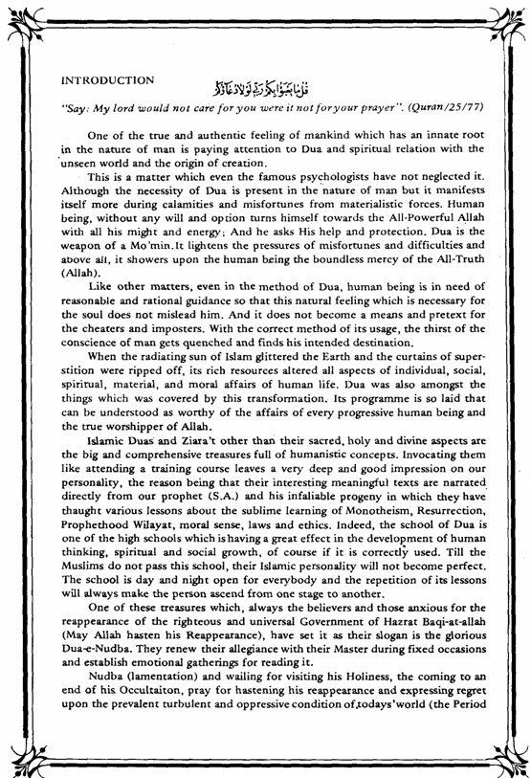

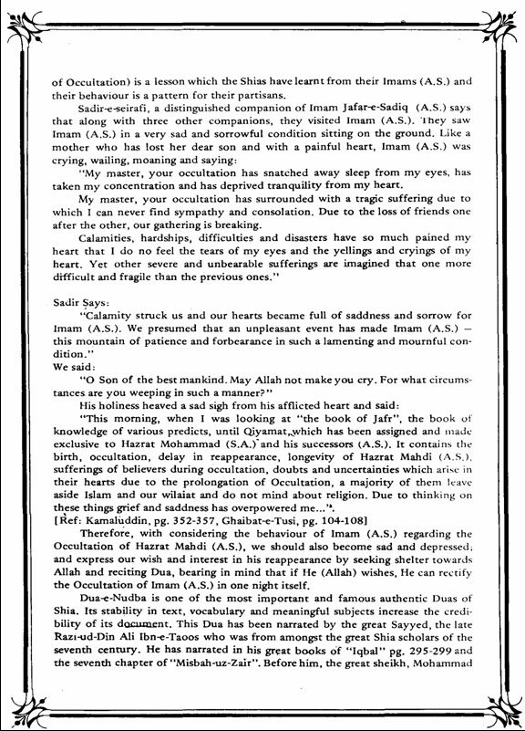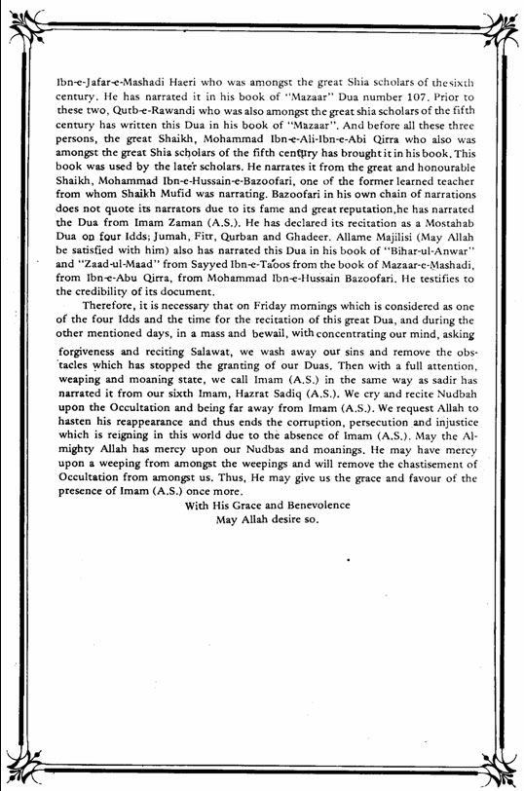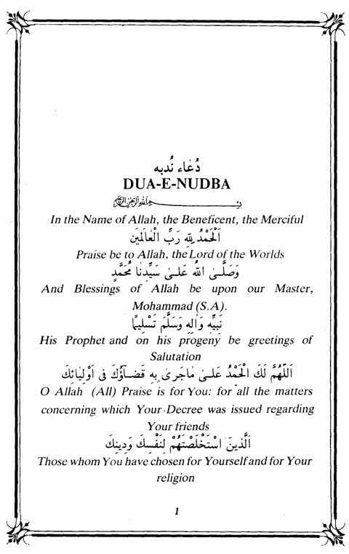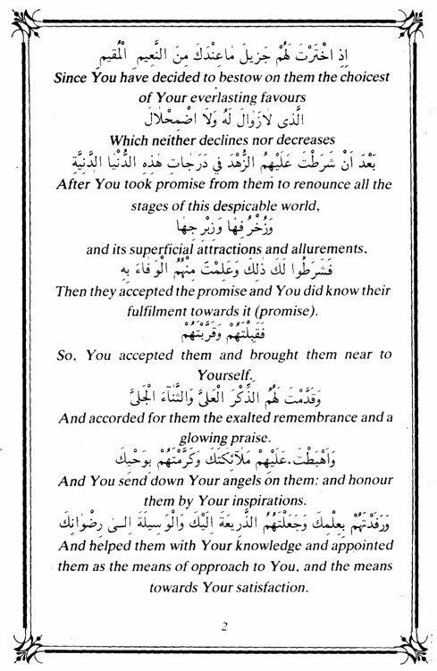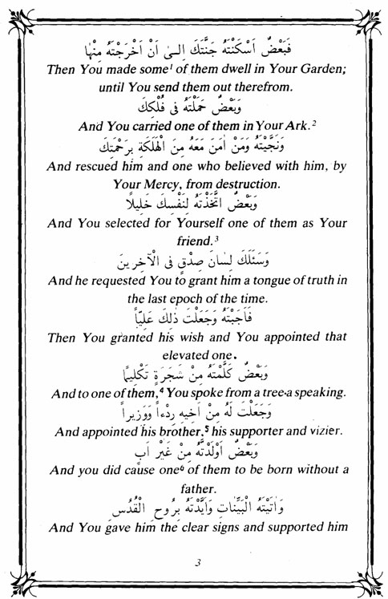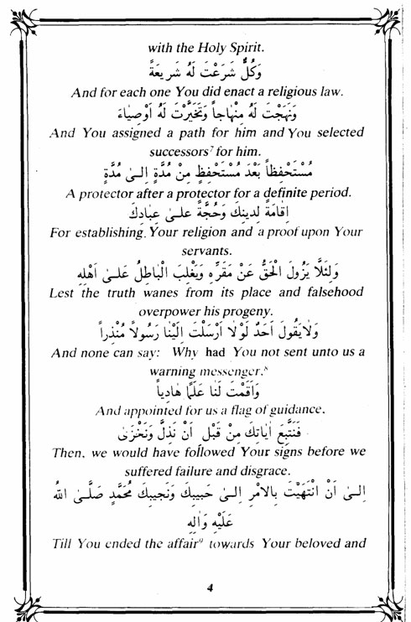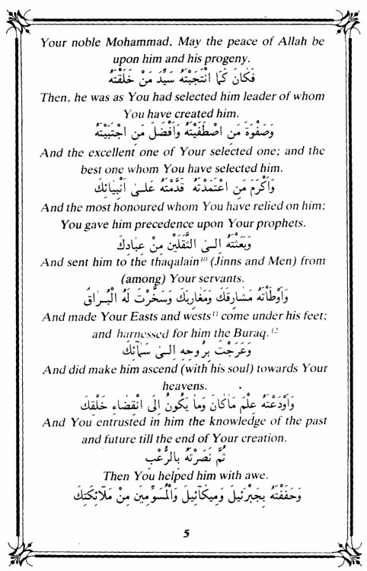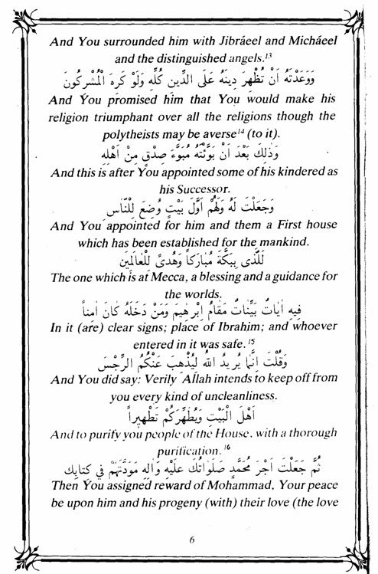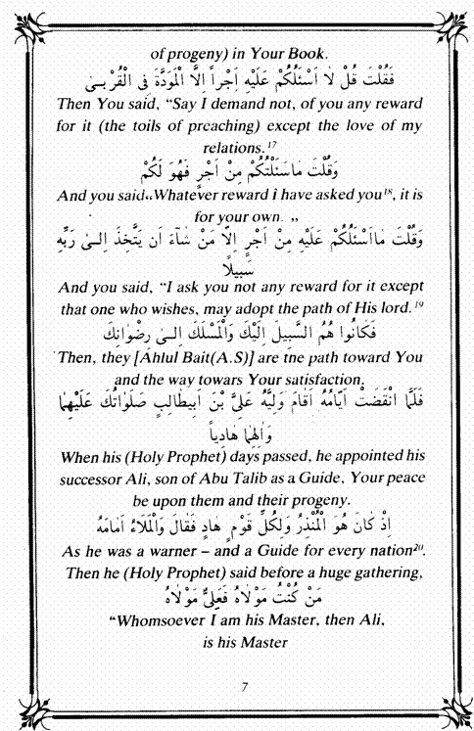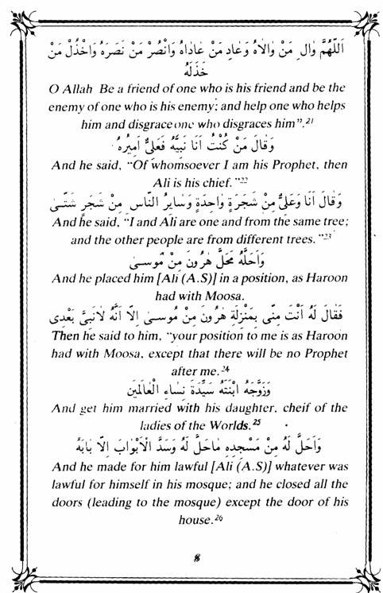

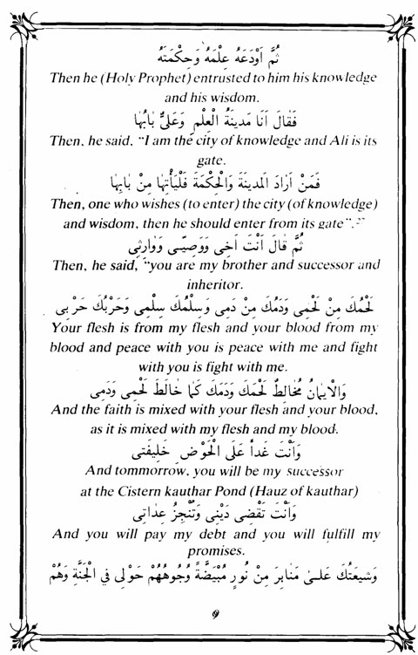

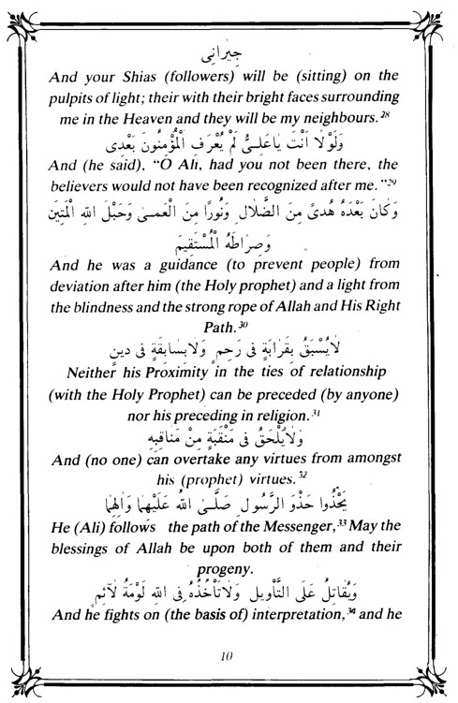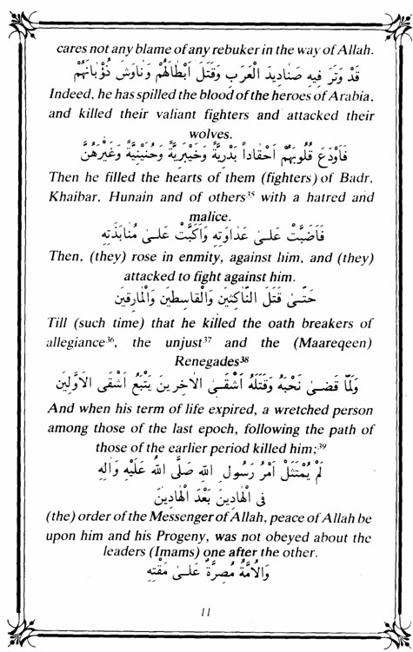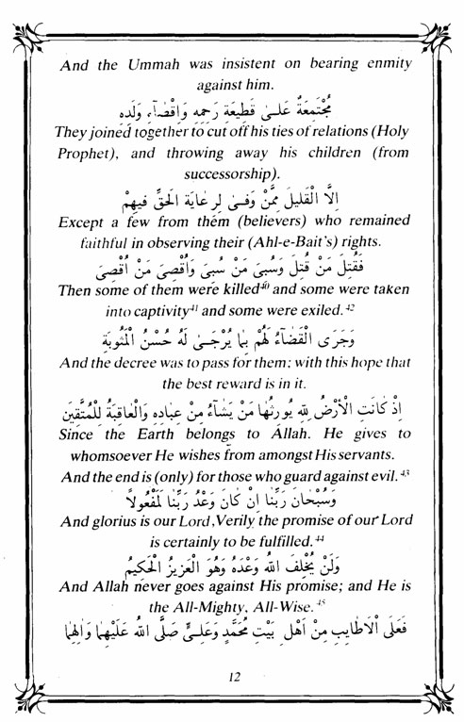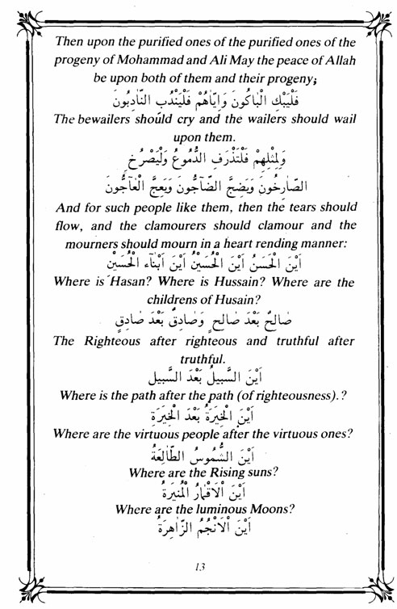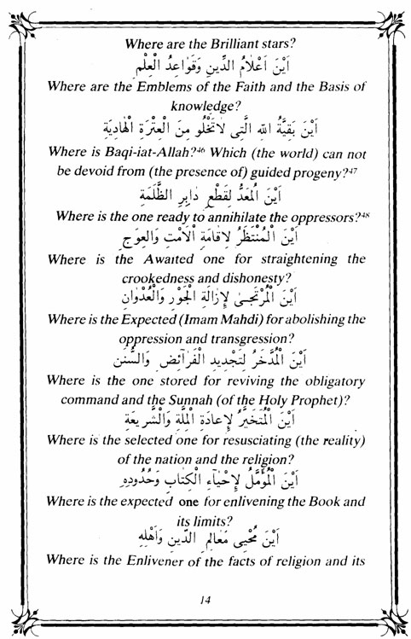

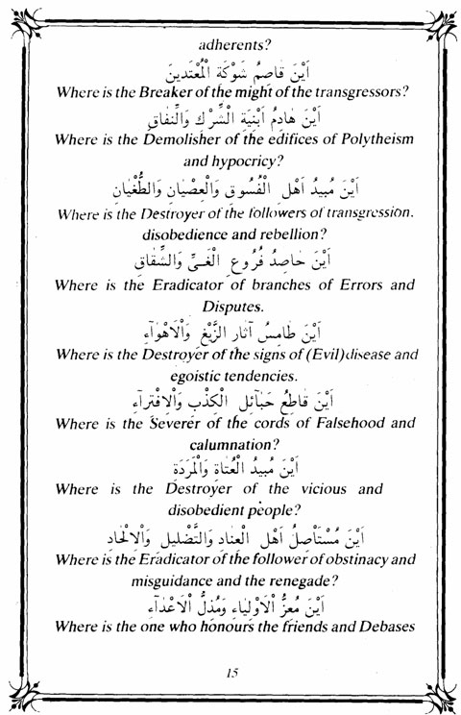

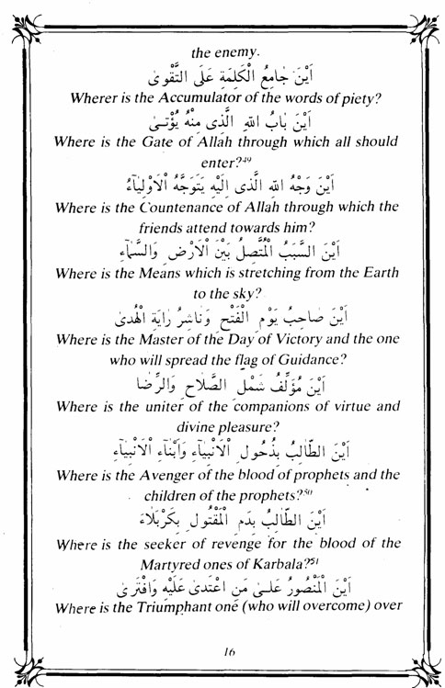

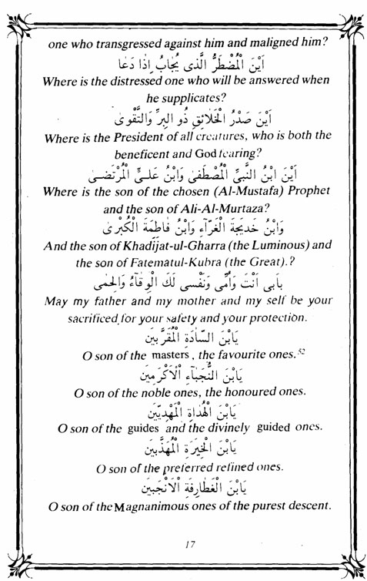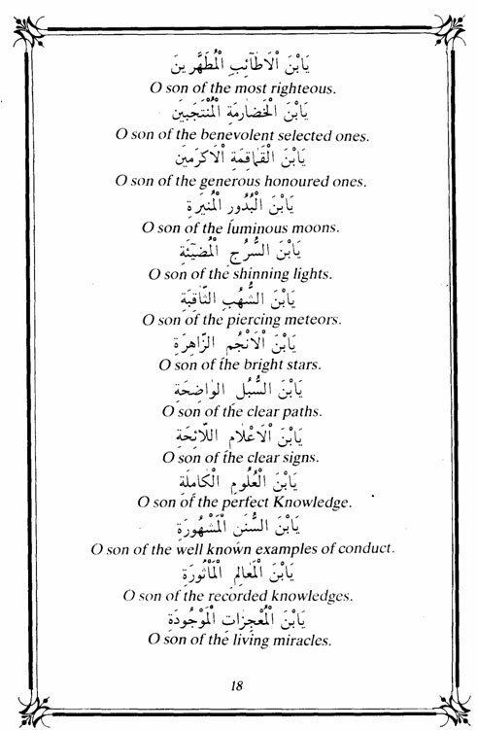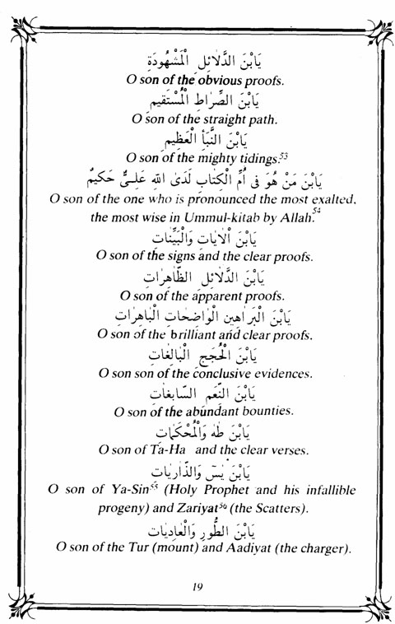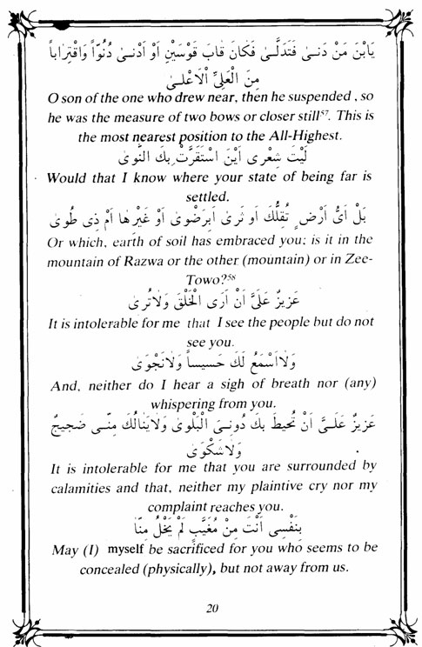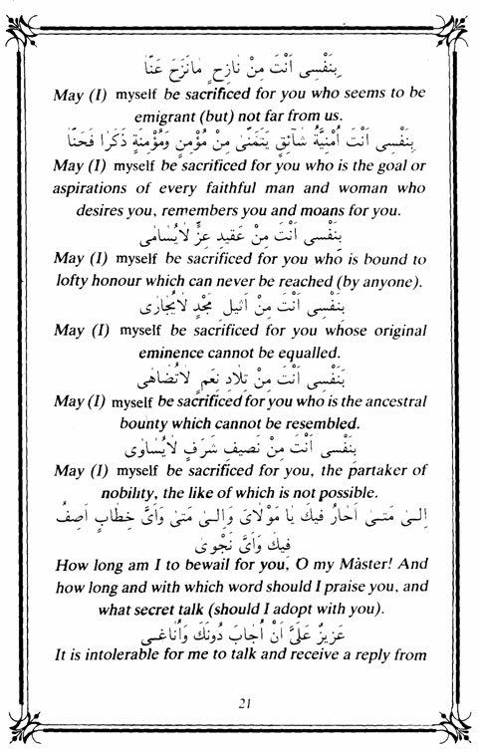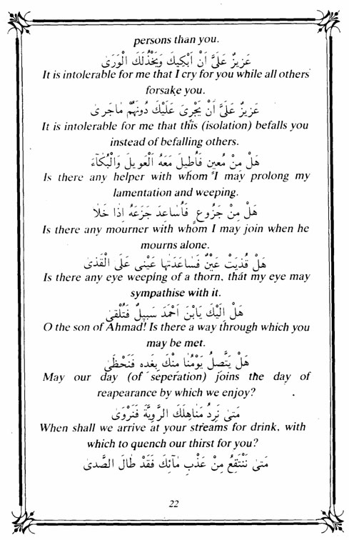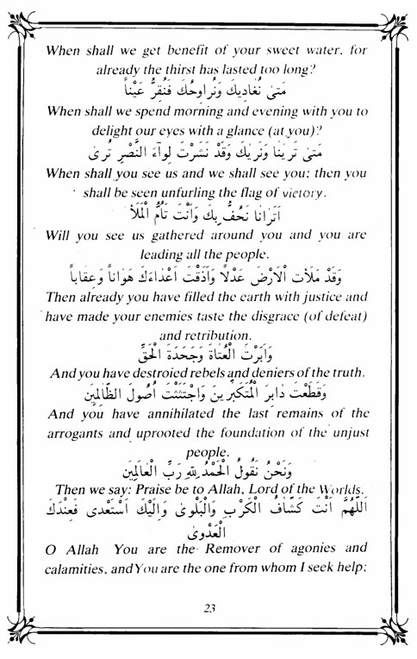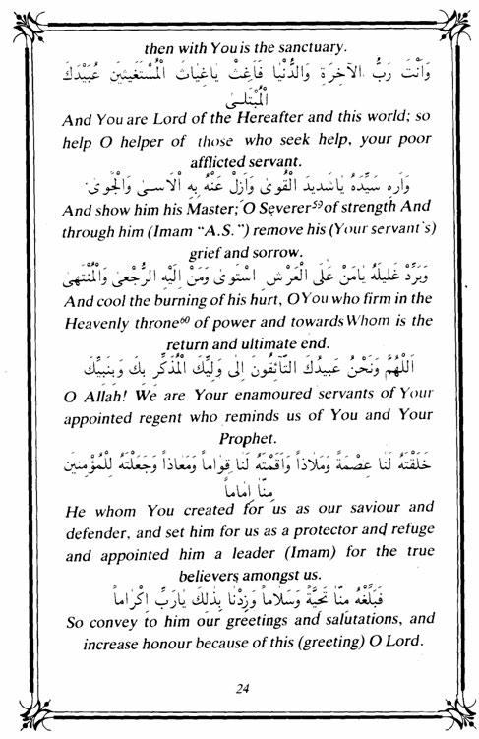

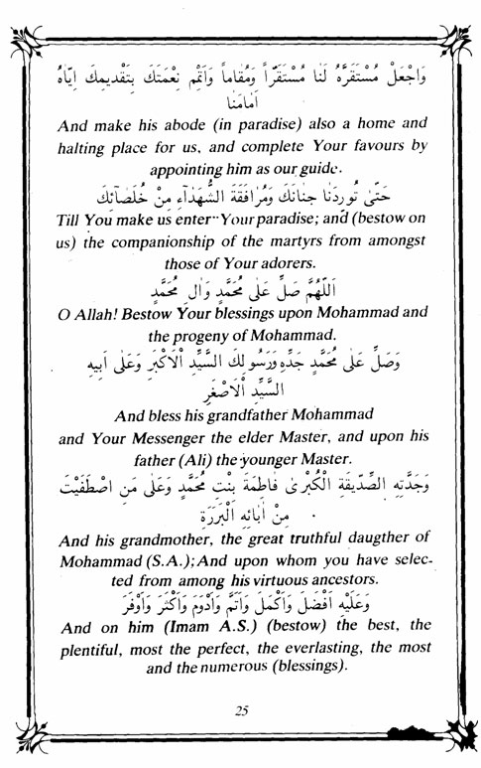

All rights reserved for Al-Hassanain (p) Network, ImamHussain (p) Foundation

Alhassanain (p) Network for Islamic Heritage and Thought

[www.alhassanain.org/english](http://www.alhassanain.org/english)