Pilgrimage Sites

Table of Contents

Pilgrimage Sites 6

Saudi Arabia 7

Makkah al-Mukarramah 9

1. Masjid al-Haraam 9

2. Jannat al-Mualla (Cemetery in Makkah) 9

3. Jabal Nur. The mount on which the Cave of Hira is found 10

4. Cave (ghar) of Hira 10

5.Cave of Thaur 10

6.Birth Place of the Holy Prophet [s] 10

7.The house of Khadija [a] and birth place of Fatima [a] 10

8.House of Ibrahim [a] 11

9.House of Abu Talib [a], father of Imam Ali [a] 11

10.Masjid Jin 11

11.Masjid Bilal 11

12.Mount Abu Qubais 11

13.Saraf 11

14.Feel 11

15.Fakh 11

Madina al-Munawwarah 12

1.Masjid al-Nabawi 12

2.Jannatul Baqi 12

3.Masjid Quba 12

4.Imam Ali [a]'s house 12

5.Well of the Prophet [s] 12

6.Mashrabat Umm Ibrahim 13

7.Masjid Fadhikh 13

8.Masjid Qiblatayn (i.e. the mosque of two qiblas) 13

9.Sab'a Masajid (lit. 'The place of 7 mosques') 13

10. Masjid Ummul Mu'minin Mariyah Qibtiya [a] 13

11.Masjid Raj'atu-Shams - now destroyed 13

12.The houses of Imam Zaynul Abidin [a] and Imam Ja'far al-Sadiq [a] 13

13.Masjid Mubahala 13

14.Masjid Ghamamah. Also called Masjid Eid 13

15.Well (*bir*) of Ali, peace be upon him 13

16.Masjid Shajarah 13

Jeddah 15

Taif 16

1.Masjid Abdullah Ibn Abbas [r] 16

2.Grave of Abdullah Ibn Abbas [r] 16

Abwa 17

1.Birth place of the 7th Imam Musa al-Kadhim, peace be upon him 17

2.Grave of Amina, mother of the Holy Prophet, peace be upon him & his Household 17

Badr 18

1.Martyrs of Badr 18

2.Masjid al-Arish 18

Uhud 19

1.Grave of Hamza [a], 19

2.Graves of the other martyrs (shuhada) of Uhud 19

Arafat 20

1.Jabal Rahmah 20

2.Masjid Numrah 20

Mina 21

1.Masjid Kheef 21

2.Masjid Kauthar 21

3.The Three Jamaraat: Jamaraat al-Ula, Jamaraat al-Wusta, and Jamaraat al-Uqba 21

Useful Maps for Pilgrims to Makkah & Madinah 23

Iraq 37

Najaf 39

1.Mausoleum of 1st Imam Ali b. Abi Taalib, peace be upon him 39

2.Wadi-us Salaam 39

3.Tomb of Hadrat Kumayl - companion of Imam Ali [a] 39

4.Tomb of Rashid Hijri - companion of Imam Ali [a] 39

5.Masjid Hannana 39

Kufa 40

1.Masjid Kufa 40

2.House of Imam Ali, peace be upon him 40

3.Mausoleum of Sayyida Khadijatul Sughra daughter of Imam Ali [a] 40

4.Mausoleum of Prophet Yunus [a] 40

5.Masjid Sahla 40

6.Kooba of Ebrahim ibn Hasan al-Muthanna ibn Imam Hasan [a] 40

7.Mausoleum of Maytham al-Tammar, companion of Imam Ali [a] 40

8.Mosque of Zaid - near Masjid Sahla 40

9.Mosque of Sa'asa ibn Sauhan, companion of Imam Ali [a] 40

Karbala 41

1.Mausoleum of 3rd Imam al-Husayn, peace be upon him 41

2.Mausoleum of Hadrat Abbas b. Ali [a] 41

3.Grave of Habib ibn Madhaher [a] 41

4.Ganj-e-Shohada 41

5.Qatl-ghah. 41

7.Til-e-Zaynabiya 41

8.Khaimaghah 41

9.Garden of 6th Imam Ja'far al-Sadiq, peace be upon him 41

10.Garden of 12th Imam Sahib al-Asr, Al-Mahdi, peace be upon him 41

11.Mausoleum of Hur (companion of Imam Husayn [a] in Karbala) 41

12.Mausoleum of Aun, son of Sayyida Zaynab [a] 41

Moosayab 42

Location 42

Kadhmayn 43

1.Mausoleum of 7th and 9th Imams, Imam Musa al-Kadhim and Imam Muhammad al-Jawad, peace be upon them 43

2.Grave of Shaykh al-Mufid 43

3.Grave of Sayyid Ismail Safrudin 43

4.Grave of Khwaja Nasirudin Tusi 43

5.Grave of Sayyid Murtada 43

6.Grave of Sayyid Razi 43

Baghdad 44

Location 44

Madain/Salman Pak 45

Samarra 46

Location 46

1.Mausoleum of 10th and 11th Imams, Imam Ali al-Naqi and Imam Hasan al-Askari, peace be upon them 46

2.Cellar (*sardab*) of 12th Imam Al-Mahdi, peace be upon him 46

3.Masjid Jamia 46

Balad 47

Location 47

Hillah 48

Basra 49

Iran 50

Mashad al-Muqaddas, Tus, Khorasan 51

1.Mausoleum of 8th Imam Ali b. Musa al-Rida, peace be upon him 51

2.Tomb of Khwaja Aba Salat Harvi 51

3.Tomb of Imamzada Sultan Ahmed [a] 51

4.Tomb of Sayyid Ahmed Kabir 51

5.Tomb of Shaykh Bahauddin Ameli 51

6.Tomb of Mohamed ibn Hasani Alhuri Ameli 51

7.Tomb of Abu Ali Hazal ibn Hasan Al-Tibrasi 51

8.Tomb of Khwaja Murad 51

9.Tomb of Khwaja Rabi'i 51

Qum 52

1.Mausoleum of Fatima bint Musa [a] 52

2.Masjid Imam Hasan al-Askari, peace be upon him. 52

3.Tomb of Aqa Burujardi 52

4.Masjid Jamkaran 52

Tehran 53

1.Mausoleum of Shah Abdul Azim [a] 53

2.Tomb of Abdul Qasim son of Imam Musa al-Kadhim [a] (7th Imam) 53

3.Tomb of Imamzada Musa [a] 53

Shimran 54

Location 54

Jerusalem 56

Baitul Muqaddas 57

Hebron - Khalil al-Rahman 58

Egypt 59

Cairo 60

Syria 61

Damascus 62

1.Tomb of Lady Zaynab, peace be upon her 62

2.Bab Saghir (also called "Goristan-e-Ghariban") 62

3.Prison 62

4.Ummayyad Mosque (Jaami al-Amawi) 62

5.Salera (Hill) 62

6.Another Hill (dangerous to ascend) 63

Pilgrimage Sites

Have they not travelled in the land so that they should have hearts with which to understand, or ears with which to hear? (Qur'an, 22:46)

Planning a pilgrimage (ziyarat) to one of the places below? Click on a country to see important places you shouldn't miss visiting and taking note of.

Saudi Arabia

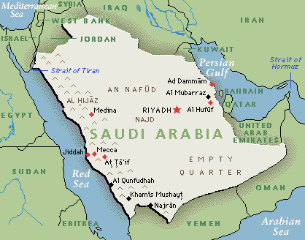

Places to Visit

Makkah

Madina

Jeddah

Taif

Abwa

Badr

Uhud

Arafat

Mina

[Makkah al-Mukarramah](http://www.al-islam.org/pilgrimage-sites/saudi-arabia#makkah-al-mukarramah)

1. Masjid al-Haraam

The Holy Ka'aba. The House of Allah and the birth place of Imam Ali b. Abi Taalib [a]

Hajar al-Aswad (The Black Stone)

Maqam Ibrahim

Hijr Ismail. This was the location of the house of Prophet Ismael [a]. He and his mother are buried here. He denied access to anyone because he did not like it to be walked on. Other prophets are buried in this place also. According to Imam Baqir [a], the place between Rukn and Maqam is full of graves of the Prophets. According to Imam Sadiq [a], seventy prophets are buried between Rukn al-Aiman and Hajar al-Aswad

Well of Zamzam

Mizabe Rahmah: the golden trough (water channel) between Rukn Iraqi and Rukn Shami

Shadharwan

Mustajar: This is just before Rukn Yamani whilst walking from Rukn Shami to Rukn Yamani. It has also been defined as the area between the Black Stone (hajar al-aswad) and the door of the Ka'aba

Mutaawadh or Multazam: The place between Rukn Yamani and the Black Stone (hajar al-aswad)

Hatwim. According to the book "Adabul Haramain", this is the place between the door of the Ka'aba and Hajar al-Aswad. It is called Hatwim "the smasher" because it smashes major and minor sins of one who seeks forgiveness here. It is said that this is the place where Adam [a] was forgiven. According to the book ""Umra & Ziyarat", this is the place where Prophet Ismail, his mother and many other prophets are buried. See Hijr Ismail above.

Rukn al-Aiman (the right-hand side corner of the Ka'aba).This is opposite the Black Stone behind the House. The Prophet [s] said "Whenever I come at this point, I find Jibril is already there before me." Imam al-Sadiq [a] said: "Rukn al-Aiman is our gate to Paradise". He also said: "In this place is one of the doors of Paradise that has never been closed since it was opened. There is a river from Paradise in which deeds of the servants are dropped." Also called Rukn al-Junubi. It comes before the Black Stone corner.

Rukn Shami/Gharbi. This is the corner of the Ka'aba that comes after Hijr Ismail

Rukn al-Sharqi. This is the corner where Hajar al-Aswad rests.

Rukn al-Shimali / Iraqi. This is corner that comes after the Ka'aba's door before one reaches Hijr Ismail.

Mount Safa. When going to Safa for Sa'y, use the same door that the Prophet [s] used, which is Bab as-Safa, opposite the Black Stone.

Mount Marwa

2. Jannat al-Mualla (Cemetery in Makkah)

Also known as Al-Hajun. The Prophet [s] used to visit it frequently. It is the 2nd holiest graveyard after Baqi. Those buried here include:  
Abd Manaf: Great, great-grandfather of the Holy Prophet [s]

Grave of Hashim: Great-grandfather of the Holy Prophet [s]

Grave of Abdul Muttalib: Grandfather of the Holy Prophet [s]

Grave of Amina: Mother of the Holy Prophet [s]

According to another source, Amina is buried in Abwa (between Makkah and Madina) - where the 7th Imam [a] was born

Grave of Abu Talib: Father of First Imam Ali [a]

Grave of Khadija: First wife of the Holy Prophet [s] and mother of Sayyida Fatima [a]

Qasim: son of the Holy Prophet [s] who died in his infancy

Amongst the famous scholars buried in the graveyard of Hajun are:  
Marhum Agha Mirza Muhammad al-Istrabadi - author of Rijal al-Kabir wa Ayat al-Ahkam

Sayyid Mir Muhammad Mu'min al-Istrabadi author of Al-Ruj'a. He lived near Makkah

Sayyid al-Shahid Mir Zeinul Abideen al-Husseini al-Kashani. He was martyred in Makkah and buried in a grave he had chosen himself in the graveyard of Mu'alla. He was amongst those who laid the foundation of the House after it was demolished.

Sheikh Muhammad son of the author of Al-Maalim. His grave lies near the grave of Khadija [a]

Ibn Sheikh Muhammad - buried beside his father. Used to take a lot of care in matters concerning Ihtiyat (caution) and fear of Allah

3. Jabal Nur. The mount on which the Cave of Hira is found

4. Cave (ghar) of Hira

The cave where the Holy Prophet [s] used to meditate frequently during the first forty years of his life. This is also the place he received the first revelation

5.Cave of Thaur

The cave where the Holy Prophet [s] hid from his enemies when migrating to Madina

6.Birth Place of the Holy Prophet [s]

Situated near "Suq Lail". Presently a library by the name of "Maktaba Makkah al-Mukarramah"

7.The house of Khadija [a] and birth place of Fatima [a]

This is where the Prophet [s] lived until he migrated. It is where Khadija [a] died and where Fatima [a] was born. It is also the place where the Meccans had planned to kill the Prophet [s] on the night of Hijrat and Imam Ali [a] slept in his place. It is a place where Jibrail used to descend with revelations from Allah

8.House of Ibrahim [a]

the son of the Holy Prophet [s] who died in infancy

9.House of Abu Talib [a], father of Imam Ali [a]

10.Masjid Jin

11.Masjid Bilal

12.Mount Abu Qubais

Near this is the place where the Prophet [s] performed the miracle of splitting the moon in two

13.Saraf

About two farsakhs from Makkah. Maimuna, wife of the Prophet [s], is buried here

14.Feel

Near Makkah. Abdullah b. Ismail b. Badhee's grave is at "Feel". He was amongst the companions of the 5th, 6th, 7th and 8th Imams, peace be upon them

15.Fakh

Another place for ziyarat is the graveyard of the Martyrs of Fakh. Fakh is the name of a place which used to be Miqat-e-Swibyaan. In this place, about a hundred people from the descendants of Fatima [a] lost their lives in the hands of the puppets of Musa al-Hadi al-Abbasi. Muhadith al-Qumi quotes the 9th Imam al-Jawad [a] as having said that after Taf there had been no other fatal and destructive battle like the one of Fakh. Du'bal also mentions Fakh in one of his poems

[Madina al-Munawwarah](http://www.al-islam.org/pilgrimage-sites/saudi-arabia" \l "madina-al-munawwarah)

1.Masjid al-Nabawi

Shrine of Holy Prophet of Islam, peace be upon him & his Household

Grave of Sayyida Fatima al-Zahra [a]. Daughter of the Prophet [s] and wife of Imam Ali [a]. According to some historians she is buried in Jannatul Baqi

Room (hujra) of Sayyida Fatima al-Zahra, peace be upon her

Pulpit (minbar) of the Holy Prophet [s]

Prayer niche (mihrab) of the Holy Prophet [s]

The Rawda

The door (bab) of Archangel Jibrail [a]

Maqam of Archangel Jibrail [a]

Pillar of Abu Lubaba

2.Jannatul Baqi

Graves of Imam Hasan (2nd Imam), Imam Zaynul Abidin (4th Imam), Imam Muhammad al-Baqir (5th Imam), and Imam Ja'far al-Sadiq (6th Imam), peace be upon them

Grave of Sayyida Fatima [a]. Daughter of the Prophet [s] and wife of Imam Ali [a]. Location of her grave is unknown. According to some historians she was buried in her own room (now inside Masjid Nabawi) next to the Holy Prophet [s]'s darih

Grave of Abbas b. Abdul Muttalib [r]: Uncle of the Holy Prophet [s] and Imam Ali [a]

Grave of Fatima bint. Asad [a]: Mother of Imam Ali [a]

Grave of Ja'far al-Tayyar [a] - brother of Imam Ali, peace be upon him.

Graves of Safiya and Aatika [r]: Aunts of the Holy Prophet [s]

Grave of Ummul Baneen [a]: Wife of Imam Ali [a] and mother of Hadrat Abbas [a] ( - Safiya, Aatika & Ummul Baneen)

Grave of Ibrahim [a]: son of the Holy Prophet [s]

Grave of Haleema [r]: Nursing mother of the Holy Prophet [s]

Graves of the Holy Prophet's [s] wives (ummahat al-mu'minin)

Graves of various companions (as-haab) of the Holy Prophet [s]

3.Masjid Quba

First mosque of Islam. The Prophet [s] spent more than 20 nights here (after migrating) praying qasr while waiting for Imam Ali [a]. It is mentioned in the Qur'an as the mosque founded on piety and devoutness

4.Imam Ali [a]'s house

Behind Masjid Quba is Imam Ali [a]'s house

5.Well of the Prophet [s]

Infront of Masjid Quba, is a sweet-water well that is now closed. The Prophet [s]'s ring fell into this well hence the name Bi'ru al-Khatam (khatam = ring). It is also called Bi'ru Tufla because at first its water was salty but when the Holy Prophet [s] spat into it, it changed to sweet refreshing water

6.Mashrabat Umm Ibrahim

Joined to Masjid Quba is "Mashrabat Ummu Ibrahim". This is the room of the Prophet [s]'s wife Mariah Qibtwiyya (Umm Ibrahim). The Prophet [s] used to live and pray here

7.Masjid Fadhikh

It is situated in the eastern part of Masjid Quba. It is named after a palm tree that used to be at the place. It is also called Masjid Nakhl. Here is where the sun was brought back for Imam Ali's to pray Asr which he missed because the Prophet [s] was sleeping on his laps

8.Masjid Qiblatayn (i.e. the mosque of two qiblas)

The mosque where the Holy Prophet [s] was commanded to change his qibla from Masjid al-Aqsa (Jerusalem) to the Holy Ka'aba (Makkah)

9.Sab'a Masajid (lit. 'The place of 7 mosques')

There are now only five mosques - Masjid Ali , Masjid Fatima , Masjid Fath , Masjid Salman al-Farsi , & Masjid Umar.

Masjid Fath (lit. "mosque of victory") is at the top of a mountain. This is named after the Muslims victory in the Battle of Khandaq when Imam Ali [a] killed Amr b. Abd Wudd and the Prophet [s] prayed here for the Muslims victory

10. Masjid Ummul Mu'minin Mariyah Qibtiya [a]

wife of the Holy Prophet [s] and mother of Ibrahim [a]. This could be one of the two demolished mosques at Sab'a Masajid (No. 9 above)

11.Masjid Raj'atu-Shams - now destroyed

12.The houses of Imam Zaynul Abidin [a] and Imam Ja'far al-Sadiq [a]

13.Masjid Mubahala

14.Masjid Ghamamah. Also called Masjid Eid

The Holy Prophet [s] said his Eid prayers here

15.Well (bir) of Ali, peace be upon him

16.Masjid Shajarah

Also known as Masjid Ali [a]. This place is a miqat for those going for umra from Madina to Makkah. The place is also known amongst the locals as Abar Ali

[Jeddah](http://www.al-islam.org/pilgrimage-sites/saudi-arabia" \l "jeddah)

Grave of Lady Hawa (Eve), peace be upon her. First woman on earth and wife of Prophet Adam, peace be upon him. Jeddah is named after her. Its the Arabic equivalent for "Grandmother"

[Taif](http://www.al-islam.org/pilgrimage-sites/saudi-arabia" \l "taif)

1.Masjid Abdullah Ibn Abbas [r]

2.Grave of Abdullah Ibn Abbas [r]

Cousin and companion of Imam Ali [a]. Very often referred to by Imam Ali [a] as "Ibn Abbas". See Nahjul Balaagha

[Abwa](http://www.al-islam.org/pilgrimage-sites/saudi-arabia" \l "abwa)

1.Birth place of the 7th Imam Musa al-Kadhim, peace be upon him

2.Grave of Amina, mother of the Holy Prophet, peace be upon him & his Household

According to some historians, she is buried in Jannat al-Mu'alla (Makkah)

[Badr](http://www.al-islam.org/pilgrimage-sites/saudi-arabia" \l "badr)

1.Martyrs of Badr

Badr is a village between Makkah and Madina. 14 companions of the Holy Prophet [s] were martyred here in the Battle of Badr

2.Masjid al-Arish

Nearby the Martyrs of Badr is Masjid al-Arish where the Prophet [s] prayed during the battle

[Uhud](http://www.al-islam.org/pilgrimage-sites/saudi-arabia" \l "uhud)

1.Grave of Hamza [a],

uncle of the Holy Prophet [s] who was martyred at the Battle of Uhud

2.Graves of the other martyrs (shuhada) of Uhud

[Arafat](http://www.al-islam.org/pilgrimage-sites/saudi-arabia#arafat)

1.Jabal Rahmah

2.Masjid Numrah

[Mina](http://www.al-islam.org/pilgrimage-sites/saudi-arabia#mina)

1.Masjid Kheef

2.Masjid Kauthar

3.The Three Jamaraat: Jamaraat al-Ula, Jamaraat al-Wusta, and Jamaraat al-Uqba

Related Article on the Web:

History of the graveyard of Jannatul Baqi (Madina) & Jannatul Mualla (Makkah)

The Map



Useful Maps for Pilgrims to Makkah & Madinah

[Makkah](http://www.al-islam.org/pilgrimage-sites/useful-maps-pilgrims-makkah-madinah" \l "makkah)

[1. Places of Worship in Haram al-Sharif](http://www.al-islam.org/pilgrimage-sites/useful-maps-pilgrims-makkah-madinah" \l "1-places-worship-haram-al-sharif)

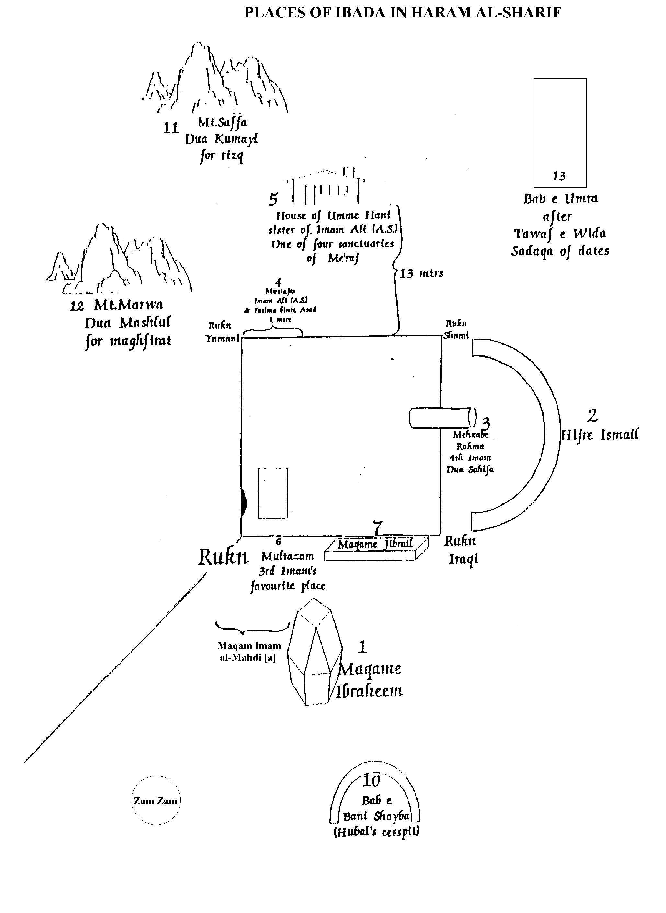

[2. Illustration of the Kaaba](http://www.al-islam.org/pilgrimage-sites/useful-maps-pilgrims-makkah-madinah" \l "2-illustration-kaaba)

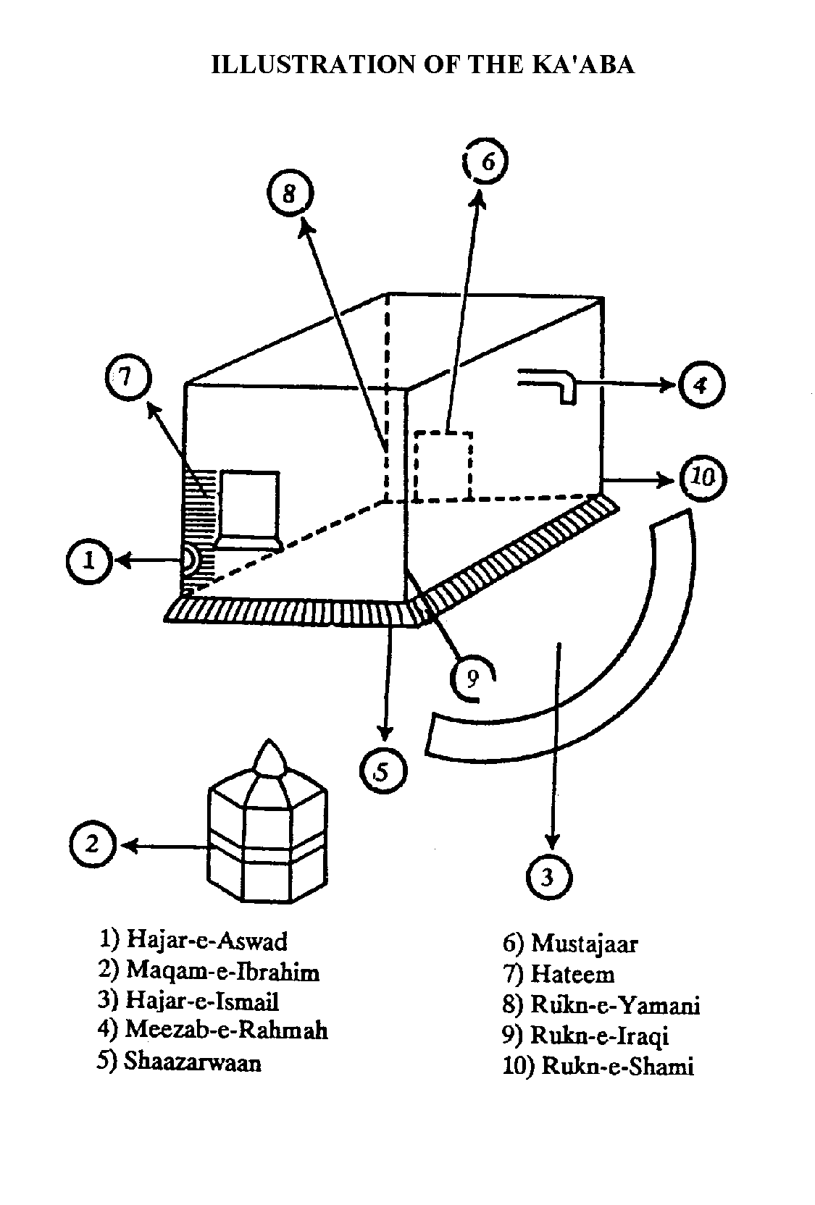

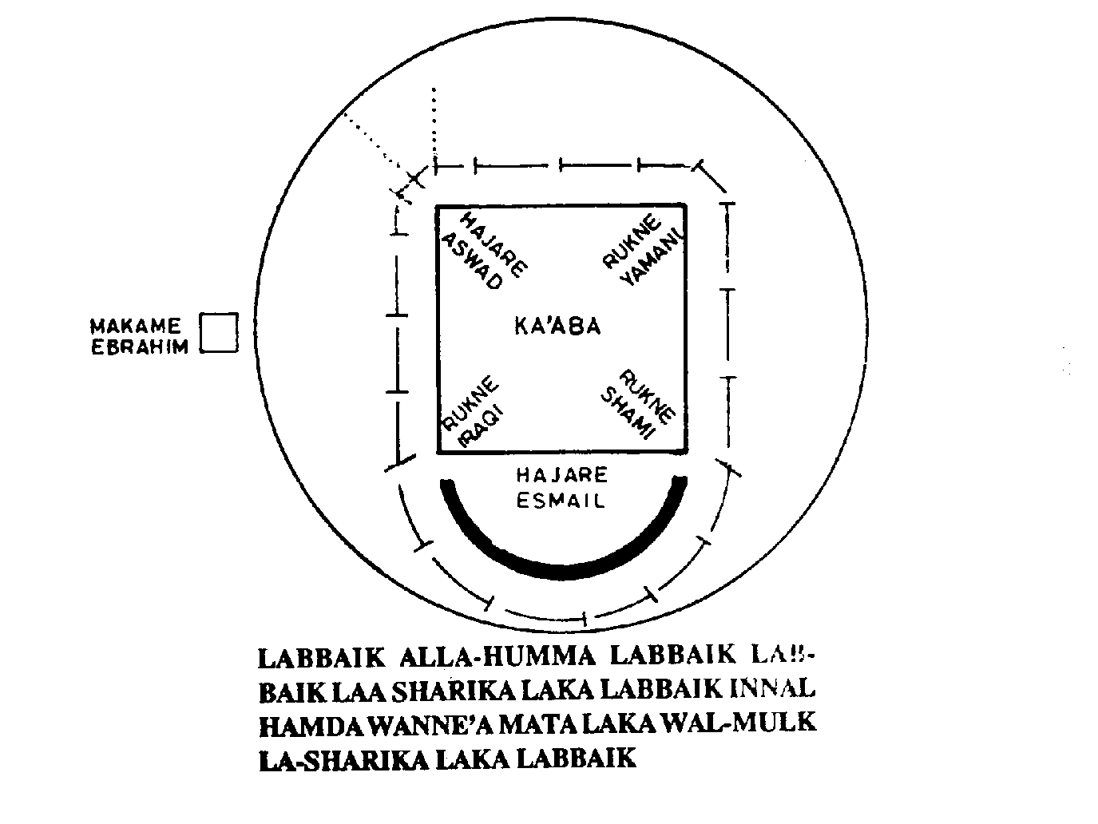

[3. Another Illustration of the Kaaba](http://www.al-islam.org/pilgrimage-sites/useful-maps-pilgrims-makkah-madinah" \l "3-another-illustration-kaaba)

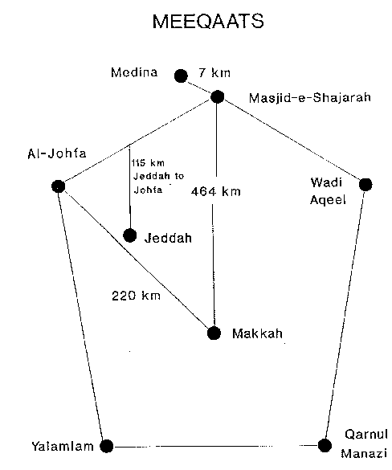

[Maps of Makkah and Surrounding Holy Places](http://www.al-islam.org/pilgrimage-sites/useful-maps-pilgrims-makkah-madinah" \l "maps-makkah-and-surrounding-holy-places)

[Greater Makkah](http://www.al-islam.org/pilgrimage-sites/useful-maps-pilgrims-makkah-madinah" \l "greater-makkah)

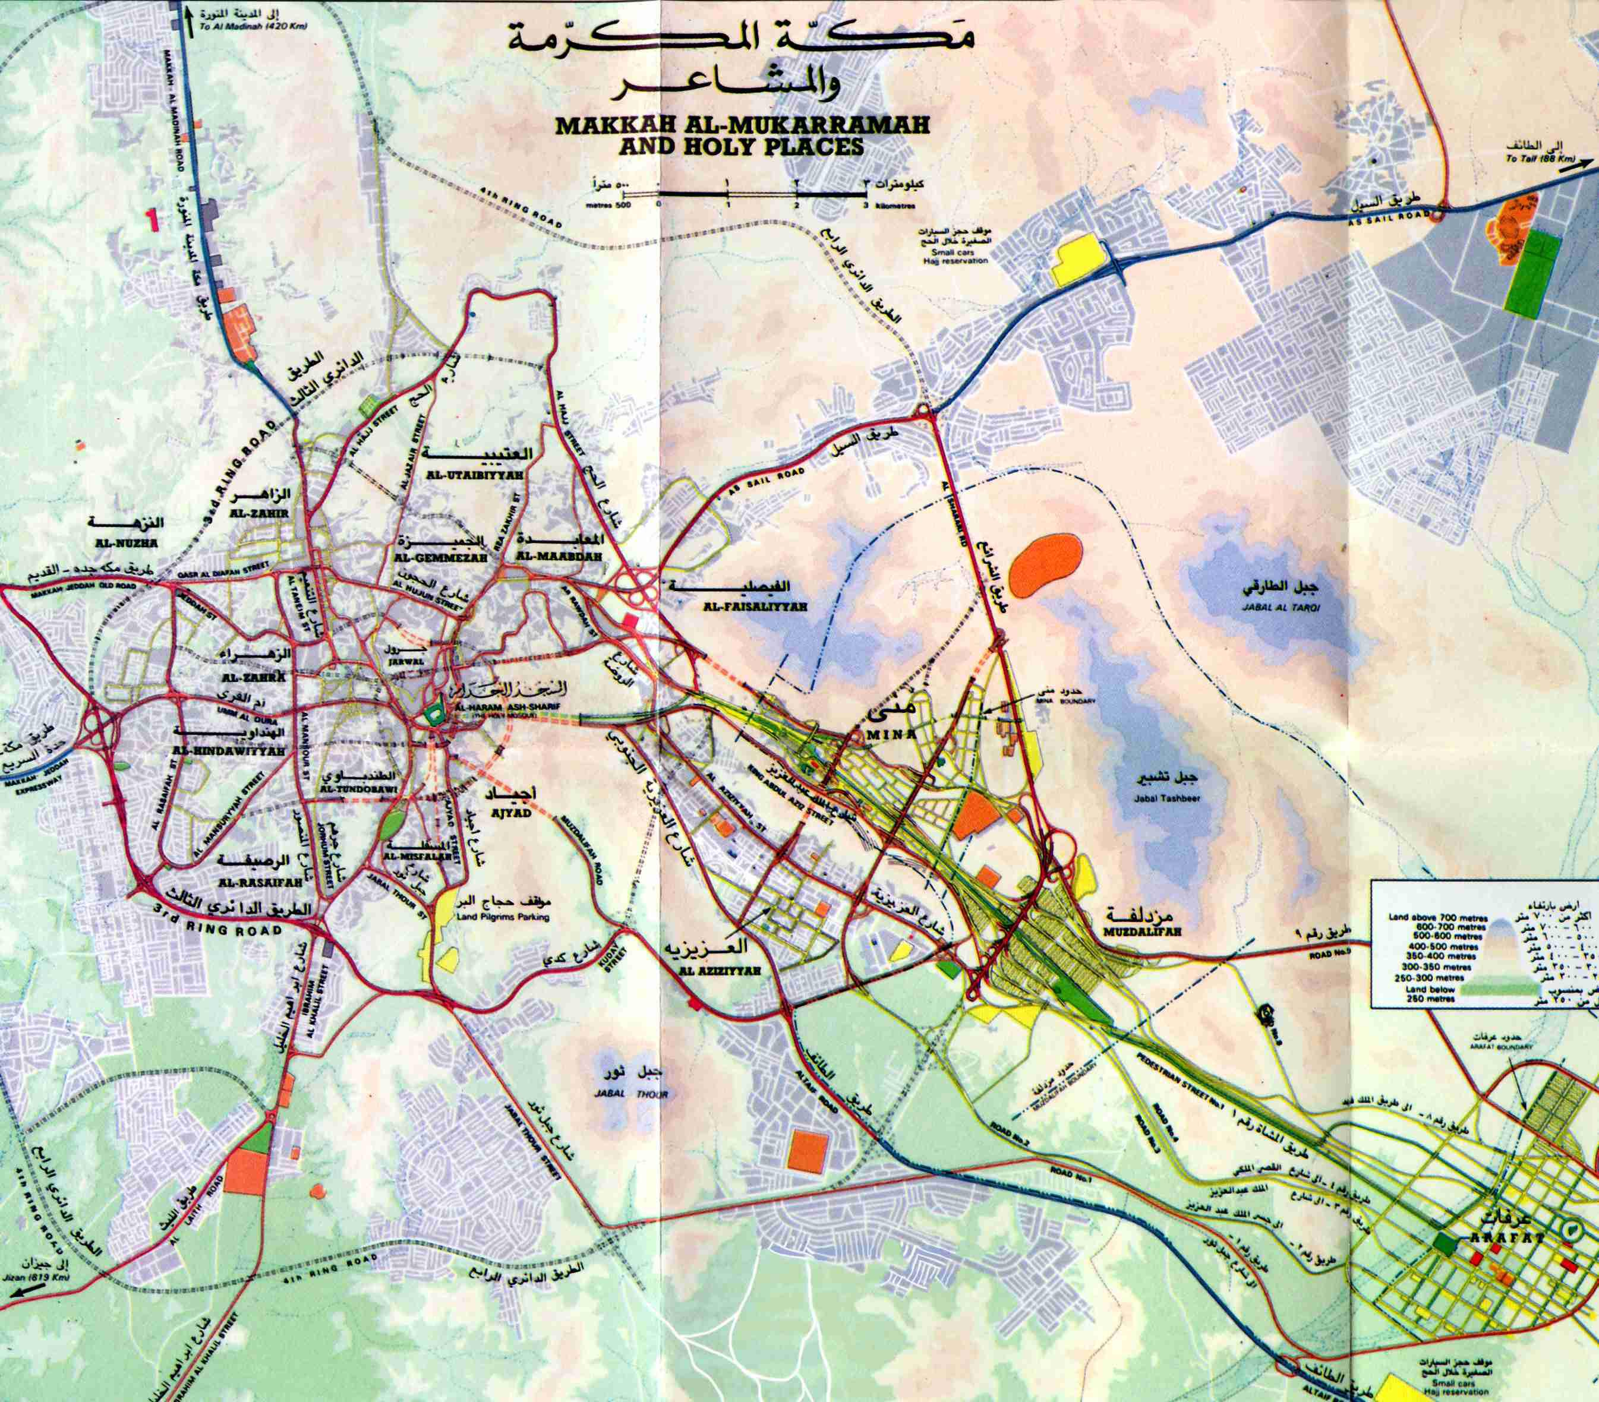

[The Haram Area](http://www.al-islam.org/pilgrimage-sites/useful-maps-pilgrims-makkah-madinah" \l "haram-area)

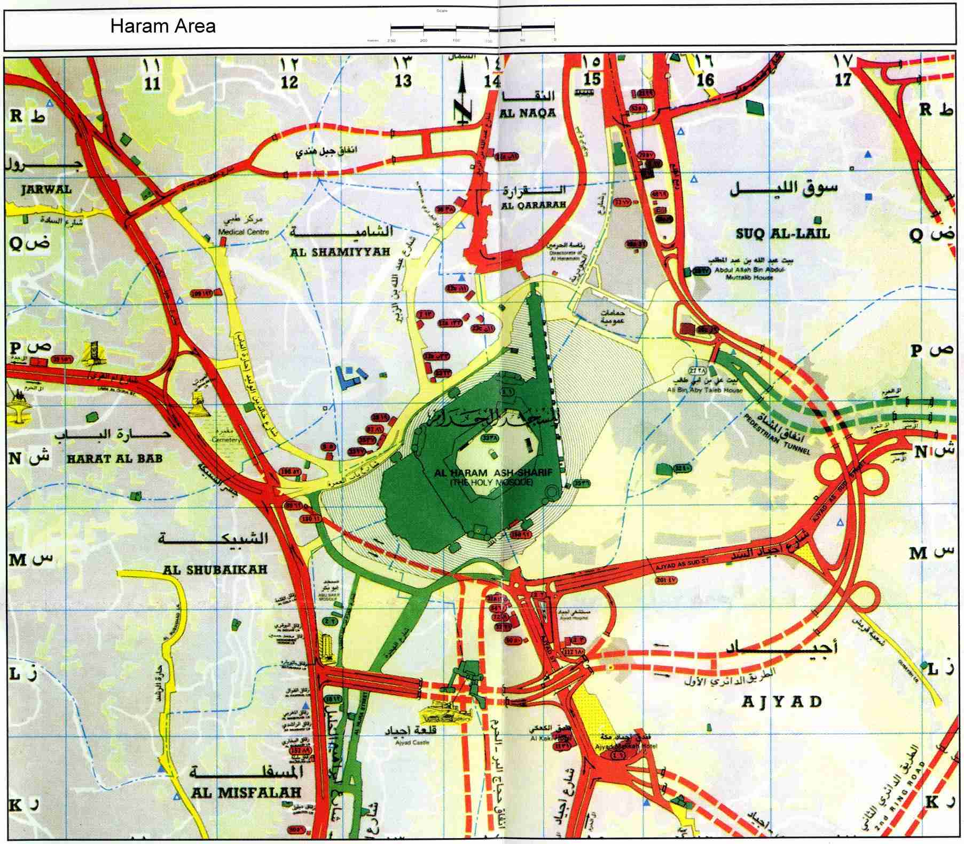

[Arafat](http://www.al-islam.org/pilgrimage-sites/useful-maps-pilgrims-makkah-madinah#arafat)

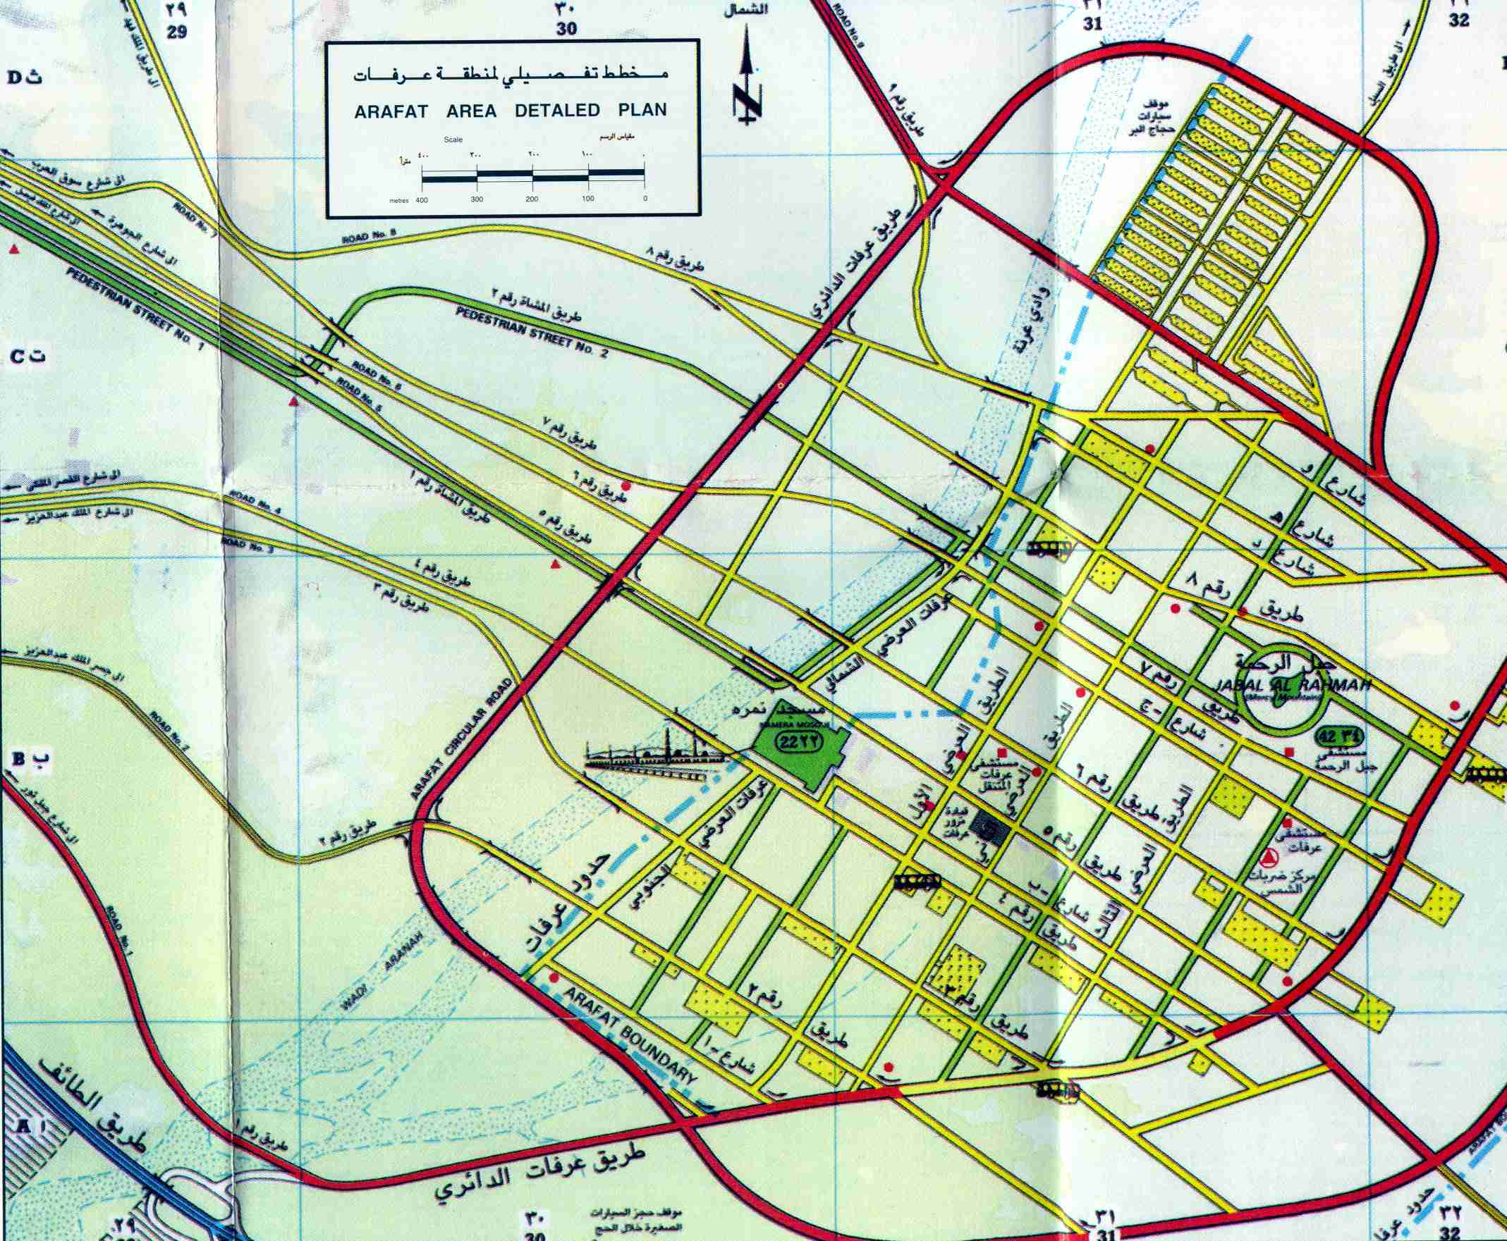

[Mina](http://www.al-islam.org/pilgrimage-sites/useful-maps-pilgrims-makkah-madinah#mina)

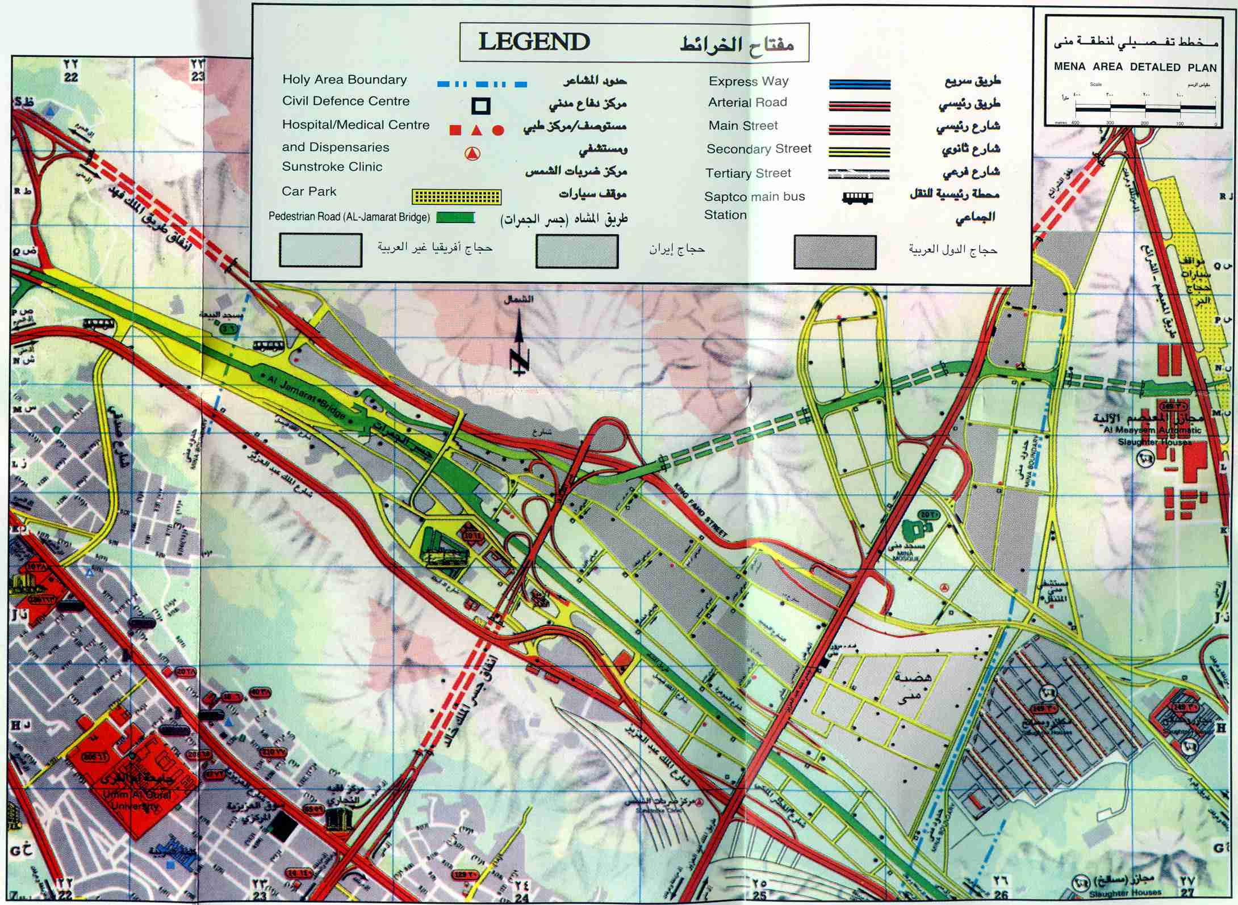

[Madinah](http://www.al-islam.org/pilgrimage-sites/useful-maps-pilgrims-makkah-madinah" \l "madinah)

[Position of the Pillars inside Masjid al-Nabawi](http://www.al-islam.org/pilgrimage-sites/useful-maps-pilgrims-makkah-madinah" \l "position-pillars-inside-masjid-al-nabawi)

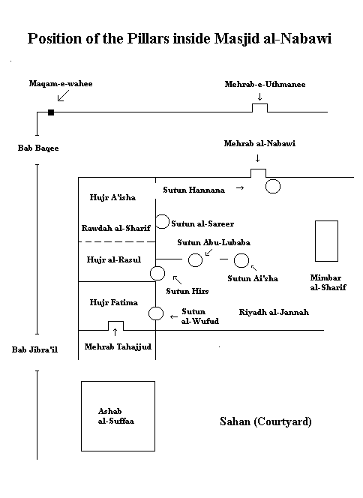

[The Area Inside And Surrounding The Holy Rawdah of The Holy Prophet’s (S) Mosque](http://www.al-islam.org/pilgrimage-sites/useful-maps-pilgrims-makkah-madinah" \l "area-inside-and-surrounding-holy-rawdah-holy-prophet%E2%80%99s-s-mosque)

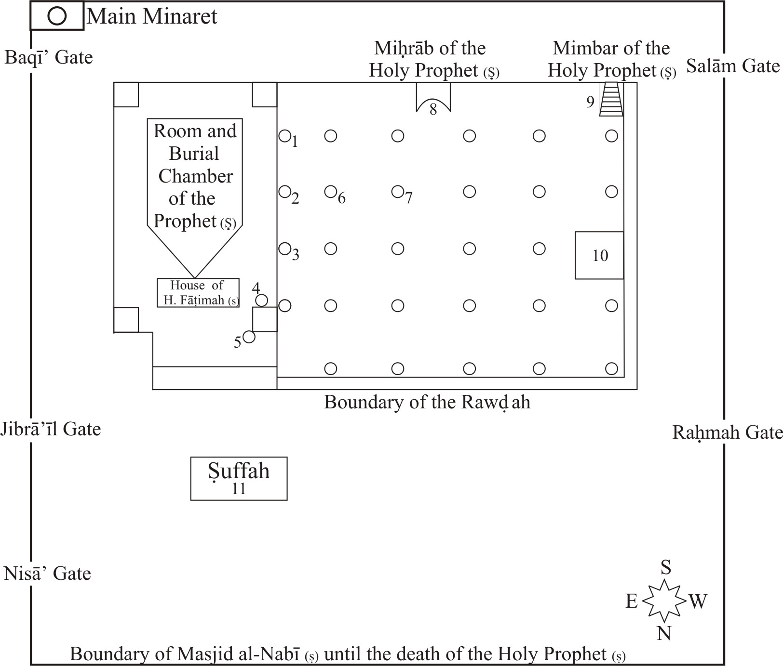

(Not to scale)

1. The Pillar of “Sarīr” (Bed): During the time of i‘tikāf , the Holy Prophet (S) would stay near this pillar and his companions would spread date leaves there so that he could rest on them.

2. The Pillar of “Ĥaras” (Guard): Ĥaďrat ‘Alī (‘a) used to sit next to this pillar and guard the Holy Prophet (S).

3. The Pillar of “Wufūd” (Delegations): The Holy Prophet (S) would meet various heads of tribes and delegations next to this pillar, and would inform them about the teachings of Islam and discuss political issues with them.

4. The Pillar of “Maqām al-Jibrā’īl” (Station of Jibrā’īl): Ĥaďrat Jibrā’īl used to come to the Holy Prophet (S) from this place. This is also the location of the door of Ĥaďrat Fāťimah’s (s) house.

5. The Mihrāb of “Tahajjud” (Night Vigil): The Holy Prophet (S) would sometimes recite his Night Prayer here.

6. The Pillar of “Tawbah” (Repentance): Abū Lubābah carelessly disclosed confidential military plans made by the Holy Prophet (S) to the Jews and then having realised his mistake, tied himself to this pillar and sought repentance there until he was forgiven.

7. The Pillar of “Qur‘ah” / “‘Ā’ishah” / “Muhājirīn”: This pillar has been given these three names due to the following reasons:

“Qur‘ah” (Lots), as it is narrated by ‘Ā’ishah that the Holy Prophet (S) said that there is a piece of land next to this pillar that if people knew the value of, they would draw lots to pray there.

“‘Ā’ishah”, as she narrated this ĥadīth and disclosed the virtues of this place.

“Muhājirīn” (Emigrants), as the Emigrants used to gather next to it.

8. The Pillar of “Mukhallaqah” (Fragrant): The Muslims would fragrant the air of the Mosque as well as themselves before they met the Holy Prophet (S) with incense placed on this pillar.

9. The Pillar of “Ĥanānah” (Compassion): Before the mimbar was built, the Holy Prophet (S) used to deliver his sermons whilst leaning on a tree. When the mimbar was made and the Holy Prophet (S) started delivering his sermons from it, the tree cried out. The Holy Prophet (S) ordered that the tree be buried in that exact place.

10. Maqām al-Bilāl (Station of Bilāl): This is the place where Bilāl would call the adhān.

11. Suffah (Platform / Ledge): Following the Emigration to Madīnah, poor Emigrants were given food and shelter in this place. It should be noted that the original location of the Suffah was at the eastern end of the Mosque as it stood at the time of the Holy Prophet (S), and adjacent to the northern wall.

[Map of Jannat al-Baqi](http://www.al-islam.org/pilgrimage-sites/useful-maps-pilgrims-makkah-madinah" \l "map-jannat-al-baqi)

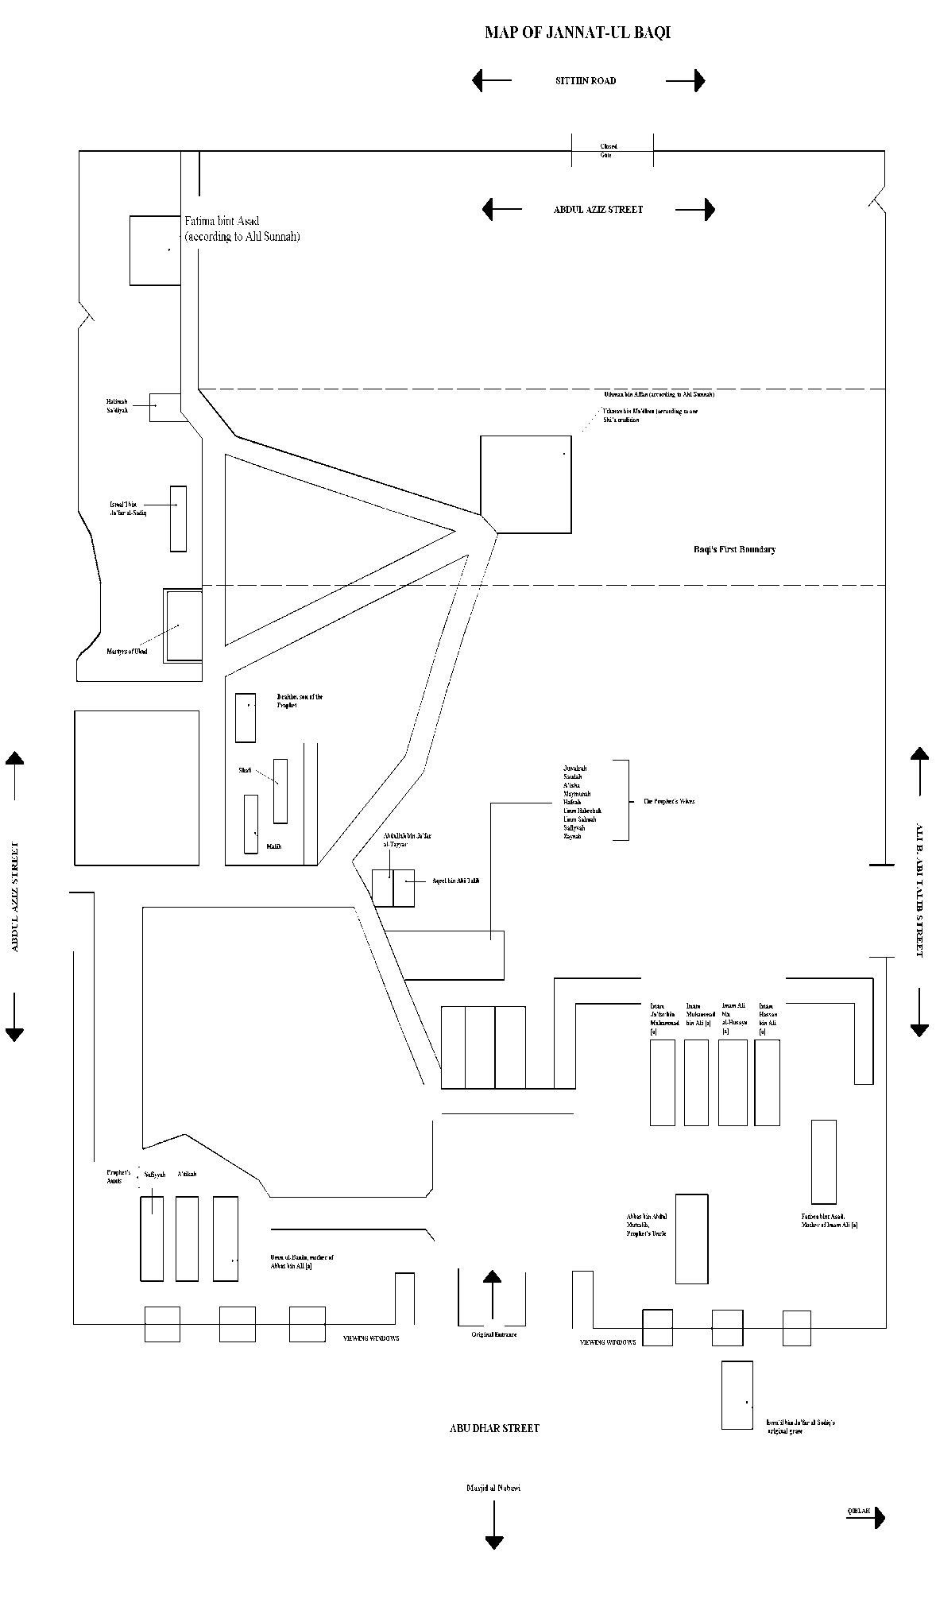





Iraq

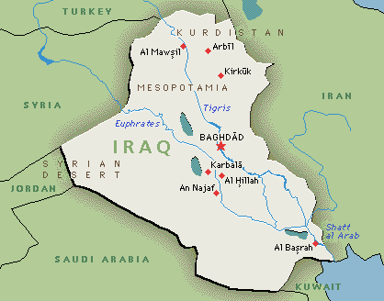

Places to Visit:

Najaf

Kufa

Karbala

Moosayab

Kadhmayn

Baghdad

Madain /Salman Pak

Samarra

Balad

Hillah

Basra

[Najaf](http://www.al-islam.org/pilgrimage-sites/iraq#najaf)

1.Mausoleum of 1st Imam Ali b. Abi Taalib, peace be upon him

There are 3 graves in one darih:

Grave of Imam Ali [a]

Grave of Prophet Adam [a] - 1st prophet and man on earth

Grave of Prophet Nuh [a]

2.Wadi-us Salaam

Tomb of Prophet Hud [a]

Tomb of Prophet Saleh [a]

Maqam of Imam Ja'far al-Sadiq [a]

Maqam of Saheb al-Asr, Imam Al-Mahdi [a]

Mosalla of Imam Ali Zayn al-Abidin [a]

3.Tomb of Hadrat Kumayl - companion of Imam Ali [a]

4.Tomb of Rashid Hijri - companion of Imam Ali [a]

5.Masjid Hannana

This mosque is between Kufa and Najaf. The significance of this mosque is that when Imam Hasan [a] and Imam Husayn [a] were carrying the janaza of Imam Ali [a] from Kufa to Najaf, they passed near this mosque, and as they were passing, the pillars of the mosque inclined towards Imam Ali [a] as if paying its last respects. It is also believed that some of the skin from Imam Husayn [a]'s head (that came off when Khul Mal'un was disrespecting the head of Imam Husayn [a] with a knife) is buried here.  
6.Grave of Sayyid al-Khui

Grand-mujtahid (marja') to 450 million Muslims since 1970 (d. 8th August 1992)

[Kufa](http://www.al-islam.org/pilgrimage-sites/iraq" \l "kufa)

1.Masjid Kufa

Mehrab-e-Ibadat. The place where Imam Ali [a] was martyred

Court room of Imam Ali [a]

Mausoleum of Muslim ibn Aqil [a], cousin and ambassador of Imam Husayn [a] to Kufa

Mausoleum of Mukhtar, the avenger of Imam Husayn [a]'s massacre

Mausoleum of Hani ibn Urwa, companion of Imam Husayn [a] who was killed by Ubaydullah Ibn Ziyad for sheltering and supporting Muslim ibn Aqil

Mosalla of several prophets

Tanoor. The place from where the deluge (toofan) of Prophet Nuh [a] began

2.House of Imam Ali, peace be upon him

3.Mausoleum of Sayyida Khadijatul Sughra daughter of Imam Ali [a]

outside Masjid Kufa

4.Mausoleum of Prophet Yunus [a]

near the river

5.Masjid Sahla

Recommended to be in this mosque at the maghrib time of a Wednesday i.e. at the end of a Tuesday

Mosalla of 6th Imam Ja'far al-Sadiq [a]

Mosalla of Prophet Ibrahim [a]

Mosalla of Prophet Idris [a]

Mosalla of Prophet Khidr [a]. Also called Maqam al-Saleheen

Maqam of Imam Ja'far al-Sadiq [a]

6.Kooba of Ebrahim ibn Hasan al-Muthanna ibn Imam Hasan [a]

7.Mausoleum of Maytham al-Tammar, companion of Imam Ali [a]

8.Mosque of Zaid - near Masjid Sahla

9.Mosque of Sa'asa ibn Sauhan, companion of Imam Ali [a]

[Karbala](http://www.al-islam.org/pilgrimage-sites/iraq#karbala)

1.Mausoleum of 3rd Imam al-Husayn, peace be upon him

There are 3 graves in one darih:

Grave of Imam Husayn [a]

Grave of Ali Akbar, son of Imam Husayn [a]

Grave of Ali Asgher, son of Imam Husayn [a]

2.Mausoleum of Hadrat Abbas b. Ali [a]

Brother and Standard-bearer of Imam Husayn [a]

3.Grave of Habib ibn Madhaher [a]

4.Ganj-e-Shohada

graves of the rest of the martyrs of Karbala

5.Qatl-ghah.

6.Grave of Ibrahim son of 7th Imam Musa al-Kadhim, peace be upon him.

7.Til-e-Zaynabiya

8.Khaimaghah

9.Garden of 6th Imam Ja'far al-Sadiq, peace be upon him

10.Garden of 12th Imam Sahib al-Asr, Al-Mahdi, peace be upon him

11.Mausoleum of Hur (companion of Imam Husayn [a] in Karbala)

3 miles from Karbala

12.Mausoleum of Aun, son of Sayyida Zaynab [a]

6 miles from Karbala. One can visit this place as well as the mausoleum of Tiflane Muslim while going back to Kadhmayn

[Moosayab](http://www.al-islam.org/pilgrimage-sites/iraq#moosayab)

[Location](http://www.al-islam.org/pilgrimage-sites/iraq" \l "location)

This place is on the way to Kadhmayn while going from Karbala.

[Pilgrimage site](http://www.al-islam.org/pilgrimage-sites/iraq#pilgrimage-site)

Mausoleum of the two sons of Muslim ibn Aqil [a]:-

Muhammad ibn Muslim ibn Aqil [a], and

Ibrahim ibn Muslim ibn Aqil [a]

They are also known as Tiflan-e-Muslim.

[Kadhmayn](http://www.al-islam.org/pilgrimage-sites/iraq#kadhmayn)

1.Mausoleum of 7th and 9th Imams, Imam Musa al-Kadhim and Imam Muhammad al-Jawad, peace be upon them

2.Grave of Shaykh al-Mufid

3.Grave of Sayyid Ismail Safrudin

4.Grave of Khwaja Nasirudin Tusi

5.Grave of Sayyid Murtada

6.Grave of Sayyid Razi

[Baghdad](http://www.al-islam.org/pilgrimage-sites/iraq#baghdad)

[Location](http://www.al-islam.org/pilgrimage-sites/iraq#location)

Baghdad and Madain are very close to Kadhmayn.

[Pilgrimage sites](http://www.al-islam.org/pilgrimage-sites/iraq#pilgrimage-sites)

1.The four representatives of the 12th Imam [a] during the minor occultation (ghaybat al-sughra) are buried here i.e.  
Uthman b. Sayeed

Muhammad b. Uthman

Ali b. Muhammad Foor, and

Husayn b. Rooh

The graves of Uthman & Husayn are easy to find whereas the other two are inside the bazaar. One will need some guidance from the local people to locate this place if one is going by bus.

2.Tomb of Qambar the slave of Imam Ali [a]

3.Tomb of Shaykh Muhammad ibn Yaqub al-Kulayni, the compiler of Al-Kafi

4.Masjid Boorasa. This mosque is on the way to Baghdad from Kadhmayn

[Madain/Salman Pak](http://www.al-islam.org/pilgrimage-sites/iraq" \l "madainsalman-pak)

[Pilgrimage sites](http://www.al-islam.org/pilgrimage-sites/iraq#pilgrimage-sites)

1.Tomb of Salman Farsi, companion of the Holy Prophet [s]

2.Tomb of Hudhaifa al-Yamani, companion of the Holy Prophet [s]

3.Tomb of Jabir b. Abdullah al-Ansari, companion of the Holy Prophet [s]

4.Masjid Jum'a - near the tomb of Salman Farsi

Note: On 26th March 1934, King Faisal I of Iraq supervised the transfer of the remains of Hudhaifa al-Yamani and Jabir b. Abdullah al-Ansari, the two trusted companions of the Holy Prophet [s] from their resting places in Madain which were endangered with water from River Tigris to a new site at Salman Pak near the resting place of Salman Farsi.

[Historic site](http://www.al-islam.org/pilgrimage-sites/iraq" \l "historic-site)

Tak-e-Kisra, the palace of Nausherwan - part of ancient Babylonian civilization. When the Holy Prophet [s] was born in Makkah, this huge edifice is said to have developed cracks on its walls.

[Samarra](http://www.al-islam.org/pilgrimage-sites/iraq#samarra)

[Location](http://www.al-islam.org/pilgrimage-sites/iraq#location)

Samarra is closer (and therefore easier to go to) from Kadhmayn than it is from Karbala. Try and spend atleast one night in Samarra so as to perform ziyarat and a'amals properly. Most people make a quick trip to Samarra lasting only a few hours which is most unfortunate.

[Pilgrimage sites](http://www.al-islam.org/pilgrimage-sites/iraq#pilgrimage-sites)

1.Mausoleum of 10th and 11th Imams, Imam Ali al-Naqi and Imam Hasan al-Askari, peace be upon them

The main darih has four graves:

Grave of 10th Imam Ali al-Naqi, peace be upon him

Grave of 11th Imam Hasan al-Askari, peace be upon him

Grave of Sayyida Halima Khatoon [a] daughter of Imam Ali al-Naqi [a] and sister of Imam Hasan al-Askari [a]. Her narration of the birth of the 12th Imam [a] is reported extensively as she was a mid-wife to Sayyida Nargis Khatoon the mother of the 12 Imam [a]

Grave of Sayyida Nargis Khatoon [a], mother of the 12th Imam Al-Mahdi, peace be upon him

2.Cellar (sardab) of 12th Imam Al-Mahdi, peace be upon him

where he was last seen. Also called Maqam Ghaybat (i.e. the place of occultation)

3.Masjid Jamia

[Historic sites](http://www.al-islam.org/pilgrimage-sites/iraq" \l "historic-sites)

Mosque built during the time of Mutawakkil - at one time the largest mosque in the world.

[Balad](http://www.al-islam.org/pilgrimage-sites/iraq#balad)

[Location](http://www.al-islam.org/pilgrimage-sites/iraq#location)

This place lies between Kadhmayn and Samarra. One can visit it on the way to Samarra or while returning to Kadhmayn.

[Pilgrimage site](http://www.al-islam.org/pilgrimage-sites/iraq" \l "pilgrimage-site)

Mausoleum of Muhammad ibn Imam Ali al-Naqi, peace be upon him.

[Hillah](http://www.al-islam.org/pilgrimage-sites/iraq#hillah)

[Pilgrimage sites](http://www.al-islam.org/pilgrimage-sites/iraq#pilgrimage-sites)

1.Tomb of Hamza [a]

2.Tomb of Qasim b. Imam Musa al-Kadhim [a]

3.Tomb of Prophet Ayyub [a]

4.Tomb of Prophet Daniel [a]

5.Tomb of Prophet Dhul Kifl [a]. Known as "Chifl"

6.Maqam Sahib al-Zamaan [a]

[Basra](http://www.al-islam.org/pilgrimage-sites/iraq#basra)

[Pilgrimage sites](http://www.al-islam.org/pilgrimage-sites/iraq" \l "pilgrimage-sites)

Masjid Ali, peace be upon him

Related Articles on the Web:

History of the Mausoleum in Najaf

History of the Mausoleum in Karbala

History of the Mausoleum in Kadhmayn

History of the Mausoleum in Samarra



Iran

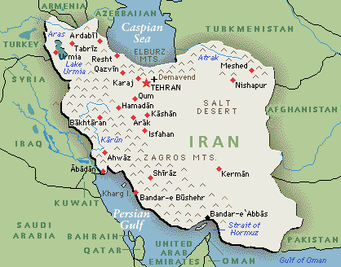

Places to Visit:

Mashad

Qum

Tehran

Shimran

Kashan

[Mashad al-Muqaddas, Tus, Khorasan](http://www.al-islam.org/pilgrimage-sites/iran" \l "mashad-al-muqaddas-tus-khorasan)

[Pilgrimage sites](http://www.al-islam.org/pilgrimage-sites/iran#pilgrimage-sites)

1.Mausoleum of 8th Imam Ali b. Musa al-Rida, peace be upon him

2.Tomb of Khwaja Aba Salat Harvi

3.Tomb of Imamzada Sultan Ahmed [a]

4.Tomb of Sayyid Ahmed Kabir

5.Tomb of Shaykh Bahauddin Ameli

6.Tomb of Mohamed ibn Hasani Alhuri Ameli

7.Tomb of Abu Ali Hazal ibn Hasan Al-Tibrasi

8.Tomb of Khwaja Murad

9.Tomb of Khwaja Rabi'i

[Historic sites](http://www.al-islam.org/pilgrimage-sites/iran#historic-sites)

1.Masjid Gowhar shad

2.Museum/Library in the Haram of Imam al-Rida, peace be upon him

3.Tomb of Nader Shah.

4. Statue of Nader Shah

5.Tombs of Attar and Kamalul Mulk

6,.Tomb of Omar Khayyam

7.Semnan Jameh mosque

8.Mahruq shrine

9.Aryamehr Park

10.Tomb of Ferdowsi

11.Statue of Ferdowsi

12.Tomb of Shahrokh Mirza Afshar

Note: Khorasan means "Land of the Rising Sun".

[Qum](http://www.al-islam.org/pilgrimage-sites/iran#qum)

[Pilgrimage sites](http://www.al-islam.org/pilgrimage-sites/iran#pilgrimage-sites)

1.Mausoleum of Fatima bint Musa [a]

Daughter of 7th Imam [a]. Well-known as Masooma Qum

2.Masjid Imam Hasan al-Askari, peace be upon him.

Near the mausoleum of Masooma Qum

3.Tomb of Aqa Burujardi

(the marja before Ayatullah Mohsin al-Hakim)

Inside the Haram of Masooma Qum

4.Masjid Jamkaran

Built in 393 AH under orders of the 12th Imam [a]. This is outside Qum

[Tehran](http://www.al-islam.org/pilgrimage-sites/iran#tehran)

[Pilgrimage sites](http://www.al-islam.org/pilgrimage-sites/iran#pilgrimage-sites)

1.Mausoleum of Shah Abdul Azim [a]

2.Tomb of Abdul Qasim son of Imam Musa al-Kadhim [a] (7th Imam)

3.Tomb of Imamzada Musa [a]

4.Tomb of Imamzada Shah Tahir [a]

5.Koh-e-Bibi Shahrbanu [a]

6.Tomb of Shaykh Saduq "Baabawayh"

This is near the mausoleum of Shah Abdul Azim [a]. Shaykh Saduq was one of the greatest Shi'a Alims to have ever lived. He is said to have been born with the prayers of the 12th Imam Al-Mahdi, peace be upon him.

[Shimran](http://www.al-islam.org/pilgrimage-sites/iran#shimran)

[Location](http://www.al-islam.org/pilgrimage-sites/iran#location)

Approximately one hour by bus from Tehran.

[Pilgrimage sites](http://www.al-islam.org/pilgrimage-sites/iran#pilgrimage-sites)

Mausoleum of Imamzada Saleh son of Imam Musa al-Kadhim, peace be upon him.

[Sight-seeing](http://www.al-islam.org/pilgrimage-sites/iran" \l "sight-seeing)

Animal zoo on the way to Shimran.

[Kashan](http://www.al-islam.org/pilgrimage-sites/iran#kashan)

[Pilgrimage sites](http://www.al-islam.org/pilgrimage-sites/iran#pilgrimage-sites)

Tomb of Abu Loolu

Related Article on the Web:

History of the Mausoleum in Mashad



Jerusalem

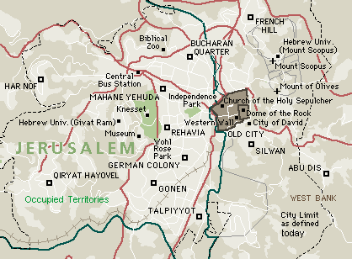

Places to Visit:

Baitul Muqaddas

Hebron

[Baitul Muqaddas](http://www.al-islam.org/pilgrimage-sites/jerusalem#baitul-muqaddas)

[Pilgrimage sites](http://www.al-islam.org/pilgrimage-sites/jerusalem#pilgrimage-sites)

1.Masjid al-Aqsa (Dome of the Rock)

Prayer-niche (mihrab) of Imam Ali, peace be upon him

Room of Maryam, mother of Prophet Isa, peace be upon them

Room in which there are the mosallas of forty prophets

2.Masjid Sakhra

Sakhratullah: reported hillock from where Prophet Muhammad [s] ascended (me'raj)

Mosalla of nine prophets

The tongue of the stone that replied Prophet Muhammad [s]

Mosallas of Prophet Dawood [a], Prophet Sulaiman [a], Prophet Ibrahim [a], Prophet Muhammad [s], and Archangel Jibrail [a]

3.Tomb of Bibi Maryam [a], the mother of Prophet Isa [a]

4.The Cave of Prophets (ghar al-anbiya): between Jerusalem and Damascus

5.According to the book "Umra and Ziyarat", tomb of Prophet Uzair [a] - between Jerusalem and Damascus. (Isn't he supposed to be one of the four prophets still alive?)

6.Tomb of Prophet Musa [a]: 10 miles from Jerusalem

[Historic sites](http://www.al-islam.org/pilgrimage-sites/jerusalem#historic-sites)

1.Court room of Prophet Sulaiman [a]

2.Stable made by Prophet Sulaiman [a] - now closed

3.Well of Rooh - now closed

[Hebron - Khalil al-Rahman](http://www.al-islam.org/pilgrimage-sites/jerusalem" \l "hebron-khalil-al-rahman)

[Pilgrimage sites](http://www.al-islam.org/pilgrimage-sites/jerusalem#pilgrimage-sites)

1 Tomb of Prophet Ibrahim, peace be upon him.

2 Tomb of Sarah, wife of Prophet Ibrahim and mother of Prophet Ishaq, peace be upon them.

3 Tomb of Prophet Ishaq, son of Prophet Ibrahim, peace be upon them.

4 Tomb of Rifka, wife of Prophet Ishaq, peace be upon them.

5 Tomb of Prophet Ya'qub, son of Prophet Ishaq, peace be upon them.

6 Tomb of Lanika, wife of Prophet Ya'qub, peace be upon them.

7 Tomb of Prophet Yusuf, son of Prophet Ya'qub, peace be upon them.



Egypt

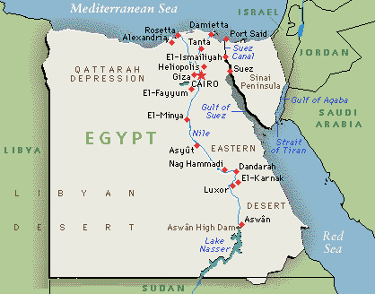

[Cairo](http://www.al-islam.org/pilgrimage-sites/egypt#cairo)

[Pilgrimage sites](http://www.al-islam.org/pilgrimage-sites/egypt#pilgrimage-sites)

1 Masjid Ra's al-Husayn

According to a belief, the head of Imam Husayn, peace be upon him, was buried here.

2 Sit Zainab

According to some, Zainab, the sister of Imam Husayn and daughter of Imam Ali, peace be upon them, is buried here and not in Damascus.

3.Grave of Malik al-Ashtar [r]

Standard-bearer and close companion of Imam Ali [a]. He was appointed by Imam Ali [a] as the governor or Egypt but was poisoned by Muawiya on his way there.

[Historic sites](http://www.al-islam.org/pilgrimage-sites/egypt#historic-sites)

1 Al-Azhar mosque and Al-Azhar university.

2 Cairo museum - here is where the mummified body of Firaun is kept.

3 Islamic museum.

4 Mosque and Fort of Salahuddin Ayyubi.

5 Citadel mosque.

6 Pyramids of Giza.

7 Sak'kara - where the first pyramid was built, known as the "Step Pyramid".

8 Memphis - the first capital of Egypt.

Note: Sak'kara and Memphis are to the south of Cairo.

Syria

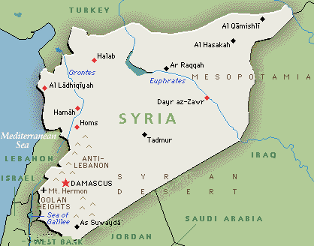

[Damascus](http://www.al-islam.org/pilgrimage-sites/syria#damascus)

[Pilgrimage sites](http://www.al-islam.org/pilgrimage-sites/syria#pilgrimage-sites)

1.Tomb of Lady Zaynab, peace be upon her

Daughter of Imam Ali [a] and Sayyida Fatima al-Zahra [a]

2.Bab Saghir (also called "Goristan-e-Ghariban")

This is a street with cemeteries on either side of the road

Tomb of Lady Ruqayya [a]: daughter of Imam Husayn [a]

Tomb of Lady Umm Kulthum [a]: sister of Imam Husayn [a]

Tomb of the Prophet's [s] wives (ummahatul mu'minin): Umm Salma and Umm Habiba

Tomb of Lady Fidha, the maid of Sayyida Fatima (the Prophet's daughter), [a]

Tomb of Hujr Ibn Adi [r], companion of Imam Ali [a]

Tomb of Kamaid bin Aswad al-Kindi [r], companion of Imam Ali [a]

Tomb of Abdullah b. Ja'far al-Tayyar [a], husband and cousin of Lady Zaynab [a]

Tomb of Obay ibn Ka'b [r]: husband of Halima [r], nursing mother of the Prophet [s]

Tomb of Bilal al-Habashi, the Muazzin of the Holy Prophet [s]

Tomb of Abdullah bin Umm Maktoum - Muazzin

Tomb of Abdullah b. Imam Zaynul Abideen [a]

Tomb of Abdullah b. Imam Ja'far al-Sadiq [a]

Tomb of Fatima Sughra bint Imam Husayn [a]

Maqam Ra's Shuhada. The burial place of the heads of the martyrs of Karbala. Also called "ganj-e-sarha-e-shuhada-e-Karbala"

3.Prison

This place can be reached by walking through Souk Hamidiyya (i.e. the Hamidiyya bazaar)  
Mausoleum of Sakina [a]: daughter of Imam Husayn [a]

Prison of Ahlul Bayt [a]

Pulpit (minbar) of Imam Zaynul Abideen [a]

Niche (mihrab) where Imam Zaynul Abideen [a] used to say his prayers

Place where Imam Zaynul Abideen [a] prayed when he went to take the head of Imam Husayn [a]

4.Ummayyad Mosque (Jaami al-Amawi)

This is a walking distance from the Prison:

The Pulpit from which Imam Zaynul Abidin [a] delivered a sermon before Yazid

Grave of Prophet Yahya (John the Baptist) [a] son of Prophet Zakariya [a]

Maqam Ra'sul Husayn [a]. Place where the head of Imam Husayn [a] is said to have been buried

Place where the head of Imam Husayn [a] was kept in Yazid's treasury

5.Salera (Hill)

Cave of Ashab al-Kahf

Koh-e-Raqim

Masjid Sulayman

Small Masjid

Footprint of Imam Ali, peace be upon him

Sermon (khutba) writtten by Imam Ali [a] on stone with his finger

6.Another Hill (dangerous to ascend)

Place where Qabil killed his brother Habil (sons of Adam [a])

The "two eyes" from which water drops like tears

Fingerprint of the Archangel Jibrail [a]

Forty (arbain) Mosallas: place where 40 prophets are buried

[Historic sites](http://www.al-islam.org/pilgrimage-sites/syria#historic-sites)

1.House of Hinda - the pious wife of Yazid

2.1300 year old door in the bazaar of Damascus

3.Well of Prophet Hud [a] and a stone pot for wudu

