Journey to the Unseen World

A picture book with an abridged text of the original book 'Jouney to the Unseen World' in simple English, which discusses the circumtances of life after death.

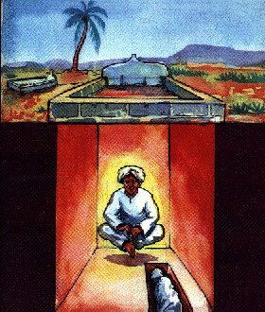

Author(s): Hujjatul Islam Najafi Quchani

Publisher(s): Tabligh Sub-Committee

Table of Contens

Foreword 3

Journey to the Unseen World 4

Post-Scriptum 62

Foreword

This picture book contains an abridged text of the original book by Hujjatul Islam Najafi Quchani. This was prepared as an easy reader for all age groups. However, it is strongly suggested that the youth and the older readers also study the original book which makes very interesting reading and explains in detail various issues, discussions and circumstances of Barzakh in detail (in the light of Qur'an and Ahadith) which was beyond the scope of this picture book.

Please note, the figures drawn in this book are from the artist's imagination and do not bear any resemblance to the supernatural beings.

Your ideas and suggestions for improvement of this book are most welcome and will definitely be considered for inclusion in the next edition. Please feel free to write to:

The Secretary

Tabligh Sub-Committee

P. 0. Box 233

Dar es Salaam

Tanzania

East Africa

Journey to the Unseen World

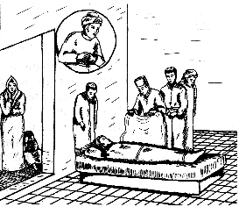

When I died, I saw myself standing, relieved of my illness, feeling fit and healthy; I saw my relatives mourning around my corpse. I was saddened by their crying and told them that I was cured and not dead; but nobody heard me.

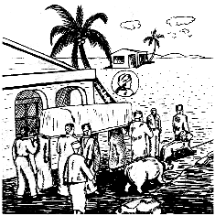

My body was bathed and shrouded. I even joined the funeral procession, in which I saw many wild animals which frightened me. But the other people didn't even notice these beasts.

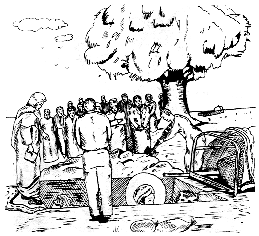

My body was lowered head-first into the grave. Just at that moment many animals emerged and started attacking my body. My fear knew no bounds but the other people behaved as if they did not even see them! My cries for help fell on deaf ears!

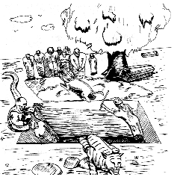

Suddenly some people entered the grave and shooed away the animals. I thanked them. They told me that they were my “Good Deeds”, while the beasts were my “Evil Deeds”.

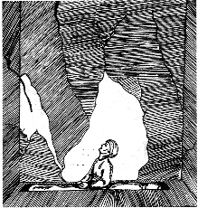

The grave was closed over my dead body and all my friends and relatives deserted me in my lonely confinement. I was afraid and bewildered. Suddenly the grave trembled and split open.

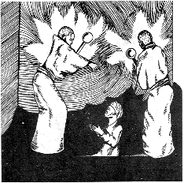

Two huge Angels with fearful faces entered. Smoke and fire bellowed from their mouths and nostrils. They were holding red hot iron rods in their hands. Suddenly in a thundering voice, they asked me: “Who is your Lord?” In my extreme fear I could not speak and beseeched Allah for help and sought the intercession of Imam ‘Ali (as) knowing that he helps in the most difficult of circumstances.

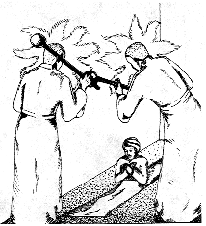

My silence angered them and they repeated their question. My fear left me and I replied by reciting the ayats of Sura al-Hashr (Verse 22, 23). Next they asked me, “Who is your Prophet? Which is your Book? (Kitaab), Direction of Worship (Qibla), Imams”. My answers seemed to satisfy them.

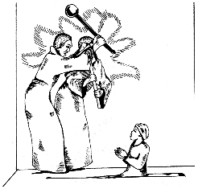

They then asked me “What is the source of these answers?” I again became confused. Would the arguments I learned in the dark, ignorant and material world hold true in this enlightened, illuminated place ?

I again beseeched Allah with Imam ‘Ali's intercession. Suddenly the answer was revealed to me. I was guided by Allah. I replied. They said “Then sleep like a newly-wed” and left me. I felt the fear leave me and I slept peacefully.

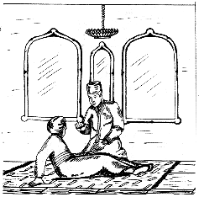

When I woke up, I found myself in a pleasant room with a handsome youth. After greeting each other with respect, he told me “My name is Haadi (Guide). I guided you to your last answers. Had you answered wrongly your grave would have been filled with fire from Hell.”

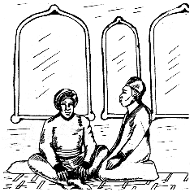

I asked him “Tell me how do you know me so well, without having met me? “ He replied “I am the relationship of love and friendship which you had with Imam ‘Ali (as) and the Ahle-Bayt of the Holy Prophet (S). I have been with you always, but you never sensed my presence since in the material world your sight lacked the power to perceive me.” After some discussions, he left me. I soon went to sleep.

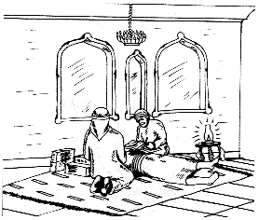

On awakening, I saw two men sitting on my either side, one handsome and the other ugly. They kept sniffing my body from head to toe, whispered to each other, and then filled up certain boxes and sealed them. I realized that my deeds were being judged and recorded. On completing their task, they tied some sheets round my neck and kept the boxes beside my head.

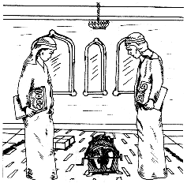

Next they put me inside an iron cage, which was made smaller by twisting a lever. I was terrified and couldn't breathe. I heard my bones cracking and oil oozed out of my body which they mopped up. I soon fainted and became unaware of what was going on.

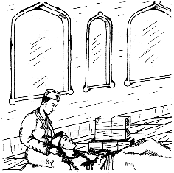

When I regained consciousness, I found my head on Haadi's lap. I started crying in a weak voice. He consoled me and then said, “Everyone has to face this in the initial stage in the grave. It is due to one's own past deeds.” After making things comfortable, he left me. My body appeared to have been purged of all debasements and become pure and clean. I now understood that the constriction had actually been an act of purifying, so that if a man possessed evil traits these debasements would, as a result of the constriction, be squeezed out of him like the black oil which I had seen.

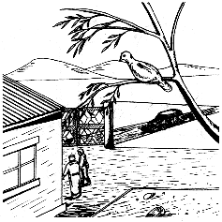

On Thursday night, I visited my house in the form of a dove. I saw my family and friends were reciting Quran, listening to religious lectures and then eating good food. I was saddened as all this was being done for tradition's sake. No needy or deserving person was invited. Of what good was such food to me?

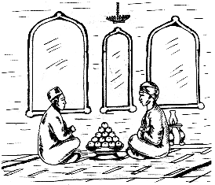

When I returned to the grave, I saw Haadi with a tray of sweet ripe apples. “Where have these come from?” I asked. “Somebody sincerely recited Sura al-Fateha near your grave, and Allah has rewarded you”, he replied. He then informed me of another good news, “The Imam's son whose grave you visited and the religious scholars whom you used to remember in your night prayers are coming to visit you.”

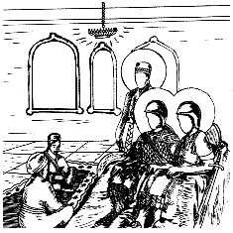

Suddenly the guests arrived, most prominent amongst them were Hazrat Abbas and Hazrat ‘Ali Akber Their majestic faces were very bright and they were wearing a war-helmet, shield, sword etc. as if prepared for battle. Hazrat Abbas spoke to me, “Your remembering my father, Imam ‘Ali (as), has proved your salvation. You have been pardoned and absolved.” After some conversation, the guests departed.

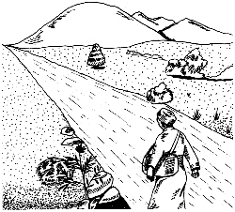

It was time to move ahead and picking up my bag of Deeds, I started walking along the path that Haadi had shown me. After covering some distance, I began feeling a bit tired and thirsty.

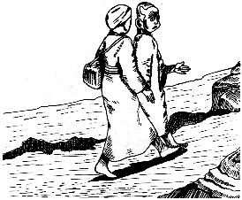

At this point, an ugly person, “Abu Lahaw” joined me. He told me, “They call me “Ignorance.” My title is “Waywardness”. My family name is “Abu Lahaw” (Father of playfulness and wasting time). My aim is to create mischief, mislead people and cause them to go astray.”

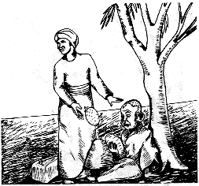

He tempted me into a “short cut” and I left the main road. This proved to be more difficult, full of ditches, dirt and thorns with many snakes and scorpions. The unbearable heat made me very thirsty, but my companion laughed and seemed to enjoy my plight.

On an open ground, we saw some watermelons which he ate with relish and also offered me some. “It is somebody's property and hence it's not right to eat this without permission.” He tempted me again saying, “Don't be so pious. The Qur'an says, “Whoever is driven to necessity, not desiring nor exceeding the limits….” I fell into his trap again and bit into the fruit. To my horror, it was so bitter that my mouth and throat hurt.” Watermelons of Satan and Ignorance!” I thought.

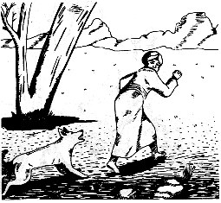

Suddenly we were attacked by a dog and a guard of the land. I was beaten viciously for being on the property without permission. By the time I reached the true road, I was in a bad state. Abu Lahaw, who had escaped the beating, was laughing and enjoyed seeing me crying and calling out to Haadi for help. “The seeds of these sorrows were laid by yourself on the earth.” he shouted.

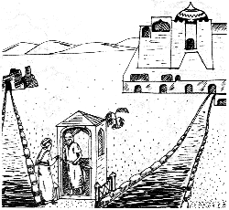

After sometime, I reached an open airy and bright city. I requested the guard to rid me of Abu Lahaw. He replied, “Abu Lahaw is inseparable just like your shadow! But he cannot enter the City of Light. Though, when you resume tomorrow, he'll be beside you again.”

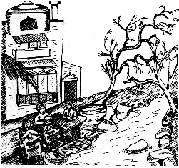

I spent the night in this place. It was beautiful and here I met some old acquaintances. We were happy here with the best of people, food and service. We were thankful to Allah that for our small deeds on the earth, He had richly rewarded us.

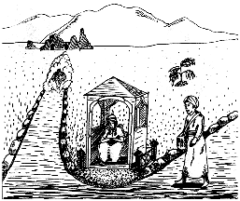

The next day, I moved on. At a bisection, to my dismay, I saw Abu Lahaw approaching me like a black smoke. The Duty-officer saw this and said, “Abu Lahaw is the face of your own bad traits, like injustice, pride, desire, anger etc. etc. If you did not desist from them on earth, how can you separate them from yourselves now?”

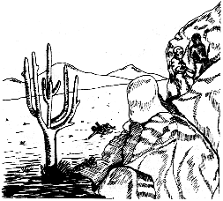

I moved on with Abu Lahaw by my side. We soon reached a mountain, which had a deep moat on one side. Abu Lahaw tempted me to climb this. I accepted and to my great surprise, it proved to be very difficult and dangerous. Several times, I slipped and hurt myself almost falling into the moat. Abu Lahaw laughed and said, “He who is proud in this world, Allah will break his back, and he who tries to be higher than others, Allah will rub his nose in dust. You have read all this (in the Qur'an), but never acted on it!”

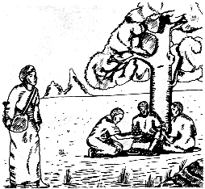

After some time I reached a garden with a pond around which some people were sitting and eating fruits. They greeted me and invited me, “We had been fasting at the time of our death; Since you had played host to people who were fasting, you can also have these fruits. As for Abu Lahaw, your defense weapon against him is the control which you had exercised in your life over your desires.”

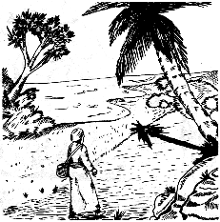

The next part of the journey was easy going. There were fruit laden trees on both sides of the road and a river flowed alongside it. It was as if we were beholding the beauty of God.

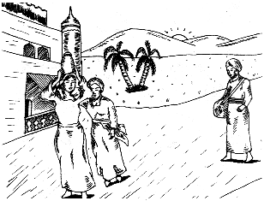

I reached the next station without feeling tired. A separate silver and gold bricked palace reserved for me to stay in. The servants were handsome and well-mannered and took care of every comfort for me.

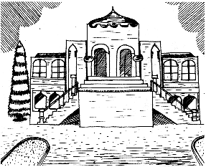

At nightfall, the palace became illuminated. I realized at once, that this light was of the tree of Muhammad (S) and his progeny and this city, was for those who had love for them. I thanked Allah for His Grace and Bounty and to Muhammad (S) and his progeny for having guided us towards the straight path.

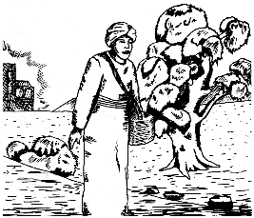

The next morning, I headed for the next station. Again the path was easy and beautiful with lush green trees, cool water in the lakes and a pleasant breeze.

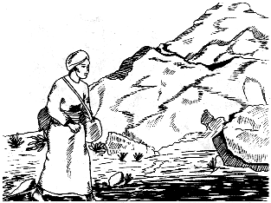

Once out of the city, the path became narrow and rocky. Suddenly, Abu Lahaw appeared by my side and tried to tempt me into taking another “short cut”, but I kept to the same road, having no trust for him and having already suffered at his hands before. As Imam ‘Ali (as) has said, “To try him whom you have already tried (and he has failed) is stupidity.”

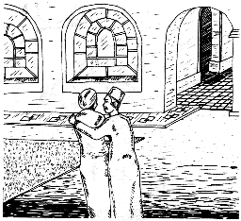

In a short while we reached the good road again and were soon at the next station. Haadi met me at the gate. We greeted and embraced. He said, “Don't consider yourself to be safe from Abu Lahaw as yet. He has powerful weapons of deception and I can only warn and alert you against Abu Lahaw's deceptions, so be very careful that you don't fall into traps now. As today is Friday, go and visit your family, and see if they have done any good deeds on your behalf.”

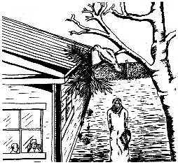

I visited my home again. What I saw saddened me. My family was going through difficult times without anyone caring for their welfare. I prayed “O Most Merciful, have pity on my family and myself, because you are the Lord of all.” I then noticed that my family were also praying for me and weeping remembering the good times they had in my lifetime.

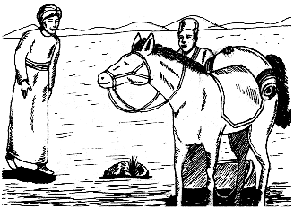

When I returned, I found a strong horse besides Haadi. “Your family prayed for you and Allah's blessings has come to you in this form. You'll need this horse for your next journey,” he said, “Moreover, your prayer for your family has been granted and henceforth, they will live in comfort and well-being.”

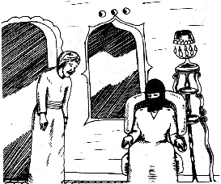

I returned to my room and was pleasantly surprised to find a beautiful maiden there. Her eyes were bright and her shining face seemed to illuminate the whole room. “This maiden has been wed to you and especially sent here for tonight from the valley of Peace.” Haadi announced and left us.

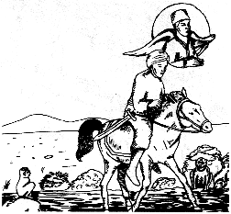

The next morning with a stick and sword, I mounted the horse and rode away. The ground was sandy and slippery. I saw monkey-like creatures who, I realised were actually humans for they had no tails nor hair and walked on two legs. Pus and blood emitted from their private parts accompanied by a bad stink. “This is the land of Lust and Desire,” Haadi said, “These people were adulterers. Beware you don't deviate from the straight path, or it might spell the end of you.”

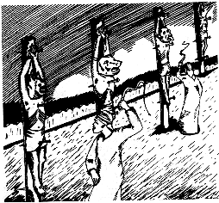

Next, I saw people resembling animals hanging from posts and their private parts had been nailed to the posts with big iron nails. Some were also being whipped and were screaming in pain. Haadi informed me that these people used to indulge in various forbidden sexual pleasures.

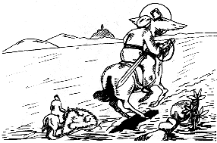

Suddenly, Abu Lahaw appeared and tried to lure me into the adjoining path. I resolutely followed Haadi's advice and stuck to the straight path because salvation lies only in following the straight path.

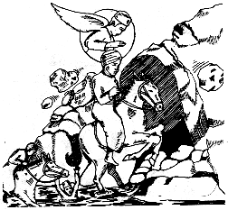

Riding on, I experienced the earth shaking, the winds raging and the sky darkening. A hail storm of stones was falling. All around me I saw people who had followed their Abu Lahaw's advice sinking into the mire or being crushed by the falling huge stones. “These people were homosexuals.” Haadi cried. “Now get out fast from here, or otherwise you might be subjected to the same punishment!”

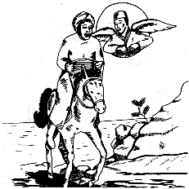

We travelled only a couple of miles more to find ourselves out of the place. I thanked Allah and went on with the journey.

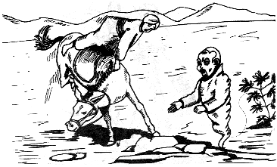

Suddenly the accursed Abu Lahaw arrived. My horse shied at his sight and threw me down. I was badly hurt. Haadi arrived and helped me mount again. I bitterly complained, “whenever you leave, Abu Lahaw arrives to cause trouble.” He replied, “No, I always leave when Abu Lahaw arrives, but this is also due to your misdeeds on earth”.

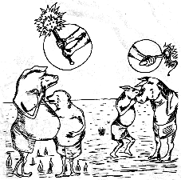

Ahead of us was another Land of Desire. Here were people who used to be heavy eaters. Those who used to overeat their food obtained by lawful means, had faces like donkeys and cows. Those who had obtained their food by unlawful means had faces of pigs and bears with huge bellies and thin legs! They were being severely punished. It was as if their bellies were full of fire.

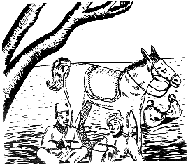

We quickly moved on and soon reached a rest house in a barren and deserted area. Some other travelers were also there, eating from their bags. As my limbs were still painful, Haadi applied some ointment and instantly the pain vanished! “Haadi, what medicine is this?” I inquired. “This is the praises and thanks to Allah you used to give for any gift you were blessed with!

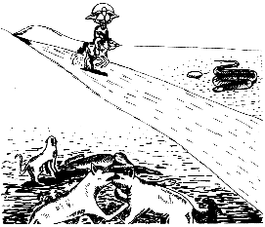

The next day, Haadi warned me that I would now witness punishments due to the sins of the tongue and advised me to take along water and shield. “Your fasts on the earth is the shield which will now protect you from Hell fire.” On the way we saw various animals fighting with each other viciously, some even eating the flesh of the dead bodies. They were extremely thirsty and flames emerged from their mouth and ears. These are the back-biters and their audience, liars, fault finders and those who laughed and made fun of the faithful.”

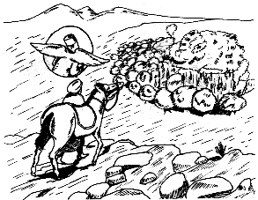

We then came near a garden with fruit trees. Suddenly I realized that they were burning! “What is happening here?” I asked. “This is the garden made by the faithful from the praise and remembrance of Allah. But when these faithful lied, or indulged in back-biting or insulting, this garden went up in flames. That is their sins caused the reward of their good deeds to go to waste”.

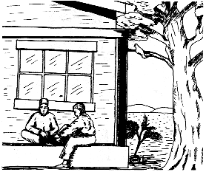

On Friday night, I went to my home again as a bird. My children had gathered under the fruit tree I was sitting on. “Our father planted this fruit tree and we are enjoying its fruits. May Allah bless him.” One recalled and then they recited Sura al--Dukhan and Sura al-Dahr Their prayers made me happy and I also prayed for them and then returned to my current abode.

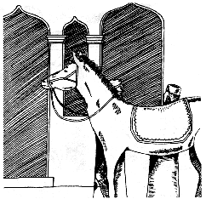

When I returned, my horse was ready. Haadi presented me two gifts. One was from Hazrat Fatimah Zehra (as) and the other from Hazrat ‘Ali (as) as the two Suras recited by my children are connected to them. “At the time of need these two gifts will open by themselves.” Haadi told me.

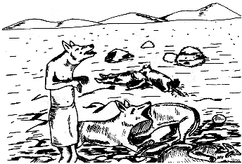

After some time, we reached the land of Greed and Avarice. There we saw people with faces like dogs fighting among themselves. Some were eating dead bodies and fire was coming out from their behinds. Haadi informed me, “These people used to take bribes and embezzle or steal wealth belonging to orphans.”

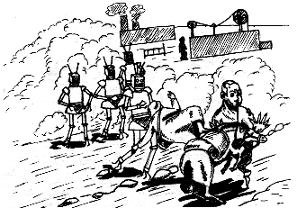

Next we entered the Land of Jealousy. I saw robot like giants approaching us. Suddenly Abu Lahaw appeared. My horse shied away at his sight, throwing me down. Abu Lahaw screamed with laughter, “O fool! Name me one learned man who has been free from jealousy. You'll never get out from this trap of mine!”

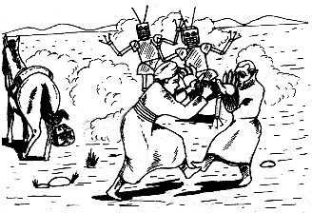

I was angry and started fighting him but he was stronger and was overpowering me. I cried for help. “Ya ‘Ali Madad!”

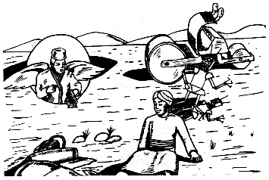

Immediately the robot like creatures turned around and retreated. Abu Lahaw too tried to run away but was crushed under the wheels of a giant roller. This was my last encounter with him!

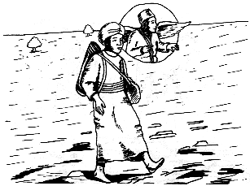

Getting up, Haadi and I started walking away quickly. “Haadi, it seems Abu Lahaw is dead”. I said. “No,” Haadi replied, “Abu Lahaw never dies. But he will not approach you now as we are quite far from the Valley of Barhoot. Ahead, people are being punished for Pride and Arrogance but since you rid yourself of these traits in your lifetime, you will not be troubled.”

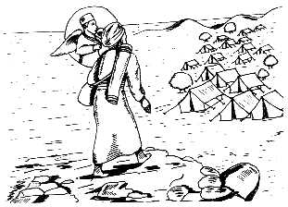

It got pleasant as we went ahead, with cool breeze, mountains, greenery and waterfalls. Numerous tents soon became visible. “This is the city of 'Huma', Haadi told me. It is the valley of Right and Sacred Land and you'll stay here a few days.”

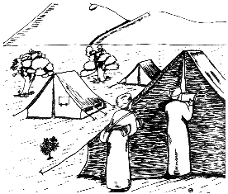

Some attendants appeared and Haadi instructed me to go with them, “Go to your tent with them. You'll find friends there”.

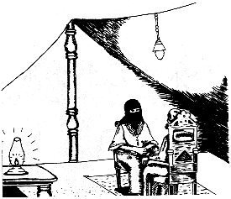

On entering, a beautiful maiden greeted me. We sat down and were served by a handsome lad. She spoke to me about religious issues. The depth of her knowledge impressed me. “I was educated in the Holy City of Medina and brought up by Hazrat Fatimah (as) who, like her father is herself a city of knowledge and purity”. She told me.

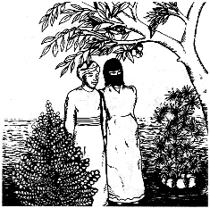

Then we went for a walk in the woods. As I would approach a tree, its fruit laden branch would bend down towards me. The fruits were sweet and fresh and did not decrease regardless of how many I ate. Melodious voices rang out from the trees inviting me to eat whatever I liked.

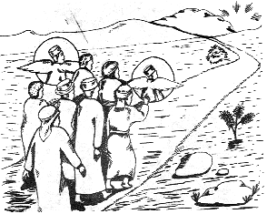

On returning to the tent, I was greeted by Haadi, ready for the onward journey. We departed, accompanied by friends and some angels. Soon we approached a hill overcast with dark clouds and sparks emitting from it. We could hear thunder in the distance. The angels immediately burst out, “There is no course of circumstances and no power except Allah's!”

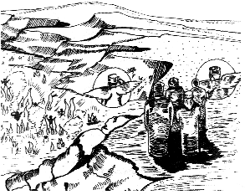

We climbed down the hill and looked down. “This is the Valley of Barhoot”, the Angels said, “and these sparks resembling arrows, spears and swords are in fact curses which the faithful send upon the enemies of the Ahlul Bayt (as) and these are hitting their targets.

We could see these fiery arrows passing through numerous people in the valley and they could not escape these. They were wailing and the voices sounded like yelping of dogs! All of us cursed the enemies of the Ahlul Bayt. This resulted in a ten-fold increase in the fiery showers.

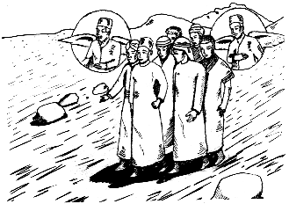

Seeing the fate of the enemies of Ahlul Bayt made me happy and satisfied and we resumed our journey saying, “O Allah, give them such a punishment from which even the dwellers of Hell would wish they were freed”.

The End

Post-Scriptum

Although the events after death have been described already and will prove to be an incentive towards preparing ourselves for the Hereafter, I wish to list some practices and occasions described by Revered personalities, which will help everybody in their preparations.

Only those who are aware of the reality and facts about the Hereafter, can inform us about this and these are Muhammad (S) and his progeny, who are the cause of creation of the Universe. The gist of their teachings is that if anybody has to undertake a journey, he should make preparations for it.

Therefore daily before sleeping, Imam ‘Ali (as) used to announce from the mosque, “O People, get ready and make preparations for your journey of the Hereafter. May Allah have mercy on you. The proclaimer of Death is announcing. Take heed. Be prepared. You will face numerous hazards there.” (Nahjul Balagha)

The first occasion of these is the time when one experiences the pangs of death.

“And the stupor of death will come in truth; that is what you were trying to escape” (Sura Qaf, 50:19)

This is an extremely hard time. On one side there is the intensity of pain and illness, the tongue becomes mute and the body refuses to respond.

On the other hand, the crying and wailing relatives and the thought of being separated from them forever, the grief of the children becoming orphans, separation from one's mate and life-partner and from wealth and other worldly goods (in the collection of which one had spent his lifetime): the agony of death, combined with these hardships to be faced after death, all cause this time to be painful beyond imagination.

Shaykh Saduq has quoted Imam Ja'far al-Sadiq (as) as saying, “If anyone wishes to make the pangs of death easy and light, he should maintain good relations with his relatives and should be kind and gentle with his parents. One who behaves thus will die easily and in his lifetime will not be troubled with paucity and will on the contrary live happily.”

The Holy Prophet (S) has recommended Sura Yasin (36) and Sura al-Saffat (37) and reading the dua “La Ilaha Illa Allah al-Haleemul Karim...” (There is no power except Allah, the Forbearing and Gracious) to the end in the Qunoot as being beneficial for the time of death. (Recommending of particular Sura and Dua for particular objectives is because of the special meanings contained in them; which if understood and taken to heart have corrective influences upon man).

Second Occasion: Adeela indal-Maut (Satanic thought in death). This is the turning away from the truth to the false and wrong at the time of death. This is because Satan approaches men at the time of their death creating and raising doubts in their minds to the extent that one's correct faith may be completely shaken.

One may even become bereft of it and he may die an infidel or faithless. Traditions advice us that as a safeguard one should be in the habit of recalling Usul al-Deen with its proof so that when he is reminded of the Usul al-Deen on his death-bed and in Talqeen, certainty of his faith would

prevail and doubts would cease. Dua al-Adeela in Mafatihul Jinan is also helpful and should be read at the death-bed.

Reciting the Tasbih of Hazrat Fatima (as), wearing Aqiq (Carnelian) ring, reading Sura al-Mu'minun on Fridays, reading “Bismillahi La Hawla Wala Quwwata Illa Billah” after Morning and Maghrib Prayers, are all beneficial.

Third Occasion: Wahshat al-Qabr (Fear and horror of the Grave): This is more severe, and fearful than the previous occasions. When the body is brought near the grave, it should not be put into it at once.

Since this is a very fearful time, it should rather be prepared for it by breaking the journey thrice (Manzil), because the spirit still retains interest in the body. The Holy Prophet has said, “The most fearful time for the dead is their first night in the grave. Help your dead in this time of need by giving charity on their behalf and by praying for them (Salaat al-Wahshat).

In this prayer in the first rakat, one should read Ayaat al-Kursi (2:255) after Sura al-Hamd (1) and in the second Sura al-Qadr (97) ten times after Sura al-Hamd (1). Alternatively, Sura al-Tawheed twice in the first rakat and Sura al-Takathur ten times in the second rakat. ( i.e. after Sura al-Hamd). Also beneficial is reading “LA Ilaha Illa Allahu Al-Malikul Haqqul Mubeen” (There is no power except Allah, the King, the Right, the Manifest) 100 times daily and reading Sura Yaseen (36) every night before sleeping.

Fourth Occasion: Constriction in the Grave: This is also a difficult time. The grave calls out everyday. “I am the rest-house of the travellers. I am a house of horror and also of Respect.” For some, the grave will be a garden from amongst the gardens of Heaven and for others a pit from the pits of Hell.

Imam al-Sadiq (as) has said that nobody can escape this constriction, but there are practices which can prove helpful in this regard. e.g. 1) Imam ‘Ali (as) has said that reading of Sura al-Nisa (4) every Friday will save one from constriction. 2) One who makes a habit of reading Sura al-Zukhruf (43) will remain safe from the constriction and beasts in the grave. 3) Imam Ja'far al-Sadiq (as) has said that whoever dies between Thursday noon and Friday noon will be spared constriction. 4) Imam al-Ridha (as) has said that the habit of night prayers keeps one safe from constrictions. 5) The Holy Prophet (S) has said that reciting Sura al-Takathur (102) before sleeping helps to ward off constrictions. 6) People buried in the sacred land of Najaf are also spared constrictions.

Fifth Occasion: The Questioning by Munkar and Nakeer: Imam Ja'far al-Sadiq (as) has said that one who does not believe that questioning will take place in the grave is not a true faithful. These questions have been already mentioned. Reading Talqeen twice before the burial is completed is very beneficial but specially (and maybe only) if the person had these beliefs and thoughts in his lifetime.

Sixth Occasion: Barzakh. Barzakh has been discussed already. It is a time of extreme helplessness. Deeds done for the dead and the benefits arising from one's previous deeds are the only useful things at this time and most fearful day.

Seventh Occasion: Day of Judgement: It is the harshest and severest. There are fifty stations in the Day of Judgement; each more difficult than the previous one. We hope that you, dear reader, will pray for us.