The Holy City of Samarra (In the Mirror of Pictures)

Authors(s): [Abbas Jaffer](http://www.al-islam.org/person/abbas-jaffer)

Tabl of Contents

Brief Facts 15

"An appointment in Samarra", an old famous story 16

Mosques (Masajids) 17

Holy Shrines 18

Pictures 19

1. Shrines of the Holy Imams (A) 19

2. Shrines of the Holy Imams (A) after 22 Feb 2006 bombing 22

3. The Abu Dulaf Mosque 26

4. The Great Mosque 30

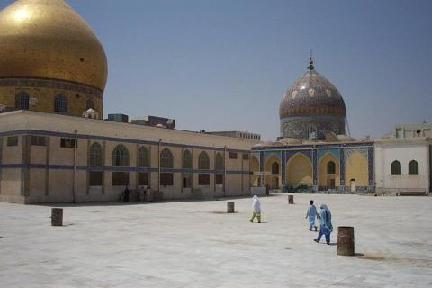

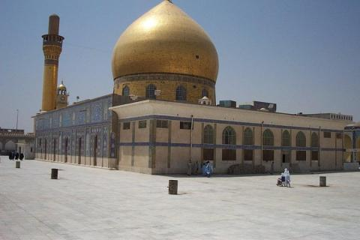

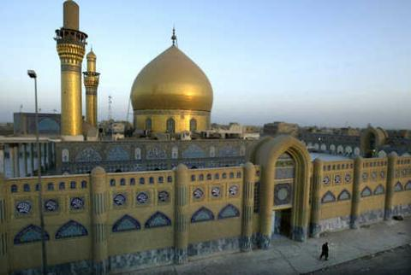

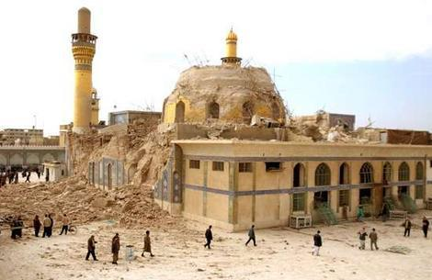

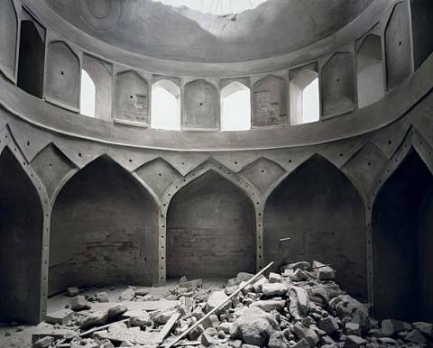

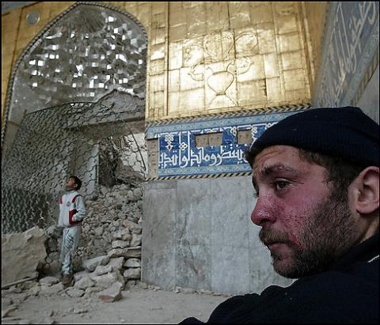

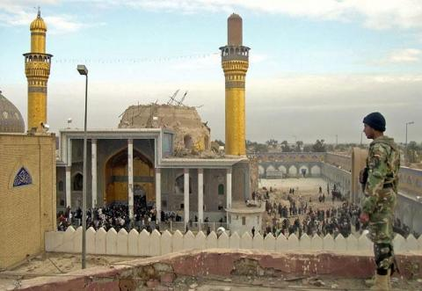

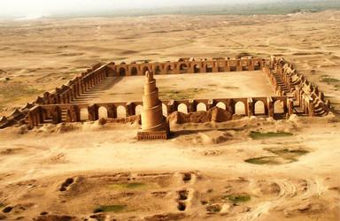

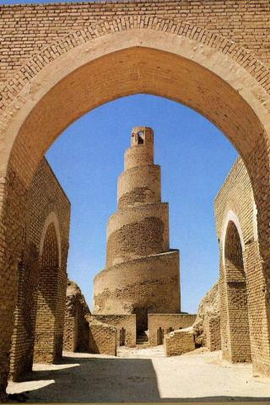

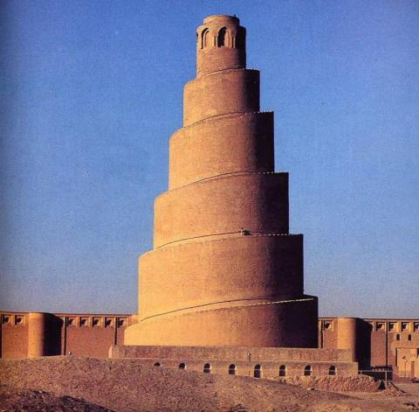

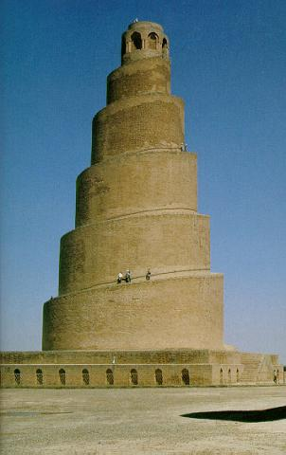

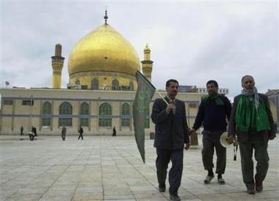

A short text describing the historical significance of the Holy City of Samarrah, including photographs of the Holy Shrines of Imams al-Hadi (A) and al-Askari (before and after it's destruction in February 2006).

*****

Brief Facts

• Samarra is the resting place of Imam Ali al-Hadi and Imam Hasan al-Askari (A)

• It is located on the eastern bank of the Tigris, about 120 km north of Baghdad, Iraq. Its population in 2002 was 200,000.

• It was originally built in 217/833 by the Abbaside caliph al-Mu’tasim as a new capital for the Abbasides, following agitation ad unrest caused by the Mamluks in Baghdad. It was called “Sarra man ra’a (a joy for all who see) and later nicknamed to “Sa’a man ra’a” (a sadness for all who see) by Armenian soldiers.

• In 278/892, the Abbaside caliph al-Mu’tamid moved the capital back to Baghdad and Samaara was developed as a commercial city.

• The fortunes of Samarra declined markedly after the course of the Tigris shifted in the 13th century. The population was greatly increased when a permanent lake (Lake Tharthar) was created near the town to prevent the frequent floods. As a result, people were displaced from the nearby villages and moved to Samarra.

• It is the key city in Salahuddin province, and consists of 3 districts: Takrit, Balad and al-Dujail.

• Despite being an important site of ziyarat for the Shia, the city’s population has long been Sunni.

"An appointment in Samarra", an old famous story

Death speaks: There is a merchant in Baghdad who sent his servant to buy provisions from the market and in a little while the servant came back, white and trembling, and said, Master, just now when I was in the market-place I was jostled by a woman in the crowd and when I turned I saw it was Death that jostled me.

She looked at me and made a threatening gesture; now, lend me your horse, and I will ride away from this city to avoid my fate. I will go to Samarra and there Death will not find me.

The merchant lent him his horse, and the servant mounted it, and he dug his spurs in its flanks and as fast as the horse could gallop he went. Then the merchant went down to the market-place and he saw me standing in the crowd and he came to me and said, Why did you make a threatening gesture to my servant when you saw him this morning?

That was not a threatening gesture, I said, it was only a start of surprise. I was astonished to see him in Baghdad, for I had an appointment with him tonight in Samarra.

Mosques (Masajids)

1. Great Mosque – built by the Abbaside caliph al-Mu’tasim, when the city was founded as a new capital for the Abbasides in 221AH.

2. Mosque of al-Qal’ah.

3. Mosque of Hasan Pasha.

4. Mosque of Hamid al-Hasan.

5. Mosque of Sayyid Darwesh.

6. Mosque of Ali bin Abi Talib (A).

7. Mosque of al-Arqam.

8. Mosque of Awlad al-Hasan (A).

9. Mosque of al-Faruq.

10. Mosque of Abu Dulaf - Samarra has a very long axial street called Al-Adham (the Greatest), at the end of which, 22 km away north of the modern city, are the remnants of a large mosque still mostly extant, with its beautiful courtyard and a small 19 m high spiral minaret. It was built by Al-Mutawakkil in 860 AD as a smaller version of the Great Mosque and its Spiral minaret.

Holy Shrines

1. The shrines of Imams al-Hadi (A) and al-Askari (A). Before its destruction, the shrine contained one of the largest domes in the Muslim world. Its circumference was 68m and it was tiled with 72000 gold tiles. Its two golden minarets are 38m high.

2. The Dome of the cellar from which Imam al-Mahdi (AJ) went into occultation.

3. The shrine of Lady Narjis Khatun, mother of Imam al-Mahdi (AJ) (d. 260AH).

4. The shrine of Lady Halima, daughter f Imam al-Jawad (A) (d. 260AH).

5. The shrine of Muhammad, son of Imam al-Hadi (A) (d. 252 AH).

6. The shrine of Abi Hashim al-Dawud, descendant of Abdulla b. Ja’far (d. 261AH).

7. The shrine of Muhammad al-Dariy, descendant of Imam al-Kazim (A) (d. 300 AH).

8. Shrines of daughters of Imam al-Kazim (A) in al-Dujail area.

9. Shrines of daughters of Imam Hasan (A) in al-Jalam.

Pictures

1. Shrines of the Holy Imams (A)

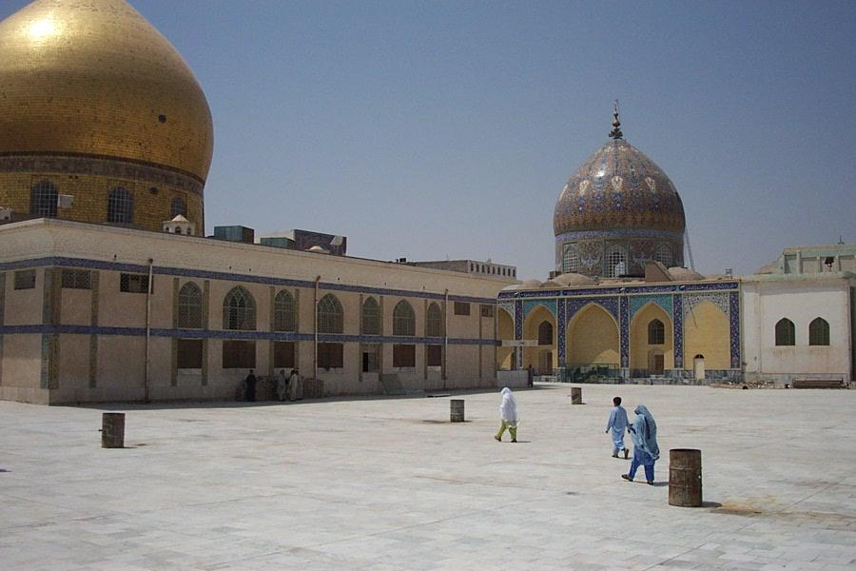

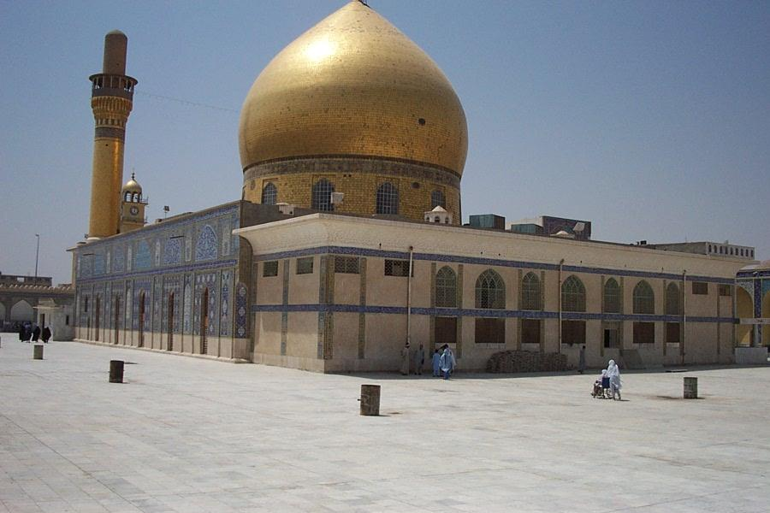

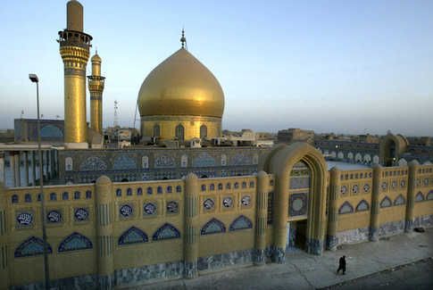

2. Shrines of the Holy Imams (A) after 22 Feb 2006 bombing

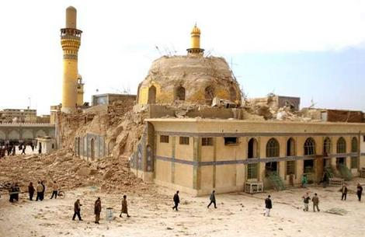

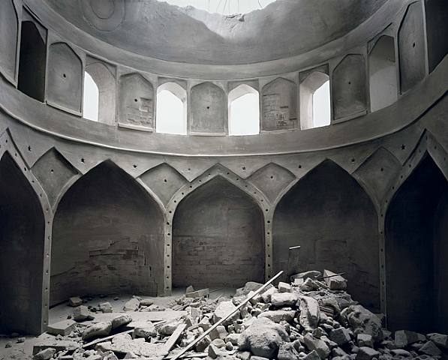

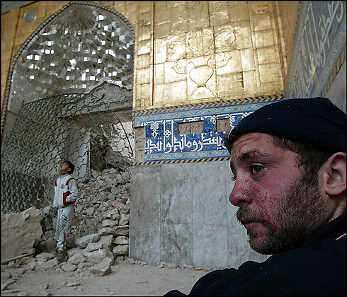

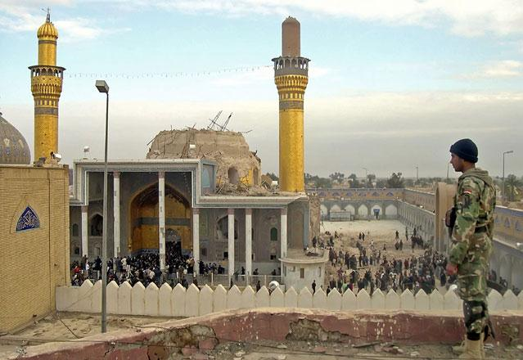

3. The Abu Dulaf Mosque

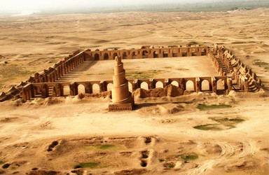

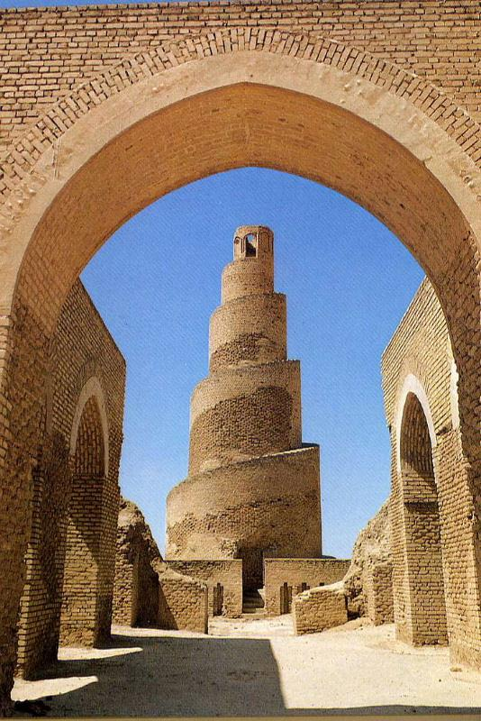

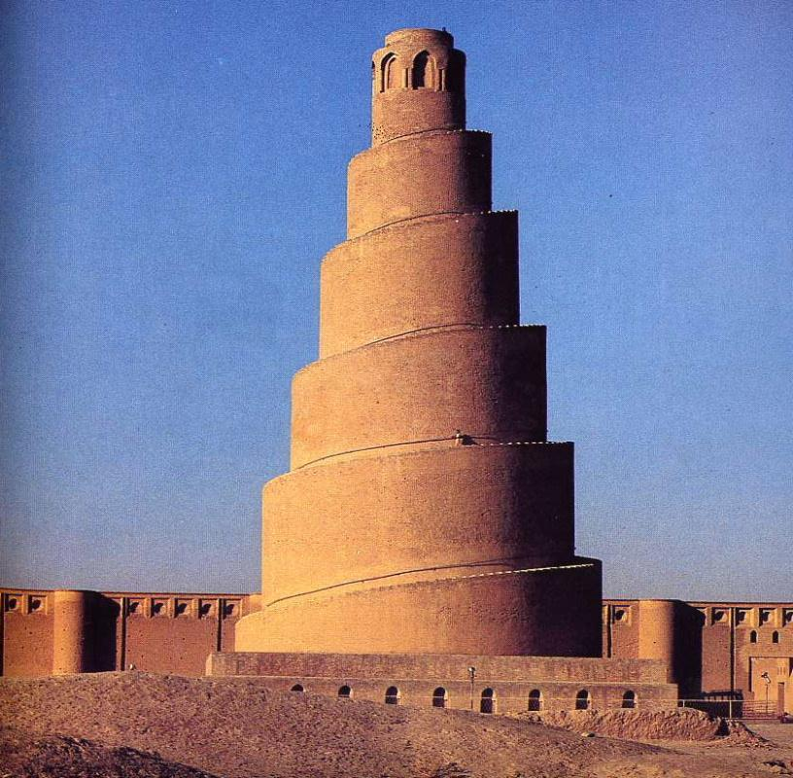

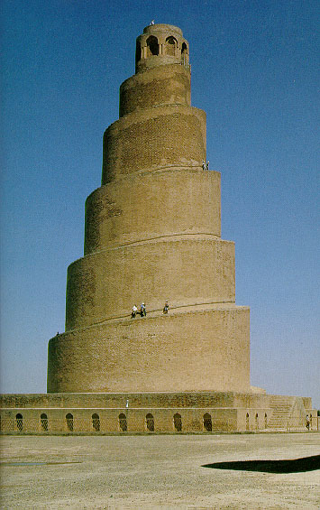

4. The Great Mosque

