Alhassanain (p) Network for Islamic Heritage and Thought



BY

ASH-SHAYKH ABU JA‘FAR MUHAMMAD IBN YA‘QUB IBN IS'HÃQ AL-KULAYNI AR-RÃZI

Volume One

AL-USŨL,.. Part One

1) THE BOOK OF REASON AND IGNORANCE

World Organization for Islamic Services,

TEHRAN – IRAN

[www.alhassanain.org/english](http://www.alhassanain.org/english)

English translation with Arabic text

First edition 1398/1978

Second & Third edition n.d

Fourth edition 1422/200

© All rights reserved

http://www.wofis.com/

Translated and published by:

World Organization for Islamic Services,

P. O. Box 11365-1545,

Tehran - 15837,

ISLAMIC REPUBLIC OF IRAN



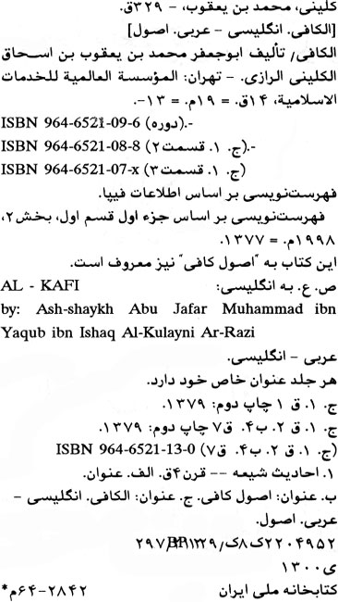



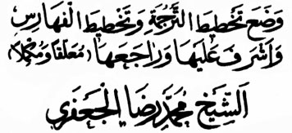

This part has been translated by:

SAYYID MUHAMMAD HASAN RIZVI

Design of the book for its translation, indexes, revisions, explanatory remarks and other related work has been done by:

ASH-SHAYKH MUHAMMAD RIDA AL-JA‘FARI

IN THE NAME OF ALLÃH, THE MOST COMPASSIONATE, THE MERCIFUL

Praise belongs to Allãh, the Lord of all beings; the Most Compassionate, the Merciful; the Master of the Day of Judgment; Thee only we serve, and to Thee alone we pray for succour; Guide us in the straight path; the path of those whom Thou hast blessed, who are immune from Thy wrath and have never gone astray.

\* \* \* \* \*

O Allãh! Send your blessings to the head of your messengers and the last of your prophets Muhammad, and his pure and cleansed progeny.

Also send your blessings to all your prophets and envoys.

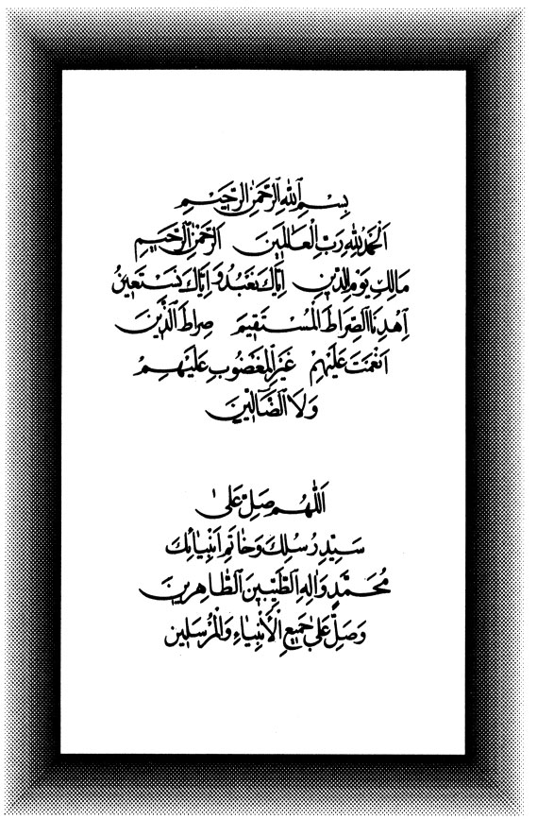

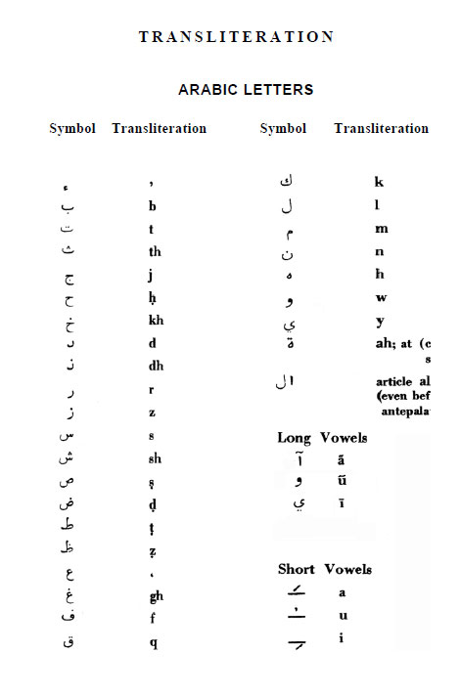

Table of Contents

[FOREWORD 10](#_Toc448666830)

[AL-KULAYNI and AL-KÃFI 20](#_Toc448666831)

[PLACE OF HADĪTH (TRADITION) FOR SHI‘AH 21](#_Toc448666832)

[KULAYN 22](#_Toc448666833)

[Biography of al-Kulayni, the Compiler 23](#_Toc448666834)

[A WORD IN HIS APPRECIATION 24](#_Toc448666835)

[HIS COMPILATIONS 25](#_Toc448666836)

[AL - KÃFI 25](#_Toc448666837)

[Distinctive Features 26](#_Toc448666838)

[SUB-DIVISIONS OF AL-KÃFI 26](#_Toc448666839)

[PART I – AL – USUL: 26](#_Toc448666840)

[PART II – AL – FURŨ: 27](#_Toc448666841)

[PART III - AR-RAWDAH: 28](#_Toc448666842)

[Commentaries of al-Kãfi 28](#_Toc448666843)

[The Year of al-Kulayni's Death? 29](#_Toc448666844)

[His Shrine in Baghdad 29](#_Toc448666845)

[NOTES 29](#_Toc448666846)

[CAUTION 32](#_Toc448666847)

[LIST OF Technical terms and special signs used in the Traditions: 33](#_Toc448666848)

[INTRODUCTION 34](#_Toc448666849)

[The Book of REASON and IGNORANCE 54](#_Toc448666850)



FOREWORD

D:\barkatullah\books\new books\rajab\al_kafi_vol_01_dr_hassan_rizvi\photo shop\image009.jpg

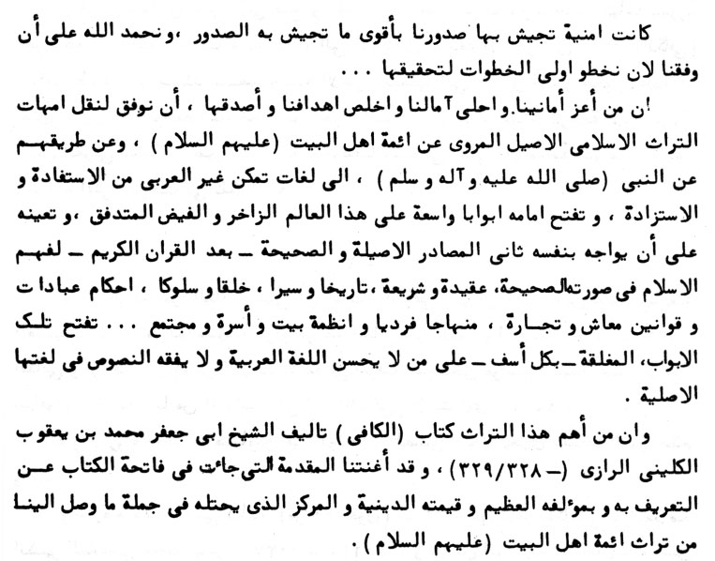

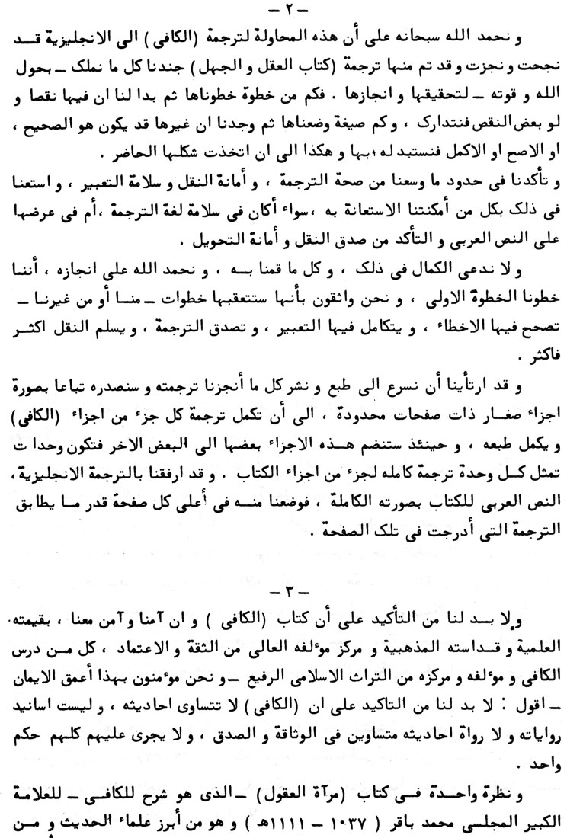

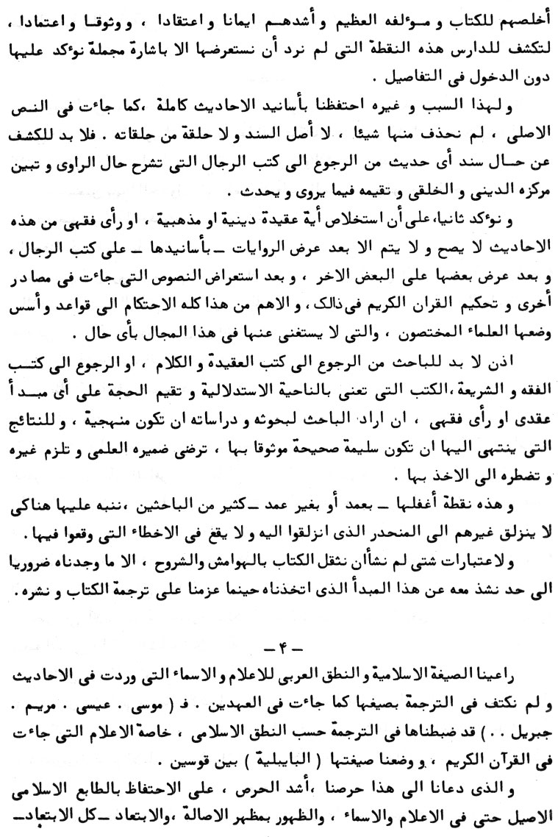

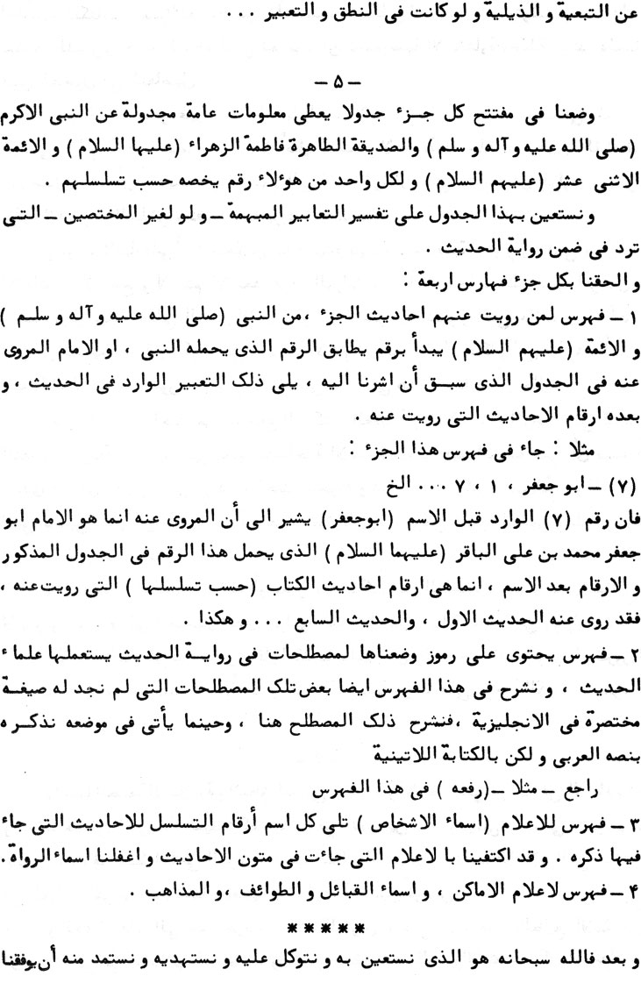

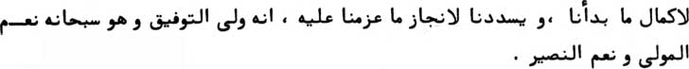



-1-

In our continuous effort to propagate Islam through our numerous publications we have had a persistent desire to include amongst our publications translations of the most important reference books recog-nized by the Shī‘ah. To be able to publish such key books in the Shī‘ah heritage in foreign languages does not only give us great pleasure and pride but it conforms very well to our wishes and our true sincere objectives. No doubt the non-Arab speaking researchers would now have better access to the true Islamic heritage since such books contain the ahãdīth (traditions) of the holy Imãms (peace be upon them) and the Holy Prophet (peace be upon him and his progeny). Moreover, these books constitute the second source - the holy Qur'an being the first - whereby one would have better understanding of the Islamic ideology, jurisprudence, history, tradition, manners, Islamic laws pertaining to worship, business, Islamic considerations for the individual, family and society...

One of the important books in question is al-Kãfi whose author was ash-Shaykh Abu Ja‘far Muhammad ibn Ya‘qub al-Kulayni ar-Rãzi ( 328/329 = 940/941). We need not introduce either the book or its author since the introduction to the book takes care of that and also shows its religious significance and its status in our heritage, namely the heritage transmitted to us through Ahlu'l-bayt (the House-hold of the Holy Prophet - p.b.u.t.).

-2-

Our gratitude to Allãh, the Almighty, for being able to commence the translation of al-Kãfi to English. So far, the translation of the section pertaining to the “Reason and Ignorance” (‘aql and jahl) has been completed. No doubt we had to utilize all the means at our disposal and to rely on Allãh's unlimited strength in order to accomplish this translation. As a matter of fact, we had to do a lot of screening before coming up with this version. Furthermore, we took every possible effort to make sure that the translation is satisfactory and acceptable in terms of accuracy and grammar.

We do not wish to claim perfection in this humble effort to trans-late one section of al-Kãfi. Nevertheless, we have taken the first step and we are confident that subsequent steps would be taken, either by us or by somebody else, to both remove any errors and optimize the translation so that exactness in the narration process is improved.

We have decided to speed up the printing and publication of the translated section of al-Kãfi. The other sections, it is hoped, would be published in due course on individual basis; this process would be continued until all the sections of al-Kãfi are translated and published.

You will note that we have also included along with the English translation, the complete original Arabic version, this being placed at the top of each page with the corresponding English translation below.

-3-

We believe, and so does everybody who studied it believe, that and so holy in the Shī‘ah circles and that the author is considered highly honest and highly reliable. However, we should emphasize that neither the ahadīth are equal in value and significance nor are the supporting evidence for the narrations or the persons relating the ahadīth equal in terms of reliability and credibility and in no way can one give them the same appraisal.

A glance at the book entitled mir’ãtu'l- ‘ugũl (reflection of the minds) would reveal to the researcher this very point in more detail. Mir'ãtu'l-‘uqul is an explanatory book to al-Kãfi and is authored by the great scholar Muhammad Bãqir al-Majlisi (1037/1628-1111/1700). al-Majlisi is one of the prominent scholars of hadīth (tradition) and one of the most loyal and faithful to the book (al-Kãfi) and its great author and one of the most faithful and pious scholars of Islam.

Because of this - that is, the question of unequal credibility of the ahãdith, narrations and narrators - and for completeness we have retained the complete supporting evidence of the ahãdīth as in the original Arabic text. We have not omitted any original support for any ahadīth, neither have we omitted any of the links in a narration chain. In order to reveal the credibility, or otherwise, of the support for a par- ticular hadīth, one has to refer to special books dealing with the biogra- phy and the religious and moral status of the narrator/s; such books also carry an appraisal of what the narrator transmits and relates. We would like to re-emphasize that the inference of any religious or ritual doctrine or any law pertaining to jurisprudence from these ahãdīth is a long process. To start with, the researcher would have to refer the nar- rations along with their supporting chain of evidence - to the special biographic books referred to above. The narrations would have to be cross-checked against one another. Later the researcher would have to consider all other declarations and citations on the same topic from other references and then use the holy Qur'an as the arbitrator. Of more significance still, one has to abide by the rules and regulations laid down by the specialists and which rules can never be ignored. Therefore, the researcher would have to go back either to the ideological and linguistic books or to the books of jurisprudence and legislation, that is, those books which cover the inference aspects and the evaluation of various proofs and evidence used to back-up any ideological principle or jurisprudence. This is the approach to be adopted if he wants his research to be systematic and if he wants the results to be sound, accurate and reliable, thus satisfying his scientific conscience and obliging others to honour and follow such inferences.

This very point has been ignored - intentionally or otherwise - by many researchers and we are stressing it here in order that other researchers would neither make the same mistake of ignoring it nor suffer the same deviation.

And for several considerations we refrained from introducing unnecessary explanatory notes, except where it was absolutely necessary, so as to stick to our .original aim of merely translating and publishing the book.

- 4 -

In the translation we have retained the Islamic format and Arabic pronunciation of the names and proper nouns encountered in various ahãdīth. We were not content with the Biblical equivalents, but, instead, retained the Islamic articulations in the text, following each proper noun or name (especially those mentioned in the holy Qur'an) like, Musã (Moses), ‘Isã (Jesus), Maryam (Marry), Jibrīl (Gabriel)...with its Biblical equivalent in brackets.

We took this measure because we strongly believe in preserving the original Islamic character even with respect to names and proper nouns. We believe in originality even when it comes to appearances, and we will completely avoid imitation and reproduction even if it were merely with respect to pronunciation and expression...

- 5 -

We have put a table at the beginning of each section giving general particulars and information in tabular form about the Holy Prophet (p.b.u.h.a.h.p.) and Fãtima az-Zahra' (p.b.u.h.) and the twelve Imãms (p.b.u.t.). For each of them we have assigned a number according to their sequence.

It is hoped that this table would help the reader - even the non-specialist to understand some important expressions encountered in the process of the narration of hadīth.

Furthermore, we have included four indexes at the end of each section:-

a) The first index lists the originators of the ahadīth to be found in the section - the Holy Prophet (p.b.u.h.a.h.p.) and the Imãms (p.b.u.t.).

It begins with a number corresponding to the serial number of the originator of the hadīth, the originator being the Prophet or one of the Imãms. The serial number has already been assigned in the table at the beginning of the section.

After the number, the format of the name used in the hadīth appears.

After that, the serial number's of ahadīth related to the originator is/are listed.

For example, in the first index of this section:

(7) - Abu Ja‘far, 1, 7 ...etc.

The number (7) preceding the name (Abu Ja‘far) indicates that the originator is Imãm Abu Ja‘far Muhammad ibn ‘Ali al-Bãqir (p.b.u.t.) who was assigned with this number in the table at the beginning of the section. The number following the name are the serial number of the ahadīth in the book (or section) related to him: that is, the first and the seventh hadīth are related to him...etc.

b) An index containing symbols for terminology commonly encountered in the process of narration of hadīth. We have introduced these because scholars of hadīth often use them. In this index we have also explained some of those terminologies for which no simple English equivalent can be found. We have explained such terminology in the index and when it appears in the text we also mention the Arabic text in the Latinized form: e.g. “rafa ahu” - Ref. Index no.3

c) Index of the names of key personalities. Following each name the serial numbers of ahãdīth in which such a name appears are cited. We were content with citing only those names that appeared in the contexts of the ahãdīth proper and ignored the names of narrators.

d) Index of key places, names of tribes and families and sects.

Finally, it is Allãh, the Almighty, from Whom we seek help and guidance and upon Whom we rely for the success of our efforts. Moreover, we pray that He paves the way for us to complete what we have commenced and to redeem us in order to achieve what we have planned...We strongly believe that He is the reconciliator and that He is the best guide and the best artisan.

WORLD ORGANIZATION FOR ISLAMIC SERVICES

Tehran - IRAN.

6/2/1398

16/1/1978

AL-KULAYNI and AL-KÃFI

An abstract from the preface

By

Dr. Husayn `Ali Mahfuz, introducing AL-KULAYNI and AL-KÃFI, with some additions

In the Name of Allãh, the Beneficent, the Merciful

PLACE OF HADĪTH (TRADITION) FOR SHI‘AH

1

The first book of hadīth (tradition) compiled in the world of Islam was the book of `Ali ibn Abi Tãlib (p.b.u.h.) which was dictated by the Holy Prophet (Muhammad - p.b.u.h.a.h.p.) himself and which was put down in black and white by `Ali himself on a sheet of paper. This book contains all the details about what is lawful and what is unlawful.2 This book also contains a document regarding blood money and indemnity for bodily injuries and its (document) used to be hung by the scabbard of his sword.3 And al-Bukhari has quoted from it.4

Thereafter, Abu Rafi‘ al-Qibti ash-Shi‘i the emancipated slave of the Holy Prophet compiled another book named - Kitãb as-Sunan wa'l-ahkãm wa'l-qadaya. 5

Then the great scholars duly acquainted with the categories of the traditionists, assorted and composed various books of traditions and they also composed four hundred books named as usũl 6 - the originals, which were, later on, collected, connected and compiled by a group of reliable experts in the art of traditions in the shape of their collections of traditions. The greatest among these collections are the books of:-

1. al-Kãfi,7 collected and compiled by al-Kulayni (d. 329/941);

2. Man la yahduruhul faqih,8 compiled by ash-Shaykh as-Saduq, Abu Ja‘far Muhammad ibn `Ali ibn al-Husayn ibn Babawayh al-Qummi (306/919 - 381/991);

3. Tahdhīb al-ahkãm9 and al-Istibsãr10 by ash-Shaykh Abu Ja‘far Muhammad ibn al-Husayn at-Tusī (385/995 - 460/ 1076);

4. Jãmi‘ al-akhbãr fi īdãh al-istibsãr by ash-Shaykh 'Adul-Latīf ibn Abi Jãmi‘ al-Hãrithi al-Hamadãni (d. 1050/1640);11

5. al-Wafi12 by Muhammad Muhsin al-Fayd al-Kashani (1010/ 1599 - 1091/1690);')

6. Tafstl wasa’il ash-Shi‘ah ila tahsil masã’il ash-sharī‘ah13 by Muhammad ibn al-Hasan al-Hurr al-‘Ãmili (1033/1625 - 1104/1693);

7. Bihãr al-anwãr al jãmi`ah li durar akhbãr ala'immah al-athãr14 by Muhammad Baqir ibn Muhammad Taqi al-Majlisi (1037/ 1928 - 1111/1700);

8. al- ‘Awãlim15 (in 100 volumes) by ash-Shaykh `Abdullah ibn Nuru'1-lah al-Bahrãni (contemporary, of al-Majlisi);

9. ash-Shifã fi hadīth Ãl al-Mustafã16 by ash-Shaykh Muhammad Rida ibn `Abdu'l-Latīf at-Tabrizi (d. 1158/1745);

10. Jami‘ al-ahkãm (in 25 thick volumes)17 by as-Sayyid `Abdul-lah ibn Muhammad Rida Shubbar (1188/1774 - 1242/1827);

11. Mustadrak al-wasã'il wa mustanbat al-masa'il18 by al-Hãj Mirza Husayn ibn Muhammad Taqi an-Nuri at-Tabarsi (1254/ 1838 - 1320/1902);

12. Jami‘ ahãdith ash-Shi‘ah (in a number of volumes) by the Grand Shi‘ite Mufti as-Sayyid Aqa Husayn ibn ‘Ali ibn Ahmad at-Tabataba’i al-Burujirdi (1292/1875 - 1380/1961). So far, out of this voluminous book, seven volumes have been already published in Iran, and the rest of the volumes are being gradually published.

The Shi‘ite scholars and the narrators of the traditions from the progeny of the Holy Prophet (the twelve Imãms) have consistently made efforts, one after the other, to pay great attention to the narra-tion of the traditions to the keeping of them intact, to their criticism and collection to their regulation, to the acquisition of the knowledge of this art,19 to the skill of its authentication and to the specialization in the research regarding the dates and categories of the narrators.20 They used to issue detailed certificates (to their students) with liberty to quote them in relating the` traditions. In this regard voluminous books have been written by some of the Shiite scholars, not to speak of the small collections which are countless and which are scattered.21

What significance does the tradition (hadīth) have in the eyes of Shī’ah, can be judged from this example of hadīth.

Imãm Muhammad al-Bãqir (p. b. u. h.) addressed Jãbir (his companion) saying, “O Jãbir! by Allãh, a tradition (hadīth) emerging from an authentic source is infinitely better for you than any thing the sun shines over, till it sets down.”22

Further, Imãm Ja‘far as-Sãdiq (p.b.u.h.) has observed (in this regard), “A tradition received from a truthful person regarding what is lawful and what is unlawful is far better than the whole world and whatever wealth like gold or silver it contains.”23

An idea of the importance of the tradition for the Shī’ah is also known from these traditions which indicate the close attention paid by the associates of the Imãms in picking them up from the Imãms,24 in remembering them by heart and also from their eagerness, high esteem and long journeys they 25 undertook to get them from the scholars and narrators of the traditions.

In addition, there are numerous traditions which urge people to acquire the knowledge (of traditions). Other traditions indicate the need of their verification and the need for precaution in matters of faith and also the need to acquire them, to adhere to them and to make deduction from sunnah - the sayings and doings of the Prophet and the Imãms (from the progeny of the Holy Prophet - peace be upon him and his progeny).

Imãm Muhammad al-Bãqir (p. b. u. h.) used to say, “When I receive a young person from amongst my followers having no under-standing of religion I would like 'I deal with him very strictly till he acquires the knowledge of religion.”26

\* \* \* \* \*

KULAYN

Kulayn was the name of a village under the jurisdiction of `Ray' - the well known city of Iran. This village is now in ruins which are still to be found 'near Tehran - the capital city of Iran even this day. This village was the birth place of Muhammad ibn Ya‘qub Kulayni, the compiler of this book al-Kãfi.27

The fact of his belonging to this village Kulayn, can also be proved by his relationship with Ray.28 He was the Shaykh - the religious head of the Shī’ah scholars of Ray in his time.29

Biography of al-Kulayni, the Compiler

Muhammad ibn Ya‘qub ibn Ishãq al-Kulayni ar-Rãzi al-Baghdadi belonged to a noble family of Kulayn which has produced a group of outstanding scholars in Islamic Jurisprudence and hadith. Among them was his uncle al-‘Allãmah al-Kulayni himself was the Shaykh - head of the. Shī’ahs and was the most prominent religious figure of his time in Ray (the most important ancient city of Iran). Afterwards he stayed at Baghdad (Iraq) at Bãb Kũfa (name of a locality in Baghdad) as the Chief of the Shi‘ite Scholars in Islamic Jurisprudence during the reign of al-Muqtadir - the Abbasid Caliph. The unique qualification of al-Kulayni, the compiler of al-Kãfi, is that among all other compilers of /Judith, he alone was the cotemporary of all the four successive representatives and ambassadors of Imãm al-Mahdi - the twelfth Imãm. Hence he had all the facilities of collecting traditions from the requisite sources. Therefore, al-Kãfi is rightly regarded as a unique collection and compilation during the life time of all the four successive ambassadors of Imãm al-Mahdi. al-Kulayni compiled this book on the request of the prominent Shiite scholars who wanted to have a comprehensive book containing all information of Islamic literature which would be sufficient for them.

His court was the rendezvous of the great scholars in Islamic studies who used to go in search of knowledge to different places. The great scholars of the time used to present themselves in his court to discuss, to exchange notes and to confer with him and to acquire full understanding of Islamic problems.

al-Kulayni was a great scholar, a reliable traditionist and a man of great learning. He was among the outstanding jurist and an authority in traditional science. He was the chief of the Islamic jurists and an outstanding scholar of Islamic literature. He was a man of great abstinence, piety, integrity and holiness.

His book al-Kãfi is no doubt an outstanding collection of reliable traditions in the largest measure. It is a treasure of Islamic literature, Shari `ah (code), divine commandments inclusive of imperatives, prohibitions, reprimands and sunan - the sayings and doings of the Holy Prophet and the twelve Imãms. It is a collection about Islamic education and culture. It contains the record of the sayings and doings of the Holy Prophet and the twelve Imãms.

al-Kulayni has himself written preface of his book al-Kãfi and has also added some needed explanatory notes on some of the chapters which are indicative of his high skill and proficiency in the art of writing and in his knowledge of Arabic literature, its depth and its hidden wisdom. It also indicates his convincing presentation, his fluency, his eloquence and also his high place in the art of Arabic composition.

He was an expert historian and was well versed in categorising the narrators of hadīth and the traditionists. He is also an author of a book in the art and science of traditions (hadīth) and was an expert in scrutinising the narrators. He was so great an expert of the science of scholastic theology that he has written a book refuting al-Qarãmitah (one of the several names applied to the sect of Isma‘ilis who were once very active in their political activities).

Regarding his association with education and literature, it is quite sufficient to point out his two books namely:-

1) Rasã’il al-a’immah on the letters of the Imãms.

2) A book on verse - a compilation of eulogies to the Imãms.

In addition, his book on the interpretation of the dreams is regarded to be the best book in this field.

\* \* \* \* \*

A WORD IN HIS APPRECIATION

an-Najãshi says: “Amongst our associates, al-Kulayni was the chief and the most prominent in Ray (Iran). He was the most reliable,30 ac-credited and the weightiest in hadīth (tradition).

al `Allãmah al-Hilli31 has confirmed this and Ibn Dãwud32 also did the same with a very minor change.

at-Tusi - the great scholar has regarded him as the most depend-able and an expert in hadīth (tradition).33 He has also described him as the man of highest esteem and a scholar in hadīth.34

as-Sayyid Radi ad-Din ibn Tãwus said, “Muhammad ibn Ya‘qub al-Kulayni is universally accepted for his leadership and reliability.”35 He has also said:

“Muhammad ibn Ya‘qub (al-Kulayni) is the most eloquent and the most truthful in the knowledge of hadīth.”36

Ibn al-Athīr has regarded him “Amongst the outstanding leaders of the Shī‘ah and their great scholar.”37

He has also described him as “A reformer of the Shī’ahs at the end of the third century, as their leader and as a renowned scholar among them.”38

at-Tayyibi counted him as the reviver of the ummah - the whole Muslim community at the end of that century ...He was among the most learned in Islamic Jurisprudence.”

Ibn Hajar said, “He was one among the Shī‘ah Jurists and an author of their school.”40

He has also added, “Abu Ja‘far Muhammad ibn Ya‘qub al-Kulayni was among the chief scholars of the Shī‘ah world in the days of al-Mugtadir.”41

Says ash-Shaykh Husayn ibn `Abd as-Samad al-Harithi al-Hamdãni, “Muhammad ibn Ya‘qub al-Kulayni was the religious chief of his time and an outstanding, noble minded and high born scholar. He was the most reliable person in the field of tradition, their best critic and the most conversant in it.”42

al-Qãdi Nurullah ash-Shushtari puts him at the top of the traditionist and regards him as the Chief and their guardian.43

Muhammad Taqi al-Majlisi - the great scholar says about him, “The truth is that he is unparalleled amongst all the scholars we have seen. Everyone who ponders over the traditions he has compiled and also the manner of his editing and compiling them, will soon recognise him as the one especially endowed by God Almighty.

“May Allãh bestow upon him the highest rewards reserved for the doers of the good for his services to Islam and the Muslim Com-munity.”44

He also regarded him as “The Shaykh (the chief) as-Sadũq (the most truthful) and Thiqatu'l-Islam (the most trustworthy in respect of all about Islam), as one accepted by the people of all classes. He has been praised both in general and in particular.”45

Mirza. `Abdullah al-Afandi has said :

“The person generally meant by the title Thiqatu'l-Islam' (the trustworthy in Islam) is Muhammad ibn Ya‘qub ibn Ishãq al-Kulayni ar-Rãzi, the compiler of the book al-Kãfi. He is the oldest religious chief of the Muslim world by the masses and by the elite alike and the Mufti - the Chief judge for both the groups - the Shī’ahs and the Sunnis.”46

HIS COMPILATIONS

1. Kitãb tafsir ar-ru'yã;47

2. Kitãb ar-rijãl;48

3. Kitãb ar-radd ‘alã al-Qarãmitah;49

4. Kitãb ar-rasã'il50 - Rasa'il al-a'immah (`alayhimu's-salam); 51

5. Kitãb al-Kãfi;52

6. Kitãb mã qīla fī al-a'immah ('alayhimu's-salãm)- mina'l-shi‘r.53

\* \* \* \* \* \*

AL - KÃFI

This book is known after the name of the compiler al-Kulayni54 and also by the name of al-Kafi.55 While replying to one of his associates, al-Kulayni himself explained why he compiled this book “al-Kãfi.”

He wrote:

“You wanted a book to be handy, to be comprehensive and to be inclusive of all knowledge about your religion (Islam) - a book on which a student of religion could safely rely, to which the seeker of light and guidance should turn and from which a student seeking the knowledge of religion should derive full benefit and act on the traditions of the truthful Imãms (p.b.u.t.).” 56

The task of compiling this invaluable work has taken twenty years to complete.57 It is evident from this quotation that a group of the Shī‘ah community, living in distant cities, requested him to compile a book which would be sufficient to benefit them for purposes of perusal reference and recollection of reliable knowledge of the tradition.58

The intellectual stalwarts of his time took down the traditions from his book verbatim and then used to read aloud to him to get them verified. They then used to quote the traditions on the basis of its being duly read and verified by al-Kulayni and also on the basis of his written permission59 to quote him. As was by his students like Abu'l-Husayn Ahmad ibn Ahmad al-Kũfi al-Katib,60 who was in his turn referred to and quoted by a group of renowned Shiite scholars; Abu `Abdillah Muhammad ibn Ahmad ibn `Abdillah as-Safwani who was a .contemporary of al-Kulayni61 and Abu `Abdillah Muhammad ibn Ibrãhīm ibn Ja‘far an Nu‘mãni, Ibn Abi Zaynab who was also a contemporary of the author.62

The first and the foremost narrators who quoted him (al-Kulayni), directly or indirectly, on whom the chain of further narrations ends, are:-

1. Abu'l-Qãsim Ja‘far ibn Muhammad ibn Qulawayh al-Qummi (d. 368/978/979);63

2. Ahmad ibn Muhammad ibn Muhammad ibn Sulaymãn ash-Shaybãni, Abu Ghãlib az-Zurari (285/872 - 368/978/ 979);64

3. Abu Ja`far Muhammad ibn `Ali ibn al-Husayn ibn Babawayh as-Saduq (305/917 - 381/991);65

4. Abu Muhammad Hãrun ibn Mũsã ash-Shaybanī at-Talla-‘ukbari (d.385/995);66

5. Abu `Abdillah Muhammad ibn Muhammad ibn an-Nu‘mãn al-Baghdãdi, ash-Shaykh al-Mufīd (336/947/948 - 413/ 1022);67

6. Abu'l-Qãsim `Ali ibn al-Husayn al-Musawi, ash-Sharīf al-Murtadã (355/966 - 436/1044): 68

7. Abu'l-`Abbãs Ahmad ibn `Ali an-Najãshi (373/982 - 450/ 1058);69

8. Abu Ja‘far Muhammad ibn al-Hasan at-Tũsi, Shaykh at-Tã'ifah (385/995 - 460/1067);70

Distinctive Features

The following are the numerous features of al-Kãfi on the basis of which it has been accorded a place of great honour:

1. The first and the foremost feature is that the compiler of this book (al-Kulayni) was a contemporary of the four successive representatives of Imãm al-Mahdi (p.b.u.h.). As as-Sayyid ibn Tãwus has pointed out, “All the works and the collections (of the traditions) of ash-Shaykh Muhammad ibn Ya‘qub (al-Kulayni) had been completed' during the life time of the said representatives (of Imãm al-Mahdi). Therefore, there is a ground for us to believe the veracity about his collections and narrations.71

2. Secondly, the compiler of this book has made it compulsory for himself except in the case of a few traditions, to give the whole chain of references through which the tradition has passed between him and the infallible Imãm - the real source; although the compiler deletes the first reference of the traditions. This is probably because he himself has already got the original book of the first reference in his possession.72

3. The third distinctive feature of the compiler, as mentioned by some of our great research scholars, is that his method of collecting and grading the traditions in a chapter is according to The order of the authenticity and the clarity of their meaning. It is therefore the last traditions of every chapter that are always very general, brief and cryptic.73

4. The fourth feature of the book is that the compiler generally drops those traditions which, in any way are contradictory, and con-fines himself only to the traditions which come under the heading of that chapter. Perhaps, it indicates his giving the traditions he has mentioned a preference to the traditions he has dropped and has not mentioned.74

\* \* \* \* \*

SUB-DIVISIONS OF AL-KÃFI

al-Kulayni has sub-divided his book into three parts:-

PART I – AL – USUL:

It consists of the traditions on the principles of faith, and the explanation concerning the belief. This part is called by the scholars “Usũl al-Kãfi “ (basic traditions).

The subject matter dealt in this part are under the following titles:-

1. The Book of Reason and Ignorance (Kitãb al-'aql wa'l-jahl);

2. The Book of Excellence of Knowledge (Kitãb fadlu'l-‘ ilm);

3. The Book of Divine Unity (Kitãb at-tawhīd );

4. The Book of Proof (Kitãb al-hujjah);

5. The Book of Belief and Unbelief (Kitãb al-imãn wa'l-kufr);

6. The Book of Invocation (Kitãb ad-du‘ a');

7. The Book of Excellence of Qur'an (Kitãb fadlu'l-Qurãn);

8. The Book of Social Relations (Kitãb al-‘ ishrah);

Editions of this part:-

1. Shiraz edition 1278/1861;

2. Tabriz edition 1281/1864 in 494 pages;

3. Tehran edition 1311/1893 in 627 pages;

4. Tehran edition 1311/1893 in 467 pages;

5. Lucknow edition 1302/1885;

The above-mentioned editions were printed by lithography.

PART II – AL – FURŨ:

In this part al-Kulayni has quoted traditions on Islamic jurisprudence, and explained the order and commandments about the acts of worship (‘ibãdãt), transactions (mu‘ãmalãt), judgment (qadã’), etc.

This part is called “Furũ‘. al-kãfī” or Branches of Islamic Law, which consists of the following:-

1. The Book of Cleanliness (Kitãb at-tahãrah);

2. The Book of Menstruation (Kitãb al-hayd);

3. The Book of Death Ceremonies (Kitãb al-jana'iz);

4. The Book of Prayer (Kitãb as-salãt);

5. The Book of Alms Tax (Kitãb az-zakãt);

6. The Book of Fasting (Kitãb as-iyãm);

7. The Book of Pilgrimage (Kitãb al-Hajj);

8. The Book of holy War (Kitãb al-jihãd);

9. The Book of Livelihood (Kitãb al-ma‘ishah);

10. The Book of Marriage (Kitãb an-nikãh);

11. The Book of Acts of Children (Kitãb al ‘aqiqah);

12. The Book of Divorce (Kitãb at-talãq);

13. The Book of Regulations on the Emancipation of Slaves (Kitãb al-‘itq wa't-tadbir wa 'l-mukãtabah) ;

14. The Book of Hunting (Kitãb as-sayd);

15. The Book of Animal Slaughtering (Kitãb adh-dhabã'ih);

16. The Book of Foods (Kitãb al-at‘imah);

17. The Book of Beverages (Kitãb al-ashribah);

18. The Book of Dresses, Beautifying and the ideal of Manhood (Kitãb az-zay wa 't-tajammul wa'l-murũ’ah);

19. The Book of Tame Animals (Kitãb ad-dawãjin);

20. The Book of Wills (Kitãb al-wasãya);

21. The Book of Inheritances (Kitãb al-mawãrīth);

22. The Book of (Islamic) Punishments (Kitãb al-hudũd);

23. The Book of Indemnity for Bodily Injuries (Kitãb ad-diyãt);

24. The Book of Evidences (Kitãb ash-shahãdãt);

25. The Book of Judgment and Decisions (Kitãb al-qada' wa'l-ahkãm);

26. The Book of Oathes, Vows and Expiations (Kitãb al-aymãn wa'n-nudhũr wa 'l-kaffãrãt) ;

This part was printed by lithographic process in Tehran in 1315; 1897 in two volumes, and in Lucknow (India) in 1302/1885.

PART III - AR-RAWDAH:

With regard to this part, the author has not exhaustively scrutinized the arrangement of the subject matter or names. Although he has quoted many traditions (ahãdīth), the chapters are not arranged in alphabetic manner in terms of narration or narrators of the traditions.

This part in itself is like an encyclopaedia but not properly arranged where the traditions of the Islamic principles (usũl) and branches of Islamic Laws (furũ‘) such as acts of worship, transactions, Islamic history and the life sketch of Divine Leaders, e.g. the Holy Prophet (p.b.u.h.a.h.p.) and Imãms (p.b.u.t.) as well as the short history of the enemies of Islam are being dealt without any proper arrangements.

This part is called “ar-Rawdah” (the Garden [of al-Kãfi] ), printed in Tehran in 1303/1886 combined with other books in one volume, but thereafter, this part was printed separately in Lucknow (India) in 1302/1885.

\* \* \* \* \* \*

In 1374/1955 - 1377/1958 the book of al-Kãfi was reprinted in Tehran by typographic process in the following arrangements :-The first part in two volumes;

The second part in five volumes; and

The third part in one volume.

Hereafter, the book was reprinted repeatedly, and the English translation of the same is based on this revised edition.

Commentaries of al-Kãfi

There are various commentaries written for the book of al-Kãfi by different scholars, among which we wish to quote herebelow some famous and well known ones:

1. ash-Shãfi fi sharh al-kãfi, by ash-Shaykh Khalil ibn al-Ghãzi al-Qazwini (1001/1595 - 1089/1678);

2. The commentary of al-Mawlã Sadru'd-Din ash-Shirazi (d. 1050/1640); published in thick volume;

3. The commentary of al-Mawlã Muhammad Salih al-Mazan-darãni (d. 1081/1670); published in Tehran in twelve volumes in 1382/1962 - 1388/1968;

4. Mir'ãt al-‘uqũl fi sharh akhbãr Ãl ar-Rasũl, by al-Mawlã Muhammad Bãqir ibn Muhammad Taqi, al-‘Allãmah al-Majlisi (1037/1628 - 1111/1700); published in Tehran in 1321/1903 in four thick volumes.

This book is” now under printing in Tehran, out of which eight volumes have already come out from the printing and the rest are being gradually printed.

The Year of al-Kulayni's Death?

According to an-Najãshi, al-Kulayni (the compiler) died at Baghdad in 329/941,75 and according to at-Tint, he died in 328/940.76 But afterwards at-Tũsi agreed with an-Najãshi as recorded in his book ar-Rijãl77 which he compiled later on.

Says as-Sayyid Radiyu'd-Dīn ibn Tãwũs, “It was ash-Shaykh Muhammad ibn Ya‘qũb (al-Kulaynī) who was a contemporary of (all the four) representatives of Imãm al-Mahdī (p.b.u.h.) namely:

i) ‘Uthmãn ibn Sa‘īd al-‘Amri;

ii) Abi Ja‘far Muhammad (son of al-‘Amri);

iii) Abi'l-Qãsim Husayn ibn Rawh; and

iv) ‘Ali ibn Muhammad as-Samuri.”

as-Samuri died after the death of the compiler (al-Kulayni). He died in the month of Sha‘bãn 329 A. H. (941 A. D.) and al-Kulayni died in 328/940. Both of them died in Baghdad.78

Ibn al-Athīr and Ibn Hajar both agree that al-Kulayni died in 328/940.79

ash-Shaykh al-Bahã'ī al-‘Ãmilī says in his book al-Wajīzah that al-Kulayni died in 329/941 or 330/942.80

To me, the correct date of his death is Sha‘bãn 329/941 which has also been described by an-Najãshi, who was the closest to the period of al-Kulayni. Further, ash-Shaykh at-Tũsī and al-‘Allãmah al-Hillī have also agreed with the same date.81 These were the persons who had better knowledge of the life history of the Shī‘ite scholars than Ibn al-Athīr and Ibn Hajar.

His Shrine in Baghdad

After his death, al-Kulayni (the compiler) was buried in the city of Baghdad near Bãb al-Kufah.82 Today his shrine is found in the eastern part of Baghdad on the bank of the River Tigris (Dejlah) near al-Jisr al-‘Atiq - the old bridge.83

\* \* \* \* \* \*

NOTES

AL-KULAYNI and AL-KÃFI

1. For detailed study see Ta'sis ash-Shī‘ah, pp.278-291; A‘yan ash-Shī‘ah, vol.I, pp.147-148.

2. ar-Rijãl, an-Najãshi, p.255; A`yan ash-Shī‘ah, vol.!, pp.169-170.

3. Ta'sis ash-Shī‘ah, p.278; Sahīfat ar-Rida, p.118 (tradition no.135).

4. vol.1, p,40; vol.IV, p.289.

5. ar-Rijãl, an-Najãshi, first publication p.4; A‘yãn ash-shī‘ah, vol.1, pp. 147-148.

6. These are the original books of the traditions. See al-Wajīzah by ash-Shaykh al-Bahã’i, p.l83; adh-Dharī‘ah, vol.II„ pp.125-170; vol.VI, PP-301-374; A‘yãn ash-Shī‘ah, vol.I, pp.262-263.

7. Refer to the heading “AL-KÃFI” in this very preface.

8. Printed in Tehran in 1324/1906, India in 1306/1890, later in an-Najaf al-Ashraf - (Iraq) and Tehran in 1392/1972 - 1394/1974 in four volumes.

9. Printed in Tehran in 1318/1900 in two volumes and in an-Najaf al-Ashraf (Iraq) and Tehran in 1392/1972 - 1394/1974 in four volumes.

10. Printed in Lucknow (India) in 1308/1890 in two volumes and in an-Najaf al-Ashraf in 1375/1955 - 1376/1956 in four volumes.

11. Refer to Kashf al-Hujub wa'l-astãr, p.150; Ta'sīs ash-shi‘ah, p.290; adh-Dhari‘ah, vol.V, pp.37-38.

12. Printed in Tehran in 1310/1892 and in 1324/1906.

13. Printed in Tehran in 1324/1906 in three thick volumes and was also printed earlier, and later in Tehran 1380/1960 - 1389/1968 in twenty volumes.

14. Printed in Iran in twenty-six thick volumes, and later in Tehran in 1376/ 1957 - 1392/1972 in hundred and ten volumes.

15. Ta'sis ash-shi`ah, p.290.

16. ibid. p.291.

17. ibid. p.290.

18. Printed in Tehran in 1321 A. H. in three volumes.

19. Ta'sis ash-shī`ah, pp.294-295.

20. ibid. pp.232-275.

21. adh-Dhari`ah, vol.I, pp.123-266.

22. al-Mahãsin, vol.I, p.227.

23. ibid. vol.I, p.229.

24. Safinat al-bihãr, vol.I, p.231.

25. ibid. vol.I, pp.532-533.

26. al-Mahãsin, vol.I, p.228.

27. Khulãsat al-aqwãl, p.11; Tãj al-‘arũs, vol.IX, p.322; al-Kãmil, vol.VIII, p.128; Lisãn al-mizãn, vol.V, p.433.

28. Lisan al-mizan, vol.V, p.433; Rawdãt al-jannãt, p.551.

29. ar-Rijãl, an-Najãshi, p.266.

30. ibid. p.266.

31. Khulãsat al-aqwãl, p.71.

32. ar-Rijãl, Ibn Dawud at the back of the leaf 48.

33. al-Fihrist, ash-Shaykh at-Tusi, p.135.

34. ar-Rijãl, ash-Shaykh at-Tusi, at the back of the leaf 119.

35. Kashf al-mahajjah, p.158.

36. Faraj al-mahmũm, p.90.

37. al-Kãmil, Ibn al-Athīr, vol.VIII, p.128.

38. Muntaha al-maqãl, p.298; Rawdãt al-jannãt, p.551; Lu'lu'at al-bahrayn, p. 237; al-Wajīzah, al-Bahã’i al-‘Ãmilī, p.184.

39. Rawdãt al-jannãt, p.551.

40. Lisãn al-mizãn, vol.V, p.433.

41. Rawdãt al-jannãt, p.551, quoted from at-Tabsīr.

42. Wusũl al-akhyãr, p.69.

43. Majãlis al-mu'minin, p.194.

44. Sharh Mashyakhat, Man lã yahduruhul faqīh, p.267.

45. Mir'ãt al ‘uqũl, vol.I, p.3.

46. Riyãd al-`ulamã , p.226.

47. al-Fihrist, at-Tũsi, p.135; ar-Rijãl, an-Najãshi, p.267; Ma`ãlim al-`ulamã , p.88.

48. ar-Rijãl, an-Najashi, p.267.

49. ar-Rijãl, an-Najãshi, p.268; al-Fihrist, at-Tũsi, p.125; Ma`ãlim al-`ulamã , p.88; Kashf al-hujub wa 'l-astãr, p.442.

50. al-Fihrist, at-Tusi, p.135; Ma‘ãlim al-‘ulamã’ , p.88; Kashf al-hujub, p.291.

51. ar-Rijãl, an-Najãshi, p.267.

52. Kashf al-hujub wal-astãr, p.418-420.

53. ar-Rijãl, an-Najãshi, p.267.

54. ibid. p.266.

55. ar-Rijãl, an-Najãshi, p.266; al-Fihrist, at-Tusi, p.135; Ma`ãlim al-`ulamã , p.88.

56. Usul al.kãfi p.8.

57. ar-Rijãl, an-Najãshi, p.266.

58. Rawdãt al-jannãt, p.553.

59. ar-Rijãl, an-Najãshi, p.167; al-Istibsãr, vol.II, p.353.

60. ar-Rijãl, an-Najãshi, p.267.

61. ar-Rijãl, an-Najãshi, p.279; al-Fihrist, at-Tusi, p.159.

62. ar-Rijãl, an-Najãshi, p.271; al-Fihrist, at-Tusi, p.199.

63. ar-Rijãl, an-Najãshi, p.267.

64. al-Fihrist, at-Tusi, p.139.

65. al-Wãfī, vol.III, part XIV, p.146; Mustadrak al-wasa'il, vol.III, p.666; Wasã'il ash-Shī‘ah, vol.1I1, p.516.

66. al-Fihrist, at-Tusi, p.136.

67. Wasa'il ash-Shī‘ah, p.519.

68. Maqãbis al-anwãr, p.7.

69. ar-Rijãl, an-Najãshi, p.267.

70. Tahdhib al-ahkãm, vol.11, p.480; al-Istibsãr, vol.II, p.353; Wasã'il ash-Shī‘ah, vol.111, p.519; Khulãsat al-aqwãl, p.136.

71. Kashf al-mahajjah, P.159; Mustadrak al-wasã'il, vo1.III, pp.532,533,546.

72. al- Wãfī, vol.I, part I, p.13.

73. Rawdãt al-jannãt, p.553; Nihãyat ad-dirãyah, p.222.

74. Rawdãt al-jannãt, pp.219,222.

75. ar-Rijãl, an-Najãshi, p.267; Khulãsat al-aqwãl, p.71.

76. al-Fihrist, at-Tusi, p.126.

77. ar-Rijãl, at-Tusi, p.495.

78. Kashf al-mahajjah, p.159.

79. al-Kãimil, Ibn al-Athir, vol.VIII, p.128; Lisãn al-mīzãn, vol.V, p.433.

80. al-Wajīzah, p.184.

81. ar-Rijãl, at-Tusi, p.496; ar-Rijãl, an-Najãshi, p.267; Khulãsat al-aqwãl, p.71, Lu'lu'at al-bahrayn, p.237; Nukhbat al-maqãl p.98.

82. ar-Rijãl, an-Najãshi, p.267; al-Fihrist, at-Tusi, p.136; Khulãsat al-aqwãl, p.71.

83. Maqãbīs al-anwãr, p.7; Lu'lu'at al-bahrayn, pp.236-237; Rawdãt al-jannãt, p.553; Ahsan al-wadi'ah, vol.2, pp.226-228; Muntahã al-maqãl, p.298.

CAUTION

I - Wherever the author (al-Kulaynī) says in the book of al-Kãfī “A group of our associates,” quoting from Ahmad ibn Muhammad ibn ‘Isã, the Group here means the following five persons:

1. Abu Ja‘far Muhammad ibn Yahyã al-‘Attãr al-Qummī;

2. `Ali ibn Mũsã ibn Ja‘far al-Kamandãnī;

3. Abu Sulaymãn Dawũd ibn Kawrah al- Qummī;

4. Abu ‘Ali Ahmad ibn Idrīs ibn Ahmad al-Ash‘arī al- Qummī;

5. Abu'l-Hasan `Ali ibn Ibrãhīm ibn Hãshim al- Qummī.

II. - Wherever the author (al-Kulaynī) says in the book of al-Kãfī “A group of our associates,” quoting from Ahmad ibn Muhammãd ibn Khãlid al-Barqī, the Group here means the following four persons:

1. Abu'l-Hasan `Ali ibn Ibrãhīm ibn Hãshim al-Qummī;

2. Muhammad ibn `Abdullãh ibn Udhaynah;

3. Ahmad ibn `Abdullah ibn Umayyah;

4. `Ali ibn al-Husayn as-Sa'd Ãbãdī;

III. - Wherever the author (al-Kulaynī) says in the book of al-Kafī “A group of our associates,” quoting from Sahl ibn Ziyãd, the Group here means the following four persons:

1. Abu'l-Hasan `Ali ibn Muhammad ibn Ibrãhīm ibn Aban ar-Rãzī, who is renowned with `Allãn al-Kulayni;

2. Abu'l-Husayn Muhammad ibn Abī 'Abdillãh Ja‘far ibn

Muhammad ibn `Awn al-Asadi al-Kufī, resident of Ray;

3. Muhammad ibn al-Husayn ibn Farrũkh as-Saffãr al-Qummī;

4. Muhammad ibn ‘Aqīl al-Kulaynī;

IV. - Wherever the author (al-Kulaynī) says in the book of al-Kãfi “A group of our associates,” quoting from Ja‘far ibn Muhammad who quoted from al-Hasan ibn ‘Ali ibn Faddãl, one of them is, Abu `Abd-Allãh al-Husayn ibn Muhammad ibn `Imrãn ibn Abī Bakr al-Ash'arī al-Qummī.

LIST OF Technical terms and special signs used in the Traditions:

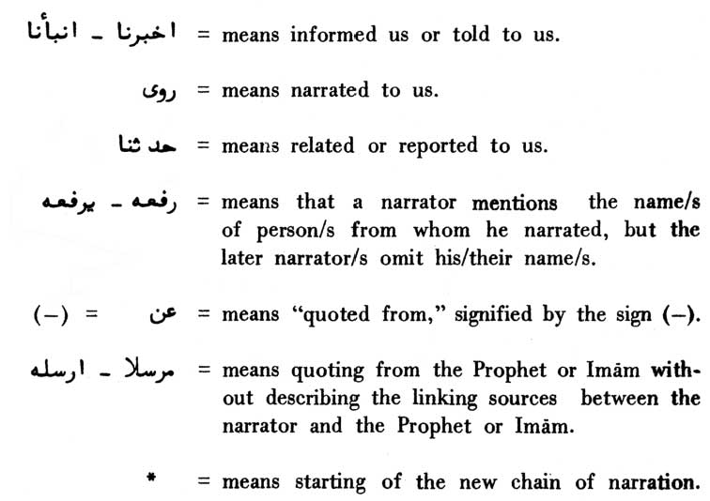

USŨL AL-KÃFI



INTRODUCTION



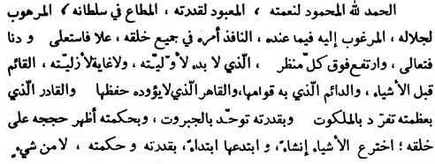

In the Name of Allãh, the Beneficent, the Merciful

All praise be to Allãh Who is praised for His bounties, worshipped for His Might, obeyed in His reign, feared for His Majesty. He possesses all things that allure, His commands pervade all through His creation. He is elevated to the extent He liked. He is too near to find, too high for everyone to see, Whose beginning has no beginning and Whose eternity has no end, Who existed before the existence of all things and Who is an eternal supporter of all things. The Conqueror Whom the preservation of the things does not tire. The Almighty Who is in a class by Himself in His sublimity throughout His realm, the unique in His Might because of His power. Who, out of His Wisdom, manifested His signs (proofs) and mercy for His creation. Who out of His Might and grief it will be on his

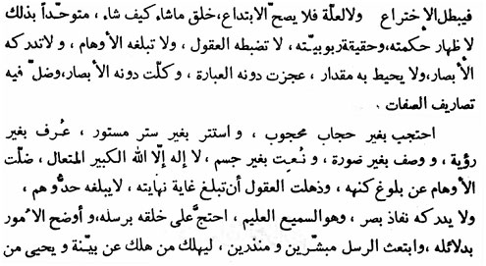

\* \* \* \* \* \* \*

Wisdom originated all things anew from the very beginning. Nothing existed (at that time) to falsify His being the originator (of all things), nor did any other cause (of creation) exist to nullify His being the (first) originator. All alone He created what He liked and as He liked to manifest His Wisdom and the truth of His being the Nourisher. Reason cannot grasp Him. Imagination cannot reach Him. Eyes cannot see Him. Measurement cannot encompass Him. Every explanation fails in His description. Eyes are blurred in seeing Him. Attributing different qualities to Him goes astray in His description.

He is veiled without any veil and is concealed without any covering. He is recognized without being seen and has been described as being formless. He is described as having no corporal form. There no God save Him, the great the elevated. Imagination goes astray in trying to reach the reality about Him (Godhood). Thoughts get con-founded in trying to reach His finality. No flight of fancy can touch Him. He is all knowing, all hearing. He (Allãh) has offered proofs (of truth and reality) through His messengers (peace be upon them) and has explained things through reasons. He has sent His messengers with glad tidings and due warnings. So that, if, thereafter one comes to

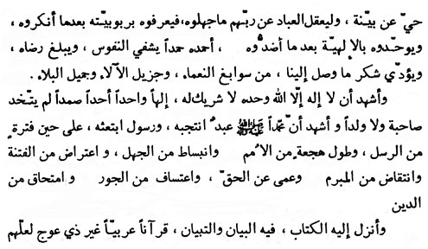

\* \* \* \* \* \* \*

so that people should understand what they do not know about their Lord and they should recognise God's Lordship after their having denied it. And, so that people should believe in His unity after believing in His plurality. To Him (Allãh) do we accord such a praise as is the solace of the souls, as secures God's pleasure and as will acquit us of our gratitude for His perfect bounties, abundant favours and graceful tests.

I am a witness to there being no God save Him. Who has no partner, the one, the eternally Besought and Who has taken no wife nor a son. And I have been witness to Muhammad (peace be upon him and his progeny), His select slave, and to his being sent as a messenger when the coming of such messengers had been suspended. The period when the nations were in deep slumber, when ignorance prevailed, distress and affliction were rampant, firm pledges were being violated, people were blinded against all truth, when oppression was in great vogue and honesty was being obliterated.

So (under the circumstances such as these) did Allãh send His book to him (Muhammad, the prophet) containing description and explanation (of all good), a book readable (Qur'an) in Arabic language totally free from all slant, so that mankind may guard itself against

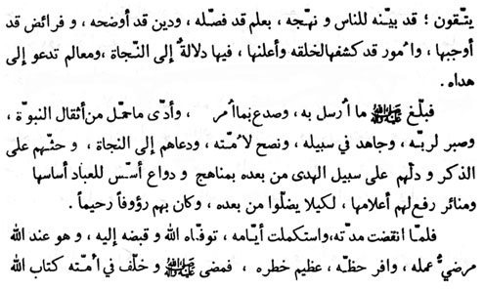

\* \* \* \* \* \* \*

every evil. This book (Qur'an) describes clearly before the people the distinct path (of truth) with reason and knowledge. It also elucidates the (divine) religion, describing the imperatives imposed on them by Allãh, the things which God has revealed and announced for the people. This book contains guidance for salvation, and is a milestone leading towards the right path.

The Prophet delivered what he received (from God) and acknow-ledged whatever was ordained. He bore the weight of the responsibilities of prophethood on him. He exercised patience to please His Lord. He strove in the way of God and consulted his people and called them towards their salvation. He roused them to the remembrance of God and guided them towards the right path. Afterwards he built the highways and erected the light house for the guidance of mankind and raised minarets, the flags of which fluttered high for the-people to watch. All this He did so that people should not go astray, since he (the Prophet) was very kind and merciful to them.

When his (Prophet's) period of life ended and his days were done, God took out his soul and brought it to Himself. Now he is with God in a state where God is pleased with each of his actions. He is venerable and his share of divine rewards is the greatest. He departed (from the

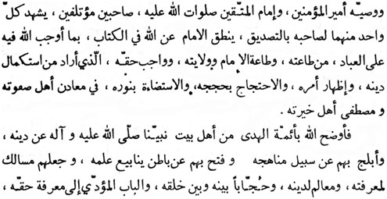

\* \* \* \* \* \* \*

world) and has left behind him the book of Allãh and his deputy (nominated executor, ‘Ali ibn Abī Tãlib) the chief of the believers and the guide (Imãm) for those who guard themselves against evil. May peace of Allãh be upon him. Both of them (the Prophet and `Ali, his executor) were comrades and close associates. Each one of whom bore witness to the integrity of the other. (‘Ali) the Imãm spoke for God about (the import) of His book (Qur'an) in respect of the imperatives, God has imposed upon the people for His obedience and the obedience of the Imãm (the divinely appointed guide). He also spoke (towards God), about the rule and rights of the Imãm, through whom God intended perfecting His religion, expressing His commands, offering His reasons and arguments and (finally) His effulgence (guidance).

He did all this through those who were the fountain spring of all divinely chosen, the unique, the righteous, belonging to the house (progeny) of our Prophet Muhammad, may peace of Allãh be upon him and upon his progeny. God the Almighty explained His religion through them and lighted through them the path that leads to Him and through them He unearthed the deep springs of divine knowledge. God appointed them as the milestones on the highways of God conscious-ness, sign posts for His religion and ushers between Himself and His

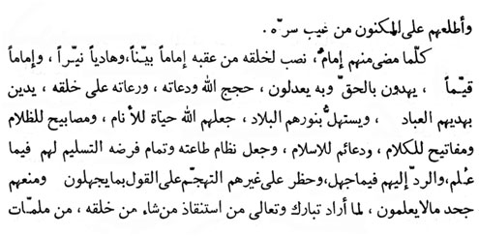

\* \* \* \* \* \* \*

creation. He made them the doorways which lead to divine rights, secrets and the realisation of obligations of God consciousness. Further, God informed them His secrets and mysteries.

Whoever among the Imãms died, he used to nominate after him his successor as a declared luminous, righteous guide (Imãm). Who would guide people (towards the Truth) and would be constant in his guidance. These guides (Imãms) called the people towards Allãh as His demonstrators and are designated by God as the patrons for His crea-tion. Because of their guidance the people adopt religion and Godliness and due to them the cities get illuminated (with Truth and guidance). God the Almighty designated them as the life and soul of the people, beacon lights in darkness, keys to the fort of knowledge and as the bedrock of His religion (Islam). God determined obedience and sub-mission to the Imãms as obedience and acme of submission to Himself and His religion, in respect of the commands known to them. Regarding God's commands unknown to them, God wanted them to refer to Imãm (to know the Truth), forbidding all other people to pass hasty verdicts. God also forbade them from rejecting them and not accepting the verdicts passed by the Imãms in respect of those divine commands they do not know. God did all this at the time He intended redeeming the people, He liked, from the curse of darkness (of misguidance), from

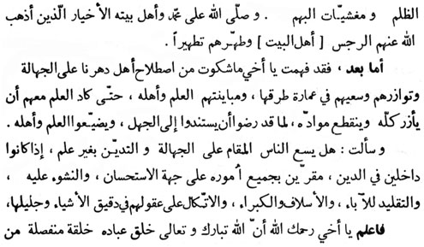

\* \* \* \* \* \* \*

the rampant ambiguity (in faith). May peace of Allãh be upon Muhammad and upon the folk of his house, the righteous, from whom Allãh wish as to wipe out uncleanliness away from them (the folk of the house) and cleanse them with thorough cleansing.

To come to the point, I have fully comprehended your complaint about the people of our lime how proverbially they are accustomed to ignorance and how they assist and help each other in rehabilitating its ways and means and in getting farther away from learnings and from the men of learning. Until the plant of learning not only gets dried up but is also completely uprooted from their life. It is because they have all helped in elevating the state of ignorance in wiping off learning and the men of learning.

And you have asked me whether it is proper for the people to take up a stand in ignorance and to adopt religion without knowing religion, behaving all its theories and concepts in all excellence, and also following it in every way. But they are doing it all blindly in following their fore-fathers, ancestors and their chiefs, completely relying upon their thoughts and reasons in matters (of religion) small or big.

Know thou, my brother, may God be merciful to you, verily, God the Almighty has brought human beings into existence as

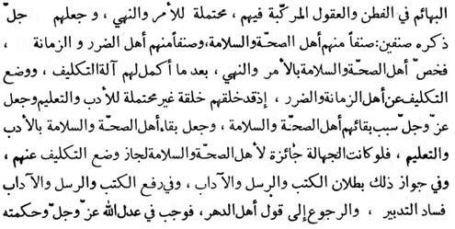

\* \* \* \* \* \* \*

distinct from the animals, in respect of intelligence and understanding of which they are compounded, and has imposed upon them the load of imperatives and preventives. Afterwards Allãh of the highest praised, has divided them into two categories - the healthy, the sound and the second the unhealthy and disable. God has singled out the former category for the enforcement of His imperatives and preventives after perfecting in them the (intelligence and understanding) the instrument of His (arduous) responsibility, and has relieved the disabled and the unhealthy of this heavy task of responsibility, as they have been created as beings quite unfit for the task of discipline and education. God has made the people of sound health the instrument of safety and preservation of the later category. And has made discipline and education as the instrument of safety and preservation of the former. Should ignorance have been made permissive for the former, the very responsibility (of imperatives and preventives)-would have been taken away from them. Once this is made permissible, the entire structure of divine books, prophet and education falls to the ground. In this case, the divine books, the prophets and their education would have been nullified and the whole set up would have come to naught. In that case we would have had to turn to the beliefs and concepts of atheism. Hence, Providence in its justice and wisdom

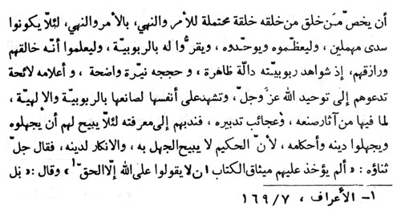

\* \* \* \* \* \* \*

requires from men (of sagacity) that they should, in view of their nature and the very purpose of their creation, single themselves out to shoulder the burden of certain imperatives and prohibitions, lest their existence may not be regarded as in vain and purposeless. And so that they should glorify God, regard Him as one, and acknowledge His Lordship. And so that they should know God to be the creator and their All-giver, since the evidence of His Lordship is manifest, His arguments are self-evident and His symbols are unmistakable. They (people of health, peace and sagacity) should invite mankind towards Unity of Allãh, the Almighty. They themselves bear witness, on the basis of their own existence that they have their creator, Who is their Lord, Who is worshipped. It is because there are wonderful signs of His Providence within themselves. Allãh Himself accorded to them God consciousness since, for Him it was not proper for such people to remain without His awareness and in ignorance of (His) religion and His commandments. It is because Allãh in His Wisdom deems ignorance about Him and the denial of His religion highly improper, as He Himself has said:

“Has not the compact of the Book been taken touching them, that they should say concerning God nothing but the truth? ...” (al-A‘rãf, 7:169).

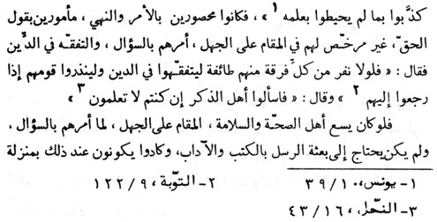

\* \* \* \* \* \* \*

Allãh has (also) said:

“...No; but they have cried lies to that whereof they comprehended not the knowledge, ...” (Yũnus, 10:39)

So mankind has been earmarked for (divine) imperatives and prohibitions and it has been ordained to speak the truth. Men have not been allowed to remain in ignorance (regarding the ultimate truth and the divine imperatives and prohibitions). Hence Allãh has ordained mankind to be interrogative (in this connection) and to acquire understanding in the religion (of Allãh) saying:

“...but why should not a party of every section of them go forth, to become learned in religion, and to warn their people when' they return to them ...” (at-Tawbah, 9:122)

Allãh has further said: “...Question the people of the remembrance, if it should be that you do not know ...” (an-Nahl, 16:43).

If it had been proper for the people of health and peace to remain ignorant, then God would have never ordered them to be interrogative, and the need for sending the prophets with the books and the codes would never have arisen. In that case all mankind would have been maimed

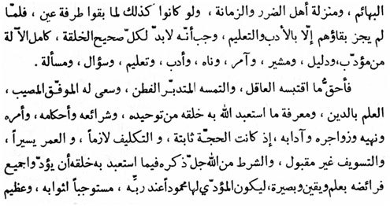

\* \* \* \* \* \* \*

and disabled and would have remained on the animal plane. Had all this been so, then all mankind would have been set at naught within the twinkling of an eye. When there is no justification for its (mankind) existence without a code and education, then it is incumbent on each and every perfectly sound individual to have a teacher, a guide, a director, a preventer, a code, an education and interrogation to discharge his responsibilities. The privilege of a sage and a lucky rightful and a brilliant statesman, is to endeavour in the acquisition of the know-ledge of religion and God consciousness on account of which God is worshipped by His creation, which (in essence) is God's unity, divine code, divine commandments, divine imperatives and preventives. His admonitions and His etiquette. If it is established that the divine proofs are there, that our responsibilities are evident, that our life span is very short, that evasion and procrastination are unacceptable, then the divine condition, on account of which God is worshipped by His creatures, is to discharge all divine obligations consciously, in true belief and with due insight, so that (the divine obligations) performer be deemed praiseworthy in the eye of God and be entitled to divine rewards in high compensation. Since the one who performs divine

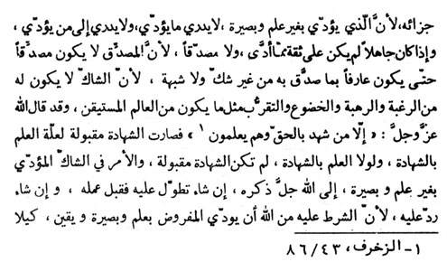

\* \* \* \* \* \* \*

obligations without knowledge and insight, does not really know what he has performed and in whose obedience he has done so; and because the ignorant can neither have any confidence in what have they done in the performance of divine obligations, nor can he truly believe in his deeds, for the simple reason that the believer can never believe unless he is the knower of the things he believes in, without the least doubt; and because of this reason, neither can the sceptic be like those who in all submission long for and fear God, nor can they have that nearness to God which a sage with true belief has. Thus has God observed:

“... Save such as have testified to the truth and that knowingly” (az-Zukhruf, 43:86).

Evidence is acceptable on the basis of the knowledge of what is, witnessed. Evidence without the knowledge of what is witnessed is not at all acceptable. In the case of a person performing divine duties in a state of doubt and uncertainty without the knowledge of insight (into them) is left to Allãh's Will either to accept it in His grace, or to reject it totally since the indispensable condition laid by God on the person for whom they (divine duties) are made imperative, is to act upon them with knowledge, insight and conviction, so that such people

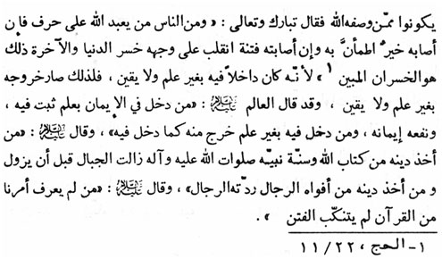

\* \* \* \* \* \* \*

may not be included among those whom God has described with the following words:

“And among men 'there is such a one as worships God upon the very edge - if good befalls him he is at rest in it, but if a trial befalls him he turns completely over; he loses this world and the world to come; that is indeed the manifest loss” (al-Hajj, 22:11).

For this reason, the entrance of such a type of man in religion without knowledge and belief in it and his exist also therefrom, is without knowledge and belief. The `Alīm (the Imãm) has observed:

“The faith of a man accepted knowingly remains steadfast, and is of profit for him. Whoever enters the house of faith without knowledge, makes his exit from that house in the same way in which he entered it.” The Imãm (peace be upon him) has said, “Whoever derives his faith from the knowledge of the Book of Allãh and the precepts of the Prophet of God (peace be upon him and his progeny) is more difficult to be dislodged from his faith than the mountains are, from their places. And the faith of a person derived from the words of the mouth of the, people is repudiated by the people themselves.”

The Imãm added, “He, who does not recognize our (Imãms from

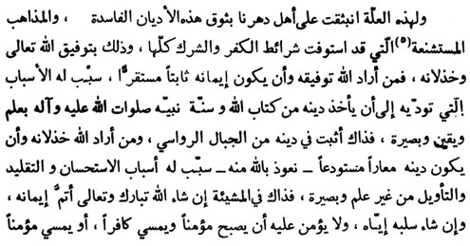

\* \* \* \* \* \* \*

the progeny of Prophet Muhammad - p.b.u.h.a.h.p.) case in the light of Qur'an, will not be able to turn the errors aside.”

For this reason false and detestable faiths fulfilling all the conditions of infidelity and polytheism hold their sway over the people of our time. All this, (the recognition and non-recognition of our position) depends upon the favour and disfavour of God. Whomsoever God grants His favour of keeping his faith steady, He also creates such conditions for him as will lead to derive his faith from the Book of Allãh and the precepts of Prophet (Muhammad) with knowledge, belief and insight. It is such people that are firmer in their faith than the high mountains in their places. Should God intend alienating Himself from a person, then, the faith He lends him is rendered superficial and temporary - may God protect us all from this situation. God provides such a person with ways and means on account of which he begins perceiving only the superficial beauty of every thing. He takes to following every thing blindly, and he starts interpreting (the scriptures) without knowledge and insight. The case of such a person entirely rests on the Will of God the Almighty whether to rectify his faith or to forfeit it from him altogether. Such a person cannot remain in peace when he is a believer in the morning and infidel in the evening or vice versa. All this is because

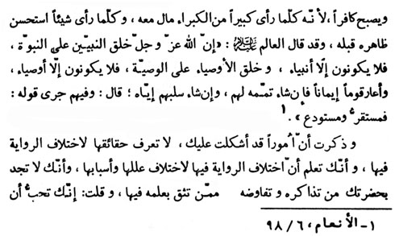

\* \* \* \* \* \* \*

he falls in for everything that appears great to him and accepts every-thing with a glittering appearance. The ‘Ãlim (the Imãm) - peace be upon him - has observed: “God, the Almighty has so created His prophets as to infuse prophethood into their blood and so they cannot remain except as prophets (peace be upon them all). He has also created their vicegerents in the same mode; so they cannot remain except as the vicegerents (of the prophets). He lent faith temporarily to another group of people, so that should He so like, He may perfect it into them or forfeit it from them altogether. These words of Allah hold true in the case of such people: “... And then a lodging-place, and then a repository, ...” (al-An‘ãm, 6:98).

You (the interrogator) have spoken of matters that are difficult for you. Your main difficulty is that you do not know the truth because of the conflicting versions of traditions coming from different narrators. And you know that conflicting versions of traditions have their own causes and effects. Further, your problem is that you do not find whether any expert knowledge (of the authenticity of narrators) can be

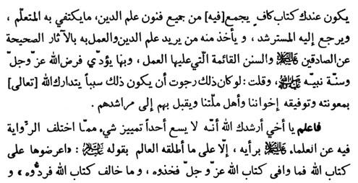

\* \* \* \* \* \* \*

relied upon and whom you can approach, talk to and have your problem solved. And for all this you earnestly want to have a book with you, inclusive of all branches of the science of religion, which could wholly satisfy all the students of religion and which seekers of guidance could turn to, and from which they could derive the specific knowledge of religion they intend to, and they could act thereon with genuine traditions from the truthful Imãms, (the divinely appointed guides) which (Book) ensures the practice on the codified divine law. And finally by means of which (Book) the divine obligations and the precepts of the prophet could be implemented. And you have said, “In case such a book is compiled then I can hope by God that with His grace and help it will lead our brethren in faith their and our (Muslim) community to their truthful guides - the Imãms.”

O’ brother! may God guide you. It is upto no person to discriminate between different versions of the traditions of the Imãms according to his own light and except on the basis of the verdicts (criterion) laid down by the Imãm himself. The verdict of the Imãm is: “Check it up with the text of the Book of God (Qur'an), accept it if it agrees with the text and reject it if it does not.”

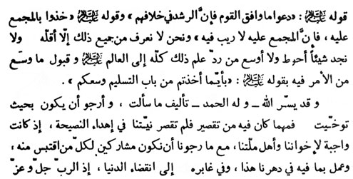

\* \* \* \* \* \* \*

The verdict further lays down, “Let alone the agreeing with what is on the lips of general people since the truth is just the opposite.” The third verdict lays down: “Accept what is held in common by all the narrators quoting us. Since there can be no doubt about what is unanimously held by all.” (The narrators of our traditions - ahãdīth. ) But, to our knowledge, very few such contradicting traditions can be solved on the basis of the above described criterion. In the case of such (contradicting) traditions the best, the simpler and the more compre- hensive solution is to leave all knowledge (regarding contradicting traditions) to the Imãm himself. Imãm has given us the easiest solution to choose and follow any of the version among such contradicting traditions. The Imãm has said, “Whatever you have accepted and followed with the 'intention of obeying (the Imãm) is valid for you.” Thus has Allah made (the task of selecting and collecting the traditions) easy. All praise is due to Allah, that He has enabled me to compile the book you have requested for. I hope this book will be after your liking. There may be some deficiency (in this work of mine) but there is none in the sincerity of intention to counsel my people, which is essential (especially) in the case of our brethren and co-relitionists. Simultaneously we ourselves earnestly desire to be among the participants deriving benefits (from this book) and among

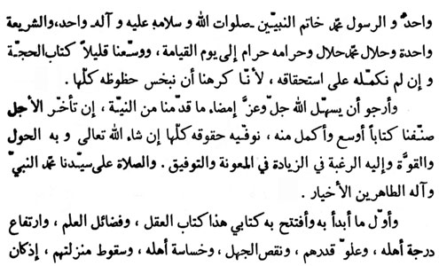

\* \* \* \* \* \* \*

those who act upon it in this age and in the ages hereafter coming, till the Day of Judgment. God the Almighty is one, His Prophet Muhammad (peace be upon him and his progeny) the last of the prophets, is one and the divine code is also one. What Muhammad, the Prophet (p.b.u.h.a.h.p.) declared to be unlawful is unlawful till the Day of Judgment. The chapter on divine proofs has slightly been expanded although the expansion is not in the measure the chapter deserves, since it was distasteful for us to reducing any portion thereof.

We hope that Allah, the great and the Almighty, will make it easy for us and will grant us further span of life for the fulfilment of our objective of making this chapter widest and fullest, in the manner it deserves, provided Allah wills since all power and might is His. With Him are all our longings for increased help and favour. May Allah's peace and blessings be upon our chief, Muhammad the Prophet and upon his progeny - the purified, the excellent.

I have commenced and inaugurated this book of mine with the chapter on reason, the greatness of knowledge, the great status of those who possess it, their high worth, the defectiveness of ignorance, the



\* \* \* \* \* \* \*

baseness of its possessor, and their lowered rank. Since reason is the axis on which every thing revolves, it is on the reason that all the argument rests. All divine rewards and punishments are in accordance with it. (It is Allah that grants the favour of reason.)

\* \* \* \* \* \* \*

USUL AL-KÃFI



The Book of REASON and IGNORANCE



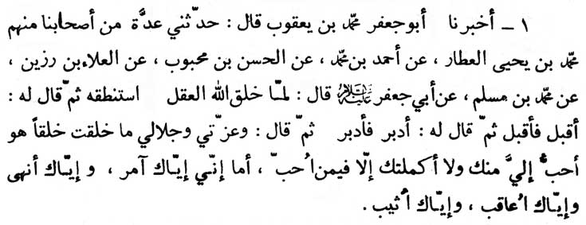

In the Name of Allãh the Beneficent, the Merciful

1. Abu Ja‘far Muhammad ibn Ya‘qub (al-Kulayni, the compiler of this book al-Kãfi) informed us (al-Kulayni's disciples) saying: “A group of our (al-Kulayni's) associates handed down this tradition. Muhammad ibn Yahya al-‘Attãr quoted Ahmad ibn Muhammad who quoted from al-Hasan ibn Mahbub who quoted from al-‘Ala’ Razin who quoted from Muhammad ibn Muslim on the authority of Abu Ja‘far (Muhammad al-Bãqir - peace be upon him), as saying:

‘When Almighty Allah created reason, He tested it. Then He ordered it to come forward and it came forward. Then He ordered it to go back and it went back. On this Almighty God said: I swear by my power and majesty that no creation of Mine is dearer to Me than you are, and I have only made you perfect in those whom I love.

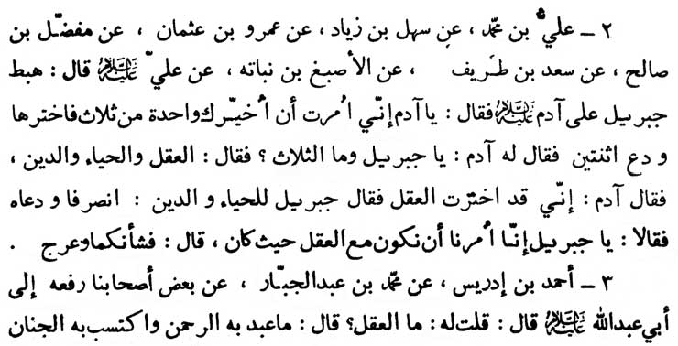

\* \* \* \* \* \* \*

Lo! To you are My orders and prohibitions addressed. And for you are My rewards and retributions reserved.’ “

2. ‘Ali ibn Muhammad (-) Sahl ibn Ziyãd (-) ‘Amr ibn ‘Uthmãn (-)Mufaddal ibn Sãlih (-) Sa‘d ibn Tarif (-) al-Asbagh ibn Nubatah (-) ‘Ali (ibn Abi Tãlib - p.b.u.h.) as saying :

“Jibrīl (Gabriel) came to Adam, and informed him: ‘O Adam! I have been ordered to let you choose one out of three things. Therefore, choose one and leave the other two.’ Adam asked: ‘What are the three things?’ He replied, ‘Reason, modesty and religion (din).’ Then Adam said: ‘I choose reason.’ So Jibrīl ordered modesty and faith to withdraw and leave reason but they said: ‘O Jibrīl! we both have been instructed (by God) to remain with reason wherever it may be.’ Jibrīl answered: ‘Then that is your situation,’ and he ascended towards Heaven.”

3. Ahmad ibn Idrīs (-) Muhammad ibn ‘Abd al-Jabbar (-) some of his associates (rafa ahu) who made a reference climaxing into Abu ‘Abdillãh (p.b.u.h.) that the narrator inquired of the Imãm;

“What is reason?” The Imãm replied: “Reason is that by which God is worshipped and a place in Paradise earned.” The Imãm was then asked: “What did Mu‘awiyah have?” The Imãm replied: “That

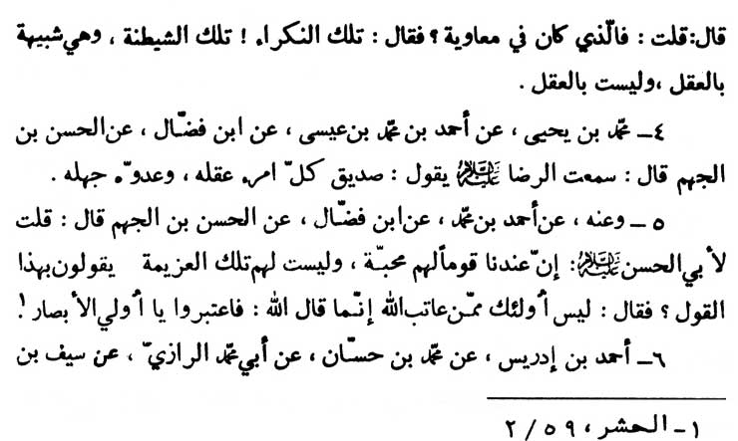

\* \* \* \* \* \* \*

was just wickedness and cunning, which seemed like reason, but it was not reason.”

4. Muhammad ibn Yahya (-) Ahmad ibn Muhammad ibn ‘Isa (-) Ibn Faddãl (-) Hasan ibn al-Jahm, as saying:

“I have heard ar-Rida (p.b.u.h.), as saying: ‘The friend of every man is his reason and his foe is his ignorance.’”

5. Muhammad ibn Yahya (-) Ahmad ibn Muhammad (-) Ibn Faddãl (-) al-Hasan ibn al-Jahm, as saying:

“I asked Abu'l-Hasan (p.b.u.h.) about a group of people that were among us who had love (for prophet and his progeny) but had not the resolution of will to confess the belief in your Imãmate. The Imãm replied: ‘Such men are not among those whom God will blame (for their failure in finding truth) verily, Allah has said: ‘...therefore take heed, O you have eyes.’ “ (al-Hashr, 59:2)

6. Ahmad ibn Idris (-) Muhammad ibn Hasan (-) Abi Muhammad ar-Rãzi (-) Sayf ibn ‘Amayrah (-) Is'hãq ibn ‘Ammar

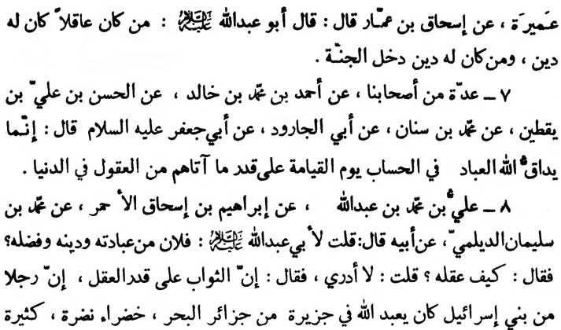

\* \* \* \* \* \* \*

(-) Abu ‘Abdillãh (p.b.u.h.) as saying:

“One who has reason has faith. And he who has faith will have a place in Paradise.”

7. A group of our (compilers') associates (-) Ahmad ibn Muhammad ibn Khãlid (-) al-Hasan ibn ‘Ali ibn Yaqtin (-) Muhammad ibn Sinãn (-) Abi al-Jãrud (-) Abu Ja‘far (p.b.u.h.) as saying:

“On the Day of Judgment, Almighty Allah will exact a detailed account from His servants, in exact proportion to the reason with which He had endowed them in the worldly life.”

8. ‘Ali ibn Muhammad ibn ‘Abdillãh (-) Ibrãhīm ibn Is'hãq al-Ahmar (-) Muhammad ibn Sulayman al-Daylami (-) his father, who said :

“I told Abu ‘Abdillãh (p.b.u.h.), ‘Such and such a person is praiseworthy for his devotion and religious practice.’ The Imãm inquired, ‘How his reason is?’ I replied, ‘I know nothing about his reason.’ Upon this, the Imãm explained, ‘The Divine reward is in relation to one's reason. There was a person from Bani Isrã'īl

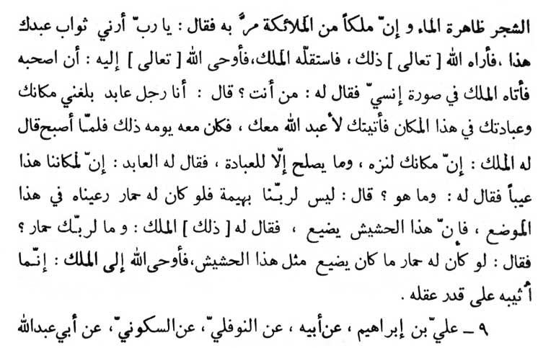

\* \* \* \* \* \* \*

who used to worship God devotedly in an island full of lush green and clear water. An angel happened to watch that person, asked God, ‘Kindly show me the rewards meant for that person.’ When the angel was shown the rewards by God, they appeared to be very little to him. Upon this God suggested to him to go and stay with that person (for some time). The angel appeared before that man in human guise. The man asked the angel, ‘Who are you?’ The angel replied, ‘I am also one of the devotees of God and I have heard about this place and your worship in it. Therefore, I have come to you so that I can also pray to Almighty God with you.’ So the angel stayed with him for a day. When it was morning, the angel remarked, ‘This is a pleasant place; no place could be better than this for worshipping God.’ Then the devotee-replied, ‘There is only one defect in this place.’ The angel asked what it was and the man replied, ‘My Lord has no animal. If He had a donkey, we could pasture it in this place, for the grass is going waste.’ The angel remarked, ‘Your Lord has no donkey?’ The man further said, ‘If He (Allah) had a donkey such a quality of grass would not be wasted.’ Then Almighty God revealed to the angel, ‘My rewards are in relation to a person's reason.’ “

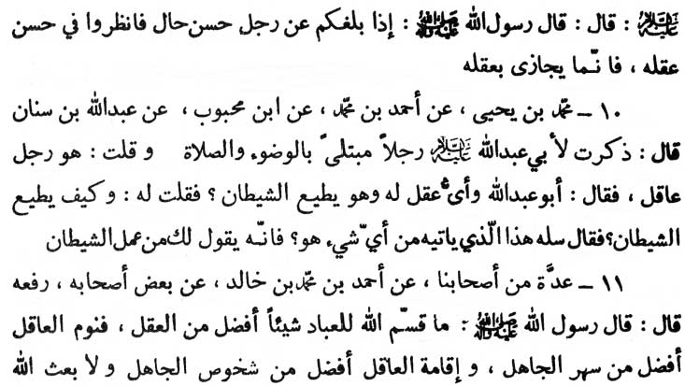

\* \* \* \* \* \* \*

9. ‘Ali ibn Ibrãhīm (-) his father (-) an-Nawfali (-) as-Sakuni (-) Abu ‘Abdillãh (p.b.u.h.) as saying:

“The Holy Prophet said, ‘Whenever you hear about the good act and behaviour (hal) of a man, you should consider the goodness of his reason, since the divine rewards are based upon ones reason.’ “

10. Muhammad ibn Yahya (-) Ahmad ibn Muhammad (-) Ibn Mahbub (-) ‘Abdillãh ibn Sinan as saying:

“I praised before (Imãm) Abu ‘Abdillãh (p.b.u.h.), the reason of a person who was wrought with anxiety about ritual ablutions and prayer. The Imãm remarked, ‘What reason has he got when he is actually obeying the Devil?’ I inquired of the Imãm, ‘How, is he obeying Shaytãn (Satan)?’ The Imãm replied, ‘Ask him from where this anxiety comes to him. Surely he will tell you that (it comes) from the work of Shaytãn.’ “

11. A group of our (al-Kulayni's) associates (-) Ahmad ibn Muhammad ibn Khãlid (-) some of his companions (rafa‘ahu) the Holy Prophet (p.b.u.h.a.h.p.), saying:

“Almighty God has endowed upon mankind nothing better than reason. The slumber of the man of reason is better than the waking

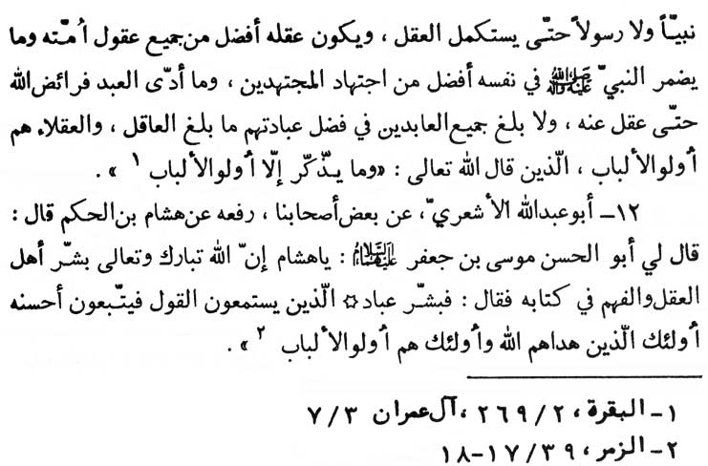

\* \* \* \* \* \* \*

hours of the ignorant. Comforts of the stationary life of the man of reason is better than the movement of the ignorant. God has sent no prophet nor messenger without first perfecting his reason. And his reason stands superior to all the reasons of (the people of) his community. What the Prophet has hidden in his heart is better than all the striving after knowledge of those who strive after it. No creature of God can ever discharge his obligations to God unless he comprehends them consciously. All the worshippers taken together cannot reach that height of excellence in their devotion to God as the man of reason does. The men of reason who are the possessors of understanding minds about whom God has said, ‘... But none mindeth save the possessors of understanding minds.” (al-Baqarah, 2:269; Ãl- ‘Imrãn, 3:7)

12. Abu ‘Abdillãh al-Ash‘ari (-) some of our (Shi'ite) narrators, (rafa'ahu) Hishãm ibn al-Hakam who states that Abu'l-Hasan Mũsã ibn Ja‘far (peace be upon them), addressed him thus:

“O’ Hishãm’ Almighty God has given good news to the people of reason and understanding to this effect, ‘... So bear thou the glad

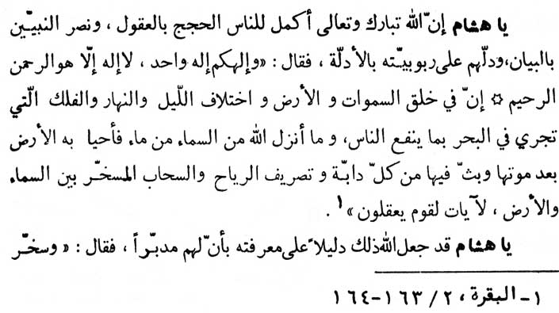

\* \* \* \* \* \* \*

tidings unto My servants. Those who hearken unto the word and follow the best of it; those are they whom God has guided and those they are men possessed of mind.’ (az-Zumar, 39:17-18)

“O’ Hishãm! It is through reason and understanding that God has completed evidence and proof (in respect of Himself and His religion) for mankind. He has helped His prophets and messengers by endowing them with the gift of elocution and guided them to comprehend His overlordship through reason and understanding. As He Himself has said: ‘And your God is one God! There is no god but He, the All-merciful, the All-compassionate. Surely in the creation of the heavens and the earth and the alternation of night and day and the ship that runs in the sea with profit to men, and the water God sends down from heaven therewith reviving the earth after it is dead and His scattering abroad in it all manner of crawling thing, and the turning about of the winds and the clouds compelled between heaven and earth - surely there are signs for a people having understanding.’ (al-Baqarah, 2:163-164)

“O’ Hishãm! This consciousness (that there is some Master mind working behind this cosmos) has been presented by God as a

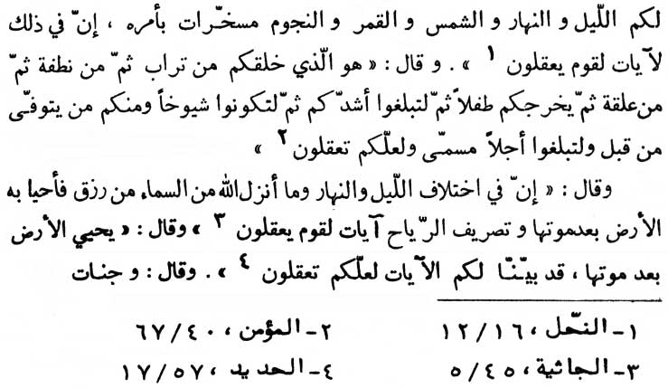

\* \* \* \* \* \* \*

proof and demonstration for His recognition as He Himself has declared: ‘And He subjected to you the night and day and the sun and moon; and the stars are subjected by His command. Surely in that are signs for a people who understand.’ (an-Nahl, 16:12)

“And He has further said, ‘It is He who created you of dust then of a sperm-drop, then of a blood-clot, then that you may come of age, then that you may be old men - though some of you there are who die before it - and that you may reach a stated term; haply you will understand.’ (al-Mu'min, 40:67)

“He has again said: ‘And in the alternation of night and day, and what God sendeth down from heaven, of the provision and therewith revives the earth after its death, and the turning about of the winds, there are signs for a people who understand.’ (al-Jathiya, 45:5)

“And He argued further, ‘...God revives the earth after it was dead, we have indeed made clear for you that haply you will understand.’ (al-Hadīd, 57:17)

“And He (God) argues still further: ‘... And gardens of vines,

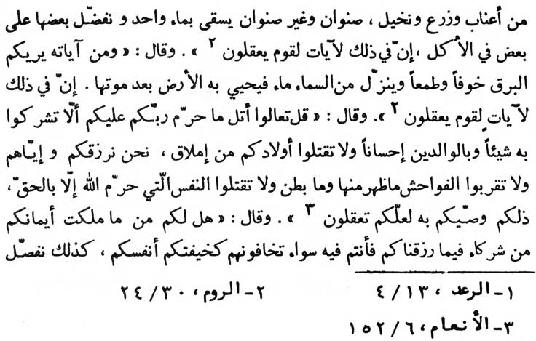

\* \* \* \* \* \* \*

and fields sown, and palms in pairs, and palms single, watered with one water; and some of them We prefer in produce above others. Surely in that are signs for a people who understand.’ (ar-Ra‘d, 13:4)

‘And of His signs He shows you lightning, for fear and hope, and that He sends down out of heaven water and he revives the earth after it is dead. Surely in that are signs for a people who understand.’ (ar-Rũm, 30:24)

‘Say: Come, I will recite what your Lord has forbidden you; that you associate not anything with Him, and to be good to your parents, and not to slay your children because of poverty; We will provide you and them; and that you approach not any indecency outward or inward, and that you slay not the soul God has forbidden, except by right. That then He has charged you with; haply you will understand.’ (al-An‘ãm, 6:152)

‘... do you have, among that your right hands own, associates in what We have provided for you so that you are equal in regard to it, you fearing them as you fear each other? So We distinguish the signs

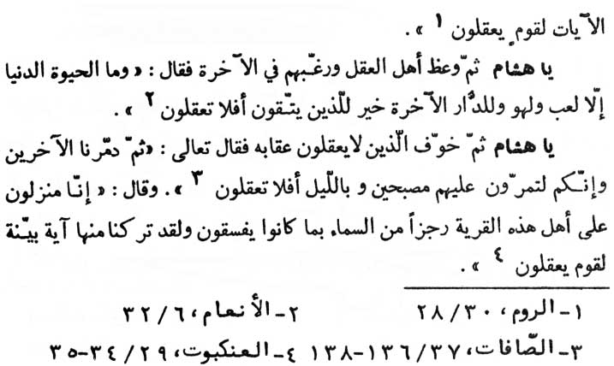

\* \* \* \* \* \* \*

for a people who understand.’ (ar-Rũm, 30:28)

“O’ Hishãm! God has counselled the people of reason and has drawn their attention towards the life hereafter with the words:

‘And the life of this world is naught but play and vain sport; certainly the abode of the hereafter, is the best for those who guard (themselves against evil). Do you not then understand?’ (al-An'ãm, 6:32)

“O’ Hishãm! God has put fear of His chastisement in the hearts of the people who do not act with reason and understanding to the affect, ‘Then We destroyed the others. And you pass by them in the morning and in the night; will you not understand?’ (as-Sãfãt, 37: 136-138)

“And He declared once again: ‘Verily, We are bringing down upon the people of this town a punishment from heaven for what they were transgressing. And indeed We have left a clear sign of it for a people to understand.’ (al-‘Ankabũt, 29:34-35)

“O’ Hishãm! remember that reason is in alliance with knowledge, as God has said: ‘And those similitude We strike them for the people, but none understands them save those who know.’ (al- ‘Ankabũt,29:43)

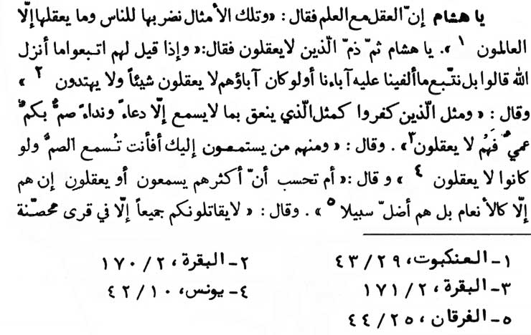

\* \* \* \* \* \* \*

“O’ Hishãm! God has further censured those who do not exercise their reason with the words: ‘And when it is said unto them, Follow what God has sent down. They say: No! but will follow such things as we found our fathers doing. What? And if their fathers had no understanding of anything, and if they were not guided?’ (al-Baqarah, 2:170)

“And God has said: ‘The likeness of those who disbelieve is as the likeness of one who shouts to that which hears nothing, save a call and a cry; deaf, dumb, blind – they do not understand.’ (al-Baqarah, 2:171)

“And God has said, ‘And some of them give ear to thee; what, wilt thou make the deaf to hear, though they understand not?’ (Yũnus, 10:42)

“And God has said, ‘Or deemest thou that most of them hear or understand? They are but as the cattle; nay, they are further astray from the way.’ (al-Furqãn, 25:44)

“And God has further declared: ‘They will not fight against you

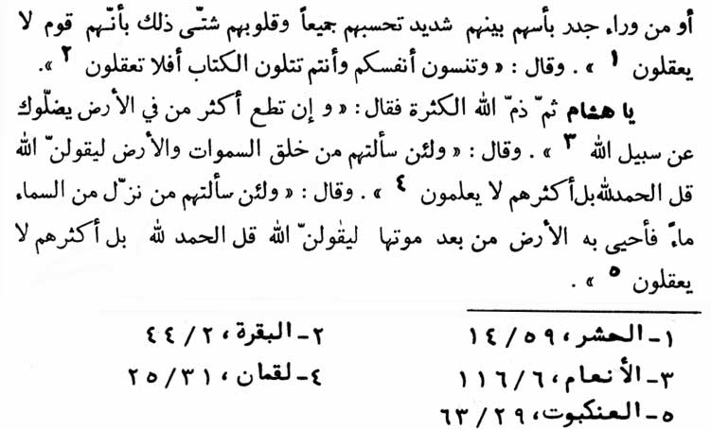

\* \* \* \* \* \* \*

all together except in fortified cities, or from behind walls. Their valour is great, among themselves; you think of them as a host; but their hearts are scattered; that is because they are a people who have no sense.’ (al-Hashr, 59:14)

“And God has further said: ‘... And (you) forget yourselves while you recite the Book? Do you not understand?’ (al-Baqarah, 2:44)

“O’ Hishãm! God has censured majority as a criterion of truth with the words, ‘And if thou obeyest the most part of those on earth they will lead thee astray from the path of God; ...’ (al-An‘ãm, 6:116)

‘And if thou askest them: Who created the heavens and the earth? Certainly they will say: God. Say : All praise belongs to God. Nay, but most of them have no knowledge.’ (Luqmãn, 31:25)

‘And if thou askest them: Who sends down out of heaven water, and therewith revives the earth after it is dead? Certainly (they) will say: God. Say: All praise belongs to God. Nay, but most of them have no understanding.’ (al-‘Ankabũt, 29:63).

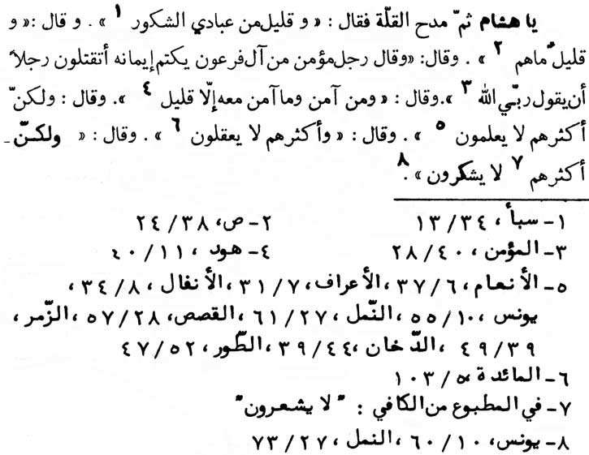

\* \* \* \* \* \* \*

“O’ Hishãm ! on the contrary, God has praised the minority with the words: ‘Few of My bond men are thankful.’ (Saba', 34:13) ‘...And few are they!’ (Sãd, 38:24)

‘Then said a (certain) man, a believer of Pharaoh's folk that kept hidden his belief: What, will you slay a man because he says: My Lord is God.’ (al-Mu'min, 40:28)

‘... and those who believed. And there believed not with him (Noah) but a few.’ (Hũd, 11:40)

‘... but most of them know it not.’ (6:37; 7:131; 8:34; 10:55; 27:61;28:57;39:49;44:39;52:47)

‘... and most of them have no understanding.’ (al-Mãidah, 5:103) ‘...but most of them are not thankful.’ (Yũnus, 10:60; an-Naml, 27:73)

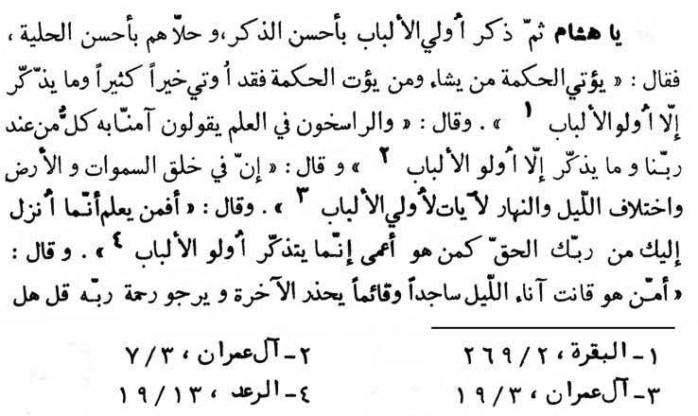

\* \* \* \* \* \* \*

“O’ Hishãm! Almighty God has mentioned about the people of reason in high terms and has adorned them with the finest ornaments as per his own words:

‘He gives the Wisdom to whomsoever He will, and whoso is given the Wisdom, has been given much good; yet none remembers but men possessed of minds.’ (al-Baqarah, 2:269)

‘... And those firmly rooted in knowledge say: We believe in it; all is from our Lord; yet none remembers, but men possessed of minds.’ (Ãl ‘Imrãn, 3:7)

‘Surely, in the creation of the heavens and the earth and in the alternation of night and day, there are signs for men possessed of minds.’ (Ãl ‘Imrãn, 3:190)

‘What, is he who knows what is sent down to thee from thy Lord is the truth, like him who is blind (void of knowledge)? Only men possessed of minds will remember.’ (ar-Ra‘d, 13:19)

‘What (this) he who is prayerful during the hours of the night, prostrating in obedience and standing, he being afraid of the world to come and hoping for the mercy of his Lord! Say: Are they equal

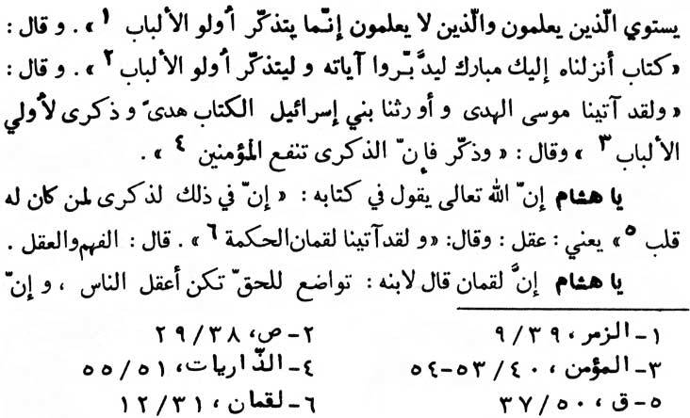

\* \* \* \* \* \* \*

- those who know and those who know not? Only men possessed of minds remember.’ (az-Zumar, 39:9)

‘(O’ Our apostle Muhammad!) A Book We have sent down to thee, Blessed, that men possessed of minds may ponder its signs and so remember.’ (Sãd, 38:29)

‘We also gave Moses the guidance and We bequeathed upon the Children of Isra'īl the Book for a guidance and for a reminder to men possessed of minds.’ (al-Mu'min, 40:53-54)

‘And remind; surely the Reminder profits the believers.’ (adh-Dhãriyãt, 51:55)

“O’ Hishãm! Almighty God has said in His Book: ‘Surely in that there is a reminder to him who has a heart ...’ (Qãf, 50:37). Heart means reason. And, God has further said: ‘Indeed We gave Luqmãn wisdom’ (Luqmãn, 31:12). Wisdom means (the capacity of) understanding and reasoning.

“O’ Hishãm! Luqmãn the sage counselled his son: ‘If you bow before the Truth and the Inevitable, you will be the wisest among

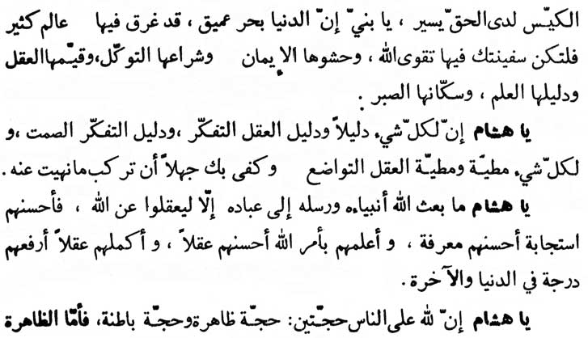

\* \* \* \* \* \* \*

men, since a wise man treats himself as of little account before the Truth and the Inevitable. O’ my son! this world is like an unfathomable ocean in which many a creation had drowned. Make therefore the fear of God your boat in this ocean; your faith, the main plank of the boat; reliance on God as its sails; the reason as its rower; knowledge as its captain, and patience as its anchor.'

“O’ Hishãm! everything has its indicator. Man's thoughtfulness is the hall-mark of his reason. The symbol of thoughtfulness is silence. Everything has its climax and the climax of reason is humility. It is enough to prove your ignorant and unwise if you act in contravention of what has been prohibited by God.

“O’ Hishãm! God has deputed the prophets as His messengers to make the people wise and mindful of God. The more they accept and believe in these messengers the greater is their God-consciousness. The wisest among men is he who knows about Godliness most. And he who is the most perfect in his reasoning enjoys the highest status among men, in this life and the life hereafter.

“O’ Hishãm! God has given two proofs for the guidance of man-kind. - the explicit and the implicit. The explicit and the

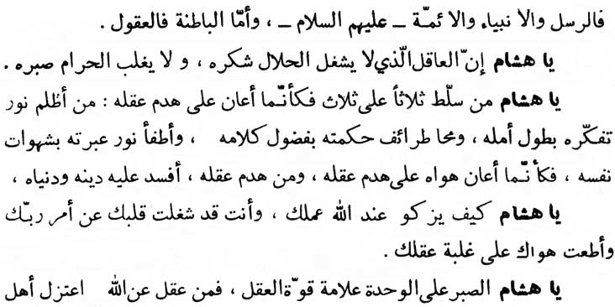

\* \* \* \* \* \* \*

external proof is in the form of prophets, divine messengers and the Imãms (divinely appointed guides); and, the implicit and the internal proof is in the form of reasoning and understanding.

“O’ Hishãm! a man of reason is not only grateful to God for his lawful (means of living) nor does the (attraction of) unlawful gains wear out his patience. (A man of reason is also grateful to God for His spiritual bounties.)

“O’ Hishãm! one who allows a set of three things to be dominated by another set of three things has actually undone reason. The first thing is to allow the reason to be dominated by excessive hopes and expectations. The second thing is to allow highest of wisdom to be dominated by excessive utterances. The third thing is to allow his admonition light to be extinguished (to be dominated) by carnal desires. In fact, such a person undoes his reason by his carnal desires. And one who destroys his reason (as illustrated in the three cases) also destroys both his worldly life and his faith.

“O’ Hishãm! how could your conduct be clean in the eyes of God when you have alienated your heart from God and His commandments and when you have been subservient to your carnal desires to the point of your reason being dominated by them (carnal desires).

“O’ Hishãm! to be patient in loneliness is a sign of the power of

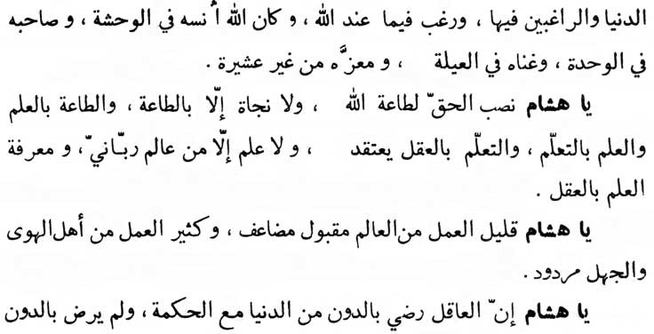

\* \* \* \* \* \* \*

reason. One who acquires reason from God (i.e., from His Book and His prophets and their vicegerents - the Imãms) has succeeded in keeping himself aloof from people of the world and from those who are lost in worldly life. Such a man turns his attention to what God holds instead of what people have. The result of all this is that God Himself becomes his solace in his discomfiture, and ally in his loneliness, wealth in his poverty, and his honour without the backing of any tribe.

“O’ Hishãm! truth is a sign for obeying God (truth leads to obey God). And there is no salvation except through obedience to God. Obedience to Him can only be performed by means of knowledge. And knowledge is a matter of acquisition, and this acquisition is through reason and intellect. And there can be no knowledge except through the learned in divinity. And the consciousness of knowledge is through reason and intellect.

“O’ Hishãm! virtuous conduct of a learned man, though limited, is acceptable (to God) at many times its value. On the contrary, virtuous conduct of a greedy, lustful, and ignorant person is totally rejected.

“O’ Hishãm! limited material possessions with sound wisdom are perfectly acceptable to a man of reason. Whereas unlimited material possessions with little wisdom are not at all

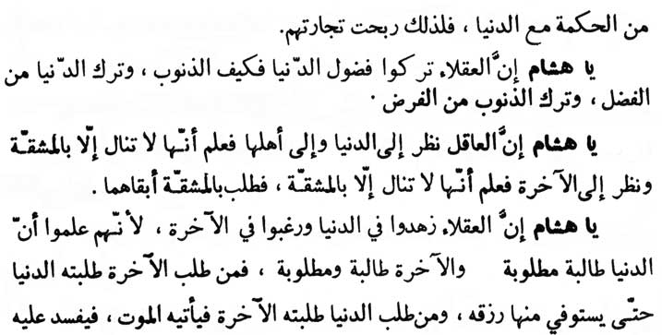

\* \* \* \* \* \* \*

acceptable to him. This is why such people have actually earned profit in the trade (of their life).

“O’ Hishãm! what to speak of the sinful life when the people of reason abandon even its superfluity! Forsaking its superfluity is excellence and honour while forsaking the sinful life is obligatory.

“O’ Hishãm! Lo! A man of reason pondered over the world and its people. He realised that he could not get the success in worldly life without hard struggle. Then he pondered over the life hereafter and again realised that the success in life hereafter would not also be secured without hard struggle. Thereupon the man of reason decided in favour of the struggle which brought eternal success, as compared with the temporary one of the worldly life.

“O’ Hishãm! The wise people remain detached from the worldly possessions and its attractions, and they remain attached to life hereafter. It is because they have realised that the world lures and is lured by the people. In the same way, the life hereafter also lures and is lured. But the world itself runs after the man who struggles for the life hereafter to the extent that he receives in full what share is allotted to him from his worldly life. On the contrary, one who spend his life and struggles for the worldly gains till such time as the life hereafter demands his own share in the form of death; it is then that he realises that he is the loser of both, the life

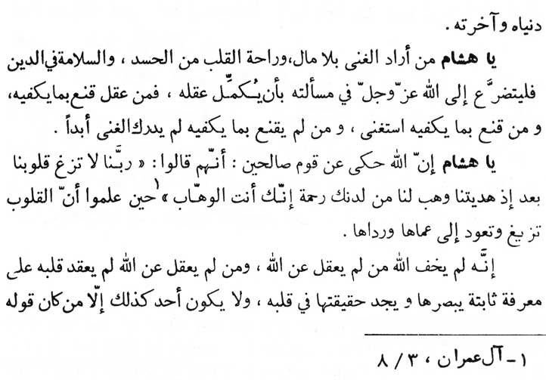

\* \* \* \* \* \* \*

here and the life hereafter.

“O’ Hishãm! whoever seeks contentment without wealth and desires solace free from jealousy and security for his faith, must implore God from the bottom of his heart for making his reason perfect.

Since one who acts with reason remains contented over what suffices his genuine needs and whoever is contented over what suffices his needs becomes actually rich and without want. And he who is not satisfied with what is enough for him can never be contented.

“O’ Hishãm! Almighty God has related about a group of virtuous people who used to pray:

‘Our Lord, make not our hearts to swerve after that Thou hast guided us; and give us mercy from Thee; Thou art the Giver.’ (Ãl ‘Imrãn, 3:8)

In offering this prayer, they realised that human hearts could be deflected and could retrograde towards blindness and lowness. Secondly, they also learnt that those who don't seek guidance and

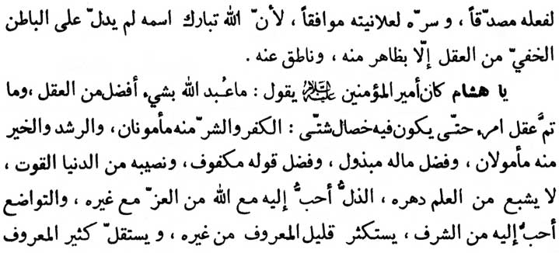

\* \* \* \* \* \* \*

reason from God, are the people who are not afraid of God's (punishments) at all; and, whoever is deprived of reason by God can never be firm and steady in God consciousness in a way as to enable him to see and find the truth about God in his own heart. No one can reach this stage unless his deeds corroborate his words and what is within him is in full accord with what is without him. Since God the Almighty never guides the inside of the reason, except what comes out of it through deeds and the words.

“O’ Hishãm! ‘Ali (the first Imãm), Amīr al-mu'minīn (p.b.u.h.) the Chief of the believers, used to say: ‘Of all the observance and devotions offered to God the best one is of and by (the people of) reason. Reason of a person does not reach perfection unless it possesses some specific characteristics. The Characteristics are:- (1) It gives immunity against disbelief and evil; (2) Virtue and true guidance is expected to flow from such a man (of reason); (3) He expends his superfluous wealth in good deeds; (4) He protects himself from irresponsible gossips; (5) His share in the worldly life amounts to what is needed for his subsistence; (6) He is never fed up with knowledge throughout his life; (7) Humiliation in pursuit of (belief, obedience and favour of) God is dearer to him than any honour in pursuit of things other than God; (8) Humility is dearer to him than any dignity; (9) He regards the little good of others to him as much and the good from him to others as little; (10) He regards all the people as better

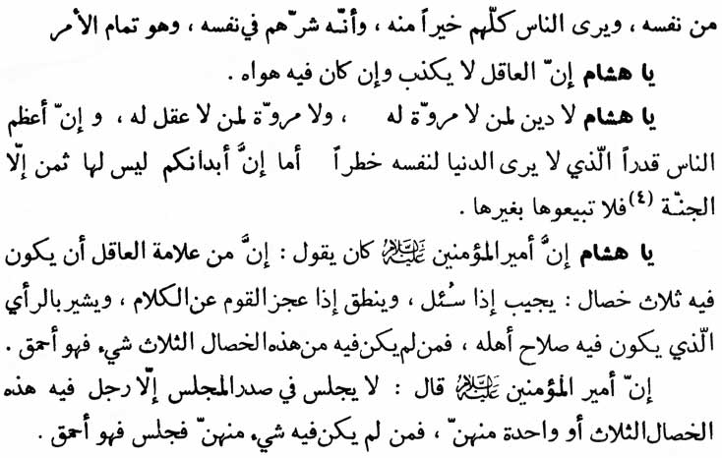

\* \* \* \* \* \* \*

than himself and regards himself in the heart of his heart as of little consequence.’ This is the climax.

“O’ Hishãm! the wise man never lies in spite of his desire to do so.

“O’ Hishãm! he who has no manliness, has no religion and he who has no reason has no manliness. The greatest man is he who never deems himself equal in value to the worldly life. (He deems himself very high in value to worldly material possessions.) Verily, your bodies cannot be sold except in exchange for Paradise. Hence, don't sell for any thing below Paradise - God's supreme and eternal bounties.

“O’ Hishãm! Amīr al-mu'minīn ‘Ali (p.b.u.h.) used to say: ‘Of the signs of a man of reason, one is that he has got three characteristics: (i) He replies only when he is questioned; (ii) Speaks when all others fail; and (iii) Advises what is suitable for the good of a person. One who has none of these three said qualities is stupid.'

“Amīr al-mu’minīn (‘Ali p.b.u.h.) further added:

‘No one should preside over a meeting except when he possesses either all the three or at least one of the above qualities. If a person without having the three or (at least) any one of the three said qualities presides over a meeting then he is just stupid.’

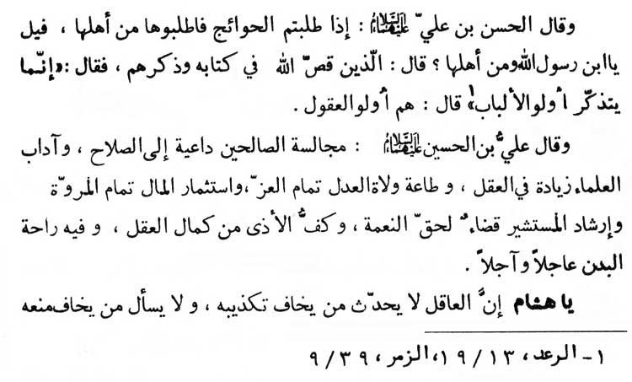

\* \* \* \* \* \* \*

“Imãm Hasan ibn ‘Ali (p.b.u.t. - the second Imãm) has said, ‘Whenever you seek fulfilment of your needs, seek them from chose who are competent to do so.’ The interrogator asked, ‘O’ son of the Prophet! Who are those competent people?’ Imãm Hasan replied, ‘They are those whom Almighty God has described and has remembered them with the words: “But only men of understanding heed” (ar-Ra‘d, 13:19; az-Zumar, 39:9).’ The Imãm further explained that the competent people (referred to above) are the people of reason and understand.

“Imãm All ibn al-Husayn (p.b.u.t. - the fourth Imãm) has said, ‘Being in the company of the virtuous people is a source of good. And to trouble the learned (being in their company and being interrogative with them) improves our reason and understanding. Obedience to the just rulers enhances our power. Expending money (in virtuous deeds) is the climax of manliness. Directing properly a person who asks for your advice is the due discharge of one's obligations on God's bounties received to him. It is the climax of intellect and reason to restrain your-self from doing harm to others. In this lies the happiness of both the life here and the life hereafter.'

“O’ Hishãm! the man of reason does not speak in the presence of

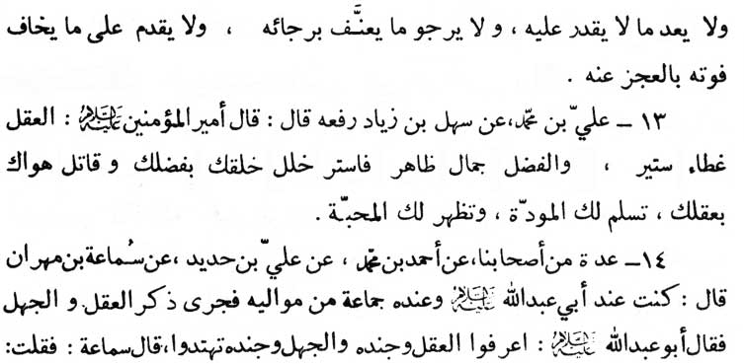

\* \* \* \* \* \* \*

a person who he fears will falsify his statement. Never does he ask for anything from a person who he fears will refuse it. Never does a man of reason make a promise which he thinks he cannot fulfil. Never does he entertain any hope for a thing which he fears he will be reprimanded for. And never does he take any initiative in a task in which, he fears, he will fail because of his disability.”

13. ‘Ali ibn Muhammad (-) Sahl ibn Ziyãd (rafa’ahu) [related the following tradition without mentioning the source] quoted Amīr almu'minīn, the Chief of the believers, as saying:

“Reason is the best covering curtain, while accomplishment is an external beauty. Then cover your flaws by your accomplishment and eliminate your evil desires with your reason. This will compel you to such an extent that it (love for you) will manifest itself openly.”

14. A group of our associates (-) Ahmad ibn Muhammad (-) ‘Ali ibn Hadīd (-) Samã‘ah ibn Mihrãn as saying:

“I was in the presence of (Imãm) Abu ‘Abdillãh (p.b.u.h.). Once, he (the Imãm) was in the company of his followers and his disciples. And there ensued a discussion about Reason and Ignorance.

“(Imãm) Abu ‘Abdillãh observed: ‘Recognise Reason and its paraphernalia, and also recognise Ignorance and its paraphernalia. If you do so, you will receive guidance.’”

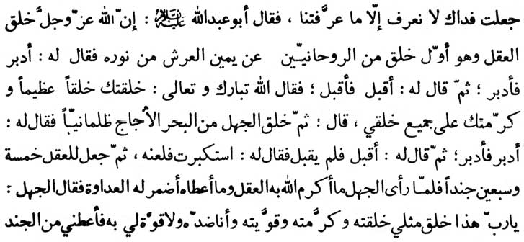

\* \* \* \* \* \* \*

Samã‘ah (one of the audience) said, “May my life be sacrificed for you, we know not except what you have taught us.” Upon this (Imãm) Abu ‘Abdillãh (p.b.u.h.) explained: “Lo, Almighty God created the Reason out of His Own Light on the right side of His throne and it was the first creation among the spirits. After its creation Almighty God commanded it to go back (to life in this world) the intellect (Reason) obeyed the order. Then God commanded it to come forward (towards) Him. The intellect did accordingly. Upon this, God addressed it with the words, ‘I have created you in all your glory and bestowed upon you the honour and preferences over all of My creatures.’ After-wards, Almighty God created Ignorance out of the dark and saltish ocean and ordered it to go back (to life in this world). Ignorance did accordingly. Then God ordered it to come to Him (life hereafter). Ignorance did not obey the command. Therefore, God addressed it thus: ‘You are conceited,’ and then God cursed it.

“Afterwards Almighty God bestowed seventy-five armies on Reason. When Ignorance 'observed how God has honoured Reason and how God bestowed upon it the armies, feeling of hostility sprang in its breast; and Ignorance addressed God, ‘O’ my Lord! Reason is a creation as I am, you have created it, honoured it, and also strengthened it with the armies of capabilities, and I am exactly the opposite of it. I have not been strengthened (to compete with it). Hence bestow upon me the armies (capabilities)

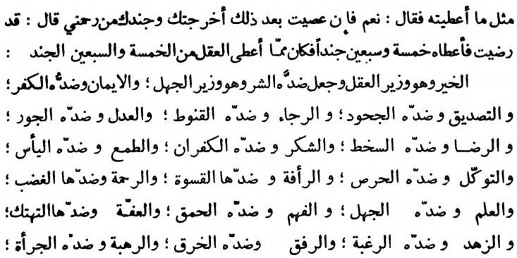

\* \* \* \* \* \* \*

as you have done on Reason.’ The Almighty God accepted its request and said, ‘Should you defy My orders again I shall dismiss you and your allies from My clemency.’ Ignorance said, ‘I accept (the condition).’ The Almighty God bestowed upon it seventy-five forces.”

Good which has been appointed as the wazīr (vizier) of Reason is the opposite of Evil which, in its turn, is the wazīr of Ignorance; Faith and Belief, opposite of which is Disbelief; Confirmation, the opposite of which is Repudiation; Hope, the opposite of which is Frustration; Justice, the opposite of which is Oppression; Divine Pleasure, the opposite of which is (divine) displeasure; Gratitude, the opposite of which is Ingratitude; Optimism (in respect of all good in this life and the life hereafter), the opposite of which is Pessimism; Complete Reliance on God, the opposite of which is Lust and greed (which is the result of distrust in God); Kind heartedness, the opposite of which is Hard heartedness; Mercifulness, the opposite of which is Indignation; Knowledge, the opposite of which is Ignorance; Wisdom, the opposite of which is Stupidity; Chastity, the opposite of which is Shamelessness; Renunciation (from what God has declared to be unlawful), the opposite of which is Temptation; Friendliness and Sociability, the opposite of which is Stupidity and Awkwardness (which doesn't enable a man to adjust himself to the society); Divine Fear, the opposite of which is

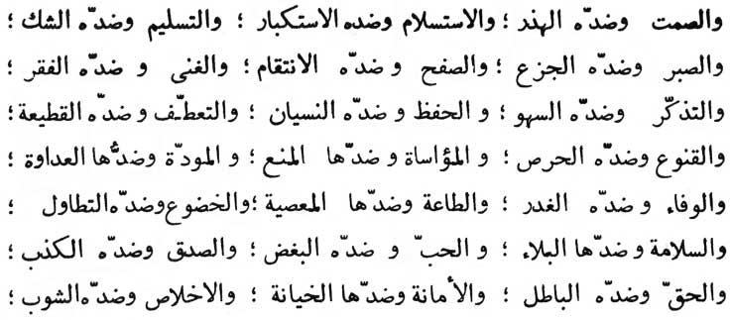

\* \* \* \* \* \* \*

Audacity; Humility, the opposite of which is Conceit; Ease, the opposite of which is Hastiness; Forbearance, the opposite of which is Insolence and shallowness of mind; Silence, the opposite of which is Garrulity; Resignation to God, the opposite of which is Conceit and defiance; Acceptance, the opposite of which is Scepticism. Patience, the opposite of which is Impatience and restlessness; Forgiveness, the opposite of which is Vengeance; Contentment, the opposite of which is Neediness; Remembrance (of God and the life hereafter), the opposite of which is Forget-fullness and indifference; Keeping (in mind), the opposite of which is Forgetfulness and oblivion; Sympathy (with others), the opposite of which is Estrangement and alienation; Contentment, the opposite of which is Greed; Consolation, the opposite of which is Forbiddance; Amity, the opposite of which is Enmity; Fidelity, the opposite of which is Treachery; Obedience (to God and His prophets), the opposite of which is Defiance and disobedience (to them); Submission, the opposite of which is Domination; Safety and Security, the opposite of which is Calamity and peril; Love, the opposite of which is Hatred and detestation; Truthfulness, the opposite of which is Falsehood; Right, the opposite of which is Wrong; Discharge of Trust, the opposite of which is Defalcation; Sincerity (purity of motives), the opposite of which is Hypocrisy (mixed motives);

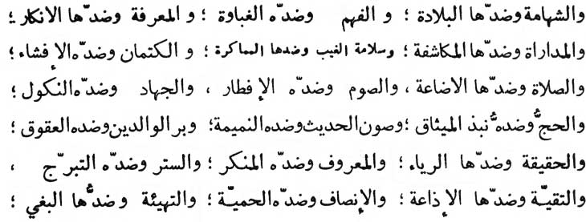

\* \* \* \* \* \* \*

Gallantry, the opposite of which is Cowardice; (Understanding, the opposite of which is Stupidity; Knowledge [of God and His religion], the opposite of which is [their] denial).

Affability and Toleration (which leads to the keeping of secrets of others), the opposite of which is Exposure and Betrayal; Soundness and, good faith for others behind their back, the opposite of which is Cunning and Double-talk. Covering the secrets (of others), the opposite of which is their exposure; Observance of prayers, the opposite of which is the neglect of prayers; Observance of Fast, the opposite of which is Gluttony; Struggle (in propagating truth), the opposite of which is the withdrawal from it. Performance of Pilgrimage at Mecca, which means the observance of pledge made to God before creation (i.e. not to worship any one except Allah), the opposite of which is Violation of that Pledge; Concealing the tales of others, the opposite of which is tale-bearing; Doing good to Parents, the opposite of which is disobeying and disregarding their rights; Reality as against display; Good as against being bad; Self-concealment and Self-restraint (in respect of one's capabilities) as against self-adornment and self-aggrandisement; Guarding the secret of religion from the enemies to save life as a measure of strategy as against its senseless disclosure involving loss of prestige and life; Doing justice as against partiality; Organisation in human society (i.e. cordiality of social relations) as against iniquity and injustice;

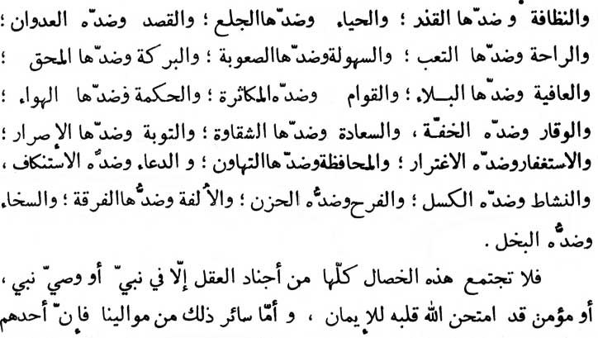

\* \* \* \* \* \* \*

Purity and refinement as against. impurity and coarseness; Modesty as against immodesty; Moderation as against extravagance; Cheerfulness and freshness of heart as against fatigue and depression; Facility as against adversity; Blessing and enrichment as against wretchedness and eradication; [Safety and Good Health as against calamity and affliction;] Steadfastness as against garrulity; Wisdom as against worldly possessions;

Prestige and reverence as against lowness and lightness; Happiness and felicity as against unhappiness and misery; Repentance and penitence as against persistence, in sinful life; Repentance (i.e. asking God for forgiveness) as against deception and guile over one's sins; Preservation (of one's capabilities and possessions) as against negli- gence and carelessness; Prayerfulness to God as against turning away from Him; Liveliness with briskness as against dullness with sloth; Delightfulness as against sadness; Friendship, intimacy and union against separation and disunion; Generosity as against miserliness. All the said high qualities which serve as a powerful army of Reason are never concentrated in any single individual except in a Prophet, his vicegerent and a believer whose faith has duly been

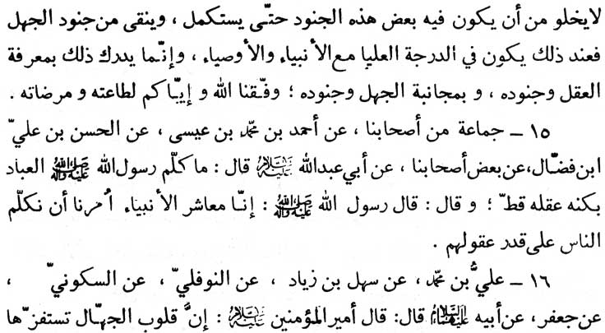

\* \* \* \* \* \* \*

tried and tested by the Almighty God. And there is no friend of ours (divinely appointed Imãm) who does not possess any of these qualities but also possess at the same time some of the disabilities allotted to ignorance until he develops his Reason to perfection and eradicates the disability accruing from ignorance. It is at this stage that he is installed in the high ranks at par with the prophet and his vicegerents. This higher status is achieved through the recognition of Reason and its formidable army and after keeping aloof from ignorance and its allies. May God grant us the ability to obey God and earn His pleasures.

15. A group of our (al-Kulayni's) associates (-) Ahmad ibn Muhammad ibn 'ha (-) al-Hasan ibn ‘Ali ibn Faddãl (-) some of our associates (-) Abu ‘Abdillãh (p.b.u.h.) as saying:

“Never did the Prophet of Islam address the people according to the full extent and depth of his own reason. (On the contrary) the Prophet used to say, ‘We the group of prophets have been ordained (by God) always to speak to the people according to their mental capacity.’ “

16. ‘Ali ibn Muhammad (-) Sahl ibn Ziyãd (-) an-Nawfali (-) as-Sakũni (-) Ja‘far (as-Sãdiq) (-) his father (Muhammad al-Bãqir - p.b.

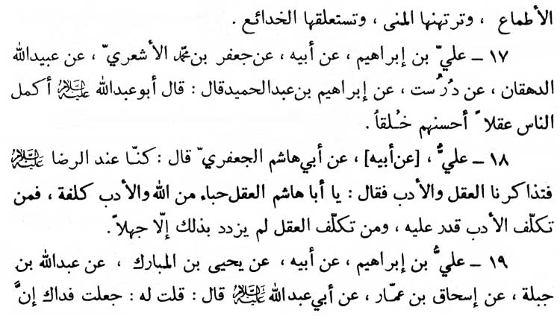

\* \* \* \* \* \* \*

u.h.) (-) Amīr al-mu’minīn (Ali - p.b.u.h.), as saying :

“Hearts (emotions) of the rustic are instigated by lust. Their longings imprison them and their hearts are trapped into illusions and deceptions (of life).”

17. ‘Ali ibn Ibrãhīm (-) his father (-) Ja‘far ibn Muhammad al-Ash‘ari (-) ‘Ubaydillãh al-Dihqãn (-) Durust (-) Ibrãhīm ibn ‘Abdi'l-Hamīd (-) Abu ‘Abdillãh (p.b.u.h.) as saying :

“In point of reason the most perfect man is he who has the noblest bearing.”

18. ‘Ali (-) his father (-) Abi Hãshim al-Ja‘fari said:

“We were in the company of (Imãm) ‘Ali ar-Ridã (p.b.u.h.), when a discussion about reason, education and culture ensued. The Imãm observed, ‘O’ Aba Hãshim! Reason and Intellect is a free gift of Allah, but education and culture are a laborious acquisition. One who takes pains in their acquisition acquires them. And one who takes pains in acquiring intellect promotes nothing but his own ignorance.’ “

19. ‘Ali ibn Ibrãhīm (-) his father (-) Yahya ibn al-Mubãrak (-) ‘Abdullãh ibn Jabalah (-) Is'hãq ibn ‘Ammãr (-) Abu ‘Abdillãh

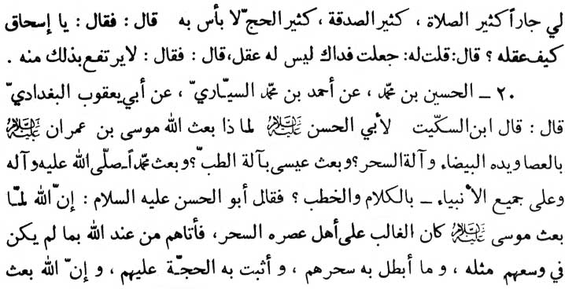

\* \* \* \* \* \* \*

(p.b.u.h.) as saying :

“My neighbour is the most devout in his prayers, in giving alms and in performing pilgrimages. Nor is there anything bad in his composition.” The Imãm asked (‘Ammãr) about the kind of intellect and reason he has. ‘Ammãr (the reporter) replied, “May my life be sacrificed for you, he has not (exploited his) intellect and reasoning power in religion.” Hearing this the Imãm remarked: “His status (in the eye of Allah) will not be any the higher just because of his devout performances.”

20. al-Husayn ibn Muhammad (-) Ahmad ibn Muhammad as-Sayyãri (-) Abi Ya‘qũb al-Baghdãdi, as stated:

“Ibn as-Sikkīt (the great scholar of his time) inquired from Imãm Abu'1-Hasan(‘Ali al-Hãdi) the reason why Almighty Allah sent Mũsã (Moses - the prophet) along with the staff, the luminous palm and with instruments (to dispel) magic. And why ‘Isã (Jesus - the prophet) was sent with the medical miracles. And why the Prophet Muhammad, peace be upon him and upon all the prophets, was sent with the gift of oration.” (Imãm) Abu'l-Hasan (p.b.u.h.) replied, ‘It is because when Moses (p.b.u.h.), was sent it was the time when magic had its sway over the people. Hence Moses (p.b.u.h.) brought with him such divine power as the people (scientists) of that time did not possess, power which completely

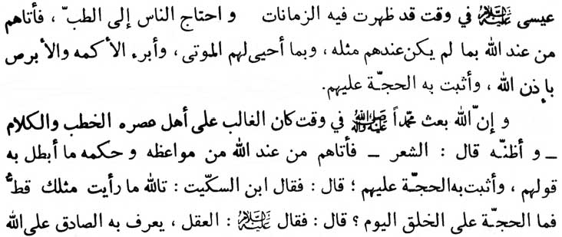

\* \* \* \* \* \* \*

rendered their magic powerless. Thus, the divine power gifted to Moses clearly demonstrated the divine truth to those magic-mad people.

‘Jesus (p.b.u.h.) was sent at the time when the people were under the grip of chronic diseases. Hence Jesus brought from God such medical powers as the people of that time did not possess. Jesus (p.b.u.h.) brought the dead back to life and healed the people born blind and leperous by the will of Allah. Thus the divine reason and justification was demonstrated to the people.

‘Almighty Allah sent Prophet Muhammad (p.b.u.h.a.h.p.) at the time when oratory and speech had a tremendous sway over the people.'

“I (the narrator) think that the Imãm used the word “poetry” (i.e. he added “poetry” to the “oratory and speech”). (Then the Imãm continued):

‘In view of this trend of the time, Prophet Muhammad (p.b.u.h.a.h.p.) was gifted by God with such sublime sermons, admonitions, and such eloquent discourses of wisdom which clearly demonstrated the divine truth to them (by defeating them on their own ground, the field of oratory and poetry).'

“Hearing this highly learned and scholarly statement, Ibn as-Sikkīt (the great scholar) exclaimed, ‘By God, I have never seen any scholar like you.’ Then Ibn as-Sikkīt inquired of the Imãm,

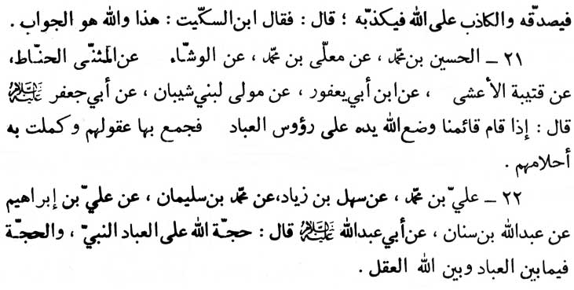

\* \* \* \* \* \* \*

‘Who is the man personifying this divine proof and demonstration for the people of this time?’ The Imãm replied, ‘It is through intellect and reason one can recognise and corroborate the truthful divine demonstrator. And it is through reasoning one can falsify the pretender who claims divine representation as a divine demonstrator.’ Hearing this, Ibn as-Sikkīt exclaimed, 'By Allah this is the one and the only reply.'

21. al-Husayn ibn Muhammad (-) Mu‘alla ibn Muhammad (-) al-Washsha’ (-) Muthannã al-Hannãt (-) Qutaybah al-A‘sha (-) Ibn Abi Ya‘fũr (-) the slave of Bani Shaybãn (-) Abu Ja‘far (p.b.u.h.) as saying:

“At the time when Imãm al-Mahdi (the twelfth Imãm in the line-age of Prophet Muhammad's progeny) will make an appearance in the world, Almighty Allah will put His blessed Hand over the heads of the people of that time through which the Reason of the people will be completely restored and their comprehension will be brought to perfection.”

22. ‘Ali ibn Muhammad (-) Sahl ibn Ziyãd (-) Muhammad ibn Sulaymãn (-) Ali ibn Ibrãhīm (-) ‘Abdullãh ibn Sinãn (-) Abu ‘Abdillãh (p.b.u.h.) as saying :

“Each prophet personifies the proof and divine. demonstration for mankind (taken collectively). While Reason is the proof and demonstration between God and mankind (taken individually).”

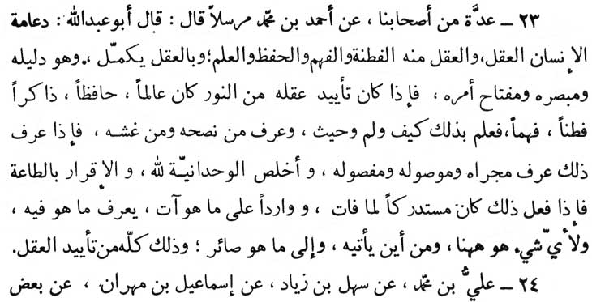

\* \* \* \* \* \* \*

23. A group of our associates (-) Ahmad ibn Muhammad (Mursalãn - without describing the chain of narrators) quoted Abu ‘Abdillãh (p.b.u.h.), as saying :

“The reasoning capacity is the chief pillar of human existence. It is the fountain spring of sagacity, comprehension, memory and knowledge. Man is perfected through Reason and it is this which is a guide, a discriminator and a key to every success. When Reason secures the approval of Divine Light, it earns (perfection in) know-ledge, memory, sagacity, level headness and God mindedness. It is through Reason one understands how, why and where. It is through Reason one knows who guides him and who misguides him. Having known all this he comes to realise what source of life he should adopt, whom he should meet and whom he should not. He becomes pure and sincere in his concept of Unity of God and also in his acceptance, and belief, and ultimately in His obedience and submission to Him. When he has reached this stage, he has redressed every loss. He has acquired every gain he can secure. He quickly comprehends where he stands, and what is what, which is which, and why he has been sent here in this worldly life, where he is brought from and where he has to go. All this can be secured with the assistance of Reason.”

24. ‘Ali ibn Muhammad (-) Sahl ibn Ziyãd (-) Ismãīl ibn

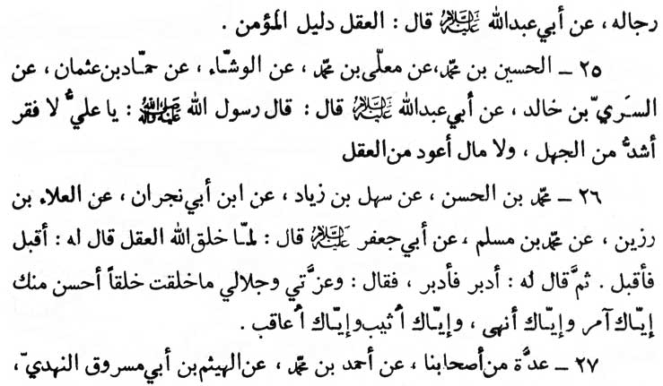

\* \* \* \* \* \* \*

Mihrãn (-) some of his associated narrators (-) Abu ‘Abdillãh (p.b.u.h.) as saying:

“Reason is a guide to every believer.”

25. al-Husayn ibn Muhammad (-) Mu’alla ibn Muhammad (-) al-Washshã’ (-) Hammãd ibn ‘Uthmãn (-) as-Sari ibn Khãlid (-) Abu ‘Abdillãh (p.b.u.h.) as saying:

“The messenger of Allah (Muhammad, the prophet - p.b.u.h.a. h.p.), said (to ‘Ali):

‘O ‘Ali, no poverty is as great as ignorance and no wealth is as profitable as the reasoning capacity.’ “

26. Muhammad ibn al-Hasan (-) Sahl ibn Ziyãd (-) Ibn Abi Najrãn (-) al-’Alã ibn Razīn (-) Muhammad ibn Muslim (-) Abu Ja‘far (p.b.u.h.), as saying:

“When Almighty Allah created Reason, He ordered it to come forward and it came forward. Then He ordered it to go back and it went back. On this Almighty Allah said : ‘I swear by My power and Majesty that no creation of Mine is dearer than you are. Lo! to you are My orders and prohibitions addressed and for you are My rewards and retributions reserved.’ “

27. A group of our associates (-) Ahmad ibn Muhammad (-)

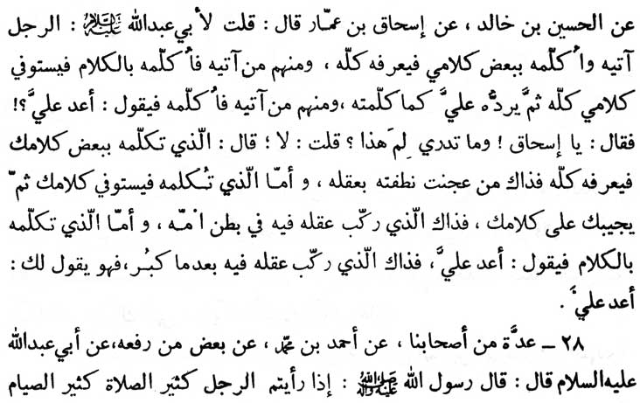

\* \* \* \* \* \* \*

(-) al-Haytham ibn Abi Masrũq an-Nahdi (-) al-Husayn ibn Khãlid (-) Is'hãq ibn ‘Ammãr who reports:

“I inquired of Imãm Abu ‘Abdillãh, ‘How is it that certain people understand much although I speak to them only a little? How and why is it that certain people understand, memorise and repeat to me the whole (subject) after I speak a lot. How and why is it that certain other people request me to repeat although I have spoken a lot.’ The Imãm replied, ‘The man who understands the whole (subject) after hearing a little is one whose intellect and reason is kneaded along with his gene. The man who understands, memorises and repeats to you the whole (subject) after your speaking fully over it, is one whose intellect and reason develops in the embryo of his mother. And the man who requests you to repeat the subject for him after hearing you in full, is one whose Reason develops after he is grown up.”

28. A group of our associates (-) Ahmad ibn Muhammad (-) some (narrators) (rafa‘ahu) Abu ‘Abdillãh (p.b.u.h.) as saying:

“The Messenger of Allah (Muhammad, the prophet - p.b.u.h.a.

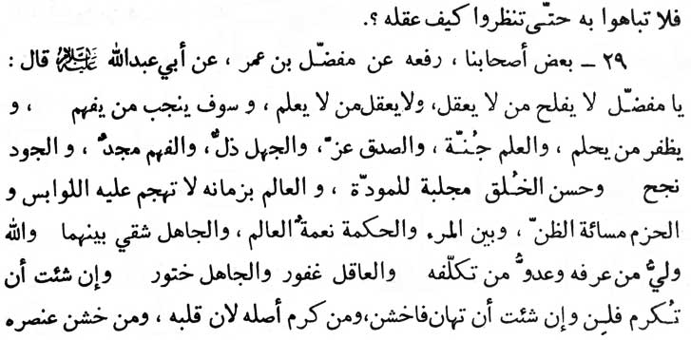

\* \* \* \* \* \* \*

h.p.) stated: ‘Don't pride on a person performing too many prayers and observing too many fasts until and unless you determine what degree of Reason he possesses.’”

29. Some of our associates (rafa‘ahu) (related the following tradition without mentioning the sources quoted from) (-) Mufaddal ibn ‘Umar (-) Abu ‘Abdillãh (p.b.u.h.) as saying:

“O’ Mufaddal! one who has no Reason, secures no success. He who has no knowledge has no Reason. And he who has understanding is closer to excellence. He who has a quality of forbearance is bound to secure success. Knowledge is a shield (against all evil); truthfulness is an honour; ignorance is a disgrace; understanding is glory; generosity is salvation; good bearing is a magnet of love. One who is a sage of his time cannot be assailed by doubts and confusions. Wisdom and caution demand misapprehensions about others. (Presuming all persons to be angels runs counter to wisdom and maturity of judgment.) Men of learning - the scholars are the divine bounties and are the bridge between people and wisdom. And men of ignorance - the rustics are the bridge between the people and miseries. Almighty God is a friend to him who takes pains to know Him and He is unfriendly to him who does not take pains to know Him. A man of wisdom is always forgiving and a man of ignorance is always treacherous. If you want

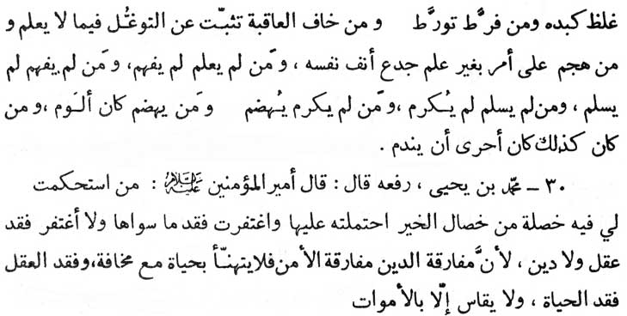

\* \* \* \* \* \* \*

to be honoured, be gentle to others and if you want to be disgraced be harsh to others. One who is noble by birth is gentle at heart, and one who is ignoble by birth is crude at heart. One who transgresses (the divine limits) is caught up in a sad plight. One who is afraid of consequences never takes any wrong step. One who rushes in doing what he does not know disgraces himself. (There is an English proverb to this effect : ‘Fools rush in where angels fear to tread.’) One who has no knowledge cannot understand and he who does not understand cannot be in peace. He who is not in peace cannot have any honour. And he who has no honour is abashed. And he who is abashed is a target of general condemnation. And he who is like this has ultimately to meet repentance and disgrace.”

30. Muhammad ibn Yahya (rafa‘ahu) Amīr al-mu’minīn (‘Ali, - the Chief of the believers) as saying :

“One who is fortified at least in one virtue from amongst the rest to my satisfaction, will be acceptable to me just on the score of that virtue alone. I can overlook and forgive his lack of other virtues, but the lack of Reason and faith in no case can be overlooked and forgiven. Being without faith and religion is equal to being without peace and security. Verily, life in fear is totally unpleasant and lack of Reason is tantamount to lack of life. A

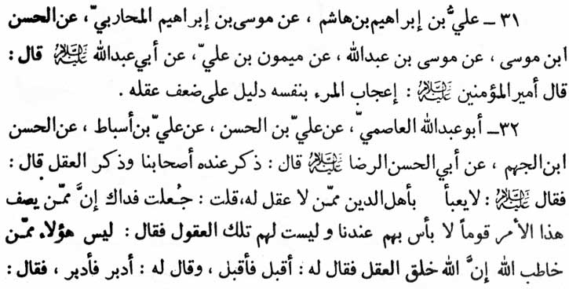

\* \* \* \* \* \* \*

person devoid of reason cannot be conceived except as a corpse.”

31. ‘Ali ibn Ibrãhīm ibn Hãshim (-) Mũsã ibn Ibrãhīm al-Muhãribi (-) al-Hasan ibn Mũsã (-) Mũsã ibn ‘Abdillãh (-) Maymũn ibn ‘Ali (-) Abu ‘Abdillãh (p.b.u.h.) as saying:

“Amīr al-mu’minīn (‘Ali - the Chief of the believers) has stated, ‘Self Conceit is a proof of feeble Reason.’ “

32. Abũ ‘Abdillãh al-‘Ãsimi (-) ‘Ali ibn al-Hasan (-) ‘Ali ibn Asbãt (-) al-Hasan ibn al-Jahm (-) Abi'l-Hasan ar-Ridã (p.b.u.h.), when a discussion about Reason took place before him, (the Imãm) observed :

“A believer in religion who has no Reason is of no consideration at all.” The narrator asked, “May my life be sacrificed for you, there are certain people in our community who, in our eyes are without any fault, but they don't possess (sufficient) Reason and understanding (of religion).” The Imãm remarked, “Such people are not among those God has considered eligible to be addressed. When Almighty God created Reason, He ordered it to come forward. The Reason came forward. Then He ordered it to go back. It went back. On this, God the Almighty observed : ‘I swear by My power and Majesty that I have not created anything more handsome and dearer

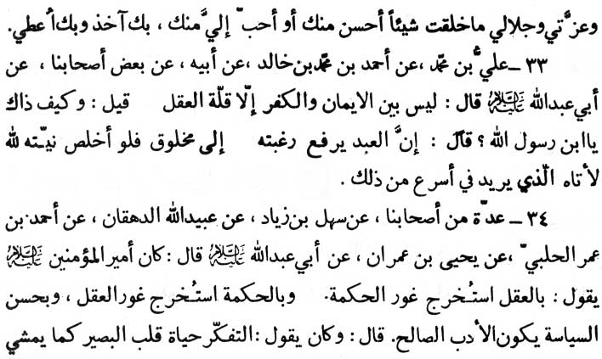

\* \* \* \* \* \* \*

than you. It is only on your account that I shall take people to task and it is only on your account that I grant My rewards.’ “

33. ‘Ali ibn Muhammad (-) Ahmad ibn Muhammad ibn Khãlid (-) his father (-) some of our associates (-) Abu ‘Abdillãh (p.b.u.h.), as saying :

“There is no distinguishing feature between faith and infidelity apart from the lack of reasoning.” Hearing this someone asked the Imãm, “O’ son of the Prophet, how is this?” The Imãm replied, “In-stead of turning to God, man turns to other men for the fulfilment of his needs. If he had turned to God exclusively, in all sincerity, God would have fulfilled his need much speedily than any man could have done.”

34. A group of our associates (-) Sahl ibn Ziyãd (-) ‘Ubaydillãh al-Dihqãn (-) Ahmad ibn ‘Umar al-Halabi (-) Yahya ibn ‘Imrãn (-) Abu ‘Abdillãh (p.b.u.h.) as saying that Amīr al-rnu'minīn. (‘Ali - the Chief of the believers) used to say :

“It is through Reason that wisdom can be fathomed in all its depth. And, it is through wisdom that the depth of Reason can be

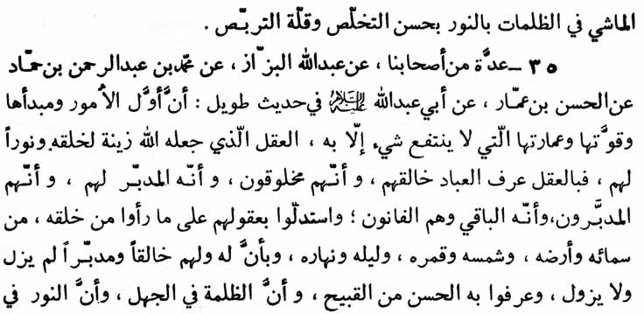

\* \* \* \* \* \* \*

fathomed. Good supervision gives birth to good bearing and social decorum.” Also Hadrat ‘Ali used to say, “Meditation grants real life to the heart and soul of an observant person. As a pedestrian goes along in darkness with the help of a lamp, we should go (along on the path of life continuously) with the help of the lamp of our reason, guarding ourselves against the evils, without unnecessary delay.”

35. A group of our associates (-) ‘Abdullãh al-Bazzãz (-) Muhammad ibn ‘Abd ar-Rahmãn ibn Hammãd (-) al-Hasan ibn ‘Ammãr (-) Abu ‘Abdillãh (p.b.u.h.) as saying :

“The initiation, the development and the power of any task productive of any advantage cannot be undertaken without reason which has been designed by God as light and ornament for His creation. It is through reason that man recognises his Creator. It is through reason that they recognise themselves to be not self created but God is their Disposer and that they are at His disposal. It is through reason that they comprehend the object behind the creation of the heavens, the earth, the sun, the moon, the night and the day. It is through reason they realise that there is a Creator and Disposer for them, and for all the universe that has always been and will always be. It is through reason that they discriminate between good and bad. It is through reason that they understand that darkness (the evils) lies in ignorance and the light (every

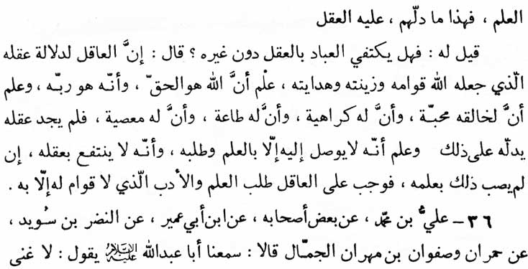

\* \* \* \* \* \* \*

good) lies in knowledge. All these facts are known to men through reason.”

It was asked of the Imãm, “Is it possible for the people to be contented with their reason leaving every other thing behind?” The Imãm replied, “Lo! the reason which has been designed by the God to be the foundation, the ornament and guidance is a light house for the wise, who recognise that God is the Truth and He is man's sustainer. They realise that their Creator has His likes and dislikes and He could be obeyed and disobeyed.

“They also recognise that- they cannot understand the manner in which His likes and dislikes operate with the help of mere reason. Hence, in this respect it is essential for them to take the help of knowledge. It means that they have derived no benefit from their intellectual capabilities. It is therefore imperative for men of reason to acquire knowledge and decorum without which their life has no support.”

36. ‘Ali ibn Muhammad (-) some of his associates (-) Ibn Abi ‘Umayr (-) an-Nadr ibn Suwayd (-) Humrãn and Safwãn ibn Mihrãn al-Jammãl, as saying: “We both have heard Abu ‘Abdillãh (p.b.u.h.), as often saying :

‘No wealth is so prolific as that of Reason. No destitution is



\* \* \* \* \* \* \*

worse than stupidity. In nothing does success surpass so much as in obtaining councils, from the people of Reason and Knowledge.’ “

(This is the end of the First Part of the Book of REASON and IGNORANCE).

All praise to Allah alone and bit sings of Allah be upon Muhammad and upon his Progeny, with the best of regards.

All rights reserved for Al-Hassanain (p) Network, ImamHussain (p) Foundation

Alhassanain (p) Network for Islamic Heritage and Thought

[www.alhassanain.org/english](http://www.alhassanain.org/english)