Alhassanain (p) Network for Islamic Heritage and Thought



BY

ASH-SHAYKH ABU JA‘FAR MUHAMMAD IBN YA‘QUB IBN IS'HÃQ AL-KULAYNI AR-RÃZI

Volume One

AL-USŨL - Part One

2) THE BOOK OF EXCELLENCE OF KNOWLEDGE

World Organization for Islamic Services,

TEHRAN - IRAN

[www.alhassanain.org/english](http://www.alhassanain.org/english)

English translation with Arabic Test

First edition 1398/1978

Fifth edition 1418/1998

Translated and published by:

World Organization for Islamic Services,

P. O. Box 11165-1545,

Tehran - 15837,

ISLAMIC REPUBLIC OF IRAN

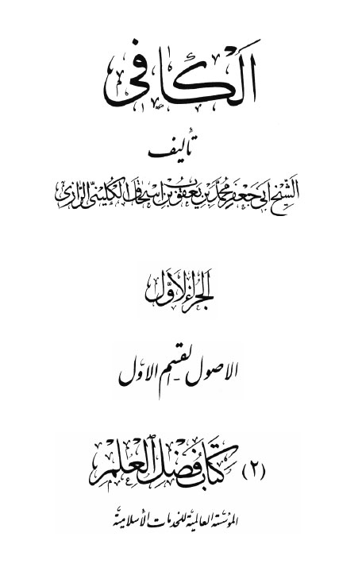

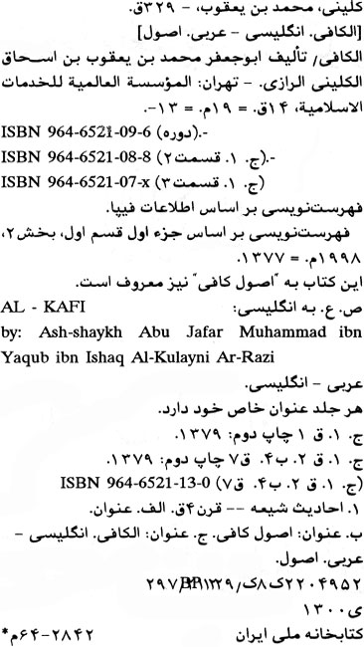



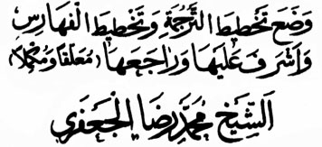

This part has been translated by:

SAYYID MUHAMMAD HASAN RIZVI

Design of the book for its translation, indexes, revisions, explanatory remarks and other related work has been done by:

ASH-SHAYKH MUHAMMAD RIDA AL-JA‘FARI

IN THE NAME OF ALLÃH, THE MOST COMPASSIONATE, THE MERCIFUL

Praise belongs to Allãh, the Lord of all beings; the Most Compassionate, the Merciful; the Master of the Day of Judgment; Thee only we serve, and to Thee alone we pray for succour; Guide us in the straight path; the path of those whom Thou hast blessed, who are immune from Thy wrath and have never gone astray.

\* \* \* \* \*

O Allãh! Send your blessings to the head of your messengers and the last of your prophets Muhammad, and his pure and cleansed progeny.

Also send your blessings to all your prophets and envoys.

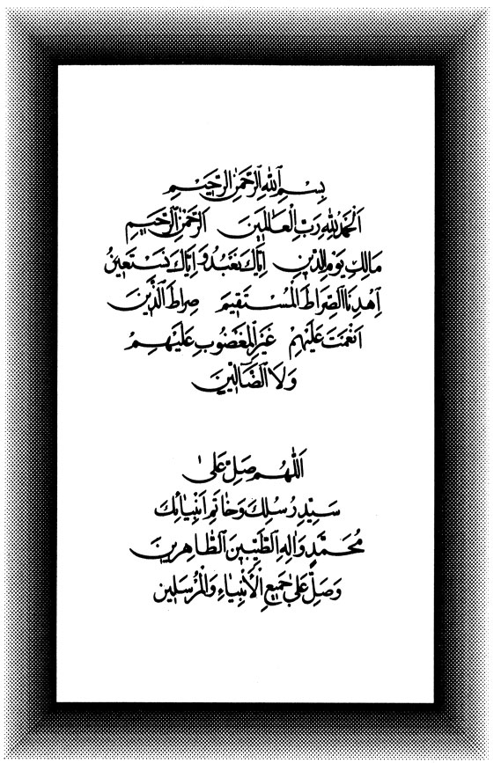

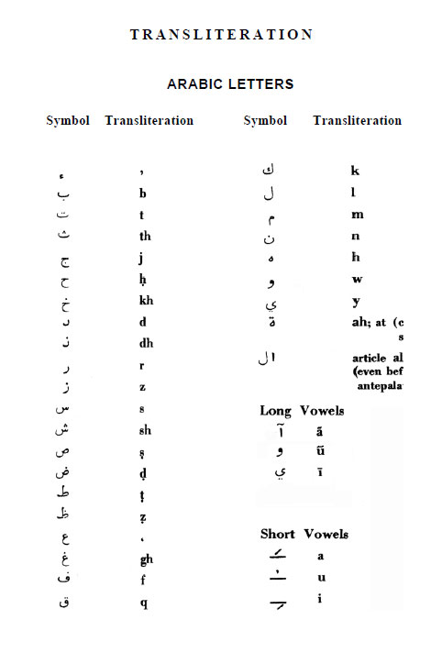

Table of Contents

[FOREWORD 10](#_Toc449444657)

[1) Caution 20](#_Toc449444658)

[2) A Chronological List of the Holy Prophet, his Daughter and the Twelve Holy Imãms. 20](#_Toc449444659)

[3) List of Technical Terms and Special Signs used in the Traditions. 20](#_Toc449444660)

[The Book of EXCELLENCE OF KNOWLEDGE 25](#_Toc449444661)

[1: CHAPTER ON THE NECESSITY OF KNOWLEDGE, THE OBLIGATION OF ITS QUEST AND ITS INCITEMENT 26](#_Toc449444662)

[2: CHAPTER ON PROPERTY AND SIGNIFICANCE OF KNOWLEDGE AND THE EMINANCE OF THE LEARNED 30](#_Toc449444663)

[3: CHAPTER ON CATEGORIES OF THE PEOPLE 35](#_Toc449444664)

[4: CHAPTER ON THE DIVINE REWARDS FOR THE LEARNED AND THE LEARNERS. 38](#_Toc449444665)

[5: CHAPTER ON ATTRIBUTES OF THE LEARNED SCHOLARS 42](#_Toc449444666)

[6: CHAPTER ON RIGHTS AND PRIVILEGES OF A LEARNED SCHOLAR 46](#_Toc449444667)

[7: CHAPTER ON THE PASSING AWAY OF THE SCHOLARS 47](#_Toc449444668)

[8: CHAPTER ON THE COMPANY OF THE LEARNED AND HAVING ASSOCIATION WITH THEM 50](#_Toc449444669)

[9: CHAPTER ON ASKING QUESTIONS AND INTERCHANGING WITH A LEARNED SCHOLAR 52](#_Toc449444670)

[10: CHAPTER ON DEFUSION OF KNOWLEDGE 56](#_Toc449444671)

[11: CHAPTER ON NOT TO SPEAK WITHOUT KNOWLEDGE 58](#_Toc449444672)

[12: CHAPTER ON ACTING WITHOUT KNOWLEDGE 63](#_Toc449444673)

[13: CHAPTER ON APPLICATION AND USE OF KNOWLEDGE 64](#_Toc449444674)

[14: CHAPTER ON ONE WHO LIVES BY AND IS PROUD OF HIS KNOWLEDGE 69](#_Toc449444675)

[15: CHAPTER ON ACCOUNTABILITY OF THE LEARNED (BEFORE ALLAH) AND ITS SEVERITY 73](#_Toc449444676)

[16: CHAPTER ON MISCELLANEOUS TRADITIONS 75](#_Toc449444677)

[17: CHAPTER ON QUOTING BOOKS AND THE TRADITION. SIGNIFICANCE OF WRITING AND ADHERING TO THE BOOKS. 84](#_Toc449444678)

[18: CHAPTER ON BLIND FOLLOWING 91](#_Toc449444679)

[19: CHAPTER ON INNOVATIONS, OPINION AND GUESS WORK - DERIVING CONCLUSIONS ON THE BASIS OF SIMILARITIES, SEMBLENCES AND APPEARANCES (IN RELIGION) 93](#_Toc449444680)

[20: CHAPTER ON TAKING (EVERY CASE) BACK TO THE QUR'AN AND AS-SUNNAH, VERILY, THERE IS NOTHING FROM WHAT IS LAWFUL AND WHAT IS UNLAWFUL AND WHAT IS NEEDED BY THE MANKIND, BUT THE BOOK (OF ALLAH) AND AS-SUNNAH INCLUDES IT. 108](#_Toc449444681)

[21: CHAPTER ON CONFLICTING TRADITIONS 115](#_Toc449444682)

[22 CHAPTER ON TAKING HOLD OF AS-SUNNAH AND THE EVIDENCES FROM THE BOOK OF ALLAH 131](#_Toc449444683)



FOREWORD

D:\barkatullah\books\new books\rajab\al_kafi_dr_hassan_rizvi\al_kafi_vol_01_part_02\photo shop\Untitled-2.jpg

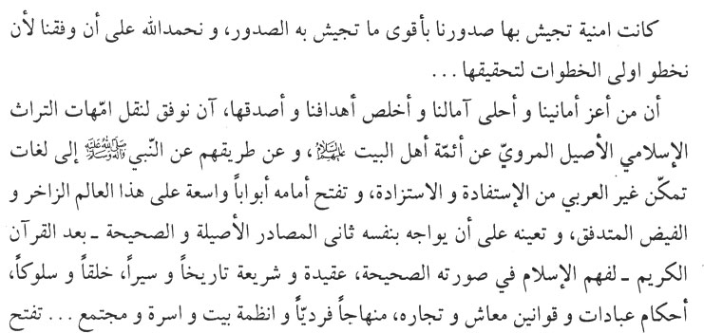

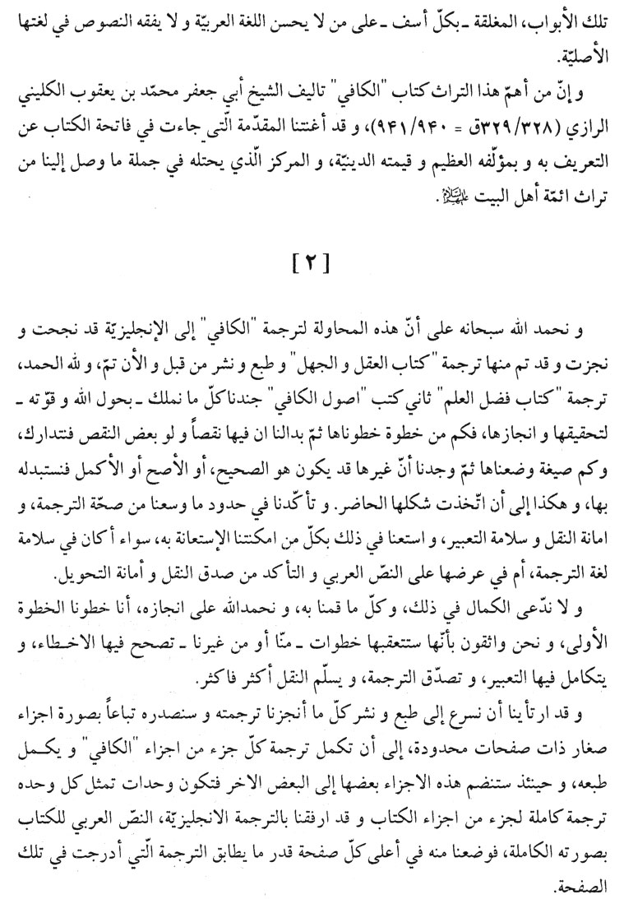

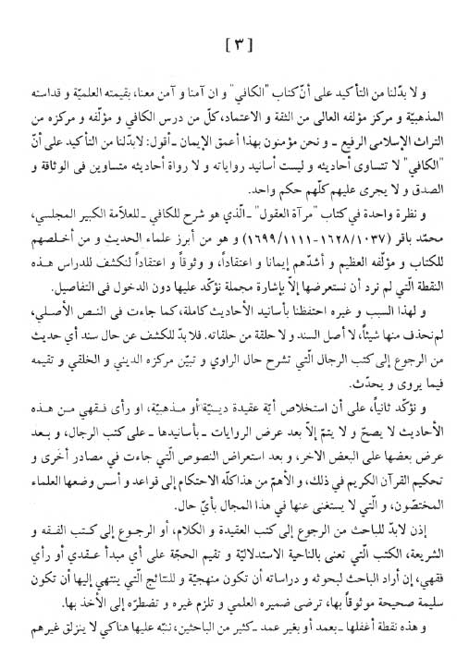

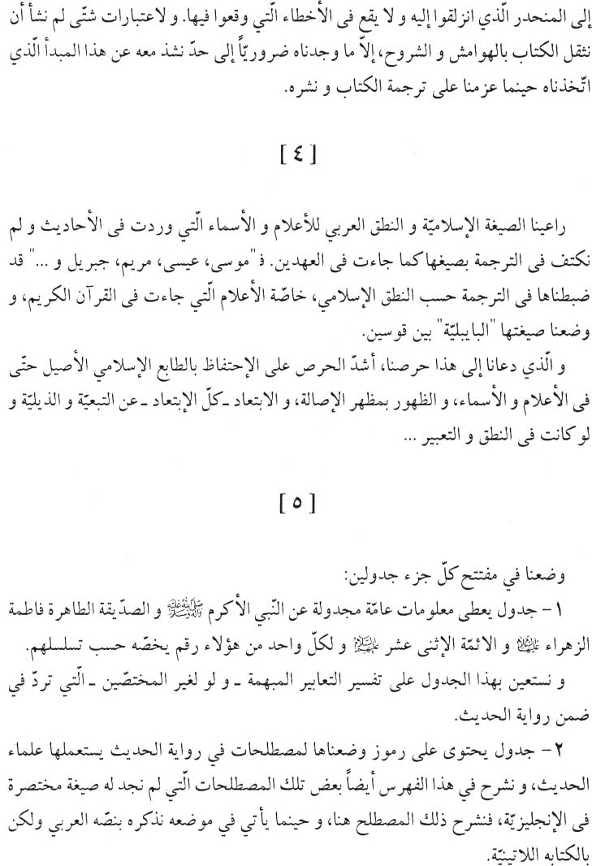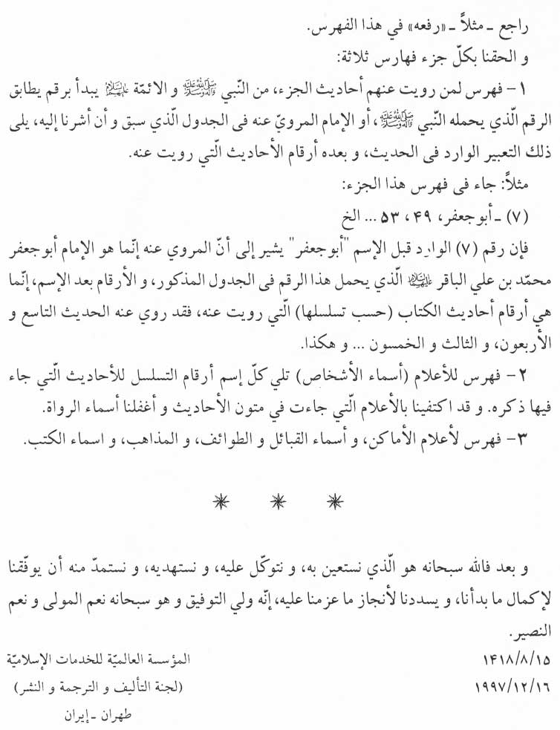

-1-

In our continuous effort to propagate Islam through our numerous publications we have had a persistent desire to include amongst our publications translations of the most important reference books recog-nized by the Shī‘ah. To be able to publish such key books in the Shī‘ah heritage in foreign languages does not only give us great pleasure and pride but it conforms very well to our wishes and our true sincere objectives. No doubt the non-Arab speaking researchers would now have better access to the true Islamic heritage since such books contain the ahãdīth (traditions) of the holy Imãms (peace be upon them) and the Holy Prophet (peace be upon him and his progeny). Moreover, these books constitute the second source - the holy Qur'an being the first - whereby one would have better understanding of the Islamic ideology, jurisprudence, history, tradition, manners, Islamic laws pertaining to worship, business, Islamic considerations for the individual, family and society...

One of the important books in question is al-Kãfi whose author was ash-Shaykh Abu Ja‘far Muhammad ibn Ya‘qub al-Kulayni ar-Rãzi ( 328/329 = 940/941). We need not introduce either the book or its author since the introduction to the book takes care of that and also shows its religious significance and its status in our heritage, namely the heritage transmitted to us through Ahlu'l-bayt (the House-hold of the Holy Prophet - p.b.u.t.).

-2-

Our gratitude to Allãh, the Almighty, for being able to commence the translation of al-Kãfi to English. So far, the translation of the section pertaining to the “Reason and Ignorance” (‘aql and jahl) has been completed. No doubt we had to utilize all the means at our disposal and to rely on Allãh's unlimited strength in order to accomplish this translation. As a matter of fact, we had to do a lot of screening before coming up with this version. Furthermore, we took every possible effort to make sure that the translation is satisfactory and acceptable in terms of accuracy and grammar.

We do not wish to claim perfection in this humble effort to trans-late one section of al-Kãfi. Nevertheless, we have taken the first step and we are confident that subsequent steps would be taken, either by us or by somebody else, to both remove any errors and optimize the translation so that exactness in the narration process is improved.

We have decided to speed up the printing and publication of the translated section of al-Kãfi. The other sections, it is hoped, would be published in due course on individual basis; this process would be continued until all the sections of al-Kãfi are translated and published.

You will note that we have also included along with the English translation, the complete original Arabic version, this being placed at the top of each page with the corresponding English translation below.

-3-

We believe, and so does everybody who studied it believe, that and so holy in the Shī‘ah circles and that the author is considered highly honest and highly reliable. However, we should emphasize that neither the ahadīth are equal in value and significance nor are the supporting evidence for the narrations or the persons relating the ahadīth equal in terms of reliability and credibility and in no way can one give them the same appraisal.

A glance at the book entitled mir’ãtu'l- ‘ugũl (reflection of the minds) would reveal to the researcher this very point in more detail. Mir'ãtu'l-‘uqul is an explanatory book to al-Kãfi and is authored by the great scholar Muhammad Bãqir al-Majlisi (1037/1628-1111/1700). al-Majlisi is one of the prominent scholars of hadīth (tradition) and one of the most loyal and faithful to the book (al-Kãfi) and its great author and one of the most faithful and pious scholars of Islam.

Because of this - that is, the question of unequal credibility of the ahãdith, narrations and narrators - and for completeness we have retained the complete supporting evidence of the ahãdīth as in the original Arabic text. We have not omitted any original support for any ahadīth, neither have we omitted any of the links in a narration chain. In order to reveal the credibility, or otherwise, of the support for a par- ticular hadīth, one has to refer to special books dealing with the biogra- phy and the religious and moral status of the narrator/s; such books also carry an appraisal of what the narrator transmits and relates. We would like to re-emphasize that the inference of any religious or ritual doctrine or any law pertaining to jurisprudence from these ahãdīth is a long process. To start with, the researcher would have to refer the nar- rations along with their supporting chain of evidence - to the special biographic books referred to above. The narrations would have to be cross-checked against one another. Later the researcher would have to consider all other declarations and citations on the same topic from other references and then use the holy Qur'an as the arbitrator. Of more significance still, one has to abide by the rules and regulations laid down by the specialists and which rules can never be ignored. Therefore, the researcher would have to go back either to the ideological and linguistic books or to the books of jurisprudence and legislation, that is, those books which cover the inference aspects and the evaluation of various proofs and evidence used to back-up any ideological principle or jurisprudence. This is the approach to be adopted if he wants his research to be systematic and if he wants the results to be sound, accurate and reliable, thus satisfying his scientific conscience and obliging others to honour and follow such inferences.

This very point has been ignored - intentionally or otherwise - by many researchers and we are stressing it here in order that other researchers would neither make the same mistake of ignoring it nor suffer the same deviation.

And for several considerations we refrained from introducing unnecessary explanatory notes, except where it was absolutely necessary, so as to stick to our .original aim of merely translating and publishing the book.

- 4 -

In the translation we have retained the Islamic format and Arabic pronunciation of the names and proper nouns encountered in various ahãdīth. We were not content with the Biblical equivalents, but, instead, retained the Islamic articulations in the text, following each proper noun or name (especially those mentioned in the holy Qur'an) like, Musã (Moses), ‘Isã (Jesus), Maryam (Marry), Jibrīl (Gabriel)...with its Biblical equivalent in brackets.

We took this measure because we strongly believe in preserving the original Islamic character even with respect to names and proper nouns. We believe in originality even when it comes to appearances, and we will completely avoid imitation and reproduction even if it were merely with respect to pronunciation and expression...

- 5 -

We have put a table at the beginning of each section giving general particulars and information in tabular form about the Holy Prophet (p.b.u.h.a.h.p.) and Fãtima az-Zahra' (p.b.u.h.) and the twelve Imãms (p.b.u.t.). For each of them we have assigned a number according to their sequence.

It is hoped that this table would help the reader - even the non-specialist to understand some important expressions encountered in the process of the narration of hadīth.

Furthermore, we have included four indexes at the end of each section:-

a) The first index lists the originators of the ahadīth to be found in the section - the Holy Prophet (p.b.u.h.a.h.p.) and the Imãms (p.b.u.t.).

It begins with a number corresponding to the serial number of the originator of the hadīth, the originator being the Prophet or one of the Imãms. The serial number has already been assigned in the table at the beginning of the section.

After the number, the format of the name used in the hadīth appears.

After that, the serial number's of ahadīth related to the originator is/are listed.

For example, in the first index of this section:

(7) - Abu Ja‘far, 1, 7 ...etc.

The number (7) preceding the name (Abu Ja‘far) indicates that the originator is Imãm Abu Ja‘far Muhammad ibn ‘Ali al-Bãqir (p.b.u.t.) who was assigned with this number in the table at the beginning of the section. The number following the name are the serial number of the ahadīth in the book (or section) related to him: that is, the first and the seventh hadīth are related to him...etc.

b) An index containing symbols for terminology commonly encountered in the process of narration of hadīth. We have introduced these because scholars of hadīth often use them. In this index we have also explained some of those terminologies for which no simple English equivalent can be found. We have explained such terminology in the index and when it appears in the text we also mention the Arabic text in the Latinized form: e.g. “rafa ahu” - Ref. Index no.3

c) Index of the names of key personalities. Following each name the serial numbers of ahãdīth in which such a name appears are cited. We were content with citing only those names that appeared in the contexts of the ahãdīth proper and ignored the names of narrators.

d) Index of key places, names of tribes and families and sects.

Finally, it is Allãh, the Almighty, from Whom we seek help and guidance and upon Whom we rely for the success of our efforts. Moreover, we pray that He paves the way for us to complete what we have commenced and to redeem us in order to achieve what we have planned...We strongly believe that He is the reconciliator and that He is the best guide and the best artisan.

WORLD ORGANIZATION FOR ISLAMIC SERVICES

Tehran - IRAN.

6/2/1398

16/1/1978

### 1) Caution

### 2) A Chronological List of the Holy Prophet, his Daughter and the Twelve Holy Imãms.

### 3) List of Technical Terms and Special Signs used in the Traditions.

CAUTION

I - Wherever the author (al-Kulaynī) says in the book of al-Kãfī “A group of our associates,” quoting from Ahmad ibn Muhammad ibn ‘Isã, the Group here means the following five persons:

1. Abu Ja‘far Muhammad ibn Yahyã al-‘Attãr al-Qummī;

2. `Ali ibn Mũsã ibn Ja‘far al-Kamandãnī;

3. Abu Sulaymãn Dawũd ibn Kawrah al- Qummī;

4. Abu ‘Ali Ahmad ibn Idrīs ibn Ahmad al-Ash‘arī al- Qummī;

5. Abu'l-Hasan `Ali ibn Ibrãhīm ibn Hãshim al- Qummī.

II. - Wherever the author (al-Kulaynī) says in the book of al-Kãfī “A group of our associates,” quoting from Ahmad ibn Muhammãd ibn Khãlid al-Barqī, the Group here means the following four persons:

1. Abu'l-Hasan `Ali ibn Ibrãhīm ibn Hãshim al-Qummī;

2. Muhammad ibn `Abdullãh ibn Udhaynah;

3. Ahmad ibn `Abdullah ibn Umayyah;

4. `Ali ibn al-Husayn as-Sa'd Ãbãdī;

III. - Wherever the author (al-Kulaynī) says in the book of al-Kafī “A group of our associates,” quoting from Sahl ibn Ziyãd, the Group here means the following four persons:

1. Abu'l-Hasan `Ali ibn Muhammad ibn Ibrãhīm ibn Aban ar-Rãzī, who is renowned with `Allãn al-Kulayni;

2. Abu'l-Husayn Muhammad ibn Abī 'Abdillãh Ja‘far ibn

Muhammad ibn `Awn al-Asadi al-Kufī, resident of Ray;

3. Muhammad ibn al-Husayn ibn Farrũkh as-Saffãr al-Qummī;

4. Muhammad ibn ‘Aqīl al-Kulaynī;

IV. - Wherever the author (al-Kulaynī) says in the book of al-Kãfi “A group of our associates,” quoting from Ja‘far ibn Muhammad who quoted from al-Hasan ibn ‘Ali ibn Faddãl, one of them is, Abu `Abd-Allãh al-Husayn ibn Muhammad ibn `Imrãn ibn Abī Bakr al-Ash'arī al-Qummī.

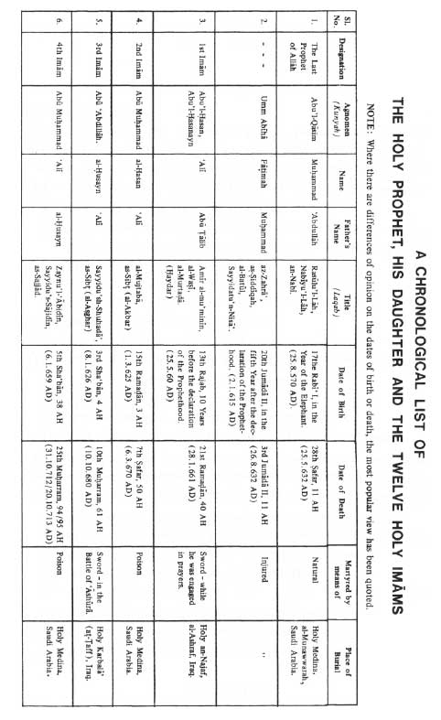

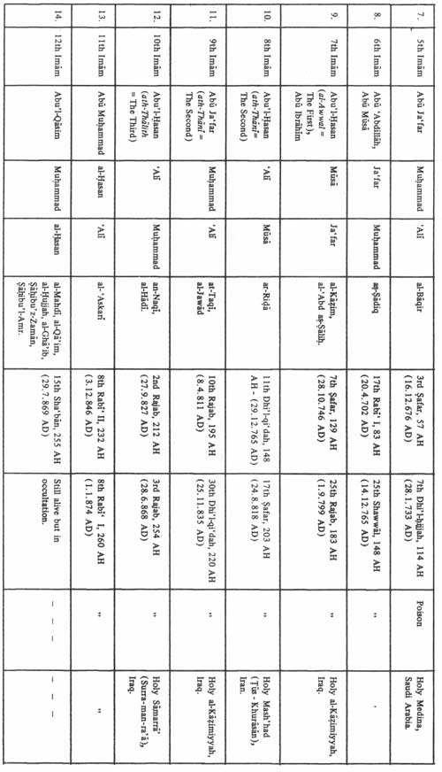

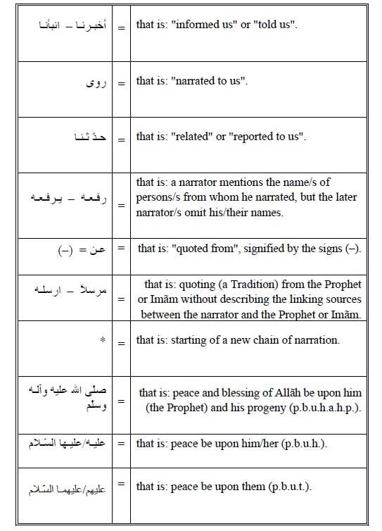

USUL AL-KÃFI



The Book of EXCELLENCE OF KNOWLEDGE



D:\barkatullah\books\new books\rajab\al_kafi_dr_hassan_rizvi\al_kafi_vol_01_part_02\photo shop\Untitled-13.jpg

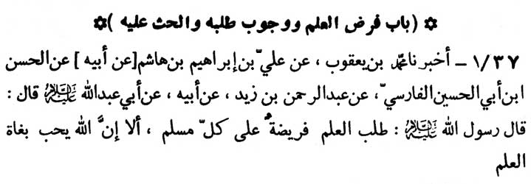

In the Name of Allãh, the Beneficent, the Merciful

1: CHAPTER ON THE NECESSITY OF KNOWLEDGE, THE OBLIGATION OF ITS QUEST AND ITS INCITEMENT

37-1. Muhammad ibn Ya‘qũb has informed us (-) ‘Ali ibn Ibrãhīm ibn Hãshim (-) his father (-) al-Hasan ibn Abi 'l-Husayn al-Fãrsi (-) ‘Abd ar-Rahmãn ibn Zayd (-) his father (-) Abu ‘Abdillãh (peace be upon him) as saying:

“The Messenger of Allãh (peace be upon him and his progeny) has observed, 'To acquire knowledge is obligatory on every Muslim. Lo! Allãh loves those who have longing for knowledge.”

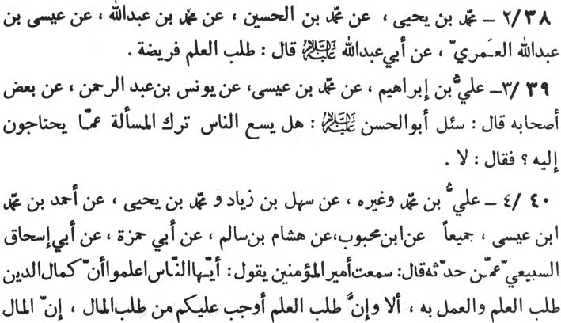

\* \* \* \* \* \* \*

38-2. Muhammad ibn Yahya (-) Muhammad ibn al-Husayn (-) Muhammad ibn ‘Abdillãh (-) ‘Isã ibn ‘Abdillãh al-‘Umary (-) Abu ‘Abdillãh (p.b.u.h.) as saying: “To acquire knowledge is imperative.”

39-3. ‘Ali ibn Ibrãhīm (-) Muhammad ibn ‘Isã (-) Yũnus ibn ‘Abdu 'r-Rahmãn (-) some of his associates as saying:

“It was asked of Abu 'l-Hasan (p.b.u.h.) whether it is permis-sible for people not to ask questions on a subject which they must know. The Imãm replied, 'Certainly not.”

40-4. ‘Ali ibn Muhammad and others (-) Sahl ibn Ziyãd\* and Muhammad ibn Yahyã (-) Ahmad ibn Muhammad ibn ‘Isã, both of them (-) Ibn Mahbũb (-) Hishãm ibn Sãlim (-) Abi Hamzah (-) Abi Ishãq as-Sabi‘i (-) (unknown person) who narrated to him, as saying:

“I have (myself) heard Amīr al-mu'minīn, saying. 'O’ people, you should know that the climax of religion is to acquire knowledge and to act upon it. Verily, acquisition of knowledge is more incum-bent on you than the acquisition of wealth and money, since wealth and money already stand distributed and guaranteed (by Allãh). It

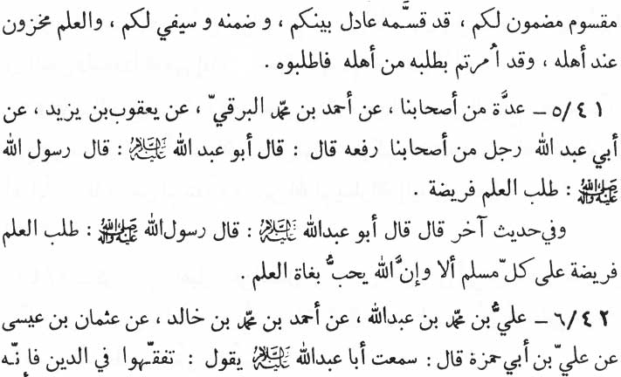

\* \* \* \* \* \* \*

has been so done by One Who is just. Wealth is destined to reach you, but the knowledge has been reserved only for those who are worthy of it. Hence you have been ordered (by Allãh) to acquire knowledge from those who really possess it. Do acquire it from such people.”

41-5. A group of our associates (-) Ahmad ibn Muhammad al-Barqi (-) Ya‘qũb ibn Yazid (-) Abi ‘Abdillãh, one of our associates (rafa‘ahu) Abu ‘Abdillãh (p.b.u.h.) as saying:

“The Messenger of Allãh (p.b.u.h.a.h.p.) has observed, 'Ac-quiring knowledge is imperative.”

Another tradition says that Abu ‘Abdillãh (p.b.u.h.) quoted the Messenger of Allãh (p.b.u.h.a.h.p.) as saying:

“Acquiring knowledge is imperative upon each and every Muslim. Beware, verily, Allãh loves those who have longing for knowledge.”

42-6. ‘Ali ibn Muhammad ibn ‘Abdillãh (-) Ahmad ibn Muhammad ibn Khãlid (-) ‘Uthmãn ibn ‘Isã (-) ‘Ali ibn Abi Hamzah as saying: “I have heard Abu ‘Abdillãh (p.b.u.h.) as saying:

'Acquire sound understanding of religion, since he who amongst you does not acquire it, is a (rustic) Bedouin (a‘rãbi) since

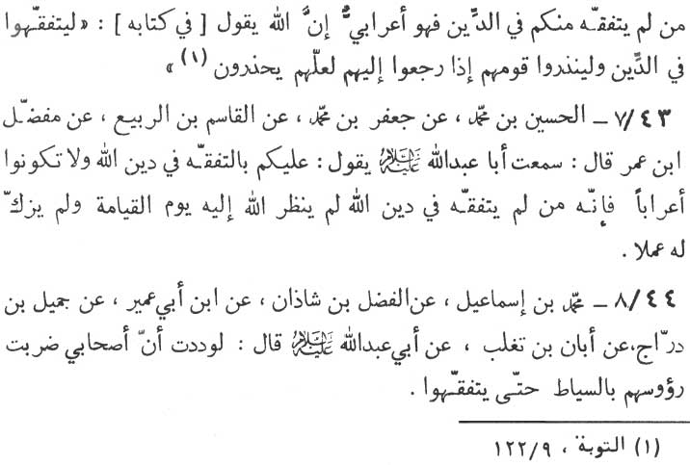

\* \* \* \* \* \* \*

Almighty Allãh has said (in his holy Book [Qur'ãn] ), 'They (a group of Muslims) may gain sound knowledge in religion and they may warn their folk when they returned to them, so that they may be aware.”(at-Tawbah, 9:122)

43-7. al-Husayn ibn Muhammad (-) Ja‘far ibn Muhammad (-) al-Qãsim ibn ar-Rabī‘ (-) Mufaddal ibn ‘Umar as saying : “I have heard Abu ‘Abdillãh (p.b.u.h.) as saying:

'It is an obligation on you to gain sound comprehensions of the religion of Allãh and not to be like (rustic) Bedouin Arabs, since Allãh on the Day of Judgment, will neither cast even a glance at nor will He purify the deeds of a person who has developed no understanding of the religion.”

44-8. Muhammad ibn Ismã‘īl (-) al-Fadl ibn Shãdhãn (-) Ibn Abi ‘Umayr (-) Jamīl ibn Darrãj (-) Abãn ibn Taghlib (-) Abu ‘Abdillãh (p.b.u.h.) as saying:

“It will be to my liking if whip blows continue to be delivered on the heads of my companions (followers) till the time they acquire understanding (in religion).”

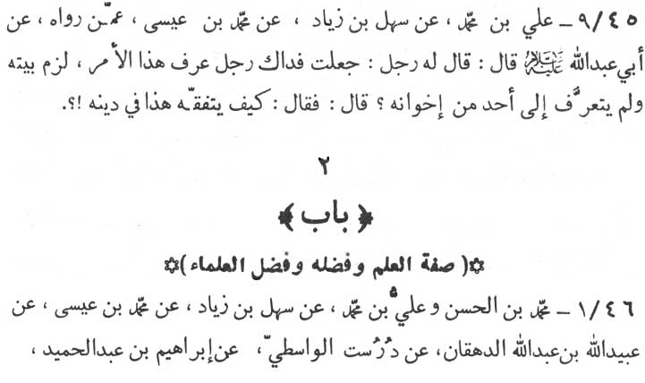

45-9. ‘Ali ibn Muhammad (-) Sahl ibn Ziyãd (-) Muhammad ibn ‘Isã (-) someone (unknown to the previous narrator) who nar-rated to him as saying:

“Someone asked Abu ‘Abdillãh (p.b.u.h.) 'May my life be sacrificed for you, there is a person who knows all about this affair (of Imãmat), but he has confined himself to his house and has no contacts with his fellow brothers, (What do you say about such per-son?) The Imãm remarked, 'How can such a person have any knowledge and understanding of the religion?”

2: CHAPTER ON PROPERTY AND SIGNIFICANCE OF KNOWLEDGE AND THE EMINANCE OF THE LEARNED

46-1. Muhammad ibn al-Hasan and ‘Ali ibn Muhammad (-) Sahl ibn Ziyãd (-) Muhammad ibn ‘Isã (-) ‘Ubaydillãh ibn ‘Abdillãh

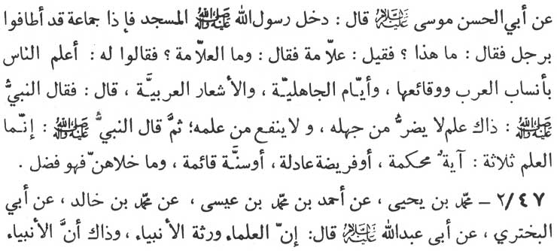

\* \* \* \* \* \* \*

ad-Dihqãn (-) Durust al-Wãsitī (-) Ibrãhīm ibn ‘Abd al-Hamīd (-) Abu'l-Hasan Musa (p.b.u.h.) as saying:

“Once the Messenger of Allãh (Muhammad - p.b.u.h.a.h.p.) while entering into the mosque saw a man surrounded by the people. The Prophet inquired about the man. He was informed that the man was an ‘Allãmah - a learned doctor. The Prophet inquired, 'What is an ‘Allãmah?' The people told the Prophet, '‘Allãmah is a person who of all the people knows most about Arab lineage, Arab battles, the days of ignorance (historical conditions prevailing before the coming of the Prophet Muhammad (p.b.u.h.a.h.p.) and all about the Arab verses and Arab literature.' Hearing this the Prophet remarked:

'This precisely is the knowledge, the acquisition of which is neither of any profit nor is the non-acquisition of it of any loss.'

Then the Prophet added:

'True knowledge is of three kinds. The first is the knowledge of the verses of Allãh which are precise and un-equivocal. The second is the knowledge of the obligations of equity and moderation. The third is the knowledge of as-Sunnah Islamic code (of musts and mustn'ts, imperatives and prohibitions). The rest is to excel or a surplus.'“

47-2. Muhammad ibn Yahyã (-) Ahmad ibn Muhammad ibn ‘Isã (-) Muhammad ibn Khãlid (-) Abi'l-Bakhtari (-) Abu ‘Abdillãh (p.b.u.h.) as saying:

“Scholars, the learned (in religion), are the heirs of the prophets,

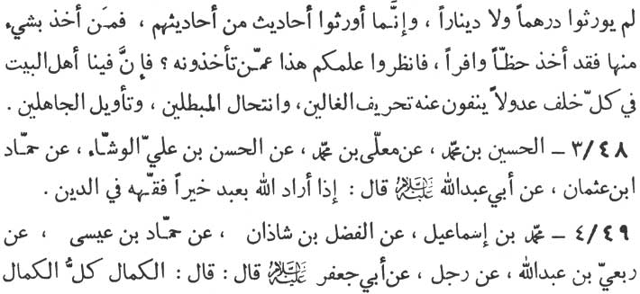

since the prophets do not leave behind them any monetary legacy. But they leave behind them, the legacy of some of the aggregate of their traditions (ahãdīth). (Since it is not proper for them to leave monetory legacy behind them for their followers, as being their guide.) He who has secured a share from the legacy of these traditions, has actually secured the lion's share. So you must look at the source from where these traditions has been taken. Verily, the source of these traditions is to be found in us - the worthy family of the Prophet Muhammad (p.b.u.h.a.h.p.). Every one of us who comes after the other is an embodiment of justice who nullifies every distortion and deviation of the extremist (ghãli),1 erases every falsehood and cuts out the misinterpretations and misconstructions of the ignorant (in divine revelations).”

48-3. al-Husayn ibn Muhammad (-) Mu‘alla ibn Muhammad (-) al-Hasan ibn ‘Ali al-Washshã' (-) Hammãd ibn ‘Uthmãn (-) Abu ‘Abdillãh (p.b.u.h.) as saying:

“When Allãh wishes well of any person He endows him with the true understanding of religion.”

49-4. Muhammad ibn Ismã‘īl (-) Fadl ibn Shãdhãn (-) Hamm-ãd ibn ‘Isã (-) Rib‘i ibn ‘Abdillãh (-) a person (unknown) (-) Abu

Note

1. (Extremist - Ghãli is the one who elevates the status of the Prophet and the Imãms to the point of God-hood.)

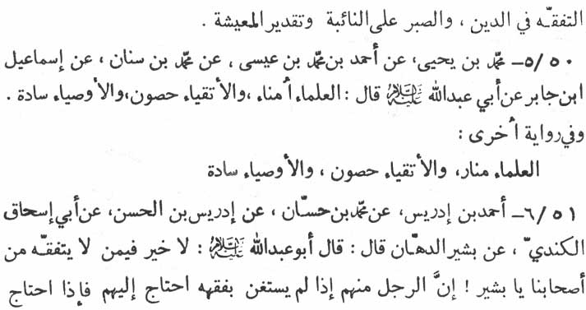

Ja‘far (p.b.u.h.) as saying:

“To have true understanding of the religion, to be patient in adversities and to be balanced and well planned in ones economic dealings is an accomplishment of all accomplishments.”

50-5. Muhammad ibn Yahyã (-) Ahmad ibn Muhammad ibn ‘Isã (-) Muhammad ibn Sinãn (-) Ismã‘īl ibn Jãbir (-) Abu ‘Abdillãh as saying :

“The learned scholars are the custodians (of divine religion and of knowledge). The pious are its fortresses, and the vicegerents of the prophets (the Imãms) are the chiefs.”

Another tradition to this tradition says : “The scholars (of religion) are the light houses, the pious are the fortresses and the vicegerents of the prophets are the chiefs.”

51-6. Ahmad ibn Idrīs (-) Muhammad ibn Hassan (-) Idris ibn al-Hasan (-) Abi Ishãq al-Kindi (-) Bashīr ad-Dahhãn (-) Abu ‘Abdillãh (p.b.u.h.) as saying:

“From amongst our companions (followers) he who has not developed any understanding of religion has no good to his share. O’ Bashīr, one who does not acquire sufficient knowledge of religion will have to depend on others (our opponents). And one who depends on them (regarding the knowledge of

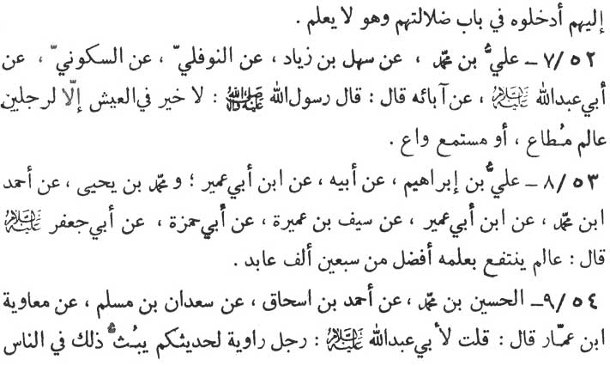

religion), they misguide him without knowing that he is misguided.”

52-7. ‘Ali ibn Muhammad (-) Sahl ibn Ziyãd (-) an-Nawfali (-) as-Sakkũni (-) Abu ‘Abdillãh (p.b.u.h.) (-) his forefathers (one after the other) till it reaches to ‘Ali ibn Abi Talib (p. b. u. h.) who said:

“The Messenger of Allãh (p. b. u. h. a. h. p.) has observed, 'Except in the life of two categories of persons there is no good in the life of others. The first category is the 'learned scholars' whom people obey. The second is the category of the attentive listeners (of the discourses of these learned scholars). “'

53-8. ‘Ali ibn Ibrãhīm (-) his father (-) Ibn Abi ‘Umayr \*and Muhammad ibn Yahyã (-) Ahmad ibn Muhammad (-) Ibn Abi ‘Umayr (-) Sayf ibn ‘Amirah (-) Abi Hamzah (-) Abu Ja‘far (p.b.u.h.) as saying :

“The scholar who derives (spiritual) benefit from his knowledge is far better than seventy thousand devotees to Allãh.”

54-9. al-Husayn ibn Muhammad (-) Ahmad ibn Ishãq (-) Sudan ibn Muslim (-) Mu‘awiyah ibn Ammar, as saying:

“I asked Abu ‘Abdillãh (p.b.u.h.) about a person who quoted

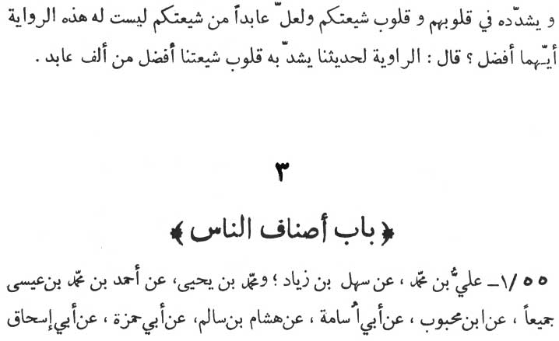

\* \* \* \* \* \*

your (the Imãm's) traditions, propagated them among the people, imprinted and fortified the traditions in their hearts and the hearts of your (Imãm's) followers. On the other hand there was another devotee to Allãh among your followers who had no such quality of relating and propagating your traditions, which of the two was better? The Imãm replied, 'He who relates our traditions, imprints and fortifies them in the hearts of our followers is far better than one thousand devotees.”

\* \* \* \* \* \*

3: CHAPTER ON CATEGORIES OF THE PEOPLE

55-1. ‘Ali ibn Muhammad (-) Sahl ibn Ziyãd \*and Muham-mad ibn Yahyã (-) Ahmad ibn Muhammad ibn ‘Isã (both of them)

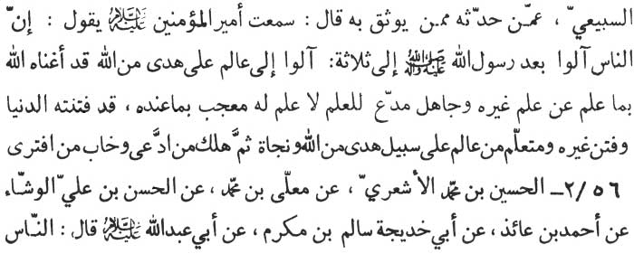

(-) Ibn Mahbũb (-) Abu Usãmah (-) Hishãm ibn Sãlim (-) Abi Hamzah (-) Abi Ishãq as-Sabi‘i (-) whoever narrated it from a reliable source as saying :

“I have heard Amīr al-mu'minīn (the Chief of the believers) as usually saying, 'After the death of the Messenger of Allãh (Muhammad p.b.u.h.a.h.p.), people turned towards three types of men as their leaders. The first type was the learned scholar who received guidance from Allãh and was on the right path. Almighty Allãh has enriched him with so much of knowledge as to make him free and independent of any other person's knowledge (and guidance). The second category (whose leadership was accepted by the people) was of the rustic, the ignorant who (falsely) claimed learning but actually had no knowledge at all, and who were still proud over what they had. Such a person had enchanted and mislead others and was himself enchanted and misguided. The third is the category of the leaders acquiring knowledge from the learned scholar who was on the right path under the guidance of the Almighty Allãh. Such a leader is the one who has earned his salvation. Further, he who has made a false claim, has met his doom and he who tampered (with religion) has been completely disappointed.”

56-2. al-Husayn ibn Muhammad al-Ash‘ari (-) Mu‘allã ibn Muhammad (-) al.-Hasan ibn ‘Ali al-Washshã' (-) Ahmad ibn ‘Ã'idh (-) Abu Khadījah Sãlim ibn Mukram (-) Abu ‘Abdillãh (p.b.u.h.) as saying :

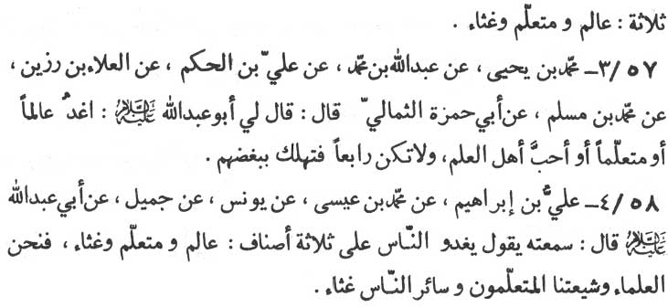

“People are of three kinds : (i) The learned scholars; (ii) The learners; and (iii) The rubbish.”

57-3. Muhammad ibn Yahyã (-) ‘Abdillãh ibn Muhammad (-) ‘Ali ibn al-Hakam (-) al-‘Alã' ibn Razin (-) Muhammad ibn Muslim (-) Abu Hamzah ath-Thumãli as saying, “Abu ‘Abdillãh (p.b.u.h.) addressed me thus:

'Lead your life in such a way that you either be a scholar or a learner or (at least) lover of the people of knowledge. Never be in the fourth category, otherwise you will meet your doom because of their enemity.”

58-4. ‘Ali ibn Ibrãhīm (-) Muhammad ibn ‘Isã (-) Yunus (-) Jamīl (-) Abu ‘Abdillãh (p.b.u.h.) as saying:

“People are of three types; (i) The learned scholars; (ii) the learners; and (iii) the rubbish. We (the worthy progeny of the Pro-phet) are the learned scholars, our disciples and followers are the learners and the rest are just rubbish.”

\* \* \* \* \* \*

D:\barkatullah\books\new books\rajab\al_kafi_dr_hassan_rizvi\al_kafi_vol_01_part_02\photo shop\Untitled-26.jpg

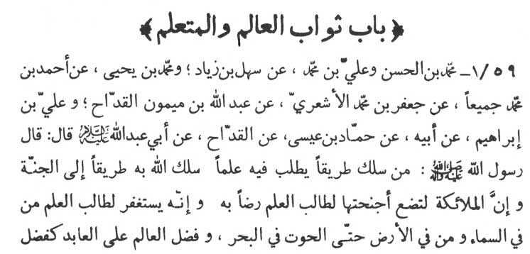

4: CHAPTER ON THE DIVINE REWARDS FOR THE LEARNED AND THE LEARNERS.

59-1. Muhammad ibn al-Hasan and ‘Ali ibn Muhammad (-) Sahl ibn Ziyãd \*and Muhammad ibn Yahyã (-) Ahmad ibn Muhammad, both of them (-) Ja‘far ibn Muhammad al-Ash‘ari (-) ‘Abdullãh ibn Maymũn al-Qaddãh and ‘Ali ibn Ibrãhīm (-) his father (-) Hammãd ibn ‘Isã (-) al-Qaddãh (-) Abu ‘Abdillãh (p.b.u.h.) as saying :

“The Messenger of Allãh (p.b.u.h.a.h.p.) observed :

'Almighty Allãh will lead along the path of paradise a person who treads along the path that leads to knowledge. Verily, the angels spread their wings under the feet of a person who goes in search of knowledge. Verily, all the creations of heaven and earth including the fish of oceans pray for his redemption. The man of learning in

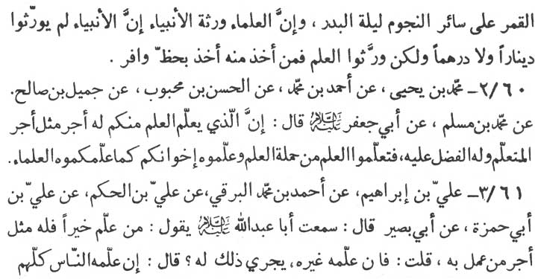

comparison with a man of prayers and devotion, stands on the same footing as the fourteenth moon stands in comparison with all the stars. Verily, the scholars (in religion) are the heirs of the prophets. The prophets do not leave behind them any monetary legacy. (It is not proper for the prophets to leave monetary legacy behind them for their followers, as being their guide.) They leave behind their knowledge. He who has a share in that knowledge has actually secured the lion's share.”

60-2. Muhammad ibn Yahyã (-) Ahmad ibn Muhammad (-) al-Hasan ibn Mahbũb (-) Jamīl ibn Sãlih (-) Muhammad ibn Muslim (-) Abu Ja‘far (p.b.u.h.) as saying:

“The giver of knowledge is blessed by Allãh in the same way as the taker of it, rather the former has precedence over the later. Acquire knowledge from those who are its true possessors. Teach your brothers as the learned have taught you.”

61-3. ‘Ali ibn Ibrãhīm (-) Ahmad ibn Muhammad al-Barqi (-) ‘Ali ibn al-Hakam (-) ‘Ali ibn Abi Hamzah (-) Abu Bash. as saying, “I have heard Abu ‘Abdillãh (p.b.u.h.) as saying:

'He who teaches any good to others will have the same reward as the one who acts upon it.' I asked him, 'Should the same person teach the good to someone else, will the first person who taught it

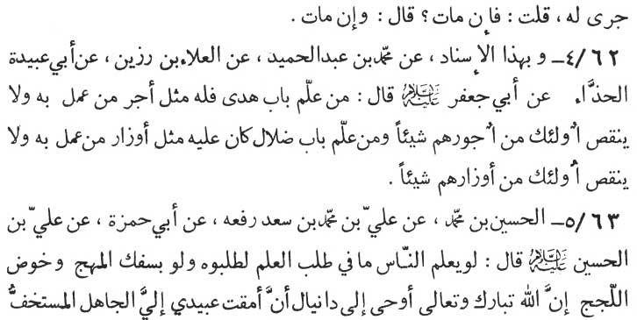

be entitled to the same reward?' The Imãm replied, 'If the first teaches the good to all mankind, even then, the first person will continue to share the equal rewards with all the doers of the good.' I (the narrator) again asked, 'What the position would be in the case of the death of the first teacher.' The Imãm replied, 'His death makes no difference. He will go on receiving the divine rewards although dead.”

62-4. According to same ascription (-) Muhammad ibn ‘Abd al-Hamīd (-) al-‘Alã ibn Razīn (-) Abi ‘Ubaydah al-Hadhdhã' (-) Abu Ja‘far (p.b.u.h.) as saying:

“He who gives any lesson in any gateway towards guidance shares equal rewards with the people who act upon it without the slightest deduction in the rewards of the doers. And he who gives any lesson in any gateway towards misguidance, shares equal punishment with the people who act upon it, without the slightest deduction in the punishments of the sinners.”

63-5. al-Husayn ibn Muhammad (-) ‘Ali ibn Muhammad ibn Sa‘d (rafa‘ahu) (-) Abi Hamzah (-) ‘Ali ibn al-Husayn (p.b.u.t.) as saying:

“Had the people known the real worth of the acquisition of knowledge they would have acquired it even if they had to pay for it with a bleeding heart or if they had to dive in the deep seas. Almighty Allãh revealed to Dãniyãl (the prophet), 'Most wretched

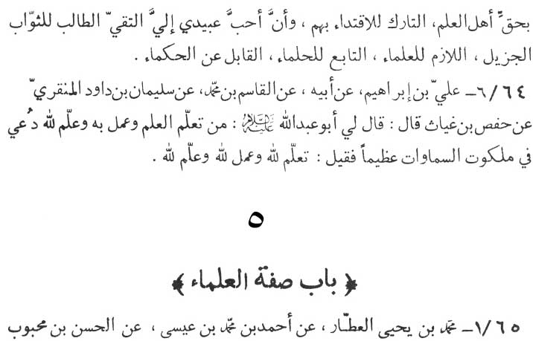

among My creation is the rustic who makes light of the learned and stops following them. And the most lovable among My creation is the person who guards himself against evil seeking My maximum rewards, attaches himself to the learned, follows the path of the patient and the for-bearing, and always accepts the words of the wise.”

64-6. ibn Ibrãhīm (-) his father (-) al-Qãsim ibn Muhammad (-) Sulaymãn ibn Dãwũd al-Minqarī (-) Hafs ibn Ghiyãth as saying: “Abu ‘Abdillãh (p.b.u.h.) addressed me thus:

'He who acquires knowledge, acts upon it and imparts it to others only to please Allãh is proclaimed (by all existing beings) throughout the realm of Heavens as the great and the magnificent. It is proclaimed (about him) that he is the one who acquired knowledge to please Allãh, acted upon it to please Allãh and also propagated it amongst the people only to please Allãh.”

\* \* \* \* \* \*

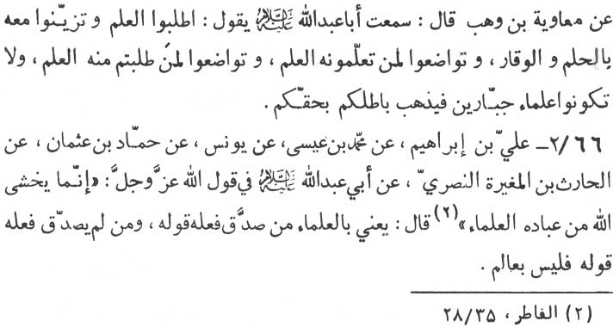

5: CHAPTER ON ATTRIBUTES OF THE LEARNED SCHOLARS

65-1. Muhammad ibn Yahyã al-‘Attãr (-) Ahmad ibn Muhammad ibn ‘Isã (-) al-Hasan ibn Mahbũb (-) Mu‘awiyah ibn Wahab as saying, “I have heard Abu ‘Abdillãh (p.b.u.h.) as saying:

'Acquire knowledge and adorn it with forbearance and reverence. Be humble to those whom you give knowledge and also to those from whom you received it. Never be among the harsh tempered scholars. Lest you should forfeit your title (to all rewards of your learning) because of your wrong and harsh demeanour.” 4

66-2. ‘Ali ibn Ibrãhīm (-) Muhammad ibn ‘Isã (-) Yunus (-) Hammãd ibn ‘Uthmãn (-) al-Hãrith ibn Mughīrah an-Nasri (-) Abu ‘Abdillãh (p.b.u.h.) regarding the (following) words of Allãh, the Almighty :

“Verily, fear Allãh only those of His servants endowed with knowledge.” (al-Fãtir, 35:28)

“Learned here means those whose deed corroborate their word. And he whose deed do not corroborate his word is not at all a learned scholar.”

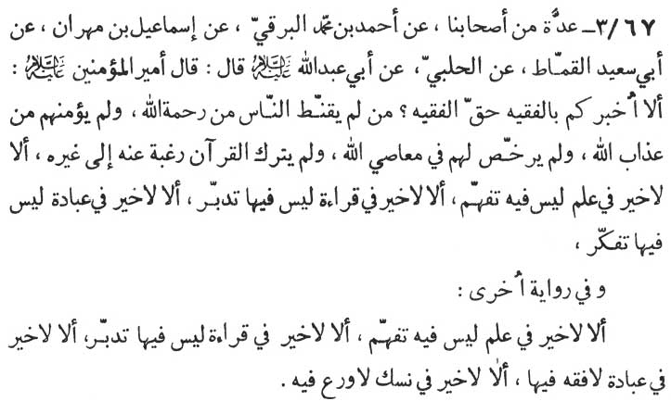

67-3. A group of our associates (-) Ahmad ibn Muhammad al-Barqi (-) Ismã‘īl ibn Mihrãn (-) Abu Sa‘īd al-Qammãt (-) al-Halabī (-) Abu ‘Abdillãh (p.b.u.h.) as saying:

“Amīr al-mu'minīn observed, 'Verily, let me inform you about a person who truly is a learned scholar. It is he who neither disappoints the people from the mercy of Allãh and nor does he set them free (the people) from the fear of divine curse and punishment, nor does he let the people commit sins, nor does he turn away from Qur'ãn to other things for the reason of his personal longings and inclinations. Verily, there is no virtue of any sort in the knowledge which is devoid of comprehension. There is no virtue of any sort in the recitation of the verses of Qur'ãn which is devoid of understanding of their thought power. Lo, there is no virtue of any sort in the devotedness and prayers which are devoid of deliberation and meditation.”

Another narration (of this tradition) says :

“Verily, there is no virtue in the knowledge which is devoid of comprehension. Lo, there is no virtue in recitation of the words of Allãh which is devoid of thinking. Lo, there is no virtue in devotion and prayerfulness which is devoid of knowledge and

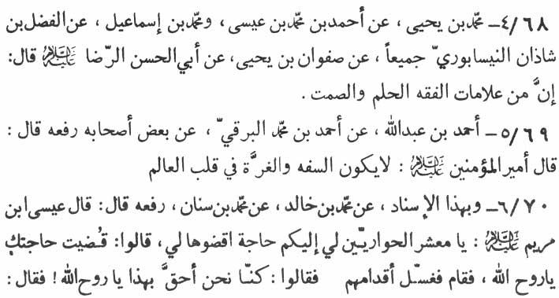

comprehension. Lo, there is no virtue in the devotedness which is void of piousness.”

68-4. Muhammad ibn Yahyã (-) Ahmad ibn Muhammad ibn ‘Isã \*and Muhammad ibn Ismã‘īl (-) al-Fadl ibn Shãdhãn an-Naysãburi, both of them (-) Safwãn ibn Yahyã (-) Abu'l-Hasan ar-Ridã (p.b.u.h.) as saying:

“Forbearance and silence are two among the symbols of know-ledge and understanding.”

69-5. Ahmad ibn ‘Abdillãh (-) Ahmad ibn Muhammad al-Barqi (-) some of his associates (rafa‘ahu) Amīr al-mu'minīn (p.b.u.h.) as saying:

“The heart of a learned scholar is always free from stupidity and inadvertence.”

70-6. According to the same ascription (-) Muhammad ibn Khãlid (-) Muhammad ibn Sinãn (rafa‘ahu) as saying :

“ ‘Isã ibn Maryam (Jesus - p.b.u.h.) said (addressing his people), 'O’ my comrades, I need you for something, would you like to fulfil it for my sake?' They (the comrades) replied, 'O’ spirit of Allãh, we are ready to fulfill every need of yours.' Then he (Jesus - p.b.u.h.) got up and started washing their feet. The comrades exclaimed, 'O’ spirit of Allãh ! In fact it is we who deserve the honour of washing your feet. Jesus replied,

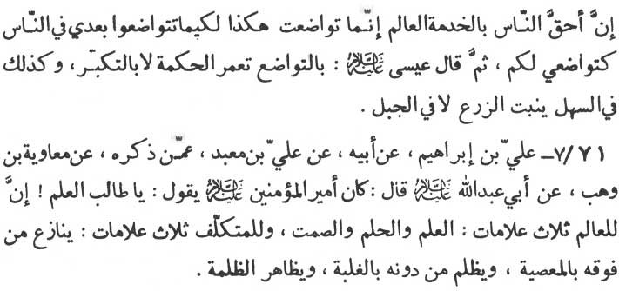

'The person who can lay the greatest claim render service (to mankind) is the learned scholar himself. Lo, I have showed humility to this extent to you so that after me you should also show the same humility to mankind.' Jesus, the prophet, added 'It is through humility that wisdom and knowledge are nurtured, not through conceit and haughtiness in the same way as a crop is raised only from a leveled ground and not from mountainous regions.”

71-7. ‘Ali ibn Ibrãhīm (-) his father (-) ‘Ali ibn Ma‘bad (-) the person whose name was mentioned (-) Mu‘ãwiyah ibn Wahb (-) Abu ‘Abdillãh (p.b.u.h.) as saying: “Amīr al-mu'minīn (p.b.u.h.) has observed :

'O’ seeker of knowledge! there are three signs of a learned scholar. They are, knowledge, forbearance and silence. Similarly there are three signs of a fake scholar. He is always a quarrelsome and insubordinate to one superior to him. He is tyrannical to those who are inferior to him through browbeating and through riding over them rough shod. Thirdly he is the backbone of the tyrants and the oppressors.”

\* \* \* \* \* \*

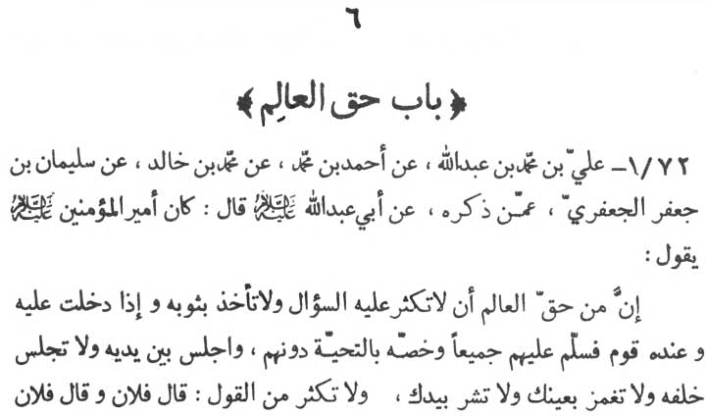

6: CHAPTER ON RIGHTS AND PRIVILEGES OF A LEARNED SCHOLAR

72-1. ‘Ali ibn Muhammad ibn ‘Abdillãh (-) Ahmad ibn Muhammad (-) Muhammad ibn Khãlid (-) Sulaymãn ibn Ja‘far al-Ja‘fari (-) the person whose name was mentioned (-) Abu ‘Abdillãh (p.b. u.h.) as saying, “Amīr al-mu'minīn observed :

'Among the rights and privileges of a learned scholar is, that you should not ask him numerous questions, you should not pull him by his gown (in demanding answers). When you get into his presence, you should pay distinct and special compliments to him, while paying compliments to all present in his audience. Always sit in front of him and never sit at his back. Never gesticulate with your eyes and hands in his presence. In his presence avoid referring

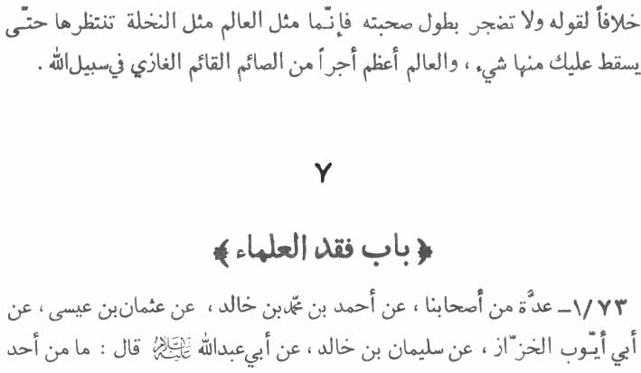

frequently 'such and such man has said this and that and has repudiated you like this and like that.' Never be impatient and restless on his long speeches and discourses since a learned scholar is like a palm tree under which the people wait for some fruit to drop down to them. A learned scholar is entitled to far greater divine rewards than the rewards of a person who fasts (in the day) and stands (in prayers) in the night and who wages a war in the way of Allãh “

\* \* \* \* \* \*

7: CHAPTER ON THE PASSING AWAY OF THE SCHOLARS

73-1. A group of our associates (-) Ahmad ibn Muhammad ibn Khãlid (-) ‘Uthmãn bin ‘Isã (-) Abi Ayyũb al-Khazzãz (-) Sulaymãn ibn Khãlid (-) Abu ‘Abdillãh (p.b.u.h.) as saying:

“Among all the deaths of Muslim believers (mu'minīn) none

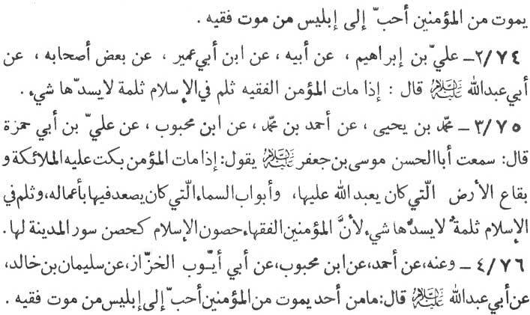

is so lovable for iblīs (Satan) as the death of a learned scholar (of Islamic).”

74-2. ‘Ali ibn Ibrãhīm (-) his father (-) Ibn Abi ‘Umayr (-) some of his associates (-) Abu ‘Abdillãh (p.b.u.h.) as saying:

“The death of a believer scholar causes such a cleft in (the fort-ress of) Islam as can never be repaired with anything.”

75-3. Muhammad ibn Yahyã (-) Ahmad ibn Muhammad (-) Ibn Mahbũb (-) ‘Ali ibn Abi Hamzah as saying: “I have heard Abu'l-Hasan Mũsã ibn Ja‘far (p.b.u.t.) as saying:

'When a (true Muslim) believer dies the angeles, the spot of the earth on which he used to offer prayers to Allãh, and the doors of the heaven through which his good deeds ascended, all lament the death of him. His death causes a vacuum in Islam (itself) which can never be filled with anything. It is because the believer scholars (of Islamics) are the fort of Islam like the fort which is built round the city.”

76-4. From him (i.e. Muhammad ibn Yahyã) (-) Ahmad (-) Ibn Mahbũb (-) Abi Ayyũb al-Khazzãz (-) Sulaymãn ibn Khãlid (-) Abu ‘Abdillãh (p.b.u.h.) as saying:

“Among all the deaths of Muslim believers none is so lovable to

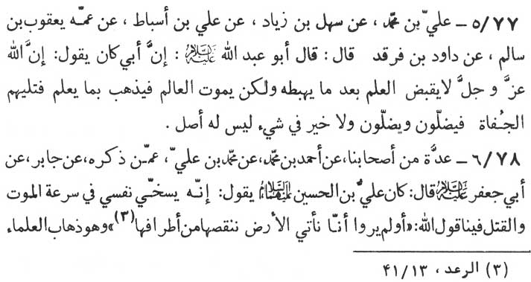

iblis (Satan) as the death of a learned scholar (of religion and Islamics).”

77-5. ‘Ali ibn Muhammad (-) Sahl ibn Ziyãd (-) ‘Ali ibn Asbãt (-) his uncle Ya‘qũb ibn Sãlim (-) Dãwũd ibn Farqad (-) Abu ‘Abdillãh (p.b.u.h.) as saying, “My father has observed:

'Almighty Allãh never withdraws the knowledge after sending it down to mankind, unless it were the knowledge of a learned scholar who dies. In this case the death of a scholar takes away his knowledge with him. His place is then taken by such rude and rough people as are not only themselves misguided but they also misguide others. And there is no virtue in a thing which has no base.”

78-6. A group of our associates (-) Ahmad ibn Muhammad (-) Muhammad ibn ‘Ali (-) the person whose name was mentioned (-) Jãbir (-) Abu Ja‘far (p.b.u.h.) as saying, “ ‘Ali ibn al-Husayn (p.b. u.h.) observed :

'My own death and the assassination of my family members have been rendered quite easy and bearable (even) for me because of these words of Allãh :

'Have they not seen how We come to the land diminishing it in its extremities?' (ar-Ra‘d, 13:41)

It means the death of the learned.”

\* \* \* \* \* \* \*

D:\barkatullah\books\new books\rajab\al_kafi_dr_hassan_rizvi\al_kafi_vol_01_part_02\photo shop\Untitled-38.jpg

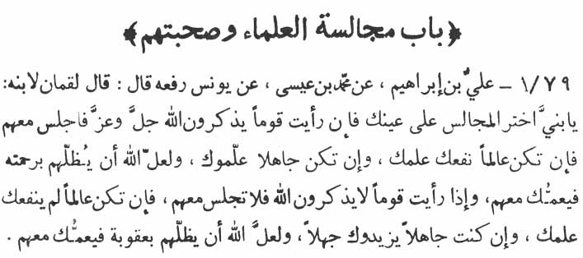

8: CHAPTER ON THE COMPANY OF THE LEARNED AND HAVING ASSOCIATION WITH THEM

79-1. ‘Ali ibn Ibrãhīm (-) Muhammad ibn ‘Isã (-) Yũnus (raja‘ahu) Luqmãn the wise as saying :

“O’ my son be always on the look for (different) companies of the people and if you see people engaged in talks and remembrance of Allãh, join them. In case,you are already in the know of (the points under discussion), their company will give you (fresh) knowledge. Perhaps the Almighty Allãh will bestow upon the scholars His bounties and you will also receive some of them. If you see people forgetful of Allãh, then avoid their company. In case, you are learned, your know-ledge will not benefit you at all. (Because their company will not increase your knowledge at all.) In case,you are devoid of knowledge their company will add to your ignorance. Perhaps the wrath of Allãh will descend on them and you will

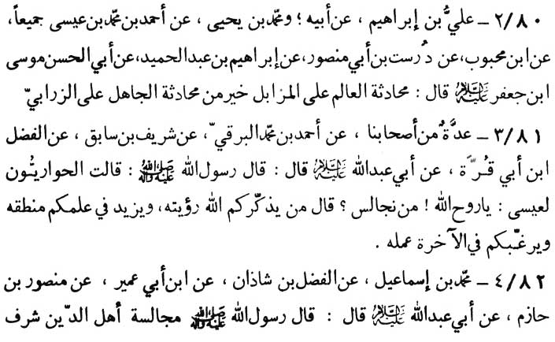

also be a victim along with them.”

80-2. ‘Ali ibn Ibrãhīm (-) his father \*and Muhammad ibn Yahyã (-) Ahmad ibn Muhammad ibn ‘Isã, both of them (-) Ibn Mahbũb (-) Durust ibn Abi Mansũr (-) Ibrãhīm ibn Abd al-Hamīd (-) Abu'l-Hasan Mũsã ibn Ja‘far (p.b.u.t.) as saying:

“Having discourses with a learned scholar even on a garbage dump is better than a talk with an ignorant and illiterate person on a carpet.”

81-3. A group of our associates (-) Ahmad ibn Muhammad al-Barqi (-) Sharīf ibn Sãbiq (-) al-Fadl ibn Abi Qurrah (-) Abu Abdillãh (p.b.u.h.) as saying, “The Messenger of Allãh (p.b.a.h. a.h.p.) has said :

'The companions of ‘Isã (Jesus, the prophet - p.b.u.h.) inquired from him, 'O’ spirit of Allãh, whose company should we keep?' He (Jesus) replied, 'The company of those whose appearance reminds you of Allãh, whose talks enhance your knowledge, and whose deeds persuade you to work for your life hereafter.”

82-4. Muhammad ibn Ismã‘īl (-) al-Fadl ibn Shãdhãn (-) Ibn Abi ‘Umayr (-) Mansũr ibn Hãzim (-) Abu ‘Abdillãh (p.b.u.h.)

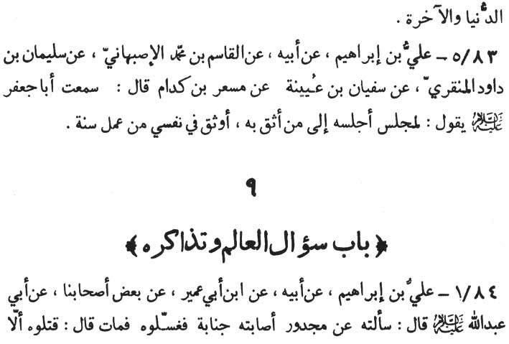

as saying, “The Messenger of Allãh (p.b.u.h.a.h.p.) said:

'Keeping the company of the holy religious people is a matter of honour in this life and also in the life hereafter.”

83-5. ‘Ali ibn Ibrãhīm (-) his father (-) al-Qãsim ibn Muhammad al-Isbahãni (-) Sulaymãn ibn Dãwũd al-Minqari (-) Sufyãn ibn ‘Uyay-nah (-) Mis‘ar ibn Kidãm, as saying, “I have heard Abu Ja‘far (p.b. u.h.) saying:

'To me having a single session with a man of integrity and con-fidence is far better than doing good deed for the whole year.”

\* \* \* \* \*

9: CHAPTER ON ASKING QUESTIONS AND INTERCHANGING WITH A LEARNED SCHOLAR

84-1. ‘Ali ibn Ibrãhīm (-) his father (-) Ibn Abi ‘Umayr (-) some of our associates (-) Abu ‘Abdillãh (p.b.u.h.). The narrator

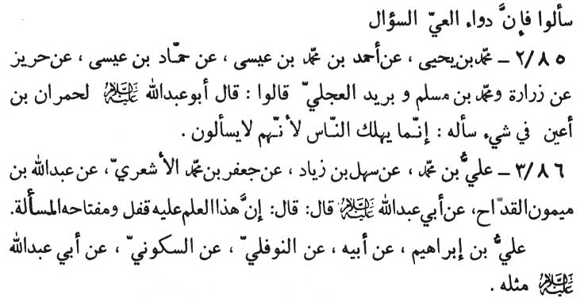

says, "I inquired from the Imãm about the case of a person who was a patient of small-pox and who had died as a result of a compulsory bath which he was given after his sexual union. The Imãm remarked,

'In fact they have killed the person. Before giving him the bath, why was guidance not sought? The only remedy of ignorance and lassitude is interrogation. '

85-2. Muhammad ibn Yahyã (-) Ahmad ibn Muhammad ibn ‘Isã (-) Hammãd ibn ‘Isã (-) Harīz (-) Zurãrah, Muhammad ibn Muslim and Burayd a1-‘Ijli, as saying :

“Abu ‘Abdillãh (p.b.u.h.) while addressing Humrãn ibn A‘yan, who has inquired from him about something, said, 'Verily, many a people met their doom just because they do not interrogate.”

86-3. ‘Ali ibn Muhammad (-) Sahl ibn Ziyãd (-) Ja‘far ibn Muhammad al-Ash‘ari (-) ‘Abdullãh ibn Maymũn al-Qaddãh (-) Abu ‘Abdillãh (p.b.u.h.) as saying:

“Verily, knowledge is under a lock, the key of which is inter-rogation.”

The same (tradition has also been narrated by the following chain of narrators):

‘Ali ibn Ibrãhīm (-) his father (-) an-Nawfali (-) as-Sakũnī (-) Abu ‘Abdillãh (p.b.u.h.).

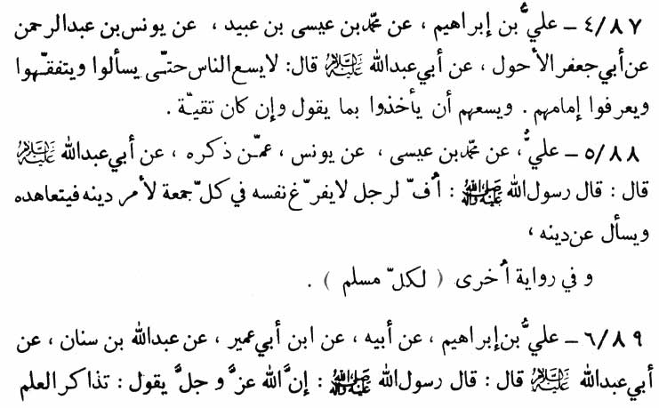

87-4. ‘Ali ibn Ibrãhīm (-) Muhammad ibn ‘Isã ibn ‘Ubayd (-) Yũnus ibn ‘Abd ar-Rahmãn (-) Abu Ja‘far al-Ahwal (-) Abu ‘Abdillãh (p.b.u.h.) as saying:

“People don't receive anything until and unless they ask for it, understand it and recognise their (divinely appointed) Imãms - guides. And it is expedient for the people to listen, accept and obey their Imãms' words though they have to hide their faith to the people under the pressure of the tyranny against them.”

88-5. ‘Ali (-) Muhammad ibn ‘Isã (-) Yũnus (-) the person whose name was mentioned (-) Abu ‘Abdillãh (p.b.u.h.) as saying:

“The Messenger of Allãh (p.b.a.h.a.h.p.) has observed, 'Fie upon every person who does not make himself free on every Friday for his religious affairs so that he could devote himself to his faith and interrogate about his religion.”

According to some other authorities (the Imãm has obseved), “(Fie upon) every Muslim” (instead 'Fie upon every person.')

89-6, ‘Ali ibn Ibrãhīm (-) his father (-) Ibn Abi ‘Umayr (-) ‘Abdullãh ibn Sinãn (-) Abu ‘Abdillãh (p.b.u.h.) as saying:

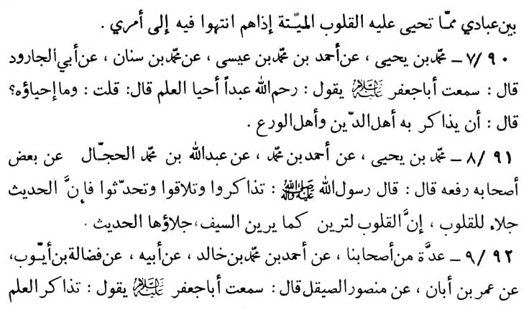

“The Messenger of Allãh (p.b.u.h.a.h.p.) has said, 'Says Allãh Almighty, “Learned discourses among My creatures is an instrument to bring the dead hearts back to life provided that they intend to (learn) My commands.”

90-7. Muhammad ibn Yahyã (-) Ahmad ibn Muhammad ibn ‘Isã (-) Muhammad ibn Sinãn (-) Abu al-Jarud (-) Abu Ja‘far (p.b.u.h.) as saying :

“May Allãh be merciful to a person who revives knowledge.” The narrator says, “I inquired of the Imãm, 'What is the meaning of the revival of knowledge?' The Imãm replied, 'It means to have discourses with the worthy religious and pious people.”

91-8. Muhammad ibn Yahyã (-) Ahmad ibn Muhammad (-) ‘Abdullãh ibn Muhammad al-Hajjãl (-) some of his associates (rafa‘ahũ) The Messenger of Allãh (p.b.u.h.a.h.p.) as saying:

“Talk and meet each other to have learned discourses since such talks and discourses on a tradition (hadīth) make your hearts transparent. Since the hearts (minds) rust in the same way as the sword does and its polish is such talks on our traditions (hadīth).”

92-9, A group of our associates (-) Ahmad ibn Muhammad ibn (-) Mansũr as-Sayqal, as saying, “I have heard Abu Ja‘far

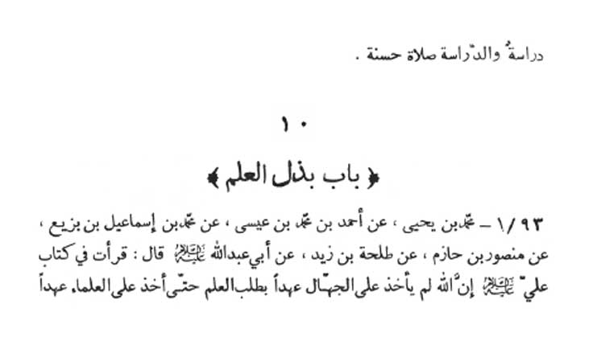

\* \* \* \* \* \* \*

(p.b.u.h.) as saying :

'Learned discourses are the instructions and lessons in themselves and they are the best prayers.”

\* \* \* \* \* \*

10: CHAPTER ON DEFUSION OF KNOWLEDGE

93-1. Muhammad ibn Yahyã (-) Ahmad ibn Muhammad ibn ‘Isã (-) Muhammad ibn Ismã‘īl ibn Bazī‘ (-) Mansũr ibn Hãzim (-) Talhah ibn Zayd (-) Abu ‘Abdillãh (p.b.u.h.) as saying:

“I have read in the book of ‘Ali (p.b.u.h.) 'not until Allãh took the pledge from the learned to defuse knowledge freely, did Allãh take the pledge from the illiterate to acquire knowledge. It is because

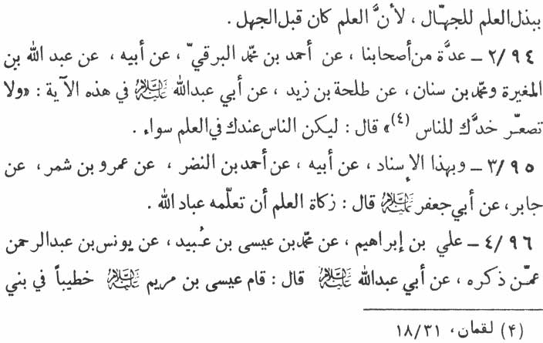

knowledge had been there already and ignorance came afterwards.”

94-2. A group of our associates (-) Ahmad ibn Muhammad al-Barqi (-) his father (-) ‘Abdullãh ibn Mughīrah and Muhammad ibn Sinãn (-) Talhah ibn Zayd (-) Abu ‘Abdillãh (p.b.u.h.) regarding the words of Allãh which says :

“Turn not thy cheek (face) toward folk” (Luqmãn, 31:18).

(The Imãm remarked), “The reason (why the Prophet was not to turn his face away from the people) was that the Prophet was ordained to treat all the people quite equally as far as (the de.fusion) of knowledge is concerned.”

95-3. According to the same ascription (-) his father (-) Ahmad ibn Nadr (-) ‘Amro bin Shimr (-) Jãbir (-) Abu Ja‘far (p.b.u.h.) as saying:

“The divine tax on knowledge is to teach it to Allãh's creatures - people.”

96-4. ‘Ali ibn Ibrãhīm (-) Muhammad ibn ‘Īsã ibn ‘Ubayd (-) Yũnus ibn ‘Abd ar-Rahmãn (-) the person whose name was mentioned (-) Abu ‘Abdillãh (p.b.u.h.) as saying:

“ ‘Isã ibn Maryam (Jesus, the Prophet) stood up to address

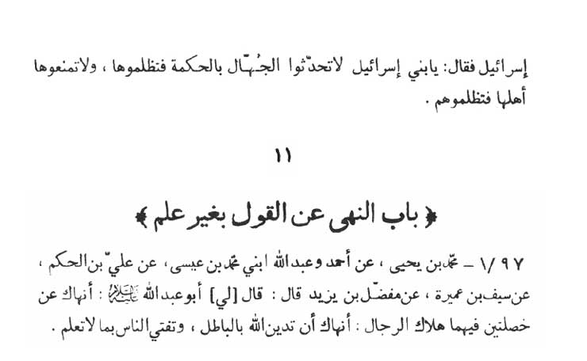

the Children of Israel, said :

'O’ Bani Isrã'īl! Never reveal wisdom to the rustic since this is tyranny on wisdom (itself), and never conceal it from those worthy of it since this will be a tyranny on the worthy.”

\* \* \* \* \* \*

11: CHAPTER ON NOT TO SPEAK WITHOUT KNOWLEDGE

97-1. Muhammad ibn Yahyã (-) Ahmad ibn ‘Abdullãh (both) sons of Muhammad ibn ‘Isã (-) ‘Ali ibn al-Hakam (-) Sayf ibn ‘Amirah (-) Mufaddal ibn Yazīd as saying, “Abu ‘Abdillãh (p.b.u.h.) addressed (me) thus:

'I restrain you from two propensities as they bring all mankind to grief. Firstly, not to resort to wrong ways regarding your divine religion. Secondly, not to pronounce any verdict without knowledge before the people without knowing it.”

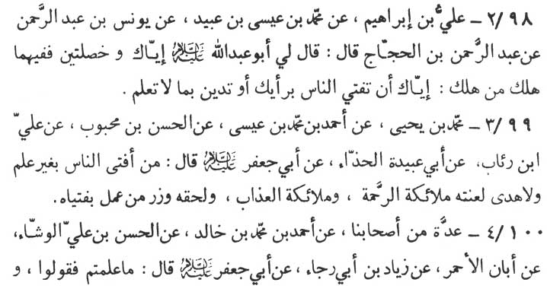

98-2. ‘Ali ibn Ibrãhīm (-) Muhammad ibn ‘Isã ibn ‘Ubayd (-) Yũnus ibn ‘Abd ar-Rahmãn (-) ‘Abd ar-Rahmãn ibn al-Hajjaj as saying, “Abu ‘Abdillãh (p.b.u.h.) addressed me thus:

'I restrain you from two propensities since all who met their doom was the result of these two. Firstly, I restrain you from pro-nouncing a verdict (in religious affairs) based on your personal opinion before the people. Secondly, I restrain you from treating anything as religious without knowing it.”

99-3. Muhammad ibn Yahya (-) Ahmad ibn Muhammad ibn ‘Isã (-) al-Hasan ibn Mahbũb (-) ‘Ali ibn Ri'ãb (-) Abi ‘Ubaydah al-Hadhdhã' (-) Abu Ja‘far (p.b.u.h.) as saying:

“All the angels of divine mercy and the angels of divine wrath invoke curse for the person who pronounces verdicts regarding religious affairs before the people without having knowledge and guidance. Further such a person is liable to bear all the responsibilities of the persons who follow his wrong verdicts.”

100-4. A group of our associates (-) Ahmad ibn Muhammad ibn Khãlid (-) al-Hasan ibn ‘Ali al-Washshã' (-) Abãn al-Ahmar (-) Ziyãd ibn Abī Rajã' (-) Abu Ja‘far (p.b.u.h.) as saying:

“Tell the people what you know, and in case you don't know

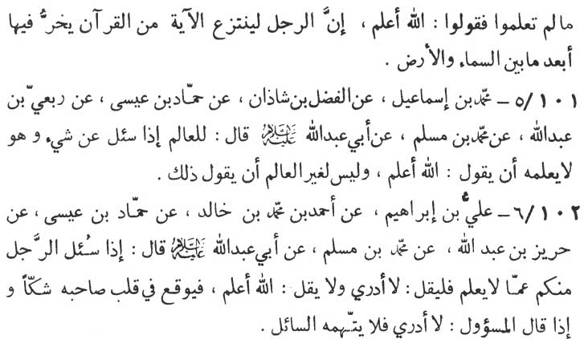

say, 'Allãh knows best.' Lo, if a person singles out any verse from Qur'ãn - the Book of Allãh (to mis-interpret it) - he falls down as far away as the heaven is from the earth.”

101-5. Muhammad ibn Ismã‘īl (-) al-Fadl ibn Shãdhãn (-) Hammãd ibn ‘Isã (-) Rib‘ī ibn ‘Abdillãh (-) Muhammad ibn Muslim (-) Abu ‘Abdillãh (p.b.u.h.) as saying:

“If a learned man is interrogated on something he does not know, it is obligatory on him to state Allãh knows best' But if he is not learned (and still interrogated) then he has no right even to state that much.” (that is, “Allãh knows best.”)

102-6. ‘Ali ibn Ibrãhīm (-) Ahmad ibn Muhammad ibn Khãlid (-) Hammãd ibn ‘Isã (-) Harīz ibn ‘Abdillãh (-) Muhammad ibn Muslim (-) Abu ‘Abdillãh (p.b.u.h.) as saying:

“If any one of you is interrogated on something he knows nothing about, then he must confess, 'I don't know' and not to state, Allãh knows best; as the latter reply will rouse a doubt in the mind of the interrogator (that he being learned is not willing to answer him or being ignorant he is posing as learned). But in case, the interrogated plainly states 'I don't know' the interrogator cannot accuse him of any cupidity.”

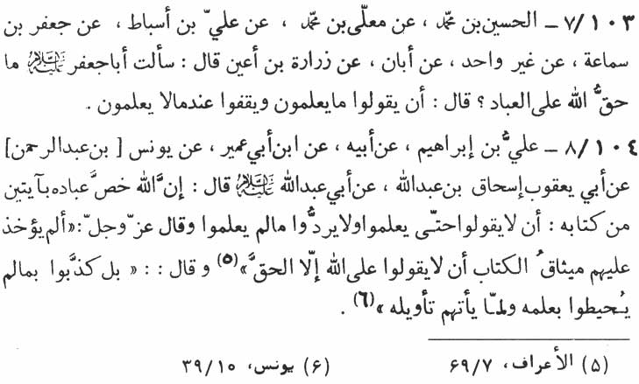

103-7. al-Husayn ibn Muhammad (-) Mu‘allã ibn Muhammad (-) ‘Ali ibn Asbãt (-) Ja‘far ibn Samã‘ah (-) (some others) more than one (-) Abãn (-) Zurãrah ibn A‘yan as saying, “I asked Abu Ja‘far (p.b.u.h.) 'What does man owe Allãh?' The Imãm replied, 'He who knows should say what he knows and he who does not know should cease talking about it.”

104-8. 'Ali ibn Ibrãhīm (-) his father (-) Ibn Abi ‘Umayr (-) Yũnus (ibn ‘Abd ar-Rahmãn) (-) Abi Ya‘qũb Is'hãq ibn ‘Abdillãh (-) Abu ‘Abdillãh (p.b.u.h.) as saying:

“Almighty Allãh has earmarked two verses from His Book (Qur'ãn) for His creatures. (The first is) not to reply until they know and (secondly) to rebut and redirect the querry, if they don't know. Allãh the Almighty has said : 'Has not the compact of the Book been taken touching them, that they should say concerning Allãh nothing but the truth?' (al-A‘rãf, 7:169)

And (Allãh) has said, 'Nay they belied that which they com-prehended not with the knowledge of it and the explanation of it came not unto them.” (Yũnus, 10:39)

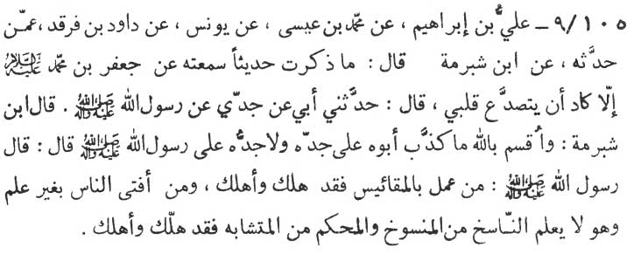

105-9. ‘Ali ibn Ibrãhīm (-) Muhammad ibn ‘Isã (-) Yũnus (-) Dãwũd ibn Farqad (-) Whoever (unknown) narrated it to him (-) Ibn Shubrumah (the chief judge of Kufah) as saying:

“My heart starts trembling like anything, whenever I (Ibn Shubrumah) remember this very tradition which I have heard from Ja‘far ibn Muhammad (p.b.u.t.) as saying, 'My father has quoted my grand-father who has narrated it from the Prophet - the Messenger of Allãh (p.b.u.h.a.h.p.).” Says Ibn Shubrumah (the narrator) after swearing in the name of Allãh that his (Imãm's) father had never made any false reference to his great grand-father and his great grand-father had never made any false reference to the Prophet - the Messenger of Allãh. “The Imãm observed :

'Says the Messenger of Allãh (p.b.u.h.a.h.p.) 'Whoever acted on guess work (in the matter of religion and divine commands) met his doom and brought (others to their doom). And whosoever pro-nounced a verdict without knowledge of the annulment against what is annuled and which (of the verses from Qur'ãn) are obvious (muh-kam) and which are ambiguious (mutashãbih), not only met his doom but also brought others to their doom.”

\* \* \* \* \*

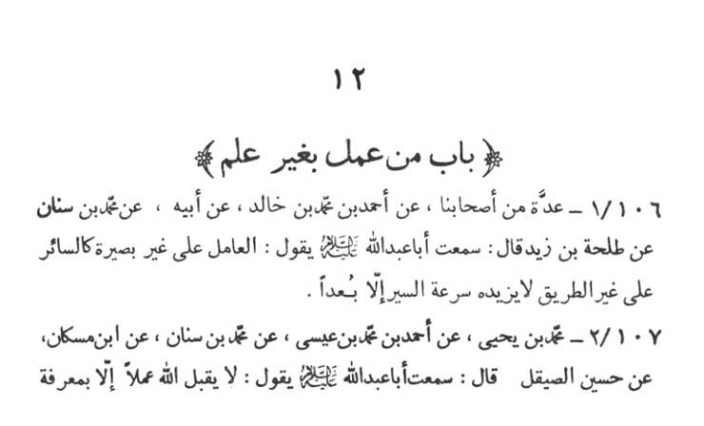

12: CHAPTER ON ACTING WITHOUT KNOWLEDGE

106-1. A group of our associates (-) Ahmad ibn Muhammad ibn Khãlid (-) his father (-) Muhammad ibn Sinãn (-) Talhah ibn Zayd as saying, “I have heard Abu ‘Abdillãh (p.b.u.h.) saying:

'One who acts without insight (knowledge) is like a pedestrian on a wrong path, whose speed along the way, only carries him further away (from his destination).”

107-2. Muhammad ibn Yahyã (-) Ahmad ibn Muhammad ibn ‘Isã (-) Muhammad ibn Sinãn (-) Ibn Muskãn' (-) Hasan as-Sayqal as saying, “I have heard Abu Abdillãh (p.b.u.h.) as saying :

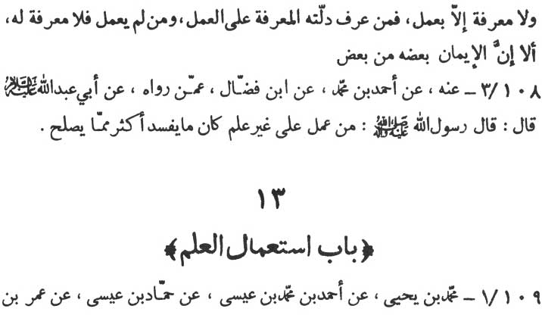

'Almighty Allãh never accepts any virtuous act unless it is ac-companied by knowledge and consciousness. And there can be no knowledge and consciousness without the virtuous acts. He who has acquired knowledge and consciousness, is guided by it towards virtuous deeds. And he who has no virtuous deeds, has basically no such know-ledge and consciousness at all. Verily, belief and its results (that is, virtuous deeds) inter act on each other.”

108-3. From him (-) Ahmad ibn Muhammad (-) Ibn Faddãl (-) Whoever narrated it to him (-) Abu ‘Abdillãh (p.b.u.h.) as saying:

“The Messenger of Allãh (p.b.u.h.a.h.p.) said, 'Whoever acts without knowledge actually wrongs more than he corrects.”

\* \* \* \* \*

13: CHAPTER ON APPLICATION AND USE OF KNOWLEDGE

109-1. Muhammad ibn Yahyã (-) Ahmad ibn Muhammad

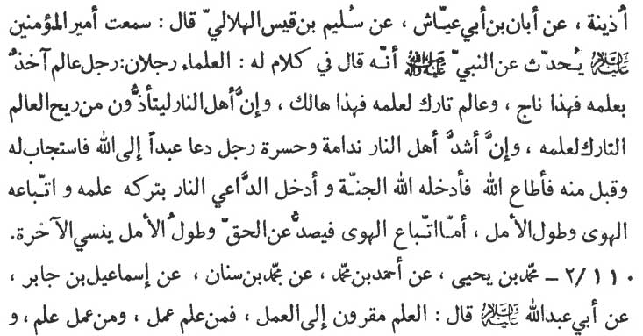

ibn ‘Isã (-) Hammãd ibn ‘Isã (-) ‘Umar ibn Udhaynah(-) Abãn ibn Abi ‘Ayyãsh (-) Sulaym ibn Qays al-Hilãlī as saying, “I have heard from Amīr al-mu'minīn - the Chief of the believers (‘Ali - p.b.u.h.) quoting the Prophet (p.b.u.h.a.h.p.) as saying during his (Prophet's) discourses :

'Religious scholars are of two types. The first is the scholar who derives from his knowledge by putting it into practical use. He is due to get salvation. The second is the scholar who sets aside his knowledge (without deriving any benefit from its practical use). He is the scholar who is destined to meet his doom. Lo, even the dwellers of Hell will be tormented by the stink (spreading) from such a scholar. No other dweller of Hell shall face so intense a repentance and frustration as the learned one who invited another man towards Allãh and in response to whose call, the other man accepted him and obeyed Allãh and as a result entered Paradise, but the scholar himself was sent to Hell because he had forsaken the knowledge and its practical use, and that he had followed his evil desires and had entertained wild hopes. Since the pursuit of evil desires repels from the truth and the wild hopes make one forget the life hereafter.”

110-2. Muhamman ibn Yahyã (-) Ahmad ibn Muhammad (-) Muhammad ibn Sinãn (-) Ismã‘īl ibn Jãbir (-) Abu ‘Abdillãh

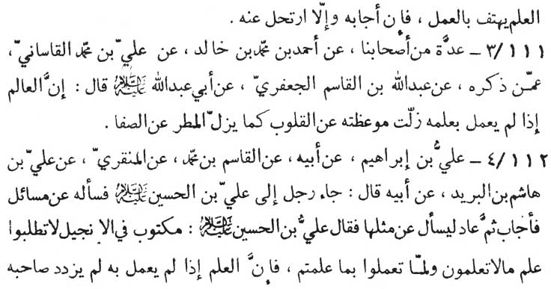

(p.b.u.h.) as saying:

“Knowledge is coupled with practice. He who knows, acts and he who acts, acquires true knowledge. Knowledge gives a call to practice. If the practice responds to the call of knowledge (it makes it-self available to the practice). If it does not, then knowledge gives it a go by.”

111-3. A group of our associates (-) Ahmad ibn Muhammad ibn khãlid (-) ‘Ali ibn Muhammad al-Qãsãni (-) whoever (unknown to us) mentioned by the narrator (-) ‘Abdullãh ibn al-Qãsim al-Ja‘fari (-) Abu ‘Abdillãh (p.b.u.h.) as saying:

“Verily, if a man of knowledge does not act on his knowledge, his words of advice spil through the heart (of the listerners) as the rain water does over (the duck) the smooth stone.”

112-4. ‘Ali ibn Ibrãhīm (-) his father (-) al-Qãsim ibn Muhammad (-) al-Minqari (-) ‘Ali ibn Hãshim ibn al-Burayd (-) his father as saving, “A man came to ask some questions from 'Ali ibn al-Husayn (p.b.u.t.). The Imãm gave him satisfactory answers. The man came again to ask similar questions. Upon this the Imãm observed:

'It is written in Injīl (the holy Book of Allãh revealed to Jesus, the Prophet), that not until you have practiced what you have learnt should you try to learn what you don'nt know. It is because the

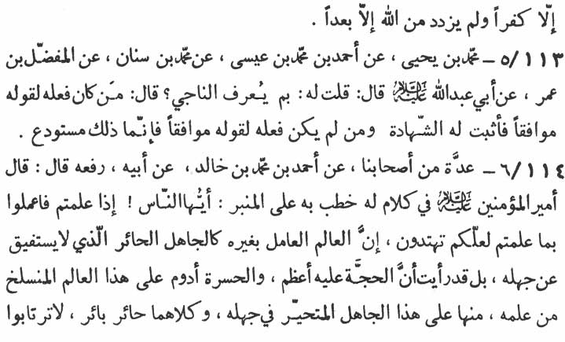

knowledge which is not practiced enhances nothing but thanklessness, disbelief and remoteness from Allãh.”

113-5. Muhammad ibn Yahyã (-) Ahmad ibn Muhammad ibn ‘Isã (-) Muhammad ibn Sinãn (-) al-Mufadclal ibn ‘Umar as saying:

“I asked Abu ‘Abdillãh (p.b.u.h.) 'How to recognise one who secures his salvation?' The Imãm replied, It is he whose deeds completely accord with his words. If so the evidence of his salvation is absolute. And in case, his actions are discordent with his words, then his knowledge is just a repository.”

114-6. A group of our associates (-) Ahmad ibn Muhammad ibn Khãlid (-) his father (rafa‘ahu) Amīr al-mu'minīn (‘Ali - p.b.u.h.) while addressing the people on a pulpit, said :

“O’ people, practice what once you have already learnt, so that you may be the recepient of guidance. A learned scholar who acts besides his knowledge is just like a confounded rustic who does not recover from his ignorance. Rather I see that divine proofs (and hence responsibilities) are greater for a learned who sets aside the practice over his knowledge and hence eternal frustration is his lot. His case is worse than the case of a rustic puzzled over his ignorance. Both of them are confounded and doomed to hell fire.

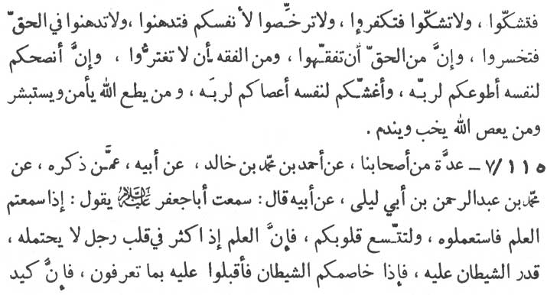

Don't be indecisive, otherwise you will be a sceptic. And don't be sceptic otherwise you will be an infidel. And don't try to free yourself from religious responsibilities lest you should be a victim of laziness. Don't be sluggish in the matter of truth lest you should be in loss. And it is a part of Truth that you acquire understanding of religion. And it is a part of this understanding that you should not be defrauded. He amongst you is the most self-advised and self-presumed who is most willingly obedient to Allãh. And he amongst you is the most self-deceived, who is most disobedient to Allãh. Whoever disobeys Allãh is a failure in life and becomes subject to repentance.”

115-7. A group of our associates (-) Ahmad ibn Muhammad ibn Khãlid (-) his father (-) whoever (unknown to us) mentioned by the narrator (-) Muhammad ibn ‘Abd ar-Rahmãn ibn Abi Laylã (-) his father as saying, “I have heard Abu Ja‘far (p.b.u.h.) saying:

'When you have acquired knowledge, put it into practice soon and keep your mind open. Since when a person (without opening the doors of his mind and bringing his knowledge into practice) goes on acquiring too much of knowledge, it becomes an unbearable load for him and thereby he passes under the control of the Shaytãn (Satan). Whenever Satan quarrels with you, you should face him with the help of the knowledge you have. Verily, the wiles and deceipts of

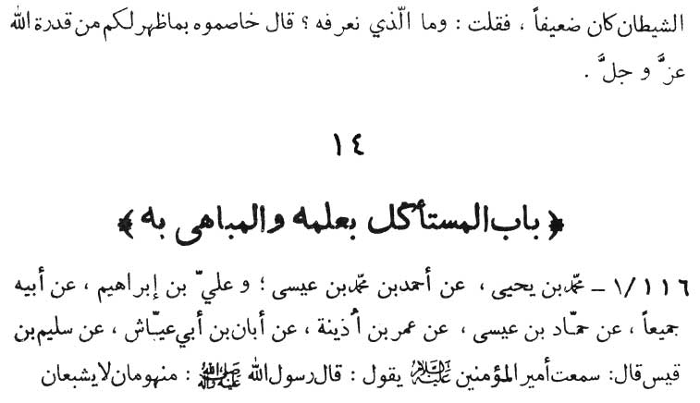

Satan are quite feeble.' Hearing it I (the narrator) inquired, 'What is that knowledge which we should acquire?' The Imãm replied, 'It is the knowledge of the Omnipotence of Allãh manifested to you, with which you should lace Satan (every evil in life).”

\* \* \* \* \*

14: CHAPTER ON ONE WHO LIVES BY AND IS PROUD OF HIS KNOWLEDGE

116-1. Muhammad bin Yahyã (-) Ahmad ibn Muhammad ibn ‘Isã and ‘Ali ibn Ibrãhīm (-) his father, both of them (-) Hammãd ibn ‘Isã (-) ‘Umar ibn Udhaynah (-) Abãn ibn Abi ‘Ayyãsh (-) Sulaym ibn Qays as saying, “I have heard Amīr al-mu'minīn (p.h.u.h.) saying:

'The Messenger of Allãh (p.b.u.h.a.h.p.) observed: Two types of hungry person can never be appeased (i) the seeker of the worldly

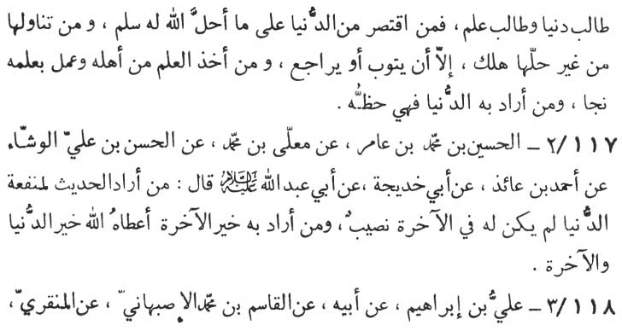

gains, and (ii) the seeker of knowledge. He who confined himself in respect of his worldly gains within what Allãh has sanctioned for him, achieves the real peace. And he who achieves the worldly gains through what Allãh has not allowed him, meets his doom, except when he repents and turns away from this evil (through repaying what he owed to others). And he who acquires knowledge from the one worthy of it and brings his knowledge into practice, secures his sal-vation. And the share of the person who acquires knowledge (of re-ligion) with the motive of worldly gains shall only be limited to the extent of these worldly gains themselves.”

117-2. al-Husayn ibn Muhammad ibn ‘Ãmir (-) Mu‘allã ibn Muhammad (-) al-Hasan ibn ‘Ali al-Washshã' (-) Ahmad ibn ‘Ã'idhī (-) Abi Khadījah (-) Abu ‘Abdillãh (p.b.u.h.) as saying:

“He who acquires knowledge of the traditions to earn worldly gains will have no share of Divine rewards in his life hereafter. And he who acquires this knowledge for the betterment of his life here-after will be sanctioned by Allãh the good of this life and the life hereafter.”

118-3. ‘Ali ibn Ibrãhīm (-) his father (-) al-Qãsim ibn Muham-mad al-Isbahanī (-) al-Minqarī (-) Hafs ibn Ghiyãth (-) Abũ ‘Abdillãh (p.b.u.h.) as saying:

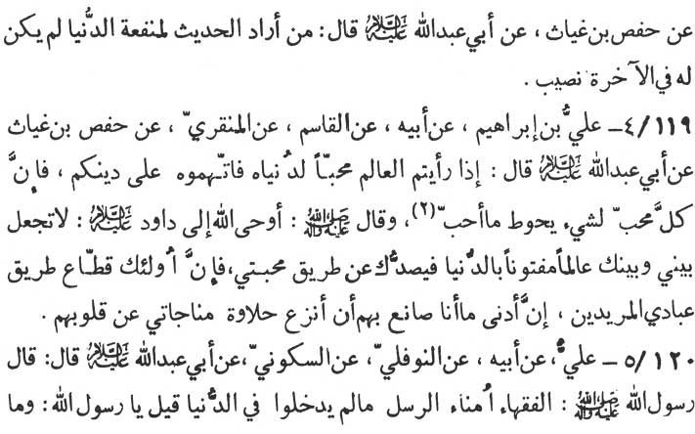

“He who intends worldly gains through his knowledge of the traditions, has no share (of Divine rewards) in his life hereafter.”

119-4. ‘Ali ibn Ibrãhīm (-) his father (-) al-Qãsim (-) al-Minqari (-) Hafs ibn Ghiyãth (-) Abu ‘Abdillãh (p.b.u.h.) as saying :

“Never entrust your religion to a scholar if you find him in love of worldly gains, (rather) charge him that he will be hostile to your religion. Verily, all those who have been in love for a thing, revolve around it. The Prophet (p.b.u.h.a.h.p.) has observed, 'Allãh revealed to Dãwũd (David, the Prophet - p.b.u.h.): Don't let a scholar who intensely loves his worldly gains, between Me and you, since he will restrain you from the path of My love. Verily, they are the highway robbers for those of My creatures who intend Me (in their lives). The minimum of My punishment for such scholars is that I deprived their hearts of the joy of the communion with Me (in their prayers).”'

120-5. ‘Ali (-) his father (-) an-Nawfali (-) as-Sakkũni (-) Abu ‘Abdillãh (p.b.u.h.) as saying :

“The Messenger of Allãh (p.b.u.h.a.h.p.), has observed, 'The scholars (in religion) are the trustees of the Prophets so long as they

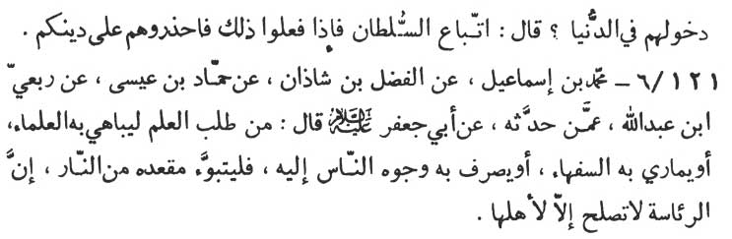

are not worldly minded.' The Prophet was asked, 'What is meant by being worldly minded?' The Prophet replied, 'It means following the reigning power. Should they do so, then, beware of them in res-pect of your religion.”

121-6. Muhammad ibn Ismã‘īl (-) al-Fall ibn Shãdhãn (-) Hammãd ibn ‘Isã (-) Rib‘ī ibn ‘Abdillãh (-) whoever narrated it to him (-) Abu Ja‘far (p.b.u.h.) as saying:

“He who acquires knowledge for the purpose of priding him-self on it before other scholars, or for the purpose of debating with the fools, or for playing to the gallery, has actually built for him-self an abode in the hell. Verily, leardership is not proper except of 'him who is worthy of it.”

\* \* \* \* \*

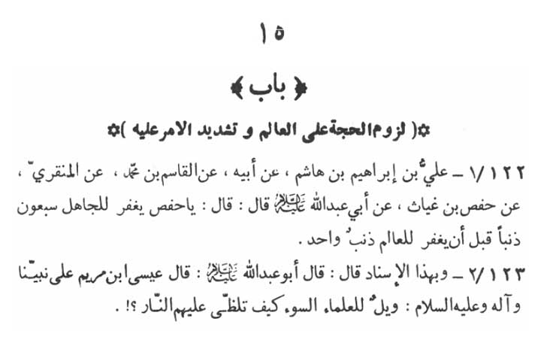

15: CHAPTER ON ACCOUNTABILITY OF THE LEARNED (BEFORE ALLAH) AND ITS SEVERITY

122-1. ‘Ali ibn Ibrãhīm ibn Hãshim (-) his father (-) al-Qãsim ibn Muhammad (-) al-Minqari (-) Haft ibn Ghiyãth (-) Abu ‘Abdillãh (p.p.u.h.) as saying:

“O’ Hafs'. Seventy sins of an ignorant person are forgiven by Allãh before He forgives one single sin of a learned one.”

123-2. According to the above mentioned authorities, “Abu ‘Abdillãh (p.b.u.h.) has observed, ‘Isã son of Maryam (Jesus, the Prophet - peace be upon him and upon our Prophet and his progeny)

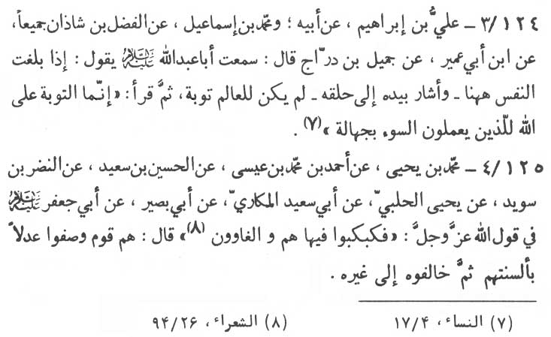

has said, 'Woe to the wicked scholars, how fiercely do the flames of hell fire envelope them.”

124-3. ‘Ali ibn Ibrãhīm (-) his father and Muhammad ibn Ismã‘īl (-) al-Fadl ibn Shãdhãn, both of them (-) Ibn Abi ‘Umayr (-) Jamīl ibn Darraj as saying, “I have heard Abu ‘Abdillãh (p.b.u.h.) saying:

'When the last breath of life reaches upto this place,' then the Imãm pointed out to his throat, 'the time for the scholars to repent is over once for all.' Then the Imãm recited this verse from Qur'ãn;

'Verily repentance (acceptable) to Allãh is only for those who do evil ignorantly.” (an-Nisã', 4:17)

125-4. Muhammad ibn Yahyã (-) Ahmad ibn Muhammad ibn ‘Isã (-) al-Husayn ibn Sa‘īd (-) an-Nadr ibn Suwayd (-) Yahyã al-Halabi (-) Abi Sa'id al-Mukãrī (-) Abi Basīr (-) Abu Ja‘far (p.b. u.h.) as saying:

“Regarding the words of Allãh, 'So they shall be thrown down into it (the hell fire), they are those gone astray.' (ash-Shu‘arã', 26:94) (The Imãm observed) This is a group of people which praised justice with the tongue and contravened it with its deeds.”

\* \* \* \* \*

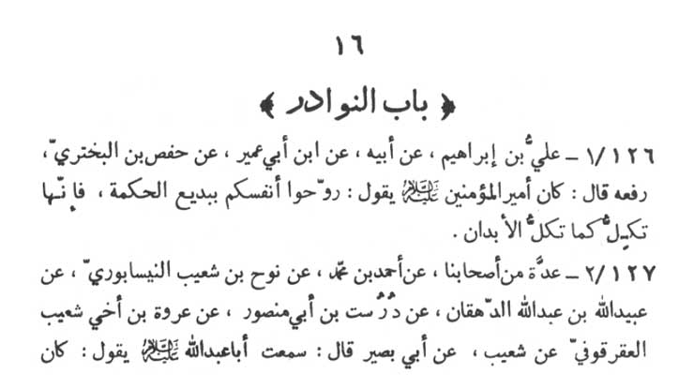

16: CHAPTER ON MISCELLANEOUS TRADITIONS

126-1. ‘Ali ibn Ibrãhīm (-) his father (-) Ibn Abi ‘Umayr (-) Hafs ibn al-Bakhtari (rafa‘ahũ) as saying:

“Amīr al-mu'minīn - the Chief of the believers (‘Ali - p.b.u.h.) has said, 'Refresh yourself with the marvellous and wonderful words of wisdom since the soul (mind) is tired in the same way as your body does.”

127-2. A group of our associates (-) Ahmad ibn Muhammad (-) Nũh ibn Shu‘ayb an-Naysãbũrī (-) ‘Ubaydillãh ibn ‘Abdillãh ad-Dihqãn (-) Durust ibn 'Abi Mansũr (-) ‘Urwah ibn Akhi Shu‘ayb al-‘Aqarqũfi (-) Shu‘ayb (-) Abi Basīr as saying, “I have

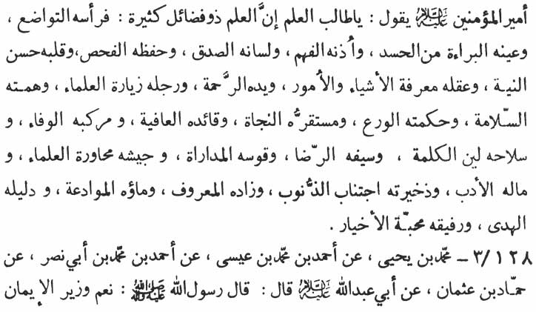

heard Abũ ‘Abdillãh (p.b.u.h.) saying, 'Amīr al-mu'minīn - the Chief of the believers (‘Ali - p.b.u.h.) used to say :

'O’ seeker of knowledge! there are numerous virtues of know-ledge. (Should knowledge be incorporated in human form then) humility would be its head; absence of jealousy would be its eye; understanding would be its ear; truth its tongue, search and preser-vation of truth its memory; purity of motives its heart; recognition and knowledge of (human) affairs and (attributes of) things its reasoning; its hand mercy; its legs visit to the scholars; its ambition peacefulness; its wisdom guarding against evil; its headquarter salvation; its leader health and vigour; its ride fidelity; its armament sweet words; its sword acceptance (of the truth); its bow sympathy and hospitality; its army discourses with the scholars; its wealth manners and good bearing. Guarding against evil is its treasure; its kit and tiffin good deeds; getting on well (with others) its drink; its guide divine guidance; its mate love of virtuous.”

128-3. Muhammad ibn Yahyã (-) Ahmad ibn Muhammad ibn ‘Isã (-) Ahmad ibn Muhammad ibn Abi Nasr (-) Hammãd ibn ‘Uthmãn (-) Abu ‘Abdillãh (p.b.u.h.) as saying, “The Messenger

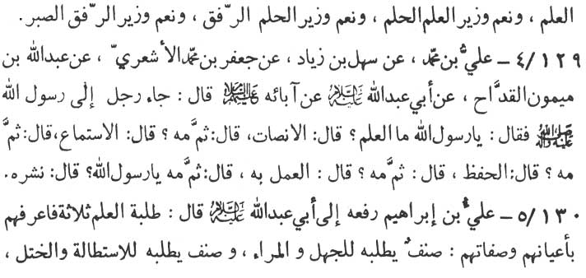

of Allãh (p.b.u.h.a.h.p.) has observed:

'The ablest vizier (wazīr) of faith is knowledge, and the ablest vizier of knowledge is forbearance, and that of forbearance is kind-ness and of kindness is patience.”

129-4. ‘Ali ibn Muhammad (-) Sahl ibn Ziyãd (-) Ja‘far ibn Muhammad al-Ash‘ari (-) Abdullah ibn Maymũn al-Qaddãh (-) Abu ‘Abdillãh (p.b.u.h.) (-) his fore-fathers (the Imãms - p.b.u.t.) as saying :

“A person came to the Messenger of Allãh (p.b.u.h.a.h.p.) and asked, 'What is knowledge?' The Prophet replied, 'It is to remain silent (before the teacher).' The man inquired, 'What is the next stage?' The Prophet replied, 'It is to listen (to the learned at-tentively).' The man inquired, 'What is after that?' The Prophet replied, 'It is to remember (what one has listened to).' The man in-quired, 'What is next?' The Prophet replied, 'It is to act upon (what one has learnt).' The man inquired, 'What is next?' The Prophet replied, 'It is to propagate it.”

130-5. ‘Ali ibn Ibrãhīm (rafa‘ahũ) Abu ‘Abdillãh (p.b.u.h.) as saying:

“Seekers of knowledge are of three types; identify them by their personality, specific individuality and attributes. The first is

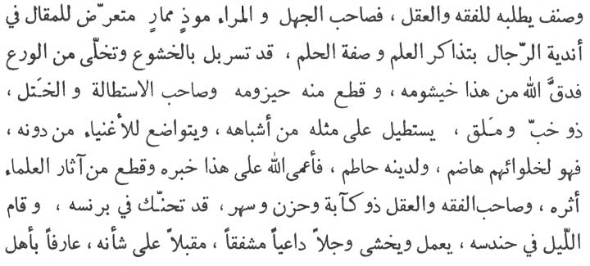

the type which seeks knowledge for foolishness, stupidity and de-ception display. The second is the type which seeks it for over-bearing attitude. The third is the type which seeks knowledge to comprehend and to contemplate.

“(The first type of man) who is a man of display and stupidity always tantalises and plays to the gallery. He is in the state of tern-pramental readiness for expression in the company of the people for learned discussions on forbearance. Outwardly he appears to be an embodiment of reverence for Allãh but inwardly his heart is totally devoid of piety and Godliness. Almighty Allãh gives him a punch on his nose and breaks his back bone.

“(Second is the type) who is a case of over-bearing attitude and desception is really a man cheating and flattery. He is the type which seeks to dominate its equals and which is servile before the rich, who are lessen in knowledge. He is the man who tastes from their lavish tables and (with every morsal he takes) he degrades and demolishes his religion. Almighty Allãh will make him slink into oblivion and will banish all traces of him from among those of the learned.

“(The third is the type) who is a man of meditation and under-standing; who is always sad, sober and is wide awake. He dresses his burnoose (gown) for worship and stands for the prayers in the darkness of night. He acts in hope and fear. He is fearful, prayerful, guardful and engrossed in his own affairs. He knows the people

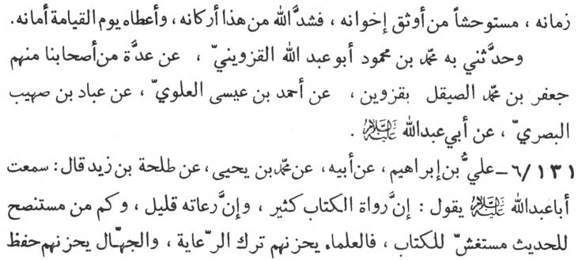

of his time inside out and therefore is vigilant even against his most reliable friends and brothers. (Because of his virtues) Almighty Allãh Himself strengthens the pillars (of his life) and grants him peace on the Day of Judgment.”

The same tradition has also been narrated by Muhammad ibn Mahmũd, Abu ‘Abdillãh al-Qazwīnī (-) a group of our associates among them are Ja‘far ibn Muhammad as-Sayqal in Qazwīn (-) Ahmad ibn ‘Isã al-‘Alawī (-) ‘Abbãd ibn Suhayb al-Basri (-) Abu ‘Abdillãh (p.b.u.h.).

131-6. ‘Ali ibn Ibrãhīm (-) his father (-) Muhammad ibn Yahyã (-) Talhah ibn Zayd as saying, “I have heard Abu ‘Abdillãh (p.b.u.h.) saying :

'Many are the people who quote the scriptures very often, but those who really pay due regards to them (acts upon them) are few. Many are the people who are in pursuit of the validity of the traditions but they are deceptive about the validity of the Book (Qur'ãn). The real learned scholars are grieved at the non-implementation of Qur'ãnic teachings but the ignorant are in pursuit of the verbal- utterances in narrating (the traditions) and are taking troubles in remembering the words by heart. The former are actually sowing the seeds of their eternal life of peace,

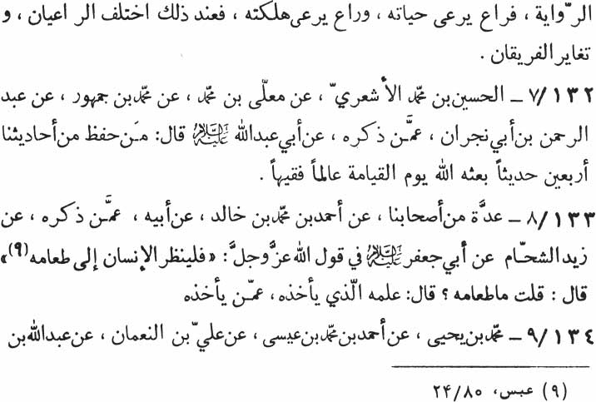

whereas the latter are actually hastening towards their own destruction. Thus at this juncture have they branched off in two categories (those who only recite and remember the words and those who act upon it and are trying to implement Islamic teachings in the society). Thus have they been clearly divided in two opposite camps.”

132-7. al-llusayn ibn Muhammad al-Ash‘ari (-) Mu‘allã ibn Muhammad (-) Muhammad ibn Jumhũr (-) ‘Abd ar-Rahmãn ibn Abi Najrãn (-) whoever mentioned by the narrator (-) Abu ‘Abdillãh (p.b.u.h.) as saying:

“On the Day of Judgment Allãh will raise as a scholar and a learned jurist a person who learns by heart or preserves (in letters and the spirit) of at least forty out of our total traditions.”

133-8. A group of our associates (-) Ahmad ibn Muhammad ibn Khãlid (-) his father (-) whoever mentioned by the narrator (-) Zayd ash-Shahhãm (-) Abu Ja‘far (p.b.u.h.) as saying in respect of the words of Allãh, “Then let man look at his food” (‘Abasa, 80:24).

“Food here signifies the knowledge (of religion) and looking into the food means the source from which it is acquired.”

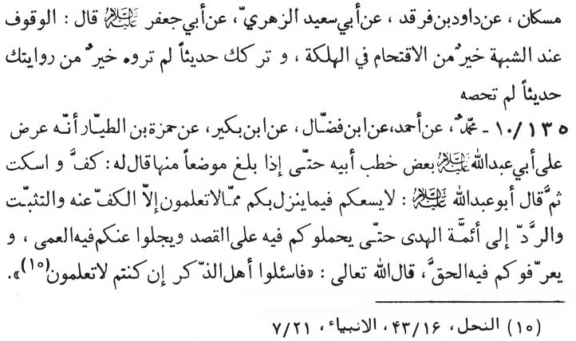

134-9. Muhammad ibn Yahyã (-) Ahmad ibn Muhammad ibn ‘Isã (-) ‘Ali ibn an-Nu‘mãn (-) ‘Abdullãh ibn Muskãn (-) Dãwũd ibn Farqad (-) Abi Sa‘īd az-Zuhri (-) Abu Ja‘far (p.b.u.h.) as saying:

“In a doubtful case, it is better to wait and deliberate than to take any fatal decision forthwith. It is better to abandon a tradition which, in your opinion is not correctly reproduced than to continue its reproduction unchecked and un-examined.”

135-10. Muhammad (-) Ahmad (-) Ibn Faddãl (-) Ibn Bukayr (-) Hamzah ibn at-Tayyãr who reproduced some extracts from the speeches of the father of Abu ‘Abdillãh (p.b.u.h.) in his presence. Till he reached a stage when the Imãm intervened saying, “Stop and be silent.” Then the Imãm added:

“That which comes to you and you cannot authenticate it, your duty in such a case is nothing but to stop, verily and refer it to the divine Imãms (guides) who will lead you to the correct version, give you light and guidance in which you are misguided and provide you the understanding of its hidden truth. Allãh the Almighty has Himself so ordered:

'So ask you the people of dhikr (Qur'ãn) if you know not.” (an-Nahl, 16:43)

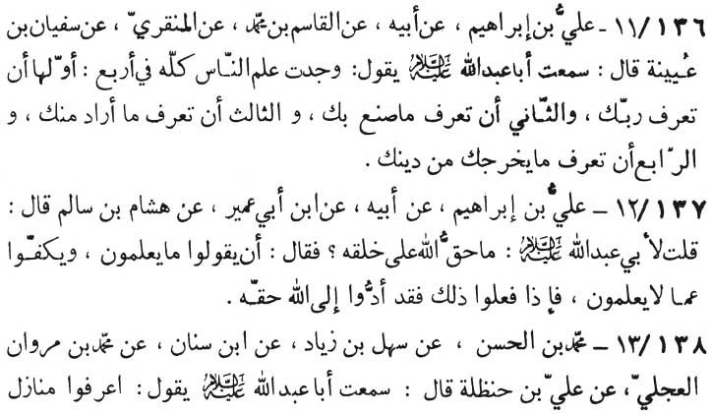

136-11. ‘Ali ibn Ibrãhīm (-) his father (-) al-Qãsim ibn Muhammad (-) al-Minqari (-) Sufyãn ibn ‘Uyaynah as saying, “I have heard Abu ‘Abdillãh (p.b.u.h.) saying:

'For me all knowledge of the people could be divided in four heads. The first head of knowledge is the recognition of Allãh Who is your Lord and sustainer. The second is the knowledge of what Allãh has made of and for you. The third is the knowledge which Allãh expects of you. The fourth is the knowledge of what expels you from your religion.”

137-12. ‘Ali ibn Ibrãhīm (-) his father (-) Ibn Abi ‘Umayr (-) Hishãm ibn Sãlim as saying:

“I have inquired of Abu ‘Abdillãh (p.b.u.h.), 'What right does Allãh have over His creation?' The Imãm replied, 'Allãh's right is to speak out what one knows and to refrain from speaking of what one does not know about anything. Whoever has done so, has fulfilled the divine rights and duties.”

138-13. Muhammad ibn al-Hasan (-) Sahl ibn Ziyãd (-) Ibn Sinãn (-) Muhammad ibn ‘Imrãn al-‘Ijli (-) ‘Ali ibn Hanzalah, as saying, “I have heard Abu ‘Abdillãh (p.b.u.h.) saying :

'Recognise the status of the people in accordance with the

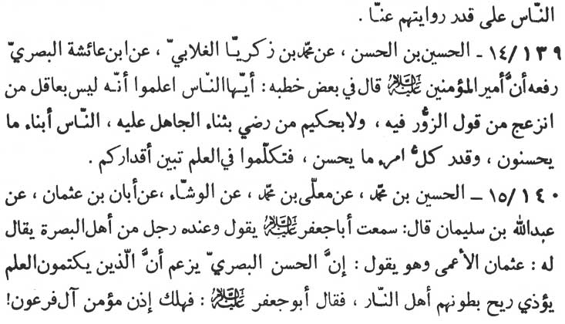

frequency in which they quote us (the Prophet and the twelve Imãms).”

139-14. al-Husayn ibn al-Hasan (-) Muhammad ibn Zakariyya al-Ghalãbi (-) Ibn ‘Ã'ishah al-Basri (rafa‘ahũ) says on the authority of Amīr al-mu'minīn (p.b.u.h.) who has said in some of his speeches:

“O’ people, know that, that a person is not wise who is upset over a false statement (accusation) against him. Nor is he wise who is pleased with the praise of the ignorant and the rustic. People are the products of the virtuous deeds they have done, and the value of every person is just in proportion to the good deeds he has performed. Hence always talk intelligently and knowingly, it will reveal your worth.”

140-15. al-Husayn ibn Muhammad (-) Mu‘allã ibn Muhammad (-) al-Washshã' (-) Abãn ibn ‘Uthmãn (-) ‘Abdullãh ibn Sulaymãn as saying;

“I have heard the remarks of Abu Ja‘far (p.b.u.h.) when a man from Basrah named ‘Uthmãn al-A‘mã (the blind) informed him (the Imãm) that (the great scholar) al-Hasan al-Basri thinks that the stink of those who hide knowledge will torment (even) the people in Hell. Hearing this the Imãm remarked:

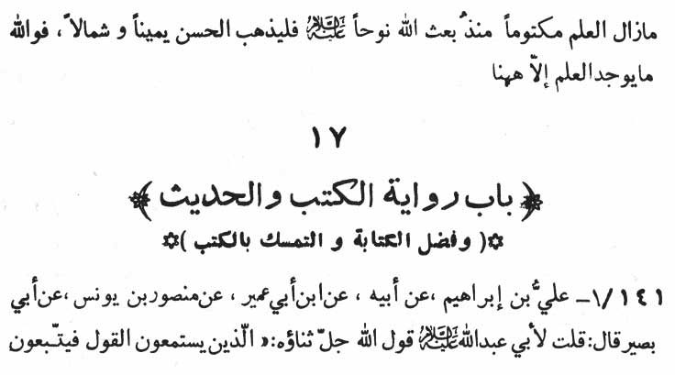

'In that case mu'min ãl Fir‘awn (the believer among the folk of Pharaoh who is highly praised in the Holy Qur'ãn with the words, 'Then said a certain man, a believer of Fir‘awn's folk that kept hidden his belief ... [al-Mu'min, 40:28] ) should go to Hell. The knowledge was kept secret ever since Nũh (Noah, the Prophet - p.b.u.h.) was sent. Hasan al-Basri may go! this, that or the other side but, by Allãh, the true knowledge is not found except here (with the twelve Imãms).”

\* \* \* \* \*

17: CHAPTER ON QUOTING BOOKS AND THE TRADITION. SIGNIFICANCE OF WRITING AND ADHERING TO THE BOOKS.

141-1. ‘Ali ibn Ibrãhīm (-) his father (-) Ibn Abi ‘Umayr (-) Mansũr ibn Yũnus (-) Abi Basīr as saying:

“I have inquired from Abu ‘Abdillãh (p.b.u.h.) regarding the words of Allãh, 'Who hear advice and follow the best thereof, (such

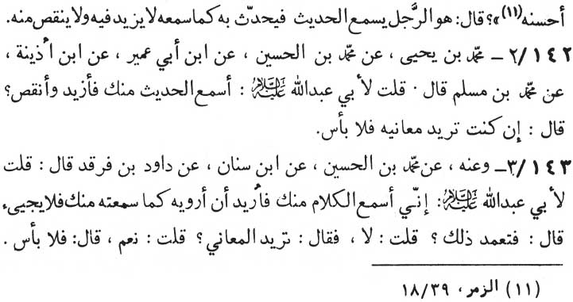

are those whom Allãh guideth and such are men of understanding).' (az-Zumar, 39:18)

“The Imãm observed, 'This is a person who hears the tradition and relates it exactly as he heard it without adding and substracting from it.”

142-2. Muhammad ibn Yahyã (-) Muhammad ibn al-Husayn (-) Ibn Abi ‘Umayr (-) Ibn Udhaynah (-) Muhammad ibn Muslim as saying,

“I have inquired of Abu ‘Abdillãh (p.b.u.h.), 'I hear the tradition from you and then (while quoting it to others) I add to and substract something from it.' The Imãm replied, 'It does not matter, if you intend to convey the meaning of the tradition.”

143-3. From him (-) Muhammad ibn al-Husayn (-) Ibn Sinãn (-) Dãwũd ibn Farqad as saying;

“I asked Abu ‘Abdillãh (p.b.u.h.) 'I hear the words and then intend to relate them as I have heard from you, but I cannot recall your words.' The Imãm inquired of me, 'Do you deliberately change my words?' I replied, 'No, not at all.' The Imãm further inquired, 'Do you intend to convey my meaning?' I replied, 'Certainly.' At this the Imãm observed, 'Then it does not matter.”

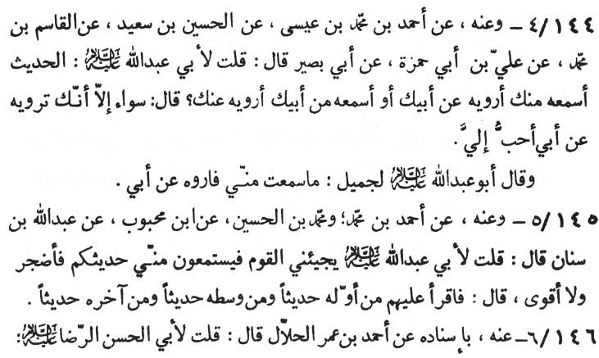

144-4. From him (-) Ahmad ibn Muhammad ibn ‘Isã (-) al-Husayn ibn Sa‘īd (-) al-Qãsim ibn Muhammad (-) ‘Ali ibn Abi Hamzah (-) Abi Basīr as saying:

“I asked Abu ‘Abdillãh (p.b.u.h.), '(Many a time) I hear tradition from you but related it on the authority of your father (Imãm Abu Ja‘far Muhammad al-Bãqir) or I hear from your father, but relate it on the authority of you.' The Imãm replied, 'There is no difference at all between the two, except that I would extremely love the traditions (which you have heard from my father) being attributed to my father.' Imãm Abu ‘Abdillãh (p.b.u.h.) addressed Jamīl and observed, 'Attribute to my father what you hear from me.”

145-5. From him (-) Ahmad ibn Muhammad and Muhammad ibn al-llusayn (-) Ibn Mahbũb (-) ‘Abdullãh ibn Sinãn as saying,

“I inquired of Abu ‘Abdillãh (p.b.u.h.), 'People come to me to hear your traditions (from my book) to narrate it on my authority. It makes me exhausted and weary (to read the book completely): The Imãm replied, 'Read a tradition from the beginning, a tradition from the middle and a tradition from the last (part) of your book.”

146-6. From him (-) Ahmad ibn ‘Umar al-Hallal as saying,

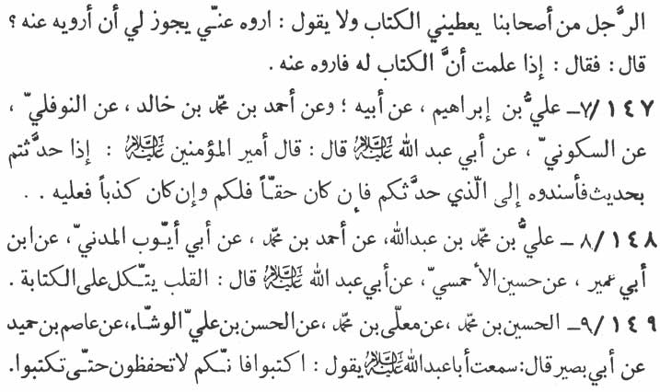

"I inquired of Abu'l-Hasan ar-Ridã (p.b.u.h.) that a person from our circle gives me a book (of traditions noted by him) and does not specifically allow me to narrate the traditions on his authority. Will it be proper for me to quote him on the authority of his book? The Imãm replied, 'If you know the book to be his compilation, then you can quote that book on his authority.”

147-7. 'Ali ibn Ibrãhīm (-) his father (-) Ahmad ibn Muham-mad ibn Khãlid (-) an-Nawfali (-) as-Sakkũni (-) Abu ‘Abdillãh (p.b.u.h.) as saying, “Says Amīr al-mu'minīn (‘Ali - p.b.u.h.):

'While narrating any tradition before others quote the person who has narrated it to you. If it was true the credit is yours, and if false, the debit is his.”

148-8. ‘Ali ibn Muhammad ibn ‘Abdillãh (-) Ahmad ibn Muhammad (-) Abi Ayyũb al-Madani (-) Ibn Abi ‘Umayr (-) Husayn al-Ahmasi (-) Abu ‘Abdillãh (p.b.u.h.) as saying:

“Hearts (of the people) put their faith on something written.”

149-9. al-Husayn ibn Muhammad (-) Mu‘allã ibn Muhammad (-) al-Hasan ibn ‘Ali al-Washshã' (-) ‘Ãsim ibn Humayd (-) Abi Basīr as saying, “I have heard Abu ‘Abdillãh (p.b.u.h.) saying:

'Write (down the traditions) since so long as they are not put

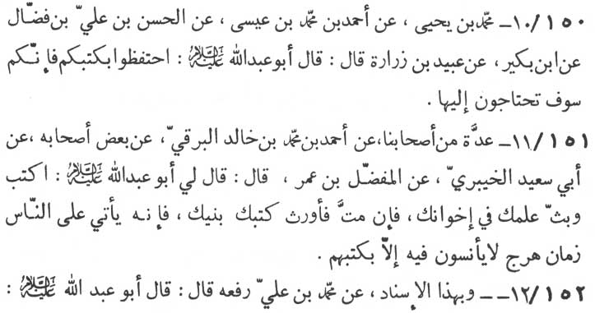

in black and white, neither can you preserve them nor can you learn them by heart.”

150-10. Muhammad ibn Yahyã (-) Ahmad ibn Muhammad ibn ‘Isã (-) al-Hasan ibn ‘Ali ibn Faddãl (-) Ibn Bukayr (-) ‘Ubayd ibn Zurãrah as saying, “Abu ‘Abdillãh (p.b.u.h.) observed:

'Guard your books (of written traditions). Soon you will stand in acute need of them.”

151-11. A group of our associates (-) Ahmad ibn Muhammad ibn Khãlid al-Barqi (-) some of his associates (-) Abi Sa‘īd al-Khaybari (-) al-Mufaddal ibn ‘Umar as saying, “Abu ‘Abdillãh (p.b.u.h.) addressed me thus :

'Write (down the traditions) and propagate the knowledge among your brothers. When you die, bequeath these books as your legacy to your sons. Verily, there will come on the people a time of disturbance, when nothing will give them any satisfaction and to nothing will they pay any heed except to their books.' '

152-12. On this ascription (-) Muhammad ibn ‘Ali (rafa‘ahũ) relates on the authority of Abu ‘Abdillãh (p.b.u.h.) as saying:

“Beware of telling a lie which is derivative.” It was asked, “What such a lie is?” The Imãm explained, “If a person quotes

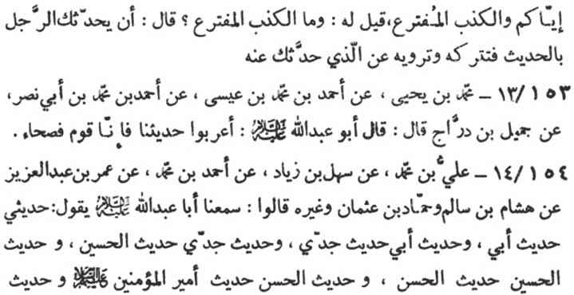

before you a tradition and you while citing, omit the name of the person who has narrated it to you. quoting the person directly who has narrated it to the one who narrated the tradition to you.”

153-13. Muhammad ibn Yahyã (-) Ahmed ibn Muhammad ibn ‘Isã (-) Ahmad ibn Muhammad ibn Abī Nasr (-) jamīl ibn Darrãj as saying, “Abũ ‘Abdillãh (p.b.u.h.) observed:

'Arabicise our traditions (grammatically and phonetically. Nar-rate our traditions with all the formalities of grammar and phonetics), since we (the Prophet and the Imãms) are the people with linguistic eloquence.”

154-14. 'Ali ibn Muhammad (-) Sa‘īd ibn Ziyãd (-) Ahmad ibn Muhammad (-) 'Umar ibn ‘Abd al-‘Aziz (-) Hishãm ibn Sãlim. Hammãd ibn ‘Uthmãn and others a, saying, “We have heard Abu ‘Abdillãh (p.b.u.h) saying:

'All I narrate are the words of my father. And all the narrations of my father are the words of my grandfather. And all the narrations of my grandfather are the words of (my great-grandfather al-Husayn. And all the narrations of al-Husayn are the words of al-Hasan. And all the narrations of al-Hasan are the words of his father) Amīr al-mu'minīn (‘Ali - p. b. u. h.) ; and all the narrations of Amīr al-mu'minīn (‘Ali - p. b. u. h.) are the words of the Messenger of

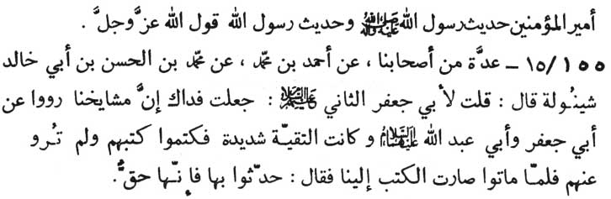

Allãh (Muhammad, the Prophet - p.b.u.h.a.h.p.). And all the traditions of the Prophet are the words of Allãh the Almighty the Great.”

155-15. A group of our associates (-) Ahmad ibn Muhammad (-) Muhammad ibn al-Hasan ibn Abi Khãlid Shaynulah as saying :

“I inquired of Abu Ja‘far (p.b.u.h.), the second (the 9th Imãm), 'May my life be sacrificed for you, our chieftains (in traditions) narrated the traditions on the authority of Abu Ja‘far (the fifth Imãm) and Abu ‘Abdillãh (p.b.u.h.) and (at that time) they had to observe 'taqiyyah' (tactical measures in concealing their special beliefs). Hence they used to conceal their written note books, consequently, these books had never been quoted from them. Now they (the compilers of those traditions) have passed away (from this world) and their (concealed) books have reached us. (Hearing this) the Imãm observed :

'Do narrate from those books. Since those books are surely authentic.”

\* \* \* \* \*

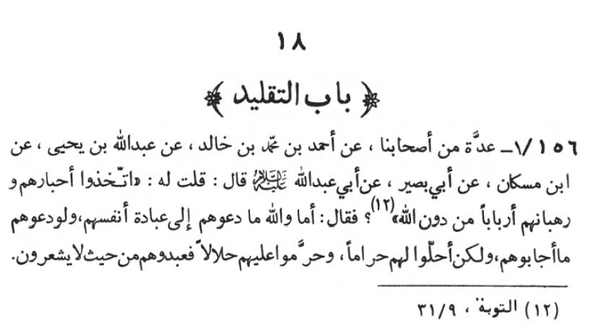

18: CHAPTER ON BLIND FOLLOWING

156-1. Some of our associates (-) Ahmad ibn Muhammad ibn Khãlid (-) ‘Abdullãh ibn Yahyã (-) Ibn Muskan (-) Abi Basīr as saying, “I inquired from Abu ‘Abdillãh (p. b. u. h.) (regarding these words of Allãh) :

'They (Christians) have taken as (their) rabbis and monks as the lords, besides Allãh.' (at-Tawbah, 9:31)

“The Imãm observed, 'By Allãh they (rabbis and monks) never invited them (Christians) for their worship (since) if they had invited them for their worship, at no cost would they have responded to them. Actually those monks and rabbis rendered unlawful what was (divinely) lawful to them (on their own accord) and vice versa. Thus they worshipped them unconsciously.”

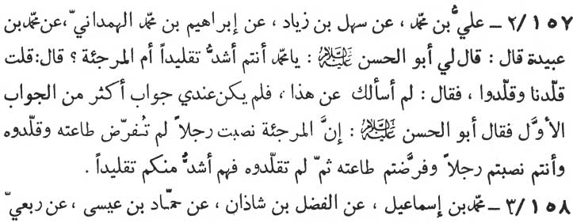

157-2. ‘Ali ibn Muhammad (-) Sahl ibn Ziyãd (-) Ibrãhīm ibn Muhammad al-Hamdãni (-) Muhammad ibn ‘Ubaydah as saying, “(Imãm) Abu'l-Hasan (p.b.u.h.) addressed me thus:

'O’ Muhammad are you (Shi‘ites) stronger in following your Imãms or the Murji'ites?' (a sect of Muslims to whom only belief is sufficient for the salvation and no sin can harm the belief). I (the narrator) replied, 'We (Shi‘ites) do follow our Imãms and they do follow their leaders.' The Imãm replied, 'I did not ask for this,' I (the narrator) replied, 'I cannot answer more than what I have al-ready stated.' (At this Imãm) Abu'l-Hasan (p.b.u.h.) observed:

'Verily, Murji'ites have appointed for themselves a person (as their leader) and then started following him, although the following of such leaders (appointed by or elected from the persons themselves) was never made obligatory on them (by Allãh). While you Shi‘ites have accepted a person (as your Imãm - divinely appointed guide) whose obedience has been made obligatory on you (by Allãh). Not-withstanding, this, you (Shi‘ites) do not follow him (the Imãm com-pletely). Hence they (Murji'ites) are stronger than you in their fol-lowing.”

158-3. Muhammad ibn Ismã‘īl (-) al-Fadl ibn Shãdhãn (-) Hammãd ibn ‘Isã (-) Rib‘i ibn Abdillãh (-) Abi Basīr (-) Abu ‘Abdil-lãh (p.b.u.h.) as stating regarding these words of Allãh the Almighty, the Great:

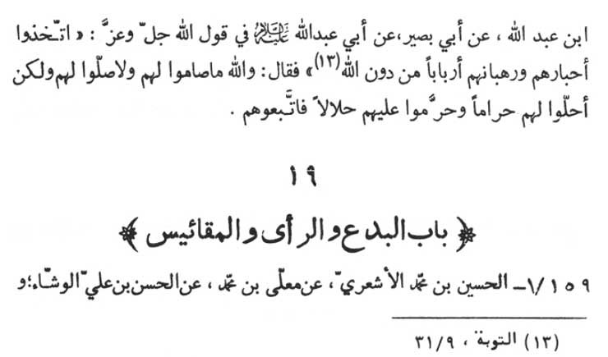

"They (Christians) have taken as their rabbis and monks as their lords, besides Allãh.” (at-Tawbah, 9:31)

The Imãm observed :

“By Allãh, neither did they (Christians) fast for their monks and rabbis, nor did they prayed for them, but actually they followed them (blindly) when they declared the unlawful as lawful and the lawful as unlawful.”

\* \* \* \* \* \*

19: CHAPTER ON INNOVATIONS, OPINION AND GUESS WORK - DERIVING CONCLUSIONS ON THE BASIS OF SIMILARITIES, SEMBLENCES AND APPEARANCES (IN RELIGION)

159-1. al-Husayn ibn Muhammad al-Ash‘ari (-) Mu‘allã ibn Muhammad (-) al-Hasan ibn ‘Ali al-Washshã' and a group of our

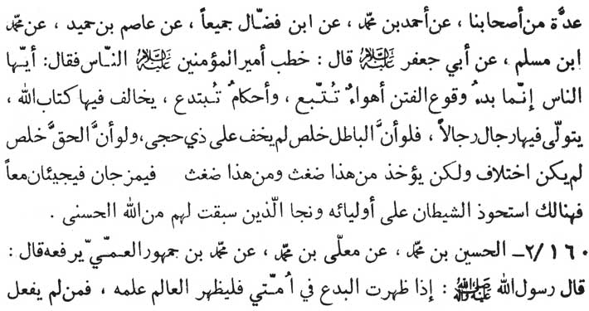

associates (-) Ahmad ibn Muhammad (-) Ibn Faddãl, both of them (-) ibn Humayd (-) Muhammad ibn Muslim (-) Abu Ja‘far (p.b.u.h.) as saying, “Amīr al-mu'minīn (‘Ali) addressed the people:

'O’ people! All mischief and misguidance originated from the pursuit of carnal (evil) desires and on innovations in divine commands, which run counter to the Book of Allãh (Qur'ãn). Through such practices people make others subservant to themselves. If falsehood and mischief were (to appear) in the real and unrnixed form, it would have never remained concealed from the people of reason. Similarly, if truth were in its purest and truest form, there would have been no difference of opinion. But, as a matter of fact, something is taken from the false-hood and something from the truth. In this way they appear in the mixed form. Thus Shaytan (Satan) secures his grip over his followers. In a situation like this, only those unto whom already the reward most fair has gone forth from Allãh, secure their salvation.”

160-2. al-Husayn ibn Muhammad (-) Mu‘allã ibn Muhammad (-) Muhammad ibn Jumhũr al-'Ami (rafa‘ahũ), the Messenger of Allãh observed:

“When innovation appears among my people (the Muslims), it is obligatory of the learned to declare his knowledge (about the innovation introduced in religion). May the curse of Allãh fall

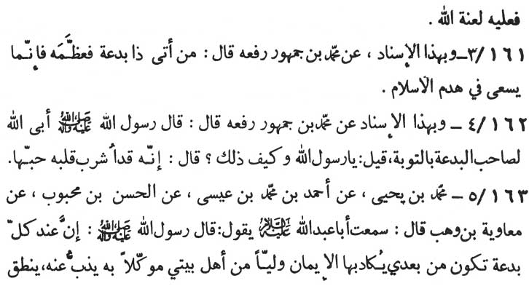

upon the learned if he does not declare (the truth).”

161-3. According to the same authorities (named above) (-) Muhammad ibn Jumhũr (rafa‘ahu) :

“He who pays respect to any one who introduces and accepts any innovation (in religion) has actually tried to demolish the house of Islam.”

162-4. On the basis of the same (above named) authorities (-) Muhammad ibn Jumhũr (rafa‘ahu) the Messenger of Allãh (p.b. u.h.a.h.p.) as saying :

“Allãh has closed the doors of His forgiveness on an innovator (in Islam) and also on his followers.” The Prophet was asked “O’ Messenger of Allãh, why it is so?” The Prophet observed, “It is be-cause of the love (of innovation) which has been fully satiated in his heart.”

163-5. Muhammad ibn Yahyã (-) Ahmad ibn Muhammad ibn ‘Isã (-) al-Hasan ibn Mahbũb (-) Mu‘ãwiyah ibn Wahb as saying: “I have heard Abu ‘Abdillãh (p. b. u. h.) saying that the Messenger of Allãh (p.b.u.h.a.h.p.) said:

'For each and every innovation (in Islam) which deceives the very faith, there will be after my death, a sentinel and a guide (Imãm) from my progeny, being in charge of the belief to challenge it, to defend it. He will speak under divine inspiration

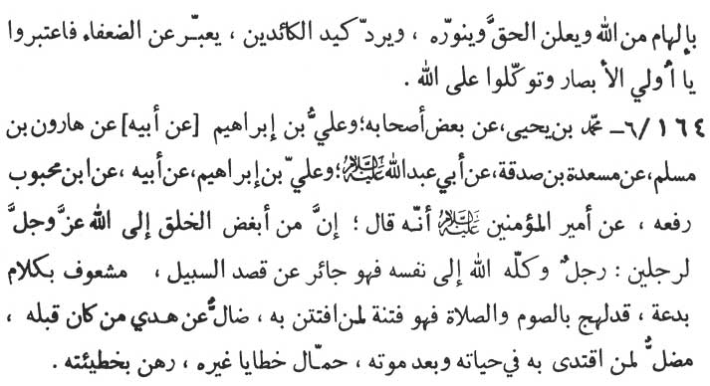

from Allãh, will declared and enlighten the truth, will negate the wiles of the cunning and will speak on behalf of the feeble (truthful). Take heed you who have eyes, and have full faith in Allãh.”

164-6. Muhammad ibn Yahyã (-) some of his associates and ‘Ali ibn Ibrãhīm (-) his father (-) Hãrũn ibn Muslim (-) Mas‘adah ibn Sadaqah (-) Abu ‘Abdillãh (p.b.u.h.) and ‘Ali ibn Ibrãhīm (-) his father (-) Ibn Mahbũb (rafa‘ahũ) (-) Amīr al-mu'minīn (‘Ali - p.buh.) as saying:

“The two most hated persons in the eye of Allãh are :

1)

The person whom Allãh has abandoned to his own lot, there-fore he has left the right path and is infatuated with new words of innovations (in religion). This is the person who has the words of prayers and fasts always on his lips but actually he is a devil (from inside, at heart) for those who fall into his trap. He who accepts his words goes astray from the path of guidance. He himself (the inno-vator) goes astray from the right path of his previous ones. He is a source of misguidance for the one who follows him in his life or after his death. He is the bearer of the burden of the sins of others and is entangled in the net work of his own sins.

2)

The second is the man who has picked up the ignorance

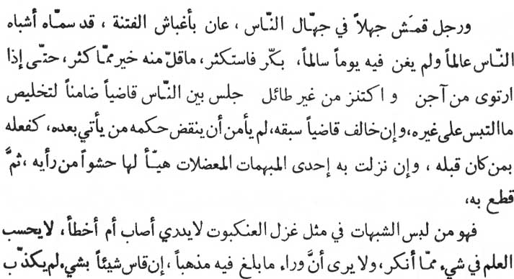

within the ignorant, preoccupied with the facinations which blind the eyes. People resembling to human beings named him as a scholar, although any a day knowledge has ever been pure in him. Every morning he has hastily acquires the maximum (ignorance) when the minimum of it would have been better for him, till he is satiated with such rubbish, and has collected the foolish redundant and irrelevant information and then occupies a seat of justice among his people, assuming the monopoly of the doubts and misgivings of the people (in respect of religion). As he himself was not afraid of opposing the verdicts of the judge before him, so those who come after him will not be afraid of opposing his verdicts and the verdicts of their predecessors. When-ever he is confronted with some complicated and enegmatic problems, he is quite ready with his solutions based on his rubbish informations and calculations, which he considers to be the last word. It is he, who has woven a cobweb of reprideable and doubtful contents. Nor is he himself convinced of his own logical stand in this respect. It is inconceivable for him to see any truth in what he desires, nor is it possible for him to see that there could be any correct ideology higher than what he himself has imagined. Because of his guessing tendencies and passing judgments on the basis of similarities, he

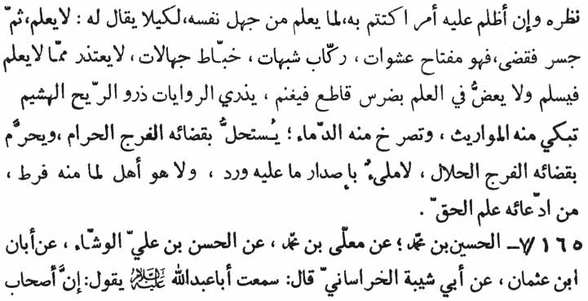

can not repudiate his conclusions. He never allows it to be brought in front of him what he is ignorant about. Thus he shields his ignorance. He stages all this drama so that people may not have any occasion to say that he is ignorant. He stupidly heartens himself and pronounces his verdicts. He is an instrument for dark misconstructions and misinterpretations (of the words of Allãh and the Prophet). He always remains immersed in doubts. He knocks at the doors of ignorance. Never does he apologise for his lack of knowledge as a measure of his safety. He has a grab at knowledge biting away a mouthful from it and starts issuing verdicts to monopolise the whole credit for him-self. He winnows the traditions and narrations (of the Prophet and the Imãms), like chef (by distorting them out of their true complexion and context). The heir mourns and the split of unlawful blood screams over his atrocious decisions. It is through his judgments the sexually unlawful is made sexually lawful and vice versa. Never is he satiated from the position of vantage he occupies. All this is the result of his claim that he knows the truth (perfectly).”

165-7. al-Husayn ibn Muhammad (-) Mu‘allã ibn Muhammad (-) al-Hasan ibn ‘Ali al-Washshã' (-) Abãn ibn ‘Uthmãn (-) Abi Shaybah al-Khurãsãni as saying, “I have heard Abu 'Abdillãh (p.b. u.h.) saying:

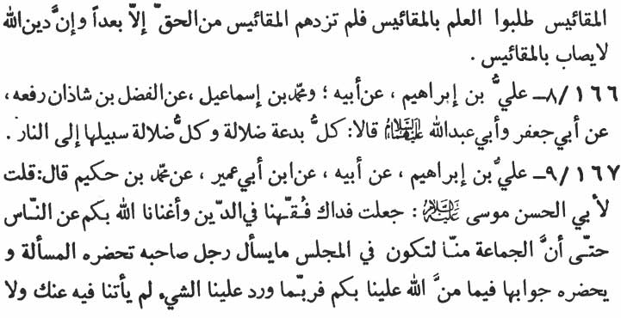

'Those who derived conclusions (in religion) on the basis of guess work are the persons who take the same as the source of the knowledge. The more they conclude in this way the further away they get from the truth, since the religion of Allãh can never be realised through such conclusions and judgments.”

166-8. ‘Ali ibn Ibrãhīm (-) his father (-) Muhammad ibn Ismã‘īl (-) al-Fadl ibn Shãdhãn (rafa‘ahu) (-) Abu Ja‘far and Abu ‘Abdillãh (p.b.u.t.) as saying:

“Every innovation (in religion) is misguidance. And every misguidance leads to hell.”

167-9. ‘Ali ibn Ibrãhīm (-) his father (-) Ibn Abi ‘Umayr (-) Muhammad ibn Hukaym as saying:

“I inquired of Abu'l-Hasan Mũsã (p.b.u.h.), 'May my life be sacrificed for you, it is through your blessings and guidance, we (the Shiites) have learnt religion (Islãm) and have developed insight into it in such a way that during any meeting and discussion, no one among our people has any need to ask from any one else. No sooner does the problem arise, forthcomes the answer in our mind. All this is so because blessings of Allãh has reached us through you. But it frequently happens that an issue arises on which there is no specific ruling (precedents) available from your traditions, nor from those traditions which are related from

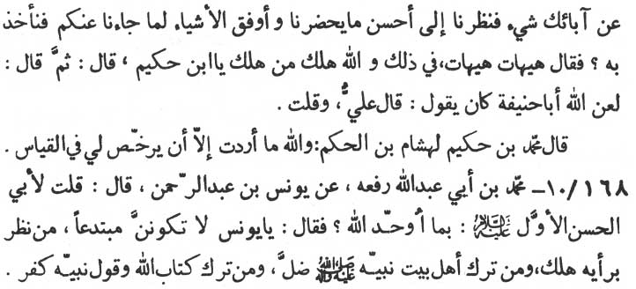

your fore-fathers (the Imãms). Could we in such a case consider the issue in the light of the best, the most related and the most relevant of your traditions? To cope with the issue could we adopt from your traditions the ones which are the most similar?' Hearing this the Imãm replied:

'This mode of dealing with the issues is remote, very remote from the truth. O’ son of Hukaym, he who ever met his doom, met it only because he acted on this very method.' Then the Imãm added, 'Curse of Allãh may fall upon Abu Hanīfah who used to say, “Ali (p.b.u.h.) has said so and so, but I say so and so.”

At this the narrator Muhammad ibn Hukaym addressed Hishãm ibn al-Hakam, “By Allãh, my intention all through this discussion was to obtain permission of the Imãm for freedom to solve religious problems through 'qiyãs' (deriving conclusions on the basis of similarities and superficialities through independent opinions. But the Imãm rejected the idea as a whole).”

168-10. Muhammad ibn Abi ‘Abdillãh (rafa‘ahu) (-) Yũnus ibn 'Abd ar-Rahmãn as saying, “I inquired of Abu'l-Hasan, the first (p.b.u.h.), 'How should I believe the Oneness of Allãh?' The Imãm replied: 'O’ Yũnus'. Never be among the innovators in religion since whoever derived conclusions (in religious affairs) according to his personal opinion, met his doom and whoever has abandoned following the progeny of the Prophet (the twelve Imãms) has gone

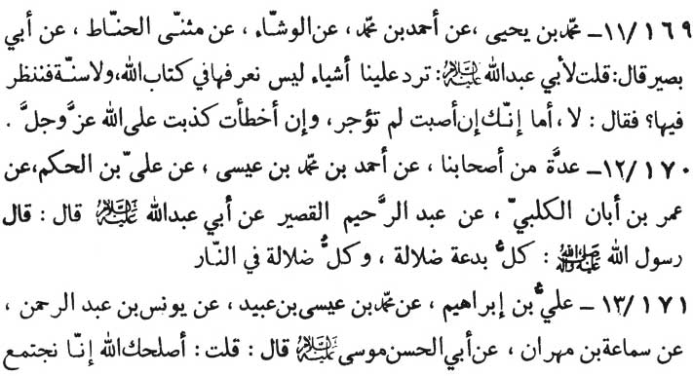

astray, and whoever has forsaken the Book of Allãh and the sayings of the Prophet has actually indulged in infidelity.”

169-11. Muhammad ibn Yahyã (-) Ahmad ibn Muhammad (-) al-Washshã' (-) Muthanna al-Hannãt (-) Abī Basīr, as saying:

“I inquired of Abu ‘Abdillãh (p.b.u.h.) It happened that we are confronted by certain issues which can neither be solved by us on the basis of the Book of Allãh (Qur'ãn) nor do we find their sol-ution in as-Sunnah (the sayings and doings of the Prophet and the twelve Imãms). Can we consider such cases by ourselves?' The Imãm replied :

'No, if you are right in your conclusions you are not at all re-warded by Allãh. And if you are wrong in your conclusions and guess work, you are as a matter of fact guilty of falsifying Allãh, the Al-mighty, the Great.”

170-12. A group of our associates (-) Ahmad ibn Muhammad ibn ‘Isã (-) ‘Ali ibn al-Hakam (-) ‘Umar ibn Abãn al-Kalbi (-) ‘Abd al-Rahmãn al-Qasīr (-) Abu ‘Abdillãh (p.b.u.h.) as saying: “The Messenger of Allãh (the Prophet - p.b.u.h.a.h.p.) has observed :

'Every innovation in religion is misguidance and every misguidance leads into hell fire.'“

171-13. ‘Ali ibn Ibrãhīm (-) Muhammad ibn ‘Īsã ibn ‘Ubayd

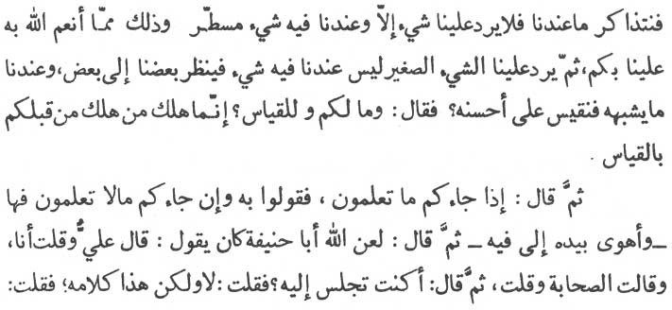

(-) Yũnus ibn ‘Abd ar-Rahmãn (-) Samã‘ah ibn Mihrãn (-) Abu'l-Hasan Mũsã (al-Kãdhim - p.b.u.h.). Samã‘ah, the narrator relates;

“I addressed Imãm (Abu'l-Hasan Mũsã) saying, 'I pray Allãh for your good (health)., It is due to your blessings that we are di-vinely favoured in a way that whenever we (Shi‘ites) get together to discuss your traditions and practices, no problem arises before us for which we do not find a ready answer from your dictations we already have. Then in the process (of discussions), there arises certain petty issues for which we find do direct reference (solution) in your traditions. In such cases, can we perceive, examine and conclude on the basis of your similar traditions, following 'qiyãs' the guess work of the highest quality?'

“The Imãm replied, 'How are you concerned with such qiyãs superficial conclusions and guess work on the basis of similar tra-ditions? He, who met his doom before you, met so because of qiyãs'. Then the Imãm instructed, 'Say what you have received from us. But if you face what you don't know,' then the Imãm pointed to his lips, that is, (our words will solve your problem). The Imãm further added, 'Curse of Allãh may fall on Abu Hanīfah who used to say, “Ali has said so and so, but I say so and so. The companions of the Prophet said so and so but my verdicts are so and so.' Then the Imãm inquired from me (the narrator), 'Have you ever been in the company of Abu Hanīfah?' I replied, 'No, but these are, no doubt, the words of Abu Hanīfah.' I further inquired

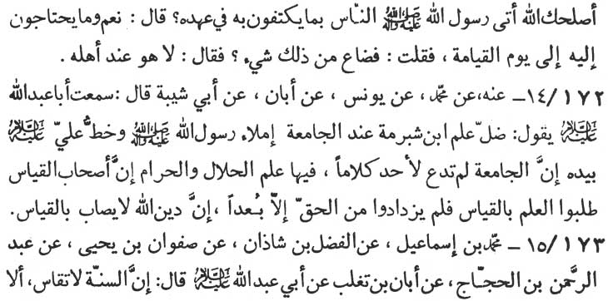

of the Imãm, 'Had the Messenger of Allãh (Muhammad - p.b.u.h.a.h.p.) brought what was sufficient for the people of his time?' The Imãm replied, 'Certainly, the Prophet had also brought what mankind will need till the Day of Judgment.' I again inquired, 'Has something been lost from it?' The Imãm finally replied, 'No, nothing has been lost at all. Everything from what the Prophet had brought is intact and is in the custody of those who are worthy of it.”

172-14. From him (-) Muhammad (-) Yũnus (-) Abãn (-) Abi Shaybah as saying, “I have heard Abu ‘Abdillãh (p.b.u.h.) saying:

'The knowledge of Ibn Shubrumah is defective and misleading regarding the book al-Jãmi‘ah which ‘Ali (the first Imãm - p.b.u.h.) has compiled under the dictation of the Prophet. (Ibn Shubrumah was of the opinion that the existence of such a book is doubtful and it has also been lost.) In fact, so complete and comprehensive is this collection as to leave nothing for any one else to add. It is a complete code of what is permissible and what is forbidden (under the divine law). Verily, those who seek knowledge (of divine commands) on the basis of qiyãs (that is, their guess work, on semblances and superficialities), go further away from the truth. Verily, the religion of Allãh can never be approached through such guess work.”

173-15. Muhammad bin Ismã‘īl (-) al-Fadl bin Shãdhãn (-)

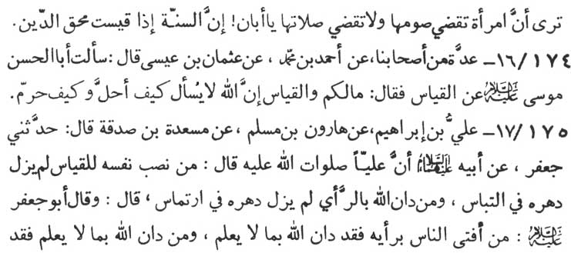

Safwãn ibn Yahyã (-) ‘Abd ar-Rahmãn ibn al-Hajjãj (-) Abãn ibn Taghlib (-) Abu ‘Abdillãh (p.b.u.h.) as saying:

“as-Sunnah (the Prophet's deeds, utterances and his unspoken approval. The divine order is understood by this) can never be guessed. Don't you see that women have to perform their fastings (for the period of their menstruation etc., after the month of Ramadan) but they have not to perform their daily prayers after their menstruation period. (Although offering prayers stands at a higher level than fasting.) O’ Abãn! If as-Sunnah - are manipulated on the basis of semblances and appearances, the religion of Allãh (dīn) will totally be annihilated.”

174-16. A group of our associates (-) Ahmad ibn Muhammad (-) ‘Uthmãn ibn ‘Isã as saying, “I inquired of Abu'l-Hasan Mũsã (p.b.u.h.) about qiyãs deriving the conclusions on the basis of appearances and similarities regarding divine commands. The Imãm replied, 'What concern do you have with such conclusions? Verily, Allãh will never ask you how and why certain things have been made lawful and others unlawful.”

175-17. ‘Ali ibn Ibrãhīm (-) Hãrũn ibn Muslim (-) Mas‘adah ibn Sadaqah as saying: “Ja‘far (p.b.u.h.- the Imãm) narrated to me on the authority of his (grand) father ‘Ali (p.b. u.h.) saying:

'He who puts all his efforts in qiyãs such superficial thinking and deriving conclusions on the basis of similarities and semblances (in his religion) passes his whole life in confusion and hesitation.

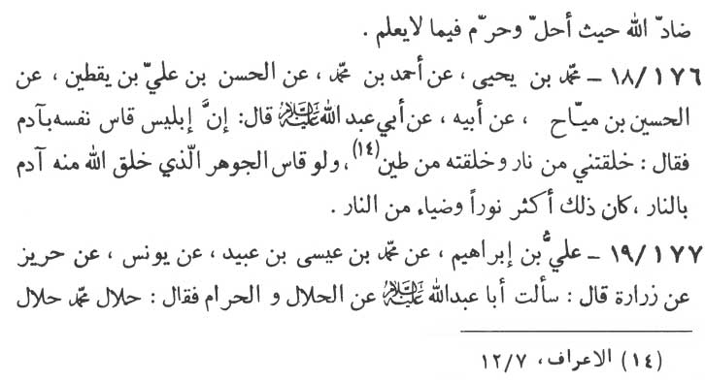

And he who adopts divine religion on the basis of his own inclinations and opinions remains always in doubts.'

“Abu Ja‘far (p.b.u.h.) said, 'He who has given his verdicts (in matters of religion) on the basis of his own opinion, has actually followed a religion which he himself does not know. And he who accepts hid religion in such a manner, has actually contradicted Allãh, since he has declared something lawful and something unlawful with-out knowing it.”

176-18. Muhammad ibn Yahyã (-) Ahmad ibn Muhammad (-) al-Hasan ibn ‘Ali ibn Yaqtīn (-) al-Husayn ibn Mayyãh (-) his father (-) Abu ‘Abdillãh (p.b.u.h.) as saying:

“Iblīs (Satan) judged himself by qiyãs comparing the appearances of Adam (the Prophet) with himself and said, '(O’ Allãh!) You have created me from the fire and created Adam from the clay.' (al-A‘rãf, 7:12) (On this very basis he refused to bow before Adam, considering himself superior to him.) If he (Iblīs) had compared the essence and the quintessence with which Allãh has created Adam, he would have understood that the essence with which Adam was created far excels in radiation to the radiation of the fire with which Satan was created.”

177-19. ‘Ali ibn Ibrãhīm (-) Muhammad ibn ‘Isã ibn ‘Ubayd (-) Yũnus (-) Harīz (-) Zurãrah as saying, “I inquired of Abu ‘Abdillãh (p.b.u.h.) regarding the lawful and the unlawful.

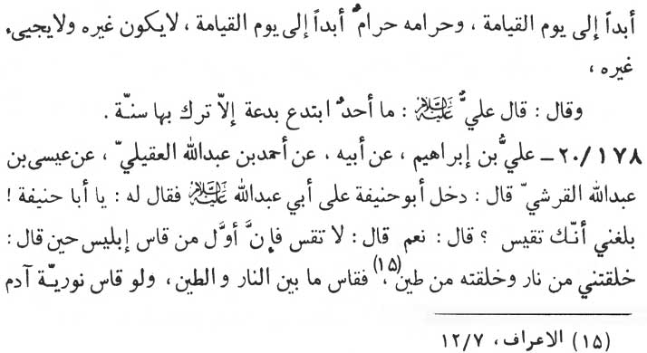

The Imãm replied:

'What Muhammad (p.b.u.h.a.h.p.) declared to be lawful is eternally lawful till the Day of Judgment. And what Muhammad (p.b.u.h.a.h.p.) declared to be unlawful is eternally unlawful till the Day of Judgment. Neither will any one be designated any more (as a divine messenger) nor will any one come (with any further divine commands). ‘Ali (p.b.u.h.) has observed:

'There is none who has introduced anything new in religion without forsaking as-Sunnah.'“

178-20. ‘Ali ibn Ibrãhīm (-) his father (-) Ahmad ibn ‘Abdillãh al-‘Aqīlī (-) ‘Isã ibn ‘Abdillãh al-Qurashi as saying:

“Abu 1-lanifah (the great scholar of Islamic Jurisprudence of his time) came to see Abu ‘Abdillãh (p.b.u.h.). The Imãm (Abu ‘Abdillãh) inquired of him, 'O’ Abu Hanīfah it has come to my knowledge that you indulge in qiyãs concluding on the basis of similar divine commands.' Abu Hanīfah replied, 'Yes, I do so.' The Imãm thereupon instructed him, 'Never resort to judging the religious issues by semblance, appearances and superficialities. Since it was Iblīs (Satan) who first judged in this manner (qiyãs), when he said, '(O’ Allãh) You have created me from fire and Adam from clay.' (al-'A‘rãf, 7:12). So he (Iblīs) judged by comparing fire with the earth. If he had corn pared the quintessence and elegance

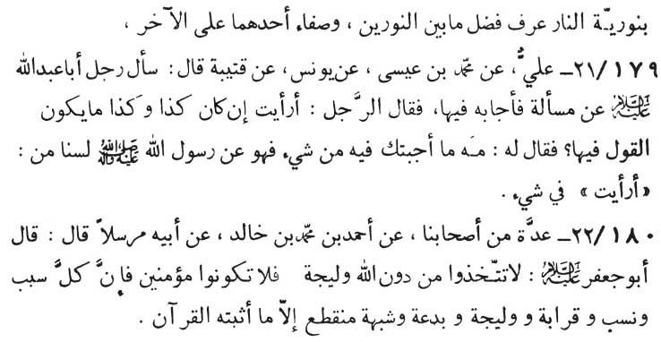

of Adam with the quintessence and elegance of the fire, he would have recognized which elegance is superior to which.”

179-21. ‘Ali (-) Muhammad ibn ‘Isã (-) Yũnus (-) Qutaybah as saying:

“A person once asked (Imãm) Abu ‘Abdillãh (p.b.u.h.) a ques-tion, of which the Imãm gave an answer. The man further asked, 'If the matter had been such and such, what would your opinion have been?' Hearing this, the Imãm ordered him to be silent and then observed :

'Whatever answer I give is of and from the Prophet himself. What is your opinion (the personal conclusion) is unknown to us (the twelve Imãms) in any matter whatsoever?'

180-22. A group of our associates (-) Ahmad ibn Muhammad ibn Khãlid (-) his father (Mursalan) as saying:

“(Imãm) Abu Ja‘far (p.b.u.h.) observed, 'Except Allãh, never take any intimate, otherwise you will exclude yourselves from the folk of the believers, since all relationship, all lineage, kinship, in-timacy, innovations and misgivings, all are bound to perish except what Qur'ãn (the Book of Allãh) has established.'

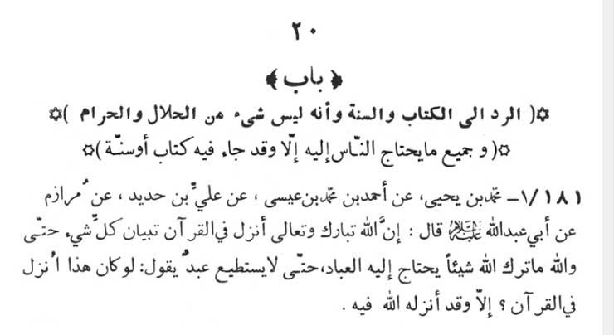

20: CHAPTER ON TAKING (EVERY CASE) BACK TO THE QUR'AN AND AS-SUNNAH, VERILY, THERE IS NOTHING FROM WHAT IS LAWFUL AND WHAT IS UNLAWFUL AND WHAT IS NEEDED BY THE MANKIND, BUT THE BOOK (OF ALLAH) AND AS-SUNNAH INCLUDES IT.

181-1. Muhammad ibn Yahyã (-) Ahmad ibn Muhammad ibn ‘Isã (-) ‘Ali ibn Hadīd (-) Murazim (-) Abu ‘Abdillãh (p.b. u.h.), as saying:

“Verily, Allãh the Almighty has revealed in Qur'ãn, description of each and every thing to such an extent as to leave out nothing which mankind needs. The description is so all inclusive that there is nothing a man could wish, saying, 'Would it be revealed in Qur'ãn,' but is already revealed in it.”

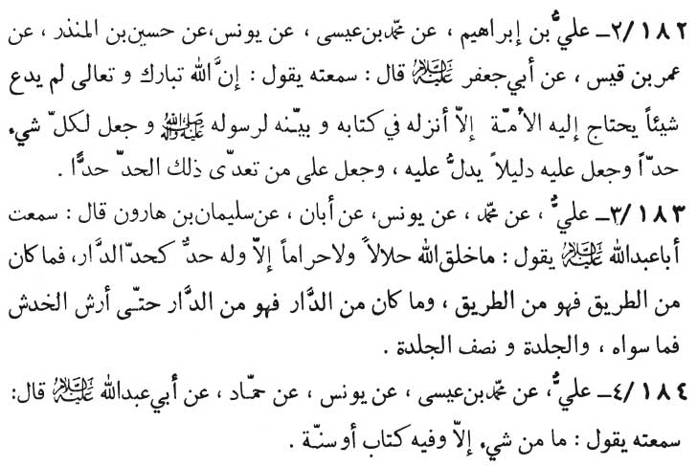

182-2. ‘Ali ibn Ibrãhīm (-) Muhammad ibn ‘Isã (-) Yũnus (-) Husayn ibn al-Mundhir (-) ‘Umar ibn Qays (-) Abu Ja‘far (p.b.u.h.) as saying :

“Verily, Allãh the Almighty has not left anything which the Muslim community needs, except that lie has revealed it in His Book and has described it to His Messenger - the Prophet. He has prescribed specific limits for each and every thing and has assigned to it distinct symbols indicative of those limits. He has also provided penalties for their transgressions.”

183-3. ‘Ali (-) Muhammad (-) Yũnus (-) Abãn (-) Sulaymãn ibn Hãrũn as saving, “I have heard Abu ‘Abdillãh (p.b.u.h.) saying:

'Allãh has made nothing lawful and unlawful but has prescribed clear limits thereof, in the same way as (a house master) erects clearly marked boundaries for his house which clearly discriminate between the private house and a public road. So thorough and precise are divine limits that even a little scratch or other than this and a full or half a whip have their own prescribed punishments.”

184-4. ‘Ali (-) Muhammad ibn ‘Isã (-) Yũnus (-) Hammãd

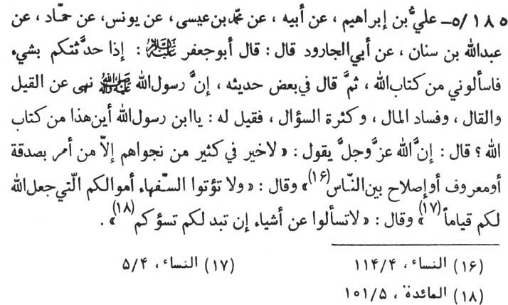

(-) Abu ‘Abdillãh (p.b.u.h.) as saying:

“Nothing exists but it has been described in the Book (of Allãh, i.e. Qur'ãn) and as-Sunnah.”

185-5. ‘Ali ibn Ibrãhīm (-) his father (-) Muhammad ibn ‘Isã (-) Yũnus (-) Hammãd (-) ‘Abdullãh ibn Sinãn (-) Abi'l-Jãrũd, as saying:

“Abu Ja‘far has said, 'Whenever I say anything to you, do demand from me its reference from the Holy Book of Allãh.' Then the Imãm added, 'It has been mentioned in certain traditions that the Messenger of Allãh (p.b.u.h.a.h.p.) prevented the people from indulging in loose talks, squandering money and from excessive interrogation.' Hearing this, the people demanded, son of the Prophet, where is the relevant reference in the Book of Allãh?' At this, the Imãm observed : 'Allãh the Almighty has said, 'There is nothing good in most of their whisperings except (in him) who bideth charity or goodness or peace among the people.' (an-Nisã ', 4:114)

'Allãh has also said :

'And give not away to the weak in mind, your property which Allãh hath made for you (a means of) your subsistence.' (an-Nisã', 4:5).

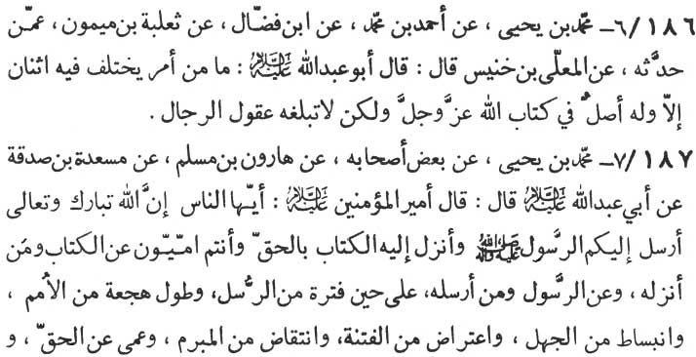

'And, Allãh has further said :

'(O’ Ye who believe) Ask ye not about things which if declared unto you will (only) pain you.” (al-Mã'idah, 5:101)

186-6 Muhammad ibn Yahyã (-) Ahmad ibn Muhammad (-) Ibn Faddãl (-) Tha‘labah ibn Maymũn (-) whoever has narrated to him (unknown) (-) al-Mu‘allã ibn Khunays as saying, “Abu ‘Abdillãh (p.b.u.h.) has observed:

'There can be no issue which is the subject of dispute between two persons, but whose essence and solution is found in the holy Book of Allãh, the Almighty, however, the intelligence of the people is not sharp enough to reach it.”

187-7. Muhammad ibn Yahyã (-) some of his associates (-) Hãrũn ibn Muslim (-) Mas‘adah ibn Sadaqah (-) Abu ‘Abdillãh (p.b. u.h,) , as saying, “Amīr al-mu'minīn (‘Ali - the Chief of the Believers) has observed :

'O’ people, Allãh the Almighty has sent His messenger (the Prophet) to you and revealed to him the Book of eternal truth, while your people were totally ignorant of the Book and of Him Who re-vealed it and also of him to whom the Book was revealed. It was a period when prophethood was suspended and the people were sunk in slumber. Ignorance was rampant. Every mischief was at large.

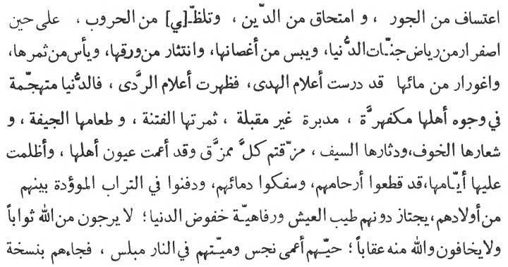

pledges were violated. People had grown blind to all truth. Oppression was the order of the day. Religiousness was totally annihilated. The flames of wars raged all around. It was the period when all the gardens of the world (beauties of life) had grown pale. Their branches had dried up. Their leaves were scattered and the people had grown hope-less about their fruits being borns. Their water level had sunk deep. The flags of guidance were torn down and the flags of evil were raised. The world with its black and menancing complexion had made a terrific onslaught on the life of mankind, and all its charm and happyness had irretrievably turned its back on man. Its fruits were evil and mischief. Its meal rotten corpse. Its inner dress was fear and outer cover was sword. You people had been utterly torn to pieces. Their eyes had been blinded and their lives darkened. They cut themselves aloof from and spilled the blood of their relations. They buried their new born daughters. The pleasures, comforts, and the conveniences of life had totally disappeared from amongst them. Neither did they entertain any hope of grace and reward from Allãh the Almighty nor did they have any fear of any divine punishment. Those of them who live were stark blind and polluted. And those of them who were dead were being consumed by the flames of (hell) fire. It was then, that the Holy Prophet appeared amongst them with a prescription inclusive

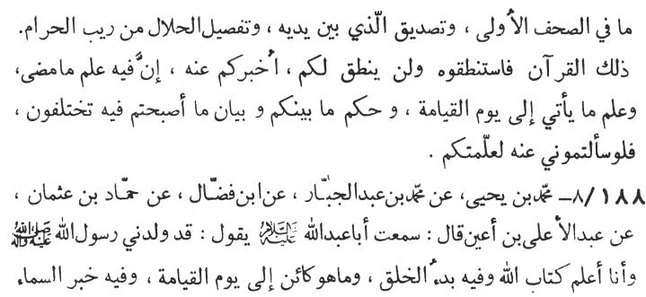

of all that was revealed in the preceding divine books, collaborating the truth of divine books they already had in their hands, distinguishing in the detail what was lawful from Allãh and what was unlawful. This (prescription) is none other than the holy Qur'ãn itself. And from it only ask whatever you have to ask. However the Qur'ãn itself will never speak to you. It is I (the divinely appointed guide) who will answer to you each and every question from the Qur'ãn itself. Verily, there is in this Book (of Allãh) the knowledge of every thing that has happened and every thing that will happen till the Day of Judgment. This book is the last word for you and is a (irrefutable) verdict and description for every dispute amongst you. And were you to ask me about it, I am prepared to teach you each and every thing from it ( Qur'ãn).”

188-8. Muhammad ibn Yahyã (-) Muhammad ibn ‘Abd al-Jabbãr (-) Ibn Faddãl (-) Hammãd ibn ‘Uthmãn (-) ‘Abd al-'A‘lã ibn A‘yan, as saying, “I have heard Abu ‘Abdillãh (p. b. u. h.) saying :

'I have been given birth by the Messenger of Allãh (p.b.u.h.a.h.p.) , I know of the Book of Allãh. How the Creator originated and what will happen till the Day of Judgment, all is to be found in this holy Book of Allãh. It tells every thing about the heavens, the earth, the paradise, the hell and also about what had been and what will be. I know them all as clearly as though they

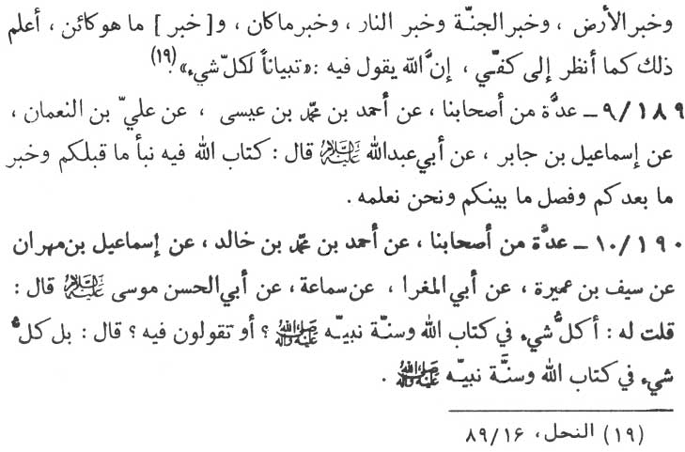

were mirrored in the palm of my hand. Lo, Allãh, the Almighty has Himself pro-claimed about His book. 'It contains descriptions of all things.'“ (an-Nahl, 16:89)

189-9. A group of our associates (-) Ahmad ibn Muhammad ibn ‘Isã (-) ‘Ali ibn Nu‘mãn (-) Ismã‘īl ibn Jãbir (-) Abu ‘Abdillãh (p.b.u.h.) as saying:

“The Book of Allãh tells all about those who preceded you, and also about those who will follow you. And in it is to be found the final verdict about your mutual disputes, and we (the twelve Imãms) are in the know of it all. “

190-10. A group of our associates (-) Ahmad ibn Muhammad ibn Khãlid (-) Ismã‘īl ibn Mihrãn (-) Sayf ibn ‘Amirah (-) Abi 'l-Maghrã (-) Samã‘ah (-) Abu'l-Hasan Mũsã (p.b.u.h.), as replying, when the narrator asked him :

“In each and every thing to be found in the Book of Allãh and as-Sunnah of the Prophet? Or is this merely a statement of you?” The Imãm replied, “Certainly, the Book of Allãh and as-Sunnah of the Prophet contain each and every thing.”

\* \* \* \* \* \*

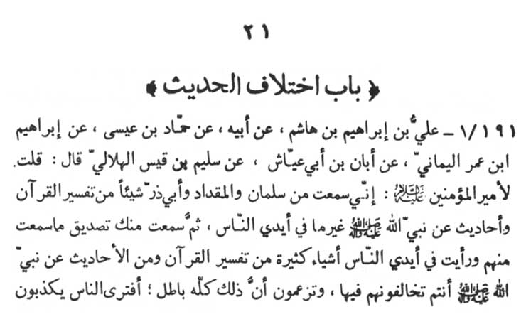

21: CHAPTER ON CONFLICTING TRADITIONS

191-1. ‘Ali ibn Ibrãhīm ibn Hãshim (-) his father (-) Hammãd ibn ‘Isã (-) Ibrãhīm ibn ‘Umar al-Yamãni (-) Abãn ibn Abi ‘Ayyãsh (-) Sulaym ibn Qays al-Hilãlī as saying:

“I told Amīr al-mu'minīn, 'I have heard from Salmãn (al-Fãrsi) and al-Miqdãd (ibn al-Aswad al-Kindi) as well as Abu Dharr (al-Ghiffari) something on the interpretation of the Qur'ãn and the traditions of the Prophet of Allãh (which are) different from what people generally have. Then I heard you confirm what I have heard from them (Salmãn, al-Miqdãd and Abũ Dharr). Also, I have noticed many things with the people on the interpretation of the Qur'ãn as well as the traditions of the Prophet of Allãh which

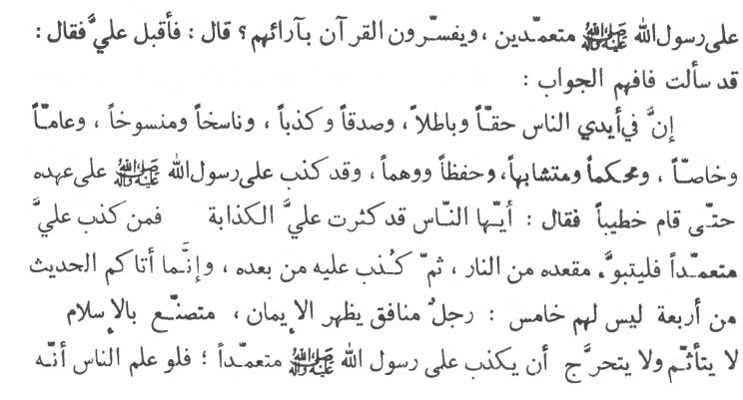

you disagree with them and believe them all to be void. Are you of the opinion that people intentionally lie against the Messenger of Allãh (p.b.u.h.a.h.p.) and interpret the Qur'ãn according to their own opinion.?' Hearing this query, ‘Ali (p.b.u.h.) turned towards me (the narrator) and observed :

'Since you have raised the question, now you must understand the answer. Verily, whatever people have is true as well as false, right as well as wrong, superseding as well as superseded, general as well as particular, exact as well as analogous and rightly remembered as well as fancied. Even in the life time of the Holy Prophet, people did at-tribute false statements to him to such an extent that he himself stood up and addressed the people, 'O’ people, those who attribute false statements to me are in great numbers. Whoever attributes any false statement to me secures his abode in the Hell.' Then the people went on attributing false statements to him after his death. Whatever traditions you (people) have received are from four categories (of narrators). There is no fifth category.

'The first is a hypocrite who poses himself as a believer and actually is a shame Muslim. Attributing false statements to the Prophet intentionally, is not considered by him as a sin, nor does he mind such an attribution. Were the people even to know how

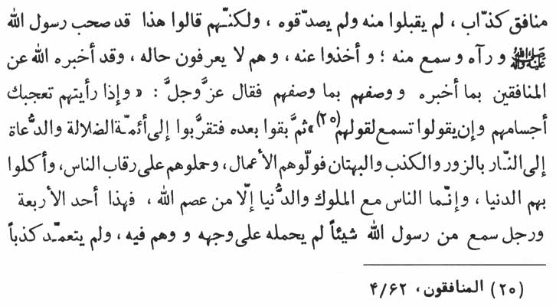

false and hypocritical he is, they would never accept a word from him, nor would they corroborate his statements. It was this type of man about whom people started saying, 'This is the one who had been honoured by the company of the Prophet and who has actually seen and heard the Prophet.' People accepted traditions from him without knowing his credentials. Allãh the Almighty has told His Prophet about the hypocrites all that was to be told and has detailed all the characteristics that were to be detailed. Allãh the Almighty has said so, 'When thou seest them, marvel thee their personalities; and if they speak, thou listeneth unto their speech.' (al-Munãfiqũn, 63:4).

'Such people remained there after the Prophet as well. Then they got near the leaders (rulers) who misguided and invited people towards the hell fire through the means of their fabrications, false-hood and slander. They were entrusted with big jobs by the rulers of the time and were thus foisted on the people, and the rulers exploited the situation through them. Except the few whom Allãh saved, the common people were always with their rulers and with the mundane business of the world. All this is the description of the one out of all categories.

(The second is the category of a person) who has actually heard something from the Prophet but was not able to retain it in

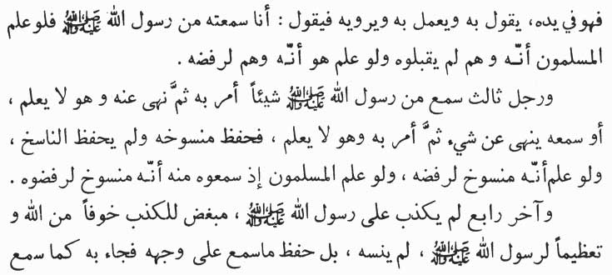

his mind and fell into doubt. He never intentionally told a lie, but he started speaking, practicing and propagating what he remembered incorrectly and sketchily, and at the same time claimed that 'I have heard the Prophet say so.' If the Muslim community had known that he was in error, they would never have accepted his words. And if the man himself had known that he was mistaken, he would have himself rejected his own version.

The third category is of the person who has heard the Prophet ordering something to be done, but the Prophet later on forbade the same. The man knows the former but is unaware of the latter. Or the man has heard the Prophet forbiding something but afterwards the Prophet has made it permissible. The man knows the former, but does not know the latter. Thus the man was in the know of the abrogated (as-Sunnah), but was not aware of its abrogative.lIf he had been aware that it has been abrogated he himself would have withdrawn his own narrated tradition. If the Muslims had been in the know that the Prophet had cancelled what the man had related (on the authority of the Prophet) they would have themselves rejected his version.

The fourth and the last is the category of the person who had never attributed false statements to the Prophet and who hated false statements because of his fear of Allãh and reverence for the Prophet. He never forgets anything from what he had heard from the Prophet. He always relates exactly what he had heard from the

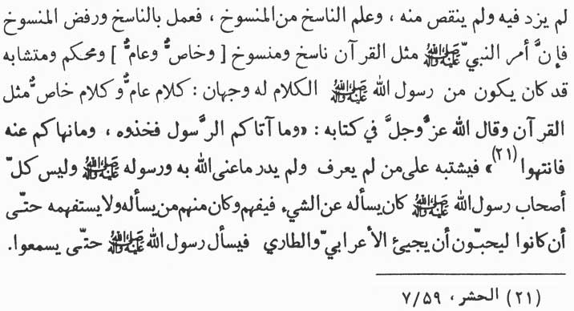

Prophet without adding anything to or subtracting anything from it. He is in the know of both what supersedes and also what has been superseded. Hence he acts according to what supersedes, leaving aside the superseded. Verily, the commands of the Prophet are also like the verses of the Qur'ãn which consist of the superseded and the superseding (general and the specific) precise (muhkam) and the ambiguous and multi meaning (mutashãbih). Like Qur'ãn, the Prophet's wordings also had two aspects, that is, the general and the specific. As Almighty Allãh Himself has said, 'And whatever giveth you the Apostle, ye accept it, and from whatever preventeth He, ye be away (from it): (al-Hashr, 59: 7) Thus the one who was not aware of all these (complications) would fall in doubt and would not understand what Allãh and His messenger exactly meant. It was not at all a fact that all the com-panions of the Prophet had the ability of either asking the Prophet a question or of understanding his answers. There were some who used to put question to the Prophet but could not understand his answer. There were also others who did ask the Holy Prophet a question but did not ask him to make understand it until they did like some Bedouins or a wayfarer to come and ask the Prophet some question so that they could have a chance to be enlightened

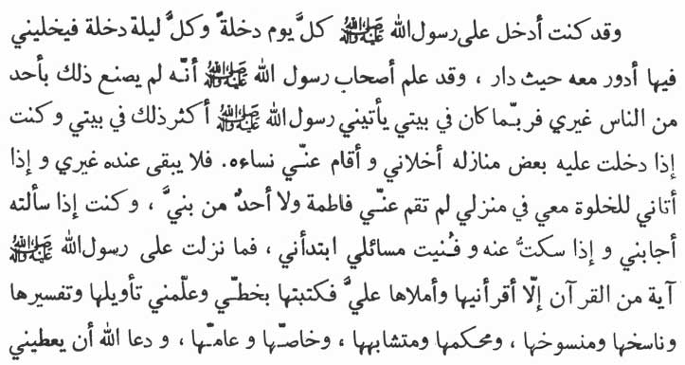

Prophet's answer. Verily, I was the person who had an admittance to the Prophet (at least) once every day and once every night when I used to be alone with him. On such occasions, I had the honour to talk with him on whichever subject he was inclined. The companions of the Prophet were in the know that to no other person did the Prophet extend such a privilege (of proximity) as he did to me. Many a time, I had been at my house and the Prophet used to come to see me and this was his usual practice. When I was to enter any of his (Prophet's) room to see him he used to vacate the room for the sake of privacy with me. In vacating the room, even his wives were not spared and there would be none with him besides myself. But when the Prophet had his turn to visit my house for private conference, he would not exclude Fãtimah (my wife) and any of my sons (p.b. u. t.) from his conference. On such occasions, he would reply to my queries and when I had exhausted my queries and remained silent, he would himself initiate further discussions. Never was there any case of revelation of any of the verse of the Qur'ãn, which the Prophet did not recite and dictate to me and which I did not write down in my own hand. Further, never was there any revelation of which the Prophet has apprised me with the basic import, its complete elucidations, with the verses that were abrogative and with the verses that were abrogated, with the verses

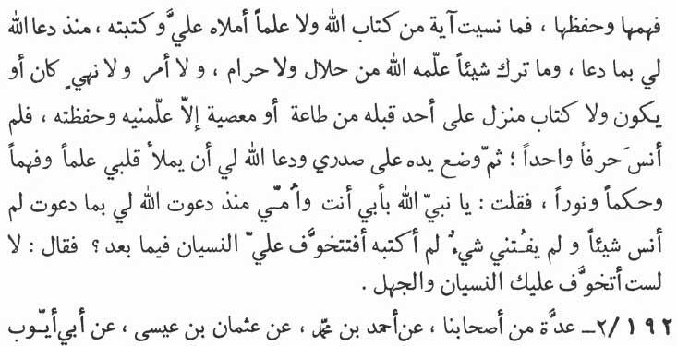

clear and the ambiguous and also with the verses general and specific.

And then the Prophet prayed to Allãh to bestow upon me its true understanding and its unfailing memory. Ever since the Prophet had prayed for me, I never forgot a single verse from the Book of Allãh, nor did I forget the knowledge which the Prophet had imparted to me and which I had taken down in my own hand. Nothing from what was revealed to the Prophet, the lawful and the unlawful; nothing from the divine imperatives and the prohibitions, nothing from what had been and what would be, and nothing from the books revealed previously to any of the Prophet regarding divine obedience and disobedience did the Prophet spare teaching me. I had fully grasped it and forgot not a word from it. Then the Prophet put his hand over my chest and prayed to Allãh to fill my heart with knowledge and understanding, wisdom and enlightenment. I, then, inquired: 'O Prophet of Allãh, may my parents be sacrificed for you ! I have never forgotten anything ever since you have prayed for me. Nor did I forget what I had not noted down. After all this, are you still afraid of my being forgetful?' Hearing this, the Prophet replied, 'No, I am never afraid of your being either forgetful or ignorant.”

192-2. A group of our associates (-) Ahmad ibn Muhammad

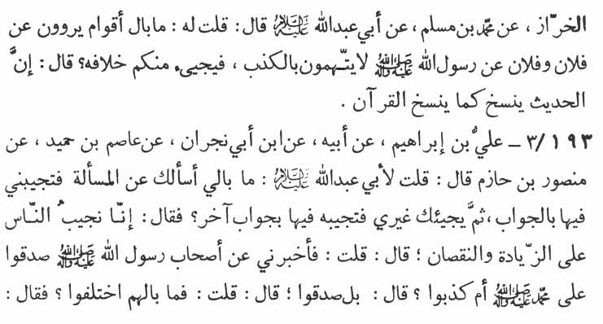

(-) ‘Uthmãn ibn ‘Isã (-) Abi Ayyũb al-Kharrãz (-) Muhammad ibn Muslim as saying :

“I inquired of Abu ‘Abdillãh (p.b.u.h.), 'What of the group of narrators who narrate traditions from such and such persons on the authority of the Messenger of Allãh (p.b.u.h.a.h. p.) and they cannot be accused as Tiers. Still what comes from you runs counter to their narrations?' The Imãm replied, 'Truly, the traditions are superseded just as the verses are.”

193-3. ‘Ali ibn Ibrãhīm (-) his father (-) Ibn Abi Najrãn (-) ‘Ãsim ibn Humayd (-) Mansũr ibn Hãzim saying :

“I have inquired of Abu ‘Abdillãh (p.b.u.h.), 'I put certain question to you (the Imãms) and certain replies are received from you. Later on, another man comes to ask you the same question but you give him a different reply.' The Imãm explained, 'We reply to the people in excess of deficiency (accroding to the circumstances).'(The narrator says), I further asked the Imãm, 'Explain me whether the companions of the Prophet were hold true or hold untrue of Muhammad (p.b.u.h.a.h.p.).' The Imãm replied, 'Certainly, they were true.' Hearing this, I inquired, 'What of them as they differ in the narrations?' The Imãm replied, 'Don't you know that persons used to come to the Holy Prophet to ask

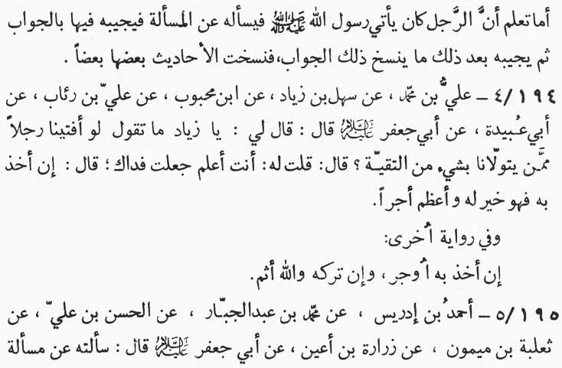

questions and the Prophet used to reply them. After some time the Prophet used to give a reply which superseded his former reply. In this way certain traditions superseded the other traditions.”

194-4. ‘Ali ibn Muhammad (-) Sahl ibn Ziyãd (-) Ibn Mahbũb (-) ‘Ali ibn Ri'ãb (-) Abi ‘Ubaydah, as saying “Abu Ja‘far (p.b.u.h.) addressed me thus :

'O’ Ziyãd! What have you to say, if we give certain verdicts to any of our followers out of taqiyyah (expediency, that is, guarding one's life and honour through concealment of the true belief)?' I (Ziyãd) replied, 'May my life be sacrificed for you ! You know far better.' Hearing this the Imãm explained, 'If a person accepts such a verdict as given under expediency (taqiyyah) and acts upon it, the highest divine rewards will be bestowed upon him.”

Another tradition says, “If a person practices the same he will be highly rewarded. If he abandons the verdict, by Allãh he will be sinful to Allãh.”

195-5. Ahmad ibn Idris (-) Muhammad ibn ‘Abd al-Jabbar (-) al-Hasan ibn ‘Ali (-) Tha‘labah ibn Maymũn (-) Zurãrah ibn

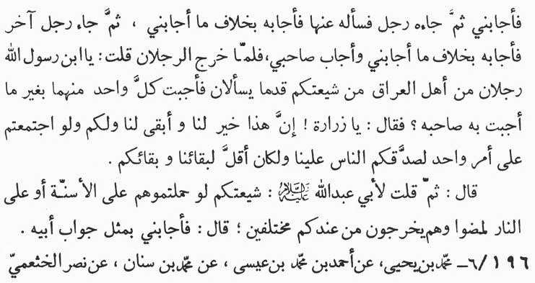

A'yan as saying:

“I asked of Abu Ja‘far (p.b.u.h.) a question, for which the Imãm gave an answer. Afterwards another person came to the Imãm and asked him the same question. But the Imãm gave an entirely different answer. Again a third person came and asked the Imãm the same question to which the Imãm gave an answer which was still different from mine and that of the second person. When the two had left, I asked, 'O’ son of the Prophet, two of your followers from Iraq asked you a question and you gave them two different answers.' Hearing this, the Imãm replied, 'O’ Zurãrah these different answers are in our own interests and they contribute to the stability of both of us (the Imãms and their followers - the Shiites). If you all (the Shiites) present a united stand, it will enable the people (opponents and the rulers) to verify the allegiance of yours to us and this will be a peril to you as well as to the life of ours.”

The narrator says, “Then again, I asked Abu ‘Abdillãh (p.b.u.h.) 'Your followers (the Shiites) are such that if you put them on the points of bayonets or in the face of roaring flames, still, when they go forth from you, they are at variance with each other.' The Imãm gave me exactly the same answer as was given by his father.

196-6. Muhammad ibn Yahyã (-) Ahmad ibn Muhammad ibn

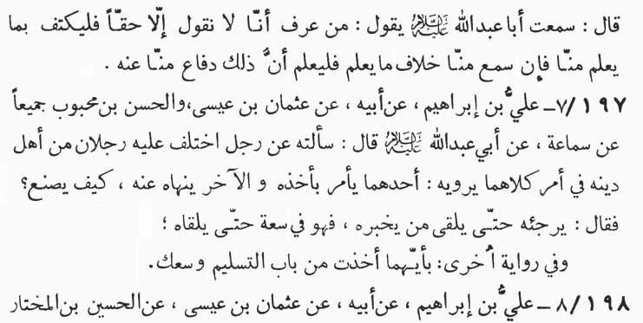

‘Isã (-) Muhammad ibn Sink]. (-) Nasr al-Kath‘amī, as saying: “I have heard Abu ‘Abdillãh (p.b.u.h.) saying:

'Whoever knows that we tell nothing but the truth, should rest content over what he has already learnt from us. If he hears some-thing contrary to what he knows already from us, he should realize that this contrariness is our device to defend the interrogator.”

197-7. Ali ibn Ibrãhīm (-) his father (-) ‘Uthmãn ibn ‘Isã and al-Hasan ibn Mahbũb both of them (-) Samã‘ah, as saying:

“I inquired of Abu ‘Abdillãh (p.b.u.h.) , about a person who receives two opposite versions of one and the same traditions from two persons belonging to his faith, one making something imperative and the other making the same thing prohibitory. In such a situation what should one do? The Imãm replied, '(In a situation like that) the person should shelve its consideration, so long as he meets a person who could tell him the truth. Until that time, the man is at liberty, either to act upon it or to leave it alone.”

According to another tradition, “You are at liberty to act upon any one of the two opposite traditions, provided that you are so doing in obedience.”

198-8. ‘Ali ibn Ibrãhīm (-) his father (-) ‘Uthmãn ibn ‘Isã (-) al-Husayn ibn al-Mukhtar (-) some of our associates (-) Abu

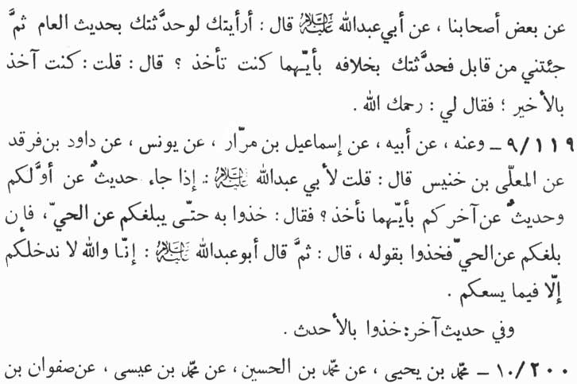

‘Abdillãh (p.b.u.h.), as inquiring (from the narrator):

“What do you think if I give a statement to you this year and when you come to see me next you, I give another statement con-trary to the first, which of the two will you accept and act upon?” “I replied, 'I shall act upon the last one.” The Imãm observed, “May Allãh be merciful to you.”

199-9. From him (-) his father (-) Ismã‘īl ibn Marra'. (-) Yũnus (-) Dãwũd ibn Farqad (-) Mu‘allã ibn Khunays as saying:

“I inquired of (Imãm) Abu ‘Abdillãh (p.b.u.h.), If we receive a tradition from the preceding one of you, and then a different version of tradition from the latter, which of the two should we accept and act upon?' The Imãm replied, 'You should go on acting upon the first tradition, till such time as you get enlighten from the living Imãm (of the time). You should then act according to this enlightenment.' Then Abu ‘Abdillãh (p.b.u.h.) added, 'By Allãh, we guide you in such a way as to make things easy for you.”

Another tradition says, “Accept the latest tradition.”

200-10. Muhammad ibn Yahyã (-) Muhammad ibn al-Husayn

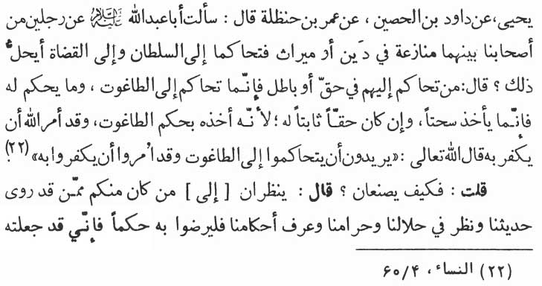

(-) Muhammad ibn ‘Isã (-) Safwãn ibn Yahyã (-) Dãwũd ibn al-Husayn (-) ‘Umar ibn Hanzalah as saying:

“I inquired of Abu ‘Abdillãh (p.b.u.h.), about two persons belonging to our folk, quarrelling with each other about debt or inheritance and referring their dispute to the ruler of the time or the judge appointed for the ruler for decision. Is this lawful for them?' The Imãm replied, 'Whoever had his disputes settled by the ruler or his judge, whether right or wrong, has actually got his disputes settled by tãghũt (a tyrant ruler whose rule is against divine law). And the gains he makes out of that decision will be illgotten for him, however, lawful may be his ownership. The reason is that he has secured his ownership through the decision of tãghũt, while Allãh has enjoined him to falsify and to reject him (tãghũt). Allãh the Almighty, the Sublime has said: 'They intend to resort to the judgment of (tãghũt) though commanded were they to disbelieve in him.' (an-Nisã', 4:60)

“I inquired, 'Then what shall they (two) do?' He replied, 'They should refer to one among you who cites and is well versed in our traditions, and who has a deep insight in the imperatives, prohibitions and (divine) commands communicated by us. They must take such a man as their arbitrator since I have appointed him as your judge. If such a person passes a verdict according to our commands and the person concerned does not accept it, then the

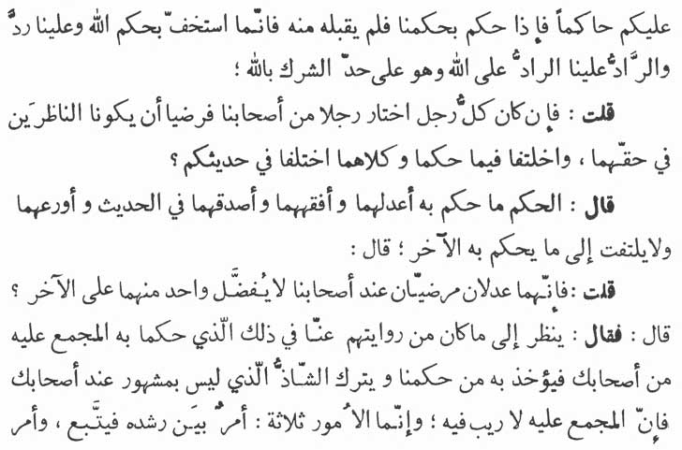

person has actually lightened the divine commands itself and has rejected us. And he who rejects us, actually rejects Allãh the Almighty, and such a person has entered the borders of polytheism.'

“I inquired, 'May my life be sacrificed for you! What is to be done, if each one of the two has accepted one of our community as watchmen for their rights and if the two differ in their decisions in a manner that both cite your traditions containing different versions?'

“The Imãm replied, 'The verdict of the one who is more just, more learned, more true and more pious shall prevail, and the verdict of the other person shall be overlooked.'

“I inquired, 'As to what should be clone in case both the persons have an equal degree of justice acceptable to all the people of our community in such a way as to render them unable to make preference over each other?'

“The Imãm replied, 'In such a situation the verdict of the person based on our tradition and commands, unanimously accepted by all of our followers, shall prevail. And the verdict based on the tradition which is rare and is not famous among your associates will be passed by. Since there can be no doubt about

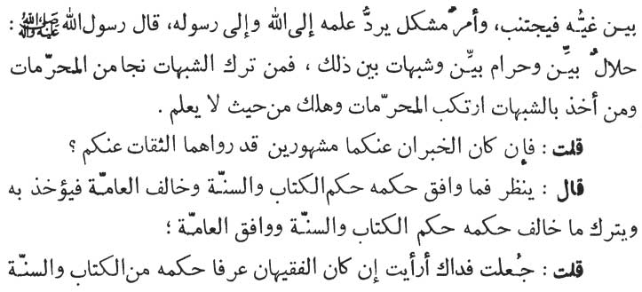

about a tradition which is unanimously accepted by all. All things are of three types :-

i) is the type which is manifestly true and self-evident. Such should be followed;

ii) is the type which manifestly false and should be left out; and

iii) is the type which comprises ambiguous things. These things should be referred to Allãh and His Prophet in respect of their correct position.

'The Prophet has observed: Manifestly lawful, manifestly un-lawful and in between the two - the ambiguous. Whoever abstains from what is ambiguous is redeemed from what is unlawful. And whoever accepts the ambiguous becomes guilty of unlawful conduct and consequently meets his doom unknowingly.'

“I inquired, 'What to do when both of the traditions are well known and are cited from you by reliable persons?'

“The Imãm replied, 'In such a case that tradition will prevail which accords (most) with the Book of Allãh and as-Sunnah and which differs from the common people (al- Ammah ). The other tradition, which differs in its contents from the contents of the Book of Allãh and as-sunnah and which accords with the contents and accepted by the common people will be overlooked.'

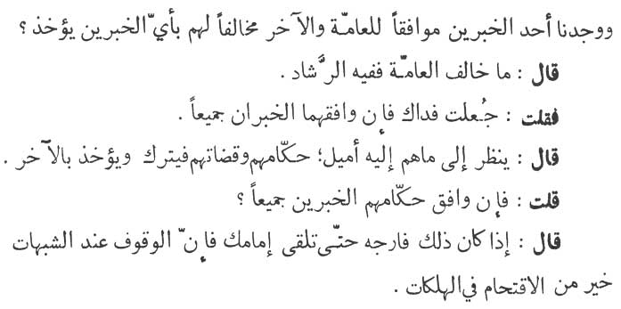

“I said, 'May my life be sacrificed for you ! What do you say if two such scholars proclaim their verdict based on their knowledge of the Book (of Allãh) and as-Sunnah and we found one of the two traditions accords with the common people and the second differs from them. Which of the two do we accept?'

“The Imãm replied, 'The tradition which is contrary to the common people has truth and guidance in it.'

“I inquired, 'May my life be sacrificed for you ! What is to be done if both the traditions (though different) accord with the common people?'

“The Imãm replied, 'In such a case the verdict which is in line with the inclinations of the rulers and the judges will be overlooked, and the other should be followed.'

“I further inquired, 'What is to be done, if both the traditions are in line with the inclinations of the rulers?'

“The Imãm replied, 'In such a case you should wait and see till such time as you meet your Imãm, since in a case of ambiguity standing still is better than falling into fatal error.”

\* \* \* \* \*

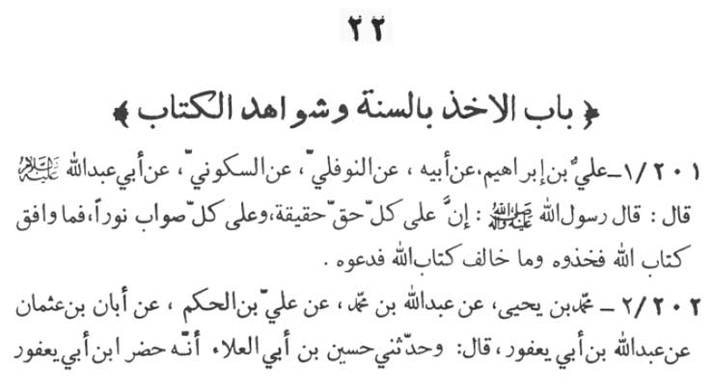

22 CHAPTER ON TAKING HOLD OF AS-SUNNAH AND THE EVIDENCES FROM THE BOOK OF ALLAH

201-1. ‘Ali ibn Ibrãhīm (-) his father (-) an-Nawfali (-) as-Sakkũni (-) Abu ‘Abdillãh (p.b.u.h.) as saying:

“The Messenger of Allãh (p.b.u.h.a.h.p.) observed:

'Above every truth there is a reality (which proves its right-ness), and every righteous thing has an enlightenment above it. There-fore accept what conforms to the Book of Allãh and leave what does not conform to it.'

202-2. Muhammad ibn Yahya (-) ‘Abdullãh ibn Muhammad (-) ‘Ali ibn al-Hakam (-) Abãn ibn ‘Uthmãn (-) ‘Abdullãh ibn Abī Ya‘fũr as saying :

“Aban says, 'Husayn ibn Abi' l-‘Alã' related to me that Ibn Abi Ya‘fũr who is present in this meeting says, 'I inquired of Abu

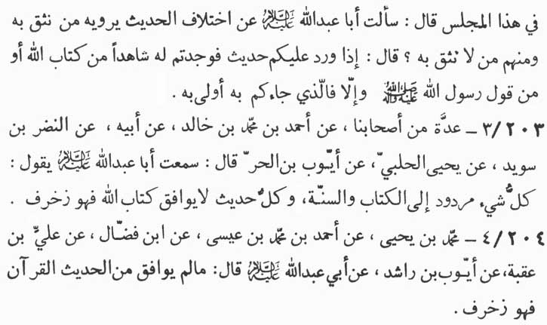

‘Abdillãh (p.b.u.h.) about the different traditions related by those whom we trust and also by those whom we don't: Hearing this, the Imãm replied:

'Whenever you receive a tradition which is borne out by any verse from the Book of Allãh or by a saying of the Prophet, then you accept it. Otherwise, the tradition is meant only for the one who has brought it to you.”

203-3. A group of our associates (-) Ahmad ibn Muhammad ibn Khãlid (-) his father (-) an-Nadr ibn Suwayd (-) Yahyã al-Halabī (-) Ayyũb ibn al-Hurr, as saying, “I have heard Abu ‘Abdillãh (pb.u.h.) saying:

'Everything should be referred back to the Book of Allãh (Qur'ãn) and as-Sunnah (the Prophet's utterances, deeds and unspoken approval). Every tradition which is not in agreement with the Book of Allãh is (nothing but) forge.”

204-4. Muhammad ibn Yahyã (-) Ahmad ibn Muhammad ibn ‘Isã (-) Ibn Faddãl (-) ‘Ali ibn 'Uqbah (-) Ayyũb ibn Rãshid (-) Abu ‘Abdillãh (p.b.u.h.) as saying:

“Every tradition which does not accord with Qur'ãn is (nothing

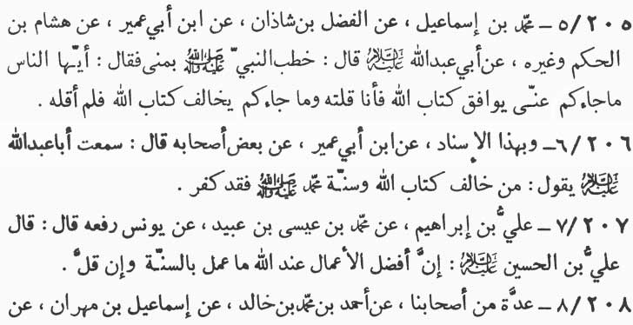

but) forge.”

205-5. Muhammad ibn Ismã‘īl (-) al-Fadl ibn Shãdhãn (-) Ibn Abi ‘Umayr (-) Hishãm ibn al-Hakam and others (-) Abu ‘Abdillãh (p.b.u.h.) as saying:

“The Prophet while addressing at Minã (Mecca) observed :

'O’ people, every one of my tradition which you receive and which accords with the Book of Allãh undoubtedly emanates from me. And whichever of my tradition you receive and which is con-trary to the Book of Allãh, surely doesn't emanate from me.”

206-6. According to the same authority (as described above) (-) Ibn Abi ‘Umayr (-) some of his associates as saying, “I have heard Abu ‘Abdillãh (p.b.u.h.) saying:

'Whoever opposes the Book of Allãh and as-Sunnah (of Muhammad - p.b.u.h.a.h.p.) turns into a heathen forthwith.”

207-7. ‘Ali ibn Ibrãhīm (-) Muhammad ibn ‘Isã ibn ‘Ubayd (-) Yũnus (rafa‘ahũ) as saying :

“ ‘Ali ibn al-Husayn (p.b.u.t.) observed:

'Verily, the best deed in the eye of Allãh, however small it may be, is the one which accords with as-Sunnah.”

208-8. A group of our associates (-) Ahmad ibn Muhammad ibn Khãlid (-) Ismã‘īl ibn Mihrãn (-) Abi Sa‘īd al-Qammãt and

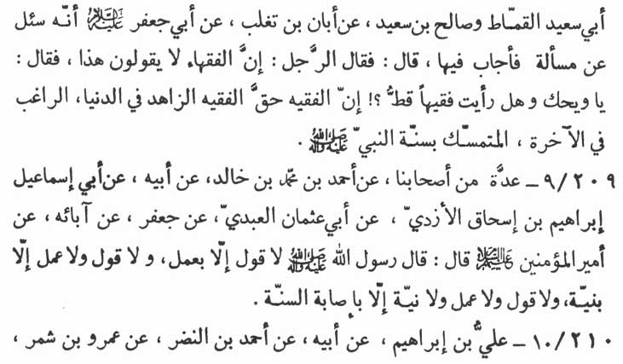

Sãlih ibn Sa‘īd (-) Abãn ibn Taghlib as saying:

“Abu Ja‘far (p.b.u.h.), was asked a question to which he re-plied. At this, the interrogator remarked, 'The other religious scholars (Fuqahã') do not reply like this.' The Imãm replied:

'Woe unto you, have you ever seen any religious scholar? Verily, the true religious scholar is the one who has forsaken the worldly pleasures, who is disposed towards the life hereafter and who always adheres to as-Sunnah.”

209-9. A group of our associates (-) Ahmad ibn Muhammad ibn Khãlid (-) his father (-) Abi Ismã‘īl Ibrãhīm ibn Ishãq al-Azdi (-) Abi ‘Uthmãn al-‘Abdi (-) Ja‘far (-) his fore-fathers (-) Amīr al-mu'minīn (‘Ali - the Chief of the Believers - peace be upon all of them), as saying :

“The Messenger of Allãh (p.b.u.h.a.h.p.) has observed:

'No word can be a word unless acted upon. No word and no act can be regarded as good unless it has been said and acted with the motive (to please Allãh or to earn divine rewards in the life here-after). And there can be no word, no act and no motive unless it accords with as-Sunnah.'

210-10. ‘Ali ibn Ibrãhīm (-) his father (-) Ahmad ibn an-Nadr

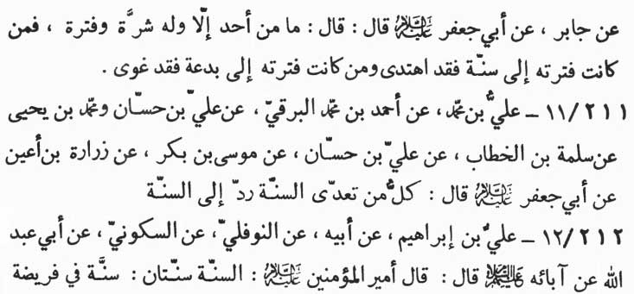

(-) ‘Amr ibn Shimr (-) Jãbir (-) Abu Ja‘far (p.b.u.h.) as saying:

“There is no one but has a greediness and emotional like (the period of activity and animation) ; and also a lassitude, tranquility and peace, (the period in which his activity is ended and is in an unchangeable fixed position). If during his tranquility and peace he is relying upon as-Sunnah, then surely he is the recipient of (true) guidance.

“Should he however be relying upon irreligiousness and innovations in religion, in the period of his tranquility and peace, then he is certainly misguided.”

211-11. ‘Ali ibn Muhammad (-) Ahmad ibn Muhammad al-Barqi (-) ‘Ali ibn Hassãn and Muhammad ibn Yahyã (-) Salamah ibn al-Khaltab (-) ‘Ali ibn Hassãn (-) Mũsã ibn Bakr (-) Zurãrah ibn A‘yan (-) Abu Ja‘far (p.b.u.h.) as saying:

“Whoever transgresses as-Sunnah should be brought back within its bounds.”

212-12. ‘Ali ibn Ibrãhīm (-) his father (-) an-Nawfali (-) as-Sakkũni (-) Abu ‘Abdillãh (-) his fore-fathers (the Imãms - p. b.u.t.) as saying, “Amīr al-mu'minīn (‘Ali - p.b.u.h.) observed:

'as-sunnah are of two categories. The first is obligatory, practicing of which is sure guidance and abandoning of which is

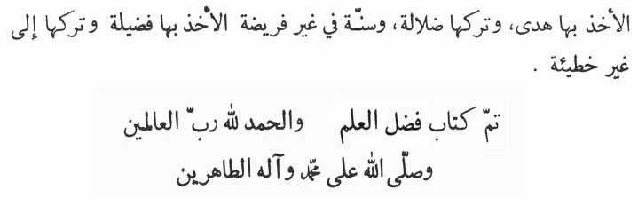

misguidance. The second category of as-Sunnah is non-obligatory, the practicing of which is excellence and abandoning of which is no sin.”

(Thus the end [of the Second Part] of the Book of EXCELLENCE OF KNOWLEDGE)

Praise belongs to Allãh, the Lord of all Being, and Blessings of Allãh be upon Muhammad and his purified progeny

All rights reserved for Al-Hassanain (p) Network, Imam Hussain (p) Foundation

Alhassanain (p) Network for Islamic Heritage and Thought

[www.alhassanain.org/english](http://www.alhassanain.org/english)