History of the Holy Shrines

Table of Contents

History of the shrine of Imam Ali ibn Abi Talib, peace be upon him 6

The visit of Prophet Abraham and Isaac and Abraham's prediction and desire to buy the Valley of Peace 6

The Mausoleum 6

The deer hunting incident of Harun al-Rashid 7

References 8

History of the Cemetery Of Jannat Al-Baqi 12

The Origins of Al-Baqi 12

Al-Baqi as viewed by historians 12

The First Destruction of Al-Baqi 13

The second plunder by the Wahhabis 14

Protest from Indian Muslims 15

Protest from other countries 15

A partial list of the demolished graves and shrines 15

History of the Shrine of Imam Husayn Ibn Ali Ibn Abi Talib 20

“Karbala” Origin & Meaning 20

Martyrdom and popularity 21

Bounty of visiting Imam Husayn [a] 21

Mausoleum of Imam Husayn, peace be upon him 21

The resting place of Abbas b. Ali, peace be upon him 22

Chronology of Imam Husayn's Shrine at Karbala 22

History of the Shrine of Imam Musa Al-Kadhim & Imam Muhammad Al-Jawad 27

References 33

History of the shrine of Imam Ali b. Musa Al-Reza, peace be upon him the history of Mashad 36

History of the construction of Astan-Qods-Razavi 36

Basts (Places of Refuge) 36

Sahne Enqelab 36

Minarets 37

Nqqareh Khaneh (Place of Kettle Drums) 37

Saqqa Khaneh (Public Drinking Place) 37

Sahne Jamhuri Islami (Islamic Republic Court) 37

Sahn Qods 37

Sahne Imam Khomeini 38

Sahne Azadi 38

Gowharshad Mosque 38

Imam Reza [a]'s Tomb 38

Dar-al Hoffaz (the place of the Reciters) 38

Towhid Khaneh (place of Divine Unity) 39

Dar-al-Siyadah 39

Bala-Sar Mosque 39

Dar-al Rahmah Porch 39

Allahverdikhan Dome 39

Hatam Khani Dome 39

The Golden Dome 39

Museum of Astaane Quds 39

Museum of The Quran 40

Museum of Stamps 40

Astane Quds Mehmansara 40

Sheikh Bahaiee 40

Sheikh Hurr Ameli 40

Sheikh Tabarasi 40

Khwajeh Morad 40

Khwajeh Rabiee 41

Gonbad (Dome) Kheshti 41

Peer-e Palandooz (the old pack saddler) 41

Gonbade Sabz (Green Dome) 41

Mosalla Mashad 41

Akhanjan Tower 41

Miami (Imamzadeh Yahya) 41

Nadir's monument 42

Ferdowsi's monument 42

Source 42

History of the Shrine of Imam Ali Al-Naqi & Imam Hasan Al-Askari, Peace Be Upon Them 43

Before Explosion 43

After Explosion 45

References 52

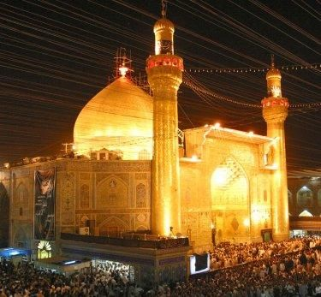

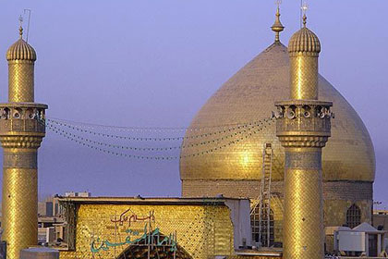

History of the shrine of Imam Ali ibn Abi Talib, peace be upon him

The visit of Prophet Abraham and Isaac and Abraham's prediction and desire to buy the Valley of Peace

Those who have visited Najaf will remember vividly that to the north and east of the town there are acres of graves and myriads of domes of various colors and at various stages of disrepair. Whoever goes to Najaf will follow a road that approaches the town by a winding course through this vast cemetery. The Prophet Abraham had come to this place along with Isaac; there had been many earthquakes in the vicinity, but while Abraham remained there, there were no tremors. On the night, however, when Abraham and Isaac went to a different village, and sure enough Najaf was visited with another earthquake.

When they returned, the people were most eager for them to make Najaf their permanent dwelling-place. Abraham agreed to do so on condition that they would sell him the valley behind the village for cultivation. Isaac protested and said that this land was neither fit for farming nor grazing, but Abraham insisted and assured him that the time would come when there would be a tomb there with a shrine, at which seventy thousand people would gain absolutely undisputed entrance to Paradise, and be able also to intercede for many others.1

The valley that Abraham wanted to buy is called the Valley of Peace (Wadiu's-Salaam), and it is related on the authority of the fourth Imam, that Ali once said that this Valley of Peace is part of Heaven and that there is not a single one of the believers in the world, whether he dies in the east or west, but his soul will come to this Paradise to rest.2“As there is nothing hidden in this world from my eyes,” Ali went on to say, “I see all the believers seated - here in groups and talking with one another.”

How Najaf was given its name is explained in the tradition. At first there was a mountain there, and when one of the sons of Noah refused to enter the Ark, he said that he would sit on this mountain until he would see where the water would come. A revelation came therefore to the mountain, “Do you undertake to protect this son of mine from punishment?” And all at once the mountain fell. to pieces and the son of Noah was drowned. In place of the mountain a large river appeared, but after a few years the river dried up, and the place was called Nay-Jaff, meaning, “the dried river.”3

And so as per the prediction of Abraham, Imam Ali was buried here.

Ali is absent today from our midst only physically. His soul even to this day is the greatest spiritual resort everyone who seeks the help of God through his medium. Thousands and thousands of people call out to him in their difficulties, and the word “Ya Ali Madad”, automatically comes to them. A famous prayer known as “NADEY ALI” (Call Ali) is recited wherever abound the lovers of Ali.

The Mausoleum

“The Mausoleum itself of Hazrat Ali at Najaf, is breathtaking. There is one large central dome which stands out of a square-shaped ornate structure

at the two sides of which are two minarets. The predominant color of' the exterior is gold, bright shining gold and the entire exterior of the mausoleum is inlaid with a mosaic pattern of light powder blue, white marble, gold again with an occasional splash of Middle East rust.”

So says D. F. Karaka after his visit to Najaf, and further adds, “I have sat and wondered at the marbled splendour of our Taj Mahal, the tomb which Shah Jahan built for his Empress Mumtaz Mahal, but despite its beauty, the Taj appears insipid in comparison with this splash of color at Najaf. The tomb surpassed anything I have seen in gorgeous splendour. All the great kings of the world put together could not have a tomb as magnificent as this, for this is the tribute which kings and peasants have built together to enshrine the mortal remains of the great Ali.”

Countless number of people from all over the world flock to his tomb day after day to pay their respects and to offer salutations and to pray to Allah seeking his intercession. And those who cannot afford to go there personally, are constantly praying to Allah to help them to visit the shrine of their Maula Ali, and when somebody goes on a pilgrimage to Najaf, they request him to offer salutations on their behalf, and to pray to God - for some particular favor - and to seek Imam Ali's intercession.

The deer hunting incident of Harun al-Rashid

“During the reigns of the Umayyad Caliphs his blessed resting-place could not be disclosed, and so it was also under the Abbasids until the reign of Harun al-Rashid. But in the year 175 A.H. (791 A.D.), Harun happened to go hunting in these parts, and the deer he was chasing took refuge on a small piece of raised ground. However much he asked his hunting dogs to capture the quarry, they refused to go near this spot.

He urged his horse to this place, and the horse too refused to budge; and on this, awe took possession of the Caliph's heart, and he immediately started to make inquiries of the people of the neighborhood, and they acquainted him with the fact that this was the grave of Imam Ali ibn Abu Talib, the cousin and son-in-law of the Holy Prophet. Harun ordered a tomb to be erected over the grave, and people soon began to settle down in its vicinity.”4

References

1. . Majlisi op. cit. page 108.

2. . Mailisi op. cit. Page 111.

3. . Majlisi op. cit. page 111.

4. . The Shrine of Ali at Najaf from “The Shi'ite Religion” by Dwight M. Donaldson.

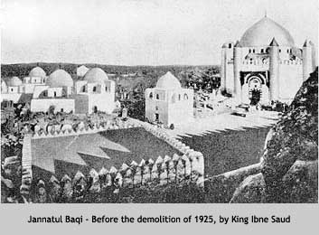

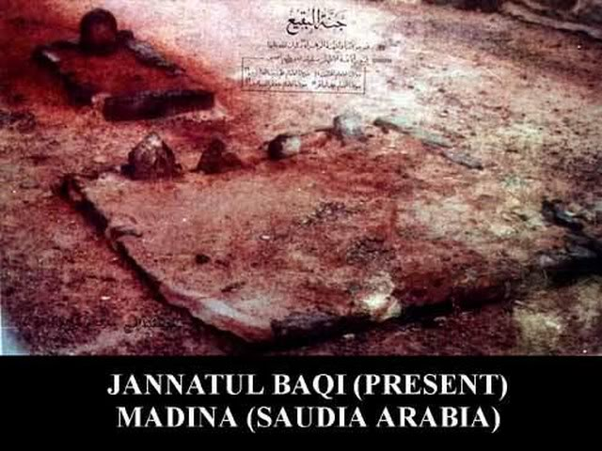

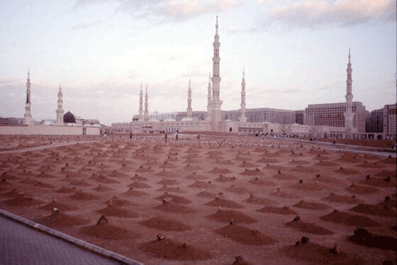

History of the Cemetery Of Jannat Al-Baqi

Where Imam Hasan Ibn Ali (2nd Imam), Imam Ali Ibn Al-Husayn (4th imam), Imam Muhammad Ibn Ali (5th imam), & Imam Ja'far Ibn Muhammad (6th imam), peace be upon them, are buried

On 8th Shawwal, Wednesday, in the year 1345 AH (April 21, 1925), mausoleums in Jannatul Al-Baqi (Madina) were demolished by King Ibn Saud.

In the same year (1925), he also demolished the tombs of holy personages at Jannat al-Mualla (Makkah) where the Holy Prophet (s)'s mother, wife, grandfather and other ancestors are buried.

Destruction of sacred sites in Hijaz by the Saudi Wahhabis continues even today. According to some scholars what is happening in Hijaz is actually a conspiracy plotted by the Jews against Islam, under the guise of Tawheed. The idea is to eradicate the Islamic legacy and heritage and to systematically remove all its vestiges so that in the days to come, Muslims will have no affiliation with their religious history.

The Origins of Al-Baqi

Literally “Al-Baqi” means a tree garden. It is also known as “Jannat Al-Baqi” due to its sanctity, since in it are buried many of our Prophet's relatives and companions.

The first companion buried in Al-Baqi was Uthman Ibn Madhoon who died on the 3rd of Sha'ban in the 3rd year of Hijrah. The Prophet (s) ordered certain trees to be felled, and in its midst, he buried his dear companion, placing two stones over the grave.

On the following years, the Prophet's son Ibrahim, who died in infancy and over whom the Prophet (s) wept bitterly, was also buried there. The people of Madina then began to use that site for the burial of their own dead, because the Prophet (s) used to greet those who were buried in Al-Baqi by saying, “Peace be upon you, O abode of the faithful! God willing, we should soon join you. O' Allah, forgive the fellows of al-Baqi”.

The site of the burial ground at al-Baqi was gradually extended. Nearly seven thousand companions of the Holy Prophet (s) were buried there, not to mention those of the Ahlul Bayt (a). Imam Hasan Ibn Ali (a), Imam Ali Ibn Al-Husayn (a), Imam Muhammad Al-Baqir (a), and Imam Ja'far Al-Sadiq (a) were all buried there.

Among other relatives of the Prophet (s) who were buried at al-Baqi are: his aunts Safiya and Aatika, and his aunt Fatima Bint Al-Asad, the mother of Imam Ali (a). The third caliph Uthman was buried outside al-Baqi, but with later extensions, his grave was included in the area. In later years, great Muslim scholars like Malik Ibn Anas and many others, were buried there too. Thus, did al-Baqi become a well-known place of great historic significance to all Muslims.

Al-Baqi as viewed by historians

Umar Ibn Jubair describes Al-Baqi as he saw it during his travel to Madina, saying “Al-Baqi is situated to the east of Madina. You enter it through the gate known as the gate of al-Baqi. As you enter, the first grave you see on your left is that of Safiya, the Prophet's aunt, and further still is

the grave of Malik bin Anas, the Imam of Madina. On his grave is raised a small dome.

In front of it is the grave of Ibrahim son of our Prophet (s) with a white dome over it, and next to it on the right is the grave of Abdul-Rahman son of Umar bin Al-Khattab, popularly known as Abu Shahma, whose father had kept punishing him till death overtook him. Facing it are the graves of Aqeel bin Abi Talib and Abdullah bin Ja'far Al-Tayyar. There, facing those graves is a small shrine containing the graves of the Prophet's wives, following by a shrine of Abbas bin Abdul Muttalib.

The grave of Hasan bin Ali (a), situated near the gate to it's right hand, has an elevated dome over it. His head lies at the feet of Abbas bin Abdul Muttalib, and both graves are raised high above the ground, their walls are paneled with yellow plates and studded with beautiful star-shaped nails. This is how the grave of Ibrahim, son of the Prophet (s) has also been adorned. Behind the shrine of Abbas there is the house attributed to Fatima, daughter of our Prophet (s), known as “Bayt Al-Ahzaan” (the house of grief) because it is the house she used to frequent in order to mourn the death of her father, the chosen one, peace be upon him. At the farthest end of al-Baqi is the grave of the caliph Uthman, with a small dome over it, and there, next to it, is the grave of Fatima bint Asad, mother of Ali b. Abi Talib (a)”

After a century and a half, the famous traveller Ibn Batuta came to describe al-Baqi in a way which does not in any way differ from the description given by Ibn Jubair. He adds saying, “At al-Baqi are the graves of numerous Muhajirin and Ansar and many companions of the Prophet (s), except that most of their names are unknown.”

Thus, over the centuries, al-Baqi remained a sacred site with renovations being carried out as and when needed till the Wahhabis rose to power in the early nineteenth century. The latter desecrated the tombs and demonstrated disrespect to the martyrs and the companions of the Prophet (s) buried there. Muslims who disagreed with them were branded as “infidels” and were subsequently killed.

The First Destruction of Al-Baqi

The Wahhabis believed that visiting the graves and the shrines of the Prophets, the Imams, or the saints was a form of idolatry and totally un-Islamic. Those who did not conform with their belief were killed and their property was confiscated. Since their first invasion of Iraq, and till nowadays, in fact, the Wahhabis, as well as other rulers of the Gulf States, having been carrying out massacres from which no Muslim who disagreed with them was spared. Obviously, the rest of the Islamic World viewed those graves with deep reverence. Had it not been so, the two caliphs Abu Bakr and Umar would not have expressed their desire for burial near the grave of the Prophet (s).

From 1205 AH to 1217 AH, the Wahhabis made several attempts to gain a foothold in Hijaz but failed. Finally, in 1217 AH, they somehow emerged victorious in Taif where they spilled the innocent blood of Muslims. In 1218 AH, they entered Makkah and destroyed all sacred places and domes there, including the one which served as a canopy over the well of Zamzam.

In 1221, the Wahhabis entered Madina to desecrate al-Baqi as well as every mosque they came across. An attempt was even made to demolish the Prophet's tomb, but for one reason or another, the idea was abandoned. In subsequent years, Muslims from Iraq, Syria, and Egypt were refused entry into Makkah for Hajj. King Al-Saud set a precondition that those who wished to perform the pilgrimage would have to accept Wahhabism or else be branded as non-Muslims, becoming ineligible for entry into the Haram.

Al-Baqi was razed to the ground, with no sign of any grave or tomb whatsoever. But the Saudis were still not quite satisfied with doing all of that. Their king ordered three black attendants at the Prophet's shrine to show him where the treasure of valuable gifts were stored. The Wahhabis plundered the treasure for their own use.

Thousands of Muslims fled Makkah and Madina in a bid to save their lives and escape from the mounting pressure and persecution at the hands of the Wahhabis. Muslims from all over the world denounced this Saudi savagery and exhorted the Caliphate of the Ottoman Empire to save the sacred shrines from total destruction.

Then, as it is known, Muhammad Ali Basha attacked Hijaz and, with the support of local tribes, managed to restore law and order in Madina and Makkah, dislodging the Al-Saud clansmen. The entire Muslim world celebrated this victory with great fanfare and rejoicing. In Cairo, the celebrations continued for five days. No doubt, the joy was due to the fact that pilgrims were once more allowed freely to go for Hajj, and the sacred shrines were once again restored.

In 1818 AD, the Ottaman Caliph Abdul Majid and his successors, Caliphs Abdul Hamid and Mohammed, carried out the reconstruction of all sacred places, restoring the Islamic heritage at all important sites. In 1848 and 1860 AD, further renovations were made at the expense of nearly seven hundred thousand pounds, most of which came from the donations collected at the Prophet's tomb.

The second plunder by the Wahhabis

The Ottoman Empire had added to the splendor of Madina and Makkah by building religious structures of great beauty and architectural value. Richard Burton, who visited the holy shrines in 1853 AD disguised as an Afghan Muslim and adopting the Muslim name Abdullah, speaks of Madina boasting 55 mosques and holy shrines. Another English adventurer who visited Madina in 1877-1878 AD describes it as a small beautiful city resembling Istanbul. He writes about its white walls, golden slender minarets and green fields.

1924 AD Wahhabis entered Hijaz for a second time and carried out another merciless plunder and massacre. People in streets were killed. Houses were razed to the ground. Women and children too were not spared.

Awn bin Hashim (Shairf of Makkah) writes: “Before me, a valley appeared to have been paved with corpses, dried blood staining everywhere all around. There was hardly a tree which didn't have one or two dead bodies near its roots.”

1925 Madina surrendered to the Wahhabi onslaught. All Islamic heritage were destroyed. The only shrine that remained intact was that of the Holy Prophet (s).

Ibn Jabhan says: “We know that the tomb standing on the Prophet's grave is against our principles, and to have his grave in a mosque is an abominable sin.”

Tombs of Hamza and other martyrs were demolished at Uhud. The Prophet's mosque was bombarded. On protest by Muslims, assurances were given by Ibn Saud that it will be restored but the promise was never fulfilled. A promise was given that Hijaz will have an Islamic multinational government. This was also abandoned.

1925 AD Jannat Al-Mu'alla, the sacred cemetery at Makkah was destroyed along with the house where the Holy Prophet (s) was born. Since then, this day is a day of mourning for all Muslims.

Is it not strange that the Wahhabis find it offensive to have the tombs, shrines and other places of importance preserved, while the remains of their Saudi kings are being guarded at the expense of millions of dollars?

Protest from Indian Muslims

1926, protest gatherings were held by shocked Muslims all over the world. Resolutions were passed and a statement outlining the crimes perpetrated by Wahhabis was issued and included the following:

1. The destruction and desecration of the holy places i.e. the birth place of the Holy Prophet [s], the graves of Banu Hashim in Makkah and in Jannat al-Baqi (Madinah), the refusal of the Wahhabis to allow Muslims to recite Ziyarah or Surah Al-Fatiha at those graves.

2. The destruction of the places of worship i.e. Masjid Hamza, Masjid Abu Rasheed, in addition to the tombs of Imams and Sahaba (Prophet's companions).

3. Interference in the performance of Hajj rituals.

4. Forcing the Muslims to follow the Wahhabis innovations and to abandon their own ways according to the guidance of the Imams they follow.

5. The massacre of Sayyids in Taif, Madina, Ahsa, and Qatif.

6. The demolition of the grave of the Imams at al-Baqi which deeply offended and grieved all Shias.

Protest from other countries

Similar protests were lodged by Muslims in Iran, Iraq, Egypt, Indonesia, and Turkey. All of them condemn the Saudi Wahhabis for their barbaric acts. Some scholars wrote tracts and books to tell the world the fact that what was happening in Hijaz was actually a conspiracy plotted by the Jews against Islam, under the guise of Tawheed. The idea was to eradicate the Islamic legacy and heritage and to systematically remove all its vestiges so that in the days to come, Muslims will have no affiliation with their religious history.

A partial list of the demolished graves and shrines

Al-Mualla graveyard in Makkah which includes the grave of Sayyida Khadija bint Khuwailid (a), wife of the Prophet (s), the grave of Amina bint Wahab, mother of the Prophet (s), the grave of Abu Talib, father of Imam Ali (a), and the grave of Abdul Muttalib, grandfather of the Prophet (s)

The grave of Hawa (Eve) in Jeddah

The grave of the father of the Prophet (s) in Madina

The house of sorrows (Bayt Al-Ahzan) of Sayyida Fatima (a) in Madina

The Salman al-Farsi mosque in Madina

The Raj'at ash-Shams mosque in Madina

The house of the Prophet (s) in Madina, where he lived after migrating from Makkah

The house of Imam Ja'far Al-Sadiq (a) in Madina

The complex (mahhalla) of Banu Hashim in Madina

The house of Imam Ali (a) where Imam Hasan (a) and Imam Husayn (a) were born

The house of Hamza and the graves of the martyrs of Uhud (a)

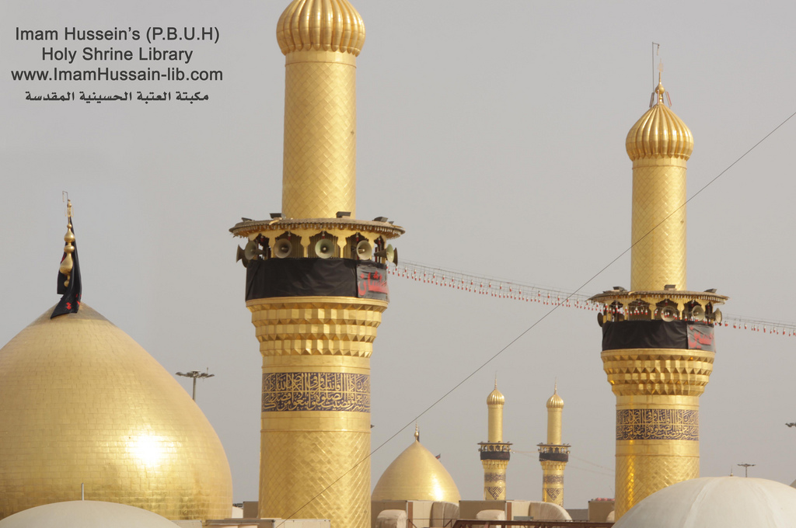

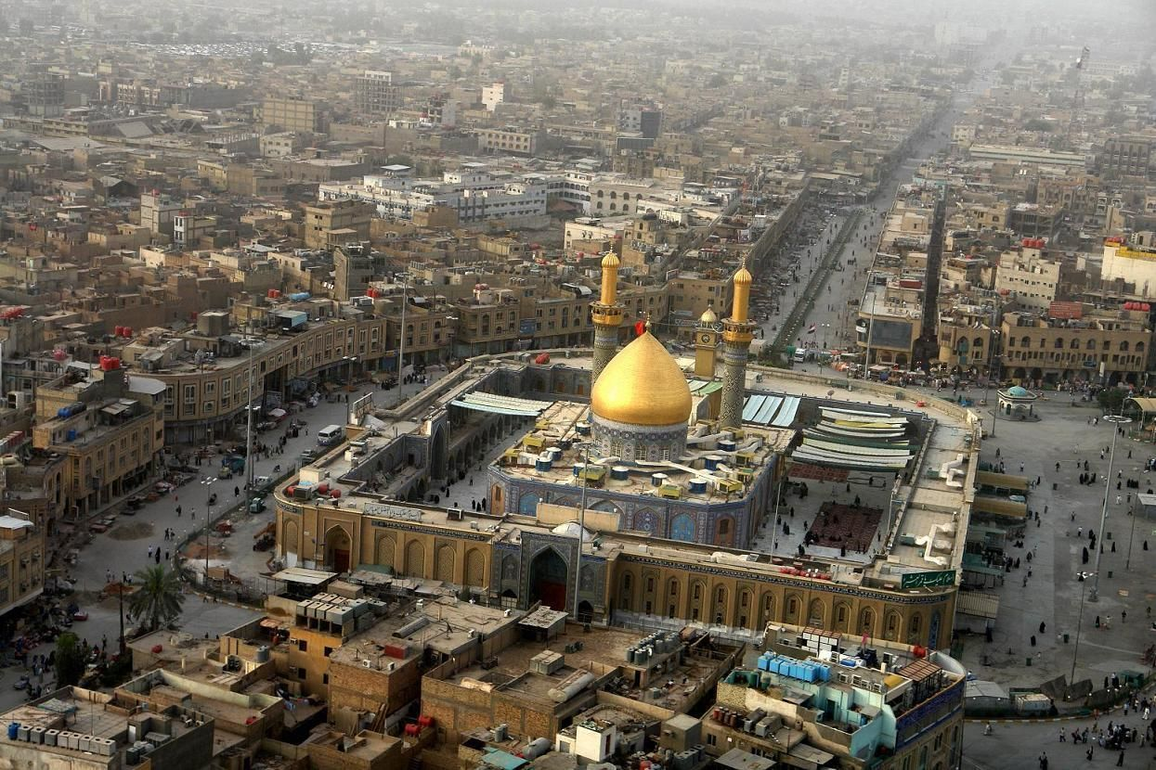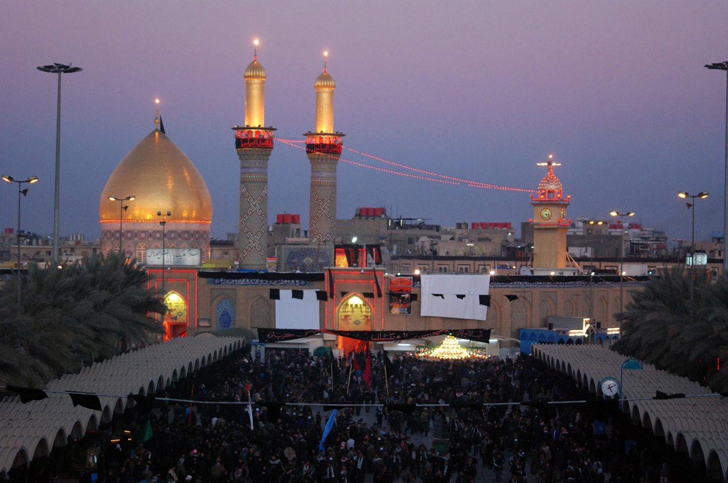

History of the Shrine of Imam Husayn Ibn Ali Ibn Abi Talib

Unlike any other city, Karbala has its named engraved in the memory of generations, and in the expanse of the Muslim world...

Believers remember that name with sorrow and distress, for they remember the history of the master of all martyrs, Imam Husayn, peace be upon him, and his sacrifice for Islam.

The wave of visitors never stopped coming to Karbala, from the time the Umayyad and Abbaside caliphs prevented the construction of the shrines to the time the believers were able to build the precinct, despite the hardships and difficulties imposed on them.

And today, since Karbala is witnessing new calamities, and the mausoleums of Imam Husayn [a] and his companions are subjected to destruction and neglect, and visitors are prevented from reaching that place, it is suitable to familiarize ourselves with Karbala...

Two main roads lead the visitor to Karbala. One is from the Iraqi capital Baghdad, through Al-Musails, and the other is from the holy city of Najaf. However, either one excites the visitor with its greenish scenery along the sides.

Upon reaching Karbala, the holy place would draw the visitor's attention to its glorious minarets and domes shining due to the light of its lord.

At the city's entrance, the visitor finds a row of houses decorated with wooden columns, and while proceeding further towards the holy mausoleum, he sees architecture similar, to some extent, to modern ones.

Upon reaching the holy shrine, one finds himself in front of a boundary wall that surrounds wooden gates covered with glass decorations, and when one enters one of those gates, he enters a precinct surrounded by small rooms called “I wans”.

The holy grave is located in the middle of the precinct, surrounded by square shaped structures called “Rawaq”.

The grave itself is located in the middle of the grave site with golden windows around it, with beautiful illumination. It really is something great to see.

“Karbala” Origin & Meaning

There are many opinions among different investigators, as to the origin of the word “Karbala”.

Some have pointed out that “Karbala” has a connection to the “Karbalato” language, while others attempt to derive the meaning of word “Karbala” by analyzing its spelling and language. They conclude that it originates from the Arabic word “Kar Babel” which was a group of ancient Babylonian villages that included Nainawa, Al-Ghadiriyya, Karbella, Al-Nawaweess, and Al-Heer. This last name is today known as Al-Hair and is where Imam Husayn's [a] grave is located.

The investigator Yaqut al-Hamawy had pointed out that the meaning of “Karbala” could have several explanations, one of which is that the place where Imam Husayn [a] was killed is made of soft earth - “Al-Karbalat”.

Other writers made the connection between the name and the disastrous event which painted the desert with blood, and so the word “Karbala” was said to compose of two Arabic words: “Karb” meaning grief and sorrow, and “Balaa” meaning affliction. Such a connection, in fact, has no scientific evidence, since Karbala was known as such even before the arrival of Imam Husayn, peace be upon him.

Martyrdom and popularity

Karbala was at first an uninhabited place and did not witness any construction activity, although it was rich in water and its soil fertile.

Following the tenth of Muharram 61 AH (680 AD), after the martyrdom of Imam Husayn [a], people from far as well as tribes living nearby started visiting the holy grave.

A lot of those who came, stayed behind and/or asked their relatives to bury them there after their demise.

Despite many attempts by successive rulers, such as Al-Rashid and Al-Mutawakkil, to put a restriction on the development of this area, it has nonetheless spread with time to become a city.

Bounty of visiting Imam Husayn [a]

There is a lot of benefit and great spiritual reward in visiting the grave of Imam Husayn [a]. The Prophet [s] has said of his grandson Imam Husayn [a]: “Husayn is of me and I am of him”. Several narrations mention that visiting the grave of Imam Husayn [a] relieves one of worldly afflictions as well as those after death.

Believers, therefore, come from all parts of the world all year round to receive the honor of visiting Imam Husayn [a], particularly during the first ten days of Muharram (Ashura) and the twentieth of Safar (the fortieth).

One common Iraqi custom during that season is to go walking from Najaf to Karbala, reflecting their strong adhesion to and adoption of the morals and principles for which Imam Husayn [a] struggled and attained martyrdom.

Mausoleum of Imam Husayn, peace be upon him

The historian Ibn Kuluwayh mentioned that those who buried Imam Husayn [a], made a special and rigid construction with signs above the grave.

Higher and bigger constructions above the grave started during the ruling of Al-Saffah, but Harun al-Rashid later on, put heavy restrictions to prevent people from visiting the grave.

At the time of Al-Mamun, construction around the grave resumed until the year 236 AH when Al-Mutawakkil ordered the destruction and digging of the grave, and then filling the pit with water. His son, who succeeded him, allowed people to visit the grave site, and since then building the precinct to the grave increased and developed step by step.

On the other hand, the historian Ibn Al-Athir, stated that in the year 371 AH, Aadod Al-Dawla Al-Boowayhi became the first to largely lay the foundations for large scale construction, and generously decorated the place.

He also built houses and markets around the precinct, and surrounded Karbala with a high boundary wall turning it into a strong castle.

In the year 407 AH, the precinct caught fire due to the dropping of two large candles on the wooden decorations, but Hasan Ibn Fadl (the state minister) rebuilt the damaged sections.

History has recorded the names of several rulers who shared the honor of widening, decorating or keeping the precinct in good condition. Amongst them is Fateh Ali al-Qajari, who in 1250 AH ordered the construction of two domes. One over Imam Husayn's [a] grave and the other over his brother Abu al-Fadl Abbas [a].

The first dome is 27 meters high and completely covered with gold. At the bottom, it is surrounded with 12 windows, each of which is about 1.25 m away from the other, from the inside, and 1.30 m from the outside.

The mausoleum has an area of 59 m / 75 m with ten gates, and about 65 rooms (I wans), well decorated from the inside and outside, used as classrooms for studying.

As for the grave itself, in the middle of the precinct, it is called the “Rawda” or garden and it has several doors. The most famous one is called “Al-Qibla” or “Bab al-Dhahab”. When it is entered, one can see the tomb of Habib ibn Madhahir al-Asadi, to the right hand side. Habib was a friend and companion of Imam Husayn [a] since their childhood. He was one of those who was honoured with martyrdom at the Battle of Karbala.

The resting place of Abbas b. Ali, peace be upon him

Abu al-Fadl Abbas, peace be upon him, was the brother of Imam Hasan [a] and Imam Husayn [a] and the standard-bearer of Imam Husayn [a] in the Battle of Karbala. He is well known in history for his valour, loyalty and similarity to his father, the Lion of God, Ali b. Abi Talib, peace be upon him.

The grave of Abbas [a] received similar attention as that of Imam Husayn [a]. In the year 1032 AH, the King Tahmaseb ordered the decoration of the grave's dome. He built a window on the 'darih' around the grave and organized the precinct. Other similar activities were done by other rulers.

As a matter of fact, Karbala contains, besides the grave of Imam Husayn [a] and his brother, the grave of all the 72 martyrs of Karbala. They were buried in a mass grave which was then covered with soil to the ground level. This mass grave is at the foot of Imam Husayn's [a] grave. In particular, besides Imam Husayn's grave are the graves of his two sons Ali Akbar and 6-month old Ali Asgher.

Chronology of Imam Husayn's Shrine at Karbala

AH CE Events

61 lst October, 680 Imam Husayn [a] was buried at this sacred spot.

65 18th August, 684 Mukhtar ibn Abu Obaidah Thaqafi built an enclosure around the grave, in the form of a mosque and erected a dome over the grave. There were two entrances to this building.

132 12th August, 749 A roof was built over a part of this mosque and two entrances were added during the reign of as-Saffah.

140 31st March, 763 The roof was demolished during the reign of al-Mansur.

158 11th November, 774 During the reign of Mahdi the roof was reconstructed.

171 22nd June, 787 During the reign of Al-Rashid the dome and the roof were demolished and the plum tree which stood near the grave was cut down.

193 25th October, 808 During the reign of Amin the building was reconstructed.

236 15th July, 850 Mutawakkil demolished the buildings and ordered that the land should be ploughed.

247 17th March, 861 Muntasir built a roof over the grave and set up an iron pillar near it, to serve as a landmark for the pilgrims.

273 8th June, 886 The roof was demolished again.

280 23rd March, 893 The Alid representative built a dome in the center, with two roofs, on either side and an enclosure with two entrances.

307 19th August, 977 Adzd ibn Boweih rebuilt the dome, the surrounding galleries and constructed a screen of teak wood around the sepulcher. He also constructed houses all round the shrine and erected the boundary wall of the city. At the same time Imran ibn Shahin built a mosque adjacent to the tomb.

407 10th June, 1016 The buildings were damaged by fire and the Vizier, Al-Hasan ibn Al Fadi rebuilt them.

620 4th February, 1223 Nasir le-din-Illah reconstructed the screens of the sepulcher.

757 18th Sept. 1365 Sultan Owais ibn Hasan Jalairi remodeled the dome and raised the walls of the enclosure.

780 24th Feb. 1384 Ahmad ibn Owais erected two minarets covered with gold and extended the courtyard.

920 26th Feb. 1514 When Shah Ismail Safawi visited the holy shrine he built a sarcophagus of the inlaid work over the grave.

1032 5th Nov. 1622 Shah Abbas Safavi constructed the screens (darih) of brass and bronze and decorated the dome with Kashi tiles.

1048 15th May 1638 Sultan Murad IV, when he visited the holy shrine, whitewashed the dome.

1155 8th March 1742 Nadir Shah visited the holy shrine and decorated the building and offered valuable presents to the treasury of the shrine.

1211 7th July 1796 Shah Muhammad Qachar covered the dome of the shrine with gold.

1216 14th May, 1801 Wahhabis attacked Kerbala, spoiled the screens and portico and looted the shrine.

1232 21st Nov., 1817 Fateh Ali Shah Qachar repaired the screens and plated them with silver. He also plated the centre of the main portico with gold and repaired the damage done by the Wahhabi robbers.

1283 16th May, 1866 Nasiruddin Shah Qachar extended the courtyard of the shrine.

1358 21st February, 1939 Dr. Syedna Taher Saifud-din, 51st Dai-el-Mutlaq of the Dawoodi Bohra community offered a set of screens of solid silver which are fixed in the shrine.

1360 29th January, 1941 Dr. Syedna Taher Saifud-din, 5lst Dai-el-Mutlaq of the Dawoodi Bohra community rebuilt the western minaret.

1367 20th Dec., 1948 Syed Abdul Rasul Khalsi, Administrator of Karbala acquired the houses in the neighbourhood of the courtyard according to the price fixed by the government, to build a road around the holy mausoleum and to extend the courtyard.

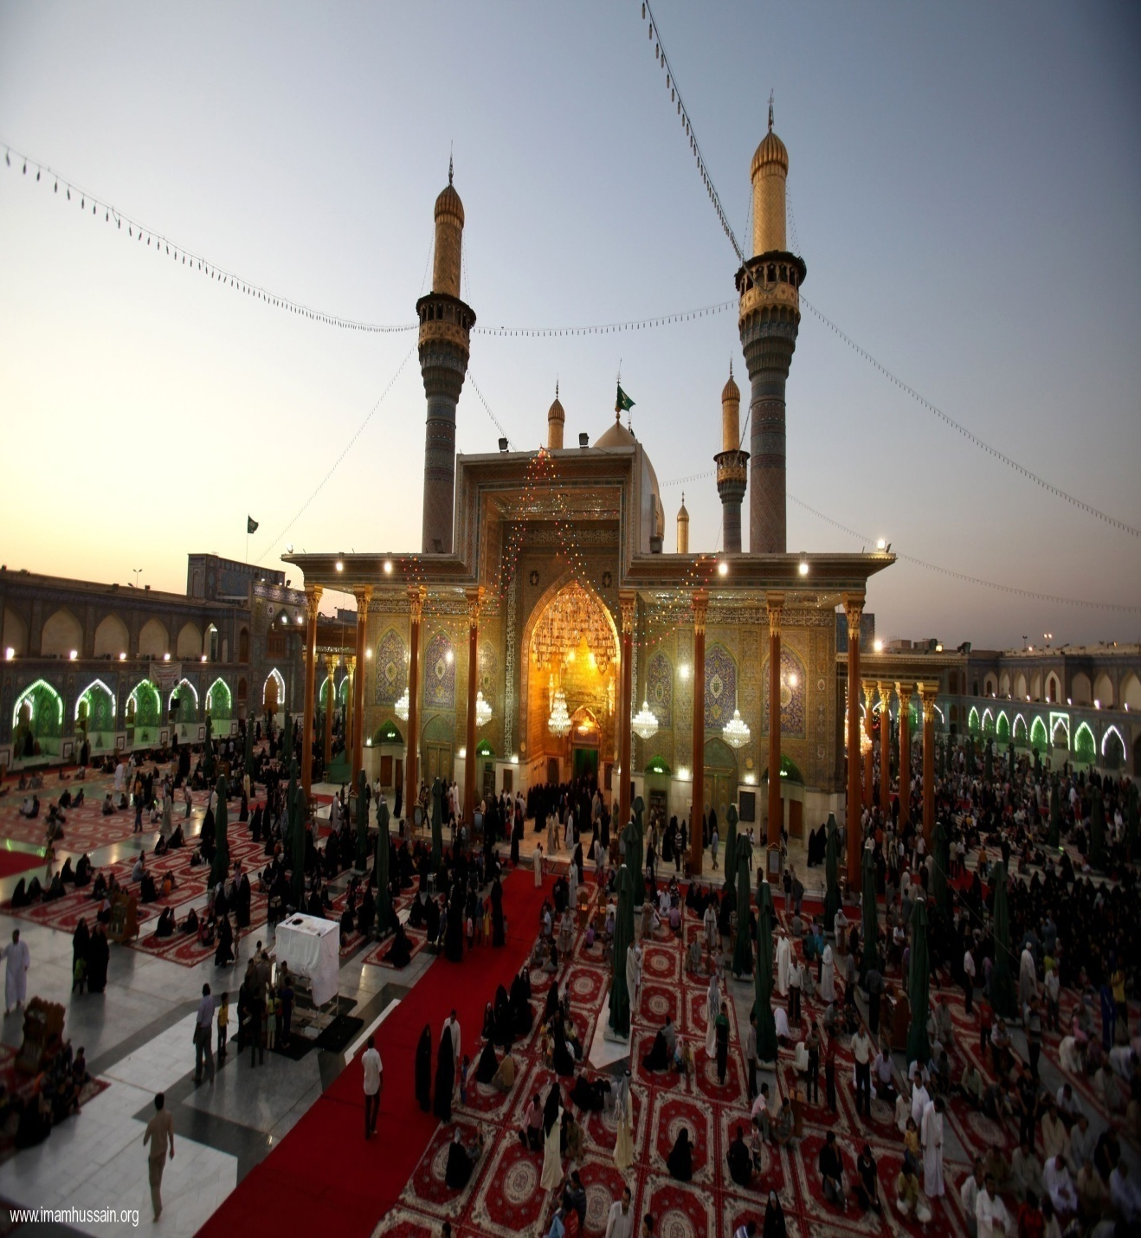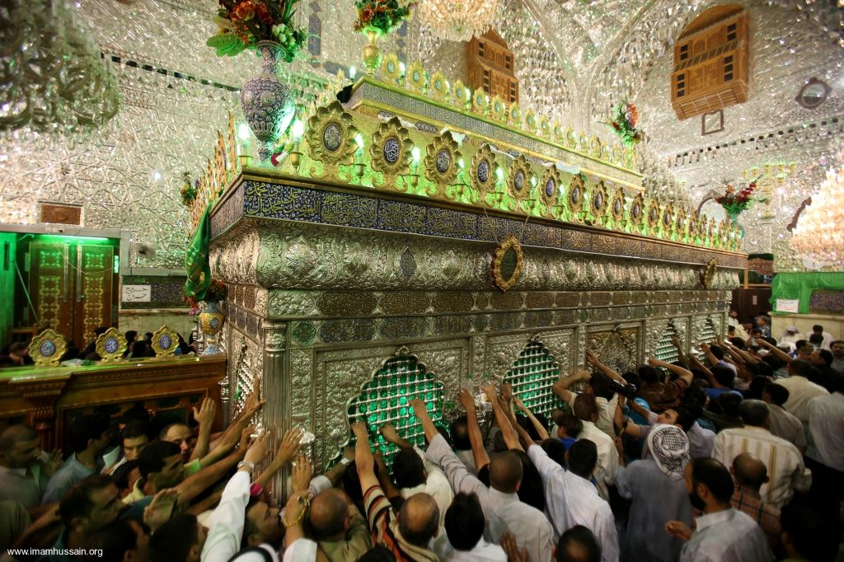

History of the Shrine of Imam Musa Al-Kadhim & Imam Muhammad Al-Jawad

Anyone approaching Baghdad from the north or the west will be impressed by the sight of the four golden minarets at Kadhmayn, the Shrine of the Two Imams, Imam Musa Al-Kadhim and Imam Muhammad Taqi Al-Jawad, peace be upon them. They are respectively the Seventh and the Ninth of the Twelve Imams, at whose tombs we are accustomed to seek healing and to invoke their intercession for the forgiveness of our sins and the fulfillment of our needs.

The present building dates back only to the beginning of the sixteenth century and has been kept in excellent repair. This building represents the restoration of Shah lsmail I (1502 - 24), though when the Turkish Sultan, Suleman the Great, captured Baghdad and remained there for four months in 1534, he visited this sacred place, and is said to have contributed to the further ornamentation of the Shrine at Kadhmayn.

The tiles for the double cupola, however, were provided in 1796 by Shah Agha Muhammad Khan, who was the first of the Persian Kadjar dynasty. In 1870, Nasr-al-Din Shah had these golden tiles repaired on one of the domes and on the minarets. It is interesting that the dates of all these alterations are clearly indicated by inscriptions.

If we bear in mind that the Two Imams who are buried here died in the beginning of the eighth century, it will be evident that there are seven hundred years of the history of their tomb to account for, previous to the comparatively modern restoration of Shah Ismail I. The Imams lived in the early days of Baghdad, while the walls of Mansur's round city on the western side of the Tigris were still standing. There were cemeteries to the north-west that went by various names - that at the Syrian Gate, that of the Abbasids, and that of the Straw Gate.1

The Two Imams were buried immediately to the west of this latter cemetery, but by the time Yakubi wrote, the whole northern district was designated in a general way as the cemetery of the Kuraish.2 Both of these Imams were poisoned at the instigation of the reigning Caliphs, but it is significant that in the case of Imam Muhammad Taqi, the funeral service was read by a representative of the royal family,3 which undoubtedly distinguished the Imam as an important person, at whose grave some sort of a mausoleum would be built.

But as to the importance attached in the early times to the visit to this tomb, the only information available is on the authority of traditions that have been attributed to the Eighth and Tenth Imams. These traditions are answers they are said to have given when they were asked by their followers concerning the merit of pilgrimage to Kadhmayn. It is related that the Imam Ali Reza, whose life in Baghdad was during the caliphate of Haroon al-Rashid, told his Shia followers to say their prayers of salutation to his father, the Imam Musa Al-Kadhim, “Outside the walls of the Shrine, or in the nearby mosques,” if the Sunni authority and prejudice in Baghdad was too great for them to do so at the tomb itself.

From this we infer that a building of some sort was recognised at that early date as marking the tomb of the Imam Musa and that it was

surrounded by a wall. Further statements are said to have been made a few years later by the Imam Ali Naqi, whose period in the Imamat began during the later part of the Caliphate of Mu'tasim, and who enjoyed greater indulgence that was shown to the Shias until the period of reaction against them and the Mu'tazalites under the Caliph Mutawakkil. The following particular instructions for visiting this Shrine have been given by Majlisi.

When you wish to visit the tomb of Musa ibn Jafar and the tomb of Muhammad ibn Ali ibn Musa, first you must bathe and make yourself clean, then anoint yourself with perfume and put on two clean garments, after which you are to say at the tomb of the Imam Musa: -

Peace be upon thee, O Friend of God!

Peace be upon thee, O Proof of God!

Peace be upon thee, O Light of God!

O Light in the dark place of the earth!

Peace be upon him whom God advances in thy regard,

Behold I come as a pilgrim, who acknowledges your right,

Who hates your enemies and befriends your friends,

So intercede for me therefore with your Lord.

“You are then free,” said the Imam Ali Naqi, “to ask for your personal needs, after which you should offer a prayer in salutation to the Imam Muhammad Taqi, using these same words.”

Majlisi, who has included these traditions in his instructions for modern pilgrims to this Shrine, makes the observation in explanation of the unusual - brevity of the prescribed prayer, “that it was necessary in those times to take great care in dissimulation (taqiyah) that the Shias should not suffer injury.”4

Another tradition that dates from the same century in which these two Imams died is attributed to a certain Hasan ibn Jamhur, who said:

“In the year 296 A.H., when Ali ibn Ahmad al-Frat was Vizier, I saw Ahmad ibn Rabi”, who was one of the Caliph's writers, when his hand had gotten infected so that it had bad odour and turned black.

Everyone who saw him had no doubt but that he would die. In a dream, however, he saw Hazrat Ali, and said to him: “O Amiru'l Momineen, will you not ask God to give me my hand?” Hazrat Ali answered, `go to Musa ibn Jafar and he will ask this for you from God.' In the morning they got a litter and carpeted it, gave him a bath and anointed him with perfume. They had him lie down in the litter and covered him with a robe.

Then they carried him to the tomb of Imam Musa, whose intercession he sought in prayer. The afflicted man took some of the earth from the tomb and rubbed it on his arm up to the shoulder and then bound the arm up again. The next day, when he opened the bandage, he saw that all the skin and flesh of the arm had fallen off, and that only the bones and veins and ligaments remained, and the bad odour had also ceased, When the vizier heard of this he took the men to testify as what had happened. In a short time the healthy flesh and skin grew back again, and he was able to resume his work of writing.”.

Majlisi adds the comment that “in every period there have been so many miracles (mu'jizaat) and demonstrations of power (karamat) at the tomb of

these two saints that there is no need to describe cases of the past. In our own times there are so many instances occurring and recurring that to recount them would be a lengthy process.”5

After the Abbasid caliphs had fallen more under the authority of the commanders of their armies of Turkish mercenaries, there was a rising of the Buyids (or Buwaihids) in Persia; and in A.D. 946 the Caliph Mustakfi was blinded by the Buyid Prince, Mu'izzu'd Dawla, who set up the blinded Caliph's son, al-Muktaddir, as a nominal ruler while he exercised the actual authority himself. Ibn Athir has related that “the Buyids were fanatical adherents of Ali and firmly convinced that the Abbasids were usurpers of a throne that rightfully belonged to others.”6

They did not take over the Caliphate, but in addition to retaining for themselves the authority and perquisites of the government of the provinces, they proclaimed the first ten days of the month of Muharram as a period of public mourning for Husayn,7 and they frequently enriched the sanctuary at Kadhmayn with their gifts. The Caliph Tai' is reported to have led the Friday prayers in the Kadhmayn mosque,8 so that in the period of the revival of the Shia influence under the protection of the Buyids, we are certain that the Kadhmayn Shrine was regularly visited by pilgrims and served as “the rallying place of the Shia party.”

It was during this period that the four great works of the Shia tradition were compiled. Kulaini died in Baghdad in A.D. 939, after completing his monumental work, the Compendium of the Science of Religion (al-Kafi fi Ilm ad-din), which is perhaps the most highly esteemed of all the Shia source books. Ibn Babuwaihi had come to Baghdad from Khorasan in 966 A.D., where he devoted himself to teaching and writing.

His `Every Man His Own Lawyer' (Kitab man la yadhuruhu' l-Faqih), is also one of the four most authoritative books on Shia law and tradition. And sixteen years after the death of Ibn Babuwaihi, Al-Tusi also came from Khorasan to teach in Baghdad, where he wrote the remaining two of the four great books of traditions that lie at the basis of Shia theology and jurisprudence, `The Correcting of judgments' (Tahzhib al-Ahkam) and the `Examination of Differences in Traditions' (Al-Istibsar).

At this time of greater boldness on the part of the Shias, riots with the Sunnis were not infrequent in Baghdad. In one of these disturbances in 1051 A.D. the Sunni leader was killed in a fight that had ensued when the Shias ventured to put an inscription laudatory of Ali above one of the city gates. The indignation of the Sunnis was so great that in the tension of the situation after their leader's funeral, they went as a mob into the Shrine of Kadhmayn and plundered the tombs of the two Imams.

After carrying off the gold and silver lamps and the curtains which adorned these sanctuaries, the rioters on the following day completed their work by setting fire to the buildings. The great teak-wood domes above the shrines of the Imams Musa and Muhammad were entirely burnt.9 This fact that the domes were at first of teak-wood has something to do doubtless with the number of times they were burned.

It was shortly after the burning of the Shrine in 1051 A.D. that the Seljuk Sultans displaced the Buwaihids as military dictators in Persia and

“Protectors” of the Caliphs in Baghdad. They learned what they knew of Islam in the distinctively Sunni atmosphere of Bukhara. Nevertheless, when they came to Baghdad, no injury was done to the Shrine at Kadhmayn. And when Sultan Malik Shah visited it in 1086, it had apparently been repaired from the damages of the fire of thirty-five years before.10

Ibn Jubayr, who gives a detailed description of Baghdad in 1184, A.D. in his Travels,11 mentions the tomb of Musa ibn Jafar, but he does not speak of it as Kadhmayn, and he makes no reference to the tomb of the Imam Muhammad Taqi, which would suggest that Shia influence was at that time at such low ebb that this shrine, so close to the city of Baghdad had, been abandoned as a place of regular pilgrimage.

Notwithstanding, before another hundred years had passed when the domes of the Shrines had again been destroyed by fire, we find that its repair was regarded as of sufficient importance to be the one and only enterprise that the short lived Caliph Zahir had been able to undertake. And Ibn Tiktaka who mentions this repair of the domes in his Kitab al-Fakhri,12 is known to have succeeded his father as supervisor of the sacred towns of the Shias in the vicinity of Baghdad, so that it is possible that the minority community, while by no means free, may have enjoyed certain prescribed and restricted rights.

Their headquarters however, were no longer in Baghdad but in Hilla, and greater importance was given to Najaf and Kerbala as places of pilgrimage. When the Mongols came with their overwhelming force in 1258, they wrought almost complete devastation in and around Baghdad. There is said to have been an understanding, however, that the holy cities of the Shias should be spared, and in fact Kadhmayn was the only one of these shrines that suffered. This was perhaps to the destruction of the western part of the city first. It may have been during the subsequent siege of the fortress on the eastern side of the Tigris that the deputation of Shias from Hilla arrived and arranged with Khulagu Khan for the special protection of Najaf and Kerbala.

However that may be, we know that the city of Baghdad was utterly ruined by the Mongols, and that the tombs of Kadhmayn were burned. “Nearly all the inhabitants, to the number, according to Rashid ad-Din, of 800,000 (Makrizi says 2,000,000) perished, and thus passed away one of the noblest cities that had ever graced the East - the Cynocure of the Muhammadan world, where the luxury, wealth and culture of five centuries had been concentrated.

The booty captured, we are told, was so great that Georgians and Tartars succumbed under the load of gold and silver, precious stones and pearls, rich stuffs, gold and silver vessels, etc., while as to the vases from China and Rashan (i.e., procelain), and those made in the country of iron and copper, they were deemed scarcely of any value, and were broken and thrown away. The soldiers were so rich that the saddles of their horses and mules and their most ordinary utensils were inlaid with stones, pearls and gold. Some of them broke off their swords at the hilt and filled up the scabbards with gold, while others emptied the body of a Baghdadian,

refilled it with gold, precious stones and pearls, and carried it off from the city.”13

The death of the last of the Abbasid Caliphs, Mustasim, has been so celebrated in literature that what actually happened is obscure.

There are numerous accounts of how Khulagu Khan was disgusted when he saw that in his avarice the Caliph had gathered gold which he had been unwilling to spend either in defence of the city or to effect favorable terms of capitulation. Marco Polo relates the story that when Khulagu Khan entered Baghdad he found to his astonishment a town that was filled with gold and silver, and in his indignation he gave orders that the avaricious Caliph should be “shut up in this same town, without sustenance; and there, in the midst of his wealth, he soon finished a miserable existence.”14

This story is based on the narrative of Mirkhond, of joinville, and of Makakia, the Armenian historian, and as Howarth remarks it has provided “one of those grim episodes which Longfellow delighted to put into verse”:-

I said to the Caliph, “Thou art old,

Thou hast no need of so much gold;

Thou should'st not have heaped and hidden it here,

Till the breath of battle was hot and near,

But have sown through the land these useless hoards,

To spring into shining blades of swords,

And keep thine honour sweet and clear.”

Then into his dungeon I locked the drone,

And left him there to feed all alone,

In the honey cells of his golden hive;

Never a prayer, nor a cry, nor a groan,

Was heard from those massive walls of stone,

Nor again was the Caliph seen alive.

One notable fact in this connection is that the life of the Caliph's vizier in Baghdad was spared. He was Muayid-ud-din Alkamiya who was known to have been favorable to the Shias, and who was also reported to have sent his submission to Khulagu, and had invited him to invade the country. However, this may be, the Caliph was put to death on the 21st February, 1258. Wassaf and Novairi say he was rolled up in carpets and, then trodden under by horses so that his blood should not be spilt. This was in accordance with the `yasa' of Jingis Khan, which forbade the shedding of the blood of royal persons.

But the Caliph's vizier, whose life was spared, “retained his post as vizier, the reward doubtless of his dubious loyalty.” Various prominent Persians, as distinguished from Arabs or Turks were appointed to important positions in the new administration of affairs, and among the first buildings to be rebuilt was the Shrine of the two Imams, at Kadhmayn.15

After the fall of the last of the Abbasid Caliph, Baghdad was never rebuilt on its former scale of grandeur. The Il-Khans, Who were the descendants of Khulagu, held the city for 82 years, not as a capital, however, but merely as the chief town of the province of Iraq. It was near the close of their period of authority that the traveller Mustawfi visited Baghdad (1339) A.D., and at that time he mentioned seeing the Shrines of

Al-Kadhim and of his grandson, Taqi, the seventh and ninth Imams. He observed that Kadhmayn was a suburb by itself, about six thousand paces in circumference.16

About that time the Mongol tribe of Julayr wrested the power from the Il-Khans, and their chief, Shaikh Hasan Buzurg, made his residence in Baghdad in 1340, as the town best suited for his tribal headquarters.

Fifty odd years later, in connection with his widespread conquests, Timur spent three months in Baghdad.

It happened to be in the summer that he besieged and captured the city, and the Persian chronicler in the Zafar Nameh remarks that “the heat was so intense, that as for the fish in the water, the saliva boiled in their mounts: and as for the birds in the air, from the fever heat their livers were cooked and they fell senseless.”The horrors of the taking of the city are described in graphic detail. So thoroughly had all avenue of escape been closed that when the wind accelerated the flames that filled the air, there were many people who threw themselves into the water, to escape the fire or sword.

It was a time when the slave market was such that an old man of eighty and a child of twelve sold for the same price and the fire of hate waxed to such a heat that the garment of the wealthy merchant and the rags of the sick beggar burned the same way. Individual soldiers in bands of the troops had been each commissioned to each get a head, but some who were not content with one head got all they could tie to their belts. It is mentioned, however, that some of the men of learning and rank as were granted his protection and shared his bounty, but the general carnage was hideous. When the inhabitants had been thus almost annihilated, their habitations were dealt with. Only the mosques, the schools, and the dormitories were spared. Accordingly, we read that Timur left Baghdad on account of “vile odour of the carcases of the dead.”17

Nevertheless, when Timur took his departure, we are told that he ordered that the city should be rebuilt. The shrine at Kadhmayn, however, was not restored. After the death of Timur, there was a brief reoccupation of Baghdad by the Julayrs, who were displaced by the “Black Sheep” Turkomans, who held the city from 1411-1469. They in turn were driven out by their rivals, the “White Sheep” Turkomans.

It was therefore after a long period of neglect, when the city had been held by successive generations of half savage tribes, that Shah Ismail I, of the Safawi dynasty captured Baghdad in 1508, and it was in 1519 that he completed the rebuilding of the Shrine at Kadhmayn much as it stands today. With the rise of Shah Ismail there is an interesting and significant story of the revival of Persian Shia Power, which belongs in the history of Ardebil in Azerbaijan rather than in a description of the Shrine of the “Two Kadhims” in Baghdad.

We are told that frequently from twenty-five, to thirty thousand pilgrims visit the Shrine in one day. If viewed from a point of vantage, this Shrine with its twin domes of gleaming gold is one of the most beautiful sights in Baghdad; and if studied in its historical associations throughout the last eleven hundred years, it affords a thrilling resume of the changing fortunes of the far-famed city of Arabian Nights.

References

1. Ibn Sa'd, Tabakat, VII, ii, pp. 68, I. 18; 99, I. 21; & 80, I. II.

2. Yakubi, Tarikh, edit, Houtsma, Vol. 11, P. 499.

3. Kulaini, Usul al-Kafi P. 203.

4. Majlisi, Toafatu's- Za'irin, pp. 308 fi.

5. Majiisi, op. cit., p. 309.

6. Ibn al-Athir, Kamil, viii, p. 177.

7. Browne, Persian Literature in Modern Times, p. 31.

8. Le Strange, Baghdad during the Abbasid Caliphate, p. 162.

9. Le Strange, Op. cit., p. 164.

10. Le Strange, Op. cit., p. 163.

11. Ibn Jubayr, Travels, Wright's text revised by de Goeje, P. 226.

12. .bn Tiktaka, Kitab al- Fakhri, p. 163.

13. Howarth, History of the Mongols, iii, pp. 126, 127.

14. Travels of Marco Polo the Venitian, ch. viii.

15. Howarth, Op. cit. pp. 127-131.

16. Mustawfi, Nuzhatu'l-Qulub, Eng. trans. Gibb Mem. series, vol. XXIII, ii, p. 42.

17. Zafar Nameh, by Sharifu'd-din Ali Yazdi, edt. Calcutta 1887-8, vol. II pp. 363-369.

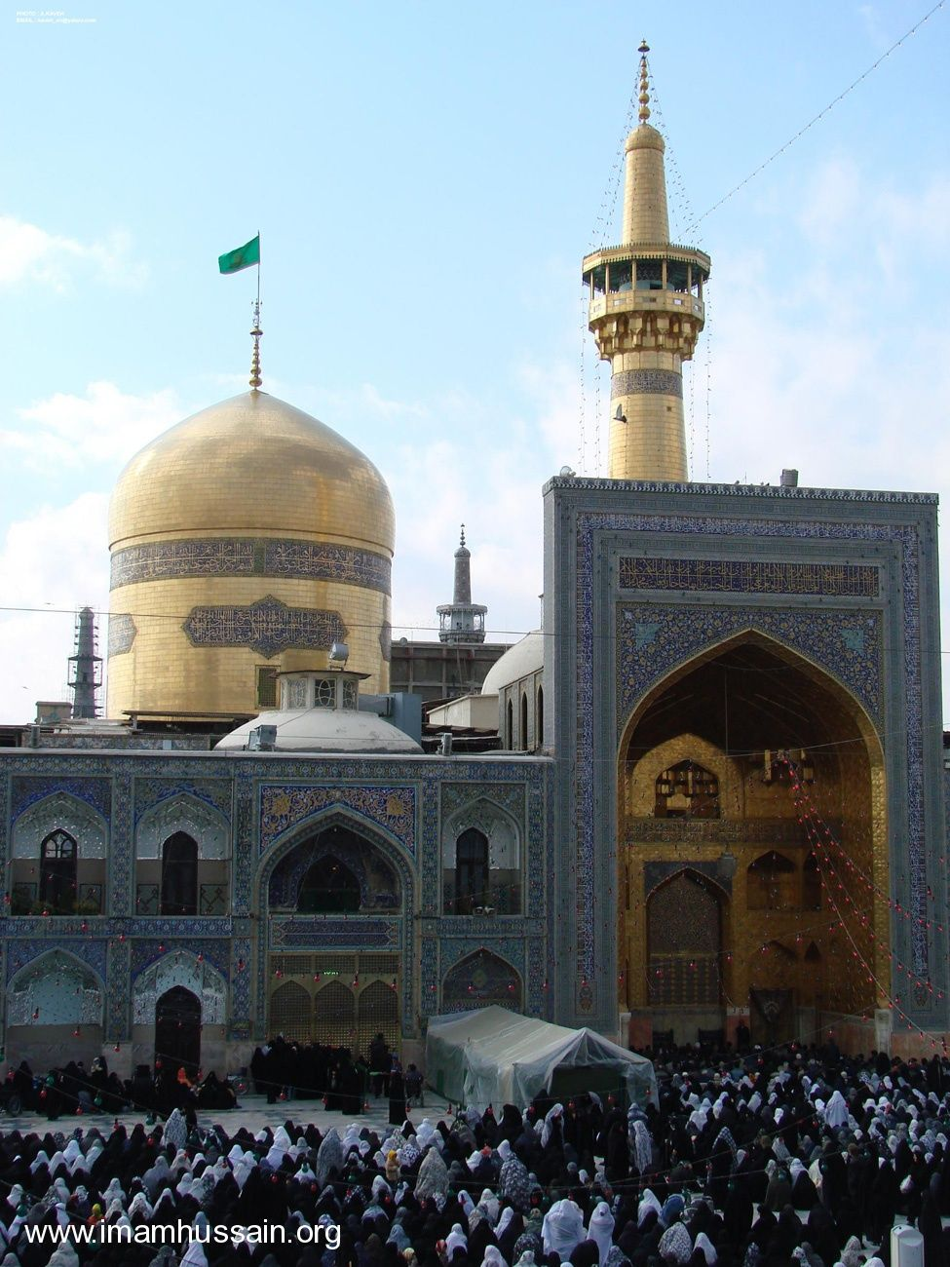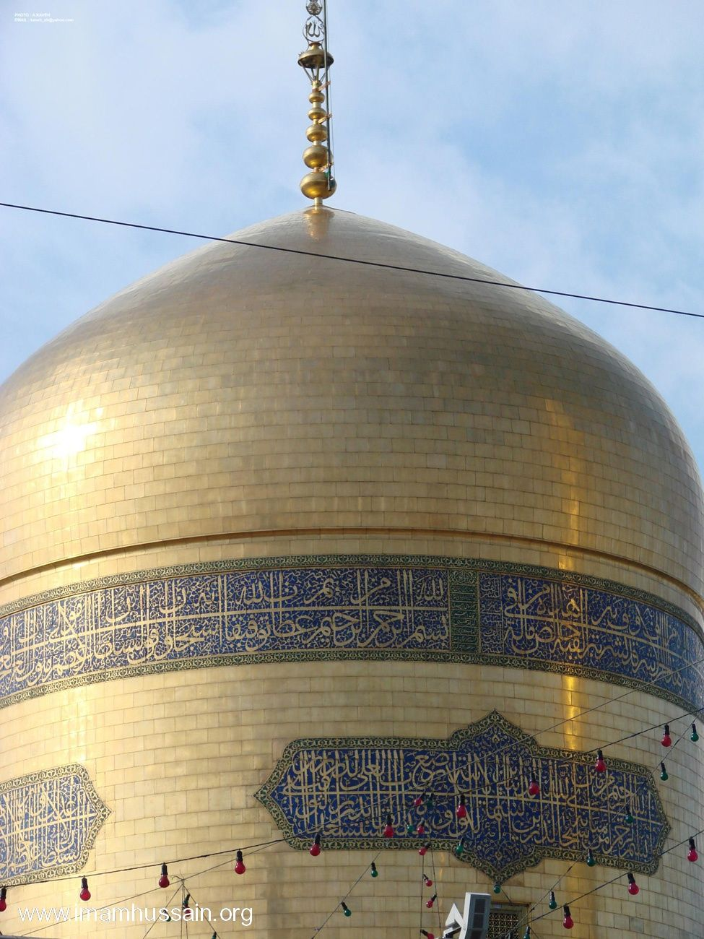

History of the shrine of Imam Ali b. Musa Al-Reza, peace be upon him the history of Mashad

Mashad is the capital of Khorasan province in the North East of Iran, 892 km away from Tehran. It is located at the altitude of 985 Meter occupying an area of 204 sq. Km. and has a population of about 1.5 million. Mashad grew from a small village called Sanabad, 24 km away from Tus. After the martyrdom of Imam Ali ibn Musa Al-Reza and his burial there in 203 AH, the place came to be known as Mashad Al-Reza. Astan-Qods-Razavi (the name given to the physical buildings comprising the Haram) is one of the most beautiful and glorious religious places in Iran. The best of Islamic art and architecture can be seen in the unique and significant monuments where Islamic art and faith is embedded.

History of the construction of Astan-Qods-Razavi

Hamza Ibn Qahtabah, the Abbasid army commander who had led the war against the Ommayids was appointed by Mansur and Al-Mahdi, the Abbasid caliphs as the Governor of Khorasan. He made a big garden between Noughan and Sanadan and erected a palace which stood up to the beginning of the 4th century AH. Haroon, who had come to Tus to suppress the Khorasan rebellion, became ill and resided in the garden during his ailment. But he died in 193 H. And was buried inside the palace. Upon his tomb a shrine was built.

In 203 AH, Imam Al-Reza, peace be upon him, was poisoned by Mamoun, the son of Haroon and Imam was buried alongside with Haroon. Since the martyrdom of Imam, his holy shrine became a place of pilgrimage for the world's Shias and the city spread so far as Noughan and Sanabad were annexed to it to become Mashad Al-Reza, shortened over time to Mashad.

The holy shrine was ruined by Saboktakin, a Ghaznavid king. But his son, Sultan Mahmoud ordered the shrine to be repaired and expanded in 428 AH. During the invasion of Changis and his son, Tooly, the holy shrine was ruined again. Sultan Mohamed Khoda-Banda, a Shiite king of Moghol dynasty, who reigned from 703 to 716 AH, had the holy shrine rebuilt. Since the time of Safavids, Afshars and Qajars to date many of the Astane-Qods buildings have been expanded.

Basts (Places of Refuge)

Basts were places of refuge from the tyranny of dictators and provided the best refuge for the people under persecution. In Astane-Qods-Razavi there exist two large yards on each side of Sahne Enqelab (Revolution Court) namely Baste Payeen Khiaban (Lower Bast) and Baste Bala Khiaban (Upper Bast). Today Basts are used as two entrances to Imam Al-Reza's Holy Shrine. In recent years two new Basts have been built namely Baste Sheikh Bahai (between Gowharshad Mosque and Sahne Jamburi Islami) and Baste Tabarsi (between the Islamic University and the new building of Astane-Qods Library).

Sahne Enqelab

This is one of the most beautiful and glorious buildings of Astane Qods Razavi. The four balconies in this court are Abbasi (North) , Tala (South), Naqqareh Khaneh (East) upon which lies Naqqareh Khaneh, Sa'at (Clock) (West) upon which is a big clock. These balconies which attest to the best of architecture are more than three centuries old. There is a big rectangular window in this court made of bronze and steel. Tala, the golden balcony was built by Amir Alishir Navaiee, Sultan Bighara's wise vizier in 872 H. The northern Abbasi balcony was constructed during Shah Abbas's reign in 1021 AH.

Minarets

The two golden minarets of Imam Reza's shrine have been specially built. The minarets are usually made on the two sides of the dome and near the dome. But these two minarets have been built far from each other. One, close to the Dome, upon Naderi balcony in the southern section of Sahne Enqelab and the other far in the northern section of Sahne Enqelab on Abbasi balcony. Although lack of symmetry can be clearly felt, it has been done on purpose so that when pilgrims enter Haram from Imam Reza Avenue they can see the minarets and the Dome in the middle. The minaret which is close to the Dome was built by Shah Tahmasb Safavi and has a height of 40.5 meters and a circumference of 13 meters. The other minaret on Abbasi balcony was built at the time of Nader Shah.

Nqqareh Khaneh (Place of Kettle Drums)

In 860 H. When Baisonqor Shahrokh's son came to Mashad from Herat to Haram to seek remedy from Imam Reza kettledrums were beaten to announce his presence. Since then this practice has been performed every day before sunrise and sunset except mourning period. The place where kettledrums are performed is on the eastern balcony of Sahne Enqelab.

Saqqa Khaneh (Public Drinking Place)

There is a public drinking place called hawze Ismail Talai in the middle of Sahne Enqelab with a gilded inscription belonging to the time of Nader Shah Afshar's reign. That is why it is called Naderi drinking place. The marble pool was brought from Her on Nader Shah's orders. The golden bricks with which the inscription has been written was made by Ismail, an artist whose name the drinking place bears. It was rebuilt in 1347 H.

Sa'at (the Clock)

There is a big clock on the western balcony of Sahne Enqelab. It dates back to the period of Mozaffar-al-Din Shah's period.

Sahne Jamhuri Islami (Islamic Republic Court)

This Sahn which is 10,000 square meters in size was built in recent years. It has two minarets at the back of the northern and Southern gates. Each minaret is 30 meters high. This Sahn provides one approach from Ravaq of Dar-al-Valayeh to the holy Shrine of Imam. The building situated on the eastern part of this Sahn is called Dar-al-Rahmeh.

Sahn Qods

This Sahn is recently built and 2500 Sq. Meters in size is situated between Sahne Imam Khomeini and Baste Shaykh Bahai. On the ground floor there are 28 chambers each six meters high and one veranda called Qebleh which is 50 Sq Meters in size. At the centre of this Sahn is a newly built public drinking place.

Sahne Imam Khomeini

This Sahn is located at the left side of the Holy Shrine of Imam Reza [a] and faces Imam Reza Avenue. Its area is more than 8300 sq Meters. Shaykh Bahai's tomb is located between this Sahn and Sahne Azadi.

Sahne Azadi

This Sahn is located east of the Holy Shrine and dates back to the time of Fath-Ali Shah Qajar. It is about 85 meters long and 54 meters wide. It has four verandas, the most famous of which is called Eivan Tala (golden Veranda) that is adjacent to the am. This veranda was gilded at the time of Nasir-al-Din Shah Qajar.

Gowharshad Mosque

This mosque is one of the most reputed in Iran and is situated adjecent to the Holy Shrine of Imam Reza. It was built in 821 AH. under the orders of Gowharshad Khatun, Shahrokh Mirza's wife. Its area is 9410 Sq Meters and includes a courtyard, four porches and seven large prayer halls. Two beautiful minarets, each 40 meters high, are located on both sides of Maqsureh Porch. There is an inscription on the left on the margin of the porch written by Baisonqor, one of the best calligraphists of the time. The Sahib-al Zaman Pulpit is in Maqsureh porch. It was built in 1243 H with walnut wood and without using any iron or nail. This mosque has a public library with 34,650 volumes.

Imam Reza [a]'s Tomb

It is located beneath the Golden Dome (The Golden Dome is the most prominent symbol of the city of Mashad with an altitude of 31.20 meters) and surrounded by different porches each bearing a separate name. The skilled artists have done their best in the creation of this place. It is square in shape and some 135 sq. meters have been added to its area after extension works. The walls are covered by marble up to twenty centimeters and the next ninety two centimeters are covered by expensive tiles known as Sultan Sanjari tiles. Quranic verses and Ahadiths of the Ahlul Bait [a] have been carved on these tiles. The important inscription written round the walls is eighty centimeters wide and written by Ali Reza Abbasi, the famous calligraphist of the Safavid period and bears Surah Jumah of the Holy Quran.

Dar-al Hoffaz (the place of the Reciters)

This porch is located south of the Holy Shrine and northeast of the Gowharshad mosque. It was built under the orders of Gowharshad khatoon. The pilgrims pray here seeking permission to enter the Holy Shrine. Dar-al-Hoffaz is connected to Haram through a doorway. It has been built for the

Quran reciters. Abbas Mirza, Fath-Ali Shah's vicegerent is buried in this porch.

Towhid Khaneh (place of Divine Unity)

It is located north of the Holy Shrine and south of Sahne Enqelab. This porch is used for ladies prayers.

Dar-al-Siyadah

Located in the western part of the Haram, this porch was built under the orders of Gowharshad Khatoon. There is a silver window in its northeastern part from where Imam Reza [a]'s Tomb can be seen.

Bala-Sar Mosque

There is a small mosque attached to the west part of the Haram. It is called Bala Sar (above the head) because pilgrims enter this mosque from the west side of Imam Reza [a]' s burial chamber which is Bala-Sar of Imam. It is one of the oldest mosques in Mashad and dates back to the time of Sultan Mahmood Ghaznavi.

Dar-al Rahmah Porch

This porch has an area of 365 sq. meters and is situated in the eastern part of Sahne Jamhuri e Islami. It has been decorated with gilding, plaster works, mirrors and fret work and was inaugurated in 1371 AH.

The other porches are Dar-al-Ekhlas, Dar-al-Shukr, Dar-al-Salaam and Dar-al-Zekr.

Allahverdikhan Dome

It is an octagonal dome built on Allahverdikhan's tomb. He was one of Shah Abbas's generals. It is located in northeast of Haram and decorated with colored tiles and beautiful drawings. It is one of the most valuable artistic works inside Haram.

Hatam Khani Dome

This dome is located east of Haram. One of Shah Abbas's ministers called Hatam Beik Ordoobadi built it in 1010 AH.

The Golden Dome

The Golden Dome on top of Imam Reza [a]'s tomb is the most prominent symbol of Mashad and has a height of 31.20 meters. A large inscription has been written round the Dome by Ali Reza Abbasi.

Museum of Astaane Quds

The Astaane Quds museum is one of the richest and most exquisite museums of Iran. The building is located in the eastern quarter of Sahne Imam Khomeini and close to Haram square. Some of its objects date back to the 6th century AH. The collection of carpets, rugs and golden covers for the Tomb are all unique and date back to the 11 and 13th centuries.

Some inscriptions written by Ali Reza Abbasi are among the valuable objects. Among the unique works of art in the museum is Imam's first tombstone, the inscription of which was carved in kufi relief script belonging to 516 H. There are also samples of relief tile work known as

Sanjari glazed tile belonging to the 6th century H. and a big stone water pool made of a piece of Blackstone decorated with the most beautiful arabesques.

Museum of The Quran

This museum is located in the vicinity of the Astaane Quds museum. It contains precious manuscripts of the Glorious Quran attributed to the Holy Imams and some gilded manuscripts. It was opened in 1364 H. The oldest manuscript attributed to the Holy Imams is in kufi script on deer skin belonging to the First century AH.

Museum of Stamps

The biggest stamp museum in Iran and was opened by Astaane Quds in 1368 AH. Some 50000 stamps from Iran and 18 foreign countries from Qajar period to the present time are on display in this museum. Astaane Quds Library: This library is located in the eastern part of Sahne Imam Khomeini and was established in 681 H. It has a unique treasure of manuscripts. It contains, according to last count done in 1368 AH., 257078 volumes of which 28218 are manuscripts and 724 photographic copies and the materials are in 36 different languages. The archives of this library are considered a treasure of documents.

Astane Quds Mehmansara

This inn is located in Baste-e Sofla and every overseas pilgrim (zair) of Imam Reza [a] has a right to one free meal as guest of Imam. Meals are served everyday.

Sheikh Bahaiee

The Tomb of Baha-o-din Mohamed Ameli, known as Sheikh Bahaiee, is located between Sahn-e-Imam and Sahn-e-Azadi in the Haram Astane Quds. Sheikh Bahaiee was born in Baalbak in 953 H. and came to Iran with his father when he was 7 years old. His genealogy dates back to Hareth Hamadani, the famous disciple of Imam Ali [a]. He had a great influence on Shah Abbas King of Iran and Iranian politics and culture and has left behind many scientific works.

Sheikh Hurr Ameli

His tomb is in Sahn-e-Enqelab in the Haram-Astaane Quds. He is one of the famous Shiite theologians and author of Wasa'el Al-Shia.

Sheikh Tabarasi

His tomb is in northern square next to Bagh-e-Rezvan and the avenue next to it has been named after him. Fazl-ibn-Hasan Tabarasi died 548 H. is the writer of the commentary Majma'-al-Bayan.

Khwajeh Morad

His tomb is 14 kilometers away in south east Mashad on the outskirts of Binalood mountains (opposite Bahesht-e-Reza cemetery). Herthameh bin Ayn, known as khwajeh Morad was a disciple of Imam Reza [a] and he died in 210 H.

Khwajeh Rabiee

Rabiee ben Haytham known as Khwajeh Rabiee was famous for his piety. His tomb is in the middle of a garden bearing a high dome. Its construction dates back to 11th century H. and is considered as a Safavid monument. It is one of the important buildings of Shah Abbas period in Khorasan.

There are two inscriptions written by Ali Reza Abbasi inside the shrine. The shrine is located at the end of Khwajeh Rabiee avenue and one of the great public cemeteries of Mashad lies next to Khwajeh Rabiee tomb. His death is recorded as in 63 H. Abasalt-e-Heravi's tomb: Abasalt, Imam Reza [a]'s servant died in 236 H and was buried beside the road to Fariman 10 kilometers from Mashad.

Gonbad (Dome) Kheshti

This dome, located in Tabarasi avenue, houses the grave of Imamzadeh Mohamed whose genealogy can be traced to Imam Sajjad [a]. The monument belongs to the Safavid period in architectural style.

Peer-e Palandooz (the old pack saddler)

Sheikh Mohammad Aref (died 985 H.) known as Peer-e-Palandooz was one of the most pious of his time. He was called so since he made pack saddles to earn his living. His tomb is in front of Baste-Payeen which was originally built by Sultan Mohammad Khoda Bandeh and has recently been reconstructed by Astan-e-Qods.

Gonbade Sabz (Green Dome)

This shrine is located in Khaki avenue and its dome has a color close to turquoise. Sheikh Mohammed Mo'men Aref Astrabadi, died 90 H. is buried here. He wrote the medical work Tohfeh Hakim Mo'men. The dome was built by Shah Abbas in 1011 H.

Mosalla Mashad

This monument is located in Payeen Khiaban and has a high porch and two porticoes on both sides. According to extant inscription it was built in 1087 H. during Shah Sulayman period. Its facade is made of bricks and it was previously used for prayers of the two Eids. The date of construction 1086 H. has been carved inside the Mehrab. The building is decorated with inscription and glazed tiles.

Akhanjan Tower

This tower is located 22 kilometers away from Mashad and it is believed that the tomb of Gowhartaj, the sister of Gowharshad Agha Taimuri is here.The facade of the tower is covered with octagon bricks and it has a conic dome.

Miami (Imamzadeh Yahya)

Imamzadeh Yahya was Zaid's son and grandson of our fourth Imam Sajjad [a] His mother Raiteh was the daughter of Abi Hashem Abdullah ibn Mohamed Hanifah. He was born in 107 H. and as his life was threatened by Umayyads, he migrated from Kerbala to Madaen and from there to

Khorasan. He was martyred at the age of 18 in Jowzjan in 125 H. His tomb is on the Sarakhs road 50 kilometers from Mashad and one kilometer from Miami village. The construction of the shrine dates back to the 10th century H.

Nadir's monument

It is located in a beautiful garden and built by National Monuments Association in 1958 A.D. Nadir's statute riding horse holding an Axe is on the top of the monument. The height is 5 meters weighing 14000 kilograms. There is a museum of weapons, helmets and armours inside the monument which was inaugurated in 1342 H. Nadir Shah ruled from 1148 to 1160 AH. The Allama Tabatabaie public library is in this monument run by Islamic Guidance Organisation.

Ferdowsi's monument

Abul Quasem Ferdowsi (died 411 H.) is the greatest epic poet who composed Shahnameh in 30 years. His shrine is located 22 kilometers northwest of Mashad alongside Quchan road. The monument is surrounded by a beautiful garden and was completed in 1968 A.D. There are still some old walls in the end side of the garden and there is a museum in the west part of the monument. Among the items in the museum is a manuscript of Shahnameh weighing 73 kilograms.

May Allah bless us all with the Ziyarat of Imam Reza [a] more and more often. I trust the above narrative will be of benefit to the pilgrims (zawwar) of Imam Reza [a].

Source

A GUIDE TO MASHAD

BY LATE MAHMUD MAHWAN

SUMMER 1994 EDITION

MAHWAN PUBLICATIONS AND YAS PUBLICATIONS

Maqbul Rahim

November 1995

History of the Shrine of Imam Ali Al-Naqi & Imam Hasan Al-Askari, Peace Be Upon Them

Before Explosion

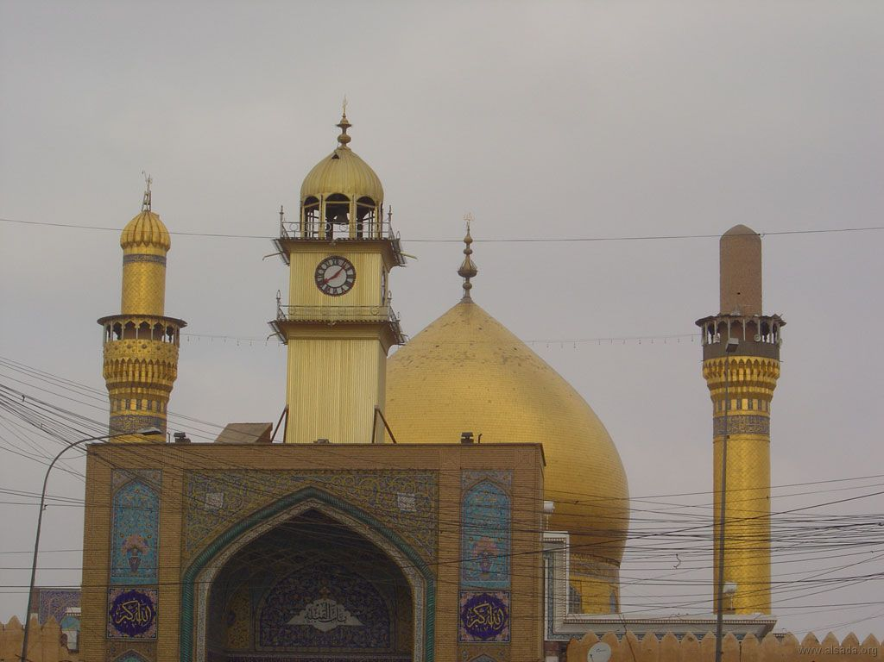

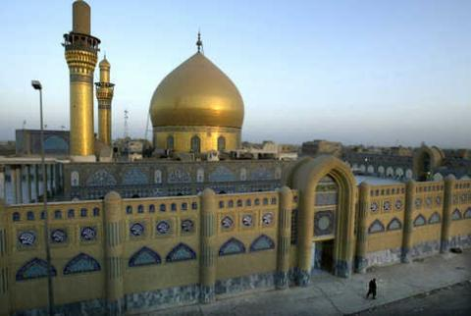

After Explosion

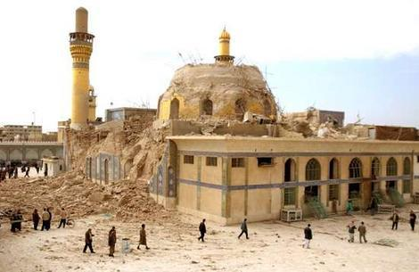

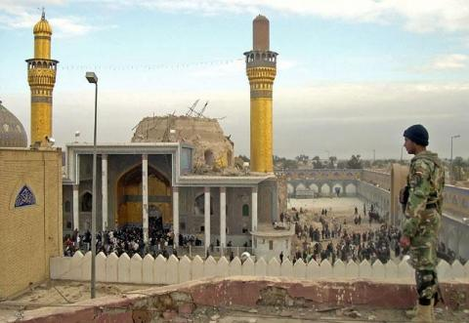

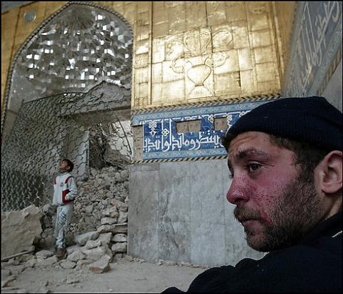

The modern city of Samarra is situated on the bank of the river Tigris some sixty miles from the city of Baghdad. The city is of outstanding importance because of its two shrines. The golden dome on one shrine was presented by Nasr al-Din Shah and completed under Muzaffar al-Din Shah in the year 1905 A.D. Beneath the golden dome are four graves, those of Imam Ali Al-Naqi (10th Imam) and his son, Imam Hasan Al-Askari (11th Imam).

The other two are of Hakimah Khatoon, the sister of Imam Ali Al-Naqi who has related at length the circumstances of the birth of Imam Al-Mahdi and the fourth grave is of Nargis Khatoon, the mother of Imam Al-Mahdi, peace be upon him. The second shrine marks the place where Imam Al-Mahdi went into concealment. It has a dome that is distinguished for the soft delicate design that is worked in blue tiles, and beneath it is the Sardab (cellar) where the Imam is said to have disappeared. Visitors may enter this Sardab by a flight of stairs.

In the year A.D. 836, after two years experience with factional strife in Baghdad, the Caliph Mu'tasim departed with his Turkish army to Samarra, “Which he founded and made his residence and military camp.”1 There eight caliphs lived in the short period of fifty-six years.2 The distance of Samarra from Baghdad is sixty miles. This name, Surra man ra'a (He who sees it, rejoices), is said to have been given by Mu'tasim himself, when, for approximately £2,000, he purchased as a site for his new city a garden that had been developed by a Christian monastery.

The Caliph's happy Arabic pun was based on the Aramaic name, Samarra, which was a town in the immediate vicinity from the times before the Arab conquest. The general district, however, was known as Tirhan.3 Thus the site chosen was an attractive garden spot in a fertile valley of the Tigris, and there the Caliph built his new capital, which became known as “the second city of the Caliphs of the Bani Hashim.” A main avenue, with many residences, ran along the river bank. In the garden of the monastery he built his royal palace, known as the Daru'l Amma, and the monastery itself became his treasury.

A Friday Mosque, was built by Mu'tasim very close to the quarter of the city that was set aside for the army.

Mustawfi informs us further that “he built a Minaret for the Mosque. 17=ells (about 19 metres) in height, with a gangway (to ascend it, that went up) outside, and no Minaret after this fashion was ever built by anyone before his time.”4 This Minaret, was so large that a man on horseback is said to be able to ascend its so-called gangway. The same thing is claimed for the similar minaret in the Mosque of Tulun, which may have been modeled after it.5

But the Turkish mercenaries, on whom Mu'tasim and his sons and grandsons relied, soon became the true masters of the situation. While they cherished their position as guardians of the caliphs, whom they permitted to live in luxury and security, nevertheless they so exploited their own opportunities - for gain, through cruelty and oppression, that in matters of internal administration the authority of the Muslim Empire sank to a low

ebb. This was at a time, however, according to Dinawari, when there were more victories, for the troops than during any preceding caliphate.6

In Samarra the caliphs busied themselves building palace after palace, on both sides of the river, and at a cost that Yakut estimated as 204 million Dinars, which would not be less than eight million sterling.7 A great cypress tree is celebrated in the Shah Nameh as having sprung from a branch brought by Zoroaster from Paradise. It is said to have stood at the village of Kishmar, near Turshiz, and to have been planted by Zoroaster in memory of the conversion of King Gushtasp to the Magian religion.

Such too was its power that earthquakes, which frequently devastated all the neighbouring districts, never did any harm in Kishmar. According to Kazvini, the caliph Mutawakkil in 247 A.H. (861 A.D.) caused this mighty cypress to be felled, and then transported it across all Persia, in places carried on camels, to be used for beams in his new palace at Samarra. This was done inspite of the grief and the protests of all the Guebres, but when the cypress arrived on the banks of the Tigris, Mutawakkil was dead, having been murdered by his son.8

Mustawfi who wrote in the fourteenth century, takes pain to mention with sympathy how the Caliph Mutawakkil enlarged Samarra, and in particular, how “he built a magnificent Kiosk, greater than which never existed in the lands of Iran, and gave it the title of the Ja'fariyyah (his name being Ja'far). But evil fortune brought down on him in that he had laid in ruins the tomb of Imam Husain, at Karbala, and furthermore he had prevented people from making their visitation to the same - decreed. that, shortly after his death, his Kiosk should be demolished, so that no trace of it now remains. Indeed, of Samarra itself, at the present time, only a restricted portion is inhabited.”9

The restricted portion that was still occupied in the fourteenth century was approximately the same as the modern Samarra, and was part of the “Camp of Mu'tasim.” Here the Imams, Ali Al-Naqi and his son, Hasan Al-Askari were imprisoned and poisoned and hence they were called the Askariyan, or the “Dwellers in the Camp.” It was here also that both of them were buried. The modern Samarra is only a few paces removed from the walls of the old Friday Mosque, which agrees with Mustawfi's observation that “in front of the mosque stands the tomb of the Imam Ali Al-Naqi, grandson of the Imam Ali Al-Reza; and also of his son, the Imam Hasan Al-Askari.”

That the city of the Caliphs was much more extensive is indicated by the modern observation that “the ground plan of the many barracks, palaces and gardens can be very plainly seen by anyone flying over the site in an aeroplane.”10 The historical topography of the ephemeral capitol of the Caliphs as outlined by the Arab geographers, Ya'kubi and Yakut, has been investigated recently by archaeologists, so that the location of the principal streets and of the many of the palaces has been determined. Also the findings have proved to be of special value to students of Muslim art, for they are representatives of the period when the civilization of the Abbasid caliphate was “shedding its lustre over the world.”11

It was in this part of Samarra that still remains that the Imam Muhammad ibn Hasan Al-Askari disappeared from human sight. Mustawfi says this happened in 264 A.H. (878 A.D.) at Samarra.12 The fact that the Shia community was permitted to have its headquarters after the fall of the Buyids in the nearby city of Hilla, from which place they conducted their negotiations at the time of the invasion of Khulagu Khan, gave rise to the tradition that the Hidden Imam would reappear in that town. This accounts for the confusion of the traveller, Ibn Batuta (A.D. 1355), who found shrines dedicated to the last Imam, both in Hilla and Samarra.

The mosque of the last Imam in Hilla marks the place of his expected reappearance, but the place of his disappearance is at Samarra. At Hilla, Ibn Batuta found that the mosque had an extended veil of silk stretched across its entrance, and it was a practice for the people “to come daily, armed to the number of a hundred, to the door of this mosque, bringing with them a beast saddled and bridled. `Come forth, Lord of the Age, for tyranny and baseness now abounds; this then is the time for thy egress, that, by thy means, God may divide between truth and falsehood.'

They wait till night and then return to their homes.” Samarra itself was at that time in ruins, though Ibn Batuta mentions that “there had been13 a Mashhad in it, dedicated to the last Imam by the Shias.” It may have been owing to the fact that the place was in ruins that pains were not taken to ascertain that the Mashhad was the “place of witness” in memory of the Imams, Ali Al-Naqi and Hasan Al-Askari, and that a different spot nearby was highly regarded as the place where the last Imam disappeared.een a Mashhad in it, dedicated to the last Imam by the Shias.” It may have been owing to the fact that the place was in ruins that pains were not taken to ascertain that the Mashhad was the “place of witness” in memory of the Imams, Ali Al-Naqi and Hasan Al-Askari, and that a different spot nearby was highly regarded as the place where the last Imam disappeared.een a Mashhad in it, dedicated to the last Imam by the Shias.” It may have been owing to the fact that the place was in ruins that pains were not taken to ascertain that the Mashhad was the “place of witness” in memory of the Imams, Ali Al-Naqi and Hasan Al-Askari, and that a different spot nearby was highly regarded as the place where the last Imam disappeared.een a Mashhad in it, dedicated to the last Imam by the Shias.” It may have been owing to the fact that the place was in ruins that pains were not taken to ascertain that the Mashhad was the “place of witness” in memory of the Imams, Ali Al-Naqi and Hasan Al-Askari, and that a different spot nearby was highly regarded as the place where the last Imam disappeared.een a Mashhad in it, dedicated to the last Imam by the Shias.” It may have been owing to the fact that the place was in ruins that pains were not taken to ascertain that the Mashhad was the “place of witness” in memory of the Imams, Ali Al-Naqi and Hasan Al-Askari, and that a different spot nearby was highly regarded as the place where the last Imam disappeared.een a Mashhad in it, dedicated to the last Imam by the Shias.” It may have been owing to the fact that the place was in ruins that pains were not taken to ascertain that the Mashhad was the “place of witness” in memory of the Imams, Ali Al-Naqi and Hasan Al-Askari, and that a different spot nearby

was highly regarded as the place where the last Imam disappeared.een a Mashhad in it, dedicated to the last Imam by the Shias.” It may have been owing to the fact that the place was in ruins that pains were not taken to ascertain that the Mashhad was the “place of witness” in memory of the Imams, Ali Al-Naqi and Hasan Al-Askari, and that a different spot nearby was highly regarded as the place where the last Imam disappeared.een a Mashhad in it, dedicated to the last Imam by the Shias.” It may have been owing to the fact that the place was in ruins that pains were not taken to ascertain that the Mashhad was the “place of witness” in memory of the Imams, Ali Al-Naqi and Hasan Al-Askari, and that a different spot nearby was highly regarded as the place where the last Imam disappeared.een a Mashhad in it, dedicated to the last Imam by the Shias.” It may have been owing to the fact that the place was in ruins that pains were not taken to ascertain that the Mashhad was the “place of witness” in memory of the Imams, Ali Al-Naqi and Hasan Al-Askari, and that a different spot nearby was highly regarded as the place where the last Imam disappeared.een a Mashhad in it, dedicated to the last Imam by the Shias.” It may have been owing to the fact that the place was in ruins that pains were not taken to ascertain that the Mashhad was the “place of witness” in memory of the Imams, Ali Al-Naqi and Hasan Al-Askari, and that a different spot nearby was highly regarded as the place where the last Imam disappeared.een a Mashhad in it, dedicated to the last Imam by the Shias.” It may have been owing to the fact that the place was in ruins that pains were not taken to ascertain that the Mashhad was the “place of witness” in memory of the Imams, Ali Al-Naqi and Hasan Al-Askari, and that a different spot nearby was highly regarded as the place where the last Imam disappeared.een a Mashhad in it, dedicated to the last Imam by the Shias.” It may have been owing to the fact that the place was in ruins that pains were not taken to ascertain that the Mashhad was the “place of witness” in memory of the Imams, Ali Al-Naqi and Hasan Al-Askari, and that a different spot nearby was highly regarded as the place where the last Imam disappeared.een a Mashhad in it, dedicated to the last Imam by the Shias.” It may have been owing to the fact that the place was in ruins that pains were not taken to ascertain that the Mashhad was the “place of witness” in memory of the Imams, Ali Al-Naqi and Hasan Al-Askari, and that a different spot nearby was highly regarded as the place where the last Imam disappeared.

References

1. . Dinawari, Akhbar at-Tiwal, et. Guirgass, p. 396.

2. . Ya'kubi (A.D. 891), Kitab al-Buldan, cd. de Goeje, p. 255, & Mustawfi, Nuzhatu'l-Qulab, Eng. trans. Le Strange, p. 40.

3. . Ya'kubi, op. cit., p. 255; and Le Strange, Lands of the Eastern Caliphate, pp. 53-54.

4. . Mustawfi, op. cit., p. 49.

5. . Encyclopedia Britannica, 11th edit., Vol. II, p. 424.

6. . Dinawari, op., cit, 396.

7. . Le Strange, op., cit., p. 55.

8. . Ibid., p. 355.

9. . Mustawfi, op. Cit., p. 49.

10. . Historical Mesopotamia, A Guide Book published by Baghdad Times, Baghdad, 1922, p. 51.

11. . Ency. Islam, art. “Samarra”, with references to the investigations of E. Herzfeld.

12. . Mustawfi, op. cit., p. 47.

13. . Ibn Batuta, cd. Paris, ii, p. 98; ibid., - trans. Lee, ch. VIII, p. 48; De Herbelot, Ann. Mosl., tom. iii, p. 716 and the Encyclopedia of Religion and Ethics, art. “Mahdi”, vol. III, p. 338.