Maytham al-Tammar

Biography of the companion of Imam 'Ali (a)

Author(s): Kamal al-Syyed

Publisher(s): Ansariyan Publications - Qum

Table of Contents

Maytham al-Tammar 3

Who was Maytham? 4

The Real Name 5

In the Desert 6

At al-Tammar's Shop 7

The Nation's Scholar 8

Amru bin Huraith 9

The Market 10

A Meeting of the Road 11

The Caravan 12

The Prison 13

Faith 14

The End 15

The Neighbour 16

People 17

Maytham's Body 18

The Tomb of Maytham 19

Maytham al-Tammar

It was dawn. As usual, Maytham went to the date-palm trunk. He splashed it with water. The good ground sent out a sweet smell. Maytham said two Raka'as. Then he put his back against the date-palm trunk.

Maytham had visited the date palm for more than twenty years. It had not been a mere dry trunk. It had been a tall date palm before twenty years.

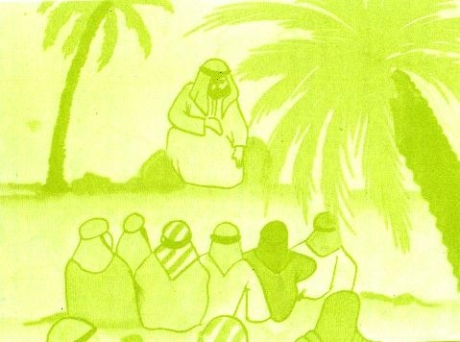

Days, months, and years passed.

Maytham said two Raka'as near the date palm. Then he addressed it:

Allah has created you for me. And He has created me for you.

Maytham liked that date palm. He watered it when it was green.

One day, he came to the date palm. He found it a dry trunk. He cut the top of the trunk. That tall date palm became a mere short trunk. Still Maytham went on visiting that dry trunk.

Who was Maytham?

What was the relationship between him and that date palm?

Maytham was born at Nihrawan near Kufa. He belonged to Iran. A woman from Bani Asad bought him. One day, Imam Ali [a] bought and gave him his freedom. Maytham became free. He sold dates in Kufa Market.

Maytham lived a simple life. Two things grew in his heart: faith in Islam and love for Imam Ali [a]. Imam Ali [a] taught him that Islam was the only way to freedom.

Imam Ali [a] liked Maytham because he was a good man. The Imam went to Maytham's shop. He taught him about Islam.

The Real Name

Imam Ali [a] bought Maytham from a woman belonged to Bani Asad. The Imam asked Maytham:

What's your name?

Saalim.

The Imam said:

Allah Apostle [s] has told me that the Iranians call you Maytham.

Maytham was astonished because no one knew his real name. So, he said:

Allah and His Apostle are truthful.

Since that day, Maytham had not left the Imam.

In the Desert

Whoever goes to the desert at night will see the sky full of stars. His heart will be afraid of Allah.

Imam Ali [a] went to the desert at night to say his prayers. He took a friend of his to that desert to teach him a lesson about Islam.

Sometimes, Imam Ali [a] took Maytham to the desert. He told him about future matters. The Imam had learnt future matters from our Master Muhammad [s].

Maytham listened to Imam Ali's words. The Imam said his prayers. Maytham said them behind him. He listened with awe to the Imam's prayers.

At al-Tammar's Shop

Imam Ali [a] went to the market to meet Maytham al-Tammar. He sat and talked with him. Some people passed by them. They did not know the Imam. And some knew him. They were astonished to see the Imam sitting with a date seller.

One day, Imam Ali [a] went to the market. He sat with Maytham. After a while, Maytham wanted to go to buy something. He asked the Imam's permission and went away.

The Imam stayed behind to sell dates. In the meantime, a man came to buy some dates worth four dirhams. The man took the dates and went away.

Maytham came back. He was astonished to see the dirhams because they were false. The Imam smiled and said:

The owner of the dirhams will come back.

Again Maytham became astonished. He wondered:

The man bought the dates by false dirhams!

Why will he come back?

After an hour, the owner of the dirhams came back. He said angrily:

I don't want these dates! They are bitter! Why are they bitter?

The Imam said:

Because your dirhams are false!

The man was full of astonishment. He took the dirhams and went away.

The Nation's Scholar

Maytham was brilliant. He got his knowledge from Imam Ali [a]. One day he said to Abdullah bin Abbas, the nation's scholar:

Ask me whatever you want about the Qur'an explanation. I've learnt everything from Imam Ali [a].

So, bin Abbas sat before Maytham to learn lessons about the Qur'an explanation.

Amru bin Huraith

Amru bin Huraith was a leader from Kufa. Maytham said to him:

I'll be your neighbour. Treat me kindly.

Amru said:

Do you want to buy bin Masoud's house or bin al-Hakim's?

Maytham kept silent. Amru bin Harith was puzzled. He wondered:

What does Maytham mean?

Days and years passed. Unjust rulers succeeded each other over Kufa. They treated its people rudely.

The Market

Ziyad bin Abeeh became a ruler over Kufa. He began killing Imam Ali's companions. He carried out Mu'awiyah orders. Mu'awiyah was full of spite. He ordered people to abuse Imam Ali [a].

The ruler appointed a man to look after the market. The man was unjust. The people complained of his bad treatment. The people were afraid of the man. Thus, they went to Maytham. They asked Maytham to go with them to the Prince. They said to him:

Maytham, come with us to the Prince.

Maytham went with them. He met the Prince and told him about the rude treatment in the market. A policeman in the Palace was displeased with Maytham's words. He said to the Prince:

Your Highness, the Prince, do you know this man?

The Prince said:

No!

He's a liar! The supporter of a liar!

The policeman meant that Maytham was one of Imam Ali's companions.

Maytham said:

Surely, I'm truthful! I'm the supporter of a truthful man. Really, he's Amirul Mu'mineen! (the Commander of the Faithful)

A Meeting of the Road

Habeeb bin Mudhahir was a good companion. After our Master Muhammad's demise, Habeeb had a close relationship with Imam Ali [a].

One day, Maytham was riding a horse. Habeeb bin Mudhahir was riding a horse, too. They met each other before Bani Asad. They had a short talk. Bani Asad listened to their talk. Habeeb said with a smile:

I predict that a bald man with a big belly will sell melons at Dar al-Rizk. The man will be killed for the love of his Prophet's family.

Maytham said:

I know that a red man with two plaits would appear. The man will support the son of the daughter of his Prophet. The man will be beheaded. His head will be carried through the streets of Kufa.

The two friends saw off each other. Bani Asad said:

They are liars.

In the meantime, Rasheed al-Hajry passed by Bani Asad. He asked them about Habeeb and Maytham. Bani Asad said:

They've just gone away.

Then Bani Asad told Rasheed about Habeeb's and Maytham's predictions.

Rasheed said with smile:

May AIlah have mercy on Maytham. He's forgotten to say: The person who brings the head will be given an extra hundred dirhams.

Rasheed went away. Bani Asad were astonished at his words. Then they said:

Rasheed is a liar; too!

Days passed. In Muharram, 61 A.H., Bani Asad saw Habeeb's head. It was tied to a long spear. They saw Ibn Ziyad's policemen carrying the head and walking through the streets of Kufa.

The Caravan

Mu'awiyah bin Abu Sufyan died. His son Yazeed succeeded him. Yazeed was a young man aged 30. He drank alcohol. He amused himself with the dogs and the monkeys.

So, Imam Husayn [a] refused to pay Yazeed homage. Meanwhile, the Kufians were tired of Mu'awiyah's persecution. Thus, they sent Imam Husayn [a] many letters. In their letters, they asked the Imam to come to save them from the Umayyad persecution.

The spies told Yazeed about the situation in Kufa. Yazeed had a spiteful Christian doctor called Sergon. He asked the advice of the doctor. Sergon advised him to appoint Ubaidullah bin Ziyad a ruler over Kufa.

The Prison

Many companions of Imam Ali [a] supported Imam Husayn [a]. Many Muslims supported him, too.

Ubaidullah bin Ziyad arrived in Kufa, He began arresting and imprisoning Imam Husayn's supporters.

Maytham, Mukhtar al-Thaqafy, Abdullah bin al-Harith were in the same prison.

Imam Husayn [a] died a martyr for Islam. The prisoners felt pain for him.

Mukhtar said to his two friends:

Be ready to meet Allah! After Imam Husayn's killing, Ubaidullah bin Ziyad will kill the Imam's supporters!

Abdullah bin al-Harith said:

Yes, he will kill us sooner or later!

Maytham said:

No, he won't kill you. My dear Imam Ali [a] has told me that you (Mukhtar) will get revenge of Imam Husayn's killers. And you will kick Ubaidullah's head with your foot.

Then Maytham said to Abdullah bin al-Harith:

You'll rule Basrah.

Faith

Maytham deeply believed in Allah. He was not afraid of the unjust. People were afraid of Ibn Ziyad. They shook with fear when they saw him. But Maytham did not pay attention to him. He knew that Ubaidullah's death was certain. He knew that the unjust would not stay alive forever.

Mu'awiyah and his son Yazeed prevented people from loving Imam Ali [a]. The police arrested and killed the Imam's companions.

Imam Ali [a] had told his companions about the Umayyad police. One day he said to Maytham:

The Umayyad will order you to disown me. Will you do that?

Maytham said:

No, I won't!

Maytham thought that to disown Imam Ali [a] meant to disown Islam. And to disown Islam meant to disown Allah. The Imam said:

Surely, you'll be killed!

Maytham said:

I'll be patient! Death is little for Allah!

The lmam said:

You'll be with me in Paradise.

The End

Ubaidullah bin Ziyad ordered the police to bring Maytham. He said to him:

I've heard that you're a companion of Ali's!

Maytham said:

Yes.

Ubaidullah bin Ziyad said to Maytham:

Will you disown him?

Maytham said:

No, I won't!

Ubaidullah bin Ziyad said:

Surely, I'll kill you!

Maytham said:

By Allah, Imam Ali [a] has told me that you will kill me! He has told me that you will cut my hands, legs, and tongue!

Ibn Ziyad stormily said:

Your Imam is a liar!

Maytham jeered at that foolish person (Ubaidullah).

Ibn Ziyad ordered the police to tie Maytham to the date-palm trunk near the house of Amru bin Huraith. Besides, he ordered them to cut off his hands and legs.

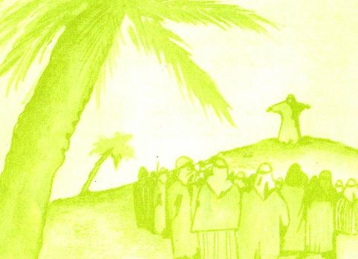

The Neighbour

Maytham was tied to the date palm trunk.

Amru bin Huraith saw him. Amru remembered Maytham's words:

I'll be your neighbour. Treat me kindly.

So, Amru bin Huraith ordered one of his daughters to sweep the ground around the date-palm trunk. He also ordered her to splash it with water.

A person looked at Maytham and said:

Disown Ali to save your soul!

Maytham said with a smile:

By Allah, this date palm has been created for me! And I've been created for it!

Thus, people knew the secret of Maytham's visit to the date palm throughout the long years.

People

Maytham addressed the people:

People, if you want to hear some information about Ali bin Abi Talib, then come to me.

The people crowded around Maytham. He began teaching them various kinds of knowledge.

The spies told Ubaidullah bin Ziyad about Maytham's words.

Ibn Ziyad ordered a policeman to cut off Maytham's tongue. Maytham said:

Amirul Mu'mineen has told me about that.

The policeman cut off his Maytham's tongue. Another policeman stabbed him with a sword.

Thus, this mujahid's life was put out like a candle!

Maytham's Body

Maytham did a lot of good for people. The people loved him very much. They wanted to take Maytham's body to bury it. But the police strictly prevented them from approaching it.

One night, seven dates-sellers came. They saw the policemen burning a fire. Two of them sawed the trunk. The seven dates-sellers carried Maytham's body outside Kufa. They buried it at a known place. Then they came back home.

Six years passed. Mukhtar announced his revolution in Kufa. His army met Ubaidullah's on al-Khazir Riverbank.

Ibrahim al-Ashtar could behead Ubaidullah bin Ziyad.

Some fighters brought Mukhtar the head of Ubaidullah. He stood up and kicked Ubaidullah's head. He remembered Maytham's words in prison.

Mukhtar, you'll get out of prison. You'll get revenge on Imam Husayn's killers.

Days passed. Imam Husayn's killers perished. People have cursed them throughout history.

Today, when a visitor leaves the Holy City of Najaf and goes to see the Kufa ruins, on the way he sees a beautiful dome. The dome decorates Maytham's shrine.

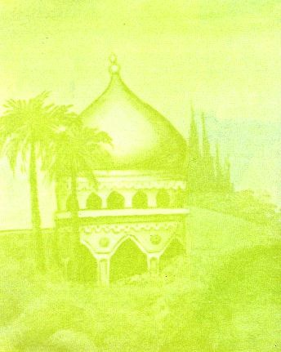

The Tomb of Maytham

